Deep Learning-Based Honey Adulteration Classification: A Comparative Study with Hyperparameter Tuning and Explainable AI
Abstract

Honey adulterated with cheap sugar syrups is still threatening consumer confidence in one of the most precious natural products globally. However, methods to detect such fraud can be slow, expensive, or destructive. This study developed an explainable deep-learning framework for distinguishing pure from adulterated honey using two complementary and openly available datasets: a large synthetic physicochemical dataset (D1; 247,903 observations, eight variables) and a visible-near-infrared (Vis-NIR) hyperspectral dataset of real honey samples (D2; 8,675 observations, 128 bands). A one-dimensional convolutional neural network (1D-CNN) and a bidirectional long short-term memory network (Bi-LSTM) were independently optimized for each dataset using Optuna and then evaluated on held-out test data using accuracy, precision, recall, F1-score, and ROC-AUC. The 1D-CNN outperformed the Bi-LSTM on both modalities. On D1, it reached 98.49% accuracy, an F1-score of 0.9881, and a ROC-AUC of 0.9994, compared with 92.42%, 0.9417, and 0.9832 for the Bi-LSTM; on D2, it reached 99.08% accuracy and a ROC-AUC of 0.9987, compared with 93.16% and 0.9846. SHAP analysis of the physicochemical model ranked pH and colour score as the dominant predictors, followed by density and water content. Two caveats temper these numbers. D1 is synthetically generated; therefore, the D1 results demonstrate that the framework recovers a known nonlinear decision boundary rather than detecting adulteration in real honey; and all four models were evaluated only through internal validation. Therefore, the framework is best understood as a reproducible, interpretable template for rapid authenticity screening, one that now requires external validation on independently collected honey spanning a range of botanical origins, adulterant types, and adulteration levels.
Keywords: Honey Adulteration, 1D CNN, Bidirectional LSTM, Explainable AI

1. Introduction
Honey is a chemically complex food. The major constituents of this food are carbohydrates, but water, organic acids, proteins, amino acids, minerals, enzymes, phenols, and volatiles all play their part in making it valuable in terms of functionality and taste. And it is exactly because of this reason that honey becomes vulnerable to economic adulteration, which primarily consists of adding inexpensive syrup to honey (Dodd et al., 2025). This is because not only does it make the volume of the product more but also produces something that cannot be differentiated from honey in terms of taste and appearance (Zhang et al., 2023).
The sugar syrups, HFCS, rice syrup, invert sugar, and similar carbohydrate-based sweeteners used to adulterate honey have a chemical composition that is comparable to that of the major sugars found in honey. A single determination of sugar content does not possess much discriminant capability (Egido et al., 2024). Chromatography, isotope analysis, spectroscopy, and molecular approaches give more chemical information than one but usually involve complex equipment, time-consuming sample preparation, skilled analysts, and an analysis cost that excludes them from screening procedures. Visible and near-infrared spectroscopy is among the most attractive alternatives.
No sample preparation is needed, and it responds to overtone and combination vibrations of O-H and C-H bonds, along with the presence of colorants at the shorter wavelengths. However, the problem lies in the fact that the honey matrix gives broad absorption spectra, with many overlaps at each wavelength, rendering any meaningful analysis impossible (Prata & da Costa, 2024). (Biswas & Chaudhari, 2024) Raise this issue in their review of honey identification based on NIR technique, and stress the significance of chemometrics modeling alongside the measurements process.
Machine learning expands on this by capturing nonlinear relationships between physicochemical or spectral variables that cannot be captured through fixed thresholds (Shi et al., 2025). Convolutional deep learning models that use hyperspectral and Raman measurements have delivered excellent classification results for honey adulteration, thus indicating that convolutional neural network structures can be used for feature extraction from complex analytical data (Ahmed, 2024). One dimensional CNN is well suited for spectrum analysis since convolution kernels learn local features based on neighboring variables, and neighboring wavelengths hold correlated information due to overlapping molecular absorptions (Malek et al., 2018). Bi-directional LSTM networks come close to the
same data in different ways, in both forward and backward directions to take advantage of distant dependencies (Schuster & Paliwal, 1997). Which model is more suited for honey authentication data can only be known through empirical comparison, which has seldom been done.
Such comparisons make sense only when both designs are compared at their optimal points. The performance relies heavily on the learning rate, kernel size, number of filters, dropout, and hidden unit size, and the tuning process requires significant costs. To solve this problem, Optuna uses the sequential model-based design approach that includes the tree-structured Parzen Estimator. This algorithm allows for efficient sampling of the areas of the hyperparameter space where promising models are likely to be found (Akiba et al., 2019).
However, accuracy alone does not tell us the reasons behind such decisions. This is where explainable AI comes into play. SHAP (SHapley Additive exPlanations) assigns a feature value to each of the predictions, allowing us to figure out which physicochemical or spectral features make the machine issue a fraud alert (Lundberg & Lee, 2017). Traceability is just as crucial as any other characteristic for a technique meant to be used in a regulated setting.
However, such studies are few in number. This is why in the current research an effort was made to (i) construct a framework within which 1D-CNN and Bi-LSTM models were optimized in the same way and evaluated using physicochemical data and Vis-NIR hyperspectral data, (ii) examine not only convergence and generalization but also classification measures, and (iii) interpret the results using SHAP.

2. Materials And Methods

2.1 Study framework
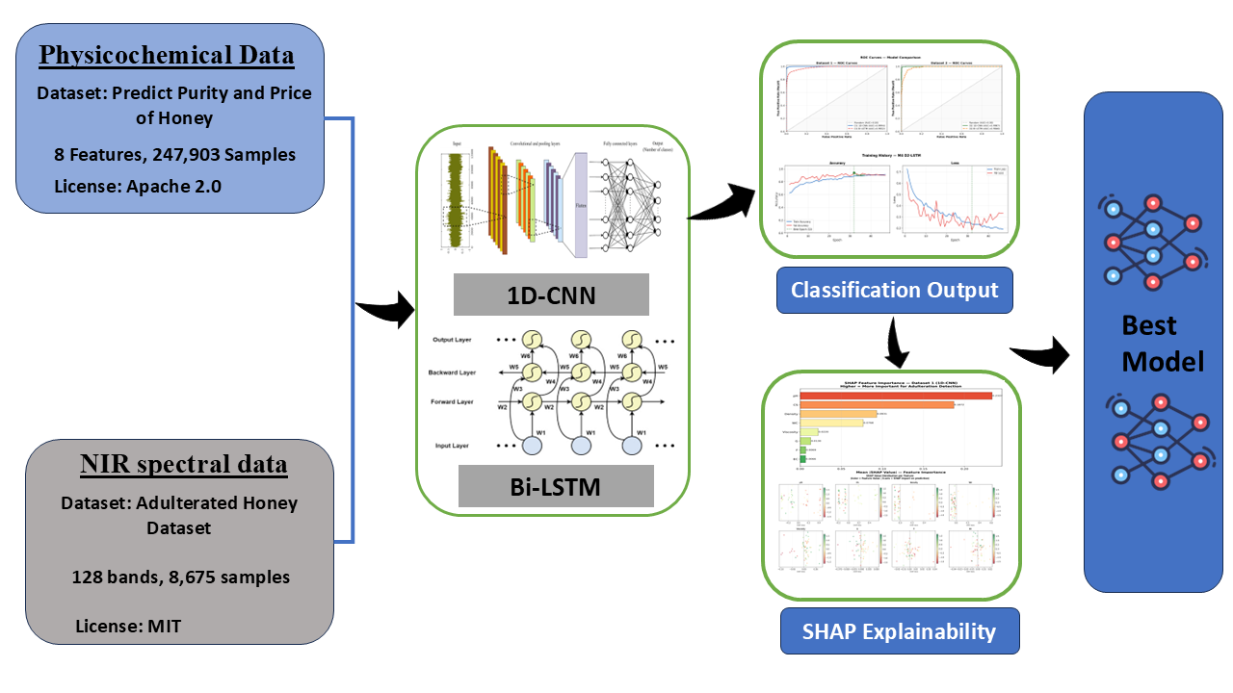
The methodology uses a single pipeline implemented twice, once per dataset, namely data preparation, exploratory data analysis, preprocessing, model building, hyperparameter tuning, evaluation on a hold-out test set, and explanation of the results. The 1D-CNN and the Bi-LSTM model were built and optimized separately for both datasets, which led to four models (M1-M4). Subsequently, SHAP was used to analyze the most accurate physicochemical model. The process is depicted in Fig. 1.
Figure 1 . Computational workflow of the proposed framework, from the two input datasets through parallel 1D-CNN and Bi-LSTM development to classification output, SHAP explainability, and model selection.

2.2 Datasets
Two datasets of different natures have been used for the experiment in order to make sure that comparison of the architectures does not depend on one particular data structure as presented in Table 1. They differ from each other in terms of size, modality, and source: D1 is synthetic and D2 is real.
Table 1. Composition and class balance of the two datasets used in this study
Dataset | Data type | Provenance | Total observations | Pure | Adulterated | Class ratio
D1 | Physicochemical (8 variables) | Synthetic | 247,903 | 159,381 (64.3%) | 88,522 (35.7%) | 1.8:1
D2 | Vis-NIR hyperspectral (128 bands) | Measured | 8,675 | 1,050 (12.1%) | 7,625 (87.9%) | 1:7.3

2.2.1 Physicochemical dataset (D1)

Dataset D1 has 247,903 observations taken from the public Kaggle repository “Predict Purity and Price of Honey” (stealthtechnologies, 2024). In total, 159,381 (64.3%) of observations are labeled as pure while 88,522 (35.7%) of observations are adulterated. There are eight input variables provided in the dataset: color score (CS), density, water content (WC), pH, electrical conductivity (EC), fructose (F), glucose (G), and viscosity. This dataset has been artificially created instead of experimentally measured. Variables of this dataset have been simulated to be distributed across a range of parameter values that are similar to those stated in the honey authenticity literature. The purity label has been generated using the continuous purity score (correlation between purity score and binary purity label, r = 0.88) with the threshold procedure. Two implications should be considered throughout the further interpretation of every D1 result. First, the eight predictors are almost independent by definition (all pairwise |r| < 0.01; Fig. 2b), whereas they do not form an independent set in the case of real honey since composition variables are correlated. Second, classifier training on D1 means learning of a synthetic generation function, and classifier performance measures the quality of boundary recovering, but not the ability to detect real honey adulteration.

2.2.2 Vis-NIR hyperspectral dataset (D2)
D2 represents the hyperspectral adulterated honey dataset that was gathered at the University of Auckland by (Phillips et al., 2021) and can be obtained from a public mirror site. The data consists of 8,675 records, which include 1,050 pure (12.1%) and 7,625 adulterated (87.9%). Each record has 128 spectral features extracted over the visible to near-shortwave infrared spectrum range (about 400-1000 nm). The data sample covers twelve different honey varieties from seven different New Zealand brands and twelve different botanical origins, half of them being Mānuka. Adulteration was performed by mixing the honey with sugar at four concentrations: 5%, 10%, 25%, and 50% weight per weight, resulting in the 1:7.3 classes imbalance, where 1 class corresponds to the pure variety, and 7.3 classes correspond to different adulteration levels.
The data is publicly available (Phillips et al., 2021) and collected through an in-lab VIS-NIR hyperspectral imaging device, functioning in a wavelength range of about 400–1000 nm (Phillips & Abdulla, 2023). The 128 selected variables are the center of the bands ranging from 399.40 to 1063.79 nm, spaced apart by approximately 5 nm, as shown in the feature table provided with the data release. The camera type, lighting source, settings for integration, and the pixel/region-of-interest value specification are all specified in the original release of the data; given that image collection is done by the original data collectors and not the current authors, these specifications are not provided herein.
2.3 Exploratory data analysis

In D1, class distribution analysis of all eight physicochemical properties was done for both pure and adulterated classes, and correlations were calculated for all predictors along with binary variable using Pearson correlation measure. In D2, average spectra of each class were obtained individually, and the difference spectra of pure and adulterated classes were obtained.

2.4 Data preprocessing
D1 data has eight physicochemical characteristics, which are standardized using the Standard Scaler technique with zero mean and unit variance; the Standard Scaler is fitted to the entire feature set before the splitting into training, validation, and testing subsets. D2 data has no baseline and scatter correction, but a Savitzky-Golay derivative was used; 128 raw reflectance values are standardized with the Standard Scaler, just like D1 data.

In both cases, the features were transformed into the shape needed by the convolutional and recurrent layers (three-dimensional tensor of samples x time-steps x channels), with eight physicochemical features and 128 spectral bands each constituting one channel.

2.5 Dataset partitioning

The data for each experiment was randomly partitioned into training, validation, and testing sets. Fitting the models was performed on the training set, hyperparameter tuning on the validation set, and testing the model on the testing set, which was only used once for final performance estimation. The data was stratified and split randomly 70/15/15 for training/validation/testing respectively with a fixed seed value 42. This resulted in a split of 173,531 / 37,186 / 37,186 for D1 and 6,071 / 1,302 / 1,302 for D2.

2.6 One-dimensional convolutional neural network
The 1D-CNN extracts local patterns by sliding learnable filters across neighboring positions in the input sequence. For spectral data, this means learning relationships among adjacent bands without any prior selection of diagnostic wavelengths; for physicochemical data, it means learning interactions among adjacent variables in the input vector. Convolutional blocks were followed by pooling and fully connected layers that terminated in a sigmoid unit that outputs the probability of the pure class (Li et al., 2022). The number of convolutional blocks, filter counts, kernel sizes, pooling configuration, dense-layer widths, activation functions, and dropout rates were all treated as hyperparameters rather than fixed in advance.

2.7 Bidirectional long short-term memory network
Bi-LSTM was included as a contrasting architecture. It processes the input sequence in both forward and reverse directions so that the representation at each position reflects context from both sides. This tests whether bidirectional sequential modelling offers any advantage over localized convolutional feature extraction on these data. The number of recurrent layers, hidden-unit counts, dropout, recurrent dropout rates, dense-layer configuration, and activation functions were optimized using the same procedure applied to the 1D CNN (Tan et al., 2022).

2.8 Automated hyperparameter optimisation
Hyperparameters were optimized separately for each of the four model–dataset combinations using Optuna with the tree-structured Parzen Estimator sampler, which builds a probabilistic model of past trial outcomes and concentrates subsequent sampling where improvement is likely (Akiba et al., 2019) Thirty trials were run sequentially for each combination, with validation accuracy as the objective. The best configuration per combination was then retrained and evaluated once on the test set. Using one search protocol for both architectures means that any performance difference reflects the architectures themselves rather than unequal tuning effort.

2.9 Model training and performance evaluation
Optimized models were trained on the training subset with validation-set monitoring and then evaluated once on the independent test subset using accuracy, precision, recall, F1-score, and area under the receiver operating characteristic curve (ROC-AUC). Confusion matrices were used to expose class-specific error patterns, and ROC curves were used to assess discrimination across thresholds (Minho et al., 2025). Throughout this study, the positive class was pure honey. Therefore, precision is the proportion of samples predicted to be pure that are genuinely pure, and recall is the proportion of genuinely pure samples that the model identifies. This convention is worth stating plainly because it determines how the errors should be read: a false positive means adulterated honey passed as pure, which is the error of regulatory concern, and low precision on the pure class is exactly the failure mode that matters. The F1-score is the harmonic mean of the two. Because D2 is strongly imbalanced, accuracy alone would be misleading, and the complementary metrics are reported alongside it throughout.

2.10 Model convergence and generalisation
Training and validation accuracy and loss were tracked across epochs to assess convergence and detect overfitting. A widening and sustained gap between training and validation performance was read as evidence of overfitting, and convergence of the two curves was read as more stable behavior. Final training–validation gaps were compared across the four optimized models (Ji et al., 2025).

2.11 SHAP-based model interpretation
SHAP was applied to the optimized physicochemical 1D CNN (M1) to quantify the contribution of each variable to the model output. Mean absolute SHAP values were used to rank global feature importance, and the signed values were examined to establish the direction in which particular feature values pushed predictions. SHAP values were computed using the model-agnostic Kernel SHAP explainer (shap.KernelExplainer) wrapped around the trained 1D-CNN (M1). The background distribution comprised the first 150 samples of the D1 training partition, and SHAP values were computed for 60 samples drawn from the D1 test partition. SHAP was not applied to the spectral models, where per-band attributions across 128 correlated variables would be difficult to interpret chemically; this is noted as a limitation in Section 4.

2.12 Computational environment
All data handling, model development, optimization, and evaluation were performed using Python 3.11.9. Model development used TensorFlow/Keras (version 2.11), together with Optuna, SHAP, scikit-learn, NumPy, and pandas. All training was run on a CPU-only Windows workstation with no GPU acceleration.

3. RESULTS AND DISCUSSION

3.1 Dataset characteristics and exploratory analysis
The two datasets present different classification problems as shown in Table 1. D1 is moderately imbalanced at 1.8:1 in favor of pure samples, while D2 is strongly imbalanced at 1:7.3 in favor of adulterated samples. This asymmetry, combined with the opposite direction of the imbalance in the two datasets, is the reason performance is reported through five complementary metrics and confusion matrices rather than accuracy alone.
Within D1, class separation was clearest for pH, density, and water content, while fructose, glucose, viscosity, and electrical conductivity overlapped almost completely between classes. Correlations with the binary label were uniformly weak: pH was the strongest (r = − 0.30), followed by density (r = −0.08), water content (r = −0.03), and color score (r = 0.05), with fructose, glucose, and electrical conductivity at effectively zero as illustrated in Figure 2(c). The following two remarks can be made. The first one is general and can be formulated as follows: none of the variables considered here has sufficient discrimination capacity to distinguish between classes, and this is in line with the approach followed by Amiry et al., 2017) chemometrics in general. and with the broader chemometric literature on honey authentication (Tsagkaris et al., 2021). The second is specific to D1 and constrains interpretation: the predictors are also uncorrelated with each other (all pairwise |r| < 0.01), a structure that arises from independent synthetic sampling and does not occur in real honey, where water content, density, and viscosity are strongly coupled. Conclusions about relative variable importance from D1 should be read in that light.
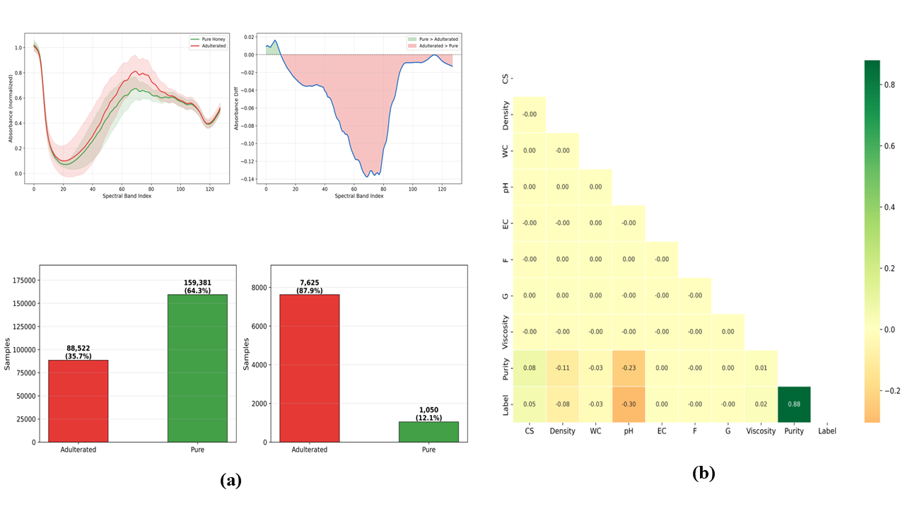
Figure 2 Exploratory analysis of the two datasets: (a) class distribution in D1 and D2; (b) mean Vis-NIR spectra of pure and adulterated honey with the corresponding difference spectrum for D2; (c) Pearson correlation matrix for the D1 predictors, purity score and binary level

3.2 Spectral characteristics and implications for convolutional modelling
The class-mean spectra of D2 differ across much of the measured range rather than at isolated bands, with the largest separation between bands 65 and 80, where the pure-minus-adulterated difference reaches approximately −0.138 as shown in Figure 2(b). Because the measurement covers roughly 400–1000 nm, these differences arise from a combination of colour-bearing constituents in the visible region and higher-order O–H and C–H overtones at the short-wave near-infrared end, both of which shift when a syrup displaces part of the honey matrix. The contrast with mid- and long-wavelength NIR work is worth drawing explicitly: (Bázár et al., 2016) located HFCS-related changes in water-associated features between 1300 and 1800 nm, a region outside the range measured here, so the present spectral evidence is complementary to that work rather than a replication of it. Within the visible and short-wave NIR range, adulteration-related discrimination has been demonstrated repeatedly for honey (El Hajj & Estephan, 2025; Yang et al., 2020).
The practical implication for modelling is that the class signal is distributed across many correlated bands rather than concentrated at a few diagnostic wavelengths. This is the situation in which the convolutional kernels are built: they learn local relationships among adjacent bands without requiring wavelength selection in advance, which is why the 1D-CNN was expected to perform well.

3.3 Optuna-based hyperparameter optimisation
Thirty trials per model were sufficient for the best-so-far curve to plateau in all four cases as illustrated in Figure 3(a). Best validation accuracies were 0.9644 for M1, 0.9209 for M2, 0.9869 for M3 and 0.9124 for M4. These values came from the Optuna trials themselves and were not directly comparable with the final retrained models reported in Sections 3.4 and 3.5, which were fitted afresh on the best configuration.
Hyperparameter importance was strongly architecture-dependent as shown in Figure 3(b). The learning rate dominated for both physicochemical models, at 0.481 for M1 and 0.672 for M2. For the spectral 1D CNN (M3), kernel size was the leading factor at 0.324, ahead of dropout (0.223), learning rate (0.171), and filter count (0.161). For the spectral Bi-LSTM (M4), sensitivity was distributed across dense-layer size (0.326), dropout (0.280), and recurrent dropout (0.235). The design can be interpreted, not arbitrary. Kernel size controls the receptive field within neighboring bands; thus, the importance of kernel size in M3 is proof that the spectral window, which is considered in the model, is a crucial design parameter for this particular data. On the other hand, in M4 all top features have the relation to capacity and regularization, and this is exactly what is supposed to occur when high-capacity recurrent model is trained on unbalanced small dataset.(LeCun et al., 2015).
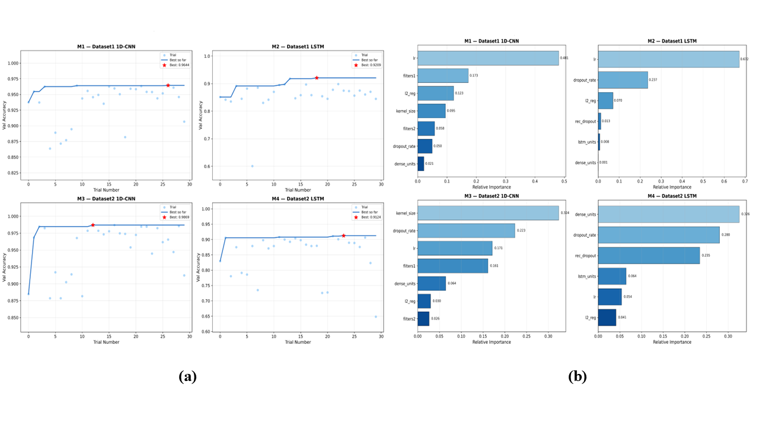
3.4 Model convergence and generalisation
Figure 3 Optuna-based hyperparameter optimisation: (a) validation accuracy across the thirty trials for each model, with the best trial marked; (b) relative importance of the optimised hyperparameters for each of the four models.
Convergence behavior played a much bigger part in distinguishing between the models compared to their final values. M3 had the best-converging path, achieving about 0.985 training accuracy and 0.9931 validation accuracy upon retraining, with the validation loss dropping below 0.10 without any divergence at all. M2 and M4 both showed some noise; M4 had a validation loss increasing after around epoch 35, whereas the training loss kept decreasing, the typical pattern of overfitting in overparameterized networks (Goodfellow I, Bengio Y, 2016).
The final training-minus-validation accuracy gaps were −1.5%, −2.8%, −0.8%, and −2.6% for M1 to M4, respectively. Since there is a negative sign, it implies that the validation accuracy marginally surpasses the training accuracy; this is an expected phenomenon considering that while the dropout was active in training, it was not active in testing. M3 had the least gap and most consistent curve. All the four gaps are quite small, implying consistency in training and validation with optimized parameters, but internal validity is established alone through this. External validity necessitates independent sample collection (Hastie et al., 2009).

3.5 Comparative classification performance
The 1D-CNN outperformed the Bi-LSTM on both modalities and on every metric, as shown in Table 2 and Figure 4. On the physicochemical data, M1 reached 98.49% accuracy with precision 0.9953, recall 0.9811, F1-score 0.9881, and ROC-AUC 0.9994, against 92.42%, 0.9307, 0.9531, 0.9417, and 0.9832 for M2. On the spectral data, M3 reached 99.08% accuracy with precision 0.9451, recall 0.9810, F1-score 0.9627, and ROC-AUC 0.9987, against 93.16%, 0.6494, 0.9491, 0.7712, and 0.9846 for M4. For M1, the confusion matrix shows 98.1% of pure samples and 99.2% of adulterated samples correctly classified.
The most informative result in this table is not the best score but the worst. M4 combines high recall (0.9491) with low precision (0.6494) on the pure class, meaning that roughly a third of the samples it calls pure are in fact adulterated. This is the dangerous direction of error in a screening context, and it is precisely the failure that a headline accuracy of 93.16% conceals: with 87.9% of D2 adulterated, a model can score above 90% while performing poorly on the minority class. This is the standard argument for precision–recall reporting on imbalanced data (Saito & Rehmsmeier, 2015), and M4 is a clean illustration of it. M3, on the same data and with the same imbalance, maintains a precision of 0.9451; therefore, the difference is attributable to the architecture rather than to the class distribution.
Table 2. Classification performance of the four optimised deep-learning models on the held-out test sets. Metrics are reported with pure honey as the positive class.
Model | Dataset | Modality | Architecture | Accuracy (%) | Precision | Recall | F1-score | ROC-AUC
M1 | D1 | Physicochemical | 1D-CNN | 98.49 | 0.9953 | 0.9811 | 0.9881 | 0.9994
M2 | D1 | Physicochemical | Bi-LSTM | 92.42 | 0.9307 | 0.9531 | 0.9417 | 0.9832
M3 | D2 | Vis-NIR | 1D-CNN | 99.08 | 0.9451 | 0.9810 | 0.9627 | 0.9987
M4 | D2 | Vis-NIR | Bi-LSTM | 93.16 | 0.6494 | 0.9491 | 0.7712 | 0.9846

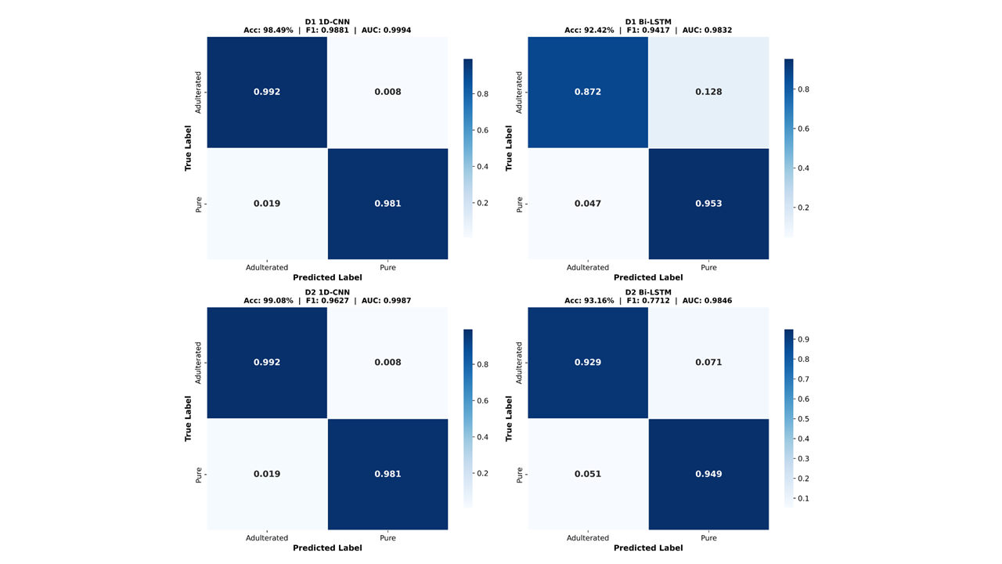
(a)

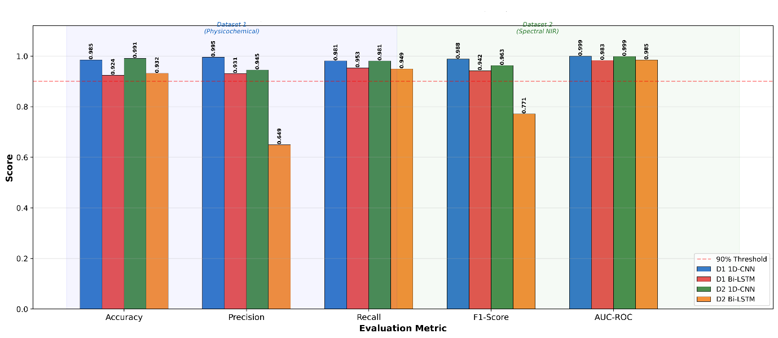
(b)

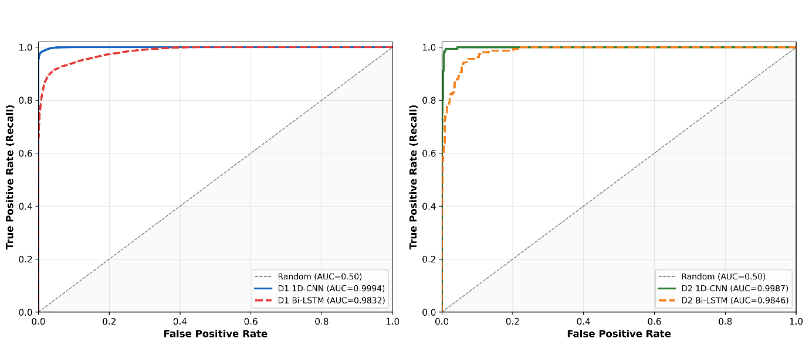
(C)

Figure 4. Comparative classification performance of the four optimised models: (a) normalised confusion matrices; (b) receiver operating characteristic curves; (c) accuracy, precision, recall and F1-score across models.
The consistent advantage of the convolutional architecture indicates that localised feature extraction matches the structure of both inputs better than bidirectional sequence modelling does. For the spectral data the reason is concrete: adjacent wavelengths carry correlated, overlapping information, which is what convolutional kernels are designed to exploit, and the dominance of kernel size in the M3 optimisation points in the same direction. For the physicochemical data the eight variables have no meaningful sequential ordering at all, so the long-range dependency modelling that justifies a recurrent architecture has nothing to act on, while its additional parameters simply increase the risk of overfitting.
These findings sit comfortably alongside earlier work. (Wu et al., 2022) coupled Raman spectroscopy with convolutional networks to detect and quantify honey adulteration at high accuracy, and (Bertotto et al., 2026) reported similar success for FTIR-based deep chemometrics. Direct numerical comparison across studies is nonetheless unwise: sample size, adulterant type and concentration, class balance, preprocessing and validation strategy all vary, and each of them moves the reported figures.

3.6 Discrimination capability and practical interpretation
All four models discriminated well across thresholds, with M1 (AUC 0.9994) and M3 (AUC 0.9987) ahead of M2 (0.9832) and M4 (0.9846). Near-unity AUC values indicate that the score distributions of the two classes barely overlap (Fawcett, 2006). Two qualifications are necessary. First, AUC is threshold-independent and therefore insensitive to the precision problem identified in M4; the two must be read together. Second, a high internal AUC does not guarantee comparable performance on honey from other sources, since composition varies with botanical and geographical origin, processing and storage (Tsagkaris et al., 2021) . The models reported here should be regarded as promising screening tools pending independent validation.

3.7 SHAP-based interpretation of the physicochemical model
SHAP analysis of M1 ranked the eight predictors as follows, by mean absolute SHAP value: pH (0.2337), colour score (0.1872), density (0.0931), water content (0.0768), viscosity (0.0220), glucose (0.0130), fructose (0.0069) and electrical conductivity (0.0066). pH and colour score together account for the majority of the attributed contribution, with density and water content playing a secondary role and the remaining four variables contributing little as shown in Figure 5(b).
The most interesting feature of this ranking is colour score. Its linear correlation with the label is only r = 0.05, yet it emerges as the second most important predictor a straightforward demonstration that marginal correlation and predictive importance are different quantities, and that a variable can contribute substantially through interactions a correlation coefficient cannot see (Lundberg & Lee, 2017). The prominence of pH is chemically sensible: honey is characteristically acidic, and syrup addition shifts it away from that range. Density and water content behave as matrix-level indicators, reflecting the altered balance of water and soluble solids that follows dilution with syrup, consistent with the compositional changes (Gajek et al., 2026) report for sugar-adulterated honey.
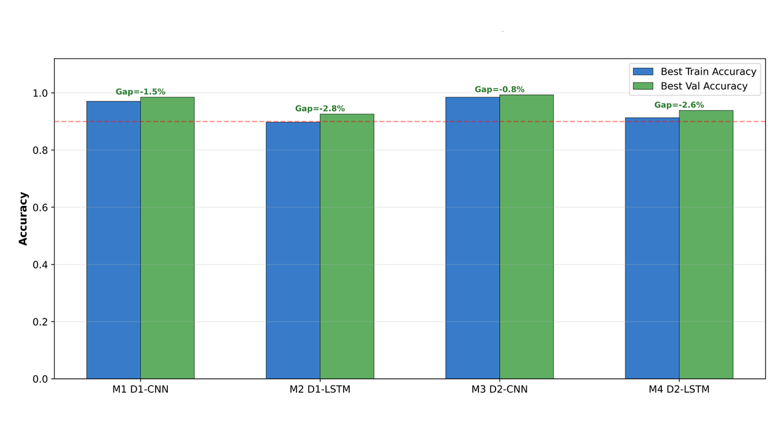
(a)
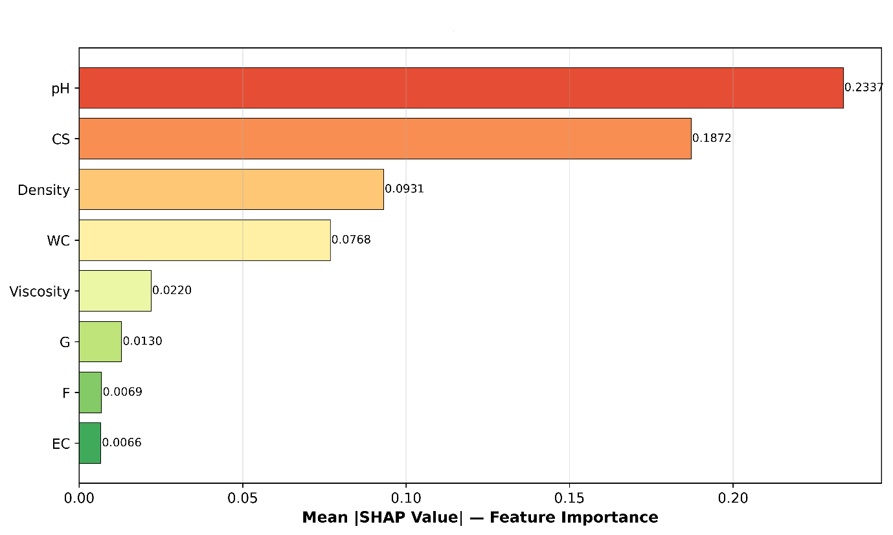
(b)

Fig. 5. Explainability and generalisation analysis: (a) training and validation accuracy trajectories for the optimised models; (b) global SHAP feature importance for the physicochemical 1D-CNN (M1), ordered by mean absolute SHAP value.

3.8 Directional interpretation and its limits
SHAP values with the opposite sign indicate how pH values outside the characteristically acidic range move predictions towards the adulterated class while those within the range predict the pure class. The contribution of density and moisture content was consistent, suggesting that they can be considered markers of compositional change at the matrix level. However, fructose and glucose did not contribute significantly. It does not mean that sugars lack chemical significance; it simply means that they cannot act as good discriminators in this case because they are major compounds in both honey and syrup used for adulteration, making their concentrations change very little during the process. Previous research supports the same conclusion: multivariate profiles are better than compositional variables for honey identification (Amiry et al., 2017; Downey et al., 2003). Chemical abundance and predictive importance are simply not the same thing in a nonlinear classifier.

However, one limitation of such an interpretation should be made clear. Since D1 is artificial, the ranking provided by SHAP reflects the data-generating mechanism for D1, but not necessarily the chemical composition of adulterated honey itself. It is encouraging to know that pH ranks the highest since it is consistent with the well-known chemistry. However, the ranking can only serve as proof that the proposed framework is able to produce chemically meaningful explanations; it is not a conclusion about which physicochemical factors are most effective for detecting adulteration. To reach such a conclusion, further work is needed.

4. Limitations
Four limitations bound the conclusions of this study and are stated here rather than distributed through the discussion, so that they can be weighed together.
- Synthetic physicochemical data. D1 is simulated. Results derived from it demonstrate that the framework recovers a known nonlinear decision rule efficiently and explains it coherently; they do not demonstrate detection performance on real honey.
- Internal validation only. All reported metrics come from held-out partitions of the same datasets used for training. No independent external test set was available, so generalisation across instruments, origins and adulteration protocols remains untested.
- Binary framing. Adulteration was treated as a two-class problem. D2 contains four adulteration levels (5–50% w/w), and a model that separates pure from 50% adulterated may perform much worse at 5%. Level-resolved performance was not assessed and is the most immediately valuable extension of this work.
- Explainability limited to one modality. SHAP was applied only to the physicochemical model. Band-level attribution for the spectral models, though computationally feasible, was not attempted, so the chemical basis of the 1D-CNN’s spectral decisions remains uncharacterised.

5. Conclusions
An optimised one-dimensional convolutional neural network classified pure and adulterated honey accurately and interpretably across two very different data modalities, outperforming a bidirectional LSTM optimised under identical conditions in every comparison made. On the Vis-NIR hyperspectral data the convolutional model reached 99.08% accuracy with a ROC-AUC of 0.9987, and, more importantly for practical screening, maintained precision of 0.9451 on the minority pure class where the recurrent model fell to 0.6494. SHAP analysis identified pH and colour score as the dominant predictors in the physicochemical model, followed by density and water content, linking model behaviour to compositional changes that are chemically plausible for syrup addition.
The contribution here is a reproducible template rather than a validated assay. Automated hyperparameter optimisation makes the architecture comparison fair, and SHAP makes the resulting model auditable, which matters for any method intended for regulatory or commercial use. Realising that potential now depends on external validation with independently collected honey spanning botanical and geographical origins, adulterant types, adulteration levels and processing conditions, together with level-resolved rather than purely binary evaluation. Consistent reporting of dataset provenance, spectral acquisition, preprocessing, architecture, optimisation ranges and software versions will be equally important, both for reproducibility and for the regulatory acceptance that practical deployment would require.

Conflict Of Interest
The authors declare no conflicts of interest that could have influenced the work presented in this manuscript.

Data Availability
Two publicly available datasets were used in this study. The physicochemical dataset (D1) was obtained from the Kaggle repository Predict Purity and Price of Honey (Stealth Technologies, 2024) and is distributed under the Apache 2.0 License. The dataset was synthetically generated to represent realistic physicochemical properties of honey. The variables included in the dataset and their corresponding parameter ranges are presented in Section 2.2. This dataset was used for the physicochemical analysis and interpretation carried out in the present study.
The Vis-NIR hyperspectral dataset (D2) was originally collected and reported by Phillips et al. (2021) and is publicly available through the University of Auckland data repository (https://doi.org/10.17608/k6.auckland.16416861.v1). The same dataset is also available through the Kaggle repository Adulterated Honey Dataset under the MIT License. In this study, D2 was used to investigate Vis-NIR hyperspectral characteristics associated with honey adulteration.
Declaration of AI Use

This manuscript was prepared through the intellectual contributions of the author(s) to the study design, data analysis, interpretation of results, and scholarly content. Grammarly and ChatGPT were used solely to assist with grammatical refinement and reference formatting during manuscript revision. The author(s) accept full responsibility for the accuracy, integrity, and final content of the manuscript.

References
Ahmed, E. (2024). Detection of honey adulteration using machine learning. PLOS Digital Health, 3(6). https://doi.org/10.1371/journal.pdig.0000536
Akiba, T., Sano, S., Yanase, T., Ohta, T., & Koyama, M. (2019). Optuna: A Next-generation Hyperparameter Optimization Framework. Proceedings of the ACM SIGKDD International Conference on Knowledge Discovery and Data Mining, 2623–2631. https://doi.org/10.1145/3292500.3330701
Amiry, S., Esmaiili, M., & Alizadeh, M. (2017). Classification of adulterated honeys by multivariate analysis. Food Chemistry, 224, 390–397. https://doi.org/10.1016/j.foodchem.2016.12.025
Bertotto, M., Krause, W. O., Bertotto, J., Ghidoli, P., Fusca, V., & Bello, M. O. (2026). Deep chemometrics with convolutional neural networks for the detection of honey adulteration using Fourier transform infrared spectroscopy. Spectrochimica Acta - Part A: Molecular and Biomolecular Spectroscopy, 355. https://doi.org/10.1016/j.saa.2025.127167
Biswas, A., & Chaudhari, S. R. (2024). Exploring the role of NIR spectroscopy in quantifying and verifying honey authenticity: A review. Food Chemistry, 445. https://doi.org/10.1016/j.foodchem.2024.138712
Dodd, S., Kevei, Z., Karimi, Z., Parmar, B., Franklin, D., Koidis, A., & Anastasiadi, M. (2025). Detection of sugar syrup adulteration in UK honey using DNA barcoding. Food Control, 167. https://doi.org/10.1016/j.foodcont.2024.110772
Downey, G., Fouratier, V., & Kelly, J. D. (2003). Detection of honey adulteration by addition of fructose and glucose using near infrared transflectance spectroscopy. Journal of Near Infrared Spectroscopy, 11(6), 447–456.
Egido, C., Saurina, J., Sentellas, S., & Núñez, O. (2024). Honey fraud detection based on sugar syrup adulterations by HPLC-UV fingerprinting and chemometrics. Food Chemistry, 436. https://doi.org/10.1016/j.foodchem.2023.137758
El Hajj, R., & Estephan, N. (2025). Advances in infrared spectroscopy and chemometrics for honey analysis: a comprehensive review. In Critical Reviews in Food Science and Nutrition (Vol. 65, Number 29, pp. 6371–6384). Taylor and Francis Ltd. https://doi.org/10.1080/10408398.2024.2439055
Fawcett, T. (2006). An introduction to ROC analysis. Pattern Recognition Letters, 27(8), 861–874. https://doi.org/10.1016/j.patrec.2005.10.010
Gajek, M., Moj, K., Wysocki, P., Kuśmierek, E., & Szynkowska-Jóźwik, M. I. (2026). Analysis of Changes in Selected Physicochemical Parameters and Elemental Composition of Honey as a Result of Adulteration with Sugar Additives. Foods, 15(3). https://doi.org/10.3390/foods15030562
Goodfellow I, Bengio Y, C. A. (2016). Deep learning. The MIT Press, Cambridge, MA, USA, 22(4), 351–354.
Hastie, T., Tibshirani, R., Friedman, J. H., & Friedman, J. H. (2009). The elements of statistical learning: data mining, inference, and prediction (Vol. 2). Springer.
Ji, S., Granato, D., Wang, K., Hao, S., & Xuan, H. (2025). Detecting the authenticity of two monofloral honeys based on the Canny-GoogLeNet deep learning network combined with three-dimensional fluorescence spectroscopy. Food Chemistry, 485. https://doi.org/10.1016/j.foodchem.2025.144509
LeCun, Y., Bengio, Y., & Hinton, G. (2015). Deep learning. Nature, 521(7553), 436–444.
Li, M., Pan, T., Bai, Y., & Chen, Q. (2022). Development of a calibration model for near infrared spectroscopy using a convolutional neural network. Journal of Near Infrared Spectroscopy, 30(2), 89–96. https://doi.org/10.1177/09670335211057234
Lundberg, S. M., & Lee, S.-I. (2017). A unified approach to interpreting model predictions. Advances in Neural Information Processing Systems, 30.
Malek, S., Melgani, F., & Bazi, Y. (2018). One-dimensional convolutional neural networks for spectroscopic signal regression. Journal of Chemometrics, 32(5). https://doi.org/10.1002/cem.2977
Minho, L. A. C., de Lima Conceição, J., Barboza, O. M., de Freitas Santos Junior, A., & dos Santos, W. N. L. (2025). Robust DEEP heterogeneous ensemble and META-learning for honey authentication. Food Chemistry, 482. https://doi.org/10.1016/j.foodchem.2025.144001
Phillips, T., & Abdulla, W. (2023). A new honey adulteration detection approach using hyperspectral imaging and machine learning. European Food Research and Technology, 249(2), 259–272.
Phillips, T., Coleman, B., Takano, S., & Abdulla, W. (2021). Hyperspectral Imaging adulterated honey dataset. The University of Auckland, 13522842.
Prata, J. C., & da Costa, P. M. (2024). Fourier Transform Infrared Spectroscopy Use in Honey Characterization and Authentication: A systematic review. In ACS Food Science and Technology (Vol. 4, Number 8, pp. 1817–1828). American Chemical Society. https://doi.org/10.1021/acsfoodscitech.4c00377
Saito, T., & Rehmsmeier, M. (2015). The precision-recall plot is more informative than the ROC plot when evaluating binary classifiers on imbalanced datasets. PLoS ONE, 10(3). https://doi.org/10.1371/journal.pone.0118432
Schuster, M., & Paliwal, K. K. (1997). Bidirectional recurrent neural networks. IEEE Transactions on Signal Processing, 45(11), 2673–2681.
Shi, S., Zhang, K., Tian, N., Jin, Z., Liu, K., Huang, L., Tian, X., Cao, C., Zhang, Y., & Jiang, Y. (2025). Spectroscopic techniques combined with chemometrics for rapid detection of food adulteration: Applications, perspectives, and challenges. In Food Research International (Vol. 211). Elsevier Ltd. https://doi.org/10.1016/j.foodres.2025.116459
stealthtechnologies. (2024). Predict purity and price of honey [Data set]. Kaggle. https://www.kaggle.com/datasets/stealthtechnologies/predict-purity-and-price-of-honey
Tan, A., Wang, Y., Zhao, Y., Wang, B., Li, X., & Wang, A. X. (2022). Near infrared spectroscopy quantification based on Bi-LSTM and transfer learning for new scenarios. Spectrochimica Acta - Part A: Molecular and Biomolecular Spectroscopy, 283. https://doi.org/10.1016/j.saa.2022.121759
Tsagkaris, A. S., Koulis, G. A., Danezis, G. P., Martakos, I., Dasenaki, M., Georgiou, C. A., & Thomaidis, N. S. (2021). Honey authenticity: analytical techniques, state of the art and challenges. In RSC Advances (Vol. 11, Number 19, pp. 11273–11294). Royal Society of Chemistry. https://doi.org/10.1039/d1ra00069a
Wu, X., Xu, B., Ma, R., Niu, Y., Gao, S., Liu, H., & Zhang, Y. (2022). Identification and quantification of adulterated honey by Raman spectroscopy combined with convolutional neural network and chemometrics. Spectrochimica Acta - Part A: Molecular and Biomolecular Spectroscopy, 274. https://doi.org/10.1016/j.saa.2022.121133
Yang, X., Guang, P., Xu, G., Zhu, S., Chen, Z., & Huang, F. (2020). Manuka honey adulteration detection based on near-infrared spectroscopy combined with aquaphotomics. LWT, 132. https://doi.org/10.1016/j.lwt.2020.109837
Zhang, X. H., Gu, H. W., Liu, R. J., Qing, X. D., & Nie, J. F. (2023). A comprehensive review of the current trends and recent advancements on the authenticity of honey. In Food Chemistry: X (Vol. 19). Elsevier Ltd. https://doi.org/10.1016/j.fochx.2023.100850

​

