A View on β-1,4-Chitosan crosslinking to Tripolyphosphate-Zinc Oxide (CTPP-ZnO) Nanomaterials in Bionanocomposite Ecofilm

ABSTRACT
Chitosan-based films provide a biodegradable polymeric platform for the preparation of composite membranes through ionic crosslinking and incorporation of inorganic materials. In this study, a chitosan–tripolyphosphate–zinc oxide (CTPP-ZnO) bionanocomposite film was prepared using chitosan dissolved in 2% acetic acid, followed by mixing with zinc oxide and crosslinking with sodium tripolyphosphate at approximately pH 5.0. The resulting mixture was cast and oven-dried to obtain a CTPP-ZnO membrane. The crosslinking mechanism is based on electrostatic interactions between protonated amino groups of chitosan and negatively charged phosphate groups of tripolyphosphate, while the β-1,4-glycosidic backbone of chitosan remains the principal structural framework of the polymer. Morphological characteristics of the prepared material were examined using scanning electron microscopy. A preliminary membrane-performance test was also conducted by passing a 4 ppm methylene blue solution through the membrane under a pressure of 10 bar. The observations support the formation of a crosslinked chitosan-based matrix containing zinc oxide and indicate morphological differences between chitosan and the composite film. However, the available measurements do not quantitatively distinguish dye adsorption, pressure-driven separation and photocatalytic degradation. Additional physicochemical, structural and membrane-performance characterization is therefore required to establish the contribution of zinc oxide and tripolyphosphate to the functional properties of the composite. The study demonstrates a simple preparation approach for a chitosan-based composite film intended for further investigation as a functional membrane material.

Keywords : Chitosan, tripolyphosphate, zinc oxide nanoparticles, biocomposite film.

[1] . INTRODUCTION :

Now a days, the bio-polymer-based films are being developed as an alternative of plastic-based films because they are effective, non-toxic, inexpensive, flexible and widely available. Knowing, the film or membrane is a thin lining selective barrier, which allow something to pass through but stop others. Such things may be molecules, ions or other small nanoparticles etc. Mostly, films are often used for purification in process such as haemodialysis, biodiesel and bioreactor type as improving the efficiency of the membranes used to continuous and conserve energy. Recent studies has been carried out the effort in study of membrane properties which synthesized from bio-polymers, for example, the membranes made from polysaccharide such as cellulose but ought chitosan based (Aranaz et al., 2021; Sacco et al., 2014). Since, the glucose ring is the basic unit of the backbone of both cellulose and chitosan polysaccharides that are linked by β-1,4 glycosidic units (Kim et al., 2022). These are insoluble in water and structural difference only at nitrogen-containing side groups. In chemical point of view, chitosan is a one of the natural polymers and it as deacetylated product of chitin, which usually sourced from molluscs and shrimp or crab skins (Zhang et al., 2024; Furlani et al., 2019). The reactive groups are found in chitosan a primary amino group (C2) and primary and secondary hydroxyl groups (C6, C3). Glycosidic bonds and the acetamide group can also be considered in functional groups, which allow for numbers of reactants base reactions to producing polymers with new behaviours and properties. In applications of chitosan based bio-polymers are including drug delivery carrier, and food preservatives, with biocompatibility, outstanding antibacterial and in biomedical aspects (Cánepa et al., 2017; Abri et al., 2019; Nguyen et al., 2019; Parchen et al., 2025).

In article, we have reported a bionanocomposite (BNC) materials based on a β-1,4-chitosan crosslinkng to multivalent tripolyphosphate (TPP) anions, which form coordination complex with embedding zinc oxide (ZnO) nanoparticles into rapid developed ecofriendly chitosan-tripolyphosphate-zinc oxide (CTPP-ZnO) film (Dimkpa et al., 2023; Chalitangkoon et al., 2025). These beta (β)-1,4-chitosan-tripolyphosphate-zinc oxide nanocomposite is a highly versatile, ecofriendly materials. The role of the β-1,4 bonds in CTPP-ZnO nanocomposite is as backbone integrity, preserving the linear polysaccharides chain rigidity and physicochemical stability to making them well suited for a range of biomedical applications, particularly as in drug delivery. The powdered and hexagonal crystal structure form of zinc oxide (ZnO) nanoparticles which can be considered as to composed of two interpenetrating hexagonal closed packed (hcp) sublattices of cation-anion (Zn⁺⁺ and O²⁻) (Cotton et al., 1999), has shown in figure 1, and the structure of β-(1-4) linked chitosan and the tripolyphosphate (CTPP) ion shown in figure-2, as well.

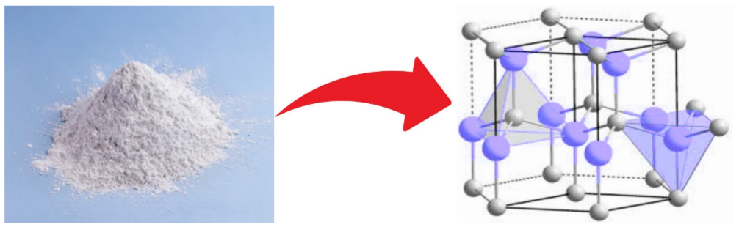

Figure 1. The powdered form and hexagonal crystal structure of zinc oxide (ZnO) nanoparticles
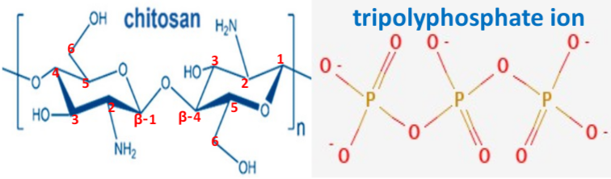

Figure 2. The structure (chair-form) of β-(1-4) linked chitosan molecule and tripolyphosphate (TPP) ion

[2]. EXPERIMENTAL :

In this procedures, the materials used as all required reagents and chemicals in preparation of CTPP-ZnO nanocomposite were as chitosan, sodium tripolyphosphate (Na₅P₃O₁₀), acetic acid (CH₃COOH) and solid zinc oxide (ZnO) powder are being laboratory based with analytical graded which have been used further as without purification for study. Typically, the carbonate free a basic NaOH solution is prepared well by adopting of Vogel procedure (Vogel, 1989). This reagent graded solutions which have made of as Na₅P₃O₁₀ (sodium tripolyphosphate) stock solutions with ionic strength CH₃COOH (acetic acid), and purified distilled water is prepared which using throughout the complete work. All the calibrated as well as volumetric glassware of A class are used. Here, firstly, chitosan is dissolved in an aqueous acidic solution, typically 2 % acetic acid (CH₃COOH), in a ratio of 1:50, then it stirred and heated at about 50 to 60 $℃$. After the chitosan solution is homogeneous, it is mixed with ZnO (zinc oxide), as well as solution is stirred at 1300 rpm for 30 minutes. Once it is homogeneous, then sodium tripolyphosphate (Na₅P₃O₁₀) solution (use as crosslinker prepared in deionized water) is added about at 5.0 pH, until a clear suspension is obtained. Then, the TPP solution is added dropwise into the earlier prepared chitosan sample solution under vigorous or magnetic stirring at room temperature. After, the 50 ml of resulting solution have taken in teflon moulds and it oven-dried about at 60$℃$, until a CTPP-ZnO membrane (film) is obtained. The membrane performance test have applied by using of methylene blue dye solution with a 4 ppm concentration is passed or diffused through the membrane under pressure controlled by valve in 10 bar, respectively.

[3]. RESULTS AND DISCUSSION :

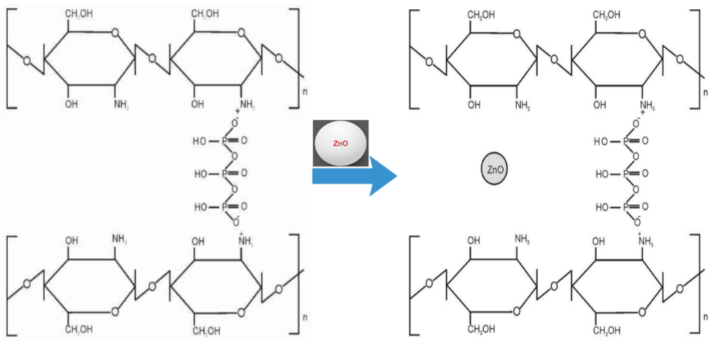

Figure 3. A schematic cross-linked structure of chitosan-tripolyphosphate (CTPP) in CTPP-zinc oxide (ZnO) nanocomposite ecofilm

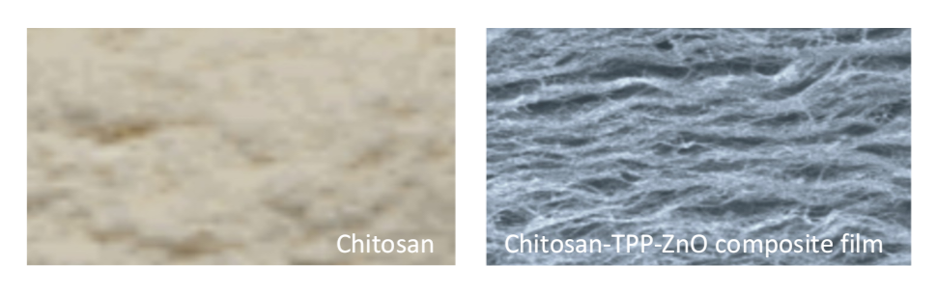

Figure 4. A SEM image of chitosan and chitosan-tripolyphosphate-zinc oxide (CTPP-ZnO) composite film

In preparation of chitosan-tripolyphophate (CTPP) films the dominant polymer solution is chitosan and acetic acid (CH₃COOH), which are added with sodium tripolyphosphate (Na₅P₃O₁₀) with 0.5, 1.0 and 1.5 % concentration range at pH 5.0. Notable, in acidic pH, the polymeric chitosan has in cation form, so it had an NH₃⁺ group which could bind with anion tripolyphosphate (TPP). Here, the triphosphate act as an ionic cross-linker that hooks onto the positively charged amino groups of the chitosan. This ‘ionotropic gelation’ bind the polymer matrix together, enhancing its tensile strength and durability. In figure 3, which has illustrated that the bonding between β-1,4 linkage chitosan and TPP with ZnO (zinc oxide) nanoparticles into CTPP-ZnO film or membrane. As in preparation of films, the mixing of chitosan-TPP with zinc oxide is performed at 1300 rpm until homogeneous, and It dried over in oven at 60$℃$ until a CTPP-ZnO hydrogel type membrane is formed. In improving the stability of CTPP membrane, a possible method is that the interlinking of chitosan with tripolyphosphates (TPP) into formation of complex polyelectrolyte CTPP-ZnO bionanocomposite films for best performance (Genedy et al., 2024; Hu et al., 2010). The CTPP-ZnO membrane having the electro-conducting property, because the structural oxygen vacancies and point defects in the ZnO lattice grant the hybrid polymer to n-type semiconducting properties.
These observations are consistent with the established ionotropic-gelation mechanism, in which protonated chitosan amine groups interact electrostatically with multivalent tripolyphosphate phosphate groups; the extent of crosslinking and the resulting network or particle morphology are sensitive to pH, polymer concentration, and the chitosan-to-tripolyphosphate ratio (Poureghbal et al., 2022; Alehosseini et al., 2022; Hamidi et al., 2022). Accordingly, the use of pH 5.0 and different tripolyphosphate concentrations in the present formulation is chemically plausible, although the degree of crosslinking would require complementary spectroscopic, swelling, or mechanical measurements for quantitative confirmation.

The β-1,4 glycosidic linkage is the primary backbone structure of linear chitosan polymer, and remaining intact during ionic crosslinking of chitosan with tripolyphosphate (TPP) to nanocomposite formation. Chemically, chitosan consists of β-1,4 glycosidic linkage (2-acetamido-2-deoxy-β-D-glucopyranose residue) which is the covalent backbone bond connecting the repeating D-glucosamine and N-acetyl-D-glucosamine units within the chitosan polymer chain. The role of the β-1,4 bonds in chitosan-TPP nanocomposites is as backbone integrity, preserving the linear polysaccharides chain rigidity and functional and physicochemical stability to making them well suited for a range of biomedical applications, particularly as in drug delivery. In ionic crosslinking the TPP acts as a polyanion of negatively charged phosphate groups (-P₃O₁₀⁵⁻) that interacts electrostatically via ionic gelation with the positively charged protonated amine groups (-NH₃⁺) of the chitosan backbone (Hidaka et al., 2024; Filion et al., 2007). These CTPP-ZnO nanocomposite ecofilms which is reported in present study have characterized by using of SEM (scanning electron microscopy) as it shown above in figure 4.
Previous studies of chitosan/ZnO composite membranes and films have shown that ZnO incorporation can alter surface morphology and that nanoparticle distribution within the chitosan matrix depends on the preparation route and ZnO loading (Li et al., 2010; Qiu et al., 2019; Zhang et al., 2021). Therefore, the morphological contrast shown in Figure 4 is consistent with formation of a chitosan/ZnO-containing composite; however, SEM alone does not establish the chemical state, crystallinity, or spatial uniformity of ZnO, and complementary XRD, EDX, or FTIR analysis would strengthen the structural interpretation.

In photocatalytic activity, the composite polymers to act as an active catalyst for degrading organic pollutants or dyes. Thus, in impregnation of ZnO (zinc oxide) nanoparticles into a chitosan-tripolyphosphate (CTPP) film is expected to degrade pollutants trapped on the membrane surface with improved antifouling performance. The pollutant use in the membrane performance test is demonstrated by the using methylene blue dye, where, the methylene blue solution is passed through the CTPP-ZnO membrane with reverse osmosis action. But so, in the fixation process a large amount of dye is lost with waste water. Another, one of the weakness of chitosan membrane is its instability in acidic pH (pKa value is approx. 6.2 to 6.5). Although, using of methylene blue dye may influence the pH on adsorption with their photocatalytic degradation activity. Since, the TPP membranes behave as hydrophilic in nature, so aqueous solution of methylene blue are diffused through the CTPP-ZnO membrane with trapping on the membrane surface. Thus, to improve the stability of chitosan membrane, one possible method is to be interlinking of chitosan with tripolyphosphates as a complex polyelectrolyte membranes for best performance (Tang et al., 2024; Cui et al., 2019).

The intermolecular bonding between CTPP membrane and water is considered in under to van der Waal’s forces. The zinc oxide nanoparticles may predicted to have capability degrading compound as methylene blue dye at membrane surface, where van der Waal’s interaction mainly reported as the ionic bonding between negatively charged of methylene blue (-SO₃⁻) and positively charged of zinc oxide as (Zn(OH)⁺) form as well. The presence of TPP and ZnO nanoparticles may inhibit the adsorption of water since they could obstruct the -OH (hydroxyl) and amine functional group of membrane. The zinc oxide nanoparticles impregnation can affect membrane morphology, making the surface rougher, as well as it affect the hydrofilicity of the membrane surface, so for the good performance test, a methylene blue dye is used with 4 ppm concentration is diffused or passed through the membrane under pressure controlled by valve in 10 bar. In applications of chitosan based bio-polymers are including drug delivery carrier, and food preservatives due to their perfect biocompatibility, outstanding antibacterial and other biomedical properties (Canama et al., 2023; Ji et al., 2024; Bui et al., 2025; Wongput et al., 2026).
Studies of chitosan/ZnO composites have reported methylene-blue adsorption and/or photocatalytic degradation, with performance strongly influenced by irradiation conditions, pH, catalyst loading, initial dye concentration, and contact time (Haldorai & Shim, 2013; Zango et al., 2022; Madhan et al., 2021). In the present study, passage of 4 ppm methylene blue through the CTPP-ZnO membrane at 10 bar provides a preliminary indication of membrane performance; however, without paired feed and permeate concentrations, irradiation conditions, flux, and rejection or degradation efficiency, adsorption, pressure-driven separation, and photocatalysis cannot be quantitatively distinguished.

[4]. CONCLUSION :

A chitosan–tripolyphosphate–zinc oxide composite film was prepared by ionic crosslinking of chitosan with tripolyphosphate in the presence of zinc oxide. The interaction between protonated chitosan amino groups and tripolyphosphate provides the principal crosslinking mechanism, while the β-1,4-glycosidic backbone remains part of the polymer framework. SEM observations indicated morphological differences between chitosan and the resulting composite film. A preliminary membrane test was performed using 4 ppm methylene blue solution at 10 bar. However, the present observations do not provide quantitative separation, adsorption or photocatalytic efficiencies. Therefore, additional structural and performance measurements are required before specific functional, biomedical or photocatalytic applications of the material can be established.

Declaration of AI Use

This manuscript was prepared through the intellectual contributions of the author(s) to the study design, data analysis, interpretation of results, and scholarly content. Grammarly and ChatGPT were used solely to assist with grammatical refinement and reference formatting during manuscript revision. The author(s) accept full responsibility for the accuracy, integrity, and final content of the manuscript.

REFERENCES:
Abri, S., Ghatpande, A. A., Ress, J., Barton, H. A., & Leipzig, N. D. (2019). Polyionic complexed antibacterial heparin–chitosan particles for antibiotic delivery. ACS Applied Bio Materials, 2(12), 5848–5858. https://doi.org/10.1021/acsabm.9b00833
Alehosseini, E., Shahiri Tabarestani, H., Kharazmi, M. S., & Jafari, S. M. (2022). Physicochemical, thermal, and morphological properties of chitosan nanoparticles produced by ionic gelation. Foods, 11(23), 3841. https://doi.org/10.3390/foods11233841
Aranaz, I., Alcántara, A. R., Civera, M. C., Arias, C., Elorza, B., Caballero, A. H., & Acosta, N. (2021). Chitosan: An overview of its properties and applications. Polymers, 13(19), 3256. https://doi.org/10.3390/polym13193256
Bui, H. T. T., Dang, L. T. T., Nguyen, H. T., Le, L. T., Tran, H. Q., & Nguyen, T. T. T. (2025). Synergic effect and biosafety of chitosan/zinc complex nanoparticle-based carboxymethyl cellulose coatings for postharvest strawberry preservation. RSC Advances, 15(20), 15539–15549. https://doi.org/10.1039/d5ra00140d
Canama, G. J. C., Delco, M. C. L., Talandron, R. A., & Tan, N. P. (2023). Synthesis of chitosan-silver nanocomposite and its evaluation as an antibacterial coating for mobile phone glass protectors. ACS Omega, 8(20), 17699–17711. https://doi.org/10.1021/acsomega.3c00191
Chalitangkoon, J., Ronte, A., Sintoppun, T., Manapradit, N., & Monvisade, P. (2025). Dual cross-linked chitosan-based films with pH-sensitive coloration and drug release kinetics for smart wound dressings. ACS Omega, 10(8), 7770–7782. https://doi.org/10.1021/acsomega.4c08089
Cotton, F. A., Wilkinson, G., Murillo, C. A., & Bochmann, M. (1999). Advanced inorganic chemistry (6th ed.). John Wiley & Sons. https://www.wiley.com/en-us/Advanced+Inorganic+Chemistry%2C+6th+Edition-p-9780471199571
Cui, L., Liu, W., Liu, H., Qin, Q., Wu, S., He, S., Pang, X., Zhu, C., & Shen, P. (2019). pH-triggered charge-reversal mesoporous silica nanoparticles stabilized by chitosan oligosaccharide/carboxymethyl chitosan hybrids for effective intracellular delivery of doxorubicin. ACS Applied Bio Materials, 2(5), 1907–1919. https://doi.org/10.1021/acsabm.8b00830
Cánepa, C., Imperiale, J. C., Berini, C. A., Lewicki, M., Sosnik, A., & Biglione, M. M. (2017). Development of a drug delivery system based on chitosan nanoparticles for oral administration of interferon-α. Biomacromolecules, 18(10), 3302–3309. https://doi.org/10.1021/acs.biomac.7b00959
Dimkpa, C. O., Deng, C., Wang, Y., Adisa, I. O., Zhou, J., & White, J. C. (2023). Chitosan and zinc oxide nanoparticle-enhanced tripolyphosphate modulate phosphorus leaching in soil. ACS Agricultural Science & Technology, 3(6), 487–498. https://doi.org/10.1021/acsagscitech.3c00054
Filion, D., Lavertu, M., & Buschmann, M. D. (2007). Ionization and solubility of chitosan solutions related to thermosensitive chitosan/glycerol-phosphate systems. Biomacromolecules, 8(10), 3224–3234. https://doi.org/10.1021/bm700520m
Furlani, F., Sacco, P., Decleva, E., Menegazzi, R., Donati, I., Paoletti, S., & Marsich, E. (2019). Chitosan acetylation degree influences the physical properties of polysaccharide nanoparticles: Implication for the innate immune cells response. ACS Applied Materials & Interfaces, 11(10), 9794–9803. https://doi.org/10.1021/acsami.8b21791
Genedy, H. H., Delair, T., Alcouffe, P., Crépet, A., Chatre, E., Alhareth, K., & Montembault, A. (2024). Nanoassemblies of chitosan-based polyelectrolyte complexes as nucleic acid delivery systems. Biomacromolecules, 25(8), 4780–4796. https://doi.org/10.1021/acs.biomac.4c00054
Haldorai, Y., & Shim, J.-J. (2013). Chitosan-zinc oxide hybrid composite for enhanced dye degradation and antibacterial activity. Composite Interfaces, 20(5), 365–377. https://doi.org/10.1080/15685543.2013.806124
Hamidi, F., Azadi Aghdam, M., Johar, F., Mehdinejad, M. H., & Norouzian Baghani, A. (2022). Ionic gelation synthesis, characterization and adsorption studies of cross-linked chitosan-tripolyphosphate (CS-TPP) nanoparticles for removal of As(V) ions from aqueous solution: Kinetic and isotherm studies. Toxin Reviews, 41(3), 795–805. https://doi.org/10.1080/15569543.2021.1933532
Hidaka, M., Kojima, M., Sakai, S., & Delattre, C. (2024). Characterization of chitosan hydrogels obtained through phenol and tripolyphosphate anionic crosslinking. Polymers, 16(9), 1274. https://doi.org/10.3390/polym16091274
Hu, M., Li, Y., Decker, E. A., Xiao, H., & McClements, D. J. (2010). Influence of tripolyphosphate cross-linking on the physical stability and lipase digestibility of chitosan-coated lipid droplets. Journal of Agricultural and Food Chemistry, 58(2), 1283–1289. https://doi.org/10.1021/jf903270y
Ji, Z., Liang, M., Wang, C., Ma, M., Tian, J., Su, Y., Chang, H., & Li, M. (2024). High-efficiency broad-spectrum antibacterial activity of chitosan/zinc ion/polyoxometalate composite films for water treatment. Langmuir, 40(51), 26997–27009. https://doi.org/10.1021/acs.langmuir.4c03784
Kim, E. S., Baek, Y., Yoo, H.-J., Lee, J.-S., & Lee, H. G. (2022). Chitosan-tripolyphosphate nanoparticles prepared by ionic gelation improve the antioxidant activities of astaxanthin in the in vitro and in vivo model. Antioxidants, 11(3), 479. https://doi.org/10.3390/antiox11030479
Li, L.-H., Deng, J.-C., Deng, H.-R., Liu, Z.-L., & Xin, L. (2010). Synthesis and characterization of chitosan/ZnO nanoparticle composite membranes. Carbohydrate Research, 345(8), 994–998. https://doi.org/10.1016/j.carres.2010.03.019
Madhan, G., Begam, A. A., Varsha, L. V., Ranjithkumar, R., & Bharathi, D. (2021). Facile synthesis and characterization of chitosan/zinc oxide nanocomposite for enhanced antibacterial and photocatalytic activity. International Journal of Biological Macromolecules, 190, 259–269. https://doi.org/10.1016/j.ijbiomac.2021.08.100
Nguyen, M.-A., Wyatt, H., Susser, L., Geoffrion, M., Suk, J. S., Hanes, J., & Rayner, K. J. (2019). Delivery of microRNAs by chitosan nanoparticles to functionally alter macrophage cholesterol efflux in vitro and in vivo. ACS Nano, 13(6), 6491–6505. https://doi.org/10.1021/acsnano.8b09679
Parchen, G. P., Quaillet, M., de Freitas, R. A., & Hillaireau, H. (2025). Chitosan-based nano-objects for drug delivery: A review of their chemical modifications, supramolecular organization and biological fate. RSC Pharmaceutics, 2(6), 1292–1322. https://doi.org/10.1039/d5pm00095e
Poureghbal, Y., Rahimi, M., & Akbari, M. (2022). Ionic gelation of chitosan with sodium tripolyphosphate using a novel combined nebulizer and falling film system. The Canadian Journal of Chemical Engineering, 100(7), 1547–1557. https://doi.org/10.1002/cjce.24234
Qiu, B., Xu, X.-F., Deng, R.-H., Xia, G.-Q., Shang, X.-F., & Zhou, P.-H. (2019). Construction of chitosan/ZnO nanocomposite film by in situ precipitation. International Journal of Biological Macromolecules, 122, 82–87. https://doi.org/10.1016/j.ijbiomac.2018.10.084
Sacco, P., Borgogna, M., Travan, A., Marsich, E., Paoletti, S., Asaro, F., Grassi, M., & Donati, I. (2014). Polysaccharide-based networks from homogeneous chitosan–tripolyphosphate hydrogels: Synthesis and characterization. Biomacromolecules, 15(9), 3396–3405. https://doi.org/10.1021/bm500909n
Tang, R., Pan, L., Bai, Q., Li, C., Ma, S., Ou, J., & Shen, Y. (2024). Biobased tannic acid-chitosan composite membranes as reusable adsorbents for effective enrichment of phosphopeptides. Langmuir, 40(1), 927–937. https://doi.org/10.1021/acs.langmuir.3c03115
Vogel, A. I. (1989). Vogel's textbook of quantitative chemical analysis (5th ed.). Longman Scientific & Technical. https://search.worldcat.org/title/Vogel%27s-textbook-of-quantitative-chemical-analysis/oclc/19846882
Wongput, S., Liou, J.-W., Yang, C.-H., & Hung, C.-H. (2026). Gelatin-incorporated chitosan-TPP nanocomposites enhanced cumulative and sustained bovine serum albumin release. ACS Omega, 11(3), 4254–4266. https://doi.org/10.1021/acsomega.5c08843
Zango, Z. U., Dennis, J. O., Aljameel, A. I., Usman, F., Ali, M. K. M., Abdulkadir, B. A., Algessair, S., Aldaghri, O. A., & Ibnaouf, K. H. (2022). Effective removal of methylene blue from simulated wastewater using ZnO-chitosan nanocomposites: Optimization, kinetics, and isotherm studies. Molecules, 27(15), 4746. https://doi.org/10.3390/molecules27154746
Zhang, S., Ji, Y., He, Y., Dong, J., Li, H., & Yu, S. (2024). Effect of environmental pH on the mechanics of chitin and chitosan: A single-molecule study. Polymers, 16(7), 995. https://doi.org/10.3390/polym16070995
Zhang, X., Zhang, Z., Wu, W., Yang, J., & Yang, Q. (2021). Preparation and characterization of chitosan/Nano-ZnO composite film with antimicrobial activity. Bioprocess and Biosystems Engineering, 44(6), 1193–1199. https://doi.org/10.1007/s00449-021-02521-x

