Original Research Article

Screening and characterization of exopolysaccharide produced from yogurt -derived Enterococcus sp with potential biological properties.

Abstract
Aim: This study produced and characterized the EPSs from Enterococcus sp and evaluated their biological and technological potential. The aim of this study was to select the best exopolysaccharide (EPS) producer among the Enterococcus strains to optimize, characterize, and evaluate its biological properties.
Study design: Screening, growth kinetics, extraction of EPS using MRS medium.
Place and Duration of study: Department of Studies in Microbiology, Davangere University, Davangere 577007. During April 2026 and July 2026.
Methodology: The four early isolated and characterized lactic acid bacteria were screened for their exopolysaccharide production ability on aniline blue agar plates and growth kinetics of the enterococcus sp was measured spectrophotometrically using Nanodrop 2000 CC for different incubation time, temperature and carbohydrates using MRS broth. The partially purified EPS was then assessed for biological properties including antibacterial and antioxidant activities.
Results: Among the four strains, Enterococcus sp was selected, and the production conditions were optimized: 5 % (w/v) sucrose, 37°C temperature and 96 h of incubation period. The antioxidant effect (2 mg/mL) against DPPH was 75 ± 0.12 %. The EPS produced from enterococcus sp also possess antimicrobial effect from 50 mg/mL for the strains of against Staphylococcus aureus ATCC 25923, Listeria monocytogenes ATCC 19115, Salmonella Typhimurium ATCC 14028, Bacillus subtilis ATCC 6051, Clostridium perfringens ATCC 13124, Proteus vulgaris ATCC 13315, Pseudomonas aeruginosa ATCC 27853 and Escherichia coli ATCC 25922.
Conclusion: Exopolysaccharides (EPSs) are carbohydrate polymers that can be produced from lactic acid bacteria. Thus, the results indicated that the EPS from enterococcus sp is a promising functional biopolymer for possible applications in the food and pharmaceutical fields.

Key words: Enterococcus sp, exopolysaccharide, DPPH assay, antibacterial activity, optimization

- Introduction

Polysaccharides are used widely in the food industry as thickeners emulsifiers or stabilizers, due to their ability to influence rheology. The recent studies regarding exopolysaccharides (EPS), in particular, highlight that EPS possess a number of underlying physiological functions and biological activities such as antioxidant, antibacterial, antiviral, antitumor, immunoregulatory, hypoglycaemic, antihypertensive, and cholesterol lowering, whilst promoting the colonization of probiotics in the host (Tiwari et al., 2021).

Generally the Exopolysaccharides (EPS) are high molecular weight carbohydrate extracellular biopolymers secreted by various microorganisms including Lactic acid bacteria (LAB) primarily to subsist with the harsh environmental conditions as EPS play an important role against desiccation, phagocytosis, cell recognition, phage attack, antibiotics or toxic compounds and osmotic stress. The EPS produced from LAB has wide range of biomedical applications due to their unique structural, physicochemical, and functional properties (Kavitake et al., 2023). The health benefits of EPS from enterococcus sp primarily associated due to their interactions with the gut microbiome, which is a complex ecosystem of microorganisms that plays a crucial role in maintaining host metabolic and immune homeostasis (Angelin and Kavitha, 2020, Yang et al., 2023).

Lactic acid bacteria and bifidobacteria spp are well documented in the previous researches for the enormous production of EPS and are particularly suited for applications in the food industry due to their generally recognized as safe (GRAS) status. Lactic acid bacteria (LAB) are one of the most important microbial groups for food industry as well as for probiotic applications and LABs were shown to produce distinct EPS at different levels which was demonstrated to be affected by various factors including strain-specific conditions, carbon sources, and environmental stress. Among LAB enterococcus spp are important and are widely used in the fermented food industry and have been reported to have various in vitro health-promoting properties (Abarquero et al., 2022, Angelin and Kavitha, 2020).
Enterococcus is one of the genera from the LAB group to produce different polysaccharides with numerous applications. Enterococci are Gram-positive, catalase-negative bacteria with the homofermentative ability to produce lactic acid in primary metabolism from glucose and formerly belong to the group D streptococci (Ryan & Ray, 2004). They play an important role in food, medicine, and the environment by different means. Earlier, this genus was found and isolated from soil, plants, animal, water, and fermented food sources. The strains from the Enterococcus genus were proven to have functional benefits in terms of preservation of foods and controlling the multidrug resistance pathogens through the production of different metabolites like bacteriocins and EPS (Kavitake et al., 2023). Unlike L. plantarum, few attempts have studied the properties of EPS produced by E. faecium isolated from infants, fermented milk product, fresh and processed fish products. However, these reports have had a limited focus on the physiological activities and biological activities namely antibacterial, antibiotic susceptibility and antioxidant properties. The present study is a comprehensive investigation of the bioactivities of EPS producing Enterococcus sp which was isolated from fermented food sample and identified as a potential probiotic (Ayyash et al., 2020). The natural antimicrobial metabolite, bacteriocins produced by Enterococcus are referred to as enterocin. Likewise, Enterococcus are known to produce different types of EPS encompassing important functional features potentially applicable in food and health segments. For a decade, LAB EPS have engrossed vast attention for multiple applications in the food, pharmaceutical, textile, and chemical sectors due to their diversified structural and bioactive properties (Kavitake et al., 2023). EPS may also improve the texture and appearance of fermented dairy products by reducing syneresis (whey separation), enhancing water retention, and forming stable gels (Abarquero et al., 2022). Therefore, EPS produced by Enterococcus sp may be used as natural thickeners or stabilizers for dairy products.

- Materials and methods
2.1 Chemicals, reagents and culture media
Culture media were sourced from Hi-Media, India, while biochemical reagents and other chemicals were obtained from Sigma, USA.

2.2 Bacterial propagation
The strain enterococcus sp which produced EPS was previously isolated from traditional yogurt and characterized for their safety potentials. The strains were preserved at −80 °C and deposited in the GenBank (Tarique et al., 2022). The cultures were reactivated in de Man, Rogosa and Sharpe (MRS) broth at 37 °C for 24 h. All chemicals used in this study were purchased from Sigma-Aldrich (St. Louis, USA) unless otherwise specified.

2.3 Screening for EPS production
To assess EPS production ability, the string test and aniline blue (AB) agar plate method, were employed (Tarannum et al., 2023). In the string test, a single colony of the isolate grown on LB agar with 5% sucrose was lifted using an inoculation loop, and the formation of a >5 mm string indicated preliminary EPS production. Further screening involved plating the isolate on AB agar plates, prepared by supplementing nutrient agar medium with 5% (w/v) sucrose and 0.005% (w/v) aniline blue, with intense blue colonies considered positive. S. aureus ATCC 6538 served as the positive control. Based on texture of the LAB on modified MRS agar containing 2% w/v sucrose instead of glucose, they were screened for EPS production. Mucoid colonies were considered as EPS producing strain. Also, EPS production was further confirmed through measuring supernatant turbidity of inoculated modified MRS broth with LAB isolates. Supernatant turbidity was assessed by measuring the absorbance at 600 nm (Cirrincione et al., 2018). Uninoculated modified MRS broth was used as blank.

2.4 Growth kinetics and EPS production potential of LAB strain
The bacterial growth rate for the production of EPS was assessed following cultivation of the LAB strain in MRS broth medium containing 2% sucrose. Briefly, the bacterial strain was cultured in both media at 37 °C anaerobically while maintaining a static condition for 24, 48, 72, and 96 h. The bacterial growth rate at different hours was determined by measuring the absorbance of the bacterial culture broth spectrophotometrically at OD₆₀₀ nm (Nanodrop 200 cc). The viable bacterial numbers were estimated as CFU mL⁻¹. Similarly influence of temperature and carbohydrate sources on the growth of EPS producing Enterococcus sp was determined by culturing the strain at different temperature range (15℃, 24℃, 37℃ and 45℃) and different carbohydrate sources at 2% concentration (glucose, sucrose, lactose and xylose) and growth rate was measured spectrophotometrically at OD₆₀₀ nm (Nanodrop 200 cc).

2.5 EPS extraction and purification
Briefly, cultured bacteria were inoculated (1 %, v/v) in fresh sterile MRS broth supplemented with 2g/100 ml sucrose in a sterile flask. The fermentation was carried out at 43 °C for 48 h maintaining pH 6. Biomass was discarded after centrifugation at 4000 RPM for 15 mins at 4 °C and the supernatant was mixed with 80 % trichloroacetic acid (TCA) to make up to 14 % TCA and stored for 1 h at room temperature. The supernatant was collected after centrifugation at 4000 RPM for 15 mins at 4 °C and mixed with two volumes of absolute chilled ethanol and stored for 24 h, at 4 °C. After centrifugation at 4000 RPM for 15 mins at 4 °C, the supernatant was discarded, and the precipitate was dissolved in warm deionized water (Tarique et al., 2024).

2.6 Antibiotic susceptibility of EPS producing LAB isolate

Antibiotic susceptibility of EPS producing isolate Enterococcus sp was detected based on the Clinical and Laboratory Standards Institute (CLSI) guidelines (CLSI 2017). Briefly, overnight culture of EPS producing isolate was diluted to prepare cell suspension (10⁷ CFU mL−1) and cultured on MRS agar plates. Antibiotic discs, including ampicillin (10 mcg), azithromycin (15 mcg), rifampicin (5 mcg), erythromycin (15 mcg), ciprofloxacin (5 mcg), ofloxacin (5 mcg), penicillin (10 mcg) and kanamycin (30 mcg) were placed on the agar surface and allowed to fuse for 5 min. the plates were then incubated at 37°C for 24 h, and the diameters (mm) of the inhibition zones were measured and determined as susceptible, S (≥21 mm); intermediate, I (16–20 mm), and resistant, R (≤15 mm) (Soliemani et al., 2022).

2.7 Determination of antimicrobial activity
The antimicrobial activity was assessed using the agar well diffusion method against five pathogenic bacteria: Staphylococcus aureus ATCC 25923, Listeria monocytogenes ATCC 19115, Salmonella Typhimurium ATCC 14028, Bacillus subtilis ATCC 6051, Clostridium perfringens ATCC 13124, Proteus vulgaris ATCC 13315, Pseudomonas aeruginosa ATCC 27853 and Escherichia coli ATCC 25922. These strains were cultured overnight in LB broth at 37 °C, with cell densities adjusted to 10⁷–10⁸ colony forming units/mL. Subsequently, 100 μL of the bacterial suspension was spread on the Mueller Hinton agar surface and wells, measuring 5 mm in diameter, were created in the agar using a sterile stainless-steel borer. Then, 60 μL of the EPS solution (0.1 mg/mL) was added to each well, and the plates were incubated at 37 °C for 48 h. Appearance of clear zone surrounding the wells indicated antimicrobial activity (Tarannum et al., 2024).

2.8 Scavenging activity of DPPH radical
The scavenging capacity of 2, 2-diphenyl-1- (2,4,6-trinitrophenyl) hydrazyl (DPPH) radical by EPS sample was determined according to Bomfim et al (2020) with modifications. Briefly, 1 mL of an aqueous solution of EPS sample at 2 mg/ml concentration and equal concentration of ascorbic acid was taken as positive control and the respective samples were added to 2 mg/ mL of the ethanolic solution of the DPPH radical (0.05 mmol/L). The mixture was vigorously homogenized and incubated at room temperature in the dark for 30 min. The absorbance of the resulting solution was measured in triplicate at 517 nm after centrifugation at 5000 x g for 5 min. The DPPH radical scavenging capacity was defined as:
Scavenging activity (%) = [1− (A_{sample} – A_{blank}) / A_{control}] × 100
Where, A_{sample} represents the absorbance of the solution with DPPH and EPS; A_{blank} represents the absorbance of the solution with EPS and ethanol (ethanol instead of DPPH) and; A_{control} represents the absorbance of the solution with DPPH and water (water instead of EPS).
3.0 Results
3.1 Screening of EPS producing LAB isolate
A total of four potent LAB strains were isolated from the fermented food samples as they showed mucoid colonies on MRS media. These four isolates were examined for EPS production yield by growing in Aniline blue medium supplemented with 1.0% sucrose. Accordingly, one isolate was selected for further studies as it shown positive results in the string test, displayed intense blue colonies on aniline blue agar.
Crude EPS was isolated from enterococcus sp via trichloroacetic acid and anhydrous ethanol precipitation, yielding 102.7 ± 4.07 mg/L. The strain was grown in MRS broth for maximum EPS production when supplemented with suitable carbon and nitrogen source. The EPS was extracted using the ethanol precipitation method. The partially purified EPS was further used for characterization purposes and evaluation of the biological activity.
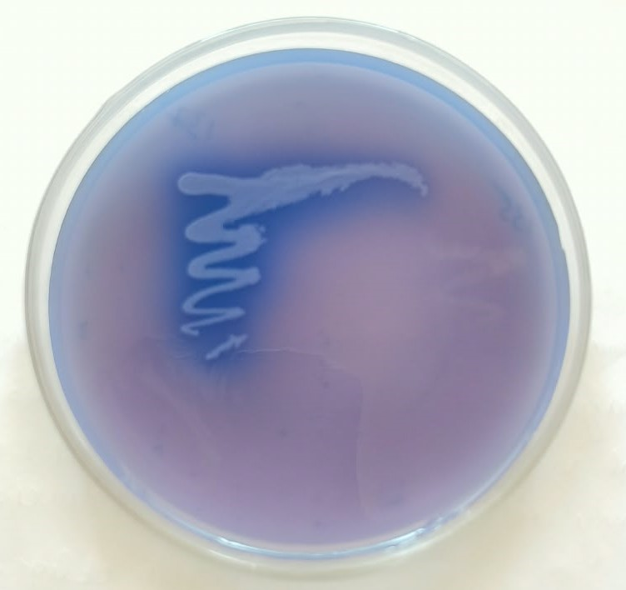
Fig.1. Exopolysaccharide production by Enterococcus sp displayed intense blue color on aniline blue agar medium.

3.2 Growth kinetics and EPS production potential
During the 72 h of incubation, the bacterial growth increased rapidly, indicating vigorous bacterial multiplication and metabolic activity. The MRS medium supplemented with sucrose supported slightly higher growth, suggesting it contains more readily available nutrients that facilitate bacterial multiplication. A marginal decline in absorbance was observed after 96 h, potentially attributed to the initiation of cell death and autolysis occurring under nutrient depletion (Fig. 2). The strain produced an EPS yield of 0.314 ± 0.01 g L⁻¹ in MRS media after 96 h anaerobic incubation at 37 °C compared to other different temperature range (15, 24 and 45) (Fig. 3.). Similarly the highest growth was observed for enterococcus sp when sucrose was used as carbohydrate source followed by glucose, xylose and lowest growth was observed in lactose (Fig. 4.).

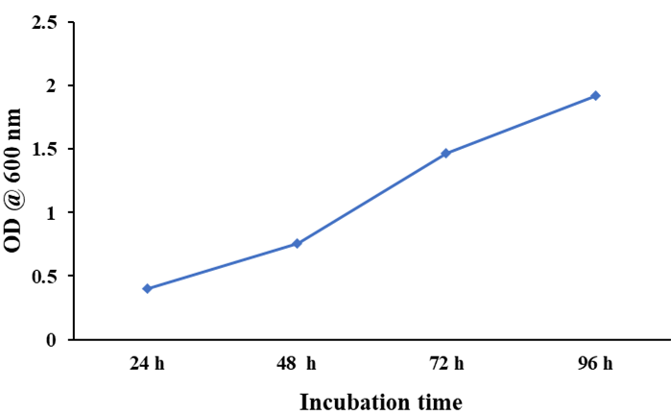
Fig. 2. Effect of incubation time on growth of enterococcus sp and EPS production; highest growth was observed at 96 h of incubation.

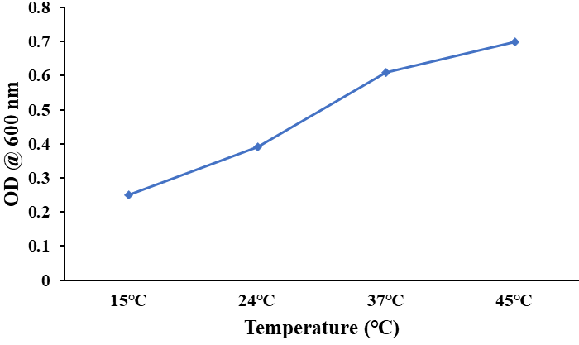
Fig. 3. Effect of different temperature range on growth of Enterococcus sp and EPS production; highest growth was observed at 45℃.

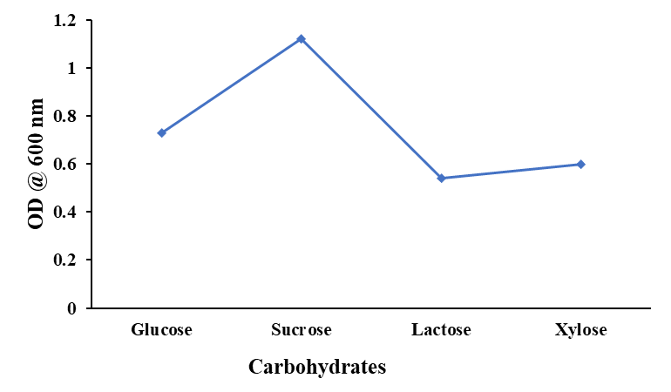
Fig. 4. Effect of different carbohydrate sources on growth of Enterococcus sp and EPS production; highest growth was observed in presence of sucrose (5 mg/100 ml).

3.3 Antibiotic sensitivity assay
The antibiotic sensitivity pattern of EPS producing enterococcus sp was evaluated for using standard antibiotic discs (Table 1). The enterococcus sp was susceptible to antibiotics including azithromycin, ciprofloxacin, penicillin, erythromycin and kanamycin. Whereas, the strain showed resistance for the antibiotic ampicillin.
Table 1. Antibiotic susceptibility tests for EPS producing enterococcus sp against commonly used antibiotics using disc diffusion assay
Bacterial strain Antibiotics
 | AMP | AZI | CIP | P | E | OF | RF | K
Enterococcus faecium GS137 | R | S | S | S | S | M | M | S

Note: S = susceptible (0 - 1 mm), M= moderately susceptible (2 - 10 mm), R = resistant ( above 10 mm diameter of zone of inhibition); AMP = ampicillin; AZI = azithromycin; CIP = ciprofloxacin; P = penicillin; E = erythromycin; OF = ofloxacin; RF = rifampicin; K = kanamycin.

3.4 Antibacterial activity of EPS extract
The antibacterial activity of the EPS extract was evaluated against a panel of bacterial strains, including E. coli, S. typhi, P. aeruginosa, C. perfringens, K. pneumoniae, P. vulgaris, B. cereus, and S. aureus. The results revealed a broad spectrum of antibacterial activity, effectively inhibiting the growth of both Gram-negative and Gram-positive test strains at a concentration of 0.1 mg/mL (Fig.5.). The assessment, estimated by measuring the diameter of inhibition zones on agar plates, indicated varying degrees of inhibition. Notably, the highest antibacterial activity was observed against Pseudomonas aeruginosa, followed by S. aureus, E. coli and L. monocytogenes. Conversely, the no inhibitory effect was noted against Clostridium perfringens.

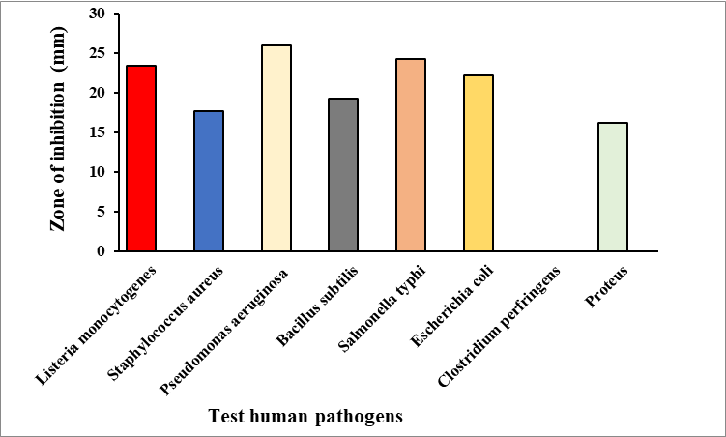
Fig. 5. Antimicrobial activity of selected EPS producing Enterococcus sp: Inhibition zones (mm) produced by strain against eight different human pathogens was measured and represented graphically as their mean SD values. Highest zone of inhibition was observed for Pseudomonas aeruginosa, where no antibacterial activity was demonstrated against Clostridium perfringens.

3.3 Antioxidant activity
The evaluation of the EPS sample for antioxidant potential encompassed a range of assays, including the DPPH and hydroxyl radical scavenging tests, along with reducing power determination. These assays revealed a substantial antioxidant activity in the EPS as evidenced by its remarkable DPPH scavenging activity of 75 ± 0.12 % (Fig.6.) and a hydroxyl radical scavenging activity of ascorbic acid (positive standard) 70.06 ± 0.02 % at a concentration of 100.13 μg/Ml, while DPPH with water was used as control.
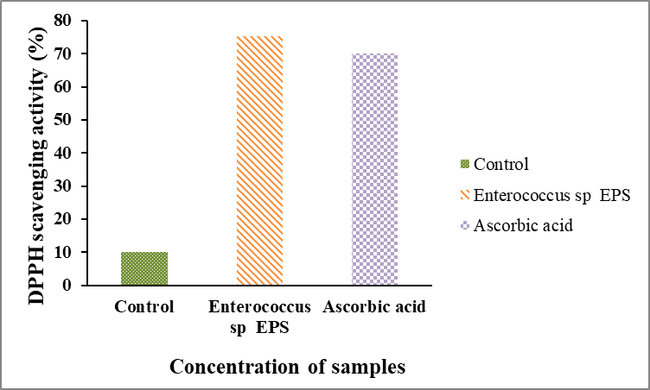
Fig. 6. Antioxidant activity of Enterococcus sp EPS was determined using DPPH method and scavenging activity was expressed in %, where, ascorbic acid was used as a positive control and normal sterile water along with DPPH was used as normal control

4.0 Discussion
Microbial-derived EPSs are environmentally safe, biocompatible, biodegradable, and non-toxic extracellular carbohydrate polymers with increased therapeutic value. They exhibit diverse health-promoting attributes and can be considered promising therapeutic carbohydrates. Antimicrobial and antioxidant EPSs may overcome the limitations caused by synthetic antibiotics (e.g., antibiotic resistance, side effects, and disruption of gut microbiota) and chemical antioxidants (e.g., potential toxicity, potential pro-oxidant effects, limited efficacy and stability). For example The EPS-MS79 produced from Enterococcus faecium could be a potent prebiotic promoting health and rheological properties of foods (Ayyash et al., 2020). Likewise, the Enterococcus faecium-derived EPS acted as reducing, capping, and stabilizing agents in green synthesizing EPS-AgNPs with potential applications in medical and food-packaging industries (Chegini et al., 2024). Enterococcus faecium EPS-F2 could be a potential alternative source of functional additives and ingredients and be applied in food industries (Jiang et al., 2021). In this regard the present study significantly focused on the production of exopolysaccharide from Enterococcus sp isolated from cereals and legumes based fermented food sample as an EPS-producing lactic acid bacterium by plating on MRS agar medium containing sucrose (2% w/v) and observing its mucoid phenotype. The strain exhibited robust physicochemical and biological characteristics, including highest EPS production, high antibacterial activity with pathogenic bacteria, high antioxidant activity and antibiotic susceptibility assay.
To determine the optimal carbon source for both cell growth and EPS production of Enterococcus sp four different carbon sources (5 g/100ml) were tested in modified MRS broth instead of glucose. Our findings revealed that sucrose exhibited the highest carbon source efficiency for EPS production in descending order of EPS yield, glucose, xylose and lactose respectively. Demonstrating the nutritional requirements for cell growth and EPS production differed. To corroborate this finding Rahnama Vosough et al. (2022) have demonstrated that the sucrose medium confers a significant advantage for the EPS production of three enterococcal strains, specifically E. durans K48, E. faecium T52, E. faecium R114 and E. faecium MC-5 (Zanan et al., 2024). Enterococcus faecium MC-5 procured from NCBI (Accession No. MN542942) was cultured in MRS broth for the production of EPS at 37°C. To enhance the production of EPS, the MRS broth was supplemented with various carbon and nitrogen sources at a concentration of 2.5 % (w/v). It was found that E. faecium MC-5 showed maximum EPS production of 8.25 ± 0.16 g/L in the presence of sucrose in the MRS broth (Tilwani et al., 2021). The influence of media compositions and cultural conditions on EPS production was determined using the PBD. Optimization of these factors is essential for achieving high EPS productivity have been identified as suitable for EPS production.
In addition to these probiotic properties, the safety profile of Enterococcus sp was preliminary evaluated. Enterococcus sp showed sensitivity to amoxicillin, erythromycin, and ciprofloxacin and moderate activity towards ofloxacin and rifampicin. However, it showed resistance to ampicillin these data are consistent with previous studies.
Although there is no definitive mode of action to explain the observed antibacterial activity of EPS against the pathogens, yet there are many potential mechanisms. EPS has the ability to disrupt the bacterial cell wall peptidoglycan layer, masking nature of some bacterial EPS that interfere with receptors and channels on the surface of Gram-negative bacterial cells, association of EPS with secondary metabolites accumulation in the growth medium that adversely affect the growth of both Gram-positive and Gram-negative bacterial pathogens (de Brito et al., 2024).

On the other hand, the antimicrobial activity of exopolysaccharide produced from enterococcus sp demonstrated wide inhibitory effects with other metabolites reported in previous studies. For example, many LAB are known to produce lactic acid, ethanol, hydrogen peroxide, bacteriocins, and short volatile fatty acid chains. In this study enterococcus sp produced EPS exhibited remarkable antibacterial activity against Pseudomonas aeruginosa followed by E. coli, S. aureus, and L. monocytogenes. These findings are consistent with previous reports, where EPS derived from probiotics demonstrated notable inhibitory effects against both Gram-positive and Gram-negative bacteria. For example, EPS-MS79 from E. faecium strongly inhibited S. aureus, S. typhimurium, L. monocytogenes, and E. coli, whereas EPS from lactic acid bacteria inhibited E. coli, E. faecalis, and L. monocytogenes (Chegini et al., 2024). Enterococcus faecium KT990028 against Escherichia coli ATCC 25922, Pseudomonas aeruginosa ATCC 27853, Listeria monocytogenes ATCC 19117, Staphylococcus aureus ATCC 6538 at 50 mg/ml concentration (de Brito et al., 2024). The antibacterial mechanism involves disruption of cell wall integrity, inhibition of peptidoglycan biosynthesis, and competitive blockade of sugar uptake, causing impaired nutrient acquisition and cell lysis. EPSs also limit bacterial translocation and promote beneficial gut microbes such as Lactobacillus and Bifidobacterium.
Generally the EPS produced from lactic acid bacteria exhibit concentration-dependent radical scavenging. In this study, enterococcus sp derived EPS-showed appreciable radical scavenging capacity, which is in line with reports on EPS from E. faecalis and E. hirae, which are known to possess strong DPPH, superoxide, and hydroxyl radical scavenging activities. The potentiality of EPS towards antioxidant property is closely associated with its structural features, monosaccharide composition, and amorphous structure, all together facilitate electron donation and free radical neutralization. Considering that oxidative stress plays a pivotal role in maintaining host homeostasis and is closely linked to intestinal inflammation and epithelial injury, the antioxidant potential of enterococcus sp EPS at 2 mg/ml concentration may contribute significantly to its protective effects on gut health (Dong et al., 2025). Likewise, E. faecium R114 and E. faecium T52 exhibited 58 and 64% of antioxidant activity at 25 mglml concentration (Rahmana Vasough et al., 2021). In addition EPS MC-5 showed a concentration-dependent manner of scavenging activity and displayed the maximum activity of 73.55 % at a concentration of 2000 μg/mL (Tilwani et al., 2021). These findings suggested that the EPS produced from the isolated bacteria can effectively reduce reactive oxygen species (ROS) at very low concentration than many other enterococcal strains.
Moreover, employing LAB-derived EPSs as natural antimicrobial agents offers several advantages over conventional chemical antimicrobials, such as reduced negative impacts on food quality and safety and decreased potential for antimicrobial resistance (Zannini et al., 2016). LAB-derived EPSs could provide a safe, effective, and sustainable alternative to chemical antimicrobials in food processing and preservation applications. The findings further support the potential utilization of enterococcus sp derived EPS as an eco-friendly and efficient alternative to chemical antimicrobials in the food industry. The potential of LAB-derived EPSs to prevents foodborne illnesses and enhance food product safety and quality. However, further research is needed to optimize the application of EPS-based strategies and assess their effectiveness in real-world food processing environments.
5.0 Conclusion
In conclusion, the present study demonstrated the potential of enterococcus sp as a safety strain capable of producing bioactive EPS with antibacterial and antioxidant properties. EPS can enhance nutritional value of functional foods through various mechanisms such as prebiotic effects, improved mineral absorption, and modulation of gut microbiota. Building on these promising results, future research could focus on expanding our understanding of enterococcus sp and its EPS. It would be beneficial to conduct in vivo studies to better represent the complexities of living systems and to explore the safety and efficacy of the strain and its EPS in animal models and human clinical trials. These potential research directions could unlock the full potential of enterococcus sp and it’s EPS for improving human health and well-being. The current findings suggest that this bacterial strain could have significant applications across various sectors, particularly in the development of functional foods and pharmaceutical products. As scientific exploration in this field progresses, it may uncover novel applications and health benefits, potentially leading to substantial advancements in human nutrition and health.

Declaration of AI Use

This manuscript was prepared through the intellectual contributions of the author(s) to the study design, data analysis, interpretation of results, and scholarly content. Grammarly and ChatGPT were used solely to assist with grammatical refinement and reference formatting during manuscript revision. The author(s) accept full responsibility for the accuracy, integrity, and final content of the manuscript.

Consent
Not applicable
Ethical approval
No animals, human subjects and plant samples were used in this study.
References
Abarquero, D., Renes, E., Fresno, J. M., & Tornadijo, M. E. (2022). Study of exopolysaccharides from lactic acid bacteria and their industrial applications: a review. International Journal of Food Science and Technology, 57(1), 16-26. https://doi.org/10.1111/ijfs.15227.
Angelin, J., & Kavitha, M. (2020). Exopolysaccharides from probiotic bacteria and their health potential. International journal of biological macromolecules, 162, 853-865. DOI: 10.1016/j.ijbiomac.2020.06.190.
Ayyash, M., Stathopoulos, C., Abu-Jdayil, B., Esposito, G., Baig, M., Turner, M. S., & Osaili, T. (2020). Exopolysaccharide produced by potential probiotic Enterococcus faecium MS79: Characterization, bioactivities and rheological properties influenced by salt and pH. Lwt, 131, 109741. https://doi.org/10.1016/j.lwt.2020.109741
Bomfim, V. B., Neto, J. H. P. L., Leite, K. S., de Andrade Vieira, É., Iacomini, M., Silva, C. M., & Cardarelli, H. R. (2020). Partial characterization and antioxidant activity of exopolysaccharides produced by Lactobacillus plantarum CNPC003. Lwt, 127, 109349. DOI:10.1016/j.lwt.2020.109349
Chegini, P., Salimi, F., Pirbodagh, Z. A., & Zare, E. N. (2024). Antilisterial and antioxidant exopolysaccharide from Enterococcus faecium PCH. 25 isolated from cow butter: characterization and probiotic potential. Archives of Microbiology, 206(9), 389. DOI: 10.1007/s00203-024-04112-2
de Brito, L. P., da Silva, E. C., Lins, L. F., de Medeiros, R. S., Silva, F. C. O., Pastrana, L., ... & Porto, A. L. F. (2024). Optimization, structural characterization, and biological applications of exopolysaccharide produced by Enterococcus faecium KT990028. International Journal of Biological Macromolecules, 282, 136926. 10.1016/j.ijbiomac.2024.136926
Dong, Z., Li, X., Wu, Y., Wang, Z., Cui, W., Hu, S., & Zhou, Z. (2025). Gut-protective and multifunctional exopolysaccharide from Enterococcus faecium HDRsEf1: structural characterization and protective effects against enteropathogenic E. coli-induced intestinal inflammation. Nutrients, 17(23), 3667. DOI: 10.3390/nu17233667
Jiang, G., Gan, L., Li, X., He, J., Zhang, S., Chen, J., & Tian, Y. (2021). Characterization of structural and physicochemical properties of an exopolysaccharide produced by Enterococcus sp. F2 from fermented soya beans. Frontiers in microbiology, 12, 744007. doi: 10.3389/fmicb.2021.744007
Kavitake, D., Devi, P. B., Delattre, C., Reddy, G. B., & Shetty, P. H. (2023). Exopolysaccharides produced by Enterococcus genus—An overview. International journal of biological macromolecules, 226, 111-120. DOI: 10.1016/j.ijbiomac.2022.12.042
Rahnama Vosough, P., Habibi Najafi, M. B., Edalatian Dovom, M. R., Javadmanesh, A., & Mayo, B. (2021). Evaluation of antioxidant, antibacterial and cytotoxicity activities of exopolysaccharide from Enterococcus strains isolated from traditional Iranian Kishk. Journal of Food Measurement and Characterization, 15(6), 5221-5230. DOI:10.1007/s11694-021-01092-5
Ryan, K. J., & Ray, C. G. (2004). Streptococci and enterococci. Medical Microbiology: An Introduction to Infectious Diseases. Fourth Edition. McGraw-Hill, USA, 273-296.
Soliemani, O., Salimi, F., & Rezaei, A. (2022). Characterization of exopolysaccharide produced by probiotic Enterococcus durans DU1 and evaluation of its anti-biofilm activity. Archives of microbiology, 204(7), 419. DOI: 10.1007/s00203-022-02965-z
Tarique, M., Ali, A. H., Kizhakkayil, J., Liu, S. Q., Oz, F., Dertli, E., & Ayyash, M. (2024). Exopolysaccharides from Enterococcus faecium and Streptococcus thermophilus: Bioactivities, gut microbiome effects, and fermented milk rheology. Food Chemistry: X, 21, 101073. DOI: 10.1016/j.fochx.2023.101073
Tiwari, S., Kavitake, D., Devi, P. B., & Shetty, P. H. (2021) Bacterial exopolysaccharides for improvement of technological, functional and rheological properties of yoghurt. Int J Biol Macromol 183:1585– 1595. https://doi.org/10.1016/j.ijbiomac.2021.05.140.
Yang, Y., Jiang, G., & Tian, Y. (2023). Biological activities and applications of exopolysaccharides produced by lactic acid bacteria: A mini-review. World Journal of Microbiology and Biotechnology, 39(6), 155. DOI: 10.1007/s11274-023-03610-7
Zanzan, M., Ezzaky, Y., Achemchem, F., Hamadi, F., Valero, A., & Mamouni, R. (2024). Fermentative optimization and characterization of exopolysaccharides from Enterococcus faecium F58 isolated from traditional fresh goat cheese: M. Zanzan et al. Food Science and Biotechnology, 33(5), 1195-1205. https://doi.org/10.1007/s10068-023-01424-9

