A new locality record of the Smooth-coated Otter (Lutrogale perspicillata) from the Sangli stretch of the Krishna River, (Maharashtra,India)

ABSTRACT
The present study the occurrence of the Smooth-coated Otter (Lutrogale perspicillata) at some sites (16⁰48’14.15”N, 74⁰34’16.78”E) in the Krishna River of Sangli District, Maharashtra, based on photographic evidences and field observations. The record is significant because otters are closely associated with healthy aquatic environments and depend on suitable water conditions, adequate prey availability, and undisturbed areas along riverbanks. The observation of L. perspicillata in the study area therefore suggests that parts of the Krishna River still provide suitable habitat conditions for this species.
Keywords: Lutrogale perspicillata, Smooth-coated Otter, photographic evidence, Krishna River, Sangli, Maharashtra, aquatic biodiversity.
Introduction:
The present study provides photographic evidence of the Smooth-coated Otter (Lutrogale perspicillata) from the Krishna River in Sangli District, Maharashtra. This observation is important because information on the occurrence of otters in many river stretches is still limited. Smooth-coated Otters are mainly associated with freshwater habitats where suitable water conditions and sufficient food resources are available (Hussain & Choudhury, 1997; Acharya et al., 2010). The record from the Krishna River therefore adds useful information to the known distribution of the species in this region.
The Krishna River provides a range of aquatic and riverbank habitats that can support otters and other wildlife. Areas with relatively shallow water, riverbank vegetation, sandbanks, and suitable feeding grounds may be particularly useful for otters. Fish and other aquatic organisms are important food resources for the species, and their availability may influence where otters occur along the river. The presence of L. perspicillata may therefore indicate that suitable food and habitat resources are still available in parts of the Krishna River. Otters are closely linked with freshwater environments and are considered ecologically important because they depend on healthy aquatic food resources. Their occurrence can provide useful information about the condition of riverine habitats, although the presence of a single species record alone cannot be used to determine the overall health of an ecosystem (Yonzon, 1998; Acharya & Rajbhandari, 2011). Freshwater ecosystems are increasingly affected by pollution, water extraction, habitat alteration, and other human pressures, which can have direct and indirect effects on aquatic biodiversity (Dudgeon et al., 2006; Vörösmarty et al., 2010).

Materials and Methods

Study Area
The study was carried out along selected stretches of the Krishna River in Sangli 16⁰48’14.15”N, 74⁰34’16.78”E). The river supports a variety of aquatic and terrestrial habitats, including riverbanks, sandbars, rocky areas, agricultural fields, and patches of vegetation. These habitats provide suitable conditions for otters and other wildlife. Selected sites were identified based on local information, previous observations, and the presence of suitable otter habitat.
Materials
Google Earth for mapping and analysis of the study area, a field notebook and data sheets for recording observations, a measuring tape for measuring transects and habitat features, a camera or mobile phone for photographic documentation, binoculars for observing otters from a distance, walking shoes and other field equipment for conducting surveys, survey maps for locating the study sites, and pen and pencil for recording field observations.

Field Survey
The survey was conducted along selected stretches of the Krishna River. The river stretches were first identified and mapped using Google Earth Pro.
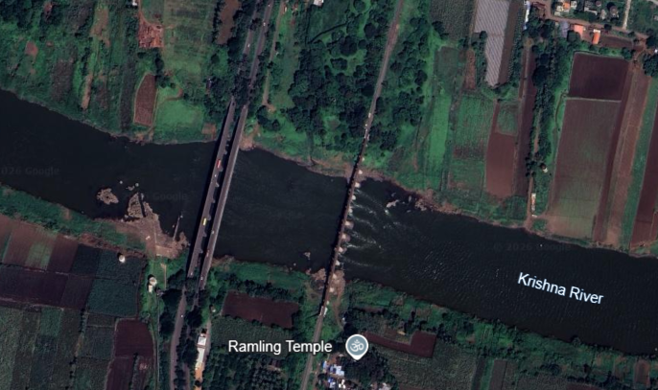
Fig: 1 Map showing Otter Distribution at Krishna River Sangli with Lat/Long – 16⁰48’14.15”N, 74⁰34’16.78”E
Observation
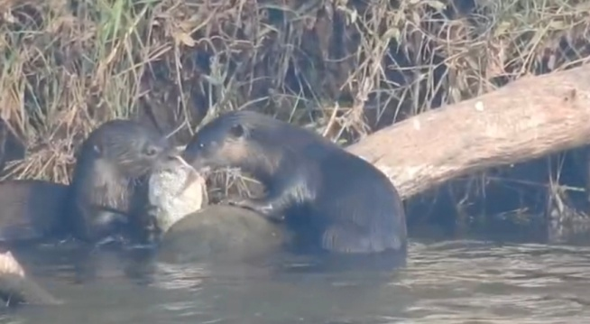 | 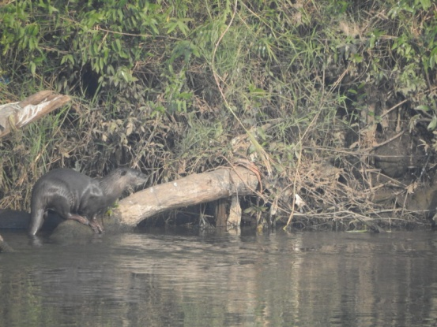
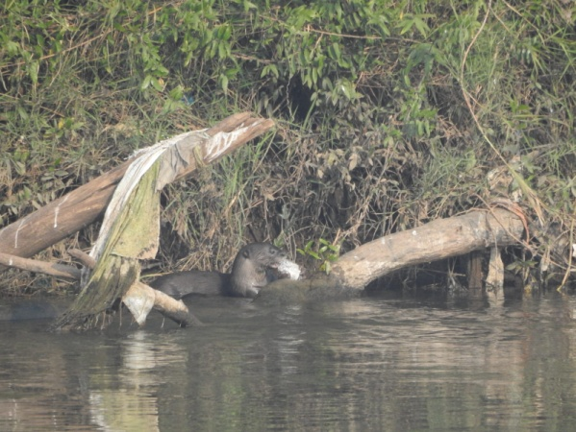 | 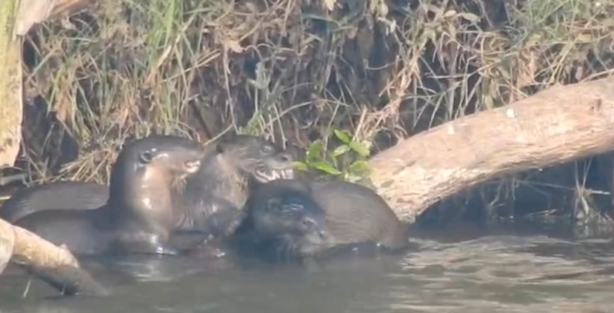
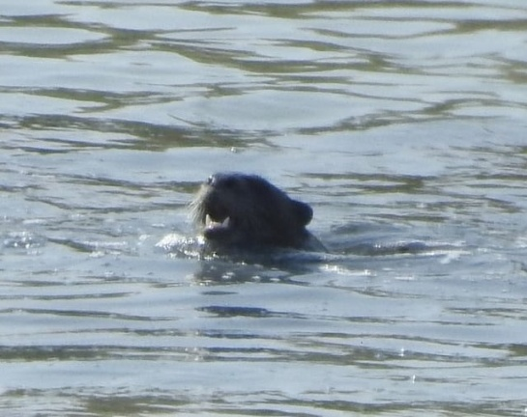 | 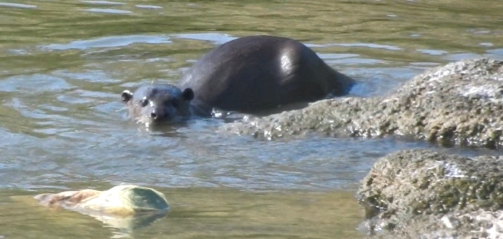
Fig.2 Smooth Coated Otter observed at Krishna River, Sangli
Field observation of the smooth-coated otter (Lutrogale perspicillata) was recorded on 5 September 2026 at approximately 18:00 h along the Krishna River near Sangli, Maharashtra. The individual was observed in the riverine environment during the evening period. Identification was based on its characteristic smooth, dark-brown dorsal pelage, comparatively lighter ventral surface, elongated body, and behavior associated with the aquatic habitat. The observation was documented photographically and provides additional field evidence for the continued occurrence of Lutrogale perspicillata in the Sangli stretch of the Krishna River.
The occurrence the smooth-coated otter at Sangli is ecologically relevant because the species is closely associated with freshwater rivers, wetlands, floodplains, and other aquatic habitats where adequate prey and suitable riparian cover are available. The IUCN SSC Otter Specialist Group describes the species as predominantly nocturnal, although it may also be active during daylight when disturbance is limited. The species generally requires riverside vegetation and suitable areas for shelter, resting and breeding. The timing of the present observation at approximately 18:00 h is therefore consistent with the species' crepuscular/evening activity pattern. Present observation provides an important new locality record of the Smooth-coated Otter (Lutrogale perspicillata) from the Sangli section of the Krishna River, Maharashtra. Although the species has previously been reported from different parts of the Krishna River system, including riverine habitats associated with sandy banks, riparian vegetation, river islands and other suitable aquatic environments, documented observations from the Sangli stretch remain limited. The present sighting therefore contributes additional evidence of the species’ occurrence in this part of the Krishna River basin. The observation was made in a riverine habitat with suitable vegetation and water resources, which may provide favourable conditions for otter movement and feeding. Recent local reports from the Sangli area have also indicated the presence of a small group of approximately eight to nine Smooth-coated Otters, suggesting that the species may use suitable stretches of the river either individually or in small groups. However, a single observation cannot be used to determine population size, abundance or population trends. Systematic surveys covering different seasons, river stretches and suitable habitats are therefore required to confirm the distribution and status of the species in the Sangli region. The present record highlights the importance of continued field monitoring and conservation of suitable riverine habitats along the Krishna River.

Survey methodology
Field surveys for the smooth-coated otter (Lutrogale perspicillata) were conducted along selected stretches of the Krishna River in Sangli District, Maharashtra. The survey sites were selected on the basis of suitable riverine habitat, including riverbanks, shallow-water areas, sand or mud banks, riparian vegetation and potential resting areas.
During field visits, accessible sections of the riverbank were searched by walking slowly along the river edge and visually scanning the river channel, opposite bank, exposed sandbars and surrounding vegetation. Observations were made during suitable daylight and evening periods. When an otter was observed, the date, approximate time, location, visible number of animals, behaviour and habitat conditions were recorded. Photographs were taken whenever possible to support species identification and document the observation.
The field observations were based on direct visual detection and photographic documentation. The same observation was not counted again when it was clearly part of the same observation event. However, because individual otters were not marked or uniquely identified, it was not possible to determine whether animals observed during different visits represented the same or different

Results and Discussion
Otters were observed at several suitable places along the study area. Most observations were made near riverbanks, sandbanks, vegetation, and places where food was available. Fish availability and suitable places for resting and grooming appeared to be important for their presence in these areas.
Human activities were present in some parts of the riverbank. Fishing, agriculture, and regular use of the riverbank by local people may affect the areas used by otters. Maintaining natural vegetation along the riverbank and avoiding unnecessary disturbance may help to retain suitable habitats for otters. Local fishermen and residents can also support conservation by reporting otter sightings and informing others about places where otters are regularly seen.
The observations from the study indicate that regular monitoring of otters and their habitats along the Krishna River is needed. Conservation measures should protect suitable riverbank habitats while also considering the daily activities and livelihood needs of local people.

Threats to the Otter population

Habitat Loss
Habitat loss is one of the major threats to otters in the study area. Otters need suitable places for resting, breeding, grooming, and defecation. Riverbanks, sandbanks, soil, leaf litter, and areas with vegetation are commonly used for these activities. However, many of these habitats are gradually decreasing because of illegal sand mining and the conversion of wetlands and natural areas into agricultural land.
Sand mining is a serious problem for river ecosystems. Excessive removal of sand from the riverbed and riverbanks changes the natural condition of the river, increases water depth in some areas, and damages places used by otters and their prey. It can also reduce the availability of fish and other aquatic organisms on which otters depend. Some parts of the river have already been heavily disturbed due to continuous sand extraction.

Otter–Fisherman Competition
Competition between otters and fishermen can occur in areas where fish are abundant. In some parts of the study area, high fishing activity was observed along with frequent otter activity. This indicates that both otters and fishermen depend on the same fish resources.
Such areas are important for otter conservation, but the livelihood of local fishermen also needs to be considered. Conservation measures should therefore focus on reducing conflicts between otters and fishermen. Sustainable fishing practices and proper management of fishing areas can help both otters and local communities use the river resources.
Otters were recorded from several suitable areas along the study site. Their presence was mainly associated with riverbanks, sandbanks, vegetation, and areas having sufficient food resources. The availability of fish and suitable resting and grooming sites appears to be important for otter occurrence.
The study shows the need for continued monitoring of otters and their habitats along the Krishna River. Conservation efforts should consider both the ecological requirements of otters and the livelihood needs of local people.

Conclusions
Photographic and direct field observations confirm the occurrence of the Smooth-coated Otter (Lutrogale perspicillata) along the surveyed Sangli stretch of the Krishna River. The observation was associated with a riverine environment containing aquatic habitat, riverbanks and vegetation suitable for otter activity. The record contributes additional information on the occurrence of the species in this part of the Krishna River basin. However, the available observations cannot be used to estimate abundance, population size or long-term trends. Continued systematic monitoring across different sites and seasons is therefore required to establish the distribution and status of Smooth-coated Otters in the Sangli region. Conservation attention should focus on maintaining suitable riverbank and aquatic habitats while considering human use of the river.

Declaration of AI Use

This manuscript was prepared through the intellectual contributions of the author(s) to the study design, data analysis, interpretation of results, and scholarly content. Grammarly and ChatGPT were used solely to assist with grammatical refinement and reference formatting during manuscript revision. The author(s) accept full responsibility for the accuracy, integrity, and final content of the manuscript.

Reference
Anoop, K. R. (2001). Factors affecting habitat selection and feeding habits of smooth-coated otter Lutra perspicillata in Periyar Tiger Reserve, Kerala [Unpublished master’s thesis]. Wildlife Institute of India.
Anoop, K. R., & Hussain, S. A. (2004). Factors affecting habitat selection by smooth-coated otters (Lutra perspicillata) in Kerala, India. Journal of Zoology, 263, 417–423. https://doi.org/10.1017/S0952836904005461
Arivoli, K., & Narasimmarajan, K. (2021). First record of an elusive predator: The smooth-coated otter (Lutrogale perspicillata) from Vaduvoor Bird Sanctuary, Thiruvarur District, Tamil Nadu, southern India. IUCN Otter Specialist Group Bulletin, 38, 79–84. https://www.iucnosgbull.org/Volume38/Arivoli_Narasimmarajan_2021.pdf
Brzeziński, M., Jędrzejewska, W., & Jędrzejewska, B. (1993). Diet of otters (Lutra lutra) inhabiting small rivers in the Białowieża National Park, eastern Poland. Journal of Zoology, 230, 495–501. https://doi.org/10.1111/j.1469-7998.1993.tb02701.x
Conroy, J. W., & Chanin, P. R. (2000). The status of the Eurasian otter (Lutra lutra) in Europe: A review. Journal of the International Otter Survival Fund, 1, 7–28.
De Silva, P., Khan, W. A., Kanchanasaka, B., Reza Lubis, I., Feeroz, M. M., & Al-Sheikhly, O. F. (2015). Lutrogale perspicillata. The IUCN Red List of Threatened Species 2015.
Khoo, M., Basak, S., Sivasothi, N., de Silva, P. K., & Reza Lubis, I. (2021). Lutrogale perspicillata. The IUCN Red List of Threatened Species 2021, e.T12427A164579961. https://doi.org/10.2305/IUCN.UK.2021-3.RLTS.T12427A164579961
Fonseca, V. C., Rheingantz, M. L., Fernandez, F. A., & dos Santos, C. S. (2008). A comparison of two different methods for estimating the diet of the Neotropical otter, Lontra longicaudis, with the proposal of a new index for dietary studies. IUCN Otter Specialist Group Bulletin, 25(1), 6–12. https://www.iucnosgbull.org/Volume25/Fonseca_et_al_2008.html
Goszczyński, J. (1974). Studies on the food of foxes. Acta Theriologica, 19, 1–18. https://rcin.org.pl/Content/10198/PDF/BI002_2613_Cz-40-2_Acta-T19-nr1-1-18_o.pdf
Gupta, N., Tiwari, V., Everard, M., Savage, M., Hussain, S. A., Chadwick, M. A., & Johnson, J. A. (2020). Assessing the distribution pattern of otters in four rivers of the Indian Himalayan biodiversity hotspot. Aquatic Conservation: Marine and Freshwater Ecosystems, 30, 601–610. https://doi.org/10.1002/aqc.3284
Hussain, S. A. (1993). Aspects of the ecology of smooth-coated otters Lutra perspicillata in National Chambal Sanctuary [Unpublished doctoral dissertation]. Aligarh Muslim University.
Hussain, S. A., & Choudhury, B. C. (1997). Status and distribution of smooth-coated otter Lutra perspicillata in National Chambal Sanctuary. Biological Conservation, 80, 199–206. https://doi.org/10.1016/S0006-3207(96)00033-X
Hussain, S. A., Gupta, S. K., & de Silva, P. (2011). Biology and ecology of Asian small-clawed otter Aonyx cinereus (Illiger, 1815): A review. IUCN Otter Specialist Group Bulletin, 28, 63–75. https://www.iucnosgbull.org/Volume28/Hussain_et_al_2011.html
Jędrzejewska, B., Sidorovich, V. E., Pikulik, M. M., & Jędrzejewska, W. (2001). Feeding habits of the otter and the American mink in Białowieża Primeval Forest (Poland) compared to other Eurasian populations. Ecography, 24, 165–180. https://doi.org/10.1034/j.1600-0587.2001.240207.x
Joshi, A. S., Tumsare, V. M., Nagar, A. K., Mishra, A. K., & Pariwakam, M. P. (2016). Photographic records of Eurasian otter Lutra lutra from the central Indian landscape. IUCN Otter Specialist Group 73–78. https://www.iucnosgbull.org/Volume33/Joshi_et_al_2016.html
Khan, M. S., Dimri, N. K., Nawab, A., Ilyas, O., & Gautam, P. (2014). Habitat use pattern and conservation status of smooth-coated otters Lutrogale perspicillata in the Upper Ganges Basin, India. Animal Biodiversity and Conservation, 69–76. https://doi.org/10.32800/abc.2014.37.0069
Narasimmarajan, K., Hayward, M. W., & Mathai, M. T. (2021). Assessing the occurrence and resource use pattern of smooth-coated otters Lutrogale perspicillata Geoffroy (Carnivora, Mustelidae) in the Moyar River of the Western Ghats biodiversity hotspot. IUCN Otter Specialist GrouBulletin,38(1https://www.iucnosgbull.org/Volume38/Narasimmarajan_et_al_2021.
Nawab, A., & Belwal, V. K. (2020). Assessing the distribution pattern of otters in four rivers of the Indian Himalayan biodiversity hotspot. Aquatic Conservation: Marine and Freshwater Ecosystems, 30, 601–610. https://doi.org/10.1002/aqc.3284
Nawab, A., & Hussain, S. A. (2012). Factors affecting the occurrence of smooth-coated otter in aquatic systems of the Upper Gangetic Plains, India. Aquatic Conservation: Marine and Freshwater Ecosystems, 22(5), 616–625. https://doi.org/10.1002/aqc.2230
Raha, A., & Hussain, S. A. (2016). Factors affecting habitat selection by three sympatric otter species in the southern Western Ghats, India. Acta Ecologica Sinica, 36, 45–49.
Raman, K., Sivangnanaboopathidossvimal, S., Kishorekumar, S., Bawa, M. K., & Selvan, K. M. (2019). Occurrence of smooth-coated otter Lutrogale perspicillata in Sankaraparani River
Raj, B. S. (1941). Dams and fisheries: Mettur and its lessons for India. Proceedings of the Indian Academy of Sciences—Section B, 14(4), 341–358. https://doi.org/10.1007/BF03051147
Puducherry, India. IUCN Otter Specialist Group Bulletin, 36(1), 28–33. https://www.iucnosgbull.org/Volume36/Raman_et_al_2019.html

