Original Research Article
Screening and Characterization of Drought- and Salt-Tolerant Plant Growth-Promoting Rhizobacteria from Wheat Rhizosphere

Abstract
Drought and salinity are among the major environmental constraints affecting wheat growth and yield, creating a need for sustainable approaches to enhance crop performance under adverse conditions. In this study, indigenous bacteria associated with the wheat rhizosphere were isolated from the Malwa and Nimar regions of Madhya Pradesh, India, with the objective of identifying strains capable of tolerating drought- and salt-related stress. A total of 150 bacterial isolates were obtained from rhizospheric soil samples collected from Indore, Khargone, and Maheshwar. From these, 20 representative isolates were selected and evaluated on the basis of their morphological, biochemical, physiological, and plant growth-promoting characteristics. The selected isolates were assessed for their ability to withstand different concentrations of NaCl, polyethylene glycol (PEG)-mediated osmotic stress, temperature variations, and pH conditions. Among the isolates, WR4, WR5, and WR9 retained growth at NaCl concentrations as high as 12%, whereas WR4, WR7, WR8, and WR9 demonstrated comparatively greater tolerance to PEG-induced osmotic stress. In addition to stress tolerance, the bacterial isolates expressed several traits associated with plant growth promotion, including nitrogen fixation, ammonia production, phosphate and potassium solubilization, hydrogen cyanide (HCN) production, and indole-3-acetic acid (IAA) synthesis. Quantitative assessment revealed phosphate-solubilizing activity in the range of 31.3–39.2 mg/mL, while IAA production varied from approximately 11 to 21 µg/mL, with WR4 exhibiting the highest level of IAA production. The findings demonstrate that wheat rhizosphere-associated bacteria from the studied regions possess a combination of abiotic stress tolerance and beneficial plant growth-promoting properties. These indigenous isolates, particularly those exhibiting multiple desirable traits, may therefore serve as promising candidates for developing microbial inoculants aimed at improving wheat production in drought- and salinity-prone environments. Molecular characterization followed by greenhouse and field experiments will be necessary to establish their taxonomic identity, functional stability, and effectiveness under actual agricultural conditions.
Keywords: Drought stress; Salt tolerance; Wheat rhizosphere; Plant growth-promoting bacteria; Rhizobacteria;

INTRODUCTION
Wheat (Triticum aestivum L.) is one of the most important cereal crops worldwide and plays a central role in global food security. However, wheat production is increasingly constrained by adverse environmental conditions, particularly drought and soil salinity. These abiotic stresses adversely affect plant growth, development, and productivity by causing osmotic stress, ionic toxicity, oxidative damage, nutrient imbalance, and disturbances in cellular metabolism (Yang et al., 2009; Vurukonda et al., 2016). Drought stress limits water availability and reduces photosynthesis, nutrient uptake, cell expansion, and biomass production, whereas salinity imposes both osmotic and ion-specific stresses that can severely impair plant physiological functions (Shrivastava and Kumar, 2015; Gupta and Huang, 2014). Consequently, the increasing occurrence of water scarcity and soil salinization represents a major challenge for sustainable wheat production. Conventional strategies for reducing the effects of drought and salinity include improved irrigation practices, soil amendments, and the development of stress-tolerant crop varieties. Salt stress is the most important abiotic variables affecting agricultural production globally, which raises concerns about crop yields and food security. According to recent estimates, salinity affects around 20% of the world's irrigated land and 6% of the overall land area; this percentage is expected to increase as a result of climate change and unsustainable farming methods (Fouad et al., 2026). Therefore, there is increasing interest in environmentally sustainable approaches that complement conventional crop management practices. Among these approaches, the use of beneficial plant-associated microorganisms has emerged as a promising strategy for improving plant growth and resilience under unfavorable environmental conditions (Vurukonda et al., 2016; Etesami and Beattie, 2018). The rhizosphere is a biologically active zone surrounding plant roots that contains diverse microbial communities influenced by root exudates and soil characteristics. Plant growth-promoting rhizobacteria (PGPR) are an important component of this microbial community and can improve plant growth through a range of direct and indirect mechanisms. These mechanisms include biological nitrogen fixation, phosphate solubilization, potassium mobilization, phytohormone production, siderophore production, and the modulation of plant responses to environmental stress (Glick, 2012; Backer et al., 2018). The identification of indigenous PGPR from crop rhizospheres is particularly valuable because locally adapted microorganisms may possess physiological characteristics that enable them to survive and function effectively under the environmental conditions prevailing in their native agricultural soils. Farmers have been enthralled with the development of sustainable agriculture practices in recent years due to the usage of PGPR for crop inoculation instead of chemical fertilizers (García et al., 2017). The PGPR uses a variety of processes to support plant growth, yield, and nutrient uptake. While some PGPR, like Aeromonas punctata, Azospirillum brasilense, Bacillus megaterium, Pseudomonas fluorescens, and Serratia marcescens, directly stimulated the production of plant hormones, other PGPR encouraged plant growth by making minerals and nitrogen available in the soil during drought (Barnawal et al., 2017; Yadav et al., 2022). PGPR-mediated alleviation of drought stress involves several interconnected mechanisms. Beneficial bacteria can promote root development, improve nutrient acquisition, produce phytohormones and osmoprotective compounds, stimulate antioxidant defense systems, and regulate stress-responsive pathways in plants. In addition, bacterial production of exopolysaccharides, volatile organic compounds, and enzymes such as 1-aminocyclopropane-1-carboxylate (ACC) deaminase may contribute to improved plant adaptation to water-deficit conditions (Yang et al., 2009; Vurukonda et al., 2016). Previous studies have demonstrated that PGPR can improve wheat performance under drought conditions through multiple physiological and biochemical mechanisms, supporting their potential use in sustainable crop production (Kumar et al., 2022; El-Saadony et al., 2024). Similarly, salt-tolerant plant growth-promoting bacteria can contribute to plant adaptation in saline soils. Halotolerant bacteria are capable of maintaining their growth and metabolic activity under elevated salt concentrations and may support plant growth by improving nutrient availability, modulating phytohormone balance, reducing stress-induced ethylene responses, and contributing to osmotic adjustment and ion homeostasis (Arora et al., 2020; Sunita et al., 2020). The use of stress-tolerant bacteria is therefore particularly attractive for agriculture in environments where drought, salinity, and other abiotic stresses occur simultaneously or sequentially.
An important characteristic of promising microbial inoculants is their ability to tolerate multiple environmental stresses while maintaining plant growth-promoting functions. Bacteria possessing tolerance to salinity, water limitation, temperature variation, and broad pH conditions may have improved survival and persistence following their introduction into agricultural soils. Furthermore, multifunctional isolates expressing several beneficial traits, such as nutrient solubilization and phytohormone production, may provide complementary benefits to plants. Recent research and reviews have emphasized the importance of identifying stress-adapted microorganisms and understanding their multiple mechanisms of action for developing effective microbial technologies for climate-resilient agriculture (Vurukonda et al., 2016; Gouda et al., 2018; Arora et al., 2020). India is an important wheat-producing country, and maintaining wheat productivity under changing environmental conditions is essential for agricultural sustainability and food security. The Malwa and Nimar regions of Madhya Pradesh represent important agricultural landscapes with diverse soil and environmental conditions. However, the diversity and functional potential of indigenous wheat rhizosphere bacteria from these regions remain comparatively underexplored. In particular, the identification of bacterial populations capable of tolerating drought- and salinity-associated stress while simultaneously expressing plant growth-promoting characteristics could provide useful candidates for future development as locally adapted bioinoculants. Therefore, the present study was undertaken to isolate and characterize bacteria from the rhizosphere of wheat cultivated in selected agricultural regions of Madhya Pradesh, India. The bacterial isolates were screened for tolerance to salinity and doughtc stress and were further characterized based on their morphological, biochemical, and physiological properties. Selected isolates were also evaluated for plant growth-promoting traits. The findings of this study provide a preliminary basis for identifying indigenous stress-tolerant bacterial isolates with potential applications in sustainable wheat production under drought- and salinity-affected conditions. Further molecular identification and greenhouse and field experiments will be required to establish the taxonomic identity, plant-colonization ability, and agronomic effectiveness of the most promising isolates.
2. Material and Methods:
2.1 Site description
Soil samples were collected from the rhizosphere of wheat plants grown in agricultural fields across the Malwa and Nimar regions of Madhya Pradesh, India. The sampling sites were selected from different agricultural areas of Indore, Khargone, and Maheshwar. Detailed information regarding the sampling locations is presented in figure 1and table 1.
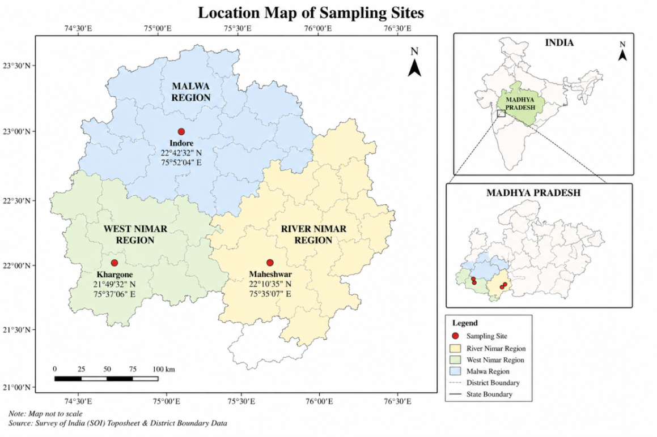
Fig. 1. locations of soil sample collection site
Table 1: Site description
S.  No. | Area  Name | Site  name | Sample  Id | Location | Collection  Date | Wheat  cultivation | Crop  Selection
1 | Maheshwar | River nimar  region | M  sample | 22˚10̍35̎̎ N  75˚35̍07̎ E | 15/03/2024 | Yes | Wheat  Rhizosphere soil
2 | Khargone | West nimar  region | K  sample | 21˚49̍̍ 32̎N  75˚37̍06̎̎ E | 15/03/2024 | Yes | Wheat  Rhizosphere soil
3 | Indore | Malwa  region | N  sample | 22˚42̍32̎N  75˚52̍04̎ E | 15/03/2024 | Yes | Wheat  Rhizosphere soil

2.2 Isolation of Rhizobacteria
Rhizobacteria were extracted from soil sample by pour plate and serial dilution techniques. One gram of each soil sample was weighed and mixed with nine millilitres of sterile distilled water to make the serial dilution. Thoroughly mix the soil sample with sterile water and vortex. Take an aliquot of 1000µl and make a solution with a dilution of 10⁻¹ to 10⁻⁹. Pour 200 µl of the dilution samples from 10⁻⁴, 10-⁵ and 10⁻⁶ into plates containing nutrient agar. Then place the media on the appropriate plates and let it incubate at room temperature for a full day. The media should then be moved onto the proper plates and allowed to incubate at room temperature for a full day. Examine the colonies on plates following incubation. Different morphological colonies were selected and inoculated on brand-new nutrient agar media for proper isolation.
2.3 Screening of stress tolerant
2.3.1 Screening of salt tolerance
Each bacterial isolate was examined for its capacity to withstand salt. After streaking a loopful of fresh bacterial culture onto nutrient agar medium supplemented with different concentrations of NaCl (2%-12%).The plates were incubated for 48 hours at ambient temperature. A distinct bacterial colony on the plates supplemented with NaCl is seen as evidence of salt tolerance (Amaresan et al. (2014).
2.3.2 Screening of drought-tolerant bacteria
The drought tolerance of the bacterial isolates was assessed using nutrient broth supplemented with different concentrations of polyethylene glycol (PEG 6000), namely 5%, 10% and 15% For each isolate, a single colony was aseptically transferred into the respective PEG-amended Nutrient broth and incubated for 48 h at 30 °C with continuous agitation at 200 rpm. Bacterial growth was evaluated by measuring the optical density (OD) of the cultures at 600 nm using a Merck UV–Visible spectrophotometer. Based on their ability to grow under increasing PEG concentrations, the most drought-tolerant isolates were selected for further evaluation of their plant growth-promoting potential, following the methodology described by Agunbiade et al. (2024).
2.4 Selection of the isolates
Serial dilution was employed to select isolates. For screening, the morphologically distinct colonies had been placed into Nutrient agar Media (NAM). Examine the various colonies on the agar plate throughout a full day of incubation. After then, a fresh culture was created and the individual colonies were chosen for screening. After that, additional investigation was done on the fresh cultures to ascertain their biochemical characteristics and possible uses. Only the most promising isolates about 20 isolates were kept for further testing due to this procedure.
2.5 Determination of Temperature, pH and salt tolerance
For evaluation of physiological growth characteristics of 20 isolates were cultured on Nutrient agar Media (NAM) plates and incubated at varying temperatures (4, 15, 25, 30, 35, 40, 45, 50, 55, and 60 °C) and pH levels ranging from (5.0 to 12.0) to determine their minimum, optimum, and maximum growth conditions. Salt tolerance was examined by growing the isolates on NAM medium amended with different NaCl concentrations (2.0 to 12%) and incubating the plates at 30 °C for 3–4 days.
2.6 Biochemical characterization
Biochemical characterization of the isolates, was conducted following the methods described by Malviya et al. (2012). Catalase activity was assessed by observing the release of oxygen bubbles after adding 3% hydrogen peroxide to the culture, while oxidase activity was confirmed through the oxidation of TMPD (tetramethyl-p-phenylenediamine dihydrochloride) using oxidase reagent discs. Starch hydrolysis was evaluated by flooding 7-day-old colonies grown on starch agar (containing 2% starch) with Gram’s iodine solution and observing the appearance of clear zones around colonies. Citrate utilization was determined by a color change in citrate agar medium, while the ability to metabolize various carbon sources was analyzed using Andrade peptone water supplemented with 0.1% Andrade indicator, where a color shift signified positive utilization.
2.6 Qualitative Evaluation of Plant Growth-Promoting traits

2.6.1 Nitrogen fixation
To evaluate the nitrogen-fixing potential of the bacterial isolates, a qualitative assay was conducted by culturing them on a nitrogen-free (NF) medium. The composition of the medium per liter included: 20 g mannitol, 0.2 g K₂HPO₄, 0.2 g NaCl, 0.2 g MgSO₄・7H₂O, 0.1 g K₂SO₄, 5 g CaCO₃,and 20 g agar in accordance with the protocol established by Khoury et al. (2015). The cultures were incubated at 28 °C for 48 h and bacterial growth was subsequently monitored to assess nitrogen fixation ability.

2.6.2 Phosphate Solubilizing
The phosphate-solubilizing potential of the bacterial isolates was evaluated using Pikovskaya’s agar medium as described by Pikovskaya (1948). An inoculum of 10 µL containing approximately 1×10⁸ CFU mL⁻¹ of each isolate was placed on the medium and incubated for three days. The solubilization of phosphate was indicated by the appearance of a clear halo zone surrounding the bacterial colony. This halo formation results from the production of organic acids by the isolates, which dissolve the tri-calcium phosphate present in the medium.
2.6.2.1 Quantitative analysis of Phosphate solubilization
The bacterial isolates were cultured in a Pikovskaya medium (10.0 g glucose, 5.0 g Ca3 (PO4)2 , 0.5 g yeast extract, 0.1 g MgSO4. 7H2 O, 0.2 g KCl, 0.2 g NaCl, and 0.5 g (NH4 ) 2SO4 , as well as the trace elements of FeSO4 and MnSO4 )to determine their ability to dissolve phosphate. Before autoclaving, the pH of the solution was adjusted to 7.0. The bacterial isolates were cultured in Pikovskaya solution (80 ml), whereas the non-inoculated medium served as a control. The flasks were shaken at 170 rpm for up to one week at 37°C. The pH of the culture medium was measured after 24 hours. Phosphate content was determined spectrophotometrically at OD880 using the standard method of Murphy and Riley.

2.6.3 Potassium Solubilization
The potassium-solubilizing capacity of the selected isolates was assessed using a modified Aleksandrov agar medium following the method described by Hu et al. (2006). Approximately 10 µL of bacterial suspension, adjusted to a concentration of about 10⁸ CFU mL⁻¹, was point inoculated on the medium and incubated at 30 °C. Observations were made after 3–5 days of incubation. The ability of the isolates to solubilize insoluble potassium source, was indicated by the development of a clear halo zone surrounding the bacterial colonies.
2.6.4 Hydrogen Cyanide Production
The production of hydrogen cyanide (HCN) by the bacterial isolates was assessed using the method described by Lorck (1948). Pure bacterial cultures were inoculated into 15 mL of LB broth supplemented with 4.4 g L⁻¹ glycine in test tubes. Sterile Whatman No. 1 filter paper soaked in 1% picric acid solution and air-dried was suspended inside each tube. The tubes were sealed with parafilm and incubated at 30 °C for 5–10 days. HCN production was indicated by a color change of the filter paper from yellow to orange-brown or reddish-brown, reflecting cyanide synthesis by the bacterial strains.
2.6.5 Indole-3-Acetic Acid (IAA) Detection
The ability of the bacterial isolates to produce indole-3-acetic acid (IAA) was evaluated using the colorimetric method described by Gordon and Weber (1951). Overnight bacterial cultures were grown in LB broth at 30 °C with shaking at 180 rpm. An inoculum of approximately 10⁶ CFU mL⁻¹ was prepared and added to LB broth supplemented with L-tryptophan (0.5 and 1.0 g L⁻¹) as a precursor for IAA synthesis. The cultures were incubated at 30 °C for seven days. Following incubation, bacterial cells were removed by centrifugation, and the resulting supernatant was used for quantitative estimation of IAA production by using Salkowski’s reagent.
2.6.6 Ammonia Production
Fresh bacterial cultures were incubated in peptone water broth at 30 °C for five days. After incubation, the cultures were centrifuged, and the supernatant was collected for ammonia estimation using Nessler’s reagent, as described by Goswami et al. (2014).
3. RESULTS
Principal Component Analysis (PCA) revealed clear variation among the wheat rhizosphere soil samples collected from different geographical regions. The I sample (Indore, Malwa region) was distinctly separated from M (Maheshwar) and K (Khargone) samples along Principal Component 1, indicating significant differences in soil characteristics. In contrast, M and K samples clustered relatively closer, suggesting similarity in their rhizospheric properties due to comparable agro-climatic conditions of the Nimar region. Separation along Principal Component 2 further indicated moderate variation between Maheshwar and Khargone samples (Figure 2).
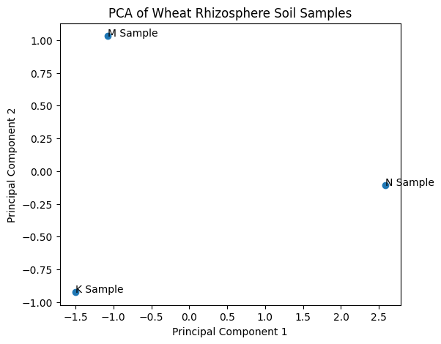
Fig. 2. The PCA plot shows the distribution and separation of M, N, and K soil samples along Principal Component 1 (PC1) and Principal Component 2 (PC2).

3.1 Isolation of Rhizobacteria
A total of 150 isolates were obtained in this study from three distinct locations within the Malwa region, and Nimar region Madhya Pradesh, India. Among these, about 20 representative isolates were characterized based on their morphological, biochemical, and plant growth-promoting traits. The highest number of isolates was obtained from M followed by N and K.
3.2 Effect of PEG 6000-induced osmotic stress on bacterial growth
PEG 6000 treatment resulted in a concentration-dependent reduction in bacterial growth in most wheat rhizobacterial isolates (figure 3). WR4 and WR9 maintained the highest OD₆₀₀ values under 15% PEG (0.77 and 0.75, respectively), while WR7 showed comparatively high tolerance with a relatively low reduction in growth. In contrast, WR11 exhibited the greatest decline in OD₆₀₀ under 15% PEG. Overall, WR4, WR7, WR8, and WR9 demonstrated comparatively higher tolerance to PEG-induced osmotic stress and were selected as promising isolates for further drought-tolerance studies.
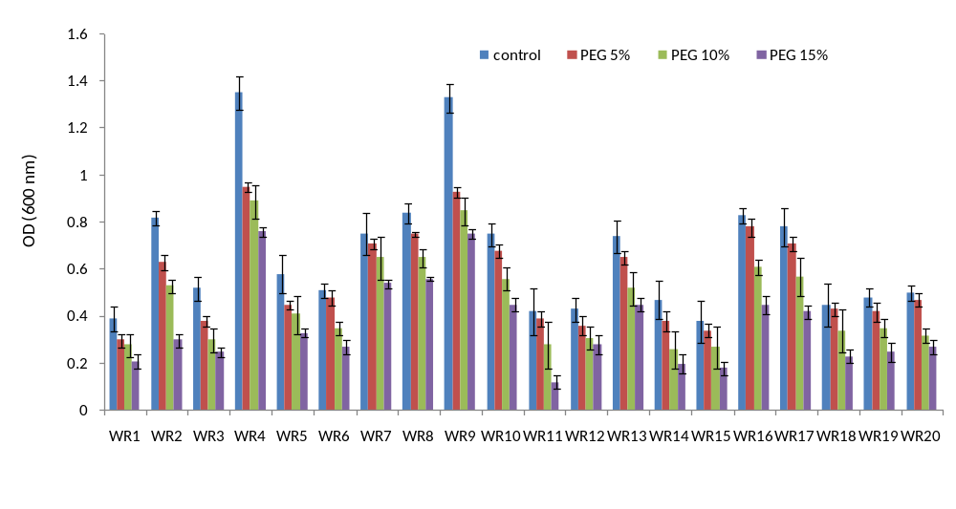
Fig. 3. Effect of PEG 6000-induced osmotic stress (0, 5, 10, and 15%) on the growth of wheat rhizobacterial isolates (WR1–WR20), measured as optical density at 600 nm (OD₆₀₀). Bars represent mean ± SD.

3.2 Morphological characterization of isolates
A total of 20 isolates were characterized on the basis of morphologically and biochemically. More than one-half of these isolates, observed mostly as Rod shaped, circular, opaque and entire margine, with a diameter of 2-6 mm after 3–5 days of incubation at 30°C. The colony and cell morphology, and growth characteristics of these 20 isolates are presented in Table 2.
Table 2 Colony morphology and microscopic characterization
Sample  Code | Size  µm | shape | Shape  of  colony | Color | margin | Opacity | Bacterium  Shape | Gram  staining
WR1 | 0.7 | Rod | Chained | Cream white | Lobate | Opaque | Small rod | Positive
WR2 | 0.2 | Rod | Wrinkled | Milky white | Undulate | Opaque | Large rod | Positive
WR3 | 0.3 | Rod | Circular | White | Undulate | Opaque | Pinpointed | Positive
WR4 | 2.0 | Rod | Circular | Cream white | Lobate | Opaque | Small rod | Positive
WR5 | 3.0 | Rod | circular | White | Lobate | Opaque | Small rod | Positive
WR6 | 0.5 | Rod | Irregular | Yellowish | Entire | Translucent | Small Rod | Negative
WR7 | 1.0 | Rod | Irregular | Red pigmented | Entir Entire | Opaque | Rod | Negative
WR8 | 1.5 | Rod | Irregular | Yellowish | Entire Entire | semi translucent | Pleomorphic | Negative
WR9 | 1.2 | Small Rod | Circular | White | Entire Entire | Opaque | pleomorphic | Negative
WR10 | 0.5 | Rod | Circular | Cream | Entire Entire | translucent | pleomorphic | Negative
WR11 | 0.9 | pleomorphic | Convex | White | Entire Entire | Opaque | Pleomorphic | Negative
WR12 | 1.2 | Pleomorphic | Circular | Yellow | Entire Entire | semi translucent | vibriod | Negative
WR13 | 1.5 | vibriod | Convex | Cream white | Entire | Opaque | spirillum | Negative
WR14 | 1.0 | spirillum | Circular | Milky white | Entire | Opaque | vibroid | Negative
WR15 | 2.1 | vibroid | Muciod | White | Entire | Opaque | spirillum | Negative
WR16 | 3.8 | spirillum | Mucoid | Pinkish | Entire | Opaque | Rod | Negative
WR17 | 0.6 | Rod | Circular | White | Entire | Opaque | Rod | Positive
WR18 | 1.0 | Rod | Circular | Cream | Entire | translucent | Rod | Positive
WR19 | 1.2 | Rod | Circular | Cream white | Entire | Opaque | Rod | Positive
WR20 | 1.2 | Rod | Circular | White | Entire | translucent | Rod | Positive

  - Biochemical Characteristics:-
20 isolates were differentiated on the basis of their biological characters table 3 represent the isolates.
Out of 20, 10 were positive for catalas, 9 oxidase, 8 indole, 9 citrate, 10 urease.

Table 3: Biochemical characteristics of bacterial isolates

Isolates | Catalase | Oxidase | Starch Test | Citrate test | Urease test
WR1 | - | - | + | - | +
WR2 | + | - | - | - | -
WR3 | + | + | - | + | +
WR4 | - | + | - | + | +
WR5 | + | - | - | - | -
WR6 | + | + | - | + | +
WR7 | - | + | - | + | +
WR8 | - | - | - | - | -
WR9 | - | - | + | - | -
WR10 | + | - | + | - | -
WR11 | + | + | - | + | +
WR12 | - | + | + | + | +
WR13 | + | - | + | - | -
WR14 | + | + | - | + | +
WR15 | - | + | - | + | +
WR16 | - | - | - | - | -
WR17 | - | - | + | - | -
WR18 | + | - | + | - | -
WR19 | - | + | - | + | +
WR20 | + | - | + | - | -

3.4 Screening of salt tolerance
To figure out how tolerant and adaptable the chosen bacterial isolate is in diverse conditions, its growth was examined at varying concentrations of salt (NaCl). The results demonstrated that isolates grew best at moderate salt concentrations, indicating that it could be used in bioremediation and industrial processes where saline conditions are common.) Stress levels up 12% of Nacl concentration. The findings demonstrated that bacteria could proliferate up to 12% NaCl (Table 4). Furthermore, it was shown that increased NaCl stress had no detrimental effects on bacterial growth. But the growth of bacteria slows down.
Table 4: Salt concentration of bacterial isolates
Isolates | Salt Concentration (In %)
 | 2% | 3% | 4% | 5% | 6% | 7% | 8% | 9% | 10% | 11% | 12%
WR1 | + | + | + | + | + | + | + | + | + | - | -
WR2 | + | + | + | + | + | + | + | + | + | - | -
WR3 | + | + | + | + | + |  | + | + | - | - | -
WR4 | + | + | + | + | + | + | + | + | + | + | +
WR5 | + | + | + | + | + | + | + | + | + | + | +
WR6 | + | + | + | + | + | + | + | + | + | - | -
WR7 | + | + | + | + | + | + | + | + | + | - | -
WR8 | + | + | + | + | + | + | + | + | + | - | -
WR9 | + | + | + | + | + | + | + | + | + | + | +
WR10 | + | + | + | + | + | + | + | + | - | - | -
WR11 | + | + | + | + | + | + | + | + | + | - | -
WR12 | + | + | + | + | - | - | - | - | - | - | -
WR13 | + | + | + | + | + | + | - | - | - | - | -
WR14 | + | + | + | + | + | + | - | - | - | - | -
WR15 | + | + | + | + | + | + | - | - | - | - | -
WR16 | + | + | + | + | + | + | - | - | - | - | -
WR17 | + | + | + | + | + | + | - | - | - | - | -
WR18 | + | + | + | + | + | + | + | + | + | - | -
WR19 | + | + | + | + | + | + | + | + | + | - | -
WR20 | + | + | + | + | + | + | + | + | + | - | -

3.4 Thermo tolerance
The Isolates were inoculated on fresh media plates after a given amount of time. In the current investigation, fresh isolates were inoculated in broth medium, which was maintained at various incubation temperatures. The majority of the isolates—though not all—are cultivated in temperatures ranging from 5 to 60 °C, demonstrating their versatility in a variety of environmental settings. 7 isolates were tolerates up 55 °C, and optimum growth was observed between 30 to 40 °C (Table 5).
Table 5: Temperature concentration of bacterial isolates
Isolates | Temperature(°C)
 | 5 | 10 | 15 | 20 | 25 | 30 | 35 | 40 | 45 | 50 | 55 | 60
WR1 | + | + | + | ++ | ++ | +++ | +++ | +++ | ++ | + | - | -
WR2 | + | + | + | ++ | ++ | ++ | ++ | +++ | ++ | + | + | -
WR3 | + | + | + | + | + | + | + | + | - | - | - | -
WR4 | + | + | + | + | ++ | ++ | ++ | + | + | + | + | -
WR5 | + | + | + | + | + | + | + | + | + | + | - | -
WR6 | + | + | + | + | + | + | + | + | + | + | + | -
WR7 | + | + | + | + | + | + | + | + | + | - | + | -
WR8 | + | + | + | + | + | + | + | + | + | + | + | -
WR9 | + | + | + | + | + | + | + | + | + | + | + | -
WR10 | + | + | + | + | + | + | + | + | + | + | + | -
WR11 | + | + | + | + | + | + | + | + | + | + | - | -
WR12 | + | + | + | + | + | + | + | + | - |  | - | -
WR13 | + | + | + | + | + | + | + | + | - |  | - | -
WR14 | + | + | + | + | + | + | + | + | - |  | - | -
WR15 | + | + | + | + | + | + | + | + | - |  | - | -
WR16 | + | + | + | + | + | + | + | + | + | - | -
WR17 | + | + | + | + | + | + | + | + | + | - | - | -
WR18 | + | + | + | + | + | + | + | + | + | - | - | -
WR19 | + | + | + | + | + | + | + | + | + | - | - | -
WR20 | + | + | + | + | + | + | + | + | + | - | - | -
* (+) growth was observed, (-) growth was not observed
  - pH tolerance:
pH tolerance of the bacterial isolates present in Table 6. Most of the isolates were tolerated up to pH 11.

Table 6: pH tolerance of the bacterial isolates
Isolates | pH tolerance
 | 555 5 | 6 | 7 | 8 | 9 | 10 | 11
WR1 WR1 | + | + | + | + | + | + | +
WR2 WR2 | + | + | + | + | + | + | +
WR3 WR3 | + | + | + | + | + | + | +
WR1 WR4 | + | + | + | + | + | + | +
WR2 WR5 | - | + | + | + | + | + | +
WR3 WR6 | + | + | + | + | + | + | -
WR1 WR7 | - | + | + | + | + | + | -
WR2 WR8 | + | + | + | + | + | + | +
WR3 WR9 | - | + | + | + | + | + | +
WR1 WR10 | + | + | + | + | + | + | +
WR2 WR11 | - | + | + | + | + | + | +
WR3 WR12 | + | + | + | + | + | + | +
WR1 WR13 | - | + | + | + | + | + | -
WR2 WR14 | + | + | + | + | + | + | -
WR3 WR15 | + | + | + | + | + | + | -
WR1 WR16 | - | + | + | + | + | + | +
WR2 WR17 | + | + | + | + | + | + | +
WR3 WR18 | + | + | + | + | + | + | +
WR2 WR19 | + | + | + | + | + | + | +
WR3 WR20 | + | + | + | + | + | + | +
* (+) growth was observed, (-) growth was not observed
3.6 Plant growth promoting traits
The plant growth promoting traits are presented in Table 7. Six were positive for Nirogen fixation, Thirteen isolates were positive for ammonia, Nine Produce IAA and eight positive for HCN, 8 solubilized phosphate and 9 solubilized potassium.
Table 7 PGPR activity of all the isolates
Isolates | Plant growth promoting traits
Isolates | 555 Nitrogen fixation | Ammonia  Production | IAA | HCN  production | Phosphate’  solubilization | Potassium  solubilization
WR1 WR1 | - | + | - | - | - | +
WR2 WR2 | - | - | + | - | + | +
WR3 WR3 | + | + | - | - | - | -
WR1 WR4 | + | + | + | + | + | +
WR2 WR5 | - | + | + | + | + | +
WR3 WR6 | + | + | + | + | + | +
WR1 WR7 | - | + | - | + | + | -
WR2 WR8 | + | + | + | + | - | +
WR3 WR9 | - | - | + | + | + | +
WR1 WR10 | + | + | + | - | + | +
WR2 WR11 | - | + | - | - | - | +
WR3 WR12 | + | + | - | + | - | -
WR1 WR13 | - | - | - | + | - | -
WR2 WR14 | - | + | - | - | - | -
WR3 WR15 | + | + | - | - | - | +
WR1 WR16 | - | + | - | + | + | -
WR2 WR17 | - | + | + | + | - | -
WR3 WR18 | - | - | - | - | - | -
WR2 WR19 | + | - | - | - | - | -
WR3 WR20 | - | - | - | - | - | -

3.7 Quantitative analysis of Phosphate solubilization
Quantitative estimation of phosphate-solubilizing activity revealed considerable variation among the selected bacterial isolates (figure 4). Quantitative phosphate solubilization varied among the selected wheat rhizobacterial isolates, ranging from 31.3 to 39.2 mg/mL. The highest phosphate-solubilizing activity was recorded for WR4 (39.2 mg/mL), followed by WR9 and WR6, whereas WR11 showed the lowest activity (31.3 mg/mL). These results indicate considerable variation in phosphate-solubilizing ability among the isolates.

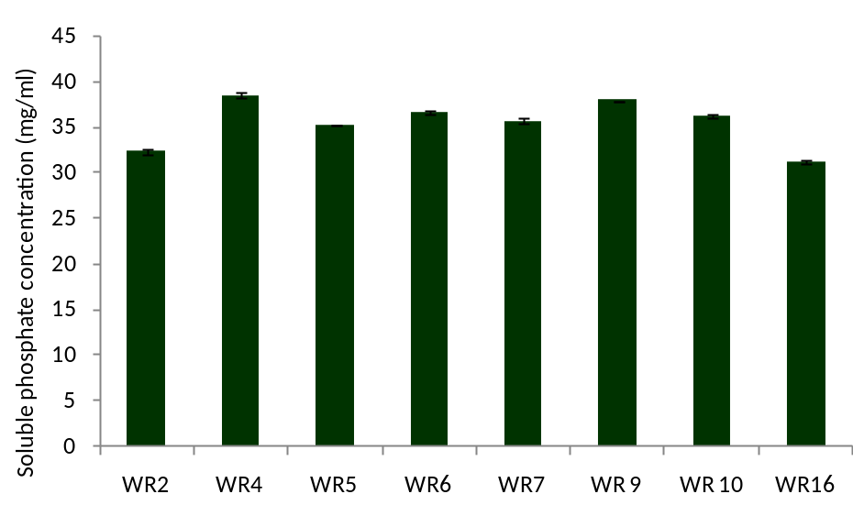
Fig. 4. Quantitative estimation of phosphate-solubilizing activity of bacterial isolates
3.8 Quantitative estimation of indole-3-acetic acid (IAA)
Quantitative estimation of indole-3-acetic acid (IAA) production by eight bacterial isolates revealed considerable variation among the isolates (Figure 5). IAA concentrations ranged from approximately 11 to 21 µg/ml, with WR4 exhibiting the highest production (≈21 µg/ml) and WR6 the lowest (≈11 µg/ml).
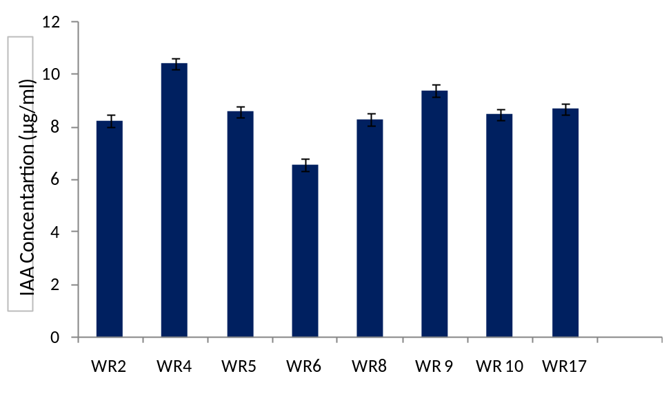
Fig. 5. Quantitative estimation of indole-3-acetic acid (IAA) activity of bacterial isolates

4. DISCUSSION
The present study demonstrated that wheat rhizosphere soils from the Malwa and Nimar regions of Madhya Pradesh harbor diverse bacterial populations with substantial tolerance to multiple abiotic stresses and several plant growth-promoting (PGP) characteristics. A total of 150 bacterial isolates were recovered, of which 20 representative isolates were selected for detailed morphological, biochemical, physiological, and PGP characterization. The variation observed among isolates indicates considerable functional diversity within the wheat rhizosphere. Such diversity is important because rhizosphere microorganisms can contribute to plant adaptation to environmental stress through multiple complementary mechanisms, including nutrient mobilization, phytohormone production, osmotic adjustment, and modulation of plant stress responses (Vurukonda et al., 2016; Glick, 2012; Etesami and Beattie, 2018). Principal component analysis demonstrated geographical variation among the rhizosphere soil samples. The Indore (Malwa) sample was clearly separated from the Maheshwar and Khargone samples along PC1, whereas the latter two showed relatively closer clustering. This pattern suggests that geographical location and associated environmental or soil characteristics may influence the composition and functional characteristics of wheat-associated bacterial communities. Similar spatial variation in rhizosphere microbial communities has been associated with differences in soil properties, climate, plant genotype, and agricultural management practices (Berendsen et al., 2012; Bulgarelli et al., 2013). However, because detailed physicochemical properties of the soils were not evaluated in the present study, the observed separation should be interpreted as an indication of spatial variation rather than a direct relationship between specific soil properties and bacterial diversity.
A major finding of the study was the ability of several isolates to tolerate elevated NaCl concentrations. Most isolates maintained growth at moderate salinity, while WR4 and WR5 were able to grow at NaCl concentrations up to 12%. Such halotolerance is particularly important for selecting bacterial inoculants intended for stress-prone agricultural environments. Salt-tolerant PGPR can potentially contribute to plant adaptation through several mechanisms, including improved nutrient acquisition, modulation of phytohormone balance, maintenance of ion homeostasis, production of exopolysaccharides, and reduction of stress-induced ethylene effects (Etesami and Beattie, 2018; Etesami and Maheshwari, 2018). Similar multifunctional behavior has been reported among halotolerant rhizobacteria associated with crops growing under saline conditions (Arora et al., 2020). Nevertheless, growth on NaCl-amended medium demonstrates bacterial salt tolerance rather than direct plant salinity tolerance; therefore, plant-based experiments are required to establish whether these isolates can improve wheat performance under saline conditions. The PEG 6000 assay revealed substantial variation in the response of the isolates to osmotic stress. Growth decreased with increasing PEG concentration in most isolates, whereas WR4 and WR9 maintained relatively high OD₆₀₀ values at 15% PEG, and WR7 also showed comparatively good tolerance. Based on their performance, WR4, WR7, WR8, and WR9 were selected as promising drought-tolerant isolates. Tolerance to PEG-induced osmotic stress indicates the ability of these bacteria to maintain growth under reduced water availability in vitro. Drought-tolerant PGPR may enhance plant performance through several mechanisms, including osmotic adjustment, exopolysaccharide production, phytohormone synthesis, improved nutrient acquisition, and modulation of plant stress responses (Vurukonda et al., 2016; Barnawal et al., 2017). However, PEG tolerance should not be considered equivalent to drought tolerance in plants, and the selected isolates require validation under soil and plant conditions.
The physiological characterization demonstrated broad environmental adaptability among the isolates. Most isolates grew over a relatively wide pH range, with several showing growth up to pH 11, while optimum growth for many isolates occurred between 30 and 40°C. Some isolates also tolerated temperatures approaching 55–60°C. Such physiological flexibility may be advantageous for bacterial survival in agricultural soils where temperature, moisture, and pH can fluctuate considerably. Stress-tolerant PGPR capable of maintaining viability under variable environmental conditions may have greater potential for persistence and establishment in the rhizosphere (Gouda et al., 2018; Arora et al., 2020). However, the ability to grow under laboratory conditions does not necessarily predict successful rhizosphere colonization, and further studies are required to evaluate bacterial survival and colonization under field-relevant conditions. The selected isolates exhibited considerable biochemical diversity, including differences in catalase, oxidase, starch hydrolysis, citrate utilization, and urease activities. Both Gram-positive and Gram-negative bacteria were represented, with rod-shaped and pleomorphic forms predominating. This phenotypic diversity indicates variation in the metabolic capabilities of the isolates. Similar phenotypic diversity has been reported among rhizosphere-associated bacterial populations, reflecting their adaptation to diverse ecological niches (Glick, 2012; Gouda et al., 2018). However, morphological and biochemical characteristics alone are insufficient for definitive taxonomic identification. Molecular approaches, particularly 16S rRNA gene sequencing and, where appropriate, genome-based characterization, should therefore be employed to establish the identity and phylogenetic relationships of the most promising isolates. An important finding was the occurrence of multiple PGP traits among the stress-tolerant isolates. In the present study, six isolates showed nitrogen-fixing potential, 13 produced ammonia, nine produced IAA, eight solubilized phosphate, and nine solubilized potassium. Several isolates expressed more than one PGP trait, indicating that the bacterial population contained potentially multifunctional PGPR. Such multifunctionality is particularly relevant under drought and salinity because nutrient availability and water uptake can be simultaneously restricted. PGPR-mediated nutrient mobilization and phytohormone production may act together to support plant growth and stress adaptation (Glick, 2012; Backer et al., 2018; Vurukonda et al., 2016). Quantitative phosphate-solubilization assays revealed considerable variation among the isolates, with values ranging from 31.3 to 39.2 mg/mL. WR4 exhibited the highest phosphate-solubilizing activity (39.2 mg/mL), followed by WR9 and WR6, whereas WR11 showed the lowest activity (31.3 mg/mL). Phosphate-solubilizing bacteria can increase the availability of poorly soluble phosphorus through mechanisms involving organic-acid production, chelation, and phosphatase activity (Rodríguez and Fraga, 1999; Alori et al., 2017). The comparatively high phosphate-solubilizing activity of WR4, together with its salt and osmotic-stress tolerance, makes this isolate an interesting candidate for further evaluation. However, phosphate solubilization in culture medium does not necessarily translate directly into increased plant phosphorus uptake or biomass under field conditions. IAA production also varied substantially among the eight tested isolates, ranging from approximately 11 to 21 µg/mL. WR4 exhibited the highest IAA production (≈21 µg/mL), whereas WR6 showed the lowest (≈11 µg/mL). Bacterial IAA production can influence root development, including lateral-root formation and root elongation, thereby potentially improving plant acquisition of water and nutrients (Spaepen and Vanderleyden, 2011; Glick, 2012). This mechanism may be particularly relevant under drought and salinity, where improved root development can contribute to stress adaptation. Previous studies have reported that IAA-producing PGPR can enhance root development and plant growth under abiotic stress conditions (Vurukonda et al., 2016; Barnawal et al., 2017). Nevertheless, the amount of IAA produced in vitro should not be directly interpreted as evidence of plant growth promotion because bacterial auxin production and plant responses depend on bacterial–plant interactions and environmental conditions.
Among the isolates, WR4 was particularly notable because it combined several desirable characteristics, including tolerance to high NaCl concentration, comparatively high tolerance to PEG-induced osmotic stress, phosphate solubilization, IAA production, nitrogen-fixing potential, ammonia production, HCN production, and potassium solubilization. This combination suggests that WR4 is a promising multifunctional PGPR candidate for further investigation. Multifunctional strains may be advantageous because plant growth promotion under abiotic stress is unlikely to depend on a single bacterial trait; rather, several mechanisms may operate simultaneously or sequentially (Gouda et al., 2018; Backer et al., 2018). Nevertheless, the present results demonstrate potential rather than confirmed plant growth-promoting efficacy. Overall, the findings indicate that wheat rhizosphere soils of the Malwa and Nimar regions contain bacterial isolates with diverse stress-tolerance and PGP characteristics. The results are particularly encouraging for isolates such as WR4, which expressed multiple beneficial traits under laboratory conditions. However, the present study represents an initial screening stage, and the observed activities should not yet be considered evidence of field-level biofertilizer efficacy. Future studies should include molecular identification of promising isolates, quantitative assessment of additional PGP mechanisms, root-colonization studies, greenhouse experiments under drought and salinity, and ultimately field trials. Such investigations will be necessary to determine whether the promising in-vitro characteristics observed in this study translate into improved wheat growth, nutrient acquisition, and productivity under stress conditions.

Conclusion
The present study demonstrated that the wheat rhizosphere soils of the Malwa and Nimar regions of Madhya Pradesh harbor diverse bacterial populations with considerable tolerance to salinity and drought-related osmotic stress. Among the 150 isolates obtained, 20 representative isolates exhibited variable responses to NaCl, PEG-induced osmotic stress, temperature, and pH, indicating substantial physiological diversity. Notably, WR4, WR5 and WR9 tolerated NaCl concentrations up to 12%, while WR4, WR7, WR8, and WR9 showed comparatively better tolerance to PEG-induced osmotic stress. The isolates also exhibited several plant growth-promoting traits, including nitrogen-fixing potential, ammonia, IAA, phosphate-solubilizing, potassium-solubilizing, and HCN-producing activities. WR4 was particularly promising, showing strong tolerance to both salinity and osmotic stress along with comparatively high phosphate-solubilizing activity and IAA production. These findings suggest that the selected isolates may have potential as multifunctional plant growth-promoting bacteria for supporting wheat growth under abiotic stress conditions.
However, the present findings are based primarily on in vitro screening. Therefore, molecular identification, quantitative characterization of functional traits, assessment of root colonization, and greenhouse and field experiments under drought and salinity stress are required to confirm their effectiveness and suitability as microbial inoculants. Overall, the study provides a useful preliminary basis for selecting stress-tolerant and plant growth-promoting bacterial candidates for further investigation in sustainable wheat production.

Declaration of AI Use

This manuscript was prepared through the intellectual contributions of the author(s) to the study design, data analysis, interpretation of results, and scholarly content. Grammarly and ChatGPT were used solely to assist with grammatical refinement and reference formatting during manuscript revision. The author(s) accept full responsibility for the accuracy, integrity, and final content of the manuscript.
COMPETING INTERESTS
Authors have declared that no competing interests exist.

References
Agunbiade, V. F., Fadiji, A. E., Agbodjato, N. A., & Babalola, O. O. (2024). Isolation and characterization of plant-growth-promoting, drought-tolerant rhizobacteria for improved maize productivity. Plants, 13, 1298. https://doi.org/10.3390/plants13101298
Alori, E. T., Glick, B. R., & Babalola, O. O. (2017). Microbial phosphorus solubilization and its potential for use in sustainable agriculture. Frontiers in Microbiology, 8, 971.
Arora, N. K., Fatima, T., Mishra, J., Mishra, I., Verma, S., Verma, R., & Verma, M. (2020). Halo-tolerant plant growth-promoting rhizobacteria for improving crop productivity under saline conditions. Plant and Soil, 447, 1–22.
Backer, R., Rokem, J. S., Ilangumaran, G., Lamont, J., Praslickova, D., Ricci, E., Subramanian, S., & Smith, D. L. (2018). Plant growth-promoting rhizobacteria: Context, mechanisms of action, and roadmap to commercialization of biostimulants for sustainable agriculture. Frontiers in Plant Science, 9, 1473. https://doi.org/10.3389/fpls.2018.01473
Barnawal, D., Bharti, N., Pandey, S. S., Pandey, A., Chanotiya, C. S., & Kalra, A. (2017). Plant growth-promoting rhizobacteria enhance wheat salt and drought stress tolerance by altering endogenous phytohormone levels and TaCTR1/TaDREB2 expression. Physiologia Plantarum, 161(4), 502–514. https://doi.org/10.1111/ppl.12614
Berendsen, R. L., Pieterse, C. M. J., & Bakker, P. A. H. M. (2012). The rhizosphere microbiome and plant health. Trends in Plant Science, 17(8), 478–486.
Bulgarelli, D., Schlaeppi, K., Spaepen, S., van Themaat, E. V. L., & Schulze-Lefert, P. (2013). Structure and functions of the bacterial microbiota of plants. Annual Review of Plant Biology, 64, 807–838.
El-Saadony, M. T., Saad, A. M., Mohammed, D. M., Fahmy, A. M., Elesawi, I. E., Ahmed, A. E., Algopishi, U. B., Elrys, A. S., Desoky, E. M., Mosa, W. F. A., El-Mageed, T. A. A., Alhashmi, F. I., Mathew, B. T., AbuQamar, S. F., & El-Tarabily, K. A. (2024). Drought-tolerant plant growth-promoting rhizobacteria alleviate drought stress and enhance soil health for sustainable agriculture: A comprehensive review. Plant Stress, 14, 100632. https://doi.org/10.1016/j.stress.2024.100632
Etesami, H., & Beattie, G. A. (2018). Mining halophytes for plant growth-promoting halotolerant bacteria to enhance the salinity tolerance of non-halophytic crops. Frontiers in Microbiology, 9, 148. https://doi.org/10.3389/fmicb.2018.00148
Etesami, H., & Maheshwari, D. K. (2018). Use of plant growth-promoting rhizobacteria (PGPRs) with multiple plant-growth-promoting traits in stress agriculture. Environmental Science and Pollution Research, 25, 13093–13105.
Glick, B. R. (2012). Plant growth-promoting bacteria: Mechanisms and applications. Scientifica, 2012, 963401. https://doi.org/10.6064/2012/963401
Gordon, S. A., & Weber, R. P. (1951). Colorimetric estimation of indoleacetic acid. Plant Physiology, 26(1), 192–195.
Gouda, S., Kerry, R. G., Das, G., Paramithiotis, S., Shin, H. S., & Patra, J. K. (2018). Revitalization of plant growth-promoting rhizobacteria for sustainable development in agriculture. Microbiological Research, 206, 131–140.
Hu, X., Chen, J., & Guo, J. (2006). Two phosphate- and potassium-solubilizing bacteria isolated from Tianmu Mountain, Zhejiang, China. World Journal of Microbiology and Biotechnology, 22, 983–990.
Khoury, C. K., Castaneda-Alvarez, N. P., Achicanoy, H. A., Sosa, C. C., Bernau, V., Kassa, M. T., Norton, S. L., Maesen, L., Upadhyaya, H. D., Ramirez-Villegas, J., Jarvis, A., & Struik, P. C. (2015). Crop wild relatives of pigeonpea (Cajanus cajan (L.) Millsp.): Distributions, ex situ conservation status, and potential genetic resources for abiotic stress tolerance. Biological Conservation, 184, 259–270. https://doi.org/10.1016/j.biocon.2015.01.032
Kumar, R., Swapnil, P., Meena, M., Selpair, S., & Yadav, B. G. (2022). Plant growth-promoting rhizobacteria (PGPR): Approaches to alleviate abiotic stresses for enhancement of growth and development of medicinal plants. Sustainability, 14, 15514. https://doi.org/10.3390/su142315514
Lorck, H. (1948). Production of hydrocyanic acid by bacteria. Physiologia Plantarum, 1, 142–146.
Malviya, M. K., Pandey, A., Sharma, A., & Tiwari, S. C. (2012). Characterization and identification of actinomycetes isolated from “fired plots” under shifting cultivation in northeast Himalaya, India. Annals of Microbiology. https://doi.org/10.1007/s13213-012-0504-x
Paul, D., & Nair, S. (2008). Stress adaptations in a plant growth-promoting rhizobacterium isolated from a Pongamia pinnata rhizosphere. Applied and Environmental Microbiology, 74(20), 7094–7100.
Pikovskaya, R. I. (1948). Mobilization of phosphorus in soil in connection with the vital activity of some microbial species. Mikrobiologiya, 17, 362–370.
Rodríguez, H., & Fraga, R. (1999). Phosphate solubilizing bacteria and their role in plant growth promotion. Biotechnology Advances, 17(4–5), 319–339.
Spaepen, S., & Vanderleyden, J. (2011). Auxin and plant-microbe interactions. Cold Spring Harbor Perspectives in Biology, 3(4), a001438.
Sunita, K., Mishra, I., Mishra, J., Prakash, J., & Arora, N. K. (2020). Secondary metabolites from halotolerant plant growth-promoting rhizobacteria for ameliorating salinity stress in plants. Frontiers in Microbiology, 11, 567768. https://doi.org/10.3389/fmicb.2020.567768
Vurukonda, S. S. K. P., Vardharajula, S., Shrivastava, M., & SkZ, A. (2016). Enhancement of drought stress tolerance in crops by plant growth-promoting rhizobacteria. Microbiological Research, 184, 13–24. https://doi.org/10.1016/j.micres.2015.12.003
Yadav, V. K., Yadav, R. C., Choudhary, P., Sharma, S. K., & Bhagat, N. (2022). Mitigation of drought stress in wheat (Triticum aestivum L.) by inoculation of drought tolerant Bacillus paramycoides DT-85 and Bacillus paranthracis DT-97. Journal of Applied Biology & Biotechnology, 10(1), 59–69. https://doi.org/10.7324/JABB.2022.10s109
Yang, J., Kloepper, J. W., & Ryu, C.-M. (2009). Rhizosphere bacteria help plants tolerate abiotic stress. Trends in Plant Science, 14(1), 1–4.

