Original Research Article
Phenotypic Detection of Multidrug-Resistant Klebsiella Species Isolated from Clinical Samples at LAUTECH Teaching Hospital, Ogbomoso, Southwest Nigeria

Abstract
Background: Klebsiella species are opportunistic Gram-negative pathogens and an important cause of nosocomial infections, and multidrug-resistant (MDR) strains are an increasing global public health concern. This study determined the prevalence and phenotypic antibiotic susceptibility profile of Klebsiella species isolated from clinical samples at Ladoke Akintola University of Technology (LAUTECH) Teaching Hospital, Ogbomoso, Nigeria.
Methods: In this cross-sectional study conducted between January and March 2022, 65 Klebsiella isolates recovered from clinical specimens (urine, wound swab, sputum, eye swab, bone biopsy, and ear swab) were identified using standard cultural, morphological, and biochemical methods. Antibiotic susceptibility to 14 antibiotics across eight classes was determined by the Kirby-Bauer disc diffusion method per CLSI guidelines. Isolates resistant to at least one agent in three or more antimicrobial categories were classified as multidrug-resistant (MDR). Data were analysed using SPSS version 19.0, with chi-square tests used to assess associations between categorical variables (α = 0.05).
Results: Klebsiella pneumoniae was the most frequently isolated species (23/65, 35.4%), followed by K. oxytoca (33.8%), K. aerogenes (23.1%), K. rhinoscleromatis (4.6%), and K. ozaenae (3.1%). Isolates showed the highest resistance to ampicillin (72.3%) and amoxicillin (43.1%), and the highest susceptibility to imipenem (83.1%) and gentamicin (64.6%). Overall, 13 of 65 isolates (20.0%) met the criteria for multidrug resistance. No statistically significant association was found between species distribution or MDR prevalence and patient age, gender, or specimen type (p > 0.05 for all comparisons).
Conclusion: One in five Klebsiella isolates was multidrug-resistant, with the highest resistance directed against penicillins and cephalosporins. Carbapenems and aminoglycosides remained the most reliably active agents. Routine phenotypic susceptibility surveillance, antibiotic stewardship, and confirmatory molecular characterisation of resistance determinants are recommended.
Keywords: Klebsiella species; multidrug resistance; antibiotic susceptibility; nosocomial infection; Nigeria

1. Introduction
The genus Klebsiella, a member of the family Enterobacteriaceae (order Enterobacterales), comprises Gram-negative, non-motile, encapsulated, lactose-fermenting, facultatively anaerobic bacilli (Dong et al., 2022). The most clinically important members are K. pneumoniae, together with its subspecies K. pneumoniae, K. ozaenae, and K. rhinoscleromatis, and the K. oxytoca complex (Dong et al., 2022; Yang et al., 2022), organisms that colonise the human gastrointestinal tract as commensals but act as opportunistic pathogens in susceptible hosts (Podschun and Ullmann, 1998). Klebsiella species are a leading cause of healthcare-associated pneumonia, urinary tract infection, bloodstream infection, wound and surgical-site infection, and meningitis, particularly among patients requiring invasive devices and those receiving prolonged antimicrobial therapy (Dong et al., 2022; Miller and Arias, 2024). Hypervirulent K. pneumoniae clones, once considered largely antibiotic-susceptible, have increasingly converged with multidrug-resistant lineages, giving rise to strains that combine high pathogenicity with extensive antimicrobial resistance (Arcari and Carattoli, 2023).
Antimicrobial resistance within the Enterobacterales, including Klebsiella, has risen markedly over the past two decades, driven by the acquisition of extended-spectrum β-lactamases (ESBLs), AmpC enzymes, and carbapenemases, together with efflux-pump-mediated and mutational resistance mechanisms (Simner et al., 2024). The resulting reduction in effective therapeutic options is associated with higher treatment costs, longer hospital stays, and increased mortality; globally, bacterial antimicrobial resistance was associated with an estimated 4.95 million deaths in 2019, of which 1.27 million were directly attributable to resistance (Murray et al., 2022). Multidrug-resistant (MDR) Klebsiella pneumoniae, together with Enterococcus faecium, Staphylococcus aureus, Acinetobacter baumannii, Pseudomonas aeruginosa, and Enterobacter species, constitutes the clinically important "ESKAPE" group of pathogens that effectively evade the action of most available antibacterial agents (Miller and Arias, 2024; Ashurst and Dawson, 2021). Reflecting the severity of this threat, carbapenem-resistant K. pneumoniae was ranked among the very highest-priority pathogens in the World Health Organization's most recent Bacterial Priority Pathogens List, on the basis of its mortality burden, transmissibility, and the limited antibacterial pipeline currently available to treat it (Sati et al., 2025).
Reliable local data on the prevalence and antibiotic susceptibility profile of Klebsiella species are essential for guiding empirical therapy and infection-control practice, particularly in resource-limited settings where such surveillance is often sparse. This study was therefore designed to phenotypically detect and characterise the antibiotic susceptibility profile of multidrug-resistant Klebsiella species isolated from clinical samples, with the specific objectives of (i) isolating and identifying Klebsiella species from clinical samples, (ii) determining their susceptibility profile against a panel of routinely used antibiotics, and (iii) establishing the prevalence of multidrug resistance among the isolates.

2. Materials and Methods

2.1 Study design, area, and duration
This was a hospital-based, cross-sectional study conducted over three months (January to March 2022) in the Department of Medical Microbiology and Parasitology, Ladoke Akintola University of Technology (LAUTECH) Teaching Hospital, Ogbomoso North Local Government Area, Oyo State, Nigeria (approximately 8°09′N, 4°15′E). Ethical approval was obtained from the Ethical Review Committee of LAUTECH Teaching Hospital.

2.2 Specimen collection and bacterial identification
Sixty-five Gram-negative clinical isolates were recovered from routine diagnostic specimens (urine, wound swabs, sputum, eye swabs, bone biopsy, and ear swabs) submitted to the laboratory. All isolates were sub-cultured on MacConkey agar, a selective and differential medium that inhibits Gram-positive organisms via crystal violet and bile salts and detects lactose fermentation via the neutral red indicator (Jung and Hoilat, 2024), and incubated aerobically at 37°C for 18-24 hours. Presumptive Klebsiella colonies (mucoid, lactose-fermenting) were confirmed to species level using standard morphological, Gram-staining, and biochemical criteria (Cheesbrough, 2005), comprising citrate utilisation, urease, catalase, indole, carbohydrate fermentation, methyl red, and Voges-Proskauer tests (Cheesbrough, 2005; Kolhatkar et al., 2008).

2.3 Antibiotic susceptibility testing
Antibiotic susceptibility was determined by the Kirby-Bauer disc diffusion method. A bacterial suspension adjusted to 0.5 McFarland turbidity standard (approximately 1 × 10⁷-1 × 10⁸ CFU/mL) was used to inoculate Mueller-Hinton agar to confluence. Antibiotic-impregnated discs were applied and plates incubated at 37°C for 16-18 hours, after which zones of inhibition were measured and interpreted as sensitive, intermediate, or resistant according to Clinical and Laboratory Standards Institute breakpoints (CLSI, 2022). Fourteen antibiotics spanning eight classes were tested: penicillins/β-lactamase-inhibitor combinations (Augmentin, ampicillin, amoxicillin), aminoglycosides (amikacin, gentamicin), a macrolide (azithromycin), cephalosporins (cefotaxime, ceftazidime), a phenicol (chloramphenicol), a nitrofuran (nitrofurantoin), fluoroquinolones (nalidixic acid, ciprofloxacin), and carbapenems (imipenem, meropenem). Laboratory detection and confirmation of carbapenemase production, an important underlying mechanism of carbapenem resistance in Enterobacterales, follows standardised phenotypic and molecular workflows (Simner et al., 2024), although such confirmatory testing was outside the scope of the present phenotypic susceptibility survey. Isolates showing resistance to at least one agent in three or more of the antimicrobial categories tested were classified as multidrug-resistant (MDR), following the standard consensus definition of Magiorakos et al. (2012).

2.4 Statistical analysis
Data were entered into Microsoft Excel and analysed using IBM SPSS Statistics version 19.0. Categorical variables were summarised as frequencies and percentages, and age was additionally summarised as mean ± standard deviation. The Pearson chi-square test was used to test for association between Klebsiella species distribution or MDR status and demographic/specimen variables, with statistical significance set at p < 0.05. Where more than 20% of cells in a contingency table had an expected count below 5 (as occurred for several specimen-type comparisons, given single observations in some categories), Fisher's exact test was applied.

3. Results

3.1 Demographic and specimen characteristics
A total of 65 Klebsiella isolates from 65 subjects were analysed (Table 1). The mean age of subjects was 43.5 ± 21.5 years; the largest age group was 21-40 years (33.8%), followed by 41-60 years (26.2%), 61-80 years (24.6%), and 1-20 years (15.4%). Slightly more isolates came from female (53.8%) than male (46.2%) subjects. Urine was the most common specimen type (38.5%), followed by wound swab (30.8%) and sputum (26.2%); eye swab, bone biopsy, and ear swab each contributed one isolate (1.5% each).
Table 1. Demographic and specimen characteristics of subjects
Variable | Category | n | % | Mean ± SD
Age (years) | 1-20 | 10 | 15.4 | 43.5 ± 21.5
 | 21-40 | 22 | 33.8
 | 41-60 | 17 | 26.2
 | 61-80 | 16 | 24.6
Gender | Male | 30 | 46.2
 | Female | 35 | 53.8
Specimen type | Urine | 25 | 38.5
 | Wound swab | 20 | 30.8
 | Sputum | 17 | 26.2
 | Eye swab | 1 | 1.5
 | Bone biopsy | 1 | 1.5
 | Ear swab | 1 | 1.5

3.2 Distribution of Klebsiella species
Klebsiella pneumoniae was the most prevalent species (35.4%), followed by K. oxytoca (33.8%), K. aerogenes (23.1%), K. rhinoscleromatis (4.6%), and K. ozaenae (3.1%) (Table 2).

Table 2. Prevalence of Klebsiella species isolated (N = 65)
Species | n | %
K. pneumoniae | 23 | 35.4
K. oxytoca | 22 | 33.8
K. aerogenes | 15 | 23.1
K. rhinoscleromatis | 3 | 4.6
K. ozaenae | 2 | 3.1
Total | 65 | 100.0

3.3 Species distribution by demographic and specimen variables
Species distribution did not differ significantly by age group (χ² = 14.567, df = 12, p = 0.266), gender (χ² = 2.925, df = 4, p = 0.571), or specimen type (χ² = 27.910, df = 20, p = 0.112) (Table 3; Figures 1-3). K. aerogenes and K. oxytoca were most frequent among subjects aged 21-40 years; K. pneumoniae was most frequent among those aged 41-60 years. K. pneumoniae, K. oxytoca, and K. rhinoscleromatis were more frequent among female subjects, while K. aerogenes was more frequent among males. By specimen type, K. oxytoca was predominantly recovered from urine, whereas K. aerogenes and K. pneumoniae were most frequently recovered from sputum.
Table 3. Distribution of Klebsiella species by patient age group
Species | 1-20y n(%) | 21-40y n(%) | 41-60y n(%) | 61-80y n(%) | Total n(%)
K. aerogenes | 1 (1.5) | 8 (12.3) | 3 (4.6) | 3 (4.6) | 15 (23.1)
K. ozaenae | 0 (0.0) | 2 (3.1) | 0 (0.0) | 0 (0.0) | 2 (3.1)
K. pneumoniae | 4 (6.2) | 4 (6.2) | 8 (12.3) | 7 (10.8) | 23 (35.4)
K. oxytoca | 4 (6.2) | 8 (12.3) | 4 (6.2) | 6 (9.2) | 22 (33.8)
K. rhinoscleromatis | 1 (1.5) | 0 (0.0) | 2 (3.1) | 0 (0.0) | 3 (4.6)
Total | 10 (15.4) | 22 (33.8) | 17 (26.2) | 16 (24.6) | 65 (100.0)
χ² = 14.567, df = 12, p = 0.266 (not significant).
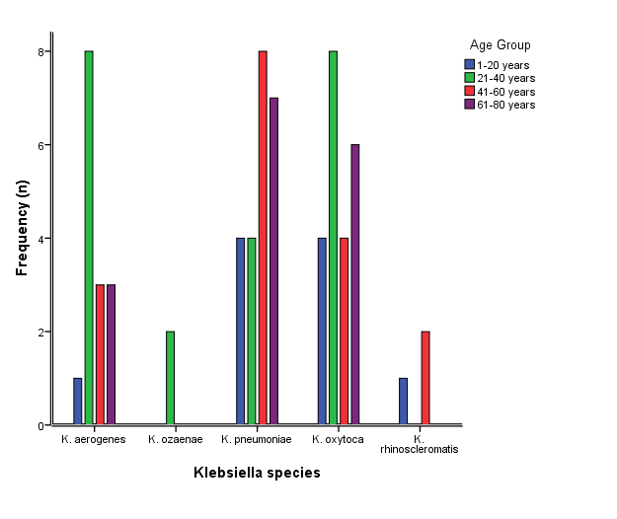
Figure 1. Distribution of Klebsiella species by patient age group.
Table 4. Distribution of Klebsiella species by patient gender
Species | Male n(%) | Female n(%) | n(%)
K. aerogenes | 8 (12.3) | 7 (10.8) | 15 (23.1)
K. ozaenae | 1 (1.5) | 1 (1.5) | 2 (3.1)
K. pneumoniae | 11 (16.9) | 12 (18.5) | 23 (35.4)
K. oxytoca | 10 (15.4) | 12 (18.5) | 22 (33.8)
K. rhinoscleromatis | 0 (0.0) | 3 (4.6) | 3 (4.6)
χ² = 2.925, df = 4, p = 0.571 (not significant).
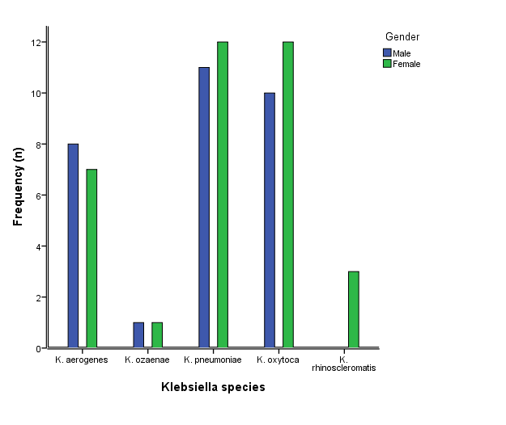
Figure 2. Distribution of Klebsiella species by patient gender.
Table 5. Distribution of Klebsiella species by specimen type
Species | Urine | Wound | Sputum | Eye | Bone | Ear
K. aerogenes | 2 | 5 | 7 | 0 | 0 | 1
K. ozaenae | 1 | 0 | 1 | 0 | 0 | 0
K. pneumoniae | 6 | 5 | 10 | 1 | 1 | 0
K. oxytoca | 16 | 3 | 3 | 0 | 0 | 0
K. rhinoscleromatis | 0 | 1 | 2 | 0 | 0 | 0
χ² = 27.910, df = 20, p = 0.112 (not significant).
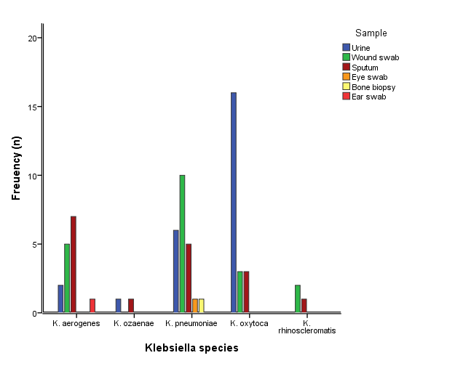
Figure 3. Distribution of Klebsiella species by specimen type.

3.4 Antibiotic susceptibility profile
Isolates showed the highest resistance to ampicillin (72.3%), amoxicillin (43.1%), and ceftazidime (40.0%), and the lowest resistance (i.e., highest susceptibility) to imipenem (83.1% sensitive), meropenem (61.5% sensitive), and gentamicin (64.6% sensitive) (Table 6). Species-specific profiles (Figure 4A-C) showed that K. aerogenes, K. pneumoniae, and K. oxytoca were each most resistant to penicillins and cephalosporins, and most susceptible to carbapenems, aminoglycosides, and macrolides.

Table 6. Antibiotic susceptibility profile of Klebsiella isolates
Class | Antibiotic | Sensitive n(%) | Intermediate n(%) | Resistant n(%)
Penicillins/BLI | Augmentin | 37 (56.9) | 6 (9.2) | 22 (33.8)
 | Ampicillin | 10 (15.4) | 8 (12.3) | 47 (72.3)
 | Amoxicillin | 29 (44.6) | 8 (12.3) | 28 (43.1)
Aminoglycosides | Amikacin | 35 (53.8) | 14 (21.5) | 16 (24.6)
 | Gentamicin | 42 (64.6) | 6 (9.2) | 17 (26.2)
Macrolide | Azithromycin | 42 (64.6) | 16 (24.6) | 7 (10.8)
Cephalosporins | Cefotaxime | 31 (47.7) | 11 (16.9) | 23 (35.4)
 | Ceftazidime | 22 (33.8) | 17 (26.2) | 26 (40.0)
Phenicol | Chloramphenicol | 37 (56.9) | 15 (23.1) | 13 (20.0)
Nitrofuran | Nitrofurantoin | 29 (44.6) | 13 (20.0) | 23 (35.4)
Fluoroquinolones | Nalidixic acid | 29 (44.6) | 18 (27.7) | 18 (27.7)
 | Ciprofloxacin | 32 (49.2) | 15 (23.1) | 18 (27.7)
Carbapenems | Imipenem | 54 (83.1) | 3 (4.6) | 8 (12.3)
 | Meropenem | 40 (61.5) | 10 (15.4) | 15 (23.1)
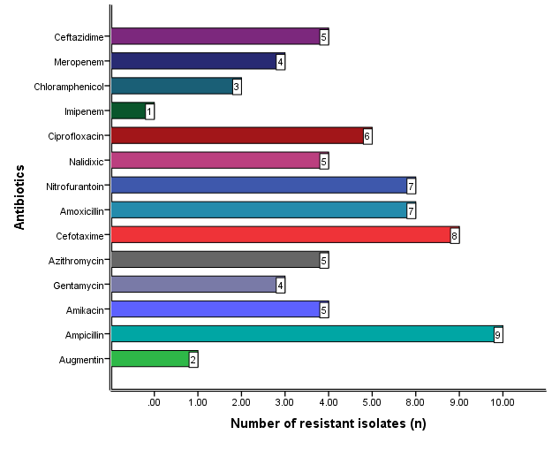
Figure 4A. Number of resistant isolates by antibiotic — K. aerogenes.
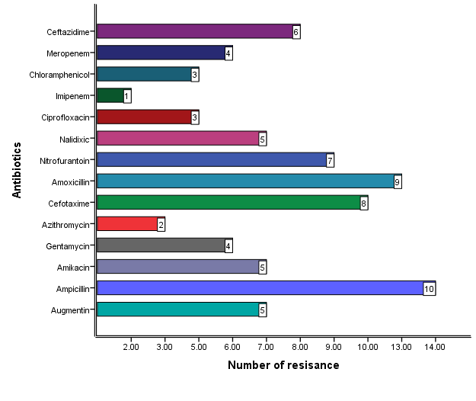
Figure 4B. Number of resistant isolates by antibiotic — K. pneumoniae.
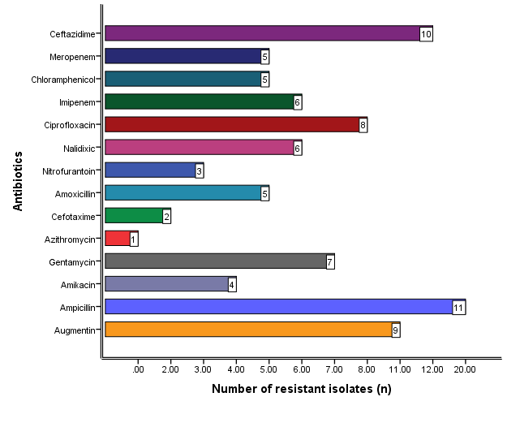
Figure 4C. Number of resistant isolates by antibiotic — K. oxytoca.

3.5 Prevalence and distribution of multidrug resistance
Thirteen of the 65 isolates (20.0%) met criteria for multidrug resistance (Table 7; Figure 5). MDR was not significantly associated with species (χ² = 2.756, df = 4, p = 0.599; Table 8, Figure 6), specimen type (χ² = 7.180, df = 5, p = 0.208; Table 9), age group (χ² = 4.340, df = 3, p = 0.227), or gender (χ² = 0.387, df = 1, p = 0.534) (Table 10).
Table 7. Overall prevalence of multidrug resistance (MDR)
Phenotype | n | %
MDR | 13 | 20.0
Non-MDR | 52 | 80.0
Total | 65 | 100.0
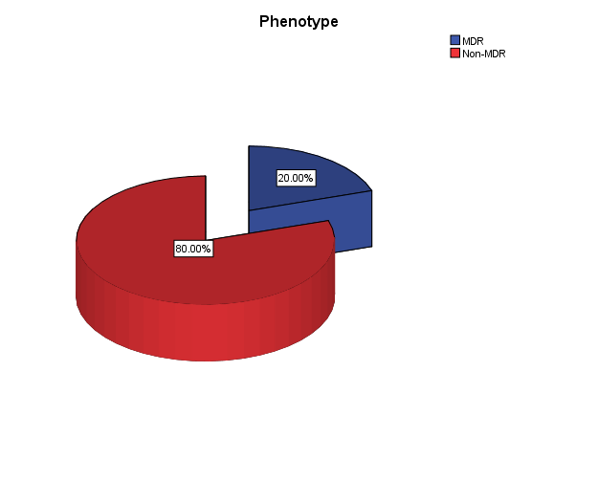
Figure 5. Overall prevalence of multidrug-resistant (MDR) Klebsiella isolates.
Table 8. Distribution of MDR status by Klebsiella species
Species | MDR n(%) | Non-MDR n(%)
K. aerogenes | 4 (6.2) | 11 (16.9)
K. ozaenae | 0 (0.0) | 2 (3.1)
K. pneumoniae | 6 (9.2) | 17 (26.2)
K. oxytoca | 3 (4.6) | 19 (29.2)
K. rhinoscleromatis | 0 (0.0) | 3 (4.6)
χ² = 2.756, df = 4, p = 0.599 (not significant).
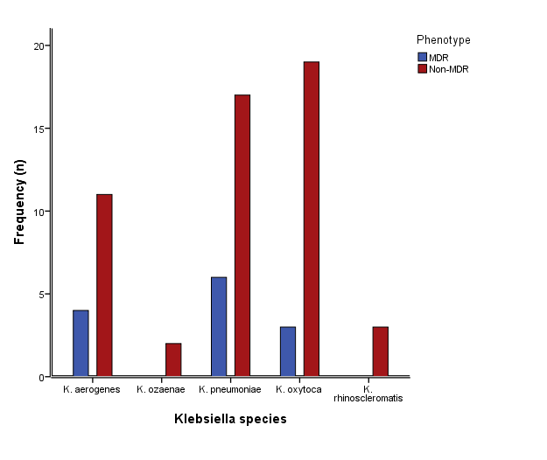
Figure 6. Distribution of MDR and non-MDR isolates by Klebsiella species.
Table 9. Distribution of MDR status by specimen type
Specimen | MDR n(%) | Non-MDR n(%)
Urine | 6 (9.2) | 19 (29.2)
Wound swab | 5 (7.7) | 15 (23.1)
Sputum | 1 (1.5) | 16 (24.6)
Eye swab | 1 (1.5) | 0 (0.0)
Bone biopsy | 0 (0.0) | 1 (1.5)
Ear swab | 0 (0.0) | 1 (1.5)
χ² = 7.180, df = 5, p = 0.208 (not significant). Several cells have expected counts below 5;
Table 10. Distribution of MDR status by age group and gender
Variable | Category | MDR n(%) | Non-MDR n(%) | Total
Age (years) | 1-20 | 2 (3.1) | 8 (12.3) | 10
 | 21-40 | 3 (4.6) | 19 (29.2) | 22
 | 41-60 | 2 (3.1) | 15 (23.1) | 17
 | 61-80 | 6 (9.2) | 10 (15.4) | 16
Gender | Male | 5 (7.7) | 25 (38.5) | 30
 | Female | 8 (12.3) | 27 (41.5) | 35
Age: χ² = 4.340, df = 3, p = 0.227. Gender: χ² = 0.387, df = 1, p = 0.534 (neither significant).

4. Discussion
Antimicrobial resistance is now recognised as one of the most pressing threats to global health security: bacterial antimicrobial resistance was associated with an estimated 4.95 million deaths in 2019, of which 1.27 million deaths were directly attributable to resistant infections (Murray et al., 2022). Klebsiella pneumoniae sits at the centre of this threat: as a core member of the ESKAPE group of pathogens, Enterococcus faecium, Staphylococcus aureus, Klebsiella pneumoniae, Acinetobacter baumannii, Pseudomonas aeruginosa, and Enterobacter species, it is defined precisely by its capacity to "escape" the action of antimicrobial agents through the accumulation of diverse resistance determinants (Miller and Arias, 2024). Its clinical importance is compounded by its versatility as both a gastrointestinal commensal and an opportunistic pathogen capable of causing pneumonia, urinary tract infection, bacteraemia, wound and surgical-site infection, and meningitis in hospitalised and immunocompromised patients (Dong et al., 2022). The findings of the present study, drawn from a tertiary hospital in southwestern Nigeria, contribute region-specific evidence of the kind needed to track this evolving threat and to inform empirical prescribing at the point of care.
Klebsiella pneumoniae was the predominant species recovered in this study, accounting for just over one-third of all isolates, followed closely by K. oxytoca and, at a lower frequency, K. aerogenes. This ranking mirrors the pattern reported across most clinical surveillance studies, in which K. pneumoniae and the K. oxytoca complex together account for the majority of clinically significant Klebsiella isolates, while the K. pneumoniae subspecies ozaenae and rhinoscleromatis are encountered comparatively rarely and are more typically associated with chronic granulomatous infection of the respiratory tract than with acute nosocomial disease (Dong et al., 2022). The prevalence of K. pneumoniae recorded here (35.4%) is broadly consistent with recent Nigerian hospital-based data, Akinyemi et al., (2021) identified K. pneumoniae in 34% of patients with suspected Gram-negative infection across four public hospitals in Lagos, and a more recent Lagos-based survey likewise reported Klebsiella species among the predominant Gram-negative organisms recovered from hospitalised patients (Abegunrin et al., 2026), whereas Ahmed Hasan et al. (2021) reported a considerably lower prevalence (7.6%) among clinical isolates in Kirkuk, Iraq. A systematic review and meta-analysis of extended-spectrum β-lactamase-producing K. pneumoniae across Nigeria similarly documents substantial variation in reported prevalence between states and institutions (Ezeh et al., 2024), underscoring the value of institution-level surveillance of the kind reported here. Such cross-study variability is unsurprising: prevalence estimates for a genus as ecologically versatile as Klebsiella are shaped by an interacting set of local variables, including the case-mix and severity of the patient population sampled, the dominant specimen types submitted for culture, and prevailing infection-control and prescribing practices, since members of the K. oxytoca complex in particular are also readily recovered from soil, water, and aquatic animals as well as from clinical specimens (Sun et al., 2024; Yang et al., 2022).
Species distribution did not differ significantly by patient age, gender, or specimen type in this cohort, indicating that Klebsiella acquisition was not confined to a particular demographic subgroup at the population level studied. Several descriptive patterns are nonetheless consistent with the wider literature. K. pneumoniae and K. oxytoca were more frequently isolated from female patients, in keeping with the female predominance previously reported by Ahmed Hasan et al. (2021), most plausibly reflecting the higher burden of urinary sampling among female patients rather than a true sex-linked susceptibility. K. oxytoca showed a strong association with urinary specimens, consistent with its established role as a common uropathogen, while K. aerogenes and K. pneumoniae were recovered predominantly from sputum, reflecting their prominence as agents of hospital- and community-acquired respiratory tract infection (Lam et al., 2021). The broad spread of isolates across the 21-60-year age range, rather than any single peak, is consistent with Klebsiella's role as an opportunistic pathogen that exploits a wide spectrum of underlying vulnerability, from surgical wounds and indwelling devices to chronic respiratory and urinary tract disease, rather than depending on a single age-defined risk factor.
The antibiotic susceptibility data generated in this study paint a coherent and clinically important picture. Resistance was concentrated overwhelmingly against the older, narrower-spectrum penicillins and, to a lesser extent, the cephalosporins. Meanwhile the carbapenems, aminoglycosides, and macrolides retained substantially higher activity. Ampicillin resistance exceeded 70%, and resistance to amoxicillin and ceftazidime each exceeded 40%, a pattern readily explained by the near-ubiquitous carriage of β-lactamases among clinical Klebsiella populations; unlike most other Enterobacterales, Klebsiella species possess an intrinsic chromosomal β-lactamase that confers innate resistance to ampicillin and amoxicillin, and this baseline resistance is readily amplified by the acquisition of extended-spectrum β-lactamases and AmpC-type enzymes that additionally compromise later-generation cephalosporins (Dong et al., 2022). Biofilm formation represents a further, non-enzymatic mechanism through which Klebsiella isolates evade antibiotic action and host clearance, and is increasingly recognised as a contributor to persistent, recurrent, and device-associated infection (Li et al., 2024). By contrast, the high susceptibility to imipenem (83.1%) and meropenem (61.5%) confirms that carbapenems remain the most dependable therapeutic option against Klebsiella infection in this setting, consistent with their continued status as agents of last resort for serious Gram-negative sepsis; the non-trivial minority of isolates already showing intermediate or resistant carbapenem phenotypes, however, is a signal that warrants close monitoring and systematic carbapenemase testing, given the well-documented capacity of carbapenemase-producing Klebsiella to disseminate rapidly once established within a healthcare facility (Simner et al., 2024). This overall pattern, preserved carbapenem and aminoglycoside activity alongside eroding penicillin and cephalosporin efficacy, mirrors the profile reported in other recent Nigerian and sub-Saharan African studies, including Akinyemi et al., (2021) in Lagos and Awoke et al., (2021) in Addis Ababa, and lends regional support to the view that carbapenem- and aminoglycoside-based regimens, used judiciously, remain rational empirical choices for confirmed or strongly suspected Klebsiella infection pending susceptibility results, whereas ampicillin- or amoxicillin-based monotherapy should be avoided as first-line empirical treatment in this setting.
Using the internationally accepted threshold of resistance to at least one agent in three or more antimicrobial categories (Magiorakos et al., 2012), one in five Klebsiella isolates (20.0%) in this study met the criteria for multidrug resistance. This figure, while clinically significant, is markedly lower than the MDR rates reported in other recent African and Middle Eastern hospital-based studies, including 62.8% among K. pneumoniae isolates in Lagos, Nigeria (Akinyemi et al., 2021), 90% among ESBL-producing K. pneumoniae isolates from the Ashanti Region of Ghana (Baidoo et al., 2025), 98.5% in a tertiary hospital in Addis Ababa, Ethiopia (Awoke et al., 2021), and 100% among isolates from Kirkuk, Iraq (Ahmed Hasan et al., 2021). Such disparities most plausibly reflect genuine differences in local antibiotic stewardship, infection-control infrastructure, and the proportion of isolates drawn from high-acuity units such as intensive care, rather than a single unifying biological explanation, and they underscore why MDR surveillance is best interpreted at the level of the individual institution rather than extrapolated wholesale from the wider literature. Within this cohort, K. pneumoniae contributed the largest absolute share of MDR isolates, and MDR was numerically, though not statistically significantly, more common among older patients (61-80 years) than in younger age groups, a pattern broadly consistent with the recognised vulnerability of older, often more comorbid and more frequently instrumented or hospitalised patients to colonisation and infection with resistant nosocomial organisms. Neither species, specimen type, age group, nor gender reached statistical significance as an independent predictor of MDR status in this study, suggesting that multidrug resistance in this hospital population is not confined to a readily identifiable clinical subgroup and should instead be regarded as a possibility across the full spectrum of patients from whom Klebsiella is isolated, an observation with direct implications for empirical prescribing policy.
Collectively, these findings reinforce the broader consensus that the drivers of antimicrobial resistance in Klebsiella are multifactorial and mutually reinforcing: unrestricted over-the-counter access to antibiotics, empirical and often unnecessarily broad-spectrum prescribing, inconsistent infection-prevention practice, and the ready dissemination of resistance genes via mobile genetic elements within the hospital environment all converge to sustain and amplify resistant clones once they emerge (Miller and Arias, 2024; Babatunde et al., 2026). The clinical consequence is a narrowing effective antibiotic armamentarium, longer hospital stays, higher treatment costs, and increased mortality risk among patients with Klebsiella infection (Murray et al., 2022). From a practical standpoint, the persistence of high-level susceptibility to carbapenems and aminoglycosides in this setting represents a valuable and still-exploitable therapeutic window. Preserving it will require deliberate antimicrobial stewardship of the kind increasingly documented across low- and lower-middle-income countries (Babatunde et al., 2026), routine local susceptibility surveillance to detect early signals of emerging carbapenem resistance, and strengthened infection-prevention measures to limit nosocomial spread of resistant clones, particularly in light of the disproportionate contribution of MDR K. pneumoniae observed in this and comparable regional studies. Taken together, these data provide clinically actionable, locally generated evidence to guide empirical antibiotic selection at this institution, while underscoring the continued need for systematic resistance surveillance as a cornerstone of antimicrobial stewardship in this and similar healthcare settings.

5. Conclusion
One-fifth of Klebsiella isolates recovered from clinical samples at this tertiary hospital were multidrug-resistant, with resistance concentrated against penicillins and cephalosporins and preserved susceptibility to carbapenems and aminoglycosides. These findings showed that that multidrug-resistant Klebsiella species are present among clinical isolates at in the study area and are consistent with the wider literature describing Klebsiella pneumoniae as an increasingly resistant nosocomial pathogen. Continued surveillance, judicious antibiotic use, and molecular confirmation of resistance mechanisms are needed to guide empirical therapy and infection control. Antibiotic stewardship programmes should be strengthened to optimise and monitor antibiotic use in this setting, alongside closer collaboration between clinical microbiologists and treating physicians.
Declaration of AI Use

This manuscript was prepared through the intellectual contributions of the author(s) to the study design, data analysis, interpretation of results, and scholarly content. Grammarly and ChatGPT were used solely to assist with grammatical refinement and reference formatting during manuscript revision. The author(s) accept full responsibility for the accuracy, integrity, and final content of the manuscript.

References
Abegunrin, R. O., Amisu, K. O., Al-Huchaimi, S. N., Ajoseh, S. O., Salami, W. O., Lawal-Sanni, A. O., Saki, M., and Akinyemi, K. O. (2026). Evaluation of occurrence, antimicrobial resistance rates, and antibiotic resistance determinants in klebsiella pneumoniae from hospitalised patients in Lagos, Nigeria. BMC Microbiology, 26(1). https://doi.org/10.1186/s12866-026-04918-8
Ahmed Hasan, S., Fakhraddin Raheem, T., & Mohammed Abdulla, H. (2021). Phenotypic, Antibiotyping, and Molecular Detection of Klebsiella Pneumoniae Isolates from Clinical Specimens in Kirkuk, Iraq. Archives of Razi Institute, 76(4), 1061–1067. https://doi.org/10.22092/ari.2021.355770.1721
Akinyemi, K. O., Abegunrin, R. O., Iwalokun, B. A., Fakorede, C. O., Makarewicz, O., Neubauer, H., Pletz, M. W., and Wareth, G. (2021). The Emergence of Klebsiella pneumoniae with Reduced Susceptibility Against Third Generation Cephalosporins and Carbapenems in Lagos Hospitals, Nigeria. Antibiotics (Basel, Switzerland), 10(2), 142. https://doi.org/10.3390/antibiotics10020142
Jung, B., & Hoilat, G. J. (2024, September 10). MacConkey medium. StatPearls Publishing. PubMed. https://www.ncbi.nlm.nih.gov/books/NBK557394/
Arcari, G., and Carattoli, A. (2023). Global spread and evolutionary convergence of multidrug-resistant and hypervirulent Klebsiella pneumoniae high-risk clones. Pathogens and global health, 117(4), 328–341. https://doi.org/10.1080/20477724.2022.2121362.
Ashurst, J. V., & Dawson, A. (2023, July 20). Klebsiella pneumonia. StatPearls Publishing. Nih.Gov. https://www.ncbi.nlm.nih.gov/books/NBK519004/
Awoke, T., Teka, B., Seman, A., Sebre, S., Yeshitela, B., Aseffa, A., Mihret, A., and Abebe, T. (2021). High prevalence of multidrug-resistant klebsiella pneumoniae in a tertiary care hospital in Ethiopia. Antibiotics, 10(8), 1007. https://doi.org/10.3390/antibiotics10081007
Babatunde, A. O., Ibrahim, A. D., Egbewande, O. M., Olabode, W., Aroyehun, N., Tieosapjaroen, W., Babatunde, Y., and Kpokiri, E. (2026). Antimicrobial stewardship interventions currently implemented at primary healthcare settings across low- and lower-middle-income countries (LLMICS). International health, 18(4), 557–569. https://doi.org/10.1093/inthealth/ihaf136
Baidoo, E. A., Boamah, V. E., Odoi, H., Boakye, Y. D., & Agyare, C. (2025). Low prevalence but high resistance of Extended Spectrum Beta-lactamase producing Klebsiella pneumoniae isolated from Hospitals in the Ashanti Region of Ghana. African health sciences, 25(2), 20–29. https://doi.org/10.4314/ahs.v25i2.4
Cheesbrough, M. (2005). District laboratory practice in tropical countries, part 2. Cambridge University Press.
Clinical and Laboratory Standards Institute (CLSI). (2022). Performance Standards for Antimicrobial Susceptibility Testing (32nd ed.). CLSI supplement M100.
Dong, N., Yang, X., Chan, E. W.-C., Zhang, R., and Chen, S. (2022). Klebsiella species: Taxonomy, hypervirulence and multidrug resistance. eBioMedicine, 79(103998), 103998. https://doi.org/10.1016/j.ebiom.2022.103998
Ezeh, C. K., Digwo, D. C., Okeke, I. A., Elebe, P. C., & Ezeh, E. O. (2024). A systematic review and meta-analysis on the prevalence of extended-spectrum beta-Lactamase-Producing Klebsiella Pneumonia in Nigeria. African health sciences, 24(3), 30–40. https://doi.org/10.4314/ahs.v24i3.5
Ochei, J. and Kolhatkar, A. (2008) Medical Laboratory Science, Theory and Practices. Tata McGraw-Hill, New York, 311-347.
Lam, M. M. C., Wick, R. R., Watts, S. C., Cerdeira, L. T., Wyres, K. L., & Holt, K. E. (2021). A genomic surveillance framework and genotyping tool for Klebsiella pneumoniae and its related species complex. Nature communications, 12(1), 4188. https://doi.org/10.1038/s41467-021-24448-3
Li, L., Gao, X., Li, M., Liu, Y., Ma, J., Wang, X., Yu, Z., Cheng, W., Zhang, W., Sun, H., Song, X., & Wang, Z. (2024). Relationship between biofilm formation and antibiotic resistance of Klebsiella pneumoniae and updates on antibiofilm therapeutic strategies. Frontiers in cellular and infection microbiology, 14, 1324895. https://doi.org/10.3389/fcimb.2024.1324895
Magiorakos, A. P., Srinivasan, A., Carey, R. B., Carmeli, Y., Falagas, M. E., Giske, C. G., Harbarth, S., Hindler, J. F., Kahlmeter, G., Olsson-Liljequist, B., Paterson, D. L., Rice, L. B., Stelling, J., Struelens, M. J., Vatopoulos, A., Weber, J. T., & Monnet, D. L. (2012). Multidrug-resistant, extensively drug-resistant and pandrug-resistant bacteria: an international expert proposal for interim standard definitions for acquired resistance. Clinical microbiology and infection : the official publication of the European Society of Clinical Microbiology and Infectious Diseases, 18(3), 268–281. https://doi.org/10.1111/j.1469-0691.2011.03570.x
Miller, W. R., & Arias, C. A. (2024). ESKAPE pathogens: antimicrobial resistance, epidemiology, clinical impact and therapeutics. Nature reviews. Microbiology, 22(10), 598–616. https://doi.org/10.1038/s41579-024-01054-w
Antimicrobial Resistance Collaborators (2022). Global burden of bacterial antimicrobial resistance in 2019: a systematic analysis. Lancet (London, England), 399(10325), 629–655. https://doi.org/10.1016/S0140-6736(21)02724-0
Podschun, R., and Ullmann, U. (1998). Klebsiella spp. as nosocomial pathogens: epidemiology, taxonomy, typing methods, and pathogenicity factors. Clinical microbiology reviews, 11(4), 589–603. https://doi.org/10.1128/CMR.11.4.589
Sati, H., Carrara, E., Savoldi, A., Hansen, P., Garlasco, J., Campagnaro, E., Boccia, S., Castillo-Polo, J. A., Magrini, E., Garcia-Vello, P., Wool, E., Gigante, V., Duffy, E., Cassini, A., Huttner, B., Pardo, P. R., Naghavi, M., Mirzayev, F., Zignol, M., Cameron, A., … WHO Bacterial Priority Pathogens List Advisory Group (2025). The WHO Bacterial Priority Pathogens List 2024: a prioritisation study to guide research, development, and public health strategies against antimicrobial resistance. The Lancet. Infectious diseases, 25(9), 1033–1043. https://doi.org/10.1016/S1473-3099(25)00118-5.
Simner, P. J., Pitout, J. D. D., & Dingle, T. C. (2024). Laboratory detection of carbapenemases among Gram-negative organisms. Clinical microbiology reviews, 37(4), e0005422. https://doi.org/10.1128/cmr.00054-22
Sun, S., Gu, T., Ou, Y., Wang, Y., Xie, L., & Chen, L. (2024). Environmental Compatibility and Genome Flexibility of Klebsiella oxytoca Isolated from Eight Species of Aquatic Animals. Diversity, 16(1), 30. https://doi.org/10.3390/d16010030
Yang J,Long H, Hu Y, Feng Y,McNally A, Zong Z,,2022.Klebsiella oxytoca Complex: Update on Taxonomy, Antimicrobial Resistance, and Virulence. Clin Microbiol Rev 35:e00006-21.https://doi.org/10.1128/CMR.00006-21

