Original Research Article
Identification of Blast-Resistant Pearl Millet Genotypes under Field Conditions

ABSTRACT

Blast caused by Pyricularia grisea is an economically important foliar disease of pearl millet. The cultivation of resistant genotypes is the most economical, environmentally safe and sustainable approach for its management. Therefore, 40 pearl millet genotypes/varieties were evaluated for resistance to blast under field conditions at the Centre for Crop Improvement, Sardarkrushinagar Dantiwada Agricultural University, Sardarkrushinagar, during the Kharif seasons of 2018 and 2019. The experiment was laid out in a randomized complete block design with two replications. A highly susceptible genotype, ICMB-95444, was planted as an infector line to ensure adequate and uniform disease development. Blast severity was assessed using the standard 0–9 disease-rating scale recommended by AICRP on Pearl Millet. None of the evaluated genotypes exhibited a highly resistant reaction. The genotypes ICMB-91777 and ICMB-10777 consistently exhibited a resistant reaction during both seasons. ICMB-91777 recorded disease intensities of 6.28 and 5.78 per cent during 2018 and 2019, respectively, whereas ICMB-10777 recorded corresponding disease intensities of 8.55 and 8.33 per cent. Eight genotypes were moderately resistant, 11 were moderately susceptible, 17 were susceptible and two were highly susceptible. JMSB-15388 and ICMB-07777 exhibited highly susceptible reactions during both seasons. The consistently resistant genotypes ICMB-91777 and ICMB-10777 may be utilized as potential resistance donors in pearl millet breeding programmes after validation across locations and against diverse pathogen populations.
Keywords: blast, disease resistance, field screening, pearl millet, Pyricularia grisea, resistant genotypes

INTRODUCTION
Pearl millet [Pennisetum glaucum (L.) R. Br., syn. Cenchrus americanus (L.) Morrone] is an important cereal crop cultivated extensively in the arid and semi-arid regions of Asia and Africa. Its ability to tolerate high temperatures, erratic rainfall, moisture stress and poor soil fertility makes it particularly valuable in environments where the cultivation of other major cereals is difficult (Satyavathi et al., 2021). Its grain is used for human consumption, while green fodder and stover are important sources of livestock feed. Pearl millet grain also provides appreciable amounts of energy, protein, dietary fibre and minerals (Saleh et al., 2013; Satyavathi et al., 2021). Consequently, the crop contributes substantially to food, fodder and nutritional security, particularly among resource-poor farming communities in dryland regions (Andrews and Kumar, 1992).
Despite its adaptation to adverse environments, pearl millet production is constrained by several diseases, including downy mildew, blast, smut, ergot and rust. Among these, blast has emerged as a serious foliar disease, particularly when susceptible cultivars and parental lines are cultivated under environmental conditions favourable for disease development (Thakur et al., 2009; Sharma et al., 2013).
Pearl millet blast is caused by Pyricularia grisea (Cooke) Sacc. [teleomorph: Magnaporthe grisea (T. T. Hebert) M. E. Barr], the name frequently used for the pathogen in pearl millet blast literature (Sharma et al., 2013; Sharma et al., 2021). The disease may develop at different stages of crop growth but predominantly affects the foliage. Initial symptoms appear as small, water-soaked or greyish-green spots. These spots gradually enlarge and develop into elliptical, spindle-shaped or diamond-shaped lesions with grey or ash-coloured centres and dark-brown margins. Under severe disease pressure, individual lesions enlarge and coalesce, causing extensive leaf blighting and premature drying (Thakur et al., 2009; Singh et al., 2021) Plat I- A, B and C.
Blast development is influenced by the interaction among a susceptible host, a virulent pathogen and favourable environmental conditions. High relative humidity, prolonged leaf wetness, frequent rainfall or drizzling and moderate temperatures favour conidial production, germination, infection and lesion development (Singh et al., 2021). Conidia produced on infected plant tissues serve as the principal units of secondary infection and are dispersed mainly by wind and rain splash. Because blast is a polycyclic disease, repeated cycles of conidial production, dispersal and infection can result in rapid disease development when favourable environmental conditions persist (Thakur et al., 2009; Singh et al., 2021).
Blast may be managed through an integrated approach involving cultural practices, fungicide application and cultivation of resistant cultivars. Cultural practices such as timely sowing, maintenance of an optimum plant population, balanced fertilization, field sanitation and destruction of infected crop residues may help reduce disease development. Fungicides can provide effective protection under severe disease pressure; however, repeated applications increase production costs and may not be practical in the low-input and rainfed production systems in which pearl millet is commonly cultivated. Therefore, cultivation of resistant or tolerant varieties is considered the most economical, environmentally safe and sustainable method of blast management (Singh et al., 2021; Sharma et al., 2013; Thakur et al., 2009).
Host-plant resistance can be incorporated into existing crop-production systems without imposing additional disease-management expenditure on farmers. Resistant cultivars may restrict infection, lesion enlargement or pathogen sporulation, thereby reducing disease severity and secondary spread (Sharma et al., 2013; Singh et al., 2018). Identification of resistant germplasm is therefore an essential prerequisite for developing blast-resistant varieties and hybrids. Resistant genotypes possessing desirable agronomic characteristics may be used directly in disease-prone areas or employed as donor parents for transferring resistance into high-yielding but susceptible breeding material (Thakur et al., 2009; Sankar et al., 2021).
The development of durable resistance is complicated by the pathogenic variability present in populations of the pearl millet blast pathogen. Sharma et al. (2013) reported considerable pathogenic variation among isolates of M. grisea and identified distinct pathotypes based on their reactions on pearl millet lines. Further evaluation of Indian isolates also demonstrated substantial variability in virulence (Sharma et al., 2021). Consequently, a genotype resistant to one isolate or at one location may not necessarily remain resistant against other pathogen populations or under different environmental conditions. Evaluation across seasons, locations and representative isolates is therefore important for identifying broad-based and stable resistance.
Field screening under sufficient and relatively uniform disease pressure provides a practical and economical method for evaluating large numbers of pearl millet genotypes. Planting a highly susceptible infector line promotes pathogen establishment, inoculum multiplication and secondary spread throughout the experimental field (Thakur et al., 2009; Sharma et al., 2013). Repeated disease observations at different stages of crop growth improve the reliability of genotypic classification (Sankar et al., 2021). Thakur et al. (2009) developed field and greenhouse screening techniques and identified several pearl millet maintainer and restorer lines with useful resistance to foliar blast.
The usefulness of blast resistance in breeding has also been demonstrated through genetic studies. Gupta et al. (2012) reported that foliar blast resistance in selected pearl millet restorer lines was controlled by a single dominant gene, suggesting that resistance could be transferred into susceptible breeding material. Multienvironment evaluation has further identified pearl millet genotypes possessing stable resistance and demonstrated the influence of genotype, environment and their interaction on the expression of blast resistance (Sankar et al., 2021).
Considering the increasing importance of blast and the need for stable resistance sources, the present investigation was undertaken to evaluate 40 pearl millet genotypes/varieties under field conditions during the kharif seasons of 2018 and 2019. The objective was to determine their reaction to foliar blast and identify consistently resistant genotypes that could be utilized as donor parents in pearl millet resistance-breeding programmes.

MATERIALS AND METHODS

Experimental location
The field experiment was conducted at the Centre for Crop Improvement, Sardarkrushinagar Dantiwada Agricultural University, Sardarkrushinagar, Gujarat, during the kharif seasons of 2018 and 2019. The experiment was undertaken to evaluate pearl millet genotypes and varieties for their reaction to foliar blast caused by Pyricularia grisea under field conditions.

Planting material
A total of 40 pearl millet genotypes/varieties were obtained from the Centre for Crop Improvement, Sardarkrushinagar Dantiwada Agricultural University, Sardarkrushinagar. The highly blast-susceptible pearl millet genotype ICMB-95444 was used as an infector line to facilitate disease development and maintain sufficient inoculum pressure throughout the experimental field.
The pearl millet genotypes/varieties evaluated in the study are presented in Table 1.
Table 1. Pearl millet genotypes/varieties evaluated against blast disease
Sr. No. | Genotype/variety | Sr. No. | Genotype/variety
1 | ICMB-98222 | 21 | GP-11
2 | ICMB-08888 | 22 | GP-3
3 | ICMB-93333 | 23 | GP-23
4 | ICMB-92333 | 24 | GP-40
5 | ICMB-04999 | 25 | GP-44
6 | ICMB-05444 | 26 | GP-5
7 | ICMB-07555 | 27 | GP-31
8 | ICMB-09111 | 28 | ICMS-10999
9 | ICMB-97111 | 29 | ICMS-04111
10 | ICMB-91777 | 30 | ICMS-05333
11 | ICMB-14333 | 31 | ICMB-13333
12 | ICMB-95222 | 32 | ICMB-07333
13 | ICMB-05888 | 33 | ICMB-98444
14 | ICMB-42299 | 34 | ICMB-92777
15 | ICMB-07777 | 35 | JMSB-20091
16 | ICMB-10777 | 36 | JMSB-20102
17 | ICMB-96222 | 37 | JMSB-20072
18 | ICMB-08444 | 38 | JMSB-15388
19 | GP-14 | 39 | JMSB-2496
20 | GP-26 | 40 | JMSB-101

Experimental design and crop establishment
The experiment was laid out in a randomized complete block design with two replications. Each test genotype was sown in a single row of 3 m length. A spacing of 45 cm between rows and 10 cm between plants was maintained.
The highly susceptible infector genotype ICMB-95444 was sown in the first row and after every four rows of the test genotypes. The infector rows were sown 15 days before sowing the test genotypes to promote early establishment of blast and ensure adequate disease pressure during the screening period.
The recommended agronomic practices (is there a standard document outlining this, please include the reference here) for pearl millet cultivation were followed to maintain satisfactory crop growth. The seedlings were thinned 15 days after emergence to maintain 15 plants in each row. From each genotype in each replication, ten plants were randomly selected and tagged for recording disease observations. Fungicides effective against blast were not applied during the experimental period.

Development of blast disease
The pearl millet genotypes were screened under natural field conditions. The early-sown susceptible infector rows served as a source of inoculum for disease development and secondary spread. The systematic placement of infector rows throughout the experimental area helped obtain relatively uniform blast pressure on the test genotypes. Disease development on the susceptible infector rows was monitored regularly to confirm the presence and adequate development of blast in the experimental field.

Recording of disease severity
Blast severity was recorded on ten randomly selected and tagged plants from each genotype in each replication. Disease observations were recorded at 30, 45, 60 and 75 days after sowing.
Disease severity was assessed using the progressive 0–9 foliar blast rating scale adopted by the All India Coordinated Research Project on Pearl Millet (AICRP-Pearl Millet, 2015). The disease rating, symptom description, percentage disease intensity range and corresponding host reaction used for classifying the genotypes are presented in Table 2 and Plat II.
Table 2. Foliar blast disease-severity rating scale used for screening pearl millet genotypes
Disease rating | Description of symptoms | PDI (%) | Host reaction
0 | No visible blast lesions | 0 | Highly resistant (HR)
1 | Small, brown, pinhead-sized specks without a sporulating centre | ≤11 | Resistant (R)
2–3 | Small, round to slightly elongated necrotic grey spots, approximately 1–2 mm in diameter, with distinct brown margins; lesions mainly present on the lower leaves | 12–33 | Moderately resistant (MR)
4–5 | Typical blast lesions generally confined to the areas between the main veins; lesions cover less than 5% to approximately 10% of the leaf area | 34–55 | Moderately susceptible (MS)
6–7 | Typical blast lesions covering approximately 11–50% of the leaf area | 56–77 | Susceptible (S)
8–9 | Typical blast lesions covering approximately 51–75% or more of the leaf area, accompanied by severe blighting and death of leaves | ≥78 | Highly susceptible (HS)

Calculation of percentage disease intensity
The disease ratings recorded from the ten tagged plants were converted into percentage disease intensity using the following formula:
The percent disease index was calculated by using the following formula (Wheeler, 1969).
Percent disease index (PDI) $=\frac{Sum of individual disease ratings }{Number of leaves observed ×Max. Grade}$ ×100
where the maximum disease rating was 9.

Statistical analysis
The percentage disease-intensity data were subjected to angular transformation before statistical analysis to stabilize the variance. The transformed values were analyzed separately for the 2018 and 2019 seasons by applying the analysis of variance appropriate for a randomized complete block design.
The original percentage disease-intensity values were used to interpret and describe the disease reactions of the genotypes. In the results table, angular-transformed values were presented together with the original percentage disease-intensity values in parentheses. The consistency of resistance was determined by comparing the disease reaction of each genotype across the two kharif seasons.

Results and Discussion

Reaction of pearl millet genotypes to blast during 2018
Considerable variation in blast severity was observed among the 40 pearl millet genotypes/varieties evaluated under field conditions during the kharif season of 2018. The percentage disease intensity ranged from 6.28 to 80.17%, indicating the presence of substantial variability in the reaction of the tested material to Pyricularia grisea. The development of severe disease on the susceptible infector rows confirmed that sufficient inoculum and favourable conditions were available for differentiating resistant and susceptible genotypes.
None of the evaluated genotypes exhibited a highly resistant reaction. Two genotypes, ICMB-91777 and ICMB-10777, recorded disease intensities of 6.28 and 8.55%, respectively, and were classified as resistant. ICMB-91777 exhibited the lowest blast severity among all the entries evaluated during 2018.
Eight genotypes, namely ICMB-07333, ICMB-92777, ICMB-09111, GP-26, ICMB-42299, ICMS-05333, ICMB-08444 and GP-5, exhibited a moderately resistant reaction. Their disease intensities were 15.53, 20.01, 24.67, 27.72, 29.22, 30.81, 31.95 and 34.01%, respectively.
Eleven genotypes were classified as moderately susceptible. These included ICMS-04111, ICMB-93333, ICMB-97111, ICMB-07555, ICMB-13333, JMSB-20091, JMSB-101, ICMB-05888, ICMS-10999, GP-11 and GP-44. Disease intensity among these genotypes ranged from 34.41% in ICMS-04111 to 52.11% in GP-44.
Seventeen genotypes, namely ICMB-98222, ICMB-98444, ICMB-08888, GP-40, GP-31, ICMB-95222, ICMB-14333, JMSB-2496, ICMB-92333, JMSB-20072, GP-3, JMSB-20102, ICMB-04999, ICMB-96222, GP-23, ICMB-05444 and GP-14, exhibited a susceptible reaction. Disease intensity in this group ranged from 57.06% in ICMB-98222 to 77.25% in GP-14.
JMSB-15388 and ICMB-07777 exhibited highly susceptible reactions, recording disease intensities of 78.78 and 80.17%, respectively. Extensive lesion development, coalescence of lesions and severe foliage damage were observed in these genotypes.

Reaction of pearl millet genotypes to blast during 2019
A similar pattern of disease reaction was recorded during the kharif season of 2019. Blast intensity ranged from 5.78 to 79.78%, demonstrating marked differences in susceptibility among the evaluated genotypes. As observed during 2018, none of the genotypes was categorized as highly resistant.
ICMB-91777 and ICMB-10777 again exhibited resistant reactions, with disease intensities of 5.78 and 8.33%, respectively. ICMB-91777 recorded the lowest disease intensity for the second consecutive season, demonstrating a stable reaction to blast under field conditions.
Eight genotypes—ICMB-07333, ICMB-92777, ICMB-09111, GP-26, ICMB-42299, ICMS-05333, ICMB-08444 and GP-5—were classified as moderately resistant. Their respective disease intensities were 14.78, 19.33, 25.67, 27.22, 29.67, 30.67, 31.44 and 33.78%.
The moderately susceptible group consisted of ICMS-04111, ICMB-93333, ICMB-97111, ICMB-07555, ICMB-13333, JMSB-101, JMSB-20091, ICMS-10999, GP-44, ICMB-05888 and GP-11. Disease intensity in this group varied from 34.33% in ICMS-04111 to 52.67% in GP-11.
Seventeen genotypes—ICMB-98222, ICMB-98444, ICMB-08888, GP-40, GP-31, ICMB-95222, ICMB-14333, JMSB-2496, ICMB-92333, JMSB-20072, JMSB-20102, GP-3, ICMB-04999, ICMB-96222, ICMB-05444, GP-23 and GP-14—were susceptible, with disease intensities ranging from 57.56 to 77.11%.
JMSB-15388 and ICMB-07777 were again classified as highly susceptible, recording disease intensities of 79.78 and 79.67%, respectively. The consistently severe infection recorded in these two genotypes indicated their high level of susceptibility to the prevailing population of P. grisea.

Consistency of genotypic reactions across seasons
The reaction of the 40 pearl millet genotypes remained highly consistent during both seasons. No genotype changed from one reaction category to another between 2018 and 2019. The distribution of genotypes among the different reaction groups is summarized in Table 3 and Plat III A, B, C, D, E and Fig-1.
Table 3. Classification of pearl millet genotypes based on their consistent reaction to blast during 2018 and 2019
Host reaction | Number of genotypes | Genotypes/varieties
Highly resistant | 0 | None
Resistant | 2 | ICMB-91777 and ICMB-10777
Moderately resistant | 8 | ICMB-07333, ICMB-92777, ICMB-09111, GP-26, ICMB-42299, ICMS-05333, ICMB-08444 and GP-5
Moderately susceptible | 11 | ICMS-04111, ICMB-93333, ICMB-97111, ICMB-07555, ICMB-13333, JMSB-101, JMSB-20091, ICMB-05888, ICMS-10999, GP-11 and GP-44
Susceptible | 17 | ICMB-98222, ICMB-98444, ICMB-08888, GP-40, GP-31, ICMB-95222, ICMB-14333, JMSB-2496, ICMB-92333, JMSB-20072, GP-3, JMSB-20102, ICMB-04999, ICMB-96222, ICMB-05444, GP-23 and GP-14
Highly susceptible | 2 | JMSB-15388 and ICMB-07777
ICMB-91777 recorded mean disease intensities of 6.28 and 5.78% during 2018 and 2019, respectively, resulting in a two-year mean of 6.03%. Similarly, ICMB-10777 recorded disease intensities of 8.55 and 8.33%, with a two-year mean of 8.44%. The consistently low disease intensities of these genotypes indicate that they possess useful resistance to pearl millet blast.
In contrast, ICMB-07777 recorded disease intensities of 80.17 and 79.67%, giving a two-year mean of 79.92%. JMSB-15388 recorded disease intensities of 78.78 and 79.78%, with a corresponding mean of 79.28%. These genotypes may be useful as susceptible checks in future blast-screening experiments, subject to further validation.

Discussion
The evaluated pearl millet genotypes exhibited substantial variation in their reaction to blast, with disease intensity ranging from 5.78 per cent in ICMB-91777 to 80.17 per cent in ICMB-07777. Because the genotypes were evaluated under similar field conditions and exposed to inoculum from systematically planted susceptible infector rows, these differences indicate variation in host response to Pyricularia grisea. Comparable variation in foliar blast resistance has been reported in pearl millet germplasm and breeding lines (Thakur et al., 2009; Sharma et al., 2013; Khandelwal et al., 2021).
None of the tested genotypes was highly resistant. However, ICMB-91777 and ICMB-10777 consistently exhibited resistant reactions during both 2018 and 2019, suggesting that they possess useful resistance to the prevailing pathogen population. Consistent performance across seasons is important because blast severity is influenced by environmental conditions, crop-growth stage, inoculum pressure and pathogen virulence. Sankar et al. (2021) similarly demonstrated that genotype, environment and genotype × environment interaction influence the expression of blast resistance in pearl millet.
Eight genotypes were moderately resistant during both seasons. Among these, ICMB-07333 and ICMB-92777 recorded comparatively low disease intensities and may provide additional sources of partial resistance. Both resistant and moderately resistant genotypes may be valuable in breeding programmes, particularly when resistance is combined with desirable agronomic characteristics. The inheritance of foliar blast resistance in selected pearl millet lines has been reported to involve a dominant gene, demonstrating the possibility of transferring resistance into susceptible breeding material (Gupta et al., 2012).
Most of the evaluated entries were moderately susceptible or susceptible, while JMSB-15388 and ICMB-07777 were highly susceptible during both seasons. Their consistent susceptibility indicates the importance of including blast resistance as a selection criterion while developing pearl millet parental lines, hybrids and varieties.
The pearl millet blast pathogen exhibits substantial pathogenic variability, and resistance effective against one isolate or at one location may not remain effective against other pathogen populations (Sharma et al., 2013; Sharma et al., 2021). Therefore, ICMB-91777 and ICMB-10777 should be evaluated against multiple isolates and across different agroclimatic locations before being confirmed as stable resistance sources. After validation, these genotypes may be utilized as donor parents for developing high-yielding pearl millet cultivars with durable blast resistance.

Conclusion
Field evaluation of 40 pearl millet genotypes during the 2018 and 2019 kharif seasons revealed substantial variation in reaction to blast caused by Pyricularia grisea. No genotype was highly resistant, while ICMB-91777 and ICMB-10777 consistently showed resistant reactions and recorded comparatively low disease intensities in both seasons. Several additional genotypes expressed moderate resistance, whereas JMSB-15388 and ICMB-07777 were consistently highly susceptible. These results identify potentially useful genetic material for subsequent blast-resistance evaluation and breeding. However, resistance observed under the prevailing field conditions should be validated across multiple locations and against diverse pathogen populations before the identified genotypes are considered stable sources of resistance.

Competing Interests
The authors declare that they have no competing financial or non-financial interests that could have influenced the work reported in this paper.

Ethical Approval
This investigation involved only field evaluation of pearl millet genotypes and did not involve humans, animals or genetically modified organisms. Therefore, approval from an institutional ethics committee was not required.
Declaration of AI Use

This manuscript was prepared through the intellectual contributions of the author(s) to the study design, data analysis, interpretation of results, and scholarly content. Grammarly and ChatGPT were used solely to assist with grammatical refinement and reference formatting during manuscript revision. The author(s) accept full responsibility for the accuracy, integrity, and final content of the manuscript.

References

Andrews, D. J., & Kumar, K. A. (1992). Pearl millet for food, feed, and forage. Advances in Agronomy, 48, 89–139. https://doi.org/10.1016/S0065-2113(08)60936-0
Gupta, S. K., Sharma, R., Rai, K. N., & Thakur, R. P. (2012). Inheritance of foliar blast resistance in pearl millet (Pennisetum glaucum). Plant Breeding, 131(1), 217–219. https://doi.org/10.1111/j.1439-0523.2011.01929.x
Khandelwal, V., Ram, D., Satyavathi, C. T., Beniwal, B. R., Bishnoi, J. P., Meena, R. C., Panwar, D., Yadav, S. L., Bhanwariya, S., & Ambawat, S. (2021). Evaluation of pearl millet R-line under field condition to identify resistance sources of foliar blast pathogen. The Pharma Innovation Journal, 10(4), 157–159. https://doi.org/10.22271/tpi.2021.v10.i4c.5910
Saleh, A. S. M., Zhang, Q., Chen, J., & Shen, Q. (2013). Millet grains: Nutritional quality, processing, and potential health benefits. Comprehensive Reviews in Food Science and Food Safety, 12(3), 281–295. https://doi.org/10.1111/1541-4337.12012
Sankar, S. M., Singh, S. P., Prakash, G., Satyavathi, C. T., Soumya, S. L., Yadav, Y., Sharma, L. D., Rao, A. R., Singh, N., & Srivastava, R. K. (2021). Deciphering genotype-by-environment interaction for target environmental delineation and identification of stable resistant sources against foliar blast disease of pearl millet. Frontiers in Plant Science, 12, 656158. https://doi.org/10.3389/fpls.2021.656158
Satyavathi, C. T., Ambawat, S., Khandelwal, V., & Srivastava, R. K. (2021). Pearl millet: A climate-resilient nutricereal for mitigating hidden hunger and provide nutritional security. Frontiers in Plant Science, 12, 659938. https://doi.org/10.3389/fpls.2021.659938
Sharma, R., Goud, T. Y., Prasad, Y. P., Nimmala, N., Kadvani, D. L., Mathur, A. C., Thakare, C. S., Uma Devi, G., & Naik, M. K. (2021). Pathogenic variability amongst Indian isolates of Magnaporthe grisea causing blast in pearl millet. Crop Protection, 139, 105372. https://doi.org/10.1016/j.cropro.2020.105372
Sharma, R., Upadhyaya, H. D., Manjunatha, S. V., Rai, K. N., Gupta, S. K., & Thakur, R. P. (2013). Pathogenic variation in the pearl millet blast pathogen Magnaporthe grisea and identification of resistance to diverse pathotypes. Plant Disease, 97(2), 189–195. https://doi.org/10.1094/PDIS-05-12-0481-RE
Singh, S., Sharma, R., Chandra Nayaka, S., Satyavathi, C. T., & Raj, C. (2021). Understanding pearl millet blast caused by Magnaporthe grisea and strategies for its management. In S. Chandra Nayaka, R. Hosahatti, G. Prakash, C. T. Satyavathi, & R. Sharma (Eds.), Blast disease of cereal crops: Evolution and adaptation in context of climate change (pp. 151–172). Springer. https://doi.org/10.1007/978-3-030-60585-8_11
Singh, S., Sharma, R., Pushpavathi, B., Gupta, S. K., Durgarani, C. V., & Raj, C. (2018). Inheritance and allelic relationship among gene(s) for blast resistance in pearl millet [Pennisetum glaucum (L.) R. Br.]. Plant Breeding, 137(4), 573–584. https://doi.org/10.1111/pbr.12607
Thakur, R. P., Sharma, R., Rai, K. N., Gupta, S. K., & Rao, V. P. (2009). Screening techniques and resistance sources for foliar blast in pearl millet. Journal of SAT Agricultural Research, 7, 1–5.

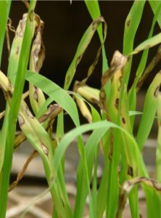
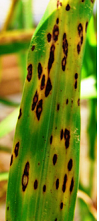
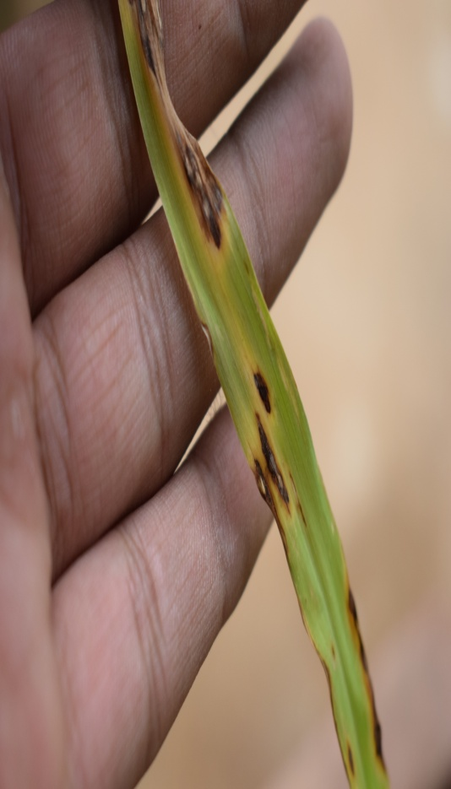
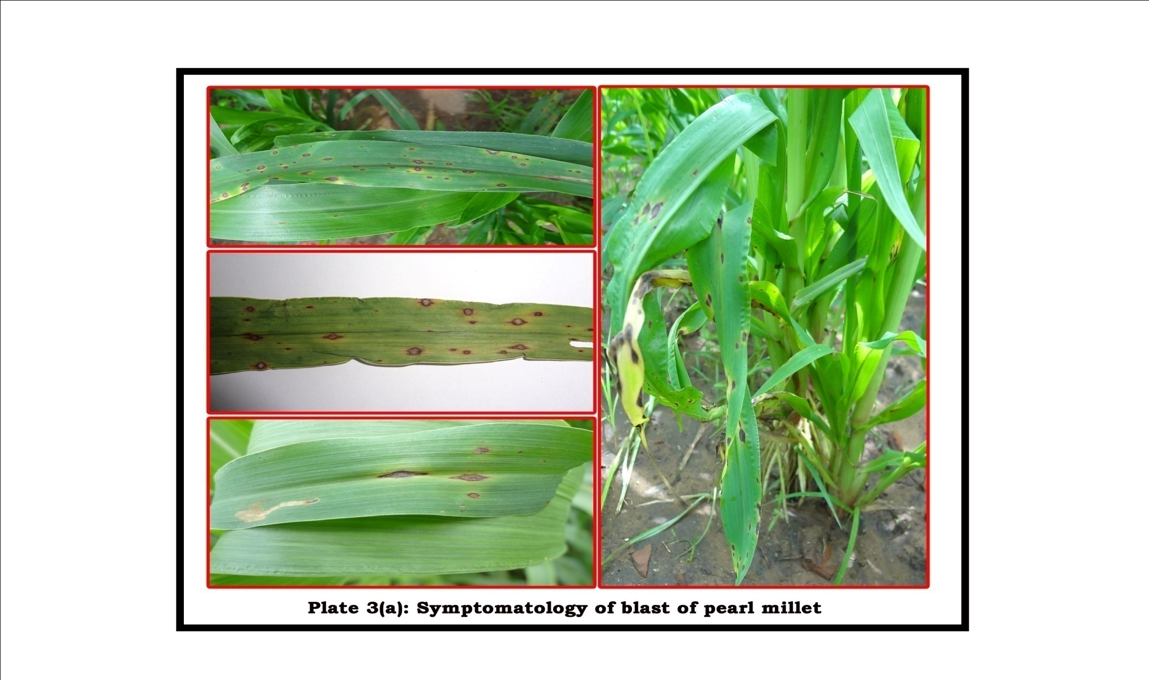
Plate I: Disease symptoms of blast of pearl millet

Plate I: Disease symptoms of blast of pearl millet
Plate I (B): Initiation to drying of diseased symptoms
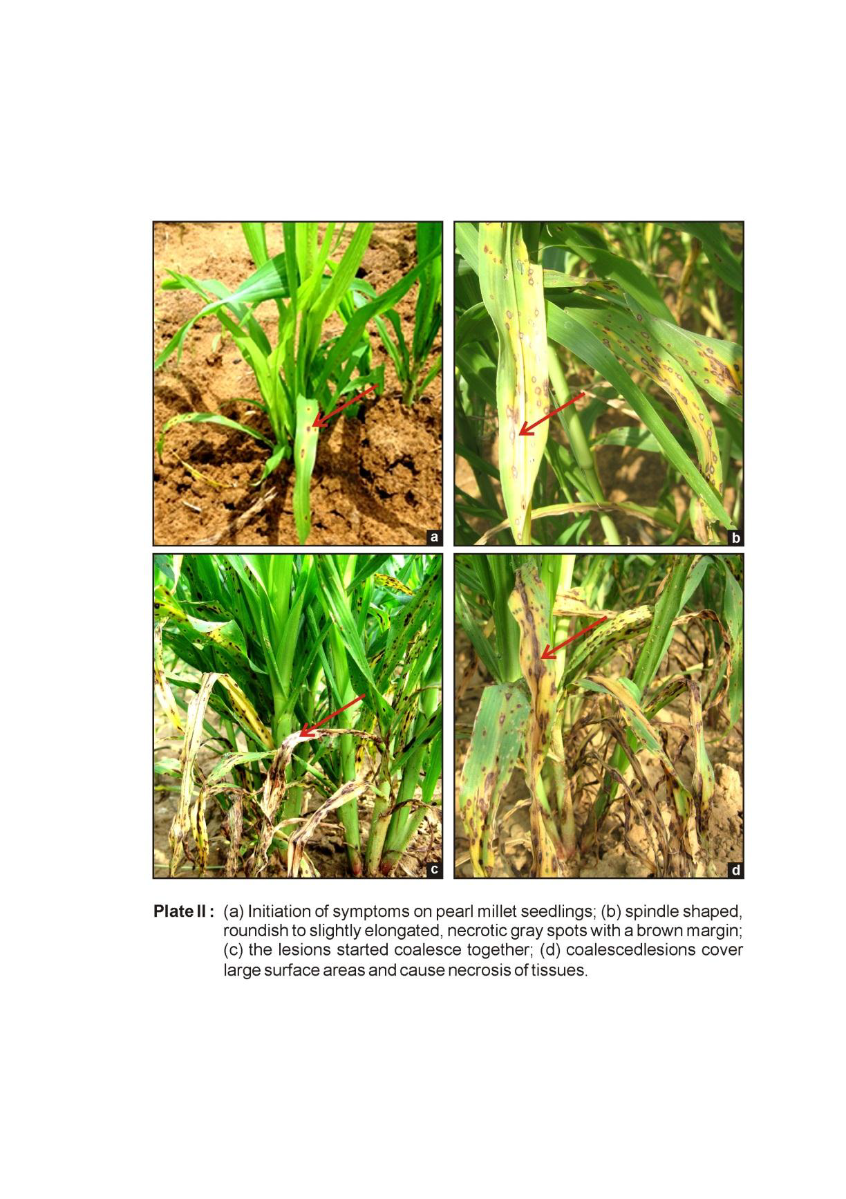
A. Initiation of symptoms on pearl millet seedlings
B. Spindale shaped roundish to slightly elongated, necrotic grey spots with a brown margin
C. The lesions started coalesce together
D. Coalesced lesions cover large surface areas and cause necrosis of tissues
C
D
A
B

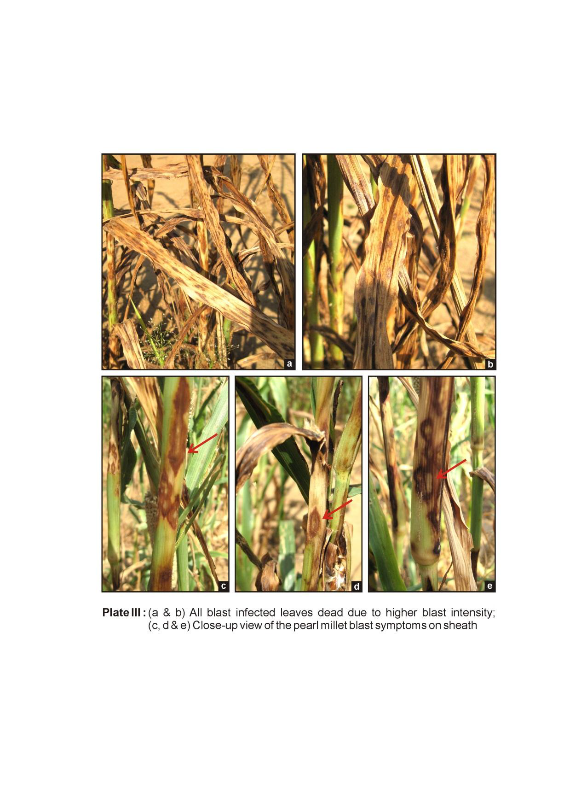
A
C
D
B
E
A &B. All the blast infected leaves due to higher blast intensity
C,D& E. Close – up view of the pearl millet blast symptoms on sheath
Plate II (C) : Close – up view of the pearl millet blast symptoms
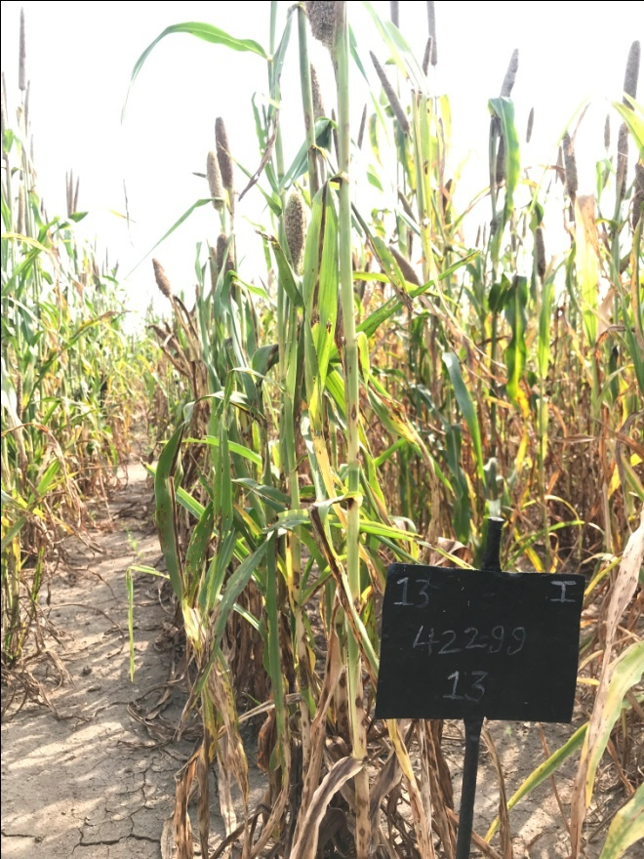
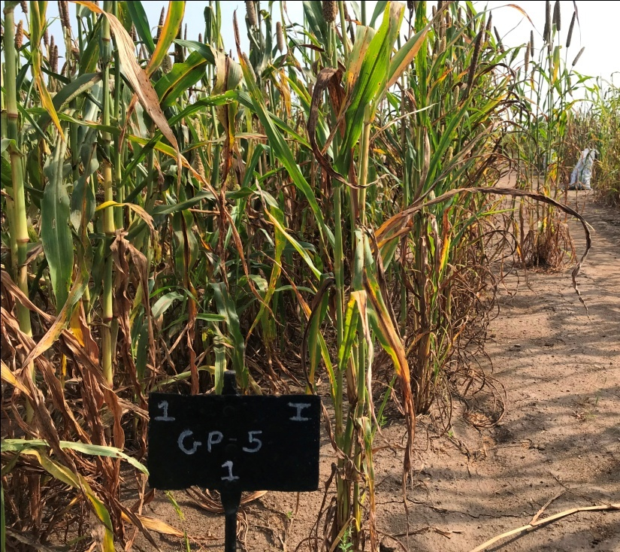
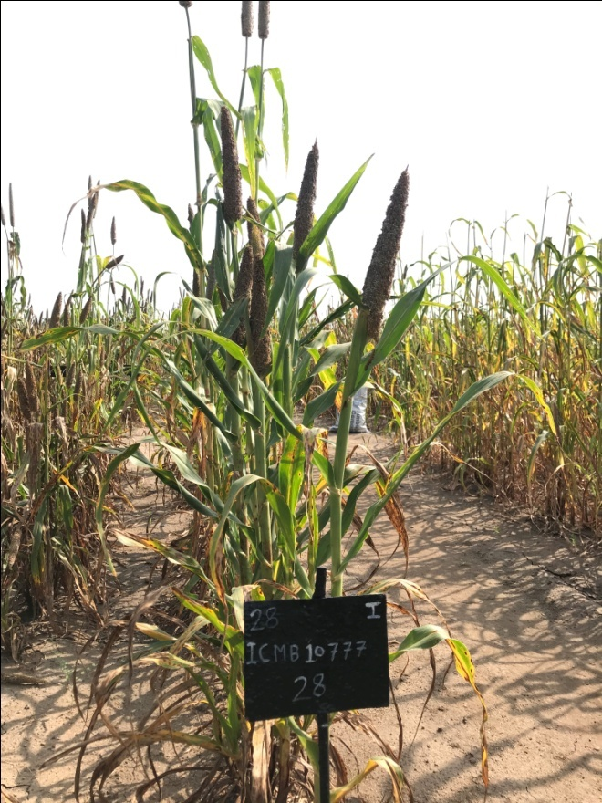
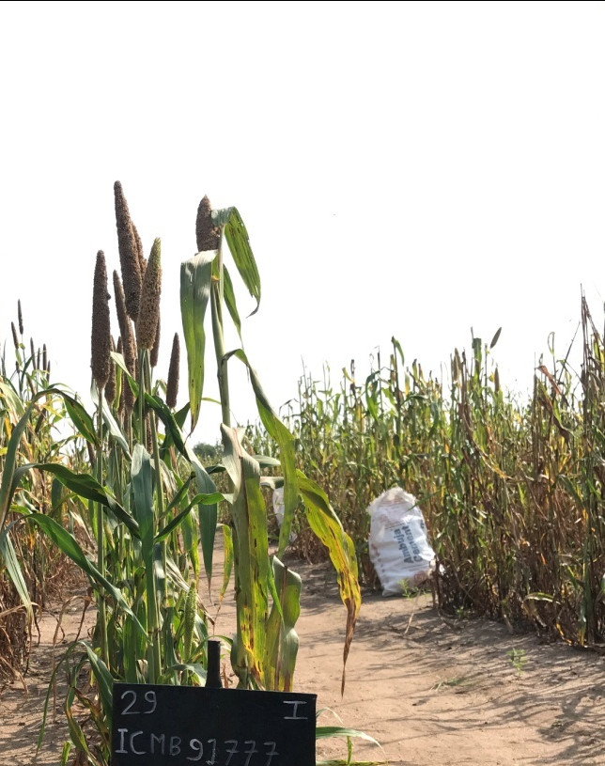
Plate III (B): Screening of pearl millet genotypes/ varieties against blast disease
MODERATELY RESTISTANT
RESISTANT
Plate III (A): Screening of pearl millet genotypes/ varieties against blast disease
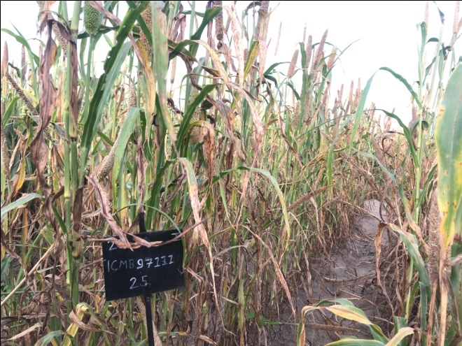
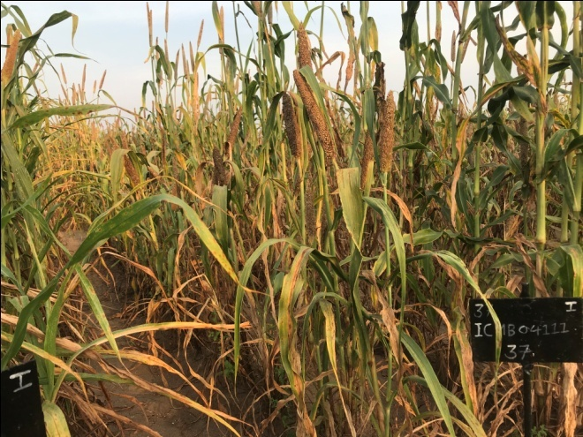
MODERATELY SUCCEPTIBLE
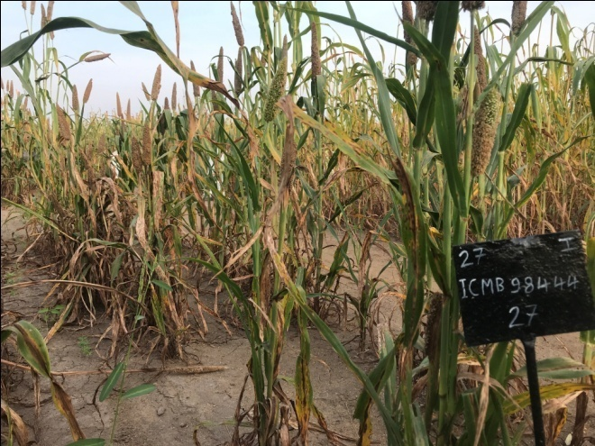
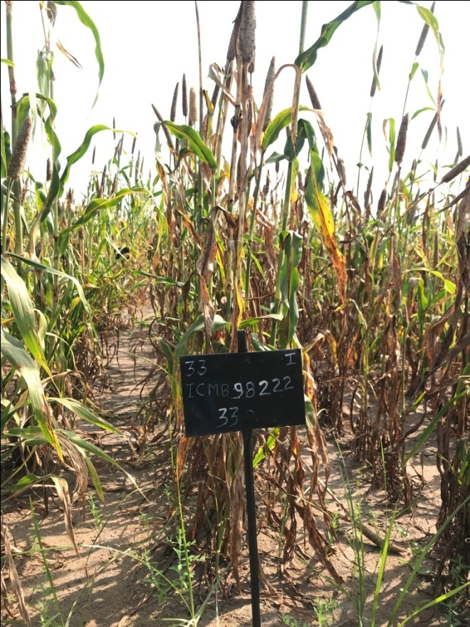
Plate III (C): Screening of pearl millet genotypes/ varieties against blast disease
SUCCEPTIBLE
Plate III (D): Screening of pearl millet genotypes/ varieties against blast disease
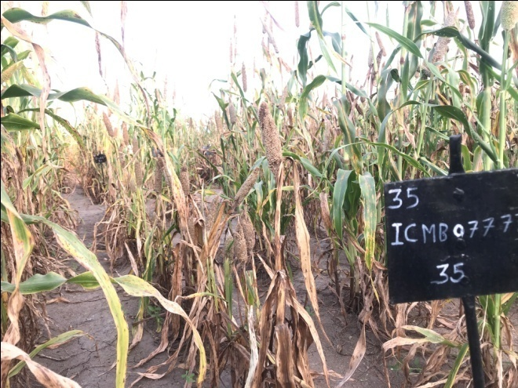
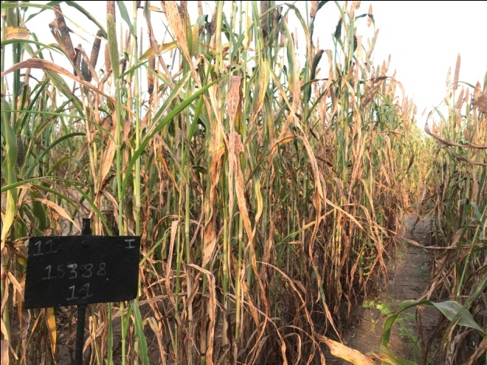
HIGHLY SUCCEPTIBLE
Plate III (E): Screening of pearl millet genotypes/ varieties against blast disease

Fig. 1: Disease reaction of pearl millet genotypes/ Varieties against blast (Pyricularia grisea) under field conditions during Kharif 2018 and 2019
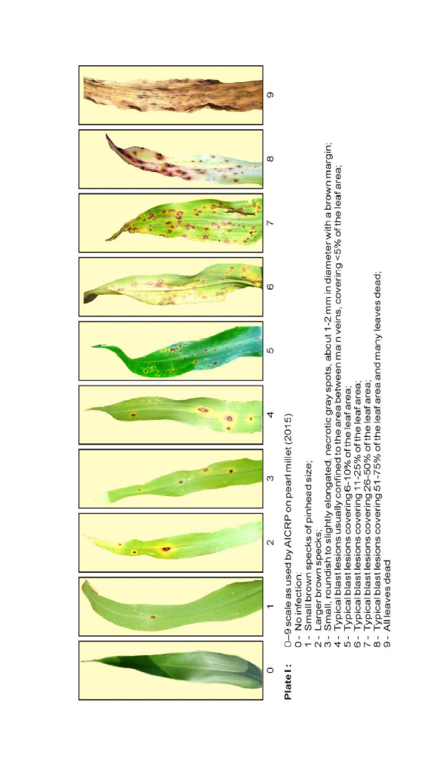
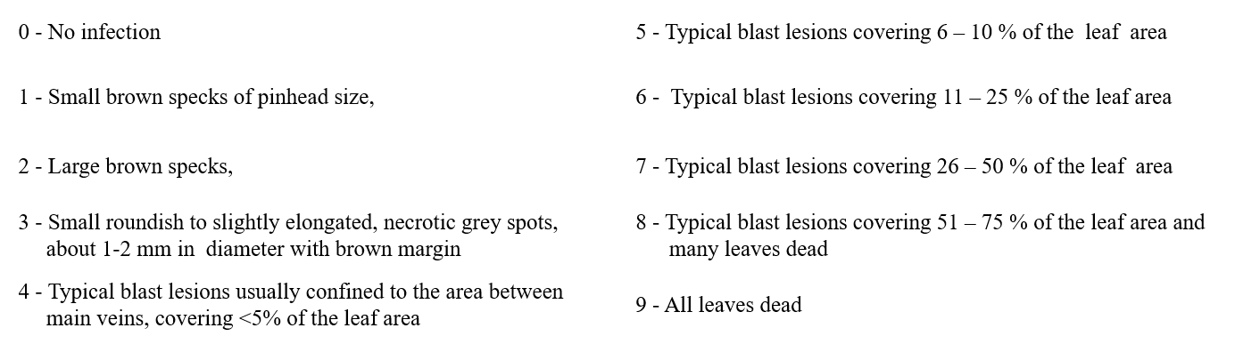
Fig 2: A series of Pearl Millet leaves showing progressive development of leaf spot disease symptoms, ranging from small discrete lesions to extensive necrosis and severe leaf blighting.
0
1
2
4
3
5
6
7
8
9

