Identification of Genomic Regions Associated with Grain Zinc concentration in Rice (Oryza sativa L.)

Abstract
Micronutrient malnutrition, commonly referred to as “hidden hunger”, continues to affect more than a billion people globally, particularly in developing nations where diets are heavily cereal-based. To combat this crisis sustainably, bio-fortification in rice represents a step towards that vision, one gene at a time. Rice, being the dominant cereal and a major staple food in Asia, is a prime target for bio-fortification to tackle micronutrient malnutrition in South Asia and Southeast Asia. Since zinc is an essential micronutrient for plants, its uptake is required for general metabolism, while Fe plays an irreplaceable role in oxygen transport via haemoglobin and myoglobin. In the present study, parental polymorphism between two parents was studied using rice microsatellite (RM) markers. The experiment was conducted at the Indian Institute of Rice Research, Rajendranagar, Hyderabad, India. Rice varieties RNR15048 and Karuppunel, which are rich in grain iron and zinc, were used to study parental polymorphism. Of the 1,600 SSR markers used for parental polymorphism, 210 markers exhibited polymorphism at the expected base-pair size, of which 38 Zn-related SSR markers were selected for further study. Therefore, these polymorphic rice microsatellite markers can be used for fine mapping of zinc-related genes in mapping populations obtained from these parents. ZBR (0.898619**) was positively correlated with ZPR. A total of 39 QTLs were identified on seven chromosomes, including 9 QTLs for plant height, 3 for number of tillers, 4 for number of productive tillers, 2 each for SPAD, DFF, and SPY, 6 for ZBR, and 11 for ZPR. Most QTLs for the different traits were identified on chromosome 1. The phenotypic variability explained ranged from 2.1037 to 12.958. Furthermore, exploiting information regarding molecular markers tightly linked to QTLs governing these traits will facilitate future crop improvement strategies in rice.
Keywords: Rice; grain zinc concentration; bio-fortification; simple sequence repeat markers; parental polymorphism; F₂ population; QTL mapping; linkage mapping; marker-assisted selection; micronutrient breeding.
Introduction
Rice (Oryza sativa L.), often hailed as the "Global Grain" or "Grain of Life", stands as one of the world’s most indispensable food crops. Cultivated across diverse geographical regions, rice serves as the staple food for more than two billion people in Asia and millions more across Africa and Latin America. According to Chatterjee (1948), rice belongs to the genus Oryza, which comprises 24 species. This rich genetic diversity not only reflects rice's evolutionary history but also provides the foundation for modern breeding strategies targeting both productivity and nutritional security. For more than half of the global population, rice is not just a food source but a ‘way of life’. It supplies a significant proportion of daily calorie intake through starch, alongside essential proteins and micronutrients (Mahender et al., 2016). However, with rising global concern over nutrient deficiencies in cultivated crops, malnutrition has emerged as one of the most pressing challenges of the 21st century (Horton et al., 2008). Among these, zinc (Zn) and iron (Fe) deficiencies are the most common, affecting approximately two billion people globally each year, as reported by the World Health Organization. A promising strategy to combat this “hidden hunger” is bio-fortification, which refers to the genetic improvement of crops to enhance their nutritional value through plant breeding and biotechnology (Bouis, 2002; Phattarakul et al., 2012). Recent genomic analyses have further highlighted the value of precise Zn-related QTLs, candidate genes, and haplotypes for genomics-assisted rice biofortification (Joshi et al., 2023). Zn functions as a critical co-factor for numerous enzymes involved in metabolic processes (Frassinetti et al., 2006; Roohani et al., 2013), while Fe plays an irreplaceable role in oxygen transport via haemoglobin and myoglobin. In recent years, the focus of crop improvement programmes has gradually shifted from merely increasing yield to enhancing the nutritional quality of staple foods such as rice and wheat. The inherent genetic variability in micronutrient concentrations among rice genotypes provides the foundation for such nutritional improvements. However, effective utilisation of this variability requires precise identification of donor genotypes and efficient tools for introgression into elite cultivars. Molecular breeding enables the identification and transfer of desirable traits through tools such as marker-assisted selection (MAS) and marker-assisted backcross breeding (MABB) (Xu & Crouch, 2008; Jiang, 2013). A crucial prerequisite for successful MAS or MABB is the analysis of parental polymorphism—the assessment of genetic differences between the donor and recipient parents for the trait of interest. Without polymorphism at the molecular level, especially in target QTL regions, effective selection and transfer of traits become challenging. In this context, simple sequence repeats (SSRs), or microsatellites, have emerged as preferred molecular markers. These markers consist of short tandem repeats of 1–6 base pairs distributed across coding and non-coding regions of the genome (Gemayel et al., 2012). Their co-dominant inheritance, high allelic polymorphism, reproducibility, and ease of PCR amplification make them suitable for genotyping (Cho et al., 2000; Mason, 2015). Recent parental-polymorphism analysis using rice microsatellite markers similarly demonstrated that SSR screening can identify informative markers relevant to grain iron and zinc improvement (Saikrishna et al., 2025). In rice, SSRs have been effectively used for gene tagging, diversity analysis, marker-assisted selection, marker-assisted introgression, marker-assisted backcrossing, and trait association studies (McCouch et al., 1997; Singh et al., 2010), making them useful tools in molecular breeding. QTL mapping is an efficient strategy for dissecting the molecular mechanisms underlying rice yield traits; it enables the identification of small base-pair variations that can be used to study genetic diversity and as tools for plant breeding. Recent rice studies have also shown that QTL mapping across defined breeding populations can identify grain-Zn loci whose effects may vary in stability across populations, seasons, or locations, supporting population-specific validation before breeding deployment (Hore et al., 2024; Habde et al., 2024). In the RNR15048 × Karuppunel F₂ population evaluated here, the utility of Zn-related SSR markers for validating genomic regions associated with grain Zn concentration alongside the measured agronomic traits has not yet been established. Therefore, this study focuses on validating Zn QTL regions in an F₂ population to confirm their efficacy and reliability for Zn biofortification programmes.
Materials and Methods
The experimental studies were undertaken at the farm of the ICAR-Indian Institute of Rice Research (IIRR), Hyderabad, located at 17.53 N latitude and 78.27 E longitude, at an altitude of 545 m, with a mean temperature of 31.2°C and mean annual precipitation of 988.3 mm.
Development and evaluation of F₂ population
An F₂ population was developed from the cross between RNR15048 (Zn:11.2 ppm in brown rice) as the recipient parent and Karuppunel (Zn:30.5 ppm in brown rice) as the donor parent for high grain Zn. A total of 80 F₂ individuals were evaluated under field conditions. Individual F₂ plants were maintained at a spacing of 20 × 15 cm. Data were recorded on three randomly selected plants of each replication for characters such as days to 50% flowering (DFF), plant height (PH), number of tillers per plant (NT), number of productive tillers per plant (NPT), panicle length (PL), flag leaf length (FL), and single-plant yield (SPY). Grain observations for zinc and iron were recorded using an energy-dispersive X-ray fluorescence spectrophotometer (ED-XRF) (Oxford Instruments: X-Supreme 8000) at ICAR-IIRR according to the standardised protocols (Rao et al., 2014).
Genotyping with SSR markers
Tissue samples from 21-day-old seedlings were used for DNA isolation following the CTAB protocol (Doyle & Doyle, 1987). DNA was quantified using a NanoDrop (Thermo Fisher Scientific, Wilmington, USA). In the present study, SSR markers that are efficient for estimating diversity among parental lines, cultivars, and inbred lines in rice were used (Singh et al., 2010). A total of 1,600 SSR markers, well distributed across 12 chromosomes, were used to identify polymorphism between the parents. Of the 1,600 SSR markers, 210 were found to be polymorphic, with an overall polymorphism of 13.13%. Of these 210 polymorphic markers, 38 Zn-related SSR markers (shown in Table 1) were further selected for genotyping the 80 F₂ individuals.
The percentage polymorphism was calculated using the formula below:
Percent Polymorphism= Number of Polymorphic Markers /Total Number of Markers Screened X 100
Based on grain Zn concentration, 24 contrasting F₂ individuals, comprising 12 high-Zn individuals (35–45 ppm) and 12 low-Zn individuals (9–14 ppm), were initially used for comparison of marker profiles. Subsequently, the complete set of 80 F₂ individuals was genotyped using the 38 selected polymorphic SSR markers, and the resulting genotype data were used for linkage-map construction and QTL analysis.
A PCR mixture consisted of 30 ng/µL of template DNA, 1X PCR buffer (10mMTris, pH8.4, 50mMKCl, 1.5 mM MgCl2 and 0.01mgmL-1 gelatin), 5.0 mM of Betain, 5 pm of forward and reverse primers, 2.5 Mm of dNTPs, and 1 U Taq polymerase (GeNei). PCR amplification was performed in a programmable thermal cycler (Applied Biosystems, Foster City, USA), using the following thermal profile: (a) initial denaturation for 5 minutes at 94°C, (b) 35 cycles of denaturation for 30 seconds at 94°C, (b) primer annealing for 30 seconds at 55°C, (c) elongation or extension for 1 minute at 72°C, and (d) final extension for 10 min at 72ºC. Amplicons containing ethidium bromide were separated by submarine electrophoresis in 3% agarose gel at 90V for 1 to 2h. Following gel documentation (Medicare gelstan 4X advanced- gel doc), the gel was exposed to UV transillumination for visualisation, and the respective bands were estimated with the help of a standard DNA ladder (Gene Ruler100-bpladder) (Balaji Suresh et al., 2012).
Descriptive Statistics and Correlation Analysis
Descriptive statistical analyses were performed for the studied traits using Microsoft Excel 2016. The parameters estimated included mean, minimum, maximum, range, standard deviation, coefficient of variation (CV%), skewness and kurtosis.
Pearson correlation coefficients were estimated among the evaluated agronomic and grain Zn traits using Microsoft Excel 2016 to determine the direction and magnitude of associations among traits.

Table-1: List of 38 Zn polymorphic SSRs used in the study
S.No. | SSR | Forward sequence | Reverse sequence | Chr. No. | Repeat motif | Expected target size
1 | RM562 | CACAACCCACAAA CAGCAAG | CTTCCCCCAAAGT TTTAGCC | 1 | (AAG)13 | 243
2 | RM11943 | CTTGTTCGAGGAC GAAGATAGGG | CCAGTTTACCAGG GTCGAAACC | 1 | (GA)11 | 76
3 | RM12276 | GTCGACGGCTTCCT CAAGATTGG | TGAGACCTCTGTG AAGGCACTCG | 1 | (TC)17 | 188
4 | RM5638 | GGCTTCCTCATCGC CATC | CTGAGCAGCATTC CAGTCTG | 1 | (AAG)13 | 203
5 | RM243 | GATCTGCAGACTG CAGTTGC | AGCTGCAACGAT GTTGTCC | 1 | (CT)18 | 116
6 | RM5461 | GCCTCCCATATAA ACCGGC | AGCGAAGGGAAC ACGACAG | 1 | (TC)19 | 134
7 | RM488 | CAGCTAGGGTTTTG AGGCTG | TAGCAACAACCA GCGTATGC | 1 | (GA)17 | 177
8 | RM490 | ATCTGCACACTGC AAACACC | AGCAAGCAGTGC TTTCAGAG | 1 | (CT)13 | 101
9 | RM24 | GAAGTGTGATCAC TGTAACC | TACAGTGGACGG CGAAGTCG | 1 | (GA)29 | 192
10 | RM6 | GTCCCCTCCACCCA ATTC | TCGTCTACTGTTG GCTGCAC | 2 | (AG)16 | 163
11 | RM154 | GACGGTGACGCAC TTTATGAACC | CGATCTGCGAGA AACCCTCTCC | 2 | (GA)21 | 183
12 | RM489 | ACTTGAGACGATC GGACACC | TCACCCATGGATG TTGTCAG | 3 | (ATA)8 | 271
13 | RM523 | AAGGCATTGCAGC TAGAAGC | GCACTTGGGAGG TTTGCTAG | 3 | (TC)14 | 148
14 | RM231 | CCAGATTATTTCCT GAGGTC | CACTTGCATAGTT CTGCATTG | 3 | (CT)16 | 182
15 | RM520 | AGATTGATCTCCCA TTCCCC | CACGAGCATATTA CTAGTGG | 3 | (AC)12 | 247
16 | RM85 | CCAAAGATGAAAC CTGGATTG | GCACAAGGTGAG CAGTCC | 3 | (TGG)5(TCT)12 | 107
17 | RM55 | CCGTCGCCGTAGT AGAGAAG | TCCCGGTTATTTT AAGGCG | 3 | (GA)17 | 226
18 | RM470 | TCCTCATCGGCTTC TTCTTC | AGAACCCGTTCTA CGTCACG | 4 | (CTT)14 | 83
19 | RM13 | TCCAACATGGCAA GAGAGAG | GGTGGCATTCGAT TCCAG | 5 | (GA)6- (GA)16 | 141
20 | RM8226 | GCGTGTTCAGAAA TTAGGATACGG | GATCTCGCCACGT AATTGTTGC | 6 | (AAG)14 | 251
21 | RM225 | TGCCCATATGGTCT GGATG | GAAAGTGGATCA GGAAGGC | 6 | (CT)18 | 140
22 | RM253 | TCCTTCAAGAGTGC AAAACC | GCATTGTCATGTC GAAGCC | 6 | (GA)25 | 141
23 | RM541 | TATAACCGACCTC AGTGCCC | CCTTACTCCCATG CCATGAG | 6 | (TC)16 | 158
24 | RM340 | GGTAAATGGACAA TCCTATGGC | GACAAATATAAG GGCAGTGTGC | 6 | (CTT) 8T3(CTT)14 | 163
25 | RM3404 | AGTCCTGAGTCTCC TGTCCT | CCTGTTCGATCTT GAACTTC | 7 | (CT)17 | 136
26 | RM234 | ACAGTATCCAAGG CCCTGG | CACGTGAGACAA AGACGGAG | 7 | (CT)25 | 156
27 | RM1132 | ATCACCTGAGAAA CATCCGG | CTCCTCCCACGTC AAGGTC | 7 | (AG)12 | 93
28 | RM248 | TCCTTGTGAAATCT GGTCCC | GTAGCCTAGCATG GTGCATG | 7 | (CT)25 | 102
29 | RM1111 | CCTCCTGTCGGATC TGGTAG | CTTATCCACTTGC CCTCTCG | 8 | (AG)12 | 111
30 | RM264 | GTTGCGTCCTACTG CTACTTC | GATCCGTGTCGAT GATTAGC | 8 | GA)27 | 178
31 | RM3909 | GATCACCAAAACA GTCCAAC | AAACTGTCCTCCC CACAG | 9 | (GT)21 | 205
32 | RM216 | GCATGGCCGATGG TAAAG | TGTATAAAACCAC ACGGCCA | 10 | (CT)18 | 146
33 | RM332 | GCGAAGGCGAAGG TGAAG | CATGAGTGATCTC ACTCACCC | 11 | (CTT)5-12- (CTT)14 | 183
34 | RM224 | ATCGATCGATCTTC ACGAGG | TGCTATAAAAGG CATTCGGG | 11 | (AAG)8(AG) 13 | 157
35 | RM8216 | AGTTGATTATCCAT CATGTGC | TGTAGGCCCTATG AATCTCC | 12 | (TAA)25 | 210
36 | RM247 | TAGTGCCGATCGA TGTAACG | CATATGGTTTTGA CAAAGCG | 12 | (CT)16 | 131
37 | RM3331 | CCTCCTCCATGAGC TAATGC | AGGAGGAGCGGA TTTCTCTC | 12 | (CT)15 | 129
38 | RM19 | CAAAAACAGAGCA GATGAC | CTCAAGATGGAC GCCAAGA | 12 | (ATC)10 | 226

Genetic linkage map construction and QTL identification
Genotypic data generated from 80 F₂ individuals using 38 polymorphic Zn-related SSR markers were used for genetic linkage-map construction and QTL analysis using QTL IciMapping version 4.2. The mapping population was specified as F₂, and recombination frequencies were converted into genetic distances using the Kosambi mapping function. Linkage groups were established using the GROUP function at a minimum LOD score of 3.0, and the SSR markers were ordered according to their recombination frequencies and estimated genetic distances.
QTLs associated with the evaluated traits were identified using inclusive composite interval mapping (ICIM) in QTL IciMapping v4.2. Background marker variables were selected through stepwise regression. A total of 1,000 permutation tests at P = 0.05 were performed for assessment of QTL significance, and a minimum LOD score of 2.5 was used as the criterion for declaring putative QTLs. For each detected QTL, the chromosomal position, flanking markers, LOD score, phenotypic variance explained (PVE%), and additive and dominance effects were estimated.
Results
The descriptive statistics presented in Table 2 were computed for all the traits in the 80 F₂ population. Mean, range, standard deviation, and coefficient of variation (CV%) were estimated to understand the extent of phenotypic variability. The mean values ranged from 16.67 to 153.24, while the trait-wise ranges varied from 18.5 to 107.8. Considerable variation was observed among the studied traits based on the CV values. The highest CV was recorded for SPY (86.30%), followed by ZPR (43.22%) and ZBR (37.16%). Skewness values varied among the traits, indicating both negatively and positively skewed distributions, while kurtosis also varied considerably among the studied traits.
Table –2: Descriptive analysis of F₂ population
Trait | Mean | Standard Deviation | CV% | Range | Minimum | Maximum | Kurtosis | Skewness
PH | 153.238 | 31.4157 | 20.5 | 107.8 | 98.9 | 206.7 | -1.2522 | -0.1352
FLL | 45.8125 | 10.4138 | 22.73 | 50.3 | 22.3 | 72.6 | -0.198 | 0.34403
PL | 24.15 | 2.78731 | 11.54 | 18.5 | 17.9 | 36.4 | 4.70734 | 1.35767
NT | 27.4875 | 8.10999 | 29.5 | 32 | 16 | 48 | -0.4434 | 0.70425
NPT | 27.1625 | 8.05589 | 29.65 | 32 | 16 | 48 | -0.5494 | 0.6597
SPAD | 40.306 | 6.96565 | 17.28 | 43.64 | 10.43 | 54.07 | 3.1222 | -0.8245
DFF | 101.7 | 9.06712 | 8.91 | 51 | 61 | 112 | 5.09875 | -1.771
SPY | 16.6716 | 14.3872 | 86.3 | 88.07 | 2.27 | 90.34 | 8.10731 | 2.28847
ZBR | 25.3244 | 9.41052 | 37.2 | 35.56 | 9.84 | 45.4 | -1.0986 | 0.24745
ZPR | 22.03 | 9.52098 | 43.2 | 32.3 | 7.8 | 40.1 | -1.305 | 0.29077

Correlation coefficient
The study of genetic correlation provides an indication of the extent to which characters are under genetic control, and this type of analysis can help breeders design selection strategies for effective improvement of characters. In the present study, ZBR was positively and non-significantly associated with NT (0.13134), NPT (0.151645), DFF (0.181076), and SPY (0.178366), whereas ZPR was significantly and positively associated with ZBR (0.898619**) and significantly negatively associated with PH (-0.251*). SPY was significantly and positively associated with DFF (0.385088**), NT (0.249399*), and NPT (0.236306*), and was positively but non-significantly associated with PH (0.028757), FLL (0.046407), and SPAD (0.033344) (shown in Table 3).
Table-3: Correlation coefficient studies among different characters
Trait | PH | FLL | PL | NT | NPT | SPAD | DFF | SPY | ZBR | ZPR
PH | 1
FLL | 0.672095** | 1
PL | 0.323647* | 0.27308* | 1
NT | 0.222814* | 0.186872 | -0.05989 | 1
NPT | 0.211835 | 0.182503 | -0.06001 | 0.996579** | 1
SPAD | -0.05828 | -0.11223 | -0.01498 | 0.074268 | 0.066282 | 1
DFF | 0.059556 | 0.198286 | -0.03561 | -0.00229 | -0.00938 | -0.27402* | 1
SPY | 0.028757 | 0.046407 | -0.06699 | 0.249399* | 0.236306* | 0.033344 | 0.385088** | 1
ZBR | -0.21528 | -0.10112 | -0.10925 | 0.13134 | 0.151645 | -0.0821 | 0.181076 | 0.17837 | 1
ZPR | -0.251* | -0.19495 | -0.0968 | 0.090861 | 0.104478 | -0.08293 | 0.117137 | 0.08668 | 0.898619** | 1

Parental Polymorphism and F₂ genotyping using 38 selected Zn-related polymorphic markers
Approximately 1,600 SSR markers were initially screened for parental polymorphism between RNR15048 and Karuppunel. Of these, 210 SSR markers were found to be polymorphic between the two parents, corresponding to an overall parental polymorphism of approximately 13.13%. From the 210 polymorphic markers, 38 Zn-related SSR markers distributed across the 12 rice chromosomes were selected for genotyping the F₂ population.
Among the selected markers, 9 were polymorphic on chromosome 1, 2 on chromosome 2, 6 on chromosome 3, 1 on chromosome 4, 1 on chromosome 5, 5 on chromosome 6, 4 on chromosome 7, 2 on chromosome 8, 1 on chromosome 9, 1 on chromosome 10, 2 on chromosome 11, and 4 on chromosome 12. The allelic range of the 38 polymorphic SSRs extended from 76 bp to 271 bp (Table 4).
Among the total of 80 F₂ individuals evaluated for grain Zn concentration, 12 individuals with high Zn concentration (35–45 ppm) and 12 individuals with low Zn concentration (9–14 ppm) were identified as contrasting groups for marker evaluation. The 38 polymorphic Zn-related SSR markers were subsequently used to genotype the complete 80 F₂ population for linkage and QTL analysis. SSR alleles were scored according to parental allele size as A for the RNR15048 allele, B for the Karuppunel allele, H for the heterozygous genotype containing alleles from both parents, and X for no amplification, as shown in Fig-1.
Table-4: Chromosome-wise distribution of polymorphic SSR markers and Zn-related SSR markers selected for genotyping of the F₂ population
Sr. No. | Chromosome | Polymorphic SSR markers | Zn related SSR markers selected
1 | Chr1 | 42 | 9
2 | Chr2 | 22 | 2
3 | Chr3 | 22 | 6
4 | Chr4 | 14 | 1
5 | Chr5 | 14 | 1
6 | Chr6 | 18 | 5
7 | Chr7 | 18 | 4
8 | Chr8 | 11 | 2
9 | Chr9 | 11 | 1
10 | Chr10 | 12 | 1
11 | Chr11 | 13 | 2
12 | Chr12 | 13 | 4
 | Total | 210 | 38
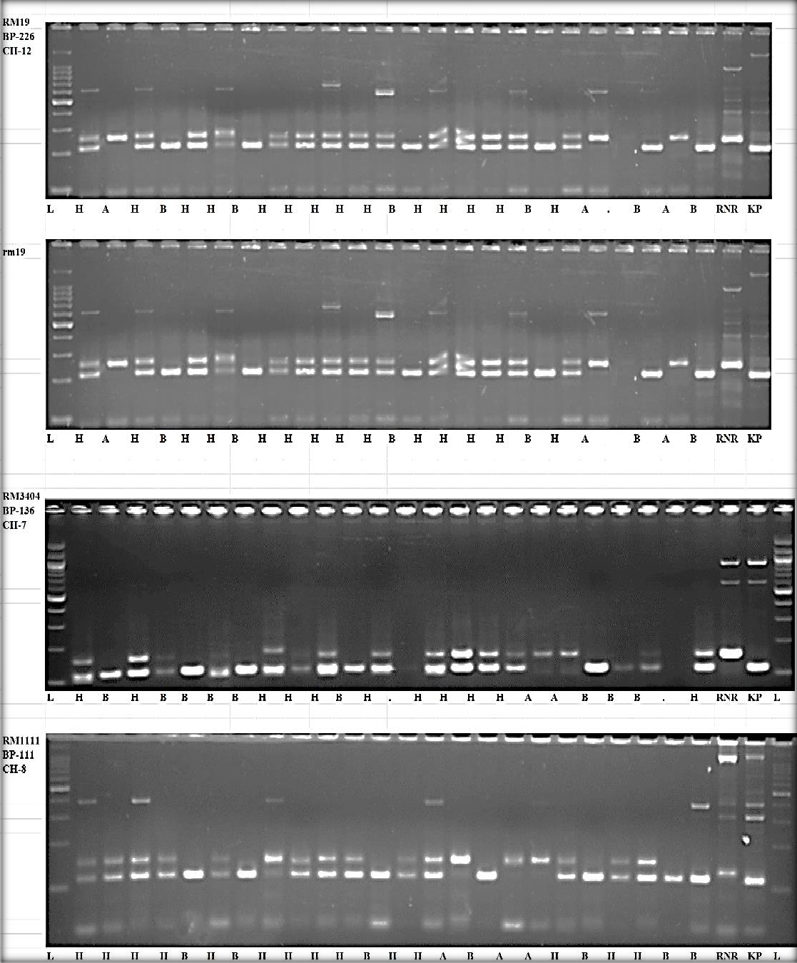

Fig-1: Gel image of representative polymorphic markers, where L:Ladder; A:RNR15048; B:karuppunel; H: Both RNR15048 and Karuppunel.

Identification of QTLs for various traits
Using inclusive composite interval mapping (ICIM), a total of 39 QTLs were identified on seven chromosomes. The phenotypic variability explained (PVE) ranged from 2.1037 to 12.958. The 39 QTLs were identified for all the traits, along with chromosome number, position, LOD, marker interval, additive effect, dominance effect, and PVE, as shown in Table 5.
A total of six QTLs were identified for ZBR. Of these, four QTLs, named qZBR1.1, qZBR1.2, qZBR1.3, and qZBR1.4, were detected on chromosome 1 at positions 133, 272, 287, and 295 cM, respectively, between the marker intervals RM5638-RM490 and RM562-RM11943, with PVE values of 3.4096, 3.3117, 3.5688, and 3.3105%, respectively. Two additional QTLs, named qZBR6 and qZBR8, were located on chromosomes 6 and 8 at positions 117 and 70 cM, respectively, between the marker intervals RM541-RM8226 and RM1111-RM264, with PVE values of 3.2883 and 2.4229%, respectively.
Eleven QTLs were identified for ZPR. Of these, two QTLs, named qZPR1.1 and qZPR1.2, were identified on chromosome 1 at positions 134 and 280 cM, respectively, between the marker intervals RM5638-RM490 and RM562-RM11943, with PVE values of 3.7617 and 3.6341%, respectively. Three QTLs, named qZPR3.1, qZPR3.2, and qZPR3.3, were identified on chromosome 3 at distances of 71, 138, and 189, respectively, between the marker intervals RM85-RM523, RM231-RM520, and RM520-RM489, with PVE values of 3.6316, 3.6292, and 3.6268%, respectively. Two QTLs, qZPR7.1 and qZPR7.2, were detected on chromosome 7 at distances of 33 and 105, respectively, between the marker intervals RM3404-RM234 and RM1132-RM248, with PVE values of 3.9 and 3.745%, respectively. Two additional QTLs, qZPR8.1 and qZPR8.2, were identified on chromosome 8 at distances of 32 and 61, respectively, between markers RM1111-RM264, with PVE values of 3.6835 and 3.6045%, respectively. One QTL, qZPR6, and another QTL, qZPR12, were found on chromosomes 6 and 12 at positions 118 and 74, respectively, between markers RM541-RM8226 and RM8215-RM247, with PVE values of 3.6293 and 3.6206%, respectively.
On chromosome 6, two QTLs, qSPY6.1 and qSPY6.2, were discovered at 90 and 107 cM, respectively, with the flanking marker interval RM541-RM8226 and PVE values of 2.4811 and 2.5791%, respectively.
A total of nine QTLs were identified for plant height. Of these, four QTLs, named qPH1.1, qPH1.2, qPH1.3, and qPH1.4, were detected on chromosome 1 at positions 16, 142, 218, and 29 cM, respectively, between the marker intervals RM12276-RM24, RM5638-RM490, RM490-RM562, and RM562-RM11943, with phenotypic variability explained (PVE) values of 2.1037, 2.4326, 2.1171, and 2.5102%, respectively. Two additional QTLs, named qPH3 and qPH6, at positions 64 and 105 cM, were located on chromosomes 3 and 6, respectively, between the marker intervals RM85-RM523 and RM541-RM8226, with PVE values of 2.2429 and 2.1468%, respectively. Other QTLs were located on chromosomes 7, 8, and 12 at the flanking marker intervals RM1132-RM248, RM1111-RM264, and RM3331-RM8216, respectively, at positions 108, 45, and 24 cM. These were named qPH7, qPH8, and qPH12, with PVE values of 2.1484, 2.5151, and 2.1987%, respectively.
Three QTLs were identified for number of tillers. Of these, two QTLs, named qNT1.1 and qNT1.2, at positions 153 and 301 cM, respectively, were found on chromosome 1 between the marker intervals RM5638-RM490 and RM562-RM11943, respectively. One QTL, named qNT3, at a distance of 174 cM, was found on chromosome 3 with the flanking marker RM520-RM489. The PVE values were 7.3772, 7.6837, and 9.2597% for qNT1.1, qNT1.2, and qNT3, respectively.
Four QTLs were identified for number of productive tillers. Of these, three QTLs were located on chromosome 1 at the flanking marker intervals RM5638-RM490, RM490-RM562, and RM562-RM11943, at positions 153, 204, and 301 cM, respectively. These were named qNPT1.1, qNPT1.2, and qNPT1.3, with PVE values of 5.4066, 5.4565, and 5.7242%, respectively. Another QTL was located on chromosome 3 at the flanking marker RM520-RM489 at a position of 175 cM, named qNPT3, with a PVE of 6.9508%.
Two QTLs were identified for SPAD at distances of 34 and 140 cM on chromosomes 1 and 6, respectively. The QTLs qSPAD1 and qSPAD6 were found with the flanking markers RM24-RM488 and RM541-RM8226, with PVE values of 12.958 and 10.615%, respectively.
Two QTLs, qDFF1 and qDFF11, were found within the marker intervals RM490-RM562 and RM332-RM224 at distances of 212 and 19 cM on chromosomes 1 and 11, respectively. The PVE values were 6.1633 and 7.8828%, respectively.
The RM5638-RM490 interval contained similar QTL regions for PH, NT, NPT, ZBR, and ZPR; RM541-RM8226 showed similar QTL regions for PH, SPY, SPAD, ZBR, and ZPR; and RM1132-RM248 was common to PH and ZPR. DFF, PH, and NPT had the common interval RM490-RM562; RM1111-RM264 was common to PH, ZBR, and ZPR; RM85-RM523 was common to PH and ZPR; and RM520-RM489 was common to NT, NPT, and ZPR.

Table-5: High and Low Zn pool RK F2 QTL IciM mapping results
TraitName | Chr | Position | LeftMarker | RightMarker | LOD | PVE(%) | Add | Dom | LeftCI | RightCI
PH | 1 qPH1.1 | 16 | RM12276 | RM24 | 5.0281 | 2.1037 | 5.8769 | -58.5931 | 10.5 | 20.5
PH | 1 qPH1.2 | 142 | RM5638 | RM490 | 5.9863 | 2.4326 | -11.9475 | -55.1446 | 128.5 | 153.5
PH | 1 qPH1.3 | 218 | RM490 | RM562 | 3.9022 | 2.1171 | 3.2077 | 54.904 | 215.5 | 226.5
PH | 1 qPH1.4 | 295 | RM562 | RM11943 | 6.4915 | 2.5102 | -38.2857 | 9.5849 | 287.5 | 299.5
PH | 3 qPH3 | 64 | RM85 | RM523 | 3.5815 | 2.2429 | -19.8704 | 43.0075 | 56.5 | 70.5
PH | 6 qPH6 | 105 | RM541 | RM8226 | 4.1416 | 2.1468 | -2.3947 | -54.8559 | 97.5 | 114.5
PH | 7 qPH7 | 108 | RM1132 | RM248 | 4.6272 | 2.1484 | 4.2387 | 55.8445 | 96.5 | 121.5
PH | 8 qPH8 | 45 | RM1111 | RM264 | 5.958 | 2.5151 | -37.5765 | 9.3004 | 31.5 | 59.5
PH | 12 qPH12 | 24 | RM3331 | RM8216 | 3.5516 | 2.1987 | -7.6258 | -54.557 | 20.5 | 30.5
NT | 1 qNT1.1 | 153 | RM5638 | RM490 | 2.5292 | 7.3772 | 3.3628 | -11.0594 | 131.5 | 164.5
NT | 1 qNT1.2 | 301 | RM562 | RM11943 | 3.544 | 7.6837 | 5.347 | -7.7349 | 280.5 | 314.5
NT | 3 qNT3 | 174 | RM520 | RM489 | 4.922 | 9.2597 | -0.1537 | 13.7311 | 161.5 | 183.5
NPT | 1 qNPT1.1 | 153 | RM5638 | RM490 | 2.5267 | 5.4066 | 3.1429 | -11.1733 | 132.5 | 164.5
NPT | 1 qNPT1.2 | 204 | RM490 | RM562 | 2.5158 | 5.4565 | 3.1468 | -10.6298 | 195.5 | 215.5
NPT | 1 qNPT1.3 | 301 | RM562 | RM11943 | 3.8748 | 5.7242 | 5.165 | -8.1665 | 281.5 | 314.5
NPT | 3 qNPT3 | 175 | RM520 | RM489 | 4.9968 | 6.9508 | -0.4225 | 13.9457 | 165.5 | 184.5
SPAD | 1 qSPAD1 | 34 | RM24 | RM488 | 2.5092 | 12.958 | -0.854 | 7.0397 | 19.5 | 48.5
SPAD | 6 qSPAD6 | 140 | RM541 | RM8226 | 2.8495 | 10.615 | 3.6987 | -2.2221 | 121.5 | 140
DFF | 1 qDFF1 | 212 | RM490 | RM562 | 2.818 | 6.1633 | 7.6525 | 4.4523 | 193.5 | 230.5
DFF | 11 qDFF11 | 19 | RM332 | RM224 | 3.4917 | 7.8828 | -10.4728 | 6.6854 | 3.5 | 33.5
SPY | 6 qSPY6.1 | 90 | RM541 | RM8226 | 3.4795 | 2.4811 | -1.5057 | 31.0862 | 86.5 | 97.5
SPY | 6 qSPY6.2 | 107 | RM541 | RM8226 | 4.8593 | 2.5791 | 20.8686 | -19.0166 | 106.5 | 120.5
ZBR | 1 qZBR1.1 | 133 | RM5638 | RM490 | 4.9602 | 3.4096 | -2.101 | -15.986 | 127.5 | 133.5
ZBR | 1 qZBR1.2 | 272 | RM562 | RM11943 | 5.3977 | 3.3117 | -0.6759 | 16.3882 | 263.5 | 273.5
ZBR | 1 qZBR1.3 | 287 | RM562 | RM11943 | 3.1224 | 3.5688 | -11.1891 | 2.9133 | 283.5 | 290.5
ZBR | 1 qZBR1.4 | 295 | RM562 | RM11943 | 5.0526 | 3.3105 | -0.8973 | 16.2498 | 293.5 | 300.5
ZBR | 6 qZBR6 | 117 | RM541 | RM8226 | 4.8797 | 3.2883 | 0.068 | 16.5165 | 106.5 | 123.5
ZBR | 8 qZBR8 | 70 | RM1111 | RM264 | 2.6499 | 2.4229 | -8.7956 | -4.8558 | 48.5 | 88.5
ZPR | 1 qZPR1.1 | 134 | RM5638 | RM490 | 10.6127 | 3.7617 | -2.4105 | -16.9062 | 124.5 | 134.5
ZPR | 1 qZPR1.2 | 280 | RM562 | RM11943 | 9.9801 | 3.6341 | -0.5995 | 17.314 | 264.5 | 305.5
ZPR | 3 qZPR3.1 | 71 | RM85 | RM523 | 8.7052 | 3.6316 | 0.3563 | 17.4942 | 67.5 | 76.5
ZPR | 3 qZPR3.2 | 138 | RM231 | RM520 | 7.9945 | 3.6292 | 0.1285 | 17.4924 | 134.5 | 142.5
ZPR | 3 qZPR3.3 | 189 | RM520 | RM489 | 7.717 | 3.6268 | -0.0817 | 17.4965 | 180.5 | 191.5
ZPR | 6 qZPR6 | 118 | RM541 | RM8226 | 10.416 | 3.6293 | 0.2664 | 17.3941 | 107.5 | 126.5
ZPR | 7 qZPR7.1 | 33 | RM3404 | RM234 | 12.2454 | 3.9 | -3.3519 | -17.5994 | 24.5 | 41.5
ZPR | 7 qZPR7.2 | 105 | RM1132 | RM248 | 9.5085 | 3.745 | 2.1981 | -17.281 | 100.5 | 107.5
ZPR | 8 qZPR8.1 | 32 | RM1111 | RM264 | 9.4594 | 3.6835 | -1.8134 | -17.4474 | 31.5 | 32.5
ZPR | 8 qZPR8.2 | 61 | RM1111 | RM264 | 4.9312 | 3.6045 | -8.8425 | -8.4554 | 47.5 | 66.5
ZPR | 12 qZPR12 | 74 | RM8216 | RM247 | 6.5627 | 3.6206 | 0.0619 | 17.4509 | 71.5 | 78.5

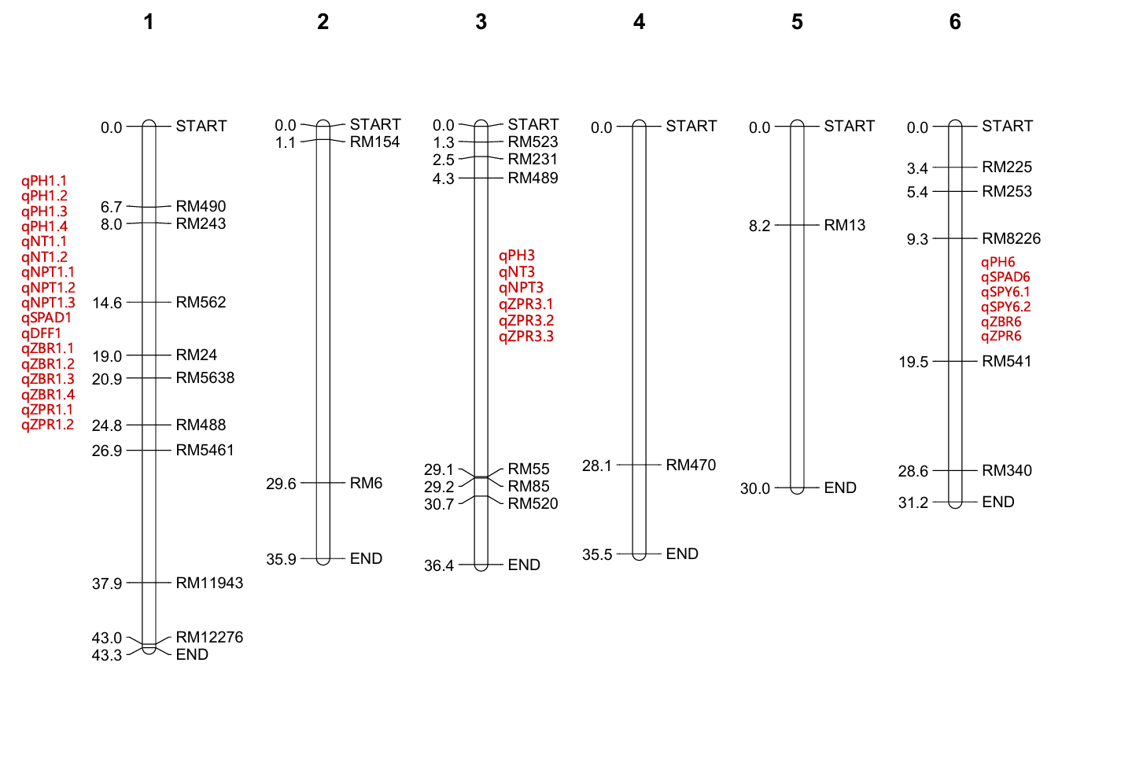
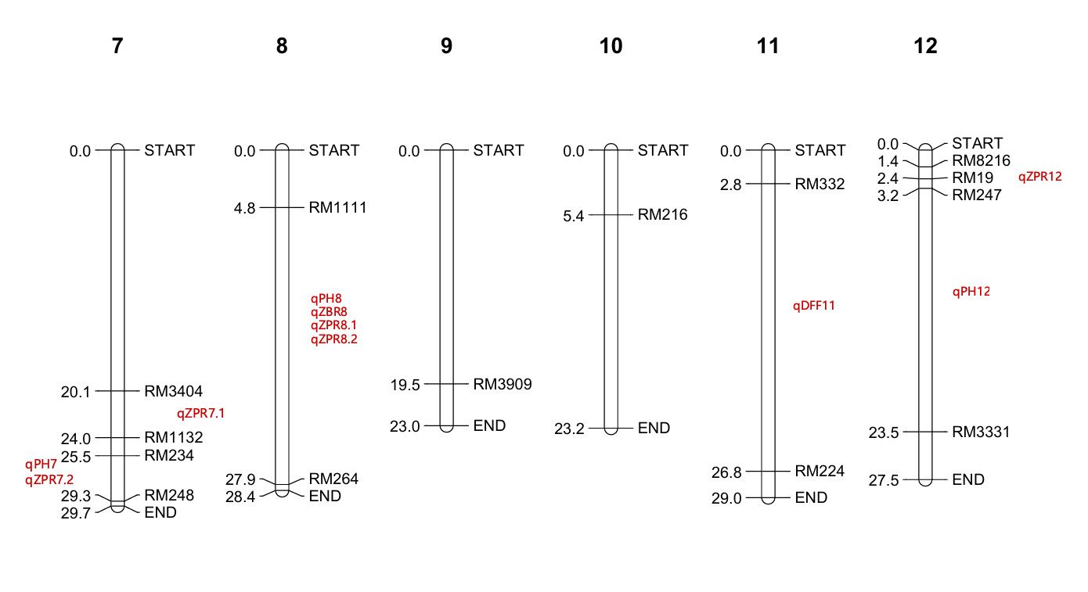
Fig-2: Chromosome wise physical distribution of 38 Polymorphic SSR markers between RNR15048 & Karuppunel along with QTL locations for all the traits.

Discussion
As rice is an important staple food globally, research on its development and the improvement of its nutritional value is an imperative task. Global climate change poses a significant threat to agricultural productivity, with profound implications for global food and nutritional security. Among the critical micronutrient deficiencies, Zn deficiency remains a major public health concern, affecting almost a billion people worldwide. Therefore, rice bio-fortification is a sustainable and eco-friendly approach to addressing micronutrient malnutrition.
In the descriptive analysis, the CV% was highest for SPY (86.30%), followed by ZPR (43.22%) and ZBR (37.16%), indicating the presence of phenotypic variability. For successful selection, it is necessary to study the nature of the association between the character in question and other relevant traits. The associations may be either positive or negative. In this study, ZBR was positively and non-significantly associated with NT, NPT, DFF, and SPY, whereas ZPR was significantly and positively associated with ZBR (0.898619**). SPY was significantly and positively associated with DFF, NT, and NPT. Other findings showed a significant negative correlation between heading date and Zn concentration in brown rice, which was observed for 2 years in the RIL population by Alam et al. (2020). In the parental polymorphism analysis, 210 SSR markers were polymorphic between the parents, of which a total of 38 Zn-related SSR markers identified across the 12 chromosomes were further used in the F₂ population. Similar results on parental polymorphism were reported by Kiranmayi et al. (2014), who used 71 gene-specific markers, of which only 13 (18.3%) were polymorphic, while Choudhary et al. (2013) used 64 rice SSR markers, of which 52 showed polymorphism. Of the 50 SSR markers, 23 were observed to show distinct polymorphism (Suman et al., 2020). A total of 948 SSR markers were screened for parental polymorphism, and 119 were found to be polymorphic between the parents and used for genotyping the population. On selective genotyping, 60 were found to be polymorphic between the parents and RILs. These 60 markers were further utilised for construction of the linkage map and QTL detection by Rathod et al. (2021). Similarly, Sairachana et al. (2023) reported that 166 SSR markers were employed, of which 58 were found to be polymorphic between the parents, with 35% parental polymorphism and a polymorphic information content of about 0.6.
A total of 39 QTLs were identified on seven chromosomes. Nine QTLs were identified for plant height, 3 for number of tillers, 4 for number of productive tillers, 2 for SPAD, 2 for days to flowering, and 2 for single-plant yield. Six QTLs were identified for ZBR, and a total of 11 QTLs were identified for ZPR. Most of the QTLs for different traits were identified on chromosome 1. qSPAD1 had the highest PVE (12.958), while qPH1.1 had the lowest PVE (2.1037). These QTLs and candidate genes help to further elucidate the genetic basis of grain micronutrient concentration and may prove useful for marker-assisted breeding for this important trait (Swamy et al., 2018). Similar findings were reported by Bhat et al. (2022), in which a total of 30 QTLs governing nine different traits were identified using the composite interval mapping (CIM) method. Most of the QTLs were detected on chromosome 2. Other studies obtained 42 and 3 SSR marker associations with grain Fe and Zn content, respectively. Using a GLM model with r 2 >0.10 and p 0.05 filters, novel QTLs qFe3.3 and qFe7.3 for grain Fe and qZn2.2, qZn8.3, and qZn12.3 for Zn were reported in 485 germplasm lines of milled rice by Pradhan et al. (2020). Islam et al. (2020) worked on landraces and reported 15 QTLs, of which only one QTL (QTL.Fe.9) for Fe content was located on chromosome 9 and two (QTL.Zn.4 and QTL.Zn.5) for Zn were located on chromosome 4. A total of 17 QTLs for P, K, Na, Ca, and Mg contents in brown and milled rice, distributed across eight regions, were identified in the BC1F5 population and explained 5.98% to 56.80% of the phenotypic variance. Two regions controlling qCa1.1 and qCa4.1 were validated, and seven new QTLs for Ca and Mg contents were identified in the BC2F4:5 population (Hu et al., 2021). Similarly, in 96 ILs, six QTLs were identified on chromosomes 6, 8, and 10, and all O. rufipogon alleles increased trait values. The positions of qFe10 and qZn10 were further defined; higher Fe and Zn contents were associated with the O. rufipogon segment between the markers RM1873 and RM25612. This study provides valuable information on candidate genes qFe10 and qZn10 from O. rufipogon, which may be vital in developing rice varieties with increased Fe and Zn content (Adeva et al., 2023). Overall, these results show that association mapping represents a possible option for identifying QTLs for the traits. SSRs are therefore becoming a more efficient tool for identifying loci for a particular trait in crop plants. In the present investigation, this technique has been utilised to detect candidate QTLs for bio-fortification of rice for micronutrient traits.

Conclusion
In the present investigation, 38 Zn-related SSR markers that were polymorphic between RNR15048 and Karuppunel were used for genotyping and QTL analysis. The parental genotypes contrasted for grain Zn concentration, with RNR15048 showing approximately 11.2 ppm Zn in brown rice and Karuppunel showing 30.5 ppm. Analysis of the F₂ population revealed substantial phenotypic variability, with the highest CV recorded for single-plant yield, while zinc concentration in polished rice showed a positive association with zinc concentration in brown rice. A total of 39 QTLs associated with the studied traits were identified. Most of the detected QTLs exhibited small individual effects, indicating that the evaluated traits were influenced by multiple genomic regions rather than a few major-effect loci. In several QTL regions, alleles contributed by Karuppunel were associated with increased Zn concentration. Promising lines in the population with high grain Zn can be used for further validation and the development of bio-fortified rice.
Limitation
The findings are specific to the RNR15048 × Karuppunel F₂ population and the evaluated field environment. The population comprised 80 F₂ individuals, and QTL analysis was based on 38 selected polymorphic SSR markers. These features may limit the precision and transferability of QTL interval and effect estimates, particularly for loci with small phenotypic variance explained. Validation in larger populations, additional genetic backgrounds, and further environments is therefore required before the detected QTLs are considered for routine breeding deployment.

Declaration of AI Use

This manuscript was prepared through the intellectual contributions of the author(s) to the study design, data analysis, interpretation of results, and scholarly content. Grammarly and ChatGPT were used solely to assist with grammatical refinement and reference formatting during manuscript revision. The author(s) accept full responsibility for the accuracy, integrity, and final content of the manuscript.

References
Adeva, C., Yun, Y.-T., Shim, K.-C., Luong, N. H., Lee, H.-S., Kang, J.-W., Kim, H.-J., & Ahn, S.-N. (2023). QTL mapping of mineral element contents in rice using introgression lines derived from an interspecific cross. Agronomy, 13(1), 76. https://doi.org/10.3390/agronomy13010076
Alam, M., Chen, Y., Li, P., Lou, G., Zhou, H., Wang, L., Liu, R., Chen, P., Zhou, Y., Gao, G., Tai, D., Zhang, X., & He, Y. (2020). Ghd7 is a negative regulator of zinc concentration in brown rice. Molecular Breeding, 40, 110. https://doi.org/10.1007/s11032-020-01193-x
Bhat, R., Singh, A. K., Mushtaq, M., Salgotra, R. K., Sharma, M., Bhat, B. A., Basu, U., Al-Ashkar, I., Hossain, M. A., Ueda, A., & El Sabagh, A. (2022). Identification of QTLs for yield and associated traits in F₂ population of rice. Phyton-International Journal of Experimental Botany, 91(11), 2439–2459. https://doi.org/10.32604/phyton.2022.020100
Bouis, H. E. (2002). Plant breeding: A new tool for fighting micronutrient malnutrition. The Journal of Nutrition, 132(3), 491S–494S. https://doi.org/10.1093/jn/132.3.491S
Chatterjee, D. (1948). A modified key and enumeration of the species of Oryza Linn. Indian Journal of Agricultural Sciences, 18, 185–192.
Cho, Y.-G., Ishii, T., Temnykh, S., Chen, X., Lipovich, L., McCouch, S. R., Park, W. D., Ayres, N., & Cartinhour, S. (2000). Diversity of microsatellites derived from genomic libraries and GenBank sequences in rice (Oryza sativa L.). Theoretical and Applied Genetics, 100(5), 713–722. https://doi.org/10.1007/s001220051343
Choudhary, G., Ranjitkumar, N., Surapaneni, M., Deborah, D. A., Vipparla, A., Anuradha, G., Siddiq, E. A., & Vemireddy, L. R. (2013). Molecular genetic diversity of major Indian rice cultivars over decadal periods. PLoS ONE, 8(6), e66197. https://doi.org/10.1371/journal.pone.0066197
Doyle, J. J., & Doyle, J. L. (1987). A rapid DNA isolation procedure for small quantities of fresh leaf tissue. Phytochemical Bulletin, 19(1), 11–15. https://worldveg.tind.io/record/33886
Frassinetti, S., Bronzetti, G. L., Caltavuturo, L., Cini, M., & Della Croce, C. (2006). The role of zinc in life: A review. Journal of Environmental Pathology, Toxicology and Oncology, 25(3), 597–610. https://doi.org/10.1615/JEnvironPatholToxicolOncol.v25.i3.40
Gemayel, R., Cho, J., Boeynaems, S., & Verstrepen, K. J. (2012). Beyond junk-variable tandem repeats as facilitators of rapid evolution of regulatory and coding sequences. Genes, 3(3), 461–480. https://doi.org/10.3390/genes3030461
Habde, S. V., Singh, S. K., Singh, D. K., Singh, A. K., Sah, R. P., Korada, M., Khaire, A. R., Majhi, P. K., Singh, U. M., Singh, V. K., & Kumar, A. (2024). QTL mapping reveals different set of candidate genes governing stable and location specific QTLs enhancing zinc and iron content in rice. Euphytica, 220, 179. https://doi.org/10.1007/s10681-024-03433-z
Hore, T. K., Balachiranjeevi, C. H., Inabangan-Asilo, M. A., Deepak, C. A., Palanog, A. D., Hernandez, J. E., Gregorio, G. B., Dalisay, T. U., Diaz, M. G. Q., Fritsche Neto, R., Kader, M. A., Biswas, P. S., & Swamy, B. P. M. (2024). Genomic prediction and QTL analysis for grain Zn content and yield in Aus-derived rice populations. Journal of Plant Biochemistry and Biotechnology, 33(2), 216–236. https://doi.org/10.1007/s13562-024-00886-0
Horton, S., Alderman, H., & Rivera, J. A. (2008). Hunger and malnutrition: Copenhagen Consensus 2008 challenge paper. Copenhagen Consensus Center.
Hu, B.-L., Li, X., Wu, T., Huang, D.-R., Huang, F.-L., Yin, J.-H., & Wu, Y.-S. (2021). Identification and validation of QTLs for macronutrient contents in brown and milled rice using two backcross populations between Oryza sativa and O. rufipogon. BioMed Research International, 2021, 5561734. https://doi.org/10.1155/2021/5561734
Islam, M. Z., Arifuzzaman, M., Banik, S., Hossain, M. A., Ferdous, J., Khalequzzaman, M., Pittendrigh, B. R., Tomita, M., & Ali, M. P. (2020). Mapping QTLs underpin nutrition components in aromatic rice germplasm. PLoS ONE, 15(6), e0234395. https://doi.org/10.1371/journal.pone.0234395
Jiang, G.-L. (2013). Plant marker-assisted breeding and conventional breeding: Challenges and perspectives. Advances in Crop Science and Technology, 1(3), e106. https://doi.org/10.4172/2329-8863.1000e106
Joshi, G., Soe, Y. P., Palanog, A., Hore, T. K., Nha, C. T., Calayugan, M. I., Inabangan-Asilo, M. A., Amparado, A., Pandey, I. D., Cruz, P. C. S., Hernandez, J. E., & Swamy, B. P. M. (2023). Meta-QTLs and haplotypes for efficient zinc biofortification of rice. The Plant Genome, 16(4), e20315. https://doi.org/10.1002/tpg2.20315
Kiranmayi, S. L., Manorama, K., Tripura Venkata, V. G. N., Radhika, K., Cheralu, C., Roja, V., & Sarla, N. (2014). Identification of markers associated with iron and zinc concentration in recombinant inbred lines of brown rice. The Indian Journal of Genetics and Plant Breeding, 74(4), 423–429. https://doi.org/10.5958/0975-6906.2014.00865.7
Mahender, A., Anandan, A., Pradhan, S. K., & Pandit, E. (2016). Rice grain nutritional traits and their enhancement using relevant genes and QTLs through advanced approaches. SpringerPlus, 5, 2086. https://doi.org/10.1186/s40064-016-3744-6
Mason, A. S. (2015). SSR genotyping. In J. Batley (Ed.), Plant genotyping: Methods and protocols (Methods in Molecular Biology, Vol. 1245, pp. 77–89). Humana Press. https://doi.org/10.1007/978-1-4939-1966-6_6
McCouch, S. R., Chen, X., Panaud, O., Temnykh, S., Xu, Y., Cho, Y. G., Huang, N., Ishii, T., & Blair, M. (1997). Microsatellite marker development, mapping and applications in rice genetics and breeding. Plant Molecular Biology, 35(1–2), 89–99. https://doi.org/10.1023/A:1005711431474
Phattarakul, N., Rerkasem, B., Li, L. J., Wu, L. H., Zou, C. Q., Ram, H., Sohu, V. S., Kang, B. S., Surek, H., Kalayci, M., Yazici, A., Zhang, F. S., & Cakmak, I. (2012). Biofortification of rice grain with zinc through zinc fertilization in different countries. Plant and Soil, 361(1–2), 131–141. https://doi.org/10.1007/s11104-012-1211-x
Pradhan, S. K., Pandit, E., Pawar, S., Naveenkumar, R., Barik, S. R., Mohanty, S. P., Nayak, D. K., Ghritlahre, S. K., Sanjiba Rao, D., Reddy, J. N., & Patnaik, S. S. C. (2020). Linkage disequilibrium mapping for grain Fe and Zn enhancing QTLs useful for nutrient dense rice breeding. BMC Plant Biology, 20, 57. https://doi.org/10.1186/s12870-020-2262-4
Rao, D. S., Babu, P. M., Swarnalatha, P., Kota, S., Bhadana, V. P., Varaprasad, G. S., Surekha, K., Neeraja, C. N., & Babu, V. R. (2014). Assessment of grain zinc and iron variability in rice germplasm using energy dispersive X-ray fluorescence spectrophotometer (ED-XRF). Journal of Rice Research, 7(1–2), 45–52. https://sarr.co.in/wp-content/uploads/jrr-volume-7-6-1.pdf
Rathod, R., Suman, K., Madhubabu, P., Subbarao, L. V., Eswari, K. B., Srinivasa Chary, D., & Neeraja, C. N. (2021). Identification of genomic regions associated with grain zinc concentration in RILs derived from popular cultivar MTU1010 and BR2655 of rice. The Indian Journal of Genetics and Plant Breeding, 81(4), 538–547. https://doi.org/10.31742/ISGPB.81.4.6
Roohani, N., Hurrell, R., Kelishadi, R., & Schulin, R. (2013). Zinc and its importance for human health: An integrative review. Journal of Research in Medical Sciences, 18(2), 144–157. https://www.research-collection.ethz.ch/handle/20.500.11850/65889
Saikrishna, M., Maurya, C. L., Neeraja, C. N., Suman, K., Taidalwar, M. M., Keerthi, I., Haobam, R., Bollinedi, H., & Singh, S. (2025). Simple sequence repeat (SSR) marker-based parental polymorphism analysis between Improved Samba Mahsuri and Karuppunel for grain iron and zinc content in rice (Oryza sativa L.). Journal of Advances in Biology & Biotechnology, 28(5), 737–751. https://doi.org/10.9734/jabb/2025/v28i52335
Sairachana, R., Suji, K. K., Gokulakrishnan, M., Raveendran, M., Gopalakrishnan, C., & Ramalingam, J. (2023). Parental polymorphism survey using rice microsatellite markers between VGD 1 and ADT 55 for marker-assisted backcross breeding program. The Pharma Innovation Journal, 12(6), 3256–3259. https://doi.org/10.22271/tpi.2023.v12.i6al.20850
Singh, H., Deshmukh, R. K., Singh, A., Singh, A. K., Gaikwad, K., Sharma, T. R., Mohapatra, T., & Singh, N. K. (2010). Highly variable SSR markers suitable for rice genotyping using agarose gels. Molecular Breeding, 25(2), 359–364. https://doi.org/10.1007/s11032-009-9328-1
Suman, K., Madhubabu, P., Rathod, R., Sanjeeva Rao, D., Rojarani, A., Prashant, S., Subbarao, L. V., Ravindrababu, V., & Neeraja, C. N. (2020). Variation of grain quality characters and marker-trait association in rice (Oryza sativa L.). Journal of Genetics, 99, 5. https://doi.org/10.1007/s12041-019-1164-4
Balaji Suresh, P., Srikanth, B., Hemanth Kishore, V., Subhakara Rao, I., Vemireddy, L. R., Dharika, N., Sundaram, R. M., Ramesha, M. S., Sambasiva Rao, K. R. S., Viraktamath, B. C., & Neeraja, C. N. (2012). Fine mapping of Rf3 and Rf4 fertility restorer loci of WA-CMS of rice (Oryza sativa L.) and validation of the developed marker system for identification of restorer lines. Euphytica, 187(3), 421–435. https://doi.org/10.1007/s10681-012-0737-6
Swamy, B. P. M., Descalsota, G. I. L., Nha, C. T., Amparado, A., Inabangan-Asilo, M. A., Manito, C., Tesoro, F., & Reinke, R. (2018). Identification of genomic regions associated with agronomic and biofortification traits in DH populations of rice. PLoS ONE, 13(8), e0201756. https://doi.org/10.1371/journal.pone.0201756
Xu, Y., & Crouch, J. H. (2008). Marker-assisted selection in plant breeding: From publications to practice. Crop Science, 48(2), 391–407. https://doi.org/10.2135/cropsci2007.04.0191

