Review Article

Plant DNA damage response and repair pathways: From molecular mechanisms to crop improvement

ABSTRACT
Genome stability is essential for plant growth, development, reproduction and adaptation under changing environmental conditions. Plants are continuously exposed to endogenous metabolic by-products and environmental stresses that generate diverse DNA lesions and threaten genome integrity. This review synthesises the molecular basis of plant DNA damage responses and major repair pathways, with emphasis on their coordination and relevance to crop improvement. The plant DNA damage response integrates lesion sensing, signal transduction, cell-cycle regulation, chromatin remodelling and repair. ATM and ATR kinases, together with the plant-specific transcription factor SOG1, coordinate responses to double-strand breaks, replication stress and other forms of DNA damage. Major repair mechanisms include direct reversal repair, base excision repair, nucleotide excision repair, mismatch repair, homologous recombination, classical non-homologous end joining and alternative end joining. Their combined activities support genome stability, stress adaptation, photosynthetic performance and reproductive fitness. DNA repair pathway choice also influences the outcomes of mutagenesis and CRISPR/Cas-mediated genome editing, including gene knockout, targeted insertion and allele replacement. Integration of DNA repair biology with molecular breeding, genomic selection, speed breeding and multi-omics approaches provides a framework for improving editing precision and exploiting useful genetic variation. A more integrated understanding of plant DNA repair regulation may therefore support the development of crop varieties with improved resilience to adverse environmental conditions.
Keywords: crop improvement; DNA damage response (DDR); DNA repair pathways; genome stability; stress adaptation.

1. INTRODUCTION

Plants are continuously exposed to harsh environmental conditions. These conditions can threaten the integrity of genetic material throughout their life cycle. Unlike mobile organisms, plants cannot escape adverse conditions and therefore rely on sophisticated DNA damage response and repair systems. Genome stability is essential for plant growth, development, reproduction and evolutionary success (Roy, 2014). Consequently, plants have efficient genome surveillance systems that monitor DNA integrity and coordinate cellular responses to maintain genomic stability (Manova & Gruszka, 2015). Recent syntheses further emphasise that maintenance of plant genome integrity depends on coordinated interactions among DNA repair, chromatin dynamics, and stress-responsive regulatory processes (Bergis-Ser et al., 2024; Sincinelli et al., 2025).
Despite the remarkable stability of the plant genome, DNA is inherently vulnerable to damage arising from endogenous metabolic activities and exogenous environmental stresses (Nimeth et al., 2020). DNA damage refers to any alteration in the chemical composition or structural organisation of the DNA molecule. Damaged DNA alters essential biological processes such as replication, transcription, recombination and chromosome segregation (Hacker et al., 2020). Failure to repair damaged DNA has negative consequences for cellular homeostasis and plant growth. At the cellular level, these molecular defects manifest as impaired growth, reduced fertility, developmental abnormalities, premature senescence and reduced tolerance to environmental stresses (Waterworth et al., 2011).
To counteract the threats of DNA damage, plants rapidly activate an evolutionarily conserved signalling network collectively referred to as the DNA Damage Response (DDR). DDR integrates damage sensing, signal transduction, cell-cycle regulation, chromatin remodelling and DNA repair (Szurman-Zubrzycka et al., 2023; Herbst et al., 2024). DDR is initiated primarily through the activation of phosphatidylinositol-3-kinase-related kinases, Ataxia Telangiectasia Mutated (ATM) and ATM and Rad3-Related (ATR). ATM and ATR act as major sensors of DNA double-strand breaks and replication stress, respectively. These signalling pathways subsequently activate the plant-specific NAC-domain transcription factor Suppressor of Gamma Response 1 (SOG1). SOG1 functions as a central transcriptional regulator of the plant DNA damage response by coordinating the expression of numerous genes involved in DNA repair, cell-cycle arrest, endoreduplication and programmed cell death. Plants possess highly conserved DNA repair pathways, including photoreactivation (PR), base excision repair (BER), nucleotide excision repair (NER), mismatch repair (MMR), homologous recombination (HR) and non-homologous end joining (NHEJ), each specialised for repairing specific types of DNA damage, thereby preserving genome integrity and ensuring normal cellular function (Merker et al., 2024; Asik et al., 2026).
In addition to their biological significance, plant DNA repair pathways have gained considerable attention as valuable targets for modern crop improvement strategies. Advances in genome editing technologies, particularly CRISPR/Cas systems, have demonstrated that editing efficiency and repair precision are determined by DNA repair pathways. Recent studies demonstrate that chromatin organisation and epigenetic modifications influence DNA damage formation, lesion recognition and repair efficiency. The DNA repair pathway choice influences the spectrum of mutations generated during mutagenesis and genome editing. This variation has important implications for both natural evolution and crop improvement (Pacher & Puchta, 2017; Monroe et al., 2022). Recent reviews of CRISPR/Cas9 applications in crops further support the use of targeted genome editing as a practical approach for accelerating trait improvement through controlled genome modification (Sathiyabalan et al., 2024).Despite substantial progress in defining individual plant DNA repair pathways and their roles in genome maintenance, an integrated synthesis linking damage sensing, pathway coordination, stress adaptation, and crop-improvement applications remains comparatively limited. This review therefore addresses this gap by bringing these interconnected aspects together within a single framework.
This review summarises recent advances in plant DNA damage response and repair pathways with an emphasis on molecular mechanisms, regulatory networks and functional roles. Furthermore, the review discusses how advances in DNA repair biology are shaping modern crop improvement strategies through molecular breeding, genome editing and the development of climate-resilient crop varieties.

2. Sources of DNA damage in plants.

Endogenous DNA damage is an inevitable consequence of normal cellular metabolism and occurs continuously even under optimal growth conditions (Thada & Greenberg, 2022). One of the primary endogenous sources is the generation of reactive oxygen species (ROS), such as superoxide radicals (O₂•⁻), hydrogen peroxide (H₂O₂) and hydroxyl radicals (•OH) (Alam et al., 2025; Fathi et al., 2025). ROS are generated during photosynthesis, mitochondrial respiration and photorespiration (Mansoor et al., 2022). These highly reactive molecules oxidise DNA bases, generate abasic (AP) sites, and cause single- and double-strand breaks. In addition, spontaneous hydrolytic reactions such as depurination, deamination, DNA replication errors, DNA polymerase slippage and topoisomerase-mediated strand cleavage contribute to DNA damage (Lindahl, 1993).
Exogenous factors such as solar ultraviolet (UV) radiation, including UV-B radiation, directly induce cyclobutane pyrimidine dimers (CPDs) and 6-4 photoproducts. These CPDs and 6-4 PPs distort the DNA helix and obstruct transcription and replication (Fraikin et al., 2024). Ionising radiation, including X-rays and gamma rays, generates DNA double-strand breaks either directly or indirectly through ROS formation. Exposure to heavy metals (cadmium, chromium, arsenic, aluminium), environmental pollutants, pesticides and herbicides enhances oxidative stress, leading to DNA fragmentation (Mohamed et al., 2025). Heat stress disrupts DNA replication, destabilises replication forks and increases ROS production (Liu et al., 2026). Cold stress can promote chromosomal fragmentation through oxidative injury. Salinity and drought can additionally induce replication stress and impair DNA replication fork progression (Singh et al., 2022). Infection by viruses, bacteria, fungi and nematodes often elevates ROS levels that inadvertently damage host DNA. Certain pathogens additionally manipulate host DNA replication, chromatin organisation and cell-cycle regulation to increase the incidence of DNA lesions (Nisa et al., 2019).
Collectively, these stresses generate a broad spectrum of DNA lesions that differ in their chemical nature, frequency and biological consequences. The diversity and complexity of these lesions necessitate specialised DNA damage response and repair pathways in plants. The diverse sources of DNA damage in plants are summarised in Figure 1.
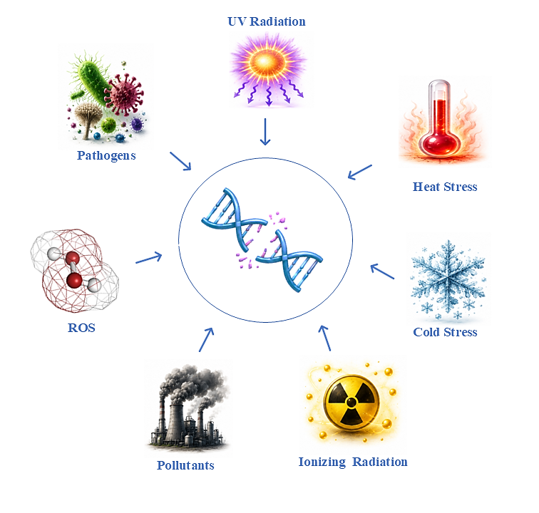
Figure 1. Major sources of DNA damage in plants.
3. Types of DNA damage in plants.

Diverse physical, chemical and biological agents produce different forms of DNA damage. Each genotoxic stress induces a characteristic spectrum of DNA lesions depending on its mode of action, exposure intensity and the physiological condition of the plant. Collectively, DNA damage in plants can be broadly categorised into base modifications, abasic (AP) sites, single-strand breaks (SSBs), double-strand breaks (DSBs), bulky DNA adducts, pyrimidine dimers and DNA–protein crosslinks (DPCs) (Shen & Li, 2022). Base modifications constitute one of the most common forms of DNA damage and include oxidation, alkylation and deamination of nucleotides (Andrés et al., 2023). Oxidative lesions such as 8-oxoguanine (8-oxoG) can frequently cause GC→TA transversion mutations. Spontaneous depurination generates abasic (AP) sites, and deamination converts cytosine to uracil or 5-methylcytosine to thymine, hindering normal base-pairing (Grin et al., 2023). These minor lesions can significantly compromise replication fidelity and gene expression when accumulated over time (Lindahl, 1993).

More severe forms of DNA damage include single-strand breaks (SSBs), double-strand breaks (DSBs), DNA-protein crosslinks, interstrand crosslinks, intrastrand crosslinks, bulky DNA adducts and chromosomal rearrangements. Among these, DSBs are considered the most cytotoxic because both DNA strands are simultaneously disrupted, posing a serious threat to chromosome integrity and cell viability (Roy, 2014). UV-induced cyclobutane pyrimidine dimers (CPDs) and 6-4 photoproducts create bulky distortions that block transcription and DNA replication (Kaya et al., 2024). Interstrand crosslinks prevent strand separation during replication and transcription. If these lesions remain unrepaired or are inaccurately repaired, they may lead to chromosomal deletions, inversions, translocations, aneuploidy or cell death (Nakamura et al., 2021).

Before DNA repair can be initiated, damaged DNA must be accurately detected and the appropriate repair machinery must be recruited. Plants have a highly coordinated DNA damage response (DDR) that senses DNA damage, transduces damage signals, and activates cell-cycle checkpoints and DNA repair gene expression. This integrated response not only facilitates efficient lesion repair but also enhances plant adaptation to environmental stresses. The major forms of DNA lesions encountered in plants and their structural characteristics are illustrated in Figure 2.
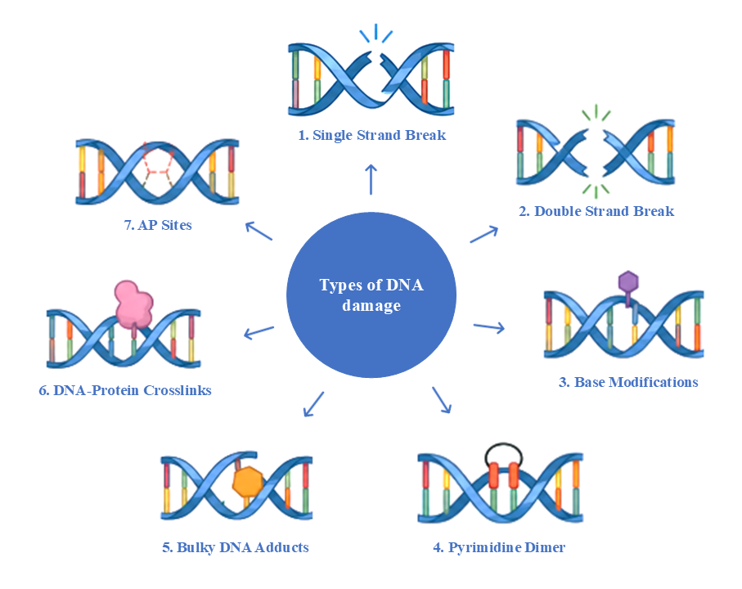
Figure 2. Major types of DNA damage in plants.

- DNA DAMAGE RESPONSE (DDR): SENSING AND SIGNALLING
DNA repair in plants is initiated through a well-conserved surveillance system commonly known as the DNA Damage Response (DDR). DDR continuously monitors and coordinates appropriate cellular responses following DNA damage. Since plants are sessile organisms and remain continuously exposed to fluctuating environmental stresses, an efficient DDR is indispensable for balancing genome maintenance with growth, development and reproduction (Serrano-Mislata et al., 2025; Raina et al., 2021). DDR is an integrated signalling network that senses DNA lesions, amplifies damage signals, regulates the cell cycle and remodels chromatin. DDR ultimately determines whether damaged cells undergo repair, endoreduplication or programmed cell death (Clay & Fox, 2021). This coordinated response ensures that damaged DNA is not replicated or transmitted to daughter cells, preventing the accumulation of deleterious mutations. The major components and sequential events of the plant DDR signalling network are summarised in Figure 3.
The first stage of the DDR involves the recognition of DNA lesions by specialised sensor proteins. DNA double-strand breaks (DSBs), considered the most severe form of DNA damage, are rapidly recognised by the MRE11–RAD50–NBS1 (MRN) complex, which recruits downstream signalling proteins to damaged chromatin. Replication stress, characterised by stalled replication forks and extensive single-stranded DNA, is detected through the accumulation of Replication Protein A (RPA) on exposed DNA. These primary sensor complexes serve as molecular platforms for recruiting phosphatidylinositol-3-kinase-related protein kinases (PIKKs) (Park & Lee, 2026).
Central to plant DDR are the protein kinases Ataxia Telangiectasia Mutated (ATM) and ATM and Rad3-Related (ATR), which function as master regulators of DNA damage signalling. ATM is predominantly activated in response to DNA double-strand breaks, whereas ATR is primarily activated by replication stress (Martens et al., 2020). Following activation, ATM and ATR phosphorylate numerous downstream proteins involved in DNA repair, checkpoint regulation and chromatin remodelling. Although their activation mechanisms differ, both kinases exhibit considerable functional overlap and collectively ensure robust protection of the plant genome.
Unlike mammals, higher plants do not possess the canonical p53–CHK2 signalling module that coordinates the DNA damage response. Plants have a unique regulatory module centred on the NAC-domain transcription factor Suppressor of Gamma Response 1 (SOG1). SOG1 is directly phosphorylated by ATM and ATR following DNA damage and functions as the principal transcriptional regulator of the plant DNA damage response. Once activated, SOG1 induces the expression of hundreds of genes associated with DNA repair, homologous recombination, nucleotide metabolism, antioxidant defence, cell-cycle arrest and programmed cell death. Consequently, SOG1 is widely recognised as the functional equivalent of mammalian p53 despite lacking sequence homology, representing a remarkable example of convergent evolution in genome surveillance mechanisms (Ogita et al., 2018).
An essential function of the DDR is the temporary arrest of the cell cycle to provide sufficient time for DNA repair before DNA replication or mitosis proceeds. DNA damage activates checkpoint pathways that inhibit cyclin-dependent kinase (CDK) activity through induction of SIAMESE-RELATED (SMR) proteins and repression of mitotic cyclins. If genomic damage exceeds the repair capacity of the cell, irreversible pathways including programmed cell death are activated to eliminate severely damaged cells and protect surrounding tissues.
Recent studies have further demonstrated that chromatin architecture plays a pivotal role in regulating DDR efficiency. Histone phosphorylation, acetylation, methylation and ubiquitination dynamically modify chromatin accessibility surrounding DNA lesions. These modifications facilitate the recruitment of repair proteins while simultaneously influencing repair pathway selection. Chromatin-remodelling complexes transiently relax nucleosome organisation to expose damaged DNA; additionally, epigenetic modifications contribute to transcriptional reprogramming during stress adaptation. Collectively, the plant DNA damage response represents an efficient signalling network that integrates lesion recognition, downstream repair mechanisms and developmental decisions. The DDR enables plants to adapt to fluctuating environmental conditions while ensuring the continuity of cellular functions.
Table 1. Functional Components of the Plant DNA Damage Response (DDR) Signaling Network
DDR component | Protein type | Molecular function | References
MRN complex  (MRE11–RAD50–NBS1) | DNA damage sensor complex | Recognizes DSBs and recruits ATM kinase | (Herbst et al.,2024)
ATM | Ser/Thr protein kinase | Phosphorylates checkpoint and repair proteins following DSB detection | (Ashley et al., 2014)
ATR | Ser/Thr protein kinase | Activates checkpoint signaling during DNA replication stress | (Nisa et al., 2019)
SOG1 | NAC-family transcription factor | Master transcriptional regulator of the plant DDR | (Ogita et al.,2018)
WEE1 | Cell-cycle checkpoint kinase | Delays G2/M transition to allow DNA repair | (Szurman-Zubrzycka et al., 2023)
RAD51 | Recombinase | Catalyzes homologous strand invasion during HR | (Shen et al., 2022)
CDKs/Cyclins | Cell-cycle regulators | Control cell-cycle progression after DNA damage | (Ashley et al., 2014)

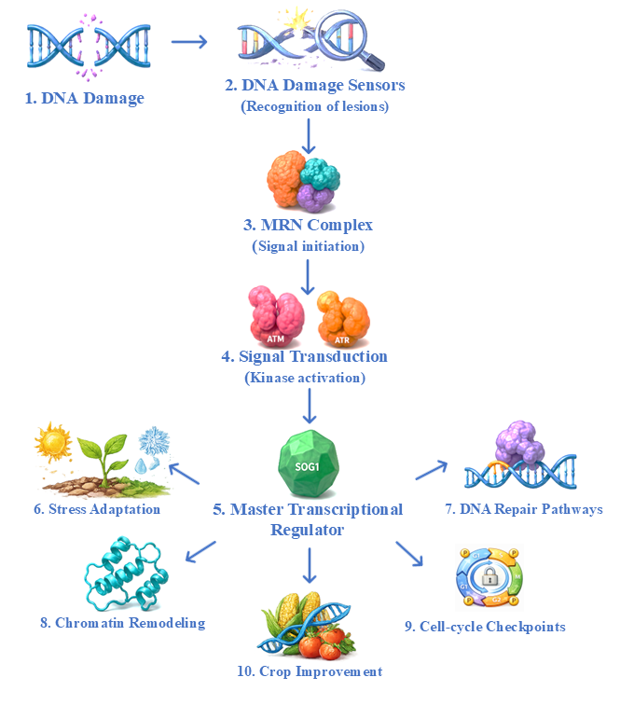
Figure 3. Schematic overview of the plant DNA damage response (DDR).
- DNA REPAIR MECHANISMS IN PLANTS.
DNA lesions vary considerably in their chemical composition, structural complexity and biological consequences. Plants have specialised DNA repair pathways that recognise and eliminate specific types of damage through distinct molecular mechanisms. These pathways operate in a coordinated manner to restore normal DNA structure, ensure accurate DNA replication and transcription, and minimise mutations. The principal repair systems identified in plants include direct reversal repair (DRR), base excision repair (BER), nucleotide excision repair (NER), mismatch repair (MMR), homologous recombination (HR) and non-homologous end joining (NHEJ) (Hacker et al., 2020; Asik et al., 2026).

5.1 Direct reversal repair (DRR):
Direct reversal repair (DRR) constitutes the first line of defence against specific forms of DNA damage by directly restoring chemically modified nucleotides without excision or DNA resynthesis (Manova & Gruszka, 2015). Following lesion recognition and activation of the DNA damage response, plants recruit specialised repair pathways according to the chemical nature of the DNA lesion. Among these, direct reversal repair (DRR) represents the simplest mechanism. Because plants rely on sunlight for photosynthesis, photoreactivation is considerably more prominent in plants than in many animal systems. In higher plants, photoreactivation represents the predominant DRR mechanism and serves as the primary defence against ultraviolet (UV)-induced DNA damage (Sancar, 2003). The major steps involved in photoreactivation of UV-induced DNA lesions in plants are illustrated in Figure 4.

Solar UV-B radiation (280–315 nm) primarily induces two classes of DNA photoproducts: cyclobutane pyrimidine dimers (CPDs) and pyrimidine (6–4) pyrimidone photoproducts (6–4 PPs). These lesions are generated when adjacent pyrimidine bases (thymine and cytosine) become covalently linked following photon absorption. The rapid removal of these lesions is particularly critical for photosynthetically active tissues since they are continuously exposed to sunlight.

Photoreactivation is catalysed by DNA photolyases, members of the highly conserved cryptochrome/photolyase family (CPF) of flavoproteins that specifically recognise UV-induced photoproducts and repair them using blue or near-ultraviolet light (approximately 350–500 nm) as an external energy source. Plant genomes encode two major classes of photolyases, i.e., CPD photolyase (PHR1) and (6–4) photolyase (UVR3). CPD photolyase (PHR1) specifically repairs cyclobutane pyrimidine dimers, and (6–4) photolyase (UVR3) removes 6–4 photoproducts. Both enzymes contain the catalytic cofactor reduced flavin adenine dinucleotide (FADH⁻) and a light-harvesting chromophore, commonly methenyltetrahydrofolate (MTHF) or 8-hydroxy-5-deazariboflavin (8-HDF) (Zgłobicki et al., 2024). Upon absorption of blue light, excitation energy is transferred to FADH⁻, initiating electron transfer to the damaged DNA and cleaving the abnormal covalent bonds linking adjacent pyrimidines. This reaction restores the native DNA structure without generating strand breaks or requiring DNA synthesis. Photoreactivation is one of the fastest and most accurate DNA repair mechanisms identified in plants. Photolyases are evolutionarily conserved across bacteria, fungi and plants, although they have been lost in placental mammals (Sancar, 2008).
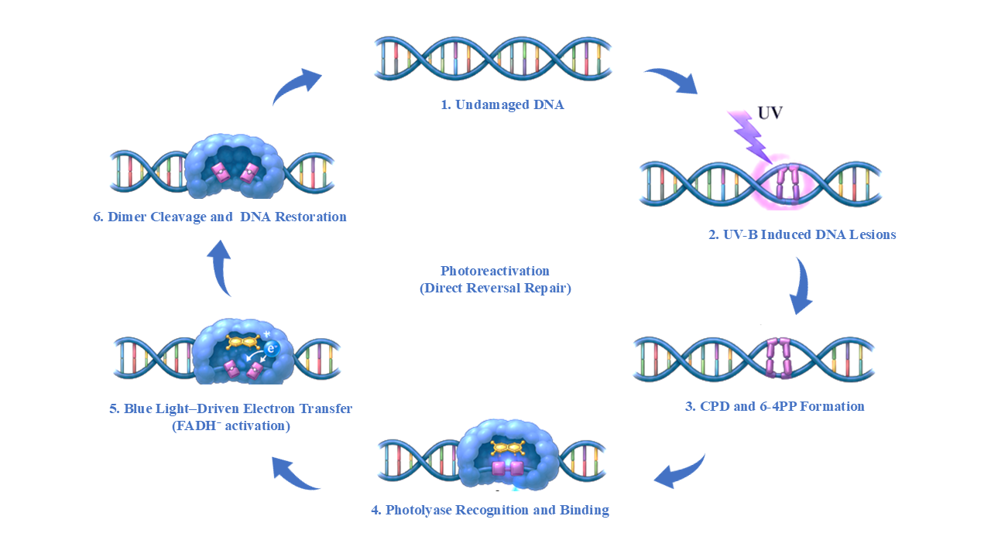
Figure 4. Schematic representation of photoreactivation, a direct reversal DNA repair mechanism in plants.

5.2 Base Excision Repair (BER)

In plants, BER primarily functions to eliminate small, non-helix-distorting DNA lesions. Unlike bulky DNA damage repaired by nucleotide excision repair, BER specifically targets chemically modified bases generated through oxidation, alkylation, deamination, spontaneous hydrolysis and base loss. Since plants experience persistent oxidative stress during photosynthesis, respiration and abiotic stress conditions, BER represents one of the major defence mechanisms in plants. A schematic representation of the major steps involved in plant BER is presented in Figure 5.

The BER pathway proceeds through a sequence of enzymatic reactions involving damage recognition, base excision, AP-site processing, gap filling and DNA ligation. The repair process is initiated by lesion-specific DNA glycosylases, which continuously scan genomic DNA and recognise chemically modified bases. Upon lesion recognition, DNA glycosylases cleave the N-glycosidic bond between the damaged base and the deoxyribose sugar, releasing the altered nucleotide and generating an apurinic/apyrimidinic (AP) site (Wallace, 2014). Plant genomes encode a diverse repertoire of DNA glycosylases specialised for different classes of damaged bases. 8-Oxoguanine DNA glycosylase (OGG1) specifically removes the highly mutagenic oxidative lesion 8-oxoguanine, whereas formamidopyrimidine DNA glycosylase (FPG) excises oxidised purines generated by reactive oxygen species. Uracil DNA glycosylase (UNG) removes uracil residues resulting from cytosine deamination or nucleotide misincorporation during DNA replication (Zhao et al., 2025).

Following the removal of a damaged base, the resulting AP site is processed by AP endonucleases, principally APE1L and ARP. These AP endonucleases cleave the phosphodiester backbone immediately adjacent to the abasic site. This incision generates a single-strand DNA break containing appropriate 3′-hydroxyl and 5′-deoxyribose phosphate termini required for subsequent repair synthesis (Jordano-Raya et al., 2025). In plants, AP endonucleases also exhibit phosphodiesterase and phosphatase activities that remove blocking groups generated during oxidative damage, thereby facilitating efficient DNA repair. AP sites themselves are highly cytotoxic and can interfere with DNA replication and transcription (Córdoba-Cañero et al., 2014).

Repair synthesis is subsequently carried out by specialised DNA polymerases that restore the missing nucleotide(s). Plant BER operates through two complementary mechanisms: short-patch BER, in which a single nucleotide is inserted, and long-patch BER, in which two to several nucleotides are synthesised before strand displacement (Roldán-Arjona et al., 2019). DNA polymerase λ is the principal polymerase involved in plant BER. The remaining nick is finally sealed by DNA ligase I, thereby restoring the original DNA sequence and completing the repair process with high fidelity (Morales-Ruiz et al., 2024).

Transcriptomic and functional genomic analyses have demonstrated that genes encoding OGG1, UNG, APE1L and DNA ligase I are strongly induced under drought, salinity, heat stress, heavy metal exposure and oxidative stress conditions (Zhao et al., 2025). Enhanced BER activity has been correlated with improved stress tolerance, maintenance of photosynthetic efficiency, reduced mutation frequency and increased survival under adverse environments. Moreover, because chloroplasts and mitochondria generate large quantities of reactive oxygen species during photosynthesis and respiration, BER represents the predominant DNA repair pathway operating within these organelles (Mahapatra et al., 2021).

5.3 Nucleotide Excision Repair (NER)
NER is a versatile and evolutionarily conserved DNA repair pathway responsible for removing bulky, helix-distorting DNA lesions that cannot be corrected by direct reversal repair or base excision repair. Unlike BER, which excises a single damaged base, NER removes a short oligonucleotide fragment containing the lesion, followed by DNA resynthesis and ligation to restore genome integrity. In plants, NER serves as the primary light-independent mechanism for repairing ultraviolet (UV)-induced DNA photoproducts, bulky chemical adducts, intra-strand crosslinks and numerous helix-distorting DNA lesions (Manova & Gruszka, 2015).

NER proceeds through a sequence of molecular events comprising damage recognition, local DNA unwinding, dual incision, repair synthesis and ligation. Based on the mode of lesion recognition, NER is divided into two interconnected subpathways, i.e., Global Genome Repair (GGR) and Transcription-Coupled Repair (TCR). Although both pathways utilise common excision and repair machinery after lesion recognition, they differ in how DNA damage is initially detected. Global Genome Repair continuously surveys the entire genome for structural distortions regardless of transcriptional activity. Transcription-Coupled Repair specifically removes lesions that obstruct RNA polymerase II during active transcription. This dual surveillance strategy enables plants to protect both coding and non-coding genomic regions (Marteijn et al., 2014).

In the Global Genome Repair pathway, lesion recognition is mediated primarily by the UV-Damaged DNA Binding (UV-DDB) complex and the Xeroderma Pigmentosum Complementation Group C (XPC) protein. The UV-DDB complex exhibits exceptionally high affinity for UV-induced photoproducts, particularly cyclobutane pyrimidine dimers, and facilitates recruitment of XPC to damaged chromatin. XPC subsequently serves as the principal damage sensor that initiates assembly of the pre-incision repair complex (Kusakabe et al., 2019). Following lesion recognition, local DNA unwinding is accomplished by the Transcription Factor IIH (TFIIH) complex containing the ATP-dependent helicases XPB and XPD (Masuda et al., 2020). These helicases unwind approximately 20–30 nucleotides surrounding the damaged DNA, generating an open repair bubble that permits precise positioning of downstream repair proteins. Additional factors, including XPA and Replication Protein A (RPA), stabilise the unwound DNA and verify the presence of the lesion before excision occurs. During Transcription-Coupled Repair, stalling of RNA polymerase II at DNA lesions promotes recruitment of Cockayne Syndrome proteins CSA and CSB, which facilitate displacement of the polymerase and assembly of the common NER repair machinery (Bravo & Fan, 2026; Kose et al., 2024).

Once the repair complex has been assembled, the damaged DNA strand undergoes dual incision on both sides of the lesion. The structure-specific endonucleases XPF–ERCC1 and XPG introduce incisions at the 5′ and 3′ sides of the damaged nucleotide, respectively. These endonucleases release an oligonucleotide fragment approximately 24–32 nucleotides in length that contains the DNA lesion. DNA polymerases subsequently synthesize new DNA using the undamaged complementary strand as a template. DNA ligase I seals the remaining nick to restore the integrity of the phosphodiester backbone. Consequently, NER restores DNA integrity with high fidelity while preserving genomic stability and ensuring continued transcription and replication (Canturk et al., 2016).

5.4 Mismatch Repair (MMR)

Mismatch repair (MMR) is a post-replicative DNA repair pathway that maintains replication fidelity by correcting base-base mismatches and insertion/deletion loops (IDLs). By eliminating these replication-associated errors before they become permanently fixed, MMR suppresses spontaneous mutations and preserves genome stability.

The MMR pathway is initiated by the recognition of mismatched bases or IDLs by MutS homolog (MSH) proteins. In plants, MSH2 functions as the central recognition factor by forming heterodimers with MSH6 (MutSα) or MSH3 (MutSβ) (Wu et al., 2003). The MutSα complex primarily recognises single-base mismatches and small IDLs, whereas MutSβ preferentially detects larger insertion/deletion loops. Following lesion recognition, the MutL homolog complex, mainly MLH1–PMS1, is recruited to coordinate downstream repair events (Witte et al., 2023). The error-containing DNA segment of the newly synthesised strand is subsequently excised, after which DNA polymerase synthesises the correct sequence using the undamaged parental strand as a template. DNA ligase I seals the remaining nick and restores DNA integrity with high fidelity (Palacio et al., 2025).

5.5 Homologous Recombination (HR)

HR is a DNA double-strand break (DSB) repair pathway that restores genome integrity by using an intact homologous DNA sequence, i.e., a sister chromatid, as a repair template (Ranjha et al., 2018). Unlike non-homologous end joining (NHEJ), HR accurately repairs DNA breaks with minimal sequence alteration, making it the most precise mechanism for DSB repair in plants. HR is predominantly active during the S and G₂ phases of the cell cycle (Ranjha et al., 2018).

The HR pathway is initiated by recognition of DSBs through the MRE11–RAD50–NBS1 (MRN) complex together with CtIP/COM1, which promotes 5′ to 3′ resection of DNA ends to generate 3′ single-stranded DNA (ssDNA) overhangs. These ssDNA regions are initially coated by Replication Protein A (RPA), after which BRCA2 facilitates the replacement of RPA with RAD51 to form a nucleoprotein filament. RAD51 mediates a homology search and strand invasion into an intact homologous DNA molecule, forming a displacement loop (D-loop) that serves as a template for DNA synthesis. Following DNA extension, recombination intermediates are resolved through synthesis-dependent strand annealing (SDSA) or double Holliday junction (dHJ) pathways, resulting in accurate restoration of chromosome integrity.

CRISPR/Cas-mediated gene replacement and targeted gene insertion rely on HR to accurately integrate donor DNA into specific genomic loci. However, HR occurs at relatively low frequencies in most plant species, and current research focuses on enhancing HR efficiency through manipulation of key recombination factors and transient suppression of competing end-joining pathways (Barakate et al., 2020; Barco et al., 2025).

5.6 Classical Non-Homologous End Joining (c-NHEJ)

Classical non-homologous end joining (c-NHEJ) is the predominant pathway for repairing DNA double-strand breaks (DSBs) in somatic plant cells. Unlike homologous recombination (HR), c-NHEJ directly rejoins broken DNA ends without requiring a homologous repair template. c-NHEJ repairs damaged DNA throughout the cell cycle, particularly when sister chromatids are unavailable (G₁ phase). This pathway is inherently more error-prone than HR because limited processing of DNA ends may introduce small insertions or deletions (indels).

The c-NHEJ pathway is initiated by the binding of the KU70–KU80 heterodimer to exposed DNA ends, protecting them from excessive degradation and facilitating the recruitment of downstream repair factors. Unlike mammals, plants lack the DNA-dependent protein kinase catalytic subunit (DNA-PKcs) and instead rely on conserved proteins including XRCC4, XLF (Cernunnos) and DNA Ligase IV to coordinate DNA end processing and ligation (Khan & Ochi, 2023; Kumar, 2023). In mammals, when DNA termini are incompatible, limited end processing generates ligatable ends, after which DNA Ligase IV acts together with XRCC4 and XLF. This complex seals the DNA backbone to restore chromosome continuity. In plants, incompatible DNA termini are processed by the LIG4/XRCC4 short-range complex, with PAXX fulfilling end-bridging and ligation functions (Conlin et al., 2017).

5.7 Alternative End Joining (Alt-EJ)

Alternative end joining (Alt-EJ), also known as microhomology-mediated end joining (MMEJ), is a secondary DNA double-strand break (DSB) repair pathway that functions when the classical non-homologous end joining (c-NHEJ) machinery is unavailable or inefficient (Truong et al., 2013). Unlike c-NHEJ, Alt-EJ utilises short regions of microhomology (typically 2–20 bp) to align broken DNA ends before ligation. Although this pathway restores chromosome continuity, it is intrinsically error-prone and frequently generates deletions, insertions and chromosomal rearrangements. Consequently, Alt-EJ is considered a mutagenic repair mechanism that contributes to genome instability and promotes genetic diversity and adaptation in plants (Schimmel et al., 2019; Du et al., 2020; Hou et al., 2024).

The Alt-EJ pathway is initiated by 5′ to 3′ resection of DNA ends mediated by the MRE11–RAD50–NBS1 (MRN) complex and associated nucleases, with complementary microhomologous sequences subsequently aligned. These regions then anneal, while non-complementary DNA flaps are removed by structure-specific nucleases. DNA Polymerase θ (POLQ) extends and stabilises the annealed DNA ends before DNA ligases complete strand sealing. Alt-EJ repair relies on limited sequence homology rather than an intact homologous template. Nucleotide loss frequently occurs at the repair junction and results in deletions (Black et al., 2016; Li et al., 2023).

Table 2. Comparative overview of major DNA repair pathways in plants
DNA repair pathway | Primary function | Predominant DNA lesions repaired
Direct Reversal Repair (DRR) / Photoreactivation | Light-dependent direct reversal of UV-induced DNA damage | Cyclobutane pyrimidine dimers (CPDs), 6–4 photoproducts (6–4PPs)
Base Excision Repair (BER) | Removal of small base modifications and oxidative DNA damage | Oxidized bases (8-oxoG), uracil, AP sites, single-strand breaks
Nucleotide Excision Repair (NER) | Excision of bulky, helix-distorting DNA lesions | Bulky DNA adducts, CPDs, 6–4PPs
Mismatch Repair (MMR) | Correction of replication-associated mismatches | Base-base mismatches and insertion/deletion loops
Homologous Recombination (HR) | High-fidelity repair of DNA double-strand breaks | DNA double-strand breaks
Non-Homologous End Joining (NHEJ) | Rapid ligation of DNA double-strand breaks | DNA double-strand breaks

Table 3. Comparative analysis of Homologous Recombination (HR) and Non-Homologous End Joining (NHEJ) pathways in plants.
Feature | Homologous Recombination (HR) | Non-Homologous End Joining (NHEJ)
Repair accuracy | High (error-free) | Moderate to low (error-prone)
Template requirement | Requires homologous DNA template | No homologous template required
Cell cycle preference | Mainly S and G2 phases | Predominantly G1 phase; active throughout cell cycle
Repair speed | Relatively slower | Rapid repair response
Key proteins | MRN complex, RAD51, BRCA1, BRCA2, RAD54 | KU70, KU80, DNA Ligase IV, XRCC4, XLF, PAXX
Repair mechanism | Uses homologous sequence for precise repair | Direct ligation of broken DNA ends
Mutation frequency | Very low | Frequently generates small insertions/deletions (InDels)
Role in genome stability | Maintains chromosome integrity and faithful DNA repair | Prevents chromosome fragmentation and ensures rapid survival after DNA damage
Role in plant breeding | Gene targeting, allele replacement, trait introgression | Gene knockout and mutant development
Major limitation | Low efficiency in higher plants | Generates unpredictable mutations at repair sites

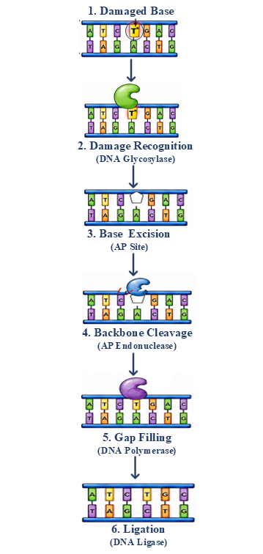
Figure 5: mechanism of BER in plants

- DNA REPAIR PATHWAYS IN CROP IMPROVEMENT
The growing understanding of plant DNA damage response (DDR) and repair mechanisms has transformed DNA repair pathways from fundamental genome maintenance systems into valuable tools for crop improvement. Efficient DNA repair not only preserves genome integrity under normal growth conditions but also enhances plant resilience to environmental stresses. Natural variation in DNA repair genes influences mutation rates, recombination frequency, genome stability and stress tolerance (Verma et al., 2020). Identification and utilisation of favourable alleles through marker-assisted selection (MAS), genomic selection (GS) and quantitative trait locus (QTL) mapping provide opportunities to develop crop varieties with improved tolerance to drought, salinity, heat, radiation and pathogen attack (Shim et al., 2018).

DNA repair pathways interact extensively with cellular stress-signalling networks to regulate plant adaptation. Plant DNA repair pathways also interact with phytohormones such as abscisic acid (ABA), salicylic acid (SA), jasmonic acid (JA) and ethylene, which enhance stress tolerance (Jiang et al., 2025). Such crosstalk enables plants to balance DNA repair with growth, development and defence (Bertoncini et al., 2025).

The emergence of CRISPR/Cas genome editing has highlighted the central role of DNA repair pathways in determining genome-editing outcomes. CRISPR/Cas nucleases introduce site-specific DNA double-strand breaks (DSBs), after which endogenous repair pathways dictate the final genetic modification. Repair through classical non-homologous end joining (c-NHEJ) frequently produces small insertions or deletions (indels) that are widely exploited for targeted gene knockouts. Alternative end joining (Alt-EJ/MMEJ) also contributes to repair outcomes by generating larger deletions and structural rearrangements (Kumar et al., 2024). Strategies such as transient suppression of c-NHEJ components (e.g., KU70, KU80, LIG4) or enhancement of HR-associated proteins (RAD51, BRCA2, MRE11) have significantly increased targeted gene integration and precise genome editing in several crop species (Xue & Greene, 2021; Kamoen et al., 2024).

Beyond genome editing, DNA repair pathways have important applications in mutation breeding and the development of climate-resilient crops. Physical mutagens and chemical mutagens induce diverse DNA lesions that are subsequently processed through endogenous repair pathways. The balance between accurate repair and mutation fixation determines the extent of genetic variation available for crop improvement. The integration of DNA repair biology with advanced breeding technologies is expected to reshape the future of crop improvement. Combining genome editing with genomic selection, speed breeding, high-throughput phenotyping, artificial intelligence (AI)-assisted breeding and multi-omics approaches will enable rapid development of stress-tolerant cultivars.

- APPLICATIONS
- CRISPR/Cas-mediated gene knockout: DNA double-strand breaks generated by CRISPR/Cas are predominantly repaired through the c-NHEJ pathway.
- Homology-directed gene replacement: HR enables precise insertion or replacement of desired DNA sequences.
- Base and prime editing: BER- and MMR-associated repair mechanisms influence editing efficiency and the accuracy of nucleotide substitutions.
- Molecular breeding: DNA repair genes serve as functional markers for identifying superior alleles associated with genome stability and stress tolerance. Integration of DNA repair-associated loci into marker-assisted selection (MAS), QTL mapping and genomic selection (GS) accelerates the development of improved crop varieties.
- Mutation breeding: Physical mutagens and chemical mutagens induce DNA lesions that are processed by endogenous repair pathways. Understanding repair mechanisms helps optimise mutation frequency while minimising undesirable genomic alterations.
- Development of climate-resilient crops: Engineering or regulating DNA repair genes enhances tolerance to UV radiation, drought, salinity, heat stress, oxidative stress and pathogen infection. Improved DNA repair capacity contributes to genome stability, reproductive success and yield stability under adverse environmental conditions.
- Functional genomics: DNA repair mutants are valuable tools for investigating gene function and genome stability. Reverse genetics and CRISPR-based approaches enable characterisation of repair genes involved in plant growth, development and stress responses.
- Biotechnology and synthetic biology: Manipulation of DNA repair pathways improves transformation efficiency and precise gene integration. DNA repair engineering is increasingly being combined with synthetic biology to develop next-generation crop improvement strategies.
Table 4. Crop-specific applications of DNA damage response and repair pathways in crop improvement.
Crop | DNA Repair Pathway / Gene | DNA Repair Mechanism | Applications | Reference
Rice (Oryza sativa) | OsRAD51, OsBRIP1, OsRAD51C; OsXPB1, OsXPC, OsRAD23 | Homologous recombination (HR) and nucleotide excision repair (NER) | Enhanced DNA repair contributes to chromium tolerance | (Lin et al., 2022)
Rice (Oryza sativa) | ALS locus | Homology-directed repair (HDR) | Herbicide-resistant rice through precise allele replacement | (Li et al., 2018)
Wheat (Triticum aestivum) | WDV replicon-assisted HDR | Homology-directed repair | Approximately 12-fold increase in gene targeting efficiency | (Gil-Humanes et al., 2017)
Maize (Zea mays) | ZmRAD51A | Homologous recombination | Improved resistance to fungal and bacterial pathogens | (Liu et al., 2019)
Tomato (Solanum lycopersicum) | ALS locus | Homology-directed repair | Transgene-free herbicide-resistant tomato | (Danilo et al., 2019)
Soybean (Glycine max) | LbCpf1 multiplex editing | Double-strand break repair | High editing efficiency and large chromosomal deletions | (Xia et al., 2021)
Chickpea (Cicer arietinum) | DNA repair and recombination response (DRRR) genes | Multiple DNA repair pathways | Improved drought tolerance and flowering adaptation | (Basu et al., 2022)
Brassica napus | BnLIG4 | Non-homologous end joining (NHEJ) | DNA double-strand-break repair and genome stability | (Yin et al., 2021)

- CHALLENGES AND LIMITATIONS
- Low efficiency of homology-directed repair (HDR): One of the major limitations in plant genome editing is the inherently low efficiency of homologous recombination (HR)-mediated DNA repair. Since plant cells predominantly repair double-strand breaks through the faster c-NHEJ pathway, precise gene replacement and targeted gene insertion remain challenging in most crop species.
- Error-prone DNA repair: Although c-NHEJ and Alt-EJ rapidly restore chromosome integrity, they frequently introduce insertions, deletions or chromosomal rearrangements at repair sites.
- Species-specific differences in DNA repair: Most current knowledge of plant DNA repair has been obtained from Arabidopsis thaliana, whereas comparatively limited information is available for economically important crops. Differences in genome size, ploidy level, chromatin organisation and repair pathway activity often limit the direct translation of discoveries from model plants to crop species.
- Complexity and crosstalk of DNA repair networks: DNA repair pathways function as highly interconnected networks involving extensive interactions with DNA replication, chromatin remodelling, cell-cycle regulation, epigenetic modifications and stress-signalling pathways. Manipulation of one repair component may unintentionally influence other cellular processes.
- Limited transformation and genome editing efficiency: The successful application of DNA repair-based genome editing depends not only on repair pathway activity but also on efficient plant transformation and regeneration systems. Many crop species remain recalcitrant to genetic transformation.
- Regulatory and public acceptance challenges: Although genome editing offers enormous potential for sustainable agriculture, regulatory policies governing genome-edited crops vary considerably among countries. Public perception, biosafety concerns, intellectual property issues and commercialization barriers continue to influence the adoption of DNA repair-based biotechnological approaches in agriculture.

- FUTURE PERSPECTIVES
The rapidly expanding knowledge of plant DNA damage response (DDR) and DNA repair pathways provides unprecedented opportunities for improving crop resilience and agricultural sustainability. Although considerable progress has been made in elucidating the molecular mechanisms of DNA repair, many regulatory networks and signalling pathways remain incompletely understood. Future studies integrating molecular genetics, structural biology and systems biology will be essential for identifying novel DNA repair regulators and deciphering their interactions.

Recent advances in genome editing are expected to further revolutionise the application of DNA repair biology in crop improvement. The efficiency of homologous recombination can be improved and error-prone repair through c-NHEJ and Alt-EJ can be minimised by optimising DNA repair pathways. Emerging technologies such as CRISPR/Cas variants, base editing, prime editing and programmable recombinases offer promising avenues for precise genetic manipulation in diverse crop species. Integrating these technologies with an improved understanding of endogenous DNA repair mechanisms will substantially enhance editing accuracy and broaden their application in precision breeding. The integration of artificial intelligence (AI), machine learning, high-throughput phenotyping and multi-omics approaches is expected to accelerate the discovery of DNA repair-associated genes and predict their functional roles in stress adaptation.

Looking forward, DNA repair pathways are likely to become central components of next-generation precision breeding strategies. Combining genome editing, molecular breeding, genomic selection, speed breeding and synthetic biology with targeted manipulation of DNA repair pathways has the potential to accelerate the development of high-yielding, stress-resilient and genetically stable crop varieties.

- CONCLUSION
Plant genome stability depends on a coordinated DNA damage response that links lesion sensing, ATM–ATR–SOG1-mediated signalling, cell-cycle control, chromatin remodelling and specialised repair pathways. Direct reversal, BER, NER, MMR, HR, c-NHEJ and Alt-EJ collectively repair chemically and structurally distinct DNA lesions, while the balance among these pathways influences mutation formation, genome stability and cellular survival. The same repair mechanisms are increasingly relevant to crop improvement because they determine many outcomes of CRISPR/Cas-mediated editing and contribute to responses to environmental stress. HR offers a route to precise sequence replacement, whereas c-NHEJ and Alt-EJ are important for efficient end joining but can generate sequence changes at repair junctions. The manuscript also highlights the value of integrating DNA repair knowledge with molecular breeding, genomic selection, speed breeding, synthetic biology and multi-omics. Continued clarification of pathway regulation and species-specific differences will be important for improving editing precision and for translating DNA repair biology from model plants into crop improvement strategies.

Declaration of AI Use

This manuscript was prepared through the intellectual contributions of the author(s) to the study design, data analysis, interpretation of results, and scholarly content. Grammarly and ChatGPT were used solely to assist with grammatical refinement and reference formatting during manuscript revision. The author(s) accept full responsibility for the accuracy, integrity, and final content of the manuscript.

REFERENCES

Alam, P., Faizan, M., Arif, Y., Azzam, M. M., Hayat, S., Afzal, S., & Albalawi, T. H. (2025). Reactive oxygen species: Balancing agents in plants. Frontiers in Plant Science, 16, 1713590. https://doi.org/10.3389/fpls.2025.1713590
Andrés, C. M. C., de la Lastra, J. M. P., Juan, C. A., Plou, F. J., & Pérez-Lebeña, E. (2023). Chemical insights into oxidative and nitrative modifications of DNA. International Journal of Molecular Sciences, 24(20), 15240. https://doi.org/10.3390/ijms242015240
Ashley, A. K., Shrivastav, M., Nie, J., Amerin, C., Troksa, K., Glanzer, J. G., Liu, S., Opiyo, S. O., Dimitrova, D. D., Le, P., Sishc, B., Bailey, S. M., Oakley, G. G., & Nickoloff, J. A. (2014). DNA-PK phosphorylation of RPA32 Ser4/Ser8 regulates replication stress checkpoint activation, fork restart, homologous recombination and mitotic catastrophe. DNA Repair, 21, 131–139. https://doi.org/10.1016/j.dnarep.2014.04.008
Asik, E., Kashif, S. Z., & Oztas, O. (2026). Plant tolerance mechanisms to DNA-damaging UV stress. Journal of Experimental Botany, 77(1), 27–50. https://doi.org/10.1093/jxb/eraf272
Barakate, A., Keir, E., Oakey, H., & Halpin, C. (2020). Stimulation of homologous recombination in plants expressing heterologous recombinases. BMC Plant Biology, 20, 336. https://doi.org/10.1186/s12870-020-02545-7
Barco, B., Dong, S., Matsuba, Y., Crook, A., Xu, R., Zhang, Y., Zhang, C., Carlin, R., Potter, K., Rigoulot, S. B., Park, J., Seaberry, E. M., Parrish, A., Elumalai, S., Nalapalli, S., Schuller, C., Prairie, A., Mangum, A., Mei, K., … Que, Q. (2025). Development of efficient targeted insertion mediated by CRISPR-Cas12a and homology-directed repair in maize. Frontiers in Genome Editing, 7, 1713347. https://doi.org/10.3389/fgeed.2025.1713347
Basu, U., Sharma, A., Bajaj, D., Malik, N., Jha, U. C., Upadhyaya, H. D., & Parida, S. K. (2022). The DNA replication, repair, and recombination pathway genes modulating yield and stress tolerance traits in chickpea. Plant Molecular Biology Reporter, 40, 119–135. https://doi.org/10.1007/s11105-021-01303-9
Bergis-Ser, C., Reji, M., Latrasse, D., Bergounioux, C., Benhamed, M., & Raynaud, C. (2024). Chromatin dynamics and RNA metabolism are double-edged swords for the maintenance of plant genome integrity. Nature Plants, 10(6), 857–873. https://doi.org/10.1038/s41477-024-01678-z
Bertoncini, A., Pagano, P., & Macovei, A. (2025). Arabidopsis thaliana DNA damage response mutants challenged with genotoxic agents: A different experimental approach to investigate the TDP1α and TDP1β genes. Genes, 16(1), 103. https://doi.org/10.3390/genes16010103
Black, S. J., Kashkina, E., Kent, T., & Pomerantz, R. T. (2016). DNA polymerase θ: A unique multifunctional end-joining machine. Genes, 7(9), 67. https://doi.org/10.3390/genes7090067
Bravo, M., & Fan, L. (2026). Integrating structural, biochemical, and cellular perspectives on the TFIIH helicases XPB and XPD. Biomolecules, 16(3), 435. https://doi.org/10.3390/biom16030435
Canturk, F., Karaman, M., Selby, C. P., Kemp, M. G., Kulaksiz-Erkmen, G., Hu, J., Li, W., Lindsey-Boltz, L. A., & Sancar, A. (2016). Nucleotide excision repair by dual incisions in plants. Proceedings of the National Academy of Sciences of the United States of America, 113(17), 4706–4710. https://doi.org/10.1073/pnas.1604097113
Clay, D. E., & Fox, D. T. (2021). DNA damage responses during the cell cycle: Insights from model organisms and beyond. Genes, 12(12), 1882. https://doi.org/10.3390/genes12121882
Conlin, M. P., Reid, D. A., Small, G. W., Chang, H. H., Watanabe, G., Lieber, M. R., Ramsden, D. A., & Rothenberg, E. (2017). DNA ligase IV guides end-processing choice during nonhomologous end joining. Cell Reports, 20(12), 2810–2819. https://doi.org/10.1016/j.celrep.2017.08.091
Córdoba-Cañero, D., Roldán-Arjona, T., & Ariza, R. R. (2014). Arabidopsis ZDP DNA 3′-phosphatase and ARP endonuclease function in 8-oxoG repair initiated by FPG and OGG1 DNA glycosylases. The Plant Journal, 79(5), 824–834. https://doi.org/10.1111/tpj.12588
Danilo, B., Perrot, L., Mara, K., Botton, E., Nogué, F., & Mazier, M. (2019). Efficient and transgene-free gene targeting using Agrobacterium-mediated delivery of the CRISPR/Cas9 system in tomato. Plant Cell Reports, 38, 459–462. https://doi.org/10.1007/s00299-019-02373-6
Du, Y., Hase, Y., Satoh, K., & Shikazono, N. (2020). Characterization of gamma irradiation-induced mutations in Arabidopsis mutants deficient in non-homologous end joining. Journal of Radiation Research, 61(5), 639–647. https://doi.org/10.1093/jrr/rraa059
Hacker, L., Dorn, A., & Puchta, H. (2020). Repair of DNA-protein crosslinks in plants. DNA Repair, 87, 102787. https://doi.org/10.1016/j.dnarep.2020.102787
Fathi, A., Shiade, S. R. G., Saleem, A., Shohani, F., Fazeli, A., Riaz, A., Zulfiqar, U., Shabaan, M., Ahmed, I., & Rahimi, M. (2025). Reactive oxygen species (ROS) and antioxidant systems in enhancing plant resilience against abiotic stress. International Journal of Agronomy, 2025, Article 8834883. https://doi.org/10.1155/ioa/8834883
Fraikin, G. Y., Belenikina, N. S., & Rubin, A. B. (2024). Photochemical processes of cell DNA damage by UV radiation of various wavelengths: Biological consequences. Molecular Biology, 58, 1–16. https://doi.org/10.1134/S0026893324010047
Gil-Humanes, J., Wang, Y., Liang, Z., Shan, Q., Ozuna, C. V., Sánchez-León, S., Baltes, N. J., Starker, C., Barro, F., Gao, C., & Voytas, D. F. (2017). High-efficiency gene targeting in hexaploid wheat using DNA replicons and CRISPR/Cas9. The Plant Journal, 89(6), 1251–1262. https://doi.org/10.1111/tpj.13446
Grin, I. R., Petrova, D. V., Endutkin, A. V., Yu, B., Li, H., & Zharkov, D. O. (2023). Base excision DNA repair in plants: Arabidopsis and beyond. International Journal of Molecular Sciences, 24(19), 14746. https://doi.org/10.3390/ijms241914746
Herbst, J., Li, Q. Q., & De Veylder, L. (2024). Mechanistic insights into DNA damage recognition and checkpoint control in plants. Nature Plants, 10, 539–550. https://doi.org/10.1038/s41477-024-01652-9
Hou, Z., Yu, T., Yi, Q., Du, Y., Zhou, L., Zhao, Y., Wu, Y., Wu, L., Wang, T., & Bian, P. (2024). High complexity of DNA double-strand breaks is key for alternative end-joining choice. Communications Biology, 7, 936. https://doi.org/10.1038/s42003-024-06640-5
Jiang, J., Zhu, Q., Li, Y., Wu, J., Zou, C., Li, H., Lei, X., Zhang, F., Lin, Y., Cao, R., Cao, Y., Mo, J., Lai, J., Zhao, J., Wang, C., & Yang, C. (2025). Abscisic acid enhances DNA damage response through the nuclear shuttling of clathrin light chain 2 in plant cells. Science Advances, 11(24), eadt2842. https://doi.org/10.1126/sciadv.adt2842
Jordano-Raya, M., Schrader, C. E., Ariza, R. R., Roldán-Arjona, T., & Córdoba-Cañero, D. (2025). Divergent evolution of opposite base specificity and single-stranded DNA activity in animal and plant AP endonucleases. Nucleic Acids Research, 53(1), gkae1297. https://doi.org/10.1093/nar/gkae1297
Kamoen, L., Kralemann, L. E. M., van Schendel, R., van Tol, N., Hooykaas, P. J. J., de Pater, S., & Tijsterman, M. (2024). Genetic dissection of mutagenic repair and T-DNA capture at CRISPR-induced DNA breaks in Arabidopsis thaliana. PNAS Nexus, 3(3), pgae094. https://doi.org/10.1093/pnasnexus/pgae094
Kaya, S., Erdogan, D. E., Sancar, A., Adebali, O., & Oztas, O. (2024). Global repair is the primary nucleotide excision repair subpathway for the removal of pyrimidine-pyrimidone (6-4) damage from the Arabidopsis genome. Scientific Reports, 14, 3308. https://doi.org/10.1038/s41598-024-53472-8
Khan, H., & Ochi, T. (2023). Plant PAXX has an XLF-like function and stimulates DNA end joining by the Ku-DNA ligase IV/XRCC4 complex. The Plant Journal, 116(1), 58–68. https://doi.org/10.1111/tpj.16359
Kose, C., Cao, X., Dewey, E. B., Malkoç, M., Adebali, O., Sekelsky, J., Lindsey-Boltz, L. A., & Sancar, A. (2024). Cross-species investigation into the requirement of XPA for nucleotide excision repair. Nucleic Acids Research, 52(2), 677–689. https://doi.org/10.1093/nar/gkad1104
Kumar, K. R. R. (2023). Lost in the bloom: DNA-PKcs in green plants. Frontiers in Plant Science, 14, 1231678. https://doi.org/10.3389/fpls.2023.1231678
Kumar, R., Das, S. P., Choudhury, B. U., Kumar, A., Prakash, N. R., Verma, R., Chakraborti, M., Devi, A. G., Bhattacharjee, B., Das, R., Das, B., Devi, H. L., Das, B., Rawat, S., & Mishra, V. K. (2024). Advances in genomic tools for plant breeding: Harnessing DNA molecular markers, genomic selection, and genome editing. Biological Research, 57, 80. https://doi.org/10.1186/s40659-024-00562-6
Kusakabe, M., Onishi, Y., Tada, H., Kurihara, F., Kusao, K., Furukawa, M., Iwai, S., Yokoi, M., Sakai, W., & Sugasawa, K. (2019). Mechanism and regulation of DNA damage recognition in nucleotide excision repair. Genes and Environment, 41, 2. https://doi.org/10.1186/s41021-019-0119-6
Li, F., Mladenov, E., Sun, Y., Soni, A., Stuschke, M., Timmermann, B., & Iliakis, G. (2023). Low CDK activity and enhanced degradation by APC/C^CDH1 abolishes CtIP activity and Alt-EJ in quiescent cells. Cells, 12(11), 1530. https://doi.org/10.3390/cells12111530
Li, S., Li, J., Zhang, J., Du, W., Fu, J., Sutar, S. H., Zhao, Y., & Xia, L. (2018). Synthesis-dependent repair of Cpf1-induced double-strand DNA breaks enables targeted gene replacement in rice. Journal of Experimental Botany, 69(20), 4715–4721. https://doi.org/10.1093/jxb/ery245
Lin, Y. J., Feng, Y. X., Zhang, Q., & Yu, X. Z. (2022). Proline-mediated modulation on DNA repair pathway in rice seedlings under chromium stress by integrating gene chip and co-expression network analysis. Ecotoxicology, 31, 1266–1275. https://doi.org/10.1007/s10646-022-02586-8
Lindahl, T. (1993). Instability and decay of the primary structure of DNA. Nature, 362, 709–715. https://doi.org/10.1038/362709a0
Liu, F., Xu, Y. J., Zhou, L., Ali, A., Jiang, H., Zhu, S., & Li, X. (2019). DNA repair gene ZmRAD51A improves rice and Arabidopsis resistance to disease. International Journal of Molecular Sciences, 20(4), 807. https://doi.org/10.3390/ijms20040807
Liu, R., Wang, S., & Song, J. (2026). New progress in the production, oxidative damage, and scavenging mechanisms of reactive oxygen species in plants under abiotic stress. Frontiers in Plant Science, 17, 1774033. https://doi.org/10.3389/fpls.2026.1774033
Mahapatra, K., Banerjee, S., De, S., Mitra, M., Roy, P., & Roy, S. (2021). An insight into the mechanism of plant organelle genome maintenance and implications of organelle genome in crop improvement: An update. Frontiers in Cell and Developmental Biology, 9, 671698. https://doi.org/10.3389/fcell.2021.671698
Manova, V., & Gruszka, D. (2015). DNA damage and repair in plants: From models to crops. Frontiers in Plant Science, 6, 885. https://doi.org/10.3389/fpls.2015.00885
Mansoor, S., Wani, O. A., Lone, J. K., Manhas, S., Kour, N., Alam, P., Ahmad, A., & Ahmad, P. (2022). Reactive oxygen species in plants: From source to sink. Antioxidants, 11(2), 225. https://doi.org/10.3390/antiox11020225
Marteijn, J. A., Lans, H., Vermeulen, W., & Hoeijmakers, J. H. J. (2014). Understanding nucleotide excision repair and its roles in cancer and ageing. Nature Reviews Molecular Cell Biology, 15(7), 465–481. https://doi.org/10.1038/nrm3822
Martens, M., Horres, R., Wendeler, E., & Reiss, B. (2020). The importance of ATM and ATR in Physcomitrella patens DNA damage repair, development, and gene targeting. Genes, 11(7), 752. https://doi.org/10.3390/genes11070752
Masuda, H., Nakabashi, M., Morgante, P. G., Kajihara, D., de Setta, N., Menck, C. F. M., & Van Sluys, M.-A. (2020). Evidence for sub-functionalization of tandemly duplicated XPB nucleotide excision repair genes in Arabidopsis thaliana. Gene, 754, 144818. https://doi.org/10.1016/j.gene.2020.144818
Merker, L., Feller, L., Dorn, A., & Puchta, H. (2024). Deficiency of both classical and alternative end-joining pathways leads to a synergistic defect in double-strand break repair but not to an increase in homology-dependent gene targeting in Arabidopsis. The Plant Journal, 118(1), 242–254. https://doi.org/10.1111/tpj.16604
Mohamed, H. I., Ullah, I., Toor, M. D., Tanveer, N. A., Din, M. M. U., Basit, A., Sultan, Y., Muhammad, M., & Rehman, M. U. (2025). Heavy metals toxicity in plants: Understanding mechanisms and developing coping strategies for remediation: A review. Bioresources and Bioprocessing, 12, 95. https://doi.org/10.1186/s40643-025-00930-4
Monroe, J. G., Srikant, T., Carbonell-Bejerano, P., Becker, C., Lensink, M., Exposito-Alonso, M., Klein, M., Hildebrandt, J., Neumann, M., Kliebenstein, D., Weng, M.-L., Imbert, E., Ågren, J., Rutter, M. T., Fenster, C. B., & Weigel, D. (2022). Mutation bias reflects natural selection in Arabidopsis thaliana. Nature, 602(7895), 101–105. https://doi.org/10.1038/s41586-021-04269-6
Morales-Ruiz, T., Beltrán-Melero, C., Ortega-Paredes, D., Luna-Morillo, J. A., Martínez-Macías, M. I., Roldán-Arjona, T., Ariza, R. R., & Córdoba-Cañero, D. (2024). The enzymatic properties of Arabidopsis thaliana DNA polymerase λ suggest a role in base excision repair. Plant Molecular Biology, 114(1), 3. https://doi.org/10.1007/s11103-023-01407-8
Nakamura, M., Nunoshiba, T., & Hiratsu, K. (2021). Detection and analysis of UV-induced mutations in the chromosomal DNA of Arabidopsis. Biochemical and Biophysical Research Communications, 554, 89–93. https://doi.org/10.1016/j.bbrc.2021.03.087
Nimeth, B. A., Riegler, S., & Kalyna, M. (2020). Alternative splicing and DNA damage response in plants. Frontiers in Plant Science, 11, 91. https://doi.org/10.3389/fpls.2020.00091
Nisa, M.-U., Huang, Y., Benhamed, M., & Raynaud, C. (2019). The plant DNA damage response: Signaling pathways leading to growth inhibition and putative role in response to stress conditions. Frontiers in Plant Science, 10, 653. https://doi.org/10.3389/fpls.2019.00653
Ogita, N., Okushima, Y., Tokizawa, M., Yamamoto, Y. Y., Tanaka, M., Seki, M., Makita, Y., Matsui, M., Okamoto-Yoshiyama, K., Sakamoto, T., Kurata, T., Hiruma, K., Saijo, Y., Takahashi, N., & Umeda, M. (2018). Identifying the target genes of SUPPRESSOR OF GAMMA RESPONSE 1, a master transcription factor controlling DNA damage response in Arabidopsis. The Plant Journal, 94(3), 439–453. https://doi.org/10.1111/tpj.13866
Pacher, M., & Puchta, H. (2017). From classical mutagenesis to nuclease-based breeding—Directing natural DNA repair for a natural end-product. The Plant Journal, 90(4), 819–833. https://doi.org/10.1111/tpj.13469
Palacio, T., Calil, F. A., Bowen, N., Griffith, J. D., Putnam, C. D., & Kolodner, R. D. (2025). DNA mismatch repair mediated by Mlh1-Pms1 endonuclease-catalyzed mispair excision. Proceedings of the National Academy of Sciences of the United States of America, 122(52), e2528670122. https://doi.org/10.1073/pnas.2528670122
Park, H. J., & Lee, J. H. (2026). ATM kinase in plants: Integrating DNA damage response, development, and stress adaptation. Plant Stress, 21, 101338. https://doi.org/10.1016/j.stress.2026.101338
Raina, A., Sahu, P. K., Laskar, R. A., Rajora, N., Sao, R., Khan, S., & Ganai, R. A. (2021). Mechanisms of genome maintenance in plants: Playing it safe with breaks and bumps. Frontiers in Genetics, 12, 675686. https://doi.org/10.3389/fgene.2021.675686
Ranjha, L., Howard, S. M., & Cejka, P. (2018). Main steps in DNA double-strand break repair: An introduction to homologous recombination and related processes. Chromosoma, 127(2), 187–214. https://doi.org/10.1007/s00412-017-0658-1
Roldán-Arjona, T., Ariza, R. R., & Córdoba-Cañero, D. (2019). DNA base excision repair in plants: An unfolding story with familiar and novel characters. Frontiers in Plant Science, 10, 1055. https://doi.org/10.3389/fpls.2019.01055
Roy, S. (2014). Maintenance of genome stability in plants: Repairing DNA double-strand breaks and chromatin structure stability. Frontiers in Plant Science, 5, 487. https://doi.org/10.3389/fpls.2014.00487
Sancar, A. (2003). Structure and function of DNA photolyase and cryptochrome blue-light photoreceptors. Chemical Reviews, 103(6), 2203–2238. https://doi.org/10.1021/cr0204348
Sancar, A. (2008). Structure and function of photolyase and in vivo enzymology: 50th anniversary. Journal of Biological Chemistry, 283(47), 32153–32157. https://doi.org/10.1074/jbc.R800052200
Sathiyabalan, A., Amir, M., Sandhu, R., & Bhattacharya, S. (2024). Evaluating CRISPR/Cas9's progressive role in crop enhancement and sustainable agriculture. Journal of Advances in Biology & Biotechnology, 27(6), 855–867. https://doi.org/10.9734/jabb/2024/v27i6949
Schimmel, J., van Schendel, R., den Dunnen, J. T., & Tijsterman, M. (2019). Templated insertions: A smoking gun for polymerase theta-mediated end joining. Trends in Genetics, 35(9), 632–644. https://doi.org/10.1016/j.tig.2019.06.003
Serrano-Mislata, A., Hernández-García, J., de Ollas, C., Blanco-Touriñán, N., Jurado-García, S., Úrbez, C., Carbonell, J., Blázquez, M. A., Agustí, J., & Alabadí, D. (2025). Growth arrest is a DNA damage protection strategy in Arabidopsis. Nature Communications, 16, 5635. https://doi.org/10.1038/s41467-025-60733-1
Shen, H., & Li, Z. (2022). DNA double-strand break repairs and their application in plant DNA integration. Genes, 13(2), 322. https://doi.org/10.3390/genes13020322
Shim, J. S., Oh, N., Chung, P. J., Kim, Y. S., Choi, Y. D., & Kim, J.-K. (2018). Overexpression of OsNAC14 improves drought tolerance in rice. Frontiers in Plant Science, 9, 310. https://doi.org/10.3389/fpls.2018.00310
Sincinelli, F., Gaonkar, S. S., Tondepu, S. A. G., Dueñas, C., Jr., & Pagano, A. (2025). Hallmarks of DNA damage response in germination across model and crop species. Genes, 16(1), 95. https://doi.org/10.3390/genes16010095
Singh, A. K., Mehta, S., Yadav, S., Nagar, G. C., Ghosh, R., Roy, A., Chakraborty, A., & Singh, I. K. (2022). How to cope with the challenges of environmental stresses in the era of global climate change: An update on ROS stave off in plants. International Journal of Molecular Sciences, 23(4), 1995. https://doi.org/10.3390/ijms23041995
Szurman-Zubrzycka, M., Jędrzejek, P., & Szarejko, I. (2023). How do plants cope with DNA damage? A concise review on the DDR pathway in plants. International Journal of Molecular Sciences, 24(3), 2404. https://doi.org/10.3390/ijms24032404
Thada, V., & Greenberg, R. A. (2022). Unpaved roads: How the DNA damage response navigates endogenous genotoxins. DNA Repair, 118, 103383. https://doi.org/10.1016/j.dnarep.2022.103383
Truong, L. N., Li, Y., Shi, L. Z., Hwang, P. Y.-H., He, J., Wang, H., Razavian, N., Berns, M. W., & Wu, X. (2013). Microhomology-mediated end joining and homologous recombination share the initial end resection step to repair DNA double-strand breaks in mammalian cells. Proceedings of the National Academy of Sciences of the United States of America, 110(19), 7720–7725. https://doi.org/10.1073/pnas.1213431110
Verma, P., Tandon, R., Yadav, G., & Gaur, V. (2020). Structural aspects of DNA repair and recombination in crop improvement. Frontiers in Genetics, 11, 574549. https://doi.org/10.3389/fgene.2020.574549
Wallace, S. S. (2014). Base excision repair: A critical player in many games. DNA Repair, 19, 14–26. https://doi.org/10.1016/j.dnarep.2014.03.030
Waterworth, W. M., Drury, G. E., Bray, C. M., & West, C. E. (2011). Repairing breaks in the plant genome: The importance of keeping it together. New Phytologist, 192(4), 805–822. https://doi.org/10.1111/j.1469-8137.2011.03926.x
Witte, S. J., Rosa, I. M., Collingwood, B. W., Piscitelli, J. M., & Manhart, C. M. (2023). The mismatch repair endonuclease MutLα tethers duplex regions of DNA together and relieves DNA torsional tension. Nucleic Acids Research, 51(6), 2725–2739. https://doi.org/10.1093/nar/gkad096
Wu, S.-Y., Culligan, K., Lamers, M., & Hays, J. B. (2003). Dissimilar mispair-recognition spectra of Arabidopsis DNA mismatch repair proteins MSH2·MSH6 (MutSα) and MSH2·MSH7 (MutSγ). Nucleic Acids Research, 31(20), 6027–6034. https://doi.org/10.1093/nar/gkg780
Xia, L., Wang, K., & Zhu, J.-K. (2021). The power and versatility of genome editing tools in crop improvement. Journal of Integrative Plant Biology, 63(9), 1591–1594. https://doi.org/10.1111/jipb.13160
Xue, C., & Greene, E. C. (2021). DNA repair pathway choices in CRISPR-Cas9-mediated genome editing. Trends in Genetics, 37(7), 639–656. https://doi.org/10.1016/j.tig.2021.02.008
Yin, L., Zhu, Z., Huang, L., Luo, X., Li, Y., Xiao, C., Yang, J., Wang, J., Zou, Q., Tao, L., Kang, Z., Tang, R., Wang, M., & Fu, S. (2021). DNA repair- and nucleotide metabolism-related genes exhibit differential CHG methylation patterns in natural and synthetic polyploids (Brassica napus L.). Horticulture Research, 8(1), 142. https://doi.org/10.1038/s41438-021-00576-1
Zgłobicki, P., Hermanowicz, P., Kłodawska, K., Bażant, A., Łabuz, J., Grzyb, J., Dutka, M., Kowalska, E., Jawor, J., Leja, K., & Banaś, A. K. (2024). The photoreactivation of 6-4 photoproducts in chloroplast and nuclear DNA depends on the amount of the Arabidopsis UV repair defective 3 protein. BMC Plant Biology, 24, 723. https://doi.org/10.1186/s12870-024-05439-0
Zhao, Y., Chen, D., Grin, I. R., Zharkov, D. O., & Yu, B. (2025). Developing plant-derived DNA repair enzyme resources through studying the involvement of base excision repair DNA glycosylases in stress responses of plants. Physiologia Plantarum, 177(2), e70162. https://doi.org/10.1111/ppl.70162

