Original Research Article
Genetic diversity analysis of chickpea (Cicer arietinum L.) genotypes using Mahalonobis D² Statistics

ABSTRACT
Chickpea (Cicer arietinum L.) is an important pulse crop, and the identification of genetically divergent parents is useful for crop improvement through hybridisation. The present investigation evaluated genetic diversity among 50 chickpea genotypes grown during Rabi 2024–25 at Dr. BRC Agricultural Research Station, Mandor, Jodhpur. The experiment was conducted in a randomised block design with three replications, and observations were recorded for 15 phenological, yield-related, physiological, and biochemical traits. Genetic divergence was assessed using Mahalanobis D statistics, and the genotypes were grouped into 11 clusters using Tocher’s method. The maximum intra-cluster distance was recorded in Cluster IX (167.27), followed by Clusters II, VI, and I, indicating comparatively greater variability within these groups. The highest inter-cluster distance was observed between Clusters III and IX (573.48), followed by Clusters V and XI (542.06) and Clusters VI and XI (511.71), suggesting substantial divergence among these cluster combinations. Protein content contributed most to total genetic divergence (29.80%), followed by chlorophyll content (24.41%), days to 50% flowering (20.16%), and relative water content (10.78%). Cluster means also revealed substantial variation among groups for yield-related, physiological, and biochemical traits. The findings indicate that genetically divergent genotypes, particularly those belonging to widely separated clusters, may be useful as parental material in chickpea breeding programmes aimed at generating variability and improving desirable traits.

Keywords: Cicer arietinum L.; genetic diversity; Mahalanobis D² statistics; Tocher’s method; cluster analysis; genetic divergence; intra-cluster distance; inter-cluster distance; parental selection
- INTRODUCTION
Among pulse crops, chickpea (Cicer arietinum L.) is a significant legume crop. Chickpea belongs to the family Leguminosae and subfamily Papilionaceae. It belongs to the genus Cicer, which has nine annual wild species and thirty-four perennial species (Singh et al., 2008). It is a self-pollinated legume crop with a chromosome number of 2n = 2x =16. Chickpea is called the "King of Pulses" and is also known as Egyptian pea, garbanzo bean, Bengal gram, and gram. The origin and initial domestication of chickpea were in south-eastern Turkey and the neighbouring regions of Syria and Iran. Vavilov (1926) considered South-West Asia and the Mediterranean to be the primary centre of origin of chickpea, with Ethiopia as the secondary centre. Chickpea is the most widely cultivated and consumed pulse crop in India. It is an essential source of protein in the human diet as well as in animal feed. Chickpea is a substantial and reasonably priced source of protein compared with animal protein. The protein content of chickpea is between 21 and 24 %, together with 2.2 % fat and 62 % carbohydrates. In addition, it contains a high proportion of other mineral elements, unsaturated oleic and linoleic acid, calcium (190 mg/100g), phosphorus (280 mg/100g), iron (90.5mg/100g), and other mineral nutrients. Despite having less protein than other pulses, it has a higher biological value and is more digestible. The granular hairs present on chickpea leaves and pods secrete a liquid containing Malic acid (90-96 per cent) and Oxalic acid (90-96 per cent). The grain portion of chickpea is a key source of protein in the human diet. It has the ability to improve soil fertility and fix nitrogen from the atmosphere at a low cost of production. It can be used in low-fat, low-sodium, low-calorie, low-cholesterol, low-salt, gluten-free, diabetic, and high-fibre diets. Additionally, the grain helps control the body's cholesterol levels. In South Asian countries, green chickpea leaves are used to prepare a nutritious vegetable. India accounts for around two-thirds of the world's chickpea production, making it the world's leading producer and consumer. In the agricultural year 2023-24, the total area under chickpea cultivation in India was 9.46 (M ha), with a total production of 11.58 (MT) and a productivity of 1224 (kg/ha). After Maharashtra and Madhya Pradesh, Rajasthan is the third-largest producer of chickpea. The total area under chickpea cultivation in Rajasthan was 1.81 (M ha), with a total production of 2.23 (MT) and a productivity of 1232 (kg/ha), followed by Uttar Pradesh and Gujarat (Anonymous, 2023). The widespread development of high-yielding cultivars based on a narrow genetic base has resulted in large genetic bottlenecks. Present-day chickpea cultivars are susceptible to changing climatic conditions and biotic/abiotic challenges (Kushwah et al., 2022; Varshney et al., 2021). A full description of germplasm, to decrease this vulnerability, can provide the basis for the identification of beneficial alleles controlling seed nutritional quality and physiological resilience to climate-related stresses (Costantini et al., 2021). Many plant scientists have estimated genetic diversity in chickpea. Karthikeyan et al. (2021) applied D2 statistics to determine the genetic diversity of twenty different chickpea genotypes and grouped the genotypes into four distinct clusters. The results revealed that the genotypes were grouped into 11 clusters and that the maximum inter-cluster distance was recorded between Clusters X and XI.
Recent studies reinforce the value of combining diverse genetic resources with trait-based screening in chickpea improvement. Super-pangenome analysis has highlighted the restricted diversity of cultivated chickpea relative to wild Cicer resources and the potential value of broader genetic variation for crop improvement (Khan et al., 2024). Field evaluation under moisture stress has also demonstrated genotype-dependent differences in morpho-physiological and yield performance (Diwedi et al., 2025). Likewise, Mahalanobis D² analysis has been used to separate chickpea genotypes into distinct clusters and identify divergent materials for breeding (Yadav et al., 2023). Multi-trait assessment under irrigated and drought conditions further supports the use of integrated phenotypic and physiological indices to distinguish drought-tolerant chickpea genotypes (Basavaraj et al., 2025).
Research gap: However, there remains a need to characterise the combined phenological, yield-related, physiological, and biochemical divergence of the selected chickpea genotypes under the specific agro-ecological conditions of Jodhpur, Rajasthan. Such a location-specific assessment is necessary for identifying divergent parental material relevant to the breeding environment considered in this study.
Objective of the study
Hence, the present investigation was undertaken to investigate the intrinsic developmental characteristics and seed-yield parameters of chickpea under the environmental conditions of Jodhpur, Rajasthan, to identify genetically diverse genotypes that would assist in selecting parents for a hybridisation procedure.
- MATERIALS AND METHODS
  - Experimental site and materials
The present study was conducted at Dr. BRC Agricultural Research Station, Mandor, Jodhpur, which falls under Zone-Ia (Arid Western Plains), using 50 chickpea genotypes (Table 1) planted in a randomised block design with 3 replications during Rabi 2024-25. To produce a healthy crop, all recommended agronomic practices were adopted, and appropriate preventive measures against pests and diseases were taken.
  - Observations recorded
    - Phenological traits
Statistical analysis was performed on the mean values of observations recorded for traits such as days to 50% flowering, days to maturity, and days to pod initiation on an entire-plot basis. The remaining data from each replication were averaged from five randomly selected plants for the traits of plant height, number of pods per plant, number of effective pods per plant, 100 seed weight, number of seeds per pod, seed yield per plant (g), harvest index (%), and dry fodder yield per plant (g).
    - Physio-biochemical traits
Relative water content (%) in chickpea was determined using the Barrs and Weatherley (1962) method; membrane stability index (%) in chickpea was determined using a formula developed by Blum and Ebercon (1981); chlorophyll was extracted from a leaf sample using acetone, and the chlorophyll concentration was calculated using a spectrophotometer (Arnon, 1949); and seed protein content was estimated using the micro-Kjeldahl technique, as suggested by Kjeldahl (1883).
  - Statistical analysis
The data collected from the field and laboratory for fifteen characters were statistically analysed using WINDOSTAT Version 9.3 software. Mahalanobis’s D² technique, as suggested by Rao (1952), was used to study genetic divergence.
Table 1: List of Chickpea genotypes
S.No. | Name of Genotypes | Source | S.No. | Name of Genotypes | Source
1 | ICC 15925 | ICRISAT, Hyderabad | 26 | IPC 2006-77 | ICAR-IIPR, Kanpur
2 | ICC 96029 | ICRISAT, Hyderabad | 27 | DCP 92-3 | ICAR-IIPR, Kanpur
3 | ICC 16348 | ICRISAT, Hyderabad | 28 | JG 315 | JNKVV, Jabalpur
4 | ICC 92944 | ICRISAT, Hyderabad | 29 | JG 11 | JNKVV, Jabalpur
5 | ICC 10685 | ICRISAT, Hyderabad | 30 | JG 16 | JNKVV, Jabalpur
6 | ICC 07110 | ICRISAT, Hyderabad | 31 | RKGK 13-515 | ARS, Kota
7 | ICC 07118 | ICRISAT, Hyderabad | 32 | RKGK 13-416 | ARS, Kota
8 | ICC 6953 | ICRISAT, Hyderabad | 33 | RKGK 13-499 | ARS, Kota
9 | ICC 6788 | ICRISAT, Hyderabad | 34 | GNG 2207 | ARS, Sriganganagar
10 | ICC 81-82 | ICRISAT, Hyderabad | 35 | GNG 1969 | ARS, Sriganganagar
11 | ICC 1826 | ICRISAT, Hyderabad | 36 | GNG 2144 | ARS, Sriganganagar
12 | ICC 12453 | ICRISAT, Hyderabad | 37 | GNG 1958 | ARS, Sriganganagar
13 | ICC 2156 | ICRISAT, Hyderabad | 38 | GNG 1581 (Gangaur) | ARS, Sriganganagar
14 | ICC 1214 | ICRISAT, Hyderabad | 39 | GNG 2171 | ARS, Sriganganagar
15 | ICC 9029 | ICRISAT, Hyderabad | 40 | GNG 2261 | ARS, Sriganganagar
16 | ICC 1212 | ICRISAT, Hyderabad | 41 | KWR 108 | CSAUA&T, Kanpur
17 | ICC 8507 | ICRISAT, Hyderabad | 42 | Sadabahar | CSAUA&T, Kanpur
18 | ICC 1205 | ICRISAT, Hyderabad | 43 | CSJ 884 | RARI,Durgapura
19 | ICC 9942 | ICRISAT, Hyderabad | 44 | RSG 895 | RARI,Durgapura
20 | JAKI 9218 | ICRISAT, Hyderabad | 45 | HC 5 | CCSHAU, Hisar
21 | IPC 2015-55 | ICAR-IIPR, Kanpur | 46 | Pant G-114 | GBPUAT, Pantnagar
22 | IPC 2011-78 | ICAR-IIPR, Kanpur | 47 | Vijay | MPKV, Rahuri
23 | IPC 2014-55 | ICAR-IIPR, Kanpur | 48 | NPC-59 | IGKV, Raipur
24 | IPC 2014-19 | ICAR-IIPR, Kanpur | 49 | CSG-8962 | CSSRI, Karnal
25 | IPC 2015-81 | ICAR-IIPR, Kanpur | 50 | BDG 372 | IARI, New Delhi
- RESULTS AND DISCUSSION
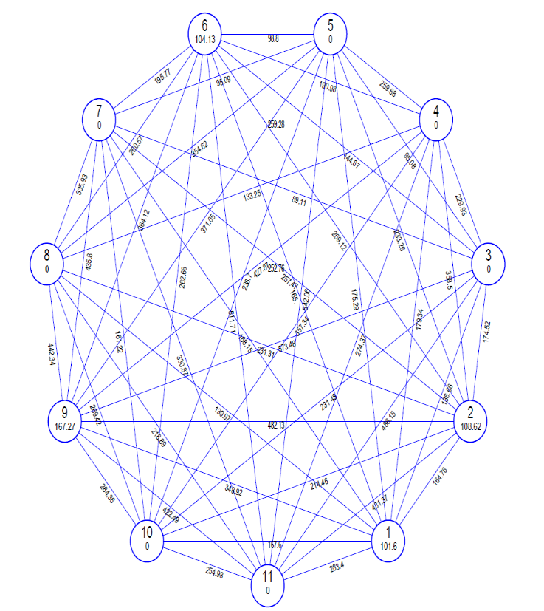
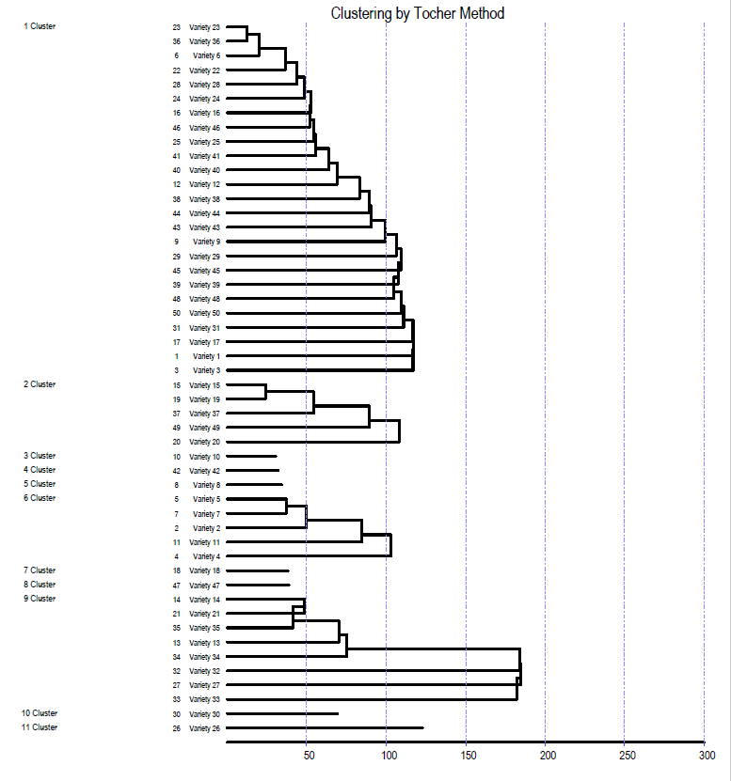
3.1 Cluster Composition and Grouping Pattern
Fig. 1. (a) Dendrogram representing grouping of genotypes into 11 clusters. (b) Cluster diagram representing genetic distance between 11 diverse cluster.
a
b
Fifty chickpea genotypes were clustered into 11 different non-overlapping clusters on the basis of Mahalanobis D2 values using Tocher’s method (Figure 1a, Table 2). The distribution pattern was highly diverse in the studied dataset. The largest cluster was Cluster I, with 25 genotypes (50% of the total material), followed by Cluster IX with 8 genotypes, Cluster II with 5 genotypes, and Cluster VI with 5 genotypes. However, Clusters III, IV, V, VII, VIII, X, and XI were single-member clusters with ICC-6788, Sadabahar, ICC-6953, ICC-1205, Vijay, JG-16, and IPC-2006-77, respectively. Monogenotypic clustering of these seven genotypes indicates their high divergence from the broader germplasm base. These grouping trends are mostly in accordance with the findings of Karthikeyan et al. (2021), who reported clustering patterns caused by morpho-physiological divergence rather than geographical origin alone.
3.2 Intra- and Inter-Cluster Distance
Intra-cluster distances indicate how heterogeneous a cluster is, whereas inter-cluster distances indicate how genetically distinct the clusters are from one another. Intra-cluster D² ranged from 0.00 to 167.27 (Table 3, Figure 1b). The maximum intra-cluster distance was recorded in Cluster IX (167.27), followed by Cluster II (108.62), Cluster VI (104.13), and Cluster I (101.60). The remaining clusters (III, IV, V, VII, VIII, X, and XI) had zero intra-cluster distances because they were monogenotypic. The highest inter-cluster distance was found between Cluster III and Cluster IX (573.48), followed by Cluster V and Cluster XI (542.06), Cluster VI and Cluster XI (511.71), Cluster III and Cluster XI (486.15), and Cluster II and Cluster IX (482.13). Crossing genotypes selected from these highly divergent combinations (e.g., ICC-6788 from Cluster III with superior-yielding lines from Cluster IX) can harness maximum heterosis and generate broad transgressive segregation in later generations. However, the lowest inter-cluster distance was recorded between Cluster III and Cluster VII (89.11), followed by Cluster III and Cluster V (95.08), Cluster V and Cluster VII (95.09), and Cluster V and Cluster VI (98.80), indicating close genetic affinity among these groups. Desirable diversity is unlikely to be produced by hybridisation between genotypes from these closely related clusters. Reddy and Lal (2021) reported similar observations for chickpea cluster-distance dynamics.
Table 2: Distribution of 50 chickpea genotypes into different clusters.
Cluster | No. of genotypes | Name of genotypes
Ⅰ | 25 | IPC 2014-55, GNG 2144, ICC 07110, IPC 2011-78, JG 315, IPC 2014-19, ICC 1212, Pant G-114, IPC 2015-81, KWR 108, GNG 2261, ICC 12453, GNG 1581 (Gangaur), RSG 895, CSJ 884, ICC 6788, JG 11, HC 5, GNG 2171, NPC-59, BDG 372, RKGK 13-515, ICC 8507, ICC 15925, ICC 16348
Ⅱ | 5 | ICC-9029, ICC 9942, GNG 1958, CSG-8962, JAKI 9218
Ⅲ | 1 | ICC 81-82
Ⅳ | 1 | Sadabahar
Ⅴ | 1 | ICC 6953
Ⅵ | 5 | ICC 10685, ICC 07118, ICC 96029, ICC 1826, ICC 92944
Ⅶ | 1 | ICC-1205
Ⅷ | 1 | Vijay
Ⅸ | 8 | ICC-1214, IPC 2015-55, GNG 1969, ICC 2156, GNG 2207, RKGK 13-416, DCP 92-3, RKGK 13-499
Ⅹ | 1 | JG 16
Ⅺ | 1 | IPC 2006-77
Table 3: Intra and inter cluster D² values for different cluster
Cluster | C Ⅰ | C Ⅱ | C Ⅲ | C Ⅳ | C Ⅴ | C Ⅵ | C Ⅶ | C Ⅷ | C Ⅸ | C Ⅹ | C Ⅺ
Cluster Ⅰ | 101.60 | 164.76 | 136.66 | 179.34 | 175.29 | 165.00 | 168.15 | 139.97 | 348.92 | 167.60 | 283.40
Cluster Ⅱ |  | 108.62 | 174.52 | 358.50 | 233.26 | 269.12 | 257.47 | 231.31 | 482.13 | 214.46 | 431.37
Cluster Ⅲ |  |  | 0.00 | 229.93 | 95.08 | 144.67 | 89.11 | 252.76 | 573.48 | 231.48 | 486.15
Cluster Ⅳ |  |  |  | 0.00 | 259.68 | 190.98 | 259.28 | 133.25 | 427.87 | 357.34 | 274.37
Cluster Ⅴ |  |  |  |  | 0.00 | 98.80 | 95.09 | 354.62 | 371.05 | 238.70 | 542.06
Cluster Ⅵ |  |  |  |  |  | 104.13 | 195.77 | 260.57 | 364.12 | 262.66 | 511.71
Cluster Ⅶ |  |  |  |  |  |  | 0.00 | 335.93 | 435.80 | 161.22 | 330.87
Cluster Ⅶ |  |  |  |  |  |  |  | 0.00 | 442.34 | 269.42 | 218.89
Cluster Ⅸ |  |  |  |  |  |  |  |  | 167.27 | 284.36 | 422.49
Cluster Ⅹ |  |  |  |  |  |  |  |  |  | 0.00 | 254.98
Cluster Ⅺ |  |  |  |  |  |  |  |  |  |  | 0.00
3.3 Contribution of individual traits to the genetic divergence
The proportionate contribution of each attribute to overall genetic divergence is shown in Table 4. Biochemical and physiological factors explained much of the genetic difference. Seed protein content explained the highest proportion of the overall divergence (29.80%) and ranked first 365 times. This was followed by chlorophyll content (24.41%, 299 times), days to 50% flowering (20.16%, 247 times), relative water content (10.78%, 132 times), 100-seed weight (6.78%, 83 times), number of pods per plant (3.02%, 37 times), days to pod initiation (2.29%, 28 times), and plant height (1.71%, 21 times). The remaining parameters, namely days to maturity, seed yield per plant, membrane stability index, and harvest index, contributed less than 1% to the total divergence, whereas effective pods per plant, seeds per pod, and dry fodder yield made negligible contributions. The higher contribution of seed protein content and phenological traits towards genetic divergence is in conformity with the findings of Nimbalkar et al. (2017) and Jayalakshmi et al. (2021). The significant contributions of traits such as relative water content, protein, and chlorophyll to total divergence are in line with the findings of Basso et al. (2024) and Kushwah et al. (2022).
Table 4 :Contribution percentage of individual characters towards genetic divergence.
S. No. | Characters | Contribution | No. of times ranked first
1 | Days to 50% flowering | 20.16% | 247
2 | Days to pod initiation | 2.29% | 28
3 | Days to maturity | 0.16% | 2
4 | Plant height (cm) | 1.71% | 21
5 | Number of pods per plant | 3.02% | 37
6 | Number of effective pods per plant | 0% | 0
7 | Number of seeds per pod | 0% | 0
8 | 100 seed weight (g) | 6.78% | 83
9 | Harvest Index (%) | 0.08% | 1
10 | Seed yield per plant (g) | 0.65% | 8
11 | Dry fodder yield per plant (g) | 0% | 0
12 | Protein content (%) | 29.8% | 365
13 | Relative water content(%) | 10.78% | 132
14 | Membrane stability index (%) | 0.16% | 2
15 | Chlorophyll Content (%) | 24.41% | 299
3.4 Cluster mean performance
The mean performance of the 11 clusters varied widely for phenological, physiological, and yield-attributing parameters (Table 5). For phenological traits, the minimum number of days to 50% flowering was found in Cluster III (47.00 days), and the maximum was found in Cluster IX (77.46 days). Days to pod initiation varied from 71.67 days (Clusters III and IV) to 103.33 days (Cluster X). Days to maturity varied from 111.67 days (Cluster VIII) to 127.00 days (Cluster X). For growth and yield parameters, Cluster IX plants were the tallest (55.15 cm), whereas Cluster VIII plants were the shortest (34.20 cm). Cluster VI recorded the maximum number of pods per plant (88.95) and seeds per pod (2.13), while the minimum number of pods per plant (36.00) and seeds per pod (1.67) were found in Cluster IV. The maximum number of effective pods per plant was observed in Cluster IX (75.73), and the minimum was observed in Cluster III (27.77). Cluster IV had bold seeds, with a 100-seed weight of 23.30 g, whereas Cluster X had petite seeds, with a 100-seed weight of 9.82 g. The maximum seed yield per plant was recorded in Cluster V (47.13 g), followed by Cluster II (45.71 g), while the minimum was recorded in Cluster XI (40.29 g). Cluster V recorded the highest harvest index (23.27%), and Cluster VII recorded the lowest (13.43%). For physiological and biochemical attributes, Cluster XI had the highest crude protein content (24.40%) and relative water content (86.23%), whereas Cluster V had the lowest protein content (14.47%) and Cluster II had the lowest RWC (68.02%). The maximum membrane stability index was observed in Cluster IV (93.23 %), and the minimum was observed in Cluster VII (70.33 %). The highest total chlorophyll content was observed in Cluster IV (2.85%), and the minimum was observed in Cluster V (1.36%). Such unique cluster features are in agreement with prior diversity assessments by Gaikwad et al. (2014), Parhe et al. (2014), Babbar et al. (2015), Karthikeyan et al. (2021), and Reddy and Lal (2021).
3.5 Limitation of this Study
Although the current study offers useful insights into the phenotypic and physio-biochemical divergence among the 50 chickpea genotypes, certain intrinsic limitations need to be acknowledged. The field evaluation was conducted during a single crop season (Rabi 2024–25) at a single agro-ecological location (Dr. BRC Agricultural Research Station, Mandor, Jodhpur; Zone-Ia). Quantitative and physiological variables are affected by genotype × environment (G X E) interactions; thus, multi-location and multi-year experiments are required to confirm the temporal and spatial stability of the observed clustering patterns. The experiment was laid out in a Randomized Block Design (RCBD) with 3 replications. The conventional statistical methods used were valid for initial diversity screening; however, a greater number of replications across different contexts would improve precision and reduce experimental error. In the present study, genetic diversity was calculated only from phenological, yield-attributing, and physio-biochemical variables using Mahalanobis D2 statistics. These morpho-biochemical traits are indicators of agronomic performance and functional diversity but are subject to environmental conditions and developmental stages. The use of DNA-based molecular markers (e.g. SSRs or SNPs) to validate these categories would provide an environment-neutral assessment of genome-wide genetic divergence.
4. Conclusion
The present study on genetic divergence in chickpea genotypes using Mahalanobis D statistics showed that 50 genotypes were grouped into 11 distinct clusters, with Cluster IX recording the highest intra-cluster distance and therefore showing the greatest within-cluster diversity for the traits evaluated. Furthermore, protein content, chlorophyll content, and days to 50% flowering were identified as the most important contributors to genetic divergence, emphasising their role in differentiating genotypes and guiding trait-based selection. The maximum inter-cluster distance was recorded between Clusters III and IX; therefore, crosses between genotypes from these highly divergent clusters can be employed to exploit heterosis and generate superior transgressive segregants. Such crosses can broaden the genetic base and accelerate the development of high-yielding chickpea varieties.

Table 5: Cluster mean for yield and yield contributing traits.
Characters | DFF | DPI | DM | PH (cm) | NPPP | NEPPP | NSPP | 100-SW (g) | HI (%) | SYPP (g) | DFYPP  (g) | PC (%) | RWC% | MSI (%) | CHL (%)
Cluster Ⅰ | 54.29 | 74.19 | 115.20 | 42.70 | 52.98 | 41.86 | 1.82 | 15.18 | 15.52 | 42.17 | 21.12 | 19.50 | 69.46 | 74.85 | 2.10
Cluster Ⅱ | 54.07 | 74.20 | 114.40• | 45.31 | 86.07 | 74.83 | 2.03 | 19.44 | 22.31 | 45.71 | 25.64# | 22.19 | 68.02• | 76.78 | 1.47
Cluster Ⅲ | 47.00• | 71.67 | 116.00 | 35.60 | 39.63 | 27.77• | 1.87 | 16.60 | 14.57 | 42.71 | 19.50• | 16.43 | 71.09 | 77.33 | 1.47
Cluster Ⅳ | 52.67 | 71.67• | 115.67 | 45.50 | 36.00• | 28.07 | 1.67• | 23.30# | 16.03 | 44.03 | 20.37 | 16.53 | 76.64 | 93.23# | 2.85#
Cluster Ⅴ | 63.00 | 79.33 | 124.67 | 52.43 | 80.67 | 66.90 | 2.07 | 14.86 | 23.27# | 47.13# | 25.90 | 14.47• | 71.41 | 74.33 | 1.36•
Cluster Ⅵ | 59.00 | 79.93 | 126.07 | 46.91 | 88.95# | 75.47 | 2.13# | 17.13 | 18.80 | 44.77 | 23.03 | 14.99 | 68.38 | 73.13 | 2.02
Cluster Ⅶ | 56.00 | 75.00 | 117.00 | 41.20 | 55.70 | 44.57 | 1.80 | 11.39 | 13.43• | 40.84 | 19.50 | 16.80 | 81.96 | 70.33• | 1.45
Cluster ⅦI | 49.00 | 72.67 | 111.67 | 34.20• | 52.23 | 41.40 | 1.73 | 16.60 | 20.87 | 45.44 | 24.93 | 20.37 | 68.93 | 70.57 | 2.85
Cluster IX | 77.46# | 95.67 | 125.25 | 55.15# | 87.60 | 75.73# | 2.04 | 11.85 | 17.83 | 43.01 | 23.38 | 20.55 | 72.13 | 75.54 | 2.43
Cluster X | 54.00 | 103.33# | 127.00# | 47.97 | 67.43 | 53.93 | 1.73 | 9.82• | 15.67 | 42.10 | 21.30 | 22.60 | 78.70 | 77.33 | 1.89
Cluster XI | 53.00 | 74.00 | 118.00 | 51.07 | 43.90 | 32.23 | 1.67 | 10.94 | 14.40 | 40.29• | 21.50 | 24.40# | 86.23# | 81.77 | 2.93
•, # represents minimum and maximum values, respectively.
*Where DFF = Days to 50% flowering , DPI = Days to pod initiation , DM = Days to maturity , NPPP = Number of pods per plant , NEPPP = number of effective pods per plant , NSPP = number of seeds per pod , 100-SW = 100 seed weight, HI(%) = Harvest index , SYPP (g) = Seed yield per plant , DFYPP (g) = Dry fodder yield per plant , PC (%) = Protein content, RWC (%) = Relative water content , MSI (%) = Membrane stability index, CHL (%) = Chlorophyll content

Competing interests
Authors have declared that no competing interests exist.

Declaration of AI Use

This manuscript was prepared through the intellectual contributions of the author(s) to the study design, data analysis, interpretation of results, and scholarly content. Grammarly and ChatGPT were used solely to assist with grammatical refinement and reference formatting during manuscript revision. The author(s) accept full responsibility for the accuracy, integrity, and final content of the manuscript.

REFRENCES
Anonymous. (2023). Estimate by AICRP in pulses, Kanpur, Uttar Pradesh. ICAR-Indian Institute of Pulses Research. https://www.icar-iipr.org.in/aicrp-on-rabi-pulses/
Arnon, D. I. (1949). Copper enzymes in isolated chloroplasts: Polyphenoloxidase in Beta vulgaris. Plant Physiology, 24(1), 1–15. https://doi.org/10.1104/pp.24.1.1
Babbar, A., Pandey, S., & Singh, R. (2015). Genetic studies on chickpea genotypes grown in late sown under rice fallow conditions of Madhya Pradesh. Electronic Journal of Plant Breeding, 6(3), 738–748. https://www.ejplantbreeding.org/index.php/EJPB/article/download/385/501
Barrs, H. D., & Weatherley, P. E. (1962). A re-examination of the relative turgidity technique for estimating water deficits in leaves. Australian Journal of Biological Sciences, 15(3), 413–428. https://doi.org/10.1071/BI9620413
Basavaraj, P. S., Rane, J., Jangid, K. K., Babar, R., Kumar, M., Gangurde, A., Shinde, S., Boraiah, K. M., Harisha, C. B., Halli, H. M., Reddy, K. S., & Prabhakar, M. (2025). Index-based selection of chickpea (Cicer arietinum L.) genotypes for enhanced drought tolerance. Scientific Reports, 15, 8282. https://doi.org/10.1038/s41598-025-93273-1
Basso, M. F., Girardin, G., Vergata, C., Buti, M., & Martinelli, F. (2024). Genome-wide transcript expression analysis reveals major chickpea and lentil genes associated with plant branching. Frontiers in Plant Science, 15, 1384237. https://doi.org/10.3389/fpls.2024.1384237
Blum, A., & Ebercon, A. (1981). Cell membrane stability as a measure of drought and heat tolerance in wheat. Crop Science, 21(1), 43–47. https://doi.org/10.2135/cropsci1981.0011183X002100010013x
Costantini, M., Summo, C., Centrone, M., Rybicka, I., D’Agostino, M., Annicchiarico, P., Caponio, F., Pavan, S., Tamma, G., & Pasqualone, A. (2021). Macro- and micro-nutrient composition and antioxidant activity of chickpea and pea accessions. Polish Journal of Food and Nutrition Sciences, 71(2), 177–185. https://doi.org/10.31883/pjfns/135813
Diwedi, R., Syed, M., & Singh, M. (2025). Morpho-physiological characterization and yield performance of chickpea genotypes under moisture stress conditions. Asian Journal of Research and Review in Agriculture, 7(1), 202–214. https://doi.org/10.56557/ajrra/2025/v7i1170
Gaikwad, A. R., Desai, N. C., Pawar, G. H., & Langhi, A. M. (2014). Genetic divergence in chickpea. International Journal of Agricultural Sciences, 10(2), 812–815.
Jayalakshmi, V., Imran, M. M., & Reddy, A. T. (2021). Genetic analysis for protein, micronutrients and yield attributing traits in chickpea (Cicer arietinum L.). Journal of Food Legumes, 34(3), 188–193. https://pub.isprd.in/index.php/jfl/article/download/254/143/636
Karthikeyan, M., Pandey, S., Synrem, G., & Saravanan, K. R. (2021). Assessment of genetic diversity of chickpea genotypes (Cicer arietinum L.) using D² statistics. Current Journal of Applied Science and Technology, 40(24), 51–56. https://doi.org/10.9734/cjast/2021/v40i2431504
Khan, A. W., Garg, V., Sun, S., Gupta, S., Dudchenko, O., Roorkiwal, M., Chitikineni, A., Bayer, P. E., Shi, C., Upadhyaya, H. D., Bohra, A., Bharadwaj, C., Mir, R. R., Baruch, K., Yang, B., Coyne, C. J., Bansal, K. C., Nguyen, H. T., Ronen, G., … Varshney, R. K. (2024). Cicer super-pangenome provides insights into species evolution and agronomic trait loci for crop improvement in chickpea. Nature Genetics, 56(6), 1225–1234. https://doi.org/10.1038/s41588-024-01760-4
Kjeldahl, J. (1883). Neue Methode zur Bestimmung des Stickstoffs in organischen Körpern. Zeitschrift für Analytische Chemie, 22(1), 366–382. https://doi.org/10.1007/BF01338151
Kushwah, A., Bhatia, D., Barmukh, R., Singh, I., Singh, G., Bindra, S., Vij, S., Chellapilla, B., Pratap, A., Roorkiwal, M., Kumar, S., Varshney, R. K., & Singh, S. (2022). Genetic mapping of QTLs for drought tolerance in chickpea (Cicer arietinum L.). Frontiers in Genetics, 13, 953898. https://doi.org/10.3389/fgene.2022.953898
Nimbalkar, R. D., Katre, Y. Y., & Phad, D. S. (2017). Genetic diversity in chickpea (Cicer arietinum L.). Bioinfolet, 14(1), 60–63.
Parhe, S. D., Harer, P. N., & Nagawade, D. R. (2014). Investigation of genetic divergence in chickpea (Cicer arietinum L.) genotypes. The Bioscan, 9(Supplement 2), 879–882. https://thebioscan.com/index.php/pub/article/view/2240
Rao, C. R. (1952). Advanced statistical methods in biometric research. John Wiley & Sons. https://campuslib.keralauniversity.ac.in/cgi-bin/koha/opac-detail.pl?biblionumber=524467
Reddy, M. A., & Lal, G. M. (2021). Assessment of genetic diversity for different quantitative traits in chickpea (Cicer arietinum L.). The Pharma Innovation Journal, 10(9), 2135–2139. https://www.thepharmajournal.com/archives/?ArticleId=7967&issue=9&vol=10&year=2021
Singh, R., Sharma, P., Varshney, R. K., Sharma, S. K., & Singh, N. K. (2008). Chickpea improvement: Role of wild species and genetic markers. Biotechnology and Genetic Engineering Reviews, 25(1), 267–313. https://doi.org/10.5661/bger-25-267
Varshney, R. K., Roorkiwal, M., Sun, S., Bajaj, P., Chitikineni, A., Thudi, M., Singh, N. P., Du, X., Upadhyaya, H. D., Khan, A. W., Wang, Y., Garg, V., Fan, G., Cowling, W. A., Crossa, J., Gentzbittel, L., Voss-Fels, K. P., Valluri, V. K., Sinha, P., … Liu, X. (2021). A chickpea genetic variation map based on the sequencing of 3,366 genomes. Nature, 599(7886), 622–627. https://doi.org/10.1038/s41586-021-04066-1
Vavilov, N. I. (1926). Studies on the origin of cultivated plants. Bulletin of Applied Botany and Plant Breeding, 16(2), 1–248.
Yadav, R. K., Tripathi, M. K., Tiwari, S., Asati, R., Chauhan, S., Sikarwar, R. S., & Yasin, M. (2023). Evaluation of genetic diversity through D² statistic in chickpea (Cicer arietinum L.). International Journal of Environment and Climate Change, 13(10), 1598–1611. https://doi.org/10.9734/ijecc/2023/v13i102815

