In vitro Efficacy of Fungicides, Bio-agents, and Organic Amendments Against Sclerotium rolfsii Causing Stem Rot of Chilli

ABSTRACT
Aims: To assess the in vitro fungitoxic and antagonistic potential of systemic fungicides, contact/combi-product fungicides, fungal and bacterial biocontrol agents, and organic amendments against Sclerotium rolfsii, the causal agent associated with stem rot of chilli.
Study Design: Completely Randomised Design (CRD).
Place and Duration of Study: Department of Plant Pathology, College of Agriculture, Latur, Maharashtra, India; 2025–2026.
Methodology: The pathogen was isolated from symptomatic chilli collar/root tissues and identified morphologically on Potato Dextrose Agar (PDA). Seven systemic fungicides (500 and 1000 ppm), seven contact/combi-product fungicides (2000 and 2500 ppm), and seven organic amendments (5% and 10%) were evaluated using the poisoned-food technique. Seven biocontrol agents were screened using a dual-culture assay. Each experiment was conducted in a CRD with three replications.
Results: Propiconazole 25% EC, Tebuconazole 25.9% EC, and Hexaconazole 5% SC produced 100.00% inhibition at both systemic-fungicide concentrations. Six of the seven contact/combi-product fungicides produced 100.00% inhibition at 2000 and 2500 ppm; copper oxychloride was less effective. Among the bioagents, Trichoderma harzianum produced the greatest inhibition (66.22%; colony diameter 30.40 mm), followed by Aspergillus niger (65.52%; 31.03 mm). Groundnut and cotton seed cake extracts produced 100.00% inhibition at 10%, with average inhibitions of 92.27% and 89.46%, respectively.
Conclusion: The assays identified several treatments with strong in vitro activity against S. rolfsii. These treatments are candidates for subsequent compatibility, greenhouse, phytotoxicity, and field efficacy studies before being recommended as components of integrated disease management.
Keywords: Bioagents; chilli; fungicides; organic amendments; Sclerotium rolfsii; stem rot.

1. INTRODUCTION
Chilli (Capsicum annuum L.) is an economically important vegetable and spice crop cultivated widely across tropical and subtropical regions. Its fruits are consumed in fresh and processed forms and contain nutritionally relevant vitamins, minerals, carotenoids, flavonoids, and capsaicinoids (Hernández-Pérez et al., 2020).
Stem or collar rot associated with Sclerotium rolfsii is an important soilborne disease constraint. Current taxonomy places the pathogen as Agroathelia rolfsii (anamorph: Sclerotium rolfsii), while the name S. rolfsii remains widely used in agricultural plant-pathology literature. The pathogen is necrotrophic, has a host range exceeding 500 plant species, and forms persistent sclerotia that facilitate survival in soil (Mascarenhas & Quesada-Ocampo, 2024; Punja, 1985). In the Marathwada region of Maharashtra, surveys have documented substantial collar-rot incidence in chilli, and regional literature has summarised reported crop losses ranging from 16% to 80% under conducive conditions (Daunde et al., 2018).
The persistence of sclerotia and the broad host range of S. rolfsii make reliance on a single control tactic undesirable. Chemical fungicides can provide strong suppression, whereas antagonistic microorganisms and organic amendments may contribute complementary modes of action. Recent work from the same agro-ecological setting has also demonstrated measurable in vitro antagonism of several bioagents against chilli-associated S. rolfsii (Karande et al., 2025). The present study broadens this laboratory evidence by comparing, within one experimental programme, systemic fungicides, contact/combi-product fungicides, seven bioagents, and seven organic amendments. The objective was to identify treatments with sufficient in vitro activity to justify subsequent greenhouse and field validation.

2. MATERIALS AND METHODS

2.1 Isolation and Morphological Identification of Sclerotium rolfsii
Naturally infected chilli plants showing characteristic collar/stem-rot lesions and collar constriction were collected from experimental fields and farmer plots in Latur district, Maharashtra. Tissue pieces (approximately 2.5 mm) were excised from the advancing margins of affected collar/root tissues, surface-disinfected in 0.1% sodium hypochlorite for 30 s, rinsed three times in sterile distilled water, and placed aseptically on Potato Dextrose Agar (PDA). Plates were incubated at 27 ± 1 °C for 5–7 days. Pure cultures were maintained on PDA slants after hyphal-tip isolation. Identification was based on cultural and microscopic characters, including hyaline, septate, branched hyphae with clamp connections and the formation of globose, smooth, brown sclerotia.

2.2 In Vitro Evaluation of Systemic, Contact, and Combi-product Fungicides
Seven systemic fungicides—Propiconazole 25% EC, Carbendazim 50% WP, Thiophanate-methyl 70% WP, Tebuconazole 25.9% EC, Hexaconazole 5% SC, Azoxystrobin 23% SC, and Difenoconazole 25% EC—were evaluated at 500 and 1000 ppm. Three contact fungicides—Mancozeb 75% WP, Propineb 70% WP, and Copper oxychloride 50% WP—and four combi-products—Azoxystrobin 18.2% + Difenoconazole 11.4% SC, Carbendazim 12% + Mancozeb 63% WP, Tebuconazole 50% + Trifloxystrobin 25% WP, and Tebuconazole 6.7% + Captan 26.9% SC—were evaluated at 2000 and 2500 ppm using the poisoned-food technique (Nene & Thapliyal, 1993). Quantities were calculated on an active-ingredient basis and incorporated into sterilised molten PDA. Plates were centrally inoculated with 5-mm mycelial discs cut from the actively growing margin of a 7-day-old S. rolfsii culture and incubated at 27 ± 1 °C. Unamended PDA served as the control. Colony diameter was recorded when the control reached 90 mm.
Percentage inhibition was calculated using Vincent’s (1947) formula: I = [(C − T)/C] × 100, where I is inhibition of mycelial growth (%), C is colony diameter in the untreated control (mm), and T is colony diameter in the treatment (mm).

2.3 In Vitro Evaluation of Bio-agents
Seven antagonists—Trichoderma koningii, T. hamatum, T. harzianum, T. asperellum, Aspergillus niger, Bacillus subtilis, and Pseudomonas fluorescens—were screened using a dual-culture assay based on Dennis and Webster (1971). In 90-mm PDA plates, 5-mm culture discs of the test pathogen and the respective antagonist were positioned on opposite sides of the plate, approximately 60 mm apart. Plates containing only S. rolfsii served as controls. Incubation was at 27 ± 1 °C until the control attained 90-mm colony diameter. Percentage inhibition was calculated from control and treatment colony diameters using the relationship described by Arora and Upadhyay (1978).

2.4 In Vitro Evaluation of Organic Amendments
Seven organic amendments—groundnut seed cake, cotton seed cake, neem seed powder, sesame seed cake, safflower seed cake, mustard seed cake, and vermicompost—were evaluated at nominal assay concentrations of 5% and 10% using the poisoned-food technique. Aqueous stock extracts were prepared by soaking each material in sterile distilled water at 1:1 (w/v) for 24 h, followed by filtration through Whatman filter paper. The filtrates were incorporated into double-strength PDA to obtain the stated assay concentrations. Plates were centrally inoculated with 5-mm discs of S. rolfsii and incubated at 27 ± 1 °C. Colony diameter was measured and percentage inhibition was calculated relative to the unamended PDA control using Vincent’s (1947) formula.

2.5 Statistical Analysis
All experiments were arranged in a Completely Randomised Design with three replications. Percentage inhibition data were arcsine-transformed before analysis of variance (Panse & Sukhatme, 1978). Standard error of the mean (S.E. ±) and critical difference (C.D.) values were calculated at the 1% significance level (P = .01). Untransformed means are presented in the tables to facilitate biological interpretation; percentage inhibition is a derived measure calculated from colony diameter.

3. RESULTS AND DISCUSSION

3.1 In Vitro Efficacy of Systemic Fungicides Against Sclerotium rolfsii
All systemic fungicides reduced S. rolfsii colony growth relative to the untreated control (Table 1). At 500 ppm, Propiconazole 25% EC, Tebuconazole 25.9% EC, and Hexaconazole 5% SC produced complete inhibition (100.00%; 0.00 mm). Difenoconazole 25% EC and Azoxystrobin 23% SC produced 86.00% and 81.63% inhibition, respectively, whereas Carbendazim 50% WP (18.56%) and Thiophanate-methyl 70% WP (16.73%) were the least effective. At 1000 ppm, Difenoconazole also produced complete inhibition, while Azoxystrobin reached 85.93%.
Across concentrations, Propiconazole, Tebuconazole, and Hexaconazole maintained 100.00% inhibition, followed by Difenoconazole (93.00%) and Azoxystrobin (83.78%). The relatively weak performance of Carbendazim and Thiophanate-methyl is consistent with reports that carbendazim can be substantially less active than triazole fungicides against Indian S. rolfsii isolates (Sharma & Dhruj, 2018). High in vitro activity of tebuconazole and difenoconazole against chilli/capsicum-associated S. rolfsii has also been reported by Madhavi and Bhattiprolu (2011) and Sahana et al. (2020). Representative plates and the response pattern are shown in Plate 1 and Figure 1.
Table 1. In vitro efficacy of systemic fungicides against Sclerotium rolfsii causing stem rot of chilli
Tr. No. | Treatment | 500 ppm  (mm) | 1000 ppm  (mm) | Average  (mm) | 500 ppm  (%) | 1000 ppm  (%) | Average  (%)
T1 | Propiconazole 25% EC | 0.00 | 0.00 | 0.00 | 100.00 | 100.00 | 100.00
T2 | Carbendazim 50% WP | 73.29 | 70.65 | 71.97 | 18.56 | 21.50 | 20.03
T3 | Thiophanate-methyl 70% WP | 74.94 | 72.23 | 73.58 | 16.73 | 19.74 | 18.23
T4 | Tebuconazole 25.9% EC | 0.00 | 0.00 | 0.00 | 100.00 | 100.00 | 100.00
T5 | Hexaconazole 5% SC | 0.00 | 0.00 | 0.00 | 100.00 | 100.00 | 100.00
T6 | Azoxystrobin 23% SC | 16.53 | 12.66 | 14.59 | 81.63 | 85.93 | 83.78
T7 | Difenoconazole 25% EC | 12.60 | 0.00 | 6.30 | 86.00 | 100.00 | 93.00
T8 | Control (untreated) | 90.00 | 90.00 | 90.00 | – | – | –
 | S.E. ± | 0.45 | 0.52 | – | – | – | –
 | C.D. at 1% | 1.89 | 2.16 | – | – | – | –
Note. Values are means of three replications. Percentage inhibition was calculated relative to the 90-mm untreated control. S.E. = standard error; C.D. = critical difference at P = .01.
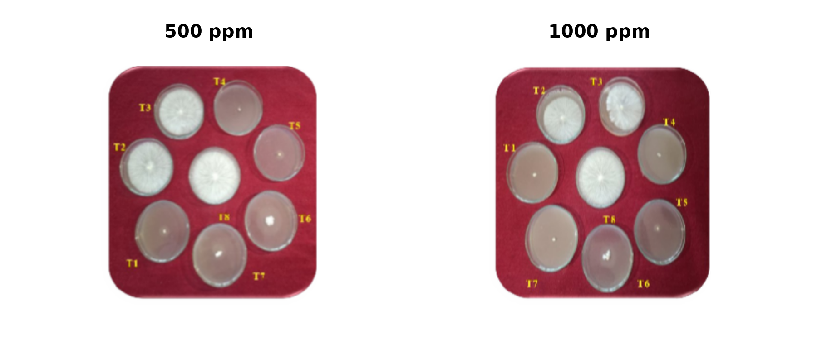
Plate 1. Representative in vitro response of Sclerotium rolfsii to systemic fungicides at 500 and 1000 ppm.
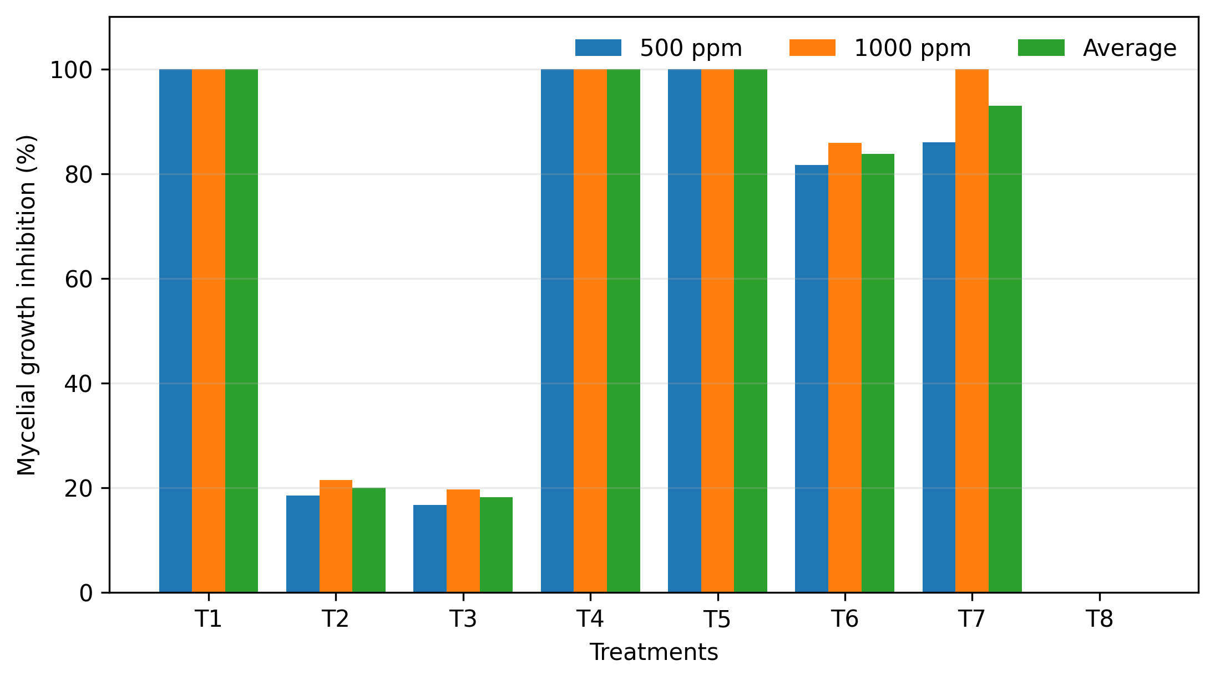
Figure 1. Mycelial growth inhibition of Sclerotium rolfsii by systemic fungicides. Treatment codes correspond to Table 1.

3.2 In Vitro Efficacy of Contact and Combi-product Fungicides Against Sclerotium rolfsii
Six of the seven contact/combi-product formulations—Mancozeb 75% WP, Propineb 70% WP, Azoxystrobin 18.2% + Difenoconazole 11.4% SC, Carbendazim 12% + Mancozeb 63% WP, Tebuconazole 50% + Trifloxystrobin 25% WP, and Tebuconazole 6.7% + Captan 26.9% SC—completely inhibited colony growth at both 2000 and 2500 ppm (Table 2). Copper oxychloride 50% WP was less active, producing 41.43% inhibition at 2000 ppm and 54.05% at 2500 ppm, with an average inhibition of 47.74%.
These findings are consistent with the strong in vitro activity reported for mancozeb-containing and triazole-containing treatments against S. rolfsii in chilli/capsicum systems (Madhavi & Bhattiprolu, 2011; Sahana et al., 2020; Sharma & Dhruj, 2018). Mixtures containing partners with different modes of action may contribute to resistance management when each component remains effective, although the benefit depends on dose, partner efficacy, and resistance risk rather than on the mere presence of two active ingredients (van den Bosch et al., 2014). The tested concentrations produced a ceiling response for six formulations, so those treatments cannot be meaningfully ranked within this assay. Representative plates and the inhibition pattern are shown in Plate 2 and Figure 2.
Table 2. In vitro efficacy of contact and combi-product fungicides against Sclerotium rolfsii causing stem rot of chilli
Tr. No. | Treatment | 2000 ppm  (mm) | 2500 ppm  (mm) | Average  (mm) | 2000 ppm  (%) | 2500 ppm  (%) | Average  (%)
T1 | Mancozeb 75% WP | 0.00 | 0.00 | 0.00 | 100.00 | 100.00 | 100.00
T2 | Propineb 70% WP | 0.00 | 0.00 | 0.00 | 100.00 | 100.00 | 100.00
T3 | Copper oxychloride 50% WP | 52.71 | 41.35 | 47.03 | 41.43 | 54.05 | 47.74
T4 | Azoxystrobin 18.2% + Difenoconazole 11.4% SC | 0.00 | 0.00 | 0.00 | 100.00 | 100.00 | 100.00
T5 | Carbendazim 12% + Mancozeb 63% WP | 0.00 | 0.00 | 0.00 | 100.00 | 100.00 | 100.00
T6 | Tebuconazole 50% + Trifloxystrobin 25% WP | 0.00 | 0.00 | 0.00 | 100.00 | 100.00 | 100.00
T7 | Tebuconazole 6.7% + Captan 26.9% SC | 0.00 | 0.00 | 0.00 | 100.00 | 100.00 | 100.00
T8 | Control (untreated) | 90.00 | 90.00 | 90.00 | – | – | –
 | S.E. ± | 0.39 | 0.33 | – | – | – | –
 | C.D. at 1% | 1.64 | 1.35 | – | – | – | –
Note. Values are means of three replications. Percentage inhibition was calculated relative to the 90-mm untreated control. S.E. = standard error; C.D. = critical difference at P = .01.
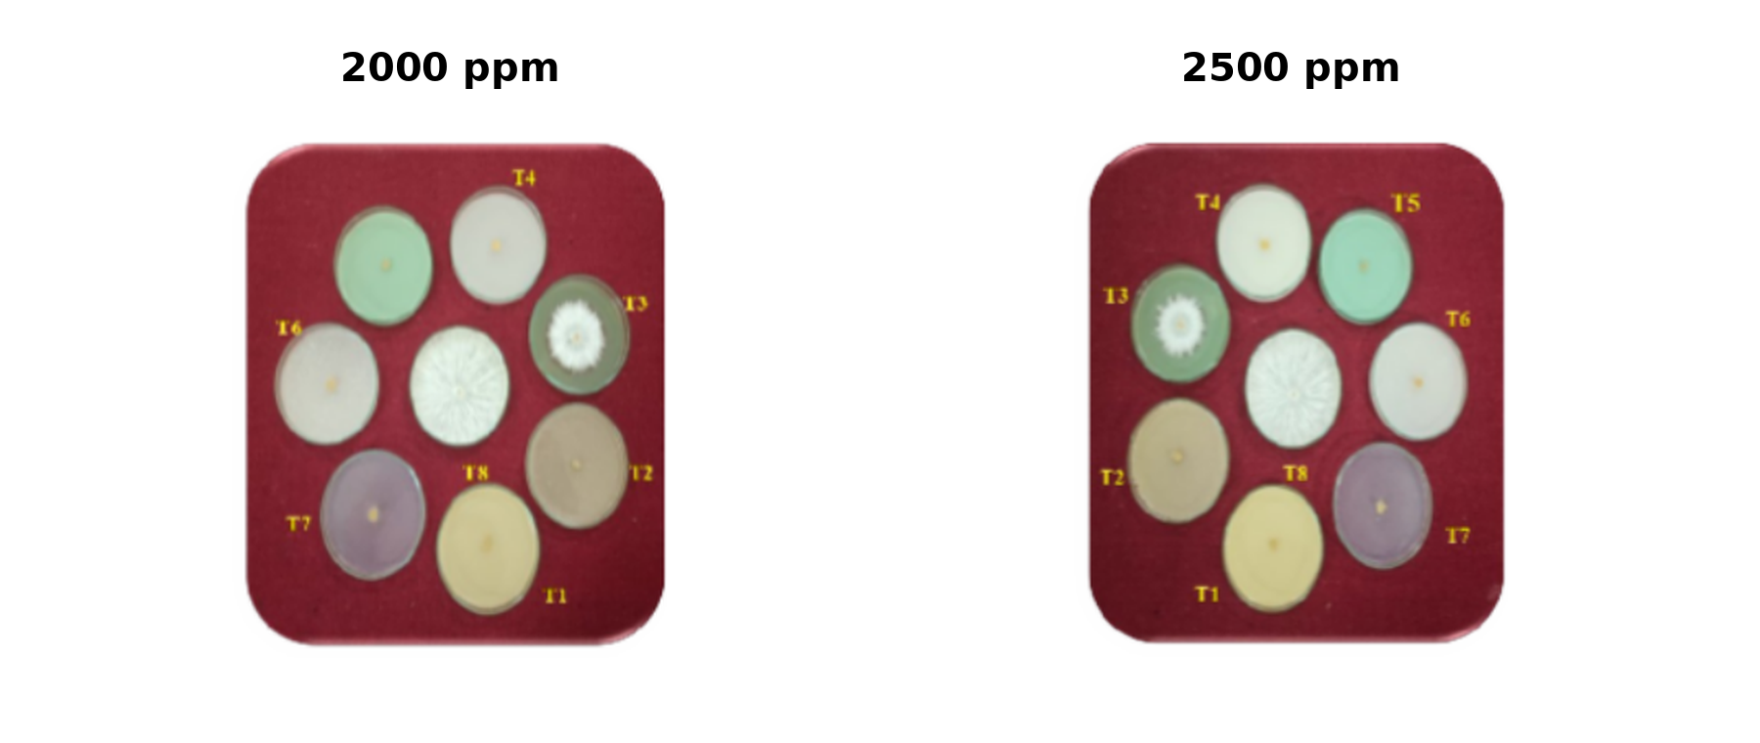
Plate 2. Representative in vitro response of Sclerotium rolfsii to contact/combi-product fungicides at 2000 and 2500 ppm.
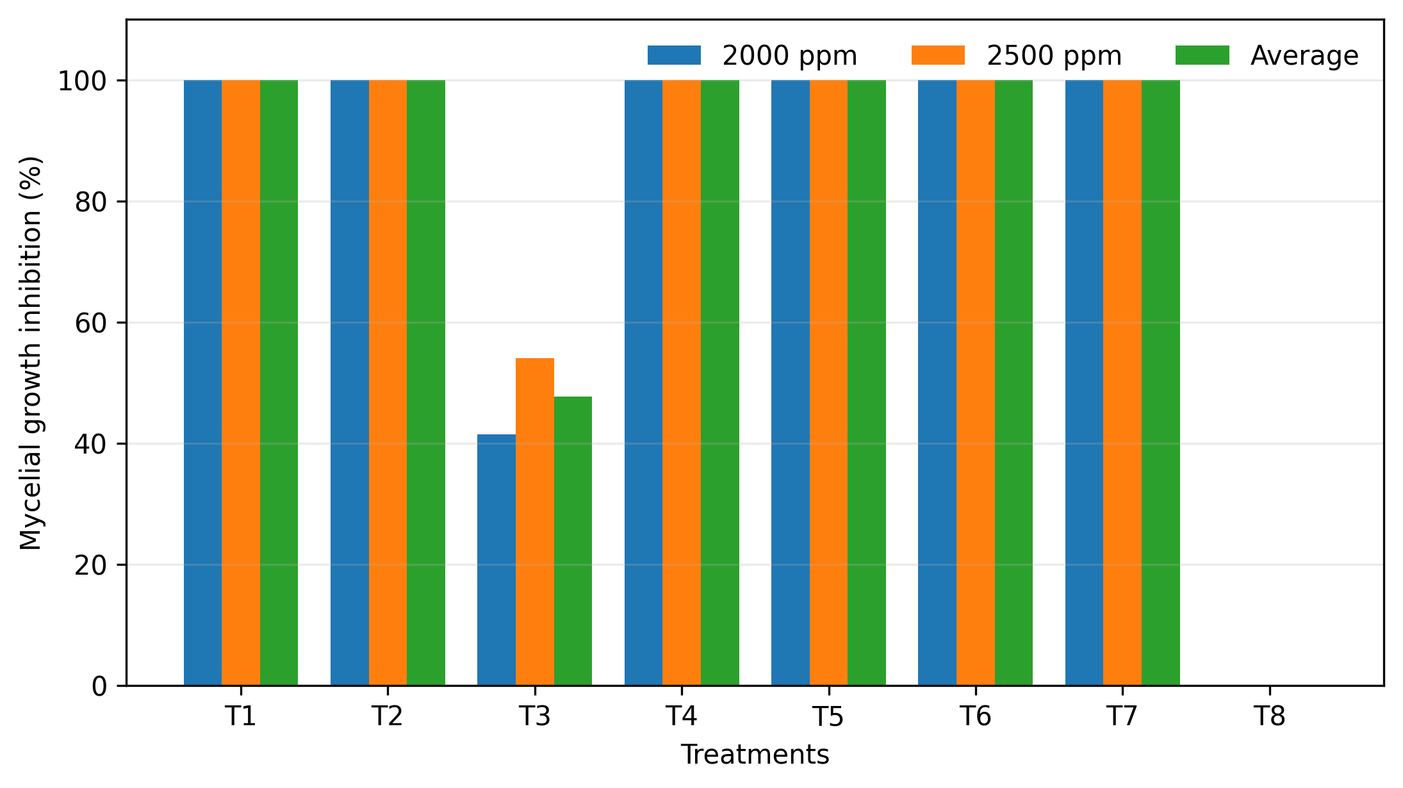
Figure 2. Mycelial growth inhibition of Sclerotium rolfsii by contact and combi-product fungicides. Treatment codes correspond to Table 2.

3.3 In Vitro Efficacy of Biocontrol Agents Against Sclerotium rolfsii
All seven antagonists restricted S. rolfsii colony growth compared with the 90-mm untreated control (Table 3). Trichoderma harzianum produced the greatest inhibition (66.22%; 30.40 mm), closely followed by A. niger (65.52%; 31.03 mm). T. koningii, T. asperellum, and T. hamatum produced intermediate inhibition of 61.41%, 60.63%, and 59.66%, respectively. The two bacterial antagonists produced lower inhibition in this plate-based screening: P. fluorescens 46.60% and B. subtilis 44.15%.
The activity of T. harzianum is biologically plausible because Trichoderma spp. can suppress fungal pathogens through competition, mycoparasitism, antibiosis, and hydrolytic enzymes; these mechanisms are generally established but were not measured directly in the present experiment (Harman et al., 2004). Dutta & Das (2002) also reported strong antagonistic activity of T. harzianum against S. rolfsii. Karande et al. (2025) demonstrated that the relative performance of bioagents can vary among chilli-associated isolates and assay conditions, supporting the need for isolate-specific validation. Although A. niger showed strong laboratory antagonism here, field deployment would require strain-level identity and safety characterisation because ochratoxin A production occurs in a minority of A. niger strains under favourable conditions (Schuster et al., 2002). Plate 3 and Figure 3 summarise the assay.

Table 3. In vitro efficacy of bioagents against Sclerotium rolfsii causing stem rot of chilli
Tr. No. | Treatment | Mean colony diameter (mm) | Inhibition over control (%)
T1 | Trichoderma koningii | 34.73 | 61.41
T2 | Trichoderma hamatum | 36.30 | 59.66
T3 | Trichoderma harzianum | 30.40 | 66.22
T4 | Trichoderma asperellum | 35.43 | 60.63
T5 | Aspergillus niger | 31.03 | 65.52
T6 | Bacillus subtilis | 50.26 | 44.15
T7 | Pseudomonas fluorescens | 48.06 | 46.60
T8 | Control (untreated) | 90.00 | –
 | S.E. ± | 0.56 | –
 | C.D. at 1% | 2.34 | –
Note. Values are means of three replications. Percentage inhibition was calculated relative to the 90-mm untreated control. S.E. = standard error; C.D. = critical difference at P = .01.
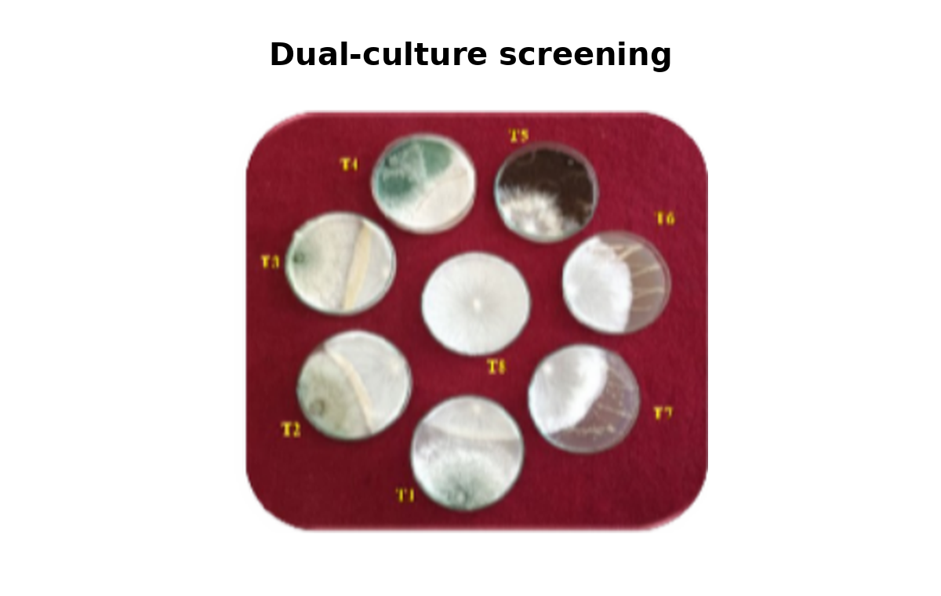
Plate 3. Representative dual-culture screening of bioagents against Sclerotium rolfsii.
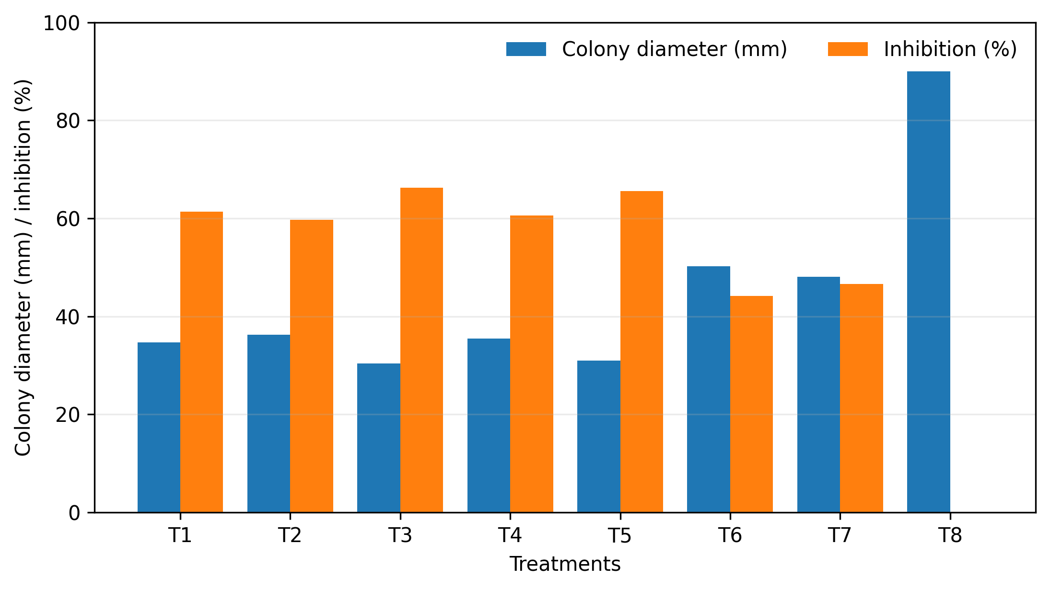
Figure 3. Colony diameter and percentage inhibition of Sclerotium rolfsii in the bioagent screening. Treatment codes correspond to Table 3.

3.4 In Vitro Efficacy of Organic Amendments Against Sclerotium rolfsii
The aqueous organic-amendment extracts differed markedly in activity and generally produced greater inhibition at 10% than at 5% (Table 4). At 5%, groundnut seed cake was the most active treatment (84.55% inhibition; 13.90 mm), followed by sesame seed cake (79.41%), cotton seed cake (78.93%), and safflower seed cake (71.30%). At 10%, groundnut seed cake and cotton seed cake completely inhibited colony growth. Sesame and safflower seed cakes produced 85.55% and 81.93% inhibition, respectively. Neem seed powder, mustard seed cake, and vermicompost were comparatively weak under the conditions tested.
Vineela et al. (2020) similarly reported complete in vitro inhibition of S. rolfsii by groundnut cake extract. Organic amendments can suppress soilborne pathogens through interacting chemical and biological processes, but suppressiveness varies substantially with amendment type, decomposition status, microbiota, and pathogen (Bonanomi et al., 2018). Accordingly, the present paper-filtered extract assay should be interpreted as measuring the activity of the amendment preparation as tested rather than demonstrating a specific chemical mechanism. Pawar et al. (2014) also reported disease-management benefits from organic amendments in S. rolfsii-affected soybean systems. Representative plates and the inhibition pattern are shown in Plate 4 and Figure 4.
Table 4. In vitro efficacy of organic amendments against Sclerotium rolfsii causing stem rot of chilli
Tr. No. | Treatment | 5%  (mm) | 10%  (mm) | Average  (mm) | 5%  (%) | 10%  (%) | Average  (%)
T1 | Groundnut seed cake | 13.90 | 0.00 | 6.95 | 84.55 | 100.00 | 92.27
T2 | Cotton seed cake | 18.96 | 0.00 | 9.48 | 78.93 | 100.00 | 89.46
T3 | Neem seed powder | 77.60 | 63.75 | 70.67 | 13.77 | 29.16 | 21.46
T4 | Sesame seed cake | 18.53 | 13.00 | 15.76 | 79.41 | 85.55 | 82.48
T5 | Safflower seed cake | 25.83 | 16.26 | 21.05 | 71.30 | 81.93 | 76.61
T6 | Mustard seed cake | 79.80 | 65.50 | 72.65 | 11.33 | 27.22 | 19.27
T7 | Vermicompost | 82.50 | 77.15 | 79.83 | 8.33 | 14.27 | 11.30
T8 | Control (untreated) | 90.00 | 90.00 | 90.00 | – | – | –
 | S.E. ± | 0.58 | 0.26 | – | – | – | –
 | C.D. at 1% | 2.40 | 1.07 | – | – | – | –
Note. Values are means of three replications. The average colony diameter for safflower seed cake is 21.05 mm, calculated from 25.83 and 16.26 mm. Percentage inhibition was calculated relative to the 90-mm untreated control. S.E. = standard error; C.D. = critical difference at P = .01.
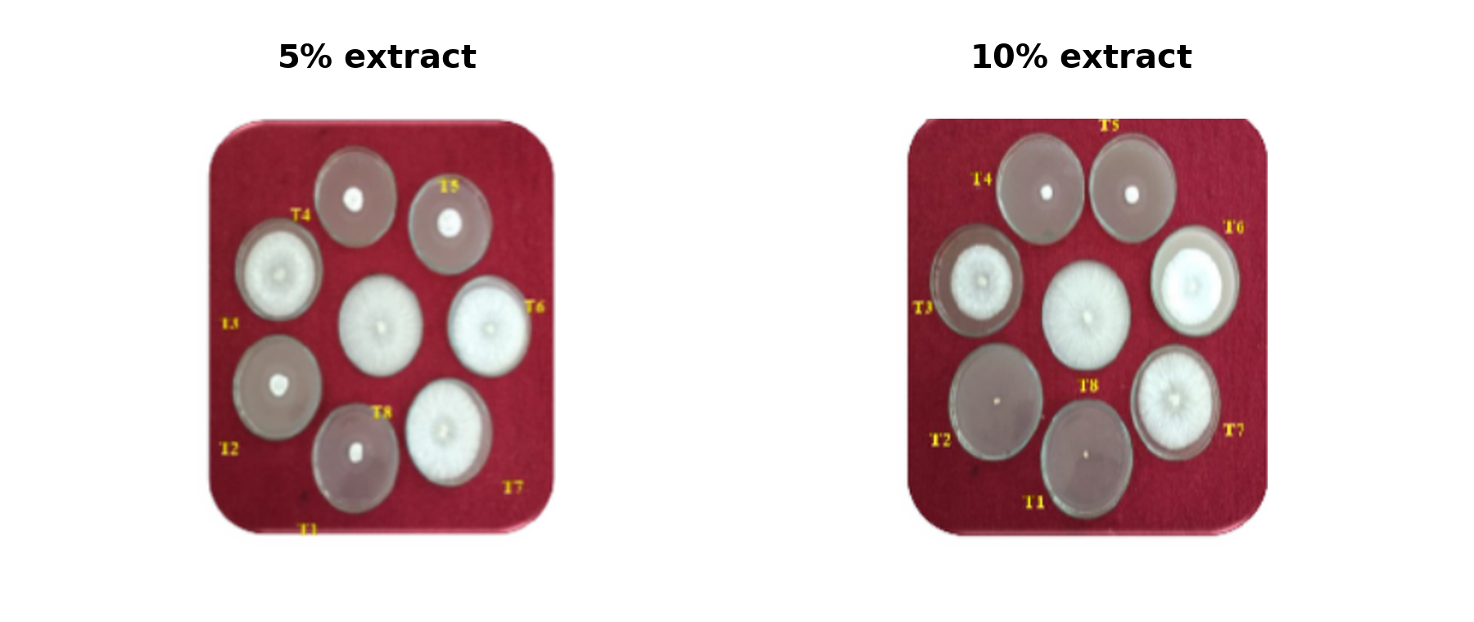
Plate 4. Representative in vitro response of Sclerotium rolfsii to organic-amendment extracts at 5% and 10%.
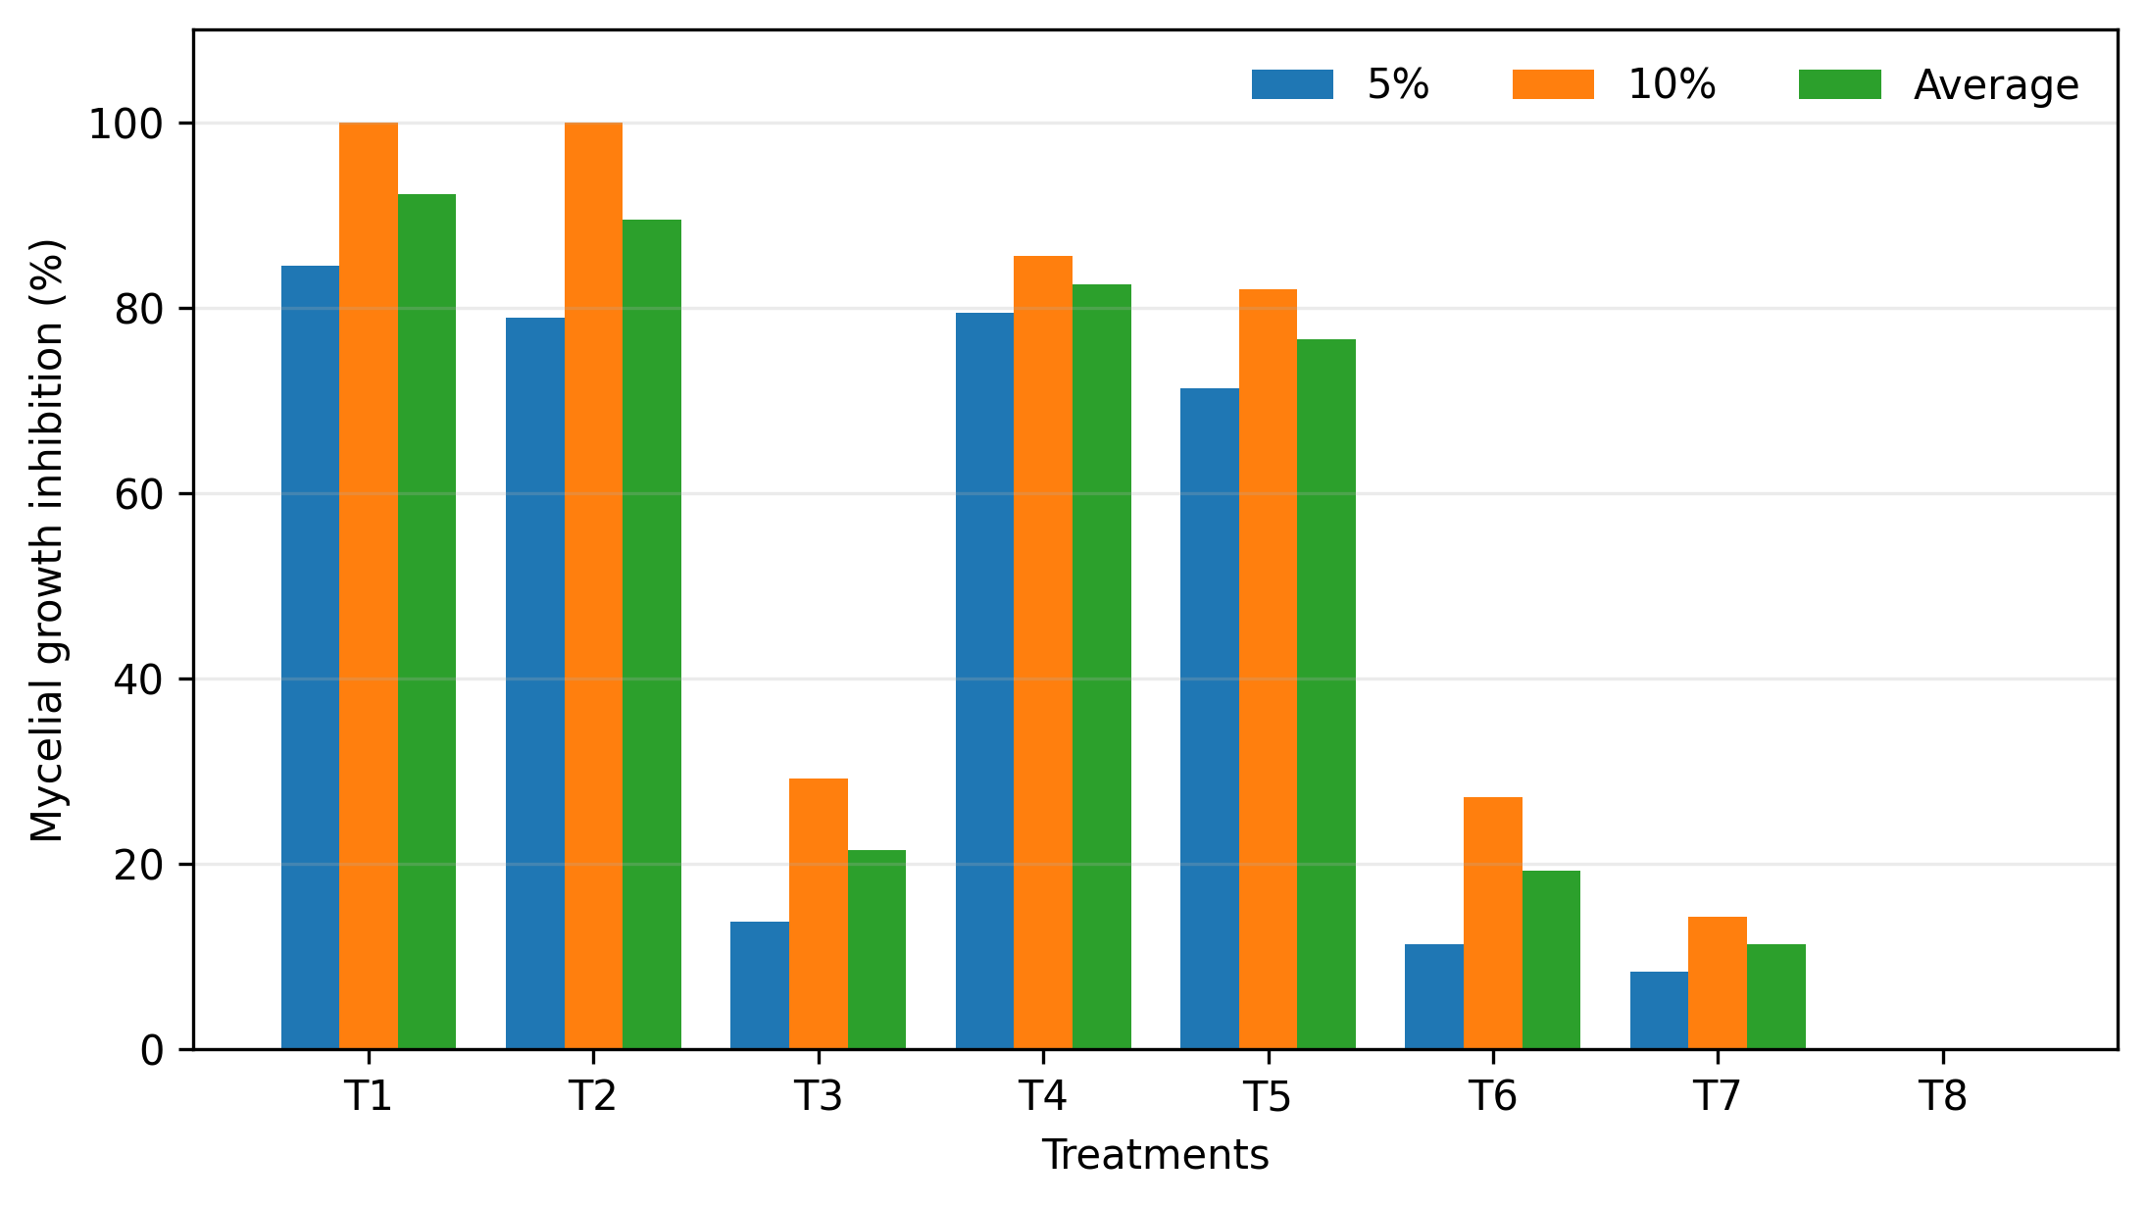
Figure 4. Mycelial growth inhibition of Sclerotium rolfsii by organic-amendment extracts. Treatment codes correspond to Table 4.

3.5 Study Limitations and Translational Implications
The study was designed as an in vitro screening experiment. The test isolate was identified by cultural and microscopic characters; pathogenicity confirmation and molecular identification are not presented and should be incorporated in future isolate-characterisation work. The fungal and bacterial antagonists were compared in a common plate-based assay rather than through propagule-normalised potency estimates, so cross-kingdom comparisons should be interpreted as screening-level evidence. Likewise, paper-filtered organic extracts may reflect both soluble constituents and biological components of the preparation. Most importantly, complete inhibition on PDA does not establish crop safety, persistence, compatibility, field efficacy, or registered-use suitability. These findings therefore identify candidates for subsequent greenhouse and field validation rather than field-ready management recommendations.

4. CONCLUSION
Under the conditions of this laboratory study, Propiconazole 25% EC, Tebuconazole 25.9% EC, and Hexaconazole 5% SC consistently produced complete inhibition of S. rolfsii at 500 and 1000 ppm. Six contact/combi-product formulations also produced complete inhibition at 2000 and 2500 ppm, whereas copper oxychloride was substantially less active. Among the bioagents, T. harzianum was the most inhibitory, while groundnut and cotton seed cake extracts completely inhibited growth at 10%. These results provide a rational shortlist for subsequent compatibility, safety, greenhouse, and field studies. Integrated disease-management recommendations should be made only after such validation and in accordance with locally registered fungicide uses.

COMPETING INTERESTS
The authors declare no competing interests.

CONSENT AND ETHICAL APPROVAL
Not applicable.

DECLARATION OF AI USE
This manuscript was prepared through the intellectual contributions of the author(s) to the study design, data analysis, interpretation of results, and scholarly content. Grammarly and ChatGPT were used solely to assist with grammatical refinement and reference formatting during manuscript revision. The author(s) accept full responsibility for the accuracy, integrity, and final content of the manuscript.

REFERENCES
Arora, D. K., & Upadhyay, R. K. (1978). Effect of fungal staling growth substances on colony interaction. Plant and Soil, 49(3), 685–690. https://doi.org/10.1007/BF02183297
Bonanomi, G., Lorito, M., Vinale, F., & Woo, S. L. (2018). Organic amendments, beneficial microbes, and soil microbiota: Toward a unified framework for disease suppression. Annual Review of Phytopathology, 56, 1–20. https://doi.org/10.1146/annurev-phyto-080615-100046
Dutta, P., & Das, B. C. (2002). Management of collar rot of tomato by Trichoderma spp. and chemicals. Indian Phytopathology, 55(2), 235–237. https://epubs.icar.org.in/index.php/IPPJ/article/view/18711
Daunde, A. T., Apet, K. T., Suryawanshi, A. P., & Khandare, V. S. (2018). Prevalence of collar rot of chilli caused by Sclerotium rolfsii Sacc. under the agro-climatic zones of Marathwada region of Maharashtra. Journal of Pharmacognosy and Phytochemistry, 7(4), 1905–1908.
Dennis, C., & Webster, J. (1971). Antagonistic properties of species-groups of Trichoderma: I. Production of non-volatile antibiotics. Transactions of the British Mycological Society, 57(1), 25–39. https://doi.org/10.1016/S0007-1536(71)80077-3
Harman, G. E., Howell, C. R., Viterbo, A., Chet, I., & Lorito, M. (2004). Trichoderma species—opportunistic, avirulent plant symbionts. Nature Reviews Microbiology, 2(1), 43–56. https://doi.org/10.1038/nrmicro797
Hernández-Pérez, T., Gómez-García, M. del R., Valverde, M. E., & Paredes-López, O. (2020). Capsicum annuum (hot pepper): An ancient Latin-American crop with outstanding bioactive compounds and nutraceutical potential. A review. Comprehensive Reviews in Food Science and Food Safety, 19(6), 2972–2993. https://doi.org/10.1111/1541-4337.12634
Karande, S. A., Tekale, A. G., Kadam, A. M., Chavan, B. K., & Darandale, V. D. (2025). Efficacy of bioagents against Sclerotium rolfsii of chilli. International Journal of Researches in Biosciences, Agriculture and Technology, 13(2), 46–54.
Madhavi, G. B., & Bhattiprolu, S. L. (2011). Integrated disease management of dry root rot of chilli incited by Sclerotium rolfsii (Sacc.). International Journal of Plant, Animal and Environmental Sciences, 1(2), 31–37.
Mascarenhas, J., & Quesada-Ocampo, L. M. (2024). Diagnostic guide for sclerotial blight and circular spot of sweetpotato. Plant Health Progress, 25(3), 340–344. https://doi.org/10.1094/PHP-12-23-0110-DG
Nene, Y. L., & Thapliyal, P. N. (1993). Fungicides in plant disease control (3rd ed.). Oxford & IBH Publishing Co.
Panse, V. G., & Sukhatme, P. V. (1978). Statistical methods for agricultural workers (3rd rev. ed.). Indian Council of Agricultural Research.
Pawar, A. K., Surywanshi, A. P., Gawade, D. B., Zagade, S. N., & Wadje, A. G. (2014). Effects of organic amendments and fungicides on the survival of collar rot fungus of soybean incited by Sclerotium rolfsii. African Journal of Agricultural Research, 9(27), 2124–2131. https://doi.org/10.5897/AJAR10.592
Punja, Z. K. (1985). The biology, ecology, and control of Sclerotium rolfsii. Annual Review of Phytopathology, 23, 97–127. https://doi.org/10.1146/annurev.py.23.090185.000525
Sahana, B., Manjunatha Reddy, T. B., Mushrif, S. K., Anjaneya Reddy, B., & Doddabasappa, B. (2020). Evaluation of fungicides against stem rot of capsicum caused by Sclerotium rolfsii Sacc. International Journal of Chemical Studies, 8(4), 306–312. https://doi.org/10.22271/chemi.2020.v8.i4e.9706
Schuster, E., Dunn-Coleman, N., Frisvad, J. C., & van Dijck, P. W. M. (2002). On the safety of Aspergillus niger—a review. Applied Microbiology and Biotechnology, 59(4–5), 426–435. https://doi.org/10.1007/s00253-002-1032-6
Sharma, R. K., & Dhruj, I. U. (2018). In vitro evaluation of some fungicides against Indian isolates of Sclerotium rolfsii Sacc. [Teleomorph: Athelia rolfsii (Curzi) Tu & Kimbrough]. International Journal of Current Microbiology and Applied Sciences, 7(11), 1561–1586. https://doi.org/10.20546/ijcmas.2018.711.179
van den Bosch, F., Paveley, N., van den Berg, F., Hobbelen, P., & Oliver, R. (2014). Mixtures as a fungicide resistance management tactic. Phytopathology, 104(12), 1264–1273. https://doi.org/10.1094/PHYTO-04-14-0121-RVW
Vincent, J. M. (1947). Distortion of fungal hyphae in the presence of certain inhibitors. Nature, 159(4051), 850. https://doi.org/10.1038/159850b0
Vineela, D. R. S., Beura, S. K., Dhal, A., & Swain, S. K. (2020). Efficacy of bio-agents, botanicals, organic amendments against groundnut pathogens Sclerotium rolfsii and Aspergillus niger in-vitro. Journal of Pharmacognosy and Phytochemistry, 9(3), 1206–1210.

