Original Research Article

Comparative In Vitro Evaluation of Systemic Fungicides and Bioagents against Pigeonpea Wilt Caused by Fusarium oxysporum f. sp. udum

ABSTRACT

Aims: To evaluate the in vitro fungitoxic potential of seven systemic fungicides at concentrations of 500 and 1000 ppm and seven fungal biological control agents against Fusarium oxysporum f. sp. udum, the causal pathogen of pigeonpea wilt.
Study Design: Completely Randomized Design (CRD).
Place and Duration of Study: Department of Plant Pathology, College of Agriculture, Latur, Maharashtra, India. The study was conducted during 2025–2026.
Methodology: The wilt pathogen (F. oxysporum f. sp. udum) was isolated from infected pigeonpea root tissues displaying characteristic vascular discolouration. Seven systemic fungicides (Carbendazim 50% WP, Myclobutanil 10% WP, Propiconazole 25% EC, Thiophanate methyl 70% WP, Difenoconazole 25% EC, Tebuconazole 25.9% EC, and Hexaconazole 5% EC) were screened at concentrations of 500 and 1000 ppm using the Poisoned Food Technique. Seven fungal bioagents (T. harzianum, T. virens, T. hamatum, T. asperellum, Penicillium chrysogenum, Aspergillus niger, and Aspergillus flavus) were evaluated using the dual-culture technique on Potato Dextrose Agar (PDA).
Results: All tested systemic fungicides significantly inhibited pathogen mycelial growth compared with the control (P = .01). Carbendazim 50% WP produced complete growth inhibition (100.00%) at both 500 ppm and 1000 ppm. Among the remaining fungicides, Tebuconazole 25.9% EC exhibited mean inhibition of 85.18%, followed by Propiconazole 25% EC (82.78%),
Thiophanate methyl 70% WP (80.14%) and Hexaconazole 5% EC (71.77%). Among the bioagents, T. harzianum achieved the maximum growth inhibition (82.04%), closely followed by T. virens (80.55%) and T. asperellum (74.82%), whereas Aspergillus flavus recorded the lowest inhibition (63.71%).
Conclusion: Among the chemical treatments, Carbendazim 50% WP, and among the biocontrol agents, T. harzianum, exhibited high efficacy in vitro, highlighting their potential for incorporation into integrated disease management strategies against pigeonpea wilt.

Keywords: Pigeonpea; vascular wilt; Fusarium oxysporum f. sp. udum; systemic fungicides; Carbendazim; Tebuconazole; Propiconazole; Trichoderma harzianum; poisoned food technique; dual-culture technique.

INTRODUCTION
Pigeonpea (Cajanus cajan (L.) Millsp.), locally referred to as Arhar or Tur, is an essential short-lived perennial pulse legume belonging to the family Fabaceae. Cultivated extensively across tropical and semi-arid regions, pigeonpea occupies a central position in dryland agricultural systems owing to its drought tolerance, deep taproot system, and soil-enriching symbiotic nitrogen fixation with Rhizobium, which contributes up to 20 kg N/ha under favourable field conditions. The crop serves as a vital source of dietary protein (15.5% to 28.8%) for vegetarian populations in India and other developing countries, while also supplying carbohydrates (57.2% to 58.6%), crude fibre (1.2% to 8.1%), essential minerals (iron and iodine), and key amino acids, including lysine, tyrosine, cystine, and arginine (Salunkhe et al., 1986).
Globally, pigeonpea is cultivated in over 22 nations across tropical and subtropical zones, with major production centred in India, Myanmar, Malawi, Tanzania, Kenya, and Mozambique (Food and Agriculture Organization of the United Nations [FAO], 2024). India dominates global acreage and production. During the 2025–2026 cropping season, national pigeonpea acreage reached approximately 4.60 million hectares, yielding an estimated output of 3.597 million tonnes with a mean productivity of 782 kg/ha (Ministry of Agriculture & Farmers Welfare, 2025). Within Maharashtra State, pigeonpea covers nearly 1.28 million hectares (27.83% of national acreage), generating 1.04 million tonnes (~29.00% of national production) with an average yield of 812 kg/ha.
Although pigeonpea is subject to over 100 pathogens (Nene et al., 1989), vascular wilt caused by Fusarium oxysporum f. sp. udum (Butler) Snyder & Hansen (syn. Fusarium udum Butler) remains the most destructive soil-borne fungal disease across the Indian subcontinent (Butler, 1910; Kannaiyan & Nene, 1981; Karimi et al., 2012). The disease inflicts severe economic losses ranging from 30% to 100% when infection occurs before pod formation (Kannaiyan et al., 1984; Pawar et al., 2013). In the Marathwada region of Maharashtra, field surveys during the 2025–2026 season recorded average wilt incidence levels ranging from 4.20% to 36.80% (averaging 11.45%), with levels exceeding 45% and reaching up to 60% in endemic, monocropped belts. Recent studies have reported that culture conditions influence the growth and sporulation of F. udum and that Indian Fusarium populations associated with pigeonpea wilt show substantial pathogenic and genetic diversity (Sapna et al., 2024; Reddy et al., 2024a).
The pathogen F. oxysporum f. sp. udum enters the host plant through root tips or mechanical injuries, colonises the xylem vessels, and induces vascular browning, leaf chlorosis, drooping, and sudden collapse of the plant (Avinash et al., 2019; Ghante et al., 2019). Because of its soil-borne nature, persistent chlamydospore survival in soil, and systemic vascular infection habit, managing vascular wilt requires the identification of highly active fungitoxic chemical molecules and potent biological antagonists.
Recent evidence also supports the antagonistic activity of Trichoderma and other native microbial agents against F. udum in pigeonpea, while an in vitro study of Fusarium wilt in cotton similarly reported strong inhibitory activity of Trichoderma spp. (Mishra et al., 2023; Reddy et al., 2024b; Alam & Singh, 2026).
However, comparative information on the relative in vitro performance of the selected systemic fungicides and fungal bioagents against F. oxysporum f. sp. udum under a common experimental framework remains limited.
Therefore, the present study aimed to evaluate the in vitro fungitoxic potential of seven systemic fungicides at concentrations of 500 and 1000 ppm and the antagonistic activity of seven fungal biological control agents against F. oxysporum f. sp. udum.

MATERIAL AND METHODS
  - Isolation and Identification of Fusarium oxysporum f. sp. udum
Wilted pigeonpea specimens showing typical vascular discolouration symptoms were collected from agricultural fields in Latur district, Maharashtra, India. Isolation of the pathogen was performed using standard tissue isolation procedures on Potato Dextrose Agar (PDA) (Dhingra & Sinclair, 2017). Infected root segments showing vascular browning were surface sterilised with 0.1 % HgCl2 solution for 1 minute, rinsed three times with sterile distilled water, blotted dry on sterile filter paper, and plated onto PDA dishes. The dishes were incubated at 27 ± 2℃ for 7 days. Pure cultures were obtained via single-hyphal-tip isolation and maintained on PDA slants at 25℃ in a BOD incubator (Chakrapani et al., 2023). Identification was confirmed based on cultural characteristics (cottony white mycelium and pinkish/reddish pigmentation) and diagnostic microscopic features, including hyaline septate hyphae, 0-1 septate microconidia, 1-4 septate sickle-shaped macroconidia, and thick-walled spherical/oval chlamydospores (Butler, 1918; Patra & Biswas, 2017; Ghante et al., 2018).

In Vitro Evaluation of Systemic Fungicides
The fungitoxic potential of seven systemic fungicides was evaluated against F. oxysporum f. sp. udum using the Poisoned Food Technique (Vincent, 1947).
Table 1. Details of systemic fungicides evaluated
Tr.No. | Fungicide Common Name | Trade Name | Active Ingredient(%)
T1 | Carbendazim | Bavistin | 50% WP
T2 | Myclobutanil | Systhane | 10% WP
T3 | Propiconazole | Tilt | 25% EC
T4 | Thiophanate methyl | Roko | 70% WP
T5 | Difenoconazole | Score | 25% EC
T6 | Tebuconazole | Folicur | 25.9% EC
T7 | Hexaconazole | Contaf | 5% EC

T8 | Control (Untreated) | - | Plain PDA

Required quantities of each systemic fungicide were incorporated into sterilised, molten PDA medium under aseptic conditions to achieve final concentrations of 500 ppm and 1000 ppm. The medium was thoroughly mixed and poured into sterile Petri dishes (90 mm diameter), with three replications per treatment. After solidification, a 5 mm mycelial disc cut from the active margin of a 7-day-old culture of F. oxysporum f. sp. udum was inoculated into the centre of each Petri plate. Unamended PDA plates served as the control (T8). Plates were incubated at 27 ± 2∘C. Radial colony diameter (mm) was measured when mycelial growth in the control plate reached full coverage (90 mm).
Per cent growth inhibition over the control was calculated using Vincent's (1947) formula:
C-T
(Percent inhibition of mycelial growth) = × 100
C

where:

I = Percent inhibition of mycelial growth
C = Radial growth of the pathogen in the untreated control (mm)
T = Radial growth of the pathogen in the treatment (mm)

In Vitro Evaluation of Bio-Agents
Seven fungal biocontrol agents (T. harzianum, T. virens, T. hamatum, T. asperellum, P. chrysogenum, A. niger and A. flavus) were screened for antagonistic activity against F. oxysporum f. sp. udum using the Dual Culture Technique (Morton & Stroube, 1955).
Table 2. Details of biocontrol agents evaluated
Tr. No. | Antagonist / Bio-agent | Isolation Source / Provider | Technique Applied
T1 | Trichoderma harzianum | Laboratory, VNMKV | Dual Culture
T2 | Trichoderma virens | Laboratory, VNMKV | Dual Culture
T3 | Trichoderma hamatum | Laboratory, VNMKV | Dual Culture
T4 | Trichoderma asperellum | Laboratory, VNMKV | Dual Culture
T5 | Penicillium chrysogenum | Native Soil Isolate | Dual Culture
T6 | Aspergillus niger | Native Soil Isolate | Dual Culture
T7 | Aspergillus flavus | Native Soil Isolate | Dual Culture
T8 | Control (Untreated) | Pathogen alone | Single Inoculation

Mycelial discs (5 mm) cut from active 7-day-old cultures of the pathogen and the respective antagonist were placed opposite each other near the edges of Petri dishes containing solidified PDA medium, approximately 60 mm apart. In the control plates (T8), only the pathogen disc was placed. The experiment was laid out in a Completely Randomized Design (CRD) with three replications per treatment. Plates were incubated at 27 ± 2∘C. Radial growth of the pathogen was recorded when the control plates attained full growth (90 mm). Per cent growth inhibition was computed using Vincent's (1947) formula.

where:
C-T
(Percent inhibition of mycelial growth) = × 100
C
I = Percent inhibition of mycelial growth
C = Radial growth of the pathogen in the untreated control (mm)
T = Radial growth of the pathogen in the dual culture treatment (mm)

2.3 Statistical Analysis
All laboratory experiments were conducted in a CRD with three replications. Data were subjected to analysis of variance (ANOVA). Standard errors (S.E. ±) and Critical Difference (C.D.) values at the 1% level of significance (P = .01) were calculated to compare treatment means.

RESULTS AND DISCUSSION
  - In Vitro Efficacy of Systemic Fungicides Against Fusarium oxysporum f. sp. udum. The bio-efficacy of seven systemic fungicides at concentrations of 500 ppm and 1000 ppm against F. oxysporum f. sp. udum revealed significant differences (P = .01) in radial mycelial growth and growth inhibition relative to the untreated control (Plate 1, Fig. 1 and Table 3).

Effect on Mycelial Growth
All systemic fungicides significantly restricted the radial growth of F. oxysporum f. sp. udum at both test concentrations compared to the untreated control (90.00 mm).
At 500 ppm, Carbendazim 50% WP completely inhibited pathogen growth (0.00 mm). Tebuconazole 25.9% EC was the second most effective chemical, recording a colony diameter of 17.75 mm, followed closely by Propiconazole 25% EC (17.91 mm), Thiophanate methyl 70% WP (19.66 mm), Hexaconazole 5% EC
(27.41 mm), Difenoconazole 25% EC (33.15 mm), and Myclobutanil 10% WP (37.33 mm).
At 1000 ppm, a similar trend was recorded. Carbendazim 50% WP maintained complete suppression (0.00 mm). Tebuconazole 25.9% EC recorded the lowest mycelial expansion (12.51 mm), followed by Propiconazole 25% EC (13.07 mm), Thiophanate methyl 70% WP (16.67 mm), Hexaconazole 5% EC
(23.40 mm), Difenoconazole 25% EC (28.66 mm), and Myclobutanil 10% WP (32.96 mm).
When overall mean colony diameters across concentrations were compared, Carbendazim 50% WP recorded 0.00 mm, followed by Tebuconazole 25.9% EC (15.13 mm), Propiconazole 25% EC (15.49 mm), Thiophanate methyl 70% WP (18.16 mm), Hexaconazole 5% EC (25.40 mm), Difenoconazole 25% EC (30.90 mm), and
Myclobutanil 10% WP (35.14 mm).

Effect on Mycelial Growth Inhibition
The per cent inhibition of mycelial growth varied significantly among the systemic fungicides.
At 500 ppm, Carbendazim 50% WP recorded 100.00% mycelial growth inhibition, followed by Tebuconazole 25.9% EC (80.27%), Propiconazole 25% EC (80.10%), Thiophanate methyl 70%
WP (78.82%), Hexaconazole 5% EC (69.54%), Myclobutanil 10% WP (58.52%), and Difenoconazole
25% EC (56.85%).
At 1000 ppm, Carbendazim 50% WP achieved 100.00% growth inhibition, followed by Tebuconazole 25.9%
EC (86.10%), Propiconazole 25% EC (85.47%), Thiophanate methyl 70% WP (81.47%), Hexaconazole 5%
EC (74.00%), Difenoconazole 25% EC (68.60%), and Myclobutanil 10% WP (63.37%).
The mean per cent inhibition across concentrations ranged from 60.94% to 100.00%. Carbendazim 50% WP ranked first with 100.00% mean inhibition, followed by Tebuconazole 25.9% EC (85.18%), Propiconazole 25% EC (82.78%), Thiophanate methyl 70% WP (80.14%), Hexaconazole 5% EC
(71.77%), Difenoconazole 25% EC (62.72%), and Myclobutanil 10% WP (60.94%).
The complete growth inhibition produced by Carbendazim 50% WP aligns with findings reported by Raju et al. (2008) and Patil et al. (2015), who documented 100.00% mycelial inhibition of Fusarium oxysporum isolates using benzimidazole fungicides at concentrations as low as 100 to 500 ppm. The superior performance of triazole fungicides (Tebuconazole and Propiconazole) was attributed to their inhibition of ergosterol biosynthesis (C-14 demethylase inhibition), thereby disrupting fungal cell membrane integrity (Gisi, 2014; Narsing et al., 2026).

Plate 1. In vitro efficacy of systemic fungicides against Fusarium oxysporum f. sp. udum

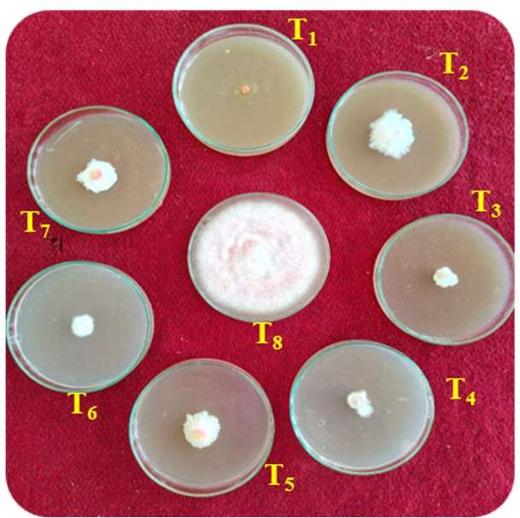
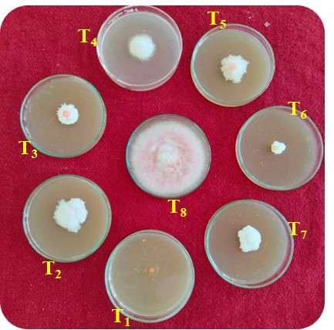
500 ppm
1000 ppm

Table 3. In vitro efficacy of systemic fungicides against Fusarium oxysporum f. sp. udum
Tr.No. | Treatments | *Colony Diameter(mm) |  | Avg. | % Inhibition |  | Avg
Tr.No. | Treatments | 500 ppm | 1000 ppm | Avg. | 500 ppm | 1000  ppm | Avg
T1 | Carbendazim 50% WP | 0.00 | 0.00 | 0.00 | 100 | 100 | 100
T2 | Myclobutanil 10% WP | 37.33 | 32.96 | 35.14 | 58.52 | 63.37 | 60.94
T3 | Propiconazole 25 % EC | 17.91 | 13.07 | 15.49 | 80.10 | 85.47 | 82.78
T4 | Thiophanate methyl 70 % WP | 19.66 | 16.67 | 18.16 | 78.82 | 81.47 | 80.14
T5 | Difenoconazole 25 % EC | 33.15 | 28.66 | 30.90 | 56.85 | 68.60 | 62.72
T6 | Tebuconazole 25.9 % EC | 17.75 | 12.51 | 15.13 | 80.27 | 86.10 | 85.18
T7 | Hexaconazole 5% EC | 27.41 | 23.40 | 25.41 | 69.54 | 74.00 | 71.77
T8 | Control (untreated) | 90 | 90 | 90 | - | - | -
SE± |  | 0.91 | 0.79 | 0.60
CD at 1% |  | 3.77 | 3.29 | 2.50
*Mean of three replications

Tr. No. | Treatments | Tr. No. | Treatments
T1 | Carbendazim 50% WP | T5 | Difenoconazole 25 % EC
T2 | Myclobutanil 10% WP | T6 | Tebuconazole 25.9 % EC
T3 | Propiconazole 25 % EC | T7 | Hexaconazole 5% EC
T4 | Thiophanate methyl 70 % WP | T8 | Control (untreated)

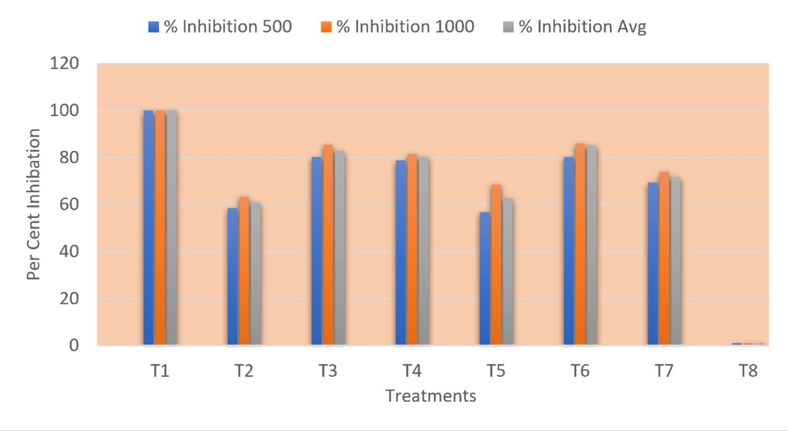
Fig. 1: In vitro efficacy of systemic fungicides against Fusarium oxysporum f. sp. udum

  - In Vitro Efficacy of Bio-Agents Against Fusarium oxysporum f. sp. udum
Screening seven biocontrol agents using the dual culture technique demonstrated significant inhibition (P = .01) of F. oxysporum f. sp. udum mycelial growth relative to the control (Plate 2, Table 4 and Fig. 2).

Effect on Pathogen Mycelial Growth
All tested biocontrol agents significantly restricted pathogen radial expansion compared with the untreated control (90.00 mm). T. harzianum resulted in the minimum radial colony diameter of the pathogen (16.16 mm), followed by T. virens (17.50 mm), T. asperellum (22.66 mm), T. hamatum (26.16 mm), A. niger (26.33 mm), P. chrysogenum (26.50 mm), and A. flavus (32.66 mm).

Effect on Per Cent Growth Inhibition
Mycelial growth inhibition by the biocontrol agents ranged from 63.71% to 82.04%. T. harzianum achieved the maximum growth inhibition (82.04%), followed by T. virens (80.55%), T. asperellum (74.82%), T. hamatum (70.93%), A. niger (70.74%), P. chrysogenum (70.55%), and A. flavus (63.71%).
The high antagonistic potential of Trichoderma species against F. oxysporum f. sp. udum observed in this study agrees with findings reported by Mahesh and Saifulla (2006) and Gowdar and Kulkarni (2007). The biological mechanisms driving Trichoderma antagonistic activity include rapid competition for space and nutrients, mycoparasitism, production of volatile/non-volatile antibiotics, and secretion of cell-wall-degrading enzymes such as -1,3-glucanases and chitinases (Sundaramoorthy & Balabaskar, 2013; Haque et al., 2023; Reddy et al., 2024b).

Plate 2: In vitro efficacy of bioagents against Fusarium oxysporum f. sp. udum
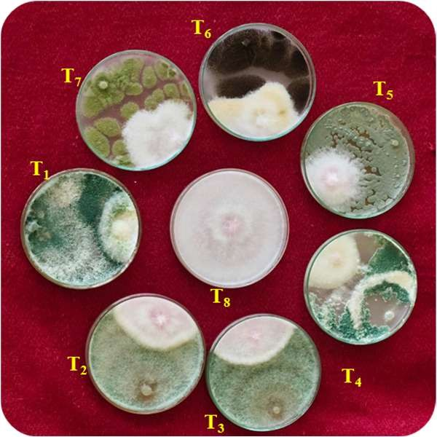

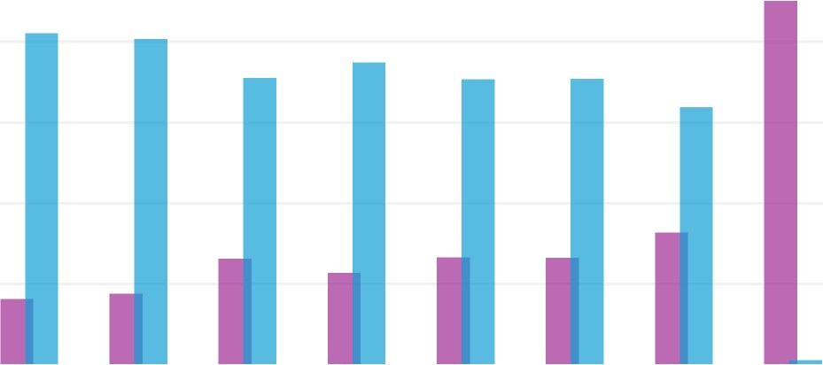
Fig. 2: In vitro efficacy of bioagents against Fusarium oxysporum f. sp. udum
Colony Diameter of Pathogen (mm) 100
80
60
40
20
0
% Inhibition
T1 T2 T3 T4 T5 T6 T7 T8
TREATMENTS
COLONY DIAMETER OF PATHOGEN (MM)

Table 4:In vitro efficacy of bio-agents against Fusarium oxysporum f. sp. udum.

Tr. No. | Treatments | Colony Diameter of Pathogen (mm) | % Inhibition
T1 | Trichoderma harzianum | 16.16 | 82.04
T2 | Trichoderma virens | 17.5 | 80.55
T3 | Trichoderma hamatum | 26.16 | 70.93
T4 | Trichoderma asperellum | 22.66 | 74.82
T5 | Penicillium chrysogenum | 26.5 | 70.55
T6 | Aspergillus niger | 26.33 | 70.74
T7 | Aspergillus flavus | 32.66 | 63.71
T8 | Control | 90 | -
 | S.E.± | 0.91
 | C.D.at 1% | 3.77

CONCLUSION
This in vitro study demonstrated significant differences in the suppression of Fusarium oxysporum f. sp. udum by the evaluated systemic fungicides and fungal bioagents. Carbendazim 50% WP was the most effective fungicide, completely inhibiting mycelial growth at both 500 and 1000 ppm. Tebuconazole 25.9% EC and Propiconazole 25% EC were the next most effective chemical treatments, with mean inhibitions of 85.18% and 82.78%, respectively, while Thiophanate methyl 70% WP produced 80.14% mean inhibition. Among the biological control agents, Trichoderma harzianum recorded the highest inhibition of 82.04%, followed closely by T. virens at 80.55%; T. asperellum also showed substantial inhibition at 74.82%. These findings identify clear differences in laboratory efficacy among the tested treatments. Within the limits of the present experimental system, Carbendazim 50% WP and T. harzianum were the strongest chemical and biological treatments, respectively. The results provide a laboratory basis for selecting effective candidates for integrated management of pigeonpea vascular wilt.

Limitation

The findings are limited to in vitro laboratory screening on potato dextrose agar using seven systemic fungicides at two concentrations and seven fungal bioagents. Consequently, the measured mycelial inhibition represents treatment performance under controlled culture conditions and should not be interpreted as direct evidence of disease suppression under field conditions. The results are therefore most appropriately used to compare the relative laboratory efficacy of the tested treatments and to identify candidates for subsequent validation.

COMPETING INTERESTS
Authors have declared that no competing interests exist

Declaration of AI Use

This manuscript was prepared through the intellectual contributions of the author(s) to the study design, data analysis, interpretation of results, and scholarly content. Grammarly and ChatGPT were used solely to assist with grammatical refinement and reference formatting during manuscript revision. The author(s) accept full responsibility for the accuracy, integrity, and final content of the manuscript.

REFERENCES
Alam, M. A., & Singh, R. (2026). Assessment of cotton wilt incidence and in vitro evaluation of botanical extracts and biocontrol agents against Fusarium, Hanumangarh District, Rajasthan, India. Asian Journal of Microbiology and Biotechnology, 11(2), 66–72. https://doi.org/10.56557/ajmab/2026/v11i210768
Avinash, M., Nagaraju, K., Muthuraju, R., Asha, N. N., Krishna Murthy, R., & Vasantha Kumari, R. (2019). In vitro biocontrol activity of rhizosphere isolates against wilt causing pathogen of redgram (Cajanus cajan). Journal of Pharmacognosy and Phytochemistry, 8(3), 235–239. https://www.phytojournal.com/archives/2019.v8.i3.8089/in-vitro-biocontrol-activity-of-rhizosphere-isolates-against-wilt-causing-pathogen-of-redgram-ltemgtcajanus-cajanltemgt
Butler, E. J. (1910). The wilt disease of pigeon-pea and the parasitism of Neocosmospora vasinfecta Smith. Memoirs of the Department of Agriculture in India: Botanical Series, 2(9), 1–64. https://epapers.bham.ac.uk/id/eprint/3559/1/OLCC_0061_A.pdf
Butler, E. J. (1918). Fungi and disease in plants: An introduction to the diseases of field and plantation crops, especially those of India and the East. Thacker, Spink & Co. https://agris.fao.org/search/en/providers/122535/records/65ddd4d00f3e94b9e5c57b0b
Chakrapani, K., Chanu, W. T., Sinha, B., Thangjam, B., Hasan, W., Devi, K. S., Chakma, T., Phurailatpam, S., Mishra, L. K., Singh, G. M., Khoyumthem, P., & Saini, R. (2023). Deciphering growth abilities of Fusarium oxysporum f. sp. pisi under variable temperature, pH and nitrogen. Frontiers in Microbiology, 14, 1228442. https://doi.org/10.3389/fmicb.2023.1228442
Dhingra, O. D., & Sinclair, J. B. (2017). Basic plant pathology methods (2nd ed.). CRC Press. https://doi.org/10.1201/9781315138138
Food and Agriculture Organization of the United Nations. (2024). FAOSTAT: Crops and livestock products. https://www.fao.org/faostat/
Ghante, P. H., Kanase, K. M., Kale, S. P., Chavan, R. L., Sharma, K. M., & Ghuge, S. B. (2018). Cultural, morphological and molecular variability of Fusarium oxysporum f. sp. udum isolates by RAPD method. International Journal of Current Microbiology and Applied Sciences, 7(10), 2109–2122. https://doi.org/10.20546/ijcmas.2018.710.243
Ghante, P. H., Kanase, K. M., Gaikwad, P. A., Pawar, S. V., & Magar, S. J. (2019). The efficacy of bioagents against Fusarium oxysporum f. sp. udum causing wilt disease of pigeonpea. Journal of Pharmacognosy and Phytochemistry, 8(1), 1966–1971. https://www.phytojournal.com/archives/2019.v8.i1.7056/the-efficacy-of-bioagents-against-ltemgtfusarium-oxysporum-ltemgtf-sp-ltemgtudum-ltemgtcausing-wilt-disease-of-pigeonpea
Gisi, U. (2014). Assessment of selection and resistance risk for demethylation inhibitor fungicides in Aspergillus fumigatus in agriculture and medicine: A critical review. Pest Management Science, 70(3), 352–364. https://doi.org/10.1002/ps.3664
Gowdar, S. B., & Kulkarni, S. (2007). Efficacy of antagonistic microorganisms against pigeonpea wilt pathogen Fusarium udum Butler. Advances in Plant Sciences, 20(1), 245–247.
Haque, Z., Pandey, K., & Zamir, S. (2023). Bio-management of Fusarium wilt of tomato (Fusarium oxysporum f. sp. lycopersici) with multifacial Trichoderma species. Discover Agriculture, 1, Article 7. https://doi.org/10.1007/s44279-023-00007-w
Kannaiyan, J., & Nene, Y. L. (1981). Influence of wilt at different growth stages on yield loss in pigeonpea. Tropical Pest Management, 27(1), 141. https://doi.org/10.1080/09670878109414184
Kannaiyan, J., Nene, Y. L., Reddy, M. V., Ryan, J. G., & Raju, T. N. (1984). Prevalence of pigeonpea diseases and associated crop losses in Asia, Africa and the Americas. Tropical Pest Management, 30(1), 62–71. https://doi.org/10.1080/09670878409370853
Karimi, R., Owuoche, J. O., & Silim, S. N. (2012). Importance and management of Fusarium wilt (Fusarium udum Butler) of pigeonpea. International Journal of Agronomy and Agricultural Research, 2(1), 1–14. https://innspub.net/importance-and-management-of-fusarium-wilt-fusarium-udum-butler-of-pigeonpea/
Mahesh, M., & Saifulla, M. (2006). Evaluation of bioagents and fungicides against Fusarium udum (Butler) under in vitro conditions. Environment and Ecology, 24(3), 824–827.
Ministry of Agriculture & Farmers Welfare. (2025, November 26). Union Minister Shri Shivraj Singh Chouhan releases first advanced estimates of Kharif crop production for 2025–26. Press Information Bureau, Government of India. https://www.pib.gov.in/PressReleasePage.aspx?PRID=2194726&lang=1&reg=3
Mishra, R. K., Pandey, S., Hazra, K. K., Mishra, M., Naik, S. J. S., Bohra, A., Parihar, A. K., Rathore, U. S., Naimuddin, Kumar, K., Singh, B., & Singh, N. P. (2023). Biocontrol efficacy and induced defense mechanisms of indigenous Trichoderma strains against Fusarium wilt [F. udum (Butler)] in pigeonpea. Physiological and Molecular Plant Pathology, 127, 102122. https://doi.org/10.1016/j.pmpp.2023.102122
Morton, D. J., & Stroube, W. H. (1955). Antagonistic and stimulatory effects of soil microorganisms upon Sclerotium rolfsii. Phytopathology, 45(8), 417–420.
Narsing, L. P., Rakholiya, K. B., & Suman, S. (2026). Comparative in vitro efficacy of fungicides against Fusarium oxysporum causing wilt of pigeonpea. Journal of Scientific Research and Reports, 32(6), 91–98. https://doi.org/10.9734/jsrr/2026/v32i64231
Nene, Y. L., Sheila, V. K., & Sharma, S. B. (1989). A world list of chickpea (Cicer arietinum L.) and pigeonpea (Cajanus cajan (L.) Millsp.) pathogens (updated April 1989). International Crops Research Institute for the Semi-Arid Tropics. https://agris.fao.org/search/en/providers/122437/records/6471d3e969d6cbfdd4a30f51
Patil, V. B., Gawade, D. B., Suryawanshi, A. P., & Zagade, S. N. (2015). Biological and fungicidal management of chickpea wilt caused by Fusarium oxysporum f. sp. ciceri. The Bioscan, 10(2), 685–690. https://thebioscan.com/index.php/pub/article/view/1275
Patra, S., & Biswas, M. K. (2017). Eco-friendly management of Fusarium oxysporum f. sp. ciceri, the causal agent of chickpea wilt disease under in vitro condition. International Journal of Current Microbiology and Applied Sciences, 6(3), 1852–1858. https://doi.org/10.20546/ijcmas.2017.603.211
Pawar, S. V., Deshpande, G. D., Dhutraj, D. N., & Dey, U. (2013). Survey of pigeonpea wilt disease in Marathwada region of Maharashtra State. Bioinfolet, 10(1), 175–176.
Raju, G. P., Rao, S. V. R., & Gopal, K. (2008). In vitro evaluation of antagonists and fungicides against the red gram wilt pathogen Fusarium oxysporum f. sp. udum (Butler) Snyder and Hansen. Legume Research, 31(2), 133–135. https://arccjournals.com/journal/legume-research-an-international-journal/ARCC2433
Reddy, B. D., Kumar, B., Sahni, S., Yashaswini, G., Karthik, S., Sai Reddy, M. S., Kumar, R., & Mukherjee, U. (2024a). Genetic diversity and population structure of Fusarium udum in India and its correlation with pigeonpea wilt incidence. Journal of Basic Microbiology, 64(7), e2300682. https://doi.org/10.1002/jobm.202300682
Reddy, B. D., Kumar, B., Sahni, S., Yashaswini, G., Karthik, S., Sai Reddy, M. S., Kumar, R., Mukherjee, U., & Sai Krishna, K. (2024b). Harnessing the power of native biocontrol agents against wilt disease of pigeonpea incited by Fusarium udum. Scientific Reports, 14, 12500. https://doi.org/10.1038/s41598-024-60039-0
Salunkhe, D. K., Chavan, J. K., Kadam, S. S., & Reddy, N. R. (1986). Pigeonpea as an important food source. Critical Reviews in Food Science and Nutrition, 23(2), 103–145. https://doi.org/10.1080/10408398609527422
Sapna, Yadav, L. B., & Dubey, S. (2024). Effect of temperature, media and pH on growth and sporulation of Fusarium udum causing wilt of pigeonpea Cajanus cajan (L.) Millsp. Journal of Experimental Agriculture International, 46(9), 1219–1227. https://doi.org/10.9734/jeai/2024/v46i92918
Sundaramoorthy, S., & Balabaskar, P. (2013). Biocontrol efficacy of Trichoderma spp. against wilt of tomato caused by Fusarium oxysporum f. sp. lycopersici. Journal of Applied Biology & Biotechnology, 1(3), 36–40. https://doi.org/10.7324/jabb.2013.1306
Vincent, J. M. (1947). Distortion of fungal hyphae in the presence of certain inhibitors. Nature, 159, 850. https://doi.org/10.1038/159850b0

