Original Research Article

Genetic diversity of chickpea (Cicer arietinum L.) using microsatellite markers

.
ABSTRACT

Aim: This study assessed SSR-based genetic diversity among 75 chickpea (Cicer arietinum L.) genotypes to identify genetically diverse parental resources for chickpea improvement.
Study design: Laboratory-based molecular characterisation and genetic diversity analysis using SSR markers followed by similarity and cluster analyses.
Place and Duration of Study: Molecular Biology Laboratory, Department of Biotechnology, College of Agriculture, Vijayapur, University of Agricultural Sciences, Dharwad in 2021.
Methodology: Seventy-five chickpea genotypes were characterised using 20 polymorphic SSR markers distributed across the genome. Genomic DNA was extracted from young leaf samples using the CTAB method, followed by PCR amplification and separation of SSR products on 3% agarose gels. The amplification profiles were scored as binary data and used to estimate genetic similarity based on the Nei and Li coefficient. Genetic relationships were assessed through UPGMA cluster analysis using NTSYSpc and marker informativeness was evaluated using polymorphic information content (PIC).
Results: The 20 SSR markers generated a total of 73 alleles across the 75 chickpea genotypes, with an average of 3.65 alleles per marker. The number of alleles per marker ranged from 1 to 6, with TA22, TA28 and TA29 exhibiting the highest allelic variation (6 alleles each). PIC values ranged from 0.419 (TA194) to 0.797 (TA28), with 17 markers recording PIC values above 0.50, indicating their high discriminatory potential. UPGMA cluster analysis grouped the genotypes into 23 distinct clusters, with Cluster II being the largest (29 genotypes), followed by Cluster I (10 genotypes), while the remaining clusters comprised fewer or single genotypes, reflecting substantial genetic differentiation among the genotypes.
Conclusion: The SSR markers effectively revealed substantial genetic diversity and distinct molecular relationships among the chickpea genotypes. The identified genetically diverse genotypes can be utilised as promising parents to broaden the breeding base and develop diverse populations for improving chickpea productivity and adaptability.

Keywords: Chickpea, Genetic Similarity, SSR markers, UPGMA clustering, molecular characterisation; UPGMA clustering

1. INTRODUCTION

Chickpea (Cicer arietinum L.) is a globally important grain legume, particularly suited to semi-arid and subtropical environments, where its nutritional richness and adaptation to limited moisture underpin its importance in pulse-based agriculture. The crop is a predominantly self-pollinated diploid species with 2n = 16 chromosomes and an estimated genome size of approximately 740 Mb (Varshney et al., 2013). Chickpea germplasm encompasses considerable variation for phenology, plant architecture, seed characteristics, yield components and adaptation, represented largely by the desi and kabuli types (Patil et al., 2021). However, domestication, directional selection and repeated use of adapted breeding material have resulted in a relatively restricted genetic base within cultivated chickpea. This limitation can reduce the availability of novel allelic combinations required for continued genetic gain, particularly under environments increasingly affected by drought, heat, disease pressure and other climatic stresses (Singh et al., 2020). Broadening the genetic base through the identification and effective utilisation of diverse germplasm is therefore an important prerequisite for developing productive and resilient chickpea cultivars (Ashwini et al., 2021).

The magnitude and distribution of genetic variation within a breeding population influence the probability of generating useful recombinants and recovering superior segregants (Gagan Narayan et al., 2024). Consequently, characterisation of germplasm is not only important for documenting existing variation but also for determining its potential in breeding programmes. Genotypes that appear distinct based on geographical origin or phenotypic characteristics may possess considerable genetic similarity, whereas apparently similar materials may carry divergent allelic combinations. Reliable information on genetic relatedness is therefore essential for selecting appropriate parental combinations and maximising the utilisation of available germplasm (Hattiholi et al., 2024).

Conventional characterisation based on morphological, phenological and agronomic traits provides valuable information on the observed performance of genotypes but may not adequately unravel their genetic relationships. The expression of many quantitative traits is influenced by environmental conditions and genotype × environment interactions, while traits governed by a relatively limited number of loci may not capture the overall genomic variation among genotypes. Molecular markers provide an alternative and complementary approach by detecting polymorphism directly at the DNA level and enabling genetic relationships to be assessed with greater precision. Recent studies have demonstrated the usefulness of molecular approaches for revealing genetic structure and identifying divergent chickpea materials that may have potential for incorporation into breeding programmes (Mohan & Kalaimagal, 2020; Philanim et al., 2025).

Among the molecular marker systems available for plant genetic characterisation, simple sequence repeats (SSRs), or microsatellites, are particularly suitable for diversity analysis. SSRs consist of short tandemly repeated nucleotide motifs that frequently exhibit variation in repeat number among genotypes. Their co-dominant inheritance allows different allelic states to be distinguished, while the locus specificity, reproducibility and high polymorphism make the microsatellite markers effective for discriminating closely related genotypes. The discriminatory potential of an SSR marker can be quantified through the number of alleles detected and its polymorphism information content (PIC), with highly informative loci providing greater resolution for differentiating genotypes. Consequently, a panel of informative SSR markers can generate a robust molecular profile of a genotype collection and facilitate the estimation of genetic similarity and divergence.

SSR-based molecular diversity analysis has important practical implications for chickpea improvement. Identification of genetically divergent genotypes can assist breeders in selecting parents representing complementary genetic backgrounds, thereby increasing the opportunity for generating broader variation in subsequent generations. Molecular information can also help identify genetically similar materials and reduce redundancy within breeding collections, while highly divergent or unique genotypes can be prioritised for further evaluation and utilisation. Recent investigations employing molecular markers in chickpea have demonstrated substantial genetic variation and population differentiation among breeding materials, reinforcing the value of molecular characterisation as a component of germplasm evaluation (Philanim et al., 2025; Ruperao et al., 2025).

Gene-based molecular markers have also been applied to distinguish chickpea genotypes for breeding-relevant traits, supporting the broader utility of marker-assisted characterisation in germplasm evaluation (Rajput et al., 2023).
Recent molecular assessments further demonstrate that DNA-marker systems can resolve genetic diversity and relationships among chickpea genotypes across different breeding contexts (Dogra et al., 2025; Alotaibi et al., 2026).
Despite the availability of diverse chickpea genetic resources, the extent of molecular variation within specific breeding populations needs to be established before their effective deployment in hybridisation programmes. Therefore, systematic assessment of genetic diversity using informative molecular markers can provide a sound basis for identifying genetically distinct materials and broadening the breeding pool. In this context, the present study was undertaken to characterise chickpea genotypes using SSR markers, assess allelic variation and marker informativeness, elucidate genetic relationships and patterns of genetic divergence and identify promising genetically distinct materials for their strategic utilisation in future chickpea improvement programmes.

2. material and methods

2.1 Plant Material
Seventy-five chickpea genotypes representing the experimental material were subjected to molecular characterisation. Young, healthy leaf samples were collected from each genotype and used for genomic DNA extraction. Molecular analysis was carried out at the Molecular Biology Laboratory, Department of Biotechnology, College of Agriculture, Vijayapur. Twenty polymorphic SSR markers distributed across the chickpea genome were employed to assess the extent of genetic diversity (Table 1).

2.2 DNA Isolation and SSR Analysis
Genomic DNA was isolated from fresh leaf tissue following the CTAB protocol of Mace et al. (2003) with minor modifications. The quality and concentration of DNA were assessed using 0.8% agarose gel electrophoresis and spectrophotometry, and the DNA samples were normalised to approximately 150 ngµL⁻¹ for PCR amplification. PCR amplification was performed using 20 SSR primer pairs under optimised thermal cycling conditions. The amplified products were resolved on 3% agarose gels, stained with ethidium bromide and visualized using a gel documentation system. A 100-bp DNA ladder was included for estimation of fragment size.

2.3 Data Analysis
Distinct SSR amplification profiles were scored in a binary format, with ‘1’ representing the presence and ‘0’ representing the absence of a band. The binary matrix was used to estimate pairwise genetic similarity using the Nei and Li (1979) coefficient. Genetic relationships among the genotypes were inferred through UPGMA cluster analysis using NTSYSpc version 2.02. The informativeness of individual SSR markers was assessed based on their polymorphic information content (PIC) following Powell et al. (1996).

Table 1: List of SSR markers used for genotyping
S. No. | Primer | Primer | Sequence (5′–3′) | Tm (°C)
1 | TR31 | F | CTTAATCGCACATTTACTCTAAAATCA | 61.75
 |  | R | ATCCATTAAAACACGGTTACCTATAA
2 | TR7 | F | GCATTATTCACCATTTGGAT | 56.35
 |  | R | TGTGATAATTTTCTAAGTGTTTT
3 | TR1 | F | CGTATGATTTTGCCGTCTAT | 58.50
 |  | R | ACCTCAAGTTCTCCGAAGT
4 | TA194 | F | TTTTTGGCTTATTAGACTGACTT | 57.90
 |  | R | TTGCCATAAAATACAAAATCC
5 | TA40 | F | AAGTGAAATATGTCATCCTTATTACTAACT | 61.30
 |  | R | AGGAAACTGTGTTTCGTCTTTTTATT
6 | TA135 | F | TGGTTGGAAATTGATGTTTT | 58.95
 |  | R | GTGGTGTGAGCATAATTCAA
7 | TA116 | F | AATTCAATGACGAATTTTTATAAGGG | 62.50
 |  | R | AAAAAGAAAAGGGAAAAGTAGGTTTTA
8 | TA200 | F | TTTCTCCTCTACTATTATGATCACCAG | 62.20
 |  | R | TTGAGAGGGTTAGAACTCATTATGTTT
9 | TR43 | F | AGGACGAAACTATTCAAGGTAAGTAGA | 62.45
 |  | R | AATTGAGATGGTATTAAATGGATAACG
10 | TA2 | F | AAATGGAAGAAGAATAAAAACGAAAC | 62.38
 |  | R | TTCCATTCTTTATTATCCATATCACTACA
11 | TA27 | F | AGGATGATCTTTAATAAATCAGAATGA | 62.85
 |  | R | GATAAAATCATTATTGGGTGTCCTTT
12 | TAA170 | F | TATAGAGTGAGAAGAAGCAAAGAGGAG | 63.25
 |  | R | TATTTGCATCAATGTTCTGTAGTGTTT
13 | TA72 | F | GAAAGATTTAAAAGATTTTCCACGTTA | 62.55
 |  | R | TTAGAAGCATATTGTTGGGATAAGAGT
14 | TA46 | F | TTTATTGCAATAAAACTCATTTCTTATC | 60.38
 |  | R | TTCTTTTTGTGTGAAAAAAAAATATAGTA
15 | TA130 | F | TCTTTCTTTGCTTCCAATGT | 59.65
 |  | R | GTAAATCCCACGAGAAATCAA
16 | TA29 | F | GCCCACTGAAAAATAAAAAG | 61.85
 |  | R | ATTTGAACCTCAAGTTCTCG
17 | TA113 | F | TCTGCAAAAACTATTACGTTAATACCA | 62.50
 |  | R | TTGTGTGTAATGGATTGAGTATCTCTT
18 | TA71 | F | CGATTTAACACAAAACACAAA | 58.35
 |  | R | CCTATCCATTGTCATCTCGT
19 | TA28 | F | TAATTGATCATACTCTCACTATCTGCC | 61.85
 |  | R | TGGGAATGAATATATTTTTGAAGTAAA
20 | TA22 | F | TCTCCAACCCTTTAGATTGA | 58.95
 |  | R | TCGTGTTTACTGAATGTGGA

3. results and discussion
The genomic DNA was isolated from all 75 chickpea genotypes. The quality and quantity of the isolated genomic DNA were assessed using a UV spectrophotometer and agarose gel electrophoresis. The A260/A280 ratio ranged from 1.78 to 1.88 and the A260/A230 ratio ranged from 1.98 to 2.08, indicating DNA free from contaminants such as polyphenols, polysaccharides, proteins and RNA. The quality of DNA was also analysed by 0.8 per cent agarose gel electrophoresis. The presence of a single conspicuous band on agarose gel electrophoresis further confirmed that genomic DNA was intact and free from any mechanical or enzymatic degradation.

3.1 Molecular Diversity
The 20 SSR markers generated a total of 73 alleles across the 75 chickpea genotypes, with an average of 3.65 alleles per marker, demonstrating appreciable allelic variation within the studied germplasm. The number of alleles per locus varied considerably, with TA22, TA28 and TA29 being the most informative loci, each producing 6 alleles. A further eight markers, namely TA113, TR31, TA72, TA71, TA116 and TAA170, produced 5 alleles each, while TA130 generated 4 alleles. In contrast, TR7, TR1 and TA2 exhibited a single allele, indicating limited variation at these loci within the evaluated material (Fig. 1).
The PIC values ranged from 0.419 (TA194) to 0.797 (TA28), indicating moderate to high discriminatory ability of the markers. Notably, 17 of the 20 markers recorded PIC values >0.50, suggesting that the majority of the markers were highly informative for characterising the genotypes. The marker TA28, which produced 6 alleles and the highest PIC value, emerged as the most informative marker in the present study (Table 2). The high PIC values observed for most loci indicate the considerable allele-frequency variation among the genotypes and demonstrate the suitability of these markers for genetic discrimination. Comparable levels of polymorphism have been reported in chickpea diversity studies, where SSR markers effectively differentiated diverse germplasm based on allele number, PIC and clustering patterns (Mohan & Kalaimagal, 2020; Rajpoot et al., 2025; Thakur et al., 2025).
3.2 Cluster analysis
To elucidate the genetic relationships among the 75 chickpea genotypes, cluster analysis was performed using the allelic data generated from 20 SSR markers. The dendrogram constructed using squared Euclidean distance grouped the genotypes into 23 distinct, non-overlapping clusters, indicating considerable genetic variation within the material studied (Fig. 2). The number and composition of clusters demonstrated that the 20 SSR markers were capable of discriminating the genotypes into several genetically distinct groups. Cluster II was the largest, comprising 29 genotypes, followed by Cluster I with 10 genotypes. Clusters III and V contained four genotypes each, while Cluster IV had three genotypes. Clusters VI–IX comprised two genotypes each, whereas the remaining clusters were solitary.
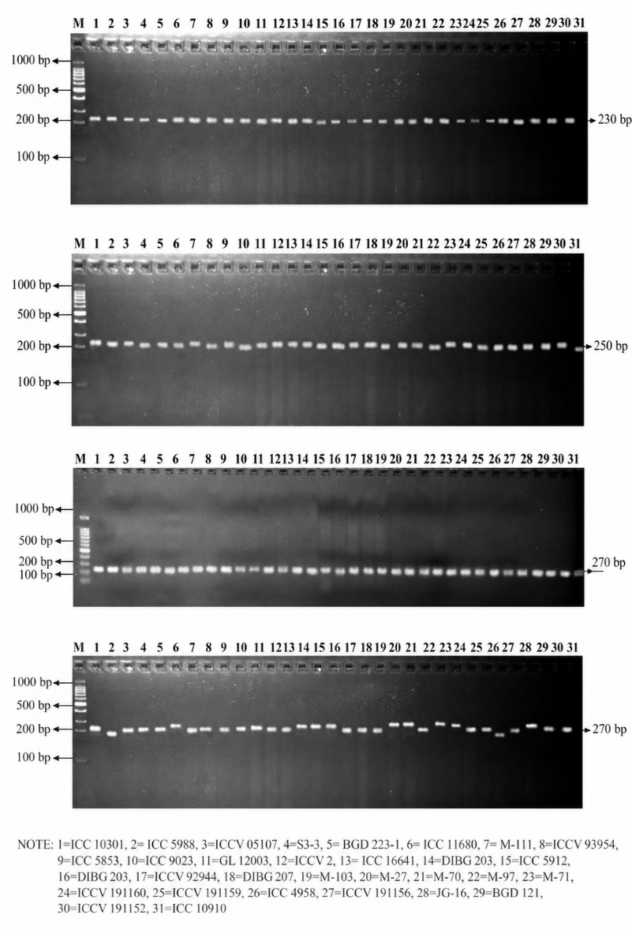
Fig. 1. Representative gel images for Primers TA 130, TR 1, TA 22, TA 113

Table 2: Marker polymorphism and PIC values of SSR primers used in the present study
S.  No. | Primer | No. of alleles amplified | Polymorphic alleles | Size range (bp) | PIC
1 | TA 113 | 5 | 5 | 188-259 | 0.513
2 | TA 194 | 2 | 2 | 190-204 | 0.419
3 | TR 7 | 1 | 1 | 204 | 0.759
4 | TR 43 | 3 | 3 | 280-350 | 0.599
5 | TA 2 | 1 | 1 | 150 | 0.403
6 | TA 14 | 2 | 2 | 288-293 | 0.505
7 | TA 22 | 6 | 6 | 206-305 | 0.695
8 | TR 31 | 5 | 5 | 140-205 | 0.637
9 | TR 29 | 6 | 6 | 178-237 | 0.753
10 | TR 1 | 1 | 1 | 210 | 0.501
11 | TA 27 | 2 | 2 | 202-219 | 0.545
12 | TA 28 | 6 | 6 | 300-402 | 0.797
13 | TA 46 | 3 | 3 | 136-169 | 0.604
14 | TA 72 | 5 | 5 | 210-256 | 0.667
15 | TA 71 | 5 | 5 | 181-230 | 0.619
16 | TA 116 | 5 | 5 | 180-203 | 0.701
17 | TA 130 | 4 | 4 | 210-238 | 0.645
18 | TA 135 | 4 | 4 | 185-210 | 0.699
19 | TA 200 | 2 | 2 | 180-310 | 0.497
20 | TAA 170 | 5 | 5 | 254-270 | 0.712

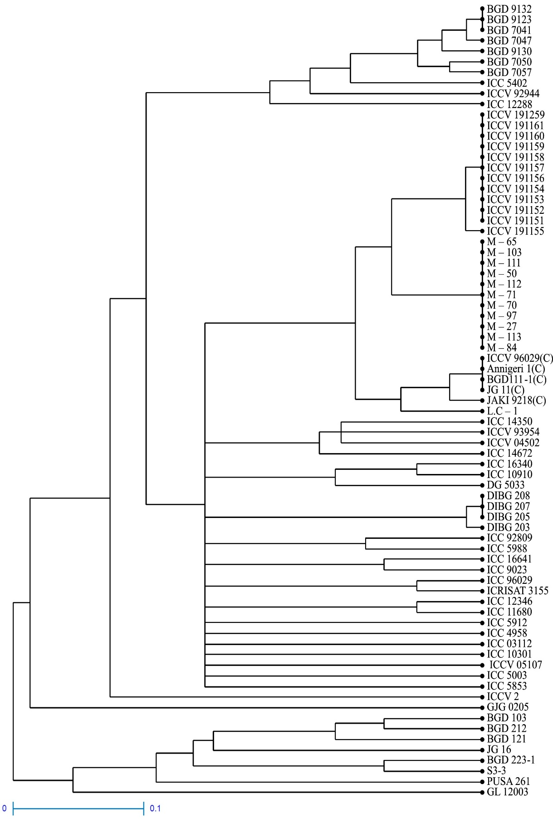

Fig. 2. Dendrogram representing 23 clusters based on molecular diversity

The occurrence of several small and solitary clusters indicates the presence of genetically distinct genotypes, which could be useful as divergent parents in chickpea breeding programmes. The clustering pattern observed in the present study was in agreement with earlier molecular diversity studies in chickpea. Mohan and Kalaimagal (2020) reported the formation of 12 clusters among 50 chickpea genotypes based on SSR markers, indicating considerable genetic variation. The substantial molecular diversity among 69 desi chickpea genotypes was reported by Rajpoot et al. (2025) with some genotypes showing distinct genetic backgrounds. Likewise, Yadav et al. (2025) identified six genetic clusters and two major populations among 71 chickpea genotypes using microsatellite markers. The greater number of clusters (23) recorded in the present study suggests greater genetic differentiation among the 75 genotypes, highlighting the potential of SSR markers for identifying diverse parental material for chickpea improvement. The identified genetically diverse genotypes can be further evaluated using high-density molecular markers and validated for important agronomic and stress-resistance traits. Singh et al. (2022) emphasised that effective utilisation of diverse chickpea germplasm and genomic resources is essential for broadening the crop's narrow genetic base and introducing desirable traits into breeding programmes to develop superior chickpea varieties.

4. Conclusion

Chickpea improvement requires the effective exploitation of available genetic variability to achieve sustained gains in productivity. The genetic diversity identified in the present study provides a strong foundation for strategic breeding and efficient utilisation of chickpea germplasm. The distinct molecular profiles and clustering pattern of the 75 genotypes enable the identification of genetically divergent parents, which can be deliberately combined to broaden the breeding base and generate greater recombination and variability in subsequent generations. The highly informative SSR markers can further support molecular characterisation, parental selection and tracking of genetic diversity in breeding populations. Targeted utilisation of the available genetic diversity in chickpea breeding programmes can accelerate the development of productive and well-adapted cultivars, contributing to increased pulse production, greater self-sufficiency and improved farm-level profitability.

Limitation
The study was based on 75 chickpea genotypes evaluated with 20 SSR markers, which provides a useful but finite representation of molecular diversity. Genetic relationships were inferred from the marker dataset and cluster analysis used in this investigation. Consequently, the identified divergence should be interpreted within the scope of the sampled germplasm and marker panel. Further evaluation with additional high-density molecular markers and assessment of important agronomic and stress-resistance traits would strengthen the practical use of the identified diverse genotypes in breeding programmes.

Competing interests

Authors have declared that no competing interests exist.

Declaration of AI Use

This manuscript was prepared through the intellectual contributions of the author(s) to the study design, data analysis, interpretation of results and scholarly content. The author(s) accept full responsibility for the accuracy, integrity and final content of the manuscript.

References

Varshney, R. K., Song, C., Saxena, R. K., Azam, S., Yu, S., Sharpe, A. G., Cannon, S., Baek, J., Rosen, B. D., Tar’an, B., Millan, T., Zhang, X., Ramsay, L. D., Iwata, A., Wang, Y., Nelson, W., Farmer, A. D., Gaur, P. M., Soderlund, C., … Cook, D. R. (2013). Draft genome sequence of chickpea (Cicer arietinum) provides a resource for trait improvement. Nature Biotechnology, 31(3), 240–246. https://doi.org/10.1038/nbt.2491
Patil, A., Patil, M. D., & Katageri, I. S. (2021). Genetic diversity for yield and yield attributing traits in chickpea (Cicer arietinum L.) under different moisture regimes. Journal of Farm Sciences, 34(2), 138–141. https://doi.org/10.61475/jfm.v34i02.181
Singh, B., Das, A., Parihar, A. K., Bhagawati, B., Singh, D., Pathak, K. N., Dwivedi, K., Das, N., Keshari, N., Midha, R. L., Kumar, R., Pratap, A., Kumar, V., & Gupta, S. (2020). Delineation of genotype-by-environment interactions for identification and validation of resistant genotypes in mungbean to root-knot nematode (Meloidogyne incognita) using GGE biplot. Scientific Reports, 10(1), 4108. https://doi.org/10.1038/s41598-020-60820-x
Ashwini, L. M. B., Patil, M. D., & Motagi, B. N. (2021). Genetic studies to identify climate resilient chickpea (Cicer arietinum L.) genotypes. Journal of Farm Sciences, 34(3), 237–243. https://doi.org/10.61475/jfm.v34i03.316
Gagan Narayan, A. N., Patil, M. D., Soregaon, C. D., & Ashvathama, V. H. (2024). Trait dynamics through association and path analysis across temperature regimes in chickpea (Cicer arietinum L.). Journal of Farm Sciences, 37(4), 323–328. https://doi.org/10.61475/JFS.2024.v37i4.01
Hattiholi, A., Patil, M. D., Soregaon, C. D., & Ashvathama, V. H. (2024). Deciphering trait association, direct and indirect effects of component traits on yield through correlation and path analysis in chickpea (Cicer arietinum L.). Journal of Farm Sciences, 37(2), 118–121. https://doi.org/10.61475/JFS.2024.v37i2.02
Mohan, S., & Kalaimagal, T. (2020). Genetic diversity studies in chickpea (Cicer arietinum L.) genotypes using SSR markers. Journal of Food Legumes, 33(1), 1–5. https://doi.org/10.59797/jfl.v33i1.617
Philanim, W. S., Bharadwaj, C., Kumar, N., Ngangkham, U., Iangrai, B., & Singh, B. K. (2025). Genetic diversity, population structure and marker-trait association analysis for yield-related traits in chickpea (Cicer arietinum L.). Genetic Resources and Crop Evolution, 72(3), 3699–3717. https://doi.org/10.1007/s10722-024-02191-0
Ruperao, P., Vemula, A. K., Valluri, V. K., Manda, S., Srivastava, R. K., Mayes, S., Varshney, R. K., & Kudapa, H. (2025). Assessing genetic diversity and performing genome-wide association studies (GWAS) using multiple marker types across desi, kabuli, and wild accessions in chickpea (Cicer arietinum L.). The Plant Genome, 18(4), e70149. https://doi.org/10.1002/tpg2.70149
Mace, E. S., Buhariwalla, H. K., & Crouch, J. H. (2003). A high-throughput DNA extraction protocol for tropical molecular breeding programs. Plant Molecular Biology Reporter, 21(4), 459a–459h. https://doi.org/10.1007/BF02772596
Nei, M., & Li, W. H. (1979). Mathematical model for studying genetic variation in terms of restriction endonucleases. Proceedings of the National Academy of Sciences of the United States of America, 76(10), 5269–5273. https://doi.org/10.1073/pnas.76.10.5269
Powell, W., Morgante, M., Andre, C., Hanafey, M., Vogel, J., Tingey, S., & Rafalski, A. (1996). The comparison of RFLP, RAPD, AFLP and SSR (microsatellite) markers for germplasm analysis. Molecular Breeding, 2(3), 225–238. https://doi.org/10.1007/BF00564200
Rajpoot, S. S., Tripathi, M. K., Payasi, D. K., Mishra, R., Sharma, S., Sikarwar, R. S., & Tiwari, P. N. (2025). Estimation of genetic diversity in desi chickpea (Cicer arietinum L.) genotypes employing microsatellites. Plant Cell Biotechnology and Molecular Biology, 26(9–10), 48–60. https://doi.org/10.56557/pcbmb/2025/v26i9-109668
Singh, R. K., Singh, C., Ambika, Chandana, B. S., Mahto, R. K., Patial, R., Gupta, A., Gahlaut, V., Gayacharan, Hamwieh, A., Upadhyaya, H. D., & Kumar, R. (2022). Exploring chickpea germplasm diversity for broadening the genetic base utilizing genomic resourses. Frontiers in Genetics, 13, 905771. https://doi.org/10.3389/fgene.2022.905771
Thakur, D., Sultana, R., Singh, R., Roy, P. K., & Sinha, S. (2025). Assessment of genetic diversity in chickpea (Cicer arietinum L.) genotypes using SSR markers. Plant Archives, 25(1), 1926–1932. https://doi.org/10.51470/PLANTARCHIVES.2025.v25.no.1.281
Yadav, R. K., Tripathi, M. K., Asati, R., & Tripathi, N. (2025). Microsatellite markers-based genotyping, population structure analysis and field screening of chickpea (Cicer arietinum L.) genotypes against Fusarium wilt. Plant Science Today, 12(2), 1–11. https://doi.org/10.14719/pst.4587

Rajput, S., Jain, S., Tiwari, S., Sikarwar, R. S., Tripathi, N., Barela, A., & Tripathi, M. K. (2023). Evaluation of gene-based markers against Fusarium wilt disease in chickpea (Cicer arietinum L.). Current Journal of Applied Science and Technology, 42(6), 26–32. https://doi.org/10.9734/cjast/2023/v42i64074
Dogra, S., Chand, G., Kumari, M., Bansal, K. K., Srivastava, H., Kumar, N., & Attri, M. (2025). Integrated assessment of cold stress tolerance in Cicer arietinum L. genotypes—Insights from biochemical and molecular characterisation in Jammu. Physiologia Plantarum, 177(5), e70558. https://doi.org/10.1111/ppl.70558
Alotaibi, F. S., Ibrahim, S. D., Alharbi, S. F., Arab, S. A., Azab, O. M., Ayaad, M. H., El-Shal, M. H., & Abouseadaa, H. H. (2026). Genetic diversity of yield-related traits in chickpea landraces revealed by ISSR and SCoT markers. Saudi Journal of Food Security and Environmental Sustainability, 1, 1. https://doi.org/10.1007/s44522-026-00003-6

