The Relationship Between Artificial Intelligence Literacy, Self-Regulated Learning, and Academic Engagement Among University Students Who Use Generative AI at Indonesian Universities

Abstract
Generative artificial intelligence (GenAI) is increasingly used by university students to support information retrieval, idea development, writing, feedback, and learning management, but its educational value may depend on students’ AI literacy and capacity for self-regulated learning. This study examined the associations of AI literacy and self-regulated learning with academic engagement among Indonesian university students who use GenAI. A quantitative associational design was applied to 312 students recruited through purposive online sampling. Data were collected using five-point Likert-scale measures and analysed through validity and reliability tests, classical assumption tests, multiple linear regression, t-tests, an F-test, and the coefficient of determination. AI literacy was positively associated with academic engagement (B = 0.463, t = 12.232, p < 0.001), while self-regulated learning also showed a positive association (B = 0.523, t = 13.263, p < 0.001). The standardised beta coefficient was higher for self-regulated learning (β = 0.496) than for AI literacy (β = 0.457). Together, the two predictors accounted for 64.5% of the variation in academic engagement (R² = 0.645; F = 281.011, p < 0.001). These findings indicate that AI literacy and self-regulated learning are complementary capabilities associated with stronger academic engagement among GenAI-using students. The results support the importance of promoting critical AI use alongside students’ capacity to plan, monitor, and regulate their learning.

Keywords: Artificial intelligence literacy; self-regulated learning; academic engagement; generative AI; higher education; university students

Introduction
Generative Artificial Intelligence has evolved from an experimental technology into a tool that college students increasingly use for information retrieval, brainstorming, writing, summarisation, problem-solving, and learning support. Studies of higher education students indicate that GenAI is perceived to offer benefits such as personalised learning support and academic efficiency, but it also raises concerns regarding accuracy, privacy, ethics, and dependency (Chan & Hu, 2023). Recent evidence from students and teachers likewise highlights the importance of institutional support and appropriate pedagogical integration when AI is introduced into educational practice (Kumar & Saratha, 2025). The Indonesian context indicates that the use of GenAI has become an integral part of students’ academic activities. A quantitative study of Indonesian students in 2026 reported that the adoption of GenAI is linked to perceptions of the technology’s practical role in supporting academic work, while recent qualitative research in Indonesian higher education highlights both efficiency benefits and risks such as dependency, a decline in critical thinking, and issues of academic integrity (Callista Syavina & Surayya Ulfa, 2026; Rahiem, 2026). Increased use of GenAI does not automatically mean that students have the ability to use the technology critically. AI literacy encompasses the ability to know and understand AI, use and apply it, evaluate its outputs, and understand ethical issues; thus, AI literacy is broader than simply the skill of crafting prompts or operating applications (Ng et al., 2021). Recent higher-education evidence likewise supports treating AI literacy as a multidimensional competency involving students’ understanding and use of AI rather than mere access to AI tools (Satapathy et al., 2026). UNESCO emphasises that the integration of GenAI into education must maintain a human-centred approach, protect students’ agency, safeguard privacy, and ensure that technology is used to enhance thinking processes rather than replace them. Therefore, the ability to evaluate AI outputs, understand its limitations, and use the technology responsibly is a crucial part of the literacy students need (UNESCO, 2023).
In addition to AI literacy, the effectiveness of GenAI-assisted learning is closely tied to students’ ability to manage their own learning processes. Self-regulated learning encompasses cognitive, metacognitive, behavioural, motivational, and affective aspects that enable individuals to set goals, choose strategies, monitor progress, and reflect on and adjust their learning processes (Panadero, 2017). The self-regulated learning model positions students as active agents who plan, monitor, and reflect on their learning activities. In the context of GenAI, self-regulation skills are crucial because the technology’s instant answers can increase efficiency while also posing the risk of superficial information processing if students do not set goals, verify sources, or independently assess the quality of the output (Zimmerman, 2002; Ng, 2024). Recent research in GenAI-supported higher education also indicates that self-regulated learning may be strengthened when students receive deliberate metacognitive support during AI-assisted learning (Xu et al., 2025).
Academic engagement describes students’ involvement in learning through the dimensions of behavioural, emotional, and cognitive engagement. This construct is important because engagement is evident not only in attendance or task completion but also in persistence, interest, cognitive investment, and the use of strategies to understand the material deeply (Fredricks et al., 2004). Previous research on ChatGPT and student engagement indicates that GenAI can lead to patterns of both engagement and disengagement; thus, the mere presence of the technology is insufficient to guarantee the quality of learning engagement. The literature suggests further research into learning habits, how students manage their use of AI, and the mechanisms through which GenAI supports productive engagement (Lo et al., 2024). Recent research further indicates that university students show heterogeneous patterns of engagement with AI that are associated with differences in AI literacy and learning practices (Medina-Gual & Parejo, 2026; Qu et al., 2024). Recent research also reveals a substantial relationship between GenAI competencies and student engagement across disciplines, as well as relationships among AI literacy, self-regulated learning, and academic achievement in GenAI-supported learning environments. However, quantitative evidence that directly tests AI literacy and self-regulated learning as two predictors of academic engagement among GenAI-using students in Indonesia remains limited (Sampah et al., 2026; Shi et al., 2025).
A preliminary exploratory survey involving 60 students was conducted to identify initial patterns regarding Generative AI usage and learning practices among university students before the main data collection. Table 1 presents the results of the preliminary survey.
Table 1. Pre-Survey Results
Statement | Yes | No | % Yes
Using Generative AI to support academic tasks or activities | 55 | 5 | 91.7%
Have used AI-generated answers without adequately verifying the sources | 41 | 19 | 68.3
Still have difficulty assessing the accuracy, bias, or limitations of AI outputs | 44 | 16 | 73.3
Generative AI helps plan and organize learning strategies | 48 | 12 | 80.0
Still having trouble managing study time even when using AI | 39 | 21 | 65.0
Feel more actively engaged when AI is used critically to understand the material | 50 | 10 | 83.3%
Source: Pre-survey data, 2026.
This phenomenon illustrates two issues that may arise simultaneously: a high intensity of GenAI use alongside critical evaluation skills and learning management that do not always align. This situation is theoretically relevant for testing whether AI literacy and self-regulated learning are associated with student engagement in academic activities (Ng et al., 2021; Panadero, 2017; Lo et al., 2024). This study aims to examine the association between AI literacy, self-regulated learning, and academic engagement among college students who use GenAI in Indonesia.

Literature Review

Artificial Intelligence Literacy
AI literacy is a set of competencies that enables individuals to understand, use, evaluate, and consider the ethical implications of AI technology. Ng and colleagues’ framework divides AI literacy into four main aspects: know and understand, use and apply, evaluate and create, and ethical issues (Ng et al., 2021).
In GenAI-based learning, AI literacy means that students are able to assess the suitability of tools for task objectives, design interactions, verify outputs, recognise biases or hallucinations, and use AI results while maintaining academic responsibility. This approach aligns with the principles of human-centred AI, which places humans at the centre of thinking and decision-making processes (UNESCO, 2023; Chan & Hu, 2023).

Self-Regulated Learning
Self-regulated learning is an active process in which students regulate their cognition, motivation, behaviour, and environment to achieve learning goals. SRL is not a single strategy but a system that encompasses goal-setting, planning, monitoring, strategy adjustment, time management, and reflection following learning activities (Zimmerman, 2002; Panadero, 2017).
The use of GenAI can support self-regulated learning when the technology is used to develop plans, obtain feedback, generate practice questions, or monitor understanding; however, this support still depends on students’ ability to maintain control over their learning goals and strategies. Experimental studies show that GenAI-based chatbots can enhance aspects of SRL, behavioural engagement, and motivation when the technology is integrated into a purposeful instructional design (Ng, 2024).

Academic Engagement
Academic engagement refers to students’ active involvement in the learning experience, which can be understood through the dimensions of behavioural, emotional, and cognitive engagement. Behavioural engagement is evident in participation and persistence; emotional engagement relates to interest and affective responses; whereas cognitive engagement is reflected in mental investment and strategies for understanding the material deeply (Fredricks et al., 2004).
In learning environments with GenAI, engagement may increase when AI facilitates exploration, explanation, and interaction with the material, but it may decrease when students become passive and merely copy AI outputs into their assignments. Systematic reviews indicate that the relationships between GenAI use and engagement are ambivalent and highly dependent on how the technology is used (Lo et al., 2024).

Hypothesis Development
AI literacy is theoretically associated with academic engagement because students who understand AI’s capabilities and limitations may be better positioned to use the technology for exploration, evaluation, and meaningful academic activities.
H₁: AI literacy has a positive and significant relationship with academic engagement.
Self-regulated learning is theoretically associated with academic engagement because students who are able to set goals, manage their time, monitor their understanding, and adjust their strategies may demonstrate stronger persistence and cognitive investment.
H₂: Self-regulated learning has a positive and significant relationship with academic engagement.
AI literacy and self-regulated learning are expected to jointly explain academic engagement because the ability to use technology must be accompanied by the ability to direct the learning process. AI literacy provides the capacity to understand and evaluate systems, while SRL provides the capacity to control learning goals, strategies, and reflection (Shi et al., 2025; Ng et al., 2021; Panadero, 2017).
H₃: AI literacy and self-regulated learning simultaneously show a significant association with academic engagement.

Research Method
This study employs a quantitative approach with an associational research design to examine the predictive association between two predictor variables and one outcome variable. A survey design was chosen because the constructs of AI literacy, self-regulated learning, and academic engagement can be measured through respondents’ perceptions using a structured instrument (Creswell & Creswell, 2018; Hair et al., 2019). The study population consisted of active college students in Indonesia who had used Generative AI for academic activities. Respondent criteria included being an active student at the diploma, bachelor’s, or master’s level; being at least 17 years old; having used GenAI within the past three months; and being willing to provide consent to participate as a respondent. The sampling technique used was purposive sampling because respondents had to meet characteristics aligned with the research objectives (Etikan et al., 2016). Data collection was conducted from January 2026 to April 2026. Respondents were recruited through online questionnaire distribution networks involving students from Indonesian universities using purposive online sampling. Participation was voluntary, and only students who met the inclusion criteria were included in the analysis.
The minimum sample requirement was determined using an a priori power analysis for multiple linear regression with two predictors. Based on Cohen’s (1988) recommendation, assuming a medium effect size (f² = 0.15), a significance level of 0.05, and statistical power of 0.80, the minimum required sample was 68 respondents. Therefore, the obtained sample size of 312 respondents exceeded the minimum requirement for regression analysis.
This study followed institutional research ethics guidelines. Participation was voluntary, informed consent was obtained from all participants before questionnaire completion, and no personally identifiable information was collected. Data were used solely for academic purposes.

Research Findings

Respondent Characteristics
Table 2 Respondent Characteristics
Characteristics | Category | n | %
Gender | Female | 176 | 56.4%
 | Male | 136 | 43.6%
Level | Diploma | 36 | 11.5%
 | Bachelor’s Degree/S1 | 224 | 71.8%
 | Master’s Degree/S2 | 52 | 16.7%
Region | Java | 150 | 48.1%
 | Sumatra | 58 | 18.6%
 | Kalimantan | 30 | 9.6%
 | Sulawesi | 32 | 10.3%
 | Bali-Nusa Tenggara | 24 | 7.7%
 | Maluku-Papua | 18 | 5.8%
Source: Research data, 2026.
Table 2 presents the demographic characteristics of the respondents. The sample consisted of 312 purposively recruited students from different educational levels and geographical regions in Indonesia. However, because the recruitment used online purposive sampling, the sample should not be interpreted as nationally representative of all Indonesian university students.

Descriptive Statistics
Table 3. Descriptive Statistics
Variables | N | Mean | Std. Dev. | Minimum | Maximum
AI Literacy (X1) | 312 | 3.287 | 1.128 | 1.00 | 5.00
Self-Regulated Learning (X2) | 312 | 3.262 | 1.083 | 1.00 | 5.00
Academic Engagement (Y) | 312 | 3.216 | 1.142 | 1.00 | 5.00

Source: Processed data, 2026.
As shown in Table 3, the average AI literacy score was 3.287, self-regulated learning was 3.262, and academic engagement was 3.216.

Validity and Reliability Tests
Table 4. Item-Total Correlation Analysis
Item | Calculated r | Table r | Sig. | Decision
AI1 | 0.795 | 0.111 | <0.001 | Valid
AI2 | 0.805 | 0.111 | <0.001 | Valid
AI3 | 0.804 | 0.111 | <0.001 | Valid
AI4 | 0.820 | 0.111 | <0.001 | Valid
AI5 | 0.811 | 0.111 | <0.001 | Valid
AI6 | 0.774 | 0.111 | <0.001 | Valid
SRL1 | 0.784 | 0.111 | <0.001 | Valid
SRL2 | 0.763 | 0.111 | <0.001 | Valid
SRL3 | 0.781 | 0.111 | <0.001 | Valid
SRL4 | 0.768 | 0.111 | <0.001 | Valid
SRL5 | 0.798 | 0.111 | <0.001 | Valid
SRL6 | 0.785 | 0.111 | <0.001 | Valid
ENG1 | 0.791 | 0.111 | <0.001 | Valid
ENG2 | 0.787 | 0.111 | <0.001 | Valid
ENG3 | 0.817 | 0.111 | <0.001 | Valid
ENG4 | 0.803 | 0.111 | <0.001 | Valid
ENG5 | 0.819 | 0.111 | <0.001 | Valid
ENG6 | 0.789 | 0.111 | <0.001 | Valid

Source: Processed data, 2026; validity criteria refer to Ghozali (2018).
Table 4 presents the item-total correlation analysis. All items showed acceptable item-total correlation coefficients exceeding the reference value of 0.111 and were statistically significant at the 0.05 level.
Table 5. Reliability Test
Variable | Number of Items | Cronbach’s Alpha | Threshold | Decision
AI Literacy | 6 | 0.933 | 0.70 | Reliable
Self-Regulated Learning | 6 | 0.924 | 0.70 | Reliable
Academic Engagement | 6 | 0.933 | 0.70 | Reliable

Source: Processed data, 2026; Hair et al. (2019).

Classical Assumptions Test
Table 6 presents the classical assumption test results. The normality test of residuals showed a Kolmogorov-Smirnov value of 0.036 with a significance level of 0.789.
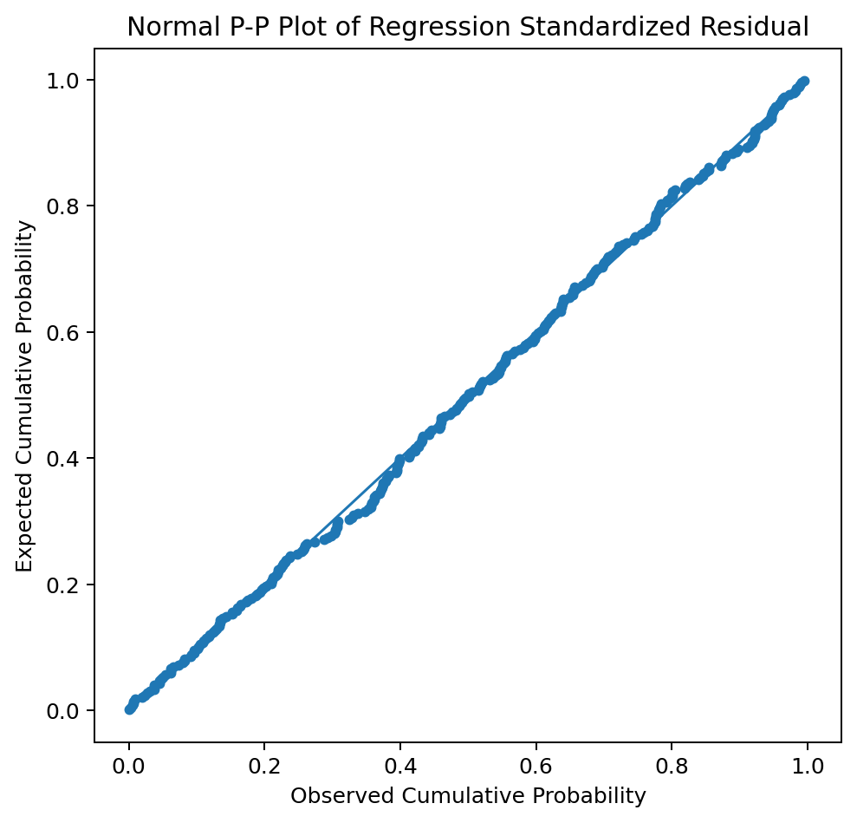
Figure 1. Normal P-P Plot of regression residuals.
Source: Processed data, 2026.
Table 6. Multicollinearity Test
Testing | Statistics | Value | Criteria | Conclusion
Multicollinearity | Tolerance X1 | 0.822 | >0.10 | No problem
Multicollinearity | VIF X1 | 1.216 | <10 | No problem
Multicollinearity | Tolerance X2 | 0.822 | >0.10 | No problem
Multicollinearity | VIF X2 | 1.216 | <10 | No problem
Glejser | Sig. X1 | 0.858 | >0.05 | Not heteroscedastic
Glejser | Sig. X2 | 0.467 | >0.05 | Not heteroscedastic
Durbin-Watson | DW | 2.057 | Approaching 2 | No indication of autocorrelation

Source: Processed data, 2026; Ghozali (2018).
The Glejser test yielded significance values of X1 = 0.858 and X2 = 0.467, both exceeding 0.05, indicating no evidence of heteroscedasticity. Figure 2 presents the residual scatterplot, which shows that the residual distribution does not form a clear pattern.
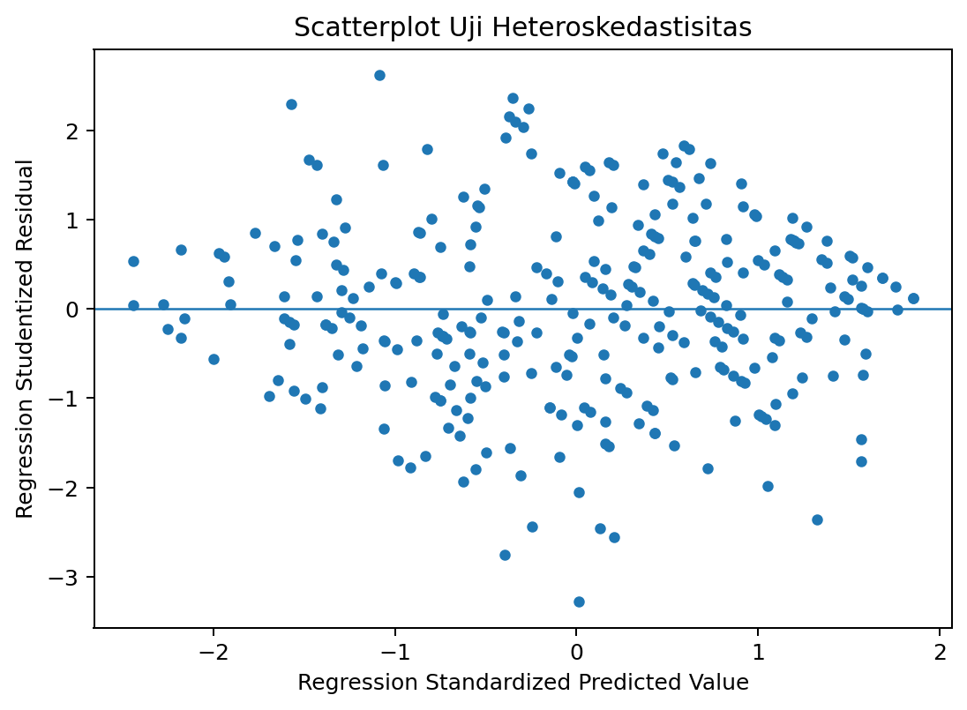
Figure 2. Residual scatterplot
Source: Processed data, 2026.

Multiple Linear Regression and Hypothesis Testing
Table 7. Multiple Linear Regression
Variables | B | Std. Error | Beta | t | Sig.
Constant | -0.010 | 0.141 | - | -0.074 | 0.941
AI Literacy (X1) | 0.463 | 0.038 | 0.457 | 12.232 | <0.001
Self-Regulated Learning (X2) | 0.523 | 0.039 | 0.496 | 13.263 | <0.001

Source: Processed data, 2026.
The resulting regression equation is Y = -0.010 + 0.463X1 + 0.523X2. The coefficients for AI literacy and self-regulated learning are both positive, indicating that higher scores on these predictors are associated with higher academic engagement scores when the other predictor is controlled for.
AI literacy has B = 0.463, t = 12.232, and p < 0.001. Thus, the findings provide statistical support for H1. These results indicate that students with the ability to understand, use, evaluate, and consider the ethical aspects of AI tend to have higher academic engagement scores.
Self-regulated learning has B = 0.523, t = 13.263, and p < 0.001. Thus, the findings provide statistical support for H2. The standardised beta for SRL (0.496) is higher than that for AI literacy (0.457), making SRL the relatively stronger predictor in the model.

F-Test and Coefficient of Determination
Table 8. F-Test
Source | Sum of Squares | df | Mean Square | F | Sig.
Regression | 261.813 | 2 | 130.906 | 281.011 | <0.001
Residual | 143.945 | 309 | 0.466
Total | 405.758 | 311
Source: Processed data, 2026.

Table 9. Coefficient of Determination
R | R-Square | Adjusted R-Square | Standard Error | Durbin-Watson
0.803 | 0.645 | 0.643 | 0.683 | 2.057

Source: Processed data, 2026.

The simultaneous regression test yielded an F-value of 281.011 with p < 0.001, indicating that AI literacy and self-regulated learning jointly predict academic engagement within the tested model.

Discussion
The positive association between AI literacy and academic engagement suggests that the ability to use AI critically can be understood as an academic resource that supports student engagement. Students who understand how AI works and its limitations are more likely to use GenAI as a tool for exploring, evaluating, and developing ideas rather than merely as a source of instant answers (Ng et al., 2021; UNESCO, 2023).
These findings align with recent research showing that GenAI competence can directly drive student engagement. Competence enables students to utilise the technology’s functions in a more purposeful manner, whereas a lack of competence may lead to superficial and transactional use of AI (Sampah et al., 2026).
Self-regulated learning (SRL) demonstrates a stronger predictive contribution than AI literacy in the regression model. These results align with SRL theory, which identifies goal setting, monitoring, regulation, and reflection as core processes that keep students actively in control of their learning—even when external assistance, such as GenAI, is available (Zimmerman, 2002; Panadero, 2017).
GenAI can support learning regulation through the creation of plans, practice questions, alternative explanations, and feedback; however, students still need the capacity to set goals and evaluate whether such assistance aligns with their learning needs. Chatbot-based studies indicate that designs that guide students towards SRL can enhance behavioural engagement and motivation (Ng, 2024).
The simultaneous association of AI literacy and SRL with academic engagement indicates that technological skills and self-regulation abilities are complementary. AI literacy addresses questions about how technology is understood and used responsibly, while SRL addresses how students direct their learning goals, strategies, time, and reflection (Ng et al., 2021; Panadero, 2017).
Based on the findings of this study, technology can lead to both engagement and disengagement; therefore, it is not enough for higher education institutions to merely provide access to AI. Institutions need to develop literacy programmes, usage guidelines, assessment designs, and activities that require students to examine, critique, elaborate on, and take responsibility for their use of AI (Lo et al., 2024; UNESCO, 2023).
The Indonesian context is important because students’ adoption of GenAI has already become part of academic practice, but local research is still developing, and many studies focus on a single institution or the adoption of a specific technology. Cross-institutional and cross-disciplinary research is needed to test whether the relationship between AI literacy, SRL, and engagement holds consistently across more diverse student groups (Callista Syavina & Surayya Ulfa, 2026; Rahiem, 2026).

Implications
The theoretical implication of this research lies in positioning AI literacy and self-regulated learning as two personal capabilities that can explain engagement in GenAI-based learning. This model can be further developed by adding variables such as AI self-efficacy, academic integrity, cognitive load, perceived autonomy, or learning outcomes as mediators or additional outcomes (Shi et al., 2025; Sampah et al., 2026).
The practical implication is that higher education institutions need to develop AI literacy programmes that not only teach the use of tools but also cover output evaluation, ethics, privacy, citation, and strategies for human-AI collaboration. These programmes should be integrated with self-regulated learning training so that students can manage their goals, time, strategies, and reflections when using GenAI (UNESCO, 2023; Ng et al., 2021; Panadero, 2017).

Conclusion
Based on the research findings, AI literacy and self-regulated learning show positive and significant associations with academic engagement among students who use GenAI, both partially and simultaneously. Self-regulated learning shows a relatively greater contribution, while the two variables together explain 64.5% of the variation in academic engagement. Conceptually, these results reinforce the argument that the benefits of GenAI in higher education depend not only on the availability of technology but also on students’ ability to critically understand AI and manage their learning processes independently. AI literacy and self-regulated learning can be positioned as the foundation for maintaining student agency and engagement in a learning environment increasingly shaped by AI.
Limitations and Future Research
This study has several limitations that should be considered when interpreting the findings. First, the cross-sectional design limits the ability to determine temporal relationships and prevents causal conclusions about artificial intelligence literacy, self-regulated learning, and academic engagement. Although the findings indicate predictive associations among the variables, future research should employ longitudinal or experimental designs to examine how students’ AI literacy and self-regulated learning develop over time and how these changes are associated with academic engagement in GenAI-supported learning environments.

Second, this study used purposive online sampling, which limits the generalisability of the findings to the broader population of Indonesian university students. Although respondents were recruited from different geographical regions, the sample cannot be considered nationally representative. Future studies should apply probability sampling approaches or larger multi-institutional sampling strategies involving diverse types of universities, academic disciplines, and student characteristics to improve external validity.
Third, the study relied on self-reported questionnaire data collected at a single time point. This approach may introduce common method bias because all constructs were measured using the same instrument and from the same respondents. Future research could combine self-report measures with objective indicators, such as AI usage records, learning analytics, academic performance data, or behavioural observations, to obtain a more comprehensive understanding of students’ interaction with GenAI.
Fourth, the measurement of the research variables focused on AI literacy, self-regulated learning, and academic engagement. While these variables represent important individual capabilities in GenAI-supported learning, other contextual and psychological factors may also contribute to students’ engagement. Future research may extend the proposed model by examining additional variables, such as AI self-efficacy, perceived usefulness of GenAI, academic integrity, cognitive load, digital competence, learning autonomy, or institutional AI policies.
Finally, future studies should further examine the mechanisms through which AI literacy and self-regulated learning are associated with academic engagement. For example, mediation or moderation models could be explored to understand whether factors such as AI usage patterns, students’ critical evaluation skills, or learning motivation explain variations in engagement outcomes.
Declaration of AI Use

This manuscript was prepared through the intellectual contributions of the author(s) to the study design, data analysis, interpretation of results, and scholarly content. Grammarly and ChatGPT were used solely to assist with grammatical refinement and reference formatting during manuscript revision. The author(s) accept full responsibility for the accuracy, integrity, and final content of the manuscript.

References
Callista Syavina, A., & Surayya Ulfa, N. (2026). The adoption of generative AI among Indonesian university students. Interaksi Online, 14(3), 183–185. https://ejournal3.undip.ac.id/index.php/interaksi-online/article/view/58306
Chan, C. K. Y., & Hu, W. (2023). Students’ voices on generative AI: Perceptions, benefits, and challenges in higher education. International Journal of Educational Technology in Higher Education, 20, 43. https://doi.org/10.1186/s41239-023-00411-8
Cohen, J. (1988). Statistical power analysis for the behavioral sciences (2nd ed.). Lawrence Erlbaum Associates.
Creswell, J. W., & Creswell, J. D. (2018). Research design: Qualitative, quantitative, and mixed methods approaches (5th ed.). SAGE.
Etikan, I., Musa, S. A., & Alkassim, R. S. (2016). Comparison of convenience sampling and purposive sampling. American Journal of Theoretical and Applied Statistics, 5(1), 1–4. https://doi.org/10.11648/j.ajtas.20160501.11
Fredricks, J. A., Blumenfeld, P. C., & Paris, A. H. (2004). School engagement: Potential of the concept, state of the evidence. Review of Educational Research, 74(1), 59–109. https://doi.org/10.3102/00346543074001059
Ghozali, I. (2018). Applications of multivariate analysis using IBM SPSS 25 (9th ed.). Diponegoro University Press.
Hair, J. F., Black, W. C., Babin, B. J., & Anderson, R. E. (2019). Multivariate data analysis (8th ed.). Cengage.
Shi, J., Liu, W., & Hu, K. (2025). Exploring how AI literacy and self-regulated learning relate to student writing performance and well-being in generative AI-supported higher education. Behavioral Sciences, 15(5), 705. https://doi.org/10.3390/bs15050705
Kumar, C. A., & Saratha, M. (2025). Exploring the students and teachers perception on artificial intelligence based techno-pedagogical integration. Asian Journal of Arts, Humanities and Social Studies, 8(2), 169–176. https://doi.org/10.56557/ajahss/2025/v8i288
Lo, C. K., Hew, K. F., & Jong, M. S. Y. (2024). The influence of ChatGPT on student engagement: A systematic review and future research agenda. Computers & Education, 219, 105100. https://doi.org/10.1016/j.compedu.2024.105100
Medina-Gual, L., & Parejo, J.-L. (2026). University students’ engagement with artificial intelligence: A cluster analysis of learner profiles in AI literacy. Technology, Knowledge and Learning, 31, 291–309. https://doi.org/10.1007/s10758-025-09926-7
Ng, D. T. K. (2024). Empowering student self-regulated learning and science education through ChatGPT: A pioneering pilot study. British Journal of Educational Technology, 55(4), 1328–1353. https://doi.org/10.1111/bjet.13454
Ng, D. T. K., Leung, J. K. L., Chu, S. K. W., & Qiao, M. S. (2021). Conceptualizing AI literacy: An exploratory review. Computers and Education: Artificial Intelligence, 2, 100041. https://doi.org/10.1016/j.caeai.2021.100041
Panadero, E. (2017). A review of self-regulated learning: Six models and four directions for research. Frontiers in Psychology, 8, 422. https://doi.org/10.3389/fpsyg.2017.00422
Qu, Y., Tan, M. X. Y., & Wang, J. (2024). Disciplinary differences in undergraduate students’ engagement with generative artificial intelligence. Smart Learning Environments, 11, 51. https://doi.org/10.1186/s40561-024-00341-6
Rahiem, M. D. H. (2026). Generative AI in higher education in Indonesia: Patterns of use and learning impact. Social Sciences & Humanities Open, 13, 102672. https://doi.org/10.1016/j.ssaho.2026.102672
Sampah, S. N. A., Nabang, M., Krampa, E. K., Issah, M., Koduah, F., Essel, H. B., & Adu-Agyem, J. (2026). Generative AI competence and student engagement in higher education: Mediating roles of utilization, autonomy, and formal learning. Journal of Interdisciplinary Studies in Education, 15(2), 109–146. https://doi.org/10.32674/3s3cx241
Satapathy, D., Kumar, P. D., Devaraj, M., Nanda, S. B., Jena, S., & Pradhan, D. K. (2026). AI literacy among higher education students: Evidence from Odisha, India. Asian Journal of Education and Social Studies, 52(6), 843–855. https://doi.org/10.9734/ajess/2026/v52i63137
UNESCO. (2023). Guidance for generative AI in education and research. https://www.unesco.org/en/articles/guidance-generative-ai-education-and-research
Xu, X., Qiao, L., Cheng, N., Liu, H., & Zhao, W. (2025). Enhancing self-regulated learning and learning experience in generative AI environments: The critical role of metacognitive support. British Journal of Educational Technology, 56, 1842–1863. https://doi.org/10.1111/bjet.13599
Zimmerman, B. J. (2002). Becoming a self-regulated learner: An overview. Theory Into Practice, 41(2), 64–70. https://doi.org/10.1207/s15430421tip4102_2

