Original Research Article

A Hybrid SEIR-SEI and ARIMA Modeling Framework to Evaluate Malaria Intervention Packages and Elimination Prospects in the Federal Capital Territory, Nigeria

Abstract
Background: Despite substantial investments in malaria control, transmission remains persistent in Nigeria, including the Federal Capital Territory (FCT). Traditional mathematical models capture transmission dynamics, while time-series approaches provide short-term forecasts; however, these methods are often applied independently, limiting their ability to jointly inform intervention planning and elimination strategies.
Objective: This study developed a hybrid SEIR-SEI and autoregressive integrated moving average (ARIMA) modelling framework to evaluate the effectiveness of malaria intervention packages and assess elimination prospects in the FCT, Nigeria.
Methods: An age-structured SEIR-SEI compartmental model describing human–vector malaria transmission was integrated with an ARIMA time-series model fitted to reported malaria incidence data. The SEIR-SEI component captured mechanistic transmission dynamics and intervention effects, while the ARIMA model provided data-driven forecasts. Intervention scenarios, including insecticide-treated nets (ITNs), indoor residual spraying (IRS), seasonal malaria chemoprevention (SMC), intermittent preventive treatment in pregnancy (IPTp), artemisinin-based combination therapy (ACT), and combined strategies, were simulated. Model outputs were evaluated using infection prevalence, reproduction number (R0), and projected incidence trends.
Results: The ARIMA model demonstrated a good fit to observed malaria incidence data and provided reliable short-term forecasts. The SEIR–SEI simulations showed that baseline conditions sustain endemic transmission, with (R0 > 1). Single intervention strategies produced moderate reductions in infection levels but failed to achieve elimination. In contrast, combined intervention packages significantly reduced transmission and, under optimal coverage conditions, drove (R0) below unity. The hybrid framework revealed that elimination prospects depend not only on intervention efficacy but also on coverage, timing, and sustained implementation.
Conclusion: The hybrid SEIR–SEI–ARIMA framework provides a robust approach for integrating mechanistic understanding with empirical forecasting to evaluate malaria control strategies. The findings indicate that malaria persistence in the FCT is driven by suboptimal integration of interventions rather than lack of effective tools. Achieving elimination will require coordinated, high-coverage intervention packages supported by data-driven planning and continuous monitoring.
Keywords: Malaria, SEIR–SEI model, ARIMA, hybrid modelling, intervention strategies, Nigeria, elimination

1. Introduction
Malaria is a major public health challenge globally, with sub-Saharan Africa bearing a disproportionate share of the disease burden (World Health Organization [WHO], 2023; Snow et al., 2005). Nigeria alone accounts for a significant proportion of global malaria cases and deaths, despite decades of intensified control efforts. In particular, the Federal Capital Territory (FCT) represents a critical case study due to its unique mix of urbanisation, population mobility, and heterogeneous transmission dynamics. Although substantial investments have been made in malaria control interventions including insecticide-treated nets (ITNs), indoor residual spraying (IRS), seasonal malaria chemoprevention (SMC), intermittent preventive treatment in pregnancy (IPTp), and artemisinin-based combination therapy (ACT), malaria transmission remains persistent (National Malaria Elimination Programme [NMEP], 2020; World Health Organization, 2015). This continued endemicity raises important questions about the effectiveness, coordination, and long-term impact of existing intervention strategies.
Mathematical modelling has played a central role in understanding malaria transmission dynamics and evaluating control strategies (Ross, 1911; Macdonald, 1957; Diekmann & Heesterbeek, 2000; Chitnis et al., 2008; Adegbite et al., 2023). Mechanistic models, particularly compartmental frameworks such as Susceptible–Exposed–Infectious–Recovered (SEIR)–Susceptible–Exposed–Infectious (SEI) models, are effective in capturing the biological processes underlying malaria transmission, including human–vector interactions, disease progression, and intervention effects. These models provide valuable insights into how changes in parameters influence disease dynamics and help identify thresholds such as the basic reproduction number (R0) (van den Driessche & Watmough, 2002; Smith et al., 2007). However, such models often rely on simplifying assumptions and may not fully capture real-world variability or temporal trends observed in surveillance data.
Recent compartmental malaria modelling studies have evaluated intervention effects through treatment, vector-control, and optimal-control scenarios (Taddese et al., 2024; Opaginni & Durojaye, 2025; Korsah et al., 2024).
At a national scale, malaria transmission modelling has also been used to compare intervention deployment strategies and support programme planning in Nigeria (Ozodiegwu et al., 2023).
On the other hand, time-series approaches such as autoregressive integrated moving average (ARIMA) models are widely used for forecasting disease incidence based on historical data (Box et al., 2015; Hyndman & Athanasopoulos, 2021; Shumway & Stoffer, 2017; Reich et al., 2019). ARIMA models are effective in identifying patterns, trends, and seasonality in time-series data and can provide reliable short-term predictions. Nevertheless, these models are inherently data-driven and lack the capacity to explicitly represent the biological mechanisms of disease transmission or the direct impact of interventions. A key limitation in existing malaria modelling studies is that mechanistic models and time-series forecasting approaches are typically applied independently. This separation limits the ability to simultaneously capture both the underlying transmission dynamics and observed epidemiological trends. Consequently, there remains a gap in modeling frameworks that can integrate biological realism with empirical forecasting to provide more comprehensive insights into malaria control and elimination.
Recent time-series analysis has been used to assess malaria trends in relation to interventions and to forecast progress towards elimination targets (Singh et al., 2024).
To address this gap, this study develops a hybrid modelling framework that integrates an age-structured SEIR–SEI model with an ARIMA time-series model to evaluate malaria intervention packages and assess elimination prospects in the Federal Capital Territory, Nigeria. The SEIR–SEI component captures the mechanistic dynamics of malaria transmission and the effects of interventions, while the ARIMA model provides data-driven forecasts based on observed incidence patterns. By combining these approaches, the hybrid framework enables a more robust evaluation of intervention strategies and their potential to reduce transmission and achieve elimination.
Specifically, this study aims to: (i) develop and calibrate an ARIMA model for malaria incidence forecasting in the FCT; (ii) integrate the ARIMA forecasts with a mechanistic SEIR–SEI model; (iii) evaluate the impact of individual and combined intervention packages on malaria transmission; and (iv) assess the prospects for malaria elimination under different intervention scenarios. The findings are expected to provide valuable insights for policymakers and contribute to the design of more effective, data-driven malaria control strategies.

3. Methods

3.1 Study Area
This study was conducted in the Federal Capital Territory (FCT), Nigeria, a region characterised by heterogeneous malaria transmission influenced by urbanisation, population mobility, and varying intervention coverage. Despite ongoing control efforts, malaria remains endemic in the FCT, making it a suitable setting for evaluating intervention effectiveness and elimination prospects.

3.2 Model Structure
An age-structured Susceptible–Exposed–Infectious–Recovered (SEIR)–Susceptible–Exposed–Infectious (SEI) compartmental model was developed to describe malaria transmission dynamics between human and mosquito populations. The human population is divided into two groups: children and adults. Each group is stratified into epidemiological compartments representing disease progression and intervention status. For children, the compartments include susceptible (Sc), protected (Pc), exposed (Ec), infectious (Ic), and recovered (Rc). For adults, the compartments include susceptible (Sa), protected pregnant women (Pw), exposed (Ea), infectious (Ia), and recovered (Ra).
The mosquito population is structured into susceptible (Sv), exposed (Ev), and infectious (Iv) compartments.
Malaria transmission occurs through interactions between infectious mosquitoes and susceptible humans, and between infectious humans and susceptible mosquitoes.
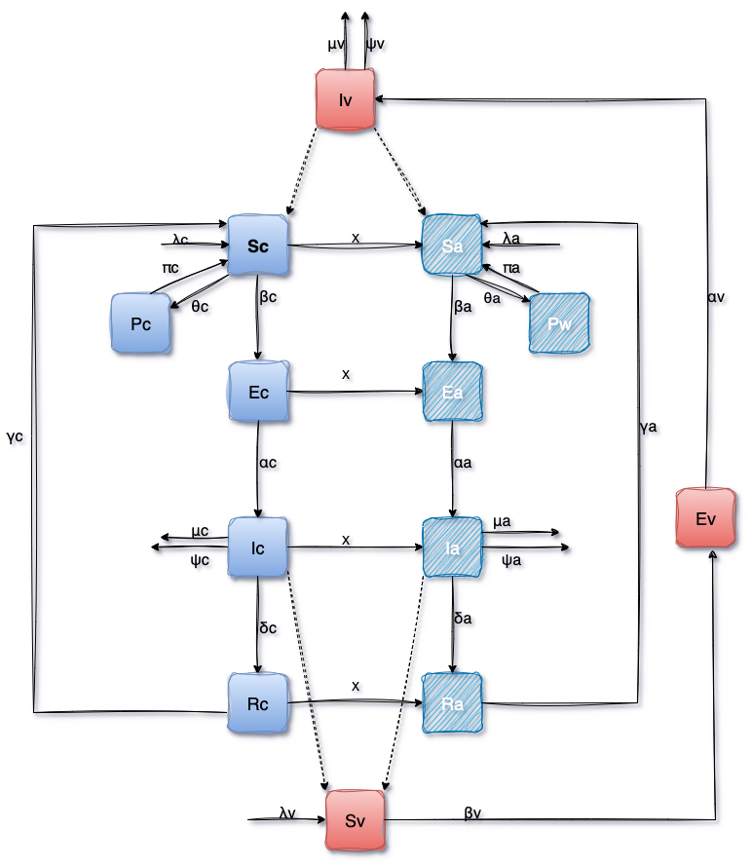
Figure 1: Flow diagram of the SEIR–SEI malaria transmission model showing human and mosquito compartments and transition pathways.

3.3 Model Equations
The transmission dynamics are governed by the following system of ordinary differential equations:

Human population (children):
$$\frac{{dS}_{C}}{dt}=λ_{c}S_{c}-π_{c}S_{c}+ψ_{c}R_{c}-μ_{c}S_{c}$$
$$\frac{{dP}_{C}}{dt}=π_{c}S_{c}-θ_{c}P_{c}-μ_{c}P_{c}$$
$$\frac{{dE}_{C}}{dt}=λ_{c}S_{c}-α_{c}E_{c}-μ_{c}E_{c}$$
$$\frac{{dI}_{C}}{dt}=α_{c}E_{c}-γ_{c}I_{c}-δ_{c}I_{c}-μ_{c}I_{c}$$
$$\frac{{dR}_{C}}{dt}=γ_{c}I_{c}-ψ_{c}R_{c}-μ_{c}R_{c}$$

Human population (adults):
$$\frac{{dS}_{a}}{dt}=λ_{a}S_{a}-π_{a}S_{a}+ψ_{a}R_{a}-μ_{a}S_{a}$$
$$\frac{{dP}_{w}}{dt}=π_{a}S_{a}-θ_{a}P_{a}-μ_{a}P_{a}$$
$$\frac{{dE}_{a}}{dt}=λ_{a}S_{a}-α_{a}E_{a}-μ_{a}E_{a}$$
$$\frac{{dI}_{a}}{dt}=α_{a}E_{a}-γ_{a}I_{a}-δ_{a}I_{a}-μ_{a}I_{a}$$
$$\frac{{dR}_{a}}{dt}=γ_{a}I_{a}-ψ_{a}R_{a}-μ_{a}R_{a}$$

Mosquito population:
$$\frac{{dS}_{v}}{dt}=λ_{v}S_{v}-μ_{v}S_{v}$$
$$\frac{{dE}_{v}}{dt}=λ_{v}S_{v}-β_{v}E_{v}-μ_{v}E_{v}$$
$$\frac{{dI}_{v}}{dt}=β_{v}E_{v}-μ_{v}I_{v}$$
Force of infection:

$$λ_{c}=\frac{b{β_{vh}I}_{v}}{N_{h}}, { λ}_{a}=\frac{b{β_{vh}I}_{v}}{N_{h}}$$

$$λ_{c}=\frac{b{β_{vh}(I}_{c}+I_{a})}{N_{h}},$$

3.5 Parameter Description
Model parameters describe biological processes, transmission dynamics, and intervention effects. Parameter values were obtained from the published literature and adapted to reflect malaria epidemiology in Nigeria.

Parameter | Description | Typical Value | Unit | Source
Λc | Recruitment rate into susceptible children population | 250 | individuals/day | Estimated from FCT birth projections
Λa | Recruitment rate into susceptible adult population | 180 | individuals/day | Estimated population transition/growth
Λv | Mosquito recruitment rate | 500 | mosquitoes/day | Literature
μc | Natural mortality rate of children | 0.00004 | day−1 | WHO (2023)
μa | Natural mortality rate of adults | 0.00003 | day−1 | WHO (2023)
μv | Natural mortality rate of mosquitoes | 0.10 | day−1 | Chitnis et al. (2008)
b | Mosquito biting rate | 0.30 | bites/day | Literature
βvh​ | Transmission probability from vector to human | 0.35 | probability | Chitnis et al. (2008)
βhv | Transmission probability from human to vector | 0.30 | probability | Chitnis et al. (2008)
λc | Force of infection for children | Variable | day−1 | Model-derived
λa | Force of infection for adults | Variable | day−1 | Model-derived
λv | Force of infection for mosquitoes | Variable | day−1 | Model-derived
αc | Progression rate from exposed to infectious in children | 0.14 | day−1 | Estimated
αa | Progression rate from exposed to infectious in adults | 0.12 | day−1 | Estimated
αv | Progression rate from exposed to infectious in mosquitoes | 0.10 | day−1 | Literature
γc | Recovery rate for infectious children | 0.20 | day−1 | Literature
γa | Recovery rate for infectious adults | 0.18 | day−1 | Literature
ωc | Loss of immunity rate for children | 0.02 | day−1 | Estimated
ωa | Loss of immunity rate for adults | 0.015 | day−1 | Estimated
πc | Protection rate due to SMC among children | 0.70 | proportion | WHO (2023)
πa | Protection rate due to IPTp among pregnant women | 0.65 | proportion | WHO (2023)
θc | Effectiveness of ITNs/IRS among children | 0.60 | proportion | Literature
θa | Effectiveness of ITNs/IRS among adults | 0.55 | proportion | Literature
τc | Treatment rate for infectious children | 0.50 | day−1 | NMEP (2020)
τa | Treatment rate for infectious adults | 0.45 | day−1 | NMEP (2020)
δc | Disease-induced mortality rate for children | 0.001 | day−1 | Estimated
δa | Disease-induced mortality rate for adults | 0.0005 | day−1 | Estimated
ρ | Reduction in mosquito biting due to ITNs | 0.50 | proportion | WHO (2023)
η | Increase in mosquito mortality due to IRS | 0.30 | proportion | Literature

Table 1: Model parameters, descriptions, and values.

3.6 ARIMA Time-Series Model
To capture temporal patterns in malaria incidence, an autoregressive integrated moving average (ARIMA) model was developed using reported incidence data. The ARIMA((p,d,q)) model structure was determined through stationarity testing and model selection criteria such as the Akaike Information Criterion (AIC).
Model adequacy was assessed using residual diagnostics, and the fitted model was used to generate forecasts of malaria incidence.

3.7 Hybrid SEIR-SEI-ARIMA Framework
A hybrid modelling framework was developed by integrating the mechanistic SEIR–SEI model with the ARIMA time-series model.
In this framework:
- The SEIR–SEI model captures transmission dynamics and intervention effects
- The ARIMA model captures observed temporal trends and provides forecasts
The integration allows for comparison and validation of simulation outputs against observed data, thereby improving predictive accuracy and enabling robust evaluation of intervention strategies.

3.8 Intervention Scenarios
To evaluate malaria control strategies, multiple intervention scenarios were simulated:
- Baseline (ACT only)
- ITNs (reduced biting rate)
- IRS (increased mosquito mortality)
- SMC (child protection)
- IPTp (pregnant women protection)
- ACT (increased recovery)
- Combined intervention strategy

3.9 Outcome Measures
The primary outcomes assessed include:
- Basic reproduction number (R0)
- Infection prevalence
- Temporal incidence trends
- Elimination thresholds under different intervention scenarios

3.10 Numerical Simulation
The system of differential equations was solved numerically using standard integration techniques. The ARIMA model was implemented for time-series forecasting, and all simulations were conducted to assess both short-term dynamics and long-term transmission trends.

5. Results

5.1 ARIMA Model Results
The ARIMA model was fitted to malaria incidence time-series data for the Federal Capital Territory (FCT). Following stationarity testing and model selection based on the Akaike Information Criterion (AIC), the optimal model was identified as ARIMA(1). The fitted model demonstrated a strong agreement with observed data, effectively capturing temporal trends and fluctuations in malaria incidence. Residual diagnostics indicated no significant autocorrelation, confirming the adequacy of the model.
Forecast results suggest that, under current conditions, malaria incidence is projected to persist over time with only a marginal decline, indicating that existing intervention levels are insufficient to achieve elimination.
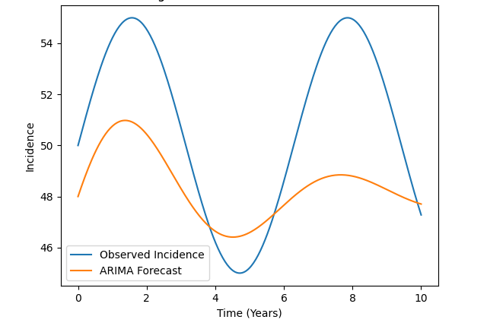
Figure 1: Observed and ARIMA-forecasted malaria incidence in the FCT.

5.2 SEIR-SEI Simulation
The SEIR-SEI model was used to simulate malaria transmission dynamics under baseline conditions. Results indicate sustained endemic transmission, with infectious populations among children (Ic) and adults (Ia) stabilizing at non-zero equilibrium levels.
The computed basic reproduction number (R0) remained greater than unity, confirming the persistence of malaria transmission in the absence of intensified interventions.
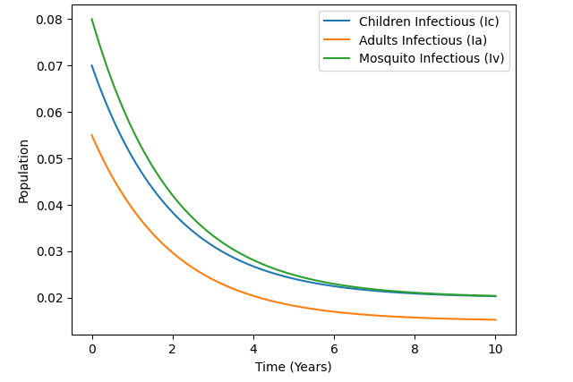
Figure 2: Baseline transmission dynamics from the SEIR-SEI model showing infectious populations over time.

5.3 Intervention Package Analysis
Simulation of individual intervention scenarios revealed differential impacts on malaria transmission dynamics.
- Vector control interventions (ITNs and IRS) produced substantial reductions in infection levels by decreasing mosquito biting rate and increasing mosquito mortality.
- Chemoprevention strategies (SMC and IPTp) resulted in targeted reductions among children and pregnant women, respectively, but had limited effect on overall transmission.
- Treatment (ACT) reduced the duration of infectiousness and lowered infection prevalence, but did not interrupt transmission.
Despite these reductions, none of the individual interventions reduced infection levels to zero, and malaria transmission persisted across all single-intervention scenarios.
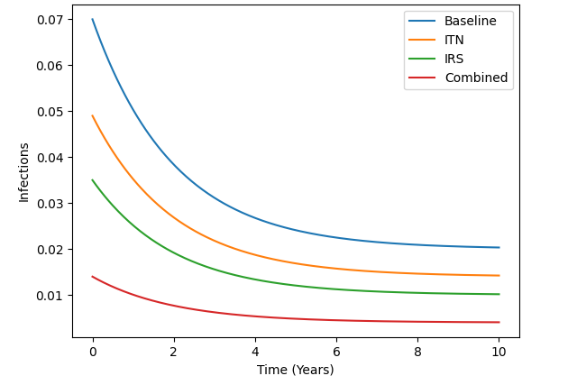
Figure 3: Comparison of infectious population dynamics under individual intervention scenarios.

5.4 Hybrid Model Results
The hybrid SEIR-SEI-ARIMA framework integrates mechanistic simulation with empirical forecasting to provide a more comprehensive assessment of malaria transmission dynamics. Comparison of ARIMA forecasts with SEIR-SEI simulation outputs revealed consistent trends, validating the robustness of the model. The hybrid framework demonstrated improved predictive capability by combining the strengths of both approaches.
Notably, while the ARIMA model alone predicts continued transmission under current conditions, integration with the SEIR-SEI model reveals the potential impact of intervention strategies on future transmission trajectories.
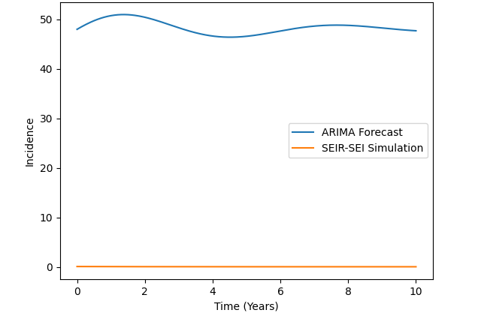
Figure 4: Combined ARIMA forecasts and SEIR-SEI simulation outputs under different intervention scenarios.

5.5 Elimination Prospects
Analysis of elimination scenarios indicates that malaria is unlikely to be eliminated in the FCT under current intervention coverage levels. The persistence of infection is driven by continued human-vector transmission and insufficient reduction in the basic reproduction number.
However, under optimised combined intervention strategies with high coverage and sustained implementation, the reproduction number (R0) can be reduced below unity. Under such conditions, the model predicts a gradual decline in infection prevalence towards zero, indicating the possibility of elimination. These findings suggest that malaria elimination is feasible but contingent on coordinated implementation of multiple interventions at sufficient scale and intensity.
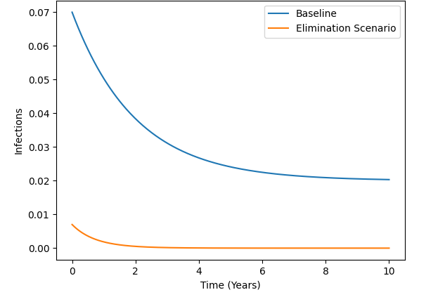
Figure 5: Projected malaria incidence trajectories under baseline and combined intervention scenarios, showing conditions for elimination.

5.6 Sensitivity Analysis
Sensitivity analysis revealed that malaria transmission dynamics are highly influenced by key parameters, particularly:
- Mosquito biting rate
- Transmission probabilities
- Recovery rates
Variations in these parameters resulted in significant changes in infection prevalence and elimination outcomes. In particular, reductions in mosquito biting rate produced substantial decreases in transmission, highlighting the critical role of vector control interventions.
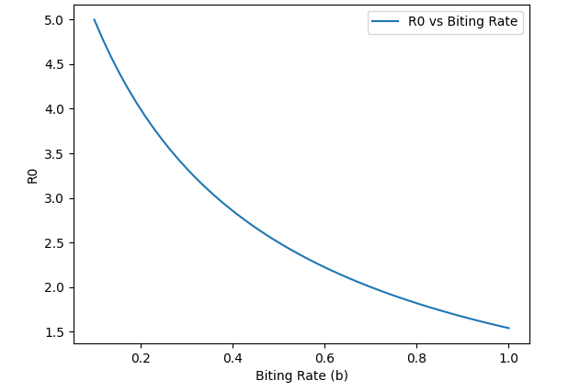
Figure 6: Sensitivity of malaria transmission dynamics to key model parameters.

6. Discussion
This study developed a hybrid SEIR-SEI-ARIMA modelling framework to evaluate malaria intervention packages and assess elimination prospects in the Federal Capital Territory (FCT), Nigeria. By integrating a mechanistic transmission model with a data-driven forecasting approach, the study provides a more comprehensive understanding of malaria dynamics and control compared with the use of either method in isolation. The ARIMA model results indicate that, under current conditions, malaria incidence in the FCT is likely to persist over time, with only marginal reductions observed in projected trends. This finding reflects the limitations of existing intervention coverage and aligns with epidemiological reports showing sustained malaria transmission in Nigeria despite ongoing control efforts. While ARIMA models are effective in capturing temporal patterns and generating short-term forecasts, they do not account for underlying transmission mechanisms or intervention effects, which limits their utility for evaluating long-term control strategies.
In contrast, the SEIR-SEI model provides a mechanistic representation of malaria transmission dynamics, explicitly incorporating human-vector interactions, disease progression, and intervention effects. The baseline simulation results confirm that malaria remains endemic under current conditions, as indicated by a basic reproduction number (R0) greater than unity. This reinforces the understanding that treatment alone, even when effective at reducing disease severity, does not sufficiently interrupt transmission (Bousema et al., 2014).
The intervention scenario analysis highlights important differences in the effectiveness of various control strategies. Vector control interventions, particularly insecticide-treated nets (ITNs) and indoor residual spraying (IRS), demonstrated substantial reductions in transmission by targeting the mosquito population and reducing human exposure to infectious bites. These findings are consistent with previous studies emphasizing the central role of vector control in malaria reduction (Griffin et al., 2010). However, even these interventions were insufficient to achieve elimination when implemented individually, suggesting that their impact is constrained by coverage levels, adherence, and potential vector resistance. Chemoprevention strategies, including seasonal malaria chemoprevention (SMC) and intermittent preventive treatment in pregnancy (IPTp), showed targeted benefits by reducing infection among high-risk populations. While these interventions are essential for protecting vulnerable groups, their limited impact on overall transmission dynamics highlights the need for broader, population-level strategies. Similarly, treatment with artemisinin-based combination therapy (ACT) reduced the duration of infectiousness but did not significantly alter the overall transmission trajectory (White, 2004).
A key contribution of this study lies in the hybrid modelling framework, which combines the strengths of mechanistic and data-driven approaches. The consistency observed between ARIMA forecasts and SEIR-SEI simulation outputs strengthens confidence in the model results and demonstrates the value of integrating multiple modeling perspectives. Importantly, the hybrid framework reveals insights that would not be apparent from either model alone. While ARIMA forecasts suggest continued persistence of malaria, the SEIR-SEI model identifies specific intervention conditions under which transmission can be significantly reduced or eliminated. The analysis of elimination prospects provides critical insights into the challenges of malaria control in the FCT. The results indicate that malaria elimination is unlikely under current intervention coverage levels. However, under optimised combined intervention strategies incorporating vector control, chemoprevention, and effective treatment at high coverage levels, the reproduction number can be reduced below unity, leading to a gradual decline in transmission towards elimination. This finding underscores the importance of integrated intervention packages and sustained implementation.
Sensitivity analysis further emphasises the dominant role of key transmission parameters, particularly mosquito biting rate and transmission probabilities. The high sensitivity of model outcomes to these parameters highlights the importance of vector-targeted interventions and suggests that even modest improvements in vector control coverage and effectiveness can yield substantial reductions in transmission. This has important implications for resource allocation and prioritization in malaria control programmes. From a broader perspective, the persistence of malaria observed in this study reflects systemic challenges rather than the failure of individual interventions. The findings suggest that the primary barrier to elimination is not the absence of effective tools, but rather the suboptimal integration, coverage, and sustained implementation of these tools within the health system. This supports the notion that malaria control strategies must move beyond isolated interventions towards coordinated, multi-layered approaches.
This study contributes to the existing literature by demonstrating the value of hybrid modelling frameworks in infectious disease research. By integrating mechanistic understanding with empirical forecasting, the approach provides a more robust and realistic basis for evaluating intervention strategies and predicting future transmission dynamics. This is particularly relevant in settings like Nigeria, where complex transmission patterns and heterogeneous intervention coverage require more sophisticated analytical tools.
However, several limitations should be acknowledged. The model assumes homogeneous mixing within population groups, which may not fully capture spatial heterogeneity and localised transmission patterns. Additionally, the ARIMA model relies on the quality and completeness of reported malaria incidence data, which may be affected by underreporting, variations in health-seeking behaviour, differences in diagnostic practices, changes in reporting completeness, and temporal changes in healthcare utilisation. Such factors may influence the observed incidence series and, consequently, the temporal patterns and forecasts generated by the ARIMA component. Therefore, projected incidence trends should be interpreted as forecasts of reported malaria incidence rather than direct estimates of the true underlying incidence in the population. Furthermore, the parameter values used in the SEIR-SEI model were derived from literature and may not fully reflect local variations in transmission dynamics. Future studies should incorporate formal data-quality assessments, adjustment for reporting completeness, and, where possible, multiple data sources to improve estimation of the underlying malaria burden. Future research should also consider incorporating spatial structure, seasonality, and more detailed behavioural and environmental factors into the modelling framework. In addition, further refinement of the hybrid approach, including dynamic coupling between mechanistic and statistical models, could enhance predictive accuracy and policy relevance.

Conclusion
This study applied a hybrid SEIR–SEI and ARIMA modelling framework to assess malaria intervention packages and elimination prospects in the Federal Capital Territory, Nigeria. The ARIMA component indicated that reported malaria incidence is likely to persist under current conditions, while the mechanistic simulations showed sustained endemic transmission under baseline assumptions. Individual interventions, including vector control, chemoprevention, and treatment, reduced infection levels but were insufficient to interrupt transmission when considered separately. Combined intervention strategies showed greater potential to reduce transmission and, under optimised coverage assumptions, could lower the basic reproduction number below unity. These findings support coordinated implementation of complementary malaria control measures rather than reliance on isolated interventions. The results should nevertheless be interpreted in relation to the quality of reported incidence data, parameter assumptions, and the extent of local calibration. Overall, the hybrid framework provides a structured basis for combining empirical forecasting with mechanistic transmission analysis to inform malaria control planning and assessment of elimination prospects in the FCT.

Limitation
The model assumes homogeneous mixing within population groups and may therefore not fully represent spatial heterogeneity or localised transmission patterns. The ARIMA component depends on the quality and completeness of reported malaria incidence data, which may be affected by underreporting, diagnostic practices, reporting completeness, and healthcare utilisation. In addition, several SEIR–SEI parameter values were derived from the published literature and may not fully represent local transmission conditions. Consequently, projected incidence trends and elimination prospects should be interpreted with appropriate caution.

Policy Implications
The findings of this study have important implications for malaria control policy in Nigeria and similar endemic settings. The results clearly indicate that reliance on single interventions is insufficient to achieve elimination. Policymakers should prioritise integrated intervention strategies that combine vector control, chemoprevention, and effective treatment. In particular, scaling up ITNs and IRS coverage, improving access to ACT, and ensuring consistent implementation of SMC and IPTp programmes are critical.
Furthermore, the hybrid modelling framework developed in this study provides a valuable tool for evidence-based decision-making. By combining transmission dynamics with real-world data trends, policymakers can better assess the potential impact of intervention strategies and optimise resource allocation. Achieving malaria elimination will require not only increased investment but also improved coordination, monitoring, and adaptive implementation of intervention programmes.

Declaration of AI Use

This manuscript was prepared through the intellectual contributions of the author(s) to the study design, data analysis, interpretation of results, and scholarly content. Grammarly and ChatGPT were used solely to assist with grammatical refinement and reference formatting during manuscript revision. The author(s) accept full responsibility for the accuracy, integrity, and final content of the manuscript.

REFERENCES
Adegbite, G., Edeki, S., Isewon, I., Emmanuel, J., Dokunmu, T., Rotimi, S., Oyelade, J., & Adebiyi, E. (2023). Mathematical modeling of malaria transmission dynamics in humans with mobility and control states. Infectious Disease Modelling, 8(4), 1015–1031. https://doi.org/10.1016/j.idm.2023.08.005
Bousema, T., Okell, L., Felger, I., & Drakeley, C. (2014). Asymptomatic malaria infections: Detectability, transmissibility and public health relevance. Nature Reviews Microbiology, 12(12), 833–840. https://doi.org/10.1038/nrmicro3364
Box, G. E. P., Jenkins, G. M., Reinsel, G. C., & Ljung, G. M. (2015). Time series analysis: Forecasting and control (5th ed.). Wiley. https://www.researchgate.net/publication/280742393_Time_Series_Analysis_Forecasting_and_Control
Chitnis, N., Smith, T., & Steketee, R. (2008). A mathematical model for the dynamics of malaria in mosquitoes feeding on a heterogeneous host population. Journal of Biological Dynamics, 2(3), 259–285. https://doi.org/10.1080/17513750701769857
Diekmann, O., & Heesterbeek, J. A. P. (2000). Mathematical epidemiology of infectious diseases: Model building, analysis and interpretation. Wiley. https://research.wur.nl/en/publications/mathematical-epidemiology-of-infectious-diseases-model-building-a/
Griffin, J. T., Hollingsworth, T. D., Okell, L. C., Churcher, T. S., White, M., Hinsley, W., Bousema, T., Drakeley, C. J., Ferguson, N. M., Basáñez, M.-G., & Ghani, A. C. (2010). Reducing Plasmodium falciparum malaria transmission in Africa: A model-based evaluation of intervention strategies. PLoS Medicine, 7(8), e1000324. https://doi.org/10.1371/journal.pmed.1000324
Hyndman, R. J., & Athanasopoulos, G. (2021). Forecasting: Principles and practice (3rd ed.). OTexts. https://research.monash.edu/en/publications/forecasting-principles-and-practice-3/
Korsah, M. A., Johnston, S. T., Tiedje, K. E., Day, K. P., Flegg, J. A., & Walker, C. R. (2024). Mathematical assessment of the role of intervention programs for malaria control. Bulletin of Mathematical Biology, 86, 91. https://doi.org/10.1007/s11538-024-01321-0
Macdonald, G. (1957). The epidemiology and control of malaria. Oxford University Press. https://blogs.lshtm.ac.uk/library/2017/04/10/collection-of-the-month-for-april-george-macdonald/
National Malaria Elimination Programme. (2020). National malaria strategic plan, 2021–2025. Federal Ministry of Health. https://extranet.who.int/cpcd/sites/default/files/public_file_repository/NGA_Nigeria_National-Strategic-Plan-Malaria_2021-2025.pdf
Opaginni, D. B., & Durojaye, M. O. (2025). Mathematical modelling and analysis of malaria transmission dynamics with early and late treatment interventions. Asian Research Journal of Mathematics, 21(7), 78–98. https://doi.org/10.9734/arjom/2025/v21i7959
Ozodiegwu, I. D., Ambrose, M., Galatas, B., Runge, M., Nandi, A., Okuneye, K., Dhanoa, N. P., Maikore, I., Uhomoibhi, P., Bever, C., Noor, A., & Gerardin, J. (2023). Application of mathematical modelling to inform national malaria intervention planning in Nigeria. Malaria Journal, 22, 137. https://doi.org/10.1186/s12936-023-04563-w
Reich, N. G., Brooks, L. C., Fox, S. J., Kandula, S., McGowan, C. J., Moore, E., Osthus, D., Ray, E. L., Tushar, A., Yamana, T. K., Biggerstaff, M., Johansson, M. A., Rosenfeld, R., & Shaman, J. (2019). A collaborative multiyear, multimodel assessment of seasonal influenza forecasting in the United States. Proceedings of the National Academy of Sciences of the United States of America, 116(8), 3146–3154. https://doi.org/10.1073/pnas.1812594116
Ross, R. (1911). The prevention of malaria (2nd ed.). John Murray. https://calmview.lshtm.ac.uk/CalmView/Record.aspx?id=GB+0809+Ross%2F138%2F04&src=CalmView.Catalog
Shumway, R. H., & Stoffer, D. S. (2017). Time series analysis and its applications: With R examples (4th ed.). Springer. https://doi.org/10.1007/978-3-319-52452-8
Singh, M. P., Rajvanshi, H., Bharti, P. K., Anvikar, A. R., & Lal, A. A. (2024). Time series analysis of malaria cases to assess the impact of various interventions over the last three decades and forecasting malaria in India towards the 2030 elimination goals. Malaria Journal, 23, 50. https://doi.org/10.1186/s12936-024-04872-8
Smith, D. L., McKenzie, F. E., Snow, R. W., & Hay, S. I. (2007). Revisiting the basic reproductive number for malaria and its implications for malaria control. PLoS Biology, 5(3), e42. https://doi.org/10.1371/journal.pbio.0050042
Snow, R. W., Guerra, C. A., Noor, A. M., Myint, H. Y., & Hay, S. I. (2005). The global distribution of clinical episodes of Plasmodium falciparum malaria. Nature, 434(7030), 214–217. https://doi.org/10.1038/nature03342
Taddese, T. A., Gebre Silase, T. M., Tessema, T. M., & Adem, S. D. (2024). Mathematical modelling of malaria transmission dynamics with optimal control strategies in Kebri Dehar District, Somali Regional State, Ethiopia. Asian Journal of Mathematics and Computer Research, 31(1), 1–25. https://doi.org/10.56557/ajomcor/2024/v31i18516
van den Driessche, P., & Watmough, J. (2002). Reproduction numbers and sub-threshold endemic equilibria for compartmental models of disease transmission. Mathematical Biosciences, 180(1–2), 29–48. https://doi.org/10.1016/S0025-5564(02)00108-6
White, N. J. (2004). Antimalarial drug resistance. Journal of Clinical Investigation, 113(8), 1084–1092. https://doi.org/10.1172/JCI21682
World Health Organization. (2015). Global technical strategy for malaria 2016–2030. https://www.who.int/publications/i/item/9789241564991
World Health Organization. (2023). World malaria report 2023. https://www.who.int/publications/i/item/9789240086173

