Case report
Multiple Cutaneous Juvenile Xanthogranuloma in an Infant: A Case Report

Abstract:
Juvenile xanthogranuloma is a benign non-Langerhans cell histiocytosis that predominantly affects infants and young children and usually presents as solitary or multiple yellow-orange cutaneous papules or nodules. This case report describes an 8-month-old infant born at term after an unremarkable pregnancy who presented with two papular lesions in the cephalic region that had evolved over six months. Clinical examination showed two well-defined, firm, rounded papules with smooth surfaces, measuring approximately 1 cm in diameter and exhibiting a characteristic orange colouration. The lesions were located at the hairline and on the cheek. No associated inflammatory signs, ulceration, or discharge were observed, and the infant was in good general condition. The characteristic clinical appearance, lesion distribution, and clinical course supported a primarily clinical diagnosis of multiple cutaneous juvenile xanthogranuloma. In the absence of severe signs or clinical evidence of extracutaneous involvement, no treatment was initiated. Clinical monitoring was recommended, and the benign, self-resolving nature of the condition was explained to the parents. The case demonstrates a multiple-lesion presentation in infancy with a cephalic distribution and conservative management. The report also emphasises the value of correlating lesion morphology with age and anatomical distribution. Recognition of the characteristic cutaneous features may facilitate appropriate clinical assessment, support careful follow-up, and help avoid unnecessary intervention in uncomplicated skin-limited presentations.

Keywords: Juvenile xanthogranuloma, histiocytosis, non-Langerhans cell histiocytosis, cutaneous lesions, paediatric dermatology
Introduction:
Juvenile xanthogranuloma is a heterogeneous non-Langerhans cell histiocytosis, characterised by a proliferation of histiocytic cells. This entity is relatively rare, with an estimated incidence of approximately 1 case per million children. It is the most common form of histiocytosis in paediatric patients (Hernandez-Martin et al., 1997). Cutaneous lesions typically emerge within the first few months of life, usually before the age of one, although they can be congenital. The preferred sites include the head (face and scalp) and neck, with a male predominance. Here, we present the case of an infant diagnosed with juvenile xanthogranuloma.
Contemporary paediatric series indicate that the clinical profile of juvenile xanthogranuloma is broader than a single fixed incidence estimate: the disorder remains uncommon, usually presents in early childhood, and most often involves the head and neck, with solitary cutaneous lesions predominating (Kundak & Çakır, 2021; Wee et al., 2022). A large 30-year clinicopathological series further demonstrated age-related and morphological heterogeneity, including distinct histopathological patterns and occasional extracutaneous disease, supporting the characterisation of juvenile xanthogranuloma as a clinically and pathologically heterogeneous non-Langerhans histiocytic disorder (Salari & Dehner, 2022). These observations underscore the importance of careful clinical recognition in infants presenting with characteristic yellow-orange papules or nodules.
Recent systematic and imaging-focused evidence further reflects the broad clinical spectrum of juvenile xanthogranuloma, including systemic disease and head-and-neck involvement, while maintaining its recognised predominance in childhood (Zou et al., 2023; Chalard et al., 2024).
Recent paediatric dermatology reporting also supports the characteristic yellowish cutaneous appearance of juvenile xanthogranuloma and the role of histopathological confirmation when the diagnosis is uncertain (Palmisano et al., 2025).
A recent paediatric case report has also documented juvenile xanthogranuloma involving the upper eyelid, reinforcing the relevance of recognising cephalic and periocular presentations of this disorder (Pinzón Gonzaléz et al., 2026).
Within the present manuscript, there is value in documenting multiple cutaneous juvenile xanthogranuloma in infancy when lesions are limited to the cephalic region and no clinical evidence of extracutaneous involvement is present. This focused case description addresses the less common multiple-lesion presentation identified within the manuscript while remaining within the benign cutaneous spectrum described for the condition.
Accordingly, the objective of this case report is to describe the clinical presentation and conservative management of multiple cutaneous juvenile xanthogranuloma in an 8-month-old infant with two cephalic lesions and no clinical evidence of extracutaneous involvement.
Case Presentation:
This case involved an 8-month-old infant born at term after an unremarkable pregnancy, with no reported neonatal anomalies. The parents sought consultation because of the appearance of two papular lesions in the cephalic region that had been evolving over the previous six months. On clinical examination, the infant was in good general condition. The dermatological examination revealed two well-defined, firm, rounded papules with smooth surfaces, measuring approximately 1 cm in diameter. The lesions exhibited a characteristic orange colouration, with no associated inflammatory signs, ulceration, or discharge. The lesions were located at the hairline and on the cheek (Figures 1 and 2), a typical distribution for juvenile xanthogranuloma lesions. Given this characteristic clinical appearance, a diagnosis of multiple cutaneous juvenile xanthogranuloma was made. The clinical course, typical lesion morphology, and cephalic localisation supported a primarily clinical diagnosis. In the absence of severe signs or extracutaneous involvement, no treatment was initiated; clinical monitoring was recommended, and the benign, self-resolving nature of the condition was explained to the parents.

Figure 1: Juvenile Xanthogranuloma: An Orange-Colored Scalp Papule
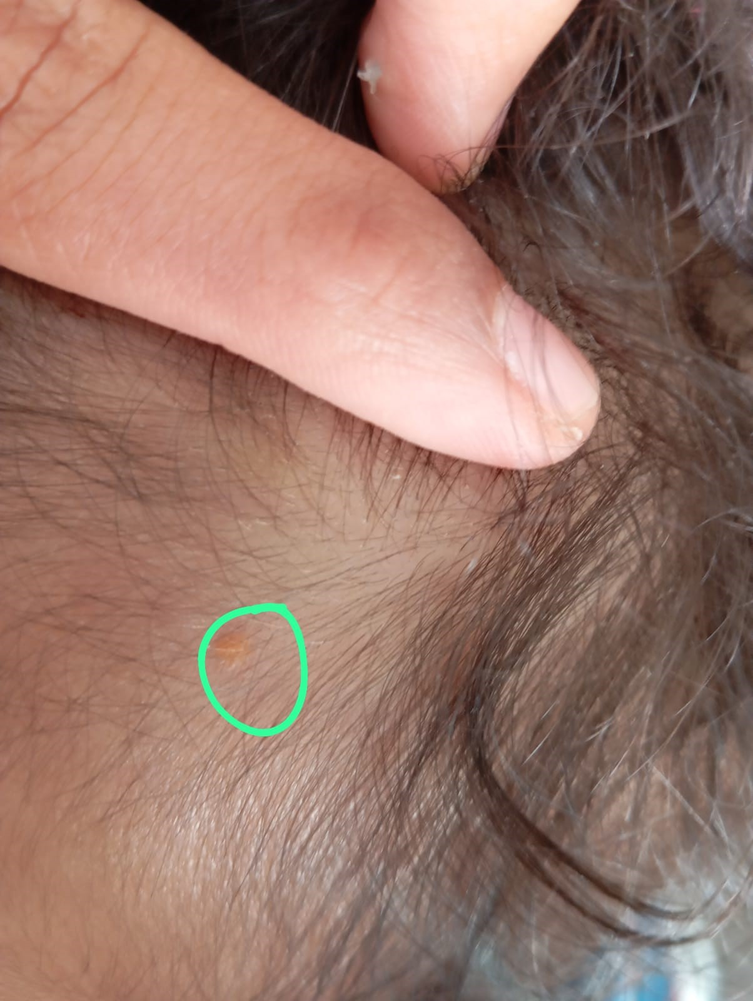
Figure 2: Juvenile Xanthogranuloma: An Orange papulonodule on the Cheek
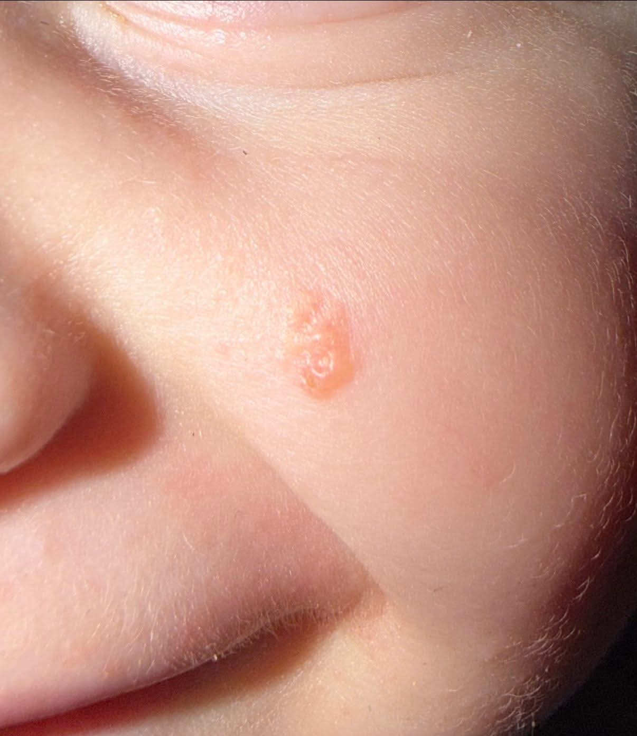

Discussion:
Juvenile xanthogranuloma is the most common non-Langerhans cell histiocytosis in children. It belongs to the group of benign histiocytic proliferations characterised by a dermal accumulation of dendritic cells derived from macrophages (Dehner, 2003). This condition occurs predominantly in infants and young children, with nearly 75% of cases diagnosed before one year of age, although later-onset forms have been described (Janssen & Harms, 2005). Clinically, juvenile xanthogranuloma presents as one or more well-demarcated papular or nodular lesions that are orange to yellow-brown in colour and range in size from a few millimetres to several centimetres. Lesions preferentially involve the head, neck, and upper trunk. Solitary lesions are most frequent, whereas multiple lesions are less common and occur mainly in infants (Janssen & Harms, 2005). The diagnosis of juvenile xanthogranuloma is primarily clinical, particularly in typical presentations. Histologically, there is a dense, well-demarcated dermal or dermo‑hypodermal infiltrate of histiocytes without epidermal involvement (Weitzman & Jaffe, 2005). The histiocytes have foamy cytoplasm and may be accompanied by multinucleated Touton giant cells, especially in more developed lesions. Although cutaneous involvement predominates, extracutaneous localisations have been reported, notably ocular, pulmonary, hepatic, neurological, and osseous sites. Ocular involvement is the most frequent extracutaneous manifestation (Chang et al., 1996). The course of juvenile xanthogranuloma is generally favourable in the majority of cases. Lesions typically regress over several years without specific treatment, sometimes leaving a slight atrophic scar or residual hyperpigmentation (Pires da Silva et al., 2019). Therefore, a conservative (watchful waiting) therapeutic approach is generally recommended for isolated cutaneous forms.
The clinical profile in the present case—infancy, cephalic distribution, and two well-demarcated orange papules—is consistent with contemporary paediatric cohorts. Kundak and Çakır (2021) described juvenile xanthogranuloma predominantly in children, while Wee et al. (2022) reported that 69.4% of 147 paediatric patients presented before two years of age and that the head and neck were the most frequently involved sites. These findings support the clinical plausibility of the diagnosis in an 8-month-old with facial and scalp lesions while indicating that multiple lesions represent a less common, but recognised, presentation.
The histopathological appearance can vary with lesion maturation; lipidisation and Touton giant-cell formation may become more conspicuous as lesions evolve (Kubota et al., 2001). Salari and Dehner (2022) identified early, classic, and transitional histopathological patterns in a large single-centre series, whereas Fraitag and Emile (2022) emphasised integrating morphology with immunophenotype when distinguishing paediatric cutaneous histiocytoses. Accordingly, biopsy is especially useful when morphology is atypical, lesions evolve unexpectedly, or the differential diagnosis remains broad, although a characteristic uncomplicated cutaneous presentation may be managed primarily on clinical grounds.
Although the current infant had no extracutaneous signs, awareness of ocular disease remains clinically important because ocular juvenile xanthogranuloma may be associated with vision-threatening complications that require active ophthalmic management (Samara et al., 2015). At the same time, a more recent cohort of 147 Asian children identified no ophthalmological complications and did not support routine ophthalmological or systemic screening in the absence of clinical indications, even in children with multiple cutaneous lesions (Wee et al., 2022). Taken together, these data support individualised surveillance guided by ocular symptoms, lesion burden, age, and examination findings rather than indiscriminate extensive investigation.
The decision for observation in this case is also concordant with contemporary outcome data. Wee et al. (2022) documented spontaneous resolution in 57.7% of children, with a mean time to resolution of 18.8 months, and Kundak and Çakır (2021) similarly described a generally benign clinical course without extracutaneous involvement in their paediatric cohort. Thus, watchful waiting is reasonable for uncomplicated skin-limited disease, provided that clinical follow-up is maintained to identify unexpected progression or extracutaneous manifestations.

Conclusion:
Juvenile xanthogranuloma is a benign non-Langerhans cell histiocytosis that predominantly affects infants and young children and usually presents as solitary or multiple yellow-orange cutaneous papules or nodules. This case report describes an 8-month-old infant born at term after an unremarkable pregnancy who presented with two papular lesions in the cephalic region that had evolved over six months. Clinical examination showed two well-defined, firm, rounded papules with smooth surfaces, measuring approximately 1 cm in diameter and exhibiting a characteristic orange colouration. The lesions were located at the hairline and on the cheek. No associated inflammatory signs, ulceration, or discharge were observed, and the infant was in good general condition. The characteristic clinical appearance, lesion distribution, and clinical course supported a primarily clinical diagnosis of multiple cutaneous juvenile xanthogranuloma. In the absence of severe signs or clinical evidence of extracutaneous involvement, no treatment was initiated. Clinical monitoring was recommended, and the benign, self-resolving nature of the condition was explained to the parents. The case demonstrates a multiple-lesion presentation in infancy with a cephalic distribution and conservative management. The report also emphasises the value of correlating lesion morphology with age and anatomical distribution. Recognition of the characteristic cutaneous features may facilitate appropriate clinical assessment, support careful follow-up, and help avoid unnecessary intervention in uncomplicated skin-limited presentations.
Limitations
The principal limitation is the inherent scope of a single-patient case report. The observations are descriptive and reflect the clinical presentation and conservative management of one infant with two cutaneous lesions. Accordingly, they should not be generalised to all patients with juvenile xanthogranuloma or used to determine disease frequency, prognosis, or comparative treatment effectiveness.
Consent :
All authors declare that ‘written informed consent was obtained from the patient (or other approved parties) for publication of this case report and accompanying images’.
Declaration of AI Use

This manuscript was prepared through the intellectual contributions of the author(s) to the study design, data analysis, interpretation of results, and scholarly content. Grammarly and ChatGPT were used solely to assist with grammatical refinement and reference formatting during manuscript revision. The author(s) accept full responsibility for the accuracy, integrity, and final content of the manuscript.

References:
Chalard, F., Nguyen, T., Morel, B., Leiber, L.-M., Roux, C.-J., Petit, P., Soto Ares, G., Donadieu, J., & Ducou le Pointe, H. (2024). Juvenile xanthogranuloma of the head and neck: Imaging findings in 11 cases. Journal of Pediatric Hematology/Oncology, 46(6), e368–e380. https://doi.org/10.1097/MPH.0000000000002872
Chang, M. W., Frieden, I. J., & Good, W. V. (1996). The risk of intraocular juvenile xanthogranuloma: Survey of current practices and assessment of risk. Journal of the American Academy of Dermatology, 34(3), 445–449. https://doi.org/10.1016/S0190-9622(96)90437-5
Dehner, L. P. (2003). Juvenile xanthogranulomas in the first two decades of life: A clinicopathologic study of 174 cases with cutaneous and extracutaneous manifestations. The American Journal of Surgical Pathology, 27(5), 579–593. https://doi.org/10.1097/00000478-200305000-00003
Fraitag, S., & Emile, J.-F. (2022). Cutaneous histiocytoses in children. Histopathology, 80(1), 196–215. https://doi.org/10.1111/his.14569
Hernandez-Martin, A., Baselga, E., Drolet, B. A., & Esterly, N. B. (1997). Juvenile xanthogranuloma. Journal of the American Academy of Dermatology, 36(3), 355–367. https://doi.org/10.1016/S0190-9622(97)80207-1
Janssen, D., & Harms, D. (2005). Juvenile xanthogranuloma in childhood and adolescence: A clinicopathologic study of 129 patients from the Kiel Pediatric Tumor Registry. The American Journal of Surgical Pathology, 29(1), 21–28. https://doi.org/10.1097/01.pas.0000147395.01229.06
Kubota, Y., Kiryu, H., Nakayama, J., & Koga, T. (2001). Histopathologic maturation of juvenile xanthogranuloma in a short period. Pediatric Dermatology, 18(2), 127–130. https://doi.org/10.1046/j.1525-1470.2001.018002127.x
Kundak, S., & Çakır, Y. (2021). Juvenile xanthogranuloma: Retrospective analysis of 44 pediatric cases (single tertiary care center experience). International Journal of Dermatology, 60(5), 564–569. https://doi.org/10.1111/ijd.15223
Palmisano, G., Cappilli, S., Bocchino, E., Di Stefani, A., & Peris, K. (2025). Skin imaging of juvenile xanthogranuloma: In vivo diagnosis by line-field confocal optical coherence tomography. Pediatric Dermatology, 42(2), 417–419. https://doi.org/10.1111/pde.15786
Pinzón Gonzaléz, M. A., Jiménez, B., Endara, M., & Vivas, S. (2026). Juvenile xanthogranuloma on the eyelid: A case report. Asian Journal of Medical Research and Case Reports, 8(1), 1–6. https://doi.org/10.56557/ajmrcr/2026/v8i152
Pires da Silva, S., Viveiros, C., Almeida, R., Almeida Pereira, M., Vaz, R., & Portela, A. (2019). Juvenile xanthogranuloma: A case report. Revista Paulista de Pediatria, 37(2), 257–260. https://doi.org/10.1590/1984-0462/;2019;37;2;00013
Salari, B., & Dehner, L. P. (2022). Juvenile and adult xanthogranuloma: A 30-year single-center experience and review of the disorder and its relationship to other histiocytoses. Annals of Diagnostic Pathology, 58, 151940. https://doi.org/10.1016/j.anndiagpath.2022.151940
Samara, W. A., Khoo, C. T. L., Say, E. A. T., Saktanasate, J., Eagle, R. C., Jr., Shields, J. A., & Shields, C. L. (2015). Juvenile xanthogranuloma involving the eye and ocular adnexa: Tumor control, visual outcomes, and globe salvage in 30 patients. Ophthalmology, 122(10), 2130–2138. https://doi.org/10.1016/j.ophtha.2015.06.009
Wee, L. W. Y., Ling, H. Y., Ho, V. P. Y., Foong, A. Y. W., & Koh, M. J. A. (2022). Juvenile xanthogranulomas in Asian children. Dermatologic Therapy, 35(2), e15224. https://doi.org/10.1111/dth.15224
Weitzman, S., & Jaffe, R. (2005). Uncommon histiocytic disorders: The non-Langerhans cell histiocytoses. Pediatric Blood & Cancer, 45(3), 256–264. https://doi.org/10.1002/pbc.20246
Zou, T., Wei, A., Ma, H., Lian, H., Liu, Y., Wang, D., Zhao, Y., Cui, L., Li, Z., Zhang, R., & Wang, T. (2023). Systemic juvenile xanthogranuloma: A systematic review. Pediatric Blood & Cancer, 70(5), e30232. https://doi.org/10.1002/pbc.30232

