Case report

Multiple Trichoadenomas of the Legs: Clinical and Dermoscopic Case Report

Abstract
Trichoadenoma is an uncommon benign adnexal tumour of follicular origin that usually presents as a solitary, slow-growing nodule, most frequently on the face. Multiple lesions and involvement of the lower limbs are unusual and may complicate clinical recognition because the external appearance is nonspecific. This case report describes a 42-year-old patient with no significant medical history who presented with multiple asymptomatic yellowish papulocystic lesions on both legs that had evolved progressively over one year. The lesions were bilateral and located on the extensor surfaces of the legs. Dermoscopic examination demonstrated small, grouped, rounded, poorly demarcated yellowish areas with a flaky appearance, together with a few serpiginous vessels. Histopathological examination confirmed trichoadenoma, showing an adnexal tumour composed of multiple keratin-filled cystic structures containing lamellar keratin, with a focal foreign-body-type reaction. The cysts were lined by regular epidermal epithelium, while the surrounding connective tissue showed fibroinflammatory changes. The bilateral multiplicity and lower-leg distribution represent an unusual clinical presentation. Dermoscopy provided supportive morphological information, but the observed structures are not specific and may overlap with other adnexal tumours and basal cell carcinoma mimickers. This case therefore emphasises the value of clinical, dermoscopic, and histopathological correlation while confirming that histopathological examination remains essential for accurate diagnosis.
Keywords: Trichoadenoma; cutaneous adnexal tumour; follicular tumour; papulocystic lesions; bilateral leg lesions, infundibulocystic structures; lamellar keratin

Introduction
Trichoadenoma is a very rare cutaneous adnexal tumour of follicular origin. It can occur at any age, regardless of sex (Lee et al., 2008). It typically presents as a solitary, slow-growing, skin-coloured or yellowish nodule. The most common sites of involvement are the face and buttocks, although unusual locations have also been reported, including the neck, extremities, shoulder, and trunk. The diagnosis of trichoadenoma is primarily based on histopathological examination, which reveals multiple variably sized, intradermal cystic structures filled with lamellar keratin (Krishna Swaroop et al., 2008).
Clinicopathological and immunohistochemical studies place trichoadenoma within the spectrum of benign follicular neoplasms and support differentiation towards the follicular infundibulum and bulge region (Kurokawa et al., 2005; Shimanovich et al., 2010).
Because most reported lesions are solitary and clinically nonspecific, unusual morphologies or anatomical sites may be difficult to recognise without histopathological confirmation; reports from uncommon sites, including the vulva, further illustrate this phenotypic variability (Mahajan et al., 2015; Rahbari et al., 1977; Sangwaiya et al., 2017).
Recent reports of follicular adnexal tumours continue to emphasise the potential for clinical overlap with malignant mimickers and the importance of histological confirmation, including in desmoplastic trichoepithelioma (Er-rachdy et al., 2025). Furthermore, a recent clinico-dermoscopic and histopathological study that included trichoadenoma found dermoscopy useful as an adjunct, while histopathology remained the benchmark for diagnosis (Reyaz et al., 2025). Contemporary dermoscopy reviews also recognise trichoadenoma among basal cell carcinoma mimickers, supporting cautious interpretation of overlapping dermoscopic structures (Wojtowicz & Żychowska, 2025). Despite these descriptions, the literature summarised in this manuscript predominantly concerns solitary lesions or uncommon single-site presentations, leaving the clinical context of multiple bilateral lesions of the legs poorly represented. The present case therefore addresses this descriptive gap by correlating the clinical, dermoscopic, and histopathological findings of an unusual multiple lower-limb presentation. We report a rare case of multiple trichoadenomas involving the legs.

Case Presentation
A 42-year-old patient with no significant medical history presented with asymptomatic lesions localised on the legs that had developed progressively over one year. Clinical examination revealed multiple yellowish papulovesicles arising on an erythematous, non-pruritic background (Figures 1 and 2). The lesions were bilateral and located on the extensor surfaces of the legs.
Dermoscopic examination revealed small, grouped, rounded, poorly demarcated yellowish areas with a flaky appearance, along with a few serpiginous vessels (Figure 3).
Histopathological examination confirmed the diagnosis, revealing an adnexal tumour composed of multiple keratin-filled cystic structures containing lamellar keratin, with a focal foreign-body-type reaction. A regular epidermal epithelium lined the cysts. The surrounding connective tissue showed fibroinflammatory changes (Figure 4).

Discussion
Trichoadenoma is a rare cutaneous tumour that has been poorly described in the literature. It primarily affects the face, although other anatomical sites may be involved less frequently. Clinically, it usually presents as a solitary, asymptomatic nodule measuring up to 15 mm. Papular variants and multiple cystic lesions involving the buttocks have also been reported (Yamaguchi & Takino, 1992). Dermoscopic features have rarely been described and may closely resemble those of desmoplastic trichoepithelioma (Huet et al., 2020). Dermoscopy typically reveals small, rounded, white-to-yellowish structures surrounded by fine, irregular linear vessels (Huet et al., 2020). These white structures correspond to infundibular cysts observed on histopathological examination (Mir-Bonafé et al., 2021).
The bilateral multiplicity and lower-leg distribution in the present case differ from the predominantly solitary lesions described in classic and more recent reports, while remaining consistent with the broader clinical variability recognised for trichoadenoma (Mahajan et al., 2015; Rahbari et al., 1977; Sangwaiya et al., 2017).
Available dermoscopic reports indicate that white or yellowish structures and shiny white lines or circles can reflect the underlying infundibulocystic architecture; however, overlap with basal cell carcinoma and desmoplastic trichoepithelioma limits specificity, so dermoscopy is best considered an adjunct to histopathology (Pampena et al., 2019; Shimanovich et al., 2010).
The clinical features of trichoadenoma are nonspecific, and the diagnosis is primarily histopathological. Histopathological examination typically reveals numerous round-to-oval infundibulocystic structures containing eosinophilic lamellar keratin and lined by stratified epithelium, located within the superficial and mid dermis (Reibold et al., 1998). In addition, surrounding solid cellular complexes, predominantly round and well-circumscribed, are observed. These are mainly composed of squamous cells and may show focal foreign-body reactions secondary to keratin extravasation.
The present histopathological findings are concordant with prior descriptions of keratin-filled infundibulocystic structures and with immunohistochemical evidence supporting follicular infundibular/bulge differentiation (Kurokawa et al., 2005; Rahbari et al., 1977; Shimanovich et al., 2010).
Accordingly, the combination of nonspecific clinical morphology, overlapping dermoscopic features, and characteristic histopathology supports a clinicopathological approach to diagnosis rather than reliance on clinical or dermoscopic appearance alone (Pampena et al., 2019; Shimanovich et al., 2010).

Conclusion
This case demonstrates an unusual presentation of trichoadenoma as multiple bilateral papulocystic lesions involving the extensor surfaces of both legs. The distribution and multiplicity differ from the more typical solitary presentation and may make clinical recognition difficult because the lesions are nonspecific in appearance. Dermoscopy showed grouped, poorly demarcated yellowish areas with a flaky surface and a few serpiginous vessels, providing useful supportive features but not a definitive diagnosis. Histopathological examination established the diagnosis by demonstrating multiple keratin-filled cystic structures containing lamellar keratin, with a focal foreign-body-type reaction and surrounding fibroinflammatory change. These findings support the importance of integrating clinical, dermoscopic, and histopathological assessment when evaluating uncommon adnexal lesions. In particular, histopathology remains necessary to distinguish trichoadenoma from other follicular or adnexal tumours with overlapping clinical and dermoscopic characteristics. The present case documents a rare multiple lower-limb presentation while supporting appropriately cautious interpretation of the findings from a single patient.
Limitations
This report is limited by its description of a single patient, which restricts the extent to which the observed clinical and dermoscopic features can be generalised. The unusual bilateral, multiple lower-leg presentation should therefore be interpreted as a descriptive observation rather than a typical pattern of trichoadenoma. Dermoscopic findings were supportive but nonspecific, and histopathological examination remained necessary for definitive diagnosis.

Declaration of AI Use

This manuscript was prepared through the intellectual contributions of the author(s) to the study design, data analysis, interpretation of results, and scholarly content. Grammarly and ChatGPT were used solely to assist with grammatical refinement and reference formatting during manuscript revision. The author(s) accept full responsibility for the accuracy, integrity, and final content of the manuscript.

Conflicts of interest
The authors declare that they have no conflicts of interest.

References
Er-rachdy, N., Essadeq, O., Aaboudech, T., Znati, K., Benzekri, L., & Meziane, M. (2025). Desmoplastic trichoepithelioma: A case report with familial context. Asian Journal of Research in Dermatological Science, 8(1), 124–128. https://doi.org/10.9734/ajrdes/2025/v8i1135
Huet, P., Jegou, M.-H., Bourlond, F., Dupin, C., & Cribier, B. (2020). Trichoadénome: Description anatomoclinique et dermatoscopique. Annales de Dermatologie et de Vénéréologie, 147(5), 334–339. https://doi.org/10.1016/j.annder.2020.01.014
Krishna Swaroop, D. S., Ramakrishna, B. A., Bai, S. J., & Shanthi, V. (2008). Trichoadenoma of Nikolowski. Indian Journal of Pathology and Microbiology, 51(2), 277–279. https://doi.org/10.4103/0377-4929.41695
Kurokawa, I., Mizutani, H., Nishijima, S., Kato, N., Yasui, K., & Tsubura, A. (2005). Trichoadenoma: Cytokeratin expression suggesting differentiation towards the follicular infundibulum and follicular bulge regions. British Journal of Dermatology, 153(5), 1084–1086. https://doi.org/10.1111/j.1365-2133.2005.06929.x
Lee, J. H., Kim, Y. Y., Yoon, S. Y., Lee, J. D., & Cho, S. H. (2008). Unusual presentation of trichoadenoma in an infant. Acta Dermato-Venereologica, 88(3), 291–292. https://doi.org/10.2340/00015555-0408
Mahajan, S. R., Shah, C. A., Shah, M. M., & Bilimoria, E. F. (2015). A rare case of trichoadenoma over the vulva. Indian Journal of Sexually Transmitted Diseases and AIDS, 36(1), 83–85. https://doi.org/10.4103/0253-7184.156741
Mir-Bonafé, J. F., Mir-Bonafé, M., Mir-Bonafé, J. M., Rozas-Muñoz, E., Piquero-Casals, J., & Terrasa-Sagristà, F. (2021). Trichoadenoma: Dermoscopic clues of a rare adnexal tumour. Australasian Journal of Dermatology, 62(1), 75–77. https://doi.org/10.1111/ajd.13394
Pampena, R., Borsari, S., Piana, S., & Longo, C. (2019). Broadening the list of basal cell carcinoma mimickers: Dermoscopic features of trichoadenoma. Dermatology Practical & Conceptual, 9(2), 160–161. https://doi.org/10.5826/dpc.0902a17
Rahbari, H., Mehregan, A. H., & Pinkus, H. (1977). Trichoadenoma of Nikolowski. Journal of Cutaneous Pathology, 4(2), 90–98. https://doi.org/10.1111/j.1600-0560.1977.tb00893.x
Reibold, R., Undeutsch, W., & Fleiner, J. (1998). Das Trichoadenom (Nikolowski): Übersicht von vier Jahrzehnten und sieben eigene Fälle. Der Hautarzt, 49(12), 925–928. https://doi.org/10.1007/s001050050849
Reyaz, S., Rather, S., Bilal, S., Trumboo, T., & Hussain, M. (2025). Clinico-dermoscopic and histopathological evaluation of benign skin, soft tissue and appendageal tumours of skin: A cross-sectional study from a tertiary care hospital. Indian Journal of Dermatology, 70(1), 50. https://doi.org/10.4103/ijd.ijd_461_24
Sangwaiya, A., Bairwa, S., Kalhan, S., Sharma, P., & Satarkar, R. N. (2017). Trichoadenoma of Nikolowski—A rare tumour with unusual presentation over vulva. Journal of Clinical and Diagnostic Research, 11(1), ED05–ED06. https://doi.org/10.7860/JCDR/2017/24237.9188
Shimanovich, I., Krahl, D., & Rose, C. (2010). Trichoadenoma of Nikolowski is a distinct neoplasm within the spectrum of follicular tumors. Journal of the American Academy of Dermatology, 62(2), 277–283. https://doi.org/10.1016/j.jaad.2009.06.086
Wojtowicz, I., & Żychowska, M. (2025). Dermoscopy of basal cell carcinoma part 3: Differential diagnosis, treatment monitoring and novel technologies. Cancers, 17(6), 1025. https://doi.org/10.3390/cancers17061025
Yamaguchi, J., & Takino, C. (1992). A case of trichoadenoma arising in the buttock. The Journal of Dermatology, 19(8), 503–506. https://doi.org/10.1111/j.1346-8138.1992.tb03270.x

Figure 1 : Trichoadenoma: Multiple Bilateral Whitish Papulocystic Lesions on the Legs
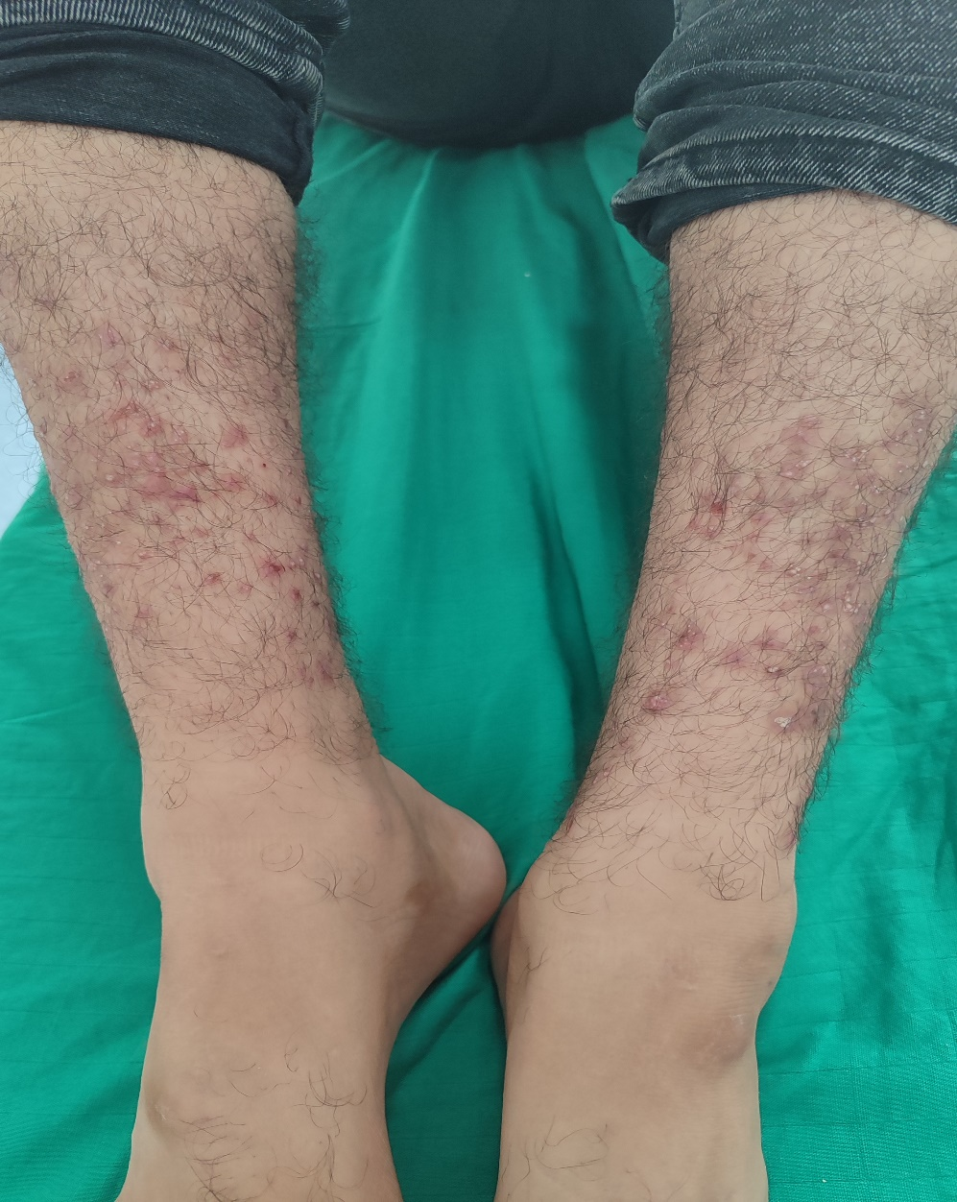

Figure 2 : Trichoadenoma: Multiple Bilateral Whitish Papulocystic Lesions on the Legs
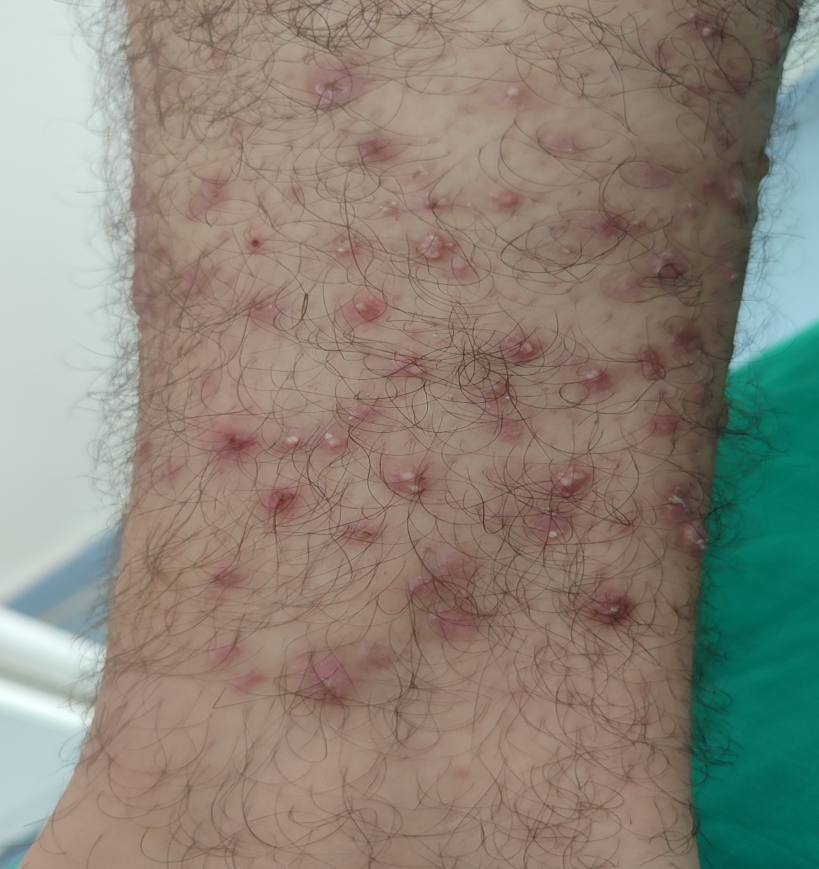

Figure 3 : Dermoscopy: small, grouped, poorly demarcated yellowish areas with a flaky appearance, along with a few serpiginous vessels.
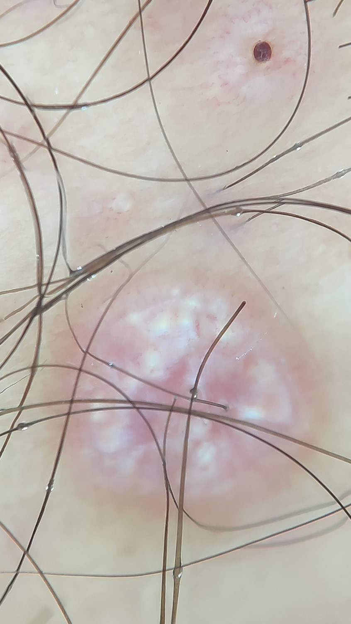

Figure 4 : Histopathology: Multiple keratin-filled cystic structures containing lamellar keratin.
