Original Research Article

Synergistic Amelioration of Endocrine Dysregulation by Vernonia amygdalina and Tamarindus indica in Letrozole and Diet-induced Polyendocrine Metabolic Ovarian Syndrome in Rats
Abstract
Background: Polyendocrine metabolic ovarian syndrome (PMOS) is characterised by endocrine and reproductive disturbances involving the hypothalamic–pituitary–ovarian axis.
Aim: The present study aimed to evaluate the synergistic effects of Vernonia amygdalina water extract (VAWE) and Tamarindus indica methanol extract (TIME) on HPO axis hormonal parameters in a letrozole and high-fat high-fructose (HF-HFr) diet-induced PMOS rat model.
Study Design: This research was an experimental, randomised, controlled in vivo study.
Place and Duration of Study: Department of Biochemistry, Lead City University, Ibadan, Nigeria, between October 2024 and August 2025.
Methods: PMOS was induced via letrozole (1 mg/kg) and HF-HFr diet for 21 days. Forty-eight (48) female Wistar rats were randomly assigned to eight groups (n=6): normal control, PMOS untreated, positive control (metformin 10 mg/kg + clomiphene citrate 1 mg/kg), VAWE monotherapy (200 mg/kg), TIME monotherapy (400 mg/kg), low-dose combination (VAWE 100 mg/kg + TIME 200 mg/kg), high-dose combination (VAWE 200 mg/kg + TIME 400 mg/kg), and mid-dose combination (VAWE 200 mg/kg + TIME 200 mg/kg). All treatments were administered orally for 21 days. Serum hormones were quantified by ELISA. Estrous cyclicity was monitored by daily vaginal smear cytology.
Results: Induction of PMOS resulted in significant hormonal imbalance characterised by elevated testosterone (0.3495 ± 0.0412 vs control 0.2310 ± 0.0189), luteinising hormone (LH: 0.1118 ± 0.005 vs control 0.06275 ± 0.001), and LH/FSH ratio (0.6900 ± 0.04761 vs control 0.2025 ± 0.1025), alongside marked reductions in progesterone (0.04775 ± 0.00275 vs control 0.3688 ± 0.08625) and sex hormone-binding globulin (SHBG: 291.1 ± 72.70 vs control 3604 ± 228.6). Treatment with VAWE 200 mg/kg effectively attenuated testosterone (0.2510 ± 0.01715), suppressed LH (0.06750 ± 0.003), and restored progesterone levels (0.2880 ± 0.03291). Single administration of TIME 400 mg/kg normalised testosterone levels (0.2215 ± 0.03794), restored SHBG (4045 ± 111.2) and improved the LH/FSH ratio (0.3450 ± 0.1025). Polyherbal combinations demonstrated dose-dependent modulation, with the low-dose combination (VAWE 100 mg/kg + TIME 200 mg/kg) showing superior restoration of progesterone (0.2428 ± 0.04125) and LH/FSH balance (0.4625 ± 0.03577) while the mid-dose (200 + 200 mg/kg) combination produced the greatest reduction in serum testosterone (0.1890 ± 0.01273).
Conclusions: These findings provide pharmacological justification for the combined ethnomedicinal use of Vernonia amygdalina and Tamarindus indica in reproductive health and warrant further mechanistic and clinical investigation.
Keywords: Polyendocrine metabolic ovarian syndrome, Hypothalamic-pituitary-ovarian axis, Letrozole-induced PMOS, Vernonia amygdalina, Tamarindus indica
Introduction
Polyendocrine metabolic ovarian syndrome (PMOS) is one of the most prevalent endocrine disorders affecting women of reproductive age, with an estimated global prevalence of 6–21% depending on diagnostic criteria applied (Meng et al., 2025). Characterised by hyperandrogenism, chronic anovulation, and polycystic ovarian morphology, PMOS is associated with significant reproductive, metabolic, and psychological morbidity (Liao et al., 2021; Huddleston et al., 2024). Diagnosis of PMOS is established using the Rotterdam criteria, which require the presence of at least two of three features: oligo-ovulation or anovulation, clinical or biochemical hyperandrogenism, and polycystic ovarian morphology on ultrasound (The Rotterdam ESHRE/ASRM-sponsored PCOS Consensus Workshop Group, 2004). The burden of PMOS is particularly significant in sub-Saharan Africa, where limited access to specialist reproductive healthcare and pharmacological treatments amplifies its impact on affected women (Salari et al., 2024).
Recent international guidance and contemporary synthesis likewise frame PCOS as a heterogeneous disorder requiring attention to both reproductive and metabolic features, which is consistent with the multidimensional burden described above (Teede et al., 2023; Stener-Victorin et al., 2024).
The pathophysiology of PMOS is characterised by increased gonadotropin releasing hormone (GnRH) pulse frequency, which selectively drives luteinising hormone (LH) hypersecretion while suppressing follicle-stimulating hormone (FSH), impairing follicular recruitment and perpetuating androgen excess (Liao et al., 2021; Szeliga et al., 2022; Su et al., 2025). Elevated testosterone and reduced sex hormone-binding globulin (SHBG) further amplify androgenic burden, contributing to anovulation and infertility (Kanbour & Dobs, 2022; Xing et al., 2022). This hormonal cascade collectively disrupts folliculogenesis, impairs corpus luteum function, and perpetuates the chronic anovulatory state that underlies PMOS-associated infertility (Cunha & Póvoa, 2021).
Recent evidence further emphasises that insulin resistance and hyperandrogenism are closely interrelated with reproductive dysfunction in PCOS, reinforcing the biological rationale for approaches that address both metabolic and endocrine disturbances (Helvaci & Yildiz, 2025).
Current pharmacological management including metformin and clomiphene citrate, targets individual aspects of this dysregulation but is associated with significant side effects, limited efficacy in resistant cases, and restricted accessibility in resource-limited settings (Malik et al., 2023). These limitations underscore the need for multi-target therapeutic alternatives that address the complexity of HPO axis dysregulation in PMOS.
Medicinal plants represent a rich and largely underexplored reservoir of multi-target bioactive compounds with potential for addressing the complex hormonal dysregulation of PMOS (Brahmi et al., 2025; Rafiu et al., 2025). Vernonia amygdalina, commonly known as bitter leaf, is widely used in sub-Saharan African traditional medicine for metabolic and reproductive disorders (Oseghale et al., 2024; Ugbogu et al., 2021). Beyond ethnomedicinal use, Vernonia amygdalina extract has shown direct pharmacological activity in a letrozole/high-fat-diet PCOS model, reducing serum insulin and luteinising hormone while increasing follicle-stimulating hormone and progesterone, alongside reductions in IL-6, CRP, and TNF-alpha (Adebodun et al., 2022). Its principal bioactive constituents including sesquiterpene lactones, flavonoids, and saponins, are consistent with these insulin-sensitising and anti-inflammatory effects (Ali et al., 2020; Edo et al., 2023; Degu et al., 2024).
Recent review and experimental literature continues to evaluate plant-derived interventions for PCOS because of their potential to influence multiple endocrine and metabolic pathways, while also indicating that findings should be interpreted cautiously across different preparations and experimental models (Masih & Paul, 2026; Shaheen et al., 2024).
Tamarindus indica has established antidiabetic and hypolipidemic activity, with seed extracts preventing fructose-diet-induced hyperinsulinaemia and the associated fall in Dehydroepiandrosterone Sulfate (DHEAS) in rat models (Shahraki et al., 2011), and tamarind-derived compounds shown to modulate Leydig cell testosterone synthesis (Cloutier et al., 2020) and suppress inflammatory mediators in rodent models (Sundaram et al., 2015). Its principal phytochemicals such as tartaric acid, phenolic acids, flavonoids, and procyanidins support a plausible mechanistic basis for metabolic and endocrine modulation (Ebabhi et al., 2025; Mohamed et al., 2025)
While Vernonia amygdalina and Tamarindus indica have each shown activity on individual hormonal and metabolic parameters relevant to PCOS, their combined effects on HPO axis dysregulation have not been investigated. Given their complementary phytochemical profiles and convergent activity on insulin sensitivity, androgen regulation, and inflammation, which are three interlinked drivers of HPO axis dysfunction in PCOS, combination therapy may achieve multi-target modulation exceeding either monotherapy.
Objective: The present study aimed to evaluate the combined effects of Vernonia amygdalina water extract (VAWE) and Tamarindus indica methanol extract (TIME) on HPO axis hormonal parameters and estrous cyclicity in a letrozole and high-fat high-fructose diet-induced PMOS rat model.
2. Material and Methods
2.1 Plant Material and Extract Preparation
The fruit of Tamarindus indica was collected from the Adeoyo area in Saki, Oyo State, Nigeria, while fresh leaves of Vernonia amygdalina were obtained from the Gowojo area, also in Saki, Oyo State. Both plant materials were authenticated at the Forest Herbarium Unit of the Forestry Research Institute of Nigeria (FRIN), Ibadan, and voucher specimens were deposited. The assigned voucher numbers were FIH/1142128 for Tamarindus indica and FIH/1142121 for Vernonia amygdalina.
The Vernonia amygdalina leaves were washed to remove dirt, shade-dried for two weeks, and ground into fine powder using a mechanical grinder. The Tamarindus indica fruit pulp was manually separated from the seeds and fibrous strands, thoroughly rinsed with clean water, and air-dried at room temperature for one week. The dried pulp was then pulverised using a blender. 150 g of each powdered material was soaked in 1000 ml of distilled water and methanol respectively. The mixture was left to stand for 72 hours with intermittent stirring to enhance solute-solvent interaction. Thereafter, the mixture was sieved using muslin cloth followed by filtration with Whatman No. 1 filter paper. The resulting filtrate was concentrated using a rotary evaporator at 40–45°C under reduced pressure and final solvent elimination was done using a regulated water bath. The concentrated extract was stored in airtight containers at 4°C until use.
2.2 Experimental Animals
Healthy female Wistar rats, aged 8–10 weeks and weighing between 120–150 g, were procured from a reliable animal breeder in Ogbomosho, Oyo State, Nigeria. Animals were housed in groups of six per cage in standard plastic cages with wood shaving bedding. The animals were acclimatised for 14 days under standard laboratory conditions: a 12-hour light/dark cycle, room temperature of 22–25°C, and ad libitum access to water and standard pellet diet.
2.3 PMOS Induction
Letrozole was administered orally at a dose of 1 mg/kg body weight once daily for 21 consecutive days (Kafali et al., 2004). The drug was suspended in 0.5% carboxymethylcellulose (CMC) to ensure uniform dispersion and ease of administration via oral gavage. The control group received 0.5% CMC orally without letrozole or dietary modification, to account for any effect of the vehicle. The HF-HFr diet was formulated by the authors based on established macronutrient ratios known to induce metabolic dysfunction in rodents. The diet consisted of 50% standard rat pellets, 30% lard as the fat source, and 20% fructose powder as the simple sugar source. This composition was designed to simultaneously induce insulin resistance and hyperandrogenaemia consistent with the metabolic phenotype of PMOS. The HF-HFr was administered ad libitum for the duration of the induction phase, typically lasting 21 days. Letrozole administration and HF-HFr diet were initiated concurrently on Day 1 of the induction phase and continued simultaneously for 21 days. The induction period lasted for three weeks, during which vaginal smear monitoring was conducted daily to track disruptions in the estrous cycle. Successful PMOS induction was confirmed by the presence of persistent diestrus on vaginal smear examination by Day 21 of induction. Only animals confirmed to be in persistent diestrus were included in the treatment phase.
2.4 Experimental Design and Treatment
A total of forty-eight Wistar rats were included in this study and were randomly assigned to eight groups, each consisting of six animals. Following the 21-day induction period, treatment was administered orally via gavage twice daily for 21 days as described below. Group 1 served as the normal control and received 0.5% carboxymethylcellulose (CMC) vehicle only, without induction or treatment, throughout the experimental period. Group 2 served as the untreated PMOS group and received letrozole (1 mg/kg) combined with the HF-HFr diet for 21 days but received no therapeutic intervention thereafter. Group 3 served as the positive control and received letrozole and HF-HFr diet for 21 days, followed by concurrent administration of metformin (10 mg/kg) and clomiphene citrate (1 mg/kg) for 21 days. Group 4 received letrozole and HF-HFr diet for 21 days, followed by Vernonia amygdalina water extract (VAWE) at 200 mg/kg for 21 days. Group 5 received letrozole and HF-HFr diet for 21 days, followed by Tamarindus indica methanol extract (TIME) at 400 mg/kg for 21 days. Group 6 received letrozole and HF-HFr diet for 21 days, followed by a low-dose combination of VAWE (100 mg/kg) and TIME (200 mg/kg) for 21 days. Group 7 received letrozole and HF-HFr diet for 21 days, followed by a high-dose combination of VAWE (200 mg/kg) and TIME (400 mg/kg) for 21 days. Group 8 received letrozole and HF-HFr diet for 21 days, followed by a mid-dose combination of VAWE (200 mg/kg) and TIME (200 mg/kg) for 21 days.
2.5. Sample Collection
At the end of the treatment period, animals were anaesthetised, and blood samples were collected via cardiac puncture into plain (non-heparinised) tubes. The blood was allowed to clot at room temperature for about 30 minutes and then centrifuged at 3,000 rpm for 10 minutes at 4°C. The clear serum obtained was carefully transferred into clean Eppendorf tubes and stored at −20°C until biochemical analysis.
2.6. Hormonal Assays
Oestrogen, progesterone, prolactin, luteinising hormone (LH), follicle-stimulating hormone (FSH), testosterone, and sex hormone-binding globulin were quantified using enzyme-linked immunosorbent assay (ELISA). Serum hormone concentrations were quantified using commercially available kits from Calbiotech (Calbiotech, Spring Valley, CA, USA). All assays were performed in accordance with the manufacturer's instructions. The LH/FSH ratio was calculated by dividing the mean serum LH concentration by the mean serum FSH concentration for each group.
2.7 Vaginal Smear Cytology
Daily vaginal smears were taken during the induction and treatment phases using standard procedures. Using a sterile pipette, a small volume of normal saline (0.9% NaCl) was gently flushed into the vaginal canal of each rat and then aspirated. The fluid was transferred onto a clean microscope slide and stained with Giemsa to improve cell visibility. The slides were examined under a light microscope at ×10 magnification. The stages of the estrous cycle (Proestrus, estrus, metestrus, and diestrus) were identified based on the predominant cell types observed (Figure 1). To determine these stages of the estrous cycle, the method by Long and Evans (1922) was adopted. The proestrus stage consists predominantly of nucleated epithelial cells with a small number of leukocytes. The estrus stage of the estrous cycle comprises cornified epithelial cells. The metestrus stage comprises leukocytes, cornified epithelial cells, and nucleated cornified cells, while the diestrus stage consists mostly of leukocytes with more mucus. Estrous cycle stage data were recorded daily for each animal and compiled into a colour-coded chart in which each phase was represented by a distinct colour, providing a visual map of estrous cycle progression across the treatment period.
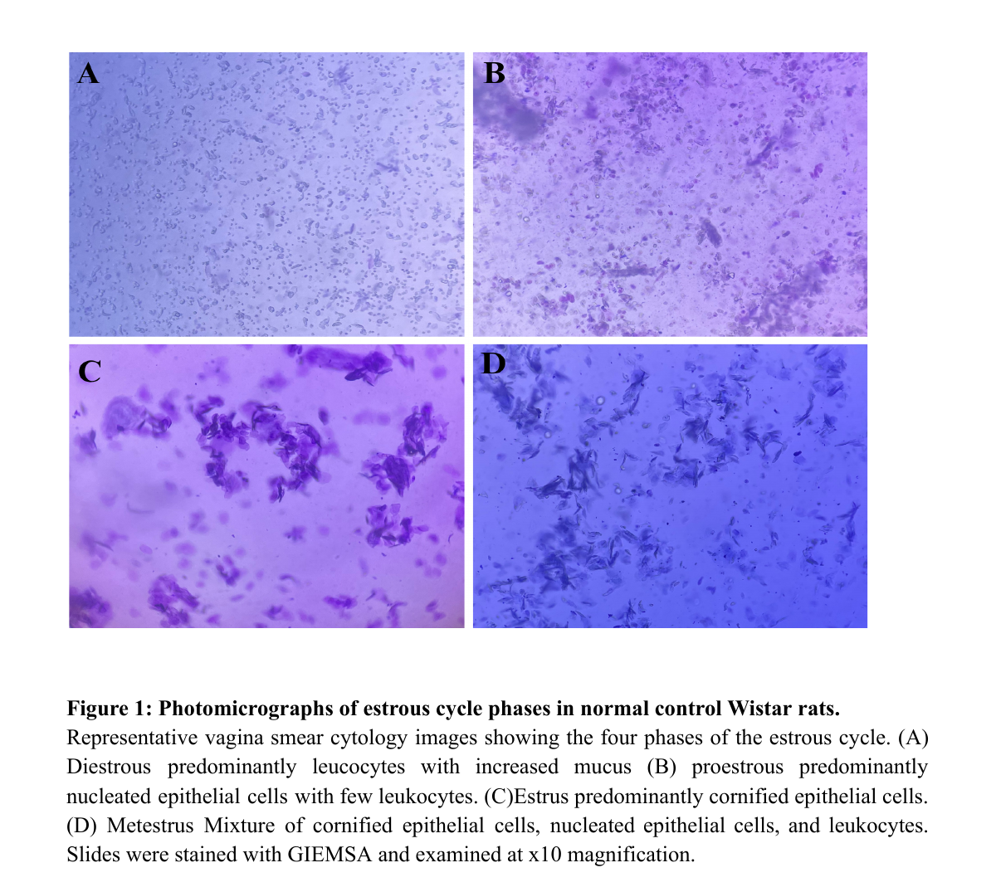
2.8. Statistical Analysis
The data obtained were analysed using the GraphPad Prism software version 10.5.2. The statistical significance of differences between groups was assessed using the one-way analysis of variance (ANOVA) followed by Tukey's multiple-comparison test at different confidence levels (P < 0.05, P < 0.01, P < 0.001, and P < 0.0001). The results obtained from this study were expressed as mean ± standard error of the mean of four replicate determinations.
3. Results
3.1. Vaginal Smear Cytology
Vaginal smear cytology was monitored daily throughout the induction and treatment phases to assess estrous cycle integrity across all experimental groups. During the induction phase, the normal control group maintained regular estrous cyclicity, progressing through all four phases: proestrus, estrus, metestrus, and diestrus in an organised and sequential manner throughout the 21-day period. In contrast, all PMOS-induced groups exhibited progressive disruption of estrous cyclicity, culminating in persistent diestrus by Day 12 of induction. This was characterised cytologically by a predominance of leukocytes with increased mucus, consistent with the anovulatory state associated with PMOS. Persistent diestrus on Day 12 across all induced groups confirmed successful PMOS induction prior to the commencement of treatment (Figure 2). Following the commencement of treatment, the normal control group continued to cycle regularly throughout the 21-day treatment period. The untreated PMOS group remained predominantly in diestrus, with at least one animal showing a first non-diestrus phase transition on Day 7, though no organised or sequential progression through the estrous cycle phases was observed. The positive control group, which received metformin and clomiphene citrate, showed the earliest resumption of non-diestrus phase activity, with at least one animal transitioning out of diestrus by Day 3 of treatment; however, cycling remained irregular throughout the treatment period without consistent phase progression. Among the plant extract treatment groups, all five groups—VAWE monotherapy, TIME monotherapy, and the low-dose, mid-dose, and high-dose combinations—showed first non-diestrus phase activity by Day 6 of treatment. Of these, the mid-dose combination group receiving VAWE (200 mg/kg) and TIME (200 mg/kg) demonstrated the most organised estrous cycle progression, showing greater regularity in phase transitions compared with all other treatment groups, though complete normalisation of cyclicity was not achieved in any treatment group within the 21-day observation period (Figure 3).
3.2. Luteinising Hormone (LH)
Serum LH levels were substantially elevated in the untreated PMOS group (0.1118 ± 0.005) compared with normal control animals (0.06275 ± 0.001). The positive control group (10 mg/kg metformin + 1 mg/kg clomiphene citrate) normalised LH concentrations back to baseline levels (0.06500 ± 0.003). VAWE monotherapy showed a potent suppressive effect on LH hypersecretion (0.06750 ± 0.003), yielding results comparable with the positive control group. TIME monotherapy also attenuated LH levels (0.08250 ± 0.01315). Polyherbal combinations in Groups 6, 7, and 8 produced moderate reductions in serum LH (0.09000 ± 0.006, 0.09260 ± 0.018, and 0.08750 ± 0.01031, respectively) compared with untreated PMOS animals (Figure 4).
3.3 Follicle-Stimulating Hormone (FSH)
Induction of PMOS (Group 2) led to a significant decrease in serum FSH concentrations (0.1600 ± 0.007021) relative to the normal control values (0.3150 ± 0.03175). TIME monotherapy (400 mg/kg, Group 5) induced the highest recovery in FSH levels (0.2400 ± 0.05196) among all intervention groups. VAWE monotherapy (200 mg/kg, Group 4) maintained FSH levels at 0.1775 ± 0.009445. Across the combination groups (Groups 6, 7, and 8), serum FSH concentrations ranged between 0.1350 ± 0.0056 and 0.1725 ± 0.006, with Group 6 showing an FSH concentration of 0.1725 ± 0.006 (Figure 5).
3.4. LH/FSH Ratio
The LH/FSH ratio was markedly elevated in untreated PMOS animals (0.6900 ± 0.04761) compared with normal controls (0.2025 ± 0.1025). Standard treatment (10 mg/kg metformin + 1 mg/kg clomiphene citrate) reduced the LH/FSH ratio to 0.3675 ± 0.01750. Single treatment with Vernonia amygdalina (200 mg/kg, Group 4) and Tamarindus indica (400 mg/kg, Group 5) lowered the ratio to 0.3200 ± 0.03464 and 0.3450 ± 0.1025, respectively. Among the combination groups, the low-dose combination (100VAWE+200TIME, Group 6) and mid-dose combination (200VAWE+200TIME, Group 8) demonstrated favourable reductions in the ratio (0.4625 ± 0.03577 and 0.4425 ± 0.04049, respectively) compared with the untreated PMOS group.
3.5 Testosterone
Induction of PMOS (Group 2) led to a significant elevation in serum testosterone levels (0.3495 ± 0.0412) compared with normal control animals (0.2310 ± 0.0189). Positive treatment in Group 3 effectively normalised serum testosterone (0.2220 ± 0.01955). TIME monotherapy (400 mg/kg, Group 5) demonstrated the most potent anti-androgenic effect among single extract treatments (0.2215 ± 0.03794), restoring levels to baseline. Monotherapy with Vernonia amygdalina (200 mg/kg, Group 4) also suppressed testosterone levels (0.2510 ± 0.01715). Polyherbal combination treatment (Groups 6, 7, and 8) consistently attenuated hyperandrogenism, with the mid-dose combination (200VAWE+200TIME) producing the greatest reduction in circulating testosterone (0.1890 ± 0.01273) overall.
3.6 Sex Hormone-Binding Globulin (SHBG)
The untreated PMOS group exhibited a drastic depletion in serum SHBG concentrations (291.1 ± 72.70) relative to the normal control group (3604 ± 228.6). Treatment with the positive control (10 mg/kg metformin + 1 mg/kg clomiphene citrate) markedly elevated SHBG concentrations above control baselines (4643 ± 354.3). Monotherapy with Tamarindus indica (400 mg/kg) exerted a pronounced restorative effect on SHBG levels (4045 ± 111.2), surpassing the control values. Vernonia amygdalina monotherapy (200 mg/kg) also substantially improved SHBG concentrations (3163 ± 716.5). Combination therapies demonstrated partial restoration of SHBG compared with the untreated model group, with the low-dose combination (100VAWE+200TIME) achieving the highest recovery (3068 ± 576.0) among the polyherbal combinations (Figure 8).
3.7 Estradiol
Serum oestrogen levels remained relatively stable across normal control (21.01 ± 0.7263) and untreated PMOS (20.84 ± 0.7042) groups. Standard treatment (Group 3) maintained comparable values (21.36 ± 0.1012). Among single treatment groups, Vernonia amygdalina (200 mg/kg) resulted in a modest reduction (18.72 ± 0.3949), whereas Tamarindus indica (400 mg/kg) led to an elevation (24.75 ± 1.825). The low-dose and high-dose combination groups (100VAWE+200TIME and 200VAWE+400TIME) maintained oestrogen levels near the control values (20.24 ± 0.6706 and 20.15 ± 0.6764, respectively), while the mid-dose combination (200VAWE+200TIME) exhibited a peak in serum oestrogen concentration (27.54 ± 0.1033) (Figure 9).
3.8 Progesterone
Serum progesterone levels were significantly suppressed in untreated PMOS animals (0.04775 ± 0.00275) relative to the normal controls (0.3688 ± 0.08625). VAWE monotherapy (200 mg/kg, Group 4) produced a robust restoration of progesterone secretion (0.2880 ± 0.03291), outperforming the standard treatment (0.06650 ± 0.00350). Polyherbal administration of the low-dose combination (100VAWE+200TIME) also markedly elevated progesterone levels (0.2428 ± 0.04125). TIME monotherapy (400 mg/kg) and the mid-dose combination (200VAWE+200TIME) showed moderate recovery (0.1573 ± 0.02475 and 0.1540 ± 0.02273, respectively) (Figure 10).
3.9 Prolactin
Serum prolactin concentrations remained relatively stable across the control group (0.4480 ± 0.0085) and untreated PMOS model (0.4868 ± 0.0160). Administration of the standard therapy (Group 3) produced a notable elevation in prolactin levels (0.8605 ± 0.00640). VAWE monotherapy (200 mg/kg) maintained baseline prolactin concentrations (0.4493 ± 0.02023), as did TIME monotherapy (400 mg/kg) (0.4848 ± 0.00281). Polyherbal combination therapies in Groups 6, 7, and 8 maintained serum prolactin concentrations near the control levels (0.4595 ± 0.009526, 0.4340 ± 0.02000, and 0.4845 ± 0.01190, respectively), showing no hyperprolactinaemic side effects (Figure 11).

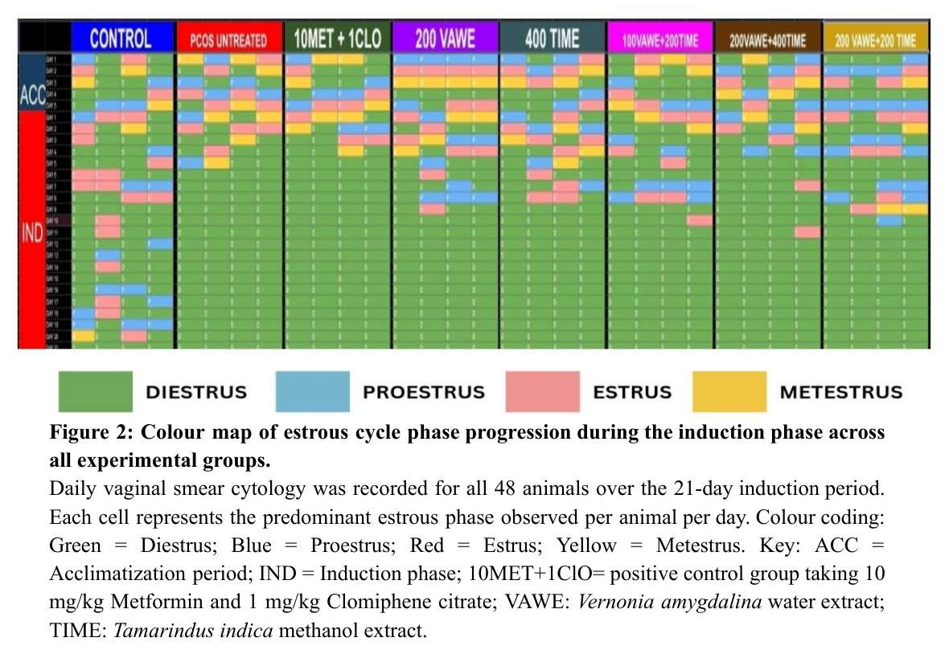

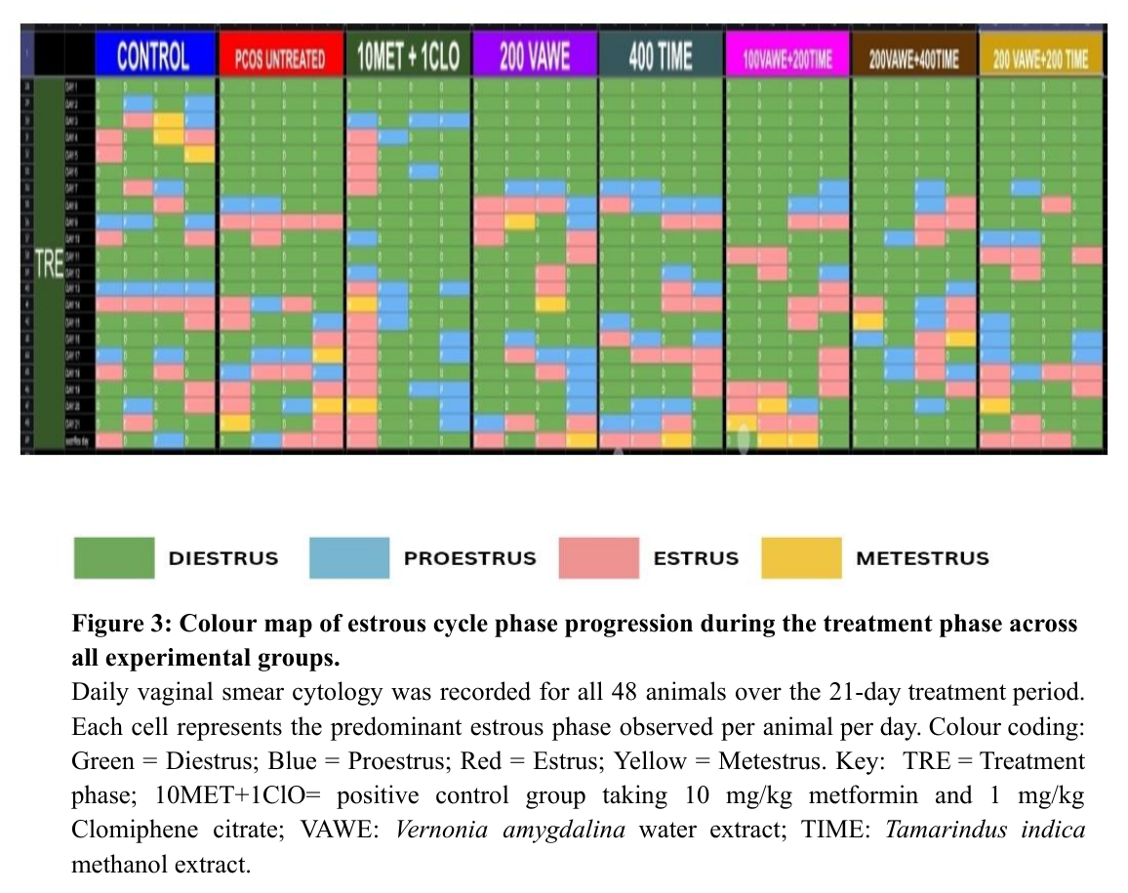

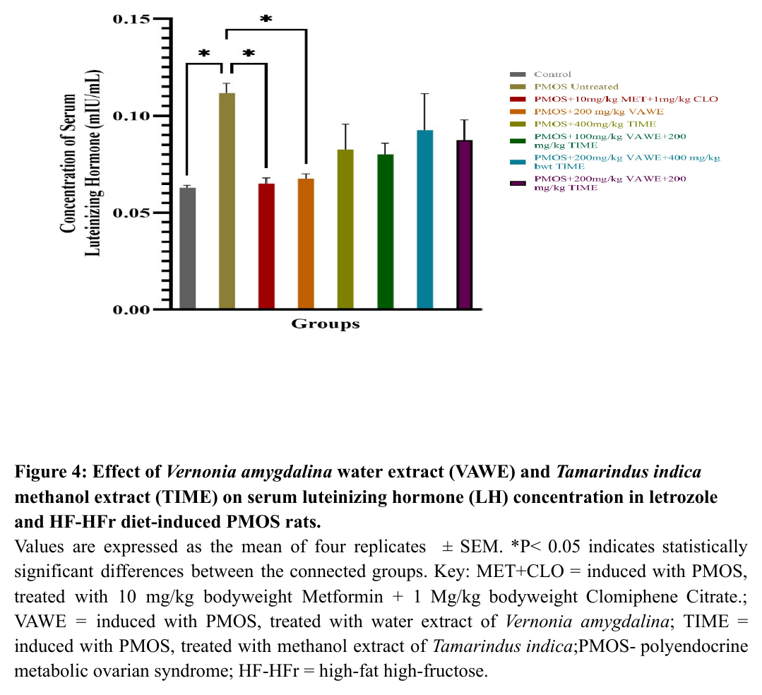

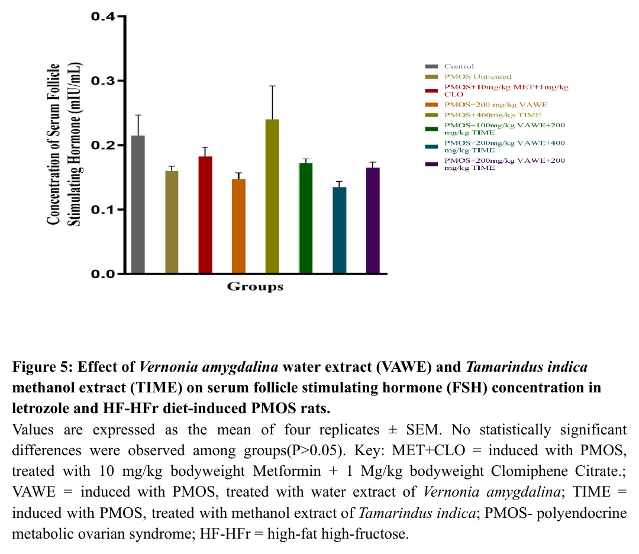

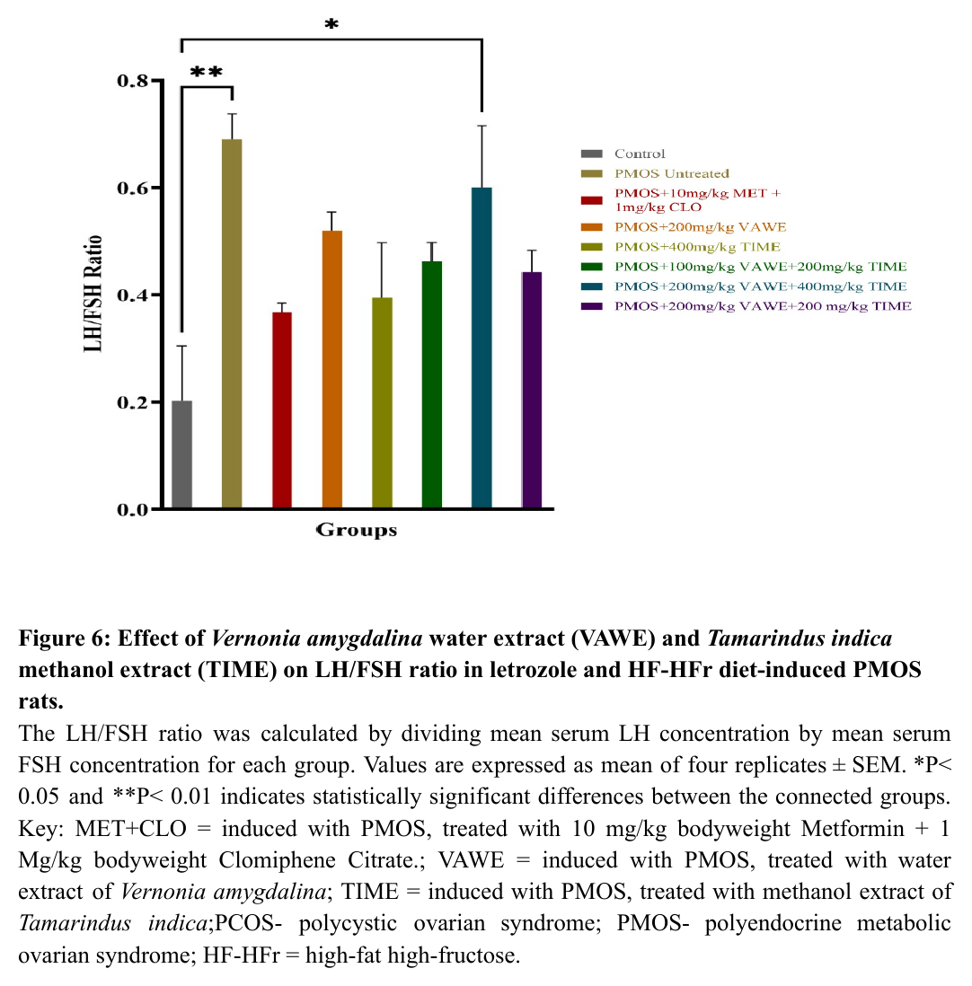

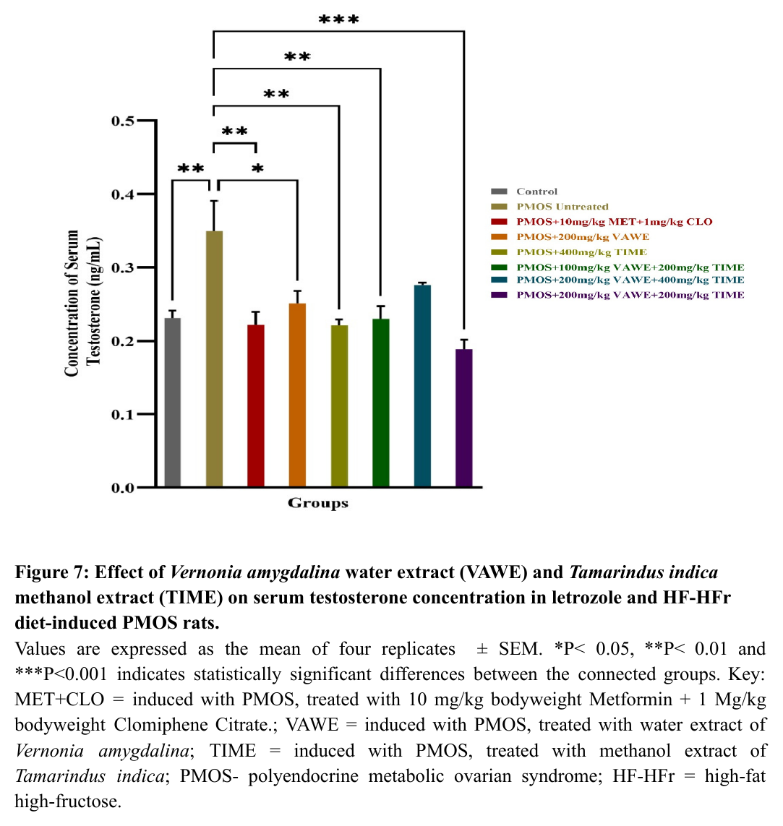

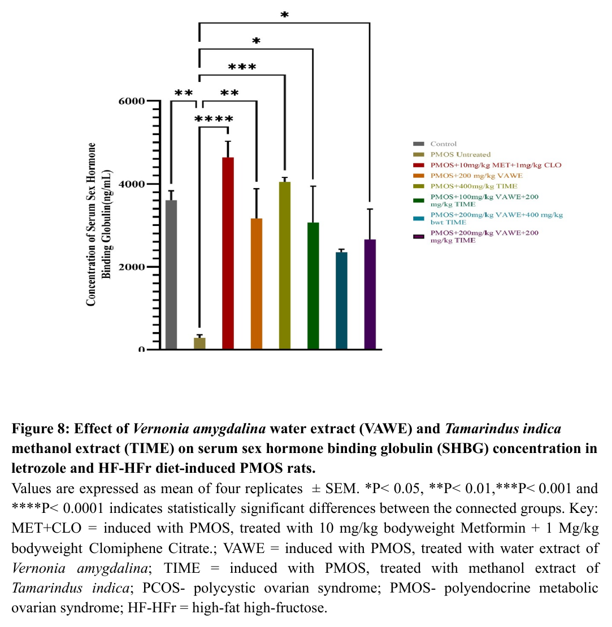

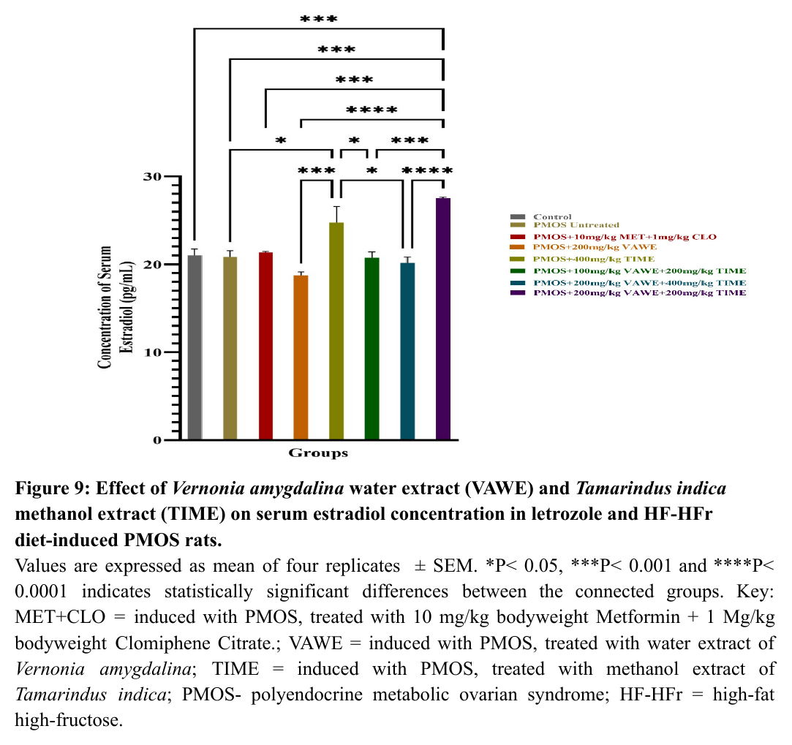

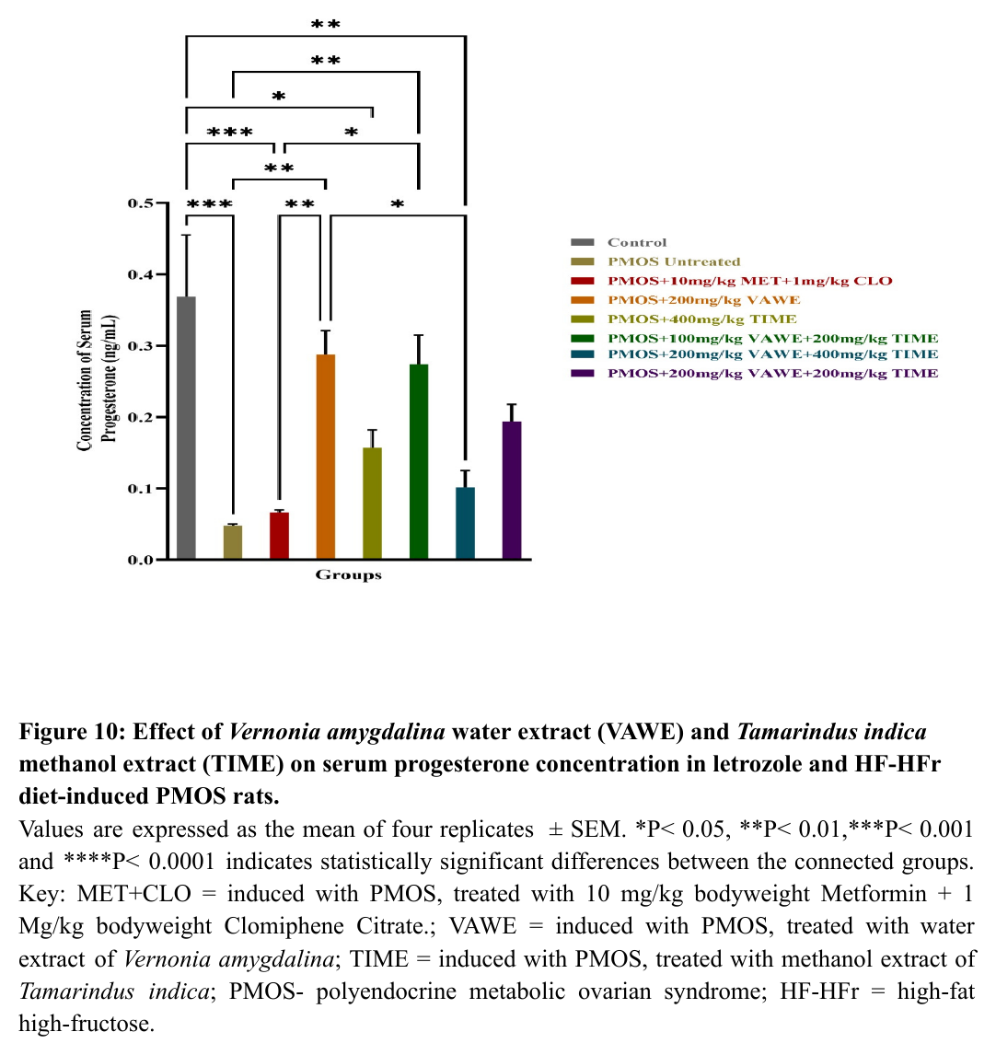

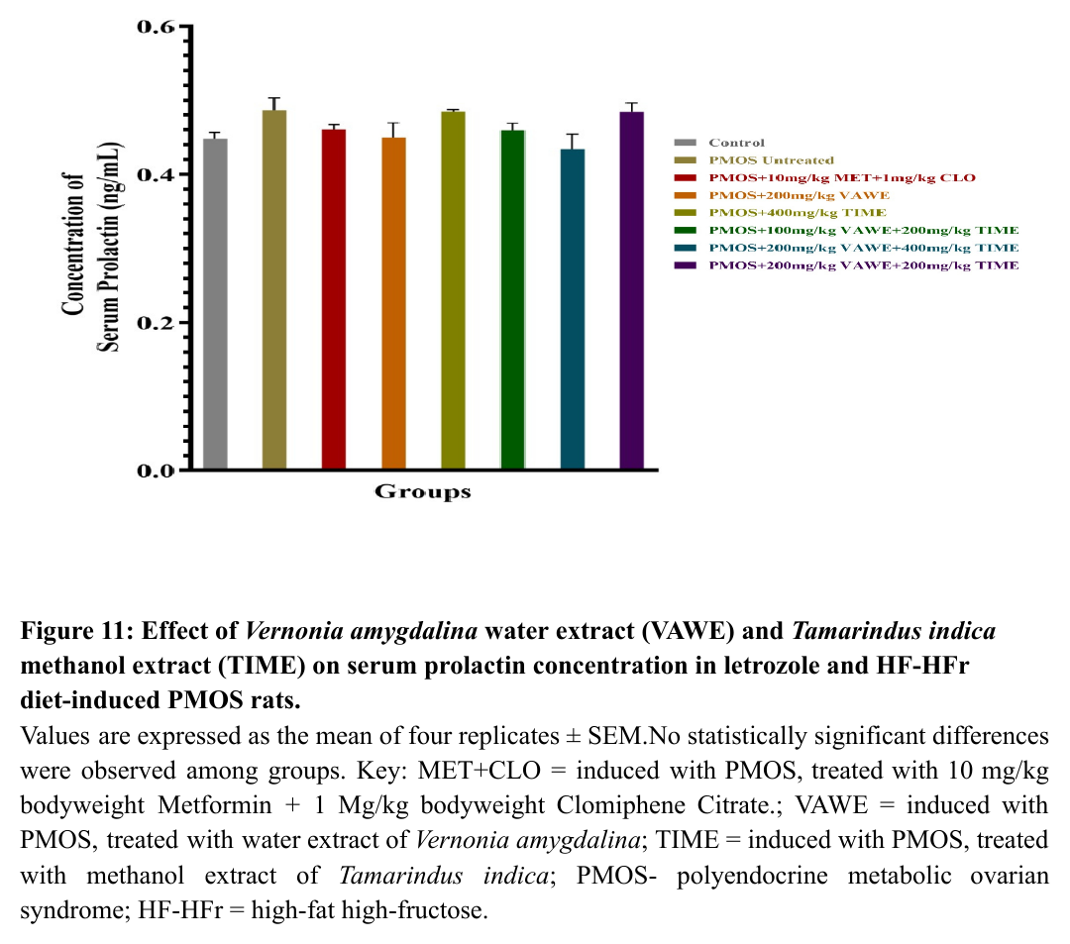
4. Discussion
Polyendocrine metabolic ovarian syndrome (PMOS) is a complex endocrine disorder characterised by hyperandrogenism, ovulatory dysfunction, and metabolic disturbances (Liao et al., 2021). Despite its high prevalence, effective multi-target therapies remain limited (Meng et al., 2025; Salari et al., 2024; Malik et al., 2023). Vernonia amygdalina and Tamarindus indica are widely used in African and Asian ethnomedicine for metabolic and reproductive health, with bioactive profiles rich in flavonoids, phenolic acids, alkaloids, and terpenoids (Ugbogu et al., 2021; Mohamed et al., 2025). This study evaluated the combined effects of Vernonia amygdalina and Tamarindus indica in a letrozole and high-fat, high-fructose (HF-HFr) diet-induced PMOS rat model. The dual induction model was employed to simultaneously recapitulate the hormonal and metabolic dimensions of PMOS, providing a more comprehensive experimental phenotype than single-induction protocols.
Estrous cycle monitoring confirmed successful PMOS induction as all untreated PMOS-induced rats displayed persistent diestrus on Day 12 of the induction phase. Persistent diestrus phase in letrozole-induced PMOS models reflects anovulation and gonadotropin imbalance, while a regular 4–5-day sequence of proestrus-estrus-metestrus-diestrus denotes normal reproductive function (Min et al., 2025). This finding is consistent with the report by Kurniawati et al. (2024), who noted that thirty-seven studies demonstrated irregular cycles during the induction phase with letrozole (Kurniawati et al., 2024). During treatment, spontaneous resumption of cycling occurred across all groups, including untreated animals, but the pattern was irregular in the latter. The mid-dose group (VAWE 200 mg/kg + TIME 200 mg/kg) demonstrated restoration of near-normal stage progression and fewer irregular transitions compared with untreated rats, the positive control, monotherapies, or other combination groups, suggesting a faster resynchronisation of the HPO axis. This finding aligns with earlier reports where letrozole induction produced persistent diestrus and estrous cycling resumed after pharmacological or herbal interventions (Adebodun et al., 2022; Younas et al., 2022).
Most reports on letrozole-induced PMOS models in rats either focus exclusively on the induction phase or omit detailed descriptions of estrous cycle progression in untreated animals beyond induction. The cessation of the HF-HFr diet following induction may have partially relieved the metabolic component of HPO axis suppression, contributing to the spontaneous cycling tendency observed in untreated animals. This highlights the reversible nature of diet-mediated reproductive dysfunction and underscores the importance of dietary modification as an adjunct to pharmacological or herbal intervention in PMOS management. Functional restoration of estrous cyclicity in the mid-dose group (VAWE 200 mg/kg + TIME 200 mg/kg) provides cytological evidence that the hormonal improvements observed biochemically translated into meaningful reproductive recovery.
PMOS induction produced the expected neuroendocrine alterations, with untreated rats showing markedly elevated LH, reduced FSH, and a significantly increased LH/FSH ratio (Szeliga et al., 2022). A high LH/FSH ratio has been considered a clinical biomarker of PMOS and is said to be consistent with HPO axis dysregulation (Mitrašinović-Brulić et al., 2021). In PMOS, rapid GnRH pulse frequency selectively increases LH release while suppressing FSH, impairing follicular recruitment, reducing aromatase activity and limiting oestrogen production (Szeliga et al., 2022; Lambalk, 2023). Treatment with both monotherapies and combinations generally shifted LH downwards and FSH upwards, although non-significantly (P > 0.05), reducing the LH/FSH ratio towards normal values. Our findings agree with previous reports in letrozole-induced PMOS models showing exaggerated LH secretion, suppressed FSH and normal LH/FSH ratios (Younas et al., 2022; Dandekar et al., 2025; Kar et al., 2024). While LH suppression did not reach statistical significance (P > 0.05) in plant-treated groups, the consistent downward trend across all treatment groups, particularly the mid-dose combination, suggests modulation of GnRH-LH signalling that may achieve significance with extended treatment duration. The relative underperformance of the high-dose combination is consistent with the dose-dependent pattern observed across multiple parameters. The absence of significant FSH dysregulation is consistent with the letrozole model literature and reflects the preferential disruption of LH pulsatility over FSH secretion in aromatase inhibitor-induced PMOS (Younas et al., 2022; Kar et al., 2024). Restoration of LH/FSH ratio to control-comparable levels in the mid-dose combination (VAWE 200 mg/kg + TIME 200 mg/kg) but not the high-dose combination (VAWE 200 mg/kg + TIME 400 mg/kg) provides the first direct statistical evidence that dose selection critically determines whether synergistic HPO axis restoration or paradoxical gonadotropin imbalance occurs.
Hyperandrogenism is a central feature of PMOS, both in clinical presentation and experimental models and is largely driven by LH-mediated stimulation of ovarian theca cells leading to elevated testosterone and low SHBG (Wang et al., 2023). Similar patterns have been reported in letrozole-induced PMOS rats, where aromatase inhibition reduces conversion of testosterone to oestrogens, resulting in androgen accumulation (Kar et al., 2024; Rajan et al., 2017; Xu et al., 2022). VAWE and TIME monotherapies each produced reductions in testosterone and moderate to large increases in SHBG compared with untreated rats. Combination regimens, except for the high-dose group, (VAWE 200 mg/kg + TIME 400 mg/kg) generally achieved similar improvements, with the mid-dose group (VAWE 200 mg/kg + TIME 200 mg/kg) showing concurrent lowering of testosterone and robust elevation of SHBG, suggesting complementary modulation of androgen production and hepatic SHBG synthesis. The mid-dose combination (VAWE 200 mg/kg + TIME 200 mg/kg) achieved the most comprehensive antiandrogenic effect, simultaneously reducing total testosterone below control levels and restoring SHBG, collectively minimising bioavailable androgen. The failure of the high-dose combination (VAWE 200 mg/kg + TIME 400 mg/kg) to replicate this effect on either parameter despite containing higher concentrations of both extracts is compelling evidence that synergy in this combination is dose-dependent rather than concentration-dependent.
Estradiol levels remained comparable to controls in this study, possibly because of compensatory mechanisms of aromatase activity in letrozole-induced PMOS. Letrozole blocks aromatase activity; however, peripheral aromatisation in adipose tissue and adrenal glands can maintain estradiol (Aydın et al., 2026). The elevation of estradiol in the mid-dose combination group (VAWE 200 mg/kg + TIME 200 mg/kg) may reflect restored aromatase activity consequent to the antiandrogenic effects observed in the testosterone analysis, suggesting that testosterone reduction by the mid-dose combination created substrate conditions favourable to estradiol synthesis; a mechanistic consequence of HPO axis restoration rather than a direct oestrogenic effect of the extracts, although direct measurement of aromatase activity was beyond the scope of this study and warrants investigation in future work.
Progesterone is a marker of luteal function as it is only produced after ovulation by the corpus luteum (Duncan, 2021). Restored progesterone, therefore, means ovulation occurred, which is the ultimate functional goal of HPO axis restoration. The failure of the positive control to restore progesterone despite pharmacological intervention, contrasted with the significant progesterone recovery in VAWE monotherapy and low-dose combination, suggests that the plant extracts engage steroidogenic pathways beyond the gonadotropin axis, an effect that may complement rather than simply replicate conventional pharmacological mechanisms. Metformin primarily targets insulin resistance and hepatic glucose production, while clomiphene citrate acts as an oestrogen receptor antagonist to stimulate gonadotropin release (Basarakod et al., 2023; Parveen et al., 2023; Zeng et al., 2025). Neither mechanism directly supports corpus luteum function or progesterone biosynthesis, which may explain the failure of the positive control to restore luteal progesterone despite partial gonadotropin normalisation. The progesterone-restorative effect of VAWE monotherapy and the low-dose combination may reflect direct steroidogenic stimulation, as Vernonia amygdalina has been reported to protect against steroidogenic pathway alteration (Oladele et al., 2020). The restoration of progesterone in these groups is further corroborated by the cytological evidence of estrous cycle resumption observed during treatment, collectively suggesting that ovulatory function was partially reinstated.
Prolactin supports luteal function in normal reproductive physiology, but sustained hyperprolactinaemia can inhibit GnRH release, reduce gonadotropin secretion, and impair ovulation (Szukiewicz, 2024). In PMOS, levels are often within the normal range, though mild elevations may occur, typically linked to stress, age, high body mass index, alopecia, altered oestrogen status, or pituitary microadenomas (Chaudhary et al., 2025). The absence of prolactin dysregulation confirms that the HPO axis disruption observed in this study was driven by letrozole-mediated androgenic mechanisms rather than hyperprolactinaemia, and that the restorative effects of the plant extracts were specific to the androgen-gonadotropin axis.
Taken together, the mid-dose combination of VAWE (200 mg/kg) and TIME (200 mg/kg) emerges from this multi-parameter analysis as the optimal therapeutic dose, demonstrating consistent superiority across gonadotropin, androgenic, oestrogenic, and functional endpoints, and the high-dose combination provides multi-parameter evidence of synergistic HPO axis restoration. The paradoxical underperformance of the high-dose combination may reflect competitive receptor interactions or phytochemical antagonism at elevated concentrations, wherein high doses of Tamarindus indica phytochemicals may exert pro-oestrogenic effects that stimulate rather than suppress GnRH pulsatility, reversing the therapeutic synergy observed at lower doses. These findings provide a pharmacological rationale for the combined ethnomedicinal use of Vernonia amygdalina and Tamarindus indica in reproductive health, and support further investigation of this combination in mechanistic and clinical studies.
Limitations
Several limitations of this study warrant acknowledgement. First, synergistic interaction between VAWE and TIME was inferred from comparative multi-parameter biochemical outcomes across treatment groups rather than formally quantified using established methods such as the Chou-Talalay combination index. Future studies should employ formal synergy quantification to mathematically confirm and characterise the nature of the interaction between these extracts. Second, the mechanistic basis of the observed hormonal effects was not directly investigated, as assessments were limited to serum biochemical parameters. The molecular pathways underlying the treatment responses, including receptor binding interactions, steroidogenic enzyme modulation, and gene expression changes at the hypothalamic, pituitary, and ovarian levels remain to be elucidated in subsequent studies. Third, the study employed a fixed 21-day treatment duration, and it remains unclear whether extended treatment would achieve complete restoration of hormonal parameters and estrous cyclicity, particularly in groups showing partial recovery. Finally, as with all rodent-based studies, the translational applicability of these findings to human PMOS requires validation through clinical investigation.
Conclusion
This study demonstrates that the combined administration of Vernonia amygdalina water extract (VAWE) and Tamarindus indica methanol extract (TIME) effectively ameliorates hypothalamic-pituitary-ovarian (HPO) axis dysregulation in letrozole- and high-fat, high-fructose diet-induced PMOS rats. Among the evaluation groups, the mid-dose equal combination of VAWE (200 mg/kg) and TIME (200 mg/kg) (Group 8) emerged as the optimal therapeutic formulation. It produced superior anti-androgenic efficacy, lowering serum testosterone below baseline control levels while simultaneously restoring LH/FSH balance and driving elevated estradiol synthesis. Additionally, monotherapy with Vernonia amygdalina (200 mg/kg) and low-dose combination therapy (100 mg/kg VAWE + 200 mg/kg TIME) exhibited strong progesterone restoration that outperformed standard treatment, highlighting distinct steroidogenic pathways that support ovulatory recovery. Conversely, the higher-dose combination (200 mg/kg VAWE + 400 mg/kg TIME) showed relative underperformance across key endocrine endpoints, pointing to a dose-dependent transition from synergism toward phytochemical antagonism at elevated concentrations.
Overall, these findings provide a scientific rationale for the combined ethnomedicinal use of Vernonia amygdalina and Tamarindus indica in managing polyendocrine metabolic ovarian syndrome. Future studies focusing on formal synergy indices, steroidogenic enzyme gene expression, and clinical evaluations are recommended to further clarify the underlying molecular mechanisms and advance translational applicability.

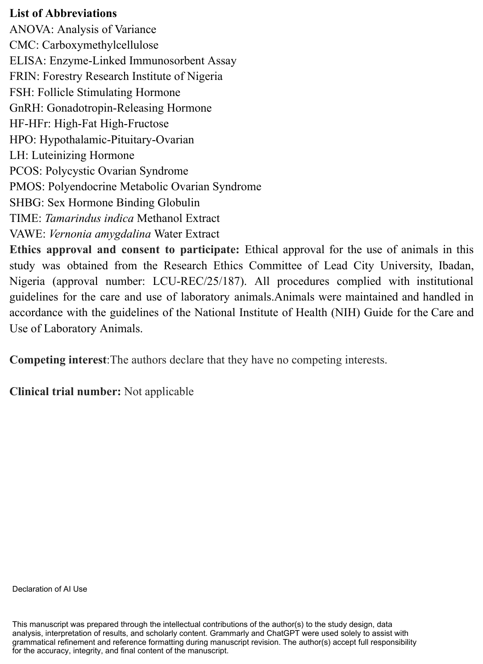
References
Adebodun, G., Ogunsola, A., & Raji, Y. (2022). The rapeutic potentials of Vernonia amygdalina in letrozole and high-fat diet induced polycystic ovary syndrome in female Wistar rats. Endocrine Abstracts, 86, P357. https://doi.org/10.1530/endoabs.86.P357
Ali, M., Mu’azu, L., Diso, S. U., & Ibrahim, I. S. (2020). Determination of proximate, phytochemicals and minerals composition of Vernonia amygdalina (bitter leaf). Nutraceutical Research, 1(1). https://doi.org/10.35702/nutri.10001
Aydın, G., Hatırnaz, Ş., Hatırnaz, E. S., Çetinkaya, M. B., Akdeniz, M., Dokuzeylül Güngör, N., Güler, O., Merdanoğlu, M. A., Uzun, A., Eroğlu, S., Tosun, Ö., Bahadırlı, A., Yurtçu, E., Keyif, B., Güvey, H., Gürkan, N., Karlı, P., Yılmaz, Z., Baldini, G. M., … Dahan, M. (2026). The letrozole use in reproductive medicine: Beyond aromatase inhibition—A comprehensive review. Turkish Journal of Obstetrics and Gynecology, 23(1), 101–114. https://doi.org/10.4274/tjod.galenos.2026.02391
Basarakod, S. S., Bharadwaj, M., Raj, P. V., & Chaitra, N. (2023). The effect of letrozole vs clomiphene citrate for ovulation induction in patients of infertility with polycystic ovarian syndrome. International Journal of Reproduction, Contraception, Obstetrics and Gynecology, 12(10), 2998–3002. https://doi.org/10.18203/2320-1770.ijrcog20232936
Brahmi, F., Kampemba Mujinga, F., Guendouze, N., Madani, K., Boulekbache, L., & Duez, P. (2025). Benefits of traditional medicinal plants to African women’s health: An overview of the literature. Diseases, 13, 160. https://doi.org/10.3390/diseases13050160
Chaudhary, K., Ghosh, S., Mitra, P., & Pradhan, A. (2025). Prevalence of hyperprolactinemia in polycystic ovary syndrome and its clinical correlates. International Journal of Reproduction, Contraception, Obstetrics and Gynecology, 14, 3034–3039. https://doi.org/10.18203/2320-1770.ijrcog20252737
Cloutier, F., Roumaud, P., Ayoub-Charette, S., Chowdhury, S., & Martin, L. J. (2020). The intake of an extract from seeds of Tamarindus indica L. modulates the endocrine function of adult male mice under a high fat diet. Heliyon, 6, e03310. https://doi.org/10.1016/j.heliyon.2020.e03310
Cunha, A., & Póvoa, A. M. (2021). Infertility management in women with polycystic ovary syndrome: A review. Porto Biomedical Journal, 6, e116. https://doi.org/10.1097/j.pbj.0000000000000116
Dandekar, M. P., Tadas, M., Satthi, S., Jangli, A., Shaikh, A. S., Rao Gajula, S. N., Kaki, V. R., & Sonti, R. (2025). Oxyberberine revokes letrozole-induced polycystic ovarian syndrome and depression-like behavior in female Sprague-Dawley rats. European Journal of Pharmacology, 997, 177613. https://doi.org/10.1016/j.ejphar.2025.177613
Degu, S., Meresa, A., Animaw, Z., Jegnie, M., Asfaw, A., & Tegegn, G. (2024). Vernonia amygdalina: A comprehensive review of the nutritional makeup, traditional medicinal use, and pharmacology of isolated phytochemicals and compounds. Frontiers in Natural Products, 3, 1347855. https://doi.org/10.3389/fntpr.2024.1347855
Duncan, W. C. (2021). The inadequate corpus luteum. Reproduction and Fertility, 2, C1–C7. https://doi.org/10.1530/RAF-20-0044
Ebabhi, A. M., Kanife, U. C., Onadeko, E., & Fasakin, O. (2025). Solvent-dependent phytochemical and antioxidant profiles of Tamarindus indica L. (tamarind) pulp: A comparative study. Egyptian Academic Journal of Biological Sciences, H. Botany, 16, 113–121. https://doi.org/10.21608/eajbsh.2025.465354
Edo, G. I., Samuel, P. O., Jikah, A. N., Onoharigho, F. O., Idu, L. I., Obasohan, P., Opiti, A. R., Electric, J., Ikpekoro, V. O., Otunuya, C. F., Ugbuwe, E., Ongulu, J., Ijide, M., Nwaose, I. D., Ajakaye, S. R., & Owigho, J. E. (2023). Biological and bioactive components of bitter leaf (Vernonia amygdalina leaf): Insight on health and nutritional benefits. A review. Food Chemistry Advances, 3, 100488. https://doi.org/10.1016/j.focha.2023.100488
Helvaci, N., & Yildiz, B. O. (2025). Polycystic ovary syndrome as a metabolic disease. Nature Reviews Endocrinology, 21, 230–244. https://doi.org/10.1038/s41574-024-01057-w
Huddleston, H. G., Milani, A., & Blank, R. (2024). Productivity loss due to polycystic ovary syndrome and its relationship to race, mental health and healthcare delivery indices. F&S Reports, 5, 157–163. https://doi.org/10.1016/j.xfre.2024.02.004
Kafali, H., Iriadam, M., Ozardalı, I., & Demir, N. (2004). Letrozole-induced polycystic ovaries in the rat: A new model for cystic ovarian disease. Archives of Medical Research, 35, 103–108. https://doi.org/10.1016/j.arcmed.2003.10.005
Kanbour, S. A., & Dobs, A. S. (2022). Hyperandrogenism in women with polycystic ovarian syndrome: Pathophysiology and controversies. Androgens: Clinical Research and Therapeutics, 3, andro.2021.0020. https://doi.org/10.1089/andro.2021.0020
Kar, T. K., Sil, S., Ghosh, A., Barman, A., & Chattopadhyay, S. (2024). Mitigation of letrozole induced polycystic ovarian syndrome associated inflammatory response and endocrinal dysfunction by Vitex negundo seeds. Journal of Ovarian Research, 17, 76. https://doi.org/10.1186/s13048-024-01378-4
Kurniawati, E. Y., Hein, Z. M., & Muhlida, V. I. (2024). Letrozole as induction of polycystic ovary syndrome model in rats. Comprehensive Health and Biomedical Studies, 3(1), e159924. https://doi.org/10.5812/chbs-159924
Lambalk, C. B. (2023). The enigma of the gonadotropin-releasing hormone pulse frequency governing individual secretion of luteinizing hormone and follicle-stimulating hormone. F&S Reports, 4, 27–32. https://doi.org/10.1016/j.xfre.2023.02.010
Liao, B., Qiao, J., & Pang, Y. (2021). Central regulation of PCOS: Abnormal neuronal-reproductive-metabolic circuits in PCOS pathophysiology. Frontiers in Endocrinology, 12, 667422. https://doi.org/10.3389/fendo.2021.667422
Long, J. A., & Evans, H. M. (1922). The oestrous cycle in the rat and its associated phenomena. University of California Press. https://search.worldcat.org/title/14774851
Malik, S., Saeed, S., Saleem, A., Khan, M. I., Khan, A., & Akhtar, M. F. (2023). Alternative treatment of polycystic ovary syndrome: Pre-clinical and clinical basis for using plant-based drugs. Frontiers in Endocrinology, 14, 1294406. https://doi.org/10.3389/fendo.2023.1294406
Masih, A., & Paul, V. (2026). Herbal therapy in the management of polycystic ovary syndrome: A critical narrative review of mechanistic claims, clinical evidence and translational barriers. Archives of Current Research International, 26(9), 272–295. https://doi.org/10.9734/acri/2026/v26i92132
Meng, Y., Zhao, T., Zhang, R., Zhu, X., Ma, C., & Shi, Q. (2025). Global burden of polycystic ovary syndrome among women of childbearing age, 1990–2021: A systematic analysis using the Global Burden of Disease Study 2021. Frontiers in Public Health, 13, 1514250. https://doi.org/10.3389/fpubh.2025.1514250
Min, D., Kim, S.-Y., Park, J.-Y., Kang, M., & Kim, B.-S. (2025). Rodent models of functional hypothalamic amenorrhea: A systematic scoping review. Frontiers in Endocrinology, 16, 1456754. https://doi.org/10.3389/fendo.2025.1456754
Mitrašinović-Brulić, M., Buljan, M., & Suljević, D. (2021). Association of LH/FSH ratio with menstrual cycle regularity and clinical features of patients with polycystic ovary syndrome. Middle East Fertility Society Journal, 26, 40. https://doi.org/10.1186/s43043-021-00085-0
Mohamed, N. E. A., Ismail, A. A. A., & Eisa, A. (2025). Phytochemical profiling, antimicrobial, and antioxidant activities of Tamarindus indica pulp extracts: A comprehensive evaluation. Biology, Medicine, & Natural Product Chemistry, 14(1), 51–56. https://doi.org/10.14421/biomedich.2025.141.51-56
Oladele, J. O., Oyeleke, O. M., Oladele, O. T., Babatope, O. D., & Awosanya, O. O. (2020). Nitrobenzene-induced hormonal disruption, alteration of steroidogenic pathway, and oxidative damage in rat: Protective effects of Vernonia amygdalina. Clinical Phytoscience, 6, 15. https://doi.org/10.1186/s40816-020-00161-4
Oseghale, I. D., Lawal, O. P., Ubebe, D. O., Orjiewulu, V. C., Igunma, A. A., Odey, O. P., Ajibola, D. T., Chima, D. I., Tuador, N. K., & Ani, C. P. (2024). Ethnomedicinal and phytopharmacological aspects of Vernonia amygdalina (bitter leaf) utilized as a traditional medicinal herb. Asian Journal of Research in Biochemistry, 14(6), 41–57. https://doi.org/10.9734/ajrb/2024/v14i6326
Parveen, S., Iram, N., Saeed, B. Z., Yaqub, U., & Niazi, N. K. (2023). Clomiphene supported ovulation induction in subfertile polycystic ovary syndrome women: Role of different insulin sensitizers. Pakistan Armed Forces Medical Journal, 73, 810–813. https://doi.org/10.51253/pafmj.v73i3.9081
Rafiu, B. O., Omotayo, A. O., Lawal, I. O., & Aremu, A. O. (2025). Ethnobotanical uses of plants in Nigeria: An analysis of current research trends and patterns. Journal of Ethnobiology and Ethnomedicine, 21, 57. https://doi.org/10.1186/s13002-025-00788-y
Rajan, R. K., Kumar, S. S. M., & Balaji, B. (2017). Soy isoflavones exert beneficial effects on letrozole-induced rat polycystic ovary syndrome (PCOS) model through anti-androgenic mechanism. Pharmaceutical Biology, 55(1), 242–251. https://doi.org/10.1080/13880209.2016.1258425
Salari, N., Nankali, A., Ghanbari, A., Jafarpour, S., Ghasemi, H., Dokaneheifard, S., & Mohammadi, M. (2024). Global prevalence of polycystic ovary syndrome in women worldwide: A comprehensive systematic review and meta-analysis. Archives of Gynecology and Obstetrics, 310, 1303–1314. https://doi.org/10.1007/s00404-024-07607-x
Shaheen, A. A., Hussain, K. A. M., & Al-Safy, A. H. (2024). Study of the effect of fresh green Asparagus officinalis L. stems extract and metformin drug on induced polycystic ovary syndrome (PCOS) in female albino rats. Uttar Pradesh Journal of Zoology, 45(17), 607–618. https://doi.org/10.56557/upjoz/2024/v45i174406
Shahraki, M. R., Harati, M., & Shahraki, A. R. (2011). Prevention of high fructose-induced metabolic syndrome in male Wistar rats by aqueous extract of Tamarindus indica seed. Acta Medica Iranica, 49(5), 277–283. https://pubmed.ncbi.nlm.nih.gov/21713743/
Stener-Victorin, E., Teede, H., Norman, R. J., Legro, R., Goodarzi, M. O., Dokras, A., Laven, J., Hoeger, K., & Piltonen, T. T. (2024). Polycystic ovary syndrome. Nature Reviews Disease Primers, 10, 27. https://doi.org/10.1038/s41572-024-00511-3
Su, P., Chen, C., & Sun, Y. (2025). Physiopathology of polycystic ovary syndrome in endocrinology, metabolism and inflammation. Journal of Ovarian Research, 18, 34. https://doi.org/10.1186/s13048-025-01621-6
Sundaram, M. S., Hemshekhar, M., Santhosh, M. S., Paul, M., Sunitha, K., Thushara, R. M., NaveenKumar, S. K., Naveen, S., Devaraja, S., Rangappa, K. S., Kemparaju, K., & Girish, K. S. (2015). Tamarind seed (Tamarindus indica) extract ameliorates adjuvant-induced arthritis via regulating the mediators of cartilage/bone degeneration, inflammation and oxidative stress. Scientific Reports, 5, 11117. https://doi.org/10.1038/srep11117
Szeliga, A., Rudnicka, E., Maciejewska-Jeske, M., Kucharski, M., Kostrzak, A., Hajbos, M., Niwczyk, O., Smolarczyk, R., & Meczekalski, B. (2022). Neuroendocrine determinants of polycystic ovary syndrome. International Journal of Environmental Research and Public Health, 19(5), 3089. https://doi.org/10.3390/ijerph19053089
Szukiewicz, D. (2024). Current insights in prolactin signaling and ovulatory function. International Journal of Molecular Sciences, 25(4), 1976. https://doi.org/10.3390/ijms25041976
Teede, H. J., Tay, C. T., Laven, J. J. E., Dokras, A., Moran, L. J., Piltonen, T. T., Costello, M. F., Boivin, J., Redman, L. M., Boyle, J. A., Norman, R. J., Mousa, A., & Joham, A. E. (2023). Recommendations from the 2023 international evidence-based guideline for the assessment and management of polycystic ovary syndrome. European Journal of Endocrinology, 189(2), G43–G64. https://doi.org/10.1093/ejendo/lvad096
The Rotterdam ESHRE/ASRM-sponsored PCOS Consensus Workshop Group. (2004). Revised 2003 consensus on diagnostic criteria and long-term health risks related to polycystic ovary syndrome (PCOS). Human Reproduction, 19(1), 41–47. https://doi.org/10.1093/humrep/deh098
Ugbogu, E. A., Emmanuel, O., Dike, E. D., Agi, G. O., Ugbogu, O. C., Ibe, C., & Iweala, E. J. (2021). The phytochemistry, ethnobotanical, and pharmacological potentials of the medicinal plant Vernonia amygdalina L. (bitter leaf). Clinical Complementary Medicine and Pharmacology, 1, 100006. https://doi.org/10.1016/j.ccmp.2021.100006
Wang, K., Li, Y., & Chen, Y. (2023). Androgen excess: A hallmark of polycystic ovary syndrome. Frontiers in Endocrinology, 14, 1273542. https://doi.org/10.3389/fendo.2023.1273542
Xing, C., Zhang, J., Zhao, H., & He, B. (2022). Effect of sex hormone-binding globulin on polycystic ovary syndrome: Mechanisms, manifestations, genetics, and treatment. International Journal of Women’s Health, 14, 91–105. https://doi.org/10.2147/IJWH.S344542
Xu, S., Liu, Y., Xue, K., Liu, X., Jia, G., Zeng, Y., & Chen, Y. (2022). Diagnostic value of total testosterone and free androgen index measured by LC–MS/MS for PCOS and insulin resistance. Journal of Clinical Laboratory Analysis, 36, e24739. https://doi.org/10.1002/jcla.24739
Younas, A., Hussain, L., Shabbir, A., Asif, M., Hussain, M., & Manzoor, F. (2022). Effects of Fagonia indica on letrozole-induced polycystic ovarian syndrome (PCOS) in young adult female rats. Evidence-Based Complementary and Alternative Medicine, 2022, 1397060. https://doi.org/10.1155/2022/1397060
Zeng, W., Luo, Y., Ou, J., Gan, D., Huang, M., Tomlinson, B., & Jiang, Y. (2025). Metformin in polycystic ovary syndrome: Unraveling multi-stage therapeutic mechanisms from puberty to long-term health outcomes. Frontiers in Pharmacology, 16, 1654372. https://doi.org/10.3389/fphar.2025.1654372

