Botanical Characteristics and In Vitro Pancreatic Lipase Inhibitory Activity of Ixora coccinea L. Flowers

Abstract
Aims: To characterise the flowers of Ixora coccinea L. botanically, screen their phytochemical constituents, and evaluate the in vitro pancreatic lipase inhibitory activity of their extracts.
Study design: Laboratory experimental study combining descriptive botanical characterisation (morphology, anatomy and powder microscopy) with an in vitro enzyme inhibition assay. No physicochemical standardisation parameters were determined.
Place and Duration of Study: Faculty of Pharmacy, Nguyen Tat Thanh University, Ho Chi Minh City, Vietnam, between April and June 2026.
Methodology: Flowers collected in Vinh Huu commune, Dong Thap province, in April 2026 were examined by light microscopy for morphology, the anatomy of the root, stem, leaf and corolla tube after carmine red – iodine green double staining, and the powder elements. A total extract from 500 g of powdered flowers, obtained by cold maceration with ethanol 96 %, was partitioned with n–hexane, dichloromethane, ethyl acetate and n–butanol. Constituents were identified by specific colour reactions; lipase inhibition was measured by the p–nitrophenyl palmitate assay at 405 nm in triplicate, with orlistat as a positive control.
Results: The morphology agreed with the published descriptions of the species, and the anatomy and diagnostic elements of the flower powder were established. The flowers contained flavonoids, tannins, polyphenols, anthocyanosides, proanthocyanidins, coumarins, anthraquinones and alkaloids. Maceration yielded 62.42 g of total extract, corresponding to a yield of 12.34 %. The total extract was the most active (IC₅₀ 83.98 ± 4.38 µg/mL), followed by the ethyl acetate (123.88 ± 3.25), dichloromethane (259.07 ± 27.81) and n–butanol (275.33 ± 10.27 µg/mL) fractions; orlistat gave 1.45 ± 0.22 µg/mL.
Conclusion: The study provides part of the botanical data required for standardising this herbal material and shows that extracts of the flowers of I. coccinea inhibit pancreatic lipase in vitro. Whether this translates into an anti-obesity effect in vivo remains to be established.
Keywords: Ixora coccinea L.; Rubiaceae; plant anatomy; powder microscopy; phytochemical screening; flavonoids; pancreatic lipase inhibition; anti-obesity; orlistat.
1. Introduction
Obesity and its associated metabolic disorders are increasing rapidly and have become priority public health concerns worldwide. In Vietnam, economic development, a sedentary lifestyle and energy-dense dietary habits have together contributed to a considerable rise in the prevalence of obesity. Between 2010 and 2025, the prevalence of high BMI among children aged 5 to 19 years in Vietnam increased at an average annual rate of 7.9 %, while the prevalence of obesity increased at an average annual rate of 8.7 %; globally, approximately 228 million children aged 5 to 19 years are projected to be living with obesity by 2040 (World Obesity Federation, 2026).
Pancreatic lipase plays a key role in the hydrolysis of dietary triglycerides into free fatty acids and monoacylglycerols, which are then absorbed through the intestinal mucosa. Inhibitors of this enzyme consequently reduce hydrolytic capacity and limit the amount of fat absorbed, thereby contributing to body-weight control and lower blood lipid levels. Orlistat is at present the only lipase inhibitor in widespread clinical use; however, its gastrointestinal adverse effects have encouraged the search for new inhibitors of natural origin (Birari & Bhutani, 2007). Recent studies continue to investigate pancreatic lipase as a target for modulating dietary lipid digestion, and plant-derived extracts have shown measurable in vitro enzyme-inhibitory activity (Yadav & Paul, 2024; Vulichi et al., 2023).
Studies of related Ixora species have also reported phenolic-rich flower extracts, while recent work on I. coccinea flower biomass has examined recovery of bioactive compounds from floral material (Dontha et al., 2015; Guddi & Sarkar, 2024). Recent comparative phytochemical work on I. nigricans further documented solvent-dependent distributions of secondary metabolites between flower and leaf extracts, providing additional genus-level context for the chemical diversity of Ixora floral material (Biswas et al., 2026).
Ixora coccinea L. is a species of the coffee family (Rubiaceae) that is commonly grown as an ornamental and is used in the traditional medicine of many Asian countries, where the flowers, leaves, roots and stems are used against diarrhoea, dysentery, fever, bronchitis and skin disorders (Đỗ et al., 2004; Baliga & Kurian, 2012). Phytochemical work on the species has identified triterpenes (lupeol, ursolic and oleanolic acids), sterols, cycloartenol esters, anthocyanins, proanthocyanidins and rhamnosides of kaempferol and quercetin (Ragasa et al., 2004; Idowu et al., 2010; Chen et al., 2016); the A-type proanthocyanidin trimer ixoratannin A-2 was isolated from the leaves together with procyanidin A2 and cinnamtannin B-1 (Idowu et al., 2010). Pharmacologically, the species has been shown to possess antioxidant (Torey et al., 2010), antibacterial (Annapurna et al., 2003; Idowu et al., 2010), wound-healing (Rajayan et al., 2024) and anti-inflammatory (Bharathy et al., 2024) activities, and the fruits are a source of sinapic acid and myricetin with cytotoxic activity against prostate carcinoma cells (Shreelakshmi et al., 2021). The flowers, however, have received far less attention than the leaves: neither the microscopic characteristics required for the standardisation of the herbal material nor the ability of the flower extracts to inhibit pancreatic lipase has been reported in Vietnam or elsewhere.
For these reasons, the present study was undertaken with two objectives: to describe the macroscopic morphology, anatomical structure and powder microscopy of the flowers of I. coccinea; and to conduct a preliminary screening of their phytochemical constituents and evaluate the in vitro pancreatic lipase inhibitory activity of the extracts prepared from them.
2. Materials and Methods
2.1 Materials and instruments
2.1.1 Plant material
The flowers of Ixora coccinea L. (Rubiaceae) were collected in Vinh Huu commune, Dong Thap province, Vietnam, in April 2026. Only fully opened flowers of the characteristic orange-red colour, collected from normally growing mature plants and free from signs of pests or disease, were retained; withered, bruised or mouldy flowers and material contaminated with foreign matter were discarded. A voucher specimen has been deposited at the Department of Pharmaceutical Botany, Faculty of Pharmacy, Nguyen Tat Thanh University.
2.1.2 Chemicals
Distilled water, ethanol 96 %, n–hexane, dichloromethane, ethyl acetate, n–butanol, sodium hypochlorite solution, acetic acid 10 %, carmine red – iodine green stain, dimethyl sulfoxide, pancreatic lipase (Sigma-Aldrich, USA), orlistat and p–nitrophenyl palmitate (p–NPP).
2.1.3 Instruments
BX41 light microscope (Olympus, Japan), 96-well ELISA plate reader, S220-K pH meter (Mettler Toledo, Switzerland), WBU 45 – UM 500 drying oven (Memmert, Germany), Hei-VAP rotary vacuum evaporator (Germany), ALS 22-4N analytical balance (Kern, Germany), moisture analyser (Sartorius, Germany), Power Sonic 410 ultrasonic bath (Hwashin, Korea), water bath (Memmert, Germany) and the usual basic laboratory equipment.
2.2 Methods
2.2.1 Identification of the herbal material
The plant material was identified by comparative morphology combined with microscopy. The whole plant was examined, the dimensions of its parts were measured, its morphological characteristics were described, and the description was compared with the published literature. Samples of root, stem, leaf and corolla tube were cut into thin sections with a razor blade, bleached with sodium hypochlorite solution, rinsed with acetic acid 10 % and double stained with carmine red – iodine green. The flowers were cut into small pieces, dried and ground into a powder for microscopic examination. The preparations were observed, photographed and described under the BX41 light microscope at magnifications of 4X, 10X and 40X (Department of Pharmacognosy, 2017).
2.2.2 Preparation of the extracts
Five hundred grams of powdered flowers was macerated in the cold with ethanol 96 % at a herbal material-to-solvent ratio of 1 : 25 for 24 h at room temperature, and the operation was repeated three times. The combined extracts were concentrated under vacuum at about 50 °C to give the total ethanol 96 % extract. This total extract was dissolved in water at a ratio of 1 : 10 and successively partitioned with n–hexane, dichloromethane, ethyl acetate and n–butanol at a ratio of 1 : 1; each of the resulting solutions was evaporated under vacuum at about 50 °C to give the corresponding fraction. The moisture content of the powdered flowers and of each extract was determined on the moisture analyser, and the extraction yield H (%) was calculated on a dry weight basis as:
H (%) = [m₂(100 – h₂)] / [m₁(100 – h₁)] × 100
where:
m₁ and h₁: mass (g) and moisture content (%) of the starting material, that is the powdered flowers when the total extract is considered and the total extract when a fraction is considered;
m₂ and h₂: mass (g) and moisture content (%) of the extract or fraction obtained.
2.2.3 Preliminary phytochemical screening
Fifteen grams of dried flowers were extracted successively with solvents of increasing polarity, namely diethyl ether, ethanol 96 % and water. The resulting solutions were used to identify the classes of natural compounds using the specific colour reactions of the routine procedure (Department of Pharmacognosy, 2017). The extent to which each class was present was assessed semi-quantitatively from the intensity of the reaction.
2.2.4 Determination of the lipase inhibitory activity
The lipase inhibitory activity was determined using the method of Nguyen et al. (2024) with modifications. The reaction mixture consisted of 16 µL of the extract solution, 162 µL of Tris – HCl buffer at pH 8.5, 12 µL of lipase (150 U/mL) and 10 µL of p–NPP (5.6 mg dissolved in 1.6 mL of acetonitrile and made up to 5 mL with ethanol 96 %). The mixture was incubated for 25 min, and the absorbance was read at 405 nm on a 96-well ELISA plate reader. Orlistat was used as the positive control at concentrations of 0.24, 0.12, 0.06, 0.03, 0.015, 0.0075, 0.00375 and 0.001875 mg/mL in ethanol 96 %. The percentage of enzyme inhibition I (%) was calculated as:
I (%) = {[(A_{std} – A_{std blank}) – (A_{test} – A_{test blank})] / (A_{std} – A_{std blank})} × 100
where A denotes the absorbance of the corresponding solution.
2.2.5 Statistical analysis
Each experiment was performed in three independent replicates. Data are expressed as the mean ± standard deviation (mean ± SD). The IC₅₀ values were derived from the logarithmic regression equation relating the logarithm of the concentration to the percentage inhibition using Microsoft Excel 2019 and GraphPad Prism.
3. Results and Discussion
3.1 Morphological characteristics
The plant is a small woody shrub 30 to 200 cm in height; the young stems are green and the older ones are pale grey, the internodes are 0.8 to 1.0 cm apart, and the root system is of the taproot type. The leaves are simple and decussate; the blade is elliptic, 3.0 to 3.5 cm long and 0.8 to 1.0 cm wide, glabrous on both surfaces, glossy dark green above and pale green beneath, with the midrib prominent on the lower surface; the margin is entire, the apex bears a short mucro and the base is cordate to obtuse; the interpetiolar stipules are triangular. The inflorescence is a dichasial cyme, with each small cyme bearing three to six flowers. The flowers are bisexual, actinomorphic and tetramerous, with contorted aestivation. The calyx consists of four free, campanulate, orange-red sepals. The corolla is fused into an orange-red tube 2.0 to 2.5 cm long and divided above into four salver-shaped lobes, each 0.7 to 0.8 cm long and 0.3 to 0.4 cm wide. The androecium comprises four stamens inserted on the corolla tube and alternating with the corolla lobes; the filaments, 2.0 to 2.5 cm long, lie within the tube, and the anthers are basifixed and extrorse. The gynoecium consists of two united carpels forming an inferior, two-locular ovary with axile placentation and a bifid stigma. The fruit is a globose berry with a smooth epicarp, green when young and purple when ripe; each fruit contains two seeds, one in each locule, convex on the dorsal side and concave and hairy on the ventral side (Fig. 1).
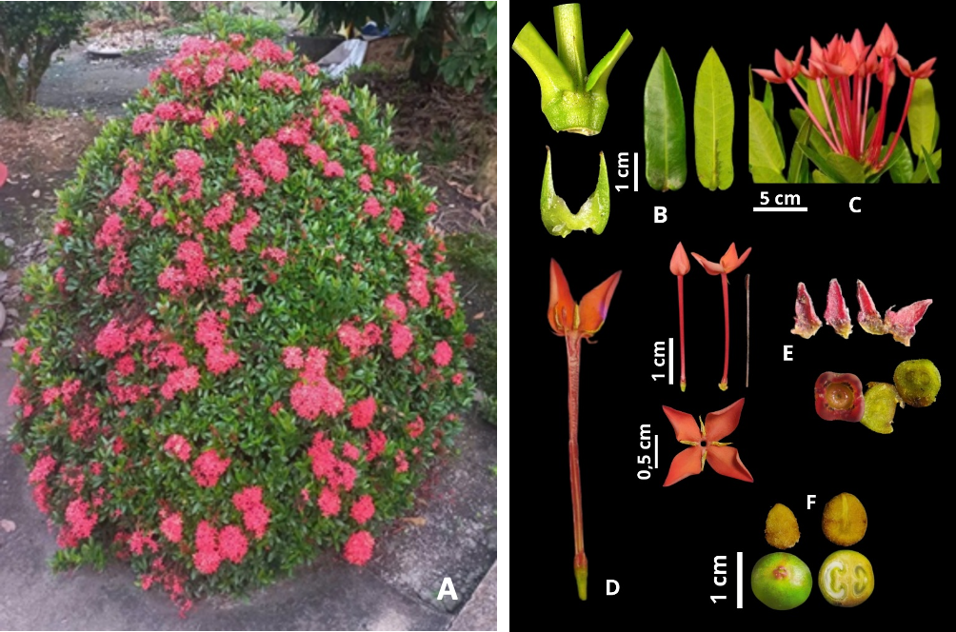
Fig. 1. Morphological characteristics of Ixora coccinea L.
A. Habit; B. Leaf and stipules; C. Inflorescence; D. Longitudinal section of the flower; E. Androecium and gynoecium; F. Fruit and seeds.
3.2 Anatomical structure
Root. The transverse section is almost circular. The cork consists of several layers of unevenly sized, closely packed rectangular cells with cellulose walls. The suberised layer comprises one to two layers of irregularly rectangular cells with suberised walls. The cortical parenchyma consists of fourteen to sixteen layers of irregularly polygonal cells with cellulose walls arranged without order. The endodermis with Casparian strips is a single layer of rectangular to polygonal cells. The pericycle comprises one to two layers of polygonal cells of uneven size, some of which are sclerified. The primary phloem lies immediately outside the secondary phloem, which is thin-walled and arranged in radial rows; the secondary xylem occupies the centre, and the primary xylem is difficult to distinguish. Prismatic calcium oxalate crystals are scattered through the cortical parenchyma (Fig. 2).
Stem. The transverse section is almost circular. The epidermis consists of a single layer of unevenly sized polygonal cells covered by a thin cuticle and bearing unicellular covering trichomes. The angular collenchyma comprises four to seven layers of irregularly polygonal cells with cellulose walls arranged without order. The cortical parenchyma consists of seven to ten layers of irregularly polygonal cells. The pericycle is sclerified and forms discontinuous groups of sclereids. The primary phloem consists of small polygonal cells with sinuous walls arranged without order, while the secondary phloem comprises four to six layers of polygonal cells arranged in radial rows. The secondary xylem consists of polygonal vessels of fairly uniform size showing centrifugal differentiation, and the primary xylem comprises three to four layers of polygonal cells alternating with the secondary xylem. The pith parenchyma consists of rounded polygonal cells arranged without order, and prismatic calcium oxalate crystals occur in the cortical parenchyma (Fig. 3).
Leaf. In the midrib, the upper and lower epidermis each consist of a single layer of relatively uniform rectangular to polygonal cells, closely packed and covered by a fairly thick cuticle. Angular collenchyma is present on both sides and comprises four to nine layers of rounded polygonal cells with cellulose walls. The parenchyma consists of five to seven layers of polygonal cells with cellulose walls. The vascular system comprises eighteen to twenty-two collateral bundles; the xylem consists of polygonal cells arranged in rows, the primary phloem consists of fairly uniform polygonal cells with cellulose walls arranged in straight rows, and one to three layers of sclereids lie outside the primary phloem. In the lamina, the upper and lower epidermis each consist of a single layer of rectangular cells of relatively uniform size, closely packed and covered by a thin cuticle; the palisade parenchyma comprises one to two layers of cells with cellulose walls, and the spongy parenchyma likewise comprises one to two layers; prismatic calcium oxalate crystals are present in the parenchyma of the midrib (Fig. 4).
Corolla tube. The inner and outer epidermis each consist of a single layer of polygonal cells of relatively uniform size. The parenchyma comprises eight to eleven layers of unevenly sized polygonal cells with cellulose walls arranged without order. Eight vascular bundles are arranged in a single circle, each consisting of primary phloem and primary xylem; the primary phloem comprises two to four layers of polygonal cells of uneven size surrounding the primary xylem, which consists of one to two layers of irregularly polygonal cells with lignified walls arranged in an arc inside the phloem (Fig. 5).
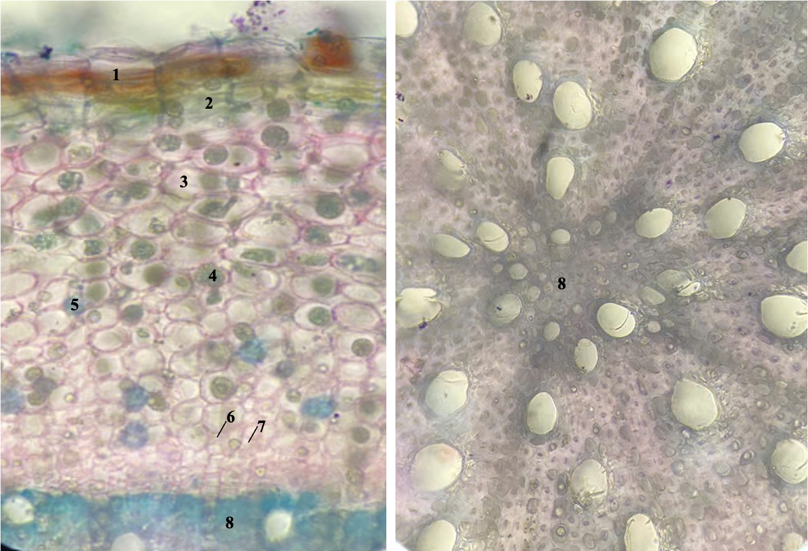
Fig. 2. Transverse section of the root (left, general view; right, detail)
(1) cork, (2) suberised layer, (3) cortical parenchyma with intercellular spaces, (4) calcium oxalate crystal, (5) sclereid, (6) primary phloem, (7) secondary phloem, (8) secondary xylem.
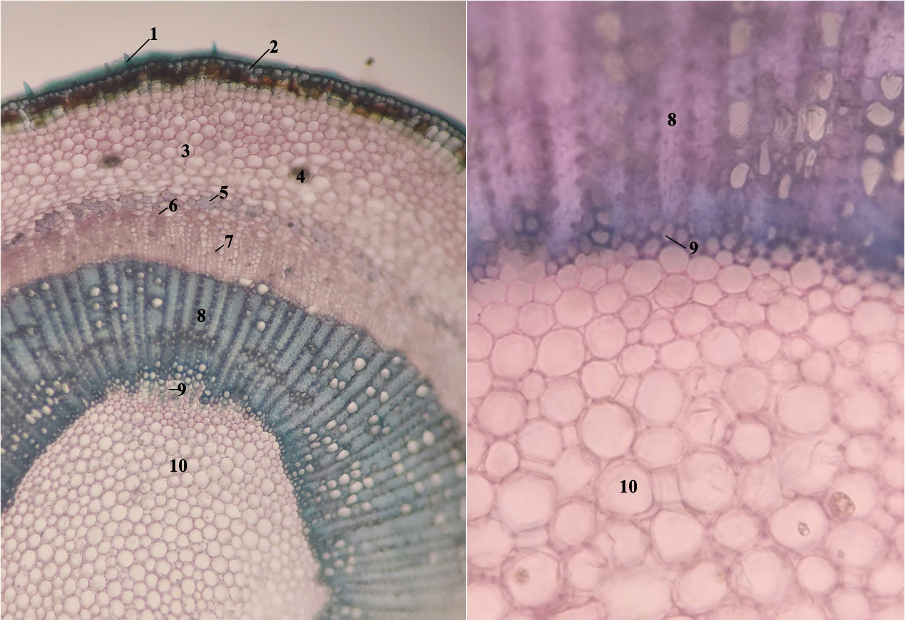
Fig. 3. Transverse section of the stem (left, general view; right, detail)
(1) unicellular covering trichome, (2) epidermis, (3) cortical parenchyma with intercellular spaces, (4) calcium oxalate crystal, (5) sclereid, (6) primary phloem, (7) secondary phloem, (8) secondary xylem, (9) primary xylem parenchyma, (10) pith parenchyma with intercellular spaces.
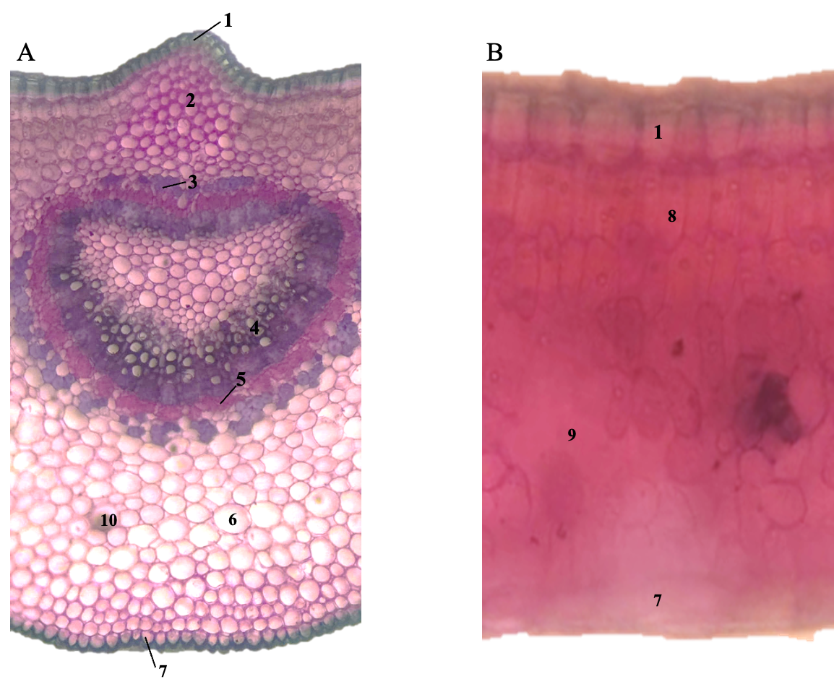
Fig. 4. Transverse section of the leaf, (A) midrib and (B) lamina
(1) upper epidermis, (2) collenchyma, (3) sclereid, (4) primary xylem, (5) primary phloem, (6) parenchyma with intercellular spaces, (7) lower epidermis, (8) palisade parenchyma, (9) spongy parenchyma, (10) calcium oxalate crystal.
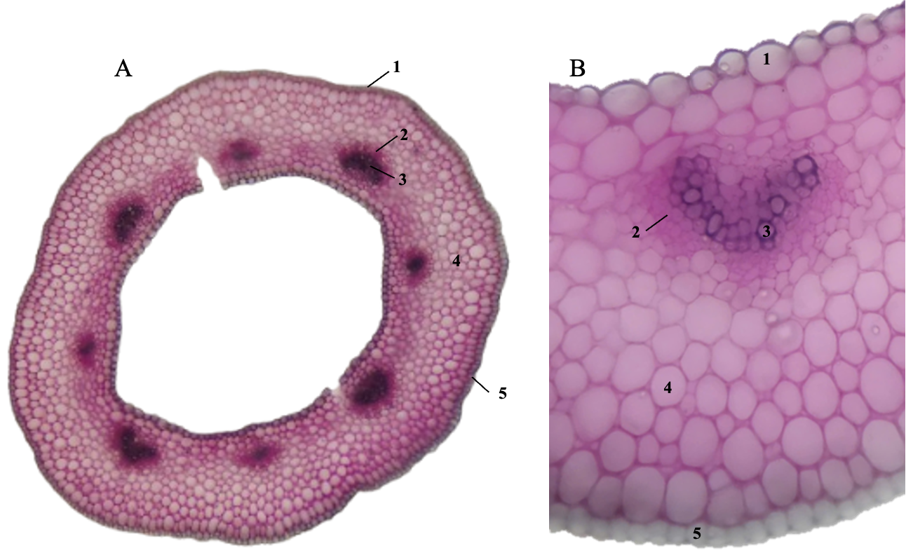
Fig. 5. Transverse section of the corolla tube, (A) general view and (B) detail
(1) outer epidermis, (2) primary phloem, (3) primary xylem, (4) parenchyma with intercellular spaces, (5) inner epidermis.
3.3 Microscopy of the flower powder
The powdered flowers are pale orange in colour (Fig. 6A), with a faint aromatic odour and no particular taste. Under the light microscope, the following diagnostic elements are seen: stomata, fragments of pigment-bearing epidermis, ovoid pollen grains with three germ pores, unicellular covering trichomes and fragments of scalariform vessels (Fig. 6).
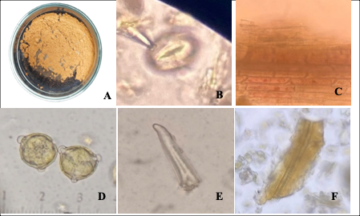
Fig. 6. Diagnostic elements of the flower powder of I. coccinea
A. Flower powder; B. Stoma; C. Fragment of pigment-bearing epidermis; D. Pollen grains; E. Unicellular covering trichome; F. Fragment of a scalariform vessel.
The morphology of the sample collected in Vinh Huu commune agreed in every respect with the descriptions of Ixora coccinea L. given in the published literature, particularly in those features that carry diagnostic weight, namely the triangular interpetiolar stipules, the orange-red dichasial cymes, the corolla fused into a long tube with four salver-shaped lobes, the stamens inserted on the corolla tube and alternating with the lobes, the inferior two-locular ovary and the berry containing two seeds (Lim, 2014; Gopalkrishnan & Chiranjeev, 2018). The authenticity of the material used in the study is thereby confirmed.
The study also provides data on the anatomical structure and microscopy of the flower powder that were previously lacking in the Vietnamese literature. The unicellular covering trichomes on the stem epidermis, the sclerified pericycle and the clearly visible endodermis with Casparian strips in the root, together with diagnostic elements of the flower powder such as pollen grains with three germ pores, fragments of pigment-bearing epidermis and fragments of scalariform vessels, constitute practical criteria for the quality control and identification of the herbal material, especially when it is presented as a powder and external morphological characteristics are no longer available. Compared with an earlier description of the flowers of the same species, the elements recorded here are similar, which indicates that these microscopic criteria remain stable between different areas of collection (Gopalkrishnan & Chiranjeev, 2018).
3.4 Phytochemical constituents
The results of the preliminary identification of the phytochemical constituents of the flowers by specific colour reactions are presented in Table 1.
Table 1. Preliminary phytochemical screening of the flowers of Ixora coccinea L.
No. | Particulars | Result of the qualitative reaction
 |  | Diethyl ether extract | Ethanol extract | Aqueous extract
1 | Alkaloids | ++ | – | ++
2 | Flavonoids | – | +++ | +++
3 | Anthraquinones | – | + | +
4 | Saponins | – | – | +
5 | Coumarins | – | ++ | +
6 | Anthocyanosides | – | – | +++
7 | Proanthocyanidins | – | – | +++
8 | Polyphenols | – | ++ | +++
9 | Tannins | – | +++ | +++
10 | Reducing compounds | – | + | –
11 | Organic acids | ++ | + | –
(–) absent; (±) doubtful; (+) present in small amount; (++) present in large amount; (+++) present in very large amount.
The flowers were rich in polar classes of compounds, with flavonoids, tannins and polyphenols present in very large amounts in both the ethanol and aqueous extracts, whereas anthocyanosides and proanthocyanidins were detected only in the aqueous extract. Alkaloids, saponins, anthraquinones, coumarins, reducing compounds and organic acids were present at lower levels.
This profile is consistent with earlier reports on the constituents of the genus Ixora (Đỗ et al., 2004). The presence of flavonoids, tannins, polyphenols, anthocyanosides and proanthocyanidins in the polar extracts is noteworthy because polyphenolic compounds, particularly flavonoids and condensed tannins, have long been recognised as widespread natural inhibitors of pancreatic lipase, acting through non-specific interactions with the active site of the enzyme and through modification of the spatial configuration of the protein (Buchholz & Melzig, 2015).
3.5 Yield of the total extract and of the fractions
Five hundred grams of powdered flowers with a moisture content of 11.5 % was macerated in the cold with ethanol 96 % and gave 62.42 g of total extract with a moisture content of 12.56 %, corresponding to an extraction yield of 12.34 % calculated on the dry weight of the herbal material taken for extraction. Liquid – liquid partitioning of this total extract with solvents of increasing polarity gave four fractions whose masses, moisture contents and yields are presented in Table 2.
Table 2. Yield of the fractions obtained from the total ethanol 96 % extract
Particulars | n–Hexane | Dichloromethane | Ethyl acetate | n–Butanol
Mass (g) | 6.19 | 9.63 | 15.71 | 10.56
Moisture (%) | 9.10 | 3.88 | 7.34 | 8.17
Yield (%) | 10.30 | 16.96 | 26.67 | 17.77
Yields are expressed on a dry weight basis, relative to the dry weight of the total extract.
The ethyl acetate fraction was by far the most abundant, accounting for more than a quarter of the dry weight of the total extract, followed by the n–butanol and dichloromethane fractions, whereas the n–hexane fraction was the smallest. The distribution of the material among the fractions is therefore consistent with the phytochemical profile described above, with the constituents of the flowers being predominantly of medium to high polarity.
3.6 Pancreatic lipase inhibitory activity of the extracts
The extracts prepared from the flowers inhibited pancreatic lipase to differing extents. The total ethanol 96 % extract was the most active, with an IC₅₀ of 83.98 ± 4.38 µg/mL. Among the fractions, the ethyl acetate fraction was the most active, followed by the dichloromethane and the n–butanol fractions, whereas the n–hexane fraction was the least active. The positive control orlistat gave an IC₅₀ of 1.45 ± 0.22 µg/mL (Table 3).
Table 3. Pancreatic lipase inhibitory activity of the extracts of I. coccinea flowers and of the reference compound
Test sample | IC₅₀ (µg/mL) | Regression equation | R²
Total ethanol 96 % extract | 83.98 ± 4.38 | y = 13.267 ln(x) + 82.964 | 0.9806
n–Hexane fraction | 1238.19 ± 19.48 | y = 19.036 ln(x) + 45.933 | 0.9598
Dichloromethane fraction | 259.07 ± 27.81 | y = 13.035 ln(x) + 67.606 | 0.9824
Ethyl acetate fraction | 123.88 ± 3.25 | y = 17.605 ln(x) + 86.767 | 0.9845
n–Butanol fraction | 275.33 ± 10.27 | y = 16.888 ln(x) + 71.784 | 0.9873
Orlistatª | 1.45 ± 0.22 | y = 7.4261 ln(x) + 98.532 | 0.9783
ª positive control. Data are expressed as mean ± SD (n = 3). In the regression equations, y is the percentage inhibition and x the concentration of the test sample in µg/mL.
The percentage inhibition recorded at each concentration is presented in Table 4 for the extracts and in Table 5 for the reference compound, and the corresponding concentration-response curves are shown in Fig. 7. All the samples inhibited the enzyme in a concentration-dependent manner over the range tested.
Table 4. Inhibition of pancreatic lipase (%) by the extracts of I. coccinea flowers at each concentration tested
Concentration (µg/mL) | Total extract | n–Hexane | Dichloromethane | Ethyl acetate | n–Butanol
15.625 | 21.56 ± 1.02 | – | 13.27 ± 0.94 | 7.41 ± 0.63 | 2.92 ± 0.31
31.25 | 40.29 ± 1.87 | – | 21.48 ± 1.13 | 26.33 ± 1.42 | 14.06 ± 0.88
62.5 | 48.39 ± 2.11 | – | 27.76 ± 1.36 | 44.59 ± 2.05 | 24.23 ± 1.19
125 | 56.33 ± 2.34 | 1.56 ± 0.18 | 42.74 ± 1.92 | 52.79 ± 2.21 | 36.96 ± 1.64
250 | 65.82 ± 2.58 | 23.14 ± 1.24 | 52.93 ± 2.17 | 63.13 ± 2.48 | 48.28 ± 1.97
500 | 75.71 ± 2.92 | 35.38 ± 1.71 | 62.77 ± 2.44 | 71.80 ± 2.73 | 52.70 ± 2.08
1000 | 81.42 ± 3.06 | 49.02 ± 2.03 | 65.22 ± 2.51 | 85.83 ± 3.12 | 74.89 ± 2.67
2000 | 89.47 ± 3.31 | 54.59 ± 2.22 | 73.99 ± 2.76 | 98.20 ± 3.45 | 86.12 ± 2.98
Values are mean ± SD (n = 3). (–) not tested at this concentration.
Table 5. Inhibition of pancreatic lipase (%) by orlistat at each concentration tested
Concentration (µg/mL) | Inhibition (%) | Concentration (µg/mL) | Inhibition (%)
1.875 | 52.18 ± 1.94 | 30 | 75.30 ± 2.61
3.75 | 56.06 ± 2.07 | 60 | 79.43 ± 2.74
7.5 | 60.04 ± 2.19 | 120 | 80.36 ± 2.79
15 | 68.58 ± 2.42 | 240 | 87.32 ± 3.03
Values are mean ± SD (n = 3).
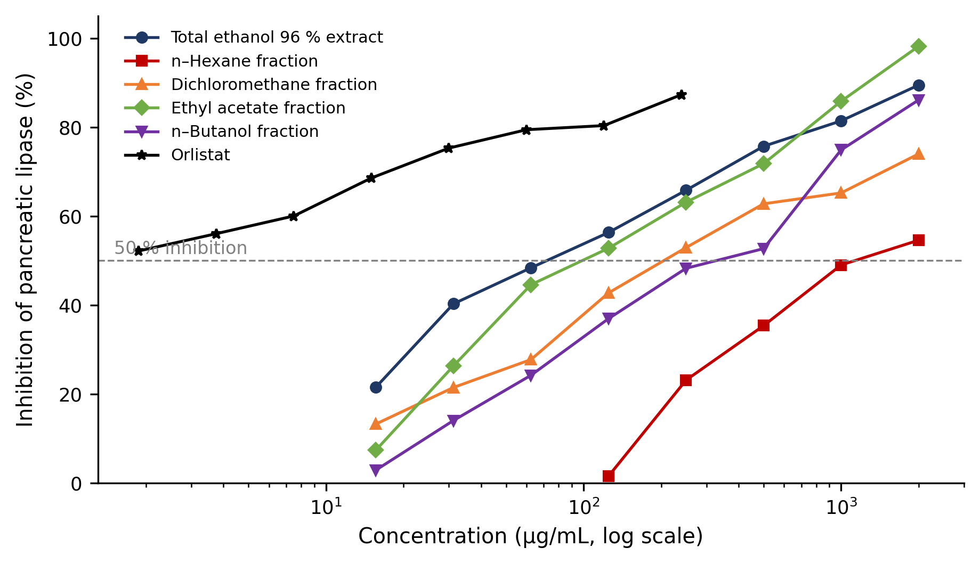
Fig. 7. Concentration-response curves for the inhibition of pancreatic lipase by the extracts of I. coccinea flowers and by orlistat
Values are mean of three independent replicates; the dashed line marks 50 % inhibition.
The trend observed here supports the hypothesis set out above. The fractions of medium and high polarity, in which the phenolic compounds are concentrated, inhibited the enzyme far more effectively than the low-polarity fraction; the n–hexane fraction, which contains chiefly fats, sterols and other weakly polar substances, showed, by contrast, very low activity. It is noteworthy that the total extract was more active than any of the fractions derived from it. Such an observation may be explained either by synergistic action among the classes of compounds coexisting in the total extract or by liquid – liquid partitioning dispersing the active constituents among several fractions, such that their concentration in any one fraction is no longer sufficient to maintain the original potency. From an application perspective, this result suggests that the total ethanol 96 % extract may be a suitable form of raw material for further product-development studies because it is both more potent and simpler to manufacture.
Compared with the reference compound, the potency of the extracts remains considerably lower than that of orlistat. This difference is expected when a multicomponent mixture is compared with a pure active substance whose structure has been optimised and which acts by irreversible inhibition. In relation to other herbal materials evaluated by the same method, such as the polyphenol- and saponin-enriched extract of Musa balbisiana fruit, the level of activity recorded for the flowers of I. coccinea supports further investigation of this species (Nguyen et al., 2024). The search for new lipase inhibitors of plant origin continues to attract interest, particularly because the gastrointestinal adverse effects of orlistat can limit adherence to treatment (Birari & Bhutani, 2007).

Limitations
The study nevertheless has certain limitations. First, the characterisation of the herbal material was botanical only: the physicochemical parameters normally used for pharmacopoeial standardisation, namely total ash, acid-insoluble ash, water-soluble ash, alcohol- and water-soluble extractive values and loss on drying, were not determined, and these remain necessary before a monograph can be drawn up. Second, the activity has so far been assessed only in vitro using the isolated enzyme, which does not fully reflect the bioavailability and metabolism of the compounds in a living organism. Therefore, no inference about an anti-obesity effect in humans can be drawn from the present data. The constituents responsible for the effect have not been isolated, and their structures have not been elucidated; consequently, no conclusion can yet be drawn about the mechanism of inhibition at the molecular level. Further work should therefore focus on isolating pure compounds from the total extract and ethyl acetate fraction, determining the type of enzyme inhibition, evaluating the effect in experimental models of obesity, and assessing the toxicity of the herbal material.
4. Conclusion
This study established the macroscopic, anatomical and powder-microscopic characteristics of Ixora coccinea L. flowers and related plant structures, providing botanical information relevant to the standardisation and quality control of the herbal material. Preliminary phytochemical screening showed that the flowers contain several polar classes of constituents, with flavonoids, tannins and polyphenols particularly prominent. Extraction of 500 g of powdered flowers with 96 % ethanol produced a total extract at a dry-weight yield of 12.34 %. In the pancreatic lipase assay, the total extract showed the greatest inhibitory activity, with an IC₅₀ of 83.98 ± 4.38 µg/mL, while the ethyl acetate fraction was the most active partitioned fraction. Orlistat remained substantially more potent, with an IC₅₀ of 1.45 ± 0.22 µg/mL. These findings support further investigation of I. coccinea flowers as a source of pancreatic lipase inhibitors. Physicochemical standardisation, isolation of active constituents, inhibition-mechanism studies, toxicity assessment and evaluation in experimental obesity models are required before any application can be considered.
Competing Interests
Authors have declared that no competing interests exist.
Ethical Approval
The study was carried out entirely on plant material and on an in vitro model; neither human subjects nor experimental animals were involved, so that the work did not fall within the remit of the Ethics Committee in Biomedical Research. The herbal material was collected from a commonly cultivated source and does not belong to the list of endangered, precious or rare species given priority for protection. The Faculty of Pharmacy, Nguyen Tat Thanh University, has authorised the use and publication of the data presented.
Declaration of AI Use

This manuscript was prepared through the intellectual contributions of the author(s) to the study design, data analysis, interpretation of results, and scholarly content. Grammarly and ChatGPT were used solely to assist with grammatical refinement and reference formatting during manuscript revision. The author(s) accept full responsibility for the accuracy, integrity, and final content of the manuscript.

References
Annapurna, J., Amarnath, P. V. S., Amar Kumar, D., Ramakrishna, S. V., & Raghavan, K. V. (2003). Antimicrobial activity of Ixora coccinea leaves. Fitoterapia, 74(3), 291–293. https://doi.org/10.1016/S0367-326X(03)00037-6
Baliga, M. S., & Kurian, P. J. (2012). Ixora coccinea Linn.: Traditional uses, phytochemistry and pharmacology. Chinese Journal of Integrative Medicine, 18(1), 72–79. https://doi.org/10.1007/s11655-011-0881-3
Bharathy, P., Thanikachalam, P. V., Shoban, A. N., & Himayavendhan, H. V. (2024). Floral fusion: Unravelling the potent blend of Ixora coccinea and Rhododendron arboreum for health and safety benefits. Cureus, 16(9), e70038. https://doi.org/10.7759/cureus.70038
Birari, R. B., & Bhutani, K. K. (2007). Pancreatic lipase inhibitors from natural sources: Unexplored potential. Drug Discovery Today, 12(19–20), 879–889. https://doi.org/10.1016/j.drudis.2007.07.024
Biswas, A., Maola, M., Islam, M. M., Mondal, S., Sachchu, M. M. H., Tandra, N., Liza, N. Y., Akand, M. S., Alam, M. A., & Al-Reza, S. M. (2026). Strategic roadmap for exploring phytochemical profiles of Ixora nigricans L. flowers and leaves extract: The X-ray diffraction overview insight. Journal of Biology and Nature, 18(1), 569–586. https://doi.org/10.56557/joban/2026/v18i110571
Buchholz, T., & Melzig, M. F. (2015). Polyphenolic compounds as pancreatic lipase inhibitors. Planta Medica, 81(10), 771–783. https://doi.org/10.1055/s-0035-1546173
Chen, L.-J., Zhang, Y., & Chen, Y.-G. (2016). Chemical constituents of plants from the genus Ixora. Chemistry & Biodiversity, 13(3), 275–283. https://doi.org/10.1002/cbdv.201500065
Department of Pharmacognosy. (2017). Phương pháp nghiên cứu dược liệu [Methods of research on medicinal plants]. University of Medicine and Pharmacy at Ho Chi Minh City.
Đỗ, H. B., Đặng, Q. C., Bùi, X. C., Nguyễn, T. D., Đỗ, T. Đ., Phạm, V. H., Vũ, N. L., Phạm, D. M., Phạm, K. M., Đoàn, T. N., Nguyễn, T., & Trần, T. (2004). Cây thuốc và động vật làm thuốc ở Việt Nam [Medicinal plants and animals used as medicine in Vietnam] (Vol. 2). Nhà xuất bản Khoa học và Kỹ thuật.
Dontha, S., Kamurthy, H., & Manthripragada, B. R. (2015). Phytochemical screening and evaluation of in-vitro anti-oxidant activity of extracts of Ixora javanica D. C flowers. American Chemical Science Journal, 10(1), 1–9. https://doi.org/10.9734/ACSJ/2016/20661
Gopalkrishnan, B., & Chiranjeev, R. (2018). Pharmacognostical study of Ixora coccinea flower. Pharmacognosy Journal, 10(5), 1042–1046. https://doi.org/10.5530/pj.2018.5.176
Guddi, K., & Sarkar, A. (2024). Optimization of green extraction technologies for recovering bioactive compounds from Ixora coccinea waste flower biomass: A comparative response surface methodology and artificial neural network modeling. Sustainable Chemistry and Pharmacy, 42, 101830. https://doi.org/10.1016/j.scp.2024.101830
Idowu, T. O., Ogundaini, A. O., Salau, A. O., Obuotor, E. M., Bezabih, M., & Abegaz, B. M. (2010). Doubly linked, A-type proanthocyanidin trimer and other constituents of Ixora coccinea leaves and their antioxidant and antibacterial properties. Phytochemistry, 71(17–18), 2092–2098. https://doi.org/10.1016/j.phytochem.2010.08.018
Lim, T. K. (2014). Ixora coccinea. In Edible medicinal and non-medicinal plants: Volume 8, flowers (pp. 734–744). Springer. https://doi.org/10.1007/978-94-017-8748-2_60
Nguyen, T. T. H., Dinh, K. D., Nguyen, H. T., & Hoang, T. N. N. (2024). Anti-lipase and MCF-7 breast cancer cell proliferation inhibition in vitro of the extract-enriched polyphenols and saponins from Musa balbisiana fruit. HUIT Journal of Science, 24(1), 93–99. https://doi.org/10.62985/j.huit_ojs.vol24.no1.24
Ragasa, C. Y., Tiu, F., & Rideout, J. A. (2004). New cycloartenol esters from Ixora coccinea. Natural Product Research, 18(4), 319–323. https://doi.org/10.1080/14786410310001630519
Rajayan, J. S., Chandrasekar, V., Duraipandian, C., & Rajendran, K. (2024). In vitro evaluation of extracts from Ixora species for a potential phytosomal formulation. Cureus, 16(3), e55396. https://doi.org/10.7759/cureus.55396
Shreelakshmi, S. V., Chaitrashree, N., Kumar, S. S., Shetty, N. P., & Giridhar, P. (2021). Fruits of Ixora coccinea are a rich source of phytoconstituents, bioactives, exhibit antioxidant activity and cytotoxicity against human prostate carcinoma cells and development of RTS beverage. Journal of Food Processing and Preservation, 45(7), e15656. https://doi.org/10.1111/jfpp.15656
Torey, A., Sasidharan, S., Latha, L. Y., Sudhakaran, S., & Ramanathan, S. (2010). Antioxidant activity and total phenolic content of methanol extracts of Ixora coccinea. Pharmaceutical Biology, 48(10), 1119–1123. https://doi.org/10.3109/13880200903490505
Vulichi, S. R., Runthala, A., Rachamreddy, S. K., Yaramanedi, R. S. P., Sahoo, P. S., Burra, P. V. L. S., Kaur, N., Akkiraju, S., Kanala, S. R., Chippada, A. R., & Murthy, S. D. S. (2023). Appraisal of pancreatic lipase inhibitory potential of Ziziphus oenoplia (L.) Mill. leaves by in vitro and in silico approaches. ACS Omega, 8(19), 16630–16646. https://doi.org/10.1021/acsomega.2c07361
World Obesity Federation. (2026). World obesity atlas 2026: Childhood obesity (2nd ed.). https://www.worldobesity.org/resources/resource-library/world-obesity-atlas-2026
Yadav, N., & Paul, A. T. (2024). Pancreatic lipase and its related proteins: Where are we now? Drug Discovery Today, 29(1), 103855. https://doi.org/10.1016/j.drudis.2023.103855

