Evaluation of Acute Oral Toxicity, Anti-inflammatory and Anti-hyperuricemic Activities of the Herbal Remedy Lamgout in Mice

Abstract
Background: Lamgout is a herbal preparation containing eight medicinal plants and was experimentally evaluated for acute oral toxicity, anti-inflammatory activity, and uric acid-lowering effects in mice. Methods: Swiss albino mice were used for the experiments. Acute oral toxicity was assessed following administration of the maximum feasible volume of Lamgout extract, corresponding to 182 g of dried herbal material/kg, and the animals were observed for up to 14 days. Anti-inflammatory activity was evaluated using a 1% carrageenan-induced hind paw oedema model after oral treatment with Lamgout at 7 or 14 g of dried herb/kg; diclofenac 5 mg/kg served as the positive control. Anti-hyperuricaemic activity was assessed in potassium oxonate-induced hyperuricaemia using preventive and therapeutic models, with allopurinol 10 mg/kg as the positive control. Results: No mortality or observable signs of acute toxicity occurred following administration of 182 g of dried herb/kg. Both Lamgout doses significantly reduced carrageenan-induced paw oedema compared with the model control. In the preventive model, plasma uric acid was reduced by 37.07% and 50.86% at 7 and 14 g/kg, respectively, compared with 82.76% for allopurinol. In the therapeutic model, the corresponding reductions were 40.52%, 43.97%, and 74.14%. Conclusion: Under the experimental conditions used, Lamgout showed no observable acute oral toxicity at the maximum tested dose and demonstrated anti-inflammatory and uric acid-lowering activities in mice. Further studies are required to characterise its active constituents, mechanisms, longer-term safety, and potential clinical relevance.

Keywords: Lamgout; acute oral toxicity; anti-inflammatory; hyperuricemia; carrageenan; potassium oxonate.
1. Introduction
For a long time, gout was regarded as a rare condition and a disease of the wealthy. Since the beginning of the twenty-first century, however, its prevalence has been rising rapidly worldwide: between 1990 and 2017, approximately 7.4 million new cases were reported every year, and both the incidence and the number of years lived with disability attributable to gout have continued to increase across most regions (Safiri et al., 2020). Gout results from a disturbance of purine metabolism that raises the concentration of uric acid in the blood; when the solubility limit is exceeded, monosodium urate crystals precipitate in joints and soft tissues and trigger an intense inflammatory response.
The management of gout in modern medicine requires a combination of several classes of drugs: non-steroidal anti-inflammatory drugs and colchicine for the acute flare, and xanthine oxidase inhibitors such as allopurinol or febuxostat for long-term control of serum urate (Pillinger & Mandell, 2020). Beneficial as they are, these agents are associated with adverse effects, including gastritis, gastrointestinal bleeding, urticaria and erythema. Allopurinol, in particular, may cause peptic ulceration, rash, Stevens-Johnson syndrome, hepatocellular necrosis and hepatic granulomas (Rundles, 1985). These limitations explain the sustained interest of researchers in herbal preparations that combine an effective urate-lowering action with a more favourable safety profile. Recent reviews of herbal and phytochemical approaches to hyperuricaemia and gout indicate that plant-derived interventions are being investigated for urate-lowering and anti-inflammatory effects, while also emphasising the need for stronger mechanistic and clinical validation (Chenchula et al., 2025; Li et al., 2025; Mahomoodally et al., 2024).
Preclinical evidence also includes uric-acid-lowering effects of an ethanolic Elephantopus scaber extract in hyperuricaemic rats, illustrating the continued experimental evaluation of plant-derived urate-lowering interventions (Musdja et al., 2019).
The Lamgout remedy was formulated from eight medicinal plants whose uric acid-lowering activity has been documented in Vietnam and abroad: Gnetum montanum Markgr., Siegesbeckia orientalis L., Caesalpinia sappan L., Tinospora sinensis (Lour.) Merr., Angelica acutiloba (Siebold & Zucc.) Kitag., Cibotium barometz J. Sm., Cinnamomum cassia Blume and Stevia rebaudiana (Bertoni) Hemsley (Trinh & Huynh, 2017). Before such a formula can be recommended for clinical use in gout or gouty arthritis, however, its safety and anti-inflammatory and urate-lowering efficacy must be established experimentally. A recent review of cinnamon, including Cinnamomum cassia, describes anti-inflammatory activity among its reported pharmacological properties, providing additional context for the anti-inflammatory component of the Lamgout formulation (Bansal et al., 2025).
Accordingly, an evidence gap remains for the complete Lamgout formulation with respect to the three outcomes examined in this study: acute oral safety, anti-inflammatory activity, and urate-lowering activity.
The present study was therefore undertaken with three specific objectives: to determine the acute oral toxicity of the Lamgout extract; to evaluate its anti-inflammatory activity in vivo using the 1 % carrageenan-induced paw oedema model; and to evaluate its preventive and therapeutic effects on potassium oxonate-induced hyperuricaemia in mice.
2. Materials and Methods
2.1 Materials and instruments
2.1.1 Test material
The aqueous Lamgout extract was supplied by MSc Hoang Van Lam, formerly a lecturer at the Department of Botany, Hanoi University of Pharmacy. All the herbal ingredients complied with the standards laid down in the Vietnamese Pharmacopoeia V. The composition of one dose of the remedy is presented in Table 1.
Table 1. Composition of one dose of the Lamgout remedy
Ingredient (Vietnamese name / botanical name) | Weight (mg)
Gam (Gnetum montanum Markgr.) | 8000
Hy thiem (Siegesbeckia orientalis L.) | 5000
To moc (Caesalpinia sappan L.) | 5000
Day dau xuong (Tinospora sinensis (Lour.) Merr.) | 4500
Duong quy (Angelica acutiloba (Siebold & Zucc.) Kitag.) | 4000
Cau tich (Cibotium barometz J. Sm.) | 4000
Que chi (Cinnamomum cassia Blume) | 4000
Co ngot (Stevia rebaudiana (Bertoni) Hemsley) | 1900
Total | 36400
One dose of Lamgout contains a total of 36.4 g of dried herbal material, which was extracted with a suitable solvent and concentrated under vacuum to yield 3.54 g of soft extract; excipients, sodium benzoate as a preservative, and purified water were then added to a final volume of 10 mL. For the pharmacological experiments, the extract was diluted with distilled water to the required concentrations, and all doses are expressed as grams of dried herbal material per kilogram of body weight. The remedy is intended to be taken by a 60 kg adult at two doses per day, equivalent to 1.2 g of dried herb/kg; conversion to the mouse using a factor of 11.76 gives a projected effective dose of 14 g of dried herb/kg/day, corresponding to 3.8 mL of Lamgout extract/kg/day (Ministry of Health of Vietnam, 2015).
Each of the eight ingredients has been investigated phytochemically, and the classes of compounds to which their reported anti-inflammatory and urate-lowering effects are attributed are summarised in Table 2. Several of these constituents, in particular the 2-phenylbenzofurans of G. montanum and the homoisoflavonoids of C. sappan, are documented inhibitors of xanthine oxidase, whereas the diterpenoids of S. orientalis and the phthalides of A. acutiloba act chiefly on inflammatory mediators. The remedy therefore brings together, within a single preparation, constituents acting on both processes evaluated in the present study.
Table 2. Principal constituents reported for the eight ingredients of the Lamgout remedy
Ingredient | Principal constituents reported | Reference
Gnetum montanum | Stilbenes and 2-phenylbenzofurans (resveratrol, gnetol, gnetifolin M, gnetumgam A and B); gnetumgam B and gnetifolin M inhibit xanthine oxidase | Xiang et al. (2002); Do et al. (2026)
Siegesbeckia orientalis | Diterpenoids, of which kirenol is the quality-control marker, together with phenolic acids and flavonoids | Wang J. P. et al. (2011); Wang Q. et al. (2021)
Caesalpinia sappan | Homoisoflavonoids and protosappanins, chiefly brazilin and brazilein; several inhibit xanthine oxidase | Nguyen M. T. T. et al. (2005); Nirmal et al. (2015)
Tinospora sinensis | Alkaloids (berberine) and phenolic acids (caffeic acid, ferulic acid) together with the flavonol myricetin | Chi et al. (2016)
Angelica acutiloba | Phthalides, of which Z-ligustilide is the principal anti-inflammatory constituent | Uto et al. (2015)
Cibotium barometz | Phenolic acids (protocatechuic acid, caffeic acid) and their glycosides, and sesquiterpenes of the 1-indanone type | Nguyen X. C. et al. (2009)
Cinnamomum cassia | Volatile constituents of the twig oil, chiefly cinnamaldehyde, which lower TNF-α, IL-1β and PGE2 | Sun et al. (2016)
Stevia rebaudiana | Steviol glycosides, chiefly stevioside and rebaudioside A, with flavonoids and phenolic acids | Orellana-Paucar (2023)
The constituents listed are those reported in the literature for each species; they were not quantified in the preparation used here.
2.1.2 Animals
Male and female Swiss albino mice, 6-8 weeks old and weighing 22 ± 2 g, were provided by the Institute of Vaccines and Medical Biologicals, Nha Trang. Only healthy animals free from malformations or abnormal behaviour were used. They were housed in cages of 25 × 35 × 15 cm with rice husk bedding and were acclimatised to laboratory conditions for two to three days before the experiments; pelleted food and water were available ad libitum throughout the study.
2.1.3 Chemicals
Uric acid assay kit (URIC ACID liquicolor, Human Ltd. Co., Germany), uric acid standard (Randox Laboratories Limited, United Kingdom), uric acid reagent (Elitech, France), carrageenan and potassium oxonate (Sigma Aldrich, USA), CMC-Na (Himedia, India), water-repellent solution (Ugo Basile, Italy), EDTA K3 tubes (An Phu Medical Investment JSC, Vietnam), NaCl 0.9 % (B. Braun, Vietnam), allopurinol 300 mg tablets (Domesco, Vietnam) and Voltaren® 50 tablets containing diclofenac 50 mg (Novartis, Turkey). Routine laboratory reagents were supplied by the Faculty of Pharmacy, Nguyen Tat Thanh University.
2.1.4 Instruments
Satorius CP 4202S technical balance (Germany), Kern ALS 22-4N analytical balance (Germany), Ugo Basile plethysmometer (Italy), BioTek ELISA reader (USA), Hermle centrifuge (Germany), Gilson micropipettes 1-10 µL and 100-1000 µL (USA) and 96-well plates (Biologix, Denmark).
2.2 Methods
2.2.1 Acute oral toxicity of the Lamgout extract
The acute oral toxicity study followed the Litchfield-Wilcoxon method (Do, 2014) and the regulations of the Ministry of Health of Vietnam on the evaluation of the safety and efficacy of traditional medicines. Principle. The acute toxicity of a test sample is characterised, where possible, by the median lethal dose (LD₅₀), that is, the dose that kills 50 % of the animals under defined conditions. The LD₅₀ allows the therapeutic index TI = LD₅₀/ED₅₀ to be calculated, with ED₅₀ being the median effective dose; a substance is considered to have a satisfactory therapeutic window when TI ≥ 10. Procedure. Twelve healthy mice (50 % male, 50 % female) with glossy fur, clear eyes and normal behaviour were randomly allocated to two groups of six. The animals were kept under laboratory conditions for five to seven days and observed so that any abnormal individual could be excluded. Before the experiment, the mice were fasted for at least 12 h with free access to water. The normal group then received distilled water, whereas the test group received a single oral dose of the Lamgout extract at the maximum feasible volume of 50 mL/kg body weight, in accordance with the national guidelines on preclinical and clinical trials of traditional medicines and herbal drugs (Ministry of Health of Vietnam, 2015). General motor activity, behaviour, coat condition, food and water intake, excretion and mortality were recorded for 72 h; if no abnormalities or deaths occurred, observations were continued for 14 days. Had deaths been observed, the dose would have been reduced to establish LD₁₀₀, LD₀ and LD₅₀.
2.2.2 Anti-inflammatory activity on the carrageenan-induced paw oedema model
Anti-inflammatory activity was studied using hind paw oedema induced by λ-carrageenan according to the method of Winter et al. (1962). Carrageenan is a natural sulfated polysaccharide extracted from the red seaweed Chondrus crispus; in pharmacology, it is widely used to screen anti-inflammatory agents, with maximum oedema being reached within 3 to 5 h. A test sample with anti-inflammatory activity reduces the volume of the injected paw. Preparation of solutions. A 1 % carrageenan suspension was soaked in 0.9 % NaCl for at least 2 h to allow complete swelling; the immersion solution consisted of 100 mL of 0.9 % NaCl in 900 mL of distilled water plus 1 mL of water-repellent solution. Procedure. The baseline volume (V₀) of the left hind paw of each mouse was measured with the plethysmometer by dipping the paw into the immersion solution up to the mark on the plantar surface; two readings were taken and averaged. The animals were then randomly allocated to five groups of ten so that V₀ did not differ significantly between groups: group 1, normal (NOR), distilled water; group 2, model control (MC), distilled water; group 3, positive control (DIC 5), diclofenac 5 mg/kg; group 4 (L7), Lamgout extract 7 g of dried herb/kg; group 5 (L14), Lamgout extract 14 g of dried herb/kg. Distilled water, diclofenac or the test extract was administered orally once daily at a volume of 10 mL/kg at a fixed time for six consecutive days. On the seventh day, after 12 h of fasting and 1 h after dosing, the mice of groups 2 to 5 received 0.04 mL of the 1 % carrageenan suspension into the plantar surface of the left hind paw, while the animals of group 1 received 0.9 % NaCl. The mice were then kept in cages fitted with a wire grid to avoid contact of the inflamed paw with the bedding and thus to prevent injury and infection. The paw volume (V_{t}) was measured 3, 5, 8, 24, 48 and 72 h after the injection. The degree of paw oedema X (%) was calculated as:
X (%) = [(V_{t} – V₀) / V₀] × 100
where:
X: degree of paw edema (%);
V₀: paw volume before induction of inflammation (mL);
V_{t}: paw volume at time t after induction of inflammation (mL).
2.2.3 Preventive effect on potassium oxonate-induced hyperuricaemia
Potassium oxonate, 1,4,5,6-tetrahydro-4,6-dioxo-s-triazine-2-carboxylic acid, is a uricase inhibitor. In studies of urate-lowering agents, it partially blocks the conversion of uric acid into allantoin and thereby raises plasma uric acid in mice (Tang et al., 2017). Allopurinol 300 mg tablets (Domesco, Vietnam) served as the positive control. Thirty mice were randomly allocated to five groups of six: group 1, normal (NOR), distilled water for 5 days; group 2, model control (MC), distilled water for 5 days; group 3 (ALLO 10), allopurinol 10 mg/kg for 5 days; groups 4 and 5, Lamgout extract at 7 g (L7) and 14 g (L14) of dried herb/kg for 5 days. All treatments were given orally at 10 mL/kg once daily for five consecutive days. On the fifth day, 1 h before dosing, the mice of groups 2 to 5 received an intraperitoneal injection of potassium oxonate 300 mg/kg at a volume of 10 mL/kg, whereas group 1 received 0.5 % CMC-Na at the same volume. Two hours after the injection, 50 µL of blood was collected from the tail vein into an EDTA K3 tube and centrifuged at 3000 rpm for 10 min at room temperature. Plasma uric acid was determined with the uric acid kit according to the manufacturer's instructions at a wavelength of 505 nm, in parallel with a blank and a uric acid standard, and was calculated as:
C_{test} = [(OD_{test} – OD_{blank}) / (OD_{std} – OD_{blank})] × C_{std} (1)
where:
OD_{test}, OD_{blank}, OD_{std}: absorbance of the test sample, of the blank and of the uric acid standard measured at 505 nm;
C_{std}: concentration of the uric acid standard, 9.22 mg/dL;
C_{test}: plasma uric acid concentration of the test sample.
The percentage reduction of uric acid produced by a test sample was calculated as:
Reduction (%) = [(UA_{MC} – UA_{test}) / UA_{MC}] × 100 (2)
where UA_{MC} and UA_{test} are the plasma uric acid concentrations of the model control group and of the treated group respectively.
2.2.4 Therapeutic effect on acute hyperuricaemia
At time T0, the mice were randomly allocated to five groups as described in section 2.2.3. The animals of the normal group received an intraperitoneal injection of 0.5 % CMC-Na, while acute hyperuricaemia was induced in the remaining groups by an intraperitoneal injection of potassium oxonate 300 mg/kg dissolved in 0.5 % CMC-Na at a volume of 10 mL/kg. One hour after the injection (T = 1 h), the mice received distilled water, allopurinol or the test extract orally at 10 mL/kg. One hour after dosing (T = 2 h), blood was collected from the tail vein and plasma uric acid was measured spectrophotometrically at 505 nm in parallel with a blank and a uric acid standard. The plasma uric acid concentration and the percentage reduction were calculated with equations (1) and (2), as described in section 2.2.3.
2.2.5 Statistical analysis
Data are expressed as mean ± SEM. Differences between groups in the inflammation and hyperuricaemia models were analysed by the Mann-Whitney and Kruskal-Wallis tests using SPSS 26.0. Differences were considered statistically significant at the 95 % confidence level, that is, when P < .05.
3. Results and Discussion
3.1 Acute oral toxicity of the Lamgout extract
To establish the scientific basis for the safety of the Lamgout extract in experimental animals, its acute toxicity was investigated first. The test was carried out on six mice (three males and three females) that received a single oral dose at the maximum feasible volume of 50 mL of extract/kg body weight, equivalent to 182 g of dried herbal material/kg. After administration, all the animals remained healthy: they ate the pelleted food, drank normally, excreted normally and moved normally; no abnormal signs were observed, and no mouse died within 72 h or during the following seven days of observation. Observation was continued for 14 days under normal husbandry conditions, and no deaths or abnormalities in behaviour, coat condition, feeding or excretion occurred. The results are presented in Table 3.
Table 3. Survival and mortality of mice in the acute oral toxicity test
Group | No. of mice | No. of deaths | Mortality (%)
Normal (distilled water) | 6 | 0 | 0
Lamgout extract, 182 g dried herb/kg | 6 | 0 | 0
No LD₅₀ could therefore be determined for the Lamgout extract, which showed no acute oral toxicity at the maximum feasible dose D_{max} of 182 g of dried herb/kg. Compared with the projected effective dose in the mouse of 14 g of dried herb/kg, D_{max} is more than thirteen times higher, which corresponds to a therapeutic index TI ≥ 13. A drug is generally considered to possess a satisfactory therapeutic window when TI ≥ 10 (Do, 2014). These findings demonstrate that the Lamgout extract has a wide margin of safety and justify the selection of the two doses of 7 and 14 g of dried herb/kg, equivalent respectively to 1.9 and 3.8 mL of Lamgout extract/kg and to 1/26 and 1/13 of D_{max}, for the subsequent pharmacological experiments.
3.2 Anti-inflammatory activity of the Lamgout extract
The anti-inflammatory activity of the Lamgout extract at 7 and 14 g of dried herb/kg was evaluated using the model of paw oedema induced by a 1 % carrageenan suspension. After the injection, the paw volume of the mice in all groups was measured 3, 5, 8, 24, 48 and 72 h later; the degrees of oedema obtained are presented in Table 4 and illustrated in Fig. 1.
Table 4. Degree of paw edema (%) in the experimental groups over time
Group (n = 10) | 3 h | 5 h | 8 h | 24 h | 48 h | 72 h
NOR | 0.93 ± 0.62### | 0.87 ± 0.58### | 0.48 ± 0.48### | 0.91 ± 0.61### | 1.35 ± 0.69### | 0.00 ± 0.00###
MC | 71.65 ± 6.19*** | 64.72 ± 4.66*** | 60.57 ± 5.46*** | 54.10 ± 3.68*** | 49.39 ± 4.62*** | 42.97 ± 2.37***
DIC 5 | 38.15 ± 3.36***### | 33.10 ± 2.48***### | 26.33 ± 1.91***### | 22.13 ± 1.40***### | 25.21 ± 2.19***## | 16.95 ± 1.66***###
L7 | 45.37 ± 2.65***## | 38.15 ± 1.99***### | 32.26 ± 1.57***### | 26.57 ± 3.46***## | 28.10 ± 1.81***## | 24.43 ± 2.20***###
L14 | 43.73 ± 3.33***## | 34.01 ± 2.30***### | 28.60 ± 2.04***### | 24.87 ± 2.60***### | 25.54 ± 0.94***### | 22.99 ± 1.59***###
*, **, *** denote P < .05, P < .01 and P < .001 respectively for the difference from the normal group at the same time point; #, ##, ### denote the same probability levels for the difference from the model control group at the same time point. NOR: normal; MC: model control; DIC 5: diclofenac 5 mg/kg; L7 and L14: Lamgout extract at 7 and 14 g of dried herb/kg.
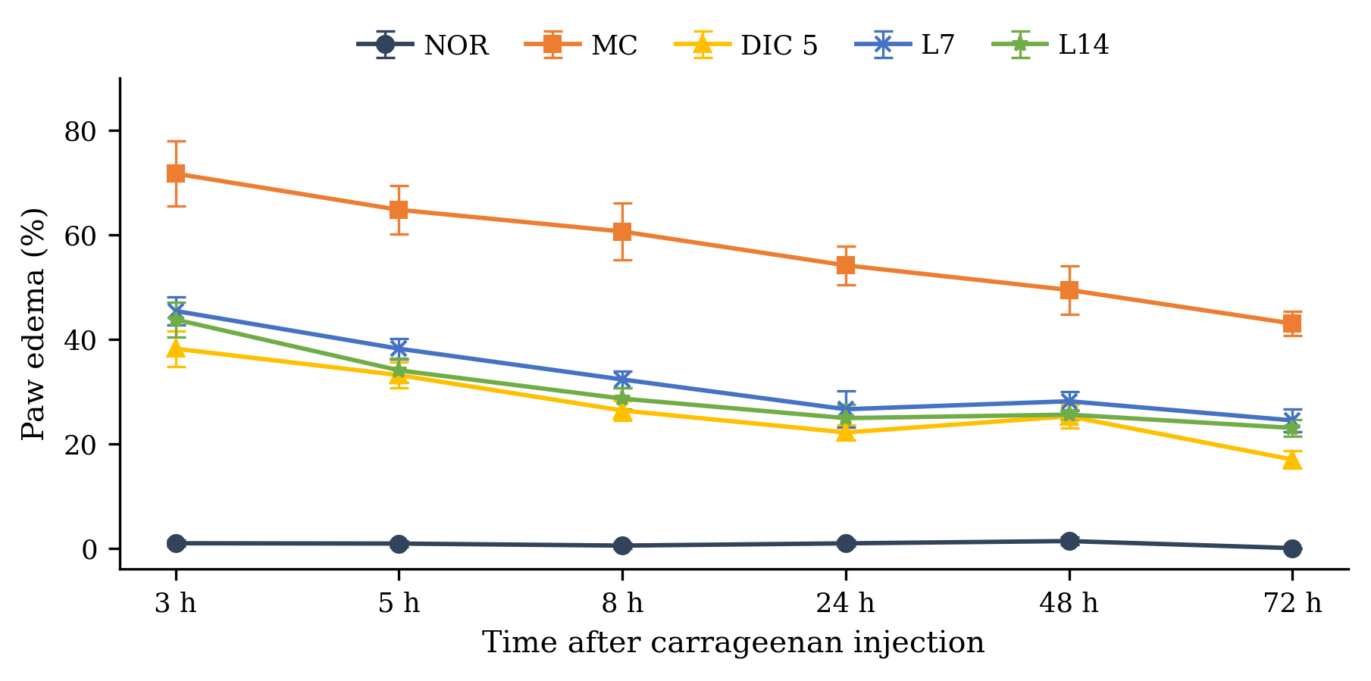
Fig. 1. Degree of paw edema of the experimental groups over time
Values are mean ± SEM (n = 10 per group).
Three hours after the injection, the degree of oedema in all the injected groups was significantly higher than in the normal group (P < .05), which shows that the injection procedure by itself did not induce inflammation of the paw. The paw of the model control group remained markedly swollen throughout the experiment, with swelling being maximal at 3 h and 5 h, with values of 71.65 % and 64.72 %; this is entirely consistent with the known kinetics of carrageenan-induced oedema, whose peak occurs within the first hours (Winter et al., 1962). The model was therefore successfully established.
After seven days of treatment, the positive control group receiving diclofenac 5 mg/kg showed a significant reduction of paw oedema compared with the model control group (P < .05). The effect was already clear 3 h after the induction of inflammation, with a degree of oedema of 38.15 %, and was maintained until the end of the experiment (16.95 % at 72 h), demonstrating that the model responds appropriately to the reference anti-inflammatory drug.
The degree of oedema in both Lamgout groups was lower than in the model control group at every time point examined (P < .05). At 3, 5 and 8 h after the injection, the values were 45.37 %, 38.15 % and 32.26 % for the dose of 7 g/kg and 43.73 %, 34.01 % and 28.60 % for the dose of 14 g/kg, against 71.65 %, 64.72 % and 60.57 % in the model control group. The reduction was most pronounced on the first day, decreased slightly on the second day and then persisted until the end of the experiment, which is consistent with the acute nature of carrageenan-induced inflammation. The onset of action of the Lamgout extract was rapid, with an anti-inflammatory effect already evident 3 h after the induction of inflammation. When the two doses were compared with each other, the degrees of oedema did not differ significantly at any time point (P > .05), and the values for both doses were comparable with those observed with diclofenac 5 mg/kg.
Carrageenan is a sulfated polysaccharide whose sulfate groups initiate the inflammatory process by activating phospholipase A2. The first phase of carrageenan-induced inflammation results from the local injury caused by the injection and from the release of inflammatory mediators, in particular serotonin and histamine, whereas prostaglandins are the main mediators of the second phase, which begins about 3 h after the injection (Winter et al., 1962). The activity observed here is consistent with previous reports on the constituent herbs of the remedy. An ethanol extract of Tinospora inhibits COX-1, COX-2, 5-lipoxygenase and phospholipase A2, thereby decreasing the release of TNF-α, IL-4, nitric oxide and IgE (Chi et al., 2016). An extract of Cinnamomum cassia twigs suppresses carrageenan-induced mechanical hypersensitivity and paw oedema by lowering the concentrations of TNF-α, IL-1β, nitric oxide and PGE₂, while Western blot analysis shows reduced expression of COX-2 and inducible nitric oxide synthase in the plantar skin (Sun et al., 2016). Z-ligustilide, an active constituent of Angelica acutiloba, exerts anti-inflammatory activity by reducing the lipopolysaccharide-induced production of prostaglandin E₂, nitric oxide and the pro-inflammatory cytokines interleukin-6 and tumour necrosis factor-α (Uto et al., 2015). The stems, leaves and rhizomes of Gnetum montanum are rich in stilbenes and stilbene-related alkaloids and are used in folk medicine for lumbago and rheumatoid joint pain. Recent phytochemical work on Caesalpinia sappan has revealed cassane diterpenes, homoisoflavones and phenolic derivatives that provide a basis for the development of herbal medicines. The anti-inflammatory activity of the Lamgout remedy may thus be attributed to the combined contribution of its individual constituents.
Given these results, the doses of 7 and 14 g of dried herb/kg were retained for the evaluation of the uric acid-lowering activity in vivo.
3.3 Preventive effect of the Lamgout extract on hyperuricaemia
The plasma uric acid concentrations measured after the injection of potassium oxonate in the preventive model are presented in Table 5 and Fig. 2.
Table 5. Plasma uric acid concentrations of the experimental groups in the preventive model
Group (n = 6) | Plasma uric acid (mg/dL) | Reduction vs. MC (%)
NOR | 1.55 ± 0.16** | –
MC | 3.05 ± 0.22 | –
ALLO 10 | 0.53 ± 0.05** | 82.76
L7 | 1.92 ± 0.45*## | 37.07
L14 | 1.50 ± 0.12**## | 50.86
*, ** denote P < .05 and P < .01 respectively for the difference from the model control group; #, ## denote the same probability levels for the difference from the allopurinol 10 mg/kg group. NOR: normal; MC: model control; ALLO 10: allopurinol 10 mg/kg; L7 and L14: Lamgout extract at 7 and 14 g of dried herb/kg.
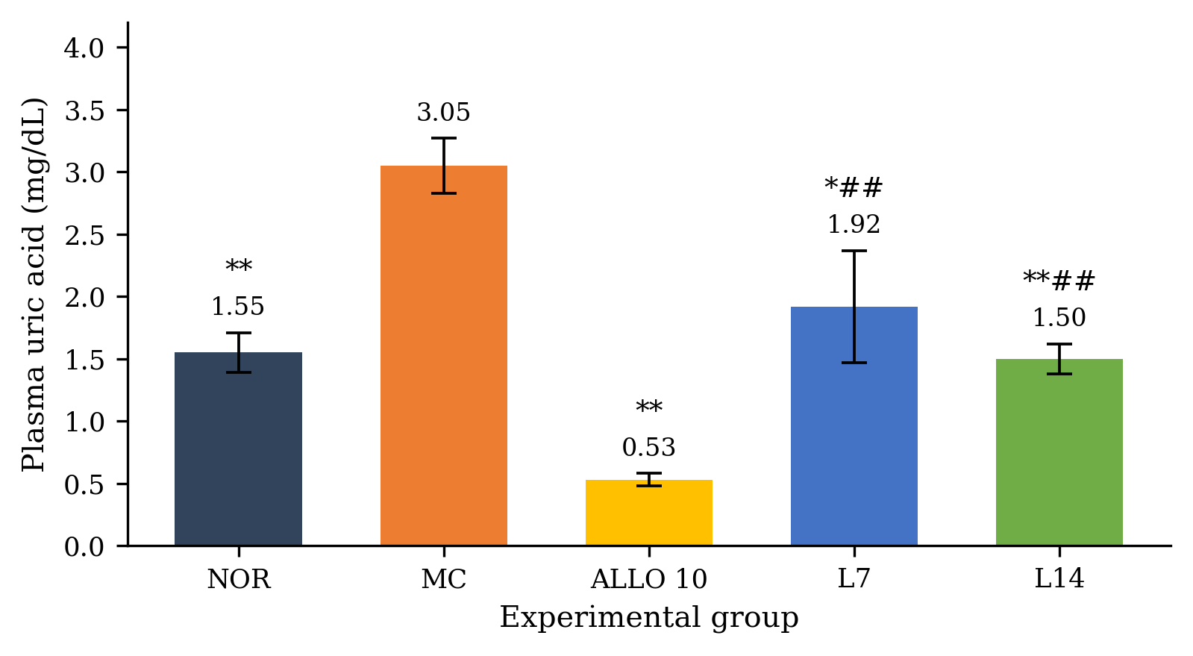
Fig. 2. Plasma uric acid concentrations of the experimental groups in the preventive model
Values are mean ± SEM (n = 6 per group).
After the intraperitoneal injection of potassium oxonate 300 mg/kg, the plasma uric acid concentration of the model control group rose to 3.05 mg/dL, significantly higher than that of the normal group (P < .01), an increase of 96.78 %. The model of hyperuricaemia was therefore successfully established. The group receiving allopurinol 10 mg/kg as prophylaxis showed a plasma uric acid concentration of only 0.53 mg/dL, a significant reduction of 82.76 % compared with the model control group (P < .01).
The mice treated with the Lamgout extract at 7 and 14 g/kg had plasma uric acid concentrations of 1.92 mg/dL and 1.50 mg/dL, respectively, corresponding to reductions of 37.07 % and 50.86 % relative to the model control group (P < .05). The concentration measured in the group receiving 7 g/kg did not differ significantly from that of the normal group (P > .05) and was comparable to that of the group receiving 14 g/kg. Plasma uric acid concentrations in both extract groups nevertheless remained significantly higher than in the allopurinol group (P < .05). These results show that, at 7 and 14 g of dried herb/kg, the Lamgout extract is able to prevent the rise in plasma uric acid in mice with acute hyperuricaemia.
3.4 Therapeutic effect of the Lamgout extract on hyperuricaemia
In this experiment, potassium oxonate was used to induce acute hyperuricaemia, which was then treated with a single dose of allopurinol 10 mg/kg or the Lamgout extract at 7 and 14 g/kg. One hour after dosing, blood was collected from the tail vein for the determination of plasma uric acid; the results are presented in Table 6 and Fig. 3.
Table 6. Plasma uric acid concentrations of the experimental groups in the therapeutic model
Group (n = 6) | Plasma uric acid (mg/dL) | Reduction vs. MC (%)
NOR | 1.71 ± 0.16** | –
MC | 3.05 ± 0.17 | –
ALLO 10 | 0.79 ± 0.11** | 74.14
L7 | 1.81 ± 0.12**## | 40.52
L14 | 1.71 ± 0.24**# | 43.97
*, ** denote P < .05 and P < .01 respectively for the difference from the model control group; #, ## denote the same probability levels for the difference from the allopurinol 10 mg/kg group.
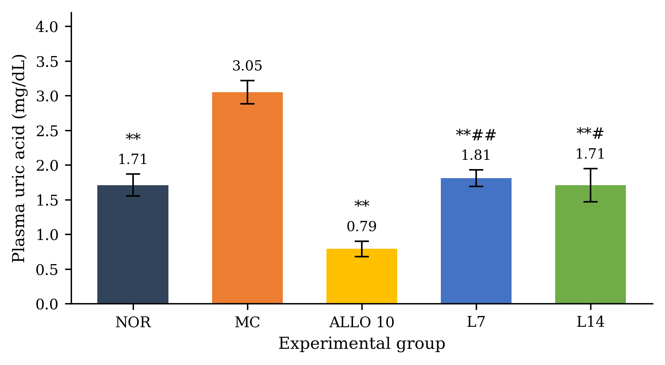
Fig. 3. Plasma uric acid concentrations of the experimental groups in the therapeutic model
Values are mean ± SEM (n = 6 per group).
The plasma uric acid concentration of the model control group rose to 3.05 mg/dL, an increase of 78.36 % that was statistically significant compared with the normal group (P < .01). Allopurinol 10 mg/kg lowered the concentration to 0.79 mg/dL, a significant difference from the model control group (P < .01).
In the mice treated with the Lamgout extract at 7 and 14 g/kg, plasma uric acid fell to 1.81 mg/dL and 1.71 mg/dL, respectively, significantly lower than in the model control group (P < .01); in other words, the extract reduced plasma uric acid by 40.52 % and 43.97 %. Both concentrations were nevertheless significantly higher than that obtained with allopurinol 10 mg/kg (P < .05). This is readily explained by the fact that allopurinol is a synthetic xanthine oxidase inhibitor whose onset of action is more rapid and whose effect is stronger than that of a preparation of natural origin such as the Lamgout extract. Allopurinol acts by inhibiting the terminal step of uric acid synthesis and is itself metabolised by xanthine oxidase into oxypurinol, which retains activity; its effect is therefore prolonged and a single daily administration is sufficient. Its use is, however, limited by adverse effects such as peptic ulceration, rash, Stevens-Johnson syndrome, hepatocellular necrosis and hepatic granulomas (Rundles, 1985), which is precisely why herbal alternatives are being sought.
3.5 Comparison of the uric acid-lowering effect in the two models
The percentage reductions of plasma uric acid obtained in the therapeutic and preventive models are compared in Table 7.
Table 7. Reduction of plasma uric acid by the Lamgout extract in the preventive and therapeutic models
Group | Preventive model (%) | Therapeutic model (%)
Allopurinol 10 mg/kg | 82.76 | 74.14
Lamgout 7 g dried herb/kg | 37.07 | 40.52
Lamgout 14 g dried herb/kg | 50.86 | 43.97
In the preventive model, plasma uric acid was reduced by 82.76 % in the allopurinol group and by 50.86 % in the group receiving Lamgout 14 g/kg, with both values being higher than those recorded in the therapeutic model. This may be explained by the design of the two experiments: in the acute therapeutic model, the animals received only a single dose of the test substance, whereas in the preventive model they were dosed for five consecutive days. Gout is classically divided into four clinical stages, which include the acute gouty arthritis flare and the intercritical period between flares. By demonstrating the uric acid-lowering activity of the Lamgout extract on two different models corresponding to two stages of the disease, the present study provides evidence relevant to both the treatment and the prevention of hyperuricaemia in patients.
The effect obtained here with the higher dose of 14 g/kg compares favourably with that reported for other traditional formulas investigated using models of similar design in terms of animal species, positive control and method of induction of hyperuricaemia.
Several herbs of the Lamgout remedy have also been reported to inhibit xanthine oxidase, the enzyme catalysing the terminal step of uric acid synthesis. This is the case for Siegesbeckia orientalis, whose phenolic-rich fraction combines anti-hyperuricaemic, anti-inflammatory and analgesic activities (T. D. Nguyen et al., 2017; J. P. Wang et al., 2011; Q. Wang et al., 2021), and for Cinnamomum cassia, Caesalpinia sappan and Tinospora sinensis, extracts of which inhibit the enzyme in vitro at concentrations below 100 µg/mL, the threshold generally used in screening studies to identify promising plant materials (M. T. T. Nguyen et al., 2005; Nirmal et al., 2015). The 2-phenylbenzofurans gnetumgam B and gnetifolin M, isolated from the lianas of Gnetum montanum, likewise inhibit xanthine oxidase directly (Do et al., 2026). Berberine, caffeic acid, myricetin and ferulic acid have been identified in the stems of the latter species, and myricetin inhibits xanthine oxidase by binding directly to the isoalloxazine ring of the enzyme. When such constituents are combined in appropriate proportions, a reinforcing inhibitory effect on xanthine oxidase may be produced, although further work is required to confirm this hypothesis for the Lamgout remedy as a whole.
A mechanistic link may also be proposed between the two activities observed. Hypoxanthine is a metabolite and precursor of adenosine, so that plant materials inhibiting xanthine oxidase raise the blood concentration of hypoxanthine and thereby contribute to an increase in adenosine, an endogenous nucleoside that signals to anti-inflammatory cells through the A2A receptor. Herbal preparations lowering plasma uric acid may therefore also contribute to reducing the inflammation associated with gouty arthritis.
3.6 Limitations of the study
Several limitations should be borne in mind when interpreting these findings. First, the study establishes the effects of the remedy but not their mechanisms: the reduction of paw oedema and of plasma uric acid was inferred from the phenotypic endpoints alone, and neither the inflammatory mediators (TNF-α, IL-1β, PGE2, COX-2) nor the activity of xanthine oxidase was measured directly in the treated animals. The mechanisms proposed in sections 3.2 and 3.5 therefore remain hypotheses drawn from the published pharmacology of the individual ingredients rather than conclusions of the present work.
Second, Lamgout is a polyherbal preparation and its constituents were not determined analytically. The compounds listed in Table 2 are those reported in the literature for each species; no chromatographic fingerprint was established for the extract actually administered, and the concentration of any individual marker compound in it is unknown. A quantitative HPLC or LC-MS profile, with one or more marker compounds assayed against reference standards, is needed both to standardise the preparation between batches and to relate the observed activity to defined constituents.
Third, the toxicological assessment was confined to a single oral dose observed over 14 days. Acute toxicity testing of this kind cannot detect cumulative organ toxicity, and no haematological, biochemical or histopathological examination was carried out. Subchronic and chronic studies, with organ function markers and histology, remain necessary before any clinical use is contemplated. Finally, the two doses studied were derived from the human dose by allometric conversion rather than being established by a dose-ranging experiment, so that neither the minimum effective dose nor the shape of the dose-response relationship can be stated; the absence of a significant difference between 7 and 14 g of dried herb/kg suggests that the plateau of the response may already have been reached at the lower dose.
4. Conclusion
The aqueous Lamgout preparation produced no mortality or observable signs of acute toxicity in mice at the maximum tested dose equivalent to 182 g of dried herbal material/kg. At doses of 7 and 14 g/kg, the extract significantly reduced carrageenan-induced paw oedema relative to the model control. The same doses also reduced plasma uric acid in potassium oxonate-induced hyperuricaemia in both preventive and therapeutic experiments, although their uric acid-lowering effects were weaker than those of allopurinol 10 mg/kg. These findings provide preclinical evidence that Lamgout possesses anti-inflammatory and anti-hyperuricaemic activities under the experimental conditions used. Further investigations are required to characterise its active constituents and mechanisms of action and to establish its longer-term safety before its potential therapeutic application can be assessed.
Competing Interests
Authors have declared that no competing interests exist.
Ethical Approval
All authors hereby declare that the "Principles of laboratory animal care" (National Research Council, 1985) were followed, as well as the specific national laws applicable in Vietnam. All experiments have been examined and approved by the appropriate ethics committee.

COMPETING INTERESTS:
Authors have declared that they have no known competing financial interests OR non-financial interests OR personal relationships that could have appeared to influence the work reported in this paper.

Declaration of AI Use

This manuscript was prepared through the intellectual contributions of the author(s) to the study design, data analysis, interpretation of results, and scholarly content. Grammarly and ChatGPT were used solely to assist with grammatical refinement and reference formatting during manuscript revision. The author(s) accept full responsibility for the accuracy, integrity, and final content of the manuscript.

References
Bansal, P., Bansal, V., Roy, A., & Kar, A. C. (2025). Cinnamon: A review on the medicinal plant and its health benefits. Asian Journal of Agriculture and Allied Sciences, 8(1), 305–315. https://doi.org/10.56557/ajaas/2025/v8i174
Chenchula, S., Ghanta, M. K., Alhammadi, M., Mohammed, A., Anitha, K., Nuthalapati, P., Raju, G. S. R., Huh, Y. S., & Bhaskar, L. V. K. S. (2025). Phytochemical compounds for treating hyperuricemia associated with gout: A systematic review. Naunyn-Schmiedeberg's Archives of Pharmacology, 398(5), 4779–4801. https://doi.org/10.1007/s00210-024-03686-4
Chi, S., She, G., Han, D., Wang, W., Liu, Z., & Liu, B. (2016). Genus Tinospora: Ethnopharmacology, phytochemistry, and pharmacology. Evidence-Based Complementary and Alternative Medicine, 2016, 9232593. https://doi.org/10.1155/2016/9232593
Do, T. D. (2014). Methods for the determination of drug toxicity. Medical Publishing House.
Do, T. N. V., Nguyen, M. H., Nguyen, H. X., Nguyen, N. T., & Nguyen, M. T. T. (2026). Gnetumgams A and B: Two new 2-phenylbenzofuran derivatives from the lianas of Gnetum montanum with xanthine oxidase inhibitory activity. RSC Advances, 16(2), 1255–1263. https://doi.org/10.1039/D5RA08293E
Li, Y., Lin, Z., Jin, H., Wei, F., Ma, S., & Zhang, B. (2025). The anti-hyperuricemia potential of bioactive natural products and extracts derived from traditional Chinese medicines: A review and perspective. Journal of Pharmaceutical Analysis, 15(7), 101183. https://doi.org/10.1016/j.jpha.2024.101183
Mahomoodally, M. F., Coodian, K., Hosenally, M., Zengin, G., Shariati, M. A., Abdalla, A. N., Alhazmi, H. A., Khuwaja, G., Mohan, S., & Khalid, A. (2024). Herbal remedies in the management of hyperuricemia and gout: A review of in vitro, in vivo and clinical evidences. Phytotherapy Research, 38(7), 3370–3400. https://doi.org/10.1002/ptr.8211
Ministry of Health of Vietnam. (2015). Guidelines for preclinical and clinical trials of traditional medicines and herbal drugs (Decision No. 141/QĐ-K2ĐT).
Musdja, M. Y., Azter, A. A., & Musir, A. (2019). The effect of ethanol extract of Elephantopus scaber Linn in decreasing blood uric acid levels of hyperuricemic male rats. European Journal of Medicinal Plants, 28(4), 1–9. https://doi.org/10.9734/ejmp/2019/v28i430140
National Research Council. (1985). Guide for the care and use of laboratory animals (NIH Publication No. 85-23, revised 1985). U.S. Department of Health and Human Services, Public Health Service, National Institutes of Health.
Nguyen, M. T. T., Awale, S., Tezuka, Y., Tran, Q. L., & Kadota, S. (2005). Xanthine oxidase inhibitors from the heartwood of Vietnamese Caesalpinia sappan. Chemical and Pharmaceutical Bulletin, 53(8), 984–988. https://doi.org/10.1248/cpb.53.984
Nguyen, T. D., Thuong, P. T., Hwang, I. H., Hoang, T. K. H., Nguyen, M. K., Nguyen, H. A., & Na, M. (2017). Anti-hyperuricemic, anti-inflammatory and analgesic effects of Siegesbeckia orientalis L. resulting from the fraction with high phenolic content. BMC Complementary and Alternative Medicine, 17, 191. https://doi.org/10.1186/s12906-017-1698-z
Nguyen, X. C., Chau, V. M., Phan, V. K., Hoang, T. H., Ninh, K. B., Nguyen, X. N., Nguyen, H. T., Jung, J.-W., Kim, H.-J., Kim, S.-Y., Kim, J. A., & Kim, Y. H. (2009). Inhibitors of osteoclast formation from rhizomes of Cibotium barometz. Journal of Natural Products, 72(9), 1673–1677. https://doi.org/10.1021/np9004097
Nirmal, N. P., Rajput, M. S., Prasad, R. G. S. V., & Ahmad, M. (2015). Brazilin from Caesalpinia sappan heartwood and its pharmacological activities: A review. Asian Pacific Journal of Tropical Medicine, 8(6), 421–430. https://doi.org/10.1016/j.apjtm.2015.05.014
Orellana-Paucar, A. M. (2023). Steviol glycosides from Stevia rebaudiana: An updated overview of their sweetening activity, pharmacological properties, and safety aspects. Molecules, 28(3), 1258. https://doi.org/10.3390/molecules28031258
Pillinger, M. H., & Mandell, B. F. (2020). Therapeutic approaches in the treatment of gout. Seminars in Arthritis and Rheumatism, 50(3 Suppl.), S24–S30. https://doi.org/10.1016/j.semarthrit.2020.04.010
Rundles, R. W. (1985). The development of allopurinol. Archives of Internal Medicine, 145(8), 1492–1503. https://doi.org/10.1001/archinte.1985.00360080174026
Safiri, S., Kolahi, A.-A., Cross, M., Carson-Chahhoud, K., Hoy, D., Almasi-Hashiani, A., Sepidarkish, M., Ashrafi-Asgarabad, A., Moradi-Lakeh, M., Mansournia, M. A., Kaufman, J. S., Collins, G., Woolf, A. D., March, L., & Smith, E. (2020). Prevalence, incidence, and years lived with disability due to gout and its attributable risk factors for 195 countries and territories 1990–2017: A systematic analysis of the Global Burden of Disease Study 2017. Arthritis & Rheumatology, 72(11), 1916–1927. https://doi.org/10.1002/art.41404
Sun, L., Zong, S.-B., Li, J.-C., Lv, Y.-Z., Liu, L.-N., Wang, Z.-Z., Zhou, J., Cao, L., Kou, J.-P., & Xiao, W. (2016). The essential oil from the twigs of Cinnamomum cassia Presl alleviates pain and inflammation in mice. Journal of Ethnopharmacology, 194, 904–912. https://doi.org/10.1016/j.jep.2016.10.064
Tang, D.-H., Ye, Y.-S., Wang, C.-Y., Li, Z.-L., Zheng, H., & Ma, K.-L. (2017). Potassium oxonate induces acute hyperuricemia in the tree shrew (Tupaia belangeri chinensis). Experimental Animals, 66(3), 209–216. https://doi.org/10.1538/expanim.16-0096
Trịnh, T. A., & Huỳnh, N. T. (2017). Sàng lọc in vitro, in vivo tác dụng hạ acid uric máu của một số dược liệu thu hái tại các tỉnh phía Nam Việt Nam [In vitro and in vivo screening of the hypouricemic activity of some medicinal plants collected in the southern provinces of Vietnam]. Tạp chí Dược học, 57(11), 53–57.
Uto, T., Tung, N. H., Taniyama, R., Miyanowaki, T., Morinaga, O., & Shoyama, Y. (2015). Anti-inflammatory activity of constituents isolated from aerial part of Angelica acutiloba Kitagawa. Phytotherapy Research, 29(12), 1956–1963. https://doi.org/10.1002/ptr.5490
Wang, J.-P., Zhou, Y.-M., Ye, Y.-J., Shang, X.-M., Cai, Y.-L., Xiong, C.-M., Wu, Y.-X., & Xu, H.-X. (2011). Topical anti-inflammatory and analgesic activity of kirenol isolated from Siegesbeckia orientalis. Journal of Ethnopharmacology, 137(3), 1089–1094. https://doi.org/10.1016/j.jep.2011.07.016
Wang, Q., Liang, Y.-Y., Li, K.-W., Li, Y., Niu, F.-J., Zhou, S.-J., Wei, H.-C., & Zhou, C.-Z. (2021). Herba Siegesbeckiae: A review on its traditional uses, chemical constituents, pharmacological activities and clinical studies. Journal of Ethnopharmacology, 275, 114117. https://doi.org/10.1016/j.jep.2021.114117
Winter, C. A., Risley, E. A., & Nuss, G. W. (1962). Carrageenin-induced edema in hind paw of the rat as an assay for antiinflammatory drugs. Proceedings of the Society for Experimental Biology and Medicine, 111(3), 544–547. https://doi.org/10.3181/00379727-111-27849
Xiang, W., Jiang, B., Li, X. M., Zhang, H. J., Zhao, Q. S., Li, S. H., & Sun, H. D. (2002). Constituents of Gnetum montanum. Fitoterapia, 73(1), 40–42. https://doi.org/10.1016/S0367-326X(01)00370-7

