Non-Invasive Infrared Thermographic Assessment of Regional Surface Temperature in Adult Tripureswari Ducks of Tripura, India

ABSTRACT

Infrared thermography (IRT) is a quick, non-contact, non-invasive, and stress-free method for assessing the thermal physiology of livestock and birds. The Tripureswari duck is an indigenous duck genetic resource of Tripura registered by ICAR-NBAGR (INDIA_DUCK_1900_TRIPURESWARI_11004) and is mostly reared under backyard and semi-intensive farming systems for egg and meat production, with an annual average egg production of 70 to 101 eggs and an adult body weight of 1.199 kg at 12 months (ICAR-National Bureau of Animal Genetic Resources. Although adapted and evolved in the hot and humid tropical climate of Tripura, its surface thermal profile has not been documented. Therefore, the present preliminary study was undertaken to assess surface temperatures at different anatomical body regions using an infrared thermal camera in six apparently healthy adult male and six adult female Tripureswari ducks. The study revealed that the uncovered and highly vascularised regions, namely the leg (39.83 ± 0.37 °C and 39.53 ± 0.17 °C), periorbital area (39.20 ± 0.12 °C and 39.00 ± 0.17 °C), and under-wing surface (39.07 ± 0.11 °C and 38.82 ± 0.19 °C), respectively, in adult male and female Tripureswari ducks had the highest recorded temperatures and were identified as primary thermal windows for radiative heat loss. Among densely insulated feathered regions, the primary feather area (rump) (29.87 ± 0.32 °C and 30.18 ± 0.18 °C), flank (29.90 ± 0.14 °C and 30.62 ± 0.35 °C), and undertail coverts showed the lowest temperatures. The sharp temperature gradient between the hottest and coolest regions supports the role of plumage in regulating core temperature while allowing selective peripheral heat dissipation. The overall surface temperature pattern recorded in the present study showed minimal influence of sex, with a significantly warmer bill temperature in females (37.57 ± 0.17 °C) than in males (37.02 ± 0.15 °C) (p < 0.05). Males had a significantly higher mantle surface temperature (35.13 ± 0.16 °C) than females (34.28 ± 0.34 °C) (p < 0.05). Chin temperature showed a non-significant trend towards a higher value in males (36.93 ± 0.10 °C) than in females, while flank temperature was slightly higher in females (30.62 ± 0.35 °C) than in males (29.90 ± 0.14 °C). Variation in mantle temperature may be due to differences in dorsal feather distribution density. Given the small sample size, imaging protocol, camera precision, and other physiological, environmental, and management-related variables, it is too early to interpret the absolute significance of sex-related patterns. These preliminary observations, recorded for the first time in the Tripureswari duck breed of Tripura, may help to validate its adaptation and hardiness to the humid wetland agro-climate of Tripura.
Keywords: Tripureswari duck; infrared thermography; surface temperature; thermal windows; thermoregulation; indigenous duck; heat dissipation; plumage insulation; avian thermal physiology

1. INTRODUCTION

Tripura has the third-highest duck population (8.54 lakh) in Northeast India, after Assam and Manipur, according to the 20th Livestock Census, 2019 (Department of Animal Husbandry and Dairying [DAHD], 2019). Ducks (Anas platyrhynchos domesticus) play an important role in household protein supply and rural livelihood security through meat and egg production and are mostly reared in the wetland-rich, humid subtropical agro-climate of Tripura. The Tripureswari duck, an indigenous duck of Tripura registered by ICAR-NBAGR (INDIA_DUCK_1900_TRIPURESWARI_11004), is mostly reared under backyard and semi-intensive farming systems for egg and meat production, with an annual average egg production of 70 to 101 eggs and an adult body weight of 1.199 kg at 12 months (ICAR-NBAGR, 2025; Kumar & Dwivedi, 2025). The breed is distributed across different districts of Tripura (Debnath et al., 2023). Despite its recent genotypic and phenotypic characterisation, no documented information is available on the surface thermal physiology of the Tripureswari duck, which is well adapted and has evolved in the hot, humid subtropical climate. This represents a research gap in the scientific understanding of its normal thermoregulatory adaptation.

Recent poultry literature has emphasised that heat stress can compromise bird health, welfare, and productivity, underscoring the value of non-invasive methods for characterising thermal responses (Sesay, 2022; Sarker et al., 2026). Infrared thermography has increasingly been evaluated for this purpose, with recent reviews highlighting its utility for non-contact assessment of livestock and poultry surface temperature while also noting that anatomical site and environmental conditions influence measurement interpretation (Cai et al., 2023; Hernández-Sánchez et al., 2024). In broiler chickens, surface temperatures of the eye, face, and breast have been shown to vary with thermal conditions and to reflect regional heat-transfer dynamics (Yehia et al., 2025).

Birds are homeothermic endotherms that lack sweat glands and dissipate metabolic heat mainly through radiative, convective, and evaporative pathways via featherless or sparsely feathered body surfaces, also called thermal windows (Crandell et al., 2025). Duck plumage is highly insulative; therefore, regions such as the legs, periorbital area, bill, under-wing surface, and thinly feathered areas remain major sites of heat dissipation. Densely feathered areas, such as the back, flank, and wing coverts, help conserve heat and protect against thermal fluctuations (McCafferty, 2013; Kim et al., 2021). Infrared thermography (IRT) is a widely used, non-contact, non-invasive, and stress-free technology (Chuang et al., 2021) for tracking differential radiative heat emission from the body surface and is increasingly used to identify thermal status and physiological stress in avian species (Speakman & Ward, 1998; Jerem et al., 2015; Tabh et al., 2021). Surface temperature may be correlated with core body temperature in birds (Svensson et al., 2025). Infrared thermography is particularly applicable to field-level evaluation of indigenous and backyard poultry and ducks because it does not require stressful restraint or invasive sampling, thereby supporting animal welfare (McCafferty, 2013). Surface temperature in chickens varies across anatomical regions according to feather density, superficial cutaneous vascularity, and proximity to the body core, thereby maintaining regional thermal gradients (Kim et al., 2021). Featherless areas, such as the periorbital region and legs, respond sensitively to changes in ambient temperature and physiological stress (Tabh et al., 2021). To adapt to an aquatic habitat, ducks and other aquatic birds must maintain an equilibrium between insulation and heat dissipation (Crandell et al., 2025). The Tripureswari duck is reared mainly in wetland paddy fields, ponds, and other microhabitats of Tripura in a hot, humid tropical climate. Therefore, a preliminary study of its thermographic profile may provide useful baseline information on its thermal architecture and adaptation potential. The hypothesis was that, as in other avian species, uninsulated, vascularised regions (leg, periorbital area, and under-wing area) would exhibit higher surface temperatures than densely feathered regions (primary feather tract, flank, undertail coverts, etc.) (Kim et al., 2021). The present investigation was therefore undertaken to map surface body temperatures non-invasively across different anatomical regions in adult male and female Tripureswari ducks using infrared thermography, identify the principal thermal windows, and assess whether sexual dimorphism in regional surface temperatures was present.

2. MATERIALS AND METHODS

2.1 Location and climate
The study was carried out in Tripureswari ducks of Tripura. During the study period, the ambient temperature ranged from 29 °C to 34 °C, and relative humidity ranged from 74% to 78%. Recording was performed during a period of thermally stable, clear-sky conditions to avoid confounding (Speakman & Ward, 1998; McCafferty, 2013).

2.2 Experimental birds
Surface temperature was recorded in a total of twelve apparently healthy adult Tripureswari ducks (six males and six females), weighing approximately 1.4 kg for males and 1.6 kg for females and of comparable age (12-15 months), randomly selected from a nearby local slaughterhouse holding area and households with the owners' consent. Six individual ducks of each sex were sampled once, and one thermogram was taken for each bird. The ducks' plumage and feathers were not directly wet during imaging. Imaging was performed from a distance on unrestrained birds to avoid stress-related vasomotor changes (Jerem et al., 2015; Tabh et al., 2021).

2.3 Thermographic imaging
Surface temperature was recorded using the protocols described by Speakman and Ward (1998) and McCafferty (2013). Thermography was performed using a HIKMICRO MiniE thermal camera (Android, 25 Hz; SuperIR, 96 × 96 resolution), which can detect a temperature difference of 0.05 °C. The camera was positioned approximately 1 m from the birds (Tabh et al., 2021). The images captured for each animal were analysed using the HIKMICRO Analyzer desktop app. Emissivity was set at 0.98. Recordings were made during the early morning from a distance without disturbing or restraining the birds. The ambient temperature and humidity on the day of recording were recorded accordingly.

2.4 Body regions evaluated
For each bird, surface temperature was recorded at the eye, periorbital area, crown, nostrils, bill, chin, throat, breast, flank, leg (maximum), talon, undertail coverts, mantle, neck, ear and nape, primary feather area, secondary feather area, wing covert area, edge of the wing, back, and under-wing surface (McCafferty, 2013; Kim et al., 2021; Crandell et al., 2025).
The thermographic data were expressed as mean ± standard error (SE). A comparative analysis of surface thermography across 21 distinct anatomical regions in male (n = 6) and female (n = 6) ducks was performed using two-sample independent t-tests and one-way analysis of variance (ANOVA).

3. RESULTS AND DISCUSSION

3.1 Regional surface temperature distribution
The region-wise surface temperatures (mean ± SE) for adult male and female Tripureswari ducks are presented in Table 1 and show variation across the different anatomical regions examined. Surface temperature ranged from lows of 29.87 °C and 29.90 °C in the primary feather area and flank, respectively, to highs of 39.20 °C and 39.83 °C in the periorbital and leg regions. This regional gradient of approximately 10 °C between the coolest and warmest parts of the same bird is consistent with findings in other avian species, in which feathered areas act as effective insulative barriers while featherless or thinly feathered areas serve as windows for heat dissipation (McCafferty, 2013; Kim et al., 2021; Crandell et al., 2025).

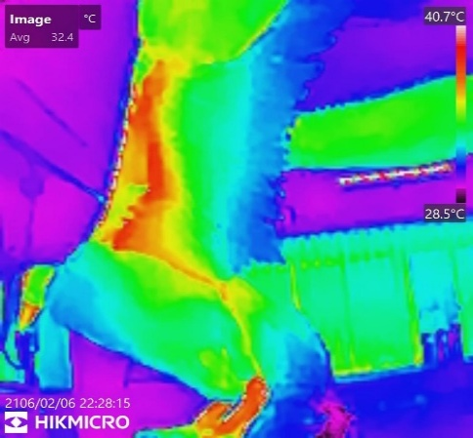
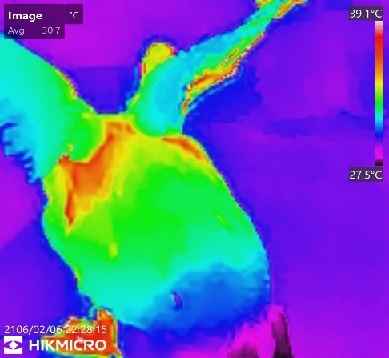
b
a
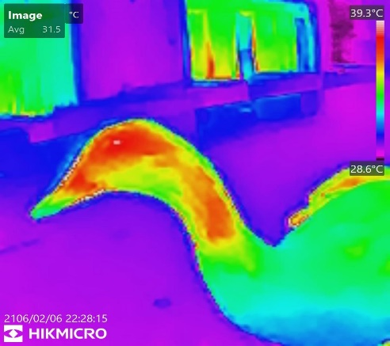
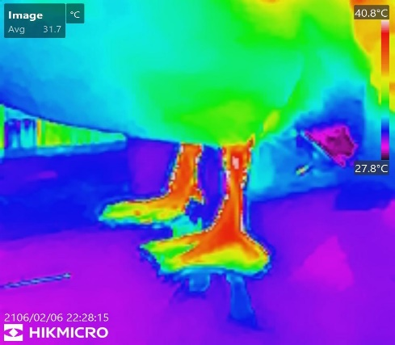
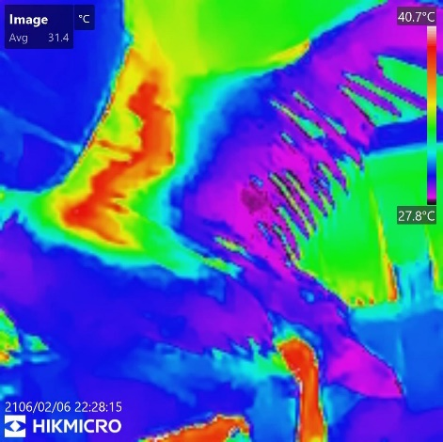
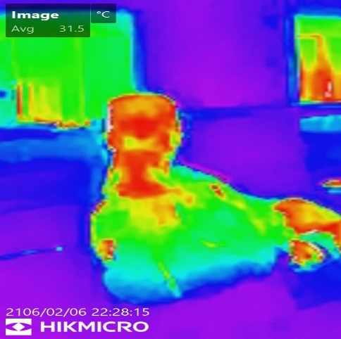
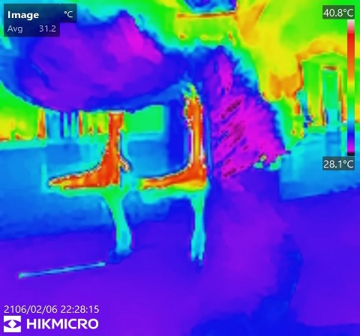
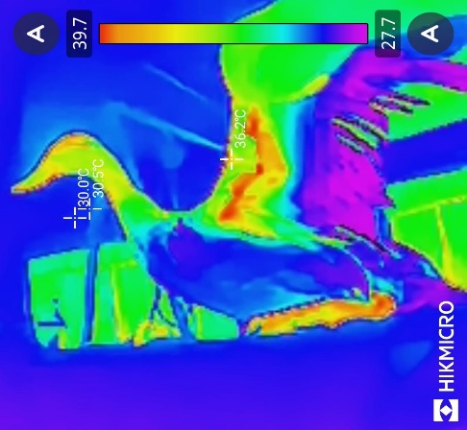
d
c
b
a
d
c
Fig-1 (a-d) Surface thermographic profile of Adult Female Tripureswari Duck of Tripura
Fig: 2 (a-d)Surface thermographic profile of Adult Male Tripureswari Duck of Tripura
Table No. 1: Showing the surface thermographic values across different anatomical region in male and female Tripureswari duck of Tripura
Anatomical Region | Male Mean ± SE (∘C) | Female Mean ± SE (∘C) | p-value | Significance Level
Eye | 37.60±0.21 | 37.80±0.19 | 0.5025 | ns
Periorbital Area | 39.18±0.12 | 38.97±0.17 | 0.3297 | ns
Crown | 34.62±0.33 | 34.78±0.23 | 0.6881 | ns
Nostrils | 37.10±0.10 | 37.02±0.18 | 0.6915 | ns
Bill (l) | 37.02±0.15 | 37.57±0.17 | 0.0376 | *
Chin | 36.93±0.10 | 36.57±0.17 | 0.0878 | ns
Throat | 34.83±0.23 | 34.97±0.20 | 0.6743 | ns
Breast | 31.63±0.21 | 31.43±0.40 | 0.667 | ns
Flank | 29.90±0.14 | 30.62±0.35 | 0.0892 | ns
Leg (max) | 39.83±0.37 | 39.53±0.17 | 0.4804 | ns
Talon | 33.12±0.42 | 33.18±0.22 | 0.8896 | ns
Undertail Coverts | 31.70±0.75 | 30.77±0.38 | 0.2943 | ns
Mantel | 35.13±0.16 | 34.28±0.34 | 0.0478 | *
Neck | 36.73±0.11 | 36.67±0.16 | 0.7402 | ns
Ear and Nape | 35.97±0.33 | 35.97±0.31 | 1 | ns
Primary Feather Area | 29.87±0.32 | 30.18±0.18 | 0.4096 | ns
Secondary Feather Area | 31.48±0.27 | 30.83±0.42 | 0.2217 | ns
Wing Covert Area | 36.12±0.43 | 36.67±0.23 | 0.2828 | ns
Edges of the Wing | 35.67±0.22 | 36.22±0.27 | 0.1465 | ns
Back | 33.38±0.40 | 33.77±0.21 | 0.416 | ns
Under Wing | 39.07±0.11 | 38.82±0.19 | 0.2743 | ns
* Statistically significant at $p<0.05$; ns = not significant ($p≥0.05$).
Table 2. Thermal-zone classification of body regions in adult male and female Tripureswari ducks
Thermal Zone | Body Region | Male (°C ± SE) | Female (°C ± SE) | Biological Role
Warmest (thermal windows) | Leg (maximum) | 39.83 ± 0.91 | 39.53 ± 0.41 | Featherless uninsulated & main heat dissipation site
 | Periorbital area | 39.20 ± 0.31 | 39.00 ± 0.42 | Vascularized and thinly feathered
 | Under wing | 39.07 ± 0.26 | 38.82 ± 0.46 | Thinly feathered and heat dissipation during flight and wing extension, proximity to the core body.
Coolest (feathered and insulated) | Primary feather area (Rump) | 29.87 ± 0.78 | 30.18 ± 0.45 | Plumage insulation
 | Flank | 29.90 ± 0.35 | 30.62 ± 0.86 | Fathered area for core body temperature retention
 | Undertail coverts | 31.70 ± 1.85 | 30.80 ± 0.93 | Waterproofing
After considering the surface temperatures recorded across all regions, the body regions were grouped by thermal function and are presented in Table 2. The leg (maximum), periorbital area, and under-wing surface consistently emerged as the warmest thermal areas in both sexes, whereas the primary feather area, flank, and undertail coverts were the coolest, heavily feathered, and insulated zones.
.

3.2 Thermal windows of heat dissipation
In the present study, the highest surface temperature was recorded in the leg (39.83 ± 0.37 °C in males and 39.53 ± 0.17 °C in females), as shown in Fig. 1 and Fig. 2; these observations are consistent with the general avian thermal-window pattern. The leg (tarsometatarsus) region is devoid of feathers and has a dense subcutaneous vascular network and a counter-current arteriovenous network that permit rapid adjustment of arterial and venous blood flow for local heat dissipation (Crandell et al., 2025). The second-warmest region was the periorbital area (39.20 ± 0.12 °C in males; 39.00 ± 0.17 °C in females), possibly because of its thin skin and high vascularisation. This region has similarly been identified as a sensitive thermal and stress-responsive site in domestic pigeons and laying hens (Kim et al., 2021; Tabh et al., 2021). The third-warmest region was the under-wing surface (39.07 ± 0.11 °C and 38.82 ± 0.19 °C in males and females, respectively), possibly reflecting exposure to convective air during wing extension and locomotion and its proximity to the body core. These observations are consistent with wing-associated heat-dissipation patterns during and after flight in columbiform birds (Crandell et al., 2025). Altogether, these three regions were identified as the primary heat-radiating surfaces in the Tripureswari indigenous duck of Tripura, facilitating rapid loss of excess metabolic and environmental heat while plumage and feathers maintain insulation and waterproofing.

3.3 Heavily insulated regions
In direct contrast, the primary feather area (29.87 ± 0.32 °C in males; 30.18 ± 0.18 °C in females), the flank (29.90 ± 0.14 °C and 30.62 ± 0.35 °C, respectively), and the undertail coverts recorded the lowest surface temperatures of the entire body (Fig. 1 and Fig. 2). These regions are characterised by dense plumage coverage that traps a layer of still air beneath the feathers, thereby minimising radiative and convective heat loss and shielding the bird's thermal core from ambient fluctuations (McCafferty, 2013). The very low surface temperature of the primary and secondary feather areas is of particular functional relevance in a waterfowl species, because dense, well-maintained plumage in these regions is simultaneously responsible for water repellence and flight function. The concurrence of low surface temperature with high insulative value in this study is therefore consistent with the dual thermoregulatory-waterproofing role of duck plumage described for other Anatidae (Crandell et al., 2025).

3.4 Sex-wise comparison
The overall mean surface temperatures at most anatomical sites did not show a significant difference between sexes (p ≥ 0.05), indicating minimal sexual dimorphism in the surface thermoregulatory pattern of Tripureswari ducks of Tripura. Temperatures recorded at the bill (lateral) and mantle showed significant differences (p < 0.05). Bill surface temperature in Anatidae is highly labile, controlled by the autonomic vasomotor system, and responsive to ambient and physiological state (Tabh et al., 2021). Variation in mantle temperature may be due to differences in dorsal feather distribution density. Given the small sample size and the potential influence of the imaging protocol, camera precision, and other physiological, environmental, and management-related variables, it is too early to interpret the observed significance patterns between sexes conclusively. Kim et al. (2021) stated that facial and peripheral temperatures are governed mainly by ambient thermal load and vascular anatomy rather than by sex. The recorded differences may also reflect transient peripheral blood flow and activity level rather than anatomical dimorphism. The flank was slightly cooler in males (29.90 ± 0.14 °C) than in females (30.62 ± 0.35 °C), suggesting individual variability rather than a sex effect. Overall, these localised differences may represent minor physiological variation in thermoregulatory architecture between the two sexes.
The Tripureswari indigenous duck of Tripura is known for its resilience and adaptability to the wet, tropical, and humid environments of Tripura under low-input backyard management (ICAR-NBAGR, 2025; Kumar & Dwivedi, 2025). These preliminary thermographic data may provide a basis for further investigation of the recognised hardiness of this breed through detailed studies with more diverse samples and consideration of management, imaging protocol, environmental, and physiological variables. The substantial temperature gradient between the heavily insulated primary feather and flank regions and the leg, periorbital, and under-wing thermal windows indicates efficient plumage for metabolic heat conservation under cool conditions, while well-vascularised, thin-skinned, and featherless or sparsely feathered sites permit rapid heat dissipation under hot, humid conditions. This dual thermoregulatory strategy of insulation and dissipation is advantageous for indigenous poultry genetic resources in maintaining thermal homeostasis across the wide seasonal climatic variation of Northeast India (McCafferty, 2013; Crandell et al., 2025). These findings therefore complement the recent molecular genetic characterisation of the breed (Debnath et al., 2023) by adding a physiological dimension to the surface thermographic profile of the Tripureswari duck and strengthening its value as a genetic resource suited to sustainable duck husbandry.

3.6 Limitations
Infrared thermographic data from feathered sites representing radiative emission may be influenced by feather depth, condition, and micro-orientation, as well as by ambient radiative heat load (Speakman & Ward, 1998; Crandell et al., 2025). In this study, the sample size was very small (n = 6 per sex) and stratified by sex. Therefore, future work incorporating larger samples, seasonal evaluations, comparisons with cloacal temperature, and uniform rearing and management conditions would strengthen inferences about the detailed thermoregulatory status of this breed (Tabh et al., 2021).

4. CONCLUSION
This study presents the first non-invasive infrared thermographic evaluation of surface body temperature in Tripureswari ducks of Tripura across different anatomical regions. Surface temperature varied across body regions. The leg, periorbital area, and under-wing surface were the principal thermal windows for heat dissipation, while the primary feather area, flank, and undertail coverts served as heat-retaining regions. Minimal sex-related variation was observed in surface thermography (p > 0.05), with minor differences in the bill, mantle, and flank (p < 0.05). The distinct temperature gradient between the warmest and coolest body surfaces may reflect better adaptation and efficient plumage insulation alongside highly vascularised, thinly feathered, and body-core-proximal heat-exchange sites, consistent with the hardiness and adaptability of this indigenous breed. However, because of the limited sample size and the lack of consideration of other physiological, management-related, and environmental variables, definitive interpretations regarding adaptation cannot be made. Nevertheless, these baseline data on the thermal profile may serve as a useful initial physiological reference for future studies on stress assessment, seasonal adaptation, and farming and conservation strategies for the Tripureswari duck of Tripura.
Declaration of AI Use

This manuscript was prepared through the intellectual contributions of the author(s) to the study design, data analysis, interpretation of results, and scholarly content. Grammarly and ChatGPT were used solely to assist with grammatical refinement and reference formatting during manuscript revision. The author(s) accept full responsibility for the accuracy, integrity, and final content of the manuscript.

REFERENCES
Cai, Z., Cui, J., Yuan, H., & Cheng, M. (2023). Application and research progress of infrared thermography in temperature measurement of livestock and poultry animals: A review. Computers and Electronics in Agriculture, 205, 107586. https://doi.org/10.1016/j.compag.2022.107586
Chuang, C.-H., Chiang, C.-Y., Chen, Y.-C., Lin, C.-Y., & Tsai, Y.-C. (2021). Goose surface temperature monitoring system based on deep learning using visible and infrared thermal image integration. IEEE Access, 9, 131203–131213. https://doi.org/10.1109/ACCESS.2021.3113509
Crandell, K. E., Powers, D. R., & Tobalske, B. W. (2025). The role of plumage and heat dissipation areas in thermoregulation in doves. Journal of Experimental Biology, 228(4), Article jeb248200. https://doi.org/10.1242/jeb.248200
Debnath, J., Debnath, S., Sarkar, D., Debroy, B., Kumar, M., & Das, A. K. (2023). Genetic characterisation of indigenous duck of Tripura state in India using microsatellite markers. Tropical Animal Health and Production, 55(3), 198. https://doi.org/10.1007/s11250-023-03629-w
Department of Animal Husbandry and Dairying. (2019). 20th Livestock Census-2019: All India report. Ministry of Fisheries, Animal Husbandry and Dairying, Government of India. https://www.dahd.gov.in/schemes/programmes/animal-husbandry-statistics
Hernández-Sánchez, R. C., Martínez-Castañeda, F. E., Domínguez-Olvera, D. A., Trujillo-Ortega, M. E., Díaz-Sánchez, V. M., Sánchez-Ramírez, E., Posadas-Hernández, E., Mejía-Flores, I., & Hernandez, E. (2024). Systematic review and meta-analysis of thermal stress assessment in poultry using infrared thermography in specific body areas. Animals, 14(22), 3171. https://doi.org/10.3390/ani14223171
ICAR-National Bureau of Animal Genetic Resources. (2025). NBAGR newsletter: January-June 2025. https://nbagr.res.in/sites/default/files/2025-10/NBAGR_Newsltr_Jan_Jun2025.pdf
Jerem, P., Herborn, K., McCafferty, D., McKeegan, D., & Nager, R. (2015). Thermal imaging to study stress non-invasively in unrestrained birds. Journal of Visualized Experiments, (105), e53184. https://doi.org/10.3791/53184
Kim, N. Y., Kim, S. J., Oh, M., Jang, S. Y., & Moon, S. H. (2021). Changes in facial surface temperature of laying hens under different thermal conditions. Animal Bioscience, 34(7), 1235–1242. https://doi.org/10.5713/ab.20.0647
Kumar, A., & Dwivedi, S. (2025). Tripureswari duck: A new feather in Indian poultry sector. Vigyan Varta, 6(3), 219–223. https://www.vigyanvarta.in/ArticleDetails.aspx?id=2558
McCafferty, D. J. (2013). Applications of thermal imaging in avian science. Ibis, 155(1), 4–15. https://doi.org/10.1111/ibi.12010
Sarker, M. A.-A., Saha, D., Akanda, M. R. R., Ahmed, F., Rahman, M. M., Islam, M. M., & Bhuiyan, M. R. (2026). Probiotics as a targeted strategy for reducing heat stress-induced gut dysbiosis and improving poultry productivity. Journal of Advances in Food Science & Technology, 13(2), 154–179. https://doi.org/10.56557/jafsat/2026/v13i210570
Sesay, A. R. (2022). Impact of heat stress on chicken performance, welfare, and probable mitigation strategies. International Journal of Environment and Climate Change, 12(11), 3120–3133. https://doi.org/10.9734/ijecc/2022/v12i111360
Speakman, J. R., & Ward, S. (1998). Infrared thermography: Principles and applications. Zoology, 101, 224–232.
Svensson, E. I., Schou, M. F., Melgar, J., Waller, J. T., Engelbrecht, A., Brand, Z., Cloete, S., & Cornwallis, C. K. (2025). Infrared thermography is a useful tool in research on thermoregulation and evolution of heat tolerance. Evolution Letters, 9(6), 611–616. https://doi.org/10.1093/evlett/qraf032
Tabh, J. K. R., Burness, G., Wearing, O. H., Tattersall, G. J., & Mastromonaco, G. F. (2021). Infrared thermography as a technique to measure physiological stress in birds: Body region and image angle matter. Physiological Reports, 9(11), e14865. https://doi.org/10.14814/phy2.14865
Yehia, M., Askri, A., Achour, A., Allard Prus, J.-M., Ouellet, V., & Alnahhas, N. (2025). Rectal temperature and heat transfer dynamics in the eye, face, and breast of broiler chickens exposed to moderate heat stress. Poultry Science, 104(2), 104748. https://doi.org/10.1016/j.psj.2024.104748

