GC-MS Profile, Antimicrobial Properties and Spectra Characterization of the Ethanol Extract of Theobroma Cacao Beans grown in Nigeria

Abstract
Cocoa (Theobroma cacao) contains several classes of bioactive compounds that may contribute to biological activity. This study characterised an ethanol extract of cocoa bean powder sourced from Nigeria and evaluated its antimicrobial activity against Klebsiella pneumoniae and Escherichia coli. Qualitative phytochemical screening was used to assess secondary metabolites, while Fourier transform infrared spectroscopy (FT-IR) and gas chromatography-mass spectrometry (GC-MS) were applied for chemical characterisation. Alkaloids, tannins, and phenols were detected, whereas saponins, flavonoids, glycosides, terpenoids, steroids, anthraquinones, and phlobatannins were not detected. FT-IR analysis showed prominent absorption bands at 3398.67, 2920.32, 2850.88, 1689.70, and 1288.49 cm⁻¹, corresponding to functional groups associated with O-H, C-H, carbonyl, and C-O vibrations. GC-MS analysis indicated multiple chemical constituents in the ethanol extract. In the antimicrobial assay, the extract produced inhibition zones of 10.50 ± 0.5 mm and 8.00 ± 1.0 mm against K. pneumoniae at 100 and 50 mg/mL, respectively, while no inhibition was observed against E. coli at the tested concentrations. Ceftriaxone showed greater activity than the extract. Overall, the findings indicate that Nigerian cocoa bean ethanol extract contains several phytochemical constituents and exhibits measurable antimicrobial activity against K. pneumoniae under the conditions of this study. The study therefore provides a combined chemical and biological profile of the locally sourced cocoa material.
Keywords: Theobroma cacao; cocoa beans; ethanol extract; phytochemical screening; antimicrobial activity; Klebsiella pneumoniae; Escherichia coli; FTIR, GC-MS.
1. Introduction
Cocoa beans, a tropical crop derived from the Theobroma cacao plant, are used in the manufacture of cocoa powder, chocolate, and various other edible products. Cocoa has received increasing scientific attention because of the wide range of bioactive substances it contains, in addition to its nutritional and industrial value. Along with methylxanthines such as theobromine and caffeine, fatty acids, and other phytochemicals, cocoa is rich in polyphenols, including catechin, epicatechin, and procyanidins (Wollgast & Anklam, 2000; Rusconi & Conti, 2010; Ackar et al., 2013). The genotype of cocoa, its geographical origin, and post-harvest conditions, including fermentation, drying, and roasting, all influence the amount and composition of these constituents (Wollgast & Anklam, 2000; Ackar et al., 2013; Hurst et al., 2011). The potential health-related effects of cocoa are thought to arise from its abundance of phytochemicals. The type of cocoa material, extraction procedures, and biological evaluation may determine the nature and extent of antioxidant, anti-inflammatory, and antimicrobial effects, while previous research has associated cocoa constituents with these activities (Rusconi & Conti, 2010; Fideles et al., 2023; Cinar et al., 2021). As resistance to commonly used antimicrobial drugs remains a major challenge in the treatment of infectious diseases, interest in plant-derived bioactive molecules as potential antimicrobial substances is increasing (Cowan, 1999; Daglia, 2012). Plant extracts may contain a wide range of compounds that can affect microorganisms through different mechanisms. For example, polyphenols and related compounds may interfere with microbial membranes, proteins, enzymes, and other biological processes (Daglia, 2012; Cushnie & Lamb, 2005). Antimicrobial activity may also depend on the microorganism studied, the concentration of the extract, and its chemical composition. Therefore, experimental testing of the antimicrobial properties of natural compounds remains important. Several studies have reported antimicrobial properties of cocoa and its derivatives (Santos et al., 2014). Cocoa extracts have been reported to suppress the growth, adhesion, and biofilm formation of bacteria associated with oral and other diseases (Cinar et al., 2021). Evidence also suggests that cocoa extracts can affect Fusobacterium nucleatum by reducing its proliferation, biofilm formation, and surface attachment (Ben Lagha et al., 2021). Studies of cocoa bean-derived substances have also shown antimicrobial activity against several bacterial species; however, the extent of this activity varies with the extraction solvent and test organism. The relevance of ethanol-recovered cocoa constituents in antimicrobial studies has been further supported by a recent report showing that an ethanol extract of cocoa beans exhibited antibacterial activity against Streptococcus mutans (Joelijanto & Sutjiati, 2025). Fermentation has also been reported to alter the phytochemical profile of Nigerian cocoa beans, further supporting the importance of post-harvest conditions when comparing cocoa materials (Ibitoye et al., 2020). Recent studies further indicate that the chemical composition and analytical fingerprints of cocoa can vary with geographical origin, genetic background, and production conditions (Sari et al., 2024; Dinh & Hoang, 2025).
Ethanol can recover a wide range of phytochemicals and is therefore useful for extracting bioactive compounds from plant sources. Because the choice of extraction solvent affects the composition and biological activity of the final extract, results from one cocoa extract study may not be generalisable to another study that used a different extraction method or cocoa material from a different geographical location (Rusconi & Conti, 2010; Daglia, 2012; Nsor-Atindana, 2012). Accordingly, extraction, phytochemical characterisation, and susceptibility-testing conditions should be interpreted together when evaluating antimicrobial activity in medicinal-plant extracts (Das et al., 2026). However, despite the available evidence on cocoa phytochemicals and antimicrobial activity, limited context-specific information is available on ethanol-extracted cocoa bean powder sourced from Nigeria and characterised alongside antimicrobial testing under the conditions used in this study. A combined assessment of its phytochemical profile, FT-IR/GC-MS characteristics, and activity against the selected bacteria was therefore needed to address this study-specific gap.
Research in Nigeria, a major cocoa producer, has a lot of promise for discovering cocoa's worth beyond its conventional commercial use. Since the composition of plant materials can be impacted by environmental conditions, geographical origin, and processing processes, studying cocoa that is sourced locally could offer valuable insights into its biological features and potential uses. This research aimed to investigate the bioactive constituents of Nigerian cocoa bean powder, with particular emphasis on alkaloids, tannins, and phenolic compounds, and to evaluate the antimicrobial activity of its ethanol extract against selected microorganisms. It was hypothesized that these phytochemical constituents may contribute to the observed antibacterial activity of the cocoa extract. This research adds to the increasing amount of data showing that T. cacao has biological potential and sheds light on how microbes react to components of cocoa bean powder from Nigeria that have been extracted using ethanol.
Objective
The objective of this study was to characterise the ethanol extract of Nigerian Theobroma cacao bean powder using phytochemical screening, FT-IR, and GC-MS analyses and to evaluate its antimicrobial activity against Klebsiella pneumoniae and Escherichia coli.
2. Material and methods
2.1 Preparation of Water Used
Distilled water was used to prepare the reagents. The distilled water was prepared using a distiller and was used to help keep the samples and extracts free from contaminants.
2.2 Plant Collection and Authentication.
Cocoa beans were harvested in 2025 from Ilesa East Local Government Area, Osun State, southwestern Nigeria.
2.3 Plant Sample Preparation and Extraction
The cocoa seeds were first wetted and then dried. The dried seeds were ground to prepare a powdered sample for further testing.

2.4 Reagent Used
The reagents used were sodium hydroxide (NaOH), ferric chloride (FeCl₃), 10% ammonia, CHCl₃, 50% sulphuric acid, Fehling's reagent, Meyer's reagent, Dragendorff's reagent, and Wagner's reagent.
2.5 Qualitative Phytochemical Screening of Plant Extracts
To screen for the presence of several classes of plant secondary metabolites, the cocoa extracts were subjected to phytochemical analysis according to the standardised methods described by Sofowora (1982), Harborne (1984), and Evans (1989).
2.5.1 Alkaloids
The test extracts were acidified in a steam bath with four (4) millilitres of 1% aqueous hydrochloric acid (HCl). A few drops of Meyer's reagent were then added separately to 1 mL of the acidified solution. The presence of alkaloids was indicated by a creamy-white precipitate. An orange precipitate was also used as an indication in the test procedure (Sofowora, 1982).
2.5.2 Tannins
Five drops of ferric chloride (FeCl₃) were added to 2 millilitres of the extract solution. The presence of tannins was indicated by a dirty-green or greenish-black precipitate (Sofowora, 1982).
2.5.3 Saponins
Five (5) millilitres of distilled water were added to two (2) millilitres of the extracts, followed by rapid shaking and heating to boiling. The presence of a frothy layer and a creamy-milk precipitate would indicate saponins; however, these were not observed (Sofowora, 1982).
2.5.4 Flavonoids
Two millilitres of the extract solution were mixed with four millilitres of aqueous sodium hydroxide (NaOH). Flavonoids were not detected, although a yellow solution would be expected to become colourless after the addition of hydrochloric acid (HCl) (Harborne, 1984).
2.5.5 Glycosides
The test extract was mixed with five (5) millilitres of 50% sulphuric acid. The mixture was heated in boiling water for fifteen minutes, after which Fehling's solution was added and the mixture was brought to the boil. The expected brick-red precipitate indicating the presence of glycosides was not observed (Evans, 1989).
2.5.6 Terpenoids (Salkowski test)
Two millilitres of the extract were combined with two millilitres of chloroform (CHCl₃), followed by the slow addition of three millilitres of concentrated sulphuric acid (H₂SO₄) to form a layer. The reddish-brown colouration of the interface that would indicate the presence of terpenoids was not observed (Sofowora, 1982).
2.5.7 Phenol
Four drops of ferric chloride solution were added to 5 millilitres of the extracts. The presence of phenols was indicated by the formation of a bluish-black colour (Harborne, 1984).
2.5.8 Steroids
Five drops of concentrated sulphuric acid (H₂SO₄) were added to 1 millilitre of the extract solution. The brownish-red colour that would indicate the presence of steroids was not observed (Sofowora, 1982).
2.5.9 Anthraquinone
Five (5) millilitres of the extract were boiled with 10% hydrochloric acid (HCl) in a water bath at 100°C for 10 minutes. After cooling, the filtrate was combined with an equal volume of trichloromethane (CHCl₃) and treated with 10% ammonia (NH₃) solution. The rose-pink colour that would indicate the presence of anthraquinone was not observed (Sofowora, 1982).
2.5.10 Phlobatanins
Five (5) millilitres of the extract were dissolved in distilled water and filtered. The filtrate was then boiled in 2% hydrochloric acid (HCl). The crimson precipitate that would support the presence of phlobatannins was not observed (Sofowora, 1982).

2.5.11 Antimicrobial Activity Test
2.6 Preparation of Agar Plates
Following the manufacturer's instructions, Muller-Hinton agar was prepared to test the antimicrobial activity of the extract against Klebsiella pneumoniae and Escherichia coli. Approximately 19 grams of dried agar were weighed and transferred to a flask, and 500 millilitres of distilled water were added. The mixture was then autoclaved at 121°C for 20 minutes. After autoclaving, it was cooled to approximately 45°C before being transferred to several Petri dishes. Once the agar had solidified, the surface was inoculated with a 0.5 McFarland standard bacterial suspension using a sterile swab stick. The bacterial plates were incubated at 35°C for 24 hours (Clinical and Laboratory Standards Institute, 2018).
2.7 Antibiotic Sensitivity Test
A 100 mg/mL stock solution was prepared by dissolving 1 gram of ceftriaxone in 10 millilitres of sterile saline water. Serial dilution of the stock solution produced concentrations of 50 mg/mL, 25 mg/mL, 12.5 mg/mL, 6.5 mg/mL, and 3.125 mg/mL, which were used to compare the antimicrobial activity of the extract with that of a clinically used antibiotic. Five separate wells were bored in each organism-containing agar plate. Twenty microlitres of the ceftriaxone solutions at the respective concentrations were added to the wells. Each test was performed in triplicate, and the zones of inhibition were measured after 24 hours of incubation.

2.8 Antimicrobial Test of the Extract
Approximately 10 mL of the extract were collected in a pre-weighed Bijou bottle and dried in an oven at 45°C to remove the ethanol used for extraction. The combined weight of the bottle and dried extract indicated that 0.13 g of dried extract was obtained. A 100 mg/mL stock solution was prepared by dissolving the dried extract in 1.3 mL of dimethyl sulfoxide (DMSO). The stock solution was serially diluted with sterile saline water to obtain extract concentrations of 50 mg/mL, 25 mg/mL, 12.5 mg/mL, 6.25 mg/mL, and 3.125 mg/mL. Each well received 20 µL of the extract solution at the relevant concentration. Each test was performed in triplicate and incubated for 24 hours before the zones of inhibition were measured.

2.9 GC-MS analysis of Extract
The plant material was transferred into an empty tube containing pure ethanol, sonicated for five minutes, centrifuged for five minutes, and 100 microlitres of the supernatant were then collected for gas chromatography-mass spectrometry. GC-MS analysis of the ethanolic plant extracts was performed using a gas chromatograph coupled to a mass spectrometer with an Elite-5MS (5% diphenyl/95% dimethyl polysiloxane) fused capillary column (30 × 0.25 μm ID × 0.25 μm df). The system comprised an Agilent 5977B GC/MSD with an Agilent 8860 autosampler. GC-MS detection was performed in electron-impact mode using an electron-ionisation energy of 70 eV. Helium (99.999%) was used as the carrier gas at a constant flow rate of 1 mL/min, with an injection volume of 1 μL and a split ratio of 10:1. Mass spectra were recorded at 70 eV with a scanning interval of 0.5 s over a fragment range of 45-450 Da. The injector temperature was maintained at 300°C and the ion-source temperature at 250°C, while the oven temperature was programmed to increase from 100°C (isothermal for 0.5 min) to 280°C (2.5 min). The typical delay was one to three minutes.
2.10 Statistical Analysis
The zones of inhibition of K. pneumoniae and E. coli were measured for the different extract and ceftriaxone concentrations. The mean values from the three tests were expressed as the mean ± standard error of the mean (SEM). As a benchmark for antimicrobial activity, the acquired data were compared with the CLSI threshold. One-way ANOVA in GraphPad Prism 9.0 indicated a statistically significant difference between the activities of the extract and ceftriaxone at the same concentrations. Statistical significance was set at p < 0.05.
2.11 Fourier Transform Infrared Analysis
Infrared (IR) spectra were acquired using a PerkinElmer Spectrum 100 Fourier transform infrared spectrophotometer (FT-IR) equipped with a universal attenuated total reflectance (ATR) sampling accessory. Functional groups in the isolated samples were identified using Fourier transform infrared spectroscopy (FTIR) with the Spectrum 100 instrument.

3. Results and discussion
3.1 Qualitative Phytochemical Screening of Phyto Constituents in Alkaloids, Tannins, Saponins, Flavonoids, Glycosides, Terpenoids, Phenols, Steroids, Anthraquinones, Phlobatanins of Ethanolic Extract of Theobroma Cacao Beans
No discernible effect on the medicinal properties or potency of the plant material was observed when ethanol was used as the extraction solvent, and the results indicated that cocoa contained abundant phytoconstituents. This finding was associated with the presence of polar secondary metabolites in the plant material.

Table 1. Results of Phytochemical Screening of the crude extracts of Ethanolic Extract of Theobroma Cacao Beans
Phytoconstituents Ethanol Extracts
Alkaloids ++
Tannins ++
Saponins – –
Flavonoids – –
Glycosides – –
Terpenoids – –
Phenols ++
Steroids – –
Anthraquinones – –
Phlobatanins – –
+ = Rich in Phytoconstituents
++ = Very Rich in Phytoconstituents
– = Not Detected
Table 2. Antimicrobial Analysis of Ethanolic Extract of Theobroma Cacao Beans and Ceftriaxone against K. pneumoniae and E. coli
Zone of Inhibition (mm)
Test Concentration Extract Ceftriaxone
(mg/mL) K. pneumoniae E. coli K. pneumoniae E. coli

100 10.50 ± 0.5 0 23.00 ± 1.0^{a,b} 18.00 ± 1.0ª
50 8.00 ± 1.0 0 23.50 ± 0.5^{a.c} 12.50 ± 0.5ª
25 0 0 21.50 ± 1.5^{a,c} 11.50 ± 0.5ª
12.5 0 0 22.50 ± 0.5^{a,c} 12.00 ± 1.0ª
6.25 0 0 14.50 ± 0.5ª 11.50 ± 0.5ª
3.125 0 0 4.50 ± 2.5^{d} 11.50 ± 0.5ª

For each concentration and both bacteria, superscript a indicates a significant difference (p < 0.001) between the zones of inhibition produced by ceftriaxone and the extract. For the indicated treatment concentrations, superscript b indicates a significant difference (p < 0.01) between the zones of inhibition produced by ceftriaxone against K. pneumoniae and E. coli. At the indicated treatment concentrations, superscript c indicates a significant difference (p < 0.001) between the zones of inhibition produced by ceftriaxone against K. pneumoniae and E. coli. At the stated treatment concentration, superscript d indicates a significant difference (p < 0.01) between the zones of inhibition produced by ceftriaxone and the extract against K. pneumoniae.

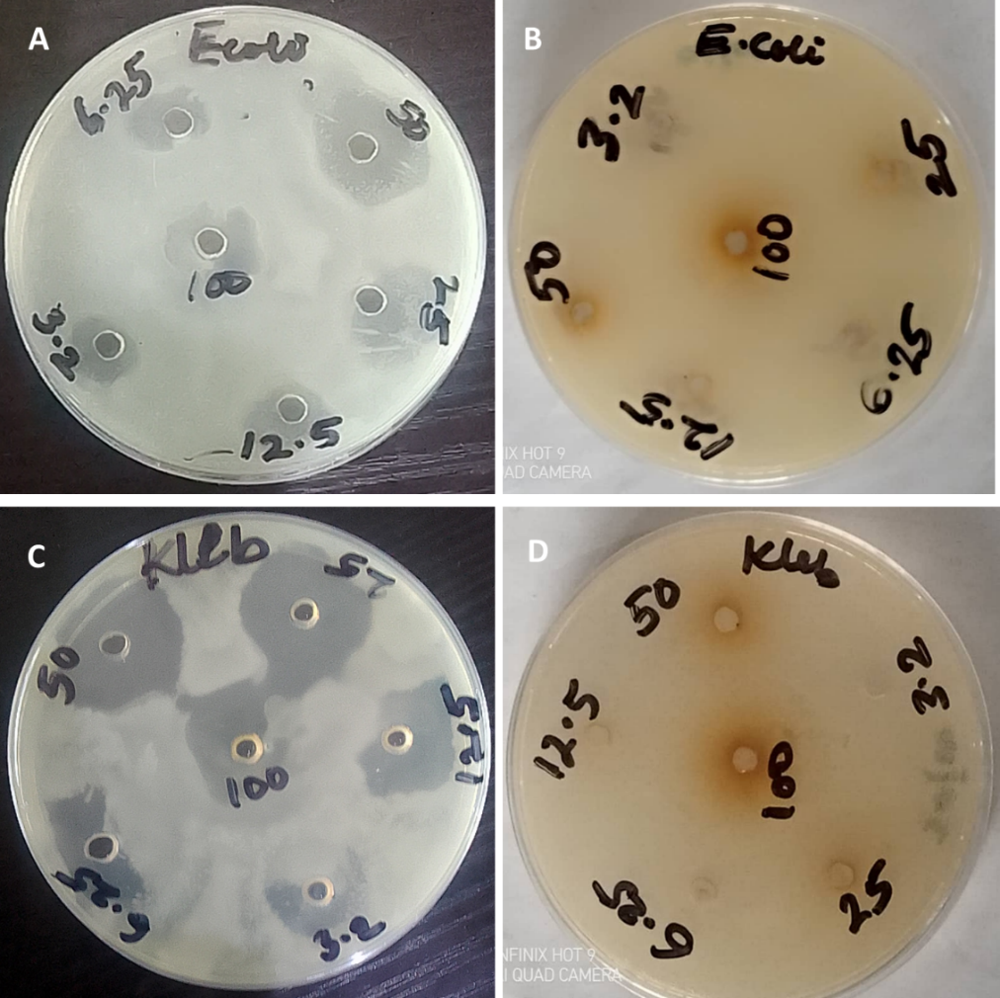
Fig. 1 (A) Ceftriaxone treatment of E. coli (B) Cocoa powder extract treatment of E. coli (C) Ceftriaxone treatment of K. pneumoniae (D) Cocoa powder extract treatment of K. pneumoniae (E): Images of the zones of inhibition of the treatment of E. coli and K. pneumoniae with Ceftriaxone and cocoa powder extract, respectively, are shown in Fig 1. The therapies are available in concentrations of 100, 50, 25, 12.5, 6.25, and 3.125 mg/mL.

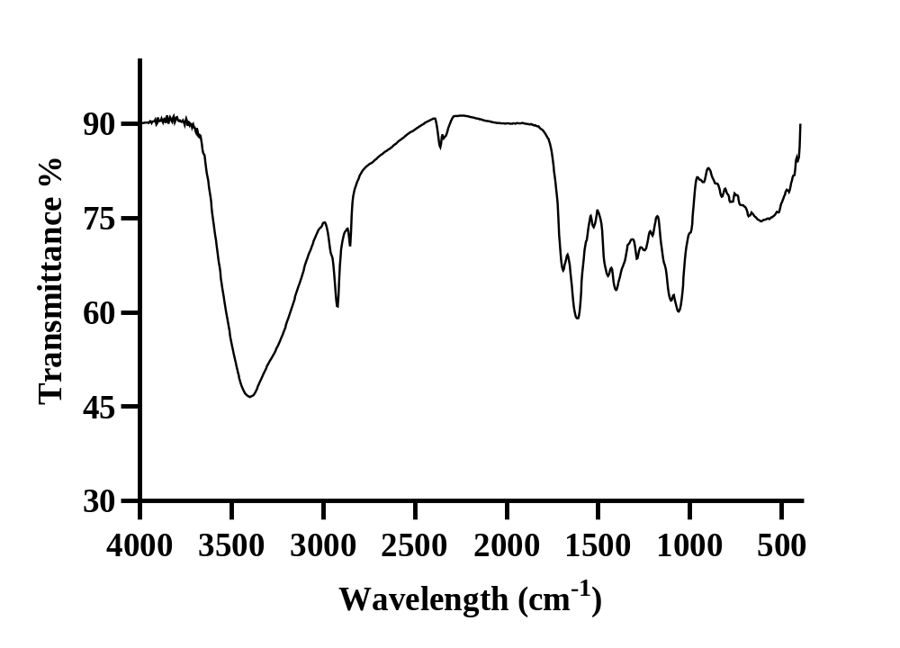
Fig 2: FTIR spectral of isolated compounds from the plants of study

Table 3: Interpretation of spectra of prominent peaks for the Cocoa beans extracts
Absorption Band Type of Vibration Frequency of Vibration
OH (hydrogen bonded) Stretching 3398.67cm⁻¹
C–H Stretching 2920.32cm⁻¹
C–H (Alkanes) Stretching 2850.88cm⁻¹
C=O of Ester Stretching 1689.70cm⁻¹
C-O. Stretching 1288.49cm-1

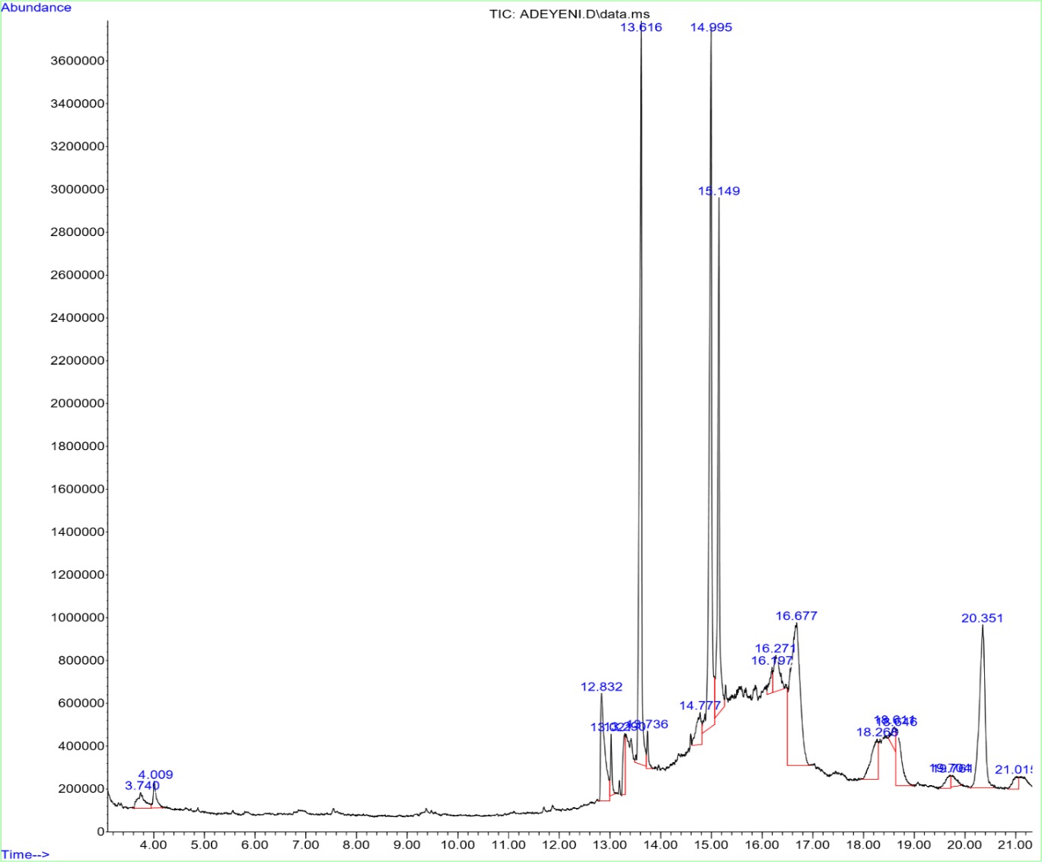
Fig 3: GC/MS spectral of crude extracts of ethanolic extracts of cocoa beans
3.2 Discussion
Qualitative phytochemical analysis of the cocoa samples was conducted using ethanol as the extraction solvent. Only alkaloids, tannins, and phenols were detected in the secondary-metabolite analysis; phlobatannins, saponins, terpenoids, and steroids were not detected. These findings indicate that cocoa contains several phytoconstituents. Polyphenols, methylxanthines, procyanidins, catechins, and caffeine are among the bioactive components reported in cocoa and are associated with various biological activities (Kim et al., 2014; Oracz et al., 2020; Reis de Araujo et al., 2016). The present investigation detected phenols, tannins, and alkaloids, which may be related to the polyphenolic composition of cocoa. The FTIR spectrum of the crude cocoa extract showed prominent peaks at 3398.67 cm⁻¹, 2920.32 cm⁻¹, 2850.88 cm⁻¹, 1689.70 cm⁻¹, and 1288.49 cm⁻¹. The peak at 3398.67 cm⁻¹ could be attributed to O-H stretching vibrations, suggesting the presence of alcohols and phenols. The peaks at 2920.32 and 2850.88 cm⁻¹ are consistent with aliphatic C-H stretching vibrations, particularly those of CH₂ and CH₃ groups, rather than terminal alkyne or C≡C stretching, which typically occurs at lower frequencies of approximately 2100-2260 cm⁻¹ (Nandiyanto et al., 2019; Stuart, 2004). Although FTIR cannot definitively differentiate among all potential carbonyl compounds, the absorption at 1689.70 cm⁻¹ suggests the presence of carbonyl-containing functional groups. Alcohols, phenols, ethers, and esters may exhibit C-O stretching vibrations, which could explain the band at 1288.49 cm⁻¹ (Nandiyanto et al., 2019; Stuart, 2004). The different functional groups and chemical bonds detected in the extract may be associated with the various bioactive constituents present in cocoa.
The antimicrobial activity of the cocoa extract against Klebsiella pneumoniae and Escherichia coli, both Gram-negative bacteria, was investigated. Ceftriaxone was used as the control, as shown in Table 2. The level of inhibition of the tested organisms was expressed as the mean ± SEM of three independent tests. Although the extract showed some activity against Klebsiella pneumoniae, its activity was lower than that of the positive control. This difference may reflect the concentration of antimicrobial constituents in the crude extract and differences in microbial susceptibility to the extract and the standard antibiotic. The observed antimicrobial activity may be associated with cocoa phytochemicals and phenolic compounds that have been linked to various biological activities, including antimicrobial activity (Oracz et al., 2020; Reis de Araujo et al., 2016).
GC-MS analysis of the ethanol extract in this investigation, with caffeine identification, revealed fourteen compounds belonging to six recognised chemical families. The reported compounds included isobutyl nonyl ester (5.45%), 1-heptadecanamine (2.75%), 6-deoxy-2-O-methyl-pentanoic acid (1.80%), 1,1-dimethyl thiirane (9.81%), 1-heptadecanamine (2.75%), and 2-methyl-2-isopropyl (62.06%). The results indicate that the extract contained multiple chemical constituents. However, the relative abundance of individual compounds detected by GC-MS cannot, by itself, establish their identity without appropriate standards or spectral confirmation; therefore, interpretation of caffeine identification should rely primarily on the chromatographic and mass-spectral identification criteria used in the study. Even when present in small quantities, phenolic and tannin constituents indicate that other phytochemicals were co-extracted and may contribute to the observed biological activity. Polyphenols and methylxanthines reported in cocoa have several biological functions, including antioxidant activity (Kim et al., 2014; Oracz et al., 2020; Reis de Araujo et al., 2016). However, in the absence of direct testing in these areas, it would be premature to attribute antioxidant or neuroprotective effects of the present extract solely to caffeine. Such effects, if investigated, could also involve caffeine together with other co-extracted phytochemicals. The relationship between the phytochemical and FTIR findings indicates that the extract contains multiple classes of bioactive chemicals and functional groups. Nevertheless, FTIR cannot independently determine compound identity, purity, or biological activity; it primarily provides information on functional groups (Nandiyanto et al., 2019; Stuart, 2004). The FTIR findings should therefore be interpreted as complementary to the GC-MS and phytochemical analyses rather than as conclusive evidence for a single constituent. Overall, the findings indicate that the cocoa ethanol extract had antimicrobial activity against K. pneumoniae and contained phytochemicals of potential biological relevance.
4. Conclusion
This study indicated that an ethanol extract of Nigerian cocoa bean powder (Theobroma cacao) contained bioactive constituents and exhibited antimicrobial activity against K. pneumoniae. The findings suggest that cocoa may have biological properties in addition to its established nutritional and industrial uses and that locally sourced Nigerian cocoa may warrant further investigation in studies of natural products and antimicrobial activity. FTIR analysis of the cocoa ethanol extract indicated the presence of hydroxyl, aliphatic C-H, carbonyl, and C-O functional groups. The extract showed lower antimicrobial activity than ceftriaxone but demonstrated measurable activity against Klebsiella pneumoniae.
The chemical profile of the extract was considered by combining the phytochemical, FTIR, and GC-MS findings. These analyses provide evidence of phytochemical constituents and associated functional groups but do not, by themselves, establish the biological activity of individual compounds. Conclusions drawn from qualitative phytochemical and FTIR analyses should therefore be supported by appropriate chromatographic and spectrometric evidence. Future biological investigations of this extract should consider its overall chemical composition rather than attributing observed effects to caffeine alone.

5. Limitation of the Study:
This study was limited to a crude ethanol extract of Theobroma cacao beans and focused on phytochemical screening, antimicrobial activity, and the identification of bioactive compounds using Fourier transform infrared spectroscopy (FT-IR) and gas chromatography coupled with mass spectrometry (GC-MS). The compounds responsible for the observed activities were not isolated or characterised individually. In addition, the antimicrobial evaluation involved a limited number of bacterial species, and in vivo studies were not conducted to confirm efficacy and safety. Further work should include compound isolation, toxicity assessment, and in vivo validation.
Declaration of AI Use

This manuscript was prepared through the intellectual contributions of the author(s) to the study design, data analysis, interpretation of results, and scholarly content. Grammarly and ChatGPT were used solely to assist with grammatical refinement and reference formatting during manuscript revision. The author(s) accept full responsibility for the accuracy, integrity, and final content of the manuscript.
Competing Interests
Authors have declared that no competing interests exist.
References
Ackar, D., Lendić, K. V., Valek, M., Šubarić, D., Miličević, B., Babić, J., & Nedić, I. (2013). Cocoa polyphenols: Can we consider cocoa and chocolate as potential functional food? Journal of Chemistry, 2013, Article 289392. https://doi.org/10.1155/2013/289392
Ben Lagha, A., Maquera Huacho, P., & Grenier, D. (2021). A cocoa (Theobroma cacao L.) extract impairs the growth, virulence properties, and inflammatory potential of Fusobacterium nucleatum and improves oral epithelial barrier function. PLOS ONE, 16(5), Article e0252029. https://doi.org/10.1371/journal.pone.0252029
Clinical and Laboratory Standards Institute. (2018). M07: Methods for dilution antimicrobial susceptibility tests for bacteria that grow aerobically (11th ed.). https://clsi.org/media/1928/m07ed11_sample.pdf
Cowan, M. M. (1999). Plant products as antimicrobial agents. Clinical Microbiology Reviews, 12(4), 564–582. https://doi.org/10.1128/CMR.12.4.564
Cushnie, T. P. T., & Lamb, A. J. (2005). Antimicrobial activity of flavonoids. International Journal of Antimicrobial Agents, 26(5), 343–356. https://doi.org/10.1016/j.ijantimicag.2005.09.002
Daglia, M. (2012). Polyphenols as antimicrobial agents. Current Opinion in Biotechnology, 23(2), 174–181. https://doi.org/10.1016/j.copbio.2011.08.007
Das, K., Manjula, S., Kumar, N. A., Sharma, B. P., Agrahari, D., Majhi, S., Mishra, S., Kumar, S., & Malwal, M. (2026). Experimental methodology for antimicrobial screening of medicinal plants: A critical review of extraction, phytochemical characterisation and susceptibility testing approaches. Asian Journal of Microbiology and Biotechnology, 11(2), 118–131. https://doi.org/10.56557/ajmab/2026/v11i210873
Dinh, A. H., & Hoang, A. Q. (2025). An updated review on chemical compositions of cocoa products and by-products with a focus on toxic elements and organic pollutants. Food Chemistry, 489, Article 145001. https://doi.org/10.1016/j.foodchem.2025.145001
Fideles, S. O. M., Ortiz, A. de C., Reis, C. H. B., Buchaim, D. V., & Buchaim, R. L. (2023). Biological properties and antimicrobial potential of cocoa and its effects on systemic and oral health. Nutrients, 15(18), Article 3927. https://doi.org/10.3390/nu15183927
Harborne, J. B. (1984). Phytochemical methods: A guide to modern techniques of plant analysis (2nd ed.). Chapman and Hall. https://doi.org/10.1007/978-94-009-5570-7
Hurst, W. J., Krake, S. H., Bergmeier, S. C., Payne, M. J., Miller, K. B., & Stuart, D. A. (2011). Impact of fermentation, drying, roasting and Dutch processing on flavan-3-ol stereochemistry in cacao beans and cocoa ingredients. Chemistry Central Journal, 5, Article 53. https://doi.org/10.1186/1752-153X-5-53
Ibitoye, F. O., Osaloni, A. R., & Adebote, V. T. (2020). Effect of fermentation on bacteria isolates and phytochemical properties of cocoa (Theobroma cacao) beans. South Asian Journal of Research in Microbiology, 7(4), 1–8. https://doi.org/10.9734/sajrm/2020/v7i430176
Joelijanto, R., & Sutjiati, R. (2025). Antibacterial activity of ethanol extract of cocoa beans (Theobroma cacao L.): In silico and in vitro study. Journal of Dentomaxillofacial Science, 10(4), 198–202. https://doi.org/10.15562/jdmfs.v10i4.1884
Kim, J., Kim, J., Shim, J., Lee, C. Y., Lee, K. W., & Lee, H. J. (2014). Cocoa phytochemicals: Recent advances in molecular mechanisms on health. Critical Reviews in Food Science and Nutrition, 54(11), 1458–1472. https://doi.org/10.1080/10408398.2011.641041
Nandiyanto, A. B. D., Oktiani, R., & Ragadhita, R. (2019). How to read and interpret FTIR spectroscope of organic material. Indonesian Journal of Science and Technology, 4(1), 97–118. https://doi.org/10.17509/ijost.v4i1.15806
Nsor-Atindana, J., Zhong, F., Mothibe, K. J., Bangoura, M. L., & Lagnika, C. (2012). Quantification of total polyphenolic content and antimicrobial activity of cocoa (Theobroma cacao L.) bean shells. Pakistan Journal of Nutrition, 11(7), 672–677. https://doi.org/10.3923/pjn.2012.672.677
Oracz, J., Nebesny, E., Żyżelewicz, D., Budryn, G., & Luzak, B. (2020). Bioavailability and metabolism of selected cocoa bioactive compounds: A comprehensive review. Critical Reviews in Food Science and Nutrition, 60(12), 1947–1985. https://doi.org/10.1080/10408398.2019.1619160
Reis de Araujo, Q., Gattward, J. N., Almoosawi, S., Silva, M. das G. C. P. C., Dantas, P. A. de S., & Reis de Araujo Júnior, Q. (2016). Cocoa and human health: From head to foot—A review. Critical Reviews in Food Science and Nutrition, 56(1), 1–12. https://doi.org/10.1080/10408398.2012.657921
Rusconi, M., & Conti, A. (2010). Theobroma cacao L., the food of the gods: A scientific approach beyond myths and claims. Pharmacological Research, 61(1), 5–13. https://doi.org/10.1016/j.phrs.2009.08.008
Santos, R. X., Oliveira, D. A., Sodré, G. A., Gosmann, G., Brendel, M., & Pungartnik, C. (2014). Antimicrobial activity of fermented Theobroma cacao pod husk extract. Genetics and Molecular Research, 13(3), 7725–7735. https://doi.org/10.4238/2014.September.26.10
Sari, A. B. T., Andriana, Y., Abdurrahman, M. F., Kurnianto, D., Sefrienda, A. R., Setiyoningrum, F., Wibowo, D. S., & Minh, T. N. (2024). Differentiation of Indonesian specialty cocoa (Theobroma cacao) varieties and origins using phenolic contents, antioxidant activities, and spectrometric fingerprints for traceability. Food Bioscience, 62, Article 105434. https://doi.org/10.1016/j.fbio.2024.105434
Sofowora, A. (1982). Medicinal plants and traditional medicine in Africa. John Wiley & Sons. https://agris.fao.org/search/en/providers/122535/records/65dde2f50f3e94b9e5c6cf26
Stuart, B. H. (2004). Infrared spectroscopy: Fundamentals and applications. John Wiley & Sons. https://doi.org/10.1002/0470011149
Evans, W. C. (1989). Trease and Evans' pharmacognosy (13th ed.). Baillière Tindall. https://www1.lib.kanazawa-u.ac.jp/recordID/catalog.bib/BA07137029
Wollgast, J., & Anklam, E. (2000). Review on polyphenols in Theobroma cacao: Changes in composition during the manufacture of chocolate and methodology for identification and quantification. Food Research International, 33(6), 423–447. https://doi.org/10.1016/S0963-9969(00)00068-5
Cinar, Z. Ö., Atanassova, M., Tumer, T. B., Caruso, G., Antika, G., Sharma, S., Sharifi-Rad, J., & Pezzani, R. (2021). Cocoa and cocoa bean shells role in human health: An updated review. Journal of Food Composition and Analysis, 103, Article 104115. https://doi.org/10.1016/j.jfca.2021.104115

