Original Research Article

Optimization of the Preparation of NaOH-Activated Carbon from Palm Kernel Shells Using Response Surface Methodology

.
ABSTRACT

Background: Palm kernel shells are lignocellulosic residues with potential as precursors for activated carbon production. However, the adsorption properties of the resulting carbon depend strongly on thermal and chemical preparation conditions. Optimising the combined effects of calcination temperature, calcination time, NaOH concentration, and impregnation time is therefore important for improving iodine adsorption capacity while avoiding unnecessarily severe treatment conditions.
Aims: This study aimed to optimise the preparation of activated carbon from palm kernel shells (Elaeis guineensis) by sodium hydroxide (NaOH) activation and to evaluate the effects of calcination and impregnation conditions on the iodine number.
Study Design: Response surface methodology, using a four-factor Box–Behnken design with 27 experimental runs, was applied.
Place and Duration of Study: The experiments were conducted at the Environmental Sciences Laboratory, Nangui ABROGOUA University, Côte d’Ivoire.
Methodology: Four preparation variables were investigated: calcination temperature (400–800 °C), calcination time (1–3 h), NaOH concentration (0.50–4.00 mol/L), and impregnation time (10–38 h). The iodine number was used as the response variable. Experimental data were fitted to a second-order polynomial model and evaluated using analysis of variance.
Results: Iodine numbers ranged from 873.10 to 1891.25 mg/g. The quadratic model was highly significant (F = 64.04; p < 0.0001) with R² = 0.9868. Calcination time, NaOH concentration, and impregnation time showed significant linear effects (p < 0.0001), whereas calcination temperature did not (p = 0.2318). The interactions between calcination time and NaOH concentration and between NaOH concentration and impregnation time were highly significant (p < 0.0001). All quadratic terms were significant. The highest iodine number (1891.25 mg/g) was obtained at 400 °C, 3 h calcination, 2.25 mol/L NaOH, and 24 h impregnation.
Conclusion: Palm kernel shells are a promising precursor for producing activated carbon with a high iodine adsorption capacity. Response surface methodology effectively revealed the combined influence of thermal and chemical preparation conditions.

Keywords: activated carbon; Box–Behnken; chemical activation ; palm kernel shells; response surface methodology.

1. INTRODUCTION

The utilisation of agricultural and agro-industrial residues represents a promising approach to reducing their environmental impact whilst producing high value-added materials. Among these residues, by-products from the oil palm sector are of particular interest for the production of activated carbon due to their high carbon content. Palm kernel shells, in particular, are a promising lignocellulosic precursor for the development of adsorbent materials. Several studies have shown that biomass and agricultural residues can be effectively converted into activated carbons, the properties of which depend heavily on the nature of the precursor and the preparation conditions (Şahin & Saka, 2013; Tiegam et al., 2021). Recent work has likewise demonstrated the conversion of plant-derived shell residues into activated carbon for adsorption applications, further supporting the use of lignocellulosic waste as an adsorbent precursor (Okoye-Anigbogu et al., 2025).
Palm kernel shells have thus been investigated as a raw material for the production of activated carbon. Kouotou et al. (2013) demonstrated that activation conditions strongly influence the characteristics of carbonaceous materials derived from these residues. Andas et al. (2017) also highlighted the potential of palm kernel shells for the production of activated carbon, whilst more recent studies have utilised response surface methodology to optimise the production conditions for activated carbons derived from this biomass (Anisuzzaman et al., 2021; Owusu et al., 2024). Palm-kernel-shell-derived activated carbon has also been studied under different thermal and chemical activation conditions and continues to be investigated for adsorption-related applications (Gopalan et al., 2024; Jawing et al., 2021; Vincent et al., 2016).
Alkaline activation, particularly with NaOH, can promote the development of a significant microporous structure (Hafizuddin et al., 2021). Furthermore, the characteristics of the resulting activated carbon depend on several process parameters, notably calcination temperature and time, the concentration of the activating agent, and impregnation time. Insufficient temperature or treatment time may limit the development of porosity, whilst excessive conditions may adversely alter the carbon structure. Similarly, the effect of NaOH concentration may depend on the thermal conditions and impregnation time. The interactions between these various parameters must therefore be taken into account when optimising the process. Among the parameters used to assess the properties of activated carbon, the iodine number is a widely used indicator for evaluating its adsorption capacity for small molecules and indirectly assessing the development of its microporosity (Wu et al., 2018). A high iodine number is generally associated with significant accessible microporosity. However, this measurement is no substitute for comprehensive textural characterisation, particularly through the determination of the BET specific surface area and pore size distribution.
Due to the possible interactions between the various preparation parameters, the approach of studying each factor separately has certain limitations. The response surface methodology (RSM) offers an alternative that allows several variables, their interactions and their quadratic effects to be studied simultaneously, whilst minimising the number of experiments. This approach has been successfully applied to optimising the production of activated carbon from different types of biomass (Ab Ghani et al., 2017; González et al., 2014). The Box–Behnken design is particularly well-suited to this type of study as it enables the establishment of a quadratic model and the identification of the factors and their interactions that significantly influence the response. Recent studies have continued to apply response surface methodology to optimise activated-carbon preparation and adsorption-related performance in biomass-derived systems (Guerra-Que et al., 2025; Kılıç et al., 2025). However, within the scope of the studies cited above, the combined influence of calcination temperature, calcination time, NaOH concentration, and impregnation time on the iodine value of palm-kernel-shell activated carbon has not been examined within a single four-factor Box–Behnken framework. Thus, the present study aims to evaluate and optimise the influence of calcination temperature, calcination time, NaOH concentration and impregnation time on the iodine value of an activated carbon prepared from palm kernel shells.

2. material and methods
2.1. Raw material
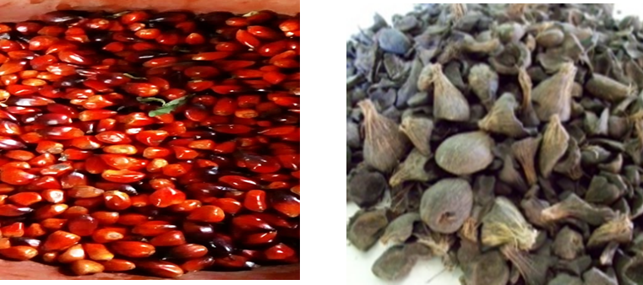
The raw material (Figure 1) used for the production of activated carbon consisted of palm seed shells collected from local residents in the village of Béoumi. These shells were derived from the African palm species Elaeis guineensis, which is very common in rural areas of Côte d’Ivoire.
b)
a)
Figure 1: Seeds (a) and husks (b) of palm kernels

The palm seed shells, with the seeds removed, were washed and dried at room temperature, particularly in the sun, to remove impurities.

2.2. Pre-treatment and chemical activation
The prepared shells were subjected to chemical activation using sodium hydroxide as the activating agent, with a shell mass (g)-to-NaOH volume (mL) ratio of 1:1. The NaOH concentration was varied between 0.50 and 4.00 mol/L, whilst the impregnation time ranged from 10 to 38 hours. Following the impregnation stage, the materials were subjected to calcination at temperatures ranging from 400 to 800 °C for a duration of between 1 and 3 hours. The heating rate was 10 °C per minute. After calcination, the activated carbon was washed with distilled water until a neutral pH was reached. It was then dried at 105 °C for 24 hours to evaporate the washing water.

2.3. Box–Behnken experimental design
The study was carried out using a randomised Box–Behnken design (Tables 1 and 2) comprising four quantitative factors and 27 experimental trials. A quadratic model was used to describe the relationship between the independent variables and the iodine number.

Table 1: Build Information using the Design Expert 13.0.5.0 software
Study Type | Response Surface | Subtype | Randomized
Design Type | Box-Behnken | Runs | 27.00
Design Model | Quadratic | Blocks | No Blocks
Build Time (ms) | 150.00

Factor A corresponded to the calcination temperature, studied between 400 and 800 °C. Factor B represented the calcination time, ranging from 1 to 3 hours. Factor C corresponded to the NaOH concentration, varying between 0.50 and 4.00 mol/L. Finally, factor D represented the impregnation time, ranging from 10 to 38 hours. The central points were 600 °C, 2 hours, 2.25 mol/L and 24 hours, respectively.
Table 2: Levels and ranges of the four experimental factors.
Factor | Name | Units | Minimum | Maximum | Coded Low | Coded High | Mean | Std. Dev.
A | Calcination temperature | °C | 400.00 | 800,00 | -1 ↔ 400 | +1 ↔ 800 | 600 | 135.87
B | Calcination time | h | 1.0000 | 3.00 | -1 ↔ 1 | +1 ↔ 3 | 2 | 0.6794
C | [NaOH] | mol/L | 0.5000 | 4.00 | -1 ↔ 0.50 | +1 ↔ 4 | 2.25 | 1.19
D | Impregnation time | h | 10.00 | 38.00 | -1 ↔ 10 | +1 ↔ 38 | 24 | 9.51

2.4. Determination of the iodine number
The iodine number, expressed in mg/g, was used as the response variable. This parameter allows an indirect assessment of the development of microporosity in activated carbon (Wu et al., 2018). The determination protocol used in this study was based on the work of Nko’o Abuiboto et al. (2016). Thus, a mass of 0.2 g of activated carbon was placed in an Erlenmeyer flask with 20 mL of an iodine solution (0.02 mol/L). The mixture was stirred for 10 minutes. After the specified time, the solution was filtered, and 10 mL of the filtrate was taken for titration with a sodium thiosulphate solution (0.1 mol/L) in the presence of starch paste. The relationship below (Equation 28) was used to calculate the iodine value.

$$Iondine number (mg/g)= \frac{\left(C_{0}-\frac{C_{th}×V_{th}}{{2×V}_{I_{2}}}\right)×M_{I_{2}}×V_{ads}}{m_{CA}}$$
where C0 is the concentration of the initial iodine solution, Cth is the concentration of the sodium thiosulphate solution, Vth is the volume of the sodium thiosulphate solution at equivalence (in mL), V(I2) is the volume of the titrated iodine solution (mL), M(I2) is the molar mass of iodine (254 g·mol⁻¹), Vads is the volume used for the adsorption test (mL), and mCA is the mass of activated carbon. Table 3 below shows the experiments for which the iodine number was determined.
Table 3: Experimental table
Std | Run | A:Calcination temperature | B:Calcination time | C:[NaOH] | D:Impregnation time
 |  | °C | h | mol/L | h
20 | 1 | 800 | 2 | 4 | 24
2 | 2 | 800 | 1 | 2.25 | 24
3 | 3 | 400 | 3 | 2.25 | 24
14 | 4 | 600 | 3 | 0.5 | 24
12 | 5 | 800 | 2 | 2.25 | 38
4 | 6 | 800 | 3 | 2.25 | 24
15 | 7 | 600 | 1 | 4 | 24
5 | 8 | 600 | 2 | 0.5 | 10
21 | 9 | 600 | 1 | 2.25 | 10
8 | 10 | 600 | 2 | 4 | 38
6 | 11 | 600 | 2 | 4 | 10
25 | 12 | 600 | 2 | 2.25 | 24
23 | 13 | 600 | 1 | 2.25 | 38
10 | 14 | 800 | 2 | 2.25 | 10
19 | 15 | 400 | 2 | 4 | 24
27 | 16 | 600 | 2 | 2.25 | 24
1 | 17 | 400 | 1 | 2.25 | 24
24 | 18 | 600 | 3 | 2.25 | 38
17 | 19 | 400 | 2 | 0.5 | 24
13 | 20 | 600 | 1 | 0.5 | 24
18 | 21 | 800 | 2 | 0.5 | 24
16 | 22 | 600 | 3 | 4 | 24
7 | 23 | 600 | 2 | 0.5 | 38
22 | 24 | 600 | 3 | 2.25 | 10
11 | 25 | 400 | 2 | 2.25 | 38
9 | 26 | 400 | 2 | 2.25 | 10
26 | 27 | 600 | 2 | 2.25 | 24

2.5. Statistical modelling
The results were fitted to a second-order polynomial model:
Y = β₀ + ΣβᵢXᵢ + ΣβᵢⱼXᵢXⱼ + ΣβᵢᵢXᵢ²
where Y represents the predicted iodine number, β₀ is the model constant, βᵢ are the linear coefficients, βᵢⱼ are the interaction coefficients, and βᵢᵢ are the quadratic coefficients. The significance of the model and its various terms was assessed using analysis of variance. The threshold for statistical significance was set at p < 0.05.

3. Results and discussion
3.1. Variation in the iodine number
Table 4 shows the iodine number values obtained under the various experimental conditions.
Table 4: Iodine number values calculated under the various experimental conditions
Std | Run | A:Calcination temperature | B:Calcination time | C:[NaOH] | D:Impregnation time | Iodine number
 |  | °C | h | mol/L | h | mg/g
20 | 1 | 800 | 2 | 4 | 24 | 1672.4
2 | 2 | 800 | 1 | 2.25 | 24 | 1702.6
3 | 3 | 400 | 3 | 2.25 | 24 | 1891.25
14 | 4 | 600 | 3 | 0.5 | 24 | 1522.55
12 | 5 | 800 | 2 | 2.25 | 38 | 1724.95
4 | 6 | 800 | 3 | 2.25 | 24 | 1880.55
15 | 7 | 600 | 1 | 4 | 24 | 873.1
5 | 8 | 600 | 2 | 0,5 | 10 | 1498.45
21 | 9 | 600 | 1 | 2.25 | 10 | 1603.15
8 | 10 | 600 | 2 | 4 | 38 | 974.05
6 | 11 | 600 | 2 | 4 | 10 | 1661.4
25 | 12 | 600 | 2 | 2.25 | 24 | 1742.6
23 | 13 | 600 | 1 | 2.25 | 38 | 1432.75
10 | 14 | 800 | 2 | 2.25 | 10 | 1830.05
19 | 15 | 400 | 2 | 4 | 24 | 1505.3
27 | 16 | 600 | 2 | 2.25 | 24 | 1742.6
1 | 17 | 400 | 1 | 2.25 | 24 | 1689.55
24 | 18 | 600 | 3 | 2.25 | 38 | 1627.5
17 | 19 | 400 | 2 | 0.5 | 24 | 1859.6
13 | 20 | 600 | 1 | 0.5 | 24 | 1872.55
18 | 21 | 800 | 2 | 0.5 | 24 | 1866.05
16 | 22 | 600 | 3 | 4 | 24 | 1698.25
7 | 23 | 600 | 2 | 0.5 | 38 | 1863.25
22 | 24 | 600 | 3 | 2.25 | 10 | 1780.2
11 | 25 | 400 | 2 | 2.25 | 38 | 1668.9
9 | 26 | 400 | 2 | 2.25 | 10 | 1878.6
26 | 27 | 600 | 2 | 2.25 | 24 | 1740.85

The 27 experimental conditions studied yielded iodine numbers ranging from 873.10 to 1891.25 mg/g, with a mean of 1659.37 mg/g and a standard deviation of 248.49 mg/g. The range observed between the minimum and maximum values indicates that the calcination and impregnation conditions had a notable influence on the adsorbent properties of the activated carbon obtained. The maximum iodine value, 1,891.25 mg/g, was obtained at a calcination temperature of 400 °C for 3 hours, with a NaOH concentration of 2.25 mol/L and an impregnation time of 24 hours. Conversely, the minimum value of 873.10 mg/g was observed at 600 °C after 1 hour of calcination, with 4 mol/L NaOH and a 24-hour impregnation time.
These results show that an increase in the concentration of the activating agent does not necessarily lead to an improvement in the iodine number. The effect of NaOH therefore depends on other preparation conditions, in particular the calcination time and the impregnation time. This trend is consistent with observations reported for activated carbons derived from lignocellulosic biomass. Hafizuddin et al. (2021) demonstrated that NaOH activation can promote the development of a highly microporous structure, but that the textural characteristics of the final material remain closely linked to the activation conditions. Similarly, Anisuzzaman et al. (2021), using response surface methodology for carbonaceous materials derived from palm kernel shells, highlighted the importance of simultaneously optimising preparation parameters rather than analysing them separately. More recently, Owusu et al. (2024) also demonstrated that the physical properties of activated carbons produced from palm kernel shells are highly dependent on process variables and their combinations.
The high iodine number values obtained in several experiments suggest a significant development of sites accessible to small molecules. This interpretation is consistent with the work of Wu et al. (2018), who demonstrated that pore accessibility and distribution play a key role in the adsorption of molecules of different sizes. Nzetchuen Kouahou et al. (2023) also used the iodine number as one of the parameters to assess the properties of highly porous activated carbons prepared from plant biomass and optimised using response surface methodology.
However, the iodine number should be regarded as an indirect indicator of microporosity and not as a direct measure of specific surface area. A high value alone does not, therefore, allow the BET surface area or pore size distribution to be determined precisely. Additional characterisation by N₂ adsorption–desorption, combined with the determination of the BET specific surface area and micropore volume, would help to confirm the relationship between the high iodine number values observed and the actual development of the carbon’s microporosity.

3.2. Significance of the quadratic model
The analysis of variance (Table 5) shows that the quadratic model is highly significant, with an F-value of 64.04 and p < 0.0001.
Table 5: ANOVA for Quadratic model
Source | Sum of Squares | df | Mean Square | F-value | P-value
Model | 1.584E+06 | 14 | 1.132E+05 | 64.04 | < 0.0001
A-Calcination temperature | 2802.96 | 1 | 2802.96 | 1.59 | 0.2318
B-Calcination time | 1.254E+05 | 1 | 1.254E+05 | 70.96 | < 0.0001
C-[NaOH] | 3.668E+05 | 1 | 3.668E+05 | 207.58 | < 0.0001
D-Impregnation time | 76872.02 | 1 | 76872.02 | 43.50 | < 0.0001
AB | 141.02 | 1 | 141.02 | 0.0798 | 0.7824
AC | 6452.11 | 1 | 6452.11 | 3.65 | 0.0802
AD | 2735.29 | 1 | 2735.29 | 1.55 | 0.2372
BC | 3.452E+05 | 1 | 3.452E+05 | 195.39 | < 0.0001
BD | 78.32 | 1 | 78.32 | 0.0443 | 0,8368
CD | 2.768E+05 | 1 | 2.768E+05 | 156.63 | < 0.0001
A² | 84907.36 | 1 | 84907.36 | 48.05 | < 0.0001
B² | 28655.41 | 1 | 28655.41 | 16.22 | 0.0017
C² | 1.394E+05 | 1 | 1.394E+05 | 78.90 | < 0.0001
D² | 31739.51 | 1 | 31739.51 | 17.96 | 0.0012
Residual | 21203.84 | 12 | 1766.99
Lack of Fit | 21201.80 | 10 | 2120.18 | 2076.91 | 0.0005
Pure Error | 2.04 | 2 | 1.02
Cor Total | 1.605E+06 | 26

The analysis of variance shows that the quadratic model is highly significant, with an F-value of 64.04 and p < 0.0001. Of the four linear effects studied, calcination time B (p < 0.0001), NaOH concentration C (p < 0.0001), and impregnation time D (p < 0.0001) had statistically significant effects on the iodine value. By contrast, the linear effect of calcination temperature A was not significant (p = 0.2318).
NaOH concentration had the most pronounced linear effect, with F = 207.58, followed by calcination time (F = 70.96) and impregnation time (F = 43.50). This predominance confirms the importance of chemical activation in the development of the material’s adsorbent properties. Hafizuddin et al. (2021) demonstrated, in particular, that NaOH treatment can lead to significant changes in the porous structure of carbonaceous materials and promote the formation of microporous structures.
However, the negative linear coefficient associated with the NaOH concentration in the model (−174.83) shows that, within the experimental range considered and with all other factors held constant, an increase in this concentration tends to reduce the iodine value. This observation shows that simply increasing the quantity of activating agent is not sufficient to improve the properties of the charcoal. It is consistent with the approach advocated by Owusu et al. (2024), according to which the performance of activated charcoals derived from palm kernel shells results from a trade-off between several operational parameters.
However, the fact that the linear effect of temperature is not significant does not mean that temperature has no influence on the iodine number. Indeed, its quadratic term A² is highly significant (p < 0.0001). The influence of temperature is therefore primarily manifested as a non-linear response within the range studied. This observation highlights the value of the response surface methodology, which enables the identification of quadratic effects and interactions that would be difficult to detect using an experimental approach that examines factors in isolation. The value of this approach for the optimisation of biomass-derived activated carbons has been demonstrated in particular by González et al. (2014), Ab Ghani et al. (2017), Nzetchuen Kouahou et al. (2023) and, more recently, Owusu et al. (2024).

3.3. Interactions between factors
The statistical analysis highlights two interactions in particular: B×C and C×D (Figures 2 and 3). The interaction between calcination time and NaOH concentration (BC) was highly significant, with F = 195.39 and p < 0.0001. Its positive coefficient of +293.79 indicates a significant synergistic effect between these two variables in certain regions of the experimental range.
This interaction shows that the influence of NaOH concentration on the iodine value depends heavily on the calcination time. In other words, a given NaOH concentration cannot be considered favourable or unfavourable independently of the duration for which the material is subjected to heat treatment. The B×C response surface presented in the study clearly illustrates this dependence between the two factors. This observation is consistent with Anisuzzaman et al. (2021), who demonstrated, whilst optimising carbon-based materials derived from palm kernel shells, that the final properties resulted from the combined effect of the preparation parameters. Owusu et al. (2024) also highlighted the value of RSM in identifying combinations of variables that improve the properties of activated carbon derived from palm kernel shells.
Conversely, the interaction between NaOH concentration and impregnation time (CD) was also highly significant (F = 156.63; p < 0.0001), but had a negative coefficient of −263.04. Increasing both the NaOH concentration and the impregnation time simultaneously does not therefore necessarily lead to an improvement in the iodine number. The C×D response surface graphically confirms this non-additive behaviour.
This result can be interpreted as indicating the existence of an optimal combination of the intensity of the chemical treatment and its duration. Indeed, the work of Hafizuddin et al. (2021) shows that NaOH plays an important role in the development of the microporosity of activated carbons. However, the results of the present study indicate that a more intense chemical treatment does not necessarily produce a better response when the treatment duration is also increased. This could correspond to further transformations of the porous structure as the activation conditions become more severe. This interpretation will, however, need to be confirmed by textural characterisation of the material.
The AB, AD and BD interactions were not statistically significant at the 5 per cent significance level, whilst the AC interaction had a p-value of 0.0802. Thus, amongst the interactions studied, those involving the NaOH concentration in combination with the calcination time or the impregnation time appear to be the most significant. This result reinforces the central role of the activator in the process.

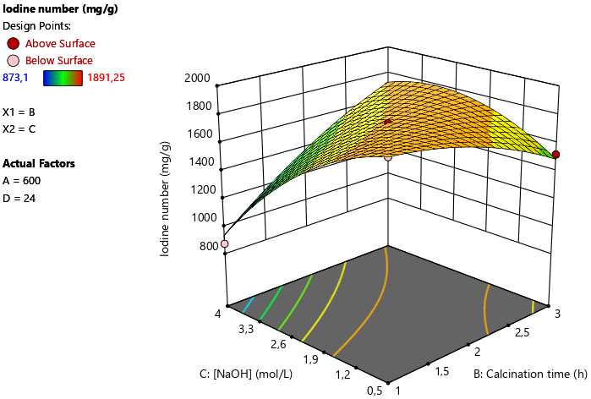

Figure 2: Interaction B × C (calcination time × NaOH concentration).
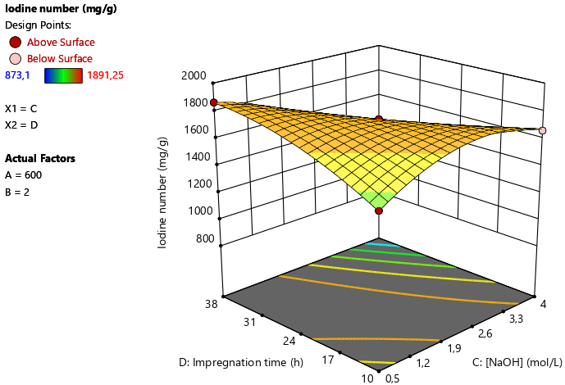

Figure 3: Interaction C × D (NaOH concentration × impregnation time).
3.4. Quadratic effects
The quadratic terms A², B², C² and D² were all statistically significant, with p < 0.0001, p = 0.0017, p < 0.0001 and p = 0.0012, respectively. These results demonstrate that variations in the iodine number as a function of the parameters studied cannot be described by simple linear relationships.
The case of calcination temperature is particularly interesting. Whilst its linear effect A was not significant (p = 0.2318), its quadratic term A² was highly significant. This indicates that the influence of temperature manifests itself primarily as a curvature in the response. Such a trend is consistent with the principle that thermal treatments progressively alter the carbon matrix and the porous structure of the material. Research on activated carbons derived from biomass does indeed show that the final properties depend heavily on the intensity of the thermal and chemical treatment (Kouotou et al., 2013; Owusu et al., 2024).
The quadratic coefficients for B², C² and D² were −73.30, −161.68 and −77.14, respectively. Their negative values reflect concave contributions to the response surface and indicate that a continuous increase in these factors does not lead to a continuous improvement in the iodine number. In particular, the C² term has the highest negative coefficient in absolute terms (−161.68), reinforcing the idea that an excessive concentration of NaOH can become detrimental under certain experimental conditions.
These observations are particularly important for process optimisation, as they show that a strategy consisting simply of increasing the NaOH concentration, the calcination time or the impregnation time would not necessarily result in the highest-performing charcoal. The response surface methodology therefore appears suitable for identifying trade-offs between these different parameters, as has also been demonstrated by Ab Ghani et al. (2017) and Nzetchuen Kouahou et al. (2023) for the optimisation of activated carbons prepared from different types of biomass.

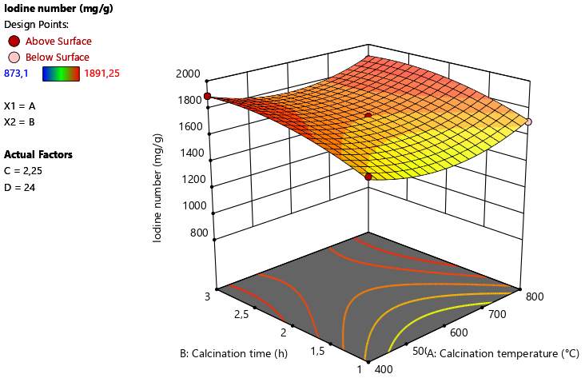
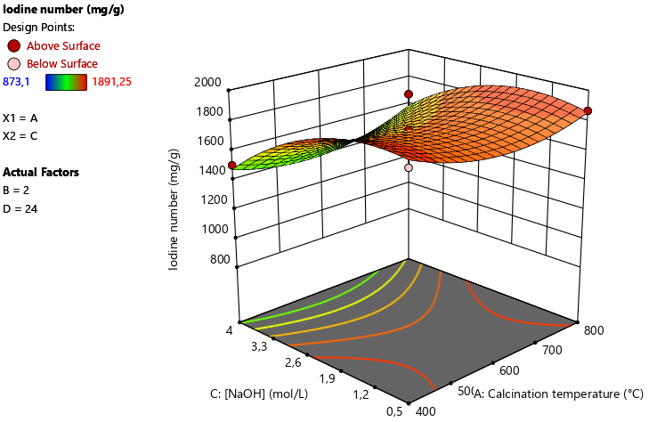
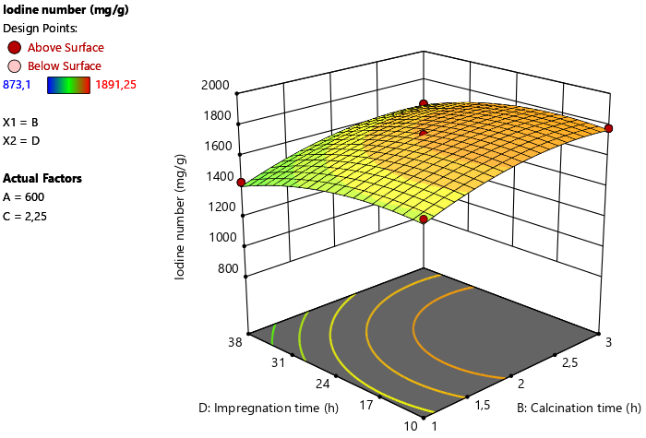
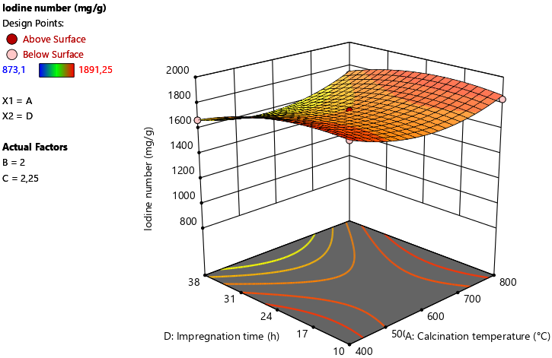
a)
b)
c)
d)

Figure 4a–d: quadratic effects associated with interactions (a: interaction between calcination time and calcination temperature; b: interaction between impregnation time and calcination time; c: interaction between impregnation time and calcination temperature; d: interaction between [NaOH] and calcination temperature).

3.5. Mathematical equation of the model
The resulting equation in coded factors is:
Y = 1742.02 + 15.28A + 102.22B − 174.83C − 80.04D − 5.94AB + 40.16AC + 26.15AD + 293.79BC + 4.43BD − 263.04CD + 126. 17A² − 73.30B² − 161.68C² − 77.14D²
According to Table 6, the model has a coefficient of determination R² = 0.9868. It therefore explains approximately 98.68 per cent of the total observed variation in the iodine number. The adjusted R² is 0.9714, and the predicted R² is 0.9239. The Adeq Precision is 30.9674, whilst the coefficient of variation is only 2.53 per cent. These statistics indicate a very good overall descriptive capacity.

Table 6: Fit Statistics
Std. Dev. | 42,04 | R² | 0,9868
Mean | 1659,37 | Adjusted R² | 0,9714
C.V. % | 2,53 | Predicted R² | 0,9239
C.V. % | 2,53 | Adeq Precision | 30,9674

These results thus confirm the value of the Box–Behnken design for simultaneously analysing several factors and their interactions. Satisfactory performance of the response surface methodology has also been reported for the optimisation of biomass-derived activated carbons by Ab Ghani et al. (2017), Anisuzzaman et al. (2021), Nzetchuen Kouahou et al. (2023) and Owusu et al. (2024).

4. Conclusion
The use of a four-factor Box–Behnken design with 27 trials highlighted the influence of preparation conditions on the iodine value of activated carbon derived from palm kernel shells. The iodine values ranged from 873.10 to 1,891.25 mg/g. The quadratic model was highly significant (F = 64.04; p < 0.0001) and exhibited a high coefficient of determination (R² = 0.9868). Calcination time, NaOH concentration, and impregnation time had significant linear effects. The BC and CD interactions were the two most significant interactions. Furthermore, the significance of the four quadratic terms confirmed the non-linear nature of the response. The best condition tested was 400 °C, 3 h, 2.25 mol/L NaOH, and 24 h of impregnation, yielding an iodine value of 1,891.25 mg/g.

Limitation
The study used the iodine number as the principal response for evaluating activated-carbon performance. Although this parameter provides an indirect indication of microporosity and accessibility to small molecules, it does not directly determine BET specific surface area or pore-size distribution. Additional textural characterisation, particularly N₂ adsorption–desorption measurements, would be required to confirm the relationship between iodine number and the detailed pore structure of the prepared activated carbon.

Competing interests
Authors have declared that no competing interests exist.

Declaration of AI Use

This manuscript was prepared through the intellectual contributions of the author(s) to the study design, data analysis, interpretation of results, and scholarly content. Grammarly and ChatGPT were used solely to assist with grammatical refinement and reference formatting during manuscript revision. The author(s) accept full responsibility for the accuracy, integrity, and final content of the manuscript.

References

Ab Ghani, Z., Yusoff, M. S., Zaman, N. Q., Zamri, M. F. M. A., & Andas, J. (2017). Optimization of preparation conditions for activated carbon from banana pseudo-stem using response surface methodology on removal of color and COD from landfill leachate. Waste Management, 62, 177–187. https://doi.org/10.1016/j.wasman.2017.02.026
Andas, J., Rahman, M. L. A., & Yahya, M. S. M. (2017). Preparation and characterization of activated carbon from palm kernel shell. IOP Conference Series: Materials Science and Engineering, 226(1), 012156. https://doi.org/10.1088/1757-899X/226/1/012156
Anisuzzaman, S. M., Sinring, N., & Mansa, R. F. (2021). Properties tuning of palm kernel shell biochar granular activated carbon using response surface methodology for removal of methylene blue. Journal of Applied Science & Process Engineering, 8(2), 1002–1019. https://doi.org/10.33736/jaspe.3961.2021
González, P. G., Hernández-Quiroz, T., & García-González, L. (2014). The use of experimental design and response surface methodologies for the synthesis of chemically activated carbons produced from bamboo. Fuel Processing Technology, 127, 133–139. https://doi.org/10.1016/j.fuproc.2014.05.035
Gopalan, J., Buthiyappan, A., Rashidi, N. A., Sufian, S., & Abdul Raman, A. A. (2024). A sustainable and economical solution for CO₂ capture with biobased carbon materials derived from palm kernel shells. Environmental Science and Pollution Research, 31(33), 45887–45912. https://doi.org/10.1007/s11356-024-34173-1
Guerra-Que, Z., López-Margalli, K. S., Urrieta-Saltijeral, J. M., Silahua-Pavón, A. A., Martínez-García, H., García-Alamilla, P., Córdova-Pérez, G. E., Arévalo-Pérez, J. C., & Torres-Torres, J. G. (2025). Activated carbon synthesised from lignocellulosic cocoa pod husk via alkaline and acid treatment for methylene blue adsorption: Optimisation by response surface methodology, kinetics, and isotherm modelling. RSC Advances, 15(55), 47231–47254. https://doi.org/10.1039/D5RA05557A
Hafizuddin, M. S., Lee, C. L., Chin, K. L., H’ng, P. S., Khoo, P. S., & Rashid, U. (2021). Fabrication of highly microporous structure activated carbon via surface modification with sodium hydroxide. Polymers, 13(22), 3954. https://doi.org/10.3390/polym13223954
Jawing, D., Syahril, S., Bahrun, M. H. V., & Mansa, R. F. (2021). Palm kernel shell activated carbon for lead and methylene blue removal. Transactions on Science and Technology, 8(3-2), 290–304. https://tost.unise.org/pdfs/vol8/no3-2/ToST-CoFA2020-290-304-OA.html
Kılıç, M., Bekman, M. E., Bodur, F., Yıldız, A., & Apaydın-Varol, E. (2025). Modeling and optimization of flash heating process conditions for activated carbon production using response surface methodology (RSM). Diamond and Related Materials, 154, 112239. https://doi.org/10.1016/j.diamond.2025.112239
Nzetchuen Kouahou, G., Fotsop, C. G., Adoum Amola, L., Donlifack Atemkeng, C., Kamdem Tamo, A., Teikam Kenda, G., Tiegam Tagne, R. F., & Kamgaing, T. (2023). Optimized preparation of activated carbon with high porosities based on puck shells (Afrostyrax lepidophyllus) by response surface methodology and physico-chemical characterization. Royal Society Open Science, 10(12), 230911. https://doi.org/10.1098/rsos.230911
Kouotou, D., Manga, H. N., Baçaoui, A., Yaacoubi, A., & Mbadcam, J. K. (2013). Optimization of activated carbons prepared by H₃PO₄ and steam activation of oil palm shells. Journal of Chemistry, 2013, 654343. https://doi.org/10.1155/2013/654343
Nko’o Abuiboto, M. C., Avom, J., & Mpon, R. (2016). Évaluation des propriétés de charbons actifs de résidus de Moabi (Baillonella toxisperma Pierre) par adsorption d’iode en solution aqueuse. Revue des sciences de l’eau / Journal of Water Science, 29(1), 51–60. https://doi.org/10.7202/1035716ar
Okoye-Anigbogu, S. M., Nwaokoro, A.-P. C., Nwagbara, N. K., & Onuegbu, T. U. (2025). Chrysophyllum albidum seed shell-derived activated carbon: A novel adsorbent for Basic Red 9 (BR9) dye adsorption. Journal of Applied Chemical Science International, 16(2), 157–174. https://doi.org/10.56557/jacsi/2025/v16i29620
Owusu, C., Mends, E. A., & Acquah, G. (2024). Enhancing the physical qualities of activated carbon produced from palm kernel shell via response surface methodology—Process variable optimization. Biomass Conversion and Biorefinery, 14(21), 27233–27247. https://doi.org/10.1007/s13399-022-03595-7
Şahin, Ö., & Saka, C. (2013). Preparation and characterization of activated carbon from acorn shell by physical activation with H₂O–CO₂ in two-step pretreatment. Bioresource Technology, 136, 163–168. https://doi.org/10.1016/j.biortech.2013.02.074
Tiegam, R. F. T., Tchuifon Tchuifon, D. R., Santagata, R., Kouteu Nanssou, P. A., Anagho, S. G., Ionel, I., & Ulgiati, S. (2021). Production of activated carbon from cocoa pods: Investigating benefits and environmental impacts through analytical chemistry techniques and life cycle assessment. Journal of Cleaner Production, 288, 125464. https://doi.org/10.1016/j.jclepro.2020.125464
Vincent, O., Solomon, N., & Jude, D. (2016). Study of kinetics of chemically activated carbon produced from palm kernel shell. British Journal of Applied Science & Technology, 16(6), 1–9. https://doi.org/10.9734/BJAST/2016/27324
Wu, Y., Xia, C., Cai, L., & Shi, S. Q. (2018). Controlling pore size of activated carbon through self-activation process for removing contaminants of different molecular sizes. Journal of Colloid and Interface Science, 518, 41–47. https://doi.org/10.1016/j.jcis.2018.02.017

