Comparative Phytochemical Analysis in Finger Millet Germplasm from Different Districts of Uttarakhand, India

Abstract:
Finger millet is a nutritionally important cereal crop that can grow under diverse environmental conditions and contributes to food and nutritional security. The present study qualitatively evaluated major phytochemical constituents in 12 finger millet germplasm samples collected from 12 districts of Uttarakhand, India. Seed samples were dried, powdered, and extracted by agitated cold maceration using methanol at a 1:10 (w/v) solid-to-solvent ratio for 24 h at room temperature and 100 rpm. The extracts were screened for alkaloids, tannins, saponins, carbohydrates, terpenoids, proteins, and phenolic compounds using standard qualitative tests. The intensity of the observed reactions was classified as absent, slightly positive, positive, or strongly positive. Proteins were detected in all treatments, while the occurrence and reaction intensity of the other phytochemical groups varied among germplasm samples. T6 showed strongly positive reactions for alkaloids, tannins, proteins, and phenolic compounds and therefore displayed the most pronounced qualitative phytochemical profile among the evaluated treatments. In contrast, T7 showed no detectable carbohydrates, tannins, saponins, or terpenoids and exhibited the lowest phytochemical diversity. Phenolic compounds were strongly positive in T6, T10, and T11, whereas terpenoids were detected in T1, T2, T3, T10, T11, and T12. These findings demonstrate qualitative variation in major phytochemical constituents among finger millet germplasm collected from different districts of Uttarakhand and provide baseline information for further evaluation of nutritionally relevant germplasm.
Keywords: Finger millet; Eleusine coracana; germplasm; phytochemical screening; alkaloids; tannins; saponins; terpenoids; phenolic compounds

Introduction
Earth's ecosystem possesses a remarkable ability to maintain ecological balance by providing essential conditions such as a life-supporting atmosphere, adequate water resources, and a stable temperature range (Spiridonov et al., 2025). In addition, nature provides a wide variety of food resources that are essential for human survival and well-being. However, modern agricultural systems and dietary habits have become increasingly dependent on a few important cereal crops such as rice, wheat, and maize, resulting in the underutilisation of many nutrient-rich crops. Among these, millets have emerged as climate-resilient and nutrient-rich crops with considerable potential to enhance food and nutritional security. They can play a key role in combating hunger, ensuring sustainable food production, supplying essential phytochemicals, dietary fibre, and vitamins, and helping to prevent various lifestyle-related diseases.
Millets are ancient grains derived from small-seeded grasses that have been cultivated for generations, particularly in arid and semi-arid regions (Kumar et al., 2018). They include several species, such as finger millet (Eleusine coracana), pearl millet (Pennisetum glaucum), and sorghum (Sorghum bicolor) (Parlikar et al., 2021; Patil & Bhambulkar, 2020).
Millets are nutritionally important crops that play a key role in food security. Their nutritional value highlights the importance of increasing their production and inclusion in diets. They are staple foods in parts of Asia and Africa, providing a reliable energy source of approximately 320–370 kcal/100 g. Encouraging their production and use can improve nutrition, particularly in regions where their consumption is already traditional (Raturi et al., 2026).
Due to their high nutritional content and ability to grow well under challenging climatic conditions, millets are important for food and nutritional security. Millets play a key role in everyday diets, particularly in Asia and Africa. However, over the past three decades, their production and consumption have decreased substantially, especially in India. The area under cultivation and total production of millets have declined because of reduced demand. Sorghum production, for example, decreased from 7 million tonnes in 2010–11 to 4.2 million tonnes in 2015–16. During the same period, finger millet (ragi) production fell from 2.2 million tonnes to 1.8 million tonnes, pearl millet (bajra) from 10.4 million tonnes to 8.1 million tonnes, and tiny millets from 0.44 million tonnes to 0.39 million tonnes. It is therefore important to promote millet production and consumption because of their high nutritional value and contribution to food security (Rao et al., 2017).

Finger millet (Eleusine coracana L.) is a nutrient-rich cereal grain cultivated in different parts of India and Africa, with promising health benefits (Devi et al., 2014; Chandra et al., 2016; Puranik et al., 2017; Antony Ceasar et al., 2018; Ramashia et al., 2018). Its common names include ‘bulo’, ‘ragi’, and ‘wimbi’ (Uganda), ‘tamba’, ‘pwana’, and ‘sarga’ (Nigeria), ‘dagussa’ (Ethiopia), ‘ragi’ and ‘mandua’ (India), ‘wimbe’ (East Africa), and ‘rapoko’ in South Africa, whereas its common English names are African millet, birdsfoot, and coracana (Abioye et al., 2022). Recent reviews further describe finger millet as a nutrient-dense cereal with a broad spectrum of bioactive constituents and potential for value-added processing, supporting continued evaluation of its nutritional and phytochemical attributes (Kaur et al., 2024; Simran et al., 2024).

Ragi is a major millet crop, with India accounting for 41% of global production, followed by Africa. Worldwide, it is considered the fourth most important millet after sorghum, pearl millet, and foxtail millet (Chandra et al., 2016).
Ragi is an important crop for food and nutritional security, particularly in developing countries and rain-fed areas. It is highly adaptable, thriving in diverse environments from high-altitude areas to deserts and often outperforming other cereals. It is cultivated mainly by small farmers and is therefore often referred to as "poor man's food" (Kumar et al., 2019).
Ragi is a lifeline crop in drought-prone areas, serving as a staple food that supports food security. Ragi grains can be stored for longer periods without substantial damage from storage pests, making them an ideal food grain for regions vulnerable to famine and food scarcity (Upadhyaya et al., 2008).
The fibre content of ragi enhances satiety, blood sugar regulation, and digestive health. Its fibre helps people manage their weight by increasing satiety, reducing excessive energy intake, and controlling hunger. Ragi porridge is frequently suggested as a suitable supplemental food for newborns and young children because of its potential benefits for gastrointestinal health. Ragi's insoluble fibre fraction supports overall gut health by enhancing intestinal motility, increasing stool bulk, improving digestive function, and helping to prevent and manage constipation (Swamy, 2023). Comparative analysis has also reported higher total antioxidant activity in finger millet flour than in refined wheat flour, indicating the relevance of antioxidant-bearing constituents when evaluating its food quality (Tiwari et al., 2025).
Antioxidant activity in ragi is determined by a number of factors, such as total flavonoid content, total phenolic content, DPPH and ABTS cation radical-scavenging activities, ferrous-ion-chelating ability, ferric-reducing antioxidant power, and oxygen radical absorption capacity. However, the grain's overall phenolic composition is determined by its activity (Somarajan & Morya, 2022). Recent analytical studies have identified diverse phenolic acids and flavonoids in finger millet fractions, and fermentation studies have shown that phenolic composition and antioxidant properties can vary with processing conditions (Soujanya et al., 2025; Udeh et al., 2025). Despite the established nutritional and phytochemical importance of finger millet, comparative qualitative information on major phytochemical groups across germplasm collected from multiple districts of Uttarakhand remains limited. District-wise screening of locally collected germplasm can therefore provide baseline evidence on variation in the presence and relative reaction intensity of key phytochemical constituents. The objective of the present study was to qualitatively compare major phytochemical constituents in 12 finger millet germplasm samples collected from 12 districts of Uttarakhand, India.

Materials and Methods
Study area: The study was carried out at the Plantica Lab in Dehradun.
Sample collection: A total of 12 germplasm samples were collected from 12 different districts of Uttarakhand.

Table 1. Passport information of finger millet germplasm used in the study

Treatment | Sample type | Sampling method |  | Habitat | Site of collection |  |  |  | Latitude (N) | Longitude (E) | Altitude (m)
Treatment | Sample type | Sampling method | Collecting site /acquisition source | Habitat | Village | Mandal/Taluk/  Tehsil | District | State | Latitude (N) | Longitude (E) | Altitude (m)
T1 | Individual | Random | Farmer’s field | Cultivated | Udiyari | Lamgarh | Almora | Uttarakhand | 29°39'00.56" | 79°37'49.55 | 1221 m
T2 | Individual | Random | Farmer’s field | Cultivated | Baikori | Kapkot | Bageshwar | Uttarakhand | 29°54'01.58" | 79°59'18.58" | 1795 m
T3 | Individual | Random | Farmer’s field | Cultivated | Champawat | Gic Road | Champawat | Uttarakhand | 29°20'12.19" | 80°05'52.30"E | 1652.03 m
T4 | Individual | Random | Farmer’s field | Cultivated | Kandai | Nanda Nagar | Chamoli | Uttarakhand | 29.5941 | 79.2475 | 980 m
T5 | Individual | Random | Farmer’s field | Cultivated | Hoda | Chakrata | Dehradun | Uttarakhand | 30°41'33.43" | 77°51'27.07" | 1,681 m
T6 | Individual | Random | Farmer’s field | Cultivated | Pandey chor | Bhimtal | Nainital | Uttarakhand | 29°21'28.16" | 79°35'20.18" | 1,339 m
T7 | Individual | Random | Farmer’s field | Cultivated | Dhaura | Satpuli | Pauri Garhwal | Uttarakhand | 29°55'00"N | 78°44'07"E | 972.07m
T8 | Individual | Random | Farmer’s field | Cultivated | Hokra | Munsiyari | Pithoragarh | Uttarakhand | 30.01 | 80.05 | 2335.44m
T9 | Individual | Random | Farmer’s field | Cultivated | Pali Gaon | Jakholi | Rudraprayag | Uttarakhand | 30°19'35.20" | 79°03'11.78" | 1,113 m
T10 | Individual | Random | Farmer’s field | Cultivated | Pipola | Tippari | Tehri Garhwal | Uttarakhand | 30.377121⁰ | 78.518342⁰ | 980 m
T11 | Individual | Random | Farmer’s field | Cultivated | Bagyal gaun | Bhatwari | Uttarkashi | Uttarakhand | 30°44'51.04"N | 78°27'16.78"E | 1247 m
T12 | Individual | Random | Farmer’s field | Cultivated | Jawahar Nagar | Kiccha | Udham Singh Nagar | Uttarakhand | 29°00'06.26" | 79°31'28.72" | 255 m

Laboratory equipment:
Glassware: BOROSIL glassware was used, including test tubes, conical flasks, pipettes, a rotatory shaker, and amber bottles.
Plasticware: Pipette tips and droppers.
General laboratory tools: Filter paper, muslin cloth, test tube stand, mortar and pestle, and tissue paper.
Laboratory equipment: Rotatory shaker, hot-air oven, and analytical balance.
Chemicals used:
For phytochemical analysis: Mercuric chloride, potassium iodide, hydrochloric acid, 0.2% ninhydrin, ethanol, 1% potassium dichromate, chloroform, sulphuric acid, and 5% alpha-naphthol.
Folin–Ciocalteu phenol reagent was also used.
Extraction of samples:
The agitated maceration extraction method was used for phytochemical analysis. In this method, a mortar and pestle were used to grind the samples into powder.

Table 2: Summary of the experiment conditions for extraction

Parameter | Materials
Common solvents | Methanol
Temperature | Room temperature
Pressure | Not applicable
Time | 24hrs
Volume of solvents | 100ml
Speed | 100rpm

Preparation of extract using the cold maceration method:
The seed samples were oven-dried at 50 °C. The dried seeds were ground using a mortar and pestle to obtain a powder. The prepared powder was soaked in the solvent. The powder was weighed before mixing with the solvent at a ratio of 1:10 (w/v), i.e., 10 g of powder in 100 mL of solvent. The flask containing the solvent and powder was placed on a rotatory shaker.
The extraction was performed at room temperature.
After extraction, the maceration mixture was filtered using Whatman No. 1 filter paper.
Phytochemical analysis:
Phytochemicals are naturally occurring, plant-derived substances obtained from plants. The term is widely used to refer to the large number of metabolic compounds found in plants. Phytochemical screening is a simple, rapid, and inexpensive method that provides a prompt indication of the different types of phytochemicals present in a mixture during bioactive compound examination.
Qualitative phytochemical analysis:
The extract was tested for the presence of bioactive compounds using standard methods.

Table 3: A summary for phytochemical screening for secondary metabolites-
Constituent | Test name | Methodology | Positive reaction
Alkaloids | Mayer’s test | Mayer’s reagent was prepared by dissolving 1.36 g HgCl₂ in 60 ml distilled water and 5 g KI in 10 ml distilled water; the two solutions were mixed and the final volume was made up to 100 ml. For the test, 2 ml of crude extract was treated with 1–2 drops of HCl followed by 2–3 drops of Mayer’s reagent. | Formation of a yellowish-cream precipitate indicates the presence of alkaloids.
Tannins | Dichromate test | Crude extract was treated with 1% potassium dichromate solution. | Formation of a yellowish-brown or dark-brown precipitate indicates the presence of tannins.
Phenolic compounds | Folin–Ciocalteu test | Crude extract was treated with diluted Folin–Ciocalteu reagent, followed by addition of 7–10% Na₂CO₃. | Development of a blue colour indicates the presence of phenolic compounds.
Saponins | Foam/frothing test | 0.5 ml of crude extract was mixed with 5 ml of distilled water in a test tube and shaken well. | Formation of persistent frothing/foam indicates the presence of saponins.
Carbohydrates | Molisch’s test | Crude extract was treated with 5% α-naphthol solution, followed by careful addition of concentrated sulphuric acid along the side of the test tube to form a separate acid layer. | Formation of a violet/purple ring at the interface indicates the presence of carbohydrates.
Terpenoids | Salkowski test | Crude extract was mixed with chloroform, followed by careful addition of concentrated sulphuric acid. | Formation of a reddish-brown colour/ring at the interface indicates the presence of terpenoids.
Proteins | Ninhydrin test | Crude extract was treated with 0.2% ninhydrin reagent and the mixture was gently heated to develop the reaction. | Development of a blue/violet colour indicates amino-containing compounds and was recorded as a positive protein-screening reaction.

Fig 1: Results of phytochemical analysis:
Fig 1.1 -Alkaloids

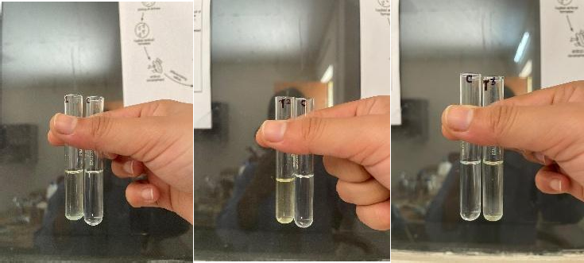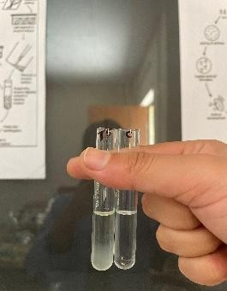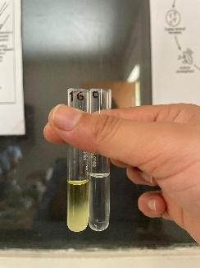
- T1
.
- T6
- T5
- T3
- T2
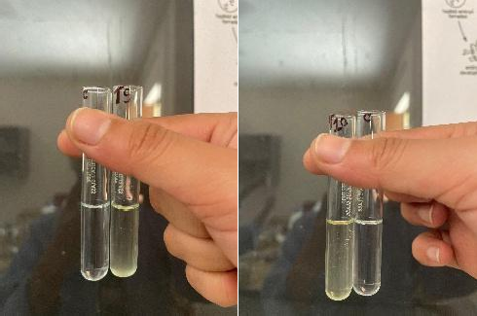
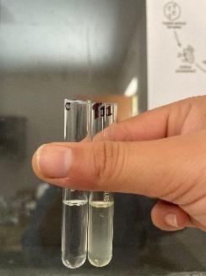
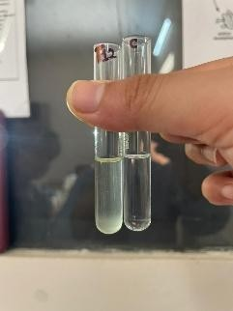
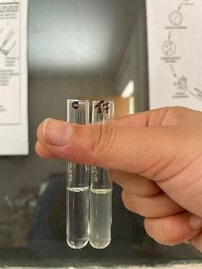
- T7
- T9
- T10
- T11
- T12

Fig 1.2 Tanins
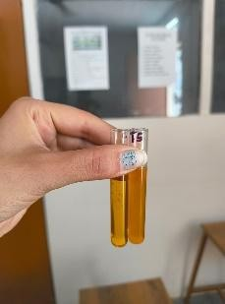
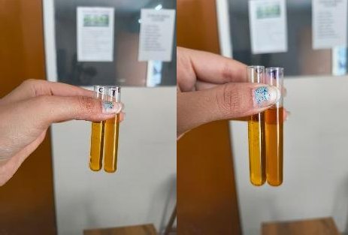
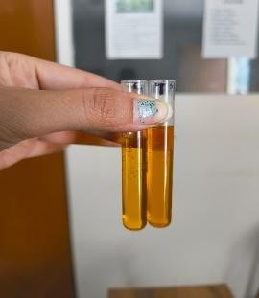
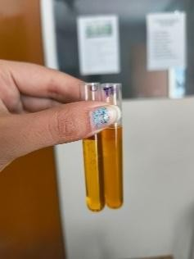
- T5
- T4
- T3
- T2
- T1
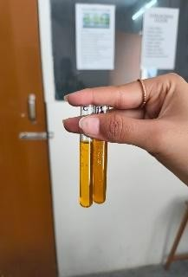
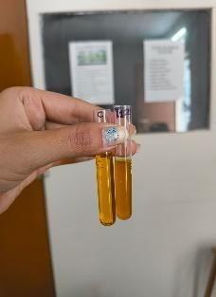
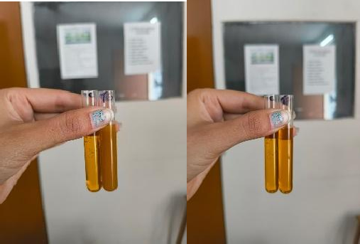
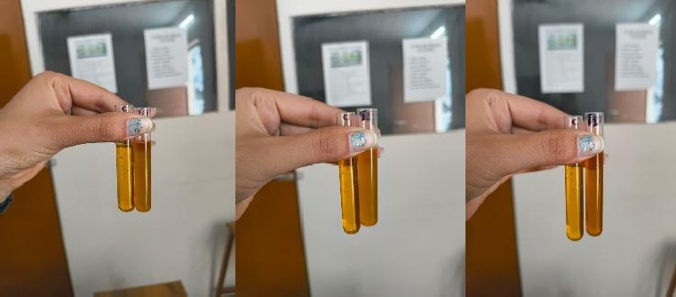
l. T12
k.T11
i. T9
j.T10
- T8
- T7
- T6

Fig 1.3 Proteins
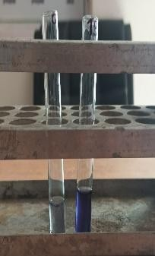
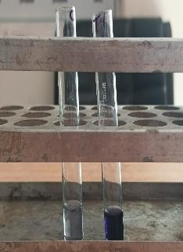
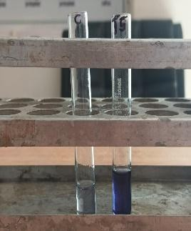
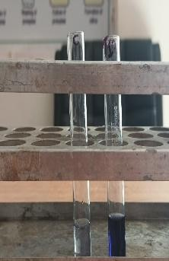
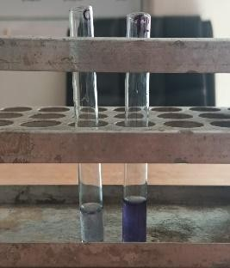
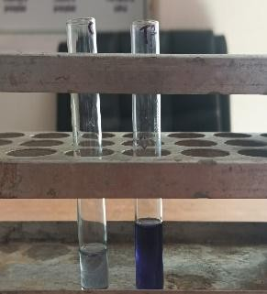
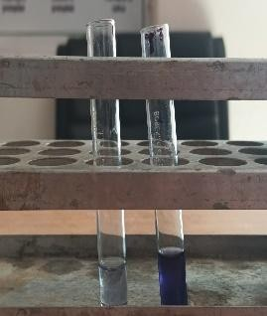
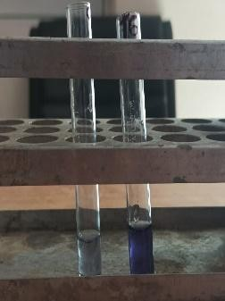
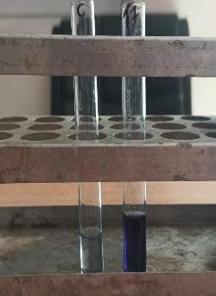
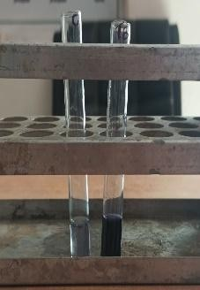
- T4
- T3
- T2V
- T5
- T1
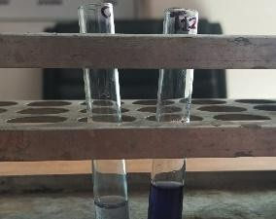
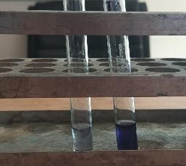
- T10
- T8
- T9
- T7
- T6
- T12
- T11
Fig 1.4 Phenolic compounds
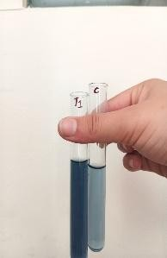
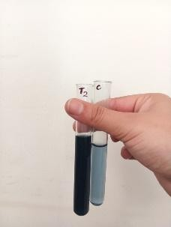
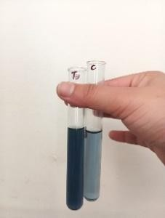
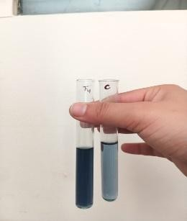
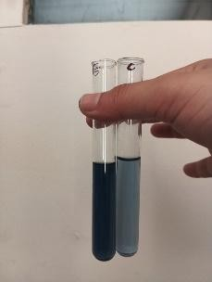
e.T5
d.T4
c.T3
b.T2
a.T1

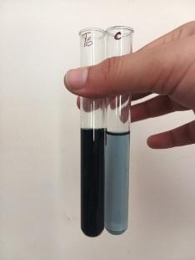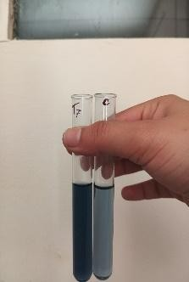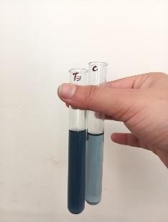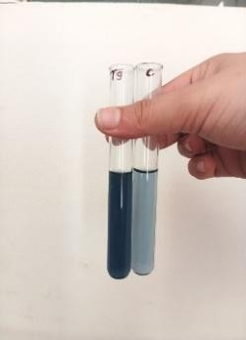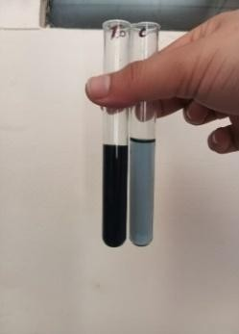

j.T10
i.T9
h.T8
g.T7
f.T6
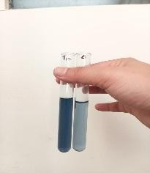
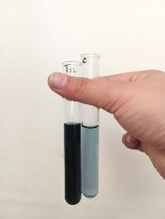
l.T12
k.T11

Fig 1.5 Carboydrates
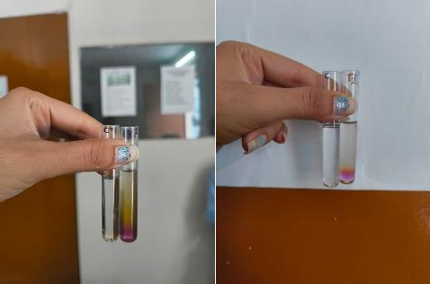
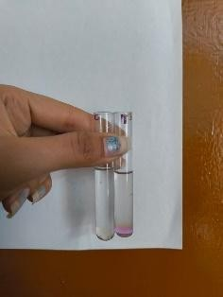
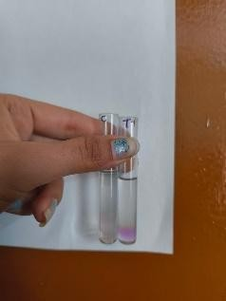
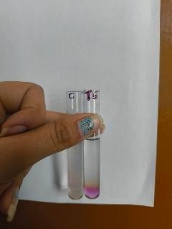
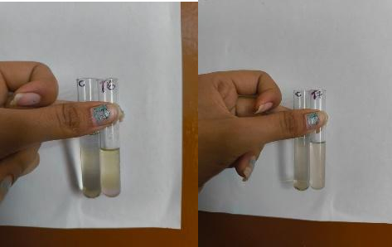
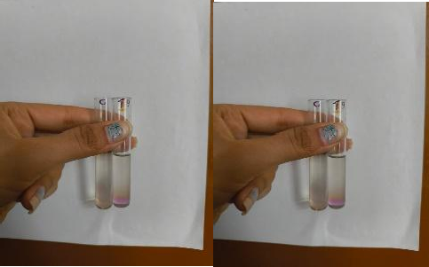
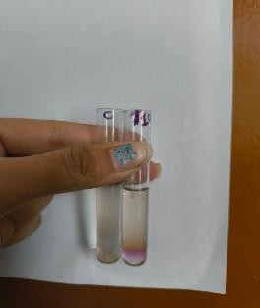
j.T10
i.T9
h.T8
g.T7
f.T6
- T5
d.T4
c.T3
b.T2
a.T1

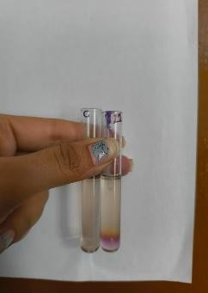
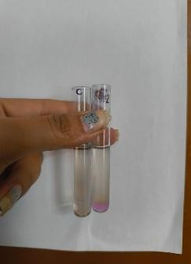
l.T12
k.T11

Fig 1.6 Terpenoids
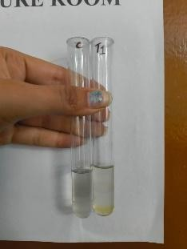
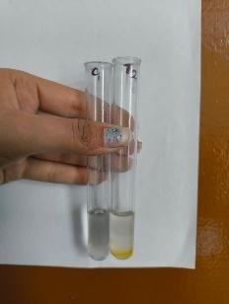
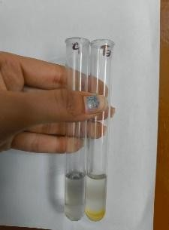
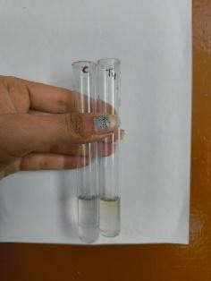
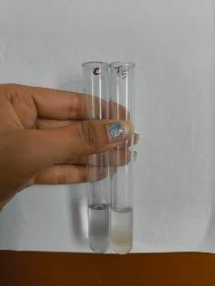
E: T5
C: T3
D: T4
B: T2
A:T1
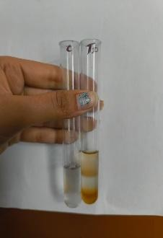
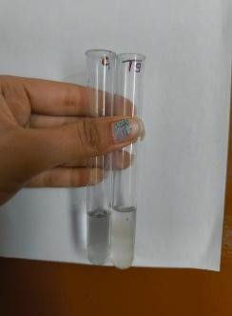
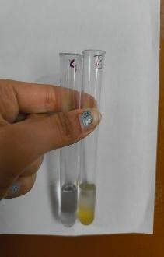
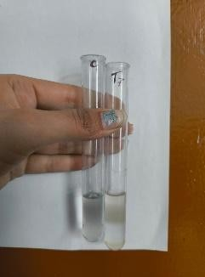
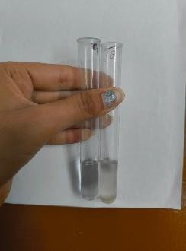
J:T10
I:T9
H:T8
F:T6
G:T7
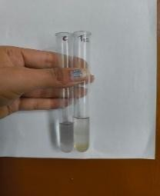
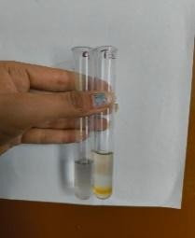
L:T12
K:T11

Treatment | Germplasm district | Alkaloids | Tannins | Saponins | Carbohydrates | Trepenoids | Proteins | Phenolic compounds
T1 | Almora | - | + | + | ++ | + | ++ | +
T2 | Bageshwar | - | - | - | ++ | + | ++ | ++
T3 | Champawat | - | - | + | + | + | ++ | +
T4 | Chamoli | + | + | + | + | - | ++ | +
T5 | Dehradun | + | + | + | ++ | - | ++ | ++
T6 | Nainital | +++ | +++ | - | + | - | +++ | +++
T7 | Pauri garhwal | + | - | - | - | - | ++ | ++
T8 | Pithoragarh | - | + | + | ++ | - | ++ | ++
T9 | Rudraprayag | + | + | + | + | - | ++ | ++
T10 | Tehri | - | - | + | + | ++ | ++ | +++
T11 | Uttarkashi | + | - | + | + | + | ++ | +++
T12 | Uddham singh nagar | + | + | + | + | + | ++ | +
Table 4: phytochemical analysis of samples

Note : Slightly Positive (+)
Positive (++)
Strongly Positive (+++)

Results

Qualitative phytochemical tests on 12 finger millet samples (T1–T12) showed the presence of compounds including alkaloids, tannins, saponins, carbohydrates, terpenoids, proteins, and phenolics. The abundance of phytochemical constituents was classified as absent (−), slightly positive (+), positive (++), or strongly positive (+++).
Among all the phytochemicals assessed, proteins were present in every treatment. Most treatments showed a positive (++) reaction, whereas T6 exhibited a strongly positive (+++) reaction, indicating the highest protein content.
Nearly every treatment contained carbohydrates. T1, T2, T5, and T8 showed positive (++) reactions, whereas T3, T4, T6, T9, T10, T11, and T12 showed slightly positive (+) reactions. T7 showed no detectable carbohydrates.
Phenolic compounds varied among the samples. Strongly positive (+++) reactions were recorded in T6, T10, and T11, whereas positive (++) reactions were observed in T2, T5, T7, T8, and T9. A marginally positive (+) response was observed in the remaining treatments.

Alkaloids were absent in T1, T2, T3, T8, and T10, whereas T6 exhibited the highest intensity (+++). The remaining treatments showed a slightly positive (+) reaction.

Tannins were strongly positive (+++) only in T6. Slightly positive (+) reactions were observed in T1, T4, T5, T8, T9, and T12, whereas no tannins were detected in T2, T3, T7, T10, and T11.
Saponins were absent in T2, T6, and T7, whereas the remaining treatments showed slightly positive (+) reactions.
The occurrence of terpenoids was treatment-dependent. Positive results were observed in T1, T2, T3, T10, T11, and T12, whereas T4, T5, T6, T7, T8, and T9 showed no detectable terpenoids.
Overall, T6 exhibited the strongest phytochemical profile, with the highest levels of alkaloids, tannins, proteins, and phenolic compounds. In contrast, T7 showed the lowest phytochemical diversity, with the absence of carbohydrates, tannins, saponins, and terpenoids.
Discussion
The qualitative phytochemical analysis showed noticeable differences among the finger millet treatments in the presence and concentration of bioactive compounds. The detection of alkaloids, tannins, saponins, terpenoids, phenolic compounds, proteins, and carbohydrates highlights the rich nutraceutical potential of finger millet and its importance as a functional food.
Protein was consistently detected at high levels across all treatments, indicating that finger millet is an excellent source of dietary protein. Among the treatments, T6 exhibited the strongest protein response, suggesting superior nutritional quality. This variation may be due to genetic differences among the finger millet treatments, which influence the accumulation of nutritional and phytochemical constituents.
The abundance of phenolic compounds in several treatments, especially T6, T10, and T11, indicated stronger antioxidant potential. In addition to protecting plants from oxidative stress and scavenging free radicals, phenolic compounds also improve human health by lowering the risk of chronic illnesses.
Similarly, the therapeutic and protective qualities of finger millet are reflected in the presence of tannins, alkaloids, saponins, and terpenoids. The antibacterial, anti-inflammatory, antioxidant, and health-promoting properties of these phytochemicals are well known. Differences in genetic background, environmental factors, and secondary metabolite production could all contribute to variation among treatments.
Overall, the findings indicate that T6 has the richest phytochemical profile among the evaluated treatments, making it a promising genotype for nutritional improvement and functional food applications. The variation observed among the different treatments provides valuable information for identifying and selecting superior finger millet genotypes with enhanced nutritional quality and higher phytochemical content. Such genotypes can be effectively utilised in future breeding programmes aimed at improving the health benefits and nutritional value of finger millet.
Conclusion:
Finger millet germplasm collected from 12 districts of Uttarakhand showed clear qualitative variation in the occurrence and reaction intensity of the phytochemical groups assessed in this study. Proteins were detected across all treatments, whereas alkaloids, tannins, saponins, carbohydrates, terpenoids, and phenolic compounds varied among samples. T6 showed the most pronounced qualitative phytochemical profile, with strongly positive reactions for alkaloids, tannins, proteins, and phenolic compounds. T7 showed the lowest phytochemical diversity because carbohydrates, tannins, saponins, and terpenoids were not detected. Strongly positive phenolic reactions were also recorded in T10 and T11, while terpenoids were present in six treatments. The observed differences indicate that the evaluated germplasm was not uniform in its qualitative phytochemical composition. These findings provide a basis for identifying germplasm that may warrant further nutritional, biochemical, and breeding evaluation. Additional quantitative analyses would be required before drawing conclusions about absolute concentrations of individual phytochemicals or comparative nutritional superiority among the germplasm samples.

Limitation

This study was based on qualitative phytochemical screening; therefore, the reaction categories indicate presence and relative test intensity rather than absolute concentrations of individual compounds. The work evaluated 12 germplasm samples collected from different districts of Uttarakhand and did not include quantitative phytochemical estimation or confirmatory instrumental analysis. Accordingly, the results should be interpreted as baseline qualitative evidence of variation among the evaluated samples rather than as definitive measurements of phytochemical abundance.
Declaration of AI Use
This manuscript was prepared through the intellectual contributions of the author(s) to the study design, data analysis, interpretation of results, and scholarly content. Grammarly and ChatGPT were used solely to assist with grammatical refinement and reference formatting during manuscript revision. The author(s) accept full responsibility for the accuracy, integrity, and final content of the manuscript.

References.
Abioye, V. F., Babarinde, G. O., Ogunlakin, G. O., Adejuyitan, J. A., Olatunde, S. J., & Abioye, A. O. (2022). Varietal and processing influence on nutritional and phytochemical properties of finger millet: A review. Heliyon, 8(12), e12310. https://doi.org/10.1016/j.heliyon.2022.e12310
Antony Ceasar, S., Maharajan, T., Ajeesh Krishna, T. P., Ramakrishnan, M., Victor Roch, G., Satish, L., & Ignacimuthu, S. (2018). Finger millet [Eleusine coracana (L.) Gaertn.] improvement: Current status and future interventions of whole genome sequence. Frontiers in Plant Science, 9, 1054. https://doi.org/10.3389/fpls.2018.01054
Chandra, D., Chandra, S., Pallavi, & Sharma, A. K. (2016). Review of finger millet (Eleusine coracana (L.) Gaertn): A power house of health benefiting nutrients. Food Science and Human Wellness, 5(3), 149–155. https://doi.org/10.1016/j.fshw.2016.05.004
Devi, P. B., Vijayabharathi, R., Sathyabama, S., Malleshi, N. G., & Priyadarisini, V. B. (2014). Health benefits of finger millet (Eleusine coracana L.) polyphenols and dietary fiber: A review. Journal of Food Science and Technology, 51(6), 1021–1040. https://doi.org/10.1007/s13197-011-0584-9
Kaur, S., Kumari, A., Seem, K., Kaur, G., Kumar, D., Verma, S., Singh, N., Kumar, A., Kumar, M., Jaiswal, S., Bhardwaj, R., Singh, B. K., & Riar, A. (2024). Finger millet (Eleusine coracana L.): From staple to superfood—A comprehensive review on nutritional, bioactive, industrial, and climate resilience potential. Planta, 260, 75. https://doi.org/10.1007/s00425-024-04502-2
Kumar, A., Chawla, H. S., Jeena, A. S., & Rohit. (2019). Morphological characterization of finger millet germplasm collected from Uttrakhand Hills for qualitative traits. International Journal of Current Microbiology and Applied Sciences, 8(9), 2105–2109. https://doi.org/10.20546/ijcmas.2019.809.243
Parlikar, A. S., Naik, C. V., & Nayak, C. B. (2021). An experimental study on effect of pharmaceutical industrial waste water on compressive strength of concrete. International Journal of Innovative Research in Science, Engineering and Technology, 10(8), 11068–11072. https://doi.org/10.15680/IJIRSET.2021.1008038
Patil, R. N., & Bhambulkar, A. V. (2020). A modern aspect on defluoridation of water: Adsorption. Design Engineering, 1169–1186.
Puranik, S., Kam, J., Sahu, P. P., Yadav, R., Srivastava, R. K., Ojulong, H., & Yadav, R. (2017). Harnessing finger millet to combat calcium deficiency in humans: Challenges and prospects. Frontiers in Plant Science, 8, 1311. https://doi.org/10.3389/fpls.2017.01311
Ramashia, S. E., Gwata, E. T., Meddows-Taylor, S., Anyasi, T. A., & Jideani, A. I. O. (2018). Some physical and functional properties of finger millet (Eleusine coracana) obtained in sub-Saharan Africa. Food Research International, 104, 110–118. https://doi.org/10.1016/j.foodres.2017.09.065
Dayakar Rao, B., Malleshi, N. G., Annor, G. A., & Patil, J. V. (2016). Nutritional and health benefits of millets. In B. Dayakar Rao, N. G. Malleshi, G. A. Annor, & J. V. Patil (Eds.), Millets value chain for nutritional security: A replicable success model from India (pp. 24–48). CABI. https://doi.org/10.1079/9781780648309.0024
Raturi, A., Meena, H., & Badoni, A. (2026). An agronomic review of finger millet (Eleusine coracana): Adaptability, nutritional value and importance for sustainable agriculture. Asian Journal of Advances in Agricultural Research, 26(3), 1–9. https://doi.org/10.9734/ajaar/2026/v26i3713
Simran, Chaudhary, S., Avinashe, H., & Dubey, N. (2024). Nutritional advantages and opportunities for its processing of finger millet (Eleusine coracana L.): A comprehensive review. Journal of Advances in Biology & Biotechnology, 27(7), 605–617. https://doi.org/10.9734/jabb/2024/v27i71021
Kumar, A., Tomer, V., Kaur, A., Kumar, V., & Gupta, K. (2018). Millets: A solution to agrarian and nutritional challenges. Agriculture & Food Security, 7, 31. https://doi.org/10.1186/s40066-018-0183-3
Somarajan, A. K., & Morya, S. (2022). A review on finger millet properties, processing, health benefits, and applications. The Pharma Innovation Journal, 11(7), 3388–3395. https://doi.org/10.22271/tpi.2022.v11.i7aq.14538
Soujanya, K. V., Gurusiddaiah, S. K., & Jayadeep, A. P. (2025). UPLC-ESI-HRMS/MS phenolic characterization, antioxidant activity, and proximate composition of drum-dried finger millet (Eleusine coracana) seed coat- and endosperm-rich fractions. ACS Food Science & Technology, 5(1), 85–94. https://doi.org/10.1021/acsfoodscitech.4c00581
Spiridonov, V., Ćurić, M., & Novkovski, N. (2025). Biosphere: Ecosystem diversity and environmental change. In Atmospheric perspectives: Unveiling Earth’s environmental challenges (pp. 51–81). Springer Nature Switzerland. https://doi.org/10.1007/978-3-031-86757-6_4
Swamy, K. R. M. (2023). Origin, domestication, taxonomy, botanical description, genetics and cytogenetics, genetc diversity, breeding of ragi (Eleusine coracana L.). International Journal of Current Research, 15(8), 25589–25610. https://doi.org/10.24941/ijcr.45819.08.2023
Tiwari, N., Srivastava, S., & Verma, H. (2025). Nutritional and antioxidant comparison of finger millet, foxtail millet, and refined wheat flour. Asian Journal of Current Research, 10(1), 185–192. https://doi.org/10.56557/ajocr/2025/v10i19149
Udeh, H. O., Duodu, K. G., & Jideani, A. I. O. (2025). Effect of fermentation time on the physicochemical properties and phenolic composition of malted finger millet beverages. Food Science & Nutrition, 13(3), e4659. https://doi.org/10.1002/fsn3.4659
Upadhyaya, H. D., Gopal Reddy, V., & Sastry, D. V. S. S. R. (2008). Regeneration guidelines: Finger millet. In M. E. Dulloo, I. Thormann, M. A. Jorge, & J. Hanson (Eds.), Crop specific regeneration guidelines [CD-ROM] (pp. 1–7). CGIAR System-wide Genetic Resource Programme. https://oar.icrisat.org/4010/

