Growth Analysis of Fodder Sorghum [Sorghum bicolor (L.) Moench] as Influenced by Varieties and Harvesting Stages under Temperate Conditions of Kashmir

ABSTRACT
Fodder scarcity is a severe constraint for livestock production in the temperate valley of Kashmir, where production falls short of the actual requirement. Cultivation of high-yielding fodder crops is one of the practical means, and fodder sorghum ranks among the best-suited crops because of its rapid growth, high biomass production, and wide adaptability. Dry matter accumulation in a crop follows a characteristic pattern that varies with variety and harvesting stage. A field investigation was carried out over two consecutive Kharif seasons of 2024 and 2025 at the Research Farm, Faculty of Agriculture, Wadura, SKUAST-Kashmir, India, to characterise the dry matter accumulation and partitioning over time in two fodder sorghum (Sorghum bicolor) varieties harvested at three stages. The experiment was laid out in a factorial randomised block design with four replications. The experiment consisted of two factors: variety and harvesting stage. The two varieties MP Chari (V₁) and SFG-5000 (V₂) were harvested at three stages, viz., flowering (S₁), soft dough (S₂) and hard dough (S₃). Crop growth rate (CGR), relative growth rate (RGR) and net assimilation rate (NAR) were recorded at 20-40 days after sowing, 40-60 days after sowing and 60 days after sowing to harvest. Leaf area index (LAI) was determined at 20, 40, 60 days after sowing and at harvest. MP Chari recorded the highest LAI from 40 DAS onwards, attaining peak values at harvest (4.595 and 5.637). Among the harvesting stages, the highest LAI was reported at the flowering stage (4.782 and 5.817). MP Chari proved significantly superior to SFG-5000 in CGR and NAR. During the 40-60 DAS interval, MP Chari recorded the highest CGR values (24.73 and 39.11 g m⁻² day⁻¹) and NAR values (9.13 and 11.54 g m⁻² day⁻¹). At all intervals, the effect of harvesting stage on CGR was non-significant, whereas significant responses in RGR and NAR were observed during the 60 DAS-to-harvest interval, where the flowering stage recorded the highest RGR (32.30 and 27.06 mg g⁻¹ day⁻¹) and the hard dough stage recorded the highest NAR (5.98 g m⁻² day⁻¹ during 2025).
Keywords: Fodder sorghum, MP Chari, SFG-5000, Harvesting stage, Leaf area index, Crop growth rate, Relative growth rate, Net assimilation rate
1. Introduction
Livestock plays a crucial role in the agricultural economy and socio-economic development in Jammu and Kashmir, where agriculture and animal husbandry contribute 60% of the revenue (Hamadani et al., 2022). The agricultural sector, including livestock, contributes 16% to the Gross State Domestic Product of Jammu and Kashmir (ICAR-IGFRI, 2021). The livestock population recorded in the 19th Livestock Census was 92.01 lakhs, decreasing to 83.19 lakhs as reported by the 20th Livestock Census (Department of Animal Husbandry and Dairying, 2019). This decline is attributed to several factors, and insufficient fodder supply is among the primary factors (ICAR-IGFRI, 2021). Jammu and Kashmir produces around 64 lakh MT of green fodder and 35 lakh MT of dry fodder. However, the requirement of green fodder is 139.13 lakh MT and dry fodder is 58.53 lakh MT (Ahmad et al., 2018). This deficit is more pronounced in the Kashmir Valley; therefore, increased production of fodder is essential to meet the nutritional requirements of the livestock.
To address fodder scarcity and boost livestock productivity, the introduction and popularisation of potential fodder crops are essential (Singh et al., 2022). Fodder sorghum emerges as a promising option for several reasons. It can produce high biomass, with a green fodder yield of 30 t ha⁻¹ (ICAR-IGFRI, 2021). Fodder sorghum is known for its adaptability to diverse climatic and soil conditions, low water requirement, deep root system, and drought resistance, making it a suitable crop for regions with variable and challenging growing conditions (Hossain et al., 2022; Kumar et al., 2024). These characteristics make fodder sorghum a promising alternative to maize under water-limited and variable growing conditions (Getachew et al., 2016; Bhattarai et al., 2020). Despite its potential benefits, fodder sorghum has not been extensively adopted by farmers in the Kashmir Valley and remains largely confined to research stations. Therefore, it is imperative to encourage the cultivation of fodder sorghum to ensure a stable fodder supply and improve livestock productivity.
The performance of fodder sorghum is determined by several factors including the variety selected for cultivation. Varieties differ in tillering, leaf production, stem thickness and total biomass, and these differences affect the quantity and quality of fodder harvested (Bhat, 2019). Recent studies have likewise documented substantial genetic variability in forage sorghum for yield, quality, leaf area and related adaptive traits, supporting the need for careful varietal evaluation under the target production environment (Ali et al., 2022; Santosh & Pandey, 2024; Behera et al., 2024). MP Chari is among the most widely grown fodder varieties in the country and is valued for its high green fodder yield (Chauhan et al., 2021). SFG-5000 is an important multi-cut fodder sorghum known for its ability to regenerate rapidly after cutting and produce successive harvests of green fodder. Its repeated regrowth potential makes it a promising option for sustained fodder production and improved forage availability. Both varieties are recommended for green fodder production, but their relative performance has not been studied under the temperate conditions of the Kashmir valley. The stage of harvest is also important because dry matter accumulation continues to increase as the crop advances towards maturity, while the nutritive value of the fodder declines (Atış et al., 2012). Shanti et al. (2017) recorded a reduction in crude protein from 10.05% at fifty percent flowering to 7.96% at physiological maturity, with crude fibre increasing over the same period. Khalilian et al. (2022) recorded the highest dry matter yield at physiological maturity and the highest feed value at the grain milk stage and recommended harvesting between the soft dough and hard dough stages when both yield and quality are taken into account. Early harvesting can pose a risk of HCN toxicity because HCN concentration is high in young tissues and decreases with crop age (Ouma et al., 2024). The harvesting stage therefore represents a trade-off between the quality and quantity of fodder obtained (Nikhil et al., 2026).
Growth analysis provides a detailed assessment by quantifying the accumulation of dry matter and the development of leaf area at successive stages of crop growth (Pandey et al., 2017). Crop growth rate (CGR) measures the dry matter produced per unit land area per unit time and represents the productivity of the crop stand (Pollo et al., 2018). Relative growth rate (RGR) expresses the dry matter produced per unit of dry matter already present and reflects the efficiency of growth. Net assimilation rate (NAR) represents the dry matter produced per unit leaf area per unit time and serves as a measure of the photosynthetic efficiency of the canopy (Zhou et al., 2024). Leaf area index (LAI) indicates the extent of leaf surface available for the interception of light per unit ground area. These indices can indicate whether varietal superiority arises from a larger canopy or from greater efficiency per unit leaf area, an important distinction that cannot be drawn from other parameters. Recent physiological screening under saline conditions has also demonstrated varietal differences in photosynthetic performance and dry matter gain in forage sorghum, providing further evidence that assimilation-related traits can distinguish physiological responses among varieties (Amombo et al., 2024).
Growth analysis has been used to characterise fodder sorghum in different environments. Pérez Hernández et al. (2019) recorded the highest crop growth rate during the interval from 56 to 85 days after sowing and observed significant differences among cultivars in leaf area index and net assimilation rate. Saberi and Siti Aishah (2013) similarly reported significant differences in relative growth rate and net assimilation rate among different fodder sorghum varieties. However, the literature remains limited regarding varietal differences in fodder sorghum and the influence of harvesting stages on growth indices. Keeping these considerations in view, the present investigation was carried out to study the crop growth rate, relative growth rate, net assimilation rate and leaf area index of two fodder sorghum varieties harvested at three stages of harvest.
2. Materials and Methods
The trial was conducted at the Research Farm of the Division of Agronomy, Faculty of Agriculture, SKUAST-K, Wadura, during kharif seasons of 2024 and 2025 to study the influence of different varieties and harvesting stages on the growth indices of fodder sorghum. The trial was laid out in the temperate region of Jammu and Kashmir at an elevation of 1584 m above mean sea level, 34°34′ N latitude and 74°40′ E longitude. The soil at the experimental site had a clay loam texture, a neutral pH (6.8), normal EC (0.35 dS m⁻¹), medium organic carbon (0.71%) and medium available nitrogen (325.2 kg ha⁻¹), phosphorus (20.7 kg ha⁻¹) and potassium (195.6 kg ha⁻¹).
2.1 Experimental Details
The experiment was laid out in a factorial randomised block design with four replications. The two factors were variety, with two levels-V₁ (MP Chari) and V₂ (SFG-5000), and harvesting stage, with three levels- S₁ (Flowering), S₂ (Soft dough) and S₃ (Hard dough). This resulted in six treatment combinations and a total of 24 plots. The size of the plot was 4 m x 3 m with row spacing of 30 cm.
2.2 Observations Recorded
The observations listed below were recorded to study the growth indices of the fodder sorghum crop. Plant samples were collected at 20, 40, and 60 days after sowing (DAS) and at the harvesting stage from each plot. The samples were dried in an oven at 65 ± 2 °C until a constant weight was attained and weighed on an electronic balance. Dry weights obtained on a plant basis were then converted to a unit land area basis. The growth rate indices were computed for the 20-40 DAS, 40-60 DAS and 60 DAS to harvest intervals following the standard procedures of Watson (1952) and Radford (1967).
2.2.1 Crop Growth Rate (g m⁻² day⁻¹)
Crop growth rate denotes the dry matter accumulated by the crop stand per unit land area per unit time. It was calculated as described by Watson (1952):
CGR (g m⁻² day⁻¹) = | W₂-W₁ | × | 1
CGR (g m⁻² day⁻¹) = | T₂-T₁ | × | A

Where, W₁ and W₂ are the dry weights recorded at times t₁ and t₂, respectively; (t₂-t₁) is the duration of the interval in days and A is the area (spacing).
2.2.2 Relative Growth Rate (g g⁻¹ day⁻¹)
Relative growth rate expresses the dry matter produced per unit of dry matter already present per unit time. The index was derived from the difference between the natural logarithms of successive dry weights (Blackman, 1919; Radford, 1967):
RGR (g g⁻¹ day⁻¹) = | ln W₂- ln W₁
RGR (g g⁻¹ day⁻¹) = | T₂-T₁
Where, ln W₁ and ln W₂ are the dry weights recorded at times t₁ and t₂, respectively. The obtained values were converted from g g⁻¹ day⁻¹ to mg g⁻¹ day⁻¹.
2.2.3 Net Assimilation Rate (g m⁻² day⁻¹)
Net assimilation rate represents the dry matter produced per unit leaf area per unit time and serves as a field measure of the net photosynthetic efficiency of the canopy. It was computed using the formula of Radford (1967):
NAR (g m⁻² day⁻¹) = | W₂ – W₁ | × | ln L₂ – ln L₁
NAR (g m⁻² day⁻¹) = | T₂–T₁ | × | L₂ –L₁

Where, L₁ and L₂ are the leaf areas corresponding to the dry weights W₁ and W₂ at times t₁ and t₂, respectively.
2.2.4 Leaf Area Index
The leaf area was measured at 20, 40, and 60 days after sowing and at harvest using an AccuPAR LP-80 canopy analyser (Decagon Devices, USA).
2.3 Statistical Analysis
The data pertaining to each parameter were analysed using an analysis of variance appropriate for a factorial randomised block design. The significance of treatment effects was tested by the F-test, and treatment means were separated by the critical difference (CD) at p ≤ 0.05. All statistical analyses were performed using R software version 4.3.1.
3. Results
3.1 Crop growth rate (CGR)
Variety significantly influenced the crop growth rate at all three intervals (Table 1). CGR increased with crop age up to 60 days after sowing and then declined (Figure 1). MP Chari exceeded SFG-5000 throughout the crop cycle. Peak values were recorded during the 40-60 DAS interval for MP Chari (24.73 and 39.11 g m⁻² day⁻¹) followed by SFG-5000 (21.46 and 31.30 g m⁻² day⁻¹) in 2024 and 2025, respectively. The effect of harvesting stage on mean crop growth rate was non-significant at all intervals.
Table 1: Crop growth rate (g m⁻² day⁻¹) of fodder sorghum as influenced by variety and harvesting stage during 2024 and 2025
Treatment | 20-40 DAS |  | 40-60 DAS |  | 60 DAS-Harvest
Treatment | 2024 | 2025 | 2024 | 2025 | 2024 | 2025
Varieties
V₁ (MP Chari) | 7.22 | 8.96 | 24.73 | 39.11 | 23.68 | 29.62
V₂ (SFG-5000) | 6.03 | 7.03 | 21.46 | 31.30 | 19.15 | 24.99
SE(m) ± | 0.08 | 0.07 | 0.11 | 0.20 | 0.91 | 1.07
CD (p ≤ 0.05) | 0.23 | 0.23 | 0.34 | 0.60 | 2.76 | 3.23
Harvesting stages
S₁ (Flowering) | 6.58 | 7.94 | 23.04 | 34.99 | 21.99 | 25.63
S₂ (Soft dough) | 6.63 | 8.03 | 23.13 | 35.28 | 19.85 | 26.12
S₃ (Hard dough) | 6.66 | 8.01 | 23.11 | 35.35 | 22.40 | 30.17
SE(m) ± | 0.09 | 0.09 | 0.14 | 0.25 | 1.12 | 1.31
CD (p ≤ 0.05) | NS | NS | NS | NS | NS | NS
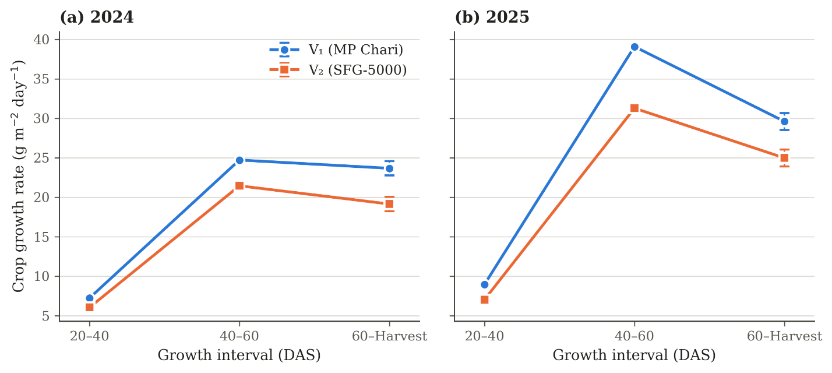
Figure 1: Crop growth rate (g m⁻² day⁻¹) of fodder sorghum as influenced by variety during year 2024 and 2025
3.2 Relative growth rate (RGR)
Relative growth rate declined steadily with advancing crop age in both varieties across both seasons, declining from 77.56-78.66 and 82.39-83.15 mg g⁻¹ day⁻¹ during 20-40 DAS to 65.44-67.01 and 75.62-76.28 mg g⁻¹ day⁻¹ during 40-60 DAS in 2024 and 2025, respectively (Table 2). Varietal differences in RGR were non-significant; however, SFG-5000 was numerically superior to MP Chari at all intervals. Harvesting stage also produced no significant effect during the first two intervals of 20-40 and 40-60 DAS. A significant response was observed during the 60 DAS to harvest interval for both years (Figure 2), where the flowering stage recorded the highest RGR (32.30 and 27.06 mg g⁻¹ day⁻¹), exceeding both the soft dough (23.08 and 21.71 mg g⁻¹ day⁻¹) and hard dough stages (22.90 and 22.03 mg g⁻¹ day⁻¹). The two dough stages did not differ significantly from each other during both years.
Table 2: Relative growth rate (mg g⁻¹ day⁻¹) of fodder sorghum as influenced by variety and harvesting stage during 2024 and 2025
Treatment | 20-40 DAS |  | 40-60 DAS |  | 60 DAS-Harvest
Treatment | 2024 | 2025 | 2024 | 2025 | 2024 | 2025
Varieties
V₁ (MP Chari) | 77.56 | 82.39 | 65.44 | 75.62 | 25.64 | 22.72
V₂ (SFG-5000) | 78.66 | 83.15 | 67.01 | 76.28 | 26.54 | 24.48
SE(m) ± | 0.52 | 0.34 | 0.44 | 0.76 | 0.93 | 0.97
CD (p ≤ 0.05) | NS | NS | NS | NS | NS | NS
Harvesting stages
S₁ (Flowering) | 78.22 | 82.83 | 66.38 | 75.94 | 32.30 | 27.06
S₂ (Soft dough) | 78.09 | 82.90 | 66.24 | 75.91 | 23.08 | 21.71
S₃ (Hard dough) | 78.02 | 82.58 | 66.05 | 76.00 | 22.90 | 22.03
SE(m) ± | 0.63 | 0.42 | 0.54 | 0.93 | 1.14 | 1.19
CD (p ≤ 0.05) | NS | NS | NS | NS | 3.43 | 3.60

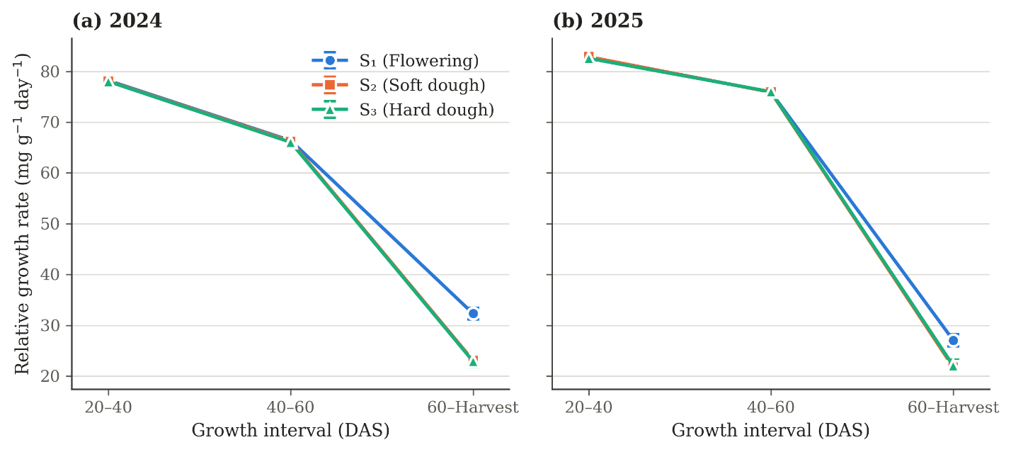
Figure 2: Relative growth rate (mg g⁻¹ day⁻¹) of fodder sorghum as influenced by harvesting stage during year 2024 and 2025
3.3 Net assimilation rate
Among the varieties, MP Chari maintained a significantly higher net assimilation rate than SFG-5000 at every interval in both years (Table 3, Figure 3). The peak values were observed during 40-60 DAS, where MP Chari recorded NAR values of 9.13 and 11.54 g m⁻² day⁻¹) compared with 7.10 and 8.26 g m⁻² day⁻¹) for SFG-5000. In both varieties, the net assimilation rate initially increased from the 20-40 DAS to the 40-60 DAS interval and then declined in the 60 DAS-to-harvest interval. Harvesting stage showed no significant influence during the 20-40 and 40-60 DAS intervals in either year. A significant response was recorded only in the 60 DAS-to-harvest interval of 2025 (Figure 4). The NAR at the hard dough stage was 5.98 g m⁻² day⁻¹, 5.06 g m⁻² day⁻¹ at the soft dough stage and 4.77 g m⁻² day⁻¹ at the flowering stage.
Table 3: Net assimilation rate (g m⁻² day⁻¹) of fodder sorghum as influenced by variety and harvesting stage during 2024 and 2025
Treatment | 20-40 DAS |  | 40-60 DAS |  | 60 DAS-Harvest
Treatment | 2024 | 2025 | 2024 | 2025 | 2024 | 2025
Varieties
V₁ (MP Chari) | 7.67 | 7.88 | 9.13 | 11.54 | 5.87 | 5.88
V₂ (SFG-5000) | 5.48 | 5.41 | 7.10 | 8.26 | 4.44 | 4.67
SE(m) ± | 0.39 | 0.19 | 0.21 | 0.21 | 0.25 | 0.20
CD (p ≤ 0.05) | 1.18 | 0.57 | 0.63 | 0.63 | 0.74 | 0.59
Harvesting stages
S₁ (Flowering) | 6.59 | 6.58 | 8.21 | 9.84 | 5.13 | 4.77
S₂ (Soft dough) | 6.62 | 6.77 | 8.18 | 10.02 | 4.75 | 5.06
S₃ (Hard dough) | 6.52 | 6.59 | 7.96 | 9.83 | 5.59 | 5.98
SE(m) ± | 0.48 | 0.23 | 0.26 | 0.26 | 0.30 | 0.24
CD (p ≤ 0.05) | NS | NS | NS | NS | NS | 0.73

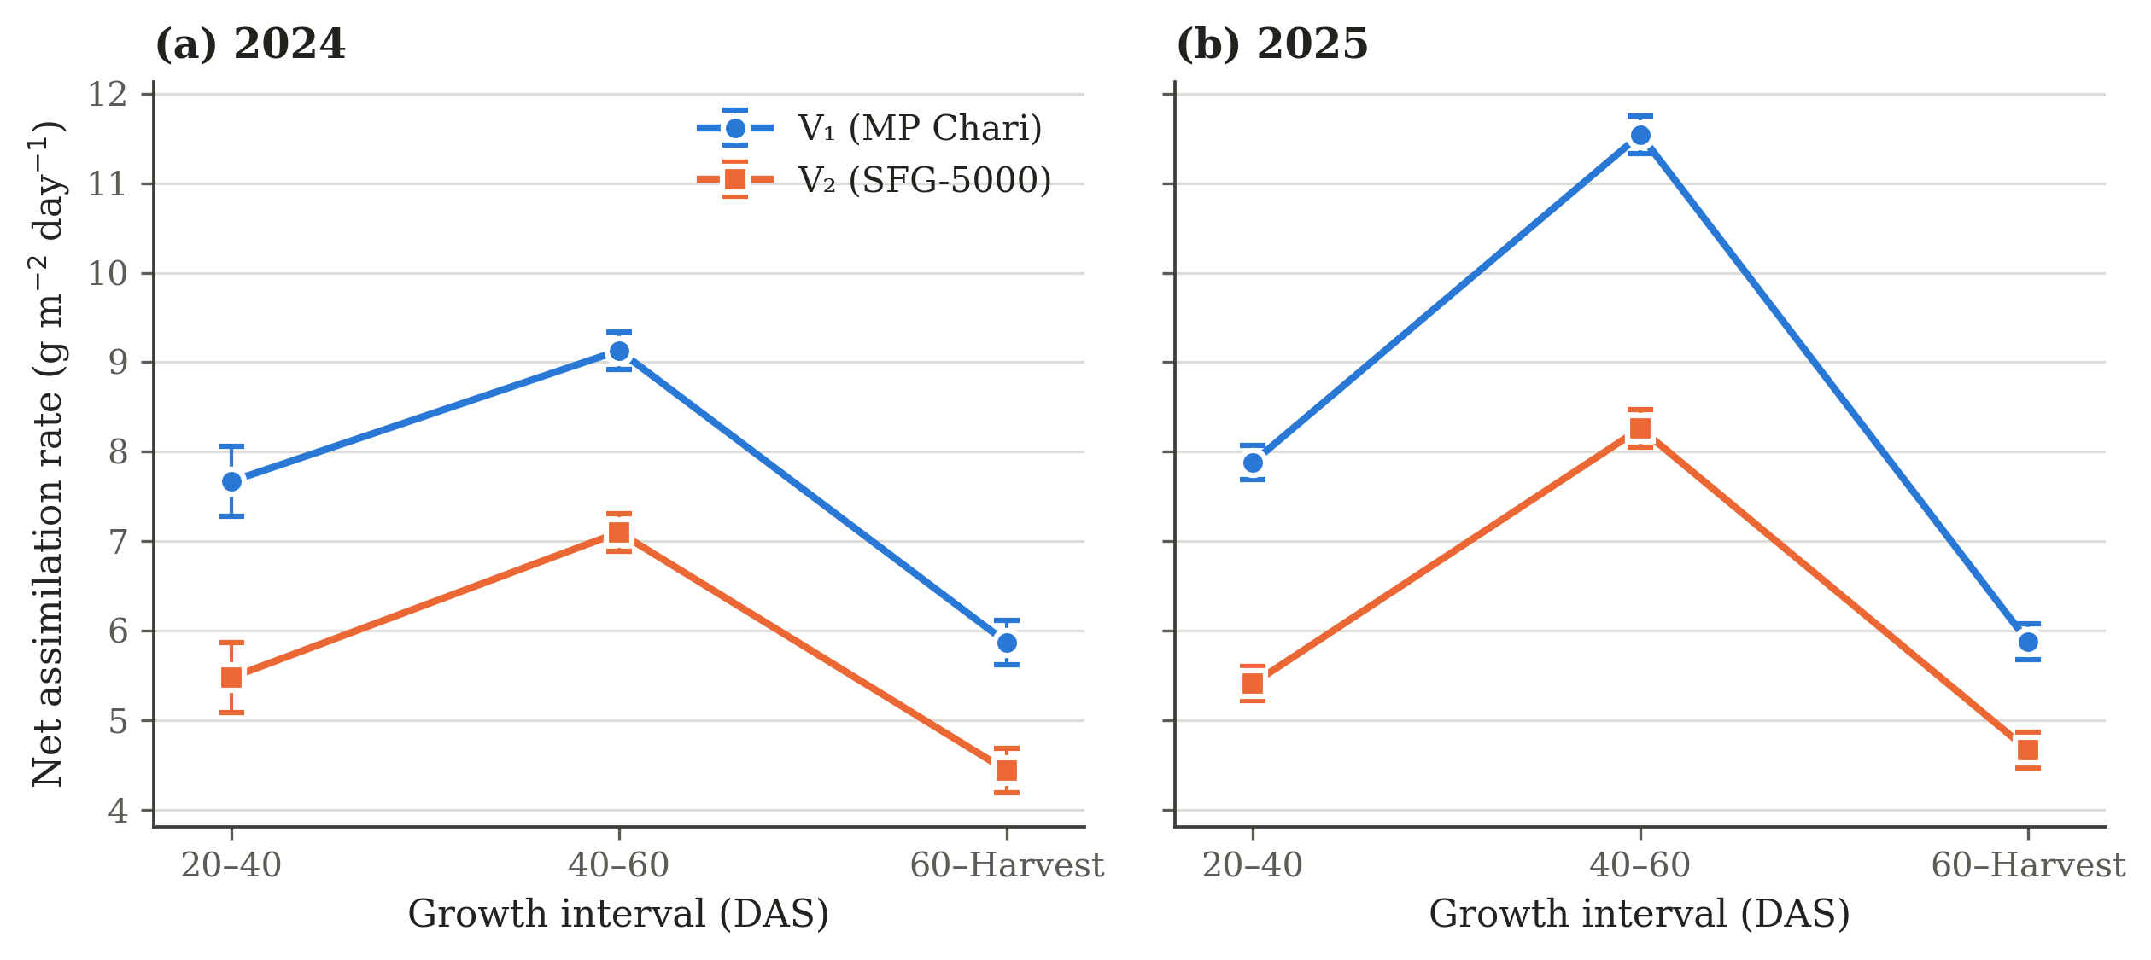
Figure 3: Net assimilation rate (g m⁻² day⁻¹) of fodder sorghum as influenced by variety during year 2024 and 2025
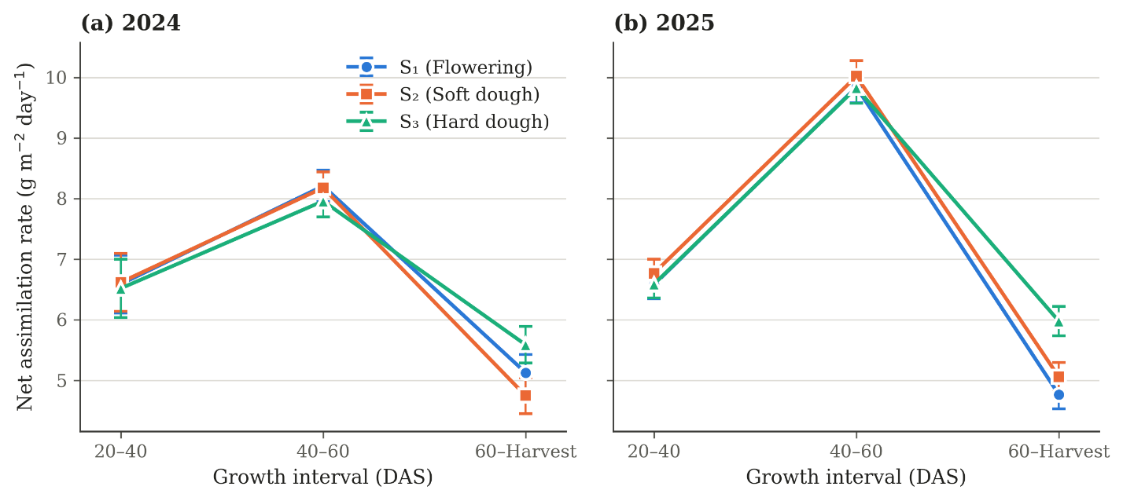
Figure 4: Net assimilation rate (g m⁻² day⁻¹) of fodder sorghum as influenced by harvesting stages during year 2024 and 2025
3.4 Leaf area index
Leaf area index increased with advancing crop age in both varieties and years (Table 4). The two varieties did not differ significantly at 20 DAS, but MP Chari recorded significantly higher values from 40 DAS onwards until harvest (Figure 5). MP Chari recorded leaf area index values of 4.595 and 5.637 at harvest against 4.297 and 5.342 for SFG-5000 during 2024 and 2025, respectively. Harvesting stage produced no significant effect at 20, 40, and 60 DAS. A significant effect was observed at harvest (Figure 6). The flowering stage exhibited the largest leaf area index (4.782 and 5.817), followed by soft dough (4.466 and 5.496) and hard dough (4.091 and 5.157).
Table 4: Leaf area index of fodder sorghum as influenced by variety and harvesting stage during 2024 and 2025
Treatment | 20 DAS |  | 40 DAS |  | 60 DAS |  | At harvest
Treatment | 2024 | 2025 | 2024 | 2025 | 2024 | 2025 | 2024 | 2025
Varieties
V₁ (MP Chari) | 0.463 | 0.493 | 2.183 | 2.751 | 4.065 | 5.093 | 4.595 | 5.637
V₂ (SFG-5000) | 0.450 | 0.459 | 1.873 | 2.304 | 3.829 | 4.798 | 4.297 | 5.342
SE(m) ± | 0.051 | 0.022 | 0.075 | 0.072 | 0.062 | 0.078 | 0.083 | 0.080
CD (p ≤ 0.05) | NS | NS | 0.227 | 0.218 | 0.188 | 0.234 | 0.250 | 0.241
Harvesting stages
S₁ (Flowering) | 0.438 | 0.474 | 2.004 | 2.528 | 3.894 | 4.936 | 4.782 | 5.817
S₂ (Soft dough) | 0.460 | 0.478 | 1.987 | 2.481 | 3.974 | 4.920 | 4.466 | 5.496
S₃ (Hard dough) | 0.471 | 0.476 | 2.092 | 2.575 | 3.974 | 4.979 | 4.091 | 5.157
SE(m) ± | 0.062 | 0.026 | 0.092 | 0.089 | 0.077 | 0.095 | 0.102 | 0.098
CD (p ≤ 0.05) | NS | NS | NS | NS | NS | NS | 0.306 | 0.295

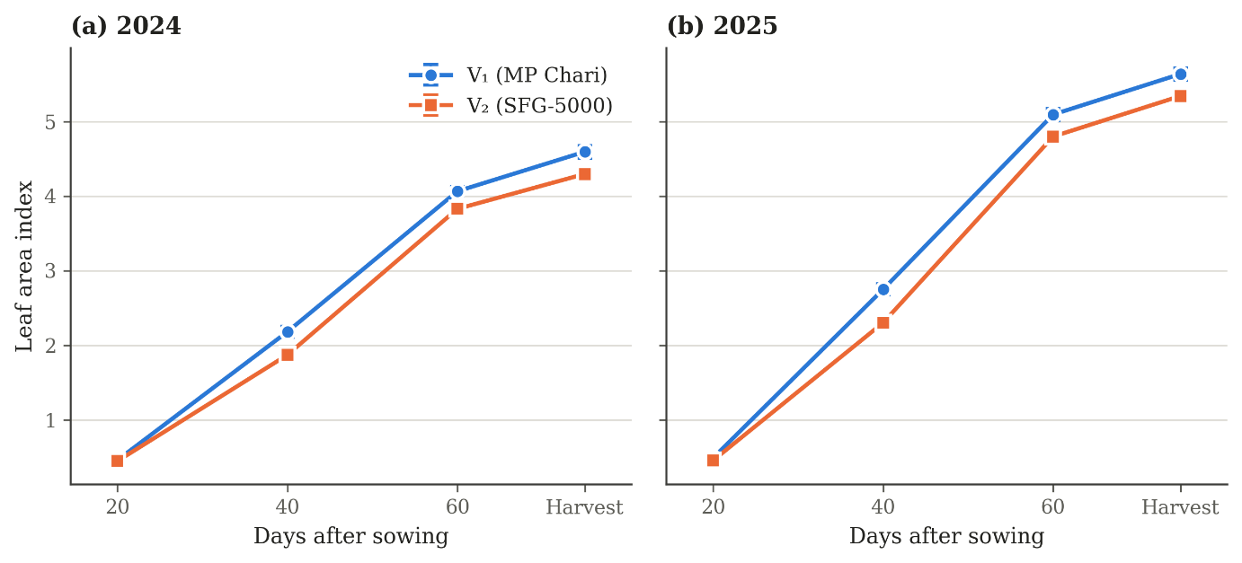
Figure 5: Leaf area index of fodder sorghum as influenced by variety during year 2024 and 2025
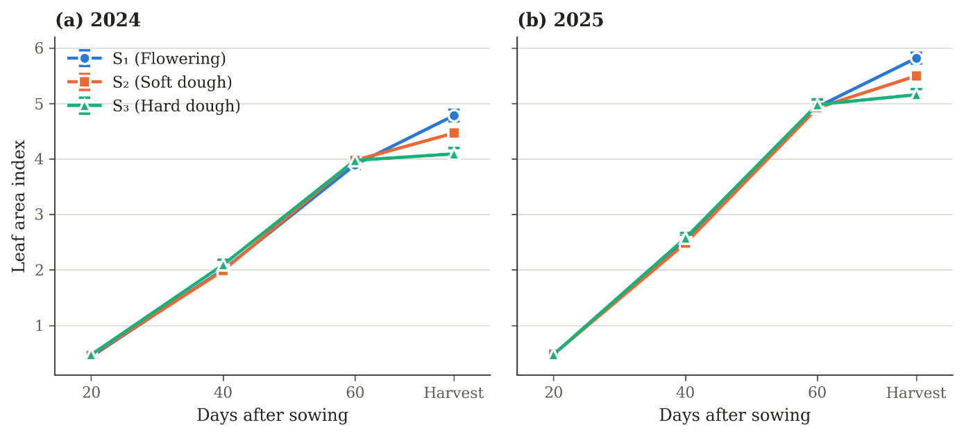
Figure 6: Leaf area index of fodder sorghum as influenced by harvesting stage during year 2024 and 2025
4. Discussion
Growth analysis provides an integrated assessment of crop growth and biomass production by describing the changes in leaf area and dry matter accumulation over time. Parameters such as leaf area index (LAI), crop growth rate (CGR), relative growth rate (RGR) and net assimilation rate (NAR) collectively reflect the ability of the crop to develop its photosynthetic surface, accumulate biomass, and utilise that surface for dry matter production.
Leaf area index increased progressively with crop age, with a marked increase between 20 and 60 DAS. Among varieties, MP Chari (V₁) recorded significantly higher LAI than SFG-5000 (V₂) from 40 DAS onwards during both years. The greater canopy development of MP Chari may be attributed to its inherently greater leaf production and expansion, which resulted in a larger photosynthetically active surface. The varieties differed significantly from 40 days after sowing onwards, showing that the canopy differences became more pronounced with the progression of crop growth. A higher leaf area index increases the interception of solar radiation and contributes to the greater biomass producing capacity of MP Chari (Chavez et al., 2022). Harvesting stage had a non-significant influence on LAI up to 60 DAS. However, significant differences were observed at harvest. During both years, LAI was highest at flowering, followed by soft dough and hard dough stages. The decline in leaf area index from flowering through soft dough to hard dough stage reflects the senescence and drying of some of the lower leaves (Shanti et al., 2017).
Among the varieties under study, MP Chari (V₁) was consistently superior to SFG-5000 (V₂) in crop growth rate, net assimilation rate, and leaf area index. MP Chari (V₁) had a significantly larger canopy from 40 DAS onwards and simultaneously produced more dry matter per unit of that canopy. The higher leaf area enhanced the interception and utilisation of incident solar radiation. The higher net assimilation rate indicates greater dry matter production per unit leaf area in MP Chari, suggesting greater assimilatory efficiency of its canopy under the prevailing field conditions. The combined advantage of larger canopy and higher assimilatory efficiency resulted in higher biomass accumulation and consequently higher crop growth rate in MP Chari (V₁) (Hilty et al., 2021). These differences may be associated with the inherent genetic characteristics of the varieties (Saberi & Siti Aishah, 2013; Pérez Hernández et al., 2019). Relative growth rate behaved differently from the other indices, namely crop growth rate and net assimilation rate. Although the varietal response was non-significant, SFG-5000 had numerically higher RGR than MP Chari. RGR is a relative measure and its high value in SFG-5000 indicates a relatively faster increase in biomass in relation to the biomass already present. This may be attributed to differences in initial biomass and relative pattern of biomass accumulation (Lamont et al., 2023). The non-significant impact of varieties indicates that these numerical differences were not sufficient for SFG-5000 to establish a varietal advantage over MP Chari.
Harvesting stage did not affect crop growth rate at any interval. Plots assigned to the three harvest stages received identical management until their harvesting times; therefore, harvesting stage was not expected to differentially influence the growth indices during the initial intervals of 20-40 and 40-60 DAS. The non-significant effect during the final interval of 60 DAS to harvest indicated that the crop continued to accumulate dry matter at a comparable rate. Cruz et al. (2025) recorded a 31 percent increase in dry matter accumulation between the milky-grain and soft-dough stages in warm-season annual forages and Khalilian et al. (2022) obtained maximum dry matter yield at physiological maturity in sorghum cultivars. A significant response in relative growth rate was observed in the 60 DAS-to-harvest interval of both years, with the flowering stage recording the highest RGR, followed by the dough stages. Higher RGR at the flowering stage may reflect relatively active growth and biomass accumulation during early reproductive phases (Ravibabu et al., 2009). As the crop progressed towards the soft and hard dough stages, this index declined further. The soft dough and hard dough stages did not differ from each other, indicating that most of the decline had already occurred by the soft dough stage. The higher net assimilation rate recorded at the hard dough stage in the 60 DAS-to-harvest interval of 2025 represents greater efficiency of dry matter production per unit leaf area. This response could be associated with the maintenance of physiologically active leaf area and continued production of assimilates during the dough stage. The difference in the magnitude of response between the two years may reflect variation in environmental conditions influencing leaf persistence, canopy activity and assimilate partitioning during the reproductive phase (Borrell et al., 2000).
5. CONCLUSION
The present investigation revealed that both variety and stage of harvest influenced the growth behaviour of fodder sorghum. Among varieties, MP Chari (V₁) proved superior to SFG-5000 (V₂) in crop growth rate, net assimilation rate and leaf area index during both years. It maintained a significantly larger canopy from 40 days after sowing onwards and produced more dry matter. Relative growth rate did not differ significantly between the varieties. MP Chari (V₁) can thus be regarded as the more productive and physiologically efficient variety under the temperate conditions. Harvesting stage did not influence crop growth rate at any of the growth intervals, indicating that the crop continued to accumulate dry matter at a comparable rate irrespective of the stage at which it was harvested. The effect of harvesting stage was confined to the final interval of 60 DAS to harvest, where the flowering stage recorded the highest relative growth rate during both years and the hard dough stage the highest net assimilation rate during 2025. Leaf area index at harvest declined progressively from flowering through soft dough to hard dough stage, reflecting the senescence and drying of the lower leaves with advancing maturity. Since the rate of dry matter accumulation remained unaffected by delaying the harvest but the green leaf area declined, the selection of harvesting stage involves a trade-off between the quantity of fodder obtained and the retention of green leaf area. The present study thus identifies MP Chari as the more productive variety under temperate conditions of Kashmir, while the selection of an appropriate harvesting stage requires further evaluation with fodder yield and quality data.
6. Limitation
The present study was confined to a single temperate location, two fodder sorghum varieties and two Kharif seasons. The responses recorded may therefore be specific to the soil and climatic conditions of the experimental site and to the varieties evaluated. Since the three harvesting stages were reached on different dates, the indices computed for the final interval represent mean values over periods of differing duration. The scope of the investigation was restricted to physiological growth indices and the interpretation accordingly applies to leaf area index, crop growth rate, relative growth rate and net assimilation rate under the conditions described. Evaluation over different locations, varieties and seasons would help establish the generality of these responses.
Competing Interests
Authors have declared that no competing interests exist.

Declaration of AI Use

This manuscript was prepared through the intellectual contributions of the author(s) to the study design, data analysis, interpretation of results, and scholarly content. Grammarly and ChatGPT were used solely to assist with grammatical refinement and reference formatting during manuscript revision. The author(s) accept full responsibility for the accuracy, integrity, and final content of the manuscript.

References
Ahmad, S., Mir, N. H., Bhat, S. S., & Singh, J. P. (2018). High altitude pasturelands of Kashmir Himalaya: Current status, issues and future strategies in a changing climatic scenario. Current Journal of Applied Science and Technology, 27(2), 1–10. https://doi.org/10.9734/CJAST/2018/40695
Ali, Z., Bibi, A., Fatima, B., Iqbal, M. A., Awais, M., Tahir, A., Shakil, Q., & Zahid, I. (2022). Utilization of multivariate analysis to ascertain selection criteria for enhanced nutritious fodder yield and contributing attributes in sorghum (Sorghum bicolor L.). Plant Cell Biotechnology and Molecular Biology, 23(21–22), 70–79. https://doi.org/10.56557/pcbmb/2022/v23i21-227700
Amombo, E., Gbibar, M., Ashilenje, D. S., Hirich, A., Kouisni, L., Oukarroum, A., Ghoulam, C., El Gharous, M., & Nilahyane, A. (2024). Screening for genetic variability in photosynthetic regulation provides insights into salt performance traits in forage sorghum under salt stress. BMC Plant Biology, 24, 690. https://doi.org/10.1186/s12870-024-05406-9
Atış, İ., Konuşkan, Ö., Duru, M., Gözübenli, H., & Yılmaz, Ş. (2012). Effect of harvesting time on yield, composition and forage quality of some forage sorghum cultivars. International Journal of Agriculture & Biology, 14(6), 879–886. https://avesis.usak.edu.tr/yayin/50fd8e04-df99-4f19-a073-88d1f815db08/effect-of-harvesting-time-on-yield-composition-and-forage-quality-of-some-forage-sorghum-cultivars
Behera, P. P., Singode, A., Bhat, B. V., Ronda, V., Borah, N., Verma, H., Gogoi, L. R., Borah, J. L., Majhi, P. K., Saharia, N., & Sarma, R. N. (2024). Genetic gains in forage sorghum for adaptive traits for non-conventional area through multi-trait-based stability selection methods. Frontiers in Plant Science, 15, 1248663. https://doi.org/10.3389/fpls.2024.1248663
Bhat, B. V. (2019). Breeding forage sorghum. In C. Aruna, K. B. R. S. Visarada, B. V. Bhat, & V. A. Tonapi (Eds.), Breeding sorghum for diverse end uses (pp. 175–191). Woodhead Publishing. https://doi.org/10.1016/B978-0-08-101879-8.00011-5
Bhattarai, B., Singh, S., West, C. P., Ritchie, G. L., & Trostle, C. L. (2020). Water depletion pattern and water use efficiency of forage sorghum, pearl millet, and corn under water limiting condition. Agricultural Water Management, 238, 106206. https://doi.org/10.1016/j.agwat.2020.106206
Blackman, V. H. (1919). The compound interest law and plant growth. Annals of Botany, os-33(3), 353–360. https://doi.org/10.1093/oxfordjournals.aob.a089727
Borrell, A. K., Hammer, G. L., & Henzell, R. G. (2000). Does maintaining green leaf area in sorghum improve yield under drought? II. Dry matter production and yield. Crop Science, 40(4), 1037–1048. https://doi.org/10.2135/cropsci2000.4041037x
Chauhan, J. S., Chand, S., Choudhury, P. R., Singh, K. H., Agarwal, R. K., Bhardwaj, N. R., & Roy, A. K. (2021). A scenario of breeding varieties and seed production of forage crops in India. Indian Journal of Genetics and Plant Breeding, 81(3), 343–357. https://doi.org/10.31742/IJGPB.81.3.1
Chavez, J. C., Ganjegunte, G. K., Jeong, J., Rajan, N., Zapata, S. D., Ruiz-Alvarez, O., & Enciso, J. (2022). Radiation use efficiency and agronomic performance of biomass sorghum under different sowing dates. Agronomy, 12(6), 1252. https://doi.org/10.3390/agronomy12061252
Cruz, A., Bangari, M., Aviles, D., Impa, S. M., Ostmeyer, T., Ritchie, G., Hayes, C., Norris, A., & Jagadish, S. V. K. (2025). Assessment of biomass and nutritive value of warm season annual forages, including prussic acid free sorghum. Plant Physiology Reports, 30(4), 749–761. https://doi.org/10.1007/s40502-025-00900-0
Department of Animal Husbandry and Dairying. (2019). 20th livestock census-2019: All India report. Ministry of Fisheries, Animal Husbandry and Dairying, Government of India. https://dahd.gov.in/en/node/3282
Getachew, G., Putnam, D. H., De Ben, C. M., & De Peters, E. J. (2016). Potential of sorghum as an alternative to corn forage. American Journal of Plant Sciences, 7(7), 1106–1121. https://doi.org/10.4236/ajps.2016.77106
Hamadani, A., Ganai, N. A., Rather, M. A., Shanaz, S., Ayaz, A., Mansoor, S., & Nazir, S. (2022). Livestock and poultry breeds of Jammu and Kashmir and Ladakh. The Indian Journal of Animal Sciences, 92(4), 409–416. https://doi.org/10.56093/ijans.v92i4.124009
Hilty, J., Muller, B., Pantin, F., & Leuzinger, S. (2021). Plant growth: The what, the how, and the why. New Phytologist, 232(1), 25–41. https://doi.org/10.1111/nph.17610
Hossain, M. S., Islam, M. N., Rahman, M. M., Mostofa, M. G., & Khan, M. A. R. (2022). Sorghum: A prospective crop for climatic vulnerability, food and nutritional security. Journal of Agriculture and Food Research, 8, 100300. https://doi.org/10.1016/j.jafr.2022.100300
ICAR–Indian Grassland and Fodder Research Institute. (2021). Fodder resources development plan for Jammu & Kashmir. https://igfri.org.in/uploads/20250916153538812J_K_Plan.pdf
Khalilian, M. E., Habibi, D., Golzardi, F., Aghayari, F., & Khazaei, A. (2022). Effect of maturity stage on yield, morphological characteristics, and feed value of sorghum [Sorghum bicolor (L.) Moench] cultivars. Cereal Research Communications, 50(4), 1095–1104. https://doi.org/10.1007/s42976-022-00244-7
Kumar, B., Singh, M., Kumar, A., Rana, R., Kumar, S., Kumar, R., & Singh, A. K. (2024). Sweet sorghum utilization for dual-purpose: Feed-fodder and fuel production (A review). Ecology, Environment and Conservation, 30(2), 852–857. https://doi.org/10.53550/EEC.2024.v30i02.072
Lamont, B. B., Williams, M. R., & He, T. (2023). Relative growth rate (RGR) and other confounded variables: Mathematical problems and biological solutions. Annals of Botany, 131(4), 555–568. https://doi.org/10.1093/aob/mcad031
Nikhil, Kaur, M., Oberoi, H. K., Singh, R., & Singh, S. (2026). Fodder productivity and nutritional value of sorghum (Sorghum bicolor) as influenced by seeding rate and harvesting time. The Indian Journal of Agricultural Sciences, 96(2), 190–196. https://doi.org/10.56093/ijas.v96i02.166759
Ouma, L., Cheruiyot, E., & Ogendo, J. (2024). Hydrocyanic acid potential in sorghums reduce with maturity and increase with temperature. Agronomy Journal, 116(1), 180–188. https://doi.org/10.1002/agj2.21491
Pandey, R., Paul, V., Das, M., Meena, M., & Meena, R. C. (2017). Plant growth analysis. In Manual of ICAR sponsored training programme on physiological techniques to analyze the impact of climate change on crop plants (pp. 103–107). Division of Plant Physiology, ICAR–Indian Agricultural Research Institute. https://doi.org/10.13140/RG.2.2.21657.72808
Pérez Hernández, A., Quero Carrillo, A. R., Garduño Velázquez, S., Escalante Estrada, J. A. S., Rodríguez González, M. T., & Miranda Jiménez, L. (2019). Análisis de crecimiento en sorgo forrajero en dos períodos de siembra [Growth analysis in forage sorghum in two planting periods]. Revista Mexicana de Ciencias Agrícolas, 10(5), 1083–1095. https://doi.org/10.29312/remexca.v10i5.1813
Pollo, R., Sitompul, S. M., Guritno, B., & Tyasmoro, Y. S. (2018). Crop growth parameters of grain sorghum varieties (Sorghum bicolor (L.) Moench) at different crop spacing. Russian Journal of Agricultural and Socio-Economic Sciences, 74(2), 224–233. https://doi.org/10.18551/rjoas.2018-02.25
Radford, P. J. (1967). Growth analysis formulae—their use and abuse. Crop Science, 7(3), 171–175. https://doi.org/10.2135/cropsci1967.0011183X000700030001x
Ravibabu, M., Swamy, N. R., Jayalalitha, K., & Ravuri, V. (2009). Physiological assessment of sweet sorghum [Sorghum bicolor (L.) Moench] cultivars in coastal Andhra. The Andhra Agricultural Journal, 56(4), 478–481. https://aaj.net.in/journal-category/archives-for-2009/
Saberi, A. R., & Hassan, S. A. (2013). Growth analysis of forage sorghum (Sorghum bicolor L.) varieties under varying salinity and irrigation frequency. The International Journal of Biotechnology, 2(7), 130–140. https://archive.conscientiabeam.com/index.php/57/article/view/1504
Santosh, & Pandey, P. K. (2024). Study on genetic variability for forage yield and quality traits in forage sorghum [Sorghum bicolor L. Moench]. Asian Research Journal of Agriculture, 17(3), 52–65. https://doi.org/10.9734/arja/2024/v17i3472
Shanti, M., Susheela, R., Umakanth, A. V., Anuradha, M., & Shashikala, T. (2017). Evaluation of sweet sorghum genotypes for fodder yield and quality under different levels of NPK. Forage Research, 42(4), 238–242. https://forageresearch.in/wp-content/uploads/2017/03/238-242.pdf
Singh, D. N., Bohra, J. S., Tyagi, V., Singh, T., Banjara, T. R., & Gupta, G. (2022). A review of India’s fodder production status and opportunities. Grass and Forage Science, 77(1), 1–10. https://doi.org/10.1111/gfs.12561
Watson, D. J. (1952). The physiological basis of variation in yield. Advances in Agronomy, 4, 101–145. https://doi.org/10.1016/S0065-2113(08)60307-7
Zhou, Y., Huang, J., Li, Z., Wang, Q., Li, Y., Zhang, Y., Zhang, X., & Wu, Y. (2024). Optimal nitrogen management for high yield and N use efficiency of ratoon sorghum. Scientific Reports, 14(1), 19566. https://doi.org/10.1038/s41598-024-70555-8

