Effect of spirulina (Spirulina platensis) administered in drinking water on growth performance and health of the rabbit (Oryctolagus cuniculus) in the post-weaning period

.
Abstract
Background: Spirulina (Spirulina platensis) is a nutrient-rich microalga that has been investigated as a feed supplement for improving animal growth and health. However, evidence regarding the effects of low doses of spirulina administered specifically through drinking water to rabbits during the post-weaning period remains limited, particularly for growth performance and health-related outcomes.
Aims: To evaluate the effect of three doses of spirulina (Spirulina platensis) administered in drinking water on growth performance and health in weaned rabbits (Oryctolagus cuniculus) during the post-weaning period.
Study Design: Randomised controlled trial with four groups: a control group and three groups receiving increasing doses of spirulina in drinking water.
Place and Duration of Study: Rabbit farm in the village of Adiopodoumé, north of the commune of Yopougon (Abidjan, Côte d'Ivoire); from weaning (35 days of age) to 70 days of age.
Methodology: Fifty-six Oryctolagus cuniculus rabbits, weaned at 35 days and with an average weight of 400 g, were allocated to four groups of 14 animals housed in individual cages: a control group (T) receiving commercial industrial pelleted feed without supplementation, and three groups additionally receiving 10 mg (D1), 50 mg (D2), or 100 mg (D3) of spirulina per day in drinking water. Feed intake, mean body weight, average daily gain (ADG), feed conversion ratio (FCR), and health risk index (HRI) were monitored from weaning to 70 days of age.
Results: No significant effect of spirulina dose was observed on feed intake (86 g/d on average), mean body weight (967–1045 g across treatment groups), ADG (24 g/d), or FCR (4.6), whereas age significantly influenced all four parameters (P<0.01). The health risk index differed significantly between groups only over the 35–50-day interval (P=0.04), with group D2 being the most affected.
Conclusion: At the doses tested, spirulina administered in drinking water did not improve growth performance or health status in rabbits during the post-weaning period.
Keywords: Rabbit; Oryctolagus cuniculus; Spirulina platensis; growth performance; health; post-weaning.

1. INTRODUCTION
In Côte d'Ivoire, livestock farming contributes only 4.5% to agricultural GDP, far behind crop production, with a deficit in animal-derived foodstuffs estimated at 60% (FAO, 2006; Kouablé Bi & Tré, 2014). Among short-cycle production sectors, rabbit farming lags behind, notably because of insufficient mastery of rearing techniques and the high cost of industrial feed, which represents more than 70% of production costs (Gidenne, 2003; Kadi, 2012).
The development of this sector requires quality feed at lower cost, which has led to the exploration of additives such as probiotics and microalgae. Spirulina (Spirulina platensis) has attracted attention because of its high protein content (50 to 70% of dry weight), its balanced composition of essential amino acids and fatty acids, and its richness in minerals and vitamins (Ciferri, 1983; Falquet & Hurni, 2006). Unlike other microorganisms proposed as protein sources, it lacks a cellulosic cell wall and has a high digestibility of approximately 83% (Falquet, 1996).
Spirulina has been mainly studied in fish and poultry production; in rabbits, the available Ivorian studies mainly concern haematological parameters (Kambou, Bleyere, Attemene, Cisse-Camara, et al., 2015; Kambou, Bleyere, Attemene, Tiahou, et al., 2015), while data relating to growth performance remain fragmentary. More recent work carried out on growing rabbits, with spirulina incorporated into feed rather than drinking water, has reported variable effects depending on dose and route of administration (Gerencsér et al., 2014; Peiretti & Meineri, 2008), which specifically justifies studying the drinking-water route and low doses.
A recent rabbit study also examined Spirulina platensis in relation to body weight and lipid-related biochemical indicators, indicating continued interest in its physiological effects in this species (Kambou et al., 2025).
Recent work on rabbit production has likewise reinforced the use of body weight and related growth traits as practical indicators of productive performance (Isaac et al., 2025).
Recent experimental evidence further shows that Spirulina extract continues to be evaluated in growing rabbits for its effects on performance and health-related variables under modified dietary conditions (Shaheen et al., 2025).
Similarly, dietary Spirulina platensis has been investigated in growing rabbits exposed to heat stress, with responses assessed across growth, feed utilisation, and health-related outcomes (Bashar et al., 2024).
However, the evidence summarised above does not resolve whether low daily doses of spirulina delivered specifically through drinking water during the post-weaning period influence both growth performance and health in rabbits; this route-and-dose combination therefore remains insufficiently characterised.
This study aimed to evaluate the effect of Spirulina platensis, administered at three doses in drinking water, on growth performance (feed intake, mean body weight, average daily gain, and feed conversion ratio) and health (health risk index) in rabbits (Oryctolagus cuniculus) during the post-weaning period, in order to assess the value of this route of administration in rabbit farming.
2. MATERIALS AND METHODS
2.1 Site, animals and material
The trial was conducted on a rabbit farm in the village of Adiopodoumé, a locality north of the commune of Yopougon (Abidjan, Côte d'Ivoire). Fifty-six (56) Oryctolagus cuniculus rabbits, weaned at 35 days of age and with a mean weight of 400 g, were used. Sex was not taken into account in this study. The rabbits were allocated to four groups of 14 animals of homogeneous mean weight. The animals were housed in individual cages (0.5 m² × 25 cm) mounted in batteries of four compartments per level, equipped with metal feeders and drinkers, in a sheet-metal-roofed building.
The plant material consisted of dry Spirulina platensis powder supplied by the Société Agro-Piscicole (SAP de la Mé), Adzopé department (Côte d'Ivoire). The base feed was a commercial industrial pellet distributed ad libitum to all groups (detailed composition in Table 1).
Table 1. Chemical composition of the commercial pelleted feed and of the spirulina used
Parameter | Commercial feed (%) | Spirulina (per 10 g)
Dry matter | 90.33 | —
Crude fat | 2.40 | 4–7%
Total nitrogenous matter | 2.94 | 55–70%
NDF | 51.10 | —
ADF | 36.03 | —
ADL | 9.50 | —
NFE | 23.73 | 15–25% (carbohydrates)
Energy (Kcal/kg) | 1811 | —
Minerals | — | 7–13%
2.2 Experimental design and treatments
The design comprised a control group (T), which received the commercial industrial feed alone with tap water, and three experimental groups (D1, D2, and D3), which additionally received 10 mg, 50 mg, and 100 mg of spirulina per animal per day, respectively, dissolved in 0.25 L of drinking water after a brief period of prior water restriction so that each animal received its full daily dose.
The animals were fed pelleted feed at a rate of 100 g per day per animal. No preventive veterinary treatment (vaccine or antibiotic) was administered to allow assessment of any therapeutic properties of spirulina.
2.3 Zootechnical and health monitoring
Feed intake was checked daily per cage, by difference between the quantity of feed distributed and the refusals the following day. Mean body weight (BW) was determined by two weekly weighings, on Monday and Friday, up to 70 days of age. Average daily gain (ADG) and feed conversion ratio (FCR) were calculated according to the usual formulas: ADG = (final weight − initial weight) / number of days; FCR = quantity of feed ingested / weight gain.
Health monitoring was based on twice-daily checks for morbidity (animals with diarrhoea or showing a decrease in intake/weight) and mortality. The health risk index (HRI) corresponded to the sum of the number of morbid animals and the number of dead animals.
2.4 Chemical and statistical analyses
Dry matter, total nitrogenous matter (Kjeldahl method), and fibre fractions (NDF, ADF, and ADL), using the method of Goering and Van Soest (1970), were determined in the experimental feed according to standard protocols. Feed intake, ADG, and FCR data were analysed by two-way ANOVA (spirulina dose × age) using R (version 3.1.0), at a 5% significance threshold, with Dunnett's post-hoc test applied when a significant difference was detected. Morbidity and mortality rates and the HRI were compared using the chi-squared test.
3. RESULTS AND DISCUSSION
The effect of spirulina on rabbit growth performance and health was assessed by evaluating feed intake, mean body weight (BW), feed conversion ratio (FCR), average daily gain (ADG), and health risk index (HRI). To better assess changes in these parameters, animal age was taken into account.
3.1 Effects of spirulina on mean body weight
No interaction between the age factor and the spirulina dose factor was observed in this trial. The groups receiving the different treatments showed similar growth in body weight. Across the four treatment groups, mean body weight ranged from 967 to 1045 g, while the age-specific mean body weight at 70 d was 1328 g (Table 2). However, when age was taken into account, mean body weight differed statistically among the age groups.
Table 2. Mean body weight of the animals as a function of spirulina dose and age
 | DOSE (D) |  |  |  | AGE (A) |  |  |  | RMS | P>F
 | T | D1 | D2 | D3 | 35 | 50 | 60 | 70 | RMS | D | A | D x A
BW (g) | 1019 | 1045 | 967 | 991 | 577c | 934b | 1182a | 1328a | 48219 | 0.83 | <0.01 | 1
T: control group; D1: 10 mg/day spirulina; D2: 50 mg/day spirulina; D3: 100 mg/day spirulina. P>F: probability; RMS: Residuals Mean Square.
Figure 1 shows the mean body weight of the four groups given different doses of spirulina according to age class. Thus, at 35 days of age, the rabbits had a mean body weight of 577 g. At 50, 60, and 70 days of age, the mean body weights of the rabbits were 934 g, 1182 g, and 1328 g, respectively.
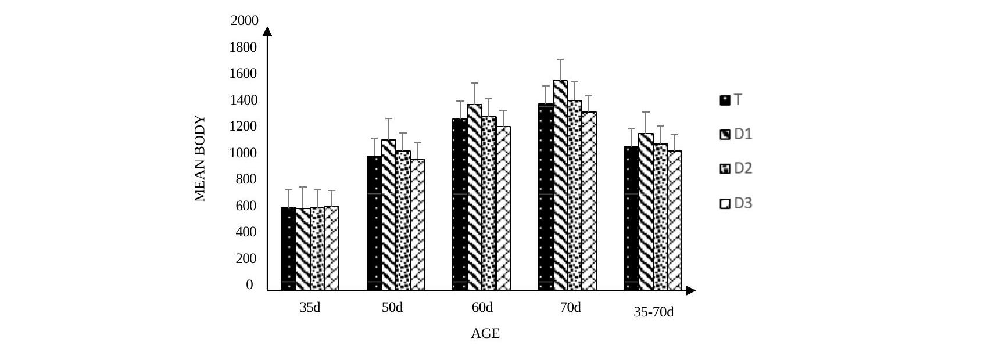
Figure 1: Mean body weight of the animals as a function of age
3.2 Effects of spirulina on feed intake, average daily gain and feed conversion ratio
Examination of Table 3 showed that there was no interaction between animal age and the dose of spirulina ingested. Furthermore, the analyses indicated no significant difference in feed intake among the four groups of animals. Mean intake was 86 g/d. The same pattern was observed for average daily gain and feed conversion ratio, with mean values of 24 g/d and 4.6, respectively. However, when age was taken into account, these parameters differed statistically among the age groups.
Table 3. Effect of spirulina and age on feed intake, ADG and FCR of the animals
 | DOSE (D) |  |  |  | AGE (A) |  |  | RMS | P>F
 | T | D1 | D2 | D3 | 35-50 | 51-60 | 61-70 | RMS | D | A | D x A
Intake (g/d) | 82 | 84 | 86 | 91 | 69b | 91a | 78a | 119 | 0.47 | <0.01 | 0.78
ADG (g/d) | 23 | 28 | 24 | 21 | 28a | 29.5a | 15b | 62.2 | 0.52 | <0.01 | 0.97
FCR | 4.7 | 3.9 | 4.5 | 5.4 | 2.7b | 3.1b | 8a | 2.2 | 0.43 | <0.01 | 0.94
T: control group; D1: 10 mg/day spirulina; D2: 50 mg/day spirulina; D3: 100 mg/day spirulina. P>F: probability; RMS: Residuals Mean Square.
3.3 Effects of spirulina on feed intake
Throughout the study, no significant difference in feed intake was observed among the four groups of animals subjected to the different treatments. The animals had similar feed intake, averaging 86 g/d.
Figure 2 shows the quantities of feed ingested by the four groups according to age class.
Thus, from 35 to 50 days of age, the different groups had a similar intake of 69 g/d. The same trend was observed in the 51–60-day and 61–70-day age classes, with mean intakes of 91 g/d and 78 g/d, respectively.
The rabbits ingested 22 g more between 51 and 60 days of age than between 35 and 50 days of age. Between 61 and 70 days of age, the rabbits ingested 7 g more than between 51 and 60 days of age.
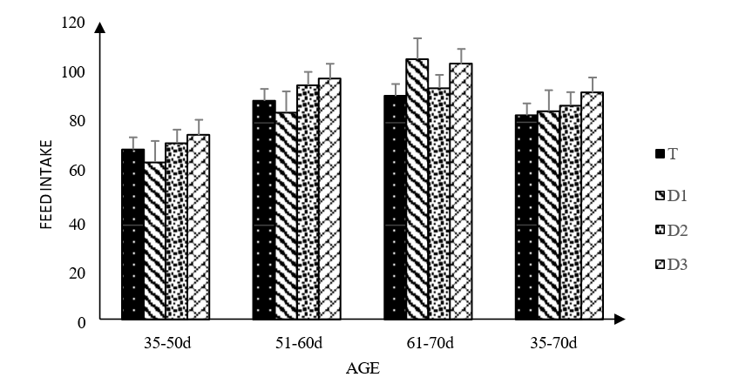
Figure 2: Feed intake of the animals as a function of age
3.4 Effects of spirulina on average daily gain
Throughout the study, no significant difference in average daily gain (ADG) was recorded among the groups subjected to the different spirulina treatments. Mean ADG was 24 g/d.
Figure 3 shows the ADG of the four groups given different doses of spirulina according to age class. Thus, from 35 to 50 days of age, the different groups showed an ADG of 28 g/d. A similar pattern was observed in the 51–60-day and 61–70-day age classes, in which the ADG of the rabbits was 29.5 g/d and 15 g/d, respectively.
Between 51 and 60 days of age, the rabbits had an ADG that was 1.5 g/d higher than that of rabbits aged between 35 and 50 days. Conversely, between 61 and 70 days of age, ADG was 14.5 g/d lower than the ADG observed between 51 and 60 days of age.
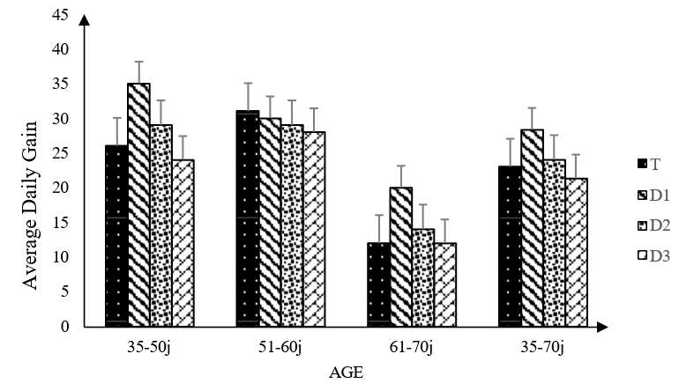
Figure 3: Average daily gain (ADG) of the animals as a function of age
3.5 Effects of spirulina on feed conversion ratio
Throughout the study, no significant difference in feed conversion ratio (FCR) was observed among the four groups of animals subjected to the different treatments. The animals had a similar FCR, averaging 4.6.
Figure 4 shows the feed conversion ratio (FCR) of the four groups according to age class. Thus, from 35 to 50 days of age, the different groups had an FCR of 2.7. The same trend was observed in the 51–60-day and 61–70-day age classes, with FCR values of 3.1 and 8, respectively.
The rabbits showed an FCR that was 0.4 higher between 51 and 60 days of age than between 35 and 50 days of age. Likewise, between 61 and 70 days of age, the rabbits had an FCR that was 4.9 higher than between 51 and 60 days of age.
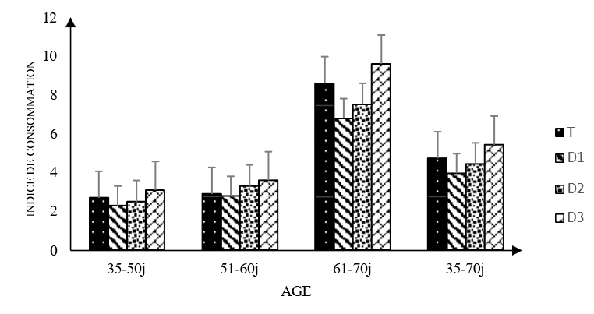
Figure 4: Feed conversion ratio of the animals as a function of age
3.6 Effects of spirulina on animal health
Across the 35–70-day period, Table 4 records 8 morbidity cases and 23 deaths across the four treatment groups. Throughout the study, the four groups of animals given the different doses of spirulina did not show major differences in health risk index (P=0.16), except during the 35–50-day age interval (P=0.04). During the 35–50 d interval, the HRI was highest in group D2. The HRI in D2 was 7, 4, and 6 points higher than in groups T, D1, and D3, respectively. Regarding morbidity and mortality, no significant difference was observed among the different groups throughout the study. Thus, the mean morbidity and mortality counts were 2.0 and 5.75 per group, respectively.

Table 4. Morbidity and mortality rates and health risk index as a function of spirulina dose and age
 | Treatments |  |  |  | P>F
 | T | D1 | D2 | D3 | P>F
35–50 d n | 14 | 14 | 14 | 14
Morbidity (%) | 0(0.0) | 1(7.1) | 3(21.4) | 1(7.1) | 0.24
Mortality (%) | 3(21.4) | 5(35.7) | 7(50) | 3(21.4) | 0.31
HRI (%) | 3(21.4) | 6(42.9) | 10(71.4) | 4(28.6) | 0.04
51–60 d n | 11 | 9 | 7 | 11
Morbidity (%) | 0(0.0) | 0(0.0) | 0(0.0) | 1(9.1) | 0.47
Mortality (%) | 1(9.1) | 2(22.2) | 0(0.0) | 1(9.1) | 0.51
HRI (%) | 1(9.1) | 2(22.2) | 0(0.0) | 2(18.2) | 0.39
61–70 d n | 10 | 7 | 7 | 10
Morbidity (%) | 0(0.0) | 1(14.3) | 0(0.0) | 1(10) | 0.51
Mortality (%) | 0(0.0) | 1(14.3) | 0(0.0) | 0(0.0) | 0.26
HRI (%) | 0(0.0) | 2(28.6) | 0(0.0) | 1(10) | 0.17
35–70 d n | 14 | 14 | 14 | 14
Morbidity (%) | 0(0.0) | 2(14.3) | 3(21.4) | 3(21.4) | 0.32
Mortality (%) | 4(28.6) | 8(57.1) | 7(50) | 4(28.6) | 0.28
HRI (%) | 4(28.6) | 10(71.4) | 7(50) | 7(50) | 0.16
T: control group; D1: 10 mg/day spirulina; D2: 50 mg/day spirulina; D3: 100 mg/day spirulina; P>F: probability; RMS: Residuals Mean Square; HRI: Health Risk Index.
Discussion
In this study, four groups of animals were used: one control group and three experimental groups. The latter received different doses of spirulina to evaluate its effects on growth and health performance. Evaluation of the growth parameters showed similar mean body weight, average daily gain, and feed conversion ratio among the four groups.
This may be because feed intake in rabbits is regulated more by the fibre content of the feed than by any other element. The different groups of animals received the same feed and therefore the same fibre content. Gidenne et al. (2009) reported that rabbits regulate their intake according to the level of digestible energy in the feed. Furthermore, Gerencsér et al. (2014) found no significant differences between animals receiving feed supplemented with 5% spirulina and those receiving feed without spirulina. These authors reported a higher intake than that observed in this study, at 133 g/d. The results of the present study showed a difference in intake according to the age of the rabbits. These results corroborate those of Gerencsér et al. (2014), who observed a 15% increase in intake between the first three weeks and the last three weeks of age. Although no statistically significant difference was observed, the intake of group D3, which received 100 mg/d of spirulina, was higher than that of the other groups.
In the rabbit diet, the use of 10, 50, and 100 mg of spirulina showed no major difference in average daily gain (ADG) or feed conversion ratio (FCR) among the animals. The animals had similar ADG and FCR values of 24 and 4.6, respectively. The absence of differences in ADG and FCR among the groups may be related to the absence of variation in the quantity of feed ingested. The results of Gerencsér et al. (2014) are consistent with those obtained here. These authors supplemented the diet with 5% spirulina and recorded similar average daily gain (38.6) and FCR (3.5) values between animals receiving spirulina and controls not receiving spirulina.
Regarding the effect of age on ADG and FCR, significant differences were observed. ADG was 28 g/d at 35–50 days and 29.5 g/d at 51–60 days, before declining to 15 g/d at 61–70 days, representing a decrease of approximately 49.2% from the 51–60-day interval. For FCR, the value increased from 3.1 at 51–60 days to 8.0 at 61–70 days, representing an increase of approximately 158.1%. The results obtained by Gerencsér et al. (2014) show the same trends. They recorded a high average daily gain (ADG) between 35–56 days of age, which then decreased by 10% between 56–77 days. They also recorded a 24% increase in feed conversion ratio between 35–56 days and 56–77 days.
Furthermore, although the highest quantity of feed ingested was observed in animals receiving the 100 mg spirulina/day dose (group D3), animals receiving 10 mg spirulina/day (group D1) showed the best feed efficiency in terms of average daily gain (ADG) and feed conversion ratio (FCR). Regarding mean body weight, no difference was observed between animals given different doses of spirulina and those not receiving spirulina. Mean body weight ranged from 967 to 1045 g across the four treatment groups. This is consistent with the absence of differences in intake or feed efficiency in this study. These results are consistent with those of Peiretti and Meineri (2008), who observed no significant difference when they supplemented rabbit diets with 5%, 10%, and 15% spirulina. Regarding the health risk index (HRI), the results of this study showed a significant difference among the different groups during the 35–50 d age interval. Most morbidity and mortality cases were recorded in the first two weeks (35–50 days) of the study, accounting for 62.5% and 78.3%, respectively. These observed health disorders could be due to the absence of vaccination or preventive treatment before the start of the experiment. One of our objectives was to evaluate the effect of spirulina on animal health; most mortality cases were due to either diarrhoea or bloating, which might have been prevented by treatment before the start of the experiment. The results of Gerencsér et al. (2014) confirm that morbidity and mortality rates are high in the first weeks after weaning, although they observed lower rates than those in our study. Indeed, they recorded morbidity and mortality rates of 9.5% and 2.4%, respectively, during the period from 35 to 56 days of age.
4. Conclusion
Under the conditions of this trial, daily administration of Spirulina platensis in drinking water at 10, 50, or 100 mg per rabbit did not significantly improve feed intake, body weight, average daily gain, feed conversion ratio, or overall health status during the post-weaning period. Growth-related responses were influenced by age rather than by the spirulina dose. The health risk index also showed no overall difference among treatment groups, although a significant difference was observed during the 35–50-day interval, with the highest value recorded in the group receiving 50 mg/day. These findings indicate that the tested low-dose drinking-water supplementation strategy did not provide measurable advantages for zootechnical performance or health under the experimental conditions. Further interpretation should also take account of the substantial morbidity and mortality recorded during the experiment and the absence of preventive veterinary treatment before or during the trial.

Limitation
This study was conducted on a single rabbit farm using 56 weaned rabbits, and sex was not considered in group allocation or analysis. Only three low daily doses of spirulina administered through drinking water were evaluated from 35 to 70 days of age. No preventive veterinary treatment was provided, and substantial morbidity and mortality occurred during the trial. These features may have influenced health-related outcomes and limit the extent to which the findings can be generalised beyond the experimental conditions, dose range, administration route, and post-weaning period examined.

Competing Interests
No conflict of interest is mentioned in the source document. No veterinary product was administered to the animals during the trial, this methodological choice being aimed at isolating the specific effect of spirulina on animal health.
Ethical Approval
Animal Ethic committee approval has been collected and preserved by the author(s).
Declaration of AI Use

This manuscript was prepared through the intellectual contributions of the author(s) to the study design, data analysis, interpretation of results, and scholarly content. Grammarly and ChatGPT were used solely to assist with grammatical refinement and reference formatting during manuscript revision. The author(s) accept full responsibility for the accuracy, integrity, and final content of the manuscript.

References
Bashar, A. M., Abdelnour, S. A., El-Darawany, A. A., & Sheiha, A. M. (2024). Dietary supplementation of microalgae and/or nanominerals mitigate the negative effects of heat stress in growing rabbits. Biological Trace Element Research, 202, 3639–3652. https://doi.org/10.1007/s12011-023-03953-0
Ciferri, O. (1983). Spirulina, the edible microorganism. Microbiological Reviews, 47(4), 551–578. https://doi.org/10.1128/mr.47.4.551-578.1983
Falquet, J. (1996). Spiruline: Aspects nutritionnels. Antenna Technologies.
Falquet, J., & Hurni, J.-P. (2006). Spiruline: Aspects nutritionnels. Antenna Technologies. https://archives.antenna.ch/en/activities/nutrition/definition-history-properties/
Food and Agriculture Organization of the United Nations. (2006). Les impacts de l’élevage sur l’environnement. AG21 Magazine Focus.
Gerencsér, Z., Szendrő, Z., Matics, Z., Radnai, I., Kovács, M., Nagy, I., Cullere, M., Dal Bosco, A., & Dalle Zotte, A. (2014). Effect of dietary supplementation of spirulina (Arthrospira platensis) and thyme (Thymus vulgaris) on apparent digestibility and productive performance of growing rabbits. World Rabbit Science, 22(1), 1–9. https://doi.org/10.4995/wrs.2014.1351
Gidenne, T. (2003). Fibres in rabbit feeding for digestive troubles prevention: Respective role of low-digested and digestible fibre. Livestock Production Science, 81(2–3), 105–117. https://doi.org/10.1016/S0301-6226(02)00301-9
Gidenne, T., Combes, S., Feugier, A., Jehl, N., Arveux, P., Boisot, P., Briens, C., Corrent, E., Fortune, H., Montessuy, S., & Verdelhan, S. (2009). Feed restriction strategy in the growing rabbit. 2. Impact on digestive health, growth and carcass characteristics. Animal, 3(4), 509–515. https://doi.org/10.1017/S1751731108003790
Goering, H. K., & Van Soest, P. J. (1970). Forage fiber analyses: Apparatus, reagents, procedures, and some applications (Agriculture Handbook No. 379). U.S. Department of Agriculture. https://www.govinfo.gov/app/details/GOVPUB-A-PURL-gpo24229
Isaac, L. J., Ekong, N. B., Udoh, U. H., & Ipinu, J. A. (2025). The growth performance and linear body measurements of mongrel rabbits in a tropical environment. Asian Journal of Research in Biosciences, 7(1), 8–17. https://doi.org/10.56557/ajorib/2025/v7i1106
Kadi, S. A. (2012). Alimentation du lapin de chair: Valorisation de sources de fibres disponibles en Algérie [Doctoral dissertation, Université Mouloud Mammeri de Tizi-Ouzou]. https://dspace.ummto.dz/items/e58bf9cf-48cf-4384-b97b-69be12beeccc
Kambou, P. S., Bleyere, M. N., Attemene, S. D. D., Tiahou, G. G., Dembele, A., & Sess, D. E. (2015). Antianaemic effect of spirulina in rabbits (Oryctolagus cuniculus), a made and used food supplement in Côte d’Ivoire. Scholars Academic Journal of Biosciences, 3(9), 725–732. https://doi.org/10.36347/sajb.2015.v03i09.001
Kambou, P. S., Bleyere, M. N., Attemene, S. D. D., Cisse-Camara, M., & Tiahou, G. G. (2015). Assessment of immunostimulatory activity of Spirulina platensis in rabbits (Oryctolagus cuniculus) in Côte d’Ivoire. International Journal of Pharmacy and Pharmaceutical Research, 4(3), 113–128. https://ijppr.humanjournals.com/16-3/
Kambou, S. P., Angbo, K. M. A., Vanie, B. F. J., Bedou, K. D., & Cisse-Camara, M. (2025). Study of the lipid and lipoprotein profile and weight gain in rabbits treated with spirulina (Spirulina platensis). European Journal of Nutrition & Food Safety, 17(11), 11–19. https://doi.org/10.9734/ejnfs/2025/v17i111888
Kouablé Bi, B. N., & Tré, B. T. C. O. (2014). Rapport définitif de l’étude évolution des exportations du bétail malien suite aux récentes crises. Côte d’Ivoire.
Peiretti, P. G., & Meineri, G. (2008). Effects of diets with increasing levels of Spirulina platensis on the performance and apparent digestibility in growing rabbits. Livestock Science, 118(1–2), 173–177. https://doi.org/10.1016/j.livsci.2008.04.017
Shaheen, M. S., Allam, A. A., Abdel Monem, U. M., Bassiony, S. M., Khalil, B. A., Salah, A. S., Alawam, A. S., Rudayni, H. A., Elolimy, A. A., & Abass, K. S. (2025). Bifidobacterium, Spirulina, and yeast extracts in low-energy diets for rabbits: Effects on performance, hematology, lipid metabolism, hepatorenal function, immunity and hormones. Frontiers in Veterinary Science, 12, 1615203. https://doi.org/10.3389/fvets.2025.1615203

