Original Research Article

Lectin histochemistry of fucosylated and mannosylated glycan epitopes in normal breast tissue, fibroadenoma, and ductal carcinoma

ABSTRACT
Breast cancer is the most common malignant tumour and the second leading cause of cancer mortality in women and is characterised by distinct shifts in the N-glycome. The aim of this study was to evaluate the expression of N-glycans in paraffin-embedded blocks from breast tissues diagnosed with breast carcinoma. Lectin histochemistry was used to examine the expression and distribution of N-glycans in paraffin-embedded blocks from breast tissues diagnosed with fibroadenoma and breast carcinoma, with 4 healthy tissue samples as controls, using lectins from Ulex europaeus I, Lens culinaris, Canavalia ensiformis, Lotus tetragonolobus and Triticum vulgaris. Results obtained with lectins from Ulex europaeus I and Canavalia ensiformis showed recognition of ducts in all the samples studied, whilst the lectins from Lens culinaris, Triticum vulgaris and Lotus tetragonolobus were observed to recognise the stroma and ducts in samples with fibroadenoma; however, in breast tissue without breast cancer and in samples with grade II and grade III breast cancer, recognition was observed only in the ducts. Statistical analysis did not reveal statistically significant differences. Our results suggest that variability in lectin affinity reflects alterations in cellular N-glycosylation between different stages of histological tumour progression; further studies are required to confirm these observations.

Keywords: Lectin histochemistry; breast carcinoma; fibroadenoma; N-glycans; fucosylation; mannosylation; invasive ductal carcinoma; glycosylation; wheat germ agglutinin; concanavalin A

1. INTRODUCTION.
Breast cancer remains the leading cause of cancer deaths in women worldwide. The chances of a woman developing this disease in her lifetime have increased significantly over the past few decades, from 1 in 11 in 1975 to 1 in 8 in 2016 (Scott & Drake, 2019). Although the mortality rate from breast cancers confined to the breast or associated draining lymph nodes is low, the majority of breast cancer deaths are due to the spread of the disease. When breast cancer spreads to other vital organs, such as the lung, liver, brain and bones, it can impair organ function and ultimately lead to death (Ibrahim et al., 2009). The progressive improvement in breast cancer mortality is largely due to the detection of early-stage carcinomas and pre-malignant lesions (Ernster et al., 2002). Breast cancer can be classified as grade 1, or well differentiated; grade 2, or moderately differentiated; or grade 3, or poorly differentiated. Grade 1 cells grow more slowly and resemble normal breast cells. Grade 2 cells grow and appear intermediate between grades 1 and 3. Grade 3 cancer cells look very different from normal cells and are likely to grow and spread more rapidly (van Dooijeweert et al., 2022). Recent reviews of breast cancer diagnosis and classification also emphasise the continuing need for molecular approaches that complement established methods of disease detection and characterisation (Begum et al., 2023).
Fibroadenomas are benign human breast tumours characterised by proliferation of the epithelial and stromal components of the terminal ductal unit. They may grow, regress or remain unchanged as the hormonal environment of the patient changes.
(Gallegos et al., 2012).
Glycosylation is a term used to describe the enzymatic process that involves the sequential addition of carbohydrates to proteins and lipids (Munkley & Elliott, 2016). For glycoproteins, the attached glycans are classified as either N-linked (Asn) or O-linked (Ser/Thr). N-linked glycans are further processed by a highly regulated sequential series of glycosidases and glycosyltransferases in the endoplasmic reticulum (ER) and Golgi apparatus. Individual glycosyltransferases may exhibit overlapping specificities in some instances (Kuzmanov et al., 2013; Spiro, 2002). In cancer, oncogenic transformation associated with changes in glycosylation was first documented over seven decades ago (Taniguchi & Kizuka, 2015). The N-glycome undergoes dynamic remodelling that facilitates tumour cell survival, migration and colonisation of distant organs. Understanding these patterns is essential for the development of next-generation biomarkers and therapies that can overcome the limitations of current clinical tools (Lee et al., 2020). Lectin-based analytical strategies have also been explored for profiling disease-associated glycans and glycoproteins, supporting the broader diagnostic relevance of altered glycosylation (Silva et al., 2016). Recent breast cancer studies further support the value of glycan profiling, including spatial mapping of fucosylated N-glycans in triple-negative breast cancer and lectin-microarray assessment of serum glycosylation patterns (Scott et al., 2025; Peng et al., 2025).
Lectins are highly specific proteins that bind to carbohydrates and are found in many plants, animals and bacteria (Yau et al., 2015). Lectins can specifically recognise N-glycans; the most widely studied include lectins from Ulex europaeus I, Lens culinaris, Canavalia ensiformis, Lotus tetragonolobus and Triticum vulgaris (Brooks, 2024). Recent work has also evaluated an antibody-lectin sandwich assay targeting a breast cancer-associated glycoform, illustrating the continued development of lectin-glycan recognition for biomarker-oriented approaches (Nikseresht et al., 2025).
A direct comparison of the binding patterns of the selected lectins across normal breast tissue, fibroadenoma, and grade II and grade III ductal carcinoma is therefore needed to characterise the tissue-associated variation examined in this study.
Changes in the expression of N-glycans may be related to the grade of differentiation in breast cancer; therefore, the aim of this study was to use histochemical lectin staining to assess the expression of N-glycans in paraffin-embedded tissues from women without breast cancer, as well as in samples with fibroadenoma and grade II and grade III breast cancer.
2 MATERIAL AND METHODS
2.1 Reagents
The biotinylated lectins Ulex europaeus I, Lens culinaris, Canavalia ensiformis, Lotus tetragonolobus and Triticum vulgaris were obtained from Vector Laboratories (Burlingame, CA, USA). Streptavidin-peroxidase and chemical reagents were obtained from Sigma Chemical Co. (USA), and the 3-Amino-9-Ethyl-carbazole (AEC) kit used as a substrate for peroxidase was obtained from Vector Laboratories.
2.2 Source of tissues
10 paraffin-embedded blocks from breast tissues diagnosed with fibroadenoma, 10 paraffin-embedded blocks from grade II breast carcinoma and 10 paraffin-embedded blocks from grade III breast carcinoma were kindly donated by Paulina Leyva from the Pathology Department of the School of Medicine, UABJO, Oaxaca, Mexico. Four healthy control tissue samples were obtained from cosmetic procedures at the Plastic Surgery Service of the Mexican Institute of Social Security (IMSS, for its initials in Spanish), Mexico.
2.3 Ethical approval
The study protocol was approved by the Institutional Review Board of Research of the Medical School of UABJO in 2016. Informed consent and the protection of personal and clinical data were the responsibility of the treating doctors.
2.4 Immunohistochemistry
Paraffin-embedded blocks from breast carcinoma and normal controls were cut into 6 µm-thick sections. The procedures for dewaxing, hydration, antigen retrieval and blocking of endogenous peroxidase were performed as described by Paulsen et al. (2015).
Selected sections were covered with 300 μl of 5% skimmed milk in PBS, pH 7.4, and incubated for 12 h at 4°C. After washing with PBS, the sections were labelled with lectins (5µg/ml) overnight at 4ºC. After incubation, the slides were washed with PBS, pH 7.4, and the samples were labelled with streptavidin-peroxidase (1:1000 in PBS) for 1 h at 37°C. Unbound conjugate was removed by washing six times with PBS. The binding of lectins or antibody was revealed by incubation with 3-amino-9-ethyl-carbazole (AEC), following the manufacturer's instructions (Invitrogen), for 15 min at 37°C. The reaction was stopped by washing with water. Slides were observed with an AXIOSCOP 40 microscope (Zeiss, Germany) equipped with an AXIOCAM MRC digital camera (Zeiss), and micrographs were analysed with ZEN 2011 software (Zeiss).
  - Lectin specificity
To determine lectin specificity in control breast epithelium and carcinoma, lectin histochemistry assays were performed using lectins incubated with 200 mM of their specific monosaccharide (Table 1) for 30 min before use in histochemistry.
2.6 Statistical Analysis
Fisher’s exact test was performed using GraphPad InStat version 3.00 (GraphPad Software, San Diego, CA). Bonferroni correction was carried out. Comparisons were made between normal tissue and fibroadenoma; normal tissue and grade II cancer; normal tissue and grade III cancer; fibroadenoma and grade II cancer; fibroadenoma and grade III cancer; and grade II cancer and grade III cancer.
3. RESULTS
3.1 Immunohistochemistry
Table 1 shows the oligosaccharide structures recognised by the lectins used.

TABLE 1
Lectins and the oligosaccharide structures they recognize
Lectin | Abbreviation | Oligosaccharide structure
Lens culinaris | LCA | Manα1,6(Manα1,3)Manβ1,4(Fucα1,6)GlcNAc-Asn.
Canavalia ensiformis | Con A | Manα1,2Manα1,2ManαGlcNAcβ1,2Man
Triticum vulgaris | WGA | GlcNAcβ1,4GlcNAc  β1-4GlcNAc; Neu5Ac
Ulex europaeus I | UEA I | α-L-Fucosa  Fuc(α1,2)Gal(β1,4)GlcNAc
Lotus tetragonolobus | LTL | Fuc(α1,2)Gal(β1,4){Fuc(α1,3)}GlcNAc

The numbers of positive and negative samples recognised by the lectins are shown in Table 2. The LTL and LCA lectins recognised two samples and did not recognise two samples in normal breast tissue, whereas UEA-1, WGA and Con A recognised three samples and did not recognise one.
Regarding the fibroadenoma samples, 10 samples were recognised by the UEA-1 and LTL lectins. Eight samples were recognised by the WGA lectin, whereas two were not. Finally, four samples were recognised by the LCA lectin, whereas six were negative; five samples were recognised by the Con A lectin, whereas five were negative.
The UEA-1, LTL and WGA lectins recognised eight samples with grade II moderately differentiated ductal carcinoma, with the remaining two being negative. The LCA and Con A lectins recognised only three samples, with the remaining seven being negative.
In breast tissue samples containing grade III poorly differentiated ductal carcinoma, the UEA-1 lectin recognised eight samples and two were negative; the LTL lectin recognised seven samples and three were negative; the Con A lectin recognised six samples and four were negative; the WGA lectin recognised three samples and seven were negative; and, lastly, the LCA lectin interacted with only two samples and eight were negative.
TABLE 2
Number of samples recognised by the lectins used
LECTIN | NORMAL  (+) (-) | FIBROADENOMA  (+) (-) | CANCER  II  (+) (-) | CANCER  III  (+) (-)
Ulex europaeus I | 3 1 | 10 0 | 8 2 | 8 2
Lens culinaris | 2 2 | 4 6 | 3 7 | 2 8
Triticum vulgaris | 3 1 | 8 2 | 8 2 | 3 7
Lotus tetragonolobus | 2 2 | 10 0 | 8 2 | 7 3
Canavalia ensiformis | 3 1 | 5 5 | 3 7 | 6 4
Normal n=4. Fibroadenoma n=10 cancer grade II n=10 cancer8 grade III n=10
+ Positive recognition
- No recognition

Figure 1 shows recognition by the Ulex europaeus I (UEA-1) lectin: (A) negative control, (B) normal tissue, (C) fibroadenoma, (D) grade II ductal carcinoma and (E) grade III ductal carcinoma. In all tissue types, the lectin recognises the epithelial cells of the ducts.

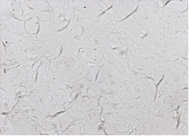

A

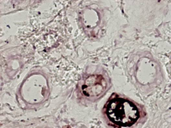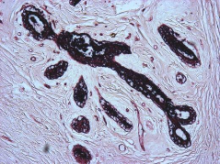
B
C
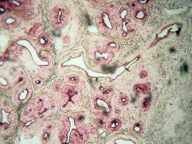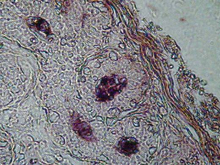
D
E
Figure 1. The results of histochemistry using Ulex europaeus I lectin are shown. A) Negative control B) shows lectin binding in the ducts of normal tissue. C) lectin binding is observed in the ducts of tissue samples containing fibroadenoma. D) shows lectin recognition in the ducts of grade II invasive ductal carcinoma. E) shows lectin recognition in the ducts of grade III invasive ductal carcinoma. The yellow arrows indicate the site of lectin recognition. Microphotographs 10x.

Figure 2 shows recognition by the Lens culinaris (LCA) lectin: (A) negative control and (B) normal tissue, in which the lectin recognises the epithelial cells of the ducts. In fibroadenoma (C), the lectin recognises the epithelial cells of the ducts and stroma. In grade II ductal carcinoma (D) and grade III ductal carcinoma (E), the lectin recognises the epithelial cells of the ducts.
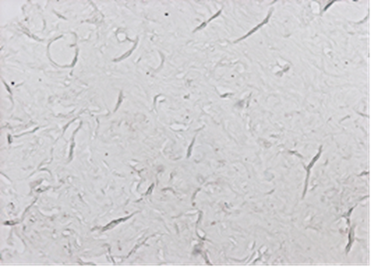
A
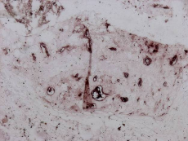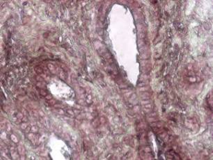
B
C
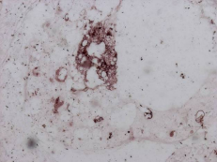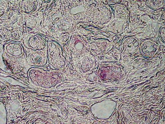
E
D
Figure 2. The results of histochemistry using Lens culinaris lectin are shown. A) Negative control B) shows lectin binding in the ducts of normal tissue. C) lectin binding is observed in the ducts and stroma of tissue samples containing fibroadenoma. D) shows lectin recognition in the ducts of grade II invasive ductal carcinoma. E) shows lectin recognition in the ducts of grade III invasive ductal carcinoma. The yellow arrows indicate the site of lectin recognition in ducts. The white arrow indicates the site of lectin recognition in stroma. Microphotographs 10x.

Figure 3 shows recognition by the Triticum vulgaris (WGA) lectin: (A) negative control.
In normal tissue (B), the lectin recognises the epithelial cells of the ducts. In fibroadenoma (C), the lectin recognises the epithelial cells of the ducts and the stroma. In grade II ductal carcinoma (D) and grade III ductal carcinoma (E), the lectin recognises the epithelial cells of the ducts.

A

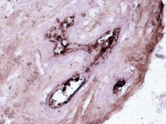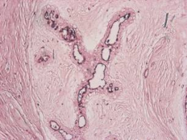
C
B
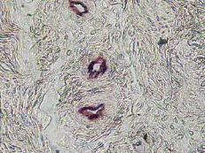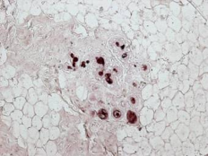
E
D
Figure 3. The results of histochemistry using Triticum vulgaris lectin are shown. A) Negative control. B) shows lectin binding in the ducts of normal tissue. C) lectin binding is observed in the ducts and stroma of tissue samples containing fibroadenoma. D) shows lectin recognition in the ducts of grade II invasive ductal carcinoma. E) shows lectin recognition in the ducts of grade III invasive ductal carcinoma. The yellow arrows indicate the site of lectin recognition in ducts. The white arrow indicates the site of lectin recognition in stroma. Microphotographs 10x.

Figure 4 shows recognition by the Lotus tetragonolobus (LTL) lectin: (A) negative control. In normal tissue (B), the lectin recognises the epithelial cells of the ducts. In fibroadenoma (C), the lectin recognises the epithelial cells of the ducts and the stroma. In grade II ductal carcinoma (D) and grade III ductal carcinoma (E), the lectin recognises the epithelial cells of the ducts.

A
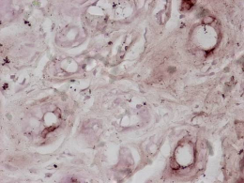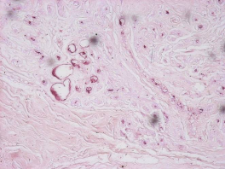
C
B
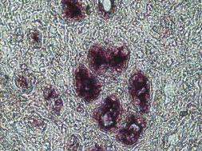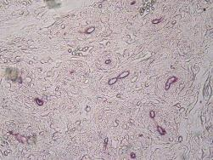
E
D
Figure 4. The results of histochemistry using Lotus tetragonolobus lectin are shown. A) Negative control. B) shows lectin binding in the ducts of normal tissue. C) lectin binding is observed in the ducts and stroma of tissue samples containing fibroadenoma. D) shows lectin recognition in the ducts of grade II invasive ductal carcinoma. E) shows lectin recognition in the ducts of grade III invasive ductal carcinoma. The yellow arrows indicate the site of lectin recognition in ducts. The white arrow indicates the site of lectin recognition in stroma. Microphotographs 10x.

Figure 5 shows recognition by the Canavalia ensiformis (Con A) lectin: (A) negative control, (B) normal tissue, (C) fibroadenoma, (D) grade II ductal carcinoma and (E) grade III ductal carcinoma. In all tissue types, the lectin recognises the epithelial cells of the ducts.
A
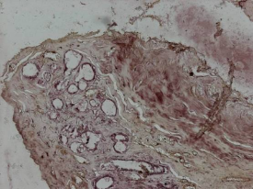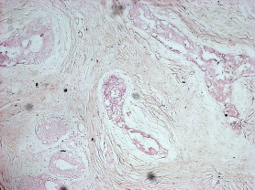
C
B
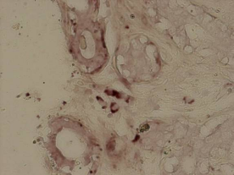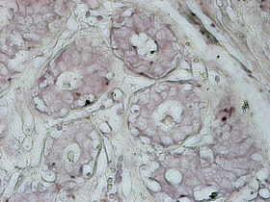
E
D
Figure 5. The results of histochemistry using Canavalia ensiformis lectin are shown. A) Negative control B) shows lectin binding in the ducts of normal tissue. C) lectin binding is observed in the ducts of tissue samples containing fibroadenoma. D) shows lectin recognition in the ducts of grade II invasive ductal carcinoma. E) shows lectin recognition in the ducts of grade III invasive ductal carcinoma. The yellow arrows indicate the site of lectin recognition in ducts. Microphotographs 10x.

3.2 Lectin specificity
In inhibition assays, lectin-specific monosaccharides at a concentration of 200 mM were incubated for 30 minutes before use in histochemistry. No recognition by the lectins employed was observed. Figure 6 shows an example of a negative result from the inhibition tests.
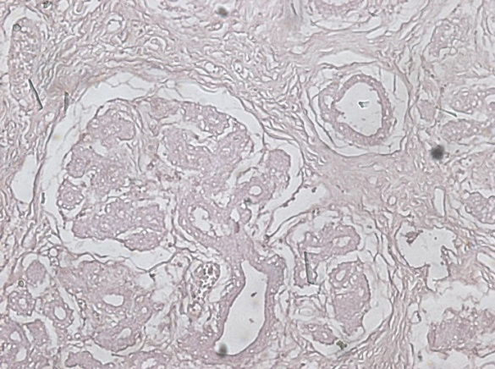
Figure 6 Example of a negative result from the inhibition tests. Lectin incubated with 200 mM of a monosaccharide or oligosaccharide structure (Table 1).

3.3 Statistical Analysis
The statistical analysis indicated that none of the comparisons between the different tissue types—normal tissue and fibroadenoma; normal tissue and grade II cancer; normal tissue and grade III cancer; fibroadenoma and grade II cancer; fibroadenoma and grade III cancer; and grade II cancer and grade III cancer—reached the threshold for statistical significance for any of the lectins (p < 0.05) (Table 3). The Bonferroni correction further confirmed that there was no statistical evidence of differences in the binding of these five lectins among the different histological grades studied (Table 4).
TABLE 3
Results of Fisher’s Exact Test (p-values)
Lectin | A | B | C | D | E | F
Ulex europaeus I | 0.286 | 1.000 | 1.000 | 0.474 | 0.474 | 1.000
Lens culinaris | 1.000 | 0.580 | 0.521 | 1.000 | 0.132 | 1.000
Triticum vulgaris | 1.000 | 1.000 | 0.245 | 1.000 | 0.070 | 0.070
Lotus tetragonolobus | 0.066 | 0.521 | 0.580 | 0.474 | 0.211 | 1.000
Canavalia ensiformis | 0.580 | 0.245 | 1.000 | 0.650 | 1.000 | 0.370
A: Normal vs. Fibroadenoma, B: Normal vs. Cancer Grade II, C: Normal vs. Cancer Grade III, D: Fibroadenoma vs. Cancer Grade II, E: Fibroadenoma vs. Cancer Grade III and F: Cancer Grade II vs. Cancer Grade III

TABLE 4
Bonferroni Correction Results (αadj = 0.00167$)

Lectin | A | B | C | D | E | E
Ulex europaeus I | 0.286 | 1.000 | 1.000 | 0.474 | 0.474 | 1.000
Lens culinaris | 1.000 | 0.580 | 0.521 | 1.000 | 0.132 | 1.000
Triticum vulgaris | 1.000 | 1.000 | 0.245 | 1.000 | 0.070 | 0.070
Lotus tetragonolobus | 0.066 | 0.521 | 0.580 | 0.474 | 0.211 | 1.000
Canavalia ensiformis | 0.580 | 0.245 | 1.000 | 0.650 | 1.000 | 0.370
A: Normal vs. Fibroadenoma, B: Normal vs. Cancer Grade II, C: Normal vs. Cancer Grade III, D: Fibroadenoma vs. Cancer Grade II, E: Fibroadenoma vs. Cancer Grade III and F: Cancer Grade II vs. Cancer Grade III

4. DISCUSSION
Breast cancer comprises ~30% of new cancer diagnoses and is one of the most common causes of cancer mortality in women (Siegel et al., 2017). Among the most significant molecular alterations observed in breast cancer is the dysregulation of N-glycosylation, a complex post-translational modification that profoundly influences protein function, stability and cellular signalling (Lee et al., 2020; Liang et al., 2023; Gupta et al., 2023). Altered glycosylation is a characteristic feature of malignant transformation, as it facilitates processes such as cell migration, invasion and immune evasion. Breast tissue may exhibit significant variations in the expression of glycans associated with tumour progression, which may lead to remodelling of the N-glycomic profile (Benesova et al., 2024).
The results obtained with the Lens culinaris (LCA) lectin showed a decline in the lectin’s ability to recognise the target as the disease progressed. Recognition fell from 50 per cent (2/4) in the normal group to 40 per cent (4/10) in the fibroadenoma group, 30 per cent (3/10) in the grade II cancer group and, finally, 20 per cent (2/10) in the grade III cancer group. LCA specifically binds to glycans with an α 1-6 linked fucose residue and exhibits broad specificity for fucosylated as well as non-fucosylated glycans, although binding strength differs among the glycans; this low specificity is a common characteristic of most lectins (Kang et al., 2011). There is no evidence that LCA has been used to study N-glycosidic epitopes in fibroadenoma; therefore, further studies are required to identify which glycoproteins carry the oligosaccharide structures recognised by the lectin. In invasive ductal carcinoma, the expression of the N-glycans recognised by the LCA lectin is associated with the activity of the enzyme fucosyltransferase FUT8 (Tu et al., 2022; Shi et al., 2024; Ma et al., 2025). It has also been reported that Lens culinaris agglutinin binds specifically to a hepatocellular carcinoma-associated glycovariant of α-fetoprotein (Taketa et al., 1993).
The results obtained for the Triticum vulgaris lectin (WGA) were as follows: normal tissue, 75% (3/4); fibroadenoma, 80% (8/10); grade II cancer, 80% (8/10); and grade III cancer, 30% (3/10), showing decreased lectin recognition in grade III cancer samples. Altered expression of the carbohydrates recognised by WGA is involved in tumour-related processes such as cell adhesion, motility, angiogenesis and apoptosis (de Melo Rêgo et al., 2013). WGA detects traces of N-acetylglucosamine (GlcNAc). In breast cancer, changes in fucosylation are heavily associated with increased invasiveness and altered cell-matrix interactions (Coulibaly & Youan, 2017). In fibroadenoma, WGA lectin has been reported to recognise cell membranes and breast carcinoma samples (Raju & Lee, 1988). Staining with WGA lectin has been observed in elastosis and on the luminal surface of normal and neoplastic duct epithelium (Davies & Mera, 1987); these results are similar to those found in the present study.
In cellular models, inhibition of cell growth by WGA lectin has been reported in MCF-7 and T 47D cells (Valentiner et al., 2003).
The results obtained with Lotus tetragonolobus lectin were as follows: normal tissue, 50 per cent (2/4); fibroadenoma, 100 per cent (10/10); grade II cancer, 80 per cent (8/10); and grade III cancer, 70 per cent (7/10). In fibroadenoma, LTL lectin has been reported to recognise cell membranes and breast carcinoma samples (Raju & Lee, 1988); these results are similar to those found in the present study. Lotus tetragonolobus lectin has been used in cancer research to detect aberrant fucosylation on breast cancer cells (Hashim et al., 2017). Lotus tetragonolobus lectin binds to Lewis^{X} and Lewis^{Y} in fucosylated semen clusterin, but not to serum clusterin or recombinant clusterin. Breast cancer cells frequently overexpress these altered fucose chains (Merlotti et al., 2019; Listinsky et al., 2011). Basal and luminal adenomas do not share the same glycosyltransferases responsible for glycosylating proteins, including the fucosyltransferases (Lai et al., 2019).
The results obtained with Ulex europaeus I lectin were positive in almost all samples: normal tissue, 75 per cent (3 out of 4); fibroadenoma, 100 per cent (10 out of 10); grade II cancer, 80 per cent (8 out of 10); and grade III cancer, 80 per cent (8 out of 10). It has been reported that Ulex europaeus I lectin recognises cell membranes and breast carcinoma samples (Raju & Lee, 1988; Andrade et al., 2013); these results are similar to those found in the present study.

The lectin from Ulex europaeus I has been used in histochemistry on breast cancer tissue samples, and its binding was associated with disease-free interval and survival (Fenlon et al., 1987). Lectin binding has also been compared with pathological prognostic factors and details of clinical follow-up using paraffin-embedded tissue samples from breast carcinoma (Erhan et al., 1996). Receptor sites for Ulex europaeus I stained non-malignant epithelium of patients with blood group H but did not stain malignant cells (Skutelsky et al., 1988). Ulex europaeus I lectin has also been used to capture circulating SW480 colon cancer cells (Tian et al., 2022).
LTL has a direct affinity for the α1,3-fucose present in the Lewis X structure. However, if that structure becomes sialylated (capped with terminal α2,3-sialic acid to form Sialyl Lewis X), the addition of sialic acid physically blocks or substantially reduces LTL’s ability to recognise the fucose (Haselhorst et al., 2001; Kratz et al., 2014). UEA-1 requires an α1,2-fucose link. When a cell actively synthesises Sialyl Lewis X, the responsible enzymes switch or suppress the biosynthetic pathways required for α1,2-fucosylation, meaning that a rise in sLeX often corresponds to a reduction in UEA-1 binding (Kratz et al., 2014). An interaction with the endothelium via the sialyl Lewis ^{X} antigen has been demonstrated in MCF-7 cell binding (Elola et al., 2007).
The results obtained with the Canavalia ensiformis lectin show a varied recognition pattern: recognition is high in normal tissue (75 per cent, 3/4), falls in fibroadenoma (50 per cent, 5/10) and grade II cancer (30 per cent, 3/10), but rises again in grade III cancer (60 per cent, 6/10). It has been reported that the Con A lectin does not recognise samples containing fibroadenoma or carcinoma (Raju & Lee, 1988). Furthermore, detection of Con A lectin in fibroadenoma and carcinoma has been reported (Andrade et al., 2013); these findings are similar to ours. The Con A lectin also exhibits limited cytotoxicity in breast and liver cancer cells (Marey et al., 2026). Canavalia ensiformis lectin inhibited the growth of MCF-7 cells in dose- and time-dependent manners (Shi et al., 2014). The most studied receptor in ConA biology is MT1-MMP (Membrane-Type Matrix MetalloProteinase-1). Evidence indicates that tumour cells benefit from MT1-MMPs because these enzymes facilitate metastasis and neovascularisation by activating different MMPs (Sato et al., 2005; Sounni et al., 2005; Cavada et al., 2023).
5.CONCLUSIONS
This study examined lectin-binding patterns associated with selected N-glycan-related structures in normal breast tissue, fibroadenoma, and ductal carcinoma. The findings showed variable lectin recognition among tissue categories, with relatively stable binding for Ulex europaeus I and Lotus tetragonolobus, reduced recognition of Lens culinaris and Triticum vulgaris in grade III carcinoma, and a variable pattern for Canavalia ensiformis. These observations suggest that breast tissue glycosylation may change during histological tumour progression. However, because the statistical comparisons did not reach significance, the findings should be interpreted cautiously. Larger studies with quantitative glycomic validation are required to confirm these preliminary observations.
6. LIMITATION OF THIS STUDY
Although this study provides valuable information on glycomic remodelling in ductal breast carcinoma, it is essential to recognise the following limitations inherent in the methodological design. As this is an observational cross-sectional study with a limited number of tissue samples, the findings may have restricted generalisability to the broader population of patients with breast carcinoma. This study did not take blood group or secretory status (FUT2) into account. The study relies primarily on the intensity of histochemical staining (qualitative or semi-quantitative analysis), which limits the ability to define the exact structural changes in N-glycans.
COMPETING INTERESTS
All authors declare no competing interests.
DECLARATION OF AI USE

This manuscript was prepared through the intellectual contributions of the author(s) to the study design, data analysis, interpretation of results, and scholarly content. Grammarly and ChatGPT were used solely to assist with grammatical refinement and reference formatting during manuscript revision. The author(s) accept full responsibility for the accuracy, integrity, and final content of the manuscript.
REFERENCES.
Andrade, C. G., Cabral Filho, P. E., Tenório, D. P. L., Santos, B. S., Beltrão, E. I. C., Fontes, A., & Carvalho, L. B., Jr. (2013). Evaluation of glycophenotype in breast cancer by quantum dot-lectin histochemistry. International Journal of Nanomedicine, 8, 4623–4629. https://doi.org/10.2147/IJN.S51065
Begum, S. A., Rani, S. J., & Yeruva, V. (2023). Modern methods for breast cancer diagnosis and classification: A current update. Uttar Pradesh Journal of Zoology, 44(19), 189–204. https://doi.org/10.56557/upjoz/2023/v44i193635
Benesova, I., Nenutil, R., Urminsky, A., Lattova, E., Uhrik, L., Grell, P., Zavadil Kokas, F., Halamkova, J., Zdrahal, Z., Vojtesek, B., Novotny, M. V., & Hernychova, L. (2024). N-glycan profiling of tissue samples to aid breast cancer subtyping. Scientific Reports, 14(1), 320. https://doi.org/10.1038/s41598-023-51021-3
Brooks, S. A. (2024). Lectins as versatile tools to explore cellular glycosylation. European Journal of Histochemistry, 68(1), 3959. https://doi.org/10.4081/ejh.2024.3959
Cavada, B. S., Oliveira, M. V., Osterne, V. J. S., Pinto-Junior, V. R., Martins, F. W. V., Correia-Neto, C., Pinheiro, R. F., Leal, R. B., & Nascimento, K. S. (2023). Recent advances in the use of legume lectins for the diagnosis and treatment of breast cancer. Biochimie, 208, 100–116. https://doi.org/10.1016/j.biochi.2022.12.015
Davies, J. D., & Mera, S. L. (1987). Elastosis in breast carcinoma: II. Association of protease inhibitors with immature elastic fibres. The Journal of Pathology, 153(4), 317–324. https://doi.org/10.1002/path.1711530405
de Melo Rêgo, M. J. B., de Mello, G. S. V., da Silva Santos, C. A., Chammas, R., & Beltrão, E. I. C. (2013). Implications on glycobiological aspects of tumor hypoxia in breast ductal carcinoma in situ. Medical Molecular Morphology, 46(2), 92–96. https://doi.org/10.1007/s00795-013-0013-4
Elola, M. T., Capurro, M. I., Barrio, M. M., Coombs, P. J., Taylor, M. E., Drickamer, K., & Mordoh, J. (2007). Lewis x antigen mediates adhesion of human breast carcinoma cells to activated endothelium: Possible involvement of the endothelial scavenger receptor C-type lectin. Breast Cancer Research and Treatment, 101(2), 161–174. https://doi.org/10.1007/s10549-006-9286-9
Erhan, Y., Alkanat, M. B., Akyildiz, M., Icoz, G., Yilmaz, R., & Erhan, Y. (1996). Ulex Europeus Agglutinin (UEA-I) lectin binding in breast carcinoma and its relationship to prognostic factors. Annals of Saudi Medicine, 16(5), 509–511. https://doi.org/10.5144/0256-4947.1996.509
Ernster, V. L., Ballard-Barbash, R., Barlow, W. E., Zheng, Y., Weaver, D. L., Cutter, G., Yankaskas, B. C., Rosenberg, R., Carney, P. A., Kerlikowske, K., Taplin, S. H., Urban, N., & Geller, B. M. (2002). Detection of ductal carcinoma in situ in women undergoing screening mammography. Journal of the National Cancer Institute, 94(20), 1546–1554. https://doi.org/10.1093/jnci/94.20.1546
Fenlon, S., Ellis, I. O., Bell, J., Todd, J. H., Elston, C. W., & Blamey, R. W. (1987). Helix pomatia and Ulex europeus lectin binding in human breast carcinoma. The Journal of Pathology, 152(3), 169–176. https://doi.org/10.1002/path.1711520305
Coulibaly, F. S., & Youan, B.-B. C. (2017). Current status of lectin-based cancer diagnosis and therapy. AIMS Molecular Science, 4(1), 1–27. https://doi.org/10.3934/molsci.2017.1.1
Gallegos, I. B., Pérez-Campos, E., Martinez, M., Mayoral, M. Á., Pérez, L., Aguilar, S., Zenteno, E., Pina, M. del S., & Hernández, P. (2012). Expression of antigen TF and galectin-3 in fibroadenoma. BMC Research Notes, 5, 694. https://doi.org/10.1186/1756-0500-5-694
Gupta, R., Ponangi, R., & Indresh, K. G. (2023). Role of glycosylation in breast cancer progression and metastasis: Implications for miRNA, EMT and multidrug resistance. Glycobiology, 33(7), 545–555. https://doi.org/10.1093/glycob/cwad046
Haselhorst, T., Weimar, T., & Peters, T. (2001). Molecular recognition of sialyl Lewisx and related saccharides by two lectins. Journal of the American Chemical Society, 123(43), 10705–10714. https://doi.org/10.1021/ja011156h
Hashim, O. H., Jayapalan, J. J., & Lee, C.-S. (2017). Lectins: An effective tool for screening of potential cancer biomarkers. PeerJ, 5, e3784. https://doi.org/10.7717/peerj.3784
Ibrahim, E., Al-Gahmi, A. M., Zeenelin, A. A., Zekri, J. M., Elkhodary, T. R., Gaballa, H. E., Fawzy, E. E., El Sayed, M. E., & Alzahrani, M. S. (2009). Basal vs. luminal A breast cancer subtypes: A matched case-control study using estrogen receptor, progesterone receptor, and HER-2 as surrogate markers. Medical Oncology, 26(3), 372–378. https://doi.org/10.1007/s12032-008-9131-6
Kang, J.-G., Ko, J.-H., & Kim, Y.-S. (2011). Pros and cons of using aberrant glycosylation as companion biomarkers for therapeutics in cancer. BMB Reports, 44(12), 765–771. https://doi.org/10.5483/BMBRep.2011.44.12.765
Kratz, E. M., Ferens-Sieczkowska, M., Faundez, R., & Kątnik-Prastowska, I. (2014). Changes in fucosylation of human seminal IgG and secretory component of IgA in leukocytospermic patients. Glycoconjugate Journal, 31(1), 51–60. https://doi.org/10.1007/s10719-013-9501-y
Kuzmanov, U., Kosanam, H., & Diamandis, E. P. (2013). The sweet and sour of serological glycoprotein tumor biomarker quantification. BMC Medicine, 11, 31. https://doi.org/10.1186/1741-7015-11-31
Lai, T.-Y., Chen, I.-J., Lin, R.-J., Liao, G.-S., Yeo, H.-L., Ho, C.-L., Wu, J.-C., Chang, N.-C., Lee, A. C.-L., & Yu, A. L. (2019). Fucosyltransferase 1 and 2 play pivotal roles in breast cancer cells. Cell Death Discovery, 5, 74. https://doi.org/10.1038/s41420-019-0145-y
Lee, S. B., Bose, S., Ahn, S. H., Son, B. H., Ko, B. S., Kim, H. J., Chung, I. Y., Kim, J., Lee, W., Ko, M.-S., Lee, K., Chang, S., Park, H. S., Lee, J. W., & Kim, D.-C. (2020). Breast cancer diagnosis by analysis of serum N-glycans using MALDI-TOF mass spectroscopy. PLoS ONE, 15(4), e0231004. https://doi.org/10.1371/journal.pone.0231004
Liang, D., Gao, Q., Meng, Z., Li, W., Song, J., & Xue, K. (2023). Glycosylation in breast cancer progression and mammary development: Molecular connections and malignant transformations. Life Sciences, 326, 121781. https://doi.org/10.1016/j.lfs.2023.121781
Listinsky, J. J., Siegal, G. P., & Listinsky, C. M. (2011). The emerging importance of α-L-fucose in human breast cancer: A review. American Journal of Translational Research, 3(4), 292–322.
Ma, Q., Liu, Y., Fan, Q., Zhu, X., Yang, D., & Zhao, Z. (2025). Advances in cancer research on FUT8 molecular mechanisms and clinical applications. International Journal of Surgery, 111(9), 6290–6304. https://doi.org/10.1097/JS9.0000000000002669
Marey, M. M., El-Akhras, B. A., El-Naa, M. M., & Talaat, R. M. (2026). Targeting breast and liver cancer cells with Phaseolus vulgaris (PHA), Phytolacca americana (PAA), and Canavalia ensiformis (Concanavalin A) lectin by inducing apoptosis and autophagy. Next Research, 9, 101772. https://doi.org/10.1016/j.nexres.2026.101772
Merlotti, A., López Malizia, A., Michea, P., Bonte, P.-E., Goudot, C., Carregal, M. S., Nuñez, N., Sedlik, C., Ceballos, A., Soumelis, V., Amigorena, S., Geffner, J., Piaggio, E., & Sabatte, J. (2019). Aberrant fucosylation enables breast cancer clusterin to interact with dendritic cell-specific ICAM-grabbing non-integrin (DC-SIGN). OncoImmunology, 8(9), e1629257. https://doi.org/10.1080/2162402X.2019.1629257
Munkley, J., & Elliott, D. J. (2016). Hallmarks of glycosylation in cancer. Oncotarget, 7(23), 35478–35489. https://doi.org/10.18632/oncotarget.8155
Nikseresht, S., Shewell, L. K., Day, C. J., Jennings, M. P., Chittoory, H., McCart Reed, A. E., Simpson, P. T., Lakhani, S. R., Nabiee, R., Moore, M., Khanabdali, R., Hinch, L. M., & Rice, G. E. (2025). Improved breast cancer diagnosis using a CA15-3 capture antibody-lectin sandwich assay. Breast Cancer Research and Treatment, 211(3), 605–615. https://doi.org/10.1007/s10549-025-07672-z
Paulsen, I. M. S., Dimke, H., & Frische, S. (2015). A single simple procedure for dewaxing, hydration and heat-induced epitope retrieval (HIER) for immunohistochemistry in formalin-fixed paraffin-embedded tissue. European Journal of Histochemistry, 59(4), 2532. https://doi.org/10.4081/ejh.2015.2532
Peng, L., Ma, M., Zhang, Y., Zhang, Z., Meng, J., Li, S., Zhao, D., Zhao, J., Mao, F., & Hu, C. (2025). Serum immunoglobulin G glycosylation profiling in breast cancer using a 56-lectin microarray and subtype-specific patterns. Gland Surgery, 14(10), 2022–2034. https://doi.org/10.21037/gs-2025-298
Raju, G. C., & Lee, Y. S. (1988). Lectin binding in the male breast. The Journal of Pathology, 156(1), 45–50. https://doi.org/10.1002/path.1711560110
Sato, H., Takino, T., & Miyamori, H. (2005). Roles of membrane-type matrix metalloproteinase-1 in tumor invasion and metastasis. Cancer Science, 96(4), 212–217. https://doi.org/10.1111/j.1349-7006.2005.00039.x
Scott, D. A., & Drake, R. R. (2019). Glycosylation and its implications in breast cancer. Expert Review of Proteomics, 16(8), 665–680. https://doi.org/10.1080/14789450.2019.1645604
Scott, D. A., Seal, S., Spruill, L., Dunne, J., Colditz, G., Mehta, A. S., Drake, R. R., Ford, M. E., & Angel, P. M. (2025). Fucosylated N-glycan landscape of triple-negative breast cancer. Molecular Cancer Research, 23(12), 984–996. https://doi.org/10.1158/1541-7786.MCR-25-0483
Shi, M., Nan, X.-R., & Liu, B.-Q. (2024). The multifaceted role of FUT8 in tumorigenesis: From pathways to potential clinical applications. International Journal of Molecular Sciences, 25(2), 1068. https://doi.org/10.3390/ijms25021068
Shi, Z., Chen, J., Li, C.-Y., An, N., Wang, Z.-J., Yang, S.-L., Huang, K.-F., & Bao, J.-K. (2014). Antitumor effects of concanavalin A and Sophora flavescens lectin in vitro and in vivo. Acta Pharmacologica Sinica, 35(2), 248–256. https://doi.org/10.1038/aps.2013.151
Siegel, R. L., Miller, K. D., & Jemal, A. (2017). Cancer statistics, 2017. CA: A Cancer Journal for Clinicians, 67(1), 7–30. https://doi.org/10.3322/caac.21387
Silva, P. M. S., Coelho, L. C. B. B., & Correia, M. T. S. (2016). Electrochemical biosensing strategies to detect serum glycobiomarkers. Advances in Research, 6(6), 1–17. https://doi.org/10.9734/AIR/2016/24734
Skutelsky, E., Hoenig, S., Griffel, B., & Alroy, J. (1988). The distribution of lectin receptor sites in human breast lesions. Pathology Research and Practice, 183(4), 469–475. https://doi.org/10.1016/S0344-0338(88)80095-5
Sounni, N. E., & Noel, A. (2005). Membrane type-matrix metalloproteinases and tumor progression. Biochimie, 87(3–4), 329–342. https://doi.org/10.1016/j.biochi.2004.07.012
Spiro, R. G. (2002). Protein glycosylation: Nature, distribution, enzymatic formation, and disease implications of glycopeptide bonds. Glycobiology, 12(4), 43R–56R. https://doi.org/10.1093/glycob/12.4.43r
Taketa, K., Endo, Y., Sekiya, C., Tanikawa, K., Koji, T., Taga, H., Satomura, S., Matsuura, S., Kawai, T., & Hirai, H. (1993). A collaborative study for the evaluation of lectin-reactive alpha-fetoproteins in early detection of hepatocellular carcinoma. Cancer Research, 53(22), 5419–5423.
Taniguchi, N., & Kizuka, Y. (2015). Glycans and cancer: Role of N-glycans in cancer biomarker, progression and metastasis, and therapeutics. Advances in Cancer Research, 126, 11–51. https://doi.org/10.1016/bs.acr.2014.11.001
Tian, R., Li, X., Zhang, H., Ma, L., Zhang, H., & Wang, Z. (2022). Ulex Europaeus Agglutinin-I-based magnetic isolation for the efficient and specific capture of SW480 circulating colorectal tumor cells. ACS Omega, 7(34), 30405–30411. https://doi.org/10.1021/acsomega.2c03702
Tu, C.-F., Li, F.-A., Li, L.-H., & Yang, R.-B. (2022). Quantitative glycoproteomics analysis identifies novel FUT8 targets and signaling networks critical for breast cancer cell invasiveness. Breast Cancer Research, 24(1), 21. https://doi.org/10.1186/s13058-022-01513-3
Valentiner, U., Fabian, S., Schumacher, U., & Leathem, A. J. (2003). The influence of dietary lectins on the cell proliferation of human breast cancer cell lines in vitro. Anticancer Research, 23(2B), 1197–1206.
van Dooijeweert, C., van Diest, P. J., & Ellis, I. O. (2022). Grading of invasive breast carcinoma: The way forward. Virchows Archiv, 480(1), 33–43. https://doi.org/10.1007/s00428-021-03141-2
Yau, T., Dan, X., Ng, C. C. W., & Ng, T. B. (2015). Lectins with potential for anti-cancer therapy. Molecules, 20(3), 3791–3810. https://doi.org/10.3390/molecules20033791

