Original Research Article

Lectin histochemistry of fucosylated and mannosylated glycan epitopes in normal breast tissue, fibroadenoma, and ductal carcinoma

ABSTRACT
Breast cancer is the most common malignant tumor and the second leading cause of cancer mortality in women and characterized by distinct shifts in the N-glycome. The aim of this study is to evaluate the expression of N-glycans in paraffin-embedded blocks from breast tissues diagnosed with breast carcinoma. Lectin histochemistry, were used to examine the expression and distribution of N-glycan in paraffin-embedded blocks from 10 breast tissues diagnosed with fibroadenoma, breast carcinoma and as control 4 healthy tissue samples, using lectins from: Ulex europaeus I, Lens culinaris, Canavalia ensiformis, Lotus tetragonolobus and Triticum vulgaris. Results with lectins from Ulex europaeus I and Canavalia ensiformis recognised ducts in all the samples studied, whilst the lectins from Lens culinaris, Triticum vulgaris and Lotus tetragonolobus were observed to recognised the stroma and ducts in samples with fibroadenoma, whereas in samples of breast tissue without breast cancer and in samples with Grade II and Grade III breast cancer, recognition was observed only in the ducts. Statistical analysis did not reveal any statistical significance. Our results suggest that the variability in lectin affinity reflects alterations in cellular N-glycosylation, between different stages of histological tumor progression; further studies are required to confirm this

Keywords: Lectin histochemistry; invasive ductal carcinoma; fibroadenoma; fucosylation; concanavalin A; wheat germ agglutinin; glycosylation; breast neoplasms

1. INTRODUCTION.
Breast cancer remains the leading cause of cancer deaths in women worldwide. The chances of a woman developing this disease in her lifetime have increased significantly over the past few decades from 1 in 11 in 1975 to 1 in 8 in 2016 (Scott & Drake, 2019). While the mortality rate from breast cancers confined to the breast or associated draining lymph nodes is low, the majority of breast cancer deaths are due to the spread of the disease. When breast cancer spreads to other vital organs such as the lung, liver, brain and bones, it can result in an impairment of the organ’s ability to function and ultimately death (Ibrahim E et al, 2009). The progressive improvement in breast cancer mortality is largely due to detection of early-stage carcinomas and pre-malignant lesions (Ernster et al, 2002) Breast cancer can be classified into: grade 1 or well differentiated. The cells are slower-growing, and look more like normal breast cells. Grade 2 or moderately differentiated. The cells are growing at a speed of and look like cells somewhere between grades Grade 3 or poorly differentiated. The cancer cells look very different from normal cells and will probably grow and spread faster (van Dooijeweert et al, 2022).
Fibroadenomas are benign human breast tumors, characterized by proliferation of epithelial and stromal components of the terminal ductal unit. They may grow, regress or remain unchanged, as the hormonal environment of the patient changes.
(Gallegos et al, 2012).
Glycosylation is a term used to describe the enzymatic process that involves the sequential addition carbohydrates to proteins and lipids (Munkley J et al, 2016). For glycoproteins, the attached glycans are classified as either N-linked (Asn) or O-linked (Ser/Thr) N-linked glycans are further processed by a highly regulated sequential series of glycosidases and glycosyltransferases in the endoplasmic reticulum (ER) and Golgi apparatus. Individual glycosyltransferases may exhibit overlapping specificities in some instances (Kuzmanov et al, 2013, Spiro 2002). In cancer, oncogenic transformation associated with changes in glycosylation was first documented over seven decades ago (Taniguch & 2 Kizuka, 2015). The N-glycome undergoes dynamic remodeling that facilitates tumor cell survival, migration, and colonization of distant organs. Understanding these patterns is essential for the development of next-generation biomarkers and therapies that can overcome the limitations of current clinical tools (Lee et al, 2020).
Lectins are highly specific proteins that bind to carbohydrates and are found in many plants, animals, and bacteria (Yau T et al, 2015). Lectins can specifically recognise N-glycans; the most widely studied are the lectins from: Ulex europaeus I, Lens culinaris, Canavalia ensiformis, Lotus tetragonolobus and Triticum vulgaris (Brooks et al, 2024).
Changes in the expression of N-glycans may be related to the grade of differentiation in breast cancer; therefore, the aim of this study was to use histochemical lectin staining to assess the expression of N-glycans in paraffin-embedded tissues from women without breast cancer, as well as in samples with fibroadenoma and samples with grade II and grade III breast cancer
2 MATERIAL AND METHODS
2.1 Reagents
The biotinylated lectins from, Ulex europaeus I, Lens culinaris, Canavalia ensiformis, Lotus tetragonolobus and Triticum vulgaris were obtained from Vector Laboratories, (Burlingame, CA USA). streptavidin-peroxiodase, and chemical reagents were from (Sigma Chemical Co, USA), 3-Amino-9-Ethyl-carbazole (AEC) kit as substrate for peroxidase was obtained from Vector Laboratories
2.2 Source of tissues
10 Paraffin-embedded blocks from breast tissues diagnosed with fibroadenoma and breast carcinoma grade II and grade III were kindly donated by Paulina Leyva from the Pathology Department of the School of Medicine, UABJO, Oaxaca, Mexico. 4 healthy control tissue samples were obtained from cosmetic procedures at the Plastic Surgery service from the Mexican Institute of Social Security (IMSS for its initials in Spanish), Mexico.
2.3 Ethical approval
The study protocol was approved by the Institutional Review Board of Research of the Medical School of UABJO. Informed consent and the protection of personal and clinical data were the responsibility of the treating doctors.

2.4 Immunohistochemistry
Paraffin-embedded blocks from breast carcinoma and normal control were cut in 6 µm-thick sections. The procedure for dewaxing, hydrating, antigen retrieval and the blocking of endogenous peroxidase was performed as described by Paulsen (Paulsen et al, 2015).
Select sections were labeled with lectins (5µg/ml) overnight at 4ºC. After incubation, the slides were washed with PBS, pH 7.4, and covered with 300 μl of 5% skimmed milk in PBS, pH 7.4, and incubated for 12 h at 4°C. Then, after washing with PBS, pH 7.4, the samples were labeled with streptavidin-peroxidase (1:1000 in PBS) for 1 h at 37°C. Unbound conjugate was removed by washing six times with PBS. The binding of lectins or antibody was revealed by incubating with 3-amino-9-ethyl-carbazole (AEC), following instructions of manufacturer (Invitrogen), during 15 min at 37°C. The reaction was stopped by washing with water. Slides were observed with an AXIOSCOP 40 microscope (Zeiss, Germany) equipped with a digital camera AXIOCAM MRC (Zeiss) and micrographs were analyzed with the ZEN 2011 Software (Zeiss).
  - Lectin specificity
To determinate the lectin specificity in control breast epithelium and carcinoma, assays using lectin histochemistry were performed using lectins incubated with 200 mM of their specific monosaccharide (table 1) 30 min before use to histochemistry.
2.6 Statistical Analysis
Fisher’s exact test was performed using GraphPad InStat version 3.00 (GraphPad Software, San Diego, CA). Comparisons were made between normal tissue and fibroadenoma; normal tissue and grade II cancer; normal tissue and grade III cancer; fibroadenoma and grade II cancer; fibroadenoma and Grade III cancer; and Grade II cancer and Grade III cancer.
3. RESULTS
3.1 Immunohistochemistry
Table 1 shows the oligosaccharide structures recognized by the lectins used

TABLE 1
Lectins and the oligosaccharide structures they recognize
Lectin | Abbreviation | Oligosaccharide structure
Lens culinaris | LCA | Manα1,6(Manα1,3)Manβ1,4(Fucα1,2)GlcNAc-Asn.
Canavalia ensiformis | Con A | Manα1,2Manα1,2ManαGlcNAcβ1,2Man
Triticum vulgaris | WGA | GlcNAcβ1,4GlcNAc  β1-4GlcNAc; Neu5Ac
Ulex europaeus I | UEA I | α-L-Fucosa  Fuc(α1,2)Gal(β1,4)GlcNAc
Lotus tetragonolobus | LTL | Fuc(α1,2)Gal(β1,4){Fuc(α1,3)}GlcNAc

The number of positive and negative samples that the lectins recognized is displayed in Table 2. The lectins LTL and LCA recognized two samples and did not recognize two samples in the normal breast tissues, while UEA 1, WGA, and Con A recognized three samples and did not recognize one.
Regarding the fibroadrmona samples, ten samples are recognized by the UEA-1 and LTL lectins. Eight samples are recognized by the WGA lectin, while two are not. Finally, only four samples are recognized by the LCA lectin, while six samples are negative; five samples are recognized by the Con A lectin, while five samples are negative.
The UEA, LTL, and WGA lectins were found to recognize eight tissues in the samples with grade II moderately differentiated ductal carcinoma, with the remaining two being negative. While the LCA and Con A lectins only recognized three tissues, with the remaining seven being negative.
In samples of breast tissue containing grade III poorly differentiated ductal carcinoma, it was found that the UEA lectin recognized eight samples, two were negative; the LTL lectin recognized seven samples and three were negative; the Con A lectin recognized six samples and four were negative; the WGA lectin recognized three samples, and were negative; and lastly, the LCA lectin only interacted with two samples and eight were negative.
TABLE 2
Number of samples recognised by the lectins used
LECTIN | NORMAL  (+) (-) | FIBROADENOMA  (+) (-) | CANCER  II  (+) (-) | CANCER  III  (+) (-)
Ulex europaeus I | 3 1 | 10 0 | 8 2 | 8 2
Lens culinaris | 2 2 | 4 6 | 3 7 | 2 8
Triticum vulgaris | 3 1 | 8 2 | 8 2 | 3 7
Lotus tetragonolobus | 2 2 | 10 0 | 8 2 | 7 3
Canavalia ensiformis | 3 1 | 5 5 | 3 7 | 6 4
Normal n=4. Fibroadenoma n=10 Cancer grade II n=10 cancer grade III n=10
+ Positive recognition
- No recognition

Figure 1 shows the recognition of Ulex europaeus I (UEA-1) lectin in normal tissue (A), in fibroadenoma (B), in samples of grade II ductal carcinoma (C) and in samples of grade III ductal carcinoma (D); in all cases, the lectin recognises the epithelial cells of the ducts and the intraductal component.

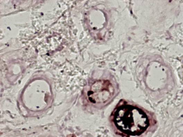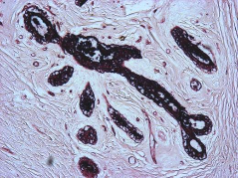
A
B
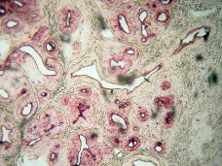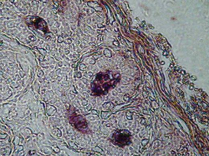
C
D
Figure 1. The results of histochemistry using Ulex europaeus I lectin are shown. A) shows lectin binding in the ducts of normal tissue. B) lectin binding is observed in the ducts of tissue samples containing fibroadenoma. C) shows lectin recognition in the ducts of grade II invasive ductal carcinoma. D) shows lectin recognition in the ducts of grade III invasive ductal carcinoma. The yellow arrows indicate the site of lectin recognition. Microphotographs 10x.

Figure 2 shows the recognition of Lens culinaris (LCA) lectin in normal tissue (A), the lectin recognises the epithelial cells of the ducts and the intraductal component. In fibroadenoma (B), the lectin recognises the epithelial cells of the ducts and the intraductal component and the stroma. In samples of grade II ductal carcinoma (C) and in samples of grade III ductal carcinoma (D); the lectin recognises the epithelial cells of the ducts and the intraductal component.

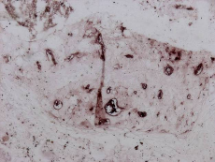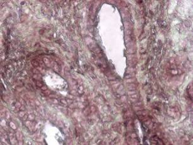
A
B
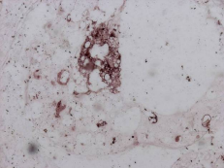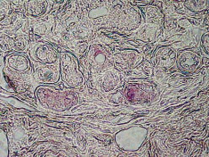
D
C
Figure 2. The results of histochemistry using Lens culinaris lectin are shown. A) shows lectin binding in the ducts of normal tissue. B) lectin binding is observed in the ducts and stroma of tissue samples containing fibroadenoma. C) shows lectin recognition in the ducts of grade II invasive ductal carcinoma. D) shows lectin recognition in the ducts of grade III invasive ductal carcinoma. The yellow arrows indicate the site of lectin recognition in ducts. The white arrow indicates the site of lectin recognition in stroma. Microphotographs 10x.

Figure 3 shows the recognition of Triticum vulgaris (WGA) lectin in normal tissue (A), the lectin recognises the epithelial cells of the ducts and the intraductal component. In fibroadenoma (B), the lectin recognises the epithelial cells of the ducts and the intraductal component and the stroma. In samples of grade II ductal carcinoma (C) and in samples of grade III ductal carcinoma (D); the lectin recognises the epithelial cells of the ducts and the intraductal component.


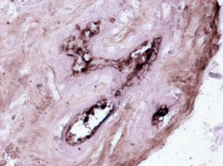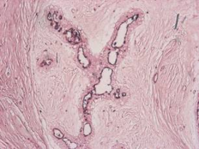
A
B
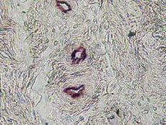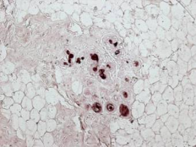
D
C
Figure 3. The results of histochemistry using Triticum vulgaris lectin are shown. A) shows lectin binding in the ducts of normal tissue. B) lectin binding is observed in the ducts and stroma of tissue samples containing fibroadenoma. C) shows lectin recognition in the ducts of grade II invasive ductal carcinoma. D) shows lectin recognition in the ducts of grade III invasive ductal carcinoma. The yellow arrows indicate the site of lectin recognition in ducts. The white arrow indicates the site of lectin recognition in stroma. Microphotographs 10x.

Figure 4 shows the recognition of Lotus tetragonolobus (LTL) lectin in normal tissue (A), the lectin recognises the epithelial cells of the ducts and the intraductal component. In fibroadenoma (B), the lectin recognises the epithelial cells of the ducts and the intraductal component and the stroma. In samples of grade II ductal carcinoma (C) and in samples of grade III ductal carcinoma (D); the lectin recognises the epithelial cells of the ducts and the intraductal component.

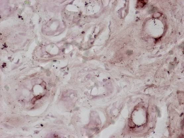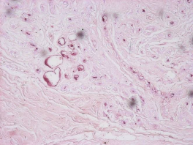
B
A
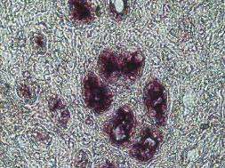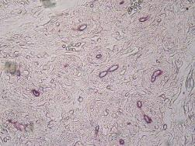
D
C
Figure 4. The results of histochemistry using Lotus tetragonolobus lectin are shown. A) shows lectin binding in the ducts of normal tissue. B) lectin binding is observed in the ducts and stroma of tissue samples containing fibroadenoma. C) shows lectin recognition in the ducts of grade II invasive ductal carcinoma. D) shows lectin recognition in the ducts of grade III invasive ductal carcinoma. The yellow arrows indicate the site of lectin recognition in ducts. The white arrow indicates the site of lectin recognition in stroma. Microphotographs 10x.

Figure 5 shows the recognition of Canavalia ensiformis (Con A) lectin in normal tissue (A), lectin in normal tissue (A), in fibroadenoma (B), in samples of grade II ductal carcinoma (C) and in samples of grade III ductal carcinoma (D); in all cases, the lectin recognises the epithelial cells of the ducts and the intraductal component.

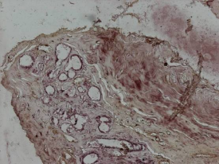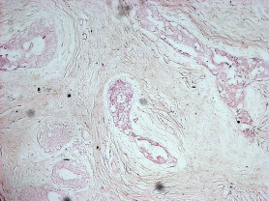
B
A
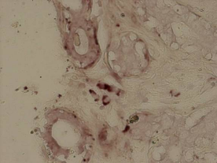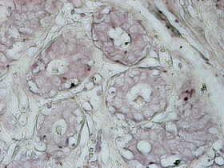
D
C

Figure 5. The results of histochemistry using Canavalia ensiformis lectin are shown. A) shows lectin binding in the ducts of normal tissue. B) lectin binding is observed in the ducts of tissue samples containing fibroadenoma. C) shows lectin recognition in the ducts of grade II invasive ductal carcinoma. D) shows lectin recognition in the ducts of grade III invasive ductal carcinoma. The yellow arrows indicate the site of lectin recognition in ducts. Microphotographs 10x.

3.2 Lectin specificity
In inhibition assays using lectin-specific monosaccharides at a concentration of 200 mM, which were incubated for 30 minutes prior to use in histochemistry, it was observed that there was no recognition by the lectins employed. Figure 6 shows an example of a negative result from the inhibition tests
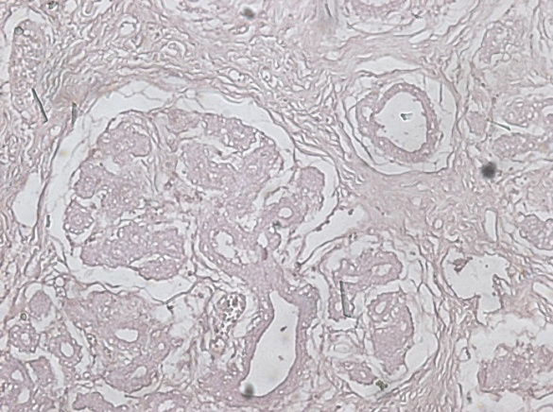
Figure 6 Example of a negative result from the inhibition tests. Lectin incubated with 200 mM of a monosaccharide or oligosaccharide structure (Table 1).

3.3 statistical analysis
The results of the statistical analysis indicate that none of the comparisons carried out between the different tissue types: normal tissue and fibroadenoma; normal tissue and grade II cancer; normal tissue and grade III cancer; fibroadenoma and grade II cancer; fibroadenoma and Grade III cancer; and Grade II cancer and Grade III cancer for any of the lectins reached the threshold for statistical significance (p < 0.05). (Table 3)
TABLE 3
Results of Fisher’s Exact Test (p-values)
Lectin | A | B | C | D | E | F
Ulex europaeus I | 0.286 | 1.000 | 1.000 | 0.474 | 0.474 | 1.000
Lens culinaris | 1.000 | 0.580 | 0.521 | 1.000 | 0.132 | 1.000
Triticum vulgaris | 1.000 | 1.000 | 0.245 | 1.000 | 0.070 | 0.070
Lotus tetragonolobus | 0.066 | 0.521 | 0.580 | 0.474 | 0.211 | 1.000
Canavalia ensiformis | 0.580 | 0.245 | 1.000 | 0.650 | 1.000 | 0.370
A: Normal vs. Fibroadenoma, B: Normal vs. Cáncer Grade II, C: Normal vs. Cáncer Grade III, D: Fibroadenoma vs. Cáncer Grade II, E: Fibroadenoma vs. Cáncer Grade III and F: Cáncer Grade II vs. Cáncer Grade II

4. DISCUSSION
Breast cancer comprises ~30% of new cancer diagnoses, and is one of the most common causes of cancer mortality in women (Siegel et al., 2017). Among the most significant molecular alterations observed in breast cancer is the dysregulation of N-glycosylation, a complex post-translational modification that profoundly influences protein function, stability, and cellular signaling (Lee et al, 2020, Liang et al. 2023 and Gupta et al., 2023). Altered glycosylation is a characteristic feature of malignant transformation, as it facilitates processes such as cell migration, invasion and immune evasion. Breast tissue may exhibit significant variations in the expression of glycans associated with tumor progression, which may lead to a remodelling of the N-glycomic profile (Benesova et al., 2024).
The results obtained with the Lens culinaris (LCA) lectin showed a decline in the lectin’s ability to recognize the target as the disease progressed. It fell from 50 per cent (2/4) in the normal group to 40 per cent (4/10) in the fibroadenoma group, 30 per cent (3/10) in the Cancer II group, and finally to just 20 per cent (2/10) in the Cancer III group. LCA specifically binds to glycans with α 1-6 linked fucose residue and exhibits a broad specificity for fucosylated as well as non-fucosylated glycans, albeit a difference in the binding strength among the glycans and this low specificity is a common characteristic for most of lectins (Kang et al., 2011). There is no evidence that LCA has been used to study N-glycosidic epitopes in fibroadenoma; therefore, further studies are required to identify which glycoproteins carry the oligosaccharide structures recognized by the lectin. In the case of invasive ductal carcinoma, the expression of the N-glycans recognized by the LCA lectin is associated with the activity of the enzyme fucosyltransferase FUT 8. (Tu et al, 2022; Shi et al, 2024; Ma et al, 2025). It has also been reported that Lens culinaris agglutinin, binds specifically to hepatocellular carcinoma associated glycovariant of α-fetoprotein (Taketa et al, 1993).
The results obtained for the Triticum vulgaris lectin (WGA) were as follows: in normal tissue: 75%, 3/4; in fibroadenoma: 80%, 8/10; in grade II cancer: 80%, 8/10; with a decrease in lectin recognition in grade III cancer samples: 30%, 3/10. Altered expression of the carbohydrates recognised by WGA is involved in tumor-related processes such as cell adhesion, motility, angiogenesis and apoptosis. (Vieira-de-Mello et al, 2013). WGA detects traces of N-acetylglucosamine (GlcNAc). In breast cancer, changes in fucosylation are heavily associated with increased invasiveness and altered cell-matrix interactions (Fohona et al, 2017). In the case of fibroadenoma, it has been reported that WGA lectin recognizes cell membranes and breast carcinoma samples (Raju et al, 1988). Staining with WGA lectin has been observed in elastosis and on the luminal surface of normal and neoplastic duct epithelium (Davies et al, 1988), these results are similar to those we found.
In cellular models, the effect of WGA lectin on the inhibition of cell growth has been reported in cells MCF-7 and T 47D (Valentiner et al, 2003).
The results obtained with Lotus tetragonobulus lectin were as follows: in normal tissue (50 per cent, 2/4); in fibroadenoma, 100 per cent (10/10) was obtained; in grade II cancer (80 per cent, 8/10); and in grade III cancer (70 per cent, 7/10). In the case of fibroadenoma, it has been reported that LTA lectin recognizes cell membranes and breast carcinoma samples (Raju et al, 1988), these results are similar to those we found. Lotus tetragonolobus lectin has been used in cancer research to detect aberrant fucosylation on breast cancer cells. (Hashim et al., 2017). Lotus tetragonolobus lectin binds to Lewis^{X} and Lewis^{Y} in fucosylated semen clusterin, but not serum clusterin or recombinant clusterin in breast cancer cells frequently overexpress these altered fucose chains (Merlotti et al., 2019 & Listinsky et al., 2011). Basal and luminal adenomas do not share the same glycosyltransferases responsible for glycosylating proteins. In this case, the fucosyltransferases (Lai et al., 2019).
The results obtained with Ulex europaeus I lectin are positive in almost all samples: normal (75 per cent, 3 out of 4), fibroadenoma (100 per cent, 10 out of 10), grade II cancer (80 per cent, 8 out of 10) and grade III cancer (80 per cent, 8 out of 10). it has been reported that WGA lectin recognizes cell membranes and breast carcinoma samples (Raju et al, 1988; Andrade et al, 2013), these results are similar to those we found.

The lectin from Ulex europaeus I have been used in histochemistry on breast cancer tissue samples and was associated with disease-free interval and survival (Fenlon et al., 1987). Lectin binding was also compared with pathological prognostic factors and details of clinical follow-up, as well as paraffin-embedded tissue samples from breast carcinoma (Erhan et al., 1996). Receptors sites for Ulex europaeus I stained non-malignant epithelium of patients with blood group H but did not stain malignant cells (Skutelsky et al., 1988). Ulex europeus I lectin has also been used to capture circulating SW480 colon cancer cells (Tian et al., 2022).
The results obtained with the Canavalia ensiformis lectin show a varied recognition pattern: it is high in normal tissue (75 per cent, 3/4), falls in fibroadenoma (50 per cent, 5/10) and grade II cancer (30 per cent, 3/10), but rises again in grade III cancer (60 per cent, 6/10). It has been reported that the Con A lectin does not recognised samples containing fibroadenoma or samples containing carcinoma (Raju et al, 1988), Furthermore, Andrade et al. report the detection of Con A lectin in fibroadenoma and carcinoma (Andrade et al, 2013), these latest results are similar to ours. The Con a lectin also exhibits limited cytotoxicity in breast and liver cancer cells (Marey et al., 2026). Canavalia ensiformis inhibited the growth of MCF-7 cells in dose- and time-dependent manners (Shi et al., 2013). The most studied receptor of ConA biology is MT1-MMP (Membrane-Type Matrix MetalloProteinase-1). It evidenced that the tumour cells benefit from MT1-MMPs since they cause a simpler metastasis and neovascularization by activating different MMPs (Sato et al., 2005, Sounni) et al., 2025, Cavada et al., 2023).
These observations suggest that breast tissue glycosylation may change during histological tumour progression. However, because the statistical comparisons did not reach significance, the findings should be interpreted cautiously. Larger studies with quantitative glycomic validation are required to confirm these preliminary observations.
5.CONCLUSIONS
Our results suggest that the variability in lectin affinity reflects alterations in cellular N-glycosylation, between different stages of histological tumour progression; further studies are required to confirm this
6. LIMITATION OF THIS STUDY
Although this study provides valuable information on glycomic remodelling in ductal breast carcinoma, it is essential to recognize the following limitations inherent in the methodological design: as this is an observational cross-sectional study with a limited number of tissue samples, this may restrict the ability to generalize the findings to the entire population of patients with breast carcinoma. The study relies primarily on the intensity of histochemical staining (qualitative or semi-quantitative analysis). This approach is limited in its ability to define the exact changes in the structure of N-glycans.
COMPETING INTERESTS
All authors declare no competing interests.
DECLARATION OF AI USE

This manuscript was prepared through the intellectual contributions of the author(s) to the study design, data analysis, interpretation of results, and scholarly content. Grammarly and ChatGPT were used solely to assist with grammatical refinement and reference formatting during manuscript revision. The author(s) accept full responsibility for the accuracy, integrity, and final content of the manuscript.
REFERENCES
Andrade, C. G., Cabral Filho, P. E., Tenório, D. P., Santos, B. S., Beltrão, E. I., Fontes, A., & Carvalho, L. B. Jr. (2013). Evaluation of glycophenotype in breast cancer by quantum dot-lectin histochemistry. International Journal of Nanomedicine, 8, 4623-4629. https://doi.org/10.2147/IJN.S51065
Benesova, I., Nenutil, R., Urminsky, A., Lattova, E., Uhrik, L., Grell, P., Kokas, F. Z., Halamkova, J., Zdrahal, Z., Vojtesek, B., Novotny, M. V., & Hernychova, L. (2024). N-glycan profiling of tissue samples to aid breast cancer subtyping. Scientific Reports, 14(1), 320. https://doi.org/10.1038/s41598-023-51021-3
Brooks, S. (2024). Lectins as versatile tools to explore cellular glycosylation. European Journal of Histochemistry, 68(1), 3959. https://doi.org/10.4081/ejh.2024.3959
Cavada, B. S., Oliveira, M. V., Osterne, V. J. S., Pinto-Junior, V. R., Martins, F. W. V., Correia-Neto, C., Pinheiro, R. F., Leal, R. B., & Nascimento, K. S. (2023). Recent advances in the use of legume lectins for the diagnosis and treatment of breast cancer. Biochimie, 208, 100-116. https://doi.org/10.1016/j.biochi.2022.12.015
Davies, J. D., & Mera, S. L. (1987). Elastosis in breast carcinoma: II. Association of protease inhibitors with immature elastic fibres. Journal of Pathology, 153(4), 317-324. https://doi.org/10.1002/path.1711530405
Erhan, Y., Alkanat, M. B., Akyildiz, M., Icoz, G., Yilmaz, R., & Erhan, Y. (1996). Ulex Europeus Agglutinin (UEA-I) lectin binding in breast carcinoma and its relationship to prognostic factors. Annals of Saudi Medicine. https://doi.org/10.5144/0256-4947.1996.509
Ernster, V. L., Ballard-Barbash, R., Barlow, W. E., Zheng, Y., Weaver, D. L., Cutter, G., Yankaskas, B. C., Rosenberg, R., Carney, P. A., Kerlikowske, K., Taplin, S. H., Urban, N., & Geller, B. M. (2002). Detection of ductal carcinoma in situ in women undergoing screening mammography. Journal of the National Cancer Institute, 94, 1546-1554. https://doi.org/10.1093/jnci/94.20.1546
Fenlon, S., Ellis, I. O., Bell, J., Todd, J. H., Elston, C. W., & Blamey, R. W. (1987). Helix pomatia and Ulex europeus lectin binding in human breast carcinoma. Journal of Pathology. https://doi.org/10.1002/path.1711520305
Fohona, S., & Coulibaly, B. C. (2017). Current status of lectin-based cancer diagnosis and therapy. AIMS Molecular Science, 4(1), 1-27. https://doi.org/10.3934/molsci.2017.1.1
Gallegos, I. B., Pérez-Campos, E., Martinez, M., Mayoral, M. Á., Pérez, L., Aguilar, S., Zenteno, E., Del Socorro Pina, M., & Hernández, P. (2012). Expression of antigen tf and galectin-3 in fibroadenoma. BMC Research Notes, 5(1), 694. https://doi.org/10.1186/1756-0500-5-694
Gupta, R., Ponangi, R., & Indresh, K. G. (2023). Role of glycosylation in breast cancer progression and metastasis: implications for miRNA, EMT and multidrug resistance. Glycobiology, 33(7), 545-555. https://doi.org/10.1093/glycob/cwad046
Hashim, O. H., Jayapalan, J. J., & Lee, C. S. (2017). Lectins: an effective tool for screening of potential cancer biomarkers. Peer J, 5, e3784. https://doi.org/10.7717/peerj.3784
Ibrahim, E., Al-Gahmi, A. M., Zeenelin, A. A., Zekri, J. M., Elkhodary, T. R., Gaballa, H. E., Fawzy, E. E., El Sayed, M. E., & Alzahrani, M. S. (2009). Basal vs. luminal A breast cancer subtypes: a matched case-control study using estrogen receptor, progesterone receptor, and HER-2 as surrogate markers. Medical Oncology, 26(3), 372-378. https://doi.org/10.1007/s12032-008-9131-6
Kang, J. G., Ko, J. H., & Kim, Y. S. (2011). Pros and cons of using aberrant glycosylation as companion biomarkers for therapeutics in cancer. BMB Reports, 44(12), 765-771. https://doi.org/10.5483/bmbrep.2011.44.12.765
Kuzmanov, U., Kosanam, H., & Diamandis, E. P. (2013). The sweet and sour of serological glycoprotein tumor biomarker quantification. BMC Medicine, 11, 31. https://doi.org/10.1186/1741-7015-11-31
Lai, T. Y., Chen, I. J., Lin, R. J., Liao, G. S., Yeo, H. L., Ho, C. L., Wu, J. C., Chang, N. C., Lee, A. C., & Yu, A. L. (2019). Fucosyltransferase 1 and 2 play pivotal roles in breast cancer cells. Cell Death Discovery, 5, 74. https://doi.org/10.1038/s41420-019-0145-y
Lee, S. B., Bose, S., Ahn, S. H., Son, B. H., Ko, B. S., Kim, H. J., Chung, I. Y., Kim, J., Lee, W., Ko, M. S., Lee, K., Chang, S., Park, H. S., Lee, J. W., Kim, D. C. (2020). Breast cancer diagnosis by analysis of serum N-glycans using MALDI-TOF mass spectroscopy. PLoS One, 15(4), e0231004. https://doi.org/10.1371/journal.pone.0231004
Liang, D., Gao, Q., Meng, Z., Li, W., Song, J., & Xue, K. (2023). Glycosylation in breast cancer progression and mammary development: Molecular connections and malignant transformations. Life Sciences, 326, 121781. https://doi.org/10.1016/j.lfs.2023.121781
Listinsky, J. J., Siegal, G. P., & Listinsky, C. M. (2011). The emerging importance of α-L-fucose in human breast cancer: a review. American Journal of Translational Research, 3(4), 292-322.
Ma, Q., Liu, Y., Fan, Q., Zhu, X., Yang, D., & Zhao, Z. (2025). Advances in cancer research on FUT8 molecular mechanisms and clinical applications. International Journal of Surgery, 111(9), 6290-6304. https://doi.org/10.1097/js9.0000000000002669
Marey, M. M., El-Akhras, B. A., Mona, M., & Talaat, R. M. (2026). Targeting breast and liver cancer cells with Phaseolus vulgaris (PHA), Phytolacca americana (PAA), and Canavalia ensiformis (Concanavalin A) lectin by inducing apoptosis and autophagy. Next Research, 101772. https://doi.org/10.1016/j.nexres.2026.101772
Merlotti, A., Malizia, A. L., Michea, P., Bonte, P. E., Goudot, C., Carregal, M. S., Nuñez, N., Sedlik, C., Ceballos, A., Soumelis, V., Amigorena, S., Geffner, J., & Piaggio, E. (2019). Aberrant fucosylation enables breast cancer clusterin to interact with dendritic cell-specific ICAM-grabbing non-integrin (DC-SIGN). Oncoimmunology, 8(9), e1629257. https://doi.org/10.1080/2162402X.2019.1629257
Munkley, J., & Elliott, D. J. (2016). Hallmarks of glycosylation in cancer. Oncotarget, 7(23), 35478-35489. https://doi.org/10.18632/oncotarget.8155
Paulsen, I. M., Dimke, H., & Frische, S. (2015). A single simple procedure for dewaxing, hydration and heat-induced epitope retrieval (HIER) for immunohistochemistry in formalin fixed paraffin-embedded tissue. European Journal of Histochemistry, 59(4), 2532. https://doi.org/10.4081/ejh.2015.2532
Raju, G. C., & Lee, Y. S. (1988). Lectin binding in the male breast. Journal of Pathology, 156(1), 45-50. https://doi.org/10.1002/path.1711560110
Sato, H., Takino, T., & Miyamori, H. (2005). Roles of membrane-type matrix metalloproteinase-1 in tumor invasion and metastasis. Cancer Science, 96(4), 212-217. https://doi.org/10.1111/j.1349-7006.2005.00039.x
Scott, D. A., & Drake, R. R. (2019). Glycosylation and its implications in breast cancer. Expert Review of Proteomics, 16(8), 665-680. https://doi.org/10.1080/14789450.2019.1645604
Shi, M., Nan, X. R., & Liu, B. Q. (2024). The Multifaceted Role of FUT8 in Tumorigenesis: From Pathways to Potential Clinical Applications. International Journal of Molecular Sciences, 25(2), 1068. https://doi.org/10.3390/ijms25021068
Shi, Z., Chen, J., Li, C. Y., An, N., Wang, Z. J., Yang, S. L., Huang, K. F., & Bao, J. K. (2014). Antitumor effects of concanavalin A and Sophora flavescens lectin in vitro and in vivo. Acta Pharmacologica Sinica, 35(2), 248-256. https://doi.org/10.1038/aps.2013.151
Siegel, R. L., Miller, K. D., & Jemal, A. (2017). Cancer Statistics, 2017. CA: A Cancer Journal for Clinicians, 67(1), 7-30. https://doi.org/10.3322/caac.21387
Skutelsky, E., Hoenig, S., Griffel, B., & Alroy, J. (1988). The distribution of lectin receptor sites in human breast lesions. Pathology Research and Practice, 183(4), 469-475. https://doi.org/10.1016/s0344-0338(88)80095-5
Sounni, N. E., & Noel, A. (2005). Membrane type-matrix metalloproteinases and tumor progression. Biochimie, 87(3-4), 329-334. https://doi.org/10.1016/j.biochi.2004.07.012
Spiro, R. G. (2002). Protein glycosylation: nature, distribution, enzymatic formation, and disease implications of glycopeptide bonds. Glycobiology, 12(4), 43R-56R. https://doi.org/10.1093/glycob/12.4.43r
Taketa, K., Endo, Y., Sekiya, C., Tanikawa, K., Koji, T., Taga, H., Satomura, S., Matsuura, S., Kawai, T., & Hirai, H. (1993). A collaborative study for the evaluation of lectin-reactive alpha-fetoproteins in early detection of hepatocellular carcinoma. Cancer Research, 53(22), 5419-5423.
Taniguchi, N., & Kizuka, Y. (2015). Glycans and cancer: role of N-glycans in cancer biomarker, progression and metastasis, and therapeutics. Advances in Cancer Research, 126, 11-51. https://doi.org/10.1016/bs.acr.2014.11.001
Tian, R., Li, X., Zhang, H., Ma, L., Zhang, H., & Wang, Z. (2022). Ulex Europaeus Agglutinin-I-Based Magnetic Isolation for the Efficient and Specific Capture of SW480 Circulating Colorectal Tumor Cells. ACS Omega, 7(34), 30405-30411. https://doi.org/10.1021/acsomega.2c03702
Tu, C. F., Li, F. A., Li, L. H., & Yang, R. B. (2022). Quantitative glycoproteomics analysis identifies novel FUT8 targets and signaling networks critical for breast cancer cell invasiveness. Breast Cancer Research, 24(1), 21. https://doi.org/10.1186/s13058-022-01513-3

