Formulation And In-Vitro Evaluation Of Oral Medicated Jellies Of Fluoxetine Hydrochloride
ABSTRACT
Aims: To formulate oral medicated jellies of fluoxetine hydrochloride using different gelling agents (agar, guar gum, gelatin, xanthan gum and gellan gum) and evaluate the prepared jellies for their pharmaceutical parameters in order to identify the optimum formulation for patients with dysphagia and medication-related fear.
Study Design: Experimental formulation and in-vitro evaluation study.
Place and Duration of Study: Department of Pharmaceutics, Adhiparasakthi College of Pharmacy, Melmaruvathur, Tamil Nadu, India, during the academic year 2025–2026.
Methodology: Six oral jelly formulations (F1–F6), each containing 20 mg of fluoxetine hydrochloride, were prepared by the heating and congealing method using varying concentrations of agar, guar gum, gelatin, xanthan gum and gellan gum as gelling agents, together with sucrose, citric acid, sodium citrate, propylene glycol, methyl paraben, propyl paraben and colouring/flavouring agents. Pre-formulation studies (solubility, melting point, UV λmax and calibration curve) and drug–excipient compatibility (FT-IR) were carried out prior to formulation. The prepared jellies were evaluated for physical appearance, weight variation, pH, stickiness/grittiness, viscosity, drug content uniformity, in-vitro dissolution and short-term stability (60 days at 25 ± 5 °C and 2–8 °C).
Results: Fluoxetine hydrochloride showed a melting point of 160.3 °C and a λmax of 226 nm in pH 6.8 phosphate buffer, with a linear calibration curve (R² = 0.999) over the 2–10 µg/ml range. FT-IR spectra of the drug–excipient mixtures showed no shifts in characteristic peaks, indicating compatibility. All six formulations were opaque with a smooth texture and differed only in colour according to the colourant used. Weight variation ranged from 3.824 ± 0.05 g to 5.634 ± 0.06 g, while pH ranged from 6.62 to 7.06; both were reported to be within acceptable pharmacopoeial limits. Except for F3, none of the formulations showed stickiness or grittiness on physical evaluation. Drug content ranged from 71.79 ± 1% to 97.43 ± 1%, and cumulative in-vitro drug release at 30 minutes ranged from 74.40% to 88.42%. Formulation F4 (containing agar, gelatin and gellan gum) showed the highest drug content (97.43 ± 1%) and the fastest drug release (88.42% in 30 minutes). No syneresis was observed in any formulation, and all formulations remained physically and chemically stable, with insignificant changes in pH and appearance over the 60-day storage period at both temperatures.
Conclusion: Oral medicated jelly is a patient-friendly, palatable and easy-to-swallow alternative dosage form for fluoxetine hydrochloride, particularly for paediatric, geriatric and psychiatric patients who have difficulty swallowing tablets or are apprehensive about conventional medication. Among the six formulations evaluated, F4 was identified as the optimum formulation based on its drug content, dissolution rate, physical characteristics and stability.

Keywords: Fluoxetine hydrochloride; oral medicated jelly; gelling agents; dysphagia; in-vitro dissolution; drug content uniformity; FT-IR compatibility; stability; patient acceptability; heating and congealing method.
1. Introduction
Oral administration remains the most widely preferred route of drug delivery because it is non-invasive, convenient, cost-effective and does not require trained personnel for administration (Jain, 2020). However, a large proportion of the population—particularly paediatric, geriatric and psychiatric patients—experience difficulty swallowing conventional solid dosage forms such as tablets and capsules, a condition broadly termed dysphagia.
Dysphagia affects patients across all age groups and is one of the most common reasons for poor medication adherence (Clavé & Shaker, 2015). Novel oral drug delivery systems such as fast-dissolving films, chewable tablets, orodispersible tablets and medicated jellies have therefore been developed to overcome this problem and improve patient acceptability (Jadhav et al., 2018; Lou et al., 2023).
Recent evidence further indicates that swallowing difficulties require careful consideration of dosage-form selection and administration practices because inappropriate manipulation of solid medicines can compromise safe and appropriate use (Ferreira-Neto et al., 2024; Marovino et al., 2022). Clinical and regulatory literature also identifies swallowability as an important product attribute relevant to medication safety and adherence, supporting the development of dosage forms that are easier to administer to affected patients (McGuire et al., 2024).
Oral medicated jelly is a semisolid, soft, chewable dosage form prepared by combining a drug with gelling agents, sweetening agents, colouring and flavouring agents in an aqueous base. It combines the advantages of both liquid and solid dosage forms — ease of swallowing without water, pleasant taste and mouthfeel, accurate unit dosing, and improved stability compared with liquid preparations.
Alternative patient-oriented oral formulations have also been investigated for psychotropic therapy; for example, an orodispersible lurasidone hydrochloride tablet was developed using an ion-exchange resin as a taste-masking approach (Diwan et al., 2021).
Medicated jellies are gaining increasing attention as a platform for improving adherence in paediatric and geriatric populations because of their palatability and ease of administration (Sunil et al., 2020). Several reviews have highlighted their advantages, formulation approaches and future prospects in oral drug delivery (Darade & Mundada, 2021; Huang et al., 2025; Patil et al., 2024). Rathod et al. (2022) similarly reviewed formulation and development approaches for oral medicated jellies of various drugs, underscoring growing interest in this dosage form.
Fluoxetine hydrochloride is a selective serotonin reuptake inhibitor (SSRI) (PubChem, n.d.) widely prescribed for the treatment of major depressive disorder, obsessive–compulsive disorder, bulimia nervosa and panic disorder. Depression is a common and serious mood disorder characterised by persistent sadness and loss of interest, affecting patients' cognitive, emotional and physical wellbeing; it arises from a combination of genetic, biological, environmental and psychological factors and is managed principally through pharmacotherapy with SSRIs, SNRIs, atypical antidepressants, tricyclic antidepressants and monoamine oxidase inhibitors, in conjunction with psychotherapy (Mayo Clinic Staff, 2026).
Adequate dietary and nutritional support is also recognised as an important adjunct in the management of depression and anxiety (Kris-Etherton et al., 2021). Patients with depressive and psychiatric illnesses frequently exhibit poor medication adherence because of fear or phobia of conventional medicines, in addition to the swallowing difficulties seen in elderly and paediatric patients (Chand & Arif, 2023; Sheffler et al., 2026). Formulating fluoxetine hydrochloride as a palatable, easy-to-swallow oral jelly is therefore expected to help address medicinal phobia, improve compliance and provide a convenient alternative for patients who cannot tolerate tablets or capsules.
Recent in-vivo evidence also shows that the method used to assist medicine swallowing can influence drug exposure: while medication-swallowing lubricants did not materially alter exposure from whole immediate-release paracetamol tablets, crushing the tablets altered peak exposure, underscoring the importance of evaluating the formulation and its administration method together (Malouh et al., 2025).
The choice and concentration of the gelling agent are critical in determining the texture, mouthfeel, drug release and stability of a medicated jelly. Natural gelling agents such as agar, gelatin, guar gum, xanthan gum and gellan gum are widely used because they are biocompatible, economical and generally recognised as safe for oral use (Rowe et al., 2006).
Gellan gum, in particular, has been reported to form clear, flexible gels suitable for pharmaceutical and food applications (Osmałek et al., 2014), while combinations of gelling agents have been used successfully in the formulation of medicated jellies of several other drugs, including domperidone (Taranum & Mittapally, 2018), trazodone hydrochloride (Kadam et al., 2020), meclizine hydrochloride (Verma & Negi, 2023), granisetron (Kadhim & Ali, 2019), dapagliflozin (Manimegalai et al., 2024), vitamin C (Ibrahim et al., 2017) and preparations for the symptomatic treatment of mouth ulcers (Patil et al., 2019). These reports collectively demonstrate that the gelling agent and its concentration influence the physical, mechanical and drug-release characteristics of the finished jelly, and that systematic evaluation of different gelling agents is necessary to identify an optimum formulation (Khade et al., 2024; Sarojini et al., 2018).
Despite the reported use of medicated jellies for several active pharmaceutical ingredients and the availability of alternative fluoxetine dosage forms (Pakhale et al., 2019; Rédai et al., 2021), the literature described in this manuscript does not establish a direct comparative evaluation of fluoxetine hydrochloride oral jellies prepared with the five selected gelling agents, individually and in combination, under a common formulation and evaluation framework.
In view of the above, the present study was undertaken to formulate oral medicated jellies of fluoxetine hydrochloride using five different gelling agents (agar, guar gum, gelatin, xanthan gum and gellan gum), individually and in combination, and to evaluate the prepared formulations for their physicochemical and pharmaceutical properties in order to identify the formulation best suited for improving patient compliance in dysphagic and medicine-averse psychiatric patients.
This research may be useful to the scientific community and may have practical relevance to day-to-day treatment. This formulation approach may be useful for delivering medication to paediatric and geriatric patients, as well as to other individuals who cannot swallow large pills.
Objective
The objective of the present study was to formulate oral medicated jellies of fluoxetine hydrochloride using agar, guar gum, gelatin, xanthan gum and gellan gum, individually and in combination, and to evaluate their physicochemical and pharmaceutical properties to identify the optimum formulation.
2. Materials and Methods
2.1 Materials
Fluoxetine hydrochloride was received as a gift sample from Strides Pharma Science Limited, Bengaluru. Agar, gelatin, guar gum, gellan gum, xanthan gum, sucrose, sodium citrate, methyl paraben and propyl paraben were procured from Loba Chemie Pvt. Ltd., Mumbai; citric acid was procured from S.D. Fine-Chem Limited; colouring agents were procured from the Central Drug House Pvt. Ltd., Delhi; and flavouring agents were procured from Scientific Chemicals Pvt. Ltd., Chennai. All other chemicals and reagents used were of analytical grade.

2.2 Equipment
The equipment used included a magnetic stirrer (Remi), electronic analytical balance (Shimadzu BZ-2204, Japan), digital pH meter (Elico SL-159), FT-IR spectrophotometer (Bruker), UV-Visible spectrophotometer (Elico SL-159, Japan), USP dissolution apparatus (Lab India Analytical Instruments Pvt. Ltd., Mumbai) and a Brookfield viscometer (Brookfield Engineering Laboratories, USA), along with standard laboratory glassware (Borosil, India).
2.3 Pre-formulation studies
2.3.1 Solubility
The solubility of fluoxetine hydrochloride was determined in methanol, dimethylformamide (DMF), water, diethyl ether, chloroform and phosphate buffer of salivary pH, in order to select suitable solvents for the formulation and dissolution studies.
2.3.2 Melting point
The melting point of the pure drug was determined by the capillary method and compared with the Indian Pharmacopoeia (IP) reference range.
2.4 Spectrophotometric analysis
The λmax of fluoxetine hydrochloride was determined by scanning a standard solution of the drug in pH 6.8 phosphate buffer between 200–400 nm using a 1 cm quartz cell. A standard calibration curve was subsequently prepared in the concentration range of 2–10 µg/ml in the same buffer, and absorbance was recorded at the determined λmax. Phosphate buffer (pH 6.8) was prepared using 28.80 g of disodium hydrogen orthophosphate and 11.45 g of potassium dihydrogen orthophosphate made up to 1000 ml with distilled water.
2.5 Drug–excipient compatibility (FT-IR) study
Drug–polymer compatibility was assessed by FT-IR spectroscopy. The IR spectrum of the pure drug was compared with the spectra of the drug mixed individually with each gelling agent and with the complete formulation mixture, to detect any shift or disappearance of the characteristic functional-group peaks that would indicate an incompatibility.
2.6 Preparation of oral medicated jelly of fluoxetine hydrochloride
The jellies were prepared by the heating and congealing method using freshly boiled and cooled distilled water. A sugar syrup base was prepared by dissolving 66.7 g of sucrose in water to 100 ml and heating with stirring at 80 °C for about 30 minutes. The pre-weighed gelling agent(s) were dispersed into this solution, and the temperature was maintained at 90 °C throughout, with continuous stirring on a magnetic stirrer for 20 minutes to ensure complete hydration of the gelling agent. Sodium citrate (stabiliser) and citric acid were then added, and the mixture was further stirred and briefly boiled to obtain the desired pH and softness. The preservatives (methyl paraben and propyl paraben) were then incorporated with thorough mixing. Fluoxetine hydrochloride, previously dissolved in distilled water, was added just before setting, followed by colouring and flavouring agents. The final mixture was poured into moulds, covered to prevent contamination, and allowed to cool and set undisturbed at room temperature.

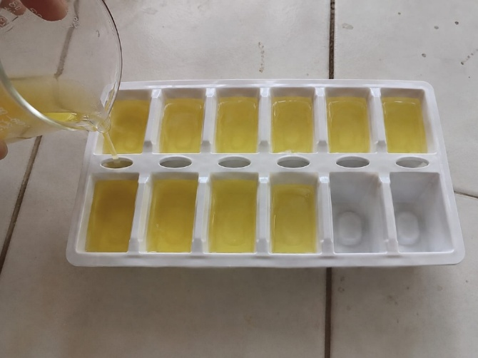
Figure 1. preparation of Fluoxetine HCl jelly
Table 1. Composition of fluoxetine hydrochloride oral medicated jelly formulations (F1–F6)
S.No. | Ingredient | F1 | F2 | F3 | F4 | F5 | F6
1 | Fluoxetine HCl | 20 mg | 20 mg | 20 mg | 20 mg | 20 mg | 20 mg
2 | Agar | 2 g | 1 g | – | 0.5 g | – | 0.5 g
3 | Guar gum | – | – | 1 g | – | – | 0.3 g
4 | Gelatin | – | – | – | 1 g | – | 0.4 g
5 | Xanthan gum | – | 1 g | – | – | 1 g | 0.3 g
6 | Gellan gum | 0.5 g | – | 0.5 g | 1 g | 1 g | 0.5 g
7 | Sucrose | 4 g | 4 g | 4 g | 4 g | 4 g | 4 g
8 | Citric acid | 0.2 g | 0.2 g | 0.2 g | 0.2 g | 0.2 g | 0.2 g
9 | Sodium citrate | 0.5 g | 0.5 g | 0.5 g | 0.5 g | 0.5 g | 0.5 g
10 | Propylene glycol | 1 ml | 1 ml | 1 ml | 1 ml | 1 ml | 1 ml
11 | Methyl paraben | 0.1 g | 0.1 g | 0.1 g | 0.1 g | 0.1 g | 0.1 g
12 | Propyl paraben | 0.1 g | 0.1 g | 0.1 g | 0.1 g | 0.1 g | 0.1 g
13 | Colouring agent | q.s. | q.s. | q.s. | q.s. | q.s. | q.s.
14 | Flavouring agent | q.s. | q.s. | q.s. | q.s. | q.s. | q.s.
15 | Distilled water | q.s. | q.s. | q.s. | q.s. | q.s. | q.s.

2.7 Evaluation of oral medicated jelly
2.7.1 Physical appearance
The prepared jellies were examined visually for colour, texture, clarity and consistency, as these attributes influence patient compliance and acceptance (Kadhim & Ali, 2019).
2.7.2 Weight variation
Four jellies from each formulation were individually weighed on an analytical balance, and the mean weight and standard deviation were calculated and compared against the Indian Pharmacopoeia limits (±7.5% and ±10%).
2.7.3 pH determination
A 0.5 g portion of jelly from each formulation was dispersed in 50 ml of distilled water to prepare a 1% w/v solution, and the pH was measured at room temperature using a calibrated digital pH meter.
2.7.4 Stickiness and grittiness
The texture of each jelly formulation was assessed for stickiness and grittiness by visual inspection after gently rubbing a sample between two fingers.
2.7.5 Viscosity study
The viscosity of each formulation was measured using a Brookfield viscometer with spindle no. 63, at 50 rpm for 2 minutes at room temperature (25 ± 5 °C), since the jellies behaved as a non-Newtonian system.
2.7.6 Content uniformity
One jelly from each formulation was dissolved in 50 ml of pH 6.8 phosphate buffer to obtain a 100 µg/ml solution; a suitable aliquot was further diluted to give a 5 µg/ml solution, and the absorbance was measured at 226 nm by UV-visible spectrophotometry (Khade et al., 2024).
2.7.7 In-vitro dissolution study
In-vitro drug release was studied using a USP type II (paddle) dissolution apparatus, with 900 ml of pH 6.8 phosphate buffer as the dissolution medium maintained at 37 ± 0.5 °C and a paddle speed of 100 rpm. Aliquots of 5 ml were withdrawn at 5, 10, 15, 20, 25 and 30 minutes and replaced with an equal volume of fresh buffer to maintain sink conditions. The withdrawn samples were suitably diluted and analysed by UV spectrophotometry at 226 nm, and the cumulative percentage drug release was calculated (Murugan et al., 2013).
2.7.8 Stability study
The optimised and other formulations were packed in plastic containers covered with aluminium foil and stored at 25 ± 5 °C and 2–8 °C for 60 days (8 weeks). Samples were withdrawn periodically (initial, 4 and 8 weeks) and evaluated for changes in physical appearance, pH and syneresis.
2.7.9 Syneresis
All formulations were observed for syneresis (contraction of the jelly matrix with expulsion of water) at 25 ± 5 °C and 8 ± 1 °C throughout the stability study period.

3. Results and Discussion
Six formulations (F1–F6) of oral medicated jelly containing fluoxetine hydrochloride were successfully prepared using different gelling agents, individually and in combination, and were evaluated for pre-formulation and post-formulation pharmaceutical parameters. The results obtained are presented and discussed below.
3.1 Pre-formulation results
Fluoxetine hydrochloride was found to be freely soluble in methanol and diethyl ether, soluble in pH 6.8 phosphate buffer and DMF, and sparingly soluble in water and chloroform. The melting point of the drug was found to be 160.3 °C, which lies within the Indian Pharmacopoeia reference range for fluoxetine hydrochloride (155–165 °C), confirming the identity and purity of the procured sample.
3.2 Calibration curve
The λmax of fluoxetine hydrochloride in pH 6.8 phosphate buffer was found to be 226 nm. The drug obeyed Beer–Lambert's law in the concentration range of 2–10 µg/ml, and the calibration curve showed good linearity with a regression coefficient (R²) of 0.999.

Figure 2. Standard calibration curve of fluoxetine HCl
Table 2. Absorbance of fluoxetine hydrochloride standard solutions in pH 6.8 phosphate buffer
Concentration (µg/ml) | Absorbance (226 nm)
2 | 0.065
4 | 0.128
6 | 0.195
8 | 0.257
10 | 0.321
This table presents the absorbance values recorded at 226 nm for standard fluoxetine hydrochloride solutions across the concentration range of 2–10 µg/ml. The steady, proportional rise in absorbance with increasing concentration reflects good linearity, forming the basis of the calibration curve used for subsequent quantitative analysis.

3.3 FT-IR compatibility study
The FT-IR spectrum of pure fluoxetine hydrochloride showed characteristic peaks corresponding to aromatic C–H, N–H, C=C, C–C, C–O and C–N stretching. Comparable peaks, within the same wavenumber ranges, were observed in the spectra of the drug mixed individually with each gelling agent (agar, gellan gum, gelatin, guar gum and xanthan gum) and in the spectrum of the complete formulation mixture, indicating the absence of any significant chemical interaction between fluoxetine hydrochloride and the excipients used.
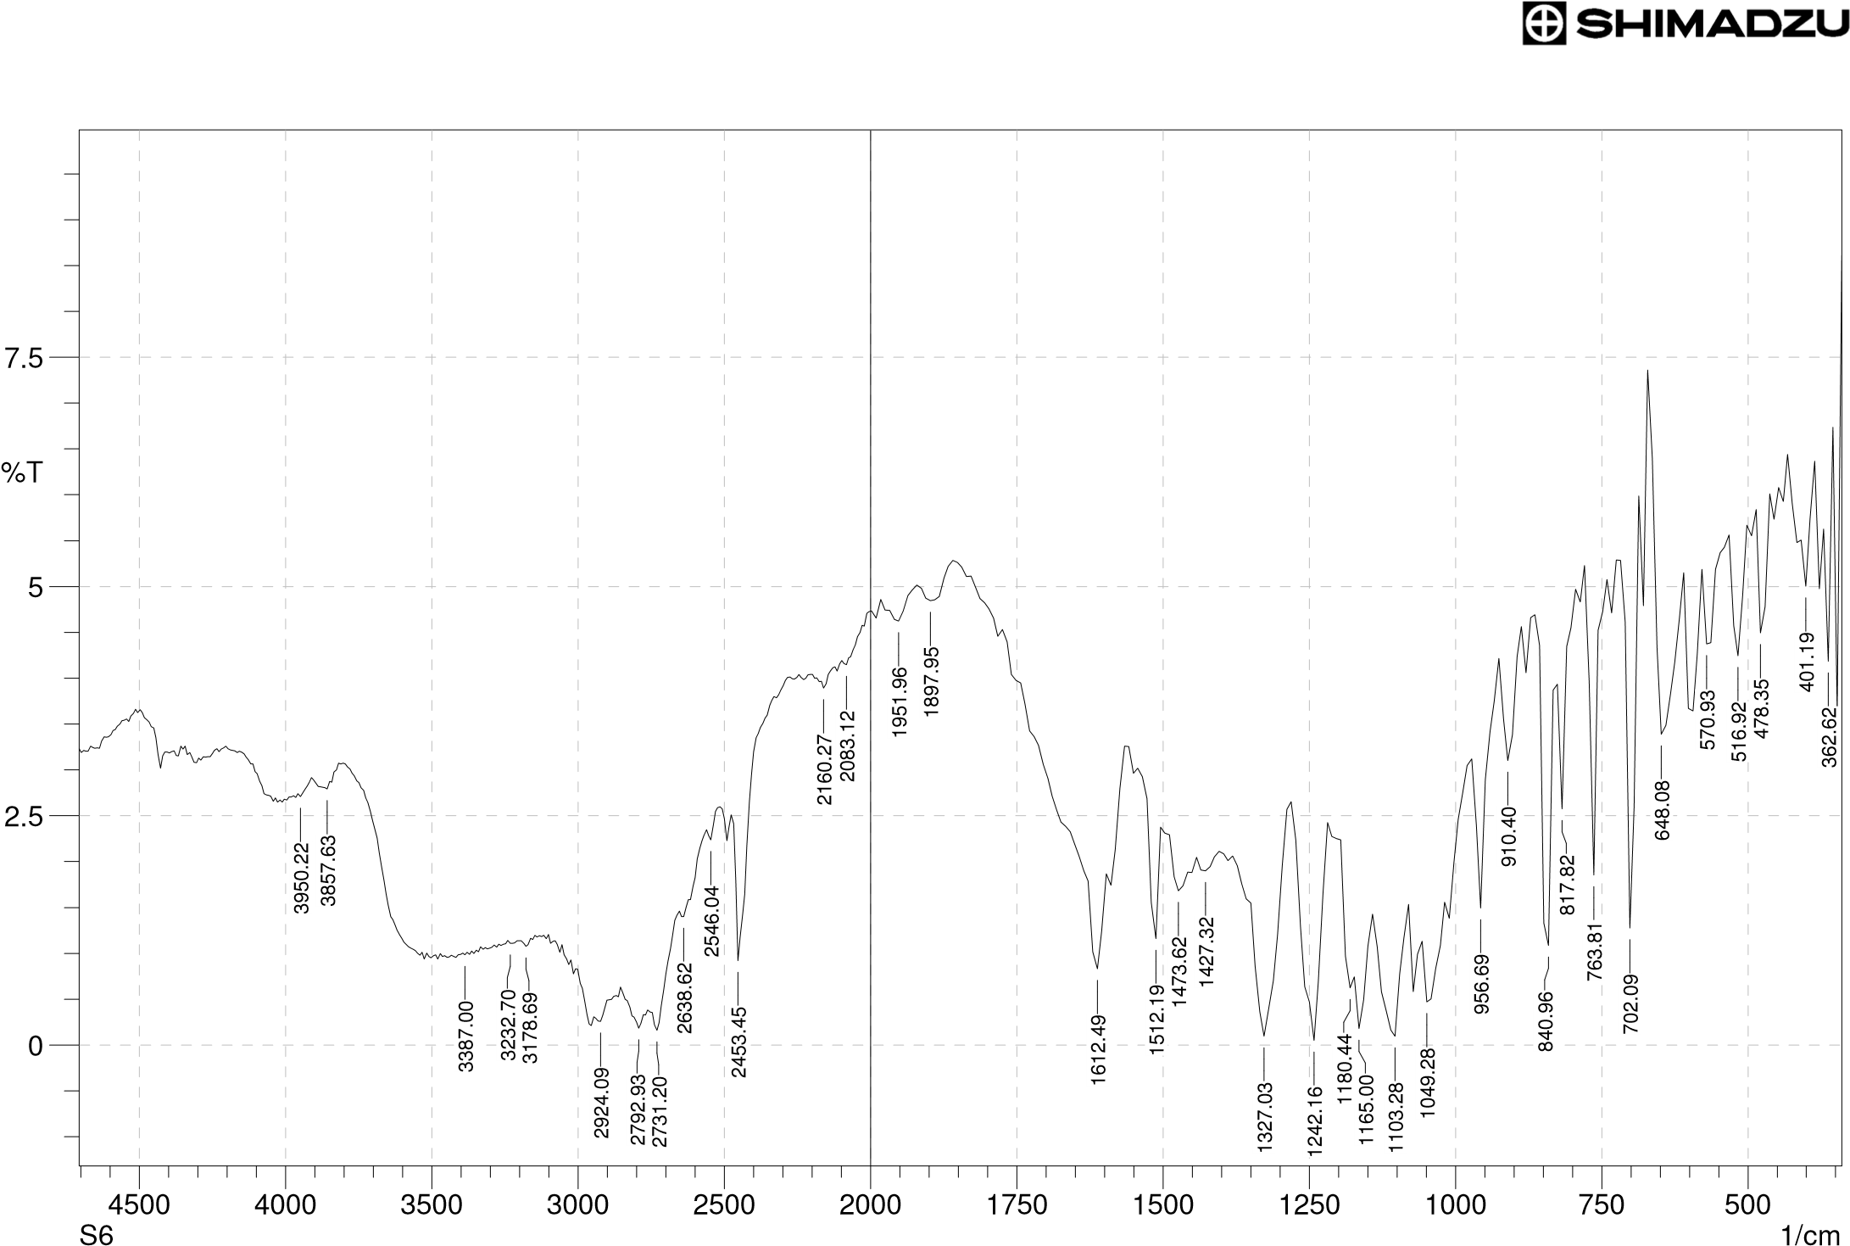
Figure 3. FT-IR spectrum of formulation mixture containing fluoxetine HCl and all excipients

Table 3. Comparison of characteristic FT-IR peaks of pure drug and formulation mixture
S.No. | Functional group / vibration | Pure drug peak (cm⁻¹) | Formulation mixture peak (cm⁻¹)
1 | C–H | 2924.09 | 2924.09
2 | N–H | 3371.57 | 3232.16
3 | C=C | 1620.42 | 1620.42
4 | C–C | 1072.42 | 1072.42
5 | C–O | 1242.16 | 1242.16
6 | C–N | 1327.03 | 1327.03
This table compares the characteristic FT-IR peak positions of the pure drug against those of the formulation mixture for each functional group. The close agreement between corresponding peak values across all six functional groups confirms the absence of any significant chemical interaction between fluoxetine hydrochloride and the excipients used.

3.4 Evaluation of oral fluoxetine hydrochloride jelly
3.4.1 Physical appearance
All six formulations were opaque with a smooth texture; they differed only in colour, depending on the colouring agent incorporated into each batch, and were visually appealing.
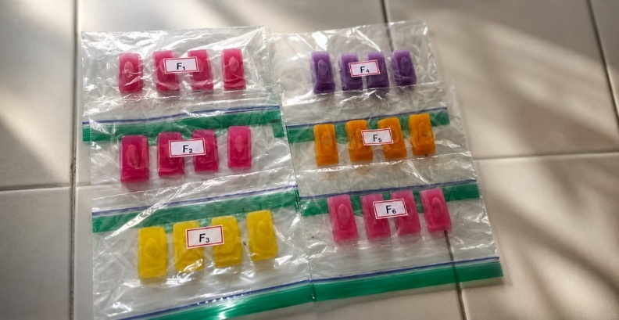
Figure 4. PHYSICAL APPEARANCE
Table 4. Physical appearance of formulated jellies
Batch No. | Appearance | Colour | Texture
F1 | Opaque | Pale pink | Smooth
F2 | Opaque | Dark pink | Smooth
F3 | Opaque | Yellow | Smooth
F4 | Opaque | Purple | Smooth
F5 | Opaque | Orange | Smooth
F6 | Opaque | Pale pink | Smooth
This table summarizes the physical appearance, colour and texture recorded for each of the six formulated jellies. All batches show a uniformly opaque, smooth texture, with colour being the only feature distinguishing one formulation from another.

3.4.2 Stickiness and grittiness
With the exception of F3, none of the formulations exhibited stickiness or grittiness on physical evaluation, indicating that the selected gelling agents and their concentrations produced an acceptable mouthfeel for oral administration.
Table 5. Stickiness and grittiness of formulated jellies
Batch No. | Stickiness | Grittiness
F1 | Non-sticky | Non-gritty
F2 | Non-sticky | Non-gritty
F3 | Non-sticky | Non-gritty
F4 | Non-sticky | Non-gritty
F5 | Non-sticky | Non-gritty
F6 | Non-sticky | Non-gritty
This table reports the stickiness and grittiness observations recorded for each formulation batch. All six formulations were found to be non-sticky and non-gritty, indicating a consistently acceptable mouthfeel across the different gelling-agent combinations tested.

3.4.3 Weight variation
The mean weight of the formulated jellies ranged from 3.824 ± 0.05 g (F1) to 5.634 ± 0.06 g (F3), which was within the Indian Pharmacopoeia weight-variation limits (±7.5% and ±10%), confirming batch-to-batch uniformity in the moulding process.
Table 6. Weight variation of formulated jellies (mean ± SD, n = 4)
Formulation code | Jelly 1 (g) | Jelly 2 (g) | Jelly 3 (g) | Jelly 4 (g) | Mean ± SD (g)
F1 | 3.972 | 3.748 | 3.841 | 3.737 | 3.824 ± 0.05
F2 | 4.427 | 4.096 | 4.325 | 4.412 | 4.315 ± 0.04
F3 | 5.428 | 5.872 | 5.816 | 5.542 | 5.634 ± 0.06
F4 | 4.363 | 4.577 | 4.553 | 4.474 | 4.481 ± 0.05
F5 | 5.054 | 5.527 | 5.555 | 5.107 | 5.310 ± 0.07
F6 | 5.298 | 5.556 | 5.476 | 5.216 | 5.386 ± 0.06
This table lists the individual and mean weights, with standard deviation, of four jelly units drawn from each formulation batch. The low variability observed within each batch confirms good uniformity and reproducibility in the moulding process across all six formulations.

3.4.4 pH
The pH of the formulated jellies ranged from 6.62 to 7.06, close to salivary pH, indicating that the formulations would not be expected to cause oral irritation on administration.
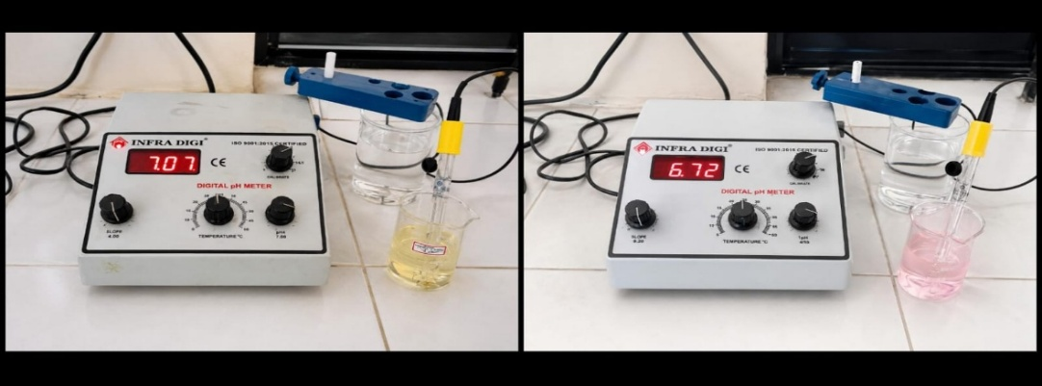
Figure 5 : Determination of pH using pH meter

Table 7. Mean pH of formulated jellies
Formulation code | pH (Mean ± SD)
F1 | 6.64 ± 0.1
F2 | 6.72 ± 0.2
F3 | 7.06 ± 0.2
F4 | 6.74 ± 0.3
F5 | 6.63 ± 0.3
F6 | 6.62 ± 0.2
This table displays the mean pH values, with standard deviation, recorded for each of the six formulations. All values remained close to salivary pH, supporting the suitability of the jellies for oral administration without a risk of irritation.

3.4.5 Viscosity
The viscosity of the six formulations, determined using a Brookfield viscometer (spindle no. 63, 50 rpm, room temperature), ranged from 1532.12 cP (F2) to 1673.78 cP (F4). All formulations exhibited adequate viscosity for pouring, moulding and oral administration, consistent with a non-Newtonian semisolid system.
Table 11. Viscosity of formulated jellies (Brookfield viscometer, spindle no. 63, 50 rpm, room temperature)
Formulation code | Viscosity (cP)
F1 | 1608.37
F2 | 1532.12
F3 | 1616.08
F4 | 1673.78
F5 | 1548.78
F6 | 1553.16
This table presents the viscosity values recorded for each formulation using a Brookfield viscometer (spindle no. 63, 50 rpm, room temperature). Formulation F4 showed the highest viscosity (1673.78 cP) and F2 the lowest (1532.12 cP), consistent with the relative gelling-agent concentrations used in each batch.
3.4.6 In-vitro dissolution study
All formulations showed maximum drug release within 30 minutes. Formulation F4 exhibited the highest cumulative drug release (88.42% at 30 minutes), followed by F5 (80.55%), F1 (78.61%), F2 (76.77%), F3 (76.35%) and F6 (74.40%), indicating that the agar–gelatin–gellan gum combination in F4 provided the most favourable drug-release profile among the formulations tested.
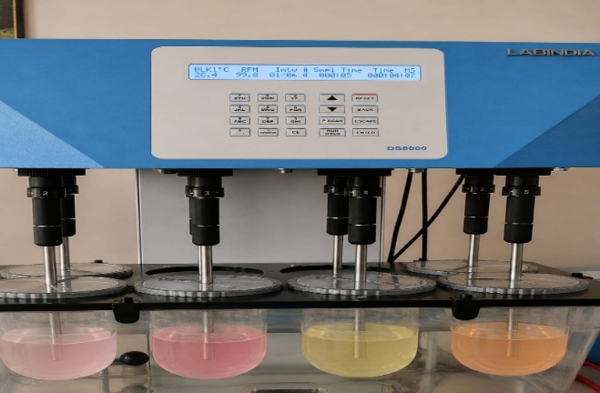
Figure 6. In-vitro dissolution
Table 8. Cumulative percentage drug release of fluoxetine hydrochloride from formulations F1–F6
Time (min) | F1 | F2 | F3 | F4 | F5 | F6
0 | 0 | 0 | 0 | 0 | 0 | 0
5 | 67.36 | 63.13 | 63.54 | 64.66 | 62.86 | 66.51
10 | 68.35 | 66.51 | 67.90 | 80.41 | 71.73 | 71.28
15 | 68.49 | 67.90 | 68.76 | 82.53 | 74.11 | 72.10
20 | 72.99 | 69.75 | 70.02 | 82.56 | 74.92 | 72.40
25 | 74.96 | 75.76 | 74.11 | 84.64 | 78.30 | 72.54
30 | 78.61 | 76.77 | 76.35 | 88.42 | 80.55 | 74.40
This table tabulates the cumulative percentage drug release from each formulation at time points from 0 to 30 minutes. The data show that F4 achieved the fastest and highest release among all batches, while F6 exhibited the slowest release profile over the same period.

3.4.7 Content uniformity
The drug content of the formulations, determined by UV spectrophotometry at 226 nm, ranged from 71.79 ± 1% (F2) to 97.43 ± 1% (F4). Formulation F4 showed the highest drug content, while F2 showed the lowest, suggesting that the gelling-agent combination and concentration used in F4 favoured more uniform drug entrapment during the congealing process.
Table 9. Drug content of formulated jellies
Formulation code | Absorbance (226 nm) | Drug content (%)
F1 | 0.156 | 80 ± 1%
F2 | 0.140 | 71.79 ± 1%
F3 | 0.178 | 91.28 ± 1%
F4 | 0.190 | 97.43 ± 1%
F5 | 0.189 | 96.43 ± 1%
F6 | 0.163 | 83.58 ± 1%
This table presents the absorbance values and corresponding drug content percentages calculated for each formulation. F4 recorded the highest drug content and F2 the lowest, reflecting differences in drug entrapment efficiency among the gelling-agent combinations used.

3.4.8 Stability study
On storage for 60 days at both 25 ± 5 °C and 2–8 °C, all formulations showed insignificant changes in pH and physical appearance, and no syneresis was observed at either storage condition, indicating that the formulated jellies were physically and chemically stable under the conditions tested.
Table 10. Short-term stability study of formulated jellies (60 days)
Storage condition | Duration (weeks) | General appearance | Syneresis | pH
2–8 °C | Initial | Non-sticky, non-gritty | Not observed | 6.72
2–8 °C | 4 | No change | Not observed | 6.62
2–8 °C | 8 | No change | Not observed | 6.63
25 ± 5 °C | Initial | Non-gritty, non-sticky | Not observed | 6.74
25 ± 5 °C | 4 | No change | Not observed | 6.54
25 ± 5 °C | 8 | No change | Not observed | 6.33
This table summarizes the appearance, syneresis and pH observations recorded for the formulations over the 60-day stability study at both 2–8 °C and 25 ± 5 °C. The consistent appearance and minimal pH drift at both storage conditions confirm that the jellies remained physically and chemically stable throughout the study period.

Taken together, the pre-formulation, compatibility, physical, and in-vitro performance data indicate that formulation F4 — prepared using a combination of agar, gelatin and gellan gum — provided the best overall balance of drug content, dissolution rate, physical acceptability and stability among the six formulations evaluated. These findings are consistent with previous reports describing the successful use of combined gelling-agent systems for optimising the release and physical characteristics of oral medicated jellies of other actives
(Kadam et al., 2020; Verma & Negi, 2023).
4. Conclusion
Oral medicated jellies containing fluoxetine hydrochloride were successfully formulated by the heating and congealing method using agar, guar gum, gelatin, xanthan gum and gellan gum, individually and in combination, as gelling agents. Pre-formulation and FT-IR compatibility studies confirmed the identity of the drug and the absence of any drug–excipient interaction. All six formulations (F1–F6) were opaque and smooth-textured and had a pH close to salivary pH, with weight variation, drug content and dissolution profiles within the reported pharmaceutical limits. Formulation F4, containing agar, gelatin and gellan gum, emerged as the optimum formulation, showing the highest drug content (97.43 ± 1%), the fastest in-vitro drug release (88.42% in 30 minutes), and satisfactory physical characteristics and stability during 60 days of storage at both refrigerated and room temperatures. The oral medicated jelly dosage form thus represents a colourful, palatable and easy-to-administer alternative to conventional tablets for the delivery of fluoxetine hydrochloride and may be particularly beneficial for paediatric, geriatric and psychiatric patients with dysphagia or fear of conventional medication. Further in-vivo evaluation and long-term stability studies under controlled humidity and temperature conditions are recommended to validate the therapeutic performance and shelf-life of the optimised formulation.
Limitation
This study was limited to laboratory formulation and in-vitro evaluation of six jelly formulations. Stability was assessed for only 60 days under the reported refrigerated and room-temperature conditions, and long-term stability under controlled humidity and temperature was not evaluated. No in-vivo assessment was performed; therefore, the observed dissolution behaviour and physical stability cannot establish bioavailability or therapeutic performance. The findings should therefore be interpreted as formulation-screening data, with F4 identified as the best-performing formulation only among the six formulations tested.
Acknowledgements
We are grateful to the Department of Pharmaceutics, Adhiparasakthi College of Pharmacy, Melmaruvathur, for providing the laboratory facilities required to carry out this work, and to Strides Pharma Science Limited, Bengaluru, for providing a gift sample of fluoxetine hydrochloride. We express our sincere gratitude to M. Sujitha, M.Pharm., Ph.D., Head of the Department of Pharmaceutics and our research guide, for her invaluable guidance, constant support and encouragement throughout the course of this research.
Competing Interests
we have declared that no competing interests exist.

Authors' Contributions
This work was carried out in collaboration among us. We participated in the design of the study, conducted the experimental work, performed the evaluation and statistical analysis, and contributed to the writing and review of the manuscript. We read and approved the final manuscript.
Declaration of AI Use
This manuscript was prepared through the intellectual contributions of the author(s) to the study design, data analysis, interpretation of results, and scholarly content. Grammarly and ChatGPT were used solely to assist with grammatical refinement and reference formatting during manuscript revision. The author(s) accept full responsibility for the accuracy, integrity, and final content of the manuscript.

References
Chand, S. P., & Arif, H. (2023). Depression. In StatPearls. StatPearls Publishing. https://www.ncbi.nlm.nih.gov/books/NBK430847/
Clavé, P., & Shaker, R. (2015). Dysphagia: Current reality and scope of the problem. Nature Reviews Gastroenterology & Hepatology, 12, 259–270. https://doi.org/10.1038/nrgastro.2015.49
Darade, A. D., & Mundada, A. S. (2021). Oral medicated jellies as a emerging platform for oral drug delivery in pediatrics. World Journal of Pharmaceutical Research, 10(6), 1628–1647. https://doi.org/10.20959/wjpr20216-20658
Diwan, A., Yadav, N., Mansuri, R., & Chauhan, D. (2021). Formulation development and characterization of oral-dispersible tablet of antipsychotic drug using Kyron-T114 ion exchange resin as taste masking agent. Uttar Pradesh Journal of Zoology, 42(24), 1249–1255. https://doi.org/10.56557/upjoz/2021/v42i243242
Ferreira-Neto, C. J. B., de Lara, J. A. A., Cominato, A., Tonin, F. S., & Wiens, A. (2024). Optimization of solid oral dosage form administration to patients with swallowing difficulties: An integrative review. Journal of Advanced Nursing, 80(4), 1335–1354. https://doi.org/10.1111/jan.15910
Huang, X., Mu, Y., Shen, L., & Zhao, L. (2025). Advantages, progress, and future trends in oral medicated jellies/gels: Focus on adherence aspects. Drug Discovery Today, 30(8), 104431. https://doi.org/10.1016/j.drudis.2025.104431
Ibrahim, K. A., Nawaz, A., Mumtaz, S., Iqbal, F. M., Khan, A., Zaman, S., Abd El-Salam, N. M., Ullah, N., Husain, T., & Shah, S. N. H. (2017). Formulation, evaluation and release rate characteristics of medicated jelly of vitamin C. Pakistan Journal of Pharmaceutical Sciences, 30(2 Suppl.), 579–583. https://pubmed.ncbi.nlm.nih.gov/28650324/
Jadhav, Y. G., Galgatte, U. C., & Chaudhari, P. D. (2018). Overcoming poor solubility of dimenhydrinate: Development, optimization and evaluation of fast dissolving oral film. Advanced Pharmaceutical Bulletin, 8(4), 721–725. https://doi.org/10.15171/apb.2018.081
Jain, K. K. (2020). An overview of drug delivery systems. In K. K. Jain (Ed.), Drug delivery systems (Methods in Molecular Biology, Vol. 2059, pp. 1–54). Humana Press. https://doi.org/10.1007/978-1-4939-9798-5_1
Kadam, V. S., Kendre, J., Shendarkar, G. R., & Kadam, S. S. (2020). Formulation and evaluation of medicated oral jelly of trazadone hydrochloride. International Journal of Pharmaceutical Sciences and Research, 11(12), 6251–6259. https://doi.org/10.13040/IJPSR.0975-8232.11(12).6251-59
Kadhim, Z. M., & Ali, W. K. (2019). Preparation and evaluation of granisetron chewable pediatric oral jelly. International Journal of Drug Delivery Technology, 9(3), 347–351. https://doi.org/10.25258/ijddt.v9i3.4
Khade, K., Kulkarni, N., Bhamare, V., & Amrutkar, R. (2024). Formulation, development and characterization of oral jelly to improve therapeutic effectiveness. International Journal of Pharmaceutical Quality Assurance, 15(2), 1023–1034. https://doi.org/10.25258/ijpqa.15.2.73
Kris-Etherton, P. M., Petersen, K. S., Hibbeln, J. R., Hurley, D., Kolick, V., Peoples, S., Rodriguez, N., & Woodward-Lopez, G. (2021). Nutrition and behavioral health disorders: Depression and anxiety. Nutrition Reviews, 79(3), 247–260. https://doi.org/10.1093/nutrit/nuaa025
Lou, J., Duan, H., Qin, Q., Teng, Z., Gan, F., Zhou, X., & Zhou, X. (2023). Advances in oral drug delivery systems: Challenges and opportunities. Pharmaceutics, 15(2), 484. https://doi.org/10.3390/pharmaceutics15020484
Malouh, M. A., Cichero, J. A. Y., Reuter, S. E., Weng, M.-T., Lau, E. T. L., Nissen, L. M., & Steadman, K. J. (2025). Does using oral medication lubricants to swallow whole or crushed tablets alter drug absorption in vivo? A randomised, single-dose crossover bioequivalence study in healthy adults. Journal of Drug Delivery Science and Technology, 104, 106552. https://doi.org/10.1016/j.jddst.2024.106552
Manimegalai, V., Deepashree, P., Kalaiyarasi, G., Priyadharshini, R., & Swetha, R. (2024). Formulation development and evaluation of oral anti-diabetic jelly by using dapagliflozin hydrochloride. World Journal of Pharmacy and Pharmaceutical Sciences, 13(2), 1253–1269. https://doi.org/10.20959/wjpps20242-26613
Marovino, E., Morgillo, A., Mazzarella, M., & Randazzo, M. F. (2022). Use of liquid pharmaceutical forms and correct handling of solid forms in the dysphagic patient. Journal of Pharmaceutical Research International, 34(45B), 1–6. https://doi.org/10.9734/jpri/2022/v34i45B36358
Mayo Clinic Staff. (2026, March 14). Depression (major depressive disorder). Mayo Clinic.
McGuire, M. R., Mostofa, A. G. M., Shon, J., Frost, M., Kim, M.-J., & Li, K. (2024). Designs of clinical swallowability assessments of solid oral dosage forms in regulatory submissions. International Journal of Pharmaceutics, 659, 124229. https://doi.org/10.1016/j.ijpharm.2024.124229
Murugan, S., Pavan Kumar, N., Kiran Kumar, C., Syam Sundhar, V., Harika, S., & Anusha, P. (2013). Method development and validation for dissolution method of tolvaptan in bulk and tablet dosage form by UV spectrophotometry. Indian Journal of Pharmaceutical Science & Research, 3(1), 17–19. https://www.ijpsrjournal.com/File_Folder/17-19.pdf
Osmałek, T., Froelich, A., & Tasarek, S. (2014). Application of gellan gum in pharmacy and medicine. International Journal of Pharmaceutics, 466(1–2), 328–340. https://doi.org/10.1016/j.ijpharm.2014.03.038
Pakhale, N. V., Gondkar, S. B., & Saudagar, R. B. (2019). Formulation development and evaluation of fluoxetine effervescent floating tablet. Journal of Drug Delivery and Therapeutics, 9(4-A), 358–366. https://doi.org/10.22270/jddt.v9i4-A.3490
Patil, S. D., Gupta, M. J., Kote, K. S., & Rajendran, R. (2019). Formulation of novel medicated jellies for treatment of mouth ulcer. Asian Journal of Pharmacy and Technology, 9(4), 241–243. https://doi.org/10.5958/2231-5713.2019.00039.4
Patil, I. P., Patil, K. K., Dhankani, M. A., Dhankani, A. R., & Pawar, S. P. (2024). A comprehensive review on oral medicated jellies. Journal of Advances in Clinical Pharmacology, 2(1), 13–26. https://www.hbrppublication.com/OJS/index.php/JACP/article/view/4023
PubChem. (n.d.). Fluoxetine hydrochloride (CID 62857). National Center for Biotechnology Information. https://pubchem.ncbi.nlm.nih.gov/compound/62857
Rathod, P. I., Deshpande, V. V., Shaikh, S., Pathare, S. B., Nawghare, S. M., & Dhamankar, S. S. (2022). Review on formulation and development of oral medicated jellies. International Journal of Pharmaceutical Research and Applications, 7(4), 174–179. https://doi.org/10.35629/7781-0704174179
Rowe, R. C., Sheskey, P. J., & Owen, S. C. (Eds.). (2006). Handbook of pharmaceutical excipients (5th ed.). Pharmaceutical Press; American Pharmacists Association. https://www.ncbi.nlm.nih.gov/nlmcatalog/101258346
Rédai, E.-M., Antonoaea, P., Todoran, N., Vlad, R.-A., Bîrsan, M., Tătaru, A., & Ciurba, A. (2021). Development and evaluation of fluoxetine fast dissolving films: An alternative for noncompliance in pediatric patients. Processes, 9(5), 778. https://doi.org/10.3390/pr9050778
Sarojini, S., Anusha, K., Maneesha, C., Mufaquam, M. A., Deepika, B., Krishna Reddy, Y., & Kandukoori, N. R. (2018). Oral medicated jellies—A review. World Journal of Pharmaceutical Research, 7(6), 352–365. https://doi.org/10.20959/wjpr20186-11502
Sheffler, Z. M., Patel, P., & Abdijadid, S. (2026). Antidepressants. In StatPearls. StatPearls Publishing. https://www.ncbi.nlm.nih.gov/books/NBK538182/
Sunil, S., Sharma, U. K., & Arathy, S. A. (2020). Pharmaceutical jellies: A novel way of drug delivery. Journal of Pharmaceutical Sciences & Research, 12(7), 904–909. https://pharmainfo.in/jpsr/Documents/Volumes/vol12issue07/jpsr12072009.pdf
Taranum, R., & Mittapally, S. (2018). Formulation and evaluation of domperidone oral jelly. International Journal of Pharmacy and Biological Sciences, 8(4), 870–878. https://www.ijpbs.com/ijpbsadmin/upload/ijpbs_5c2641399fd27.pdf
Verma, A. M. L., & Negi, P. (2023). Formulation and evaluation of oral medicated jelly of meclizine HCl. Pharmaspire, 15(4), 225–229. https://doi.org/10.56933/Pharmaspire.2023.15134

