Assessment of the Impact of Aerosol Deposits on the Electrical Performance of a Photovoltaic Module Using an IoT System: Application to the Context of Ouagadougou, Burkina Faso

.
ABSTRACT

This study focuses on the energy production of solar installations and evaluates the impact of aerosol deposits on the electrical performance of photovoltaic modules under the climatic conditions of Ouagadougou in the Sudano-Sahelian region. We designed and installed an experimental set-up comprising two identical 50 Wp monocrystalline modules exposed under the same conditions. Each module incorporated an IoT system comprising two microcontrollers, sensors, and a data acquisition system for monitoring power output. The results indicate a gradual reduction in the electrical current generated by the soiled module, with weekly relative losses ranging from 4.27% to 9.58%, together with increasing variability in the effect of soiling. This current behaviour contrasts with the voltage trend, which remained relatively stable under the experimental conditions. The power-output profile closely followed the current profile, indicating that the observed power reduction was mainly associated with changes in current. In energy terms, the effect was reflected in production losses during the sunniest hours, with estimated weekly power losses ranging from 8.65% to 19.50%. Furthermore, increasing daily loss rates, declining production efficiency indicated by the soiling ratio, and the average weekly losses support the importance of reliable, continuous, and autonomous monitoring of photovoltaic system performance using IoT-based systems, particularly in Sahelian environments subject to frequent dust events.

Keywords: Aerosol deposition; photovoltaic soiling; electrical performance; Internet of Things; PM₂.₅; power loss; solar photovoltaics; real-time monitoring; Sudano-Sahelian climate; Ouagadougou
1. INTRODUCTION

Solar energy is a suitable form of renewable energy because it is readily available, environmentally friendly, and non-polluting (Jacobson et al., 2017; Millstein et al., 2017). The African continent, particularly its northern and southern regions, has enormous solar energy potential that is well suited to photovoltaic conversion (Lu & Wang, 2025; Neher et al., 2020). Several previous studies based on in situ measurements and satellite observations have demonstrated substantial solar potential in northern regions, particularly the Sahel and the Sahara, where average monthly irradiance can reach up to 6 kWh/m²/day (Goni et al., 2019; Bado et al., 2019; Niang et al., 2023). According to the International Energy Agency, photovoltaic systems could supply around 11% of global electricity by 2050 and avoid approximately 2.3 gigatonnes of carbon dioxide (CO₂) emissions per year (Shaik et al., 2023). In the context of the global energy transition, renewable energy plays a central role in strategies for sustainable development by reducing greenhouse gas emissions and improving access to clean, sustainable energy (Almulhim & Abubakar, 2026). In Burkina Faso, solar photovoltaic energy is emerging as a preferred solution to electricity-access challenges in a context characterised by abundant sunshine and reliance on highly polluting fossil fuels (Bado et al., 2019). However, solar photovoltaic energy production is intermittent and depends on several climatic and environmental factors that affect the efficiency of photovoltaic modules (Bado et al., 2026). The efficiency of a solar photovoltaic system depends heavily on solar radiation, which is variable (Mondol et al., 2007) and is influenced by weather conditions, seasonal variations, location, time of day, and the sun's position and altitude (Fouad et al., 2017; Prema & Uma Rao, 2015). Furthermore, the performance of photovoltaic modules is significantly affected by aerosol deposits, an issue that has not yet been sufficiently studied in the West African climatic context. Burkina Faso, like most Sahelian countries, experiences recurring Saharan dust storms and dry haze, exacerbated by north-easterly Harmattan winds (Bado et al., 2024). Particles suspended in the air gradually settle on the glass surfaces of the panels, reducing the transmission of solar radiation and, consequently, the energy efficiency of the installations (Khodakaram-Tafti et al., 2025; Said et al., 2018). These atmospheric particles, particularly aerosols, absorb or scatter solar radiation, thereby reducing the amount transmitted for photovoltaic conversion (Mani & Pillai, 2010). However, dust deposition is influenced by environmental factors such as wind speed, humidity, convective systems, emission sources, particle type, and the nature of the PV module surface (Shaik et al., 2023). Field-based evaluation of photovoltaic systems also supports the use of performance indicators to assess actual system operation under local conditions (Vekariya et al., 2024). Recent experimental and review studies further show that surface soiling can reduce photovoltaic power output and that effective mitigation depends on monitoring, cleaning strategy, and local environmental conditions (Alkharusi et al., 2024; Ammari et al., 2024; Parsay et al., 2025). More specifically, recent work in Burkina Faso's Sudano-Sahelian zone has modelled photovoltaic soiling losses using site-specific environmental and particulate variables, underscoring the importance of locally resolved assessment (Kaboré et al., 2026). Despite the recognised importance of aerosol soiling, continuous, site-specific monitoring that links aerosol accumulation with the electrical response of photovoltaic modules under the climatic conditions of Ouagadougou remains necessary. In this context, Internet of Things (IoT) technologies provide opportunities for real-time monitoring of photovoltaic panel performance. Thus, the overall objective of this study is to evaluate the impact of aerosol deposits on the electrical performance of photovoltaic solar installations using an IoT system under the Sudano-Sahelian climatic conditions of Ouagadougou, Burkina Faso. Specifically, this study aims to design a monitoring system based on microcontrollers coupled with sensors that measure dust concentration and electrical parameters; experimentally compare the electrical performance of a clean, regularly cleaned panel with that of a soiled panel over a period of continuous measurement; and, finally, analyse the collected data to quantify efficiency losses caused by soiling.

2. MATERIAL AND METHODS

2.1 Photovoltaic modules and installation conditions

The selected module was a low-power monocrystalline panel from the ET-M53650 series, which is well suited to degradation studies and precise experimental measurements. Its structure consists of an array of high-efficiency silicon cells protected by approximately 3 mm of tempered glass with an anti-reflective coating to optimise solar radiation transmission. Under standard test conditions, this module delivers a maximum power output of 50 watts. At its optimal operating point, the voltage is 18.22 V and the current is 2.75 A. Under open-circuit conditions, the measured voltage is 21.96 V, while the short-circuit current reaches 3.04 A. These electrical characteristics allow the module to withstand a maximum system voltage of 1,000 V DC, with a series fuse rated at 10 amps. For this study, two photovoltaic modules were installed at the Ouagadougou site (12.20° N, 1.40° W), located in the Sudano-Sahelian zone. In Burkina Faso, and more generally throughout the Northern Hemisphere, solar panels are oriented due south to capture the maximum amount of solar radiation and produce the greatest amount of electrical energy. In addition, the tilt of the modules depends on the site's latitude, which is 12.20° N; generally, a tilt equal to the latitude is recommended. However, to facilitate self-cleaning during rainfall, the module tilt should remain above 10°. The tilt angle of photovoltaic modules is highly dependent on the site's latitude because of variations in the sun's apparent altitude and, consequently, the angle of incidence of solar radiation on the plane of the modules (Yadav & Chandel, 2013). This explains why the tilt angle of the modules ranged from 12° to 15°. The study area was carefully selected for its exposure to natural and anthropogenic aerosols, particularly desert dust, and for its accessibility. The location was free from shading, which is important for preventing measurement errors and ensuring uniform exposure of the photovoltaic cells to sunlight throughout the day.

2.2 Experimental Protocol

The IoT system uses two microcontrollers with distinct functions. The Arduino UNO collects data from sensors measuring dust, temperature, humidity, current, and voltage. The ESP then retrieves these data through interfaces such as UART or I2C and transmits them to the ThingSpeak platform using Wi-Fi and the MQTT protocol. The designed IoT device therefore operates as an information-collection and transmission chain. The sensors continuously measure the relevant parameters, and these data are first transmitted to an Arduino UNO board, which acts as the local controller. Subsequently, a second electronic board, either the ESP32 or ESP8266, transmits the data via Wi-Fi to the ThingSpeak web platform, enabling observation and analysis (Gopal et al., 2020). We developed two separate IoT systems: one to monitor the output of the soiled panel that collects aerosol particles and the other to monitor the clean panel, which is cleaned regularly. The first IoT system for the soiled panel consists of a DHT22 temperature and humidity sensor, an INA226 current, voltage, and power sensor, a DMS501 dust sensor, and an LCD screen. The second system consists of a DHT11 temperature and humidity sensor, an ACS712 current sensor, and a B25 voltage sensor. It is connected to the reference panel, which is cleaned every two days. These sensors have virtually the same accuracy; therefore, this distinction does not affect the measurement readings. This configuration reflects the fact that one panel is exposed to the elements, whereas the other is cleaned regularly to prevent aerosol build-up, which explains the absence of a dust sensor in the second IoT system.

2.3 IoT System Architecture and Sensor Placement

The system is based on a structured IoT architecture designed to collect, process, and transmit environmental and electrical data in real time. At the centre of this architecture is the Arduino UNO, which acts as the main controller of the experimental device. Programmed to coordinate operations, this microcontroller interacts directly with all sensors. Specifically, the DSM501 sensor monitors the concentration of airborne particles, particularly PM2.5, allowing assessment of aerosol accumulation that could reduce the solar panel's efficiency. At the same time, the INA226 sensor measures the voltage, current, and power generated by the photovoltaic module, providing data for analysing its performance. Finally, the DHT22 sensor records ambient temperature and relative humidity. All sensors are powered by the Arduino, enabling a simple set-up and centralised data management. The Arduino UNO works in tandem with an ESP32 module to establish IoT connectivity. Sensor data collected by the Arduino are sent to the ESP32 via serial communication. The ESP32, powered by an external source, connects to the Wi-Fi network and uses the ThingSpeak API key to transmit these data to the IoT platform, where they are stored and displayed in real time as graphs. For the reference panel, the process remains the same, but the Arduino UNO interacts with an ACS712 current sensor and a B25 0-25 V DC voltage sensor, which tracks changes in the solar panel's output voltage. In addition, the DHT11 records ambient temperature and relative humidity. The ESP32 receives data from the Arduino UNO and sends them to the ThingSpeak platform for storage and visualisation.

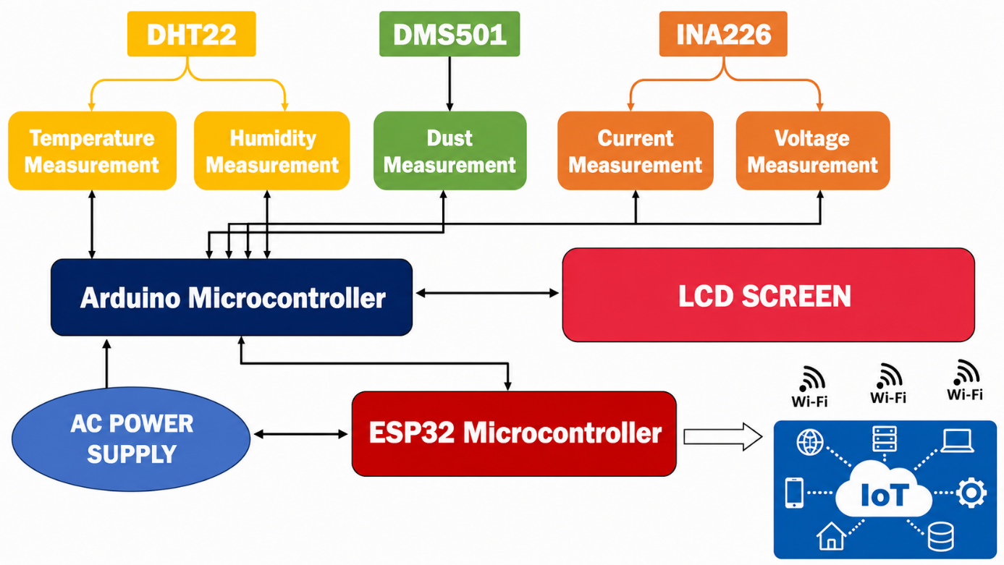
Fig. 1. Block diagram of the component layout
2.4 Overview of the experimental setup

The experimental study is based on an instrumented photovoltaic system comprising two identical modules subjected to different levels of soiling. The first module is cleaned every two days and serves as the reference panel, while the second is intentionally left exposed to aerosol deposits and serves as the soiled panel. This configuration enables direct quantification of the impact of aerosol deposits on the modules’ electrical performance. Figure 2 below depicts both the clean and soiled panels, while Figure 3 illustrates the connectivity of the various components and sensors in the IoT system.
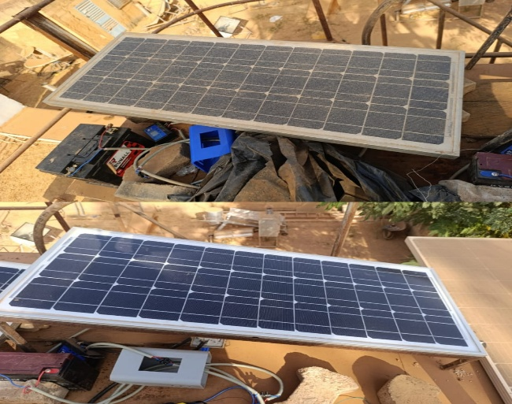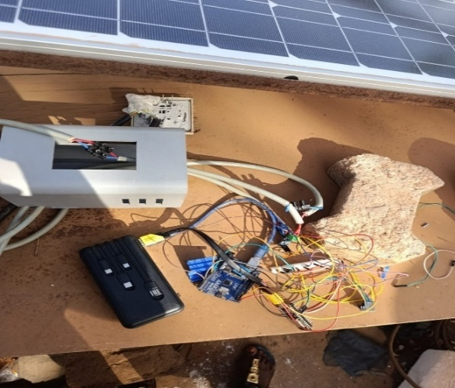
Fig. 2. Clean panel and recessed pane Fig. 3. Illustration of the designed and built IoT system

Each measurement chain is equipped with sensors that measure electrical and environmental parameters, namely current, voltage, power, ambient temperature, relative humidity, and airborne dust concentration. The data are recorded at 5-minute intervals throughout the measurement campaign, covering several weeks of continuous operation. These data, recorded every 5 minutes for each system on the ThingSpeak platform, are exported to a Google Sheets spreadsheet and then downloaded for processing and analysis.

2.5 Data and Methodology

This experimental study is based on monitoring the electrical parameters of photovoltaic modules using an IoT device. The measurements include current, voltage, and electrical power at 5-minute intervals. To better characterise these electrical parameters, we use the single-diode electrical model of the photovoltaic solar cell presented in Figure 4 (Abdulrazzaq et al., 2022):
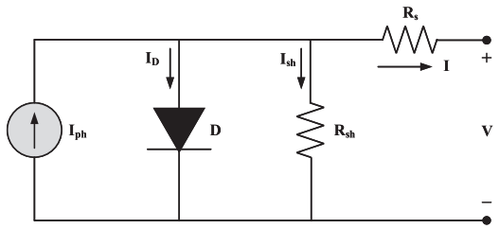
Fig. 4. Equivalent circuit of a single-diode photovoltaic cell

By applying the node theorem, we define the electric current (I) supplied by the photovoltaic module according to the following equation (Korsaga et al., 2026; Nafa et al., 2025):
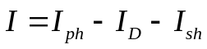 (1)
In this equation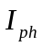 represents the photocurrent, which depends on the irradiance,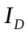 represents the diode current (D), and 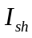 represents the current through the shunt resistor (R_{sh}) where:
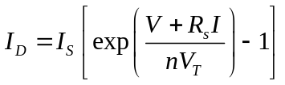 (2)
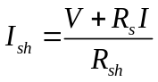 (3)
Hence, the I-V characteristic of the photovoltaic module is defined by equation (4):
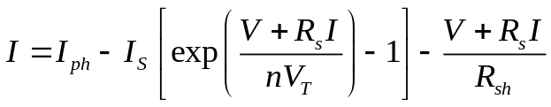 (4)
Parameters such as 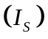 denote the diode’s saturation current, 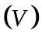 the module voltage,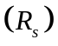 the series resistance,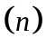 the diode’s ideality factor and 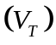 the thermal voltage. From the measured current 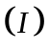 and voltage , the electrical power 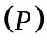 is derived according to (Ouedraogo et al., 2025):
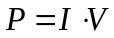 (5)
To quantify the effect of aerosol deposits on the module’s electrical performance, we calculate the soiling ratio (SR), which reflects the efficiency of the soiled module, and the soiling rate 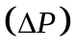 , which illustrates the relative losses, where 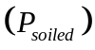 is the power output of the soiled module and 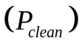 is that of the clean module (Shukla et al., 2026):
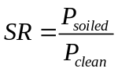 (6)
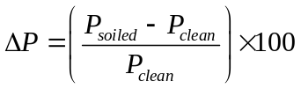 (7)

3. RESULTS AND DISCUSSION

3.1 Analysis of the profile of the electrical current
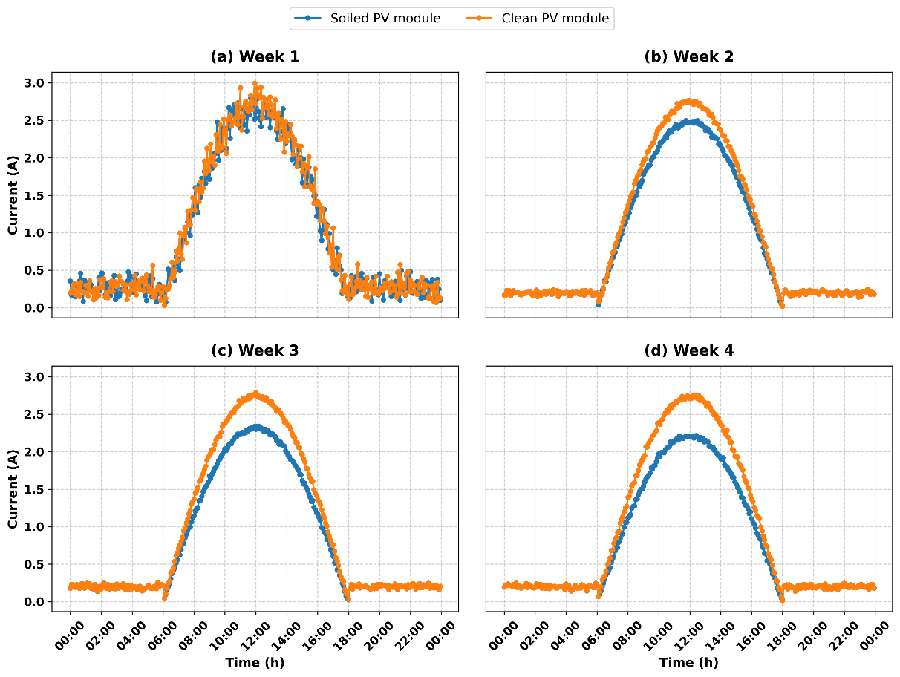
Fig. 5. Weekly electrical current profile of the panels

As shown in Figure 5, the average current profile follows a near-Gaussian curve, with a gradual rise in the early morning, a peak around noon, and a decline towards late afternoon at approximately 6:00 p.m. The current generated by the soiled panel remains lower than that of the clean panel for most of the day, reflecting the attenuating effect of dust on the incident light flux and, consequently, on charge-carrier generation. This observation is consistent with previous experimental findings (Ndiath et al., 2023), which showed that particle accumulation on the glass surface reduces current by acting as an absorbing optical barrier. The difference between the two curves is particularly pronounced around the current peak at 12:00 p.m., when the impact of soiling on module performance becomes more apparent. At this time, incident solar radiation is also near its maximum, which explains the observed current peaks. The analysis further indicates that the effect of soiling on photovoltaic current increased over the study period, which spanned nearly one month, and was reflected in average relative losses from the second week onwards. These losses were estimated at 4.27%, 7.65%, and 9.58% for the second, third, and fourth weeks, respectively. These values indicate a gradual reduction in the electrical current generated by the soiled module compared with the clean module. In addition, the dispersion of the losses increased, with standard deviations of 5.14%, 7.92%, and 10.02% for the second, third, and fourth weeks, respectively, indicating increasing variability in the effect of soiling.
3.2 Analysis of the Electrical Voltage Profile
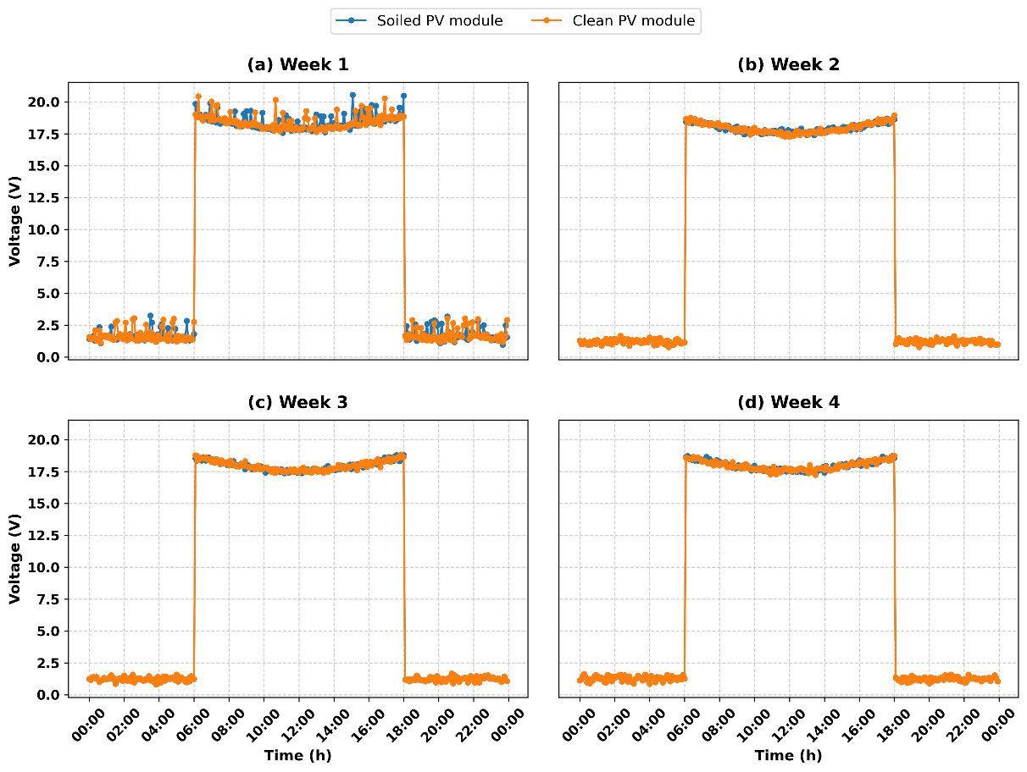
Fig. 6. Weekly voltage profile of the panels

As shown in Figure 6, the average voltage curves exhibit almost identical trends for both modules throughout the day, with comparatively small variations. Overall, the results indicate that the soiling examined did not cause a significant systematic variation in module voltage, particularly from the second to the fourth week. This behaviour contrasts with the relative current losses, which increased gradually over the same period. The effect of deposits on electrical performance therefore appeared primarily as a reduction in the current produced, while the voltage remained relatively stable under the experimental conditions considered. This observation is consistent with previous findings (Ndiath et al., 2023), in which soiling affected current more strongly than voltage, resulting in a more pronounced difference between the current profiles than between the voltage profiles. This difference in sensitivity between current and voltage underscores the importance of analysing the module's electrical parameters separately to characterise the impact of soiling.

3.3 Analysis of the Electrical Power Profile
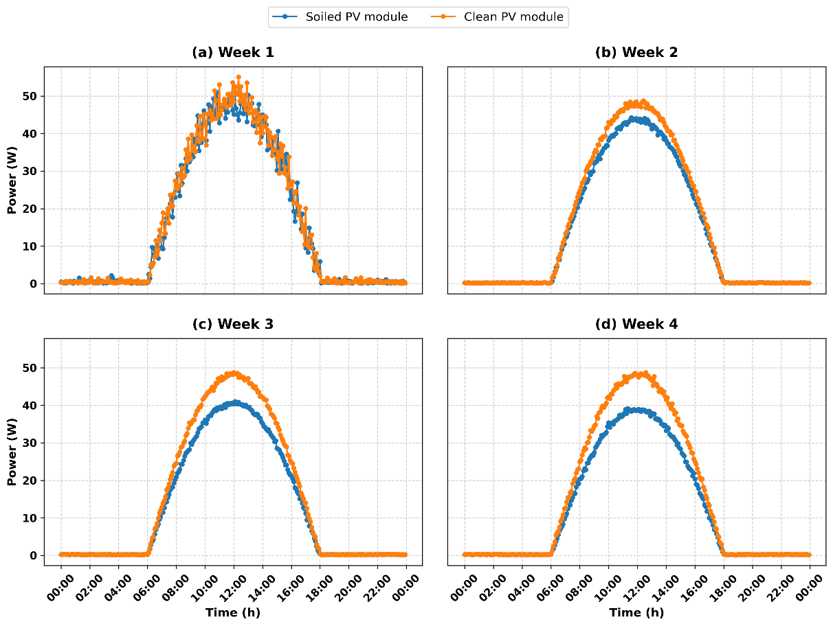
Fig. 7. Weekly profile of the panels’ electrical power

Figure 7 shows a well-defined bell-shaped weekly mean hourly power profile centred on a single peak corresponding to maximum irradiance. Over the diurnal cycle, the power output of the soiled panel remains below that of the clean panel, with the greatest difference occurring near the power peak. The power profile closely resembles the current profile, suggesting that the observed variation in power is largely associated with the current. This pattern further indicates the effect of dust on the system's energy production. The reduction in power observed for the soiled panel accumulated over the measurement campaign and resulted in a substantial production loss, particularly during the sunniest hours between 8:00 a.m. and 4:00 p.m. Estimated relative power losses increased gradually over the experimental period and became apparent from the second week onwards. The average loss increased from 8.65% in the second week to 15.51% and 19.50% in the third and fourth weeks, respectively. The first week, however, showed substantial variation in losses, with a standard deviation of 20.60% and a minimum value of -105.55%. Such values indicate that the soiled module occasionally performed better than the clean module and were likely associated with fluctuations in measurement conditions, temporal variations in irradiance, or relatively low power output due to the modules' intrinsic characteristics. The median value of 4.19% nevertheless suggests that a power loss was already present during the first week. From the second week onwards, the results became more consistent. Average losses were 8.65%, 15.51%, and 19.50% in the second, third, and fourth weeks, respectively, while the corresponding medians were 8.86%, 15.49%, and 19.23%. The small differences between the mean and median losses indicate a relatively even distribution of losses. The minimum values were positive from the third week onwards, at 4.46% and 6.77% in the third and fourth weeks, respectively, indicating that all observations recorded during these two weeks showed lower power output from the soiled module than from the clean module. This gradual increase in losses is consistent with the accumulation of particulate deposits on the photovoltaic module surface during the experiment. Increasing deposits can reduce the fraction of solar radiation reaching the photovoltaic cells and, consequently, decrease electricity production.

3.4 Study of the Impact of Aerosol Deposits on Solar Panel Output

3.4.1 Analysis of electrical power as a function of aerosol deposits
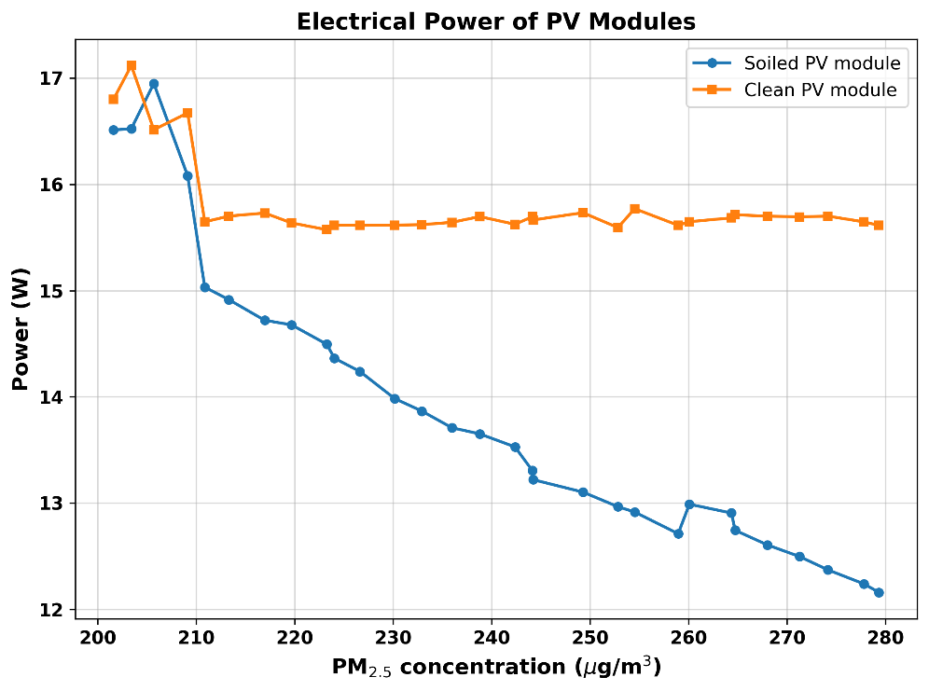
Fig. 8. Plot of average daily power output versus dust concentration

Figure 8 illustrates the variation in average daily power output with dust concentration over the measurement period and shows the relationship between dust concentration and electrical power production. The graph compares the average daily power output of the clean and soiled panels. This comparison allows the relative difference in power output associated with dust deposition to be quantified. At the beginning of the experiment, when the dust concentration remained low at around 200 µg/m³, both modules exhibited similar performance, ranging between 16.5 W and 17 W. This common starting point supports the consistency of the initial state of the two panels, an aspect also emphasised in previous experimental work (Jed et al., 2021). As exposure continued and dust levels exceeded 210 µg/m³, the divergence between the two curves became clear. The clean module stabilised rapidly, forming a nearly horizontal plateau at around 15.7 W. This pattern is consistent with mitigation strategies based on regular cleaning to maintain performance and with the techno-economic analysis of soiling-loss mitigation (Ilse et al., 2019). Previous work has also shown that periodic cleaning can restore performance by limiting the persistence of deposited dust layers (Shen et al., 2024). In contrast, the power output of the soiled module declined steadily and eventually fell below 12.5 W, representing a power loss of more than 20%. The observed reduction in electrical performance under dry deposition is consistent with findings from the Sahelian region (Diop et al., 2020) and with field observations under Sudano-Sahelian conditions (Ouedraogo et al., 2025). These comparisons support the interpretation that dust accumulation acts as an optical barrier and that appropriate cleaning is important for maintaining photovoltaic energy performance in dusty Sahelian environments.

3.4.2 Analysis of the soiling rate as a function of aerosol deposits

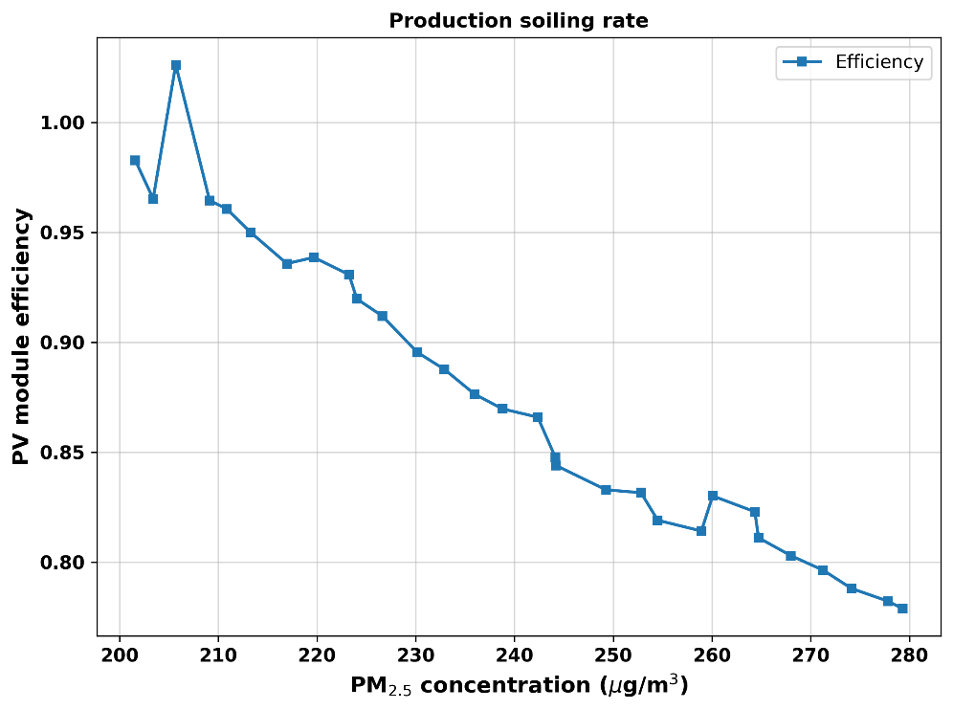
Fig. 9. Representation of the daily efficiency of the soiled module

Figure 9 presents the calculated soiling metric over the experimental period. It was calculated by dividing the average daily power output of the soiled panel by that of the clean module. This comparison reflects the relative power-output efficiency of the soiled PV module. The results show that, as aerosol concentration increased, the relative efficiency of the soiled panel decreased compared with that of the clean module. The downward trend in the calculated ratio with increasing dust concentration therefore indicates a progressive reduction in the soiled module's energy production.

3.4.3 Assessment of Daily Electrical Power Losses
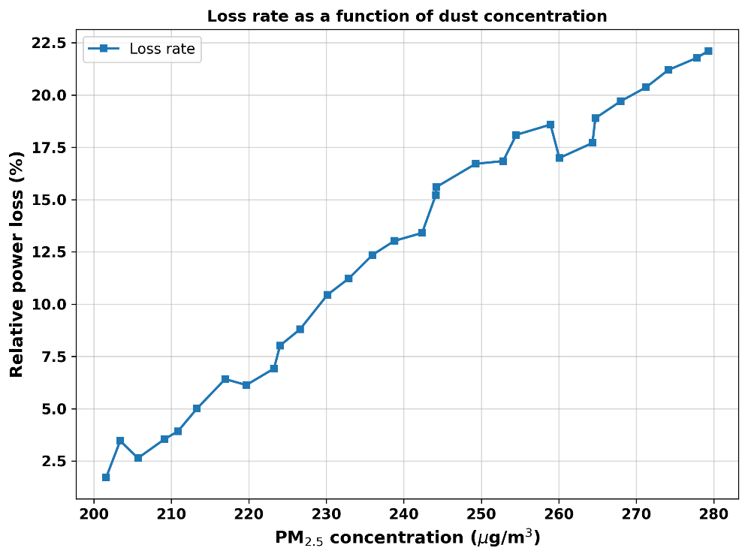
Fig. 10. Illustration of daily electrical power loss

To track this degradation trend, the loss rate ΔP was calculated for each day of the experimental period from the measured average daily electrical power. This daily-scale analysis captures short-term variations associated with weather conditions, particularly periods of wind that may temporarily limit particle accumulation under dry-deposition conditions, whereas a weekly analysis smooths out these fluctuations. Figure 10 shows the estimated daily loss rate over the 30-day study period. The figure indicates a gradual and continuous deterioration in electrical performance that may be associated with physical mechanisms discussed in the literature, including obstruction of incident radiation by the dust layer, thermal effects, changes at the glass surface, and heat absorption by carbonaceous particles. After brief fluctuations during the first three days due to noise and spurious signals, the power loss began a nearly linear increase on day 4, rising from 2.5% to a maximum of 22.3% on day 30. This reduction in power output is consistent with previous findings (Ndiath et al., 2023), which indicate that dust deposition can form an optical barrier that reduces the transmittance of the panel's front glass. By blocking a fraction of the incident solar radiation, this layer reduces the panel's electrical current and, consequently, lowers the maximum power delivered by the module. The observed pattern indicates that, without cleaning to remove surface deposits, particulate accumulation can progressively reduce the energy performance of the installation.

4. Conclusion

The study showed that dust deposits primarily hinder the electricity production of photovoltaic modules under Sahelian climatic conditions. As aerosols settle, they promote the formation of an opaque layer on the module surface and reduce the solar radiation transmitted to the PV cells for photovoltaic conversion. Consequently, these particulate deposits affect electrical parameters, notably current and power, and lead to electrical losses and a decline in photovoltaic system performance. A combined analysis of daily and weekly losses also showed that the degradation, although generally monotonic, was not perfectly linear but was punctuated by episodes of natural cleaning by wind. This pattern suggests that a condition-based maintenance strategy triggered by a dust-concentration threshold measured in real time may be more appropriate than a fixed cleaning schedule. Furthermore, this study contributes to the literature on photovoltaic soiling in Burkina Faso by combining continuous quantitative measurement of dust concentration with electricity generation. This approach may support predictive maintenance of photovoltaic installations in the Sahel region. However, the quantitative attribution of power losses exclusively to soiling should be interpreted with caution because photovoltaic power output is also influenced by solar irradiance, module temperature, and electrical operating conditions.
Limitation

The experiment used two identical 50 Wp monocrystalline modules at a single site in Ouagadougou and covered approximately 30 days, which limits the temporal and geographical generalisability of the findings. The comparison was based on one regularly cleaned reference module and one soiled module, so the results may not represent other photovoltaic technologies, installation configurations, or seasons. In addition, photovoltaic power output is influenced by solar irradiance, module temperature, and electrical operating conditions; therefore, the observed losses cannot be attributed exclusively to aerosol soiling. Longer, multi-season studies across additional sites and module technologies would strengthen the conclusions.

Competing interests

Authors have declared that no competing interests exist.

Consent

Not applicable.

Ethical approval

Not applicable.

DECLARATION OF AI USE

This manuscript was prepared through the intellectual contributions of the author(s) to the study design, data analysis, interpretation of results, and scholarly content. Grammarly and ChatGPT were used solely to assist with grammatical refinement and reference formatting during manuscript revision. The author(s) accept full responsibility for the accuracy, integrity, and final content of the manuscript.

References

Abdulrazzaq, A. K., Bognár, G., & Plesz, B. (2022). Accurate method for PV solar cells and modules parameters extraction using I–V curves. Journal of King Saud University - Engineering Sciences, 34(1), 46–56. https://doi.org/10.1016/j.jksues.2020.07.008
Alkharusi, T., Alzahrani, M. M., Pandey, C., Yildizhan, H., & Markides, C. N. (2024). Experimental investigation of nonuniform PV soiling. Solar Energy, 272, 112493. https://doi.org/10.1016/j.solener.2024.112493
Almulhim, A. I., & Abubakar, I. R. (2026). The role of renewable energy in achieving the Sustainable Development Goals: A systematic review and conceptual framework. Renewable and Sustainable Energy Reviews, 230, 116679. https://doi.org/10.1016/j.rser.2025.116679
Ammari, N., Mehdi, M., Alami Merrouni, A., Benazzouz, A., & Chaabelasri, E. (2024). In-situ soiling evaluation and cleaning schedules optimization for several PV technologies under desert climate. Renewable Energy, 224, 120167. https://doi.org/10.1016/j.renene.2024.120167
Bado, N., Bazyomo, S. D., Ouedraogo, G. W. P., Korgo, B., Dramé, M. S., Kieno, F. P., & Kam, S. (2024). Contribution of satellite observations in the optical and microphysical characterization of aerosols in Burkina Faso, West Africa. Atmospheric and Climate Sciences, 14(1), 154–171. https://doi.org/10.4236/acs.2024.141010
Bado, N., Dianda, B., Drame, M. S., Namoano, Y., Kieno, F. P., & Kam, S. (2026). Study of the seasonal effect of atmospheric parameters on solar photovoltaic production in Burkina Faso, West Africa. International Journal of Atmospheric and Oceanic Sciences, 10(1), 25–37. https://doi.org/10.11648/j.ijaos.20261001.13
Diop, D., Drame, M. S., Diallo, M., Malec, D., Mary, D., & Guillot, P. (2020). Modelling of photovoltaic modules optical losses due to Saharan dust deposition in Dakar, Senegal, West Africa. Smart Grid and Renewable Energy, 11(7), 89–102. https://doi.org/10.4236/sgre.2020.117007
Fouad, M. M., Shihata, L. A., & Morgan, E. S. I. (2017). An integrated review of factors influencing the perfomance of photovoltaic panels. Renewable and Sustainable Energy Reviews, 80, 1499–1511. https://doi.org/10.1016/j.rser.2017.05.141
Goni, S., Adannou, H. A., Diop, D., Kriga, A., Khayal, M. Y., Bado, N., Beye, A. C., Niang, S. A. A., & Drame, M. S. (2019). Observation and simulation of available solar energy at N’Djamena, Chad. Smart Grid and Renewable Energy, 10(6), 165–178. https://doi.org/10.4236/sgre.2019.106011
Gopal, M., Chandra Prakash, T., Venkata Ramakrishna, N., & Yadav, B. P. (2020). IoT based solar power monitoring system. IOP Conference Series: Materials Science and Engineering, 981(3), 032037. https://doi.org/10.1088/1757-899X/981/3/032037
Ilse, K., Micheli, L., Figgis, B. W., Lange, K., Daßler, D., Hanifi, H., Wolfertstetter, F., Naumann, V., Hagendorf, C., Gottschalg, R., & Bagdahn, J. (2019). Techno-economic assessment of soiling losses and mitigation strategies for solar power generation. Joule, 3(10), 2303–2321. https://doi.org/10.1016/j.joule.2019.08.019
Jacobson, M. Z., Delucchi, M. A., Bauer, Z. A. F., Goodman, S. C., Chapman, W. E., Cameron, M. A., Bozonnat, C., Chobadi, L., Clonts, H. A., Enevoldsen, P., Erwin, J. R., Fobi, S. N., Goldstrom, O. K., Hennessy, E. M., Liu, J., Lo, J., Meyer, C. B., Morris, S. B., Moy, K. R., … Yachanin, A. S. (2017). 100% clean and renewable wind, water, and sunlight all-sector energy roadmaps for 139 countries of the world. Joule, 1(1), 108–121. https://doi.org/10.1016/j.joule.2017.07.005
Jed, M. E. H., Logerais, P. O., Malye, C., Riou, O., Delaleux, F., & El Bah, M. (2021). Analysis of the performance of the photovoltaic power plant of Sourdun (France). International Journal of Sustainable Engineering, 14(6), 1756–1768. https://doi.org/10.1080/19397038.2021.1971321
Kaboré, A., Haro, K., Ouedraogo, T. L., Zongo, S., Bagré, B., Guy, C. T., Korsaga, B. A., Ouarma, I., Westervelt, D. M., Ouoba, S., & Béré, A. (2026). Multi-criteria modeling of photovoltaic module soiling losses in a grid-connected power plant within the Sudano-Sahelian zone (Burkina Faso) using artificial neural networks and linear regression. Current Journal of Applied Science and Technology, 45(7), 207–219. https://doi.org/10.9734/cjast/2026/v45i74725
Khodakaram-Tafti, A., Yaghoubi, M., & Ferrantelli, A. (2025). Outdoor assessment and modeling of dust deposition impact on optimal tilt angle and operating temperature of photovoltaics. International Journal of Environmental Science and Technology, 22, 16061–16078. https://doi.org/10.1007/s13762-025-06723-8
Korsaga, E., Bado, N., Bonkoungou, D., Guingane, T. T., Savadogo, H., Tassembedo, S. S. L., & Koalaga, Z. (2026). Influence of climatic parameters on the performance of polycrystalline and monocrystalline silicon photovoltaic solar modules: The case of the city of Koudougou. International Journal of Sustainable and Green Energy, 15(1), 14–22. https://doi.org/10.11648/j.ijsge.20261501.12
Lu, E., & Wang, D. (2025). Impacts of climate change on river regimes in Africa. River Studies, 2(1), 174–185. https://doi.org/10.61848/rst.v2i1.59
Mani, M., & Pillai, R. (2010). Impact of dust on solar photovoltaic (PV) performance: Research status, challenges and recommendations. Renewable and Sustainable Energy Reviews, 14(9), 3124–3131. https://doi.org/10.1016/j.rser.2010.07.065
Millstein, D., Wiser, R., Bolinger, M., & Barbose, G. (2017). The climate and air-quality benefits of wind and solar power in the United States. Nature Energy, 2(9), 17134. https://doi.org/10.1038/nenergy.2017.134
Mondol, J. D., Yohanis, Y. G., & Norton, B. (2007). The impact of array inclination and orientation on the performance of a grid-connected photovoltaic system. Renewable Energy, 32(1), 118–140. https://doi.org/10.1016/j.renene.2006.05.006
Nafa, A. Z. M., Obed, A. A., Abid, A. J., Yaqoob, S. J., Bajaj, M., & Shabaz, M. (2025). Sensorless real-time solar irradiance prediction in grid-connected PV systems using PSO-MPPT and IoT-enabled monitoring. Energy Informatics, 8(1), 99. https://doi.org/10.1186/s42162-025-00563-z
Ndiath, H. D., Senghor, A., Traoré, P. T., Mbow, B., & Youm, I. (2023). Effect of dust on the performance characteristics of different modules technologies. International Journal of Innovation and Applied Studies, 39(1), 216–224. https://ijias.issr-journals.org/abstract.php?article=IJIAS-22-331-10
Bado, N., Dramé, M. S., Korgo, B., Guengane, H., Niang, D. N., Sall, S. M., Kieno, F. P., & Bathiebo, D. J. (2019). Study of aerosol impact on the solar potential available in Burkina Faso, West Africa. International Journal of Environment and Climate Change, 9(5), 297–310. https://doi.org/10.9734/ijecc/2019/v9i530116
Neher, I., Crewell, S., Meilinger, S., Pfeifroth, U., & Trentmann, J. (2020). Photovoltaic power potential in West Africa using long-term satellite data. Atmospheric Chemistry and Physics, 20(21), 12871–12888. https://doi.org/10.5194/acp-20-12871-2020
Niang, S. A. A., Gueye, A., Sarr, A., Diop, D., Goni, S., & Bado, N. (2023). Comparative study of available solar potential for six stations of Sahel. Smart Grid and Renewable Energy, 14(8), 153–167. https://doi.org/10.4236/sgre.2023.148009
Ouedraogo, A., Ouedraogo, P. Y., Korgo, B., Ouedraogo, O. A. Y., Ky, T. S. M., Bathiebo, D. J., & Kam, S. (2025). Analyses of the dust influence on individual efficiencies of the silicon PV module in Sudano-Sahelian conditions. Results in Optics, 21, 100906. https://doi.org/10.1016/j.rio.2025.100906
Parsay, A., Gandomzadeh, M., Yaghoubi, A. A., Hoorsun, A., Gholami, A., Zandi, M., Gavagsaz-Ghoachani, R., & Kazem, H. A. (2025). Enhancing photovoltaic efficiency: An in-depth systematic review and critical analysis of dust monitoring, mitigation, and cleaning techniques. Applied Energy, 388, 125668. https://doi.org/10.1016/j.apenergy.2025.125668
Prema, V., & Uma Rao, K. (2015). Development of statistical time series models for solar power prediction. Renewable Energy, 83, 100–109. https://doi.org/10.1016/j.renene.2015.03.038
Said, S. A. M., Hassan, G., Walwil, H. M., & Al-Aqeeli, N. (2018). The effect of environmental factors and dust accumulation on photovoltaic modules and dust-accumulation mitigation strategies. Renewable and Sustainable Energy Reviews, 82, 743–760. https://doi.org/10.1016/j.rser.2017.09.042
Shaik, F., Lingala, S. S., & Veeraboina, P. (2023). Effect of various parameters on the performance of solar PV power plant: A review and the experimental study. Sustainable Energy Research, 10, 6. https://doi.org/10.1186/s40807-023-00076-x
Shen, Y., Fouladirad, M., & Grall, A. (2024). Impact of dust and temperature on photovoltaic panel performance: A model-based approach to determine optimal cleaning frequency. Heliyon, 10(16), e35390. https://doi.org/10.1016/j.heliyon.2024.e35390
Shukla, A., Pachauri, R. K., Walia, R., & Gupta, V. (2026). Machine learning-based prediction of soiling losses in photovoltaic modules under different cleaning frequencies: An experimental investigation. Scientific Reports, 16(1), 17416. https://doi.org/10.1038/s41598-026-45485-2
Vekariya, Y., Arora, S., Kathiriya, M., & Tellabati, R. (2024). Performance evaluation of solar photovoltaic systems in Anand City, Gujarat, India. Asian Journal of Current Research, 9(2), 120–127. https://doi.org/10.56557/ajocr/2024/v9i28623
Yadav, A. K., & Chandel, S. S. (2013). Tilt angle optimization to maximize incident solar radiation: A review. Renewable and Sustainable Energy Reviews, 23, 503–513. https://doi.org/10.1016/j.rser.2013.02.027

