PRODUCTION AND CHARACTERIZATION OF PULP AND PAPER FROM DIFFERENT PARTS RAPHIA PALM TREE
Abstract
The increasing demand for sustainable raw materials for pulp and paper production has created significant interest in the use of non-wood lignocellulosic biomass. This study investigated the potential of different parts of Raphia palm waste, namely fronds, petioles, piassava, and tie-tie, as alternative raw materials for pulp and paper production. The materials were subjected to soda pulping using 15% soda liquor at a solid-to-liquor ratio of 1:10 for 3 h at 120 °C in a laboratory digester. The resulting pulps were mechanically treated, washed, and bleached with sodium hypochlorite. Pulp yield, Kappa number, residual lignin, water solubility, and 1% sodium hydroxide solubility were determined according to Technical Association of the Pulp and Paper Industry (TAPPI) standards. Structural changes resulting from pulping and bleaching were examined using Fourier-transform infrared (FTIR) spectroscopy. Paper sheets were produced from the different pulps using a laboratory hand mould, and the effect of starch as a bonding agent on the properties of the paper sheets was evaluated. The results showed that the unbleached pulp yield ranged from 44.18% for piassava to 54.49% for frond. Kappa numbers ranged from 34.60 to 37.35, corresponding to residual lignin contents of 4.50–4.86%. Bleached pulp yields based on the original raw materials ranged from 29.74% for tie-tie to 43.11% for frond, while yields based on the unbleached pulp used for bleaching ranged from 57.40% for tie-tie to 81.62% for petiole. FTIR spectra showed characteristic lignocellulosic functional groups, while the reduction or disappearance of carbonyl and aromatic lignin-associated bands after pulping and bleaching confirmed the removal of substantial amounts of hemicellulose, extractives, and lignin. Paper sheets produced from frond, petiole, and piassava showed good formation, whereas tie-tie exhibited poorer sheet formation. Starch addition generally increased the grammage and thickness of the paper sheets. These findings showed that different parts of Raphia palm waste can serve as alternative non-wood fibre resources for pulp and paper production.
Keywords Raphia palm. Pulping. Pulp, Bleaching, Kappa number. Paper making

Introduction
The increasing demand for sustainable raw materials for pulp and paper production has intensified the search for non-wood lignocellulosic biomass as an alternative to conventional wood resources. The continued dependence on wood has contributed to deforestation, biodiversity loss, and depletion of forest reserves, especially in developing countries where industrial wood plantations are limited (Food and Agriculture Organization of the United Nations, 2022). Consequently, agricultural residues and palm wastes have gained considerable attention as renewable, inexpensive, and environmentally friendly feedstocks for pulp and paper manufacturing. These non-wood materials, including Raphia palm, have physicochemical properties suitable for pulp and papermaking (Akpabio et al., 2012; Akpakpan, Akpabio, et al., 2012; Hurter, 1988; Akpakpan et al., 2025).
Recent assessments likewise support agricultural residues and other lignocellulosic non-wood fibres as alternative papermaking feedstocks, while noting that their composition and pulping behaviour vary among sources (Otieno et al., 2021; Husain et al., 2024).
These non-wood materials are widely available in large quantities in Nigeria as agricultural and agro-industrial residues, particularly in the Niger Delta region, where they are generated continuously during farming, harvesting, and processing activities. Their abundance ensures a sustainable and cost-effective supply of raw materials for the pulp and paper industry. Most non-wood lignocellulosic biomass possesses appreciable cellulose content, which serves as the principal structural polymer responsible for the strength, flexibility, and durability of paper products (Fengel & Wegener, 1983; Ferdous et al., 2021). In addition, many of these materials contain lower lignin contents than most hardwoods and softwoods, making them easier to delignify during chemical pulping (Hurter, 1988; Akpakpan, Akpabio, et al., 2012). The lower lignin content reduces the consumption of pulping chemicals and energy, shortens cooking time, improves pulp yield and brightness, and minimises the formation of environmentally harmful bleaching by-products (Gupta et al., 2022). The utilisation of agricultural and agro-industrial residues for pulp and paper production minimises waste-disposal problems, reduces environmental pollution (Akpabio & Akpakpan, 2012), conserves forest resources, enhances resource efficiency, creates value from biomass wastes, promotes the principles of a sustainable circular bioeconomy (Ashori, 2006), and can enhance the industrialisation of the Nigerian economy (Osung & Akpakpan, 2012).
The recovery and characterisation of cellulose from other agricultural fruit wastes further illustrates the potential of underutilised residues as renewable cellulose sources (Akpan et al., 2025).
Raphia palm (Raphia hookeri) is one of the most abundant indigenous palms in the freshwater swamp forests of West and Central Africa, particularly in southern Nigeria and the Niger Delta region (Oduah & Ohimain, 2015). The palm plays significant economic and cultural roles, providing materials for roofing, furniture, baskets, ropes, brooms, mats, wine production, and other domestic applications (Odera et al., 2015; Obahiagbon, 2009). Despite these traditional uses, substantial quantities of Raphia palm residues are generated and are often discarded or openly burned, creating environmental and waste-management challenges (Mogue Kamga et al., 2020). The utilisation of these residues as raw materials for pulp and paper production could offer an effective strategy for waste valorisation while creating additional economic value (Pydimalla et al., 2023; Obahiagbon, 2009).
Recent studies on oil-palm biomass and non-wood fibres also indicate that feedstock characteristics and processing strategy are central to the performance and end-use suitability of pulp and paper products (Abdul Hamid et al., 2024; Urdaneta et al., 2025).
The various anatomical parts of Raphia hookeri, including the fronds, petioles, piassava fibres, and tie-tie, possess distinct structural and chemical characteristics that enhance their suitability for papermaking (Akpakpan et al., 2025). These plant parts have different physicochemical properties, fibre dimensions, and morphological indices, all of which significantly affect pulping efficiency, pulp yield, bleaching response, paper strength, and overall product quality (Smook, 2002; Biermann, 1996). Fibre dimensions and morphological indices of different parts of Raphia palm have been reported in our previous studies (Akpakpan et al., 2025). Fibre dimensions such as fibre length, lumen diameter, and cell-wall thickness, and morphological indices such as slenderness ratio and Runkel ratio, are particularly important because they determine fibre bonding, sheet formation, tensile strength, burst strength, and tear resistance of the resulting paper (Rowell, 2000; Low et al., 2024).
Comparative investigation of pulp and paper produced from different parts of Raphia palm is particularly important because each biomass fraction possesses unique anatomical and chemical properties that can influence processing performance and end-use applications. Understanding these differences will facilitate appropriate selection of the most suitable Raphia palm part for specific grades of paper while promoting efficient utilization of the entire plant. Such an approach aligns with sustainable resource management by maximizing biomass utilization and minimizing waste generation.
Within the evidence considered in this manuscript, comparative information on pulp and paper produced from the frond, petiole, piassava, and tie-tie fractions of Raphia palm under the same processing conditions remains limited. A direct comparison of these fractions is therefore needed to clarify their relative pulping, bleaching, and papermaking performance.
Therefore, this study focuses on the production and characterisation of pulp and paper from different parts of Raphia palm waste, namely the fronds, petioles, piassava, and tie-tie. The findings are expected to provide scientific information on the suitability of Raphia palm waste materials as an alternative non-wood raw material for the pulp and paper industry, thereby contributing to sustainable biomass utilisation, environmental conservation, and the development of renewable bio-based materials. The Raphia palm tree and its parts are shown in Figure 1.

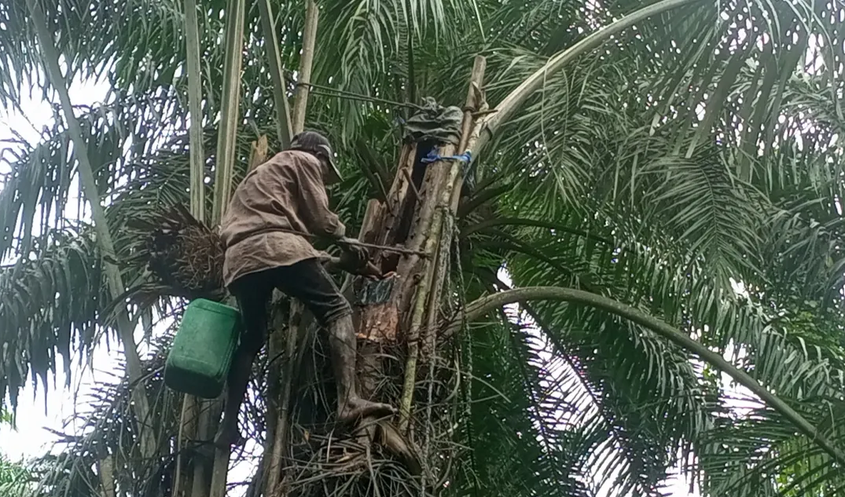

Raphia Palm Tree

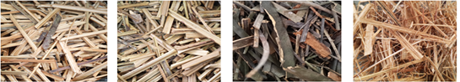
Piassava
Tie-tie
Frond
Petiole

Figure 1 :Tapped Raphia palm tree and its different parts used in pulp and paper production

Objective: The objective of this study was to produce and characterise pulp and paper from the fronds, petioles, piassava, and tie-tie of Raphia palm waste and to compare their resulting pulp and paper characteristics.
2.0 Material and methods

2.1 Sample Collection and Preparation
A mature Raphia palm tree that had previously been tapped for palm wine production and subsequently abandoned was selected for this study. After the palm had been felled, the different parts, such as fronds, petioles, piassava, and tie-tie, were carefully separated from the trunk using a sharp machete. Each component was sorted individually to avoid cross-contamination. The separated materials were thoroughly cleaned to remove adhering dirt, dust, and other extraneous matter before being manually cut into chips of approximately 1 cm × 1 cm to ensure uniform size and promote efficient penetration of the pulping liquor. The chipped samples were then air-dried under ambient laboratory conditions for 3 weeks. The dried samples were subsequently stored in clean, moisture-free polyethylene bags pending pulp production.

2.2 Pulping Process
Different parts of Raphia hookeri (fronds, petioles, tie-tie, and piassava) were individually subjected to soda pulping using a 10 L laboratory-scale digester. Briefly, 300 g of each sample was impregnated with 15% soda pulping liquor at a solid-to-liquid ratio of 1:10 (w/v) to ensure adequate contact between the biomass fibres and the cooking chemicals. The pulping process was carried out in a 10 L laboratory digester for 3 h at 120 °C to facilitate the breakdown and removal of lignin and other non-cellulosic components, thereby promoting the liberation of cellulose fibres. After completion of the pulping process, the resulting pulp was removed from the digester and separated from the black liquor through filtration. The pulp was subsequently subjected to mechanical beating to enhance fibre development, improve fibre bonding, and increase fibre flexibility and fibrillation. Thereafter, the pulp was thoroughly washed with clean tap water until a neutral pH was achieved. The washed pulp was oven-dried and then kept in an airtight container pending characterisation, bleaching, and paper-sheet production.
2.3 Bleaching of the pulp
The pulp obtained was bleached by soaking 50 g of each pulp in sodium hypochlorite solution at a ratio of 1:15. The mixture was kept for 24 h. Thereafter, the pulp was filtered and washed with tap water until a neutral pH was achieved. The yield of the bleached pulp and the solubility of the pulp in different solvents were determined. The schematic diagram of pulp production is presented in Figure 2.
Raw material chips
Pulping
Filtration
Mechanical treatment/washing
Unbleached pulp
Bleached pulp
Bleaching

Figure 2: Pulping flow diagram
2.3. Characterisation of the Pulp
2.3.1 Pulp Yield
Pulp yield was calculated using the gravimetric method, as given in the equation below:
Pulp yield (%) = $\frac{w_{1}}{w_{2}}$ x 100
Where w₁ = weight of the sample
w₂= weight of the pulp
2.3.2 Determination of Kappa Number
The Kappa number is used to describe the relative hardness of the pulp, the degree of delignification obtained in a chemical pulping process, and the bleachability or whitening aptitude of the pulp. It is defined as the volume (in millilitres) of 0.1 N (0.02 M) potassium permanganate solution consumed by one gram of moisture-free pulp. The results are corrected to 50% consumption of the permanganate added. The Kappa number was determined using TAPPI standard T 236 OM-99 (Technical Association of the Pulp and Paper Industry [TAPPI], 1999).
Approximately 0.5 g of oven-dried pulp was disintegrated in 100 mL of distilled water using an electric blender until the pulp was free of fibre clots. The disintegrated pulp was then transferred to a 500 mL reaction beaker, and 100 mL of distilled water was added to bring the total volume to 200 mL. The beaker was placed on a magnetic stirrer with continuous stirring. Twenty-five millilitres of 2 M (4 N) sulphuric acid solution and 25 mL of 0.02 M (0.1 N) potassium permanganate solution were measured and added simultaneously to the disintegrated test specimen, and a stopwatch was started. At the end of exactly 10.0 min, the reaction was stopped by adding 5 mL of 1 M (1 N) potassium iodide solution. Immediately after mixing, but without filtering out the fibres, the mixture was titrated with 0.2 M (0.2 N) sodium thiosulphate solution; a few drops of starch indicator were added towards the end of the reaction. A blank determination was carried out using exactly the same method but omitting the pulp. The Kappa number was calculated as follows:

K = $\frac{p x f}{w}$ x 100
Where
p =$\frac{(b-a )N}{0.1}$
Where:
K = Kappa number
f = factor for correction to a 50% permanganate consumption,
w = weight of moisture-free pulp in the specimen, g
p = amount of 0.1N permanganate actually consumed by the test specimen, mL
b = amount of the thiosulfate consumed in the blank determination, mL
a = amount of the thiosulfate consumed by the test specimen, mL
N = normality of the thiosulfate

2.3.3 Determination of Residual Klason Lignin
Residual Klason lignin was calculated from the Kappa number as recommended by TAPPI standard method T 236 OM-99 (TAPPI, 1999).
% Residual Klason Lignin (RKL) = Kappa number x 0.13
2.3.4 Determination of Solubility in different solvents
The solubility of the pulp in cold and hot water was determined using TAPPI standard method T 207 cm-22 (TAPPI, 2022).
For cold-water solubility, 2 g of oven-dried pulp was placed in a 250 mL beaker, and 100 mL of distilled water was slowly added, ensuring that the pulp was well wetted initially to prevent it from floating. The extraction was carried out at room temperature with constant stirring for 48 h using a magnetic stirrer. The pulp was filtered and dried to constant weight at 105 ± 3 °C.
Hot-water solubility was determined by transferring 2 g of the test specimen to a 250 mL Erlenmeyer flask. Then, 100 mL of hot distilled water was added, and the flask was placed in a boiling water bath. A reflux condenser was attached, and the sample was digested for 3 h. After digestion, the pulp was filtered, washed with 200 mL of hot water, and oven-dried to constant weight at 105 ± 3 °C.
Cold- or hot-water solubility was determined using the equation below:
Hot or cold water solubility (%) = $\frac{A-B}{A} x 100$
Where
A = initial weight of the test specimen, g oven dry (o.d.)
B = weight of the test specimen after extraction, g (o.d.)
2.3.5 Determination of solubility 1% NaOH
Solubility in 1% sodium hydroxide was determined in accordance with TAPPI standard T 212 om-02 (TAPPI, 2002). Briefly, 1 g of oven-dried pulp was dispersed in 100 mL of 1% NaOH, and the mixture was heated in a water bath for 1 h with intermittent stirring using a stirring rod at 5 min intervals. After 1 h, the pulp was filtered and washed with 25 mL of 10% acetic acid, followed by washing with distilled water until a neutral pH was achieved.
2.4 Paper making
Paper sheets (handsheets) were produced using a locally fabricated handsheet mould fitted with a wire screen measuring 14 cm × 17 cm. For each sample, 7.5 g (oven-dry basis) of pulp was dispersed in 1000 mL of distilled water and mechanically disintegrated using an electric blender to obtain a uniform fibre suspension. The resulting slurry was transferred to a 10 L plastic bucket, and additional water was added to obtain a total stock volume of 3000 mL.
For handsheet formation, the mould was first immersed in a basin containing clean water. Thereafter, 1000 mL of the pulp slurry from the stock was gently poured onto the mould screen. The mould was gently shaken in both horizontal directions to ensure uniform fibre dispersion and sheet formation. The mould was slowly lifted from the water, and excess water was removed by couching with a foam sponge. The wet handsheet was then gently detached from the mould. The sheets were subsequently calendered using a hot electric pressing iron to improve surface smoothness, fibre bonding, and sheet uniformity and dried in the oven at 85 °C until a constant weight was achieved.
To investigate the effect of starch as a strengthening additive and bonding agent, additional paper sheets were prepared by incorporating 1 mL and 2 mL of 1% (w/v) starch solution into 1000 mL portions of the pulp slurry before sheet formation; the pulp slurry was stirred using a glass rod. The starch acted as a natural bonding agent, enhancing inter-fibre bonding and improving the mechanical integrity of the resulting paper sheets. All paper sheets were produced following the same procedure to ensure consistency and enable comparison among the different Raphia palm parts. The flow diagram of papermaking is shown in Figure 3 below.
Stock
Preparation
Sheet
Formation
Coaching/
Calendaring
Drying
Finished
Paper sheet

Figure 3: Paper making flow diagram
2.5 Characterisation of the papers
The physical properties of the paper sheets, including grammage, thickness, bulk, and density, were determined using TAPPI standards T 410 for grammage, T 411 for thickness, and T 220 for density and bulk, respectively.
Grammage is the mass of paper per unit area, expressed in g/m² (gsm). It was determined by measuring the length and width of each paper using a ruler and measuring the weight of each paper using an analytical balance. The grammage was calculated as follows:
Grammage = $\frac{Mass ofthe paper (g)}{Area (m^{2})}$
The thickness of each paper sheet was measured at 10 different points using a digital micrometer screw gauge, and the mean thickness was recorded. The thickness values were subsequently used to determine the density of the paper. Paper density was determined as the mass of paper per unit volume and expressed in kg/m³. The density of each paper sheet was calculated as follows:
Density (kg/m³) = $\frac{Grammage }{Thickness}$
The bulk of the paper indicates the volume occupied by a unit mass of paper and provides information about the porosity and compactness of the sheet. It was determined using:
Bulk (cm³/g) = $\frac{1000}{Density}$
Results and Discussion
The characteristics of the handsheets obtained from the unbleached and bleached pulps of different parts of the Raphia palm tree are presented in Tables 1 and 2, respectively.

Table 1: Physicochemical properties of unbleached pulp
Sample | Yield of unbleached pulp (%) | Kappa No | Residual lignin  (%) | Solubility of unbleached in cold water (%) | Solubility of unbleached in hot water (%) | Solubility of unbleached in 1% NaOH  (%)
Frond | 54.49 | 37.35 | 4.86 | 10.80 | 12.80 | 19.00
Petiole | 46.20 | 34.60 | 4.50 | 11.20 | 11.60 | 26.08
Pissava | 44.18 | 35.80 | 4.65 | 7.60 | 8.80 | 16.12
Tie-tie | 51.81 | 36.25 | 4.71 | 15.00 | 15.20 | 31.00

Table 2: Physicochemical properties of bleached pulp
Sample | Yield based on raw material (%) | Yield based on unbleached pulp (%) | Solubility in cold water (%) | Solubility in hot water (%) | Solubility in 1%  NaOH (%)
Frond | 43.11 | 79.12 | 18.40 | 22.40 | 28.00
Petiole | 37.71 | 81.62 | 22.40 | 22.80 | 27.12
Piassava | 30.73 | 69.56 | 19.20 | 21.20 | 17.00
Tie-tie | 29.74 | 57.40 | 19.20 | 20.56 | 26.00
The unbleached pulp yield ranged from 44.18% to 54.49%, with the frond giving the highest yield (54.49%) and piassava the lowest (44.18%). The relatively high pulp yields indicate that all four parts of Raphia palm contain appreciable amounts of carbohydrate polymers that can be retained during alkaline pulping. The higher yield obtained from the frond suggests that it may possess a more favourable fibre composition (Danielewicz et al., 2021). Conversely, the lower yield of piassava may indicate greater removal of lignin, hemicellulose, and extractive materials during pulping (Pydimalla et al., 2022). The pulp yields obtained in the present study are comparable with the general range reported for many non-wood lignocellulosic materials (Jahan et al., 2006; Ashori, 2006; Akpakpan, Akpabio, et al., 2012). Non-wood fibres are considered promising because they provide appreciable pulp yields, thereby reducing dependence on conventional wood resources. Pictures of the unbleached pulps are presented in Figure 4, while a pictorial flow diagram of pulp and paper production from Raphia palm is shown in Figure 5.
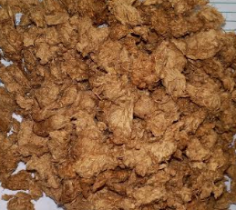
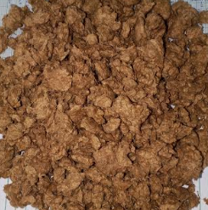
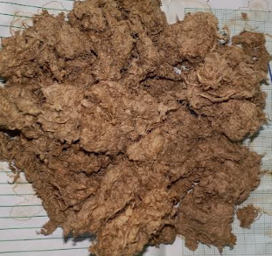
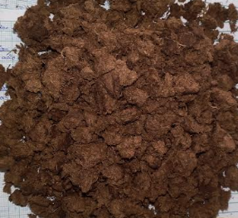
Frond
Petiole
Piassava
Tie-tie

Figure 4: Unbleached pulps
The bleached pulp yield was evaluated on the basis of the mass of the original raw material and that of the unbleached pulp used for bleaching. The bleached pulp yield based on the original raw material was 43.11%, 37.71%, 30.73%, and 29.74% for frond, petiole, piassava, and tie-tie, respectively. In comparison, the bleached pulp yield based on the unbleached pulp was 79.12%, 81.62%, 69.56%, and 57.40%, respectively. The relatively high bleaching yields for frond and petiole indicate better pulp retention during the bleaching stage, whereas the lower yield observed for tie-tie suggests greater material loss during bleaching. The reduction in pulp yield after bleaching may be associated with the removal of residual lignin and other non-cellulosic components from the unbleached pulp. However, under the bleaching conditions employed, some degradation or loss of cellulose and other carbohydrate components may also have contributed to the reduction in pulp mass (Zhu et al., 2025). Overall, frond produced the highest bleached pulp yield based on the original raw material, while petiole showed the highest pulp yield based on the unbleached pulp, indicating better pulp retention during bleaching. Tie-tie recorded the lowest bleached pulp yield based on both the original raw material and the unbleached pulp.
The Kappa number varied from 34.60 to 37.35, with the frond having the highest value and the petiole the lowest. Because the Kappa number is related to the amount of residual lignin in the pulp, the relatively high Kappa numbers indicate that an appreciable amount of lignin remained in the pulp after soda pulping. This agrees with the measured residual lignin values, which ranged from 4.50% in the petiole to 4.86% in the frond. The higher value for the frond may be attributed to its greater hardness and stiffness, which likely restricted the penetration and diffusion of the pulping chemicals into the fibre matrix, thereby limiting lignin removal compared with the softer petiole, piassava, and tie-tie samples. The petiole therefore showed the greatest extent of delignification, whereas the frond retained slightly more lignin. Residual lignin content is important because the remaining lignin would subsequently influence the bleaching requirement and optical properties of the paper (Danielewicz & Surma-Ślusarska, 2019). The Kappa number and residual lignin values reported are comparable to those reported for the Nypa fruticans petiole by Akpakpan, Akpabio, et al. (2012), but higher than those reported for soda-organosolv pulping (Akpakpan, Ogunsile, et al., 2012).
Cold-water solubility of the unbleached pulps ranged from 7.60% for piassava to 15.00% for tie-tie. Similarly, hot-water solubility ranged from 8.80% for piassava to 15.20% for tie-tie. These values are generally much lower than those of the corresponding raw materials reported in our previous work (Akpakpan et al., 2025). This may be because soda pulping removes water-soluble extractives, part of the hemicellulose fraction, lignin, and other low-molecular-weight components. Hence, the resulting pulp contains a larger proportion of relatively insoluble cellulose fibres and therefore shows lower water solubility. Bleaching increased cold-water solubility to 18.40–22.40% and hot-water solubility to 20.56–22.80%.
The 1% NaOH solubility is commonly associated with the amount of alkali-soluble low-molecular-weight carbohydrates, degraded cellulose, hemicelluloses, and other non-cellulosic components. The relatively high value for tie-tie (31%) suggests that a considerable amount of alkali-soluble material remained in this pulp, whereas the lower value for piassava (16%) suggests more extensive removal of such components during pulping (Ajayi et al., 2023).
The higher water and 1% NaOH solubility of the bleached pulps may be attributed to oxidative degradation of residual lignin and hemicelluloses during bleaching, together with the formation of more hydrophilic functional groups, which increased the accessibility and dissolution of non-cellulosic components. The increase was especially noticeable for the frond, whose cold-water solubility increased from 10.80% to 18.40%, while hot-water solubility increased from 12.80% to 22.40%.
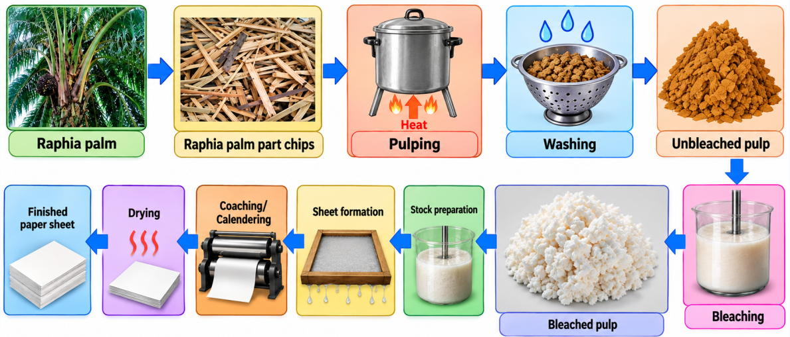
Figure 5: production of pulp and paper from Raphia palm part
FTIR spectroscopy was used to investigate the effect of soda pulping and bleaching on the surface functional groups of the resulting pulps. The results are presented in Figures 6–17 and Table 3.
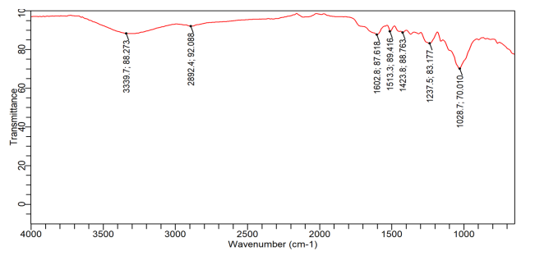
Figure 6: FTIR spectra of Tie-tie raw material

Figure 7: FTIR spectra of piassava raw material

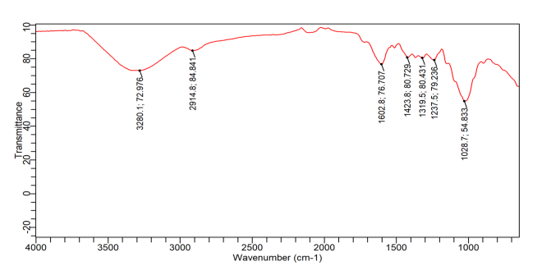
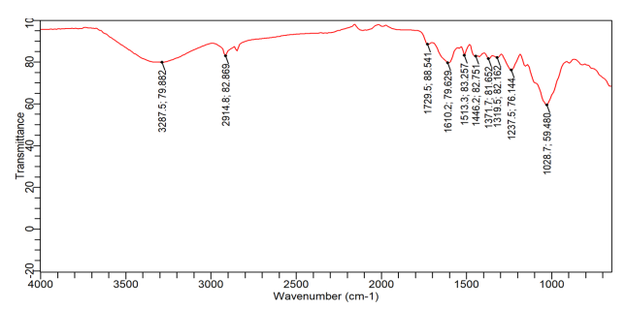
Figure 9: FTIR spectra of frond raw material

Figure 8: FTIR spectra of petiole raw material

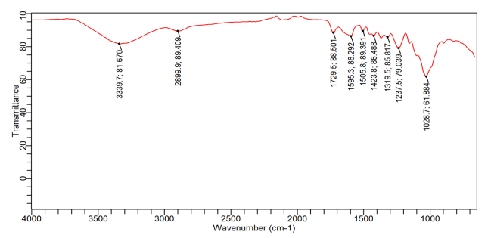
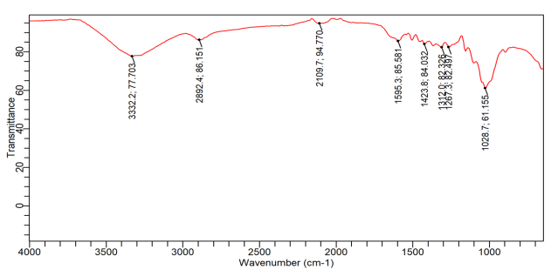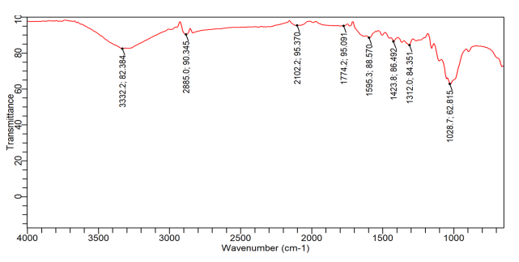
Figure 11: FTIR spectra of piassava unbleached pulp

Figure 10: FTIR spectra of Tie-tie unbleached pulp

The FTIR results of the raw materials (Figures 6–9), unbleached pulps (Figures 10–13), and bleached pulps (Figures 14–17) are presented in Table 3. The results revealed the characteristic pattern of lignocellulosic biomass. The broad absorption at approximately 3280–3340 cm⁻¹ is attributable principally to O–H stretching of hydroxyl groups present in cellulose, hemicellulose, and lignin (Akpanudo et al., 2026). Its broad nature indicates extensive hydrogen bonding within the biomass. The bands around 2890–2925 cm⁻¹ correspond to aliphatic C–H stretching of –CH, –CH₂, and –CH₃ groups. These bands are present in both carbohydrate and lignin fractions. An important difference occurs in the carbonyl region. Petiole and frond show clear C=O stretching absorption associated with hemicellulose acetyl/uronic groups, ester groups, and other oxygenated extractives at approximately 1729 cm⁻¹ (Ntuen et al., 2024; Okon et al., 2026), whereas this feature is not prominent in tie-tie and piassava. The strong band near 1028 cm⁻¹ in all four materials is associated with C–O/C–C stretching in polysaccharides, especially cellulose. Thus, all four raw materials possess a substantial carbohydrate/cellulose framework (Okon et al., 2026).
The conversion from raw biomass to unbleached pulp produced noticeable spectral changes. The most important observation was the reduction or disappearance of the 1729 cm⁻¹ carbonyl band evident in raw petiole and frond. In their unbleached pulps, this feature was no longer prominent. This indicates the removal or substantial reduction of carbonyl-containing hemicellulosic components and extractives during pulping.
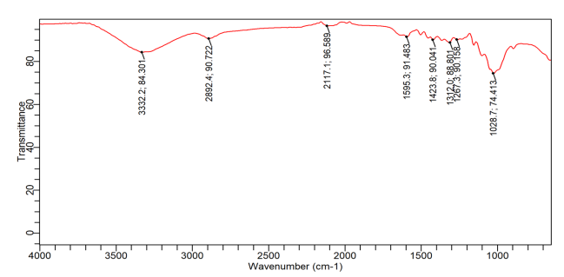
Figure 13: FTIR spectra of frond unbleached pulp

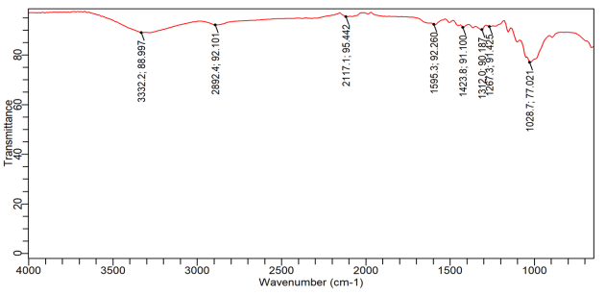
Figure 12: FTIR spectra of Petiole unbleached pulp

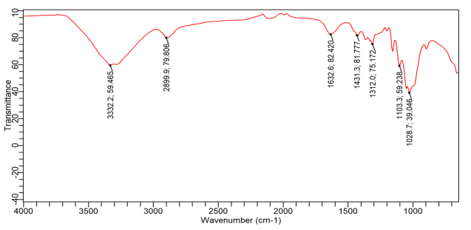
Figure 15: FTIR spectra of bleached piassava pulp

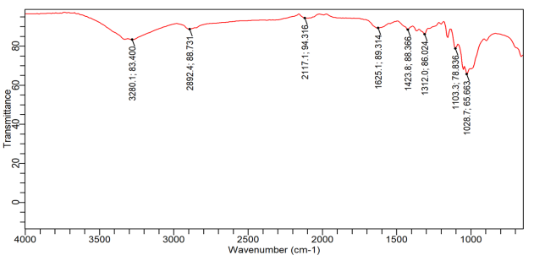
Figure 14: FTIR spectra of bleached tie-tie pulp

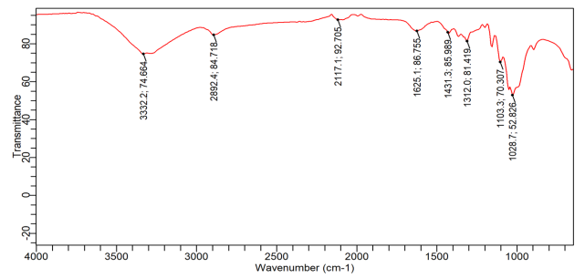
Figure 17: FTIR spectra of bleached frond pulp

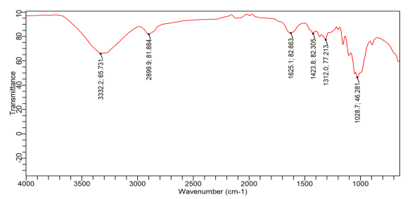
Figure 16: FTIR spectra of bleached petiole pulp

Table 3: Comparative FTIR Peak Assignments of the Lignocellulosic Samples
Wave number (cm⁻¹) | Main functional group assignment | Samples |  |  | Significance
Wave number (cm⁻¹) | Main functional group assignment | Raw materials | Unbleached pulps | Bleached pulps | Significance
~3280–3340 | O–H  stretching | Strong/broad in all | Strong/  broad | Strong/broad | Cellulose, hemicellulose and lignin hydroxyl groups; hydrogen bonding
~2890–2925 | Aliphatic  C–H stretching | Present in all | Present | Present | –CH, –CH₂ and –CH₃ groups of carbohydrates/lignin
~1725–1775 | C=O stretching | Present in (PT and FD) | Mostly reduced/  absent | Essentially absent | Carbonyl groups of hemicellulose, esters and other oxygenated extractives
~1625–1610 | C=C/aromatic skeletal vibration | Present in some raw samples | Present | Present, generally around 1625–1633 | Aromatic/lignin structures
~1515–1500 | Aromatic skeletal vibration | Present in some raw materials | Reduced | Mostly absent/weak | Characteristic of lignin aromatic rings
~1425 | CH₂ bending | Present | Present | Present | Associated with cellulose and lignocellulosic structure
~1375–1310 | C–H bending / O–H | Present | Present | Present | Polysaccharide framework
~1237–1215 | C–O stretching / lignin–hemicellulose contribution | Present | Reduced | Weak or absent in some | Useful indicator of non-cellulosic components
~1105–1028 | C–O, C–C stretching | Strong in all | Very strong | Strong | Dominantly cellulose/polysaccharide structure
Similarly, the aromatic/lignin-related bands became less pronounced after pulping. For example, the petiole raw material contained a distinct band around 1503 cm⁻¹, whereas the band was absent in its corresponding unbleached pulp. This is consistent with the preferential removal of part of the lignin and hemicellulose during pulping, leaving a pulp enriched in cellulose. However, the unbleached pulps still retained important bands such as –OH around 3320 cm⁻¹. Therefore, the FTIR results confirm that pulping did not destroy the cellulose backbone.
The effect of bleaching on the functional groups was also investigated. The strong ~1729 cm⁻¹ C=O band was observed in raw petiole and frond; its intensity was reduced in the unbleached pulps, and it was absent in the bleached pulps. This indicates further removal of residual hemicellulose and lignin. The aromatic bands around 1500–1515 cm⁻¹, which were more evident in some raw materials, became very weak or disappeared after bleaching, showing that bleaching reduced the residual lignin content. The bands around 1028–1105 cm⁻¹ remained prominent after bleaching. This indicates the presence of a high cellulose content in the bleached pulp.
Overall, the FTIR results support the effectiveness of the pulping and bleaching treatments in converting the four raw lignocellulosic materials into progressively more cellulose-rich pulps.
The results of the paper-sheet characterisation are presented in Table 4, and pictures of the paper sheets are shown in Figure 18. Frond, petiole, and piassava gave paper with good formation, while tie-tie gave paper with poor formation. This may be due to the short fibre length of tie-tie, as reported in our previous work (Akpakpan et al., 2025). The tie-tie paper sheets were not characterised due to poor formation.
Table 4: Characterization of the paper sheets
Paper  Sample | Volume of  1% starch solution (mL) | Weight  (g) | Grammage  (g/m²) | Thickness  (mm) | Density (kg/m³) | Bulk  cm³/g
Frond | - | 1.62 | 68.10 | 0.2863 | 237.86 | 4.20
 | 1 | 1.71 | 71.85 | 0.3046 | 235.88 | 4.24
 | 2 | 1.77 | 74.40 | 0.3324 | 223.83 | 4.47
Petiole | - | 1.55 | 65.10 | 0.3186 | 204.33 | 4.89
 | 1 | 1.66 | 69.70 | 0.3376 | 206.46 | 4.84
 | 2 | 1.88 | 79.00 | 0.3782 | 208.88 | 4.79
Piassava | - | 1.67 | 70.17 | 0.2560 | 274.10 | 3.65
 | 1 | 1.95 | 81.90 | 0.3005 | 272.55 | 3.67
 | 2 | 2.06 | 86.55 | 0.3834 | 225.74 | 4.43
The handsheet properties varied with the amount of starch added and among the different parts of Raphia palm. Grammage increased progressively with starch addition, from 68.10 to 74.40 g/m² for frond, 65.10 to 79.00 g/m² for petiole, and 70.17 to 86.55 g/m² for piassava. Similarly, thickness increased with starch addition, indicating greater sheet consolidation and material deposition. Density generally decreased at higher starch levels, while bulk showed variable behaviour. Piassava produced the paper with the highest grammage (86.55 g/m²), whereas petiole paper exhibited the highest initial bulk (4.89 cm³/g). Starch addition influenced sheet structure, fibre bonding, and physical properties, with 2 mL generally producing thicker and heavier sheets (Danielewicz & Surma-Ślusarska, 2019).

Conclusion
This study has shown that different parts of Raphia palm waste can be converted into pulp and paper using the soda pulping process. The four materials showed noticeable differences in pulp yield and quality. The frond produced the highest unbleached pulp yield and the highest bleached pulp yield based on the original raw material, while the petiole recorded the highest bleached pulp yield based on the unbleached pulp used for bleaching. The relatively low residual lignin values and the FTIR results confirmed the removal of substantial amounts of non-cellulosic components during pulping and bleaching. Handsheets produced from frond, petiole, and piassava showed good formation, while tie-tie produced comparatively poor sheets. Starch addition generally increased the weight and thickness of the paper sheets. Based on these findings, Raphia hookeri wastes, particularly frond, petiole, and piassava, have potential as alternative non-wood fibre sources for pulp and paper production.
Limitation:
The findings are limited to the laboratory-scale soda-pulping, bleaching, and handsheet-forming conditions used in this study. Comparisons were restricted to frond, petiole, piassava, and tie-tie from Raphia hookeri and to the reported pulp, FTIR, and basic sheet properties. Tie-tie handsheets were not physically characterised because of poor sheet formation. Accordingly, the results should be interpreted within these processing conditions and measured properties rather than generalised to other pulping, bleaching, or papermaking conditions.
Acknowledgements
This work is part of the Institution-based Research (IBR) Grant provided by TETFUND Nigeria. We acknowledge and appreciate its financial contribution towards the success of this research.
Competing Interests
Authors have declared that no competing interests exist.
Declaration of AI Use
This manuscript was prepared through the intellectual contributions of the author(s) to the study design, data analysis, interpretation of results, and scholarly content. Grammarly and ChatGPT were used solely to assist with grammatical refinement and reference formatting during manuscript revision. The author(s) accept full responsibility for the accuracy, integrity, and final content of the manuscript.

References
Abdul Hamid, F., Loh, S. K., Abdul Wahab, N., Subramaniam, V., Abdul Aziz, A., & Idris, Z. (2024). Pulp and paper from wood and oil palm biomass: Current development, issues, challenges and opportunities. Industrial Crops and Products, 222, 119938. https://doi.org/10.1016/j.indcrop.2024.119938
Ajayi, S. M., Olusanya, S. O., Diduyemi, A. E., & Olumayede, E. G. (2023). Assessment of cellulose from oil palm waste for paper-based applications. Materials Letters, 349, 134782. https://doi.org/10.1016/j.matlet.2023.134782
Akpabio, U. D., & Akpakpan, A. E. (2012). Pulp and paper from agricultural wastes: Plantain pseudostem wastes and screw pine leaves. International Journal of Modern Chemistry, 2(3), 100–107.
Akpabio, U. D., Udiong, D. S., & Akpakpan, A. E. (2012). The physicochemical characteristics of plantain (Musa paradisiaca) and banana (Musa sapientum) pseudostem wastes. Advances in Natural and Applied Sciences, 6(2), 167–172.
Akpakpan, A. E., Akpabio, U. D., & Obot, I. B. (2012). Evaluation of physicochemical properties and soda pulping of Nypa fruticans frond and petiole. Elixir Applied Chemistry, 45, 7664–7668.
Akpakpan, A. E., Enengedi, I. S., Nsi, E. W., & Umo, A. M. (2025). Evaluation of percentage solubles, fibre dimensions and morphological indices of different parts of Raphia hookies as raw materials for pulp and paper production. Journal of Materials Science Research and Reviews, 8(3), 600–609. https://doi.org/10.9734/jmsrr/2025/v8i3427
Akpakpan, A. E., Ogunsile, B. O., Akpabio, U. D., & Eduok, U. M. (2012). Comparative study on the soda-ethanol and soda-butanol pulping of Nypa fruticans petioles. International Journal of Advanced Scientific and Technical Research, 1(2), 313–324.
Akpan, U. I., Osuji, L. C., & James, A. O. (2025). Extraction and characterisation of cellulose of Chrysophyllum albidum (African star apple) fruit waste using infrared spectroscopy. Journal of Applied Chemical Science International, 16(2), 266–273. https://doi.org/10.56557/jacsi/2025/v16i29896
Akpanudo, N. W., Ntuen, I., & Akpakpan, A. E. (2026). Phytochemical composition and functional group characterization of Dacryodes edulis exudate: Implications for sustainable industrial applications. International Journal of Research, 13(7), 48–67.
Ashori, A. (2006). Nonwood fibers—A potential source of raw material in papermaking. Polymer-Plastics Technology and Engineering, 45(10), 1133–1136. https://doi.org/10.1080/03602550600728976
Biermann, C. J. (1996). Handbook of pulping and papermaking (2nd ed.). Academic Press. https://doi.org/10.1016/B978-0-12-097362-0.X5000-6
Danielewicz, D., Kmiotek, M., & Surma-Ślusarska, B. (2021). Comparison of some properties of selected non-wood plants and wood species and unbleached kraft pulps from these materials. Journal of Natural Fibers, 18(9), 1296–1306. https://doi.org/10.1080/15440478.2019.1689888
Danielewicz, D., & Surma-Ślusarska, B. (2019). Miscanthus × giganteus stalks as a potential non-wood raw material for the pulp and paper industry: Influence of pulping and beating conditions on the fibre and paper properties. Industrial Crops and Products, 141, 111744. https://doi.org/10.1016/j.indcrop.2019.111744
Fengel, D., & Wegener, G. (1983).Wood: Chemistry, ultrastructure, reactions. Walter de Gruyter. https://doi.org/10.1515/9783110839654
Ferdous, T., Ni, Y., Quaiyyum, M. A., Uddin, M. N., & Jahan, M. S. (2021). Non-wood fibers: Relationships of fiber properties with pulp properties. ACS Omega, 6(33), 21613–21622. https://doi.org/10.1021/acsomega.1c02933
Food and Agriculture Organization of the United Nations. (2022). The state of the world’s forests 2022: Forest pathways for green recovery and building inclusive, resilient and sustainable economies. https://doi.org/10.4060/cb9360en
Gupta, N., Mahur, B. K., Izrayeel, A. M. D., Ahuja, A., & Rastogi, V. K. (2022). Biomass conversion of agricultural waste residues for different applications: A comprehensive review. Environmental Science and Pollution Research, 29(49), 73622–73647. https://doi.org/10.1007/s11356-022-22802-6
Hurter, A. M. (1988). Utilization of annual plants and agricultural residues for the production of pulp and paper. In Proceedings of the 1988 TAPPI Pulping Conference (Book 1, pp. 139–160). TAPPI Press.
Husain, S. N. H., Ilyas, R. A., Jalil, R., Ibrahim, R., Majid, R. A., & Ab Hamid, N. H. (2024). Insights into lignocellulosic fiber feedstock and its impact on pulp and paper manufacturing: A comprehensive review. Sustainable Materials and Technologies, 40, e00922. https://doi.org/10.1016/j.susmat.2024.e00922
Jahan, M. S., Chowdhury, D. A. N., & Islam, M. K. (2006). Characterization and evaluation of golpata fronds as pulping raw materials. Bioresource Technology, 97(3), 401–406. https://doi.org/10.1016/j.biortech.2005.04.003
Low, L. Q., Ilyas, R. A., Jalil, R., Hawanis, H. S. N., Ibrahim, R., Azriena, H. A. A., Zuhri, M. Y. M., Ainun, Z. M. A., Fatriasari, W., Hastuti, N., & Amelia, D. (2024). Physical and mechanical properties enhancement of beaten oil palm trunk pulp and paper by optimizing starch addition: Towards sustainable packaging solutions. Industrial Crops and Products, 221, 119232. https://doi.org/10.1016/j.indcrop.2024.119232
Mogue Kamga, S., Brokamp, G., Cosiaux, A., Awono, A., Fürniss, S., Barfod, A. S., Muafor, F. J., Le Gall, P., Sonké, B., & Couvreur, T. L. P. (2020). Use and cultural significance of Raphia palms. Economic Botany, 74, 207–225. https://doi.org/10.1007/s12231-020-09487-z
Ntuen, I. U., Akpakpan, A. E., Enin, G. N., Enengedi, I. S., Uwantta, E. J., Nsi, E. W., Udo, I. E., Ikpe, E. E., & Akpabio, U. D. (2024). Preparation and characterization of ink from Hibiscus sabdariffa, Curcuma longa and Sorghum vulgare. Nepal Journal of Biotechnology, 12(2), 183–193. https://doi.org/10.54796/njb.v12i2.333
Obahiagbon, F. I. (2009). A review of the origin, morphology, cultivation, economic products, health and physiological implications of Raphia palm. African Journal of Food Science, 3(13), 447–453. https://doi.org/10.5897/AJFS.9000008
Odera, R. S., Onukwuli, O. D., & Atuanya, C. U. (2015). Characterization of the thermo-microstructural analysis of raffia palm fibers proposed for roofing sheet production. Journal of Minerals and Materials Characterization and Engineering, 3, 335–343. https://doi.org/10.4236/jmmce.2015.34036
Oduah, A. A., & Ohimain, E. I. (2015). Ethnobotany of raffia palm (Raphia hookeri), productivity assessment and characterization of raffia palm oil from the Niger Delta, Nigeria. Research Journal of Phytomedicine, 1(1), 33–38.
Okon, E. S., Olatunji, O. M., & Ekop, I. E. (2026). Characterization of functional groups in Adonidia merrillii and Dacryodes edulis seed residues using FTIR spectroscopy. International Research in Material and Environment, 6(1), 47–58. https://doi.org/10.52589/IRME-LBAQ2SWR
Osung, O. E., & Akpakpan, A. E. (2012). Application of wood and paper chemistry to the industrialization of the Nigeria’s economy: A review. International Journal of Environment and Bioenergy, 4(2), 46–63.
Otieno, J. O., Okumu, T. N., Adalla, M., Ogutu, F., & Oure, B. (2021). Agricultural residues as an alternative source of fibre for the production of paper in Kenya-A review. Asian Journal of Chemical Sciences, 10(1), 22–37. https://doi.org/10.9734/ajocs/2021/v10i119084
Pydimalla, M., Chirravuri, H. V., & Uttaravalli, A. N. (2023). An overview on non-wood fiber characteristics for paper production: Sustainable management approach. Materials Today: Proceedings. Advance online publication. https://doi.org/10.1016/j.matpr.2023.08.278
Pydimalla, M., Kamma, R., & Mamidala, A. (2022). A review on morphological, chemical and structural properties of wood and non-wood fiber species. La Pensée, 51(5), 229–239.
Rowell, R. M., Han, J. S., & Rowell, J. S. (2000). Characterization and factors effecting fiber properties. In E. Frollini, A. L. Leão, & L. H. C. Mattoso (Eds.), Natural polymers and agrofibers based composites: Preparation, properties and applications (pp. 115–134). USP-IQSC/Embrapa Instrumentação Agropecuária/UNESP.
Smook, G. A. (2002). Handbook for pulp & paper technologists (3rd ed.). Angus Wilde Publications.
Technical Association of the Pulp and Paper Industry. (1999). Kappa number of pulp (TAPPI T 236 om-99). TAPPI Press. https://www.tappi.org/
Technical Association of the Pulp and Paper Industry. (2002). One percent sodium hydroxide solubility of wood and pulp (TAPPI T 212 om-02). TAPPI Press.
Technical Association of the Pulp and Paper Industry. (2022). Water solubility of wood and pulp (TAPPI T 207 cm-22). TAPPI Press.
Urdaneta, F., Meza, L., Márquez, R., Franco, J., Vera, R. E., Urdaneta, I., Parrish, C., Saloni, D., Pawlak, J. J., Jameel, H., & Gonzalez, R. W. (2025). Comparing the impacts of wood and APMP non-wood fibers on the properties of hygiene tissue paper. Cellulose, 32(8), 5021–5034. https://doi.org/10.1007/s10570-025-06529-4
Zhu, F., Tian, Z., Ji, X., Wang, Y., Zhang, F., & Zhou, J. (2025). Super-Arundo donax as a potential non-wood raw material for the pulp and paper industry: Effect of different cooking conditions on alkaline semi-chemical pulp and paper properties. Industrial Crops and Products, 232, 121164. https://doi.org/10.1016/j.indcrop.2025.121164

