Comparative Study on the Physicochemical Properties of Soaps Prepared Using Palm Kernel Oil and Tallow

Abstract
Soap quality is strongly influenced by the type and fatty acid composition of the lipid used during production. Palm kernel oil and tallow are locally available lipid sources with distinct physicochemical characteristics that may differently affect important soap properties, including foaming, hardness, moisture content, and cleansing performance. However, direct comparison of soaps produced from these two raw materials under similar processing and analytical conditions remains limited. This study evaluated and compared the physicochemical properties of soaps produced from palm kernel oil and tallow using sodium hydroxide as the saponifying agent. The study was carried out to determine the influence of different lipid sources on soap quality and to assess their suitability as locally available raw materials for soap production. Soap samples were prepared separately from palm kernel oil and tallow under controlled conditions using the cold-process method and analysed for pH, moisture content, total fatty matter (TFM), free caustic alkali, foam height, foam stability, hardness, lathering ability, and cleansing efficiency. The results showed that the type of lipid significantly influenced the characteristics of the produced soaps. Palm kernel oil soap exhibited higher foam height (14.52 cm), foam stability (89.74%), lathering ability (9.3), and cleansing efficiency (94.61%) than tallow soap. Conversely, tallow soap showed greater hardness (4.58 kg cm⁻²) and lower moisture content (8.91%), indicating improved durability and reduced dissolution during use. Palm kernel oil soap recorded a pH of 9.68 ± 0.04, foam height of 14.52 ± 0.41 cm, foam stability of 89.74 ± 1.20%, total fatty matter of 79.45 ± 0.52%, lathering score of 9.3 ± 0.2, and cleansing efficiency of 94.61 ± 1.05%. Tallow soap recorded a pH of 9.42 ± 0.05 and showed greater hardness (4.58 ± 0.15 kg cm⁻²) and lower moisture content (8.91 ± 0.28%) than palm kernel oil soap. Both soap samples recorded acceptable pH values and low free caustic alkali content, suggesting effective saponification and suitability for domestic applications. The findings indicate that palm kernel oil is more suitable for producing soaps with strong foaming and cleansing properties, whereas tallow is advantageous for producing harder and longer-lasting soap products. A combination of both raw materials may provide a balanced formulation with improved functional properties.

: Soap production; palm kernel oil; tallow; physicochemical properties; total fatty matter; free caustic alkali; foam stability

- Introduction
Soap is among the most widely used surfactants for personal hygiene, domestic cleaning, and industrial sanitation. Its effectiveness in removing dirt, oils or grease, and microorganisms has made it indispensable in maintaining public health and preventing the transmission of infectious diseases. Chemically, soap consists of the sodium or potassium salts of long-chain fatty acids produced through the saponification of triglycerides with a strong alkali, typically sodium hydroxide (NaOH) or potassium hydroxide (KOH) (Spitz, 2009; Cavitch, 1997). The physicochemical characteristics of soap—including hardness, foaming capacity, cleansing efficiency, moisture content, pH, and total fatty matter (TFM)—are determined largely by the fatty acid composition of the oils or fats used during manufacture (Warra, 2013).
Cleaning products play an essential role in our daily lives. By safely and effectively removing soil, germs, and other contaminants, they help us to stay healthy, care for our homes and possessions, and make our surroundings more pleasant. Soap is a mixture of sodium salts of various naturally occurring fatty acids. Total alkali and fatty matter contents are among the most important characteristics used to describe soap quality and are commonly specified in commercial transactions involving toilet and washing soaps (Betsy et al., 2013).
The choice of lipid source is therefore one of the most important factors influencing soap quality. Vegetable oils and animal fats differ considerably in their fatty acid profiles, leading to variations in the physical, chemical and functional properties of the finished soap. Vegetable oils such as palm kernel oil and coconut oil are rich in medium-chain saturated fatty acids, particularly lauric acid, which enhances lather formation, foaming ability and cleansing efficiency (Gunstone et al., 2007). Animal fats such as tallow contain relatively higher concentrations of long-chain saturated fatty acids, especially palmitic and stearic acids, which contribute to soap hardness, reduced solubility and improved durability (O'Brien, 2009). Consequently, understanding how different lipid sources influence soap quality is essential for optimising formulations to meet specific consumer and industrial requirements. A recent study of black soaps prepared with palm kernel oil, tallow, palm oil, palm fatty acid distillate, and their blends further showed that the lipid source and formulation were associated with differences in measured physicochemical properties (Gold et al., 2024).
Palm kernel oil (PKO) is extracted from the kernels of the African oil palm (Elaeis guineensis), an economically important crop cultivated extensively in West and Central Africa, Southeast Asia, and South America. Unlike palm oil, which is extracted from the fruit mesocarp, palm kernel oil is characterised by a high proportion of lauric acid (approximately 45–55%), together with myristic, caprylic, capric, and oleic acids (Gunstone et al., 2007; Imoisi et al., 2020). This unique fatty acid composition makes palm kernel oil highly desirable in soap manufacturing because sodium laurate produces soaps with rapid lather formation, excellent foaming characteristics, and effective grease removal, even in hard water (Kuntom et al., 1996). Palm kernel oil is therefore widely used in the manufacture of toilet soaps, laundry soaps, shampoos, and synthetic detergent formulations.
Nigeria remains one of Africa's largest producers of oil palm, and palm kernel oil represents an important agricultural commodity with considerable industrial value. The use of locally sourced palm kernel oil in soap production supports agricultural development, reduces dependence on imported raw materials, and promotes value addition within the local economy. Furthermore, the increasing global emphasis on renewable and sustainable industrial feedstocks has renewed interest in vegetable oils as alternatives to petroleum-derived surfactants and synthetic detergents (Knothe et al., 2010; Ntuen et al., 2024).
Tallow, on the other hand, is rendered animal fat obtained primarily from cattle and sheep. Historically, it has served as one of the earliest and most important raw materials for soap manufacture due to its abundance and favourable physicochemical properties (Spitz, 2009). Tallow contains substantial amounts of palmitic acid (C16:0), stearic acid (C18:0), and oleic acid (C18:1), resulting in soaps with superior hardness, structural integrity, and longer service life. Although tallow soaps generally produce less foam than soaps derived from lauric oils, they exhibit slower dissolution during use and greater resistance to wear, making them economically attractive for household and industrial applications (O'Brien, 2009; Warra et al., 2010).
The quality of soap is commonly evaluated through physicochemical analyses that provide objective measures of product performance and compliance with quality standards (Mitsui, 1997). Among the most important parameters are pH, moisture content, total fatty matter (TFM), free caustic alkali, foam height, foam stability, hardness, lathering ability, and cleansing efficiency. Soap pH is particularly important because excessively alkaline products may cause skin irritation and reduce consumer acceptance (Mabrouk, 2005). Moisture content affects texture, storage stability, and shelf life, while TFM is widely recognised as an indicator of soap quality because it reflects the proportion of fatty acids available for cleansing (Barel, 2014). Free caustic alkali measures the amount of residual sodium hydroxide remaining after saponification; high concentrations may damage skin and fabrics, making its determination an essential quality-control parameter (Warra, 2013). Recent evaluation of commercial bar and liquid soaps likewise used physicochemical measures including pH, moisture content, foam height, total fatty matter, and alkali content to assess product quality (Nova et al., 2025).
Foaming characteristics remain among the most valued consumer attributes of soap. Although foam volume is not always directly proportional to cleaning performance, consumers frequently associate abundant and stable foam with superior cleansing ability. Lauric acid-rich oils such as palm kernel oil generally produce higher foam volumes than fats rich in palmitic and stearic acids (Gunstone et al., 2007). Conversely, soaps containing greater proportions of saturated long-chain fatty acids typically exhibit enhanced hardness, reduced water solubility, and prolonged durability (O'Brien, 2009). These contrasting characteristics highlight the importance of selecting appropriate raw materials based on the intended application of the soap. Physical characterisation of soap formulations has also included hardness-related and other mechanical measurements alongside chemical and spectroscopic analyses (Łusiak et al., 2024).
Several studies have examined the production of soap from different vegetable oils, including palm oil, coconut oil, neem oil, castor oil, soybean oil, and groundnut oil (Warra, 2013; Oyekunle et al., 2021). Other investigations have explored the use of animal fats such as tallow in commercial soap manufacture because of their favourable mechanical properties and economic advantages. However, relatively few studies have directly compared soaps produced exclusively from palm kernel oil and tallow under identical production conditions using standardised physicochemical analyses. Such comparative investigations are particularly important in regions where both raw materials are readily available and manufacturers seek to optimise product quality while minimising production costs.
The growing demand for environmentally sustainable manufacturing has also increased interest in utilising renewable and locally available feedstocks (Akpakpan et al., 2024). Vegetable oils are biodegradable, renewable, and generally perceived as environmentally friendly, while tallow represents an effective means of valorising animal by-products that might otherwise become waste. Evaluating these materials from both performance and resource-utilization perspectives contributes to more sustainable soap manufacturing practices and supports circular economy principles within the oleochemical industry. Recent work on laundry-soap production from vegetable oils also reflects continuing interest in oil-based formulations and cleansing performance within cleaner processing approaches (Stănescu et al., 2025). Physicochemical characterisation of alternative seed oils has similarly been used to assess their potential as renewable raw materials for personal-care and cleaning formulations (Egwuatu et al., 2026).
Despite the available literature, a direct comparison of soaps prepared exclusively from palm kernel oil and tallow under the same production and analytical conditions remains insufficiently documented, which provides the specific basis for the present study.
This study therefore compares the physicochemical properties of soap produced from palm kernel oil and tallow using sodium hydroxide as the saponifying agent. Specifically, the study evaluates pH, moisture content, total fatty matter, free caustic alkali, hardness, foam height, foam stability, lathering ability, and cleansing efficiency to determine the influence of lipid source on soap quality. The findings are expected to provide useful information for researchers, soap manufacturers, and the oleochemical industry regarding the selection of appropriate raw materials for the production of high-quality soaps from locally available resources.

2. Materials and Methods
  - Study Area
The study was conducted in Nna Umiang Village, Mbierebe Clan, Ibesikpo Asutan Local Government Area, Akwa Ibom State, Nigeria. Nna Umiang is one of the communities within the Mbierebe Clan, located in the central part of Ibesikpo Asutan Local Government Area. The area lies within the humid tropical rainforest belt and is characterised by abundant oil palm plantations and agricultural activities. Annual rainfall is generally high, averaging between 2,000 and 3,000 mm, while temperatures range from approximately 25°C to 32°C, with consistently high relative humidity throughout the year. Palm kernel (Elaeis guineensis) oil is readily available from local palm oil processors, while tallow was obtained from slaughterhouses within the study area. The availability of both vegetable and animal lipid sources made the area suitable for investigating their comparative suitability for soap production.

2.2 Materials
Fresh palm kernel oil was purchased from local processors in Nona Umiang market, while rendered beef tallow was obtained from a local abattoir in Itu Local Government Area, Akwa Ibom State. Sodium hydroxide (analytical grade), distilled water, ethanol, phenolphthalein indicator, hydrochloric acid, weighing balance, beakers, conical flasks, thermometer, magnetic stirrer, soap moulds, drying oven, pH meter, desiccator, graduated cylinders, stopwatches, and other laboratory glassware were used during the study.

2.3 Soap Production
The required quantity of sodium hydroxide was dissolved in distilled water to prepare the lye solution and allowed to cool. Palm kernel oil and tallow were separately heated to approximately 45–50°C. The cooled lye solution was gradually added to each oil sample while stirring continuously until trace was achieved. The soap mixtures were poured into moulds and allowed to harden for 24 hours before curing for four weeks (Muhammed et al., 2022).

2.4 Physicochemical Analysis
The soap samples were analysed for selected physicochemical properties after curing using standard analytical procedures. The following parameters were determined:
- pH
- Moisture content
- Total fatty matter (TFM)
- Foam height
- Foam stability
- Hardness
- Free caustic alkali
- Lathering ability and
- Cleansing efficiency
The results obtained for both soap samples were compared.

2.5 Data Analysis
All experiments and physicochemical analyses were carried out in triplicate (n = 3), and the results were expressed as mean ± standard deviation (SD). Descriptive statistics were used to summarise the physicochemical properties of soaps produced from palm kernel oil and tallow.

2.6 Methods
The palm kernel oil was filtered through a muslin cloth followed by Whatman No. 1 filter paper to remove suspended impurities before use. The oil was stored in clean airtight containers at room temperature until required for soap production.
Fresh beef fat obtained from the local slaughterhouse was washed thoroughly with clean water to remove blood and adhering tissues. The fat was cut into small pieces and heated gently at approximately 90–100°C until complete rendering occurred. The molten fat was filtered through a clean muslin cloth to remove solid impurities and then allowed to cool and solidify before use.
The cured soap samples were subjected to physicochemical analysis using standard analytical procedures. All determinations were carried out in triplicate, and the mean values were calculated.
The pH of the soap samples was determined by dissolving 1 g of grated soap in 10 mL of distilled water. The solution was allowed to equilibrate before measurement using a calibrated digital pH meter (Ikpe et al., 2019).
The moisture content was determined by weighing 5 g of each soap sample into a pre-weighed moisture dish and drying in a hot-air oven at 105°C until a constant weight was achieved. The percentage moisture content was calculated from the weight loss after drying (Ikpe et al., 2025).
The total fatty matter (TFM) was determined by dissolving a known quantity of soap in hot distilled water and acidifying the solution with dilute hydrochloric acid to release the fatty acids. The separated fatty matter was collected, dried to constant weight, and expressed as a percentage of the original soap sample.
The free caustic alkali content was determined by dissolving the soap sample in neutralised ethanol and titrating against standardised hydrochloric acid using phenolphthalein as an indicator. The amount of residual sodium hydroxide was calculated and expressed as a percentage of the soap sample.
The foam height was evaluated by dissolving 2 g of soap in 100 mL of distilled water in a graduated cylinder. The mixture was shaken vigorously for a fixed period, allowed to stand briefly, and the height of foam produced was measured in centimetres. Foam stability was determined by measuring the decrease in foam height after five minutes and expressing the remaining foam as a percentage of the initial foam volume.
The hardness of the soap samples was assessed after curing by measuring their resistance to deformation or penetration. Higher resistance values indicated harder soap with improved durability.
The lathering ability was determined by preparing standardised soap solutions and shaking under identical conditions. The amount and persistence of foam produced were evaluated and recorded as an indication of lather performance.
The cleansing efficiency of the soap samples was determined using oil-stained cotton fabric. Equal concentrations of soap solutions were used to wash the stained fabrics under controlled conditions, and the percentage removal of oil was calculated based on the difference in weight before and after washing.
Statistical Analysis
All determinations were carried out in triplicate, and the results were expressed as mean ± standard deviation. Statistical analysis was performed using the Statistical Package for the Social Sciences (SPSS), version 25.0. Differences between the palm kernel oil soap and tallow soap were evaluated using the independent-samples t-test. Statistical significance was set at p < 0.05.
The results obtained from all analyses were expressed as mean ± standard deviation and used to compare the effects of palm kernel oil and tallow on the quality characteristics of the produced soaps.

3. Results and Discussion
3.1 Physicochemical Properties of Soap Produced from Palm Kernel Oil and Tallow
The physicochemical properties of soap produced from palm kernel oil and tallow are presented in Table 1. The results indicate noticeable differences between the two soap samples, reflecting the influence of the fatty acid composition of the raw materials on the quality of the finished products.
The results showed variations in the quality characteristics of the two soap samples, indicating that the type of lipid used as the raw material had a significant influence on the properties of the final soap product. These differences are mainly related to variations in the fatty acid composition of palm kernel oil and tallow. Palm kernel oil contains a high proportion of medium-chain fatty acids, particularly lauric acid, which enhances foaming and cleansing properties, whereas tallow contains higher amounts of long-chain saturated fatty acids, such as palmitic and stearic acids, which contribute to soap hardness and durability.
The pH is a quantitative measure of the acidity or alkalinity of an aqueous solution. To determine the pH of each soap, a 5% (w/w) soap solution was prepared by dissolving the soap sample in hot water on a hot . The clear solution was allowed to reach ambient temperature (25 °C). The pH was measured using a pH meter. The pH values of the palm kernel oil soap and tallow soap were 9.68 ± 0.04 and 9.42 ± 0.05, respectively. Both samples were alkaline, as expected for soaps produced through sodium hydroxide saponification. The slightly higher pH observed in palm kernel oil soap may be attributed to differences in fatty acid composition and the interaction between the oil components and sodium hydroxide during the saponification process. The recorded pH values were within the acceptable range for household soaps, indicating that the saponification reaction was properly completed and that the products contained minimal residual alkalinity. Excessively high pH values may result in skin irritation; therefore, the relatively moderate values obtained suggest suitability for domestic cleaning applications.
The moisture content of palm kernel oil soap (10.82 ± 0.31%) was higher than that of tallow soap (8.91 ± 0.28%). The higher moisture retention observed in palm kernel oil soap may be associated with the presence of shorter-chain fatty acid salts, which have a greater affinity for water and tend to produce more soluble soaps. In contrast, the lower moisture content of tallow soap suggests a denser soap structure with reduced water retention. Lower moisture content is generally associated with improved storage stability, increased hardness, and slower dissolution during use, which may explain the greater durability observed in the tallow-based soap.
The total fatty matter (TFM) values were 79.45 ± 0.52% for palm kernel oil soap and 76.83 ± 0.61% for tallow soap. The higher TFM value recorded for palm kernel oil soap indicates a greater proportion of fatty acid salts in the finished product. Total fatty matter is an important quality parameter because it reflects the amount of active soap components available for cleansing. Higher TFM values are generally associated with improved soap performance, better cleansing ability, and reduced harshness. The values obtained for both samples indicate that they possess acceptable soap quality characteristics. TFM measures the amount of fatty matter present in soap. The Bureau of Indian Standards (BIS) categorises bath or toilet soaps as ‘normal’, ‘baby’, ‘transparent’, and ‘antibacterial’ soaps. The latter three are speciality soaps intended for specific users. A toilet soap is legally classified as a cosmetic and must fulfil the requirements of the relevant Indian standard. BIS categorises toilet soaps into three grades based on the total fatty matter present. Grade I has a TFM above 76%, Grade II has a TFM above 60%, and Grade III has a TFM above 50%. According to International Standards (ISO), good-quality soaps must have a TFM above 76% (Betsy et al., 2013).
The free caustic alkali content of palm kernel oil soap and tallow soap was 0.07 ± 0.01% and 0.05 ± 0.01%, respectively. The low values recorded in both samples indicate effective utilisation of sodium hydroxide during saponification, resulting in minimal unreacted alkali. Free caustic alkali is an important safety parameter because excessive residual sodium hydroxide can cause skin irritation and reduce consumer acceptability. The low levels observed suggest that both soaps were properly formulated and are suitable for household applications.
Palm kernel oil soap showed superior foaming characteristics compared with tallow soap. The foam height of palm kernel oil soap was 14.52 ± 0.41 cm, while tallow soap produced 9.83 ± 0.36 cm. Similarly, foam stability after five minutes was higher in palm kernel oil soap (89.74 ± 1.20%) compared with tallow soap (76.38 ± 1.35%). The improved foaming ability of palm kernel oil soap can be attributed to its high lauric acid content. Lauric acid forms sodium laurate during saponification, and this soap molecule has excellent water solubility and surface activity, resulting in rapid and stable foam formation. Although foam production does not always directly determine cleaning ability, it remains an important consumer preference in soap products.
The hardness results showed a contrasting trend, with tallow soap recording a higher hardness value (4.58 ± 0.15 kg cm⁻²) than palm kernel oil soap (2.84 ± 0.12 kg cm⁻²). This difference can be explained by the fatty acid composition of tallow, which contains higher concentrations of saturated long-chain fatty acids such as stearic and palmitic acids. These fatty acids form tightly packed soap structures that increase firmness and resistance to dissolution. Therefore, tallow-based soap is expected to have greater durability and a longer lifespan during repeated use compared with palm kernel oil soap.
The lathering ability results followed a similar pattern to foam production. Palm kernel oil soap recorded a higher lathering score (9.3 ± 0.2) compared with tallow soap (7.4 ± 0.3). The superior lathering performance of palm kernel oil soap is associated with its higher concentration of medium-chain fatty acids, which produce highly soluble sodium salts capable of reducing surface tension and promoting foam formation. This property makes palm kernel oil a preferred raw material for soaps where abundant lather and rapid cleansing action are desired.
Cleansing efficiency was also higher in palm kernel oil soap (94.61 ± 1.05%) than in tallow soap (87.24 ± 1.11%). The improved cleansing performance of palm kernel oil soap may be related to its higher total fatty matter, better lathering ability, and greater concentration of lauric acid-derived soap molecules. These characteristics enhance the ability of the soap to emulsify oils and remove dirt from surfaces. Although tallow soap showed comparatively lower cleansing efficiency, its greater hardness provides advantages in applications requiring long-lasting soap bars. Figures 1–9 show the physicochemical differences between the palm kernel oil and tallow soaps.

Table 1. Physicochemical properties of soaps produced from palm kernel oil and tallow
Parameter | Palm Kernel Oil Soap | Tallow Soap
pH | 9.68 ± 0.04 | 9.42 ± 0.05
Moisture Content (%) | 10.82 ± 0.31 | 8.91 ± 0.28
Total Fatty Matter (TFM, %) | 79.45 ± 0.52 | 7 6.83 ± 0.61
Free Caustic Alkali (%) | 0.07 ± 0.01 | 0.05 ± 0.01
Foam Height (cm) | 14.52 ± 0.41 | 9.83 ± 0.36
Foam Stability after 5 min (%) | 89.74 ± 1.20 | 76.38 ± 1.35
Hardness (kg cm⁻²) | 2.84 ± 0.12 | 4.58 ± 0.15
Lathering Ability (Score, 1–10) | 9.3 ± 0.2 | 7.4 ± 0.3
Cleansing Efficiency (%) | 94.61 ± 1.05 | 87.24 ± 1.11
Values are presented as mean ± standard deviation (n = 3).

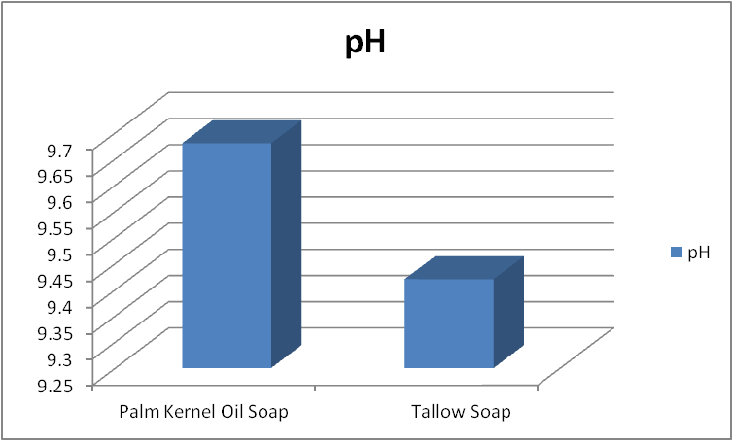
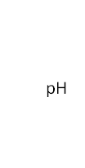

Figure 1: Column showing Palm kernel and Tallow oil soap

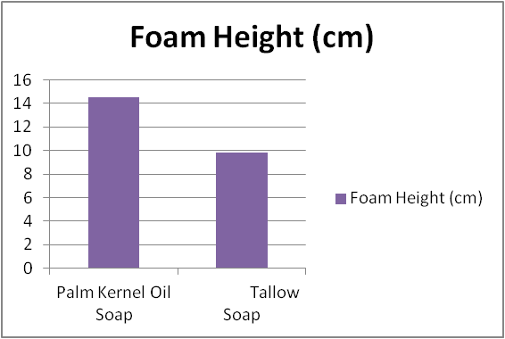


Figure2: Column Chart showing Foam height between Palm kernel and Tallow oil soap

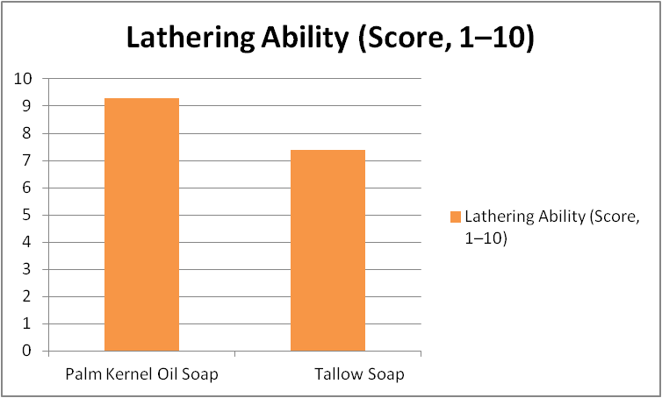


Figure3: Column chart showing Lathering ability between palm kernel and Tallow oil soap

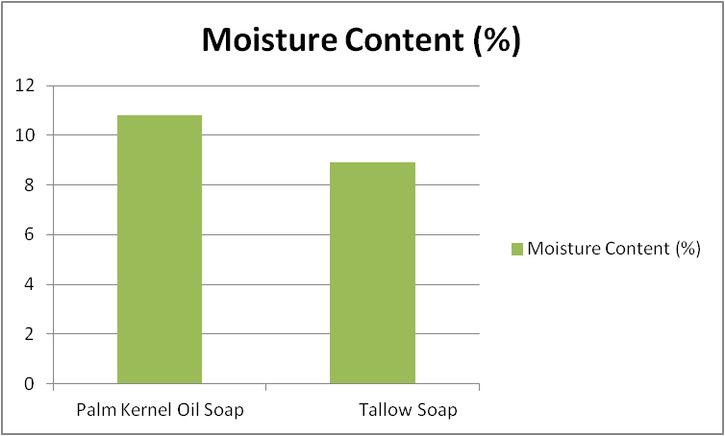


Figure 4:Column chart showing Moisture content between Palm kernel and Tallow oil soap

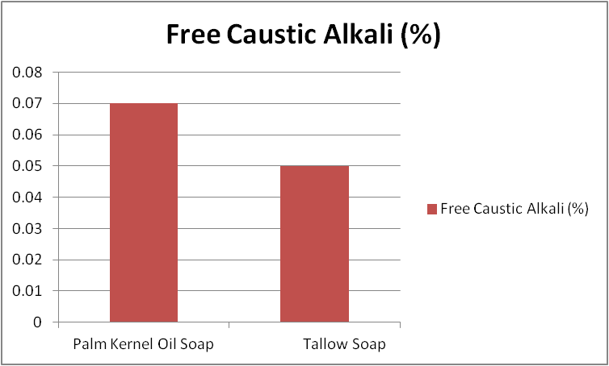


Figure 5: Column chart showing Free Caustic alkali between Palm kernel and Tallow oil soap

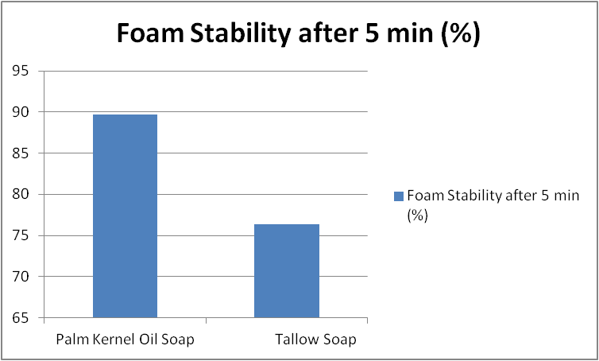


Figure 6:Column chart showing Foam stability between Palm kernel and Tallow oil soap
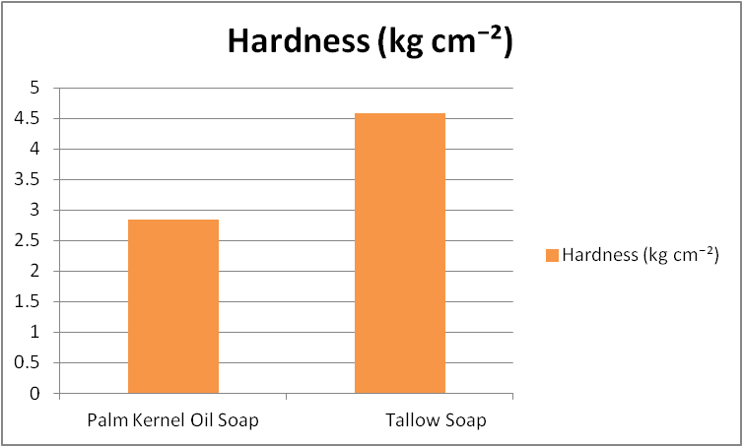


Figure 7: Column chart showing Hardness between Palm kernel and Tallow oil soap


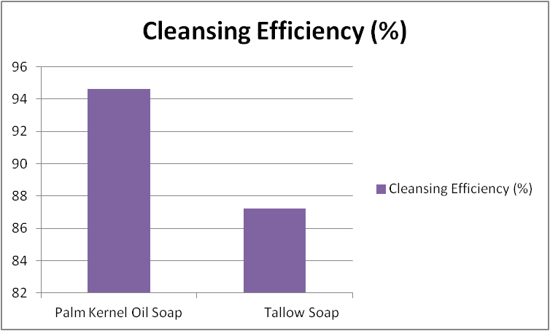

Figure 8:Column chart showing Cleansing efficiency between Palm kernel and Tallow oil soap

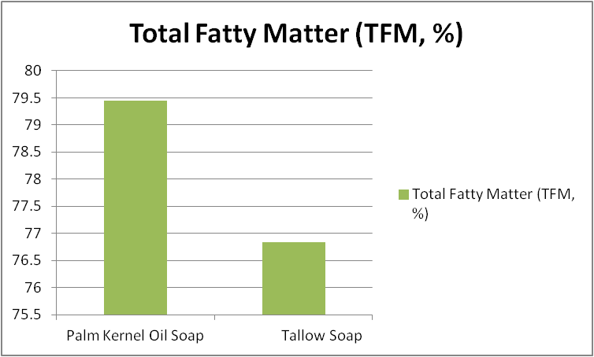
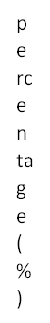

Figure 9: Column chart showing Total fatty acid between Palm kernel and Tallow oil

4. Conclusion
The study demonstrates that palm kernel oil and tallow can both serve as raw materials for soap production, but they produce soaps with different physicochemical characteristics. Palm kernel oil soap showed higher foam height, foam stability, total fatty matter, lathering ability, and cleansing efficiency, indicating stronger foaming and cleansing performance under the conditions used. Tallow soap showed greater hardness and lower moisture content, characteristics associated in this study with improved durability and slower dissolution during use. The pH values of both soaps were alkaline, while the measured free caustic alkali contents were low. Overall, the comparison confirms that the lipid source influences the balance of functional properties in the finished soap. Palm kernel oil is more suitable where foaming and cleansing characteristics are prioritised, whereas tallow is advantageous where hardness and durability are important. The results also indicate that combining the complementary characteristics of the two lipid sources may be considered when a balanced soap formulation is desired.

Limitation
This study compared soaps prepared only from palm kernel oil and tallow under the stated laboratory conditions. The assessment was limited to the selected physicochemical parameters and did not evaluate blended formulations, long-term storage stability, or broader performance conditions. The experiments were conducted in triplicate, and the findings therefore reflect the materials, preparation procedure, and analytical conditions used in this study. Further work may evaluate different blend ratios and additional quality parameters while maintaining comparable production conditions.

Declaration of AI Use

This manuscript was prepared through the intellectual contributions of the author(s) to the study design, data analysis, interpretation of results, and scholarly content. Grammarly and ChatGPT were used solely to assist with grammatical refinement and reference formatting during manuscript revision. The author(s) accept full responsibility for the accuracy, integrity, and final content of the manuscript.

REFERENCES

Oyekunle, J. A. O., Ore, O. T., Ogunjumelo, O. H., & Akanni, M. S. (2021). Comparative chemical analysis of indigenous Nigerian soaps with conventional ones. Heliyon, 7(4), e06689. https://doi.org/10.1016/j.heliyon.2021.e06689
Akpakpan, A. E., Udo, I. E., Uwanta, E. J., Akpanudo, N. W., Ikpe, E. E., Fatunla, O. K., Udoakpan, U. I., Sunday, D. G., Umoh, G. O., & Umo, A. M. (2024). Influence of operating variables on the adsorption of Pb²⁺ and Cd²⁺ from wastewater using Gmelina arborea Kraft lignin and its ester derivatives. Journal of Natural and Applied Sciences Pakistan, 6(2), 1950–1968.
Barel, A. O., Paye, M., & Maibach, H. I. (Eds.). (2014). Handbook of cosmetic science and technology (4th ed.). CRC Press. https://doi.org/10.1201/b16716
Cavitch, S. M. (1997). The soapmaker's companion: A comprehensive guide with recipes, techniques & know-how. Storey Publishing.
Gunstone, F. D., Harwood, J. L., & Dijkstra, A. J. (Eds.). (2007). The lipid handbook with CD-ROM (3rd ed.). CRC Press. https://doi.org/10.1201/9781420009675
Ikpe, E. E., Akpakpan, A. E., Akpan, P., Ukpong, E. G., & Okon, O. E. (2019). Evaluation of proximate composition of Callinectes sapidus, Procambarus clarkii and sediment from Qua Iboe River, Nigeria. International Journal of Advanced Research in Engineering Technology & Science, 6(4), 10–17.
Ikpe, E. E., Nsi, E. W., Udo, I. G., Akpan, A. O., Akpakpan, A. E., & Amayo, O. F. (2025). Investigation of total hydrocarbon contents and heavy metals in termitaria within Akwa Ibom State University, Ikot Akpaden, Nigeria. Asian Journal of Chemical Sciences, 15(4), 73–85. https://doi.org/10.9734/ajocs/2025/v15i4384
Imoisi, O. B., Ukhun, M. E., & Ikpe, E. E. (2020). Quality parameters of palm olein, palm kernel oil and its blends subjected to thermal stress using photometric technology. European Journal of Agriculture and Food Sciences, 2(5), 1–12. https://doi.org/10.24018/ejfood.2020.2.5.14
Knothe, G., Krahl, J., & Van Gerpen, J. (Eds.). (2010). The biodiesel handbook (2nd ed.). AOCS Press. https://doi.org/10.1016/C2015-0-02453-4
Betsy, K. J., Jilu, M., Fathima, R., & Varkey, J. T. (2013). Determination of alkali content & total fatty matter in cleansing agents. Asian Journal of Science and Applied Technology, 2(1), 8–12. https://doi.org/10.51983/ajsat-2013.2.1.755
Kuntom, A., Kifli, H., & Lim, P.-K. (1996). Chemical and physical characteristics of soap made from distilled fatty acids of palm oil and palm kernel oil. Journal of the American Oil Chemists' Society, 73(1), 105–108. https://doi.org/10.1007/BF02523455
Mabrouk, S. T. (2005). Making usable, quality opaque or transparent soap. Journal of Chemical Education, 82(10), 1534–1537. https://doi.org/10.1021/ed082p1534
Mitsui, T. (Ed.). (1997). New cosmetic science. Elsevier Science. https://doi.org/10.1016/B978-0-444-82654-1.X5000-5
Muhammed, H. A., Abdulrazaq, Y., Abdullah, S. S., & Adam, A. A. (2022). Formulation of laundry soap using locally made palm kernel oil in Nigeria. Dutse Journal of Pure and Applied Sciences, 8(1b), 51–57. https://doi.org/10.4314/dujopas.v8i1b.7
Ntuen, I. U., Akpakpan, A. E., Enin, G. N., Enengedi, I. S., Uwantta, E. J., Nsi, E. W., Udo, I. E., Ikpe, E. E., & Akpabio, U. D. (2024). Preparation and characterization of ink from Hibiscus sabdariffa, Curcuma longa, and Sorghum vulgare. Nepal Journal of Biotechnology, 12(2), 183–193. https://doi.org/10.54796/njb.v12i2.333
O'Brien, R. D. (2009). Fats and oils: Formulating and processing for applications (3rd ed.). CRC Press. https://doi.org/10.1201/9781420061673
Spitz, L. (Ed.). (2009). Soap manufacturing technology. AOCS Press.
Warra, A. A. (2013). A report on soap making in Nigeria using indigenous technology and raw materials. African Journal of Pure and Applied Chemistry, 7(4), 139–145. https://doi.org/10.5897/AJPAC11.016
Warra, A. A., Hassan, L. G., Gunu, S. Y., & Jega, S. A. (2010). Cold-process synthesis and properties of soaps prepared from different triacylglycerol sources. Nigerian Journal of Basic and Applied Sciences, 18(2), 315–321. https://doi.org/10.4314/njbas.v18i2.64350
Gold, I. L., Okunwaye, T., Onyia, D. C., Akpose, I. O., Imoisi, O. B., & Asiriuwa, N. U. (2024). Physicochemical properties of African black soap prepared with alkali derived from (empty) oil palm fruit bunches. Asian Journal of Research in Biochemistry, 14(4), 18–26. https://doi.org/10.9734/ajrb/2024/v14i4290
Egwuatu, C. I., Nnaji, C. E., Obumselu, O. F., & Okonkwo, C. P. (2026). Extraction and characterisation of oils from Cussonia bateri (Jansa) and Chrysobalanus icaco (Omillo) seeds as potential renewable resources. Journal of Applied Chemical Science International, 17(1), 26–38. https://doi.org/10.56557/jacsi/2026/v17i110188
Nova, J. F., Smrity, S. Z., Hasan, M., Tariquzzaman, M., Hossain, M. A. A., Islam, M. T., Islam, M. R., Akter, S., Rahi, M. S., Joy, M. T. R., & Kowser, Z. (2025). Comprehensive evaluation of physico-chemical, antioxidant, and antimicrobial properties in commercial soaps: A study on bar soaps and liquid hand wash. Heliyon, 11(4), e41614. https://doi.org/10.1016/j.heliyon.2024.e41614
Łusiak, P., Różyło, R., Mazur, J., Sobczak, P., & Matwijczuk, A. (2024). Evaluation of physical parameters and spectral characterization of the quality of soaps containing by-products from the food industry. Scientific Reports, 14, 4687. https://doi.org/10.1038/s41598-024-54794-3
Stănescu, V.-G., Popescu, V., Vasilache, V., Popescu, G., Rîmbu, C. M., & Popescu, A. (2025). Cleaner processes for making laundry soap from vegetable oils and an essential oil. Applied Sciences, 15(7), 3821. https://doi.org/10.3390/app15073821

