Diversity of Duckweed (Lemnaceae) in Water Bodies of Virudhunagar District, Tamil Nadu, India

ABSTRACT
Duckweeds are aquatic monocotyledonous herbs comprising five genera and 36 species. They commonly thrive in nutrient-rich water bodies such as brackish water, agricultural effluents, industrial wastewater and contaminated water sources. The objective of the present study was to document duckweed diversity in selected water bodies of Virudhunagar district and to identify the collected samples using their morphological, reproductive and microscopic characteristics. Duckweed diversity across the districts of Tamil Nadu has so far received little attention. To address this knowledge gap, a study of duckweed diversity and distinctiveness was conducted in various water bodies of Virudhunagar district, Tamil Nadu. The morphological and reproductive characteristics of the 11 collected samples were examined. On the basis of these characteristics and microscopic observations, three genera and five species were identified, namely Spirodela intermedia, Spirodela polyrhiza, Lemna gibba, Lemna aequinoctialis and Wolffia globosa. It was observed that Spirodela intermedia was the most dominant species, as it occurred in all three taluks, whereas Lemna aequinoctialis was the least frequent species, being recorded in only one taluk. The present study provides insight into the duckweed populations inhabiting the aquatic environments of Virudhunagar district, Tamil Nadu.
Key words: Duckweed; Lemnaceae; aquatic macrophytes; species diversity; morphological identification; microscopic characterisation; Spirodela intermedia; Lemna aequinoctialis; Wolffia globosa; Virudhunagar district
INTRODUCTION
The family Lemnaceae, commonly known as duckweeds or water lentils, comprises monocotyledonous aquatic plants belonging to the order Alismatales (Les et al., 2002; The Angiosperm Phylogeny Group, 2009). Although they are the smallest known flowering plants on Earth, they are remarkably ubiquitous and occur in water bodies throughout the world (Tippery & Les, 2020). Duckweeds are typically found in eutrophic or nutrient-rich environments, the only exception being the Polar Regions, which remain permanently frozen and lack open water. They adapt to a wide range of climates and geographical zones, although most species occur in tropical and temperate regions with moderate conditions (Skillicorn et al., 1993). Recent taxonomic studies indicate that the markedly reduced morphology of duckweeds can complicate species-level identification; consequently, integrated morphological and molecular approaches have been used to resolve closely related taxa and document regional diversity (Braglia et al., 2024; Romano et al., 2025; Stepanenko et al., 2025).
The growth and survival of Lemnaceae are governed by several environmental factors, including water temperature, pH, nutrient concentration, crowding caused by colony overgrowth, and competition with other plants for light and nutrients (Guha, 1997). Duckweed species grow best within a temperature range of 17.5 °C to 30 °C (Culley et al., 1981) and tolerate a wide pH range of 2 to 10, with optimal growth occurring between pH 6.5 and 8.0. This pH range favours the ammonium ion, which is the most readily available form of nitrogen for these plants (Jha & Pokharel, 2015). Laboratory cultivation of Lemna minor under different nutrient inputs has also shown treatment-associated variation in numerical abundance, supporting the sensitivity of duckweed growth to nutrient conditions (Ed-Idoko et al., 2024).
Lemnaceae reproduce predominantly by vegetative growth, whereas flowering and seed production, that is, sexual reproduction, occur less frequently (Landolt, 1998). In temperate regions, the survival of duckweeds during the winter months does not depend on seeds alone. Several duckweed species adapt to cold conditions by sinking to the bottom of the water body and transforming into specialised dormant structures called turions, which can withstand freezing temperatures (Kuehdorf et al., 2014). Furthermore, their dispersal is not limited to their own means of propagation; it may also be facilitated by biotic vectors such as migrating waterfowl. These birds can inadvertently transport duckweeds over long distances, either by carrying the small plants in their gastrointestinal tract or by allowing them to adhere to their bodies (Kimball et al., 2003; Green, 2016). Duckweeds are classified into two subfamilies, Lemnoideae and Wolffioideae. This group of aquatic plants comprises a total of five genera and 36 species; the subfamily Lemnoideae contains 15 species, while the subfamily Wolffioideae includes 21 species (Sree et al., 2016; Bog et al., 2020).
The present study provides valuable information on the diversity of duckweed populations in Virudhunagar district of Tamil Nadu, India. The findings show how duckweed species and their characteristics vary among different water bodies and locations within the district.
Recent wetland inventories in India have emphasised the value of site-specific surveys for documenting aquatic macrophyte diversity and establishing local ecological baselines (Doimari et al., 2024). However, information on the occurrence and morphological diversity of duckweeds in Virudhunagar district remains limited, particularly across the selected water bodies of Rajapalayam, Sivakasi and Srivilliputhur taluks.
Accordingly, the objective of the present study was to document duckweed diversity in selected water bodies of Virudhunagar district and to identify the collected samples using their morphological, reproductive and microscopic characteristics.

MATERIALS AND METHODS
Collection of duckweed
Duckweed species were collected from various water bodies, including ponds, springs, streams and waterholes, located in and around Virudhunagar district of Tamil Nadu. The survey sites were selected on the basis of the availability of duckweeds. They were collected in duplicate, each sample being placed in a 100 mL plastic container. The containers were refrigerated at approximately 10 °C and transported to the laboratory within 48 h of collection.
Sterilization and maintenance of the samples
The plants were washed in tap water and sterilised with 0.5% sodium hypochlorite, in which they were immersed for 30 s (Friedjung Yosef et al., 2022). The cleaned fronds were then transferred to Hoagland nutrient medium (Hoagland & Snyder, 1933); the composition of the growth medium is given in Table 1. Daughter plants were maintained as stock cultures under illumination at a light intensity of 100 µmol m⁻² s⁻¹ provided by fluorescent tubes (18 W/54) at 25 °C (McLaren & Smith, 1976). Individual fronds were selected for the experiments. This procedure ensured proper growth and maintenance of the plants.
Identification of the samples
The collected duckweed strains were identified manually, and the samples were assigned to genus and species primarily on the basis of their morphological characteristics (Les et al., 1997; Azer, 2013; Bog et al., 2020). A light microscope and a magnifying lens were used to examine the morphological features. The different parts of each duckweed sample, namely the fronds, papillae, root tip, root sheath and turions, were examined before identification. Each sample was identified at the genus and species level on the basis of the number of roots, the number of frond veins, the size and pattern of the fronds, the root sheath, the root tip and other related characteristics.
RESULTS
The duckweed species were collected from water bodies at Sivakasi, Rajapalayam, Srivilliputhur, Chatrapatti and Mamsapuram in Virudhunagar district of Tamil Nadu. Five species belonging to three genera were identified, namely Spirodela intermedia, Spirodela polyrhiza, Lemna gibba, Lemna aequinoctialis and Wolffia globosa. The collection sites and the duckweed diversity recorded in the water bodies of the Rajapalayam, Sivakasi and Srivilliputhur taluks of Virudhunagar district are presented in Figure 1. The collection sites, number of strains and population levels are given in Table 2, and the corresponding location maps are presented in Figure 2. The dominant duckweed species of the four locations are described below. Prominent morphological characters, such as frond shape, rhizoids, frond apex, turions and the presence or absence of internal structures, clearly distinguished the duckweed clones. In the present study, variation in the number of roots, the internal structure of the fronds and the frond shape contributed significantly to the identification of the individual propagules. The principal characteristics of all the species collected are summarised in Table 3.
Species identification and characterisation
Spirodela intermedia
Spirodela intermedia was a free-floating aquatic species whose leaves were modified into fronds. Under the light microscope, the fronds were found to possess 12–16 veins. No papillae (small projections) were observed on the dorsal (upper) surface of the fronds. The frond margin was entire, without indentations. The budding pouch was deltoid (triangular) in shape and occurred in two portions. The frond apex was of the elongate type. Turions, which are seed-like overwintering structures, were absent in this species. The species bore 16–20 roots, up to 4 cm in length. The root sheath was wingless and the root tip was acute (pointed).
Spirodela polyrhiza
Spirodela polyrhiza is a free-floating aquatic plant. It consists of a single thallus, typically 3–9 mm in size, with an oval to obovate shape. The upper surface of the thallus is generally green and contains numerous air spaces, which enable the plant to float, whereas the lower surface is purple owing to pigmentation. Approximately 5–11 veins arise from the node at the base of the thallus, together with about 11 very thin and slender roots (rhizoids) up to 10 mm long, with pointed or blunt tips. The root sheath lacks wings. Daughter fronds are produced by budding at the point where the roots are attached to the parent plant. Spirodela polyrhiza exhibits a form of vegetative propagation in which temporary clusters of two to four thalli are formed, which eventually separate into individual plants. The plant also produces small structures called turions, which are olive to pale green or brownish in colour. During winter, the turions develop on the underside of the thallus, close to the node from which the rootlets arise. The turions detach from the parent plant and sink to the bottom of the water body, where they remain throughout the winter. In spring, they rise back to the water surface and resume growth.
Lemna gibba
The thallus of Lemna gibba is obovate to almost round and typically measures 2–10 mm in length and 1.5–8 mm in breadth. On the lower surface, the thallus is markedly inflated (gibbous) and thick. The upper surface is flat to slightly convex and usually green, whereas the lower surface has a purple to reddish-purple tint owing to the presence of anthocyanin pigments. Each thallus bears a single unbranched root that may grow up to 10 cm in length. These slender roots are frequently reddish purple in colour.
Lemna aequinoctialis
Lemna aequinoctialis has a prominent winged root sheath near the basal attachment node. One of the distinctive features of this species is a conspicuous apical papule on the upper surface of the frond. It bears a single rhizoid with an obtuse root tip. The air-space layer is well defined and consists of one to three layers. Anthocyanin pigmentation was observed in this species. The maximum number of frond veins was one, and the epidermal cell wall was distinct.
Wolffia globosa
Wolffia globosa was identified as a free-floating species. The surface of the fronds was globose (spherical), and the fronds were nerveless, that is, they lacked distinct veins. The frond apex was elongate. The species possessed a single, conical budding pouch. Minute turions, the seed-like overwintering structures, were present. On completion of its life cycle, the plant became submerged. This species completely lacked root structures, including the root tip, root sheath and other root features.
DISCUSSION
A comparable study was carried out by Landolt (1975), who used morphological characterisation and geographical distribution to identify duckweed species, particularly those belonging to the genus Lemna. In that study, species were identified on the basis of habit, morphological and anatomical characters, pigments and reproductive characteristics.
Zhuang (2011) reported that Spirodela is distributed across North and South America as well as parts of Europe, and that its abundance varies with habitat, including lakes, ponds, river backwaters and marshes. Flower and turion formation were also reported to be influenced by the habitat and by the nutrient composition of the water body. Lemon and Posluszny (2000) showed that this plant tends to produce propagules by asexual reproduction, with fronds formed by branching followed by fragmentation of the shoots into separate units. They further observed that the growth rate of the plant was very rapid and that its doubling time under optimal conditions was short. In the present study, the Spirodela species collected grew mainly in brackish, contaminated and nutrient-rich water, since such habitats contain higher nutrient levels than other freshwater habitats. Azer (2013), who also studied the classification of the genus Lemna, grouped its species into three clusters on the basis of morphological and anatomical characters. The first cluster comprised L. gibba and L. minor, while the second and third clusters included L. trisulca and L. aequinoctialis. In contrast, Bog et al. (2010) divided the genus Lemna into four sections and suggested that L. gibba and L. minor share several morphological characteristics.
Al-Dakhil et al. (2021) reported the traits of duckweed samples collected from different locations in Saudi Arabia (Riyadh, Dhahran, Tohama, Al-Baha and Al-Taif). Distinctive traits such as longer roots and fronds with a higher number of veins were pronounced in L. minor and less pronounced in L. gibba, but were not observed in L. aequinoctialis and L. trisulca. More recently, various plastid markers have been widely used to identify duckweed clones, because limited experience and expertise restrict identification based on morphology and anatomy alone.
Kaplan et al. (2019) studied Wolffia globosa, which grows in mats on the surface of calm freshwater bodies such as ponds, lakes and marshes. It is an extremely small, oval plant that lacks leaves, stems and roots. The plant body, known as a frond, is translucent green and measures less than a millimetre in width. Wolffia globosa has been described as the smallest flowering plant in the world, with a diameter of only 0.1–0.2 mm (0.004–0.008 inches). The present study recorded similar characteristics for W. globosa, which are consistent with the observations of Kaplan et al. (2019).

CONCLUSION
Microscopic examination and morphological characterisation of the 11 collected duckweed samples documented three genera and five species in the surveyed water bodies of Virudhunagar district, Tamil Nadu: Spirodela intermedia, Spirodela polyrhiza, Lemna gibba, Lemna aequinoctialis and Wolffia globosa. Species identification was supported by observable differences in frond form and venation, root number and structure, papillae, budding pouches, turions and other diagnostic characteristics. Spirodela intermedia was the most prevalent species in the survey, occurring in Rajapalayam, Sivakasi and Srivilliputhur taluks, whereas Lemna aequinoctialis was recorded in only one taluk. The study therefore provides a locality-based account of duckweed diversity and morphological variation in selected aquatic habitats of the district. These observations establish descriptive baseline information on Lemnaceae in the surveyed area and may support future taxonomic and ecological work examining the distribution and variation of duckweed populations in Virudhunagar district using broader sampling and complementary identification approaches. The documented records also provide a reference point for subsequent surveys of duckweed occurrence within the district.
Limitation
This study was restricted to selected water bodies in Virudhunagar district and to sites where duckweeds were available during the survey. Species identification was based primarily on morphological, reproductive and microscopic characteristics of the collected samples. Accordingly, the recorded diversity represents the surveyed locations and samples rather than a complete inventory of all water bodies in the district. The findings should therefore be interpreted as a locality-based baseline for the sampled habitats.
Declaration of AI Use

This manuscript was prepared through the intellectual contributions of the author(s) to the study design, data analysis, interpretation of results, and scholarly content. Grammarly and ChatGPT were used solely to assist with grammatical refinement and reference formatting during manuscript revision. The author(s) accept full responsibility for the accuracy, integrity, and final content of the manuscript.

REFERENCES
Al-Dakhil, M., Alghamdi, S., Migdadi, H., Afzal, M., & Ali, A. A. (2021). Morphological characterization and DNA barcoding of duckweed species in Saudi Arabia. Plants, 10(11), 2438. https://doi.org/10.3390/plants10112438
The Angiosperm Phylogeny Group. (2009). An update of the Angiosperm Phylogeny Group classification for the orders and families of flowering plants: APG III. Botanical Journal of the Linnean Society, 161(2), 105–121. https://doi.org/10.1111/j.1095-8339.2009.00996.x
Azer, S. A. (2013). Taxonomic revision of genus Lemna L. (Lemnaceae Gray) in Egypt. Annals of Agricultural Sciences, 58(2), 257–263. https://doi.org/10.1016/j.aoas.2013.07.015
Bog, M., Baumbach, H., Schween, U., Hellwig, F., Landolt, E., & Appenroth, K.-J. (2010). Genetic structure of the genus Lemna L. (Lemnaceae) as revealed by amplified fragment length polymorphism. Planta, 232, 609–619. https://doi.org/10.1007/s00425-010-1201-2
Bog, M., Sree, K. S., Fuchs, J., Hoang, P. T. N., Schubert, I., Kuever, J., Rabenstein, A., Paolacci, S., Jansen, M. A. K., & Appenroth, K.-J. (2020). A taxonomic revision of Lemna sect. Uninerves (Lemnaceae). Taxon, 69(1), 56–66. https://doi.org/10.1002/tax.12188
Braglia, L., Ceschin, S., Iannelli, M. A., Bog, M., Fabriani, M., Frugis, G., Gavazzi, F., Gianì, S., Mariani, F., Muzzi, M., Pelella, E., & Morello, L. (2024). Characterization of the cryptic interspecific hybrid Lemna × mediterranea by an integrated approach provides new insights into duckweed diversity. Journal of Experimental Botany, 75(10), 3092–3110. https://doi.org/10.1093/jxb/erae059
Culley, D. D., Jr., Rejmánková, E., Květ, J., & Frye, J. B. (1981). Production, chemical quality and use of duckweeds (Lemnaceae) in aquaculture, waste management, and animal feeds. Journal of the World Mariculture Society, 12(2), 27–49. https://doi.org/10.1111/j.1749-7345.1981.tb00273.x
Doimari, R., Konwar, S., Dutta, A. J., Sinha, D., Daflari, K. D., & Das, M. J. (2024). Checklist of aquatic macrophytes and water quality assessment of Kakarikata Beel, Majuli District, Assam. Uttar Pradesh Journal of Zoology, 45(19), 10–16. https://doi.org/10.56557/upjoz/2024/v45i194493
Ed-Idoko, J. O., Apochi, J. O., Onah, M. O., & Ibrahim, U. O. (2024). Culturing of duckweed (Lemna minor) under different chicken manure concentration in the lab. Asian Journal of Fisheries and Aquatic Research, 26(11), 129–137. https://doi.org/10.9734/ajfar/2024/v26i11836
Friedjung Yosef, A., Ghazaryan, L., Klamann, L., Kaufman, K. S., Baubin, C., Poodiack, B., Ran, N., Gabay, T., Didi-Cohen, S., Bog, M., Khozin-Goldberg, I., & Gillor, O. (2022). Diversity and differentiation of duckweed species from Israel. Plants, 11(23), 3326. https://doi.org/10.3390/plants11233326
Green, A. J. (2016). The importance of waterbirds as an overlooked pathway of invasion for alien species. Diversity and Distributions, 22(2), 239–247. https://doi.org/10.1111/ddi.12392
Guha, R. (1997). Duckweeds. ENVIS Newsletter, 5–9. Indian Institute of Science.
Hoagland, D. R., & Snyder, W. C. (1933). Nutrition of strawberry plant under controlled conditions: (a) Effects of deficiencies of boron and certain other elements, (b) susceptibility to injury from sodium salts. Proceedings of the American Society for Horticultural Science, 30, 288–294.
Jha, S., & Pokharel (Bhattarai), B. (2015). Duckweed: The hidden treasure. Nepalese Journal of Biosciences, 5(1), 1–20. https://doi.org/10.3126/njbs.v5i1.41719
Kaplan, A., Zelicha, H., Tsaban, G., Yaskolka Meir, A., Rinott, E., Kovsan, J., Novack, L., Thiery, J., Ceglarek, U., Burkhardt, R., Willenberg, A., Tirosh, A., Cabantchik, I., Stampfer, M. J., & Shai, I. (2019). Protein bioavailability of Wolffia globosa duckweed, a novel aquatic plant—A randomized controlled trial. Clinical Nutrition, 38(6), 2576–2582. https://doi.org/10.1016/j.clnu.2018.12.009
Kimball, R. T., Crawford, D. J., Les, D. H., & Landolt, E. (2003). Out of Africa: Molecular phylogenetics and biogeography of Wolffiella (Lemnaceae). Biological Journal of the Linnean Society, 79(4), 565–576. https://doi.org/10.1046/j.1095-8312.2003.00210.x
Kuehdorf, K., Jetschke, G., Ballani, L., & Appenroth, K.-J. (2014). The clonal dependence of turion formation in the duckweed Spirodela polyrhiza—An ecogeographical approach. Physiologia Plantarum, 150(1), 46–54. https://doi.org/10.1111/ppl.12065
Landolt, E. (1975). Morphological differentiation and geographical distribution of the Lemna gibba–Lemna minor group. Aquatic Botany, 1, 345–363. https://doi.org/10.1016/0304-3770(75)90036-4
Landolt, E. (1998). Lemnaceae. In K. Kubitzki (Ed.), Flowering plants. Monocotyledons: Alismatanae and Commelinanae (except Gramineae) (pp. 264–270). Springer. https://doi.org/10.1007/978-3-662-03531-3_28
Lemon, G. D., & Posluszny, U. (2000). Comparative shoot development and evolution in the Lemnaceae. International Journal of Plant Sciences, 161(5), 733–748. https://doi.org/10.1086/314298
Les, D. H., Landolt, E., & Crawford, D. J. (1997). Systematics of the Lemnaceae (duckweeds): Inferences from micromolecular and morphological data. Plant Systematics and Evolution, 204, 161–177. https://doi.org/10.1007/BF00989203
Les, D. H., Crawford, D. J., Landolt, E., Gabel, J. D., & Kimball, R. T. (2002). Phylogeny and systematics of Lemnaceae, the duckweed family. Systematic Botany, 27(2), 221–240. https://doi.org/10.1043/0363-6445-27.2.221
McLaren, J. S., & Smith, H. (1976). The effect of abscisic acid on growth, photosynthetic rate and carbohydrate metabolism in Lemna minor L. New Phytologist, 76(1), 11–20. https://doi.org/10.1111/j.1469-8137.1976.tb01433.x
Romano, L. E., Braglia, L., Iannelli, M. A., Lee, Y., Gianì, S., Gavazzi, F., & Morello, L. (2025). A survey of duckweed species in Southern Italy provided first distribution records of the hybrid Lemna × mediterranea in nature. Perspectives in Plant Ecology, Evolution and Systematics, 67, 125863. https://doi.org/10.1016/j.ppees.2025.125863
Skillicorn, P., Spira, W., & Journey, W. (1993). Duckweed aquaculture: A new aquatic farming system for developing countries. World Bank. https://documents.worldbank.org/en/publication/documents-reports/documentdetail/499791468739284085
Sree, K. S., Bog, M., & Appenroth, K.-J. (2016). Taxonomy of duckweeds (Lemnaceae), potential new crop plants. Emirates Journal of Food and Agriculture, 28(5), 291–302. https://doi.org/10.9755/ejfa.2016-01-038
Stepanenko, A., Braglia, L., Fuchs, J., Schubert, V., Hoang, P. T. N., Lee, Y., Chen, G., Gianì, S., Morello, L., & Schubert, I. (2025). Genome diversity and evolution of the duckweed section Alatae comprising diploids, polyploids, and interspecific hybrids. The Plant Journal, 122(2), e70158. https://doi.org/10.1111/tpj.70158
Tippery, N. P., & Les, D. H. (2020). Tiny plants with enormous potential: Phylogeny and evolution of duckweeds. In X. Cao, P. Fourounjian, & W. Wang (Eds.), The duckweed genomes (pp. 19–38). Springer. https://doi.org/10.1007/978-3-030-11045-1_2
Zhuang, X. (2011). Spirodela polyrhiza. The IUCN Red List of Threatened Species 2011, e.T164229A5788133. https://doi.org/10.2305/IUCN.UK.2011-1.RLTS.T164229A5788133.en

Nutrients | Stock solution | Use (mL/L)
Macronutrients:  MgSO₄·7H₂O  Ca(NO₃)₂·4H₂O  KH₂PO₄  KNO₃. | g/100 mL  24.6  23.6  13.6  10.1 | 1  2.3  0.5  2.5
Micronutrients:  H₃BO₃  MnCl₂·4H₂O  ZnSO₄·7H₂O  Na₂MoO₄·2H₂O  CuSO₄·5H₂O | g/L  2.86  1.82  0.22  0.09  0.09 | 0.5
Fe.EDTA solution:  FeCl3·6H₂O  EDTA | g/100 mL  0.121  0.375 | 20
Table1. Composition of the Hogland nutrient solutions used in duckweed culture maintenance.

Species | No.of strains | Location | Populations
Wolffia globosa | 2 | Chatrapatti, Sivakasi | ++
Lemna aequinoctialis | 1 | Rajapalayam | +
Lemna gibba | 2 | Rajapalayam | ++
Spirodelapolyrhiza | 2 | Keelarajakularaman, Rajapalayam | ++
Spirodela intermedia | 4 | Rajapalayam, Srivilliputur, M.K.pudupatti, Sivakasi. | +++
Table2. Collected species among different locations of Rajapalayam, Srivilliputhur and Sivakasi taluks.*+ - low, ++ - moderate, +++ - high.

S. No | Characters | Spirodelapolyrrhiza | Spirodelapunctata | Lemna  gibba | Lemnaa equinotialis | Wolffia globosa
 | Habitat | Aquatic | Aquatic | Aquatic | Aquatic | aquatic
 | Frond | Floating | Floating | Floating | Floating | Free floating,
 | Seasonality | Perennial | Perennial | Seasonal | Seasonal | Seasonal
 | Fronds | Flat | Inflated | Inflated | Flat | Minute, globose
 | Fronds margin | Entire | Entire | Entire | Entire | Entire
 | Rhizoids | 13 | 8 | single | single | absent
 | Root tip | Acute | Acute | Obtuse | Obtuse | Absent
 | Maximum number of frond nerves | 16 | 7 | 3 | 1 | Nerveless
 | Root sheath | wingless | winged | winged | wingless | Absent
 | Number of fronds | 4-5 | 4-5 | 3-4 | 3-4 | Vary
 | No of air space layers | Present  2-3 | Present  2-3 | Present  1-3 | Present  1-3 | No distinct air space
 | Pigment cells | Present throughout | Present throughout | Present | present | Present
 | Anthocyanin | Present | present | present | present | Absent
 | Epidermal cell wall | Straight to slightly undulated | Straight to slightly undulated | Distinctly undulated | Distinctly undulated | Single-layered, thin epidermis
 | Root trachids | Present | present | absent | absent | Absent
Table3. Important and highlighted characteristics of collected species.

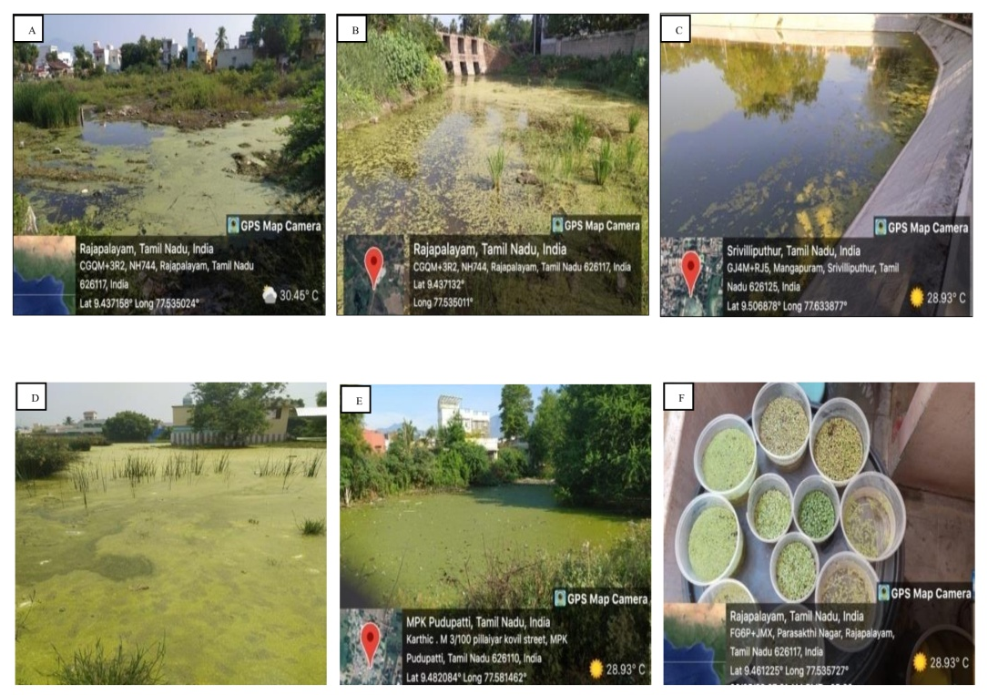

Figure1 .Collected locations of duckweeds from the water bodies of Rajapalayam, Sivakasi, Srivilliputhur taluks of Virudhunagar district, Tamil Nadu.

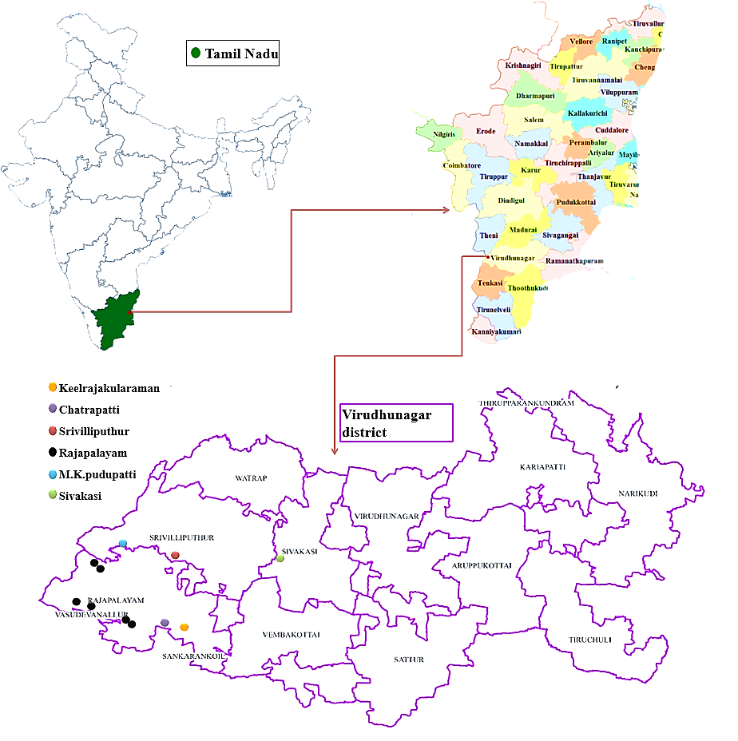
Figure2. The collected locations of Duckweed species in taluks (Rajapalayam, Srivilliputhur and Sivakasi) of Virudhunagar district, Tamilnadu.

