Physicochemical Characterization, Soil Acidity Status and Fertility Constraints of Inland Valley Swamp Soils in Moyamba District, Sierra Leone

ABSTRACT
Inland Valley Swamp (IVS) soils are important for rice production in Sierra Leone, but their acidity and associated fertility constraints can vary substantially among sites. This study characterised the physicochemical properties, acidity status and major fertility limitations of selected IVS soils in Moyamba District to support site-specific soil management. Fifty-one IVS sites were sampled during February and March 2024. At each site, ten soil cores from a depth of 0–20 cm were composited, air-dried and sieved to 2 mm before laboratory analysis. Soil pH, exchangeable acidity and Al, available P, organic C, exchangeable Ca and Mg, and particle-size distribution were determined. Descriptive statistics, Pearson correlation analysis, principal component analysis, cluster analysis and a composite constraint-priority framework were applied. Soil pH ranged from 3.90 to 6.65, with a mean of 4.79 ± 0.54, and 80.4% of the sites were strongly or very strongly acidic. Low Mg affected all sites, while very low available P, low Ca, high or very high exchangeable acidity, and high Al saturation affected 78.43%, 54.90%, 49.02% and 25.49% of sites, respectively. Three principal components explained 69.72% of the total variance, four clusters defined contrasting management domains, and 88.2% of sites had high or very high management priority. These findings indicate that acidity management should be integrated with P, Ca and Mg management and tailored to site-specific soil conditions.

Keywords: inland valley swamp; soil acidity; exchangeable aluminium; phosphorus deficiency; soil fertility; rice soils

1. INTRODUCTION
Rice (Oryza sativa L.) is Sierra Leone's principal staple crop and is central to food security, rural livelihoods and national agricultural development. Inland Valley Swamps (IVSs) are particularly important because their comparatively dependable water supply creates opportunities for intensified lowland rice production. However, IVS productivity is spatially variable, and the assumption that valley-bottom soils are uniformly fertile is not supported by field evidence from Sierra Leone. Hydrology, land use, sediment movement, weathering and nutrient management can generate marked differences in soil organic carbon, available phosphorus and other fertility indicators over short distances (Dossou-Yovo et al., 2017).
Soil acidity is a major concern in humid tropical environments because intense weathering and rainfall promote the leaching of basic cations while increasing the relative importance of H and Al on soil exchange sites. At low pH, Al toxicity, phosphorus fixation and deficiencies of Ca and Mg may occur simultaneously, restricting root development and nutrient-use efficiency. Liming can alleviate these constraints, but its effectiveness depends on soil buffering capacity, exchangeable acidity, nutrient status and crop requirements; indiscriminate or blanket application may therefore be inefficient (Fageria & Baligar, 2008). Recent global evidence further indicates that responses to soil acidification mitigation are strongly influenced by initial soil properties, supporting diagnosis-based rather than uniform amendment strategies (Xu et al., 2025). Recent research in acidic rice soils also supports calcium-based amendments for managing soil acidity while improving nutrient availability (Amalendu et al., 2026).
West African lowland soils commonly have low pH, available P, exchangeable Ca and Mg, effective cation exchange capacity and clay content, reflecting strongly weathered mineralogy and high leaching intensity (Abe et al., 2010). In flooded rice systems, interpretation is more complex because submergence can raise the pH of initially acidic soils and alter the availability of P, Fe, Mn and other elements (Ponnamperuma, 1972). Consequently, pre-flooding soil pH is best interpreted together with exchangeable acidity, Al saturation, base status, nutrient supply and hydrological context.
Despite the strategic importance of IVSs for rice production, field-scale information on the severity and spatial distribution of acidity and associated fertility constraints remains limited for Moyamba District. This study therefore characterised the physicochemical properties, acidity status and fertility constraints of 51 IVS soils and used multivariate analysis to identify major soil gradients and practical management domains. The results provide the diagnostic foundation for subsequent lime-requirement calibration and site-specific soil fertility management.

2. MATERIALS AND METHODS

2.1 Study Area
The study was conducted in Moyamba District in south-western Sierra Leone, approximately 7.55°-8.45° N and 11.70°-13.05° W. The district has a humid tropical monsoon climate, with a rainy season from May to October and a dry season from November to April. The landscape contains extensive inland valley systems that receive water from rainfall, surface runoff, shallow groundwater and localised stream inflow. The selected IVSs represented a range of hydrological and land-use conditions across the district.
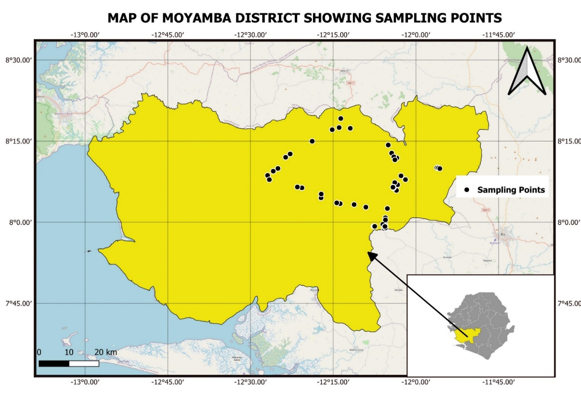
Figure 1. Moyamba District showing the locations of the selected IVS sampling sites.

2.2 Site Selection and Soil Sampling
A total of 51 IVS sites were purposively selected to capture ecological and management variability across Moyamba District. Selection considered hydrological regime (permanently flooded, seasonally flooded and comparatively well-drained swamps), land-use history (cultivated and fallow systems), geographic distribution, accessibility and suitability for future monitoring. At each site, ten soil cores were collected from the 0-20 cm layer and composited to represent the active rice root zone. Samples were labelled and transported to the Njala University Quality Control Laboratory for analysis.

2.3 Sample Preparation and Laboratory Analysis
Samples were air-dried at room temperature, gently crushed, passed through a 2-mm sieve and stored in clean labelled containers. Particle-size distribution was determined by the hydrometer method (Bouyoucos, 1962). Soil pH was measured potentiometrically in distilled water at a 1:1 soil-to-water ratio. Exchangeable acidity and exchangeable Al were determined by extraction followed by titration. Soil organic carbon was determined by the Walkley-Black wet-oxidation method (Walkley & Black, 1934), total N by Kjeldahl digestion, and available P by the Bray I extraction method (Bray & Kurtz, 1945). Exchangeable Ca and Mg were extracted and quantified using standard soil analytical procedures.

2.4 Derived Indicators and Soil-Constraint Classification
Measured soil properties were used to derive effective cation exchange capacity (ECEC), Al saturation, acidity saturation, base saturation and Ca:Mg ratio. Soil pH classes were assigned from neutral to very strongly acidic using the classification applied in the study. Major fertility constraints were summarised as frequency counts for strong/very strong acidity, high/very high exchangeable acidity, high Al saturation, very low available P, low Ca and very low/low Mg. A composite constraint score was used to rank sites into moderate, high and very high management-priority classes.

2.5 Statistical Analysis
Data were summarised using minimum, maximum, mean, standard deviation, standard error, coefficient of variation, skewness and kurtosis. Pearson correlation analysis was used to examine relationships among acidity, nutrient, base-status and textural variables. Principal component analysis was applied to reduce the measured soil variables to major multivariate gradients, and components with eigenvalues greater than 1 were retained for interpretation. Cluster analysis grouped sites into four soil-management domains based on their combined physicochemical characteristics. Analyses were conducted in R 453;.

3. RESULTS AND DISCUSSION

3.1 Descriptive Variability of Soil Properties
The 51 IVS soils were generally acidic and highly heterogeneous in several fertility indicators (Table 1). Soil pH ranged from 3.90 to 6.65 and averaged 4.79 ± 0.54, with relatively low variability (CV = 11.23%). In contrast, exchangeable acidity and exchangeable Al had CVs of 64.02% and 55.85%, respectively. Thus, sites with broadly similar pH could differ substantially in chemically active acidity and potential Al stress. This reinforces the need to diagnose acid soils using multiple indicators rather than pH alone (Fageria & Baligar, 2008).
Table 1. Descriptive statistics of selected IVS soil physicochemical properties.
Soil property | n | Minimum | Maximum | Mean ± SD | SE | CV (%)
pH | 51 | 3.90 | 6.65 | 4.79 ± 0.54 | 0.08 | 11.23
Exchangeable acidity | 51 | 0.30 | 7.10 | 2.23 ± 1.43 | 0.20 | 64.02
Exchangeable Al | 51 | 0.00 | 1.20 | 0.46 ± 0.26 | 0.04 | 55.85
Available P | 51 | 0.28 | 10.55 | 2.79 ± 2.82 | 0.40 | 101.16
Organic C | 51 | 0.11 | 14.85 | 5.38 ± 3.26 | 0.46 | 60.55
Exchangeable Ca | 51 | 0.47 | 7.69 | 2.18 ± 1.25 | 0.18 | 57.54
Exchangeable Mg | 51 | 0.07 | 0.44 | 0.18 ± 0.07 | 0.01 | 41.55
Sand (%) | 51 | 51.96 | 89.96 | 76.00 ± 8.03 | 1.13 | 10.57
Silt (%) | 51 | 3.40 | 27.40 | 8.38 ± 4.55 | 0.64 | 54.29
Clay (%) | 51 | 6.64 | 24.64 | 15.62 ± 4.99 | 0.70 | 31.92
Note: available P is reported in mg kg⁻¹; exchangeable acidity, Al, Ca and Mg are reported in cmol kg⁻¹ soil.
Available P was the most variable measured property (CV = 101.16%), with a mean of 2.79 ± 2.82 mg kg⁻¹, indicating both widespread deficiency and strong spatial heterogeneity. Exchangeable Ca averaged 2.18 ± 1.25, while Mg averaged only 0.18 ± 0.07. The soils were strongly sand-dominated (mean 76.0% sand), consistent with the low nutrient-retention potential reported for many West African lowlands where quartz and low-activity kaolinitic minerals predominate (Abe et al., 2010). These properties suggest that acidity correction alone will not fully address fertility limitations; nutrient replacement and strategies that reduce leaching losses are also required.

3.2 Distribution of Soil Acidity Classes
Strongly acidic soils accounted for 52.9% of sites and very strongly acidic soils for 27.5%; consequently, 80.4% of sampled sites belonged to the two most acidic classes (Figure 2). Only 13.7% were moderately acidic, 3.9% slightly acidic and 2.0% neutral. The distribution confirms that acidity is a district-wide constraint rather than a problem driven by a few extreme sites.
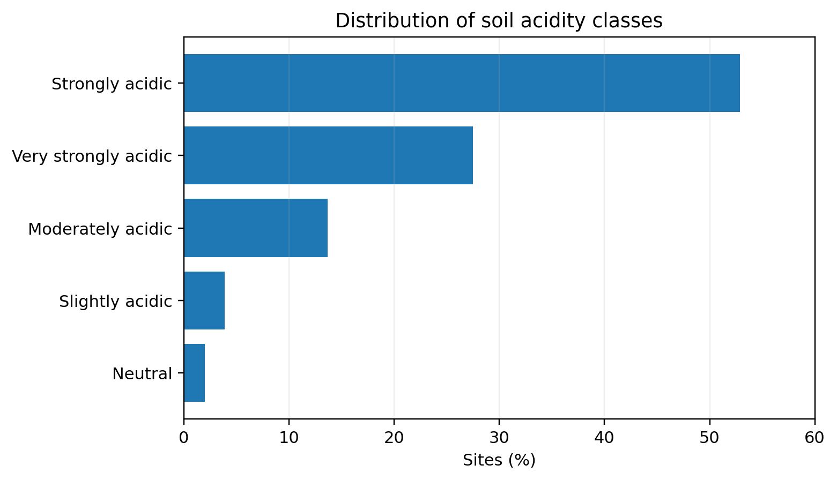
Figure 2. Distribution of soil acidity classes across the 51 IVS sites.
The agronomic interpretation of these values must nevertheless recognise the flooded nature of IVS rice production. Flooding generally shifts the pH of acid soils toward neutrality through reduction reactions and changes the solubility of P, Fe and Mn (Ponnamperuma, 1972). Hence, the pre-flooding pH values reported here are indicators of intrinsic acidity and potential amendment need, but not necessarily the pH experienced throughout the submerged rice-growing period. This supports the need for subsequent lime-incubation and field calibration under representative water regimes.

3.3 Soil Texture Classes and Fertility Implications
Sandy loam was the dominant textural class (45.10%), followed by sandy clay loam (29.41%), loamy sand (23.53%) and sand (1.96%) (Figure 3). The high prevalence of coarse-textured soils is consistent with the mean particle-size composition in Table 1 and has important consequences for nutrient and amendment management. Coarse-textured tropical soils have relatively low nutrient-holding capacity and may lose base cations rapidly under high rainfall, helping to explain the frequent occurrence of low Ca and Mg.
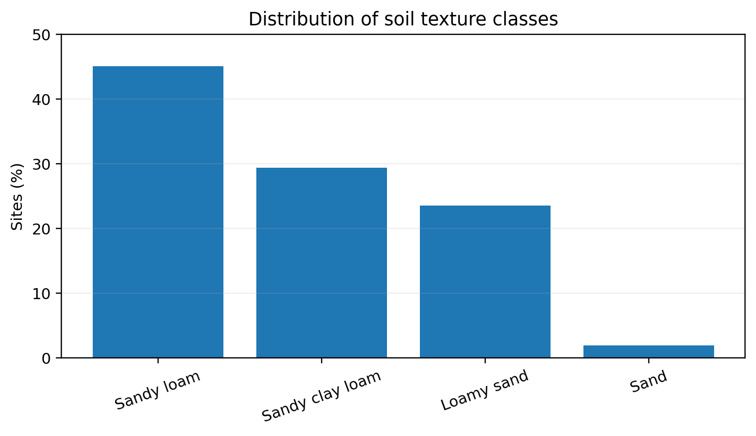
Figure 3. Distribution of soil texture classes across the study sites.

3.4 Frequency of Major Soil Fertility Constraints
The diagnostic survey revealed that low pH was only one component of a broader fertility problem (Figure 4). Very low or low Mg affected all 51 sites (100%), strong or very strong acidity affected 80.39%, and very low available P affected 78.43%. Low Ca occurred at 54.90% of sites, high/very high exchangeable acidity at 49.02%, and high Al saturation at 25.49%. The universal Mg limitation is particularly important because Mg is mobile in strongly leached soils and its availability can be reduced by soil acidity and cation competition (Gransee & Führs, 2013).
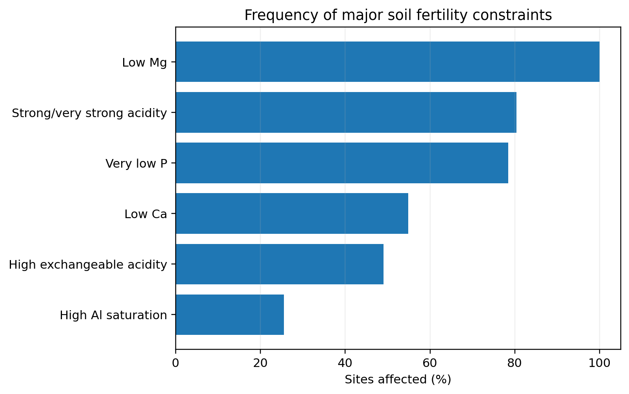
Figure 4. Frequency of major soil fertility constraints across the 51 IVS sites.
The high frequency of very low P is consistent with earlier work in Sierra Leone, where abandoned inland valleys had available P values near 3.1 mg kg⁻¹ (Dossou-Yovo et al., 2017), and with broader West African lowland assessments (Abe et al., 2010). In acidic soils, P can be strongly sorbed or precipitated by Fe and Al compounds. Organic amendments may reduce P fixation in some acid soils by complexing Al and Fe, but their effectiveness depends on amendment quality, rate and soil properties (Ch'ng et al., 2014). Therefore, P management should be evaluated together with acidity correction rather than treated as an independent constraint.

3.5 Relationships among Acidity, Base Status and Nutrients
Correlation analysis showed a coherent acid-base pattern. In the final correlation matrix, pH was negatively correlated with exchangeable acidity (r = -0.481), exchangeable Al (r = -0.478), Al saturation (r = -0.381) and acidity saturation (r = -0.476), and positively correlated with base saturation (r = 0.476). Exchangeable acidity was strongly related to acidity saturation (r = 0.821), while exchangeable Al was strongly related to Al saturation (r = 0.831). These relationships show that increasing acidity was accompanied by greater Al expression and reduced dominance of basic cations on exchange sites.
Available P had only a weak negative correlation with pH (r = -0.248), emphasising that P deficiency cannot be predicted reliably from pH alone. Its availability is controlled by interacting effects of Fe/Al oxide sorption, mineralogy, organic matter, redox status and management. Likewise, the strong negative correlations between sand and silt or clay largely reflect the compositional nature of particle-size fractions and should not be interpreted as causal biological relationships.

3.6 Principal Component Analysis
PCA reduced the ten measured soil properties to three components with eigenvalues greater than 1, together explaining 69.72% of the total variance (Table 2). PC1 explained 27.80% and represented a texture-base-status gradient, with positive loadings for sand (0.493), pH (0.307) and Ca (0.285), and negative loadings for silt (-0.418), clay (-0.413) and exchangeable Al (-0.365). PC2 explained 22.70% and was dominated by negative loadings for exchangeable acidity (-0.562), Mg (-0.401), organic C (-0.395) and exchangeable Al (-0.360), while P and pH loaded positively. PC3 explained 19.22% and was associated positively with available P (0.417) and sand (0.373), and negatively with clay, organic C, Mg and Ca.
Table 2. Loadings of selected soil properties on the first three principal components.
Soil property | PC1 | PC2 | PC3
pH | 0.307 | 0.259 | -0.362
Exchangeable acidity | -0.164 | -0.562 | 0.041
Exchangeable Al | -0.365 | -0.360 | 0.208
Available P | -0.110 | 0.281 | 0.417
Organic C | 0.169 | -0.395 | -0.346
Exchangeable Ca | 0.285 | 0.178 | -0.306
Exchangeable Mg | 0.186 | -0.401 | -0.313
Sand | 0.493 | -0.151 | 0.373
Silt | -0.418 | 0.175 | -0.278
Clay | -0.413 | 0.083 | -0.348
Eigenvalue | 2.780 | 2.270 | 1.922
Variance explained (%) | 27.80 | 22.70 | 19.22
Cumulative variance (%) | 27.80 | 50.50 | 69.72
The PCA demonstrates that the observed soil differences were organised around a small number of interacting gradients rather than independent single-variable constraints. The strong role of P on PC3, separate from the main acidity gradient, further confirms that P availability cannot be inferred from pH alone and must be measured directly in site-specific fertility diagnosis.

3.7 Multivariate Soil Clusters and Management Domains
Cluster analysis separated the soils into four management domains (Table 3). Cluster 1 comprised strongly acidic soils with comparatively high Al stress and low Ca. Cluster 2 had the highest exchangeable acidity, high organic C, low P and low base saturation. Cluster 3 was the sandiest and had the lowest pH, lowest clay and low organic C, producing the highest average constraint score. Cluster 4 had the most favourable overall acid-base status, with higher pH, Ca and base saturation and lower exchangeable Al, but still showed low P and Mg.
Table 3. Soil characteristics and constraint profiles of four multivariate soil clusters.
Indicator | Cluster 1  (n=14) | Cluster 2  (n=10) | Cluster 3  (n=5) | Cluster 4  (n=22)
pH | 4.62 | 4.54 | 4.39 | 5.11
Exchangeable acidity | 2.09 | 4.33 | 1.70 | 1.49
Exchangeable Al | 0.61 | 0.62 | 0.50 | 0.28
Available P | 3.62 | 1.03 | 7.61 | 1.97
Organic C | 4.54 | 9.38 | 2.74 | 4.69
Exchangeable Ca | 1.45 | 2.19 | 1.63 | 2.77
Exchangeable Mg | 0.16 | 0.26 | 0.12 | 0.16
Sand (%) | 68.25 | 78.76 | 87.16 | 77.14
Clay (%) | 18.78 | 15.44 | 8.64 | 15.28
ECEC | 3.69 | 6.79 | 3.45 | 4.42
Al saturation (%) | 17.19 | 9.08 | 15.23 | 6.66
Base saturation (%) | 43.25 | 37.05 | 49.25 | 65.40
Total constraint score | 8.57 | 9.40 | 10.20 | 7.18
These clusters provide a more useful basis for management than uniform district-wide recommendations. Clusters 1-3 require integrated acidity and nutrient management, while Cluster 4 represents a lower-acidity domain where P and Mg correction may be more urgent than liming. The wide variation in Ca:Mg ratios observed across individual sites should not be treated as a target ratio in itself; agronomic emphasis should be placed on correcting actual Ca and Mg deficiencies and acidity. Evidence does not support maintaining a narrow universal 'ideal' Ca:Mg ratio across soils (Kopittke & Menzies, 2007).

3.8 Site Management Priority
Constraint scoring showed that 22 sites were in the very high-priority class, 23 were high priority and only six were moderate priority; therefore, 88.2% of sites were high or very high priority. Magbondo and Gbengiti had the maximum constraint score of 12, followed by Well Body and New Mogbaskeh with scores of 11 (Table 4). Magbondo combined pH 4.29, exchangeable acidity 7.10 and base saturation 10.58%, while Gbengiti combined pH 3.91, Al saturation 17.70% and base saturation 38.05%. These sites are logical candidates for early lime-incubation and crop-response calibration. Waterloo, by contrast, had a score of 4, pH 6.28, zero Al saturation and base saturation of 96.35%, illustrating why indiscriminate liming would be inappropriate.
Table 4. Management-priority classes and selected representative sites.
Priority class | No. of sites | Share (%) | Representative sites / diagnostic examples
Very high | 22 | 43.1 | Magbondo (score 12), Gbengiti (12), Well Body (11), New Mogbaskeh (11)
High | 23 | 45.1 | Includes many strongly/very strongly acidic sites with multiple nutrient constraints
Moderate | 6 | 11.8 | Old Mogbaskeh, Mano, Nehgbama Yaquti, Govoma, Coromboya, Waterloo
High + very high | 45 | 88.2 | Indicates widespread cumulative fertility constraints across the IVS landscape

The priority framework supports a staged management strategy. The most acidic high-priority sites should first be used to calibrate lime requirement using pH response, exchangeable acidity/Al, buffering capacity and crop performance. Phosphorus should be evaluated concurrently because its deficiency is widespread and its availability may change after acidity correction. Ca and Mg replenishment also requires explicit attention, especially given the universal low-Mg status. Finally, all recommendations should be validated under representative IVS water regimes because flooding substantially modifies soil pH and nutrient chemistry (Ponnamperuma, 1972).

4. CONCLUSION
The IVS soils of Moyamba District are characterised by widespread acidity, coarse texture and multiple nutrient constraints. Mean soil pH was 4.79, and 80.4% of sites were strongly or very strongly acidic. However, the dominant fertility problem was multidimensional: low Mg affected every site, very low available P affected nearly four-fifths, and low Ca affected more than half. Exchangeable acidity and Al-related constraints varied substantially even among soils with similar pH, demonstrating that pH alone is insufficient for determining management needs.
Multivariate analyses further showed that the soils fall into distinct fertility domains rather than a single uniform class. Three principal components explained 69.72% of the total variability, four clusters defined contrasting management groups, and 88.2% of the sites were classified as having high or very high management priority. These findings support site-specific, soil-test-based management in which liming is integrated with P, Ca and Mg management and subsequently calibrated under flooded rice conditions. The characterisation provides a defensible diagnostic foundation for the next stages of lime-requirement incubation, pot and field validation in Moyamba IVS soils.

Limitations
The study was based on a single sampling period and purposively selected IVS sites, so temporal changes in soil properties were not assessed. Measurements were made on air-dried, pre-flooding soil samples; consequently, they may not fully represent the pH and nutrient dynamics occurring under prolonged submergence. The study also provides diagnostic characterisation rather than direct crop-response evidence. Lime and nutrient recommendations therefore require further incubation, pot and field validation under representative IVS water regimes before broad application.

6. COMPETING INTERESTS
Authors have declared that no competing interests exist.

7. DATA AVAILABILITY
The data supporting the findings of this study are available from the corresponding author on reasonable request.
Declaration of AI Use

This manuscript was prepared through the intellectual contributions of the author(s) to the study design, data analysis, interpretation of results, and scholarly content. Grammarly and ChatGPT were used solely to assist with grammatical refinement and reference formatting during manuscript revision. The author(s) accept full responsibility for the accuracy, integrity, and final content of the manuscript.

REFERENCES
Abe, S. S., Buri, M. M., Issaka, R. N., Kiepe, P., & Wakatsuki, T. (2010). Soil fertility potential for rice production in West African lowlands. Japan Agricultural Research Quarterly: JARQ, 44(4), 343–355. https://doi.org/10.6090/jarq.44.343
Alexander, T. (2026). Soil fertility and nutrient dynamics of two contrasting tropical wetlands of Kerala, India: Implications for sustainable agriculture. Journal of Global Agriculture and Ecology, 18(1), 111–122. https://doi.org/10.56557/jogae/2026/v18i110273
Amalendu, M. V., Binitha, N. K., Nideesh, P., Unnikrishnan, B. V., & Retheesh, P. K. (2026). Dolomite as an effective soil ameliorant for managing soil acidity, micronutrient availability and rice yield in coastal soil. Asian Journal of Soil Science and Plant Nutrition, 12(2), 258–268. https://doi.org/10.9734/ajsspn/2026/v12i2691
Aramburu Merlos, F., Silva, J. V., Baudron, F., & Hijmans, R. J. (2023). Estimating lime requirements for tropical soils: Model comparison and development. Geoderma, 432, Article 116421. https://doi.org/10.1016/j.geoderma.2023.116421
Bouyoucos, G. J. (1962). Hydrometer method improved for making particle size analyses of soils. Agronomy Journal, 54(5), 464–465. https://doi.org/10.2134/agronj1962.00021962005400050028x
Bray, R. H., & Kurtz, L. T. (1945). Determination of total, organic, and available forms of phosphorus in soils. Soil Science, 59(1), 39–46. https://doi.org/10.1097/00010694-194501000-00006
Ch’ng, H. Y., Ahmed, O. H., & Majid, N. M. A. (2014). Improving phosphorus availability in an acid soil using organic amendments produced from agroindustrial wastes. The Scientific World Journal, 2014, Article 506356. https://doi.org/10.1155/2014/506356
Dossou-Yovo, E. R., Baggie, I., Djagba, J. F., & Zwart, S. J. (2017). Diversity of inland valleys and opportunities for agricultural development in Sierra Leone. PLOS ONE, 12(6), Article e0180059. https://doi.org/10.1371/journal.pone.0180059
Fageria, N. K., & Baligar, V. C. (2008). Ameliorating soil acidity of tropical Oxisols by liming for sustainable crop production. Advances in Agronomy, 99, 345–399. https://doi.org/10.1016/S0065-2113(08)00407-0
Gransee, A., & Führs, H. (2013). Magnesium mobility in soils as a challenge for soil and plant analysis, magnesium fertilization and root uptake under adverse growth conditions. Plant and Soil, 368, 5–21. https://doi.org/10.1007/s11104-012-1567-y
Kopittke, P. M., & Menzies, N. W. (2007). A review of the use of the basic cation saturation ratio and the “ideal” soil. Soil Science Society of America Journal, 71(2), 259–265. https://doi.org/10.2136/sssaj2006.0186
Ponnamperuma, F. N. (1972). The chemistry of submerged soils. Advances in Agronomy, 24, 29–96. https://doi.org/10.1016/S0065-2113(08)60633-1
Walkley, A., & Black, I. A. (1934). An examination of the Degtjareff method for determining soil organic matter and a proposed modification of the chromic acid titration method. Soil Science, 37(1), 29–38. https://doi.org/10.1097/00010694-193401000-00003
Xu, Z., Zhang, S., Lakshmanan, P., Li, Y., Xu, D., & Zhu, Q. (2025). Mitigation of soil acidification is critical for reducing GHG emission and improving soil quality, crop yield and farm economic benefits: Evidence from a global meta-analysis. Field Crops Research, 322, Article 109757. https://doi.org/10.1016/j.fcr.2025.109757

