A Study on the Occurrence, Pathogenicity, Antimicrobial Resistance and Biofilm Formation of Yersinia enterocolitica associated with Pork and Pig Slaughterhouse Environments in Puducherry
Abstract
Yersinia enterocolitica is an important foodborne zoonotic pathogen commonly associated with pigs and pork products. The present study investigated the occurrence, pathogenicity, antimicrobial susceptibility and biofilm-forming ability of Y. enterocolitica isolated from the pork production chain in Puducherry, India. A total of 250 samples comprising pork (n = 100), pig intestinal contents (n = 100) and slaughterhouse soil (n = 50) were analysed using cold enrichment followed by selective isolation on Yersinia Selective Agar. Presumptive isolates were confirmed by morphological and biochemical characterisation. Pathogenicity was evaluated by calcium dependency and Congo Red absorption tests and further confirmed by polymerase chain reaction targeting the ail gene. Antimicrobial susceptibility was determined by the Kirby–Bauer disc diffusion method, while biofilm formation was assessed using Congo Red Agar. Eleven (4.4%) Y. enterocolitica isolates were recovered, including seven from pork, two from pig intestinal contents and two from slaughterhouse soil. Nine (81.8%) isolates exhibited pathogenic phenotypes and were positive for the ail gene, demonstrating complete agreement between conventional and molecular methods. All nine phenotypically and molecularly confirmed pathogenic isolates were biofilm-positive, whereas the two non-pathogenic isolates were biofilm-negative. The antibiogram revealed that all isolates were resistant to ampicillin and amoxicillin–clavulanic acid, while all were susceptible to the other antimicrobials tested. The findings highlight pork and slaughterhouse environments as potential reservoirs of pathogenic Y. enterocolitica and emphasise the need for continuous surveillance, improved hygiene practices and prudent antimicrobial stewardship to minimise foodborne public health risks.
Keywords: Yersinia enterocolitica; pork; pig slaughterhouse; foodborne zoonosis; pathogenicity; ail gene; antimicrobial resistance; biofilm formation; food safety; Puducherry.
1. Introduction
Pork is one of the most widely consumed animal protein sources globally and plays an important role in food security and nutrition. In India, pig farming is a significant livelihood activity, particularly among rural and tribal communities, and is increasingly shifting towards improved production systems (Drewnowski, 2024; Gupta et al., 2024). Foodborne diseases remain a major public health concern worldwide, with unsafe food causing millions of illnesses and deaths annually (WHO, 2026). Among foodborne bacterial pathogens, Yersinia enterocolitica is an important zoonotic agent associated with contaminated foods of animal origin, particularly pork and pork products (Saraiva et al., 2025). A food-chain risk assessment has similarly identified pigs as an important source of Y. enterocolitica infection and highlighted slaughter hygiene as relevant to limiting carcass contamination (Kruse et al., 2021).
Y. enterocolitica is a Gram-negative, facultatively anaerobic bacterium belonging to the family Enterobacteriaceae. The organism can survive and multiply at refrigeration temperatures, facilitating its persistence in chilled foods. Pigs are considered the principal reservoir of pathogenic Y. enterocolitica strains, with the bacterium commonly colonising the tonsils and intestinal tract of healthy animals. Contamination of pork carcasses during slaughter and processing may result in transmission to humans through the food chain (Aziz & Rausch-Phung, 2026). Evidence from a separate slaughter-associated meat setting also indicates that foodborne bacterial contamination can involve both meat and the immediate slaughter environment, supporting attention to hygiene and routine monitoring (Fayaz et al., 2026).
Consumption of raw or undercooked pork and pork products remains one of the major risk factors associated with human yersiniosis. Children are particularly susceptible to infection, often presenting with fever, abdominal pain, diarrhoea and symptoms resembling acute appendicitis. In adults, extra-intestinal manifestations such as reactive arthritis, erythema nodosum and glomerulonephritis may occur. Although infections are generally self-limiting, severe cases can result in septicaemia, particularly among immunocompromised individuals (Fredriksson-Ahomaa & Korkeala, 2003; Bari et al., 2011).
The pathogenicity of Y. enterocolitica is associated with several chromosomal and plasmid-borne virulence determinants, including the attachment-invasion locus (ail), invasion gene (inv), heat-stable enterotoxin genes (ystA, ystB and ystC) and the virulence plasmid (pYV) (Platt-Samoraj, 2022). Recent studies of Y. enterocolitica in pig and meat-related food chains have further examined antimicrobial resistance, biofilm formation and transmission across food-associated environments (Siddi et al., 2025; Lou et al., 2025; Fang et al., 2026). However, occurrence alone does not indicate whether recovered Y. enterocolitica isolates are pathogenic, antimicrobial-resistant or capable of biofilm formation; an integrated assessment of these attributes is therefore needed within the study setting. Given the importance of pork as a vehicle for foodborne pathogens and the continued global burden of yersiniosis, the present study was carried out to detect the presence of Y. enterocolitica in pork, pig intestinal contents and pig slaughter premises in Puducherry.
2. Materials and Methods
2.1 Sampling strategy and sample collection
A total of 250 samples representing different points of the pork production chain were included in the study, comprising pork (n = 100), pig intestinal contents (n = 100) and soil from slaughterhouse premises (n = 50). Samples were collected from pig slaughter premises and associated pork sources in different locations of Puducherry during the study period. The sampling strategy was designed to include both animal-derived and environmental samples to assess the occurrence of Y. enterocolitica at different points of the pork production chain.
All the samples were collected in sterile polythene bags and immediately transported to laboratory in ice box for further analysis. The samples were processed in the Biosafety Level II laboratory in the Department of Veterinary Public Health and Epidemiology, RIVER, Puducherry.
2.2 Isolation and identification of Y. enterocolitica:
Isolation of Y. enterocolitica was carried out using a cold-enrichment method followed by selective plating as described by Lal et al. (2003). Briefly, 25 g of pork, 10 g of intestinal content and 10 g of soil were homogenised in phosphate-buffered saline at a 1:10 dilution and incubated at 4°C for 21 days. Following enrichment, a loopful of the culture was streaked onto Yersinia Selective Agar supplemented with cefsulodin, triclosan (irgasan) and novobiocin and incubated at 37°C for 24 h. Presumptive Y. enterocolitica colonies exhibiting a deep red centre (bull’s eye) and a sharp border surrounded by a translucent zone were selected and subjected to biochemical characterisation according to Bergey’s Manual of Systematic Bacteriology (Krieg & Holt, 1984) (Table 1).
Table 1. Identification tests for Y. enterocolitica
S. No. | Identification Test | Characterization / Reaction
1 | Gram’s staining | Gram-negative rods
2 | Catalase | Positive
3 | Oxidase | Negative
4 | Motility | Positive
5 | Indole production | Negative
6 | Methyl red (MR) | Positive
7 | Voges–Proskauer (VP) | Negative
8 | Citrate utilization | Negative
9 | Triple sugar iron (TSI) agar | Positive
10 | Urease | Negative
11 | Lysine decarboxylase | Positive
12 | Glucose fermentation | Positive
13 | Arabinose fermentation | Positive
14 | Xylose fermentation | Positive
15 | Maltose fermentation | Positive
16 | Dextrose fermentation | Positive
Isolates showing the characteristic morphological and biochemical profile described in Table 1 were considered presumptive Y. enterocolitica and were subsequently subjected to phenotypic pathogenicity testing and molecular confirmation targeting the ail gene.
2.3 Tests for pathogenicity
The pathogenicity of Y. enterocolitica isolates was determined using calcium dependency and Congo red absorption tests as described by Bhaduri et al. (1987) and Farmer et al. (1992).
2.3.1 Calcium dependency test
The isolates were inoculated onto magnesium oxalate (MOX) agar, a calcium-deficient medium and incubated at 37°C overnight. Pathogenic strains exhibited restricted growth, producing characteristic pinpoint colonies, whereas non-pathogenic isolates formed larger colonies measuring approximately 0.5–1.0 mm in diameter.
2.3.2 Congo red absorption test
The isolates were streaked onto Congo Red–Morpholine Propane Sulphonic Acid (CRAMP) medium and incubated at 25°C for 72 h. Virulent isolates absorbed the Congo red dye and produced characteristic red colonies, whereas non-pathogenic isolates formed colourless to pale pink colonies.
2.4 Molecular Confirmation of Pathogenic Y. enterocolitica
Molecular confirmation of pathogenic Y. enterocolitica was carried out by detecting the attachment-invasion locus (ail) gene using polymerase chain reaction (PCR). Genomic DNA was extracted by the boiling and snap-chilling method as described by Lee et al. (2009). PCR amplification of the ail gene was carried out using specific primers described by Anju et al. (2014) (Table 2). The PCR assay was performed in a 25 μl reaction volume containing 12.5 μl of master mix, 1 μl each of forward and reverse primers (10 pmol), 5 μl of DNA template and 5.5 μl of nuclease-free water. The PCR cycling conditions included initial denaturation at 95ºC for 7 min followed by 35 cycles of denaturation at 95ºC for 1 min, annealing at 60ºC for 40 sec and extension at 72ºC for 2 min. Final extension was carried out at 72ºC for 10 min. DNA extracted from a reference pathogenic Y. enterocolitica strain (MTCC 859) was used as a positive control, while nuclease-free water served as the negative control. Amplified products were analysed by agarose gel electrophoresis and visualised using a gel documentation system.
Table 2. Details of primers used
Target gene | Primer | Sequence (5' 3') | Product size (bp)
ail | Forward | TAATGTGTACGCTGCGAG | 351
ail | Reverse | GACGTCTTACTTGCACTG | 351
2.5 Antibiogram:
Antibiotic susceptibility tests for Y. enterocolitica were performed using the Kirby-Bauer disc diffusion method (Bauer et al., 1966) with commonly used antibiotics. Briefly, the isolates were grown in nutrient broth at 37ºC for 24 h, and the turbidity of each culture was adjusted to a 0.5 McFarland standard. The standardised inoculum was swabbed uniformly onto Mueller-Hinton (MH) agar plates using sterile cotton swabs. The plates were allowed to dry for a few minutes. The antibiotic discs were placed on the agar surface within 15 minutes of plate inoculation, and the plates were incubated overnight at 37ºC. The isolates were tested against ampicillin (10 µg), amoxicillin–clavulanic acid (30 µg), amikacin (30 µg), cefotaxime (10 µg), ceftriaxone (30 µg), chloramphenicol (10 µg), ciprofloxacin (1 µg), co-trimoxazole (25 µg), gentamicin (10 µg), nalidixic acid (30 µg), norfloxacin (30 µg) and tetracycline (30 µg). Based on the zone of inhibition, the isolates were graded as sensitive, intermediate and resistant according to the 2025 CLSI guidelines (CLSI, 2025).
2.6 Biofilm production assay
The biofilm-producing ability of the isolates was determined qualitatively by cultivation on Congo Red Agar (CRA) plates (Dhanalakshmi et al., 2015; Freeman et al., 1989). A loopful of each isolate was streaked onto CRA plates, which were incubated at 37°C for 24 h followed by storage at room temperature for 48 h. The production of rough black colonies by bacterial cultures indicated the ability of the isolates to produce biofilm, whereas isolates incapable of biofilm production produced pink colonies.
3. Results and Discussion
3.1 Isolation of Y. enterocolitica
In the present study, of 250 samples screened, seven samples from pork (7 %), two samples from slaughterhouse soil (4 %) and two samples from pig intestinal contents (2 %) produced characteristic bull's-eye morphology with deep red-centred colonies surrounded by a transparent peripheral zone (Fig. 1), giving an overall occurrence of 4.4 %. Morphological and biochemical characterisation showed that all isolates were Gram-negative rods and uniformly positive for catalase, motility, methyl red, lysine decarboxylase, Triple Sugar Iron (TSI) reaction and fermentation of D-glucose, dextrose, arabinose, xylose and maltose with acid production. In contrast, all isolates were negative for oxidase, indole production, Voges–Proskauer, citrate utilisation and urease tests, confirming their identity as Y. enterocolitica.
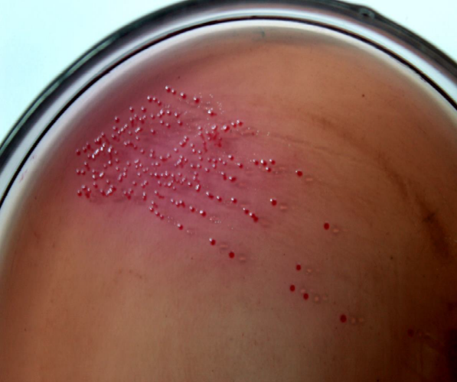
Fig. 1 Y. enterocolitica on Yersinia Selective agar
The occurrence of Y. enterocolitica in pork samples in the present study was 7.0%, which was closely consistent with the 7.6% occurrence reported by Venkata Lakshmi et al. (2025) in retail pork samples from Tirupati, India, but slightly higher than the 6.7% reported by Angelovska et al. (2023) among slaughter pigs in Bulgaria. In contrast, Hadziabdic et al. (2023) reported a higher occurrence of 16.3% in pre-packed fresh minced pork from Southern Berlin and Brandenburg. Differences in prevalence among studies may be attributed to variations in geographical location, sample type, slaughterhouse hygiene, enrichment procedures and detection methods.
Pork showed the highest recovery rate among all sample types, supporting the role of pigs as the principal reservoir of pathogenic Y. enterocolitica. Similarly, Yue et al. (2023) identified pigs as the primary reservoir and highlighted the pork production chain as the major source of human infection. Furthermore, the isolation of Y. enterocolitica from slaughterhouse soil (4.0%) indicates environmental persistence and the potential for cross-contamination during carcass processing. This observation is in agreement with Arsić et al. (2023), who emphasised the importance of slaughterhouse hygiene and contaminated processing environments in the dissemination of Y. enterocolitica throughout the pork production chain.
3.2 Tests for pathogenicity
The pathogenic potential of the isolates was evaluated using calcium dependency on MOX agar and Congo Red absorption on CRAMP agar (Figs. 2 and 3). Nine (81.8%) isolates exhibited calcium dependency and Congo Red uptake, while two isolates were negative in both assays. Among the pathogenic isolates, six originated from pork, two from pig intestinal contents and one from slaughterhouse soil. All nine isolates were confirmed by PCR targeting the ail gene (Fig. 4), indicating complete agreement between conventional and molecular methods. Similarly, Venkata Lakshmi et al. (2025) detected the ail gene in pathogenic Y. enterocolitica isolates recovered from pig carcasses (7.8%), thereby supporting the use of the ail gene as a reliable molecular marker for pathogenic strains. Furthermore, Al-Rawe et al. (2023) demonstrated through comparative genomic analysis that virulence genes involved in adhesion and invasion are highly conserved among pathogenic Y. enterocolitica.
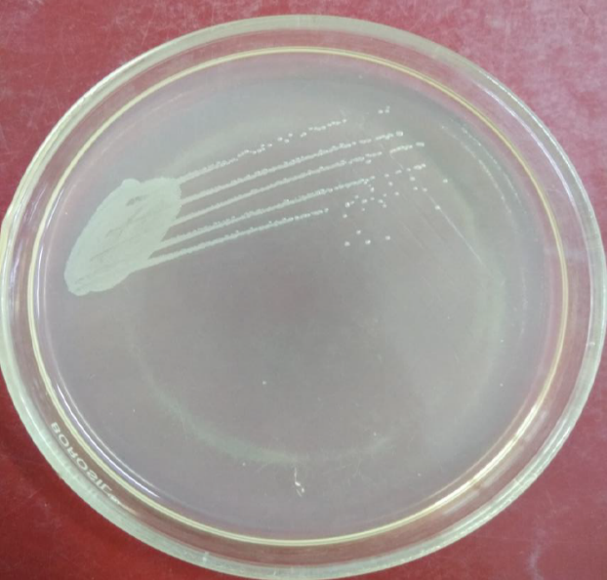
Fig. 2 Pathogenic Y. enterocolitica on MOX agar

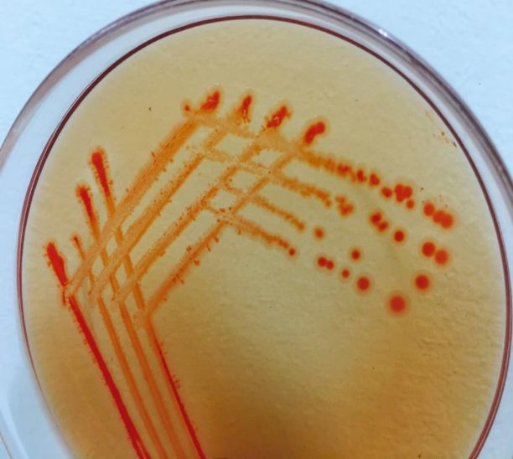
Fig. 3 Pathogenic Y. enterocolitica on CRAMP agar

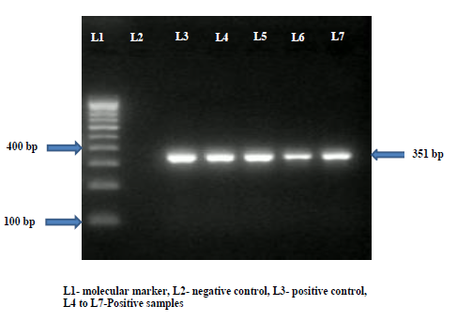
Fig. 4 Molecular confirmation of Pathogenic Y. enterocolitica targeting ail gene
3.3 Antibiogram
The antibiotic susceptibility pattern of all eleven Y. enterocolitica isolates was determined using the disc diffusion method (Fig. 5). All isolates (100%) were resistant to ampicillin and amoxicillin–clavulanic acid. Conversely, all isolates were susceptible to tetracycline, gentamicin, nalidixic acid, co-trimoxazole, ciprofloxacin, chloramphenicol and norfloxacin, indicating a uniform susceptibility profile to these antimicrobial agents.

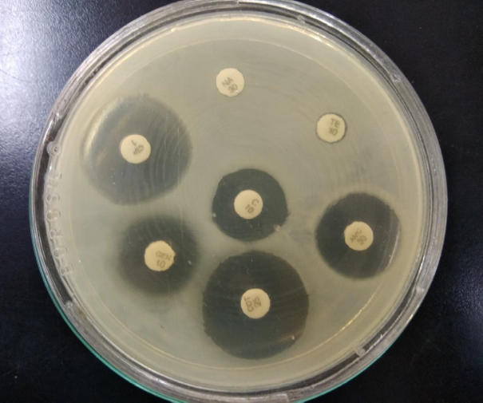
Fig. 5 Antibiogram of Y. enterocolitica
The complete resistance to ampicillin observed in the present study was comparable to the high level of ampicillin resistance (94%) reported by Seakamela et al. (2022) among Y. enterocolitica isolates recovered from meat samples in South Africa. Similarly, Lou et al. (2026) reported resistance to ampicillin, amoxicillin-clavulanic acid and nalidixic acid in foodborne Y. enterocolitica isolates at rates of 26.0%, 30.0% and 24.0%, respectively. In contrast, all isolates in the present study were susceptible to nalidixic acid despite exhibiting complete resistance to ampicillin and amoxicillin-clavulanic acid. Furthermore, Modesto et al. (2021) reported β-lactam resistance among Y. enterocolitica isolates from wild boars, while Karlsson et al. (2021) characterised multidrug-resistant outbreak strains carrying multiple antimicrobial resistance determinants. These findings highlight geographical variation in antimicrobial resistance profiles and emphasise the importance of continuous surveillance of antimicrobial-resistant Y. enterocolitica within the pork production chain.
3.4 Biofilm production assay
The ability of Y. enterocolitica isolates to produce biofilm was assessed using Congo Red Agar (Fig. 6). Of the eleven isolates, nine (81.8%) demonstrated biofilm production, whereas two isolates were biofilm-negative.
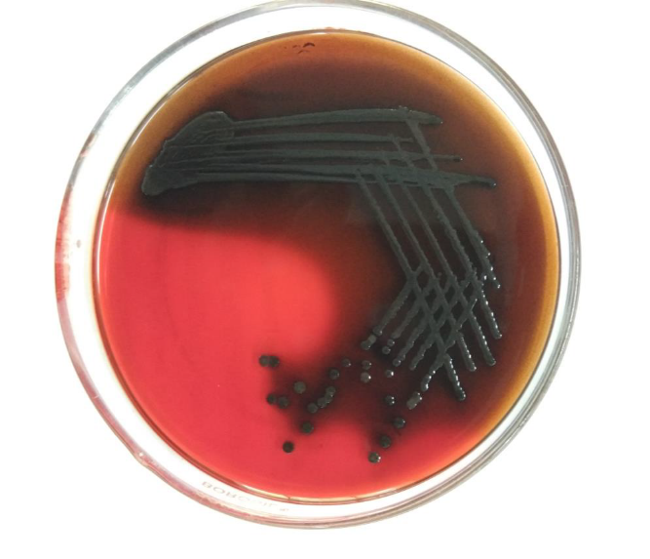
Fig. 6 Biofilm producing Y. enterocolitica
Although the proportion of biofilm-producing isolates observed in the present study was lower than that reported by Novoslavskij et al. (2013), who found 100% biofilm production among Y. enterocolitica 4/O:3 isolates recovered from the pig production chain, the strong association between pathogenicity and biofilm formation observed in the present investigation supports previous evidence that virulent Y. enterocolitica strains possess enhanced persistence within food-processing environments. Ban-Cucerzan et al. (2025) concluded that biofilm formation is one of the principal mechanisms responsible for long-term persistence of foodborne pathogens on food-contact surfaces, contributing substantially to contamination within processing facilities. Similarly, Buder et al. (2023) identified drinking systems and lairage equipment in pig abattoirs as important reservoirs of zoonotic bacteria because of persistent biofilm formation. Collectively, these findings reinforce the importance of implementing effective biofilm control strategies to minimise the persistence and transmission of pathogenic Y. enterocolitica in pork-processing environments.
4. Conclusion
Overall, The study demonstrated the occurrence of Yersinia enterocolitica in pork, pig intestinal contents and slaughterhouse soil collected from the pork production chain in Puducherry. Eleven isolates were recovered from 250 samples, and nine showed pathogenic phenotypes that agreed with polymerase chain reaction detection of the ail gene. The same nine pathogenic isolates were biofilm-positive, while the two non-pathogenic isolates were biofilm-negative, indicating concordance between pathogenicity and qualitative biofilm findings within the isolates examined. All isolates were resistant to ampicillin and amoxicillin–clavulanic acid, whereas all were susceptible to tetracycline, gentamicin, nalidixic acid, co-trimoxazole, ciprofloxacin, chloramphenicol and norfloxacin. Taken together, the findings show that both pork and the slaughterhouse environment can contain Y. enterocolitica with pathogenic and biofilm-forming characteristics. The results therefore support attention to slaughter hygiene, routine microbiological surveillance and prudent antimicrobial use across the pork production chain. Broader studies are required before these findings can be generalised beyond the sampled settings in Puducherry.
5. Limitations
The present study has certain limitations that should be considered when interpreting the findings. First, the study was conducted using a relatively limited number of samples collected from the pork production chain in Puducherry and therefore the findings may not be directly generalisable to other geographical regions or production systems. Second, the assessment of biofilm formation was performed using Congo Red Agar, which provides a qualitative indication of biofilm production and does not quantify biofilm biomass or provide information on the strength of biofilm formation. Third, molecular confirmation of pathogenicity was based on detection of the ail gene; although this provided molecular support for the pathogenic phenotype, assessment of additional virulence-associated genes and/or plasmid-associated virulence determinants would provide a more comprehensive characterisation of pathogenic strains. Fourth, antimicrobial susceptibility was evaluated by the disc diffusion method and interpreted according to applicable CLSI criteria; further studies incorporating minimum inhibitory concentration determination and molecular characterisation of antimicrobial resistance determinants would provide a more detailed understanding of resistance patterns. Future investigations involving larger sample sizes, longitudinal and multisite sampling, quantitative biofilm assays and comprehensive molecular characterisation would strengthen the epidemiological and public health significance of these findings.

Consent
Informal consent was obtained from the concerned slaughterhouse authorities for sample collection prior to commencement of the study. The study did not involve experimental infection, intervention or invasive procedures on live animals.

Declaration of AI Use

This manuscript was prepared through the intellectual contributions of the author(s) to the study design, data analysis, interpretation of results, and scholarly content. Grammarly and ChatGPT were used solely to assist with grammatical refinement and reference formatting during manuscript revision. The author(s) accept full responsibility for the accuracy, integrity, and final content of the manuscript.
Competing Interests
Authors have declared that no competing interests exist.

References
Novoslavskij, A., Šernienė, L., Ramonaitė, S., Zakarienė, G., & Malakauskas, M. (2013). Comparison of antimicrobial resistance and biofilm formation of Yersinia enterocolitica 4/O:3 strains isolated from pig production chain and patients’ clinical specimens. Veterinarija ir Zootechnika, 62(84), 62–67. https://vetzoo.lsmuni.lt/data/vols/2013/62/en/novoslavskij.pdf
Al-Rawe, A. M., Al-Jomaily, O. K. G., Yousif, Y. I., Shaban, S. A., & Suleiman, A. A. (2023). Comparative genomics, phylogenetic, and functional analyses of Yersinia enterocolitica, a gastrointestinal pathogen, with other soil-borne bacteria causing diseases. Mikrobiolohichnyi Zhurnal, 85(5), 31–41. https://doi.org/10.15407/microbiolj85.05.031
Angelovska, M., Zaharieva, M. M., & Najdenski, H. (2023). Yersinia enterocolitica—Isolation, pathogenicity, and prevalence in farms for slaughtered pigs. Acta Microbiologica Bulgarica, 39(2), 118–129. https://doi.org/10.59393/amb23390204
Anju, P., Latha, C., Sunil, B., & Sethulekshmi, C. (2014). Detection of Salmonella and Yersinia spp. in uncooked retail chicken meat in Kerala by multiplex PCR. International Journal of Current Microbiology and Applied Sciences, 3(6), 1028–1034. https://www.ijcmas.com/vol-3-6/P.Anju%2C%20et%20al.pdf
Arsić, M., Vićić, I., Petrović, M., Dmitrić, M., & Karabasil, N. (2023). Yersinia enterocolitica and control measures for reducing risks in the pork production chain. Meat Technology, 64(2), 237–241. https://doi.org/10.18485/meattech.2023.64.2.43
Aziz, M., & Rausch-Phung, E. A. (2026). Yersinia enterocolitica infection. In StatPearls. StatPearls Publishing. https://www.ncbi.nlm.nih.gov/books/NBK499837/
Ban-Cucerzan, A., Imre, K., Morar, A., Marcu, A., Hotea, I., Popa, S.-A., Pătrînjan, R.-T., Bucur, I.-M., Gașpar, C., Plotuna, A.-M., & Ban, S.-C. (2025). Persistent threats: A comprehensive review of biofilm formation, control, and economic implications in food processing environments. Microorganisms, 13(8), 1805. https://doi.org/10.3390/microorganisms13081805
Bari, M. L., Hossain, M. A., Isshiki, K., & Ukuku, D. (2011). Behavior of Yersinia enterocolitica in foods. Journal of Pathogens, 2011, 420732. https://doi.org/10.4061/2011/420732
Bauer, A. W., Kirby, W. M. M., Sherris, J. C., & Turck, M. (1966). Antibiotic susceptibility testing by a standardized single disk method. American Journal of Clinical Pathology, 45(4_ts), 493–496. https://doi.org/10.1093/ajcp/45.4_ts.493
Krieg, N. R., & Holt, J. G. (Eds.). (1984). Bergey’s manual of systematic bacteriology (Vol. 1). Williams & Wilkins. https://www.bergeys.org/publications/
Bhaduri, S., Conway, L. K., & Lachica, R. V. F. (1987). Assay of crystal violet binding for rapid identification of virulent plasmid-bearing clones of Yersinia enterocolitica. Journal of Clinical Microbiology, 25(6), 1039–1042. https://doi.org/10.1128/jcm.25.6.1039-1042.1987
Buder, C., Meemken, D., Fürstenberg, R., Langforth, S., Kirse, A., & Langkabel, N. (2023). Drinking pipes and nipple drinkers in pig abattoir lairage pens—A source of zoonotic pathogens as a hazard to meat safety. Microorganisms, 11(10), 2554. https://doi.org/10.3390/microorganisms11102554
Clinical and Laboratory Standards Institute. (2025). Performance standards for antimicrobial susceptibility testing (35th ed.; CLSI supplement M100). https://clsi.org/standards/products/microbiology/documents/m100/
Dhanalakshmi, G., Prabha, R., & Jagadheesh Kumar, D. (2015). Prevalence, antibiotic resistance and biofilm producing meat isolates in and around Namakkal, Tamil Nadu, India. International Journal of Advances in Interdisciplinary Research, 2(2), 6–10.
Drewnowski, A. (2024). Perspective: The place of pork meat in sustainable healthy diets. Advances in Nutrition, 15(5), 100213. https://doi.org/10.1016/j.advnut.2024.100213
Fang, Z., Mao, J., Chen, Z., Wu, Y., Zhao, X., Tian, R., Lv, Y., Xiao, X., Yan, J., Lou, X., & Li, J. (2026). Deciphering the potential risks of Yersinia enterocolitica across multi-points in food chain: Prevalence, biofilm, and cross-stage transmission routes. Food Research International, 226, 118107. https://doi.org/10.1016/j.foodres.2025.118107
Farmer, J. J., III, Carter, G. P., Miller, V. L., Falkow, S., & Wachsmuth, I. K. (1992). Pyrazinamidase, CR-MOX agar, salicin fermentation-esculin hydrolysis, and D-xylose fermentation for identifying pathogenic serotypes of Yersinia enterocolitica. Journal of Clinical Microbiology, 30(10), 2589–2594. https://doi.org/10.1128/jcm.30.10.2589-2594.1992
Fayaz, I. B., Zehgeer, M. M., Hussain, S. A., & Sahib, Q. S. (2026). Occurrence of Salmonella spp. in raw chicken and immediate slaughter environments from unorganised poultry houses in Kashmir, India. Uttar Pradesh Journal of Zoology, 47(12), 83–92. https://doi.org/10.56557/upjoz/2026/v47i125709
Fredriksson-Ahomaa, M., & Korkeala, H. (2003). Low occurrence of pathogenic Yersinia enterocolitica in clinical, food, and environmental samples: A methodological problem. Clinical Microbiology Reviews, 16(2), 220–229. https://doi.org/10.1128/CMR.16.2.220-229.2003
Freeman, D. J., Falkiner, F. R., & Keane, C. T. (1989). New method for detecting slime production by coagulase-negative staphylococci. Journal of Clinical Pathology, 42(8), 872–874. https://doi.org/10.1136/jcp.42.8.872
Gupta, V. K., Phand, S., Kar, P., Attupuram, N. M., Islam, R., & Das, S. (Eds.). (2024). Better livelihoods through scientific pig husbandry. ICAR-NRC on Pig & National Institute of Agricultural Extension Management. https://www.manage.gov.in/publications/eBooks/Better%20Livelihoods%20through%20Scientific%20Pig%20Husbandry.pdf
Hadziabdic, S., Haase, D., Barac, A., Hertwig, S., & Buschulte, A. (2023). Detection of pathogenic Yersinia enterocolitica strains in pre-packed fresh pork minced meat—Preliminary data. Meat Technology, 64(2), 89–92. https://doi.org/10.18485/meattech.2023.64.2.15
Karlsson, P. A., Tano, E., Jernberg, C., Hickman, R. A., Guy, L., Järhult, J. D., & Wang, H. (2021). Molecular characterization of multidrug-resistant Yersinia enterocolitica from foodborne outbreaks in Sweden. Frontiers in Microbiology, 12, 664665. https://doi.org/10.3389/fmicb.2021.664665
Kruse, H., Kapperud, G., Lassen, J., Lunestad, B. T., Nesbakken, T., Rimstad, E., Robertson, L., Skjerve, E., & Wasteson, Y. (2021). A preliminary risk assessment of Yersinia enterocolitica in the food chain: Some aspects related to human health in Norway. European Journal of Nutrition & Food Safety, 13(5), 1–2. https://doi.org/10.9734/ejnfs/2021/v13i530412
Lal, M., Kaur, H., & Gupta, L. K. (2003). Yersinia enterocolitica gastroenteritis—A prospective study. Indian Journal of Medical Microbiology, 21(3), 186–188. https://doi.org/10.1016/S0255-0857(21)03070-X
Lee, S. H., Jung, B. Y., Rayamahji, N., Lee, H. S., Jeon, W. J., Choi, K. S., Kweon, C. H., & Yoo, H. S. (2009). A multiplex real-time PCR for differential detection and quantification of Salmonella spp., Salmonella enterica serovar Typhimurium and Enteritidis in meats. Journal of Veterinary Science, 10(1), 43–51. https://doi.org/10.4142/jvs.2009.10.1.43
Lou, X., Wu, Y., Chen, Z., Zhang, Q., Xiao, X., & Fang, Z. (2025). Novel insights into biofilm formation and the key differentially expressed genes in Yersinia enterocolitica from meat: Implications for food safety and disease prevention. International Journal of Food Microbiology, 426, 110914. https://doi.org/10.1016/j.ijfoodmicro.2024.110914
Lou, X., Mao, J., Wu, Y., Xia, Y., Zhang, W., Gao, J., Wang, Y., Yan, J., Xiao, X., Li, J., & Fang, Z. (2026). From foodborne to environmental Yersinia enterocolitica: Comparative insights into antimicrobial resistance and virulence for food safety. Food Research International, 238, 119442. https://doi.org/10.1016/j.foodres.2026.119442
Modesto, P., De Ciucis, C. G., Vencia, W., Pugliano, M. C., Mignone, W., Berio, E., Masotti, C., Ercolini, C., Serracca, L., Andreoli, T., Dellepiane, M., Adriano, D., Zoppi, S., Meloni, D., & Razzuoli, E. (2021). Evidence of antimicrobial resistance and presence of pathogenicity genes in Yersinia enterocolitica isolate from wild boars. Pathogens, 10(4), 398. https://doi.org/10.3390/pathogens10040398
Platt-Samoraj, A. (2022). Toxigenic properties of Yersinia enterocolitica biotype 1A. Toxins, 14(2), 118. https://doi.org/10.3390/toxins14020118
Saraiva, S., García-Díez, J., de Sousa, T., Calouro, R., Fernandes, D., Mourão, A. V., Saraiva, C., Mesquita, J. R., Coelho, A. C., & Poeta, P. (2025). Zoonotic Yersinia enterocolitica in swine: One Health implications for food safety and public health. Veterinary Sciences, 12(9), 795. https://doi.org/10.3390/vetsci12090795
Seakamela, E. M., Diseko, L., Malatji, D., Makhado, L., Motau, M., Jambwa, K., Magwedere, K., Ntushelo, N., & Matle, I. (2022). Characterisation and antibiotic resistance of Yersinia enterocolitica from various meat categories, South Africa. Onderstepoort Journal of Veterinary Research, 89(1), a2006. https://doi.org/10.4102/ojvr.v89i1.2006
Siddi, G., Piras, F., Meloni, M. P., Migoni, M., Cuccu, M., Simbula, F., Serra, E., Crobu, L., Casula, M., Manca, F., Sau, A., Gymoese, P., Fredriksson-Ahomaa, M., De Santis, E. P. L., & Scarano, C. (2025). Salmonella and Yersinia enterocolitica through the pig meat chain in Sardinia: Occurrence, antimicrobial resistance and genetic insight. Italian Journal of Food Safety, 14(1), 13199. https://doi.org/10.4081/ijfs.2024.13199
Venkata Lakshmi, M., Annie Supriya, R., Ramya, P., Sreedevi, B. A., Siva Swetha, C., Ahmed, S., Vinayaka Siddartha, P., & Praharshini, N. (2025). Molecular characterization of Yersinia enterocolitica isolated from different parts of pig carcasses. International Journal of Advanced Biochemistry Research, 9(11), 129–137. https://doi.org/10.33545/26174693.2025.v9.i11b.6186
World Health Organization. (2026, June 4). Unsafe food causes 866 million illnesses and 1.5 million deaths annually—Young children at highest risk. https://www.who.int/news/item/04-06-2026-unsafe-food-causes-866-million-illnesses-and-1.5-million-deaths-annually--young-children-at-highest-risk
Yue, Y., Zheng, J., Sheng, M., Liu, X., Hao, Q., Zhang, S., Xu, S., Liu, Z., Hou, X., Jing, H., Liu, Y., Zhou, X., & Li, Z. (2023). Public health implications of Yersinia enterocolitica investigation: An ecological modeling and molecular epidemiology study. Infectious Diseases of Poverty, 12, 41. https://doi.org/10.1186/s40249-023-01063-6

