Original Research Article

Understanding the Trait Association and Path Analysis in Chickpea (Cicer arietinum)

.
ABSTRACT
Aim: To dissect association among morphological, phenological, productivity and seed-quality traits and to identify yield contributing traits in chickpea.
Study Design: Augmented block design with four blocks and five checks.
Place and Duration of Study: The experiment was conducted at Regional Agricultural Research Station (RARS), Vijayapura, Karnataka, India. Duration: Rabi (single season).
Methodology: Eighty-nine chickpea genotypes, including five checks, were evaluated for 13 characteristics encompassing, morphological, phenological, productivity and seed-quality traits. Phenotypic and genotypic correlations were estimated to determine associations with seed yield. Path analysis was performed with seed yield as the dependent variable to partition the correlations into direct and indirect effects and identify selection criteria.
Results: Seed yield per plant showed significant associations with plant height and secondary branches (r = 0.82 each), followed by days to maturity and seed protein content (r = 0.45 each), hundred-seed weight (r = 0.34) and days to first flowering, pods per plant and seed vigour (r = 0.28 each). Seeds per pod also showed a significant positive association with seed yield (r = 0.24). Path analysis revealed the strongest direct effect of pods per plant (0.738), followed by days to first flowering (0.198), hundred-seed weight (0.187), primary branches (0.177) and days to maturity (0.176). Plant height had a negligible direct effect (0.002) but an indirect contribution via pods per plant (0.334), whereas seeds per pod exhibited a negative indirect effect through pods per plant (−0.642).
Conclusion: Number of pods per plant and hundred-seed weight were found to be important traits for enhancing seed yield in chickpea. The direct and indirect effects observed among yield components underscore the complexity of trait interrelationships. Therefore, simultaneous consideration of trait associations along with the direct and indirect contributions can strengthen the selection efficiency and facilitate the identification of superior, high-yielding chickpea genotypes.
Keywords: chickpea, correlation, path analysis, yield
1. INTRODUCTION

Chickpea is a globally significant cool-season food legume that plays a pivotal role in pulse-based food systems, particularly across semi-arid and arid ecosystems. Its capacity to adapt to diverse agro-ecological conditions and sustain production under limited soil moisture has contributed to its widespread cultivation (Patil et al., 2021). Chickpea is a diploid (2n = 16), predominantly self-pollinated legume with an estimated haploid genome size of approximately 740 Mb (Varshney et al., 2013). Its nutritional richness, particularly its high-quality plant protein content, underpins its importance in human diets and its contribution to food and nutritional security in pulse-dependent food systems (Ashwini et al., 2021). The crop is cultivated in more than 50 countries, reflecting its importance in global pulse production systems (Narayan et al., 2024).

India occupies a leading position in global chickpea production, accounting for approximately 73.78 per cent of the world’s cultivated area and 73.45 per cent of total production, with an annual output of about 11.68 million tonnes (DAC&FW, 2024–25). In addition to its nutritional and economic value, the crop contributes to the sustainability of agricultural systems through biological nitrogen fixation, thereby improving soil fertility and reducing the requirement for external nitrogen inputs (Hattiholli et al., 2024). These attributes make chickpea particularly valuable for strengthening food and nutritional security. Despite its nutritional, economic and ecological importance, chickpea productivity is constrained by diverse biotic and abiotic stresses, climatic variability and a narrow genetic base (Amruta et al., 2026). Addressing these constraints requires the effective exploitation of available genetic variation and the identification of traits that contribute to yield performance and adaptation.

Grain yield is a complex quantitative trait governed by the interaction of several component traits, making direct selection for higher productivity challenging in chickpea improvement programmes. Correlation analysis provides insight into the magnitude and direction of associations among yield and its component traits, while path coefficient analysis further partitions these associations into direct and indirect effects (Wright, 1921). Evaluation of both genotypic and phenotypic associations enables a better understanding of the genetic relationships underlying trait expression and helps distinguish traits with genuine direct contributions to yield from those associated through other characters. Consequently, the integration of correlation and path analyses provides a quantitative framework for identifying key yield determinants and strengthening selection criteria in chickpea breeding.

2. material and methods

A field experiment comprising 89 chickpea genotypes, including checks, was conducted at Regional Agricultural Research Station (RARS), Vijayapur, Karnataka, India. The experiment was laid out employing augmented block design comprising four blocks, with five check genotypes repeated in each block.

Observations were recorded on phenological, morphological, productivity and seed-quality traits from five randomly selected plants of each genotype. The traits recorded included, days to initiation of first flower, days to 50 per cent flowering, days to initiation of first pod, days to 50 per cent pod setting, days to maturity, number of primary branches per plant, number of secondary branches per plant, plant height (cm), number of pods per plant, number of seeds per pod, 100-seed weight (g), seed yield per plant (g), seed protein content (%), seed vigour (%) and seed moisture content (%). Seed protein content was estimated using the Bradford assay, seed vigour was determined according to Ellis and Roberts (1980) and seed moisture content was measured using an automatic moisture meter. Phenotypic and genotypic correlation coefficients were estimated from genotype means to quantify associations among the measured traits and their relationship with seed yield per plant (Weber and Moorthy, 1952). The significance of correlation coefficients was assessed at the 5 and 1% probability levels. Path coefficient analysis was subsequently performed using phenotypic and genotypic correlation matrices, with seed yield per plant as the dependent variable, to resolve the direct and indirect contributions of component traits (Wright 1921., Dewey and Lu, 1959). The residual effect was calculated to quantify the proportion of variation in seed yield not explained by the traits included in the analysis.

3. results and discussion

3.1 Character association

Seed yield per plant showed significant positive associations with days to first flowering (r = 0.28), days to maturity (r = 0.45), plant height (r = 0.82), secondary branches per plant (r = 0.82), pods per plant (r = 0.28), seeds per pod (r = 0.24), 100-seed weight (r = 0.34), seed vigour (r = 0.28) and seed protein content (r = 0.45) (Table 1). The strongest associations were observed for plant height and secondary branches, highlighting the importance of plant architecture in yield determination. Similar findings were reported by Akbar et al. (2025), who reported significant positive associations of seed yield with plant height, flowering, maturity, seeds per pod and 100-seed weight in chickpea genotypes. Similarly, Yellanki et al. (2024) reported positive associations of seed yield with primary and secondary branches, supporting the contribution of branching pattern to yield formation.

The positive association of 100-seed weight with seed yield (r = 0.34) is particularly relevant because seed size is simultaneously an important yield component and a market-preferred quality attribute. Moulya et al. (2024) identified plant height, pods per plant and 100-seed weight as important traits associated with seed yield in chickpea germplasm, reinforcing their potential utility in selection. A positive correlation between seed protein content and seed yield (r = 0.45) indicates the potential for simultaneous selection for productivity and nutritional quality, although this relationship should be validated across environments before being incorporated into selection indices.

Significant negative associations were observed between days to first flowering and primary branches (r = −0.32), plant height and days to 50% flowering (r = −0.27) and days to first pod formation and plant height (r = −0.30). In contrast, days to maturity was positively associated with days to first flowering and days to 50% flowering, indicating coordinated variation among phenological traits. Such interrelationships are important because selection for one trait may alter the expression of other traits through correlated responses. Hattiholi et al. (2024) reported similar negative associations in chickpea, including negative genotypic associations of yield with primary and secondary branches, SCMR at 30 days and days to maturity. Plant height showed a significant positive association with seeds per pod (r = 0.32), whereas pods per plant and 100-seed weight (r = 0.23) and seeds per pod and 100-seed weight (r = 0.05), exhibited positive but non-significant relationships (Fig. 1).
 | DFF | DFPF | DFP | DM | PH | NPB | NSB | NPP | NSP | HSW | SM | SV | SP
DFF | 1.00
DFPF | 0.76 | 1.00
DFP | ***0.59 | 0.80 | 1.00
DM | ***0.39 | ***0.34 | 0.33 | 1.00
PH | ***-0. 32 | ***-0.27 | ***-0. 30 | -0.11 | 1.00
NPB | ***0.07 | **0.04 | **-0.03 | 0.04 | 0.01 | 1.00
NSB | -0.12 | -0.16 | -0.16 | 0.16 | 0.07 | 0.06 | 1.00
NPPP | -0.45 | -0.37 | -0.22 | 0.03 | 0.45 | -0.05 | 0.19 | 1.00
NSPP | ***-0.02 | ***-0.02 | *-0.02 | -0.11 | ***0.32 | -0.01 | * 0.07 | -0.08 | 1.00
HSW | -0.46 | -0.51 | -0.40 | -0.26 | 0.23 | -0.03 | -0.14 | 0.23 | 0.05 | 1.00
SM | ***0.13 | ***-0.03 | ***-0.02 | **-0.00 | * 0.04 | 0.05 | -0.08 | *-0.01 | -0.10 | 0.03 | 1.00
SV | -0.01 | 0.02 | 0.00 | 0.05 | -0.01 | -0.14 | -0.05 | 0.03 | 0.01 | -0.06 | 0.08 | 1.00
SP | 0.10 | 0.13 | -0.01 | -0.03 | 0.12 | 0.02 | -0.04 | 0.04 | -0.03 | 0.01 | 0.01 | 0.06 | 1.00
SYPP | 0.28** | -0.13 | 0.09 | 0.45** | 0.82** | 0.00 | 0.82** | 0.28** | 0.24** | 0.34*** | -0.13 | 0.28** | 0.45**
Table 1: Correlation coefficient among morpho-phenological and productivity traits in chickpea
*, ** and* ** indicates significance at 5%, 1% and 0.1% respectively
DFF: Days to first flowering | DM: Days to maturity | NSB: Number of Secondary branches | SM: Seed moisture NPPP: Number of pods/plant
DFPF: Days to 50% flowering | PH: Plant Height per Plant | SYPP: Seed Yield Per Plant | SV: Seed vigour NSPP: Number of seeds/pod
DFP: Days to first podding | NPB: Number of primary branches | HSW: Hundred seed weight | SP: Seed protein

3.2 Path coefficient analysis

Path coefficient analysis revealed that number of pods per plant (NPPP) recorded the highest positive direct effect (0.738) on seed yield, followed by days to first flowering (DFF; 0.198), 100-seed weight (HSW; 0.187), number of primary branches (NPB; 0.177), and days to maturity (DM; 0.176) (Table 2). The predominance of NPPP highlights pod-bearing ability as the major contributor to yield variation among the evaluated chickpea genotypes. A strong positive direct effect of NPPP on seed yield was also reported by Bhor et al. (2025), reinforcing its importance as a key selection criterion in chickpea.

The positive direct effect of HSW (0.187) further indicates the importance of seed size in enhancing productivity, complementing the contribution of pod number. Similar findings have been reported under contrasting production conditions, with HSW identified as an important direct contributor to chickpea yield under both late-sown and heat-stress environments (Hattiholli et al., 2024., Kuldeep et al., 2026). Thus, the combined consideration of NPPP and HSW may provide an effective basis for selection of high-yielding chickpea genotypes.
Interestingly, plant height showed a negligible direct effect (0.002) but contributed substantially through NPPP (0.334), suggesting that its association with yield was primarily mediated through pod production. Conversely, NSPP showed a strong negative indirect effect through NPPP (−0.642), indicating possible compensatory relationships among yield components. Such indirect effects emphasize the need to consider the interdependence of traits while selecting for yield. Negative direct effects were observed for DFPF (−0.080), seed moisture (−0.049), and seed protein (−0.031) (Fig 2). The negative direct effect of seed protein, despite its positive correlation with yield, demonstrates that the observed association was influenced by indirect effects through other traits. NPPP emerged as the most important selection criterion, followed by HSW and favourable branching and phenological traits, supporting a combined selection strategy for improving seed yield in chickpea.

Table 2: Direct (diagonal) and indirect effects of different characters on seed yield of chickpea
 | DFF | DFPF | DFP | DM | PH | NPB | NSB | NPPP | NSPP | HSW | SM | SV | SP
DFF | 0.198 | 0.152 | 0.118 | 0.078 | -0.064 | 0.015 | 0.025 | 0.090 | 0.005 | 0.092 | 0.025 | 0.002 | 0.020
DFPF | -0.061 | -0.080 | -0.064 | -0.027 | 0.022 | -0.003 | 0.013 | 0.029 | 0.001 | 0.041 | 0.002 | -0.024 | -0.011
DFP | 0.037 | 0.050 | 0.063 | 0.021 | -0.019 | -0.002 | -0.010 | -0.014 | -0.001 | -0.025 | -0.001 | 0.004 | 0.000
DM | -0.069 | -0.061 | -0.059 | 0.176 | 0.019 | -0.008 | -0.029 | -0.006 | 0.020 | 0.046 | 0.001 | -0.101 | 0.005
PH | -0.009 | -0.008 | -0.009 | -0.003 | 0.002 | 0.000 | 0.002 | 0.001 | 0.000 | 0.007 | 0.001 | 0.000 | 0.004
NPB | 0.013 | 0.008 | -0.069 | 0.008 | 0.002 | 0.177 | 0.018 | -0.009 | -0.019 | -0.055 | 0.093 | -0.026 | 0.044
NSB | -0.003 | -0.004 | -0.040 | 0.004 | 0.001 | 0.001 | 0.024 | 0.004 | 0.018 | -0.037 | -0.022 | -0.001 | -0.012
NPPP | -0.337 | -0.275 | -0.169 | 0.026 | 0.334 | -0.040 | 0.142 | 0.738 | -0.642 | 0.105 | -0.133 | 0.028 | 0.325
NSPP | 0.000 | 0.000 | 0.000 | 0.000 | 0.000 | 0.000 | 0.000 | 0.290 | 0.003 | 0.000 | 0.000 | 0.000 | 0.000
HSW | -0.086 | -0.096 | -0.075 | -0.049 | 0.043 | -0.005 | -0.027 | 0.043 | 0.099 | 0.187 | 0.068 | -0.012 | 0.037
SM | -0.006 | 0.008 | 0.001 | 0.004 | -0.022 | -0.006 | 0.004 | 0.009 | 0.051 | -0.001 | -0.049 | -0.004 | 0.000
SV | 0.000 | 0.001 | 0.000 | 0.002 | 0.000 | -0.005 | -0.002 | 0.001 | 0.000 | -0.002 | 0.003 | 0.003 | 0.002
SP | -0.003 | -0.044 | 0.000 | 0.010 | -0.039 | -0.008 | 0.015 | -0.014 | 0.010 | -0.006 | 0.000 | -0.002 | -0.031
R SQUARE = 0.5688., RESIDUAL EFFECT= 0.6567

DFF: Days to first flowering | DM: Days to maturity | NSB: Number of Secondary branches | SM: Seed moisture NPPP: Number of pods/plant
DFPF: Days to 50% flowering | PH: Plant Height per Plant | SP: Seed protein | SV: Seed vigour NSPP: Number of seeds/pod
DFP: Days to first podding | NPB: Number of primary branches | HSW: Hundred seed weight

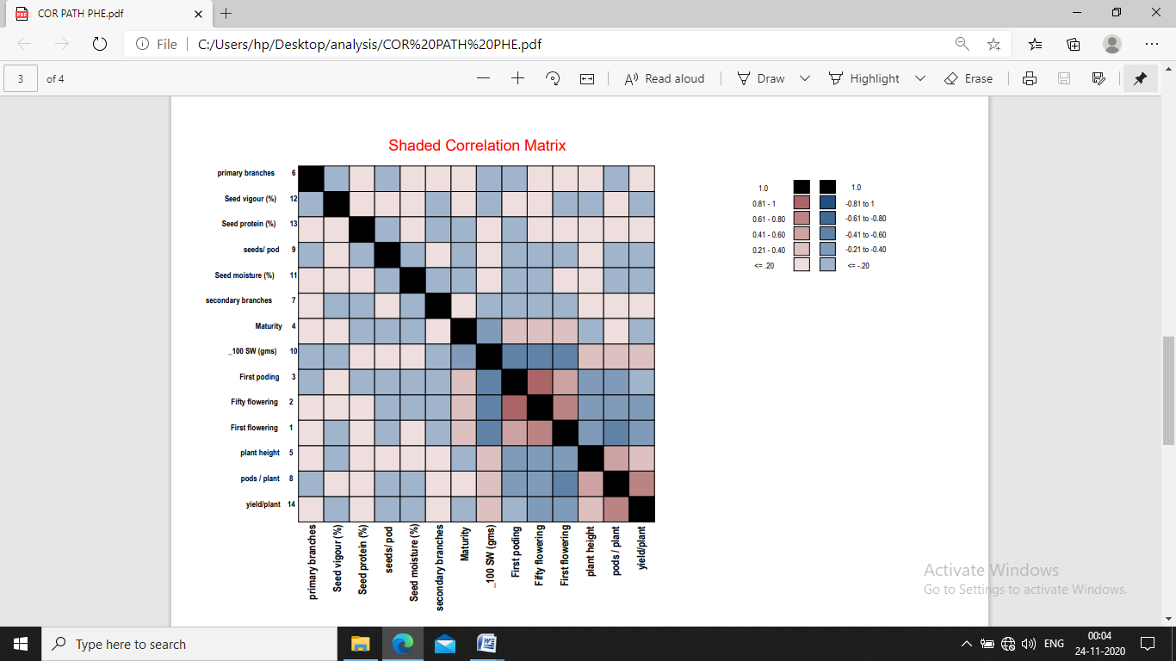

Fig. 1: Correlation studies among morpho-phenological and productivity traits in chickpea
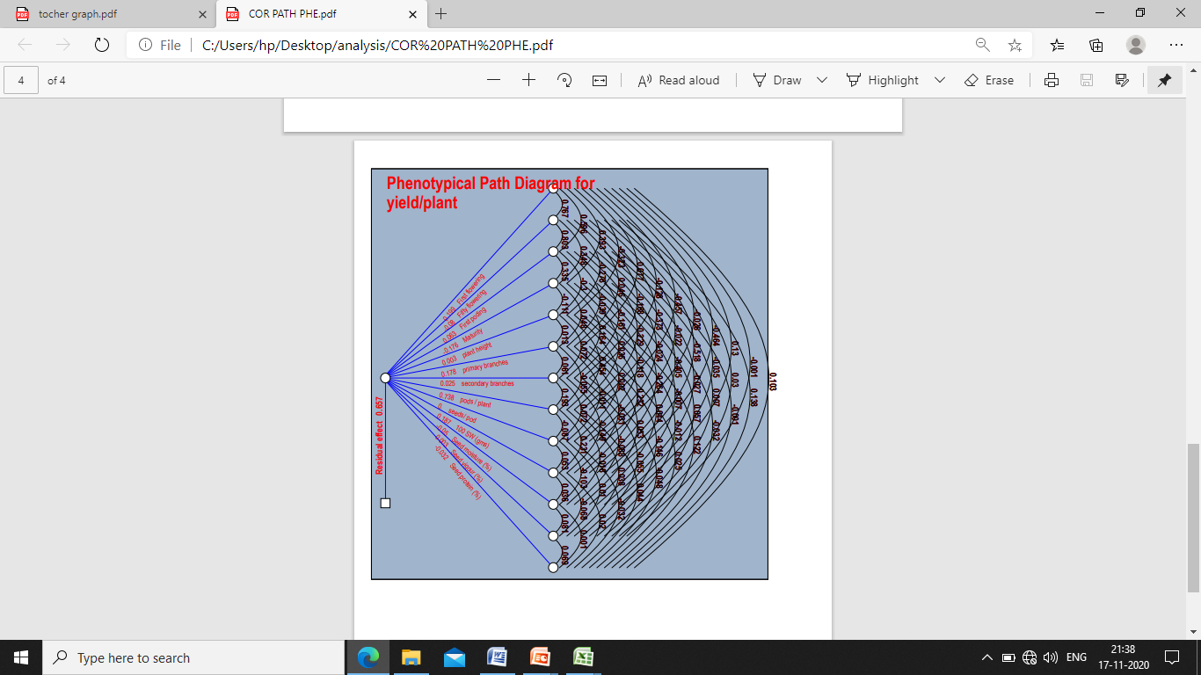

Fig 2: Phenotypic path diagram showing the influence of 13 characters on seed yield per plant in chickpea population

4. Conclusion

The correlation analysis revealed that plant height, secondary branches and other yield-contributing traits had a significant positive relationship with seed yield, suggesting their importance in indirect selection for higher productivity in chickpea. The contrasting direct and indirect effects observed for some traits emphasized that simple correlation alone may not adequately reflect their contribution to yield. In particular, plant height contributed mainly through NPPP, while the positive association of seed protein with yield was accompanied by a negative direct effect. Overall, the results indicated that the selection criteria for higher yield should fous on NPPP and HSW along with optimum branching and desirable maturity. These together may be considered in formulation of selection index to identify superior chickpea cultivars.

Competing interests
Authors have declared that no competing interests exist.

Declaration of AI Use

This manuscript was prepared through the intellectual contributions of the author(s) to the study design, data analysis, interpretation of results, and scholarly content. Grammarly and ChatGPT were used solely to assist with grammatical refinement and reference formatting during manuscript revision. The author(s) accept full responsibility for the accuracy, integrity, and final content of the manuscript.

References

Patil, A., Patil, M. D., & Katageri, I. S. (2021). Genetic diversity for yield and yield attributing traits in chickpea (Cicer arietinum L.) under different moisture regimes. Journal of Farm Sciences, 34(2), 138–141.
Varshney, R. K., Song, C., Saxena, R. K., Azam, S., Yu, S., Sharpe, A. G., Cannon, S., Baek, J., Rosen, B. D., & Tar’an, B. (2013). Draft genome sequence of chickpea (Cicer arietinum) provides a resource for trait improvement. Nature Biotechnology, 31, 240–246.
Ashwini, L. M. B., Patil, M. D., & Motagi, B. N. (2021). Genetic studies to identify climate resilient chickpea (Cicer arietinum L.) genotypes. Journal of Farm Sciences, 34(3), 237–243.
Narayan, A. N. G., Patil, M. D., Soregaon, C. D., & Ashvathama, V. H. (2024). Trait dynamics through association and path analysis across temperature regimes in chickpea (Cicer arietinum L.). Journal of Farm Sciences, 37(4), 323–328.
Directorate of Economics and Statistics (DES). 2024–25. Agricultural statistics at a glance: Area, production and productivity of chickpea in India. Department of Agriculture and Farmers Welfare (DAC&FW), Ministry of Agriculture and Farmers Welfare, Government of India, New Delhi.
Hattiholi, A., Patil, M. D., Soregaon, C. D., & Ashvathama, V. H. (2024). Deciphering trait association, direct and indirect effects of component traits on yield through correlation and path analysis in chickpea (Cicer arietinum L.). Journal of Farm Sciences, 37(2), 118–121.
Amruta, P.B., Harlapur, S.I., Balol, G.B., Patil, M.D., Prasanna Kumara, B.H. and Hosamani, R. 2026. Screening for Fusarium wilt resistance in chickpea under artificial inoculation. International Journal of Advanced Biochemistry Research 10(5S): 455–458.
Wright, S., 1921, Correlation and causation. Journal of Agricultural Research, Oxford, United Kingdom., 20: 557-585.
Ellis, R. H. and Roberts, E. H., 1980, Improved equations for the prediction of seed longevity. Annals of Botany., 45: 13-30.
Weber and Moorthy, B. R., 1952, Heritable and non-heritable relationship and variability of oil content and agronomic characteristics in the F2 generation of soyabean crosses. Journal of Agronomy., 77: 202-209.
Dewey, D. R. and Lu, K. N., 1959, A correlation and path coefficient analysis of components of crested wheat grass seed production. Agronomy Journal., 515-518.
Akbar, A., Jehan, A., Khan, S., Rehman, Z.-U., Fahad, S., Rahman, K. U., Hussain, W., Gul, R., Ullah, S., Haq, R. U., & Assogba, C. M. A. (2025). Assessment of genetic variability and heritability for yield traits in chickpea (Cicer arietinum L.) genotypes. Agrosystems, Geosciences & Environment, 8, e70177. https://doi.org/10.1002/agg2.70177
Yellanki, P., Aggarwal, N., Kumar, R., Tutlani, A., Parveen, S., & Rathore, M. (2024). Genotypic variability, correlation and path coefficient analysis for elite genotypes of chickpea (Cicer arietinum L.). International Journal of Bio-resource and Stress Management, 15(4), 1–10. https://doi.org/10.23910/1.2024.5093
Moulya G, Harish Babu B N, Lakshmana D, Dhananjaya B C and Raghavendra S. 2024. Studies on genetic variability and character association in chickpea germplasm for growth and yield attributes. Journal of Advances in Biology & Biotechnology 27(10): 1119–1125. https://doi.org/10.9734/JABB/2024/v27i101533
Bhor VB, Lad DB, Bhagat AA, Bhakare MR (2025) Correlation and path analysis in chickpea (Cicer arietinum L.) genotypes under late sown condition. International Journal of Statistics and Applied Mathematics 10(Special Issue 2):1–5.
Kuldeep, R., Pandey, S., Babbar, A. & Mishra, D.K. (2026). Genetic variability, character association and path coefficient analysis in chickpea grown under heat stress conditions. Electronic Journal of Plant Breeding. DOI: 10.37992/2026.1701.

