Genotype by Trait (GT) Biplot Analysis for Multi-Trait Evaluation and Selection in Sesame (Sesamum indicum) Genotypes

Abstract
Multi-trait evaluation of genotypes is a cornerstone of modern plant breeding, and graphical analytical tools such as the Genotype by Trait (GT) biplot have become indispensable for simultaneously interpreting complex trait-genotype relationships. In the present investigation, GT biplot analysis was employed to evaluate 45 sesame genotypes during Rabi 2025–26 across 14 yield and yield-attributing traits. The two principal components, PC1 (24.52%) and PC2 (18.45%), collectively accounted for 42.97% of the total variation. The which-won-where polygon view of the GT biplot delineated nine sectors with vertex genotypes TPTS-83, TPTS-94, TPTS-152, TPTS-66, TPTS-144, TPTS-45, TPTS-69, RMT-586 and RMT-631 exhibiting superior performance for respective trait clusters. TPTS-66 was associated with days to 50 per cent flowering, days to maturity, plant height, first capsule height, specific leaf area and oil content, whereas TPTS-69 and RMT-586 were associated with branching traits, number of capsules per plant, capsule length, thousand-seed weight, harvest index and seed yield per plant. The vector view of the GT biplot revealed significant positive associations of seed yield per plant with harvest index, 1000 seed weight, number of primary and secondary branches, number of capsules per plant, SPAD chlorophyll meter reading (SCMR) and capsule length. The genotype TPTS-45 was identified as the ideal genotype, with JCS-3993, TPTS-144, VS-21-008, TPTS-244, TPTS-69 and VS-20-001 ranking as the most desirable. The discriminativeness versus representativeness analysis highlighted seed yield per plant, number of capsules per plant, number of primary and secondary branches, plant height and first capsule axis height as the most informative and reliable traits for genotype selection. These findings provide a robust framework for multi-trait-based selection and hybridization in sesame breeding programmes aimed at developing high-yielding, early-maturing cultivars with improved oil content.
Keywords: Sesame, GT biplot, multi-trait evaluation, vertex genotypes, trait association, ideal genotype, discriminativeness, representativeness.
1. Introduction
Sesame (Sesamum indicum L.) is one of the oldest and most economically important oilseed crops cultivated across tropical and subtropical regions of the world. Its seeds are valued for their exceptionally high oil content (45–60%) and rich protein composition, making it a critical commodity in both food and industrial sectors. Despite its immense nutritional and economic significance, sesame productivity remains constrained by its inherent genetic variability, complex trait interrelationships and the challenge of simultaneously improving multiple agronomic traits.
Genetic improvement of sesame requires a thorough understanding of the relationships among key yield-contributing traits and the differential performance of genotypes across these characters. Conventional univariate selection approaches often fall short when dealing with the complexities of multiple correlated traits, since optimizing one trait may compromise another. Therefore, multi-trait evaluation techniques that allow simultaneous consideration of numerous characters are essential for effective breeding decisions.
The Genotype by Trait (GT) biplot, a specialized component of the Genotype and Genotype-by-Environment interaction (GGE) biplot framework, has emerged as a powerful multivariate graphical tool for the visual interpretation of multi-trait datasets in plant breeding research (Yan & Rajcan, 2002; Yan & Tinker, 2005). The GT biplot is constructed by regressing standardized trait values on the first two principal components (PCs), and it facilitates simultaneous visualization of genotype performance, trait associations, genotype ranking and the discriminating ability of traits all within a single, interpretable graphical display.
In sesame breeding, the simultaneous improvement of seed yield, oil content, early maturity and plant architecture presents a major challenge due to inherent trade-offs among these characters. Identifying genotypes that combine favorable values across these traits is therefore a priority. The present study was undertaken with the objectives of (i) identifying vertex genotypes and their associated traits through the which-won-where view of the GT biplot, (ii) assessing inter-trait associations through the vector view, (iii) ranking sesame genotypes based on their overall performance relative to the ideal genotype, and (iv) evaluating the discriminating ability and representativeness of measured traits to identify the most informative selection criteria.
2. Materials and Methods
A diverse set of 45 sesame genotypes was assembled from Regional Agricultural Research Station, Tirupati. The experimental material encompassed a broad range of genetic backgrounds to maximize the capture of phenotypic variation across the traits of interest. The genotypes were evaluated under field conditions following standard agronomic practices for sesame cultivation.
A total of 14 quantitative traits were recorded per genotype: days to 50% flowering (DF), days to maturity (DM), plant height (PH), first capsule axis height (FCAH), specific leaf area (SLA), number of primary branches per plant (PBP), number of secondary branches per plant (SBP), number of capsules per plant (CPP), capsule length (CL), SPAD chlorophyll meter reading (SCMR), thousand seed weight (TSW), harvest index (HI), seed yield per plant (SYP) and oil content (OC).
GT biplot analysis was performed using the R STUDIO packages. The biplot was generated based on trait-focused singular value partitioning (SVP = 2), with data standardized (scaling = 1) to ensure equal weighting of all traits irrespective of their measurement units. Four complementary biplot views were interpreted: (i) the which-won-where polygon view for identifying vertex genotypes and their associated traits; (ii) the vector view for assessing trait inter-correlations; (iii) the average tester axis (ATA) view for ranking genotypes based on mean performance; and (iv) the discriminativeness versus representativeness view for evaluating the relative utility of measured traits as selection criteria.
3. Results and Discussion
3.1 Which-Won-Where View: Identification of Vertex Genotypes and Associated Traits
The which-won-where view of the GT biplot (Fig. 1) was generated by connecting the genotypes located farthest from the biplot origin to form an irregular polygon. Perpendicular lines drawn from the biplot origin to each side of this polygon divided the biplot space into distinct sectors, each containing a vertex genotype that represented the highest-performing genotype for the traits present within that sector. This approach provides a concise and visual method for identifying specifically adapted and outstanding genotypes, which can subsequently be exploited as potential parents in hybridization programmes (Yan et al., 2000; Yan et al., 2007).
The GT biplot accounted for 42.97% of the total variation among genotypes, with PC1 and PC2 contributing 24.52% and 18.45% of the variation, respectively. A comparable level of total variation was reported by Faheem et al. (2023) at 42.6% in wheat, Sharfi and Ebadi (2018) at 46.6% in rice, and Arpitha (2025) at 46.19% in sesame, validating the adequacy of the present biplot for interpreting genotype–trait relationships.
The perpendicular lines partitioned the biplot into nine distinct polygon sectors, with vertex genotypes TPTS-83, TPTS-94, TPTS-152, TPTS-66, TPTS-144, TPTS-45, TPTS-69, RMT-586 and RMT-631 at the respective vertices. These vertex genotypes were situated farthest from the biplot origin, indicating that they were the most responsive and divergent genotypes in the evaluated set. Such vertex genotypes are of particular value to plant breeders, as they represent extreme phenotypes that can contribute novel allelic combinations when used as parents in crossing programmes.
Among the vertex genotypes, TPTS-66 was found to be associated with days to 50% flowering, days to maturity, plant height, first capsule axis height, specific leaf area and oil content, reflecting its superior performance for these traits. This suggests that TPTS-66 possesses a genetic constitution favourable for late-maturing, tall plant architecture with higher oil accumulation. In contrast, TPTS-69 and RMT-586 were positioned within the sector encompassing number of primary branches per plant, number of secondary branches per plant, number of capsules per plant, seed yield per plant, thousand seed weight, capsule length and SPAD chlorophyll meter reading (SCMR). The association of these two genotypes with such a comprehensive set of yield-contributing traits underscores their potential as donors of high yield attributes in sesame improvement programmes. These results are in agreement with the findings of Gungor et al. (2024) in barley, Gholizadeh et al. (2023) in sunflower, Bakhshi et al. (2023) in rapeseed and Ebrahimi et al. (2023) in safflower, where vertex genotypes were distinctly associated with specific trait clusters.
The remaining vertex genotypes TPTS-83, TPTS-94, TPTS-152, TPTS-144, TPTS-45 and RMT-631 occupied sectors that did not contain any trait vectors. While this indicates that these genotypes were not specifically linked to any of the measured traits, their positioning at the periphery of the biplot polygon confirms that they are highly divergent from the rest of the evaluated genotypes. Such genotypes, even without specific trait associations, can serve as valuable sources of genetic diversity in broad-based crossing programmes.
Collectively, the which-won-where analysis identifies TPTS-66, TPTS-69 and RMT-586 as the most promising genotypes for direct selection and for use as parents in hybridization aimed at combining high yield potential, early maturity and improved oil content in sesame.
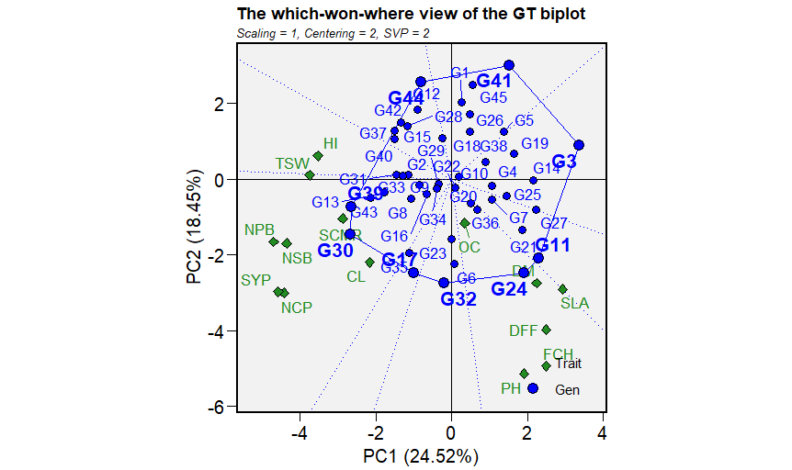

Fig. 1. “Which-won-where” genotype-by-trait biplot of 14 yield and yield components of 45 Sesame genotypes.

DFF: Days to 50% flowering, DM: Days to maturity, PH: Plant height (cm), FCH: First capsule axis height, NPB: Number of primary branches per plant, NSB: Number of secondary branches per plant, NCP: Number of capsules per plant, CL: Capsule length (cm), SCMR: SPAD chlorophyll meter reading, SLA: Specific leaf area, SW: 1000 seed weight (g), HI: Harvest index(%), OC: Oil content (%), SYP: Seed yield per plant (g)

G1: RMT-677, G2: KMR-35, G3: TPTS-94, G4: TPTS-18, G5: KMR-42, G6: VS-21-008, G7: VS-21-060, G8: MT-2019-3, G9: VS-21-078, G10: GT-10, G11: TPTS-152, G12: IC-205595, G13: TKG-22©, G14: TPTS-128, G15: PCU-23-1, G16: VS-20-001, G17: TPTS-45, G18: NIC-16386, G19: TPTS-64, G20: JCS-3287, G21: VS-20-008, G22: TPTS-95, G23: TPTS-244, G24: TPTS-66, G25: YLM-171, G26: EC-362447, G27: TPTS-67, G28: CUS-101, G29: JCS-4021, G30: TPTS-69, G31: RT-372, G32: TPTS-144, G33: TPTS-243, G34: TPTS-129, G35: JCS-3993, G36: YLM-146©, G37: JTS-8, G38: TPTS-80, G39: RMT-586, G40: VS-19-036, G41: TPTS-83, G42: DS-97, G43: JCS-4024, G44: RMT-631, G45: TPTS-235.

3.2 Vector View: Inter-Trait Associations
The vector view of the GT biplot (Fig. 2) provided a comprehensive graphical representation of the interrelationships among all 14 traits evaluated. In this view, each trait is represented by a vector originating from the biplot centre, and the cosine of the angle between any two trait vectors approximates the correlation coefficient between those traits. Vectors forming an acute angle (< 90°) indicate a positive association and obtuse angle (> 90°) indicate a negative association, vectors at approximately 90° indicate independence and vectors at or near 180° indicate a strong negative correlation (Yan et al., 2007).
Seed yield per plant exhibited a positive correlation with harvest index, 1000 seed weight, number of primary branches per plant, SPAD chlorophyll meter reading (SCMR), number of secondary branches per plant, number of capsules per plant and capsule length. These associations are agronomically logical, as a more profuse branching habit directly contributes to a greater number of capsule-bearing nodes, ultimately elevating seed yield per plant. The positive link between SCMR and seed yield further implies that genotypes with higher photosynthetic capacity, as reflected by chlorophyll content, are better equipped to assimilate carbon for grain filling. Comparable results were documented by Purwati et al. (2022) for branch number and seed weight in Jatropha, Shojaei et al. (2023) for seed weight in sunflower, Gholizadeh et al. (2023) for grain weight in sunflower, Atnaf et al. (2017) for pods per plant in lupin and Sofia et al. (2017) for pods per plant and chlorophyll content in mungbean.
Conversely, seed yield per plant was negatively correlated with plant height, first capsule axis height, days to 50% flowering, days to maturity, oil content and specific leaf area. The negative relationship between seed yield and maturity duration suggests that early-maturing genotypes tend to accumulate comparatively higher seed yields within the growing season, likely through efficient resource partitioning. The inverse association between seed yield and oil content is a well-recognized trade-off in oilseed crops, where high oil accumulation per seed often competes with total seed biomass production, and this relationship has important implications for breeding programmes that seek to optimize both parameters simultaneously.
Days to 50% flowering showed a positive association with specific leaf area, oil content, days to maturity, first capsule axis height, plant height and capsule length, while it was negatively correlated with number of capsules per plant, seed yield per plant, number of secondary branches, number of primary branches, SCMR, 1000 seed weight and harvest index. These patterns are consistent with the notion that late-flowering genotypes invest more resources in vegetative growth at the expense of reproductive output.
Plant height was positively associated with specific leaf area, oil content, days to maturity, days to 50% flowering, first capsule axis height and capsule length, and negatively correlated with number of secondary branches per plant, number of primary branches per plant, SCMR, 1000 seed weight and harvest index. Tall genotypes with extended vegetative periods appear to allocate proportionately less assimilate to reproductive structures, which is reflected in the lower branching and reduced harvest index.
Number of primary and secondary branches per plant both exhibited positive correlations with harvest index, 1000 seed weight, SCMR, number of capsules per plant, seed yield per plant and capsule length, while negative associations were found with first capsule axis height, days to 50% flowering, days to maturity and specific leaf area. The consistent directionality of these associations across both branching traits highlights their pivotal roles as yield-determining characters in sesame.
SCMR was positively correlated with harvest index, 1000 seed weight, number of primary and secondary branches per plant, seed yield per plant, number of capsules per plant, capsule length, plant height and oil content, while exhibiting a negative association with first capsule axis height, days to 50% flowering, days to maturity and specific leaf area. The dual positive relationship of SCMR with both yield and oil content is noteworthy, as it suggests that SCMR could serve as a non-destructive indirect selection criterion for improving multiple traits simultaneously.
Thousand seed weight and harvest index displayed parallel correlation patterns: both were positively associated with SCMR, number of primary and secondary branches per plant, seed yield per plant, number of capsules per plant and capsule length; and negatively correlated with plant height, first capsule axis height, days to 50% flowering, days to maturity, specific leaf area and oil content.
The vector view also revealed the association between specific genotypes and trait groups. Genotypes TPTS-152, VS-20-008, TPTS-66 and TPTS-67 were closely positioned in the direction of days to flowering, days to maturity, specific leaf area, first capsule axis height and plant height, suggesting superior expression of these characters. In contrast, TPTS-69, ICS-3993, RMT-586 and JCS-4024 were oriented toward number of primary branches, number of secondary branches, number of capsules, seed yield and SCMR, confirming their advantage for yield-related traits. Genotypes RMT-631, DS-97, JTS-8, IC-205595, CUS-101 and VS-19-036 were associated with harvest index, while RT-372, KMR-35, TPTS-243 and TKG-22 demonstrated closer association with 1000 seed weight.
Taken together, the vector view analysis establishes that seed yield improvement in sesame is best pursued through indirect selection for harvest index, number of capsules per plant, number of primary and secondary branches per plant, 1000 seed weight and SCMR, which collectively represent the most reliable yield-enhancing traits.

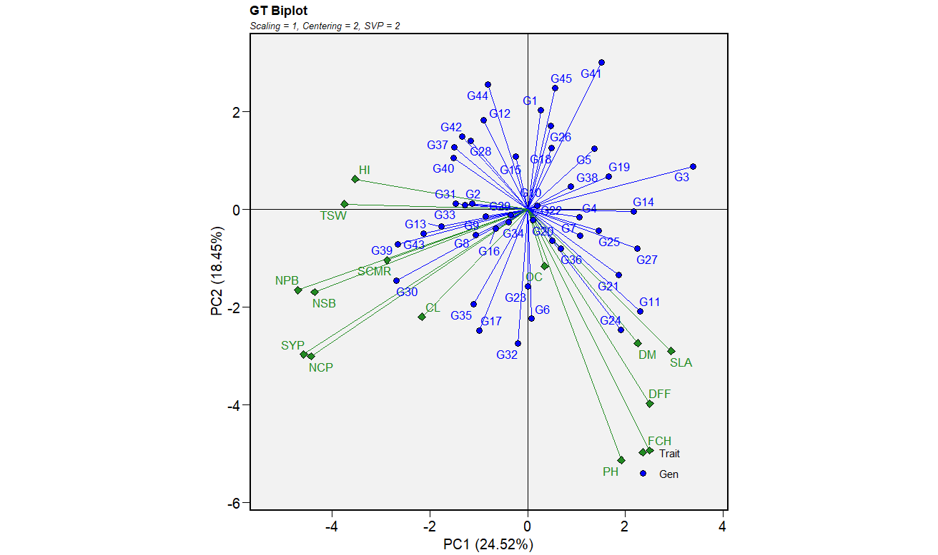

Fig. 2. A vector view of genotype-by-trait biplot, showing inter relationships among 14 yield and yield components of 45 Sesame genotypes

DFF: Days to 50% flowering, DM: Days to maturity, PH: Plant height (cm), FCH: First capsule axis height, NPB: Number of primary branches per plant, NSB: Number of secondary branches per plant, NCP: Number of capsules per plant, CL: Capsule length (cm), SCMR: SPAD chlorophyll meter reading, SLA: Specific leaf area, SW: 1000 seed weight (g), HI: Harvest index(%), OC: Oil content (%), SYP: Seed yield per plant (g)

G1: RMT-677, G2: KMR-35, G3: TPTS-94, G4: TPTS-18, G5: KMR-42, G6: VS-21-008, G7: VS-21-060, G8: MT-2019-3, G9: VS-21-078, G10: GT-10, G11: TPTS-152, G12: IC-205595, G13: TKG-22©, G14: TPTS-128, G15: PCU-23-1, G16: VS-20-001, G17: TPTS-45, G18: NIC-16386, G19: TPTS-64, G20: JCS-3287, G21: VS-20-008, G22: TPTS-95, G23: TPTS-244, G24: TPTS-66, G25: YLM-171, G26: EC-362447, G27: TPTS-67, G28: CUS-101, G29: JCS-4021, G30: TPTS-69, G31: RT-372, G32: TPTS-144, G33: TPTS-243, G34: TPTS-129, G35: JCS-3993, G36: YLM-146©, G37: JTS-8, G38: TPTS-80, G39: RMT-586, G40: VS-19-036, G41: TPTS-83, G42: DS-97, G43: JCS-4024, G44: RMT-631, G45: TPTS-235.
3.3 Ranking of Sesame Genotypes Based on Overall Performance
The average tester axis (ATA) view of the GT biplot (Fig. 3), constructed using trait-focused singular value partitioning (SVP = 2), enabled the ranking of all 45 sesame genotypes based on their mean performance across the 14 evaluated traits. The ATA, defined as the horizontal line passing through the biplot origin and the average tester, serves as the reference axis for comparing the overall merit of genotypes. The ideal genotype, represented at the centre of concentric circles in the positive direction of the ATA, served as the reference point for ranking. Genotypes positioned closer to the ideal genotype were considered superior in overall performance, while those situated farther from it were regarded as less desirable.
Among the 45 genotypes evaluated, TPTS-45 emerged as the ideal genotype, demonstrating the best balance of high performance and stability across all 14 traits. Following TPTS-45, the genotypes JCS-3993, TPTS-144, VS-21-008, TPTS-244, TPTS-69 and VS-20-001 were ranked as the most desirable, in descending order of their proximity to the ideal genotype. The ranking order was: TPTS-45 > JCS-3993 > TPTS-144 > VS-21-008 > TPTS-244 > TPTS-69 > VS-20-001. These genotypes exhibited favorable overall performance across the measured traits and are therefore recommended for direct use in breeding programmes or as parents in hybridization to develop high-yielding sesame varieties.
The remaining genotypes, which were positioned at greater distances from the ideal genotype, were considered less suitable for selection across the trait spectrum evaluated. However, some of these genotypes may still hold value for specific trait improvement programmes where a narrow-trait focus is intended.

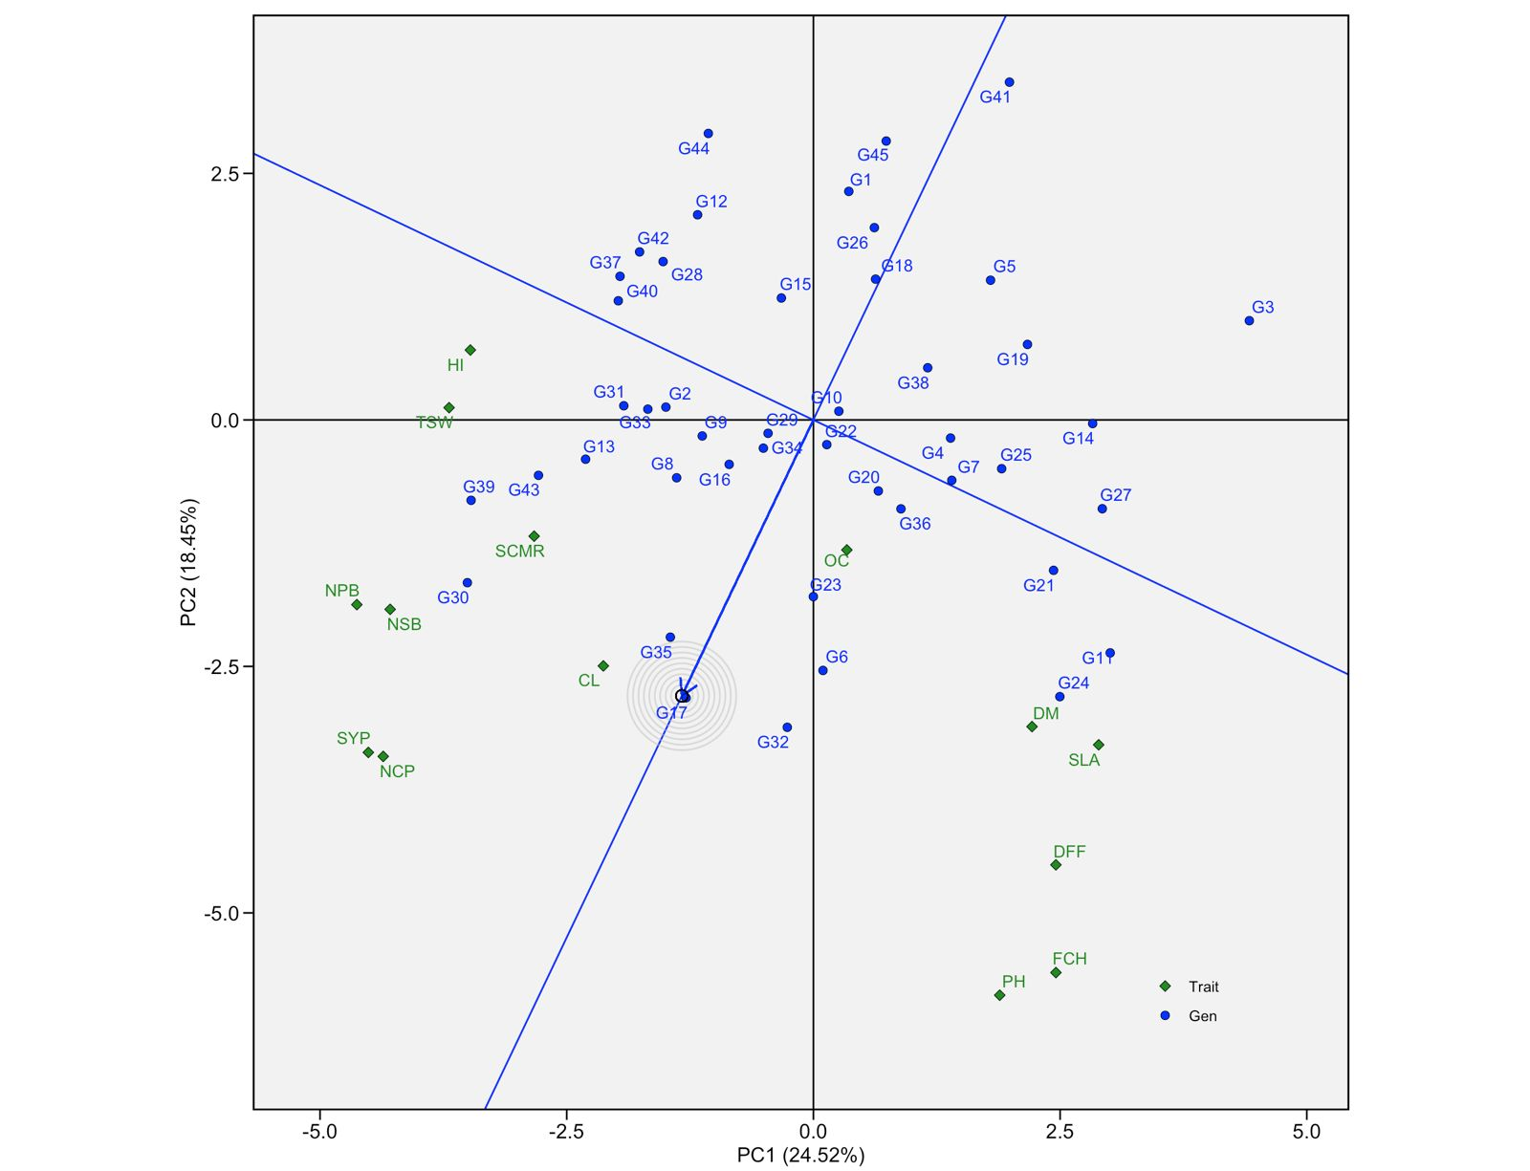

Fig. 3. An ideal entry and tester view of genotype-by-trait biplot, showing the ranking of 45 Sesame genotypes for 14 yield and its contributing traits.

DFF: Days to 50% flowering, DM: Days to maturity, PH: Plant height (cm), FCH: First capsule axis height, NPB: Number of primary branches per plant, NSB: Number of secondary branches per plant, NCP: Number of capsules per plant, CL: Capsule length (cm), SCMR: SPAD chlorophyll meter reading, SLA: Specific leaf area, SW: 1000 seed weight (g), HI: Harvest index(%), OC: Oil content (%), SYP: Seed yield per plant (g)

G1: RMT-677, G2: KMR-35, G3: TPTS-94, G4: TPTS-18, G5: KMR-42, G6: VS-21-008, G7: VS-21-060, G8: MT-2019-3, G9: VS-21-078, G10: GT-10, G11: TPTS-152, G12: IC-205595, G13: TKG-22©, G14: TPTS-128, G15: PCU-23-1, G16: VS-20-001, G17: TPTS-45, G18: NIC-16386, G19: TPTS-64, G20: JCS-3287, G21: VS-20-008, G22: TPTS-95, G23: TPTS-244, G24: TPTS-66, G25: YLM-171, G26: EC-362447, G27: TPTS-67, G28: CUS-101, G29: JCS-4021, G30: TPTS-69, G31: RT-372, G32: TPTS-144, G33: TPTS-243, G34: TPTS-129, G35: JCS-3993, G36: YLM-146©, G37: JTS-8, G38: TPTS-80, G39: RMT-586, G40: VS-19-036, G41: TPTS-83, G42: DS-97, G43: JCS-4024, G44: RMT-631, G45: TPTS-235.

3.4 Discriminativeness and Representativeness of Traits
The discriminativeness versus representativeness view of the GT biplot (Fig. 4) provides a dual evaluation of each trait based on: (i) its discriminating ability, reflected by the length of the trait vector (longer vectors = greater discrimination among genotypes), and (ii) its representativeness of the overall genotypic performance, measured by the cosine of the angle between the trait vector and the average tester axis (smaller angle = more representative). Traits that combine both a long vector and a small angle with the ATA are considered the most informative and ideal selection criteria.
Among the traits evaluated, plant height, first capsule axis height, seed yield per plant, number of capsules per plant, number of primary branches per plant, number of secondary branches per plant and days to 50% flowering exhibited the longest vectors, indicating that these traits possess the highest discriminating power for differentiating among the 45 sesame genotypes. These traits are therefore highly sensitive to genotypic variation and can effectively stratify the genotype panel.
In contrast, days to maturity, specific leaf area, 1000 seed weight, harvest index, SCMR, capsule length and oil content displayed shorter vectors, suggesting that they contribute relatively less to genotype differentiation. These traits may be more influenced by environmental factors or may show less genetic variation among the evaluated genotypes.
With respect to representativeness, seed yield per plant, number of capsules per plant, number of primary branches per plant, number of secondary branches per plant, plant height and first capsule axis height formed the smallest angles with the ATA, indicating that these traits most accurately reflect the overall performance pattern of all genotypes. Conversely, harvest index, 1000 seed weight, specific leaf area and days to maturity showed larger angles with the ATA, marking them as less representative of overall genotypic performance.
Integrating both criteria, the most desirable traits for genotype evaluation and selection in sesame were identified as plant height, first capsule axis height, seed yield per plant, number of capsules per plant, number of primary branches per plant and number of secondary branches per plant. These six traits simultaneously possessed high discriminating power and strong representativeness, making them the most reliable and efficient indices for genotype evaluation. Placing greater emphasis on these traits in future selection programmes would maximize the efficiency of genotype screening and accelerate the development of superior sesame cultivars.

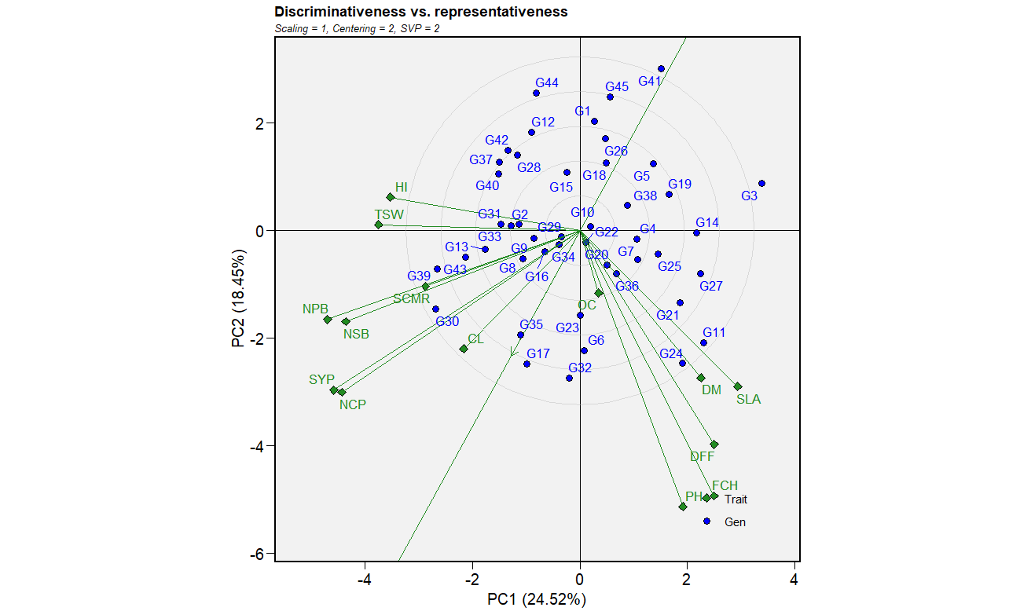

-Fig. 4. Genotype-by-trait biplot for discriminativeness and representativeness of 14 yield and yield attributing traits of 45 genotypes.

DFF: Days to 50% flowering, DM: Days to maturity, PH: Plant height (cm), FCH: First capsule axis height, NPB: Number of primary branches per plant, NSB: Number of secondary branches per plant, NCP: Number of capsules per plant, CL: Capsule length (cm), SCMR: SPAD chlorophyll meter reading, SLA: Specific leaf area, SW: 1000 seed weight (g), HI: Harvest index(%), OC: Oil content (%), SYP: Seed yield per plant (g)

G1: RMT-677, G2: KMR-35, G3: TPTS-94, G4: TPTS-18, G5: KMR-42, G6: VS-21-008, G7: VS-21-060, G8: MT-2019-3, G9: VS-21-078, G10: GT-10, G11: TPTS-152, G12: IC-205595, G13: TKG-22©, G14: TPTS-128, G15: PCU-23-1, G16: VS-20-001, G17: TPTS-45, G18: NIC-16386, G19: TPTS-64, G20: JCS-3287, G21: VS-20-008, G22: TPTS-95, G23: TPTS-244, G24: TPTS-66, G25: YLM-171, G26: EC-362447, G27: TPTS-67, G28: CUS-101, G29: JCS-4021, G30: TPTS-69, G31: RT-372, G32: TPTS-144, G33: TPTS-243, G34: TPTS-129, G35: JCS-3993, G36: YLM-146©, G37: JTS-8, G38: TPTS-80, G39: RMT-586, G40: VS-19-036, G41: TPTS-83, G42: DS-97, G43: JCS-4024, G44: RMT-631, G45: TPTS-235.
4. Conclusion
The present investigation demonstrated the utility of the GT biplot as a comprehensive multi-trait analytical framework for evaluating sesame genotypes. The which-won-where polygon view identified TPTS-66 as a superior genotype for maturity and oil-related traits, while TPTS-69 and RMT-586 were identified as outstanding donors for yield-contributing characters. The vector view established robust positive associations of seed yield with harvest index, number of capsules per plant, primary and secondary branching, SCMR and 1000 seed weight, alongside a negative relationship with oil content, days to flowering and plant height, providing clear direction for indirect selection strategies.
Genotype ranking analysis designated TPTS-45 as the ideal genotype, with JCS-3993, TPTS-144, VS-21-008, TPTS-244, TPTS-69 and VS-20-001 as the next most desirable for overall trait performance. The discriminativeness versus representativeness analysis reinforced the primacy of plant height, first capsule axis height, seed yield per plant, number of capsules per plant, number of primary and secondary branches per plant as the most informative selection traits.
These outcomes collectively provide a scientifically grounded basis for parent selection and multi-trait improvement in sesame breeding programmes targeting higher yields, earlier maturity and enhanced oil accumulation. The genotypes TPTS-45, TPTS-69 and RMT-586 are particularly recommended for utilization as parents in hybridization, while TPTS-66 may be valuable specifically for programmes aimed at improving oil content and plant architecture.
Declaration of AI Use

This manuscript was prepared through the intellectual contributions of the author(s) to the study design, data analysis, interpretation of results, and scholarly content. Grammarly and ChatGPT were used solely to assist with grammatical refinement and reference formatting during manuscript revision. The author(s) accept full responsibility for the accuracy, integrity, and final content of the manuscript.

References
Arpitha, M. (2025). Genetic evaluation of sesame genotypes for yield and yield attributes using GT biplot analysis. M.Sc. (Agri.) Thesis, University of Agricultural Sciences, India.
Atnaf, M., Tesfaye, K., Dagne, K., & Wegary, D. (2017). Phenotypic diversity and trait associations in Ethiopian white lupin (Lupinus albus L.) landrace accessions. Australian Journal of Crop Science, 11(6), 695–704.
Bakhshi, B., Sadeghzadeh, B., Mahmoudi, K., & Mohammadi, S.A. (2023). Genotype-by-trait biplot analysis for assessment of interrelationships among traits and selection of superior rapeseed genotypes. Industrial Crops and Products, 192, 116088.
Ebrahimi, A., Majidi, M.M., Arzani, A., & Mohammadi-Nejad, G. (2023). Application of GT biplot for multi-trait evaluation of safflower genotypes. Field Crops Research, 290, 108756.
Faheem, M., Ali, M.A., Ghafoor, A., & Khan, M.R. (2023). Multivariate analysis for yield and quality traits in bread wheat using genotype-by-trait biplot. Cereal Research Communications, 51, 425–435.
Gholizadeh, A., Dehghanpour, Z., & Haghparast, R. (2023). GT biplot analysis for multi-trait selection of sunflower (Helianthus annuus L.) genotypes. Helia, 46(78), 1–16.
Gungor, H., Oral, E., & Yildirim, A. (2024). Genotype by trait biplot analysis for agromorphological characterization of barley genotypes. Journal of Cereal Science, 115, 103795.
Purwati, R.D., Trisyono, Y.A., Martono, E., & Subandiyah, S. (2022). Correlation and path analysis for seed yield components in Jatropha (Jatropha curcas L.). Agronomy, 12(2), 395.
Sharfi, A.A., & Ebadi, A.A. (2018). Genotype × trait biplot analysis of interrelationships among agronomic traits in rice (Oryza sativa L.) genotypes. Iranian Journal of Crop Sciences, 20(1), 76–89.
Shojaei, S.H., Mostafavi, K., Ghaffari, M., & Mirzaee-Aghdam, M. (2023). Evaluation of sunflower genotypes for seed yield and yield components using GT biplot analysis. Helia, 46(79), 45–60.
Sofia, P.K., Prasad, R., Vijay, V.K., & Srivastava, A.K. (2017). Evaluation of antibacterial activity of Indian spices against common foodborne pathogens. International Food Research Journal, 24(2), 489–495.
Yan, W. (2001). GGE biplot: A Windows application for graphical analysis of multi environment trial data and other types of two-way data. Agronomy Journal, 93(5), 1111–1118.
Yan, W., Hunt, L.A., Sheng, Q., & Szlavnics, Z. (2000). Cultivar evaluation and mega-environment investigation based on the GGE biplot. Crop Science, 40(3), 597–605.
Yan, W., & Rajcan, I. (2002). Biplot analysis of test sites and trait relations of soybean in Ontario. Crop Science, 42(1), 11–20.
Yan, W., & Tinker, N.A. (2005). An integrated biplot analysis system for displaying, interpreting, and exploring genotype-by-environment interaction. Crop Science, 45(3), 1004–1016.
Yan, W., Fregeau-Reid, J., Pageau, D., & Martin, R. (2007). Genotype-by-environment interaction and trait associations in space and time in oat trial series. Crop Science, 47(3), 1080–1090.

