Identification of Genomic Regions Associated with Grain Zinc concentration in Rice (Oryza sativa L.)

Abstract
Micronutrient malnutrition commonly referred to as “hidden hunger” continues to affect over billion people globally, particularly in developing nations where diets are heavily cereal-based. To combat this crisis sustainably, bio-fortification in rice is a step toward that vision, one gene at a time. Rice being the dominant cereal and a major staple food in Asia, is the prime target for bio-fortification to tackle micronutrient malnutrition in South Asia and Southeast Asia. Since, zinc is an essential micronutrient for plant; its uptake is needed for general metabolism while Fe plays an irreplaceable role in oxygen transport via hemoglobin and myoglobin. In present study, the parental polymorphism was studied between two parents using rice microsatellite (RM) markers. The experiment was conducted at Indian Institute of Rice Research, Rajendranagar, Hyderabad (India). Rice varieties RNR15048 and Karuppunel dense in grain iron and zinc were used to study the parental polymorphism. Out of 1600 SSR markers used for parental polymorphism, 210 markers exhibited polymorphism with expected base pair from which 38 Zn related SSR markers were taken for further study. Therefore, these polymorphic rice microsatellite markers can be used in fine mapping of zinc related genes to study the mapping populations obtained from these parents. ZBR (0.898619**) was positively correlated with ZPR. A total of 39 QTLs were identified on seven chromosomes from which total 9 QTLs were identified for plant height, 3 QTLs were identified for number of tillers, 4 QTLs were identified for number of productive tillers, Two QTLs each were identified for SPAD, DFF, SPY, 6 QTLs were identified For ZBR & 11 QTLs were identified for ZPR. Most of the QTLs for different traits were identified on chromosome 1. The phenotypic variability explained ranged from 2.1037 to 12.958. Further, the exploitation of information regarding molecular markers tightly linked to QTLs governing these traits will facilitate future crop improvement strategies in rice.
Keywords: Rice, Microsatellite markers, Parental Polymorphism, QTLs, Bio-fortification.
Introduction
Rice (Oryza sativa L.), often hailed as the "Global Grain" or "Grain of Life," stands as one of the world’s most indispensable food crops. Cultivated across diverse geographical regions, rice serves as the staple food for more than two billion people in Asia and millions more across Africa and Latin America. According to Chatterjee (1948), rice belongs to the genus Oryza, which comprises 24 species. This rich genetic diversity not only reflects rice's evolutionary history but also provides the foundation for modern breeding strategies targeting both productivity and nutritional security. For more than half of the global population, rice is not just a food source but a ‘way of life’. It supplies a significant proportion of daily calorie intake through starch, alongside essential proteins and micronutrients (Donald et al., 2002). However, with the rising global concern over nutrient deficiencies in cultivated crops, malnutrition has emerged as one of the most pressing challenges of the 21st century (Copenhagen Consensus, 2008). Among these, Zinc (Zn) and Iron (Fe) deficiencies are the most common, affecting approximately two billion people globally each year, as per the World Health Organization. A promising strategy to combat this “hidden hunger” is bio-fortification, which refers to the genetic improvement of crops to enhance their nutritional value through plant breeding and biotechnology (Bouis, 2002; Phattarakul et al., 2012). Zn functions as a critical co-factor for numerous enzymes involved in metabolic processes (Frassinetti et al., 2006; Roohani et al., 2012), while Fe plays an irreplaceable role in oxygen transport via hemoglobin and myoglobin. In recent years, the focus of crop improvement programs has gradually shifted from merely increasing yield to enhancing the nutritional quality of staple foods like rice and wheat. The inherent genetic variability in micronutrient concentrations among rice genotypes provides the foundation for such nutritional improvements. However, effective utilization of this variability requires precise identification of donor genotypes and efficient tools for introgression into elite cultivars. This is where molecular breeding steps in, allowing the identification and transfer of desirable traits through tools like marker-assisted selection (MAS) and marker-assisted backcross breeding (MABB) (Xu & Crouch, 2008; Jiang, 2013). A crucial prerequisite to successful MAS or MABB is the analysis of parental polymorphism—the assessment of genetic differences between the donor and recipient parents for the trait of interest. Without polymorphism at the molecular level, especially in target QTL regions, effective selection and transfer of traits become challenging. In this context, simple sequence repeats (SSRs) or microsatellites have emerged as the most preferred molecular markers. These markers consist of short tandem repeats of 1–6 base pairs, distributed across coding and non-coding regions of the genome (Gemayel et al., 2013). Their co-dominant inheritance, high allelic polymorphism, reproducibility, and ease of PCR amplification make them ideal for genotyping (Cho et al., 2000; Mason, 2015). In rice, SSRs have been effectively used for gene tagging, diversity analysis, marker-assisted selection, marker-assisted introgression, marker-assisted back crossing and trait association studies (Mc Couch et al., 1997; Singh et al., 2010), making them essential tools in molecular breeding. QTL mapping is an efficient strategy to dissect the molecular mechanisms of rice yield traits which means that you can identify small bp variation, which is used to study genetic diversity and can be used as a tool for plant breeding. Therefore, this study focuses on the validation of Zn QTL regions in an F₂ population for confirmation of their efficacy and reliability for the Zn biofortification programs.
Materials and Methods
The experimental studies were undertaken in the farm of ICAR-Indian Institute of Rice Research (IIRR), Hyderabad located at 17.53N latitude and 78.27E longitude, 545m altitude, with a mean temperature of 31.2C and mean annual precipitation of 988.3mm.
Development and evaluation of F₂ population
An F₂ population was developed from the cross between RNR15048 (Zn:11.2 ppm in brown rice) as recipient parent and Karuppunel (Zn:30.5 ppm in brown rice) as donor parent for high grain Zn. A total of 80 F₂ individuals were evaluated under field conditions. Individual F₂ plants were maintained at a spacing of 20 × 15 cm. The data were recorded on three randomly selected plants of each replication for the characters such as Days to 50% flowering (DFF), Plant height (PH), Number of Tillers per plant (NT), Number of Productive tillers per plant (NPT), Panicle Length (PL), Flag Leaf length (FL), Single plant yield (SPY). Observations were recorded on grain for Zinc and Iron by energy dispersive X-ray fluorescent spectrophotometer (ED-XRF) (Oxford Instruments: X- Supreme 8000) at ICAR-IIRR as per the standardized protocols (Rao et al., 2014).
Genotyping with SSR markers
Tissue samples from 21-day-old seedlings were used for DNA isolation following the CTAB protocol (Doyle & Doyle, 1987). Quantification of DNA was done with Nano Drop (Thermo Fisher Scientific, Wilmington, USA). In the present study, we have taken SSR markers which are efficient in estimating the diversity analysis among the parental lines, cultivars and inbred lines in rice (Enoki et al., 2002). A total of 1600 SSR markers well distrubuted on 12 chromosomes were used to identify polymorphism between the parents. 210 of 1600 SSR markers were found to be polymorphic with an overall polymorphism of 13.13%. Out of 210 polymorphic markers, 38 Zn related SSR markers (shown in table-1) were further selected for genotyping of 80 F₂ population.
The percent polymorphism was calculated by the formula as below:
Percent Polymorphism= Number of Polymorphic Markers /Total Number of Markers Screened X 100
Based on grain Zn concentration, 24 contrasting F₂ individuals comprising 12 high-Zn individuals (35–45 ppm) and 12 low-Zn individuals (9–14 ppm) were initially used for comparison of marker profiles. Subsequently, the complete set of 80 F₂ individuals was genotyped using the 38 selected polymorphic SSR markers, and the resulting genotype data were used for linkage-map construction and QTL analysis.
A PCR mixture consists of 30 ng/µL of template DNA, 1X PCR buffer (10mMTris, pH8.4, 50mMKCl, 1.5 mM MgCl2 and 0.01mgmL-1 gelatin), 5.0 mM of Betain, 5 pm of forward and reverse primers and 2.5 Mm of dNTPs and 1 U Taq polymerase (GeNei). PCR was kept in a programmable thermal cycle (Applied Biosystems, Foster City, USA) for DNA amplification which was set to a thermal profile as follows i.e. (a) Initial denaturation for 5 minutes at 94°C, (b) 35 cycles of denaturation for 30 seconds at 94°C, (b) Primer annealing for 30 seconds at 55°C, (c) Elongation or extension for 1 minute at 72°C and (d) Final extension of 10 min at 72ºC. Amplicons consisting of ethidium bromide were separated by submarine electrophoresis in 3% agarose gel at 90V for 1 to 2h. Followed by gel documentation (Medicare gelstan 4X advanced- gel doc), the gel was exposed to UV transillumination for visualization and respective bands where estimated with the help of a standard DNA ladder (Gene Ruler100-bpladder) (Balaji et al.2012).
Descriptive Statistics and Correlation Analysis
Descriptive statistical analyses were performed for the studied traits using Microsoft Excel 2016. The parameters estimated included mean, minimum, maximum, range, standard deviation, coefficient of variation (CV%), skewness and kurtosis.
Pearson correlation coefficients were estimated among the evaluated agronomic and grain Zn traits using Microsoft Excel 2016 to determine the direction and magnitude of associations among traits.

Table-1: List of 38 Zn polymorphic SSRs used in the study
S.No. | SSR | Forward sequence | Reverse sequence | Chr. No. | Repeat motif | Expected target size
1 | RM562 | CACAACCCACAAA CAGCAAG | CTTCCCCCAAAGT TTTAGCC | 1 | (AAG)13 | 243
2 | RM11943 | CTTGTTCGAGGAC GAAGATAGGG | CCAGTTTACCAGG GTCGAAACC | 1 | (GA)11 | 76
3 | RM12276 | GTCGACGGCTTCCT CAAGATTGG | TGAGACCTCTGTG AAGGCACTCG | 1 | (TC)17 | 188
4 | RM5638 | GGCTTCCTCATCGC CATC | CTGAGCAGCATTC CAGTCTG | 1 | (AAG)13 | 203
5 | RM243 | GATCTGCAGACTG CAGTTGC | AGCTGCAACGAT GTTGTCC | 1 | (CT)18 | 116
6 | RM5461 | GCCTCCCATATAA ACCGGC | AGCGAAGGGAAC ACGACAG | 1 | (TC)19 | 134
7 | RM488 | CAGCTAGGGTTTTG AGGCTG | TAGCAACAACCA GCGTATGC | 1 | (GA)17 | 177
8 | RM490 | ATCTGCACACTGC AAACACC | AGCAAGCAGTGC TTTCAGAG | 1 | (CT)13 | 101
9 | RM24 | GAAGTGTGATCAC TGTAACC | TACAGTGGACGG CGAAGTCG | 1 | (GA)29 | 192
10 | RM6 | GTCCCCTCCACCCA ATTC | TCGTCTACTGTTG GCTGCAC | 2 | (AG)16 | 163
11 | RM154 | GACGGTGACGCAC TTTATGAACC | CGATCTGCGAGA AACCCTCTCC | 2 | (GA)21 | 183
12 | RM489 | ACTTGAGACGATC GGACACC | TCACCCATGGATG TTGTCAG | 3 | (ATA)8 | 271
13 | RM523 | AAGGCATTGCAGC TAGAAGC | GCACTTGGGAGG TTTGCTAG | 3 | (TC)14 | 148
14 | RM231 | CCAGATTATTTCCT GAGGTC | CACTTGCATAGTT CTGCATTG | 3 | (CT)16 | 182
15 | RM520 | AGATTGATCTCCCA TTCCCC | CACGAGCATATTA CTAGTGG | 3 | (AC)12 | 247
16 | RM85 | CCAAAGATGAAAC CTGGATTG | GCACAAGGTGAG CAGTCC | 3 | (TGG)5(TCT)12 | 107
17 | RM55 | CCGTCGCCGTAGT AGAGAAG | TCCCGGTTATTTT AAGGCG | 3 | (GA)17 | 226
18 | RM470 | TCCTCATCGGCTTC TTCTTC | AGAACCCGTTCTA CGTCACG | 4 | (CTT)14 | 83
19 | RM13 | TCCAACATGGCAA GAGAGAG | GGTGGCATTCGAT TCCAG | 5 | (GA)6- (GA)16 | 141
20 | RM8226 | GCGTGTTCAGAAA TTAGGATACGG | GATCTCGCCACGT AATTGTTGC | 6 | (AAG)14 | 251
21 | RM225 | TGCCCATATGGTCT GGATG | GAAAGTGGATCA GGAAGGC | 6 | (CT)18 | 140
22 | RM253 | TCCTTCAAGAGTGC AAAACC | GCATTGTCATGTC GAAGCC | 6 | (GA)25 | 141
23 | RM541 | TATAACCGACCTC AGTGCCC | CCTTACTCCCATG CCATGAG | 6 | (TC)16 | 158
24 | RM340 | GGTAAATGGACAA TCCTATGGC | GACAAATATAAG GGCAGTGTGC | 6 | (CTT) 8T3(CTT)14 | 163
25 | RM3404 | AGTCCTGAGTCTCC TGTCCT | CCTGTTCGATCTT GAACTTC | 7 | (CT)17 | 136
26 | RM234 | ACAGTATCCAAGG CCCTGG | CACGTGAGACAA AGACGGAG | 7 | (CT)25 | 156
27 | RM1132 | ATCACCTGAGAAA CATCCGG | CTCCTCCCACGTC AAGGTC | 7 | (AG)12 | 93
28 | RM248 | TCCTTGTGAAATCT GGTCCC | GTAGCCTAGCATG GTGCATG | 7 | (CT)25 | 102
29 | RM1111 | CCTCCTGTCGGATC TGGTAG | CTTATCCACTTGC CCTCTCG | 8 | (AG)12 | 111
30 | RM264 | GTTGCGTCCTACTG CTACTTC | GATCCGTGTCGAT GATTAGC | 8 | GA)27 | 178
31 | RM3909 | GATCACCAAAACA GTCCAAC | AAACTGTCCTCCC CACAG | 9 | (GT)21 | 205
32 | RM216 | GCATGGCCGATGG TAAAG | TGTATAAAACCAC ACGGCCA | 10 | (CT)18 | 146
33 | RM332 | GCGAAGGCGAAGG TGAAG | CATGAGTGATCTC ACTCACCC | 11 | (CTT)5-12- (CTT)14 | 183
34 | RM224 | ATCGATCGATCTTC ACGAGG | TGCTATAAAAGG CATTCGGG | 11 | (AAG)8(AG) 13 | 157
35 | RM8216 | AGTTGATTATCCAT CATGTGC | TGTAGGCCCTATG AATCTCC | 12 | (TAA)25 | 210
36 | RM247 | TAGTGCCGATCGA TGTAACG | CATATGGTTTTGA CAAAGCG | 12 | (CT)16 | 131
37 | RM3331 | CCTCCTCCATGAGC TAATGC | AGGAGGAGCGGA TTTCTCTC | 12 | (CT)15 | 129
38 | RM19 | CAAAAACAGAGCA GATGAC | CTCAAGATGGAC GCCAAGA | 12 | (ATC)10 | 226

Genetic linkage map construction & QTL identification
Genotypic data generated from 80 F₂ individuals using 38 polymorphic Zn-related SSR markers were used for genetic linkage-map construction and QTL analysis using QTL IciMapping version 4.2. The mapping population was specified as F₂, and recombination frequencies were converted into genetic distances using the Kosambi mapping function. Linkage groups were established using the GROUP function at a minimum LOD score of 3.0, and the SSR markers were ordered according to their recombination frequencies and estimated genetic distances.
QTLs associated with the evaluated traits were identified using inclusive composite interval mapping (ICIM) in QTL IciMapping v4.2. Background marker variables were selected through stepwise regression. A total of 1,000 permutation tests at P = 0.05 were performed for assessment of QTL significance, and a minimum LOD score of 2.5 was used as the criterion for declaring putative QTLs. For each detected QTL, the chromosomal position, flanking markers, LOD score, phenotypic variance explained (PVE%), and additive and dominance effects were estimated.
Results
The descriptive statistics presented in Table.2 were computed for all the traits in the 80 F₂ population. Mean, range, standard deviation and coefficient of variation (CV%) were estimated to understand the extent of phenotypic variability. The mean values ranged from 16.67 to 153.24, while the trait-wise ranges varied from 18.5 to 107.8. Considerable variation was observed among the studied traits based on the CV values. The highest CV was recorded for SPY (86.30%), followed by ZPR (43.22%) and ZBR (37.16%). Skewness values varied among the traits, indicating both negatively and positively skewed distributions, while kurtosis also varied considerably among the studied traits.
Table –2: Descriptive analysis of F₂ population
Trait | Mean | Standard Deviation | CV% | Range | Minimum | Maximum | Kurtosis | Skewness
PH | 153.238 | 31.4157 | 20.5 | 107.8 | 98.9 | 206.7 | -1.2522 | -0.1352
FLL | 45.8125 | 10.4138 | 22.73 | 50.3 | 22.3 | 72.6 | -0.198 | 0.34403
PL | 24.15 | 2.78731 | 11.54 | 18.5 | 17.9 | 36.4 | 4.70734 | 1.35767
NT | 27.4875 | 8.10999 | 29.5 | 32 | 16 | 48 | -0.4434 | 0.70425
NPT | 27.1625 | 8.05589 | 29.65 | 32 | 16 | 48 | -0.5494 | 0.6597
SPAD | 40.306 | 6.96565 | 17.28 | 43.64 | 10.43 | 54.07 | 3.1222 | -0.8245
DFF | 101.7 | 9.06712 | 8.91 | 51 | 61 | 112 | 5.09875 | -1.771
SPY | 16.6716 | 14.3872 | 86.3 | 88.07 | 2.27 | 90.34 | 8.10731 | 2.28847
ZBR | 25.3244 | 9.41052 | 37.2 | 35.56 | 9.84 | 45.4 | -1.0986 | 0.24745
ZPR | 22.03 | 9.52098 | 43.2 | 32.3 | 7.8 | 40.1 | -1.305 | 0.29077

Correlation coefficient
The study of genetic correlation gives us an idea about the extent to which the characters are under the control of genes and this type of analysis could help the breeder to design his selection for effective improvement of characters. In the present study, that ZBR was positive and non-significant with NT (0.13134), NPT (0.151645), DFF (0.181076), SPY (0.178366) where ZPR was positive significantly associated with ZBR (0.898619**) and showed negative significant with PH (-0.251*). SPY was positively significant with DFF (0.385088**), NT (0.249399*) and NPT (0.236306*) and showed positively non significance with PH (0.028757), FLL (0.046407), SPAD (0.033344) (shown in table 3).
Table-3: Correlation coefficient studies among different characters
Trait | PH | FLL | PL | NT | NPT | SPAD | DFF | SPY | ZBR | ZPR
PH | 1
FLL | 0.672095** | 1
PL | 0.323647* | 0.27308* | 1
NT | 0.222814* | 0.186872 | -0.05989 | 1
NPT | 0.211835 | 0.182503 | -0.06001 | 0.996579** | 1
SPAD | -0.05828 | -0.11223 | -0.01498 | 0.074268 | 0.066282 | 1
DFF | 0.059556 | 0.198286 | -0.03561 | -0.00229 | -0.00938 | -0.27402* | 1
SPY | 0.028757 | 0.046407 | -0.06699 | 0.249399* | 0.236306* | 0.033344 | 0.385088** | 1
ZBR | -0.21528 | -0.10112 | -0.10925 | 0.13134 | 0.151645 | -0.0821 | 0.181076 | 0.17837 | 1
ZPR | -0.251* | -0.19495 | -0.0968 | 0.090861 | 0.104478 | -0.08293 | 0.117137 | 0.08668 | 0.898619** | 1

Parental Polymorphism and F₂ genotyping using 38 selected Zn related polymorphic markers
Approximately 1,600 SSR markers were initially screened for parental polymorphism between RNR15048 and Karuppunel. Of these, 210 SSR markers were found to be polymorphic between the two parents, corresponding to an overall parental polymorphism of approximately 13.13%. From the 210 polymorphic markers, 38 Zn-related SSR markers distributed across the 12 rice chromosomes were selected for genotyping of the F₂ population.
Among the selected markers, 9 were polymorphic on chromosome 1, 2 on chromosome 2, 6 on chromosome 3, 1 on chromosome 4, 1 on chromosome 5, 5 on chromosome 6, 4 on chromosome 7, 2 on chromosome 8, 1 on chromosome 9, 1 on chromosome 10, 2 on chromosome 11, and 4 on chromosome 12. The allelic range of 38 polymorphic SSRs ranged from 76bp to 271bp (Table-.4).
Among the total of 80 F₂ individuals evaluated for grain Zn concentration, 12 individuals with high Zn concentration (35–45 ppm) and 12 individuals with low Zn concentration (9–14 ppm) were identified as contrasting groups for marker evaluation. The 38 polymorphic Zn-related SSR markers were subsequently used to genotype the complete 80 F₂ population for linkage and QTL analysis. SSR alleles were scored according to parental allele size as A for the RNR15048 allele, B for the Karuppunel allele, H for the heterozygous genotype H for the heterozygous genotype containing alleles from both parents, and X for no amplification as shown in the Fig-1.
Table-4: Chromosome-wise distribution of polymorphic SSR markers and Zn-related SSR markers selected for genotyping of the F₂ population
Sr. No. | Chromosome | Polymorphic SSR markers | Zn related SSR markers selected
1 | Chr1 | 42 | 9
2 | Chr2 | 22 | 2
3 | Chr3 | 22 | 6
4 | Chr4 | 14 | 1
5 | Chr5 | 14 | 1
6 | Chr6 | 18 | 5
7 | Chr7 | 18 | 4
8 | Chr8 | 11 | 2
9 | Chr9 | 11 | 1
10 | Chr10 | 12 | 1
11 | Chr11 | 13 | 2
12 | Chr12 | 13 | 4
 | Total | 210 | 38
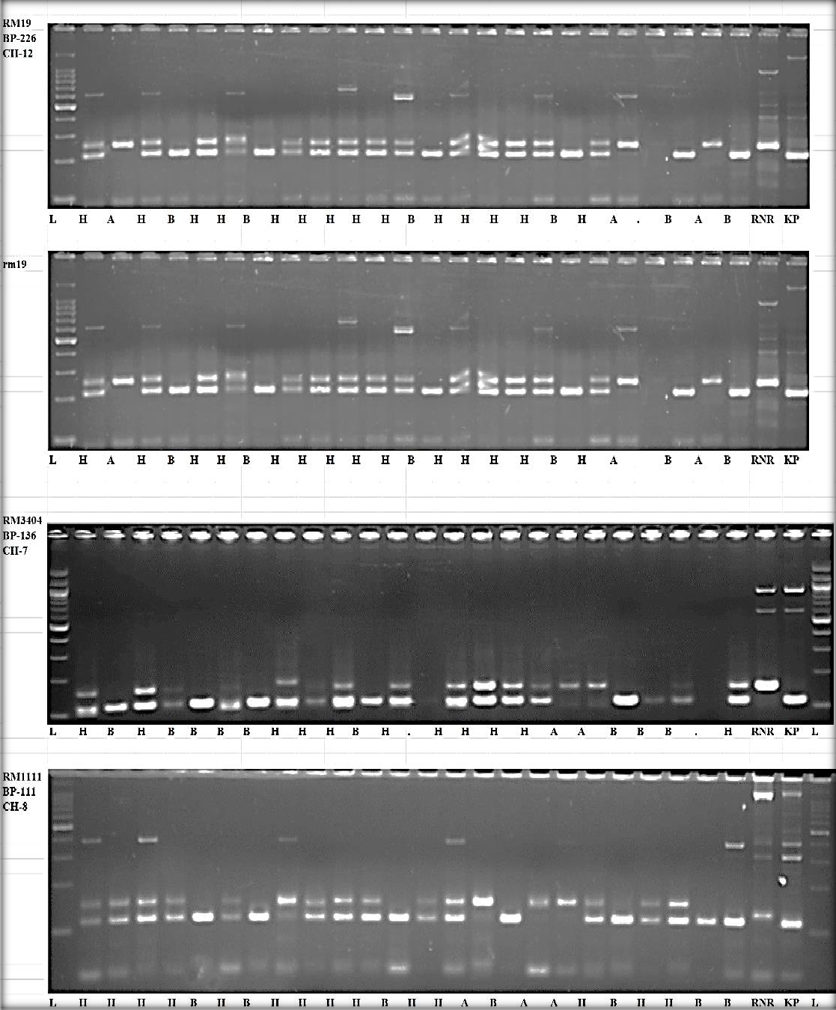

Fig-1: Gel image of representative polymorphic markers, where L:Ladder; A:RNR15048; B:karuppunel; H: Both RNR15048 and Karuppunel.

Identification of QTLs for various traits
From inclusive composite interval mapping (ICIM), a total of 39 QTLs were identified on seven chromosomes. The phenotypic variability explained (PVE) ranged from 12.958 to 2.1037. The 39 QTLs were identified for all the traits along with Chromosome number, Position, LOD, Marker interval, Additive effect, Dominance effect, PVE as shown in the table 5
A total of six QTLs were identified for ZBR, out of which 4 QTLs named qZBR1.1, qZBR1.2, qZBR1.3, qZBR1.4 were detected at chromosome 1 with 133, 272, 287, 295 cM position between the marker interval of RM5638-RM490 & RM562-RM11943 was found with 3.4096, 3.3117, 3.5688 & 3.3105 percent PVE. Another QTLs named qZBR6 and qZBR8 with 117 and 70 cM position was on chromosome 6 & 8 between marker interval of RM541-RM8226 and RM1111-RM264 and 3.2883, 2.4229 percent PVE.
11 QTLs were identified for ZPR, out of which 2 QTLs named qZPR1.1, qZPR1.2 with 134, 280 cM position were identified at chromosome 1 between marker interval RM5638-RM490 & RM562-RM11943 was found with 3.7617, 3.6341 percent PVE. Three QTLs named qZPR3.1, qZPR3.2, qZPR3.3 with 71,138,189 distance was identified at chromosome 3 between marker interval RM85-RM523, RM231-RM520 & RM520-RM489, PVE was 3.6316, 3.6292 & 3.6268 percent respectively. 2 QTLs, qZPR7.1 & qZPR7.2 were detected on chromosome 7 with 33 & 105 distance between marker interval RM3404-RM234 & RM1132-RM248 with 3.9, 3.745 percent PVE. Another 2 QTLs, qZPR8.1 & qZPR8.2 were identified at chromosome 8 with 32, 61 distance were located between marker RM1111-RM264, the PVE by 3.6835 & 3.6045. One QTL, qZPR6 and another QTL, qZPR12 was found on chromosome 6 & 12 with 118 & 74 position between marker RM541-RM8226, RM8215-RM247, the PVE 3.6293 & 3.6206 percent respectively.
On chromosome 6, two QTL qSPY6.1 & qSPY6.2 was discovered at 90 & 107 cM with a flanking marker RM541-RM8226, and the PVE by 2.4811 & 2.5791 percent.
A total of nine QTLs were identified for plant height, out of which 4 QTLs named qPH1.1, qPH1.2, qPH1.3, qPH1.4 were detected at chromosome 1 with 16,142,218,29 cM position between the marker interval of RM12276-RM24, RM5638-RM490, RM490-RM562, RM562-RM11943 and 2.1037, 2.4326, 2.1171, 2.5102 percent Phenotypic variability explained (PVE). Another, QTLs named qPH3 and qPH6 with 64 and 105 cM position was on chromosome 3 & 6 between marker interval of RM85-RM523 and RM541-RM8226 with 2.2429 & 2.1468 percent PVE. Another QTLs were located at chromosome 7, 8, 12 at flanking marker RM1132-RM248, RM1111-RM264, RM3331-RM8216 on linkage map with 108, 45,24 cM position named as qPH7, qPH8, qPH12 with PVE of 2.1484, 2.5151, 2.1987 percent.
Three QTLs were identified for number of tillers. From which 2 QTLs named qNT1.1, qNT1.2 with 153, 301 cM position was found on chromosomes 1 between marker interval RM5638-RM490 & RM562-RM11943, respectively, 1 QTL named qNT3 with 174 cM distance was found on chromosomes 3 with the flaking marker RM520-RM489. The PVE was 7.3772, 7.6837 and 9.2597 percent for qNT1.1, qNT1.2 & qNT3, respectively.
Four QTLs were identified for number of productive tillers out of which 3 QTLs were located at chromosome 1, at a flanking marker RM5638-RM490; RM490-RM562 & RM562-RM11943 on linkage map with 153, 204 & 301 cM position named qNPT1.1, qNPT1.2, qNPT1.3 and 5.4066, 5.4565 & 5.7242 percent PVE. Another QTL was located at chromosome 3, at flanking marker RM520-RM489 with 175 cM position named qNPT3, 6.9508 percent was the PVE.
Two QTLs were identified for SPAD at 34 and 140 cM distance at chromosomes 1 and 6, respectively. QTLs, qSPAD1 and qSPAD6 were found with the flaking marker RM24-RM488 and RM541-RM8226, with PVE was 12.958 percent and 10.615 percent for qSPAD1 and qSPAD6, respectively.
Two QTLs, qDFF1 and qDFF11 were found with the marker interval RM490-RM562 and RM332-RM224 with 212 and 19 cM distance at chromosomes 1 and 11, PVE was 6.1633 percent and 7.8828 percent, respectively.
The RM5638-RM490 had similar QTLs region for PH,NT,NPT,ZBR,ZPR; RM541-RM8226 showed similar QTL for PH, SPY, SPAD, ZBR, ZPR and for PH, ZPR the RM1132-RM248 were similar; DFF,PH,NPT has common RM490-RM562; RM1111-RM264 is common for PH,ZBR,ZPR; RM85-RM523 is common PH,ZPR; for NT, NPT,ZPR is having common RM520-RM489.

Table-5: High and Low Zn pool RK F2 QTL IciM mapping results
TraitName | Chr | Position | LeftMarker | RightMarker | LOD | PVE(%) | Add | Dom | LeftCI | RightCI
PH | 1 qPH1.1 | 16 | RM12276 | RM24 | 5.0281 | 2.1037 | 5.8769 | -58.5931 | 10.5 | 20.5
PH | 1 qPH1.2 | 142 | RM5638 | RM490 | 5.9863 | 2.4326 | -11.9475 | -55.1446 | 128.5 | 153.5
PH | 1 qPH1.3 | 218 | RM490 | RM562 | 3.9022 | 2.1171 | 3.2077 | 54.904 | 215.5 | 226.5
PH | 1 qPH1.4 | 295 | RM562 | RM11943 | 6.4915 | 2.5102 | -38.2857 | 9.5849 | 287.5 | 299.5
PH | 3 qPH3 | 64 | RM85 | RM523 | 3.5815 | 2.2429 | -19.8704 | 43.0075 | 56.5 | 70.5
PH | 6 qPH6 | 105 | RM541 | RM8226 | 4.1416 | 2.1468 | -2.3947 | -54.8559 | 97.5 | 114.5
PH | 7 qPH7 | 108 | RM1132 | RM248 | 4.6272 | 2.1484 | 4.2387 | 55.8445 | 96.5 | 121.5
PH | 8 qPH8 | 45 | RM1111 | RM264 | 5.958 | 2.5151 | -37.5765 | 9.3004 | 31.5 | 59.5
PH | 12 qPH12 | 24 | RM3331 | RM8216 | 3.5516 | 2.1987 | -7.6258 | -54.557 | 20.5 | 30.5
NT | 1 qNT1.1 | 153 | RM5638 | RM490 | 2.5292 | 7.3772 | 3.3628 | -11.0594 | 131.5 | 164.5
NT | 1 qNT1.2 | 301 | RM562 | RM11943 | 3.544 | 7.6837 | 5.347 | -7.7349 | 280.5 | 314.5
NT | 3 qNT3 | 174 | RM520 | RM489 | 4.922 | 9.2597 | -0.1537 | 13.7311 | 161.5 | 183.5
NPT | 1 qNPT1.1 | 153 | RM5638 | RM490 | 2.5267 | 5.4066 | 3.1429 | -11.1733 | 132.5 | 164.5
NPT | 1 qNPT1.2 | 204 | RM490 | RM562 | 2.5158 | 5.4565 | 3.1468 | -10.6298 | 195.5 | 215.5
NPT | 1 qNPT1.3 | 301 | RM562 | RM11943 | 3.8748 | 5.7242 | 5.165 | -8.1665 | 281.5 | 314.5
NPT | 3 qNPT3 | 175 | RM520 | RM489 | 4.9968 | 6.9508 | -0.4225 | 13.9457 | 165.5 | 184.5
SPAD | 1 qSPAD1 | 34 | RM24 | RM488 | 2.5092 | 12.958 | -0.854 | 7.0397 | 19.5 | 48.5
SPAD | 6 qSPAD6 | 140 | RM541 | RM8226 | 2.8495 | 10.615 | 3.6987 | -2.2221 | 121.5 | 140
DFF | 1 qDFF1 | 212 | RM490 | RM562 | 2.818 | 6.1633 | 7.6525 | 4.4523 | 193.5 | 230.5
DFF | 11 qDFF11 | 19 | RM332 | RM224 | 3.4917 | 7.8828 | -10.4728 | 6.6854 | 3.5 | 33.5
SPY | 6 qSPY6.1 | 90 | RM541 | RM8226 | 3.4795 | 2.4811 | -1.5057 | 31.0862 | 86.5 | 97.5
SPY | 6 qSPY6.2 | 107 | RM541 | RM8226 | 4.8593 | 2.5791 | 20.8686 | -19.0166 | 106.5 | 120.5
ZBR | 1 qZBR1.1 | 133 | RM5638 | RM490 | 4.9602 | 3.4096 | -2.101 | -15.986 | 127.5 | 133.5
ZBR | 1 qZBR1.2 | 272 | RM562 | RM11943 | 5.3977 | 3.3117 | -0.6759 | 16.3882 | 263.5 | 273.5
ZBR | 1 qZBR1.3 | 287 | RM562 | RM11943 | 3.1224 | 3.5688 | -11.1891 | 2.9133 | 283.5 | 290.5
ZBR | 1 qZBR1.4 | 295 | RM562 | RM11943 | 5.0526 | 3.3105 | -0.8973 | 16.2498 | 293.5 | 300.5
ZBR | 6 qZBR6 | 117 | RM541 | RM8226 | 4.8797 | 3.2883 | 0.068 | 16.5165 | 106.5 | 123.5
ZBR | 8 qZBR8 | 70 | RM1111 | RM264 | 2.6499 | 2.4229 | -8.7956 | -4.8558 | 48.5 | 88.5
ZPR | 1 qZPR1.1 | 134 | RM5638 | RM490 | 10.6127 | 3.7617 | -2.4105 | -16.9062 | 124.5 | 134.5
ZPR | 1 qZPR1.2 | 280 | RM562 | RM11943 | 9.9801 | 3.6341 | -0.5995 | 17.314 | 264.5 | 305.5
ZPR | 3 qZPR3.1 | 71 | RM85 | RM523 | 8.7052 | 3.6316 | 0.3563 | 17.4942 | 67.5 | 76.5
ZPR | 3 qZPR3.2 | 138 | RM231 | RM520 | 7.9945 | 3.6292 | 0.1285 | 17.4924 | 134.5 | 142.5
ZPR | 3 qZPR3.3 | 189 | RM520 | RM489 | 7.717 | 3.6268 | -0.0817 | 17.4965 | 180.5 | 191.5
ZPR | 6 qZPR6 | 118 | RM541 | RM8226 | 10.416 | 3.6293 | 0.2664 | 17.3941 | 107.5 | 126.5
ZPR | 7 qZPR7.1 | 33 | RM3404 | RM234 | 12.2454 | 3.9 | -3.3519 | -17.5994 | 24.5 | 41.5
ZPR | 7 qZPR7.2 | 105 | RM1132 | RM248 | 9.5085 | 3.745 | 2.1981 | -17.281 | 100.5 | 107.5
ZPR | 8 qZPR8.1 | 32 | RM1111 | RM264 | 9.4594 | 3.6835 | -1.8134 | -17.4474 | 31.5 | 32.5
ZPR | 8 qZPR8.2 | 61 | RM1111 | RM264 | 4.9312 | 3.6045 | -8.8425 | -8.4554 | 47.5 | 66.5
ZPR | 12 qZPR12 | 74 | RM8216 | RM247 | 6.5627 | 3.6206 | 0.0619 | 17.4509 | 71.5 | 78.5

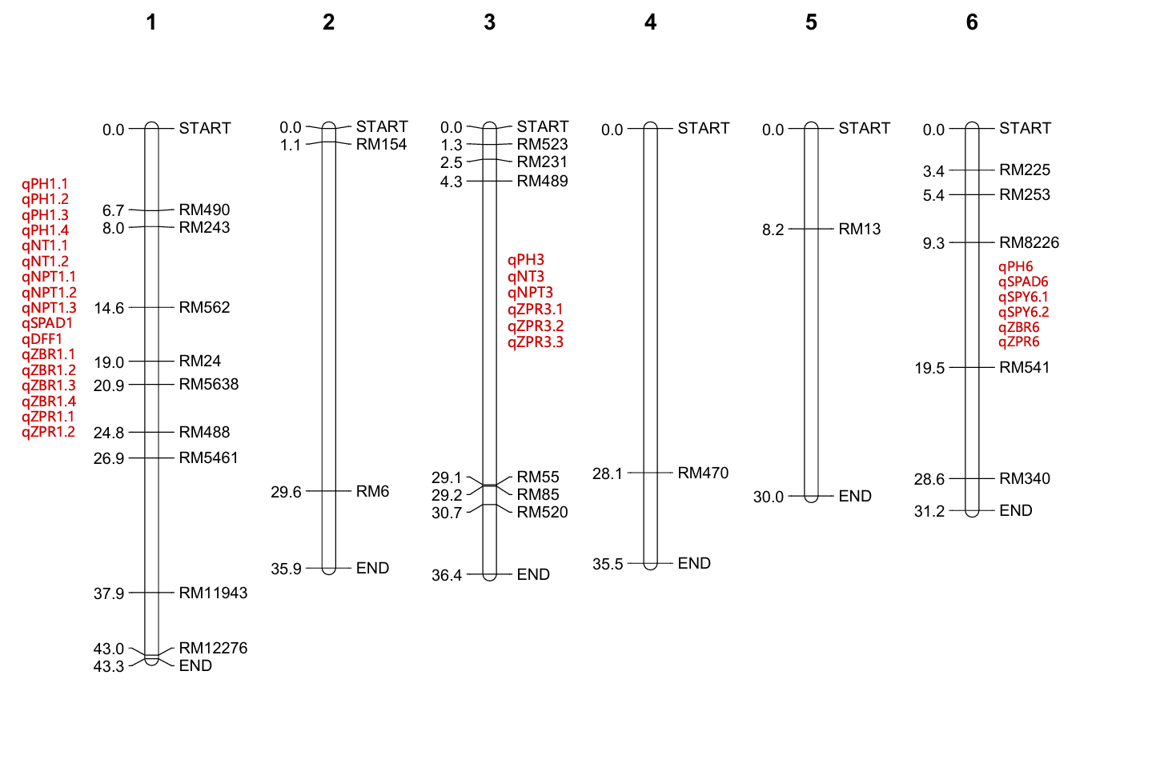
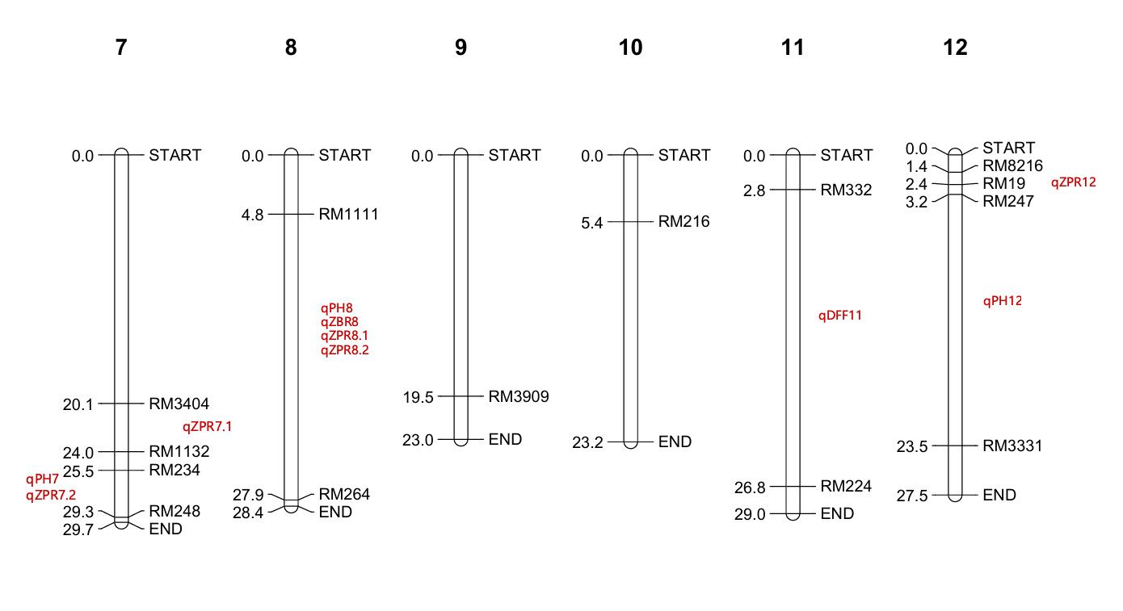
Fig-2: Chromosome wise physical distribution of 38 Polymorphic SSR markers between RNR15048 & Karuppunel along with QTL locations for all the traits.

Discussion
As rice is an important staple food globally, research for its development and improvement of nutritional value is an imperative task. Global climate change poses a significant threat to agricultural productivity, with profound implications for global food and nutritional security. Among the critical micronutrient deficiencies, Zn deficiency remains a major public health concern, affecting almost billion people worldwide. Therefore, rice bio-fortification becomes a sustainable and eco-friendly approach to address micronutrient malnutrition.
In descriptive analysis the CV% was high in SPY (86.30%), followed by ZPR (43.22%) and ZBR (37.16%) which showed presence of phenotypic variability. For successful selection, it is necessary to study the nature of association of the character in question with other relevant traits. The associations may either be positive or negative. In this study, ZBR was positive and non-significant with NT, NPT, DFF, SPY where ZPR was positive significantly associated with ZBR (0.898619**). SPY was positively significant with DFF, NT and NPT. Other findings showed a significant negative correlation between heading date and Zn concentration in brown rice and was observed for 2 years in the RIL population by Mufid Alam et al. (2020). For parental polymorphism in the study 210 SSR markers were polymorphic between parents from which a total of 38 Zn related SSR markers identified across the 12 chromosomes were further used in F₂ population. Similar results on parental polymorphism were reported by Kiranmayi et al. (2014) using 71 gene specific markers, of these only 13 (18.3%) were polymorphic while Gangaprasad Chowdary et al. (2013) used 64 rice SSR markers and of these 52 markers showed polymorphism. Of the 50 SSR markers, 23 markers were observed to show distinct polymorphism Suman et al. (2020). A total of 948 SSR markers were screened for parental polymorphism, 119 were found polymorphic between the parents and used for genotyping the population. On selective genotyping, 60 were found polymorphic between parents and RILs. These 60 markers were further utilised for construction of linkage map and QTL detection by Rathod et al. (2021). Similarly, Sai rachana et al. (2023) reported that 166 SSR markers were employed, out of which 58 are found to be polymorphic between parents with 35% parental polymorphism and the polymorphic information content is about 0.6.
A total of 39 QTLs were identified on seven chromosomes. A total of 9 QTLs were identified for plant height, number of tillers 3 QTLs were identified, 4 QTLs were identified for number of productive tillers , Two QTLs were identified for SPAD, another, Two QTLs were identified for days to flowering, two QTLs were detected for single plant yield. For ZBR 6 QTLs were identified and a total of 11 QTLs were identified for ZPR. Most of the QTLs for different traits were identified on chromosome 1. qSPAD1 which has high PVE with (12.958) and low PVE for qPH1.1 (2.1037). These QTLs and candidate genes help to further elucidate the genetic basis for grain micronutrient concentration, and may prove useful for marker assisted breeding for the important trait (Swamy et al., 2018). Similar findings were reported by Rohini bhat et al., 2022, where, a total of 30 QTLs governing nine different traits were identified using the composite interval mapping (CIM) method. Most of the QTLs were detected on chromosome 2. Other studies obtained 42 and 3 SSR markers association with grain Fe and Zn content, respectively. Using a GLM model with r 2 >0.10 and p 0.05filters, they reported novel QTLs qFe3.3 and qFe7.3 for grain Fe and qZn2.2, qZn8.3 and qZn12.3 for Zn in 485 germplasm lines of milled rice by Pradhan et al. (2020). Islam et al. (2020) worked on landraces and reported 15 QTLs from which only one QTL (QTL.Fe.9) for Fe content was located on chromosome 9 and two (QTL.Zn.4 andQTL.Zn.5) for Zn on chromosome 4. A total of 17 QTLs for P, K, Na, Ca, and Mg contents in brown and milled rice distributed on eight regions were identified in the BC1F5 population, which is explained to range from 5.98% to 56.80% of phenotypic variances. Two regions controlling qCa1.1 and qCa4.1 were validated, and seven new QTLs for Ca and Mg contents were identified in the BC2F4:5 population (Hu et al., 2021). Similarly, in 96 ILs, Six QTLs were identified on chromosomes 6, 8, and 10, and all O. rufipogon alleles increased trait values. The positions of qFe10 and qZn10 were further defined; higher Fe and Zn contents of O. rufipogon segment between the markers RM1873 and RM25612. This study provides valuable information on candidate genes qFe10 and qZn10 from O.rufipogon, which may be vital in developing rice varieties with increased Fe and Zn content by Cheryl Adeva et al. (2023). Overall, these results show that association mapping represents a possible option for identifying QTLs for the traits. SSRs are therefore, becoming a more efficient tool for identifying loci for a particular trait in crop plants. In the present investigation, this technique has been utilized to detect candidate QTLs for bio-fortification of rice for micronutrient traits.

Conclusion
In the present investigation, 38 Zn-related SSR markers that were polymorphic between RNR15048 and Karuppunel were used for genotyping and QTL analysis. The parental genotypes contrasted for grain Zn concentration, with RNR15048 showing approximately 11.2 ppm Zn in brown rice and Karuppunel showing 30.5 ppm. Analysis of the F₂ population revealed substantial phenotypic variability, with the highest CV recorded for single-plant yield, while zinc concentration in polished rice showed a positive association with zinc concentration in brown rice. A total of 39 QTLs associated with the studied traits were identified. Most of the detected QTLs exhibited small individual effects, indicating that the evaluated traits were influenced by multiple genomic regions rather than a few major-effect loci. In several QTL regions, alleles contributed by Karuppunel were associated with increased Zn concentration. Promising lines among the population with high grain Zn can be further used for validation and development of bio-fortified rice.
Declaration of AI Use

This manuscript was prepared through the intellectual contributions of the author(s) to the study design, data analysis, interpretation of results, and scholarly content. Grammarly and ChatGPT were used solely to assist with grammatical refinement and reference formatting during manuscript revision. The author(s) accept full responsibility for the accuracy, integrity, and final content of the manuscript.

References
Anuradha, K., Agarwal, S., Rao, Y.V., Rao, K.V., Viraktamath, B.C. and Sarla, N. (2012). Mapping QTLs and candidate genes for iron and zinc concentrations in unpolished rice of Madhukar× Swarna RILs. Gene, 508(2): 233-240.
Bouis, H.E. (2002). Plant breeding: A new tool for fighting micronutrient malnutrition. Journal of Nutrition, 132:491-494.
Bouis, H. E.and Saltzman, A. (2017). Improving nutrition through bio-fortification: a review of evidence from Harvest Plus, 2003 through 2016. Global Food Security, 12: 49-58.
Bouis, H. E., Saltzman, A., and Birol, E. (2019). Improving nutrition through bio-fortification. Seizing the Momentum, Wallingford UK: CAB International Agriculture for Improved Nutrition, 47-57.
Chatterjee, D.( 1948). Indian J. agric. Sci.,18: 185
Cheryl Adeva, Yeo-Tae Yun, Kyu-Chan Shim, Ngoc Ha Luong, Hyun-Sook Lee , Ju-Won Kang, Hyun-Jung Kim and Sang-Nag Ahn. (2023). QTL Mapping of Mineral Element Contents in Rice Using Introgression Lines Derived from an Interspecific Cross. Agronomy, 13: 76
Cho, Y.G., Ishii, T., Temnykh, S., Chen, X., Lipovich, L., Mc Couch, S.R., Park, W.D., Ayres, N., Cartinhour, S. (2000) Diversity of microsatellites derived from genomic libraries and GenBank sequences in rice (Oryza sativa L.). Theor Appl Genet, 100:713-722
Doyle, J.J., Doyle, J.L. (1987) A rapid DNA isolation procedure for small quantities of fresh leaf tissue. Phytochemical Bulletin, 19:11–15
Gemayel R, Cho J, Boeynaems S, Verstrepen KJ.(2012). Beyond Junk-Variable Tandem repeats as facilitators of rapid evolution of regulatory and coding sequences. Genes., 3:461-480.
Hartman Y., Hooftman D. A. P., Schranz M. E. and Van Tien deren P. H.( 2013). QTL analysis reveals the genetic architecture of domestication traits in crisp head lettuce. Genet. Res. Crops Evol. 60: 1487–1500
Hu, B. L., Li, X., Wu, T., Huang, D. R., Huang, F. L., Yin, J. H. and Wu, Y.S. (2021). Identification and validation of QTLs for macronutrient contents in brown and milled rice using two back cross populations between Oryza sativa and O. rufipogon. Bio Med Research International, (5561734):11.
Jiang, G.L.(2013). Plant marker-assisted breeding and conventional breeding: challenges and perspectives. Advance Crop Science & Technol0gy, 1:106.
Kiranmayi, S. L., Manorama, K., Venkata, V. T., Radhika, K., Cheralu, C., Roja, V. and Sarla, N. (2014). Identification of markers associated with iron and zinc concentration in recombinant inbred lines of brown rice. Indian Journal of Genetics and Plant Breeding, 74(04): 423-429.
Kumar J., Gupta D. S., Gupta S., Dubey S., Gupta P. and Kumar S. (2017) Quantitative trait loci from identification to exploitation for crop improvement. Plant Cell. Rep. 36: 1187–1213
Mahender A, Anandan A, Pradhan SK, Pandit E(2016). Rice grain nutritional traits and their enhancement using relevant genes and QTLs through advanced approaches. Springer plus, 5(1):2086.
Mason AS(2015). SSR Genotyping. In: Batley J, editor. Plant Genotyping. Springer; New York, NY, 77-89.
Mc Couch, S.R., ChenX. ,Panaud, O., Temnykh, S., Xu, Y., Cho, T. G.(1997). Microsatellite marker development, mapping and applications in rice genetics and breeding. Plant Molecular Biology, 35: 89–99.
Mc Couch, S.R.,Temnykh S.,Lukashova, A., Coburn, J., Declerck, G., Cartinhour, S.(2001). Microsatellite markers in rice: abundance, diversity and applications. In Rice genetics IV,pp. 117–135. IRRI, Manila, Philippines.
Mc Couch, S.R.,Leonid, T., Xu, Y.B., Katarzyna, B.L., Karen, C., Mark, W. (2002). Development and mapping of 2240 new SSRmarkers for rice (Oryza sativa L). DNA Res. 9: 199–207.
Mufid Alam, Yingnanjun Che, Pingbo Li, Guangming Lou, Hao Zhou, Lei Wang, Rongjia Liu, Pingli Chen, Yin Zhou, Guanjun Gao, Dewei Tai, Xiaozhong Zhang, Yuqing He (2020). Ghd7is anegative regulator of zinc concentration in brown rice. Molecular Breeding, 40:10
Neeraja, C.N., Ravindra Babu, V., Sewa Ram, Firoz Hossain, Hariprasanna, K., Rajpurohit, B.S., Prabhakar, Longvah, T., Prasad, K.S., Sandhu, J.S. and Swapan, K. Datta (2017). Bio-fortification in cereals: progress and prospects. Current science, 113(6); 1050-1057.
Pradhan, S., Pandit, E., Pawar, S., Naveen kumar, R., Barik, S., Mohanty, S. (2020). Linkage disequilibrium mapping for grain Fe and Zn enhancing QTLs useful for nutrient dense rice breeding. BMC Plant Biol. 20(1):57. https://doi.org/10.1186/s12870-020-2262-4 PMID: 32019504
Rohini bhat, Anil Kumar Singh, Muntazir Mushtaq, Romesh Kumar Salgotra, Manmohan Sharma, Basharat Ahmad Bhat, Umer Basu, Ibrahim Al-ashkar, Mohammad Anwar Hossain, Akihiro Ueda and Ayman El Sabagh (2022). Identification of QTLs for Yield and Associated Traits in F2 Population of Rice. Phyton-International Journal of Experimental Botany, 10: 32604
Roohani, N., Hurrell, R., Kelishadi, R., & Schulin, R. (2013). Zinc and its importance for human health: An integrative review. Journal of Research in Medical Sciences :The Official Journal of Isfahan University of Medical Sciences, 18(2), 144–157.
Sairachana, R., Suji, K,K., Gokulakrishnan, M., Raveendran, M., Gopalakrishnan, C. and Ramalingam, J. (2023). Parental polymorphism survey using rice microsatellite markers between VGD 1 and ADT 55 for marker assisted backcross breeding program. The Pharma Innovation Journal, 12(6): 3256-3259.
Shivani, D., Suman, K., Madhubabu, P., Rathod, R., Cheralu, C., Shankar, V. G. and Neeraja,C.N. (2020). Parental polymorphism in iron and zinc rich rice varieties (Swarna and type 3) Using ssr markers. Applied Biological Research, 22(1): 69-75.
Swamy, M. K., Akhtar, M. S. and Sinniah, U. R. (2016). Antimicrobial properties of plant essential oils against human pathogens and their mode of action: an updated review. Evidence-based Complementary and Alternative Medicine, (3012462):21.
Wang, S., Basten, C. J. and Zeng, Z. B. (2004). Windows QTL Cartographer 2.0. Department of Statistics, North Carolina State University, Raleigh.
Wang, S., Basten, C.J. and Zeng, Z.B.(2007). Windows QTL cartographer 2.5. (http://statgen.ncsu.edu/qtlcart/WQTLCart.htm).
Yonemaru, J. I., Yamamoto, T., Fukuoka, S., Uga, Y., Hori, K. and Yano, M. (2010). QTARO: QTL annotation rice online database. Rice, 3: 194–203.

