Review Article

Plant DNA damage response and repair pathways: from molecular mechanisms to crop improvement

ABSTRACT
Genome stability is a fundamental prerequisite for plant growth, development, reproduction and adaptation to continuously changing environmental conditions. Plants, throughout their life cycle, are exposed to endogenous metabolic by-products and diverse environmental stresses. These stresses can generate a wide range of DNA lesions that threaten genome integrity. Failure to repair these lesions disrupts DNA replication, transcription and chromosome segregation. Damaged DNA impairs plant growth, productivity and stress tolerance. Therefore, plants have a coordinated DNA damage response (DDR) network that integrates damage sensing, signal transduction, cell-cycle regulation, chromatin remodeling and specialized DNA repair pathways. Central regulators such as ATM, ATR and the plant-specific transcription factor Suppressor of Gamma Response-1 (SOG1) coordinate the activation of direct reversal repair, Base Excision Repair (BER), Nucleotide Excision Repair (NER), Mismatch Repair (MMR), Homologous Recombination (HR) and Non-Homologous End Joining (NHEJ). These pathways contribute significantly to abiotic and biotic stress adaptation, maintenance of photosynthetic performance and reproductive fitness. Recent advances in genome editing, molecular breeding and multi-omics technologies help establish DNA repair mechanisms as key determinants climate-resilient crop varieties. A deeper understanding of the molecular regulation and coordination of plant DNA repair pathways can accelerate the development of crop cultivars better adapted to adverse climatic conditions.
Keywords: crop improvement; DNA damage response (DDR); DNA repair pathways; genome stability; stress adaptation.

1. INTRODUCTION

Plants are continuously exposed to harsh environmental conditions. These conditions can threaten integrity of genetic material throughout their life cycle. Unlike mobile organisms, plants cannot escape adverse conditions and therefore rely on sophisticated DNA damage response and repair systems. Genome stability is essential for plant growth, development, reproduction and evolutionary success (Roy, 2014). Consequently, plants have efficient genome surveillance systems that monitor DNA integrity and coordinate cellular responses to maintain genomic stability (Manova and Gruszka, 2015).
Despite the remarkable stability of the plant genome, DNA is inherently vulnerable to damage arising from endogenous metabolic activities and exogenous environmental stresses (Nimeth et al., 2020). DNA damage refers to any alteration in the chemical composition or structural organization of the DNA molecule. Damaged DNA alters essential biological processes such as replication, transcription, recombination and chromosome segregation (Enderle et al., 2020). Failure to repair damaged DNA has negative consequences for cellular homeostasis and plant growth. At the cellular level, these molecular defects manifest as impaired growth, reduced fertility, developmental abnormalities, premature senescence and reduced tolerance to environmental stresses (Waterworth et al., 2011).
To counteract the threats of DNA damage, plants rapidly activate an evolutionarily conserved signaling network collectively referred to as the DNA Damage Response (DDR). DDR integrates damage sensing, signal transduction, cell cycle regulation, chromatin remodeling and DNA repair (Szurman-Zubrzycka et al., 2024; Herbst et al., 2024). DDR is initiated primarily through the activation of phosphatidylinositol-3-kinase-related kinases, Ataxia Telangiectasia Mutated (ATM) and ATM and Rad3-Related (ATR). ATM and ATR act as major sensor of DNA double-strand breaks and replication stress, respectively. These signaling pathways subsequently activate the plant-specific NAC-domain transcription factor Suppressor of Gamma Response 1 (SOG1). SOG1 functions as a central transcriptional regulator of the plant DNA damage response by coordinating the expression of numerous genes involved in DNA repair, cell cycle arrest, endoreduplication and programmed cell death. Plants possess highly conserved DNA repair pathways, including photoreactivation (PR), base excision repair (BER), nucleotide excision repair (NER), mismatch repair (MMR), homologous recombination (HR) and non-homologous end joining (NHEJ), each specialized for repairing specific types of DNA damage, thereby preserving genome integrity and ensuring normal cellular function (Merker et al., 2024; Asik et al., 2025).
In addition to their biological significance, plant DNA repair pathways have gained considerable attention as valuable targets for modern crop improvement strategies. Advances in genome editing technologies, particularly CRISPR/Cas systems, have demonstrated that editing efficiency and repair precision are determined by DNA repair pathways. Recent studies demonstrate that chromatin organization and epigenetic modifications influence DNA damage formation, lesion recognition and repair efficiency. The DNA repair pathway choice influences the spectrum of mutations generated during mutagenesis and genome editing. This variation has important implications for both natural evolution and crop improvement (Pacher and Puchta, 2017; Monroe et al., 2022).
This review summarizes recent advances in plant DNA damage response and repair pathways with emphasis on molecular mechanisms, regulatory networks and functional roles. Furthermore, the review discusses how advances in DNA repair biology are shaping modern crop improvement strategies through molecular breeding, genome editing and development of climate-resilient crop varieties.

2. Sources of DNA damage in plants.

Endogenous DNA damage is an inevitable consequence of normal cellular metabolism and occurs continuously even under optimal growth conditions (Thada and Greenberg 2022). One of the primary endogenous sources is the generation of Reactive Oxygen Species (ROS), such as superoxide radicals (O₂•⁻), hydrogen peroxide (H₂O₂) and hydroxyl radicals (•OH) (Alam et al., 2025; Fathi et al., 2025). ROS are generated during photosynthesis, mitochondrial respiration and photorespiration (Mansoor et al., 2022). These highly reactive molecules oxidize DNA bases, generate abasic (AP) sites, single and double-strand breaks. In addition, spontaneous hydrolytic reactions such as depurination, deamination, DNA replication errors, DNA polymerase slippage and topoisomerase-mediated strand cleavage contribute to DNA damage (Lindahl 1993).
Exogenous factors such as Solar ultraviolet (UV) radiation like UV-B radiation directly induces cyclobutane pyrimidine dimers (CPDs) and 6-4 photoproducts. These CPDs and 6-4 PPs distort the DNA helix and obstruct transcription and replication (Fraikin et al., 2024). Ionizing radiation, including X-rays and gamma rays, generates DNA double-strand breaks either directly or indirectly through ROS formation. Exposure to heavy metals (cadmium, chromium, arsenic, aluminum), environmental pollutants, pesticides and herbicides enhance oxidative stress leading to DNA fragmentation (Mohamed et al., 2026). Heat stress disrupts DNA replication, destabilizes replication forks and increases ROS production (Liu et al., 2025). Cold stress can promote chromosomal fragmentation through oxidative injury. Salinity and drought additionally can induce replication stress and impair DNA replication fork progression (Singh et al., 2022). Infection by viruses, bacteria, fungi and nematodes often elevates ROS levels that inadvertently damage host DNA. Certain pathogens additionally manipulate host DNA replication, chromatin organization and cell-cycle regulation to increase the incidence of DNA lesions (Nisa et al., 2019).
Collectively, these stresses generate a broad spectrum of DNA lesions that differ in their chemical nature, frequency and biological consequences. The diversity and complexity of these lesions necessitate specialized DNA damage response and repair pathways in plants. The diverse sources of DNA damage in plants are summarized in Figure 1.
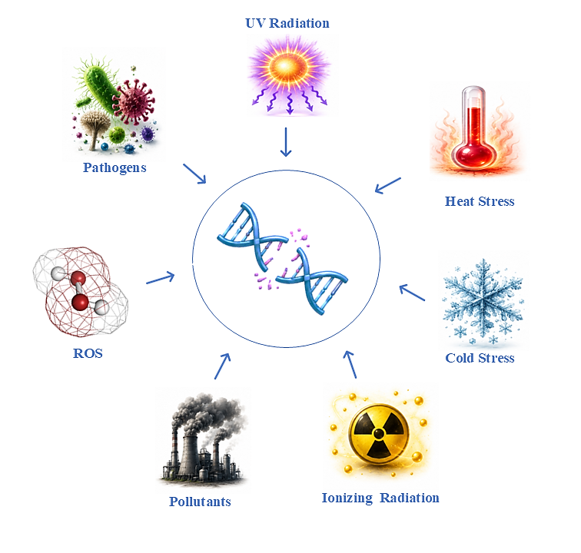
Figure 1. Major sources of DNA damage in plants.
3. Types of DNA damage in plants.

Diverse physical, chemical and biological agent produces different forms of DNA damage. Each genotoxic stress induces a characteristic spectrum of DNA lesions depending on its mode of action, exposure intensity and physiological condition of the plant. Collectively, DNA damage in plants can be broadly categorized into base modifications, abasic (AP) sites, single-strand breaks (SSBs), double-strand breaks (DSBs), bulky DNA adducts, pyrimidine dimers and DNA–protein crosslinks (DPCs) (Shen et al., 2022). Base modifications constitute one of the most common forms of DNA damage and include oxidation, alkylation and deamination of nucleotides (Andrés et al., 2023). Oxidative lesions such as 8-oxoguanine (8-oxoG) frequently can cause GC→TA transversion mutations. Spontaneous depurination generates abasic (AP) sites and deamination converts cytosine to uracil or 5-methylcytosine to thymine hindering the normal base-pairing (Grin et al., 2023). These minor lesions can significantly compromise replication fidelity and gene expression when accumulated over time (Lindahl 1993).

More severe forms of DNA damage include single-strand breaks (SSBs), double-strand breaks (DSBs), DNA-protein crosslinks, interstrand crosslinks, intrastrand crosslinks, bulky DNA adducts and chromosomal rearrangements. Among these, DSBs are considered the most cytotoxic because both DNA strands are simultaneously disrupted posing a serious threat to chromosome integrity and cell viability (Roy 2014). UV-induced cyclobutane pyrimidine dimers (CPD) and 6-4 photoproducts create bulky distortions that block transcription and DNA replication (Kaya et al., 2024). Interstrand crosslinks prevent strand separation during replication and transcription. If these lesions remain unrepaired or are inaccurately repaired, they may lead to chromosomal deletions, inversions, translocations, aneuploidy or cell death (Nakamura et al., 2021).

Before DNA repair can be initiated, damaged DNA must be accurately detected and the appropriate repair machinery must be recruited. Plants have a highly coordinated DNA damage response (DDR) that senses DNA damage, transduces damage signals, activates cell cycle checkpoints and the expression of DNA repair genes. This integrated response not only facilitates efficient lesion repair but also enhances plant adaptation to environmental stresses. The major forms of DNA lesions encountered in plants and their structural characteristics are illustrated in Figure 2.
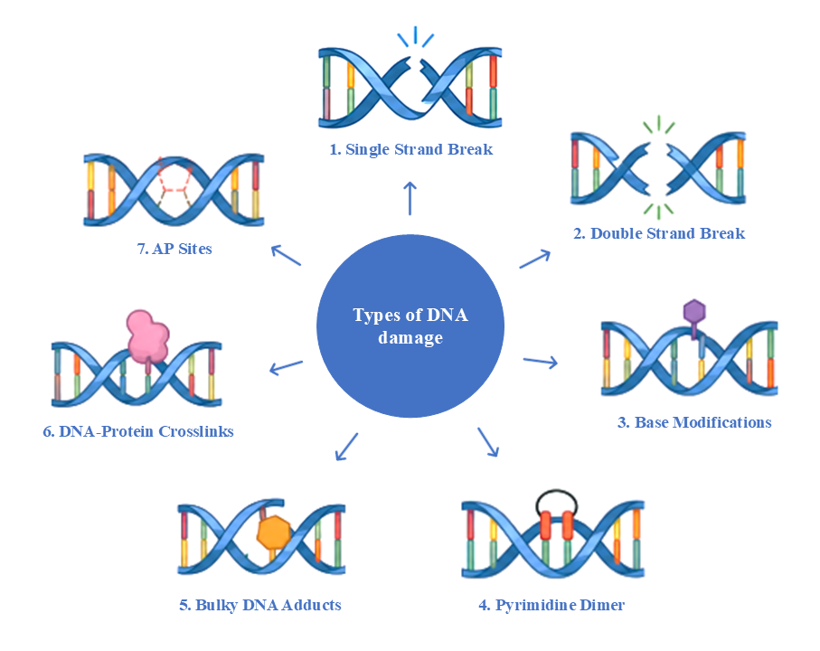
Figure 2. Major types of DNA damage in plants.

- DNA DAMAGE RESPONSE (DDR): SENSING AND SIGNALING
DNA repair in plants is initiated through a well-conserved surveillance system commonly known as the DNA Damage Response (DDR). DDR continuously monitors and coordinates appropriate cellular responses following DNA damage. Since plants are sessile organisms and remain continuously exposed to fluctuating environmental stresses, an efficient DDR is indispensable for balancing genome maintenance with growth, development and reproduction (Serrano-Mislata et al., 2025; Raina et al., 2021). DDR is an integrated signaling network that senses DNA lesions, amplifies damage signals, regulates the cell-cycle and remodels chromatin. DDR ultimately determines whether damaged cells undergo repair, endoreduplication or programmed cell death (Clay and fox 2021). This coordinated response ensures that damaged DNA is not replicated or transmitted to daughter cells preventing the accumulation of deleterious mutations. The major components and sequential events of the plant DDR signaling network are summarized in Figure 3.
The first stage of the DDR involves the recognition of DNA lesions by specialized sensor proteins. DNA double-strand breaks (DSBs), considered the most severe form of DNA damage, are rapidly recognized by the MRE11–RAD50–NBS1 (MRN) complex which recruits downstream signaling proteins to damaged chromatin. Replication stress, characterized by stalled replication forks and extensive single-stranded DNA is detected through the accumulation of Replication Protein A (RPA) on exposed DNA. These primary sensor complexes serve as molecular platforms for recruiting phosphatidylinositol-3-kinase-related protein kinases (PIKKs) (Park and Lee 2026).
Central to plant DDR are the protein kinases Ataxia Telangiectasia Mutated (ATM) and ATM and Rad3-Related (ATR), which function as master regulators of DNA damage signaling. ATM is predominantly activated in response by DNA double-strand breaks whereas ATR primarily activated by replication stress (Martens et al., 2020). Following the activation, ATM and ATR phosphorylate numerous downstream proteins involved in DNA repair, checkpoint regulation and chromatin remodeling. Although their activation mechanisms differ, both kinases exhibit considerable functional overlap and collectively ensure robust protection of the plant genome.
Unlike mammals, higher plants do not possess the canonical p53–CHK2 signaling module that coordinates the DNA damage response. Plants have a unique regulatory module centered on the NAC-domain transcription factor Suppressor of Gamma Response 1 (SOG1). SOG1 is directly phosphorylated by ATM and ATR following DNA damage and functions as the principal transcriptional regulator of the plant DNA damage response. Once activated, SOG1 induces the expression of hundreds of genes associated with DNA repair, homologous recombination, nucleotide metabolism, antioxidant defense, cell-cycle arrest and programmed cell death. Consequently, SOG1 is widely recognized as the functional equivalent of mammalian p53 despite lacking sequence homology, representing a remarkable example of convergent evolution in genome surveillance mechanisms (Ogita et al., 2018).
An essential function of the DDR is the temporary arrest of the cell cycle to provide sufficient time for DNA repair before DNA replication or mitosis proceeds. DNA damage activates checkpoint pathways that inhibit cyclin-dependent kinase (CDK) activity through induction of SIAMESE-RELATED (SMR) proteins and repression of mitotic cyclins. If genomic damage exceeds the repair capacity of the cell, irreversible pathways including programmed cell death are activated to eliminate severely damaged cells and protect surrounding tissues.
Recent studies have further demonstrated that chromatin architecture plays a pivotal role in regulating DDR efficiency. Histone phosphorylation, acetylation, methylation and ubiquitination dynamically modify chromatin accessibility surrounding DNA lesions. These modifications facilitate the recruitment of repair proteins while simultaneously influencing repair pathway selection. Chromatin remodeling complexes transiently relax nucleosome organization to expose damaged DNA and additionally epigenetic modifications contribute to transcriptional reprogramming during stress adaptation. Collectively, the plant DNA damage response represents an efficient signaling network that integrates lesion recognition, downstream repair mechanisms and developmental decisions. The DDR enables plants to adapt to fluctuating environmental conditions while ensuring the continuity of cellular functions.
Table 1. Functional Components of the Plant DNA Damage Response (DDR) Signaling Network
DDR component | Protein type | Molecular function | References
MRN complex  (MRE11–RAD50–NBS1) | DNA damage sensor complex | Recognizes DSBs and recruits ATM kinase | (Herbst et al.,2024)
ATM | Ser/Thr protein kinase | Phosphorylates checkpoint and repair proteins following DSB detection | (Ashley et al., 2014)
ATR | Ser/Thr protein kinase | Activates checkpoint signaling during DNA replication stress | (Nisa et al., 2019)
SOG1 | NAC-family transcription factor | Master transcriptional regulator of the plant DDR | (Ogita et al.,2018)
WEE1 | Cell-cycle checkpoint kinase | Delays G2/M transition to allow DNA repair | (Szurman-Zubrzycka et al., 2023)
RAD51 | Recombinase | Catalyzes homologous strand invasion during HR | (Shen et al., 2022)
CDKs/Cyclins | Cell-cycle regulators | Control cell-cycle progression after DNA damage | (Ashley et al., 2014)

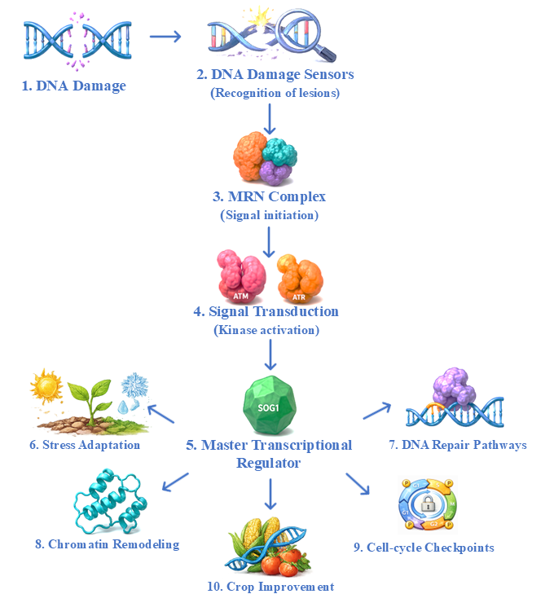
Figure 3. Schematic overview of the plant DNA damage response (DDR).
- DNA REPAIR MECHANISMS IN PLANTS.
DNA lesions vary considerably in their chemical composition, structural complexity and biological consequences. Plants have specialized DNA repair pathways that recognize and eliminate specific types of damage through distinct molecular mechanisms. These pathways operate in a coordinated manner to restore normal DNA structure, ensure accurate DNA replication, transcription and minimize the mutations. The principal repair systems identified in plants include direct reversal repair (DRR), base excision repair (BER), nucleotide excision repair (NER), mismatch repair (MMR), homologous recombination (HR), non-homologous end joining (NHEJ) (Enderle et al., 2020; Asik et al., 2025).

5.1 Direct reversal repair (DRR):
Direct reversal repair (DRR) constitutes the first line of defense against specific forms of DNA damage by directly restoring chemically modified nucleotides without excision or DNA resynthesis (Manova and Gruszka 2015). Following lesion recognition and activation of the DNA damage response, plants recruit specialized repair pathways according to the chemical nature of the DNA lesion. Among these, direct reversal repair (DRR) represents the simplest mechanism. Because plants rely on sunlight for photosynthesis, photoreactivation is considerably more prominent in plants than in many animal systems. In higher plants, photoreactivation represents the predominant DRR mechanism and serves as the primary defense against ultraviolet (UV) induced DNA damage (Sancar 2023). The major steps involved in photoreactivation of UV-induced DNA lesions in plants are illustrated in Figure 4.

Solar UV-B radiation (280–315 nm) primarily induces two classes of DNA photoproducts: cyclobutane pyrimidine dimers (CPDs) and pyrimidine (6–4) pyrimidone photoproducts (6–4 PPs). These lesions are generated when adjacent pyrimidine bases (thymine and cytosine) become covalently linked following photon absorption. The rapid removal of these lesions is particularly critical for photosynthetically active tissues since they are continuously exposed to sunlight.

Photoreactivation is catalyzed by DNA photolyases, members of the highly conserved cryptochrome/photolyase family (CPF) of flavoproteins that specifically recognize UV-induced photoproducts and repair them using blue or near-ultraviolet light (approximately 350–500 nm) as an external energy source. Plant genomes encode two major classes of photolyases i.e CPD photolyase (PHR1) and (6–4) photolyase (UVR3). CPD photolyase (PHR1), specifically repairs cyclobutane pyrimidine dimers and (6–4) photolyase (UVR3), removes 6–4 photoproducts. Both enzymes contain the catalytic cofactor reduced flavin adenine dinucleotide (FADH⁻) and a light-harvesting chromophore, commonly methenyltetrahydrofolate (MTHF) or 8-hydroxy-5-deazariboflavin (8-HDF) (Zgłobicki et al., 2024). Upon absorption of blue light, excitation energy is transferred to FADH⁻, initiating electron transfer to the damaged DNA and cleaving the abnormal covalent bonds linking adjacent pyrimidines. This reaction restores the native DNA structure without generating strand breaks or requiring DNA synthesis. Photoreactivation is one of the fastest and most accurate DNA repair mechanisms identified in plants. Photolyases are evolutionarily conserved across bacteria, fungi and plants, although they have been lost in placental mammals (Sancar 2008).
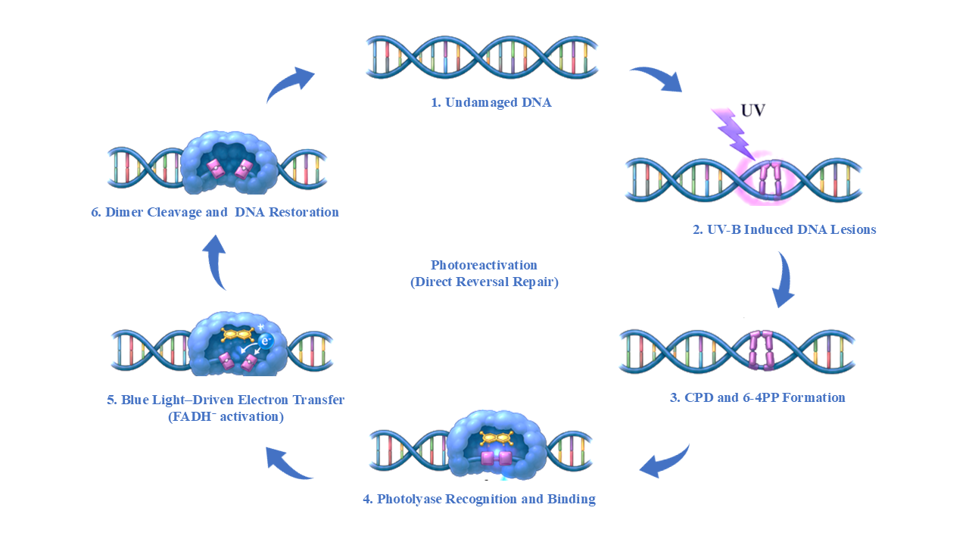
Figure 4. Schematic representation of photoreactivation, a direct reversal DNA repair mechanism in plants.

5.2 Base Excision Repair (BER)

In plants, BER primarily functions to eliminate small, non-helix-distorting DNA lesions. Unlike bulky DNA damage repaired by nucleotide excision repair, BER specifically targets chemically modified bases generated through oxidation, alkylation, deamination, spontaneous hydrolysis and base loss. Since plants experience persistent oxidative stress during photosynthesis, respiration and abiotic stress conditions, BER represents one of the major defense mechanisms in plant. A schematic representation of the major steps involved in plant BER is presented in Figure 5.

The BER pathway proceeds through a sequence of enzymatic reactions involving damage recognition, base excision, AP-site processing, gap filling and DNA ligation. The repair process is initiated by lesion-specific DNA glycosylases, which continuously scan genomic DNA and recognize chemically modified bases. Upon lesion recognition, DNA glycosylases cleave the N-glycosidic bond between the damaged base and the deoxyribose sugar releasing the altered nucleotide and generating an apurinic/apyrimidinic (AP) site (Wallace et al., 2014). Plant genomes encode a diverse repertoire of DNA glycosylases specialized for different classes of damaged bases. 8-Oxoguanine DNA glycosylase (OGG1) specifically removes the highly mutagenic oxidative lesion 8-oxoguanine, whereas formamidopyrimidine DNA glycosylase (FPG) excises oxidized purines generated by reactive oxygen species. Uracil DNA glycosylase (UNG) removes uracil residues resulting from cytosine deamination or nucleotide misincorporation during DNA replication (Zhao et al., 2025).

Following the removal of damaged base, the resulting AP site is processed by AP endonucleases, principally APE1L and ARP. AP endonucleases which cleave the phosphodiester backbone immediately adjacent to the abasic site. This incision generates a single-strand DNA break containing appropriate 3′-hydroxyl and 5′-deoxyribose phosphate termini required for subsequent repair synthesis (Jordano-Raya et al., 2025). In plants, AP endonucleases also exhibit phosphodiesterase and phosphatase activities that remove blocking groups generated during oxidative damage, thereby facilitating efficient DNA repair. Because AP sites themselves are highly cytotoxic and can interfere with DNA replication and transcription (Cordoba-Canero et al., 2014).

Repair synthesis is subsequently carried out by specialized DNA polymerases that restore the missing nucleotide(s). Plant BER operates through two complementary mechanisms: short-patch BER, in which a single nucleotide is inserted and long-patch BER, where two to several nucleotides are synthesized before strand displacement (Roldan-Arjona et al., 2019). DNA polymerase λ is the principal polymerase involved in plant BER. The remaining nick is finally sealed by DNA ligase I, thereby restoring the original DNA sequence and completing the repair process with high fidelity (Morales-Ruiz et al., 2024).

Transcriptomic and functional genomic analyses have demonstrated that genes encoding OGG1, UNG, APE1L and DNA ligase I are strongly induced under drought, salinity, heat stress, heavy metal exposure and oxidative stress conditions (Zhao et al., 2025). Enhanced BER activity has been correlated with improved stress tolerance, maintenance of photosynthetic efficiency, reduced mutation frequency and increased survival under adverse environments. Moreover, because chloroplasts and mitochondria generate large quantities of reactive oxygen species during photosynthesis and respiration, BER represents the predominant DNA repair pathway operating within these organelles (Mahapatra et al., 2021).

5.3 Nucleotide Excision Repair (NER)
NER is a versatile and evolutionarily conserved DNA repair pathway responsible for removing bulky, helix-distorting DNA lesions that cannot be corrected by direct reversal repair or base excision repair. Unlike BER, which excises a single damaged base, NER removes a short oligonucleotide fragment containing the lesion, followed by DNA resynthesis and ligation to restore genome integrity. In plants, NER serves as the primary light-independent mechanism for repairing ultraviolet (UV)-induced DNA photoproducts, bulky chemical adducts, intra-strand crosslinks and numerous helix-distorting DNA lesions (Manova and Gruszka 2015).

NER proceeds through a sequence of molecular events comprising damage recognition, local DNA unwinding, dual incision, repair synthesis and ligation. Based on the mode of lesion recognition, NER is divided into two interconnected subpathways i.e Global Genome Repair (GGR) and Transcription-Coupled Repair (TCR). Although both pathways utilize a common excision and repair machinery after lesion recognition but differ in how DNA damage is initially detected. Global Genome Repair continuously surveys the entire genome for structural distortions regardless of transcriptional activity. Transcription-Coupled Repair specifically removes lesions that obstruct RNA polymerase II during active transcription. This dual surveillance strategy enables plants to protect both coding and non-coding genomic regions. (Marteijn et al., 2014).

In the Global Genome Repair pathway, lesion recognition is mediated primarily by the UV-Damaged DNA Binding (UV-DDB) complex and the Xeroderma Pigmentosum Complementation Group C (XPC) protein. The UV-DDB complex exhibits exceptionally high affinity for UV-induced photoproducts, particularly cyclobutane pyrimidine dimers and facilitates recruitment of XPC to damaged chromatin. XPC subsequently serves as the principal damage sensor that initiates assembly of the pre-incision repair complex (Kusakabe et al., 2019). Following lesion recognition, local DNA unwinding is accomplished by the Transcription Factor IIH (TFIIH) complex containing the ATP-dependent helicases XPB and XPD (Masuda et al., 2020). These helicases unwind approximately 20–30 nucleotides surrounding the damaged DNA, generating an open repair bubble that permits precise positioning of downstream repair proteins. Additional factors, including XPA and Replication Protein A (RPA), stabilize the unwound DNA and verify the presence of the lesion before excision occurs. During Transcription-Coupled Repair, stalling of RNA polymerase II at DNA lesions promotes recruitment of Cockayne Syndrome proteins CSA and CSB, which facilitate displacement of the polymerase and assembly of the common NER repair machinery (Bravo et al., 2026; Kose et al., 2024).

Once the repair complex has been assembled, the damaged DNA strand undergoes dual incision on both sides of the lesion. The structure-specific endonucleases XPF–ERCC1 and XPG introduce incisions at the 5′ and 3′ sides of the damaged nucleotide, respectively. These endonucleases release an oligonucleotide fragment approximately 24–32 nucleotides in length that contains the DNA lesion. DNA polymerases subsequently synthesize new DNA using the undamaged complementary strand as a template. DNA ligase I seals the remaining nick to restore the integrity of the phosphodiester backbone. Consequently, NER restores DNA integrity with high fidelity while preserving genomic stability and ensuring continued transcription and replication (Canturk et al., 2016).

5.4 Mismatch Repair (MMR)

Mismatch repair (MMR) is a post-replicative DNA repair pathway that maintains replication fidelity by correcting base-base mismatches and insertion/deletion loops (IDLs). By eliminating these replication-associated errors before they become permanently fixed, MMR suppresses spontaneous mutations and preserves genome stability.

The MMR pathway is initiated by the recognition of mismatched bases or IDLs by MutS homolog (MSH) proteins. In plants, MSH2 functions as the central recognition factor by forming heterodimers with MSH6 (MutSα) or MSH3 (MutSβ) (Wu et al., 2003). The MutSα complex primarily recognizes single base mismatches and small IDLs whereas MutSβ preferentially detects larger insertion/deletion loops. Following lesion recognition, the MutL homolog complex, mainly MLH1–PMS1, is recruited to coordinate downstream repair events (Witte et al., 2023). The error-containing DNA segment of the newly synthesized strand is subsequently excised, after which DNA polymerase synthesizes the correct sequence using the undamaged parental strand as a template. DNA ligase I seals the remaining nick and restoring DNA integrity with high fidelity (Palacio et al., 2025).

5.5 Homologous Recombination (HR)

HR is a DNA double-strand break (DSB) repair pathway that restores genome integrity by using an intact homologous DNA sequence i.e sister chromatid as a repair template (10). Unlike non-homologous end joining (NHEJ), HR accurately repairs DNA breaks with minimal sequence alteration, making it the most precise mechanism for DSB repair in plants. HR is predominantly active during the S and G₂ phases of the cell cycle (Ranjha et al., 2018).

HR pathway is initiated by recognition of DSBs through the MRE11–RAD50–NBS1 (MRN) complex together with CtIP/COM1 which promotes 5′ to 3′ resection of DNA ends to generate 3′ single-stranded DNA (ssDNA) overhangs. These ssDNA regions are initially coated by Replication Protein A (RPA) after which BRCA2 facilitates the replacement of RPA with RAD51 to form a nucleoprotein filament. RAD51 mediates homology search and strand invasion into an intact homologous DNA molecule, forming a displacement loop (D-loop) that serves as a template for DNA synthesis. Following DNA extension, recombination intermediates are resolved through synthesis-dependent strand annealing (SDSA) or double Holliday junction (dHJ) pathways, resulting in accurate restoration of chromosome integrity.

CRISPR/Cas-mediated gene replacement and targeted gene insertion rely on HR to accurately integrate donor DNA into specific genomic loci. However, HR occurs at relatively low frequencies in most plant species, current research focuses on enhancing HR efficiency through manipulation of key recombination factors and transient suppression of competing end-joining pathways (Barakate et al., 2020; Barco et al., 2025).

5.6 Classical Non-Homologous End Joining (c-NHEJ)

Classical non-homologous end joining (c-NHEJ) is the predominant pathway for repairing DNA double-strand breaks (DSBs) in somatic plant cells. Unlike homologous recombination (HR), c-NHEJ directly rejoins broken DNA ends without requiring a homologous repair template. c-NHEJ repair damaged DNA throughout the cell cycle, particularly when sister chromatids are unavailable (G₁ phase). Although this pathway is inherently more error-prone than HR because limited processing of DNA ends may introduce small insertions or deletions (indels).

The c-NHEJ pathway is initiated by the binding of the KU70–KU80 heterodimer to exposed DNA ends, protecting them from excessive degradation and facilitating the recruitment of downstream repair factors. Unlike mammals, plants lack the DNA-dependent protein kinase catalytic subunit (DNA-PKcs) and instead rely on conserved proteins including XRCC4, XLF (Cernunnos) and DNA Ligase IV to coordinate DNA end processing and ligation (Khan et al., 2023; Kumar et al., 2023). In mammals, when DNA termini are incompatible, limited end processing generates ligatable ends before DNA Ligase IV along with XRCC4 and XLF. This complex seals the DNA backbone to restore chromosome continuity. In plants, incompatible DNA termini are processed by the LIG4/XRCC4 short-range complex with PAXX fulfilling the end-bridging and ligation (Conlin et al., 2017).

5.7 Alternative End Joining (Alt-EJ)

Alternative end joining (Alt-EJ) also known as microhomology-mediated end joining (MMEJ), is a secondary DNA double-strand break (DSB) repair pathway that functions when the classical non-homologous end joining (c-NHEJ) machinery is unavailable or inefficient (Truong et al., 2013). Unlike c-NHEJ, Alt-EJ utilizes short regions of microhomology (typically 2–20 bp) to align broken DNA ends before ligation. Although this pathway restores chromosome continuity, it is intrinsically error-prone and frequently generates deletions, insertions and chromosomal rearrangements. Consequently, Alt-EJ is considered a mutagenic repair mechanism that contributes to genome instability and promotes genetic diversity and adaptation in plants (Schimmel et al., 2019; Du et al., 2020; Hou et al., 2024).

The Alt-EJ pathway is initiated by 5′ to 3′ resection of DNA ends mediated by the MRE11–RAD50–NBS1 (MRN) complex and associated nucleases with complementary microhomologous sequences. These regions subsequently anneal, while non-complementary DNA flaps are removed by structure-specific nucleases. DNA Polymerase θ (POLQ) extends and stabilizes the annealed DNA ends before DNA ligases complete strand sealing. Alt-EJ repair relies on limited sequence homology rather than an intact homologous template. Nucleotide loss frequently occurs at the repair junction and results in deletions (Black et al., 2016; Li et al., 2023).

Table 2. Comparative overview of major DNA repair pathways in plants
DNA repair pathway | Primary function | Predominant DNA lesions repaired
Direct Reversal Repair (DRR) / Photoreactivation | Light-dependent direct reversal of UV-induced DNA damage | Cyclobutane pyrimidine dimers (CPDs), 6–4 photoproducts (6–4PPs)
Base Excision Repair (BER) | Removal of small base modifications and oxidative DNA damage | Oxidized bases (8-oxoG), uracil, AP sites, single-strand breaks
Nucleotide Excision Repair (NER) | Excision of bulky, helix-distorting DNA lesions | Bulky DNA adducts, CPDs, 6–4PPs
Mismatch Repair (MMR) | Correction of replication-associated mismatches | Base-base mismatches and insertion/deletion loops
Homologous Recombination (HR) | High-fidelity repair of DNA double-strand breaks | DNA double-strand breaks
Non-Homologous End Joining (NHEJ) | Rapid ligation of DNA double-strand breaks | DNA double-strand breaks

Table 3. Comparative analysis of Homologous Recombination (HR) and Non-Homologous End Joining (NHEJ) pathways in plants.
Feature | Homologous Recombination (HR) | Non-Homologous End Joining (NHEJ)
Repair accuracy | High (error-free) | Moderate to low (error-prone)
Template requirement | Requires homologous DNA template | No homologous template required
Cell cycle preference | Mainly S and G2 phases | Predominantly G1 phase; active throughout cell cycle
Repair speed | Relatively slower | Rapid repair response
Key proteins | MRN complex, RAD51, BRCA1, BRCA2, RAD54 | KU70, KU80, DNA Ligase IV, XRCC4, XLF, PAXX
Repair mechanism | Uses homologous sequence for precise repair | Direct ligation of broken DNA ends
Mutation frequency | Very low | Frequently generates small insertions/deletions (InDels)
Role in genome stability | Maintains chromosome integrity and faithful DNA repair | Prevents chromosome fragmentation and ensures rapid survival after DNA damage
Role in plant breeding | Gene targeting, allele replacement, trait introgression | Gene knockout and mutant development
Major limitation | Low efficiency in higher plants | Generates unpredictable mutations at repair sites

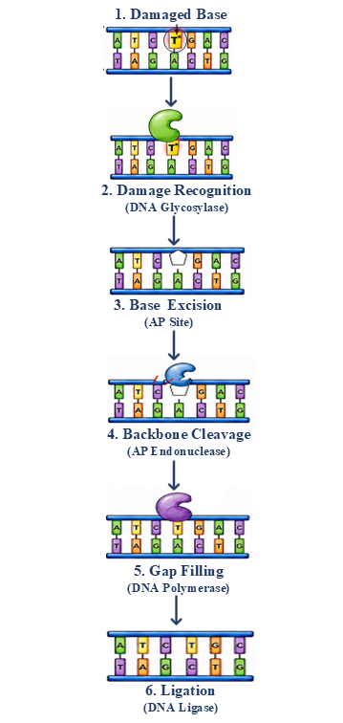
Figure 5: mechanism of BER in plants

- DNA REPAIR PATHWAYS IN CROP IMPROVEMENT
The growing understanding of plant DNA damage response (DDR) and repair mechanisms has transformed DNA repair pathways from fundamental genome maintenance systems into valuable tools for crop improvement. Efficient DNA repair not only preserves genome integrity under normal growth conditions but also enhances plant resilience to environmental stresses. Natural variation in DNA repair genes influences mutation rates, recombination frequency, genome stability and stress tolerance (Verma et al., 2020). Identification and utilization of favorable alleles through marker-assisted selection (MAS), genomic selection (GS) and quantitative trait locus (QTL) mapping provide opportunities to develop crop varieties with improved tolerance to drought, salinity, heat, radiation and pathogen attack (Shim et al., 2018).

DNA repair pathways interact extensively with cellular stress-signaling networks to regulate plant adaptation. Plant DNA repair pathways also interact with phytohormones such as abscisic acid (ABA), salicylic acid (SA), jasmonic acid (JA) and ethylene that enhance stress tolerance (Jiang et al., 2025). Such crosstalk enables plants to balance DNA repair with growth, development and defense (Bertoncini et al., 2025).

The emergence of CRISPR/Cas genome editing play a central role of DNA repair pathways in determining genome editing outcomes. CRISPR/Cas nucleases introduce site-specific DNA double-strand breaks (DSBs), after which endogenous repair pathways dictate the final genetic modification. Repair through classical non-homologous end joining (c-NHEJ) frequently produces small insertions or deletions (indels) that are widely exploited for targeted gene knockouts. Alternative end joining (Alt-EJ/MMEJ) also contributes to repair outcomes by generating larger deletions and structural rearrangements (Kumar et al., 2024). Strategies such as transient suppression of c-NHEJ components (e.g., KU70, KU80, LIG4) or enhancement of HR-associated proteins (RAD51, BRCA2, MRE11) have significantly increased targeted gene integration and precise genome editing in several crop species (Xue et al., 2021; Kamoen et al., 2024).

Beyond genome editing, DNA repair pathways have important applications in mutation breeding and the development of climate-resilient crops. Physical mutagens and chemical mutagens induce diverse DNA lesions that are subsequently processed through endogenous repair pathways. The balance between accurate repair and mutation fixation determines the extent of genetic variation available for crop improvement. The integration of DNA repair biology with advanced breeding technologies is expected to reshape the future of crop improvement. Combining genome editing with genomic selection, speed breeding, high-throughput phenotyping, artificial intelligence (AI)-assisted breeding and multi-omics approaches will enable rapid development of stress tolerant cultivar.

- APPLICATIONS
- CRISPR/Cas-mediated gene knockout: DNA double-strand breaks generated by CRISPR/Cas are predominantly repaired through the c-NHEJ pathway.
- Homology-directed gene replacement: HR enables precise insertion or replacement of desired DNA sequences.
- Base and prime editing: BER and MMR-associated repair mechanisms influence editing efficiency with accurate nucleotide substitutions.
- Molecular breeding: DNA repair genes serve as functional markers for identifying superior alleles associated with genome stability and stress tolerance. Integration of DNA repair-associated loci into marker-assisted selection (MAS), QTL mapping and genomic selection (GS) accelerates the development of improved crop varieties.
- Mutation breeding: Physical mutagens and chemical mutagens induce DNA lesions that are processed by endogenous repair pathways. Understanding repair mechanisms helps optimize mutation frequency while minimizing undesirable genomic alterations.
- Development of climate-resilient crops: Engineering or regulating DNA repair genes enhances tolerance to UV radiation, drought, salinity, heat stress, oxidative stress and pathogen infection. Improved DNA repair capacity contributes to genome stability, reproductive success and yield stability under adverse environmental conditions.
- Functional genomics: DNA repair mutants are valuable tools for investigating gene function and genome stability. Reverse genetics and CRISPR-based approaches enable characterization of repair genes involved in plant growth, development and stress responses.
- Biotechnology and synthetic biology: Manipulation of DNA repair pathways improve transformation efficiency and precise gene integration. DNA repair engineering is increasingly being combined with synthetic biology to develop next-generation crop improvement strategies.
Table 4. Crop-specific applications of DNA damage response and repair pathways in crop improvement.
Crop | DNA Repair Pathway / Gene | DNA Repair Mechanism | Applications | Reference
Rice (Oryza sativa) | OsRAD51, OsBRIP1, OsRAD51C; OsXPB1, OsXPC, OsRAD23 | Homologous recombination (HR) and nucleotide excision repair (NER) | Enhanced DNA repair contributes to chromium tolerance | (Lin et al., 2022)
Rice (Oryza sativa) | ALS locus | Homology-directed repair (HDR) | Herbicide-resistant rice through precise allele replacement | (Li et al., 2018)
Wheat (Triticum aestivum) | WDV replicon-assisted HDR | Homology-directed repair | Approximately 12-fold increase in gene targeting efficiency | (Gil-Humanes et al., 2017)
Maize (Zea mays) | ZmRAD51A | Homologous recombination | Improved resistance to fungal and bacterial pathogens | (Liu et al., 2019)
Tomato (Solanum lycopersicum) | ALS locus | Homology-directed repair | Transgene-free herbicide-resistant tomato | (Danilo et al., 2019)
Soybean (Glycine max) | LbCpf1 multiplex editing | Double-strand break repair | High editing efficiency and large chromosomal deletions | (Xia et al., 2021)
Chickpea (Cicer arietinum) | DNA repair and recombination response (DRRR) genes | Multiple DNA repair pathways | Improved drought tolerance and flowering adaptation | (Basu et al., 2022)
Brassica napus | BnLIG4 | Non-homologous end joining (NHEJ) | DNA double-strand-break repair and genome stability | (Yin et al., 2021)

- CHALLENGES AND LIMITATIONS
- Low efficiency of homology-directed repair (HDR): One of the major limitations in plant genome editing is the inherently low efficiency of homologous recombination (HR)-mediated DNA repair. Since plant cells predominantly repair double-strand breaks through the faster c-NHEJ pathway, precise gene replacement and targeted gene insertion remain challenging in most crop species.
- Error-prone DNA repair: Although c-NHEJ and Alt-EJ rapidly restore chromosome integrity but frequently introduce insertions, deletions or chromosomal rearrangements at repair sites.
- Species-specific differences in DNA repair: Most current knowledge of plant DNA repair has been obtained from Arabidopsis thaliana, whereas comparatively limited information is available for economically important crops. Differences in genome size, ploidy level, chromatin organization and repair pathway activity often limit the direct translation of discoveries from model plants to crop species.
- Complexity and crosstalk of DNA repair networks: DNA repair pathways function as highly interconnected networks involving extensive interactions with DNA replication, chromatin remodeling, cell-cycle regulation, epigenetic modifications and stress-signaling pathways. Manipulation of one repair component may unintentionally influence other cellular processes.
- Limited transformation and genome editing efficiency: The successful application of DNA repair-based genome editing depends not only on repair pathway activity but also on efficient plant transformation and regeneration systems. Many crop species remain recalcitrant to genetic transformation.
- Regulatory and public acceptance challenges: Although genome editing offers enormous potential for sustainable agriculture, regulatory policies governing genome-edited crops vary considerably among countries. Public perception, biosafety concerns, intellectual property issues and commercialization barriers continue to influence the adoption of DNA repair-based biotechnological approaches in agriculture.

- FUTURE PERSPECTIVES
The rapidly expanding knowledge of plant DNA damage response (DDR) and DNA repair pathways provides unprecedented opportunities for improving crop resilience and agricultural sustainability. Although considerable progress has been made in elucidating the molecular mechanisms of DNA repair but many regulatory networks and signaling remain incompletely understood. Future studies integrating molecular genetics, structural biology and systems biology will be essential for identifying novel DNA repair regulators and deciphering their interactions.

Recent advances in genome editing are expected to further revolutionize the application of DNA repair biology in crop improvement. Improving the efficiency of homologous recombination, minimizing error-prone repair through c-NHEJ and Alt-EJ by optimizing DNA repair pathways. Emerging technologies such as CRISPR/Cas variants, base editing, prime editing and programmable recombinases, offer promising avenues for precise genetic manipulation in diverse crop species. Integrating these technologies with an improved understanding of endogenous DNA repair mechanisms will substantially enhance editing accuracy and broaden their application in precision breeding. The integration of artificial intelligence (AI), machine learning, high-throughput phenotyping and multi-omics approaches is expected to accelerate the discovery of DNA repair-associated genes and predict their functional roles in stress adaptation.

Looking forward, DNA repair pathways are likely to become central components of next-generation precision breeding strategies. Combining genome editing, molecular breeding, genomic selection, speed breeding and synthetic biology with targeted manipulation of DNA repair pathways has potential to accelerate the development of high-yielding, stress-resilient and genetically stable crop varieties.

- CONCLUSION
Plant DNA damage response and repair pathways safeguards genome integrity while enabling plants to survive under continuously changing environmental conditions. The integration of DNA damage sensing, ATM–ATR–SOG1-mediated signaling, chromatin remodeling and specialized repair pathways ensures the accurate recognition and repair of diverse DNA lesions. Beyond their fundamental role in preserving genome stability these molecular mechanisms are the key regulators of plant adaptation in diverse stress condition. Plant DNA repair biology with advanced genome editing tools create opportunities to manipulate DNA repair pathways for precise crop improvement.

Declaration of AI Use

This manuscript was prepared through the intellectual contributions of the author(s) to the study design, data analysis, interpretation of results, and scholarly content. Grammarly and ChatGPT were used solely to assist with grammatical refinement and reference formatting during manuscript revision. The author(s) accept full responsibility for the accuracy, integrity, and final content of the manuscript.

- REFERENCES
Alam P, Faizan M, Arif Y, Azzam MM, Hayat S, Afzal S, Albalawi TH. (2025). Reactive oxygen species: Balancing agents in plants. Frontiers in Plant Science. 16:1713590. https://doi.org/10.3389/fpls.2025.1713590
Andrés CMC, Lastra JMP de la, Juan CA, Plou FJ, Pérez-Lebeña E. (2023). Chemical insights into oxidative and nitrative modifications of DNA. International Journal of Molecular Sciences. 24:15240. https://doi.org/10.3390/ijms242015240
Ashley AK, Shrivastav M, Nie J, Amerin C, Troksa K, Glanzer J, et al. (2014) DNA-PK phosphorylation of RPA32 Ser4/Ser8 regulates replication stress checkpoint activation, fork restart, homologous recombination and mitotic catastrophe. DNA Repair. 21:131-139. https://doi.org/10.1016/j.dnarep.2014.04.008
Asik E, Kashif SZ, Oztas O. (2025). Plant tolerance mechanisms to DNA-damaging UV stress. Journal of Experimental Botany. 77:27-50. https://doi.org/10.1093/jxb/eraf272
Barakate A, Keir E, Oakey H, et al. (2020). Stimulation of homologous recombination in plants expressing heterologous recombinases. BMC Plant Biology. 20:336. https://doi.org/10.1186/s12870-020-02545-7
Barco B, Dong S, Matsuba Y, Crook A, Xu R, Zhang Y, et al. (2025). Development of efficient targeted insertion mediated by CRISPR-Cas12a and homology-directed repair in maize. Frontiers in Genome Editing. 7:1713347. https://doi.org/10.3389/fgeed.2025.1713347
Basu U, Sharma A, Bajaj D, Malik N, Jha U, Upadhyaya H, et al. (2022). The DNA replication, repair, and recombination pathway genes modulating yield and stress tolerance traits in chickpea. Plant Molecular Biology Reporter. 40:119-135. https://doi.org/10.1007/s11105-021-01303-9
Bertoncini A, Pagano P, Macovei A. (2025). Arabidopsis thaliana DNA damage response mutants challenged with genotoxic agents: A different experimental approach to investigate the TDP1α and TDP1β genes. Genes. 16:103. https://doi.org/10.3390/genes16010103
Black SJ, Kashkina E, Kent T, Pomerantz RT. (2016). DNA polymerase θ: A unique multifunctional enzyme involved in alternative end joining. Genes. 41(7):631-642. https://doi.org/10.3390/genes7090067
Bravo M, Fan L. Integrating structural, biochemical, and cellular perspectives on the TFIIH helicases XPB and XPD. Biomolecules. 2026;16. https://doi.org/10.3390/biom16030435
Canturk F, Karaman M, Selby CP, Kemp MG, Kulaksiz-Erkmen G, Hu J, et al. (2016). Nucleotide excision repair by dual incisions in plants. Proceedings of the National Academy of Sciences of the United States of America. 113(17):4706-4710. https://doi.org/10.1073/pnas.1604097113
Clay DE, Fox DT. (2021). DNA damage responses during the cell cycle: Insights from model organisms and beyond. Genes. 12:1882. https://doi.org/10.3390/genes12121882
Conlin MP, Reid DA, Small GW, Chang HHY, Watanabe G, Lieber MR, et al. (2017). DNA ligase IV guides end-processing choice during nonhomologous end joining. Cell Reports. 20(12):2810-2819. https://doi.org/10.1016/j.celrep.2017.08.091
Córdoba-Cañero D, Roldán-Arjona T, Ariza RR (2014). Arabidopsis ZDP DNA 3′-phosphatase and ARP endonuclease function in 8-oxoG repair initiated by FPG and OGG1 DNA glycosylases. Plant Journal. 79(5):824-834. https://doi.org/10.1111/tpj.12588
Danilo B, Perrot L, Mara K, Botton E, Nogué F, Mazier M. (2019). Efficient and transgene-free gene targeting using Agrobacterium-mediated delivery of the CRISPR/Cas9 system in tomato. Plant Cell Reports. 38:459-462. https://doi.org/10.1007/s00299-019-02373-6
Du Y, Hase Y, Satoh K, Shikazono N. (2020). Characterization of gamma irradiation-induced mutations in Arabidopsis mutants deficient in non-homologous end joining. Journal of Radiation Research. 61(5):639-647. https://doi.org/10.1093/jrr/rraa059.
Enderle J, Dorn A, Puchta H. (2020). Repair of DNA-protein crosslinks in plants. DNA Repair. 87:102787. https://doi.org/10.1016/j.dnarep.2020.102787
Fathi A, Shiade SRG, Saleem A, Shohani F, Fazeli A, Riaz A, Zulfiqar U, et al. (2025). Reactive oxygen species (ROS) and antioxidant systems in enhancing plant resilience against abiotic stress. International Journal of Agronomy. 8834883. https://doi.org/10.1155/ioa/8834883
Fraikin G, Belenikina NS, Rubin AB. (2024). Photochemical processes of cell DNA damage by UV radiation of various wavelengths: Biological consequences. Molecular Biology. 58:1-16. https://doi.org/10.1134/S0026893324010047
Gil-Humanes J, Wang Y, Liang Z, Shan QW, Ozuna CV, Sánchez-León S, et al. (2017). High-efficiency gene targeting in hexaploid wheat using DNA replicons and CRISPR/Cas9. The Plant Journal. 89:1251-1262. https://doi.org/10.1111/tpj.13446
Grin I, Petrova DV, Endutkin AV, Yu B, Li H, Zharkov DO. (2023). Base excision DNA repair in plants: Arabidopsis and beyond. International Journal of Molecular Sciences. 24:14746. https://doi.org/10.3390/ijms241914746
Herbst J, Li QQ, De Veylder L. (2024). Mechanistic insights into DNA damage recognition and checkpoint control in plants. Nature Plants. 10:539-550. https://doi.org/10.1038/s41477-024-01652-9
Hou Z, Yu T, Yi Q, Du Y, Zhou L, Zhao Y, et al. (2024). High complexity of DNA double-strand breaks is key for alternative end-joining choice. Communications Biology. 7. https://doi.org/10.1038/s42003-024-06640-5
Jiang J, Zhu Q, Li Y, Wu J, Zou C, Li H, et al. (2025). Abscisic acid enhances DNA damage response through the nuclear shuttling of clathrin light chain 2 in plant cells. Science Advances. 11. https://doi.org/10.1126/sciadv.adt2842
Jordano-Raya M, Schrader CE, Ariza RR, Roldán-Arjona T, Córdoba-Cañero D. (2025). Divergent evolution of opposite base specificity and single-stranded DNA activity in animal and plant AP endonucleases. Nucleic Acids Research. 53. https://doi.org/10.1093/nar/gkae1297
Kamoen L, Kralemann LEM, Van Schendel R, Van Tol N, Hooykaas PJJ, De Pater S, et al. (2024). Genetic dissection of mutagenic repair and T-DNA capture at CRISPR-induced DNA breaks in Arabidopsis thaliana. PNAS Nexus. 3. https://doi.org/10.1093/pnasnexus/pgae094
Kaya S, Erdogan DE, Sancar A, Adebali O, Oztas O. (2024). Global repair is the primary nucleotide excision repair subpathway for the removal of pyrimidine-pyrimidone (6-4) damage from the Arabidopsis genome. Scientific Reports. 14(1):3308. https://doi.org/10.1038/s41598-024-53472-8
Khan, H. and Ochi, T. (2023), Plant PAXX has an XLF-like function and stimulates DNA end joining by the Ku-DNA ligase IV/XRCC4 complex. Plant Journal. 116: 58-68. https://doi.org/10.1111/tpj.16359
Kose C, Cao X, Dewey EB, Malkoç M, Adebali O, Sekelsky J, et al (2024). Cross-species investigation into the requirement of XPA for nucleotide excision repair. Nucleic Acids Research. 52:677-689. https://doi.org/10.1093/nar/gkad1104
Kumar KRR. (2023). Lost in the bloom: DNA-PKcs in green plants. Frontiers in Plant Science. 14:1231678. https://doi.org/10.3389/fpls.2023.1231678
Kumar R, Das SP, Choudhury BU, Kumar A, Prakash NR, Verma R, et al. (2024). Advances in genomic tools for plant breeding: Harnessing DNA molecular markers, genomic selection, and genome editing. Biological Research. 57. https://doi.org/10.1186/s40659-024-00562-6
Kusakabe M, Onishi Y, Tada H, Kurihara F, Kusao K, Furukawa M, et al. (2019). Mechanism and regulation of DNA damage recognition in nucleotide excision repair. Genes and Environment. 41:2. https://doi.org/10.1186/s41021-019-0119-6
Li F, Mladenov E, Sun Y, Soni A, Stuschke M, Timmermann B, et al. (2023). Low CDK activity and enhanced degradation by APC/C^CDH1 abolishes CtIP activity and Alt-EJ in quiescent cells. Cells. 12:1530. https://doi.org/10.3390/cells12111530
Li S, Li J, Zhang J, Du W, Fu J, Sutar SH, et al. (2018). Synthesis-dependent repair of Cpf1-induced double strand DNA breaks enables targeted gene replacement in rice. Journal of Experimental Botany. 69:4715-4721. https://doi.org/10.1093/jxb/ery245
Lin YJ, Feng YX, Zhang Q, Yu XZ. (2022). Proline-mediated modulation on DNA repair pathway in rice seedlings under chromium stress by integrating gene chip and co-expression network analysis. Ecotoxicology. 31:1266-1275. https://doi.org/10.1007/s10646-022-02586-8
Lindahl T. (1993). Instability and decay of the primary structure of DNA. Nature. 362:709-715. https://doi.org/10.1038/362709a0
Liu F, Xu YJ, Zhou L, Ali A, Jiang H, Zhu S, et al. (2019). DNA repair gene ZmRAD51A improves rice and Arabidopsis resistance to disease. International Journal of Molecular Sciences. 20:807. https://doi.org/10.3390/ijms20040807
Liu R, Wang S, Song J. (2026). New progress in the production, oxidative damage, and scavenging mechanisms of reactive oxygen species in plants under abiotic stress. Frontiers in Plant Science. 17:1774033. https://doi.org/10.3389/fpls.2026.1774033.
Mahapatra K, Banerjee S, De S, Mitra M, Roy P, Roy S. (2021). An insight into the mechanism of plant organelle genome maintenance and implications of organelle genome in crop improvement: An update. Frontiers in Cell and Developmental Biology.9. https://doi.org/10.3389/fcell.2021.671698
Manova V, Gruszka D. (2015). DNA damage and repair in plants: From models to crops. Frontiers in Plant Science. 6:885. https://doi.org/10.3389/fpls.2015.00885
Mansoor S, Wani OA, Lone JK, Manhas S, Kour N, Alam P, et al. (2022). Reactive oxygen species in plants: From source to sink. Antioxidants. 11:225. https://doi.org/10.3390/antiox11020225
Marteijn JA, Lans H, Vermeulen W, Hoeijmakers JH. (2014). Understanding nucleotide excision repair and its roles in cancer and ageing. nature reviews molecular cell biology. 15(7):465-481. https://doi.org/10.1038/nrm3822
Martens, M., Horres, R., Wendeler, E., & Reiss, B. (2020). The Importance of ATM and ATR in Physcomitrella patens DNA Damage Repair, Development, and Gene Targeting. Genes, 11. https://doi.org/10.3390/genes11070752
Masuda H, Nakabashi M, Morgante PG, Kajihara D, De Setta N, Menck CFM, et al. (2020). Evidence for sub-functionalization of tandemly duplicated XPB nucleotide excision repair genes in Arabidopsis thaliana. Gene.144818. https://doi.org/10.1016/j.gene.2020.144818
Merker L, Feller L, Dorn A, Puchta H. (2024). Deficiency of both classical and alternative end-joining pathways leads to a synergistic defect in double-strand break repair but not to an increase in homology-dependent gene targeting in Arabidopsis. Plant Journal. https://doi.org/10.1111/tpj.16604
Mohamed HI, Ullah I, Toor M, Tanveer NA, Din MMU, Basit A, et al. (2025). Heavy metals toxicity in plants: Understanding mechanisms and developing coping strategies for remediation: A review. Bioresources and Bioproducts. 12:093004. https://doi.org/10.1186/s40643-025-00930-4
Monroe JG, Srikant T, Carbonell-Bejerano P, Becker C, Lensink M, Exposito-Alonso M, et al. (2022). Mutation bias reflects natural selection in Arabidopsis thaliana. Nature. 602(7895):101-105. https://doi.org/10.1038/s41586-021-04269-6
Morales-Ruiz T, Beltrán-Melero C, Ortega-Paredes D, Luna-Morillo JA, Martinez-Macias MI, Roldán-Arjona T, et al. (2024). The enzymatic properties of Arabidopsis thaliana DNA polymerase λ suggest a role in base excision repair. Plant Molecular Biology. 114. https://doi.org/10.1007/s11103-023-01407-8
Nakamura M, Nunoshiba T, Hiratsu K. (2021). Detection and analysis of UV-induced mutations in the chromosomal DNA of Arabidopsis. Biochemical and Biophysical Research Communications. 554:89-93. https://doi.org/10.1016/j.bbrc.2021.03.087
Nimeth BA, Riegler S, Kalyna M. (2020). Alternative splicing and DNA damage response in plants. Frontiers in Plant Science. 11:91. https://doi.org/10.3389/fpls.2020.00091
Nisa MU, Huang Y, Benhamed M, Raynaud C. (2019). The plant DNA damage response: Signaling pathways leading to growth inhibition and putative role in response to stress conditions. Frontiers in Plant Science. 10:653. https://doi.org/10.3389/fpls.2019.00653
Ogita N, Okushima Y, Tokizawa M, Yamamoto YY, Tanaka M, Seki M, et al. (2018). Identifying the target genes of SOG1, a master regulator of the DNA damage response in Arabidopsis. Plant Journal. 94(3):439-453. https://doi.org/10.1111/tpj.13866
Pacher M, Puchta H. (2017). From classical mutagenesis to nuclease-based breeding - directing natural DNA repair for a natural end-product. The Plant Journal. 90(4):819-833. https://doi.org/10.1111/tpj.13469
Palacio T, Calil FA, Bowen N, Griffith JD, Putnam CD, Kolodner RD. (2025). DNA mismatch repair mediated by Mlh1-Pms1 endonuclease-catalyzed mispair excision. Proceedings of the National Academy of Sciences of the United States of America. 122. https://doi.org/10.1073/pnas.2528670122
Park HJ, Lee JH. (2026). ATM kinase in plants: Integrating DNA damage response, development, and stress adaptation. Plant Stress. https://doi.org/10.1016/j.stress.2026.101338
Raina A, Sahu P, Laskar RA, Rajora N, Sao R, Khan S, et al. (2021). Mechanisms of genome maintenance in plants: Playing it safe with breaks and bumps. Frontiers in Genetics. 12:675686. https://doi.org/10.3389/fgene.2021.675686
Ranjha L, Howard SM, Cejka P. (2018). Main steps in DNA double-strand break repair: An introduction to homologous recombination and related processes. Chromosoma. 127(2):187-214. https://doi.org/10.1007/s00412-017-0658-1
Roldán-Arjona T, Ariza RR, Córdoba-Cañero D. (2019). DNA base excision repair in plants: An unfolding story with familiar and novel characters. Front in Plant Science. 10:1055. https://doi.org/10.3389/fpls.2019.01055
Roy S. (2014). Maintenance of genome stability in plants: Repairing DNA double-strand breaks and chromatin structure stability. Frontiers in Plant Science. 5:487. https://doi.org/10.3389/fpls.2014.00487
Sancar A. (2023). Structure and function of DNA photolyase and cryptochrome blue-light photoreceptors. Chemical Reviews. 103(6):2203-2237. https://doi.org/10.1021/cr0204348
Sancar A. (2008). Structure and function of photolyase and in vivo enzymology: 50th anniversary. Journal of Biological Chemistry. 283(47):32153-32157. https://doi.org/10.1074/jbc.R800052200
Schimmel J, van Schendel R, den Dunnen JT, Tijsterman M. (2019). Templated insertions: A smoking gun for polymerase theta-mediated end joining. Trends in Genetics. 35(9):632-644. https://doi.org/10.1016/j.tig.2019.06.003.
Serrano-Mislata A, Hernández-García J, De Ollas C, Blanco-Touriñán N, Jurado-García S, Úrbez C, et al. (2025). Growth arrest is a DNA damage protection strategy in Arabidopsis. Nature Communications. 16. https://doi.org/10.1038/s41467-025-60733-1
Shen H, Li Z. (2022). DNA double-strand break repairs and their application in plant DNA integration. Genes. 13:322. https://doi.org/10.3390/genes13020322
Shim JS, Oh N, Chung PJ, Kim YS, Choi Y, Kim JK. (2018). Overexpression of OsNAC14 improves drought tolerance in rice. Frontiers in Plant Science. 9:310. https://doi.org/10.3389/fpls.2018.00310
Singh AK, Mehta S, Yadav S, Nagar GC, Ghosh R, Roy A, et al. (2022). How to cope with the challenges of environmental stresses in the era of global climate change: An update on ROS stave off in plants. International Journal of Molecular Sciences. 23:1995. https://doi.org/10.3390/ijms23041995
Szurman-Zubrzycka M, Jędrzejek P, Szarejko I. (2023). How do plants cope with DNA damage? A concise review on the DDR pathway in plants. International Journal of Molecular Sciences. 24(3):2404. https://doi.org/10.3390/ijms24032404
Thada V, Greenberg RA. (2022). Unpaved roads: How the DNA damage response navigates endogenous genotoxins. DNA Repair. 118:103383. https://doi.org/10.1016/j.dnarep.2022.103383.
Truong LN, Li Y, Shi LZ, Hwang PYH, He J, Wang H, et al. (2013). Microhomology-mediated end joining and homologous recombination share the initial end resection step to repair DNA double-strand breaks in mammalian cells. Proceedings of the National Academy of Sciences of the United States of America. 110(19):7720-7725. https://doi.org/10.1073/pnas.1213431110.
Verma P, Tandon R, Yadav G, Gaur V. (2020). Structural aspects of DNA repair and recombination in crop improvement. Frontiers in Genetics. 11:574549. https://doi.org/10.3389/fgene.2020.574549
Wallace SS. (2014). Base excision repair: A critical player in many games. DNA Repair. 19:14-26. https://doi.org/10.1016/j.dnarep.2014.03.030
Waterworth WM, Drury GE, Bray CM, West CE. (2011). Repairing breaks in the plant genome: The importance of keeping it together. New Phytologist. 192(4):805-822. https://doi.org/10.1111/j.1469-8137.2011.03926.x
Witte SJ, Rosa IM, Collingwood BW, Piscitelli JM, Manhart CM. (2023). The mismatch repair endonuclease MutLα tethers duplex regions of DNA together and relieves DNA torsional tension. Nucleic Acids Research. 51(6):2725-2739. https://doi.org/10.1093/nar/gkad096
Wu SY, Culligan K, Lamers M, Hays JB. (2003). Dissimilar mispair-recognition spectra of Arabidopsis DNA mismatch repair proteins MSH2·MSH6 (MutSα) and MSH2·MSH7 (MutSγ). Nucleic Acids Research. 31(20):6027-6034. https://doi.org/10.1093/nar/gkg780.
Xia L, Wang K, Zhu J. (2021). The power and versatility of genome editing tools in crop improvement. Journal of Integrative Plant Biology. 63:1523-1538. https://doi.org/10.1111/jipb.13160
Xue C, Greene EC. (2021). DNA repair pathway choices in CRISPR-Cas9-mediated genome editing. Trends in Genetics. 37(7):639-656. https://doi.org/10.1016/j.tig.2021.02.008
Yin L, Zhu Z, Huang L, Luo X, Li Y, Xiao C, et al. (2021). DNA repair- and nucleotide metabolism-related genes exhibit differential CHG methylation patterns in natural and synthetic polyploids (Brassica napus L.). Horticulture Research. 8:142. https://doi.org/10.1038/s41438-021-00576-1
Zgłobicki P, Hermanowicz P, Kłodawska K, Bażant A, Łabuz J, Grzyb J, et al. The photoreactivation of 6-4 photoproducts in chloroplast and nuclear DNA depends on the amount of the Arabidopsis UV repair defective 3 protein. BMC Plant Biology. 2024;24. https://doi.org/10.1186/s12870-024-05439-0
Zhao Y, Chen D, Grin IR, Zharkov DO, Yu B. (2025). Developing plant-derived DNA repair enzyme resources through studying the involvement of base excision repair DNA glycosylases in stress responses of plants. Physiologia of Plantarum. 177. https://doi.org/10.1111/ppl.70162

