Original Research Article

In vitro efficacy of various fungicides and bio-agent against Alternaria alternata Causing Alternaria leaf blight of groundnut

ABSTRACT
Aims: To evaluate the in vitro antagonistic potential of seven systemic fungicides @ 500 and 1000 ppm concentrations and seven fungal biological control agents against Alternaria alternata causing Alternaria leaf blight of groundnut.
Study Design: Completely Randomized Design (CRD).
Place and Duration of Study: Department of Plant Pathology, College of Agriculture, Latur, Maharashtra, India. The study was carried out during 2025–2026.
Methodology Alternaria alternata was isolated from infected groundnut plant showing small, irregular, scattered pale yellow to light brown spots on the leaves. Seven systemic fungicides (Carbendazim 50% WP, Tebuconazole 25.9% EC, Thiophanate methyl 70% WP, Propiconazole 25% EC, Hexaconazole 5% EC, Pyraclostrobin 20% WG and Difenoconazole 25% EC) were evaluated at concentrations of 500 ppm and 1000 ppm using the Poisoned Food Technique. Seven bioagents (Trichoderma asperellum, T. harzianum, Aspergillus niger, T. hamatum, T. koningii, Pseudomonas fluorescens and Bacillus subtilis) were evaluated using the dual-culture technique on Potato Dextrose Agar (PDA).
Results: All tested systemic fungicides significantly inhibited pathogen mycelial growth compared to the control (P = 0.01). Tebuconazole 25.9% EC, Propiconazole 25% EC, Hexaconazole 5% EC and Difenoconazole 25% EC recorded complete inhibition (100.00%) of mycelial growth followed by Pyraclostrobin 20% WG (52.49%), Carbendazim 50% WP (47.95%) and Thiophanate methyl 70% WP (45.68%) average inhibition.
Trichoderma asperellum recorded the lowest radial mycelial growth of 20.16 mm and the highest mycelial growth inhibition of 77.60%, followed by T. harzianum (21.16 mm and 76.48%), Aspergillus niger (23.50 mm and 73.88%), T. hamatum (29.66 mm and 67.04%), T. koningii (24.33 mm and 72.96%),Bacillus subtilis (44.33 mm and 50.74%) and Pseudomonas fluorescens (48.33 mm and 46.30%), respectively.
Conclusion: Tebuconazole 25.9% EC, Propiconazole 25% EC, Hexaconazole 5% EC and Difenoconazole 25% EC among chemical treatments and Trichoderma asperellum among biocontrol agents exhibited exceptional antagonistic efficacy in vitro, highlighting their potential for incorporation into integrated disease management strategies against Alternaria leaf blight of groundnut.

Keywords: Alternaria alternata, Alternaria leaf blight of groundnut, Bioagents, Fungicides.

- INTRODUCTION
Groundnut (Arachis hypogaea L.) is an important oilseed and food legume crop cultivated widely in India. The crop is affected by several fungal diseases, among which foliar diseases are important constraints to production. Alternaria leaf blight caused by Alternaria alternata is an important foliar disease of groundnut and can adversely affect plant growth and yield. Heba et al., 2021
Globally, groundnut is cultivated over an area 33.2 million hectares with a total production of about 55.3 million tonnes and an average productivity of 1,666 kg/ha. India, the second-largest producer of groundnut in the world, cultivates the crop on nearly 4.98 million hectares, producing around 10.45 million tonnes with an average productivity of 2,099 kg/ha. In Maharashtra, groundnut is grown on about 0.24 million hectares, with a production of nearly 0.30 million tonnes and an average productivity of 1,250 kg/ha. These statistics indicate the significant contribution of groundnut to global and national oilseed production and highlight its importance in the agricultural economy of Maharashtra. (FAOSTAT, 2025).
Groundnut production is mainly affected by several diseases caused by fungal, bacterial and viral pathogens, which considerably reduce crop yield and quality. Important diseases of groundnut include stem and root rot (Sclerotium rolfsii), wilt (Fusarium oxysporum), pod rot (Rhizoctonia solani), rust (Puccinia arachidis), early leaf spot (Passalora arachidicola), late leaf spot (Nothopassalora personata), leaf blight (Alternaria alternata), bacterial wilt (Pseudomonas solanacearum) and bud necrosis caused by Tomato Spotted Wilt Virus (TSWV). Among these diseases, Alternaria leaf blight has emerged as one of the most serious diseases of groundnut, causing significant yield losses and posing a major constraint to the economic production of the crop. (Kumar et al., 2012; Kantawa et al., 2014) The first report of Alternaria leaf blight fungus infecting groundnut was made by Balasubramanian (1979).
Alternaria alternate causing Alternaria leaf blight was reported to cause considerable losses in groundnut with reductions of 13-22 per cent in pod yield and 24-63 per cent in haulm yield (Kumar et al., 2022).
Recent field evidence in groundnut indicates that systemic triazoles such as propiconazole and tebuconazole can substantially reduce Alternaria blight severity, while repeated use of single-site fungicides should be managed carefully because sustained selection pressure can favor less-sensitive pathogen populations (Purohit et al., 2025; Yang et al., 2022). Biological antagonists offer a complementary approach: Trichoderma spp. can suppress phytopathogenic fungi through mycoparasitism, antibiosis, competition for nutrients and space, and induction of host defenses (Harman et al., 2004; Kumar et al., 2026). Accordingly, comparative in vitro screening of fungicides and locally available bioagents provides a rational first step for identifying candidates for subsequent greenhouse and field validation against A. alternata.
- MATERIAL AND METHODS
2.1 Isolation and Identification of Alternaria alternate
The Alternaria alternata pathogen was isolated from naturally infected groundnut leaf samples showing typical symptoms of Alternaria leaf blight. The collected diseased leaves were brought to the laboratory and subjected to tissue isolation on Potato Dextrose Agar medium and based on the symptoms, cultural characteristics and microscopic examination the pathogen was identified as Alternaria alternata, the causal organism of Alternaria leaf blight of groundnut. (Kumar et al., 2012) (Reddy, 2018)
2.2 In Vitro Evaluation of Systemic Fungicides
The fungitoxic potential of seven systemic fungicides was evaluated against Alternaria alternata using the Poisoned Food Technique (Vincent, 1947).
Table 1 : . Details of systemic fungicides evaluated
Tr.No. | Fungicide Common Name | Trade Name | Active Ingredient a.i. (%) | Test Concentrations (ppm)
T1 | Carbendazim 50 % WP | Bavistin | 50% WP | 500, 1000
T2 | Tebuconazole 25.9 % EC | Folicur | 25.9 % EC | 500, 1000
T3 | Thiophanate methyl 70 % WP | Roko | 70 % WP | 500, 1000
T4 | Propiconazole 25 % EC | Tilt | 25 % EC | 500, 1000
T5 | Hexaconazole 5 % EC | Tata Contaf | 5 % EC | 500, 1000
T6 | Pyraclostrobin 20 % WG | Headline | 20 % WG | 500, 1000
T7 | Difenoconazole 25 % EC | Score | 25 % EC | 500, 1000
T8 | Control (Untreated) | - | Plain PDA | 0

Requisite quantities of each systemic fungicide were incorporated into sterilized, molten PDA medium under aseptic conditions to achieve final concentrations of 500 ppm and 1000 ppm. The medium was thoroughly mixed and poured into sterile Petri dishes (90 mm diameter) with three replications per treatment. After solidification, a 5 mm mycelial disc cut from the active margin of a 7-day-old culture of Alternaria alternata was inoculated into the center of each Petri plate. untreated PDA plates served as control (T8). Plates were incubated at 27 ± 2∘C. Radial colony diameter (mm) was measured when mycelial growth in the control plate reached full coverage ( 90 mm).
Per cent growth inhibition over control was calculated using Vincent's (1947) formula:
C-T
(I) = × 100
C
Where,
I = Percent inhibition of mycelial growth
C = Radial growth of the pathogen in the untreated control (mm)
T = Radial growth of the pathogen in the treatment (mm)
2.3 In Vitro Evaluation of Bio-Agents
Seven fungal biocontrol agents (Trichoderma asperellum, T .harzianum, Aspergillus niger, T.hamatum, T. koningii, Bacillus subtilis and Pseudomonas fluorescens) were screened for antagonistic activity against Alternaria alternata using the Dual Culture Technique (Dennis and Webster (1971).
Table 2 : . Details of biocontrol agents evaluated
Tr. No. | Antagonist / Bio-agent | Isolation Source / Provider | Technique Applied
T1 | Trichoderma asperellum | Laboratory, VNMKV | Dual Culture
T2 | T. harzianum | Laboratory, VNMKV | Dual Culture
T3 | Aspergillus niger | Laboratory, VNMKV | Dual Culture
T4 | T. hamatum | Laboratory, VNMKV | Dual Culture
T5 | T. koningii | Laboratory, VNMKV | Dual Culture
T6 | Pseudomonas fluorescens | Laboratory, VNMKV | Dual Culture
T7 | Bacillus subtilis | Laboratory, VNMKV | Dual Culture
T8 | Control (Untreated) | Pathogen alone | Single Inoculation

Mycelial discs (5 mm) cut from active 7-day-old cultures of the pathogen and the respective antagonist were placed opposite each other near the edges of Petri dishes containing solidified PDA medium, approximately 60 mm apart. In the control plates (T8), only the pathogen disc was placed. The experiment was laid out in a Completely Randomized Design (CRD) with three replications per treatment. Plates were incubated at 27 ± 2∘C. Radial growth of the pathogen was recorded when control plates attained full growth (90 mm). Per cent growth inhibition was computed using Vincent's formula.(1947)
C-T
(I) = × 100
C
Where,
I = Percent inhibition of mycelial growth
C = Radial growth of the pathogen in the untreated control (mm)
T = Radial growth of the pathogen in the dual culture treatment (mm)

2.4 Statistical Analysis
All laboratory experiments were conducted in CRD with three replications. Data were subjected to Analysis of Variance (ANOVA). Standard errors (S.E. ±) and Critical Difference (C.D.) values at 1% level of significance (P = .01) were calculated to compare treatment means.
- RESULTS AND DISCUSSION
  - In Vitro Efficacy of Systemic Fungicides Against Alternaria alternata
The bio-efficacy of seven systemic fungicides at concentrations of 500 ppm and 1000 ppm against Alternaria alternata revealed significant differences (P = 01) in radial mycelial growth and growth inhibition relative to the untreated control (Plate 1, Fig. 1, and Table 3).
The marked treatment effects observed here are consistent with earlier groundnut studies reporting strong activity of systemic triazole fungicides against Alternaria leaf blight (Chaudhary et al., 2018; Purohit et al., 2025). Nevertheless, the present findings demonstrate direct fungitoxicity under controlled laboratory conditions and should not be interpreted as proof of equivalent field-level disease control, because canopy coverage, environmental conditions, residue persistence, and pathogen population structure can influence practical efficacy (Purohit et al., 2025; Yang et al., 2022).
3.1.1 Effect on Mycelial Growth
All systemic fungicides significantly restricted the radial growth of Alternaria alternata at both test concentrations compared to the untreated control (90.00 mm).
At 500 ppm, the radial mycelial growth ranged from 0.00 to 49.26 mm, compared with 90.00 mm in the untreated control. No mycelial growth was observed in T₂: Tebuconazole 25.9% EC, T₄: Propiconazole 25% EC, T₅: Hexaconazole 5% EC and T₇: Difenoconazole 25% EC. Among the remaining treatments, T₆: Pyraclostrobin 20% WG recorded 45.50 mm, followed by T₁: Carbendazim 50% WP (48.69 mm) and T₃: Thiophanate methyl 70% WP (49.26 mm).
At 1000 ppm, the radial mycelial growth ranged from 0.00 to 48.50 mm compared with 90.00 mm in the untreated control. No mycelial growth was observed in T₂: Tebuconazole 25.9% EC, T₄: Propiconazole 25% EC, T₅: Hexaconazole 5% EC and T₇: Difenoconazole 25% EC. Among the other treatments, T₆: Pyraclostrobin 20% WG recorded 40.00 mm, followed by T₁: Carbendazim 50% WP (45.00 mm) and T₃: Thiophanate methyl 70% WP (48.50 mm).
The average radial mycelial growth across both concentrations ranged from 0.00 to 48.88 mm, compared with 90.00 mm in the untreated control. Tebuconazole 25.9% EC, Propiconazole 25% EC, Hexaconazole 5% EC and Difenoconazole 25% EC recorded 0.00 mm average mycelial growth while Pyraclostrobin 20% WG recorded (42.75 mm) followed by Carbendazim 50% WP (46.84 mm) and Thiophanate methyl 70% WP (48.88 mm).( Shirke, 2024; Chaudhary et al. 2018)
The complete suppression of colony growth by several demethylation-inhibiting fungicides is biologically plausible because triazoles interfere with fungal sterol biosynthesis, and A. alternata populations can show measurable variation in triazole susceptibility (Yang et al., 2022). Comparable groundnut studies have also reported strong inhibition or disease suppression with propiconazole, hexaconazole, tebuconazole, and related systemic fungicides (Chaudhary et al., 2018; Purohit et al., 2025). Because several treatments produced 0.00 mm growth at both tested concentrations, a broader concentration-response assay would be required to estimate EC50 values and discriminate intrinsic potency among these highly active fungicides.

3.1.2 Effect on Mycelial Growth Inhibition
The per cent inhibition of mycelial growth varied significantly among the systemic fungicides. At 500 ppm, the per cent inhibition ranged from 45.26 to 100.00 per cent. Complete inhibition (100.00%) was recorded with T₂: Tebuconazole 25.9% EC, T₄: Propiconazole 25% EC, T₅: Hexaconazole 5% EC and T₇: Difenoconazole 25% EC. Among the remaining fungicides, T₆: Pyraclostrobin 20% WG recorded 49.44 per cent inhibition, followed by T₁: Carbendazim 50% WP (45.90%) and T₃: Thiophanate methyl 70% WP (45.26%).
At 1000 ppm concentration, the per cent inhibition of Alternaria alternata ranged from 46.11 to 100.00 per cent, as compared with the untreated control. Complete inhibition of mycelial growth (100.00%) was recorded with T₂: Tebuconazole 25.9% EC, T₄: Propiconazole 25% EC, T₅: Hexaconazole 5% EC and T₇: Difenoconazole 25% EC. Among the remaining fungicides, T₆: Pyraclostrobin 20% WG recorded 55.55 per cent inhibition, followed by T₁: Carbendazim 50% WP (50.00%) and T₃: Thiophanate methyl 70% WP (46.11%).
The average per cent inhibition of Alternaria alternata by the tested systemic fungicides ranged from 45.68 to 100.00 per cent. Tebuconazole 25.9% EC, Propiconazole 25% EC, Hexaconazole 5% EC and Difenoconazole 25% EC recorded complete inhibition (100.00%) followed by Pyraclostrobin 20% WG (52.49%), Carbendazim 50% WP (47.95%) and Thiophanate methyl 70% WP (45.68%) (Shirke 2024; Chaudhary et al. 2018)
The increase in inhibition from 500 to 1000 ppm for pyraclostrobin and carbendazim suggests a concentration-dependent response, whereas the four fungicides producing 100% inhibition at both concentrations cannot be differentiated within the tested range. This ceiling effect is compatible with the high efficacy of selected systemic fungicides reported against groundnut Alternaria blight (Chaudhary et al., 2018; Purohit et al., 2025), but repeated reliance on single-site chemistries should be avoided because A. alternata populations can exhibit variable triazole sensitivity (Yang et al., 2022).

Plate 1. In vitro efficacy of systemic fungicides against Alternaria alternata
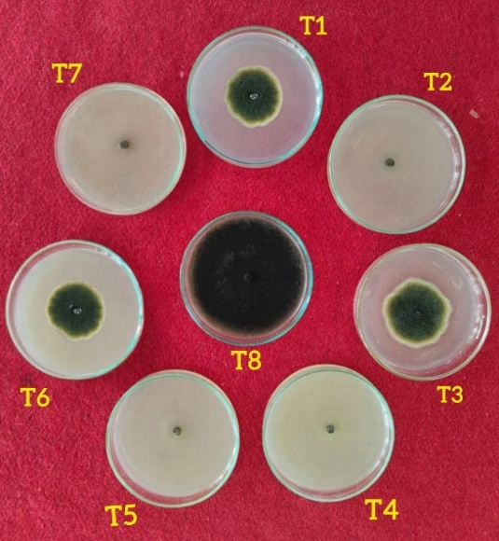
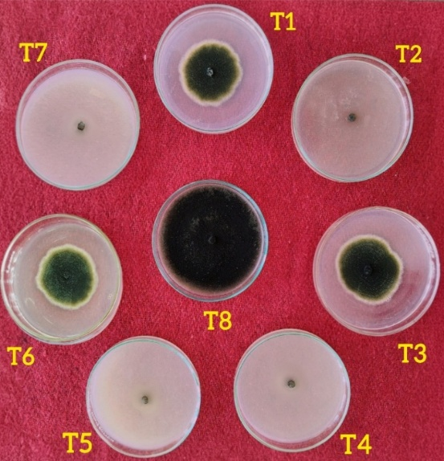
1000 ppm
500 ppm

Table 3. In vitro efficacy of systemic fungicides against Alternaria alternata
Tr.No. | Treatments | *Colony Diameter(mm) |  | Avg. | % Inhibition |  | Avg
Tr.No. | Treatments | 500 ppm | 1000 ppm | Avg. | 500 ppm | 1000  ppm | Avg
T1 | Carbendazim 50 % WP | 48.69 | 45.00 | 46.84 | 45.90 | 50.00 | 47.95
T2 | Tebuconazole 25.9 % EC | 00.00 | 00.00 | 00.00 | 100.00 | 100.00 | 100.00
T3 | Thiophanate methyl 70 % WP | 49.26 | 48.50 | 48.88 | 45.26 | 46.11 | 45.68
T4 | Propiconazole 25 % EC | 00.00 | 00.00 | 00.00 | 100.00 | 100.00 | 100.00
T5 | Hexaconazole 5 % EC | 00.00 | 00.00 | 00.00 | 100.00 | 100.00 | 100.00
T6 | Pyraclostrobin 20 % WG | 45.50 | 40.00 | 42.75 | 49.44 | 55.55 | 52.49
T7 | Difenoconazole 25 % EC | 00.00 | 00.00 | 00.00 | 100.00 | 100.00 | 100.00
T8 | Control (untreated) | 90.00 | 90.00 | 90.00 | - | - | -
SE± |  | 0.50 | 0.30 | - | - | - | -
CD at 1% |  | 2.09 | 1.26 | - | - | - | -
*Mean of three replications

Tr. No. | Treatments | Tr. No. | Treatments
T1 | Carbendazim 50 % WP | T5 | Hexaconazole 5 % EC
T2 | Tebuconazole 25.9 % EC | T6 | Pyraclostrobin 20 % WG
T3 | Thiophanate methyl 70 % WP | T7 | Difenconazole 25 % EC
T4 | Propiconazole 25 % EC | T8 | Control (untreated)
Fig. 1: In vitro efficacy of systemic fungicides against Alternaria alternata

3.2 In Vitro Efficacy of Bio-Agents Against Alternaria alternata
Screening seven biocontrol agents using the dual culture technique demonstrated significant inhibition (P =01) of Alternaria alternata mycelial growth relative to the control (Plate 2, Table 4, and Fig. 2).
The significant antagonism recorded in dual culture agrees with the established capacity of Trichoderma spp. to restrict fungal pathogens through rapid competitive growth, mycoparasitism, hydrolytic enzymes, and antifungal metabolites (Harman et al., 2004; Kumar et al., 2026). Recent experimental work with A. alternata also demonstrates substantial inhibition by Trichoderma metabolites and dual-culture interactions, supporting the biological plausibility of the present screening results (Philip et al., 2024).

3.2.1 Effect on Pathogen Mycelial Growth and Per Cent Growth Inhibition

All tested biocontrol agents significantly restricted pathogen radial expansion compared to the untreated control (90.00 mm). Among seven bioagents, Trichoderma asperellum recorded the lowest radial mycelial growth (20.16 mm) with highest mycelial growth inhibition (77.60%) followed by T. harzianum, (21.16 mm and 76.48 %), Aspergillus niger, (23.50 mm and 73.88 %), T. koningii, (24.33 mm and 72.96 %). T. hamatum (29.66 mm and 67.04 %), Bacillus subtilis (44.33 mm and 50.74 %), Pseudomonas fluorescens (48.33 mm and 46.30%) (Shirke 2024; Reddy 2018; Chaudhary et al., 2018)
The comparatively high inhibition by T. asperellum and T. harzianum is consistent with the multifunctional antagonistic behavior widely reported for Trichoderma species (Harman et al., 2004; Kumar et al., 2026). The activity of B. subtilis is also mechanistically credible because Bacillus lipopeptides can exert direct antifungal effects against A. alternata (Harish et al., 2023), while recent Trichoderma-A. alternata work has documented inhibition near the magnitude observed in the present assay (Philip et al., 2024). Because antagonistic efficacy is strain- and environment-dependent, these in vitro rankings should be treated as a basis for further compatibility, formulation, greenhouse, and field testing rather than as definitive evidence of disease control under farm conditions.
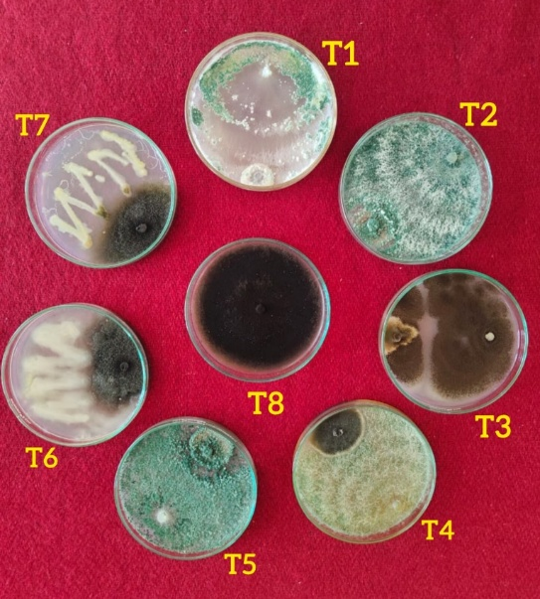

Plate 2: In vitro efficacy of bioagents against Alternaria alternata

Fig. 2: In vitro efficacy of bioagents against Alternaria alternata

Table 4: In vitro efficacy of bio-agents against Alternaria alternata
Tr. No. | Treatments | Colony Diameter of Pathogen (mm) | % Inhibition
T1 | Trichoderma asperellum | 20.16 | 77.60
T2 | T. harzianum | 21.16 | 76.48
T3 | Aspergillus niger | 23.5 | 73.88
T4 | T. hamatum | 29.66 | 67.04
T5 | T. koningii | 24.33 | 72.96
T6 | Pseudomonas fluorescens | 48.33 | 46.30
T7 | Bacillus subtilis | 44.33 | 50.74
T8 | Control | 90.00 | 00.00
 | S.E.± | 0.55
 | C.D.at 1% | 2.30
- CONCLUSION
The present in vitro investigation confirms the high fungitoxic and antagonistic potential of specific systemic fungicides and biological control agents respectively against Alternaria alternata. Among the chemical treatments, Tebuconazole 25.9% EC, Propiconazole 25% EC, Hexaconazole 5% EC and Difenoconazole 25% EC recorded complete inhibition (100.00%) of mycelial growth followed by Pyraclostrobin 20% WG (52.49%), Carbendazim 50% WP (47.95%) and Thiophanate methyl 70% WP (45.68%) average inhibition.
Among the biological control agents Trichoderma asperellum recorded the lowest radial mycelial growth of 20.16 mm and the highest mycelial growth inhibition of 77.60%, followed by T. harzianum (21.16 mm and 76.48%), Aspergillus niger (23.50 mm and 73.88%), T. hamatum (29.66 mm and 67.04%), T. koningii (24.33 mm and 72.96%), Bacillus subtilis (44.33 mm and 50.74%) and Pseudomonas fluorescens (48.33 mm and 46.30%), respectively. The Tebuconazole 25.9% EC, Propiconazole 25% EC, Hexaconazole 5% EC and Difenoconazole 25% EC among chemical treatments and Trichoderma asperellum among biocontrol agents study represent promising candidates for further evaluation and incorporation into integrated management strategies against Alternaria leaf blight of groundnut.
providing necessary laboratory facilities and equipment to conduct this research.

COMPETING INTERESTS
Authors have declared that no competing interests exist

CONSENT
Not applicable for this laboratory in vitro study.

ETHICAL APPROVAL
Not applicable. This manuscript does not contain studies involving human participants or animal subjects.

COMPETING INTERESTS DISCLAIMER:
Authors have declared that they have no known competing financial interests OR non-financial interests OR personal relationships that could have appeared to influence the work reported in this paper.

Declaration of AI Use

This manuscript was prepared through the intellectual contributions of the author(s) to the study design, data analysis, interpretation of results, and scholarly content. Grammarly and ChatGPT were used solely to assist with grammatical refinement and reference formatting during manuscript revision. The author(s) accept full responsibility for the accuracy, integrity, and final content of the manuscript.

REFERENCES
Balasubramanian, R. (1979). A new type of alternariosis in Arachis hypogea L.
Chaudhary, D.A., Nath, K., Bekariwala, T. & Mabhub, B. (2018). Management of Alternaria leaf blight of groundnut caused by Alternaria alternata. Indian Phytopathology. 71(4):543-548.
Dennis, C. and Webster, J. (1971). Antagonistic properties of species group of Trichoderma and hyphal interactions. Trans. British Mycol. Soc. 57: 363-369
FAOSTAT (2025). Food and Agriculture Organization Statistics Database (FAOSTAT). Available at: http://faostat.fao.org (Accessed 2026).
Heba, M. N., Rana, D. S., Choudhary, A. K., Dass, A., Rajanna, G. A. & Pande., P. (2021). Influence of sulphur and zinc nutrition on productivity, quality and biofortification in groundnut (Arachis hypogea L.) in south-Asian Alluvial soil. Journal of Plant Nutrients. 44(8):1151–1174.
Kantawa, S. L., Tetarwal, J. P. & Shekawat, K.S. (2014). In vitro effect of fungicides and phyto-extracts against Alternaria alternata, causing leaf blight of groundnut. Journal of Agriculture Veterinary Science. 7(1):28-31.
Kumar, N., Dutta, R., Ajay, B. C. & Radhakrishnan, T. (2022). Alternaria leaf blight (Alternaria spp.) an emerging foliar fungal disease of winter-summer groundnut (Arachis hypogaea): A review. The Indian Journal of Agricultural Sciences. 92(9).
Kumar, Vinod, Lukose, C., Bagwan, N. B., Koradia, V. G. & Padavi, R. D. (2012). Occurrence of Alternaria leaf blight of groundnut in Gujarat and reaction of some genotypes against the disease. Indian Phytopathology. 65(1):25-30.
Reddy, V.V. (2018). Studies on groundnut leaf blight caused by Alternaria spp. M.Sc. (Agri.) Thesis, Vasantrao Naik Marathwada Krishi Vidyapeeth, Parbhani (M.S.)
Shirke, A.L. (2024). Studies on leaf blight of groundnut caused by Alternaria alternata (Fr.) Keissler. M.Sc. (Agri.) Thesis, Vasantrao Naik Marathwada Krishi Vidyapeeth, Parbhani (M.S.).
Vincent, J.M. (1927). Distortion of fungal hyphae in the presence of certain inhibitors.Nature 159-180.
Harman, G. E., Howell, C. R., Viterbo, A., Chet, I., & Lorito, M. (2004). Trichoderma species—opportunistic, avirulent plant symbionts. Nature Reviews Microbiology, 2(1), 43–56. https://doi.org/10.1038/nrmicro797
Harish, B. N., Nagesha, S. N., Ramesh, B. N., Shyamalamma, S., Nagaraj, M. S., Girish, H. C., Pradeep, C., Shiva Kumar, K. S., Tharun Kumar, K. S., Pavan, S. N., & Kavan Kumar, V. (2023). Molecular characterization and antifungal activity of lipopeptides produced from Bacillus subtilis against plant fungal pathogen Alternaria alternata. BMC Microbiology, 23, 179. https://doi.org/10.1186/s12866-023-02922-w
Kumar, S., Jaiswal, S., Kumar, V., Kumari, P., & Upadhyay, R. S. (2026). Trichoderma species as sustainable biocontrol agents: Mechanisms, applications, and future prospects in plant disease management. Indian Phytopathology, 79, 281–308. https://doi.org/10.1007/s42360-026-00969-z
Philip, B., Behiry, S. I., Salem, M. Z. M., Amer, M. A., El-Samra, I. A., Abdelkhalek, A., & Heflish, A. (2024). Trichoderma afroharzianum TRI07 metabolites inhibit Alternaria alternata growth and induce tomato defense-related enzymes. Scientific Reports, 14, 1874. https://doi.org/10.1038/s41598-024-52301-2
Purohit, J., Chattopadhyay, A., Patel, D. S., Chaudhari, S. M., & Patel, K. K. (2025). Dual role of triazole fungicides in managing Alternaria blight and promoting growth in groundnut (Arachis hypogaea L.). Crops, 5(5), 60. https://doi.org/10.3390/crops5050060
Yang, G., Cui, S., Ma, N., Song, Y., Ma, J., Huang, W., Zhang, Y., & Xu, J. (2022). Genetic structure and triazole antifungal susceptibilities of Alternaria alternata from greenhouses in Kunming, China. Microbiology Spectrum, 10(3), e00382-22. https://doi.org/10.1128/spectrum.00382-22

