Original Research Article
Genetic diversity analysis in chickpea (Cicer arietinum L.) genotype using D² Statistics

ABSTRACT
Chickpea (Cicer arietinum L.) is an important pulse crop, and the identification of genetically divergent parents is useful for crop improvement through hybridization. The present investigation evaluated genetic diversity among 50 chickpea genotypes grown during Rabi 2024–25 at Dr. BRC Agricultural Research Station, Mandor, Jodhpur. The experiment was conducted in a randomized block design with three replications, and observations were recorded for 15 phenological, yield-related, physiological, and biochemical traits. Genetic divergence was assessed using Mahalanobis D² statistics, and the genotypes were grouped into 11 clusters using Tocher’s method. The maximum intra-cluster distance was recorded in Cluster IX (167.27), followed by Clusters II, VI, and I, indicating comparatively greater variability within these groups. The highest inter-cluster distance was observed between Clusters III and IX (573.48), followed by Clusters V and XI (542.06) and Clusters VI and XI (511.71), suggesting substantial divergence among these cluster combinations. Protein content contributed most to total genetic divergence (29.80%), followed by chlorophyll content (24.41%), days to 50% flowering (20.16%), and relative water content (10.78%). Cluster means also revealed substantial variation among groups for yield-related, physiological, and biochemical traits. The findings indicate that genetically divergent genotypes, particularly those belonging to widely separated clusters, may be useful as parental material in chickpea breeding programmes aimed at generating variability and improving desirable traits.

Keywords: Chickpea, genotypes, diversity, cluster, distance.
- INTRODUCTION
Among pulses crops chickpea (Cicer arietinum L.) is a significant legume crop. Chickpea belongs to the family leguminosae and subfamily papilionaceae. It belongs to the genus Cicer, which has nine annual wild species and thirty-four perennial species (Singh et al. 2008). It is a self- pollinated legume crop which have 2n = 2x =16 chromosome number in its genome. The chickpea is called as the "King of Pulses" and also known as Egyptian pea, garbanzo bean, Bengal gram, and gram. The genesis and initial domestication of chickpeas were in southeast Turkey and the neighboring regions of Syria and Iran. N.I. Vavilov considered South-West Asia and the Mediterranean to be the primary center of origin of chickpeas, and Ethiopia was the secondary center. Chickpea is most widely cultivated and consumed pulse crop in India. It is an essential source of protein in human diet as well as animal feed. Chickpea is a substantial and reasonably priced source of protein when compared to animal protein. The protein content of chickpeas is between 21 to 24 %, combined with 2.2 % fat and 62 % carbohydrates. In addition, it has a high percentage of other mineral elements, unsaturated oleic and linoleic acid, calcium (190 mg/100g), phosphorus (280 mg/100g), iron (90.5mg/100g), and other mineral nutrients. Despite having less protein than other pulses, it has a higher biological value and is more digestible. Chickpea’s granular hair which are present on leaves and pods secreted a liquid that contains Malic acid (90-96 per cent) and Oxalic acid (90-96 per cent). Grain part of chickpea is key source of protein in human diet. It has the ability to improve soil fertility and fix nitrogen from the atmosphere at a low cost of production. It can be used in diets that are low in fat and sodium, low in calories, low in cholesterol, low in salt, gluten-free, diabetic, and high in fiber. Additionally, the grain helps control the body's cholesterol levels. In South Asian countries, chickpea green leaves are utilized to form a nutritious vegetable. India accounts for around two-thirds of the world's chickpea production, making it the world's top producer and consumer. In agriculture year 2023-24 the total area under chickpea cultivation in India is 9.46 (M ha), with total production of 11.58 (MT), and productivity of 1224 (kg/ha). After the Maharashtra and Madhya Pradesh, Rajasthan is the third largest producer of chickpea. Total area under chickpea cultivation in Rajasthan is 1.81 (M ha) and total production of 2.23 (MT), with a productivity of 1232 (kg/ha) followed by Uttar Pradesh and Gujarat (Anonymous 2023). The dominance of high yielding cultivars, on the other hand, has resulted in a decline in genetic diversity, which, in the end, makes the crop vulnerable to a variety of biotic and abiotic challenges. In order to mitigate this damage, it is essential to conduct a germplasm evaluation in order to preserve the genetic diversity, and within this context, it is essential to identify promising genotypes for breeding purposes. Many of the plant scientist has estimated genetic diversity in chickpea crop like Karthikeyan et al. (2021) conducted a study applied D2 statistics to determine the genetic diversity of twenty different chickpea genotypes that grouped the genotypes in four distinct cluster. The result revealed that genotype are grouped into 11 clusters and the maximum inter-cluster distance was recorded between cluster X and XI. Hence the present investigation is needed to investigate the intrinsic developmental characters and seed yield parameters of chickpea in the environment of Jodhpur, Rajasthan for the identification of genetically diverse genotypes which would assist in selecting parents for a hybridization procedure.
- MATERIALS AND METHODS
  - Experimental site and materials
The present study was conducted at Dr. BRC agricultural research station, Mandor, Jodhpur which falls under the zone-Ia (Arid Western Plains) using 50 chickpea genotype (Table 1) planted in randomized block design having 3 replication during Rabi 2024-25. In order to produce a healthy crop, all of the recommended agronomic practices were adopted, and the appropriate preventive measures against pests and diseases were taken.
  - Observation recorded
    - Phenological traits
A statistical analysis performed on the mean values of the observations made for features such as days to 50% flowering, days to maturity and days to pod initiation for entire plot basis and the remaining data from each replication averaged from five randomly selected plants for the traits plant height, number of pods per plant, number of effective pods per plant, 100 seed weight, number of seeds per pod, seed yield per plant (g), harvest index (%) and dry fodder yield per plant (g).
    - Physio-biochemical traits
Relative water content (%) chickpea was determined by the Barrs and Weatherley method; membrane stability index(%)in chickpea was determined using a formula developed by Blum and Ebercon in 1981; chlorophyll content (%) The chlorophyll was extracted from a leaf sample using acetone, and the concentration calculated by spectrophotometer (Arnon 1949) and seeds protein content was estimated by using the micro Kjeldahl technique, as suggested by J. Kjeldahl(1883).
  - Statistical analysis
The data collected from field and lab for fifteen characters were statistically analyzed with the help of WINDOSTAT Version 9.3 software. Mahalanobis’s D² technique as suggested by Rao (1952) was used to study genetic divergence.
Table 1: List of Chickpea genotypes
S.No. | Name of Genotypes | Source | S.No. | Name of Genotypes | Source
1 | ICC 15925 | ICRISAT, Hyderabad | 26 | IPC 2006-77 | ICAR-IIPR, Kanpur
2 | ICC 96029 | ICRISAT, Hyderabad | 27 | DCP 92-3 | ICAR-IIPR, Kanpur
3 | ICC 16348 | ICRISAT, Hyderabad | 28 | JG 315 | JNKVV, Jabalpur
4 | ICC 92944 | ICRISAT, Hyderabad | 29 | JG 11 | JNKVV, Jabalpur
5 | ICC 10685 | ICRISAT, Hyderabad | 30 | JG 16 | JNKVV, Jabalpur
6 | ICC 07110 | ICRISAT, Hyderabad | 31 | RKGK 13-515 | ARS, Kota
7 | ICC 07118 | ICRISAT, Hyderabad | 32 | RKGK 13-416 | ARS, Kota
8 | ICC 6953 | ICRISAT, Hyderabad | 33 | RKGK 13-499 | ARS, Kota
9 | ICC 6788 | ICRISAT, Hyderabad | 34 | GNG 2207 | ARS, Sriganganagar
10 | ICC 81-82 | ICRISAT, Hyderabad | 35 | GNG 1969 | ARS, Sriganganagar
11 | ICC 1826 | ICRISAT, Hyderabad | 36 | GNG 2144 | ARS, Sriganganagar
12 | ICC 12453 | ICRISAT, Hyderabad | 37 | GNG 1958 | ARS, Sriganganagar
13 | ICC 2156 | ICRISAT, Hyderabad | 38 | GNG 1581 (Gangaur) | ARS, Sriganganagar
14 | ICC 1214 | ICRISAT, Hyderabad | 39 | GNG 2171 | ARS, Sriganganagar
15 | ICC 9029 | ICRISAT, Hyderabad | 40 | GNG 2261 | ARS, Sriganganagar
16 | ICC 1212 | ICRISAT, Hyderabad | 41 | KWR 108 | CSAUA&T, Kanpur
17 | ICC 8507 | ICRISAT, Hyderabad | 42 | Sadabahar | CSAUA&T, Kanpur
18 | ICC 1205 | ICRISAT, Hyderabad | 43 | CSJ 884 | RARI,Durgapura
19 | ICC 9942 | ICRISAT, Hyderabad | 44 | RSG 895 | RARI,Durgapura
20 | JAKI 9218 | ICRISAT, Hyderabad | 45 | HC 5 | CCSHAU, Hisar
21 | IPC 2015-55 | ICAR-IIPR, Kanpur | 46 | Pant G-114 | GBPUAT, Pantnagar
22 | IPC 2011-78 | ICAR-IIPR, Kanpur | 47 | Vijay | MPKV, Rahuri
23 | IPC 2014-55 | ICAR-IIPR, Kanpur | 48 | NPC-59 | IGKV, Raipur
24 | IPC 2014-19 | ICAR-IIPR, Kanpur | 49 | CSG-8962 | CSSRI, Karnal
25 | IPC 2015-81 | ICAR-IIPR, Kanpur | 50 | BDG 372 | IARI, New Delhi
- RESULTS AND DISCUSSION
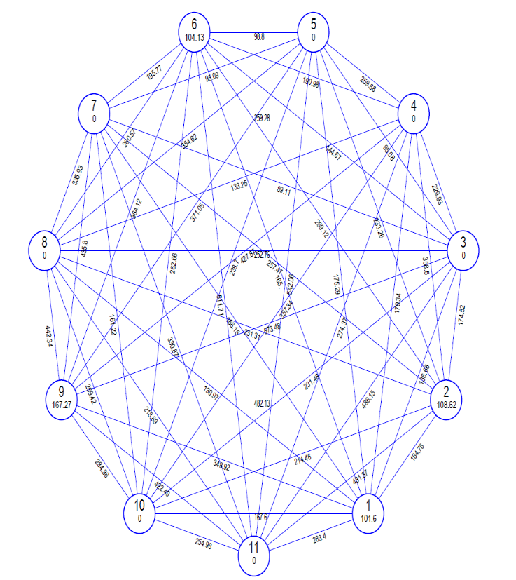
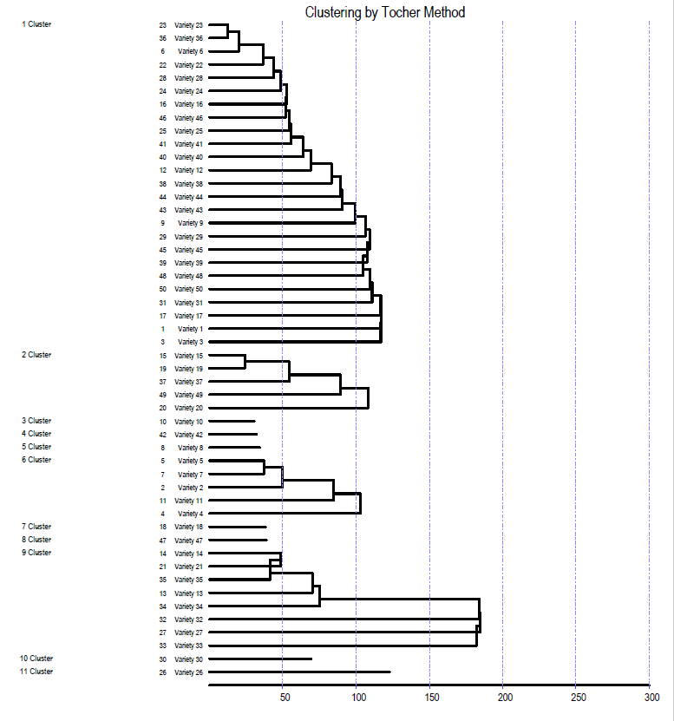
Mahalonobis D² is a useful method for assessing genetic diversity among number of genotypes, which aids in the selection of genetically diverse parents and determines the relative proportion of each component trait, considering this the Rao, 1952 method was used to calculate the D2 statistic in this study of genetic divergence among 50 genotypes of chickpea. Investigated 50 genotypes for 15 morpho-physio and biochemical traits, were classified into 11 clusters based on D² values using Tocher's techniques, with genotypes belonging to the same cluster having lower D² values on average than genotypes belonging to different clusters (figure 1 a).
Fig. 1. (a) Dendrogram representing grouping of genotypes into 11 clusters. (b) Cluster diagram representing genetic distance between 11 diverse cluster.
a
b
Out of eleven clusters, cluster Ⅰwas the largest comprising of 25 genotypes followed by cluster IX with 8 genotypes, cluster s Ⅱ with 5 genotypes, cluster s Ⅵ with 4 genotypes Ⅲ, IⅤ, V, VI, Ⅶ, X and XI were the cluster s having single genotype i.e. monogenotypic cluster suggesting the existence of high degree of heterogeneity among the genotype (Table 2) similar finding reported by Karthikeyan et al. (2021).
Table 2: Distribution of 50 chickpea genotypes into different clusters.
Cluster | No. of genotypes | Name of genotypes
Ⅰ | 25 | IPC-2015-55, GNG-2207, ICC-07110, IPC-2015-78, JG-315, IPC-2015-81, IPC-2006-19, Pant-G-114, IPC-2014-19, KWR-108, GNG-2261, ICC-1212, GNG-1581 (Gangaur), RSG-895, CSJ-884, IPC-2015-81, ICC-12453, ICC-6788, HC-5, GNG-2171, NPC-59, BDG-372, RKGK-13-515, JG-11, ICC-8507, ICC-15925, ICC-16348.
Ⅱ | 5 | ICC-9029, ICC-9942, GNG-1958, CSG-8962, JAKI-9218.
Ⅲ | 1 | ICC-6788
Ⅳ | 1 | SADABAHAR
Ⅴ | 1 | ICC-6953
Ⅵ | 5 | ICC-10685, ICC-07118, ICC-96029, ICC-1826, ICC-92944
Ⅶ | 1 | ICC-1205
VIII | 1 | Vijay
IX | 8 | ICC-1214, IPC-2011-78, GNG-1969, ICC-2156, GNG-2207, RKGK-13-416, DCP-92-3, RKGK-13-499
X | 1 | JG-16
XI | 1 | IPC-2006-77
The maximum intra cluster distance was observed in cluster IX (167.27) followed by cluster II (108.62), cluster VI (104.13), cluster I (101.60) and minimum intra cluster distance was recorded in cluster s Ⅱ, Ⅲ, Ⅴ, Ⅵ and Ⅶ (zero) (Table 3). The maximum inter cluster distance was recorded between cluster III and IX (573.48) followed by cluster V and XI (542.06), cluster VI and XI (511.71), cluster III and XI (486.15) and cluster II and IX (482.13). The distance between two clusters is directly proportional to their genetic diversity. Highly divergent genotypes would be quite useful in a recombination breeding effort to produce highly desired recombinants. The lowest inter cluster divergence was recorded between cluster III and VII (89.11) followed by cluster III and V (95.08), cluster V and VII (95.09), and cluster V and VI (98.80) (figure 1 b) demonstrating that the genotypes contained in these clusters were closely linked, these findings were as similar has been reported by Reddy and Lal (2021). Selection should be carried out in genetically varied populations to preserve a relatively broad genetic base.
Table 3: Intra and inter cluster D² values for different cluster
Cluster | C Ⅰ | C Ⅱ | C Ⅲ | C Ⅳ | C Ⅴ | C Ⅵ | C Ⅶ | C VII | C IX | C X | C XI
Cluster Ⅰ | 101.60 | 164.76 | 136.66 | 179.34 | 175.29 | 165.00 | 168.15 | 139.97 | 348.92 | 167.60 | 283.40
Cluster Ⅱ |  | 108.62 | 174.52 | 358.50 | 233.26 | 269.12 | 257.47 | 231.31 | 482.13 | 214.46 | 431.37
Cluster Ⅲ |  |  | 0.00 | 229.93 | 95.08 | 144.67 | 89.11 | 252.76 | 573.48 | 231.48 | 486.15
Cluster Ⅳ |  |  |  | 0.00 | 259.68 | 190.98 | 259.28 | 133.25 | 427.87 | 357.34 | 274.37
Cluster Ⅴ |  |  |  |  | 0.00 | 98.80 | 95.09 | 354.62 | 371.05 | 238.70 | 542.06
Cluster Ⅵ |  |  |  |  |  | 104.13 | 195.77 | 260.57 | 364.12 | 262.66 | 511.71
Cluster Ⅶ |  |  |  |  |  |  | 0.00 | 335.93 | 435.80 | 161.22 | 330.87
Cluster Ⅶ |  |  |  |  |  |  |  | 0.00 | 442.34 | 269.42 | 218.89
Cluster IX |  |  |  |  |  |  |  |  | 167.27 | 284.36 | 422.49
Cluster X |  |  |  |  |  |  |  |  |  | 0.00 | 254.98
Cluster XI |  |  |  |  |  |  |  |  |  |  | 0.00
The results on the percentage contribution of individual characters towards genetic divergence is presented in table 4 that shows maximum genetic divergence was contributed by protein content (29.8%), chlorophyll content (24.41%), days to 50% flowering (20.16%), relative water content (10.78%), 100 seed weight (6.78%), number of pods per plant (3.02%), days to pod initiation (2.29%) and plant height (1.71%) supported findings of maximum contribution of protein content were reported by Jayalakshmi et al. (2021), Nimbalkar et al. (2017).
Table 4 :Contribution percentage of individual characters towards genetic divergence.
S. No. | Characters | Contribution | No. of times ranked first
1 | Days to 50% flowering | 20.16% | 247
2 | Days to pod initiation | 2.29% | 28
3 | Days to maturity | 0.16% | 2
4 | Plant height (cm) | 1.71% | 21
5 | Number of pods per plant | 3.02% | 37
6 | Number of effective pods per plant | 0% | 0
7 | Number of seeds per pod | 0% | 0
8 | 100 seed weight (g) | 6.78% | 83
9 | Harvest Index (%) | 0.08% | 1
10 | Seed yield per plant (g) | 0.65% | 8
11 | Dry fodder yield per plant (g) | 0% | 0
12 | Protein content (%) | 29.8% | 365
13 | Relative water content(%) | 10.78% | 132
14 | Membrane stability index (%) | 0.16% | 2
15 | Chlorophyll Content (%) | 24.41% | 299
The cluster mean for different traits were presented in table 5 that indicated that the cluster mean for trait 50 % flowering was highest in cluster IX (77.46) and the lowest in cluster III (47.00). Days to pod initiation were exhibited highest means in cluster X (103.33) and lowest in cluster IV (71.67).Cluster exhibited highest mean for days to maturity (127.00) while lowest was in cluster II (114.40). Plant height exhibited highest in cluster IX (55.15) and lowest means in cluster VII (34.20) respectively. Cluster VI recorded the highest number of pods per plant (88.95) and lowest was recorded in cluster IV (36.00).Number of effective pods per plant was highest in cluster IX (75.73) and lowest was recorded in cluster I and III (27.77). The number of seeds per pod was highest in cluster VI (2.13) and lowest in cluster IV (1.67). In 100 seed weight Cluster IV exhibited highest (23.30) while in cluster X (9.82) it was the lowest. The harvest index was highest in cluster V (23.27) while lowest in cluster VII (13.43).Cluster V exhibited the highest seed yield per plant (47.13) the lowest was recorded in cluster II (40.29). The highest dry fodder yield per plant was recorded in cluster II (25.64) and the lowest was recorded in cluster III (19.50).Cluster XI exhibited the highest protein content (24.40) and the lowest was recorded in cluster V (14.47). Relative water content was recorded highest in cluster XI (86.23) and lowest in cluster II (68.02). Highest mean value for membrane stability index was recorded for cluster IV (93.23) and cluster VII (70.33) recorded the lowest mean value. Chlorophyll content was highest recorded in cluster IV (2.85) and lowest in cluster V (1.36). Similar findings were observed by Parhe et al. (2014). Babbar et al. (2015), Gaikwad et al. (2014), karthikeyan et al. (2021), Reddy and Lal (2021).
4. Conclusion
The present study on genetic divergence in chickpea genotypes using Mahalanobis D² statistics concludes that 50 genotypes were grouped into 11 distinct clusters, with the maximum number of genotypes in cluster I, confirming this cluster as most diverse, which is advantageous for hybridization strategies. Further ,protein content, chlorophyll content and days to 50% flowering were identified as the most significant contributors to genetic divergence, emphasizing their role in differentiating genotypes and guiding trait-based selection. The Cluster having maximum inter-cluster distance which us between Cluster III & IX so crossing between genotypes from these highly divergent clusters can be employed to exploit heterosis and generate superior transgressive segregants. Such crosses can broaden the genetic base and accelerate the development of high-yielding chickpea varieties.

Table 5: Cluster mean for yield and yield contributing traits.
Characters | DFF | DPI | DM | PH (cm) | NPPP | NEPPP | NSPP | 100-SW (g) | HI (%) | SYPP (g) | DFYPP  (g) | PC (%) | RWC% | MSI (%) | CHL (%)
Cluster Ⅰ | 54.29 | 74.19 | 115.20 | 42.70 | 52.98 | 41.86 | 1.82 | 15.18 | 15.52 | 42.17 | 21.12 | 19.50 | 69.46 | 74.85 | 2.10
Cluster Ⅱ | 54.07 | 74.20 | 114.40• | 45.31 | 86.07 | 74.83 | 2.03 | 19.44 | 22.31 | 45.71 | 25.64# | 22.19 | 68.02• | 76.78 | 1.47
Cluster Ⅲ | 47.00• | 71.67 | 116.00 | 35.60 | 39.63 | 27.77• | 1.87 | 16.60 | 14.57 | 42.71 | 19.50• | 16.43 | 71.09 | 77.33 | 1.47
Cluster Ⅳ | 52.67 | 71.67• | 115.67 | 45.50 | 36.00• | 28.07 | 1.67• | 23.30# | 16.03 | 44.03 | 20.37 | 16.53 | 76.64 | 93.23# | 2.85#
Cluster Ⅴ | 63.00 | 79.33 | 124.67 | 52.43 | 80.67 | 66.90 | 2.07 | 14.86 | 23.27# | 47.13# | 25.90 | 14.47• | 71.41 | 74.33 | 1.36•
Cluster Ⅵ | 59.00 | 79.93 | 126.07 | 46.91 | 88.95# | 75.47 | 2.13# | 17.13 | 18.80 | 44.77 | 23.03 | 14.99 | 68.38 | 73.13 | 2.02
Cluster Ⅶ | 56.00 | 75.00 | 117.00 | 41.20 | 55.70 | 44.57 | 1.80 | 11.39 | 13.43• | 40.84 | 19.50 | 16.80 | 81.96 | 70.33• | 1.45
Cluster ⅦI | 49.00 | 72.67 | 111.67 | 34.20• | 52.23 | 41.40 | 1.73 | 16.60 | 20.87 | 45.44 | 24.93 | 20.37 | 68.93 | 70.57 | 2.85
Cluster IX | 77.46# | 95.67 | 125.25 | 55.15# | 87.60 | 75.73# | 2.04 | 11.85 | 17.83 | 43.01 | 23.38 | 20.55 | 72.13 | 75.54 | 2.43
Cluster X | 54.00 | 103.33# | 127.00# | 47.97 | 67.43 | 53.93 | 1.73 | 9.82• | 15.67 | 42.10 | 21.30 | 22.60 | 78.70 | 77.33 | 1.89
Cluster XI | 53.00 | 74.00 | 118.00 | 51.07 | 43.90 | 32.23 | 1.67 | 10.94 | 14.40 | 40.29• | 21.50 | 24.40# | 86.23# | 81.77 | 2.93
•, # represents minimum and maximum values, respectively.
*Where DFF = Days to 50% flowering , DPI = Days to pod initiation , DM = Days to maturity , NPPP = Number of pods per plant , NEPPP = number of effective pods per plant , NSPP = number of seeds per pod , 100-SW = 100 seed weight, HI(%) = Harvest index , SYPP (g) = Seed yield per plant , DFYPP (g) = Dry fodder yield per plant , PC (%) = Protein content, RWC (%) = Relative water content , MSI (%) = Membrane stability index, CHL (%) = Chlorophyll content

Competing interests
Authors have declared that no competing interests exist.
Declaration of AI Use

This manuscript was prepared through the intellectual contributions of the author(s) to the study design, data analysis, interpretation of results, and scholarly content. Grammarly and ChatGPT were used solely to assist with grammatical refinement and reference formatting during manuscript revision. The author(s) accept full responsibility for the accuracy, integrity, and final content of the manuscript.

REFRENCES
Anonymous (2023). Estimate by AICRP in pulses, Kanpur, Uttar Pradesh. https://www.icar-iipr.org.in/aicrp-on-rabi-pulses/
Arnon. D.I. (1949). Copper enzymes in isolated chloroplasts: Polyphenoloxidase in Beta vulgaris. Plant Physiology, 24(1),1-15.
Babbar, A., Pandey, S., & Singh, R. (2015). Genetic studies on chickpea genotypes grown in late sown under rice fallow conditions of Madhya Pradesh. Electronic Journal of Plant Breeding, 6(3), 738-748.
Barrs, H.D., & Weatherley, P.E. (1962). A Re-Examination of the Relative Turgidity Technique for Estimating Water Deficits in Leaves. Australian Journal of Biological Sciences, 15, 413-428.
Blum, A., & Ebercon, A. (1981). Cell Membrane Stability as a Measure of Drought and Heat Tolerance in Wheat. Crop Science, 21, 43-47.
Gaikwad, A.R., Desai, N.C., Pawar, G.H., & Langhi, A.M. (2014). Genetic divergence in chickpea. International Journal of Agriculture Science, 10(2), 812-815.
Jayalakshmi, V., Imran, M.M., & Reddy, A.T. (2021). Genetic analysis for protein, micronutrients and yield attributing traits in chickpea (Cicer arietinum L.). Journal of Food Legumes, 34(3), 188-193.
Karthikeyan, M., Pandey, S., Synrem, G., & Saravanan, K.R. (2021). Assessment of genetic diversity of chickpea genotypes (Cicer arietinum L.) Using D² statistics. Current Journal of Applied Science and Technology, 40(24), 51-56.
Kjeldahl, J. (1883). A new method for the estimation of nitrogen in organic compounds. Z. Anal. Chem, 22, 366.
Nimbalkar, R.D., Katre, Y.Y., & Phad, D.S. (2017). Genetic diversity in Chickpea (Cicer arietinum L.). Bioinfolet, 14(1), 60-63.
Parhe, S.D., Harer, P.N., & Nagawade, D.R. 2014. Investigation of genetic divergence in chickpea (Cicer arietinum L.) genotypes. The Bioscan, 9(2), 879-882.
Rao, C. R. (1952). Advanced statistical methods in biometrical research. John Wiley and Sons, New York, p: 357-363.
Reddy, M. A., & Lal, G. M. (2021). Assessment of genetic diversity for different quantitative traits in chickpea (Cicer arietinum L.). The Pharma Innovation Journal, 10(9), 2135-2139.
Singh, R., Sharma, P., Varshney, R.K., Sharma, S.K., & Singh, N.K. (2008). Chickpea Improvement: Role of wild species and genetic markers. Biotechnology and Genetic Engineering Reviews, 25(1), 267-314.
Vavilov, N. I. (1926). Studies on the origin of cultivated plants. Bulletin of Applied Botanic, 16, 2.

