Original Research Article

In vitro efficacy of fungicides and bioagents against wilt of
pigeonpea caused by Fusarium oxysporum f. sp. udum

ABSTRACT

Aims: To evaluate the in vitro fungitoxic potential of seven systemic fungicides @ 500 and ppm concentrations and seven fungal biological control agents against Fusarium oxysporum f. sp. udum, the causal pathogen of pigeonpea wilt.
Study Design: Completely Randomized Design (CRD).
Place and Duration of Study: Department of Plant Pathology, College of Agriculture, Latur, Maharashtra, India. The study was carried out during 2025–2026.
Methodology: The wilt pathogen (F. oxysporum f. sp. udum) was isolated from infected pigeonpea root tissues displaying characteristic vascular discoloration. Seven systemic fungicides (Carbendazim 50% WP, Myclobutanil 10% WP, Propiconazole 25% EC, Thiophanate methyl 70% WP, Difenoconazole 25% EC, Tebuconazole 25.9% EC, and Hexaconazole 5% EC) were screened at concentrations of 500 ppm and 1000 ppm using the Poisoned Food Technique. Seven fungal bioagents (T.harzianum, T. virens, T. hamatum, T. asperellum, Penicillium chrysogenum, Aspergillus niger and Aspergillus flavus) were evaluated using the dual-culture technique on Potato Dextrose Agar (PDA).
Results: All tested systemic fungicides significantly inhibited pathogen mycelial growth compared to the control (P = .01). Carbendazim 50% WP produced complete growth inhibition (100.00%) at both 500 ppm and 1000 ppm. Among the remaining fungicides, Tebuconazole 25.9% EC exhibited inhibition upto 85.18%, followed by Propiconazole 25% EC (82.78%),
Thiophanate methyl 70% WP (80.14%) and Hexaconazole 5% EC (71.77%). Among bioagents, T.harzianum achieved maximum growth inhibition (82.04%), closely followed by T. virens (80.55%) and T. asperellum (74.82%), whereas Aspergillus flavus recorded the lowest inhibition (63.71%).
Conclusion: Carbendazim 50% WP among chemical treatments and T.harzianum among biocontrol agents exhibited exceptional antagonistic efficacy in vitro, highlighting their potential for incorporation into integrated disease management strategies against pigeonpea wilt.

Keywords: Bioagents, Fungicides, Fusarium oxysporum f. sp. udum, Wilt of pigeonpea

INTRODUCTION
Pigeonpea (Cajanus cajan (L.) Millsp.), locally referred to as Arhar or Tur, is an essential short-lived perennial pulse legume belonging to the family Fabaceae. Tur Cultivated extensively across tropical and semi-arid regions, pigeonpea occupies a central position in dryland agricultural systems owing to its drought tolerance, deep taproot system, and soil-enriching symbiotic nitrogen fixation with Rhizobium, which contributes up to 20 kg N/ha under favorable field conditions (Reddy et al., 1990; Singh and Kumar, 2025). The crop serves as a vital source of dietary protein (15.5% to 28.8%) for vegetarian populations in India and other developing countries, alongside supplying carbohydrates (57.2% to 58.6%), crude fiber (1.2% to 8.1%), essential minerals (iron, iodine), and key amino acids including lysine, tyrosine, cystine, and arginine (Singh and Kumar, 2025).
Globally, pigeonpea is cultivated in over 22 nations across tropical and subtropical zones, with major production centered in India, Myanmar, Malawi, Tanzania, Kenya, and Mozambique (FAOSTAT, 2024). India dominates global acreage and production. During the 2025–26 cropping season, national pigeonpea acreage reached approximately 4.60 million hectares, yielding an estimated output of 3.597 million tonnes with a mean productivity level of 782 kg/ha (Anonymous, 2025b). Within Maharashtra state, pigeonpea covers nearly 1.28 million hectares (27.83% of national acreage), generating 1.04 million tonnes (~29.00% of national production) with an average yield of 812 kg/ha (Anonymous, 2025b).
Although pigeonpea is subject to over 100 pathogens (Nene et al. 1989), vascular wilt caused by Fusarium oxysporum f. sp. udum (Butler) Snyder & Hansen (syn. Fusarium udum Butler) remains the most destructive soil-borne fungal disease across the Indian subcontinent (Butler, 1910; Kannaiyan and Nene, 1981; Karimi et al. 2012). The disease inflicts severe economic losses ranging from 30% to 100% when infection occurs prior to pod formation (Kannaiyan et al. 1984; Pawar et al. 2013). In the Marathwada region of Maharashtra, field surveys during the 2025–26 season recorded average wilt incidence levels ranging between 4.20% and 36.80% (averaging 11.45%), exceeding 45% to 60% in endemic, monocropped belts (Anonymous, 2025a; Dhandge et al.2025).
The pathogen F. oxysporum f. sp. udum enters the host plant through root tips or mechanical injuries, colonizes the xylem vessels, and induces vascular browning, leaf chlorosis, drooping, and sudden collapse of the plant (Avinash et al. 2019; Ghante et al. 2019). Because of its soil-borne nature, persistent chlamydospore survival in soil, and systemic vascular infection habit, managing vascular wilt requires identification of highly active fungitoxic chemical molecules and potent
biological antagonists.

MATERIAL AND METHODS
  - Isolation and Identification of Fusarium oxysporum f. sp. udum
Wilted pigeonpea specimens showing typical vascular discoloration symptoms were collected from agricultural fields in Latur district, Maharashtra, India. Isolation of the pathogen was performed using standard tissue isolation procedures on Potato Dextrose Agar (PDA) (Dhingra and Sinclair, 2017). Infected root segments showing vascular browning were surface sterilized with 0.1 % HgCl2 solution for 1 minute, rinsed thrice with sterile distilled water, blotted dry on sterile filter paper, and plated onto PDA dishes. The dishes were incubated at 27 ± 2℃ for 7 days. Pure cultures were obtained via single hyphal tip isolation and maintained on PDA slants at 25℃ in a BOD incubator (Chakrapani et al.2023). Identification was confirmed based on cultural characteristics (cottony white mycelium, pinkish/reddish pigmentation) and diagnostic microscopic features including hyaline septate hyphae, 0-1 septate microconidia, 1-4 septate sickle-shaped macroconidia, and thick-walled spherical/oval chlamydospores (Butler, 1918; Patra and Biswas, 2017; Ghante et al. 2018).

In Vitro Evaluation of Systemic Fungicides
The fungitoxic potential of seven systemic fungicides was evaluated against F. oxysporum f. sp. udum using the Poisoned Food Technique (Vincent, 1947).
Table 1. Details of systemic fungicides evaluated
Tr.No. | Fungicide Common Name | Trade Name | Active Ingredient(%) | Test Concentrations (ppm)
T1 | Carbendazim | Bavistin | 50% WP | 500, 1000
T2 | Myclobutanil | Systhane | 10% WP | 500, 1000
T3 | Propiconazole | Tilt | 25% EC | 500, 1000
T4 | Thiophanate methyl | Roko | 70% WP | 500, 1000
T5 | Difenoconazole | Score | 25% EC | 500, 1000
T6 | Tebuconazole | Folicur | 25.9% EC | 500, 1000
T7 | Hexaconazole | Contaf | 5% EC | 500, 1000

T8 | Control (Untreated) | - | Plain PDA | 0

Requisite quantities of each systemic fungicide were incorporated into sterilized, molten PDA medium under aseptic conditions to achieve final concentrations of 500 ppm and 1000 ppm. The medium was thoroughly mixed and poured into sterile Petri dishes (90 mm diameter) with three replications per treatment. After solidification, a 5 mm mycelial disc cut from the active margin of a 7-day-old culture of F. oxysporum f. sp. udum was inoculated into the center of each Petri plate. Unamended PDA plates served as control (T8). Plates were incubated at 27 ± 2∘C. Radial colony diameter (mm) was measured when mycelial growth in the control plate reached full coverage ( 90 mm).
Per cent growth inhibition over control was calculated using Vincent's (1947) formula:
C-T
(I) = × 100
C

where:

I = Percent inhibition of mycelial growth
C = Radial growth of the pathogen in the untreated control (mm)
T = Radial growth of the pathogen in the treatment (mm)

In Vitro Evaluation of Bio-Agents
Seven fungal biocontrol agents (T .harzianum, T. virens, T.hamatum, T.asperellum, P.chrysogenum, A.niger and A.flavus) were screened for antagonistic activity against F. oxysporum f. sp. udum using the Dual Culture Technique (Morton and Stroube, 1955).
Table 2. Details of biocontrol agents evaluated
Tr. No. | Antagonist / Bio-agent | Isolation Source / Provider | Technique Applied
T1 | Trichoderma harzianum | Laboratory, VNMKV | Dual Culture
T2 | Trichoderma virens | Laboratory, VNMKV | Dual Culture
T3 | Trichoderma hamatum | Laboratory, VNMKV | Dual Culture
T4 | Trichoderma asperellum | Laboratory, VNMKV | Dual Culture
T5 | Penicillium chrysogenum | Native Soil Isolate | Dual Culture
T6 | Aspergillus niger | Native Soil Isolate | Dual Culture
T7 | Aspergillus flavus | Native Soil Isolate | Dual Culture
T8 | Control (Untreated) | Pathogen alone | Single Inoculation

Mycelial discs (5 mm) cut from active 7-day-old cultures of the pathogen and the respective antagonist were placed opposite each other near the edges of Petri dishes containing solidified PDA medium, approximately 60 mm apart. In the control plates (T8), only the pathogen disc was placed. The experiment was laid out in a Completely Randomized Design (CRD) with three replications per treatment. Plates were incubated at 27 ± 2∘C. Radial growth of the pathogen was recorded when control plates attained full growth (90 mm). Per cent growth inhibition was computed using Vincent's formula.(1947)

where:
C-T
(I) = × 100
C
I = Percent inhibition of mycelial growth

C = Radial growth of the pathogen in the untreated control (mm)
T = Radial growth of the pathogen in the dual culture treatment (mm)

2.3 Statistical Analysis
All laboratory experiments were conducted in CRD with three replications. Data were subjected to Analysis of Variance (ANOVA). Standard errors (S.E. ±) and Critical Difference (C.D.) values at 1% level of significance (P = .01) were calculated to compare treatment means.

RESULTS AND DISCUSSION
  - In Vitro Efficacy of Systemic Fungicides Against Fusarium oxysporum f. sp. udum The bio-efficacy of seven systemic fungicides at concentrations of 500 ppm and 1000 ppm against F. oxysporum f. sp. udum revealed significant differences (P = 01) in radial mycelial growth and growth inhibition relative to the untreated control (Plate 1. Fig 1 and Table 3).

Effect on Mycelial Growth
All systemic fungicides significantly restricted the radial growth of F. oxysporum f. sp. udum at both test concentrations compared to the untreated control (90.00 mm).
At 500 ppm, Carbendazim 50% WP completely inhibited pathogen growth (0.00 mm).Tebuconazole 25.9% EC was the second most effective chemical, recording a colony diameter of 17.75 mm, followed closely by Propiconazole 25% EC (17.91 mm), Thiophanate methyl 70% WP (19.66 mm), Hexaconazole 5% EC
(27.41 mm), Difenoconazole 25% EC (33.15 mm) and Myclobutanil 10% WP (37.33 mm).
At 1000 ppm, a similar trend was recorded. Carbendazim 50% WP maintained complete suppression (0.00 mm). Tebuconazole 25.9% EC recorded the lowest mycelial expansion ( 12.51 mm), followed by Propiconazole 25% EC (13.07 mm), Thiophanate methyl 70% WP ( 16.67 mm), Hexaconazole 5% EC
(23.40 mm), Difenoconazole 25% EC (28.66 mm) and Myclobutanil 10% WP (32.96 mm)
Comparing overall mean colony diameters across concentrations, Carbendazim 50% WP recorded 0.00 mm, followed by Tebuconazole 25.9% EC (15.13 mm), Propiconazole 25% EC (15.49 mm), Thiophanate methyl 70% WP (18.16 mm), Hexaconazole 5% EC (25.40 mm), Difenoconazole 25% EC (30.90 mm), and
Myclobutanil 10% WP (35.14 mm).

Effect on Mycelial Growth Inhibition
The per cent inhibition of mycelial growth varied significantly among the systemic fungicides.
At 500 ppm, Carbendazim 50% WP recorded 100.00% mycelial growth inhibition, followed by Tebuconazole 25.9% EC (80.27%), Propiconazole 25% EC (80.10%), Thiophanate methyl 70%
WP(78.82%), Hexaconazole 5% EC (69.54%), Myclobutanil 10% WP (58.52%), and Difenoconazole
25%EC (56.85%).
At 1000 ppm, Carbendazim 50% WP achieved 100.00% growth inhibition, followed byTebuconazole 25.9%
EC (86.10%), Propiconazole 25% EC (85.47%), Thiophanate methyl 70% WP(81.47%), Hexaconazole 5%
EC (74.00%), Difenoconazole 25% EC (68.60%), and Myclobutanil 10%WP (63.37)
The mean per cent inhibition across concentrations ranged from 60.94% to 100.00%. Carbendazim 50% WP ranked first with 100.00% mean inhibition, followed by Tebuconazole 25.9% EC (85.18%), Propiconazole 25% EC (82.78%), Thiophanate methyl 70% WP (80.14%), Hexaconazole 5% EC
(71.77%), Difenoconazole 25% EC (62.72%), and Myclobutanil 10% WP (60.94%).
The complete growth inhibition produced by Carbendazim 50% WP aligns with findings reported by Raju et al. (2008) and Patil et al. (2015), who documented 100.00% mycelial inhibition of Fusarium oxysporum isolates using benzimidazole fungicides at concentrations as low as 100 to 500 ppm. The superior performance of triazole fungicides (Tebuconazole and Propiconazole) was attributed to their specific inhibition of ergosterol biosynthesis (C-14 demethylase inhibition), disrupting fungal cell membrane integrity (Verma et al.2025; Deshmukh et al. 2026).

Plate 1. In vitro efficacy of systemic fungicides against Fusarium oxysporum f. sp. udum

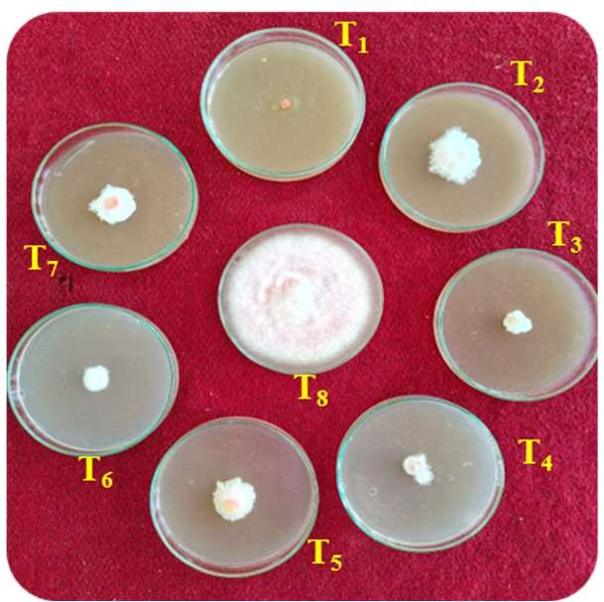
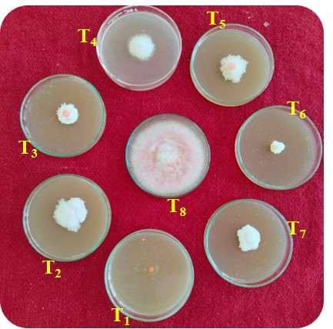
500 ppm
1000 ppm

Table 3. In vitro efficacy of systemic fungicides against Fusarium oxysporum f. sp. udum
Tr.No. | Treatments | *Colony Diameter(mm) |  | Avg. | % Inhibition |  | Avg
Tr.No. | Treatments | 500 ppm | 1000 ppm | Avg. | 500 ppm | 1000  ppm | Avg
T1 | Carbendazim 50% WP | 0.00 | 0.00 | 0.00 | 100 | 100 | 100
T2 | Myclobutanil 10% WP | 37.33 | 32.96 | 35.14 | 58.52 | 63.37 | 60.94
T3 | Propiconazole 25 % EC | 17.91 | 13.07 | 15.49 | 80.10 | 85.47 | 82.78
T4 | Thiophanate methyl 70 % WP | 19.66 | 16.67 | 18.16 | 78.82 | 81.47 | 80.14
T5 | Difenoconazole 25 % EC | 33.15 | 28.66 | 30.90 | 56.85 | 68.60 | 62.72
T6 | Tebuconazole 25.9 % EC | 17.75 | 12.51 | 15.13 | 80.27 | 86.10 | 85.18
T7 | Hexaconazole 5% EC | 27.41 | 23.40 | 25.41 | 69.54 | 74.00 | 71.77
T8 | Control (untreated) | 90 | 90 | 90 | - | - | -
SE± |  | 0.91 | 0.79 | 0.60
CD at 1% |  | 3.77 | 3.29 | 2.50
*Mean of three replications

Tr. No. | Treatments | Tr. No. | Treatments
T1 | Carbendazim 50% WP | T5 | Difenoconazole 25 % EC
T2 | Myclobutanil 10% WP | T6 | Tebuconazole 25.9 % EC
T3 | Propiconazole 25 % EC | T7 | Hexaconazole 5% EC
T4 | Thiophanate methyl 70 % WP | T8 | Control (untreated)

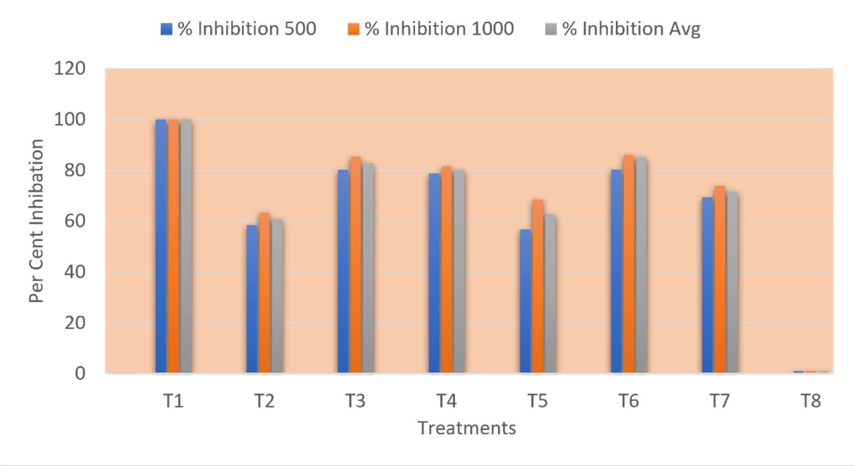
Fig. 1: In vitro efficacy of systemic fungicides against Fusarium oxysporum f. sp. udum

  - In Vitro Efficacy of Bio-Agents Against Fusarium oxysporum f. sp. udum
Screening seven biocontrol agents using the dual culture technique demonstrated significant inhibition (P =01) of F. oxysporum f. sp. udum mycelial growth relative to the control (Plate 2, Table 4 and Fig 2).

Effect on Pathogen Mycelial Growth
All tested biocontrol agents significantly restricted pathogen radial expansion compared to the untreated control (90.00 mm). T.harzianum supported the minimum radial colony diameter of the pathogen (16.16 mm), followed by T.virens (17.50 mm), T.asperellum (22.66 mm), T.hamatum (26.16 mm), A.niger ( 26.33 mm), P.chrysogenum (26.50 mm) and A.flavus (32.66 mm).

Effect on Per Cent Growth Inhibition
Mycelial growth inhibition by the biocontrol agents ranged from 63.71% to 82.04%. T.harzianum achieved maximum growth inhibition (82.04%), followed by T.virens (80.55%), T.asperellum (74.82%), T.hamatum (70.93%), A.niger (70.74%), P.chrysogenum (70.55%) and A. flavus (63.71%).
The high antagonistic potential of Trichoderma species against F. oxysporum f. sp. udum observed in this study agrees with findings reported by Mahesh and Saifulla (2006) and Gowdar and Kulkarni (2007). The biological mechanisms driving Trichoderma antagonistic activity include rapid space and nutrient competition, mycoparasitism, production of volatile/non-volatile antibiotics, and secretion of cell-wall degrading enzymes such as -1,3-glucanases and chitinases (Sundaramoorthy and Balabaskar, 2013; Haque et al. 2024; Bhende et al.2025).

Plate 2: In vitro efficacy of bioagents against Fusarium oxysporum f. sp. udum
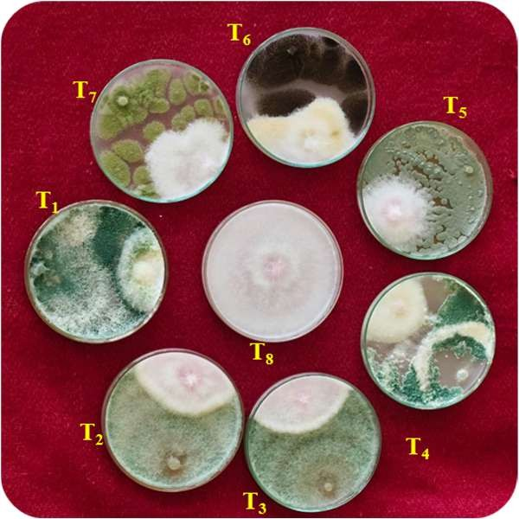

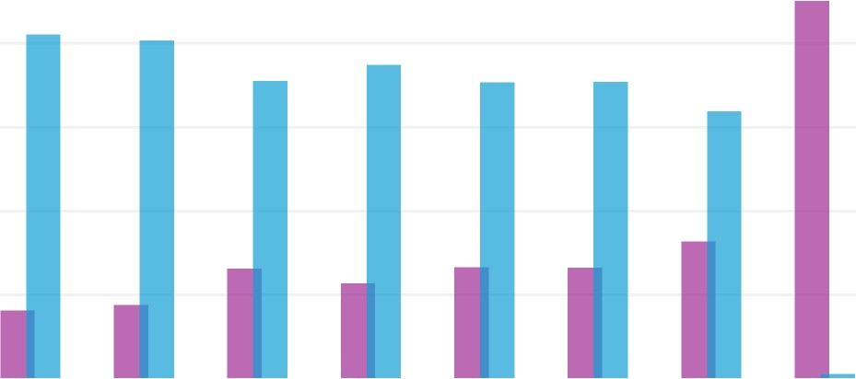
Fig. 2: In vitro efficacy of bioagents against Fusarium oxysporum f. sp. udum
Colony Diameter of Pathogen (mm) 100
80
60
40
20
0
% Inhibition
T1 T2 T3 T4 T5 T6 T7 T8
TREATMENTS
COLONY DIAMETER OF PATHOGEN (MM)

Table 4:In vitro efficacy of bio-agents against Fusarium oxysporum f. sp. udum.

Tr. No. | Treatments | Colony Diameter of Pathogen (mm) | % Inhibition
T1 | Trichoderma harzianum | 16.16 | 82.04
T2 | Trichoderma virens | 17.5 | 80.55
T3 | Trichoderma hamatum | 26.16 | 70.93
T4 | Trichoderma asperellum | 22.66 | 74.82
T5 | Penicillium chrysogenum | 26.5 | 70.55
T6 | Aspergillus niger | 26.33 | 70.74
T7 | Aspergillus flavus | 32.66 | 63.71
T8 | Control | 90 | -
 | S.E.± | 0.91
 | C.D.at 1% | 3.77

CONCLUSION
The present in vitro investigation confirms the high fungitoxic and antagonistic potential of specific systemic fungicides and biological control agents respectively against Fusarium oxysporum f. sp. udum. Among the chemical treatments, Carbendazim 50% WP achieved complete inhibition ( 100.00%) of fungal mycelial growth at both 500 ppm and 1000 ppm concentrations, while Tebuconazole 25.9% EC (85.18% mean inhibition) and Propiconazole 25% EC (82.78% mean inhibition) proved to be highly effective triazole alternatives. Among the biological control agents, Trichoderma harzianum recorded maximum pathogen inhibition (82.04%), closely followed by Trichoderma virens (80.55%). These superior systemic chemical molecules and bio-agents represent promising candidates for integration into eco-friendly management programs to mitigate pigeonpea vascular wilt.

COMPETING INTERESTS
Authors have declared that no competing interests exist

CONSENT
Not applicable for this laboratory in vitro study.

ETHICAL APPROVAL
Not applicable. This manuscript does not contain studies involving human participants or animal subjects.
Declaration of AI Use

This manuscript was prepared through the intellectual contributions of the author(s) to the study design, data analysis, interpretation of results, and scholarly content. Grammarly and ChatGPT were used solely to assist with grammatical refinement and reference formatting during manuscript revision. The author(s) accept full responsibility for the accuracy, integrity, and final content of the manuscript.

REFERENCES
Anonymous. 2025. First advance estimates of production of major kharif crops for 2025-26. Directorate of Economics and Statistics (DES), Department of Agriculture and Farmers Welfare, Ministry of Agriculture and Farmers Welfare, Government of India, New Delhi. pp. 1-15.
Avinash, M., Nagaraju, K., Muthuraju, R. and Asha, N. N. 2019. Pigeonpea Fusarium wilt: In vitro pathogenicity test of Fusarium isolates and its biological control. J. Pharmacogn. Phytochem. 8(6): 1600-1604.
Bhende, S. S., Pawar, N. B. and Suryawanshi, A. P. 2025. In vitro screening of fungal and bacterial antagonists against pigeonpea wilt pathogen Fusarium oxysporum f. sp. udum. Indian Phytopathol. 78(1): 112-119.
Butler, E. J. 1910. The wilt disease of pigeonpea and parasitism of Neocosmospora vasinfectum. Dept.
Agric. Bull. India, 2: 1.
Butler, E. J. 1918. Fungi and Disease in Plants. Thacker, Spink and Co., Calcutta. pp. 244-251. Chakrapani, K., Chanu, W. T., Sinha, B., Thangjam, B., Hasan, W., Devi, K. S., Chakma, T., Phurailatpam,
S., Mishra, L. K., Singh, G. M., Khoyumthem, P. and Saini, R. 2023. Deciphering growth abilities of Fusarium oxysporum f. sp. pisi under variable temperature, pH and nitrogen. Front. Microbiol. 14: 1228442.
Deshmukh, P. R., Rathod, P. K. and Patil, M. S. 2026. Comparative in-vitro efficacy of fungicides against
Fusarium oxysporum causing wilt of pigeonpea. J. Sci. Res. Rep. 32(6): 91-98.
Dhingra, O. D. and Sinclair, J. B. 2017. Basic Plant Pathology Methods. CRC Press, Boca Raton, Florida. Ghante, P. H., Kanase, K. M., Kale, S. P., Chavan, R. L., Sharma, K. M. and Ghuge, S. B. 2018. Cultural,
morphological and molecular variability of Fusarium oxysporum f. sp. udum isolates by RAPD Method. Int. J. Curr. Microbiol. App. Sci. 7(10): 2109-2122.
Gowdar, S. B. and Kulkarni, S. 2007. Efficacy of antagonistic microorganisms against pigeonpea wilt pathogen Fusarium udum Butler. Adv. Plant Sci. 20(1): 245-247.
Kannaiyan, J. and Nene, Y. L. 1981. Influence of wilt at different growth stages on yield loss in pigeonpea.
Trop. Pest Manage. 27(1): 141.
Karimi, R., Owuoche, J. O. and Silim, S. N. 2012. Importance and management of Fusarium wilt (Fusarium udum Butler) of pigeonpea. Int. J. Agron. Agric. Res. 2: 1-14.
Mahesh, M. and Saifulla, M. 2006. Management of pigeon pea wilt caused by Fusarium udum Butler. Indian
J. Plant Prot. 34(2): 255-256.

Morton, D. J. and Stroube, W. H. 1955. Antagonistic and stimulatory effects of soil microorganisms
upon
Sclerotium rolfsii. Phytopathology, 45: 417-420.
Patil, V. B., Gawade, D. B., Suryawanshi, A. P. and Zagade, S. N. 2015. Biological and fungicidal management of chickpea wilt caused by Fusarium oxysporum f. sp. ciceri. Bioscan, 10(2): 685-690.
Raju, G. P., Rao, S. V. R. and Gopal, K. 2008. In vitro evaluation of antagonists and fungicides against the red gram wilt pathogen Fusarium oxysporum f. sp. udum (Butler) Snyder and Hansen. Legume Res. 31(2): 133-135.
Singh, R. and Kumar, P. 2025. Agronomic benefits and nutritional profile of pigeon pea in semi-arid regions.
Indian J. Agron. 70(1): 45-52.
Sundaramoorthy, S. and Balabaskar, P. 2013. Biocontrol efficacy of Trichoderma spp. against wilt of tomato caused by Fusarium oxysporum f. sp. lycopersici. J. Appl. Biol. Biotech. 1(3): 36-40.
Verma, A. K., Singh, R. P. and Yadav, D. S. 2025. Evaluation of demethylation inhibitor (DMI) fungicides against mycelial growth and conidial germination of Fusarium udum. J. Mycol. Plant Pathol. 55(1): 44-50.
Vincent, J. M. 1927. Distortion of fungal hyphae in the presence of certain inhibitors. Nature, 159: 850.

