Original Research Article
INTEGRATED HYDROLOGICAL AND HYDRAULIC APPROACH FOR THE DESIGN OF THE SOREY BRIDGE UNDER A CONTEXT OF CLIMATE VARIABILITY (NIAMEY REGION, NIGER)

Abstract
The increasing hydroclimatic variability observed in the Sahel represents a major challenge for the design and safety of road infrastructure exposed to flooding. This study proposes an integrated hydrological and hydraulic approach for the design of the Sorey Bridge, located in the Niamey Region of Niger. The methodology is based on precipitation frequency analysis, GIS-based morphometric characterization of the watershed, flood-discharge estimation using the Overseas Office for Scientific and Technical Research (ORSTOM) and Inter-African Committee on Hydraulic Studies (CIEH) methods, extrapolation of the 100-year flood using the GRADEX method, and hydraulic analysis based on the Manning–Strickler relationship. The watershed has an area of 1,359.75 km², a perimeter of 285.32 km, and a main channel length of 50.39 km. Analysis of precipitation over the 1991–2000 period reveals strong interannual variability, with mean annual precipitation ranging from 410.7 to 816.3 mm and a maximum daily rainfall of 129 mm. The 10-year flood discharge is estimated at 196.22 m³/s using ORSTOM and 225.86 m³/s using CIEH. The mean of the two estimates, adopted as the 10-year design discharge, is 211.04 m³/s. The GRADEX method yields a 100-year flood discharge of 896.78 m³/s. Hydraulic analysis gives a flow depth of 3.40 m, a mean velocity of 2.90 m/s, and a backwater rise of 0.208 m. Total scour depth at the piers reaches 3.86 m. A 0.74-m-diameter riprap protection is proposed. These results provide reference parameters for a safer and more resilient design of the Sorey Bridge under extreme flood conditions.

Keywords: Climate variability; 10-year flood; 100-year flood; Hydrology; Bridge hydraulics; Scour

- INTRODUCTION
In the Sahelian regions, the design of hydraulic and road infrastructure is challenged by high precipitation variability and the occurrence of extreme hydrometeorological events that may increase flood risk and structural failure. In Niamey, this vulnerability is particularly significant because of the combined effects of Niger River floods, runoff from tributary catchments, and the progressive urbanization of exposed areas. Recent analyses indicate changes in the hydroclimatic regimes of the Middle Niger Basin, with increasing hydrological-extreme indicators and intensification of rainfall events over recent decades (Massazza et al., 2021). Across the Sahel, extreme rainfall events are also a major component of hydrological risk. Sanogo et al. (2022) show that these events account for a significant share of annual precipitation and exhibit strong seasonal and interannual variability. In Niamey, Garba and Abdourahamane (2023) further emphasize the importance of extreme rainfall in the generation of urban flooding. In this context, the assumption of stationarity in hydrological series should be examined with caution, since Bossa et al. (2023) found that 56% of the annual maximum-flow series analyzed in West Africa were non-stationary. Bridge design should therefore jointly account for design-flood estimation, flow conditions, backwater effects, and scour risks. Recent recommendations from the Federal Highway Administration (FHWA) (2024) emphasize the importance of an integrated hydraulic approach to ensure bridge safety and resilience under extreme events. Accordingly, this study aims to apply an integrated hydrological and hydraulic approach to the design of the Sorey Bridge in the Niamey Region. It combines precipitation frequency analysis, the Overseas Office for Scientific and Technical Research (ORSTOM) and Inter-African Committee on Hydraulic Studies (CIEH) methods for estimating the 10-year flood, the GRADEX method for the 100-year flood, and the Manning–Strickler equations to characterize hydraulic conditions, backwater effects, and scour, with the objective of proposing design parameters suited to a context of climate variability.

- STUDY METHODOLOGY
The adopted methodology is based on the collection and synthesis of hydroclimatic, topographic, and functional data required for the hydrological, hydraulic, and structural assessment of the Sorey Bridge. Data processing and analysis were performed using specialized tools, including ArcGIS and Google Earth Pro for watershed analysis, HYFRAN-PLUS for precipitation frequency analysis and rainfall estimation, and AutoCAD. The overall approach made it possible to characterize the site's hydrological and hydraulic conditions, determine design loads, and define the geometric and structural characteristics of the bridge while accounting for requirements related to strength, stability, and climate resilience under flood conditions.
  - Location of the Study Area
The study site is located in the Niamey Region (Figure 1), in southwestern Niger. The city of Niamey, situated on both banks of the Niger River, is characterized by a Sahelian climate with a short rainy season and annual precipitation ranging from 500 to 750 mm.
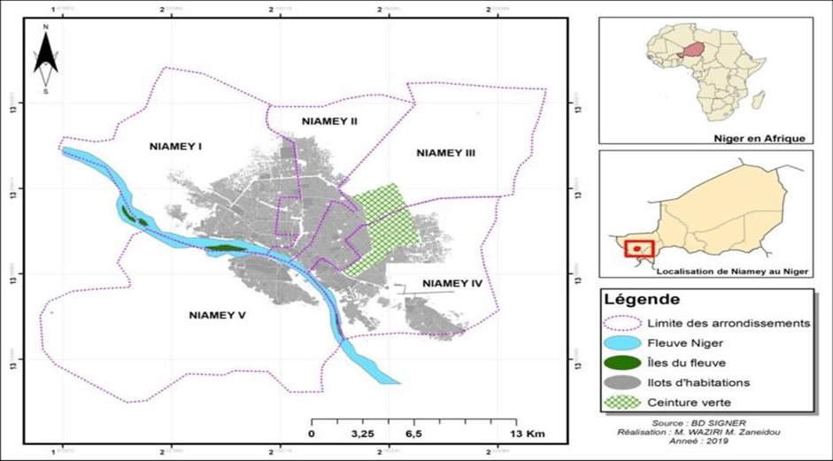
Fig. 1. Niamey Region and its municipalities
The Sorey Bridge is located on a strategic road corridor connecting Niamey with the eastern regions of the country. This area, commonly known as the airport district of Commune IV of Niamey, is located at 13°26′27.90″ N latitude and 2°13′59.59″ E longitude. Figure 2 presents a satellite image of the site and its longitudinal profile.
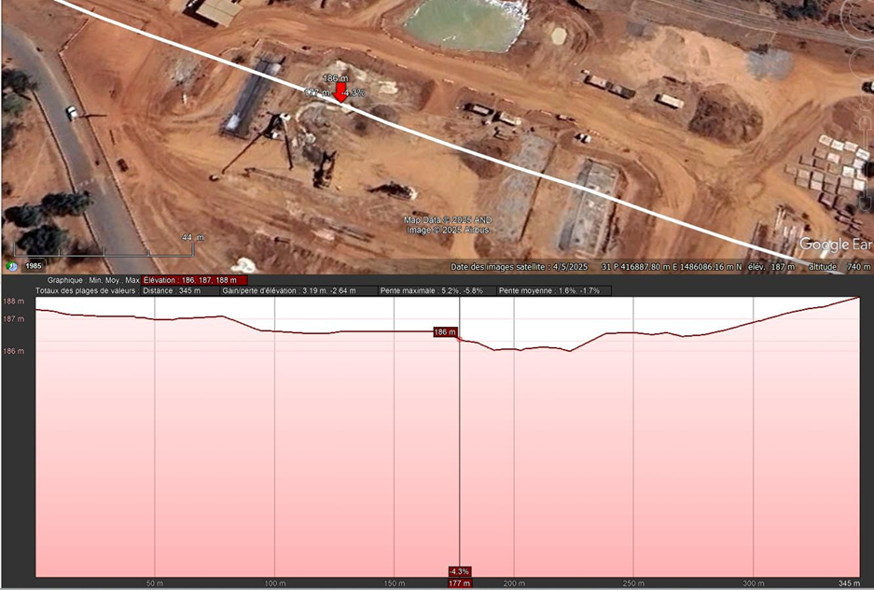
Fig. 2. Google Earth image showing the location of the Sorey Bridge site (Niamey)

  - Rainfall Analysis
The rainfall analysis focused on mean annual precipitation and maximum daily precipitation (Table 1) obtained from the National Meteorological Directorate of Niger (https://www.niger-meteo.ne/). The available series were subjected to frequency analysis to estimate the design rainfall values used to calculate flood discharges. The mean annual precipitation series was fitted using the Gaussian normal distribution, whereas the maximum daily precipitation series was fitted using the Gumbel distribution.
Table 1. Maximum daily and mean annual precipitation over a 10-year period (https://www.niger-meteo.ne/)
Year | Maximum daily rainfall (mm) | Mean annual rainfall (mm)
1991 | 61.1 | 436.4
1992 | 50.3 | 671.2
1993 | 31.6 | 426.4
1994 | 129.0 | 706.4
1995 | 43.9 | 539.5
1996 | 43.1 | 548.1
1997 | 44.4 | 410.7
1998 | 97.7 | 816.3
1999 | 70.1 | 641.3
2000 | 51.6 | 458.2

  - Determination of Watershed Parameters
- Shape Index
The shape index, denoted KG, corresponds to the ratio of the watershed perimeter to the perimeter of a circle having the same area: KG = P/$\sqrt{4πS}$ = 0.282 × P/$\sqrt{S}$ (1)
where P is the watershed perimeter (km) and S is the watershed area (km²).
- Equivalent Rectangle Length and Width
This is the rectangle having the same area, the same compactness index, and the same hypsometric distribution as the watershed. Its length is defined by the following relationship:
$Lrec=\frac{P + \sqrt{P2 - 16 * S}}{4} (2)$ $Irec=\frac{S}{Lrec} (3)$
Lrec: Equivalent rectangle length (km)
P: Watershed perimeter (km)
S: Watershed area (km²)
Irec: Equivalent width (km)
- Longitudinal Slope of the Watershed
It affects flood discharges by increasing or decreasing runoff velocities depending on whether the slope is steep or gentle. It depends on watershed area and is calculated using the simplified GRESILLON formula:
$$I_{BV}=\frac{26}{VS} (4)$$
IBV: Longitudinal slope of the watershed in ‰.
S: Watershed area in km².
V: Runoff or flood volume.
- Global Slope Index. It is calculated using the following relationship:
$$I_{g}=\frac{H5\%-H95\%}{Lrec} (5)$$
Lrec: Equivalent rectangle length (km);
When the transverse slopes of the watershed differ only slightly from Ig (difference of less than 20%), Ig provides a reasonably good representation of the watershed slope. Otherwise, the corrected global slope index (Igcor) is calculated.
It: Transverse slopes
Igcor: Corrected global slope.
- Specific Relief
The specific relief was determined as the product of the corrected global slope index Igcor and the square root of the watershed area (S).
Ds = Igcor ∗ (7)
where Igcor is the corrected global slope index (m/km);
S: Watershed area (km²).
- Drainage Density
It represents the length of the drainage network per unit area of the watershed.
$$D_{d}=\frac{Σ Li}{S} (8)$$
Dd: Drainage density (km/km²);
Σ Li: Total length of all streams in the watershed (km);
  - Determination of Flood Discharges
Several methods are available for determining flood discharges, depending on the study area and its characteristics. In this study, the Overseas Office for Scientific and Technical Research (ORSTOM) method and the CIEH (Inter-African Committee on Hydraulic Studies) method were selected. These methods are particularly suited to hydraulic studies in Sahelian and dry tropical environments.
    - ORSTOM Method
This method is used to determine flood discharge for watersheds with areas ranging from 350 to 1,500 km².
The 10-year flood discharge is defined by the following relationship:
𝑸𝟏𝟎 = 𝑨. 𝑷𝟏𝟎. 𝑲𝒓𝟏𝟎. 𝛼𝟏𝟎. 𝑺⁄𝑻𝒃𝟏𝟎 (9)
A: Reduction coefficient;
P10: 10-year daily rainfall depth in mm;
Kr10: Runoff coefficient corresponding to the 10-year flood;
α10: Peak coefficient corresponding to the 10-year flood;
S: Watershed area in km²;
Tb10: Base time corresponding to the 10-year flood, in minutes;
Q10: 10-year peak discharge in m³/s.
It is assumed that α10 is close to 2.6 regardless of watershed area. However, the configuration of the drainage network should be analyzed to identify any possible corrections, following the indications in the checklist contained in FAO Bulletin 54 (Triboulet et al., 1996).
- The reduction coefficient (A) represents the factor used, for a given return period (e.g., 10 years), to convert a point rainfall depth into an average rainfall depth over a given area located within a climatically homogeneous rainfall zone. It is obtained from the following formula :
$$A=1-[\frac{161 - 0,042 * Pan}{1000}*LogS] (10)$$
S: Watershed area in km²;
Pan: Mean annual precipitation in mm;
- Runoff coefficients: Kr10, Kr70, and Kr100.
Kr70 and Kr100 are calculated using the following formulas:
$Kr70=\frac{a^{'}+c'}{S+b'}$ (11) $Kr100=\frac{a^{'}+c'}{S+b'}$ (12)
Kr70 and Kr100, as well as the mean Kr10, can also be calculated by interpolation. The values of a′, b′, and c′ as a function of the global slope index and infiltrability are used to calculate the runoff coefficients. These parameters for the equations used to determine Kr70 and Kr100 in the Sahelian zone, as a function of the global slope index and infiltrability, are given in the reference document for West Africa (Triboulet et al., 1996). Thus, for highly permeable (HP) watersheds, median values of Kr70 = 2% and Kr100 = 3% are considered, regardless of slope.
- The base time Tb is the time interval between the beginning and the end of rapid runoff.
For the Sahelian region, Tb10 is calculated using the following formula:
Tb10 = a ∗ S^{0,35} + b (13)
Because our slope index is not included in the formulas above, the base time is extrapolated from the values corresponding to slope indices 3 and 7.
    - CIEH Method
The formulation selected to derive the expression for peak discharge Q10 is based on a multiple-regression framework and is expressed as follows:
Q10 = a. S^{s}. Pan^{p}. Ig^{i}. Kr10^{k}. Dd^{d} (14)
where a, s, p, i, k, d, … are coefficients to be determined.
S: Watershed area in km²;
Ig: Global slope index in m/km;
Pan: Mean annual precipitation in mm;
Kr10: 10-year runoff coefficient in %;
Dd: Drainage density in km/km²;
For this study, the final design flood was obtained by averaging the five design-flood estimates obtained from Equations 41, 42, 43, 44, and 45 (Triboulet et al., 1996).
    - Conversion from the 10-Year Flood to the 100-Year Flood: GRADEX Method
The conversion from the 10-year flood to the 100-year flood is performed according to GRADEX theory. The method assumes that beyond a certain return period, all rainfall becomes runoff. The 10-year return period, corresponding to the precipitation that generated the 10-year flood, is used as the threshold. The additional precipitation between the 10-year and 100-year storms is represented by a multiplier coefficient C greater than 1. This coefficient is expressed by the following relationship:
$$C=1+\frac{P100 - P10 }{P10}* \frac{\left(\frac{Tb}{24}\right)0,12 }{Kr10} (15)$$
P10: Daily precipitation corresponding to a 10-year return period;
P100: Daily precipitation corresponding to a 100-year return period;
Tb: Base time in hours.
Kr10: Runoff coefficient of the 10-year flood (expressed as a fraction rather than a percentage). The equation applies to the tropical zone.
To determine the 100-year flood, the 10-year flood discharge is multiplied by the coefficient C corresponding to a 100-year return period (C = 4.25) (Triboulet et al., 1996). Thus:
Q100 = C100 ∗ Q10 (16)
  - Determination of Hydraulic Characteristics
    - Determination of the Highest Water Level
Flood depths are determined using the MANNING–STRICKLER formula, assuming that flow in the river channel can be represented by flow through a regular geometric cross-section. The selected bridge opening length is 100 m.
$$Q=V*S=K*S*R^{\frac{2}{3}}*I^{\frac{1}{2}}= \frac{1}{n}*S*R^{\frac{2}{3}}*I^{\frac{1}{2}} (17)$$
Q: Flow discharge in m³/s.
V: Mean flow velocity in m/s.
S: Wetted cross-sectional area (area of the cross-section occupied by water) in m².
K: Strickler coefficient in m¹/³/s.
R: Hydraulic radius in m.
I: Hydraulic slope or energy grade-line slope in m/m.
n: Manning roughness coefficient in s/m¹/³.
The flow depth is then determined using the conveyance method through an iterative calculation (Table 2) based on the MANNING–STRICKLER formula, taking into account the geometric characteristics of the channel. The procedure consists of progressively varying the flow depth and identifying the value for which the calculated conveyance converges to the design discharge.
Table 2: Results of iterative calculations
Y | S | P | R | D | Q/ | |D−Q|
1,79 | 160,01 | 92,663 | 1,73 | 6909,087 | 20052,61041 | 13143,523
3,396906 | 309,11 | 97,208 | 3,18 | 20052,59 | 20052,61 | 0,021
3,396909 | 309,11 | 97,21 | 3,18 | 20052,62 | 20052,61 | 0,009
3,396908 | 309,11 | 97,21 | 3,18 | 20052,61 | 20052,61 | 0,001
Y: Flow depth in m.
P: Wetted perimeter in m.
D: Conveyance in m³/s.
    - Backwater Evaluation
Backwater is evaluated by considering the increase in water level caused by the reduction in flow cross-sectional area at the bridge and by the presence of piers.
    - Scour Assessment
Scour is analyzed by distinguishing among general scour, local scour at the piers, and scour resulting from contraction of the channel cross-section (Figure 3).
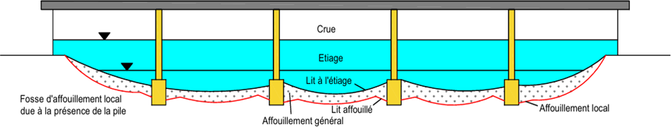
Fig. 3. Scour phenomenon
- Calculation of General Scour Depth
General scour affects the entire channel bed and occurs during a flood that causes bed sediments to become suspended. It is determined using the LACY formula:
$$Hg=0,48*Q^{0,36}-\frac{S}{B} (18)$$
Hg: General scour depth;
S: Wetted cross-sectional area;
B: Main-channel width;
Q: Design discharge.
- Calculation of Local Scour Depth
Local scour corresponds to a localized bed degradation that develops downstream of piers. Its depth is estimated using the BREUSERS formula.
Hl = 1,4 ∗ P (19)
Hl: Local scour depth;
P: Pier diameter. P is generally considered to be ≤ 1.5 m; for this project, P = 1 m.
- Scour Due to Channel Contraction
Channel contraction is negligible; therefore, Hr = 0.
- Pier scour (Hp) is calculated using the following equation:
Hp = Hg + Hr + Hl (20)
- Abutment scour (Hc) is calculated using the following equation:
Hc = Hg + Hr (21)
    - Scour Protection
To prevent scour, localized protection should be implemented, such as placing stones (rock) around the piers within the probable radius of the scour hole that may develop.
- The riprap diameter (Δ) is given by the following Izbach formula:
$$V=0,6*\sqrt{2*g*\frac{Ps-P}{P}}*∆ (22)$$
V: Flood-flow velocity.
Ps: Unit weight of riprap = 2600 kg/m³;
P: Density of water = 1000 kg/m³;
g: Gravitational acceleration = 9.81 m/s².
- Riprap width (l): l = 3D (23)
D: Pier diameter.
- Riprap layer thickness/height (E_{E})
E_{E} = Sup (D; 3Δ) (24)
    - Determination of Freeboard
Freeboard is determined based on the recommendations of Nguyen Van Tuu (1981). The selection takes into account the climatic zone and the bridge length in order to limit the risk of bridge blockage by floating debris and to protect the bearings. Nguyen Van Tuu (1981) recommends the following values:
- 1.00 m in desert or semi-desert areas;
- 1.50 m in savanna areas;
- 2.00 m in areas with dense shrub vegetation;
- 2.50 m in forested areas.
The project is located in a Sudano-Sahelian zone, which allows a freeboard of 1.5 m to be considered. However, the same document recommends adding 0.5 m when the bridge length exceeds 50 m. The adopted freeboard is therefore 2 m (Nguyen Van Tuu, 1981).
- Results and Discussion
  - Rainfall Characterization
A statistical analysis of annual rainfall and maximum daily rainfall (over a 10-year period, from 1991 to 2000) was conducted to determine the rainfall values required to estimate the design discharge of the watershed. After fitting the annual rainfall series using the GAUSSIAN normal distribution and the maximum daily rainfall series using the GUMBEL distribution, graphical results were obtained.
    - Gaussian Normal Distribution
The mean annual rainfall series was fitted using the HYFRAN software.
Figure 4 shows an increasing distribution of mean annual rainfall as a function of the non-exceedance probability. The observed values range approximately from 350 to 830 mm, with a relatively high concentration of observations between 400 and 700 mm. The progression is not uniform: lower dispersion occurs in the central part of the distribution, whereas values above approximately 700 mm increase more rapidly. It should be noted that this representation does not directly indicate a chronological rainfall trend between 1991 and 2000, but rather the frequency positioning of the observations.
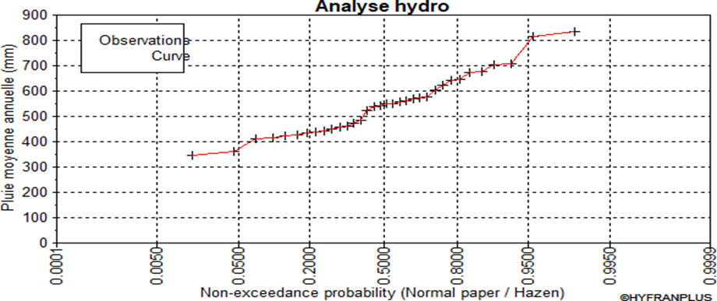
Fig. 4. Graphical representation of mean annual rainfall on normal probability paper
Figure 5 shows that most observations lie close to the normal-fit line, particularly in the central part of the distribution. This suggests that the normal distribution provides a generally acceptable representation of the annual rainfall series. However, some deviations occur at the tails, particularly for the lowest and highest rainfall values, indicating greater uncertainty in the distribution tails. This is consistent with the characteristics of the Sahelian rainfall regime, which is marked by strong interannual variability.
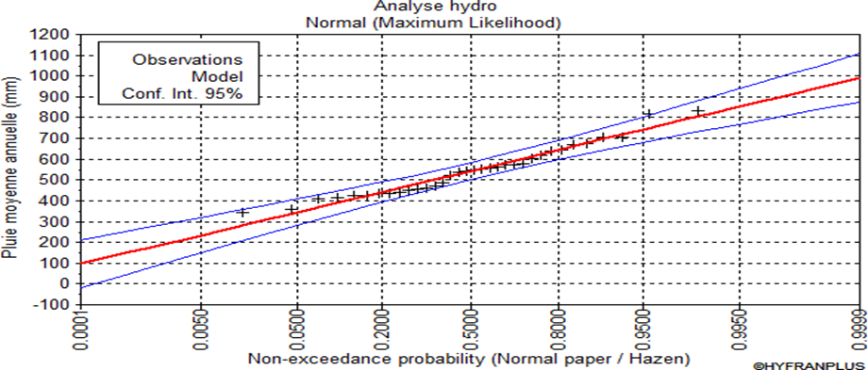
Figure 5: Graphical representation of the GAUSSIAN distribution
The studies by Le Barbé and Lebel (1997) and Lebel et al. (2003) show that rainfall in the Sahel exhibits substantial year-to-year variability. Studies by Mahé et al. (2009), Lebel and Ali (2009), and Zhang et al. (2017) also show that this variability is associated with alternating dry and wet years and changes in interannual variability since the 1990s.
    - Gumbel Distribution
The maximum daily rainfall series was fitted using the HYFRAN software. Figure 6 highlights a distribution of maximum daily rainfall ranging approximately from 30 to 140 mm. Most observations are concentrated around 40–75 mm, whereas the highest values, above approximately 80 mm, increase much more rapidly, reaching nearly 140 mm.
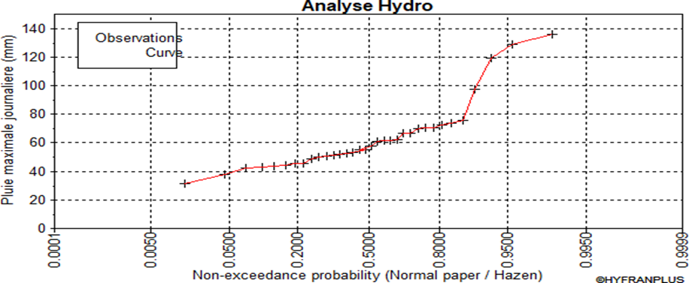
Fig. 6. Graphical representation of maximum daily rainfall on normal probability paper

Figure 7 shows that the Gumbel distribution reproduces the general trend of the observations reasonably well in the central part of the distribution: the observed points remain broadly close to the theoretical curve. In contrast, the distance between the confidence limits increases substantially in the extreme regions, indicating greater uncertainty in the estimation of rare rainfall events. This observation is particularly important for hydraulic design because the quantiles corresponding to low exceedance probabilities are precisely those used to determine design rainfall.
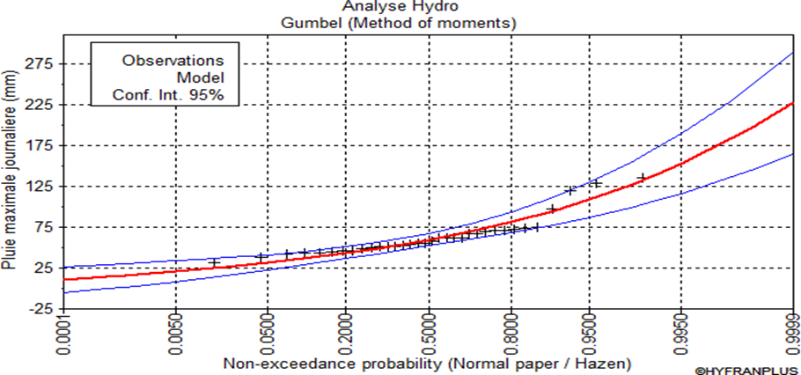
Fig. 7. Graphical representation of the GUMBEL distribution
The Gumbel distribution is widely used for analyzing rainfall maxima in West Africa and has notably been applied to Niamey data to develop intensity-duration-frequency relationships (Bigi et al., 2018). However, recent work by Anghel (2024) recommends using the Gumbel distribution cautiously for maximum rainfall, particularly when the series are short and when extrapolating toward low exceedance probabilities.
  - Watershed Characterization
A watershed is the entirety of the surface and subsurface areas that drain toward the same outlet. Table 3 shows that the Sorey watershed covers an area of 1,359.75 km², with a perimeter of 285.32 km and a main channel length of 50.39 km. Its Gravelius compactness coefficient (2.2) indicates a relatively elongated shape, while the equivalent rectangle length and width (132.39 and 10.27 km) confirm this configuration. Relief is moderate, with elevations ranging from 185 to 284 m, corresponding to a relief difference of 99 m. The longitudinal slope of 0.71‰ and the corrected global slope index of 1.41 m/km indicate generally subdued relief, which may favor relatively gradual transfer of runoff toward the outlet. However, the document reports a drainage density of 346.89 km/km², an exceptionally high value that should be verified before publication, since drainage density is normally expressed as drainage-network length per unit area and is an important indicator of runoff response time.
Table 3. Summary of watershed characteristics
Description | Formula | Units | Results
Area | S (Reading in ArcGIS) | km² | 1359,75
Perimeter | P (Reading in ArcGIS) | km | 285,32
Main channel length | L Reading in ArcGIS) | km | 50,39
Maximum elevation | H max (Reading in ArcGIS) | m | 284
Minimum elevation | H min (Reading in ArcGIS) | m | 185
Gravelius compactness coefficient | KG=0,282 ∗P/$\sqrt{S}$ | - | 2,2
Equivalent rectangle length | $$Lrec=\frac{P + \sqrt{P2 - 16 * S}}{4}$$ | km | 132,39
Equivalent rectangle width | $$Irec=\frac{S}{Lrec}$$ | km | 10,27
Drainage density | $$D_{d}=\frac{Σ Li}{S}$$ | km/km² | 346,89
Transverse slope | It (Reading in ArcGIS) | m/km | 5,08
Longitudinal slope | $$I_{BV}=\frac{26}{VS}$$ | ‰ | 0,71
Global slope index | $$I_{g}=\frac{H5\%-H95\%}{Lrec}$$ | m/km | 0,49
Corrected global slope index | $$I_{gcor}=\frac{\left(n-1\right)*Ig+It}{n}$$ | m/km | 1,41
Specific relief | Ds = Igcor ∗ $\sqrt{S}$ | m | 17,99
Elevation corresponding to 5% of the area | Read from the hypsometric curve | m | 271,6
Elevation corresponding to 95% of the area | Read from the hypsometric curve | m | 207
Watershed infiltration class | P3 / RI | - | -

Figure 8 spatially confirms the organization of the watershed: the drainage network converges toward the outlet located in the southern part, while the elevation distribution shows higher relief along the margins and lower areas along the main drainage axes. This morphometric organization is important for bridge design because watershed shape, drainage network, and relief control the concentration and propagation of water toward the structure.
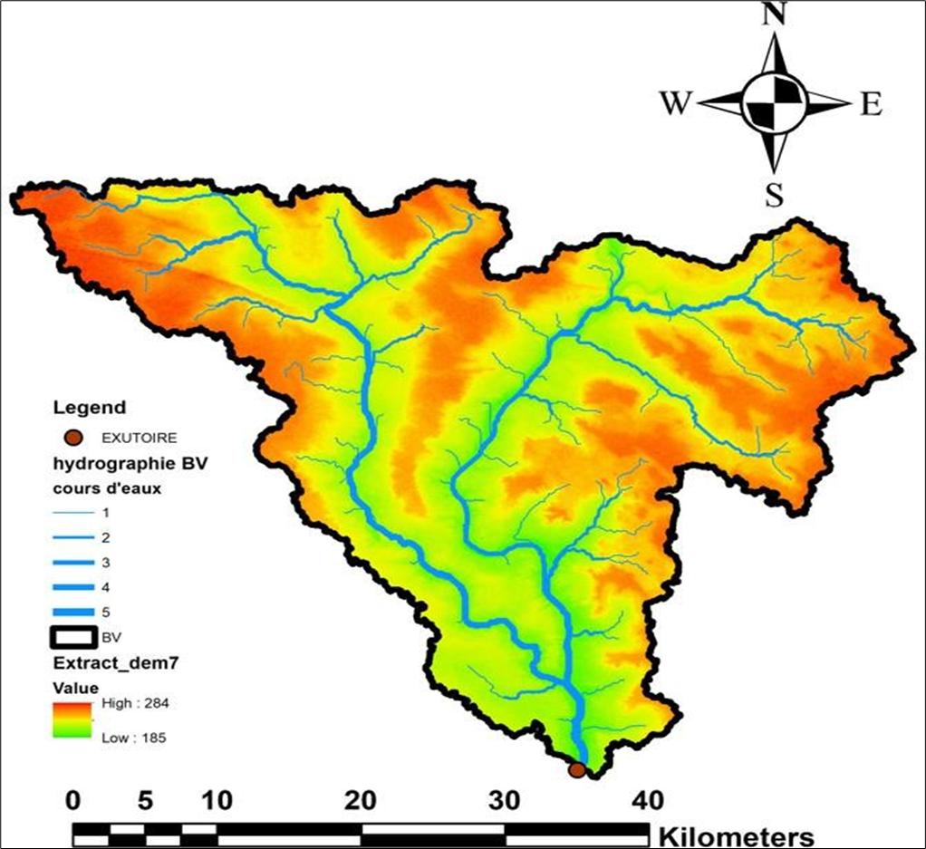
Fig. 8. Sorey watershed
GIS-based morphometric analyses are widely used to assess watershed hydrological response and flood potential (Sharma et al., 2020). In the Sahelian context, this sensitivity is reinforced by strong rainfall variability and changes in runoff coefficients observed in Niger and the Sahel, which may lead to larger floods despite highly variable precipitation (Mahé et al., 2009). Finally, Sahelian rainfall exhibits strong interannual variability and a major contribution from intense convective systems, particularly around Niamey, supporting the use of an integrated hydrological-hydraulic approach for bridge design (Lebel et al., 2003).
  - Flood Characterization
The results presented in Tables 4 and 5 make it possible to estimate the 10-year flood discharges of the Sorey watershed using two approaches suited to Sahelian watersheds: the ORSTOM method and the CIEH method. With an area of 1,359.75 km², the watershed falls within the range of applicability adopted for the ORSTOM method in this study.
    - ORSTOM Method
The calculated parameters (Table 4) show that, despite a relatively low 10-year runoff coefficient (13.81%), the large watershed area results in a 10-year discharge of 196.22 m³/s. This result appears consistent with the use of this method in the Sahelian context: ORSTOM methods were developed from observations of West African watersheds and are specifically intended for the preliminary estimation of 10-year floods (Rodier & Auvray, 1965).
Table 4. Summary of parameters determined using the ORSTOM method
Description | Formula | Unit | Result
ORSTOM method | 𝑸𝟏𝟎 = 𝑨* 𝑷𝟏𝟎* 𝑲𝒓𝟏𝟎* 𝛼𝟏𝟎* 𝑺⁄𝑻𝒃𝟏𝟎 | m³/s | -
Reduction coefficient A | $$A=1-[\frac{161 - 0,042 * Pan}{1000}*LogS]$$ | - | 0,59
Mean annual precipitation | Pan | mm | 698
Watershed area | S (Reading in ArcGIS) | km² | 1359,75
Peak coefficient corresponding to the 10-year flood | ∝10 | - | 2,6
Kr70 runoff coefficient for 𝐼𝑔=3 | $$Kr70=\frac{a^{'}+c'}{S+b'}$$ | % | 15,11
Kr70 runoff coefficient for 𝐼𝑔=7 | $$Kr70=\frac{a^{'}+c'}{S+b'}$$ | % | 18,64
Kr100 runoff coefficient for 𝐼𝑔=3 | $$Kr100=\frac{a^{'}+c'}{S+b'}$$ | % | 17,14
Kr100 runoff coefficient for 𝐼𝑔=7 | $$Kr100=\frac{a^{'}+c'}{S+b'}$$ | % | 22,17
Kr70 runoff coefficient for 𝐼𝑔=0.49 | Extrapolation between Kr70 at 𝐼𝑔=3 and Kr70 at 𝐼𝑔=7 | % | 12,89
Kr100 runoff coefficient for 𝐼𝑔=0.49 | Extrapolation between Kr100 at 𝐼𝑔=3 and Kr100 at 𝐼𝑔=7 | % | 13,99
10-year runoff coefficient Kr10 | Extrapolation between Kr70 at 𝐼𝑔=3 and Kr70 at 𝐼𝑔=7 | % | 13,81
Base Time Tb10 for 𝐼𝑔=3 | Ig = 3 Tb10 = 325 ∗ S^{0,35} + 315 | min | 4375,64
Base Time Tb10 for 𝐼𝑔=7 | Ig = 7 Tb10 = 163 ∗ S^{0,35} + 142 | min | 2178,57
Base Time Tb10 for 𝐼𝑔=0,49 | Extrapolation between Tb10 at Ig=3 and Tb10 at Ig=7 | min | 5754,30
10-year discharge (Q10) | 196,22 m³/s

    - CIEH Method
The five CIEH formulations yield estimates ranging from 103.05 to 291.30 m³/s (Table 5), corresponding to a spread of 188.25 m³/s. This dispersion shows that the estimated 10-year discharge depends strongly on the explanatory variables included in the equations. Equation 42 provides the lowest value, whereas Equation 43 gives the maximum value. The mean of the five estimates (225.86 m³/s) is 15.1% higher than the ORSTOM estimate of 196.22 m³/s. Subsequently, selecting the mean of the two approaches, 211.04 m³/s (Table 6), constitutes a conservative procedure that limits dependence on a single empirical formulation. The CIEH method was developed from the physical and hydrological characteristics of numerous West African watersheds and provides a statistical alternative to the ORSTOM approach. Therefore, for the Sorey Bridge, it is preferable to consider the relative convergence of the methods rather than arbitrarily favoring a single equation.
Table 5. 10-year floods obtained using the five CIEH equations and the coefficients considered
No. Eq. | Description | a | s | i | p | k | Q10
41 | S Kr10 | 0,407 | 0,532 |  |  | 0,941
Eq 41 : Q10=0,407*S^0,532*Kr10^0,941 |  |  |  |  |  |  | 223,62 m³/s
42 | S Ig Kr10 | 0,0912 | 0,643 | 0,399 |  | 1,019
Eq 42 : Q10=0,0912*S^0,643*Ig^0,399*Kr10^1,019 |  |  |  |  |  |  | 103,05 m³/s
43 | S PM10 | 35600 | 0,342 |  | -1,808
Eq 43 : Q10=35600*S^0,342*Pm10^-1,808 |  |  |  |  |  |  | 291,30 m³/s
44 | S PM10 Kr10 | 203 | 0,459 |  | -1,301 | 0,813
Eq 44 : Q10=203*S^0,459*Pm10^-1,301*Kr10^0,813 |  |  |  |  |  |  | 251,05 m³/s
45 | SIgPM10 Kr10 | 22400 | 0,363 | 0,059 | -1,748
Eq 45 : Q10=22400*S^0,363*Pm10^-1,748*Ig^0,059 |  |  |  |  |  |  | 260,31 m³/s
Mean of the five (5) discharges (Q10) |  |  |  |  |  |  | 225,86m³/s

The 100-year flood discharge obtained using the GRADEX method is 896.78 m³/s, compared with 211.04 m³/s for the adopted 10-year design discharge (Table 6). The Q100/Q10 ratio is therefore approximately 4.25, indicating a very large increase in the design discharge for a 100-year return period. This substantial difference is consistent with the GRADEX principle, which assumes that beyond a certain return period, the increase in flood volume is linked to the increase in extreme precipitation. In the Sahelian context, this approach is particularly relevant because changes in rainfall regimes and land-surface conditions can increase runoff coefficients and flood peaks (Guillot & Duband, 1969). Mahé et al. (2009) show that increasing runoff coefficients in Sahelian rivers, including in Niger, affects the magnitude and timing of floods. Casse and Gosset (2015) identified an increase in the frequency and intensity of floods in the Niamey region and showed, through hydrological simulations, that rainfall changes are an important factor in the recent evolution of the flood regime.
Table 6. 10-year and 100-year flood discharges obtained
Method | Discharge | Value
ORSTOM | Q10 | 196,22 m³/s
CIEH | Q10 | 225,86m³/s
Mean (ORSTOM, CIEH) | Q10 | 211,04 m³/s
GRADEX | Q100 | 896,78m³/s
The estimates obtained show overall consistency between the ORSTOM and CIEH methods, with 10-year discharges of 196.22 and 225.86 m³/s, respectively (CIEH, 1984). However, the dispersion among the five CIEH equations highlights the uncertainty associated with empirical methods, particularly when different combinations of morphometric and rainfall parameters are used. The mean of the two approaches (211.04 m³/s) therefore provides a reasonable synthetic estimate for characterizing the 10-year flood. This procedure is consistent with the principles of methods developed for Sahelian watersheds, for which uncertainties must be considered in hydraulic-structure design. Recent studies particularly emphasize that non-stationarity in flood regimes may increase the uncertainty of conventional frequency analyses (Bossa et al., 2023). The transition to the 100-year flood nevertheless yields a much higher value (896.78 m³/s), approximately 4.25 times the 10-year discharge. This result highlights the importance of considering extreme events in the design of the Sorey Bridge. This precaution is further justified because Niger River basins have experienced recent changes in hydroclimatic regimes and increases in flood indicators (Massazza et al., 2021), while extreme rainfall events are becoming more important in the Sahel (Sanogo et al., 2022).
  - Hydraulic Characterization
Table 7 presents the main results of the hydraulic analysis for the design of the Sorey Bridge. The parameters obtained describe channel geometry, flow conditions, the effects of passage beneath the structure, and scour risks.

Table 7. Main parameters and results of the hydraulic analysis
Category | Parameter | Symbol | Value | Unit
Geometric characteristics of the channel | Bridge opening length | L | 100 | m
Geometric characteristics of the channel | Channel-bed width | b | 87,6 | m
Geometric characteristics of the channel | Bank slope | - | 1 | -
Geometric characteristics of the channel | Longitudinal slope | I | 0,002 | m/m
Geometric characteristics of the channel | Roughness coefficient | Ks | 30 | -
Flow | Computed flow depth | y | 3,40 | m
Flow | High-water elevation | - | 188,40 | m
Flow | Natural ground elevation at channel bed | - | 185,00 | m
Flow | Mean velocity | V | 2,90 | m/s
Structure | Backwater rise | Δh | 0,208 | m
Scour | General scour | Hg | 2,46 | m
Scour | Local scour | Hl | 1,40 | m
Scour | Contraction scour | Hr | 0 | m
Scour | Total pier scour | Hp | 3,86 | m
Scour | Total abutment scour | Hp | 3,86 | m
Scour | Adopted abutment scour | Hc | 2,46 | m
Scour protection | Riprap diameter | Δ | 0,74 | m
Scour protection | Riprap width | l | 3,00 | m
Scour protection | Riprap layer thickness/height | E_{E} | 2,22 | m
Hydraulic safety | Adopted freeboard | - | 2,00 | m
The hydraulic analysis shows that the Sorey crossing is characterized by a 100-m opening for a channel-bed width of 87.6 m and a longitudinal slope of 0.002 m/m. The calculated flow depth reaches 3.40 m at a mean velocity of 2.90 m/s, while the backwater rise induced by the structure remains limited to 0.208 m. These results indicate generally satisfactory hydraulic performance of the proposed opening. However, scour constitutes the main constraint for structural safety (FHWA, 2024), with a total estimated depth of 3.86 m at the piers and abutments. The proposed protection using 0.74-m-diameter riprap over a width of 3 m and a thickness of 2.22 m addresses this constraint. These results are consistent with FHWA (2012) recommendations concerning the consideration of general, contraction, and local scour in bridge design, as well as with studies emphasizing the importance of jointly considering hydraulic conditions and scour when assessing foundation safety (Shan et al., 2016). In the Niamey context, characterized by strong flood variability, accounting for these hydraulic loads is therefore essential to the durability and climate resilience of the Sorey Bridge.

CONCLUSION
This study characterized the hydrological and hydraulic conditions required for the design of the Sorey Bridge under conditions of strong hydroclimatic variability in Niamey. The watershed covers an area of 1,359.75 km², with a perimeter of 285.32 km, a main channel length of 50.39 km, and a longitudinal slope of 0.71‰, indicating generally subdued relief. Analysis of precipitation over the 1991–2000 period revealed substantial interannual variability, with mean annual precipitation ranging from 410.7 to 816.3 mm and daily maxima reaching 129 mm. Hydrological estimates yielded a mean 10-year discharge of 211.04 m³/s. Application of the GRADEX method resulted in a 100-year discharge of 896.78 m³/s, approximately 4.25 times the 10-year discharge. This result highlights the importance of considering extreme events in the design of the structure. From a hydraulic standpoint, the selected opening is 100 m, for a channel-bed width of 87.6 m. The calculated flow depth is 3.40 m, with a mean velocity of 2.90 m/s and a limited backwater rise of 0.208 m. In contrast, scour, which represents the main vulnerability factor, reaches a total depth of 3.86 m at the piers. Riprap protection with a diameter of 0.74 m, a width of 3 m, and a thickness of 2.22 m is therefore proposed. Given the extreme hydroclimatic events affecting the Niamey region, incorporating these parameters is essential to strengthen the durability and resilience of the structure.
Declaration of AI Use

This manuscript was prepared through the intellectual contributions of the author(s) to the study design, data analysis, interpretation of results, and scholarly content. Grammarly and ChatGPT were used solely to assist with grammatical refinement and reference formatting during manuscript revision. The author(s) accept full responsibility for the accuracy, integrity, and final content of the manuscript.

COMPETING INTERESTS
Authors have declared that no competing interests exist.

REFERENCES
Anghel, C. G. (2024). Revisiting the use of the Gumbel distribution: A comprehensive statistical analysis regarding modeling extremes and rare events. Mathematics, 12(16), 2466.
Bigi, V., Pezzoli, A., & Rosso, M. (2018). Past and future precipitation trend analysis for the city of Niamey (Niger): An overview. Climate, 6(3), 73.
Bossa, A. Y., Akpaca, J. D., Hounkpè, J., Yira, Y., & Badou, D. F. (2023). Non-Stationary Flood Discharge Frequency Analysis in West Africa. GeoHazards, 4(3), 316-327. https://doi.org/10.3390/geohazards4030018.
Casse, C., & Gosset, M. (2015). Analysis of hydrological changes and flood increase in Niamey based on the PERSIANN-CDR satellite rainfall estimate and hydrological simulations over the 1983-2013 period. Proceedings of the International Association of Hydrological Sciences, 370, 117-123.
CIEH (Comité Interafricain d’Études Hydrauliques). (1984). Méthodes de calcul des débits de crues décennales pour les petits et moyens bassins versants d’Afrique de l’Ouest et Centrale. Ouagadougou, Burkina Faso : CIEH.
Federal Highway Administration (FHWA). (2012). Evaluating Scour at Bridges (HEC-18) (5th ed.). U.S. Department of Transportation.
Federal Highway Administration (FHWA). (2024). Hydraulic Design of Safe Bridges (2nd ed., HDS-7, FHWA-HIF-24-001). U.S. Department of Transportation.
Garba, I., & Abdourahamane, Z. S. (2023). Extreme rainfall characterisation under climate change and rapid population growth in the city of Niamey, Niger. Heliyon, 9(2), e13326. https://doi.org/10.1016/j.heliyon.2023.e13326.
Guillot, P., & Duband, D. (1969). La méthode du Gradex pour le calcul de la probabilité des crues à partir des pluies. La prévision des crues et la protection contre les inondations, Xe Journées de l'Hydraulique, 1-7.
Le Barbé, L., & Lebel, T. (1997). Rainfall climatology of the HAPEX-Sahel region during the years 1950-1990. Journal of Hydrology, 188-189, 43-73.
Lebel, T., & Ali, A. (2009). Recent trends in the Central and Western Sahel rainfall regime (1990-2007). Journal of Hydrology, 375(1-2), 52-64.
Lebel, T., et al. (2003). Seasonal cycle and interannual variability of the Sahelian rainfall at hydrological scales. Journal of Geophysical Research: Atmospheres, 108(D8), 8389.
Mahé, G., Paturel, J.-E., & al. (2009). 1896-2006 Sahelian annual rainfall variability and runoff increase of Sahelian Rivers. Comptes Rendus Geoscience, 341(7), 538-546.
Massazza, G., Bacci, M., Descroix, L., Ibrahim, M. H., Fiorillo, E., Katiellou, G. L., Panthou, G., Pezzoli, A., Rosso, M., Sauzedde, E., Terenziani, A., De Filippis, T., Rocchi, L., Burrone, S., Tiepolo, M., Vischel, T., & Tarchiani, V. (2021). Recent changes in hydroclimatic patterns over medium Niger River basins at the origin of the 2020 flood in Niamey (Niger). Water, 13(12), 1659. https://doi.org/10.3390/w13121659.
Nguyen Van Tuu. (1981). Hydraulique routière. BCEOM, Paris. 342 p.
Rodier, J., & Auvray, C. (1965). Estimation des débits de crues décennales pour les bassins versants de superficie inférieure à 200 km² en Afrique occidentale. ORSTOM.
Sanogo, S., Peyrillé, P., Roehrig, R., Guichard, F., & Ouedraogo, O. (2022). Extreme precipitating events in satellite and rain gauge products over the Sahel. Journal of Climate, 35(6), 1915-1938. https://doi.org/10.1175/JCLI-D-21-0390.1.
Shan, H., Kilgore, R., Shen, J., & Kerenyi, K. (2016). Updating HEC-18 Pier Scour Equations for Noncohesive Soils. FHWA-HRT-16-045.
Sharma, S., et al. (2020). The significance of morphometric analysis to understand the hydrological and morphological characteristics in two different morpho-climatic settings. Applied Water Science, 10.
Triboulet, J.-P., Chabi-Gonni, D., Nouvelot, J.-F., Lamachère, J.-M., Puech, C., & Faures, J.-M. (1996). Crues et apports : Manuel pour l’estimation des crues décennales et des apports annuels pour les petits bassins versants non jaugés de l’Afrique sahélienne et tropicale sèche (Bulletin FAO d’irrigation et de drainage, n° 54). Organisation des Nations Unies pour l’alimentation et l’agriculture (FAO).
Zhang, W., Brandt, M., Guichard, F., Tian, Q., & Fensholt, R. (2017). Using long-term daily satellite-based rainfall data (1983-2015) to analyze spatio-temporal changes in the Sahelian rainfall regime. Journal of Hydrology, 550, 427-440.

