The effect of mineral fertilization and planting density on the yield of Eleusine indica (L.) Gaertn. forage

ABSTRACT
Forage scarcity remains one of the major constraints limiting livestock productivity in tropical production systems, particularly in sub-Saharan Africa where ruminant feeding relies predominantly on natural pastures. Identifying locally adapted forage species and optimizing their agronomic management are therefore essential for improving biomass availability and strengthening crop-livestock integration. This study aimed to determine the effects of mineral fertilization, cutting interval, and planting density on the growth and biomass production of Eleusine indica (L.) Gaertn. under the agroecological conditions of central Côte d’Ivoire. A field experiment was conducted at the CNRA research station in Bouaké using a randomized complete block design with eight treatment combinations and three replicates. The treatments combined two planting densities (30 and 40 cm), two cutting intervals (30 and 45 days), and the presence or absence of mineral fertilization. Vegetative growth parameters (plant height, tiller number, and leaf production) and dry matter yield were measured throughout the experimental period. The results showed that the combined application of mineral fertilization, a 30-day cutting interval, and a planting density of 30 cm (T1) resulted in the highest vegetative performance, characterized by greater plant height, higher tiller density, and increased leaf production compared with the other treatments. The highest mean dry matter yields were also obtained with T1 and T2 (fertilized treatments harvested every 30 days), reaching 660 and 546.6 kg DM ha⁻¹, respectively. Although differences in dry matter yield among treatments were not statistically significant (p > 0.05), fertilized treatments harvested at shorter intervals consistently produced greater biomass and exhibited superior forage regrowth. In addition, T1 and T2 provided the longest estimated grazing durations, 37 and 31 days, respectively, indicating a greater potential for sustaining grazing livestock. Planting density had a comparatively limited effect on biomass production under the experimental conditions. Overall, the findings suggest that mineral fertilization combined with a 30-day cutting interval enhances the forage productivity and grazing potential of E. indica. The species demonstrates promising agronomic performance and could represent a valuable alternative forage resource for tropical livestock systems in Côte d’Ivoire and similar agroecological environments.

Keywords: Eleusine indica; forage production; mineral fertilization; cutting interval; planting density; dry matter yield; tropical livestock systems.

INTRODUCTION
Livestock production plays a central role in food security, rural livelihoods, and agricultural development across sub-Saharan Africa. Beyond its contribution to household income, the livestock sector provides essential ecosystem services, including nutrient recycling, traction power, and risk buffering for smallholder farmers. However, in many countries of the region, livestock farming remains largely extensive and is often considered a secondary agricultural activity, receiving limited investment in forage production, pasture improvement, and animal feeding strategies (OECD, 2020). As a result, the productivity of ruminant systems remains low, and deficits in animal products are substantial, reaching approximately 55.4% for meat and 87.4% for dairy products (Martin, 2022). Meeting the rapidly growing demand for animal products therefore requires significant improvements in the availability and quality of feed resources.
Pasture-based livestock systems dominate most production systems in sub-Saharan Africa and rely primarily on natural vegetation. Consequently, forage supply is highly dependent on rainfall patterns and seasonal climatic variability, leading to pronounced fluctuations in both forage quantity and nutritive value throughout the year (Aubert, 2020). During the dry season, the decline in herbage biomass and crude protein concentration severely limits animal performance, resulting in reduced growth rates, milk production, reproductive efficiency, and overall herd productivity (Barre, 2020). Improving forage production is thus one of the most effective strategies for increasing the efficiency and resilience of ruminant production systems in tropical environments.
The relationship between pasture management practices and forage productivity has become a major area of research because management interventions directly influence plant growth, biomass accumulation, forage quality, and persistence. A better understanding of the interactions among fertilization, cutting management, and stand establishment is essential for optimizing input use, improving nutrient use efficiency, and reducing the environmental impacts associated with forage production (Dubois, 2021). Among these practices, mineral fertilization, cutting interval, and planting density are particularly important agronomic factors because they determine canopy development, tillering capacity, leaf-to-stem ratio, and ultimately the amount of harvestable biomass.
Natural pastures still account for approximately 95% of forage resources available for cattle in many African countries (FAO, 2018). Although they provide an inexpensive feed source, they rarely ensure a continuous and adequate supply of forage throughout the year. This limitation has stimulated increasing interest in the development of cultivated forage systems capable of producing large quantities of biomass under tropical conditions. The introduction and management of adapted forage species constitute a key pathway for strengthening crop-livestock integration, enhancing nutrient cycling, improving land productivity, and increasing the economic resilience of agro-pastoral farms (Tilman et al., 2002; Bonfoh, 2004).
Among the grass species naturally occurring in tropical agroecosystems, Eleusine indica (L.) Gaertn. has attracted growing attention because of its wide ecological adaptability, rapid establishment, tolerance to repeated defoliation, and capacity to produce substantial biomass under a range of environmental conditions. The species is widely distributed throughout tropical and subtropical regions and is commonly found in cultivated fields, roadsides, and disturbed habitats. While E. indica is generally regarded as a weed in cropping systems, its vigorous growth, abundant tillering, and relatively favorable nutritive characteristics suggest that it could also serve as a promising forage resource, particularly in low-input production systems. Nevertheless, information on the agronomic management of E. indica for forage production remains limited, especially regarding the combined effects of mineral fertilization, cutting frequency, and planting density on biomass yield under West African conditions.
Mineral fertilization can enhance forage productivity by increasing nutrient availability and stimulating leaf expansion, tillering, and photosynthetic activity. Similarly, the interval between successive cuttings influences the balance between forage yield and forage quality, while planting density determines plant competition, canopy architecture, and light interception. The interaction among these factors may substantially affect the productive potential of E. indica, yet few studies have investigated their combined influence in tropical environments, and virtually no comprehensive assessment has been conducted under the agroecological conditions of Côte d’Ivoire.
The present study was conducted within this context to assess the forage production potential of Eleusine indica in Côte d’Ivoire and to identify management practices that maximize biomass production. Specifically, the study evaluates the effects of mineral fertilization, cutting interval, and planting density on the growth and biomass yield of E. indica. The results are expected to provide agronomic information that can support the integration of this species into cultivated forage systems and contribute to the development of more productive and sustainable livestock production systems in tropical regions.

MATERIALS AND METHODS
Study Area
This study was conducted from August to December 2023 at the Livestock Production Research Station (SRPEL) of the National Agricultural Research Center (CNRA), located in Bouaké (Figure 1). Bouaké is the capital of the Gbêkê region, in central Côte d’Ivoire. The city of Bouaké (7°46' N; 5°06' W; 376 m elevation) is located in the Guinean savanna zone, approximately 380 km from Abidjan and 250 km from Korhogo (Soro et Koné, 2019).
The region has a subhumid tropical climate, with average monthly temperatures ranging from 24 °C to 28 °C and rainfall varying from 20 to 180 mm depending on the month (Diomandé et al., 2018). The soils are predominantly remolded ferralitic, found on high topographic features (peaks and slopes), clayey and desaturated, sometimes shallow, gravelly, or concreted (Sicot et al., 1972; Yoro, 2000).
The current vegetation is influenced by significant human pressure, particularly land clearing for yam cultivation and bushfires during the dry season, which have led to the development of a more or less degraded shrub savanna (Guillaumet and Adjanohoun, 1971).

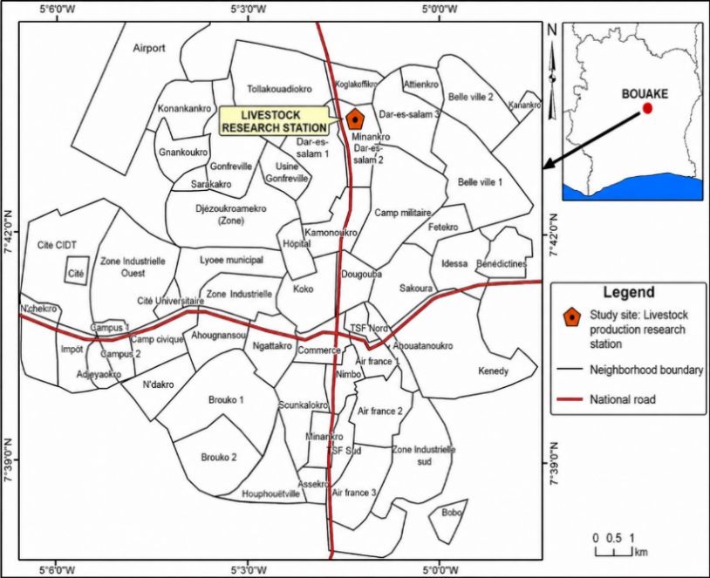
Figure 1: Location of the experimental site in the city of Bouaké

Plant material
The plant material used for this trial consists of Eleusine indica (L.) Gaertn. (Figure 2), collected from the CNRA’s botanical garden for forage plants in Bouaké.
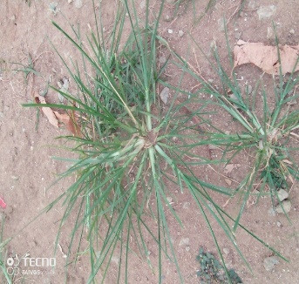
Figure 2: Eleusine indica plant

Eleusine indica is an annual grass belonging to the Poaceae family. It is commonly known as goosegrass, crowfootgrass, or wiregrass because of its finger-like inflorescences, and it has a spreading to erect growth habit, reaching a height of 20 to 60 cm depending on environmental conditions. The plant has a fibrous (fasciculate) root system that helps it adapt to compacted and relatively poor soils. Its leaves are linear, and its spikes, arranged in a fan-like pattern at the top of the stems, constitute a distinctive morphological characteristic. A species widely distributed in tropical and subtropical zones, it colonizes open areas and cultivated plots, with good tolerance to moderate stress and degraded soils. The choice of this species for this study lies in its ability to regrow rapidly and its significant biomass production, justifying its potential interest in forage production.

Experimental design
The agricultural inputs used during this experiment were a chemical fertilizer with an NPK formulation of 15-15-15, applied at a rate equivalent to 166.7 kg/ha, and a preventive phytosanitary treatment, Pyrimax 20 GR, a ready-to-use soil insecticide based on imidacloprid, applied at a rate of 20 g/kg to control termite infestations at the experimental site.
The experimental design used was a completely randomized block design (CRBD) with three replications, which allowed for the control of spatial heterogeneity within the experimental site and improved the precision of statistical comparisons between treatments. Three experimental factors were studied: (i) mineral fertilization, (ii) cutting frequency, and (iii) planting spacing (density). The factorial combination of these three variables led to the development of eight distinct treatments (Table I). This factorial approach allows for the evaluation not only of the main effects of each factor on growth and biomass production, but also of their potential interactions. Thus, the eight selected treatments are shown in Figure 3.

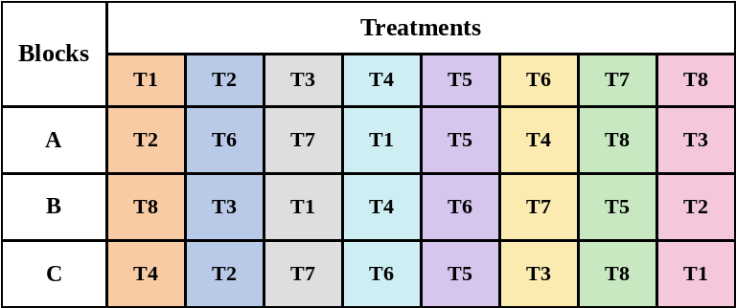
Figure 3: Layout of the different blocks and treatments
T1 = fertilizer + 30 days before cutting + 30 cm between plants; T2 = fertilizer + 30 days before cutting + 40 cm between plants; T3 = fertilizer + 45 days before cutting + 30 cm between plants; T4 = fertilizer + 45 days before cutting + 40 cm between plants; T5 = no fertilizer + 30 days before cutting + 30 cm between plants; T6 = no fertilizer + 30 days before cutting + 40 cm between plants; T7 = no fertilizer + 45 days before cutting + 30 cm between plants; T8 = no fertilizer + 45 days before cutting + 40 cm between plants.

The experiment was conducted on a 159.50 m² plot (27.50 m × 5.80 m), subdivided into three blocks using a randomized complete block design. Each block comprised eight 4.8 m² plots (1.60 m × 3.00 m), for a total of 24 experimental units. Treatments T1 through T4 received a basal mineral fertilizer application of NPK 15-15-15 at 80 g per plot (equivalent to 167 kg/ha), while treatments T5 through T8 received no fertilizer. For the fertilized treatments, fertilizer was reapplied after each harvest. Transplanting was carried out in rows spaced 40 cm apart, with an intra-row spacing of 30 cm or 40 cm depending on the treatment. Two cutting intervals were applied (30 and 45 days) to evaluate the effect of harvest age on biomass production.

Setup and monitoring of the trial
The experimental site was prepared by manual weeding and stump removal to eliminate all competing vegetation. The plots were marked out with stakes to ensure the uniformity of the experimental units. Manual tilling with a hoe was used to loosen the soil and promote root establishment. A soil insecticide treatment (Pyrimax 20GR, imidacloprid-based) was applied preventively to control termites and other pests.
Planting took place in August 2023, following the main rainy season. Planting stock was obtained from root cuttings derived from previously propagated plants. The selected propagules (10-15 cm tall) had a well-developed root system. A preventive root treatment was applied before transplanting. A thinning pruning was performed 30 days after transplanting (September 13, 2023) at 5 cm above ground level to standardize growth. Two pruning frequencies were then applied: every 30 days (October 13, November 13, and December 13, 2023) and every 45 days (October 26 and December 11, 2023).
Growth parameters (plant height, leaf length, number of leaves, and number of shoots) were measured weekly starting one week after the thinning cut. At each harvest, the above-ground biomass was cut 5 cm above the ground and weighed immediately in the field to determine fresh weight. Samples were collected and dried at 65 °C for 24 hours to estimate dry matter (DM) content. Biomass production was used to estimate carrying capacity. Seasonal stocking rate (expressed in grazing days) was calculated for one Tropical Livestock Unit (TLU) consuming 6.25 kg of DM per day, assuming that only one-third of the available biomass can be sustainably utilized, in accordance with pasture management principles (Breman and De Ridder, 1991; Boudet, 1991). Carrying capacities at different times of the year can then be calculated based on consumable phytomass using the following equations (1), (2), and (3):
- Eq. (1): CC (TLU ha⁻¹ year⁻¹) = (Productivity (kg DM ha⁻¹) × k) / (6.25 (kg DM TLU⁻¹) × duration of use), where 6.25 = daily dry matter intake (kg) of one Tropical Livestock Unit (TLU); k = grazing utilization coefficient, i.e. the proportion of standing biomass that can be sustainably removed by livestock without degrading the pasture (k = 0.35, following Toutain and Lhoste, 1999, for the northern Sudanian zone; Boudet, 1991; Breman and De Ridder, 1991); DM = dry matter.
- Eq. (2): GD (TLU) = (k × usable biomass, kg DM) / (6.25 kg DM TLU⁻¹ day⁻¹), where GD = number of grazing days provided per TLU (parameters as defined above).
- Eq. (3): SR (TLU ha⁻¹ season⁻¹) = GD (TLU) / Number of days of the growing period considered, where SR = seasonal stocking rate; GD = number of grazing days per TLU calculated in Eq. (2).

Statistical analyses
The data were entered into Microsoft Excel and then analyzed using R software version 4.3.0. The effects of mineral fertilization (with and without fertilizer), planting density (30 cm and 40 cm), cutting frequency (30 and 45 days), as well as their interactions, were evaluated using a multifactorial analysis of variance (ANOVA) adapted to a randomized complete block design. The linear model included the three factors considered as fixed effects, as well as the block effect as a random factor to account for the spatial heterogeneity of the experimental site. The normality of the residuals and the homogeneity of the variances were verified prior to the analysis. When the effect of a factor or an interaction was significant (p < 0.05), the means were compared using Fisher’s LSD test at the 5% level to identify significant differences between treatments. Throughout the tables, effects are denoted as follows: NS, not significant (p > 0.05); S, significant (0.01 < p ≤ 0.05); HS, highly significant (0.001 < p ≤ 0.01); and THS, very highly significant (p ≤ 0.001).

RESULTS
Effect of fertilization, cutting interval, and density on the growth parameters of Eleusine indica.
The effect of the treatments on the growth parameters of Eleusine indica is presented in Table II. Analysis of variance reveals a very highly significant difference between treatments (p < 0.001) for all measured variables. For plant height, treatment T1 recorded the highest mean value (19.56 cm), followed by T8 (19.1 cm), while T6 had the lowest height (12.9 cm). The other treatments showed intermediate values ranging from 15.89 to 18.22 cm. The number of tillers ranged from 14.40 to 26.47 depending on the treatment. The highest values were observed in T1 (26.47) and T4 (26.40), while T3 had the lowest mean (14.40). Regarding the number of leaves, T1 (100.98) and T4 (99.99) recorded the highest averages. Treatments T6 (51.04) and T3 (48.28) had the lowest values, with the other treatments falling at intermediate levels.

Table II: Effect of treatments on growth parameters (mean ± standard deviation)
Treatment | Plant height (cm) | Number of tillers | Number of leaves | Leaf length (cm)
T1 | 19.56±10.23ª | 26.47±18.19ª | 100.98±84.39a | 11.94±6.33a
T2 | 16.14±9.20^{b} | 22±17.87^{b} | 68.05±66.76^{bc} | 8.92±5.75^{cd}
T3 | 15.89±10.76^{bc} | 14.40±13.37^{c} | 48.28±46.44^{d} | 8.91±5.82^{cd}
T4 | 18.22±9.43^{ab} | 26.40±20.33ª | 99.99±83.24ª | 10.92±8.87^{ab}
T5 | 16.57±8.22^{b} | 18.67±10.43^{bc} | 77.36±45.56^{b} | 9.67±4.77^{bcd}
T6 | 12.9±7.23^{c} | 15.58±10.90^{c} | 51.04±39.94^{cd} | 8.92±9.40^{d}
T7 | 17.96±8.21^{ab} | 17.87±12.14^{bc} | 71.72±55.34^{b} | 10.53±5.11^{abc}
T8 | 19.1±9.94ª | 18.25±12.84^{bc} | 64.99±47.08^{bcd} | 11.22±5.40^{ab}
Significance | THS | THS | THS | THS
Probability | ≤ 0.001 | ≤ 0.001 | ≤ 0.001 | ≤ 0.001
abc: Within a column, different letters indicate a significant difference at p<0.05. THS: very highly significant; T1 = fertilizer + 30 days before cutting + 30 cm between plants; T2 = fertilizer + 30 days before cutting + 40 cm between plants; T3 = fertilizer + 45 days before cutting + 30 cm between plants; T4 = fertilizer + 45 days before cutting + 40 cm between plants; T5 = no fertilizer + 30 days before cutting + 30 cm between plants; T6 = no fertilizer + 30 days before cutting + 40 cm between plants; T7 = no fertilizer + 45 days before cutting + 30 cm between plants; T8 = no fertilizer + 45 days before cutting + 40 cm between plants.

Table III shows the growth trends of Eleusine indica as a function of fertilization. Analysis of variance indicates no significant difference between fertilized and unfertilized treatments for plant height and leaf length (p > 0.05). However, a significant difference was observed for the number of tillers and the number of leaves (p ≤ 0.05). These two parameters showed higher values in the fertilized plots compared to the unfertilized plots.

Table III: Effect of fertilization on growth parameters (mean ± standard deviation)
Fertilization | Plant height (cm) | Number of tillers | Number of leaves | Leaf length (cm)
F | 17.45±1.74ª | 22.33±5.68ª | 79.33±25.73ª | 10.17±1.51ª
NF | 16.63±2.69ª | 17.59±1.38^{b} | 66.28±11.34^{b} | 9.85±1.39ª
Significance | NS | S | S | NS
Probability | 0.640 | 0.001 | 0.012 | 0.701
ab Within a column, different letters indicate a significant difference at p<0.05. THS: very highly significant; S: significant; NS: not significant; F: fertilizer; NF: without fertilizer

Table IV presents the effect of the two cutting intervals (30 days and 45 days) on the growth parameters of Eleusine indica. Analysis of variance reveals a significant difference in the number of tillers and the number of leaves (p ≤ 0.05), with respective mean values of 20.68 ± 4.66 and 74.36 ± 20.82 for the 30-day interval, compared to 19.24 ± 5.10 and 71.24 ± 21.54 for the 45-day interval. In contrast, no significant differences were observed for plant height or leaf length (p > 0.05).
Table IV: Changes in growth parameters (mean ± standard deviation) as a function of the cutting period
Cutting interval | Plant height  (cm) |  | Number of tillers | Number of leaves | Leaf length  (cm)
30 j | 16.29±2.72ª | 20.68±4.66ª |  | 74.36±20.82ª | 9.63±1.68ª
45 j | 17.79±1.35ª | 19.24±5.10^{b} |  | 71.24±21.54^{b} | 10.39±1.03ª
Significative | NS | S |  | S | NS
Probability | 0.181 | 0.000 |  | 0.002 | 0.129
abc Within a column, different letters indicate a significant difference at p < 0.05; THS: very highly significant; S: significant; NS: not significant; 30D: 30 days; 45D: 45 days.

Table V shows the effect of planting density on the growth parameters of Eleusine indica. Analysis of variance at the 5% significance level reveals no significant difference between the 30 cm and 40 cm densities for all variables studied (p > 0.05).
Table V: Effect of density (mean ± standard deviation) on the development of growth parameters
Density | Plant height  (cm) | Number of tillers | Number of leaves | Leaf length  (cm)
30 cm | 17.49±1.63ª | 19.35±5.09ª | 74.59±21.63ª | 10.26±1.30ª
40 cm | 16.59±2.75ª | 20.57±4.72ª | 71.02±20.68ª | 9.77±1.55ª
Significance | NS | NS | NS | NS
Probability | 0.596 | 0.792 | 0.294 | 0.545
abc: Within a column, different letters indicate a significant difference at p < 0.05; NS: not significant; 30 cm: 30 cm spacing between plants; 40 cm: 40 cm spacing between plants.

Figure 3 illustrates the change in the height of Eleusine indica according to the treatments (T1 to T8) over the 13 weeks of monitoring (W1 to W13). The initial values are comparable across treatments (15-25 cm). A phase of rapid growth is observed between W1 and W5, particularly pronounced for T1, which increases from 22.33 to 44.27 cm. Starting at W5, most growth curves tend toward stabilization. Treatment T1 reaches a maximum height of 45.13 cm at W7, then remains at a plateau. Treatment T2 shows the lowest growth, with a maximum value of 29.89 cm. Treatments T3, T4, T5, T6, T7, and T8 exhibit intermediate growth rates, with maximum heights ranging from approximately 33 to 38 cm. Overall, most treatments reach a plateau before S7, indicating a stabilization of growth.
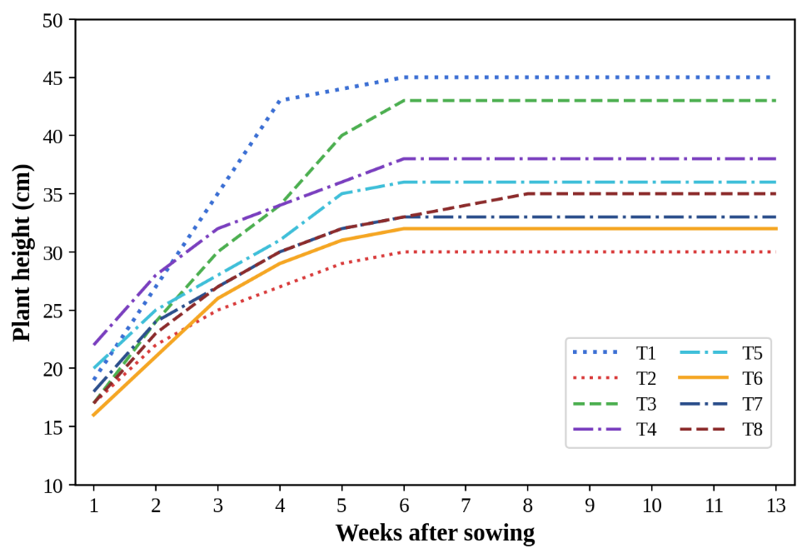
Figure 4: Growth of Eleusine indica as a function of treatment and time.
T1 = fertilizer + 30 days before cutting + 30 cm between plants; T2 = fertilizer + 30 days before cutting + 40 cm between plants; T3 = fertilizer + 45 days before cutting + 30 cm between plants; T4 = fertilizer + 45 days before cutting + 40 cm between plants; T5 = no fertilizer + 30 days before cutting + 30 cm between plants; T6 = no fertilizer + 30 days before cutting + 40 cm between plants; T7 = no fertilizer + 45 days before cutting + 30 cm between plants; T8 = no fertilizer + 45 days before cutting + 40 cm between plants.

Effect of treatments on average productivity and number of grazing days for Eleusine indica
Table VI presents the average productivity in terms of fresh (FM) and dry (DM) biomass, as well as the number of grazing days according to the treatments (T1 to T8). According to the statistical analysis, there is no significant difference between the treatments (p > 0.05). However, the observed values indicate higher average yields for treatments T1 (660 kg DM ha⁻¹) and T2 (546.6 kg DM ha⁻¹), corresponding to 37 and 31 grazing days, respectively. Treatments T3, T4, T5, T6, T7, and T8 showed average yields ranging from 413.3 to 546.6 kg DM ha⁻¹, with values generally close to one another despite the diversity of experimental conditions. Treatment T3 (fertilizer + 45 days before cutting + 30 cm spacing) had the lowest number of grazing days, at 23 days.

Table VI: Average productivity (mean ± standard deviation) of biomass and number of grazing days by treatment in Eleusine indica
Treatment | Yield  (kg FM/ha) | Potential yield  (kg DM/ha) | Potential DM rate (%) | Number of grazing days
T1 | 4363.3±2181.5ª | 660±329.9ª | 62.97 | 37
T2 | 2073.3±1036.6ª | 546.6±273.3ª | 81.48 | 31
T3 | 2470±1234.9ª | 413.3±206.6ª | 79.43 | 23
T4 | 3133.3±1566.6ª | 456.6±228.3ª | 73.23 | 26
T5 | 1550±774.9ª | 493.3±246.6ª | 89.43 | 28
T6 | 1066.6±533.3ª | 436.6±218.3ª | 93.70 | 24
T7 | 1600±799.97ª | 463.3±231.6ª | 88.63 | 26
T8 | 1553.3±776.6ª | 440±219.9ª | 88.87 | 25
Abc Within a column, different letters indicate a significant difference at p<0.05; T1 = fertilizer + 30 days before cutting + 30 cm between plants; T2 = fertilizer + 30 days before cutting + 40 cm between plants; T3 = fertilizer + 45 days before cutting + 30 cm between plants; T4 = fertilizer + 45 days before cutting + 40 cm between plants; T5 = no fertilizer + 30 days before cutting + 30 cm between plants; T6 = no fertilizer + 30 days before cutting + 40 cm between plants; T7 = no fertilizer + 45 days before cutting + 30 cm between plants; T8 = no fertilizer + 45 days before cutting + 40 cm between plants.

The seasonal carrying capacities of Eleusine indica pastures according to the treatments are shown in Figure 4. Treatment T1 has the highest carrying capacity, while T3 has the lowest value. Treatment T2 shows a carrying capacity close to that of T1. Treatments T4, T5, T6, T7, and T8 exhibit intermediate carrying capacities, with values that are generally similar to one another.
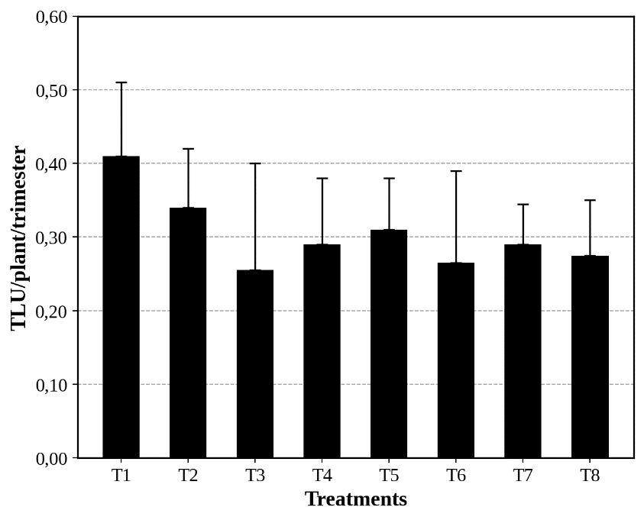
Figure 5: Seasonal carrying capacities of Eleusine indica pastures as a function of treatments

DISCUSSION
The objective of this study was to evaluate the combined effect of fertilization, planting density, and cutting interval on the growth and productivity of Eleusine indica. The results show that treatment T1 (fertilizer + 30 days before cutting + 30 cm spacing) consistently outperformed the other treatments in terms of morphological parameters (height, number of tillers, number of leaves), while treatment T6 (no fertilizer + 30 days before cutting + 40 cm spacing) performed the worst.
The highest average height observed in T1 (19.56 cm) confirms the critical role of fertilization in stimulating vegetative growth. Although T8 had a similar height (19.1 cm), the absence of fertilizer in some less-performing treatments, notably T6 (12.9 cm), underscores the importance of nutrient availability in the expression of growth potential. The increase in height under fertilization is consistent with known physiological mechanisms in grasses, where nitrogen promotes cell elongation, photosynthetic activity, and protein synthesis. Similar results were reported by Leite et al. (2021) and da Silva et al. (2026) showing a significant increase in grass height with fertilizer application, regardless of density. Similarly, Wekgari et al. (2024) observed that a shorter cutting interval (30 days) keeps plants in an active vegetative phase, promoting faster growth compared to longer intervals (45 days).
The number of tillers, a key indicator of forage production potential, is highest under T1 and T4. Since tillering is highly dependent on the plant’s nutritional status, these results confirm the stimulating effect of fertilization on the activation of axillary buds. Conversely, treatments without fertilizer (T3 and T6) show significantly lower values, reflecting a nutritional limitation. These observations are consistent with Leite et al. (2021) and da Silva et al. (2026), who demonstrated that nutrient supply increases the tillering capacity of grasses by improving meristem vigor. Furthermore, Ruillé et al. (2026) and Wang et al. (2021) notes that moderate densities, combined with adequate fertilization, optimize the trade-off between interspecific competition and light interception, which appears consistent with the performance observed under T1 and T4. The number of leaves follows the same trend, with maximum values observed under T1 (100.98) and T4. Since leaf production is directly linked to the active photosynthetic area, these results suggest an improvement in assimilatory potential under fertilization and a short cutting interval. The low values observed under T6 and T3 confirm that nutrient availability is a major limiting factor. Wang et al. (2022) also showed that leaf production is strongly correlated with soil nutrient status, while Thornton and Millard (1997) demonstrated that a shorter cutting interval promotes leaf renewal through improved nutrient mobilization.
Although statistical analysis did not reveal any significant differences between treatments for dry biomass, the observed values indicate a favorable trend for T1 and T2. This lack of statistical significance could be explained by high intra-plot variability or by a sample size that limits statistical power. The results are nevertheless consistent with those of Carroll et al. (2025), who report an increase of up to 40% in biomass in fertilized grasses. The discrepancy between fresh biomass and dry biomass, noted by Wahyuni et al. (2026), serves as a reminder that water content can modulate the apparent expression of yield, which would justify further analyses of tissue water dynamics. Regarding planting density, the lack of a significant difference between 30 and 40 cm suggests that, under the experimental conditions of this study, inter-plant competition did not reach a limiting threshold. However, the low productivity observed under T3 and its reduced number of grazing days (23 days) indicate that an interaction between density, fertilization, and cutting interval could influence forage sustainability. Zhang et al. (2021) have also shown that an optimal density improves resource use efficiency, whereas an imbalance can reduce overall productivity.
The growth dynamics reveal an initial rapid phase lasting until weeks 5-7, followed by a plateau across all treatments. Under T1, maximum height reached 45.13 cm by week 7. This phase likely corresponds to a period of maximum nutrient uptake and intense photosynthetic activity, as described by da Silva et al. (2026). The subsequent stabilization could reflect either a gradual limitation of available resources or a physiological adjustment toward a state of structural equilibrium. Harpole et al. (2016) showed that fertilization can stimulate initial growth but that the effect diminishes as resources become limiting. Jackson and Gratton (2026) also emphasize that less intensive systems, although exhibiting more moderate initial growth, may offer better long-term ecological sustainability.
Since grazing days are directly correlated with available biomass, the superior performance of T1 and T2 indicates a higher pastoral potential. However, the low value observed in T3 suggests that an imbalance between fertilization, stocking rate, and cutting interval may limit the duration of vegetation cover utilization. From an operational perspective, although yield differences are not statistically significant, the observed trends indicate that combinations incorporating fertilization and a short cutting interval (T1 and T2) are the most promising options for maximizing dry biomass and seasonal carrying capacity. Further studies incorporating edaphic parameters, soil nutrient dynamics, and water use efficiency would help refine technical recommendations and assess the long-term sustainability of the proposed systems.

CONCLUSION
This study investigated the combined effects of mineral fertilization, planting density, and cutting interval on the growth and biomass production of Eleusine indica (L.) Gaertn. under the agroecological conditions of central Côte d’Ivoire. The results demonstrate that the agronomic performance of the species can be improved through appropriate management practices, although biomass yield differences among treatments were not statistically significant under the experimental conditions.
The combination of mineral fertilization, a 30-day cutting interval, and a planting density of 30 cm (T1) consistently produced the best vegetative performance, with greater plant height, tillering, and leaf production, as well as the highest dry matter yield and grazing potential. These findings suggest that frequent harvesting combined with adequate nutrient supply enhances the productive capacity of E. indica and may contribute to increased forage availability for ruminant production systems. The absence of significant yield differences among treatments also indicates a considerable degree of agronomic plasticity, particularly with respect to the planting densities tested (30 and 40 cm), suggesting that the species is relatively tolerant to moderate variations in stand density.
Overall, E. indica appears to be a promising forage resource for tropical livestock systems and could contribute to the diversification of cultivated forage species in Côte d’Ivoire. Its ability to maintain relatively stable biomass production across the tested management conditions highlights its potential for integration into low-input and mixed crop-livestock production systems.
Future research should focus on optimizing fertilization strategies through the evaluation of different mineral fertilizer rates and nutrient combinations, assessing the contribution of organic amendments such as compost, manure, and biofertilizers, and developing management practices that ensure forage production during the dry season. Additional studies on grass-legume associations, nutrient and water use efficiency, and soil-plant-climate interactions would provide valuable information for designing productive, resilient, and environmentally sustainable forage systems in tropical agroecosystems.

Declaration of AI Use

This manuscript was prepared through the intellectual contributions of the author(s) to the study design, data analysis, interpretation of results, and scholarly content. Grammarly and ChatGPT were used solely to assist with grammatical refinement and reference formatting during manuscript revision. The author(s) accept full responsibility for the accuracy, integrity, and final content of the manuscript.

REFERENCES
Aubert, P. M. (2020). Agriculture : Vers une alimentation durable. IDDRI.
Barre, P. (2020). Gestion des troupeaux au pâturage : Impact sur les nutriments et la performance des animaux. Revue de l’Agriculture Moderne, (Pasture-based herd management: Impact on nutrients and animal performance. Modern Agriculture Review.)35(2), 112-130.
Bonfoh, B. (2004). Introduction des légumineuses fourragères dans les pratiques culturales : expériences des projets de développement du Togo. In : Actes de l’atelier de formation sur l’introduction des plantes fourragères dans les systèmes de production en Afrique de l’Ouest, Ed, Dicko M., Ehouinsou M.,( Introduction of forage legumes into cropping practices: experiences from development projects in Togo. In: Proceedings of the training workshop on the introduction of forage plants into production systems in West Africa, Eds. Dicko M., Ehouinsou M.) Aboh A. B. et Desquesnes M. Cotonou, du 19 au 21 janvier 2004. PROCORDEL, CIRDES, 59-65 pp.
Boudet, G. (1991). Manuel sur les pâturages tropicaux et les cultures fourragères. IEMVT / Ministère de la Coopération et du Développement. Paris, (Manual on Tropical Pastures and Forage Crops. IEMVT / Ministry of Cooperation and Development. Paris.)France, 226 p.
Breman, H., & De Ridder, N. (1991). Manuel sur les pâturages des pays sahéliens. CTA-ACCT-Karthala. Paris, (Handbook on Pastures in Sahelian Countries. CTA-ACCT-Karthala. Paris.)486 p.
Carroll, O. H., Seabloom, E. W., Borer, E. T., Harpole, W. S., Wilfahrt, P., Arnillas, C. A., Bakker, J. D., Blumenthal, D. M., Boughton, E., Bugalho, M. N., Caldeira, M., Campbell, M. M., Catford, J., Chen, Q., Dickman, C. R., Donohue, I., DuPre, M. E., Eskelinen, A., Estrada, C., Fay, P. A., Fraser, E. D. G., Hagenah, N., Hautier, Y., Hersh-Green, E., Jónsdóttir, I. S., Kadoya, T., Komatsu, K., Lannes, L., Liang, M., Venterink, H. O., Peri, P., Power, S. A., Price, J. N., Ren, Z., Risch, A. C., Sonnier, G., Veen, G. F., Virtanen, R., Wardle, G. M., Waring, E. F., Wheeler, G., Yahdjian, L., & MacDougall, A. S. (2025). Frequent failure of nutrients to increase plant biomass supports the need for precision fertilization in agriculture. Scientific Reports, 15(1), 14564. https://doi.org/10.1038/s41598-025-99071-z
da Silva, H. R., Cardoso, A. S., Schmitt, D., Fernandes, M. H. M. R., Carvalho, P. C. F., & de Faccio Carvalho, P. (2026). Effects of nitrogen fertilization on forage production, animal performance, and greenhouse gas emissions in tropical pastures: A systematic review. Agriculture, Ecosystems & Environment, 392, 109561. https://doi.org/10.1016/j.agee.2026.109561
Diomandé, B. I., Coulibaly, K. A., & Koné, N. (2018). Changement climatique et mutation des systèmes culturaux dans le périmètre communal de Bouaké au Centre de la Côte d’Ivoire. Afrique Science, (Climate Change and Shifts in Cropping Systems in the Bouaké Municipal Area, Central Côte d’Ivoire. Afrique Science)14(3), 1-13.
Dubois, C. (2021). Pratiques d’élevage et optimisation de la production fourragère : Impact et perspectives. Journal de l’Agriculture Durable,( Livestock farming and optimization of forage production: Impact and prospects. Journal of Sustainable Agriculture) 28(4), 145-162.
FAO. (2018). L’élevage mondial face aux défis environnementaux et sanitaires. Organisation des Nations Unies pour l’alimentation et l’agriculture.( Global livestock production facing environmental and health challenges. Food and Agriculture Organization of the United Nations.)
Guillaumet, J. L., & Adjanohoun, E. (1971). La végétation de la Côte d’Ivoire. In Le milieu naturel de la Côte d’Ivoire (The vegetation of Côte d’Ivoire. In The natural environment of Côte d’Ivoire)(Mémoires ORSTOM No. 50, pp. 157-263). ORSTOM.
Harpole, W. S., Sullivan, L. L., Lind, E. M., Firn, J., Adler, P. B., Borer, E. T., Chase, J., Fay, P. A., Hautier, Y., Hillebrand, H., MacDougall, A. S., Seabloom, E. W., Bakker, J. D., Cadotte, M. W., Chaneton, E. J., Chu, C., Cleland, E. E., D’Antonio, C., Davies, K. F., ... Stevens, C. J. (2016). Addition of multiple limiting resources reduces grassland diversity. Nature, 537(7618), 93-96. https://doi.org/10.1038/nature19324
Jackson, R. D., & Gratton, C. (2026). Grassland 2.0 - agroecosystems that care for us today while building capacity for future generations to do the same. Front. Sustain. Food Syst., 9, 1696429. https://doi.org/10.3389/fsufs.2025.1696429
Leite, R. G., Cardoso, A. da S., Fonseca, N. V. B., Silva, M. L. C., Tedeschi, L. O., Delevatti, L. M., Ruggieri, A. C., & Reis, R. A. (2021). Effects of nitrogen fertilization on protein and carbohydrate fractions of Marandu palisadegrass. Scientific Reports, 11, article no. 14786. https://doi.org/10.1038/s41598-021-94098-4
OECD. (2020). Agricultural outlook 2020-2029. OECD Publishing.
Ruillé, M., Beillouin, D., & Prudhomme, R. (2026). Ecological drivers of intercropping performance for enhanced global crop production. npj Sustainable Agriculture, 4, Article 8. https://doi.org/10.1038/s44264-025-00110-z
Sicot, M., Talineau, J.-C., Bonzon, B., Fillonneau, C., Hainnaux, G., & Picard, D. (1972). Critères agronomiques de choix des plantes fourragères en Côte d'Ivoire. ORSTOM, Centre d’Adiopodoumé.
Soro, N., & Koné, A. A. (2019). Caractéristiques du relief et répartition de l’habitat dans la ville de Bouaké. DaloGéo, Revue de Géographie de l’Université Jean Lorougnon Guédé de Daloa,( Topographic features and settlement distribution in the city of Bouaké. DaloGéo, Geography Journal of Jean Lorougnon Guédé University, Daloa.) n° 1, 150-165.
Thornton, B., & Millard, P. (1997). Increased defoliation frequency depletes remobilization of nitrogen for leaf growth in grasses. Annals of Botany, 80(1), 89-95. https://doi.org/10.1006/anbo.1997.0416
Tilman, D., Cassman, K. G., Matson, P. A., Naylor, R., & Polasky, S. (2002). Agricultural sustainability and intensive production practices. Nature, 418(6898), 671-677.

Toutain, B., & Lhoste, P. (1999). Sciences, technologies et gestion des pâturages au sahel. In : Horizons nomades en Afrique sahélienne : Sociétés, développement et démocratie. Ouvrage coordonné par Bourgeot A.,( Science, technology, and pasture management in the Sahel. In: Nomadic Horizons in Sahelian Africa: Societies, Development, and Democracy. Edited by A. Bourgeot.) Editions KARTHALA, pp. 377-394.
Wahyuni, R. D., Pötsch, E. M., Katagiri Dalmoro, Y., Sessegolo Ferzola, P., & Gierus, M. (2026). Long-Term Mineral N Fertilization in Permanent Mountain Grassland: Trade-Offs Between Dry Matter Yield and Metabolizable Energy of Grasses, Legumes and Forbs. Agronomy, 16(16), 1538. https://doi.org/10.3390/agronomy16161538
Wang, Q., Sun, Z., Bai, W., Zhang, D., Zhang, Y., Wang, R., van der Werf, W., Evers, J. B., Stomph, T.-J., Guo, J., & Zhang, L. (2021). Light interception and use efficiency differ with maize plant density in maize-peanut intercropping. Frontiers of Agricultural Science and Engineering, 8(3), 432-446. https://doi.org/10.15302/J-FASE-2021403
Wang, X., Wang, R., & Gao, J. (2022). Precipitation and soil nutrients determine the spatial variability of grassland productivity at large scales in China. Frontiers in Plant Science, 13, 996313. https://doi.org/10.3389/fpls.2022.996313
Wekgari, Y., Dereba, F., & Gamachu, N. (2024). Determination of cutting frequency for optimum herbage yield and nutritive value of Desho grass (Pennisetum glaucifolium) in western Oromia, Ethiopia. Heliyon, 10(18), e38132. https://doi.org/10.1016/j.heliyon.2024.e38132
Yoro, G. R. (2000). Les principaux sols de Côte d’Ivoire et leur corrélation avec les groupes de référence de la Base mondiale de données des sols (The main soils of Côte d’Ivoire and their correlation with the reference groups of the World Reference Base for Soil Resources)(WRB), 19 p.
Zhang, Y., Xu, Z., Li, J., & Wang, R. (2021). Optimum planting density improves resource use efficiency and yield stability of rainfed maize in semiarid climate. Front. Plant Sci., 12, 752606. https://doi.org/10.3389/fpls.2021.752606.

