Case report

Valsartan Induced Bullous Pemphigoid in a Young Adult: Clinical and Immunopathological Insights

.
ABSTRACT

Background: Bullous pemphigoid (BP) is an autoimmune blistering disorder that predominantly affects the elderly population. Although its exact pathophysiology remains incompletely understood, a strong link to pharmacological agents has been well established. Herein, we report a rare case of valsartan-induced bullous pemphigoid in a young female patient.

Presentation of case: A 40-year-old female presented to the emergency department with a widespread cutaneous eruption associated with severe pruritus. Anamnesis revealed recent initiation of an angiotensin II receptor blocker for newly diagnosed hypertension. Clinical examination demonstrated multiple urticarial plaques with polycyclic borders surmounted by numerous tense bullae with, alongside widespread post-bullous erosions involving the entire body with genital mucosal involvement. Skin biopsy with direct and indirect immunofluorescence was consistent with bullous pemphigoid. The antihypertensive agent was discontinued. Systemic therapy with oral prednisone was initiated and gradually tapered. The clinical outcome was favorable, showing marked disease improvement with complete re-epithelialization of the lesions.

Discussion: Drug-induced bullous pemphigoid is a variant triggered by a wide array of medications. It is distinguished from the idiopathic form by an earlier age of onset, an unusually frequent mucosal involvement, clinical resolution following the withdrawal of the culprit drug, and marked peripheral blood hypereosinophilia. The identification and prompt discontinuation of the offending molecule are imperative, particularly in severe, life-threatening presentations."
Conclusion: Bullous pemphigoid can occasionally manifest as an adverse drug reaction following the initiation of various medications, including antihypertensive therapies. The identification and immediate discontinuation of the offending drug are imperative, taking into account the risk-benefit ratio.

Keywords: Bullous Pemphigoid, Valsartan, Drug-induced, Hypereosinophilia, Adverse Drug Reaction

1. INTRODUCTION
Bullous pemphigoid (BP) is the most common autoimmune blistering dermatosis in the elderly, predominantly affecting individuals over 60 years of age with a peak incidence around 70 years. However, cases can also occur in younger individuals, children, or secondary to the administration of certain medications (Yulianggoro and al., 2024). BP is driven by the production of autoantibodies targeting structural antigens of the dermo-epidermal junction, mainly BP180 and BP230, which are essential components of hemidesmosomes ensuring dermo-epidermal cohesion (Kridin and al., 2018). The pathophysiology of BP involves a interplay of genetic and immunological factors, age-related cutaneous changes, and specific environmental triggers, notably drugs. Drug-induced bullous pemphigoid develops following the oral or, more rarely, topical administration of various specific agents, with a broad range of implicated molecules reported to date (Verheyden and al., 2020). Valsartan, an angiotensin II receptor blocker, remains an exceptionally rare causative culprit. Herein, we report a case of bullous pemphigoid in a young female patient triggered by valsartan initiation
2. presentation of case
A 40-year-old female with no relevant medical history presented to the emergency department with a generalized, pruritic cutaneous eruption that had been evolving for 20 days. Anamnesis revealed the initiation of valsartan one month earlier for newly diagnosed hypertension. Ten days following valsartan introduction, the clinical course was marked by the onset of severe pruritus, rapidly followed by a generalized bullous eruption.
On physical examination, the patient was febrile. Dermatological assessment revealed extensive erythematous and urticarial plaques with circinate and polycyclic borders, surmounted by multiple tense bullae with clear to turbid fluid, along with post-bullous erosions. Lesions were diffusely distributed over the trunk, back, abdomen, upper and lower extremities, flexural folds (figure 1 and 3), face, and palmaplantar surfaces. Mucosal examination revealed a tense bulla with post-bullous erosions on the genital mucosa, with sparing of the oral cavity. Signs of impetiginization were noted on certain lesions, particularly on the dorsum of the hands (figure 2). Nikolsky's sign was negative. Total body surface area involvement was estimated at 65%, with a Bullous Pemphigoid Disease Area Index (BPDAI) score of 33, indicating moderate disease activity.
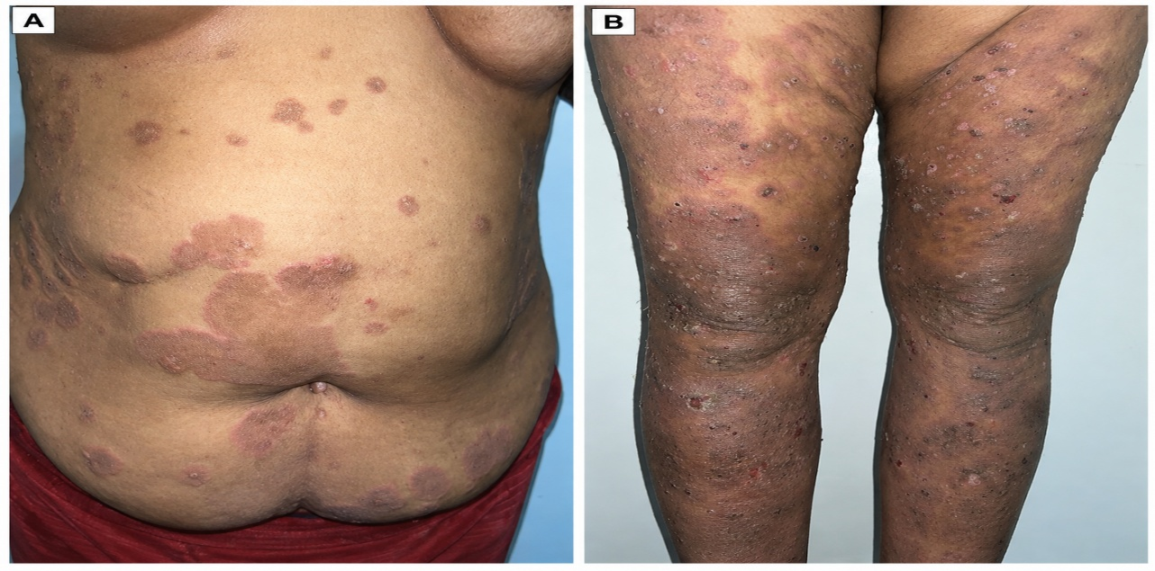
Figure 1. Clinical image showing multiple erythematous and urticarial plaques with polycyclic borders, surmounted by bullae and post-bullous erosions located on the trunk (A) and lower extremities (B).
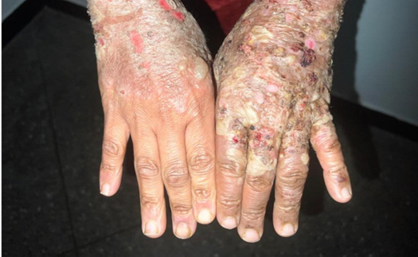
Figure 2. Clinical image showing impetiginized lesions on the dorsum of the hands.
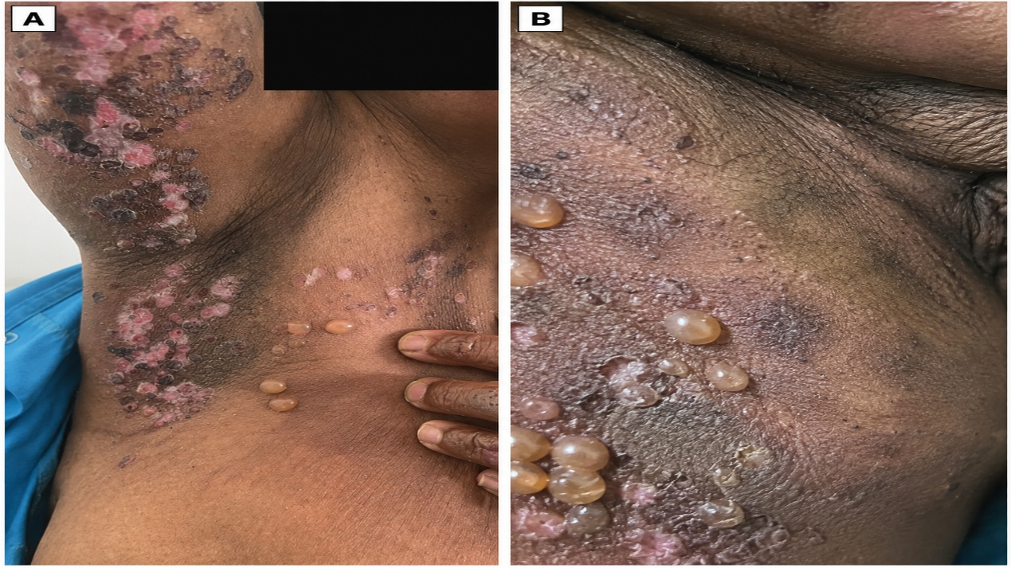
Figure 3. Clinical image showing multiple tense bullae with clear fluid in the axillary and inguinal folds, along with post-bullous erosions

Laboratory evaluation demonstrated marked peripheral blood hypereosinophilia at 7,100/mm³, with otherwise normal biological parameters. Histopathological examination of a skin biopsy showed subepidermal blistering accompanied by a polymorphous dermo-epidermal inflammatory infiltrate rich in lymphocytes and eosinophils. Direct immunofluorescence (DIF) on salt-split skin demonstrated fine linear IgG deposition along the dermo-epidermal junction, strictly localized to the epidermal roof. Indirect immunofluorescence (IIF) was positive for anti-basement membrane zone antibodies at a titer of 1:1280.
Based on historical, clinical, histopathological, and immunopathological findings, a diagnosis of valsartan-induced bullous pemphigoid was established. Valsartan was immediately discontinued and replaced with a calcium channel blocker for blood pressure control. Systemic therapy with oral prednisone (1 mg/kg/day) was initiated in combination with doxycycline (200 mg/day). The clinical course was favorable, characterized by the cessation of new lesion formation and progressive re-epithelialization of erosions."

3. discussion

Antihypertensive medications are among the most frequently prescribed drugs worldwide and are associated with adverse effects involving various organ systems in 10% to 60% of cases. Although diverse cutaneous adverse reactions have been reported with antihypertensive agents, drug-induced bullous pemphigoid (DIBP) remains a rare phenomenon (Araqi Houssaini and al., 2019). The true prevalence of DIBP is likely underestimated, primarily due to the difficulty of establishing causality, its clinical similarity to the idiopathic form, and the challenge of identifying the culprit drug in polymedicated patients. While all major antihypertensive classes have been occasionally implicated as potential triggers, cases specifically associated with valsartan remain exceptionally rare in the literature, underscoring the clinical relevance of our report.
Bullous pemphigoid is characterized by an autoimmune reaction targeting hemidesmosomal components, driven by autoantibodies against BP180 and BP230 proteins, which ultimately leads to subepidermal blister formation (Stavropoulos and al., 2014). Classic idiopathic BP typically affects patients over 70 years of age and is rarely observed in individuals under 50 years (Sadik and al., 2019).
Drug-induced bullous pemphigoid represents a distinct variant triggered or exacerbated by specific pharmacological agents. The drugs most frequently implicated include antibiotics (penicillins, cephalosporins, sulfonamides, tetracyclines), diuretics (furosemide, hydrochlorothiazide), nonsteroidal anti-inflammatory drugs (NSAIDs), oral antidiabetics—particularly dipeptidyl peptidase-4 (DPP-4) inhibitors—neuroleptics, cardiovascular agents (beta-blockers, angiotensin-converting enzyme [ACE] inhibitors), and immunosuppressive therapies (carboplatin, methotrexate, azathioprine) (Verheyden and al., 2020 ; Wirbel and al., 2019 ; Rawson and al., 2018 ; El Amrani and al., 2013. Although all classes of antihypertensives have been sporadically cited, valsartan-induced cases are extraordinarily rare.
While DIBP generally manifests with clinical features similar to idiopathic BP, certain characteristics favor a drug-induced etiology: an earlier age of onset, unusual mucosal involvement, prompt clinical improvement following drug withdrawal, marked peripheral blood hypereosinophilia, and occasionally keratinocyte necrosis on skin histology. All of these key features were identified in our patient. However, no single clinical or histopathological criterion is pathognomonic to formally differentiate idiopathic BP from DIBP. The cornerstone of diagnosis relies on the temporal relationship between drug initiation and symptom onset, followed by clinical resolution upon drug cessation. The latency period between drug intake and disease onset can be short, as seen in our case, or extend up to several months or even years (Verheyden and al., 2020 ; Stavropoulos and al., 2014).
The typical clinical presentation consists of a highly pruritic eruption featuring tense bullae with clear, turbid, or occasionally hemorrhagic content, evolving into post-bullous erosions overlying erythematous or urticarial skin. Mucosal involvement is reported in 10% to 30% of cases. Histopathological examination demonstrates a subepidermal split with a dense inflammatory infiltrate rich in eosinophils. Direct immunofluorescence (DIF) reveals linear deposits of IgG and/or C3 along the dermo-epidermal junction. Serological testing for anti-basement membrane zone antibodies or specific anti-BP180 and anti-BP230 autoantibodies returns positive (Borradori and al., 2022).
Management principally hinges on the immediate discontinuation of the offending drug, which can be challenging to pinpoint in polymedicated patients. Depending on disease severity and patient comorbidities, treatment involves either high-potency topical corticosteroids or systemic corticosteroid therapy (Pratasava and al., 2021 ; Di Lernia and al., 2020). Our observation perfectly illustrates the efficacy of this combined approach: in our patient, immediate withdrawal of valsartan combined with oral prednisone and adjuvant doxycycline achieved rapid disease control, progressive re-epithelialization, and complete absence of relapse following trigger removal, confirming the highly favorable prognosis of DIBP when recognized and managed early. In cases of corticosteroid dependence or severe, refractory disease, alternative immunosuppressive options such as methotrexate, azathioprine, or mycophenolate mofetil may be considered (Khalid and al., 2021).

4. Conclusion

Bullous pemphigoid may occasionally present as an adverse effect following the introduction of various medications, including antihypertensive agents. Prompt diagnosis is essential, particularly in severe cases that can be life-threatening. The identification and immediate discontinuation of the offending drug are imperative, while carefully evaluating the risk-benefit ratio. Following the cessation of the suspected medication, most patients show a rapid response to therapy and typically experience no disease relapses.

Competing interests
Authors have declared that no competing interests exist.
consent

Written informed consent was obtained from the patient for this case report and the accompanying clinical images.

Ethical approval

This report describes a single patient managed in the course of routine clinical care and did not require institutional review board approval. All procedures were performed in accordance with the ethical standards laid down in the 1964 Declaration of Helsinki and its later amendments.

Declaration of AI Use

This manuscript was prepared through the intellectual contributions of the author(s) to the study design, data analysis, interpretation of results, and scholarly content. Grammarly and ChatGPT were used solely to assist with grammatical refinement and reference formatting during manuscript revision. The author(s) accept full responsibility for the accuracy, integrity, and final content of the manuscript.

References

• Yulianggoro, E. R., & Astari, L. (2024). Drug-induced bullous pemphigoid: Rapid resolution with corticosteroid therapy. Journal of Medicinal and Chemical Sciences, 7(2), 300–310. https://doi.org/10.26655/JMCHEMSCI.2024.2.14
• Kridin, K., & Ludwig, R. J. (2018). The growing incidence of bullous pemphigoid: Overview and potential explanations. Frontiers in Medicine, 5, Article 220. https://doi.org/10.3389/fmed.2018.00220
• Verheyden, M. J., Bilgic, A., & Murrell, D. F. (2020). A systematic review of drug-induced pemphigoid. Acta Dermato-Venereologica, 100(15), Article adv00224. https://doi.org/10.2340/00015555-3457
• Araqi Houssaini, L., Baline, K., Hali, F., Marnissi, F., & Chiheb, S. (2019). Pemphigoïde bulleuse induite par trois classes d’antihypertenseurs différentes. Annales de Dermatologie et de Vénéréologie, 146(12), A148. https://doi.org/10.1016/j.annder.2019.09.201
• Stavropoulos, P. G., Soura, E., & Antoniou, C. (2014). Drug-induced pemphigoid: A review of the literature. Journal of the European Academy of Dermatology and Venereology, 28(9), 1133–1140. https://doi.org/10.1111/jdv.12366
• Sadik, C. D., & Schmidt, E. (2019). Resolution in bullous pemphigoid. Seminars in Immunopathology, 41(6), 645–654. https://doi.org/10.1007/s00281-019-00759-y
• Wirbel, C., Milley, S., Balme, B., & Dalle, S. (2020). Pemphigoïde bulleuse sous anti-PD1 [Bullous pemphigoid under anti-PD1 therapy]. Annales de Dermatologie et de Vénéréologie, 147(11), 795–797. https://doi.org/10.1016/j.annder.2020.04.024
• Rawson, K., Vinod, S., Sreenivasan, B., & Roy, G. (2018). Drug-induced bullous pemphigoid – A case report with review. Journal of Indian Academy of Oral Medicine and Radiology, 30(4), 427–431. https://doi.org/10.4103/jiaomr.jiaomr_118_18
• El Amrani, F., & Hassam, B. (2013). Une pemphigoïde bulleuse localisée radio-induite. The Pan African Medical Journal, 14, Article 43. https://doi.org/10.11604/pamj.2013.14.43.2327
• Borradori, L., Van Beek, N., Feliciani, C., Tedbirt, B., Antiga, E., Bergman, R., Beissert, S., Caux, F., Chaudhari, U., Daneshpazhooh, M., Drenovska, K., Dmochowski, M., Vassileva, S., Goebeler, M., Groves, R., Günther, C., Hofmann, S., Ioannides, D., Kowalewski, C., … Zillikens, D. (2022). European guidelines (S2k) on the management of bullous pemphigoid initiated by the European Academy of Dermatology and Venereology (EADV). Journal of the European Academy of Dermatology and Venereology, 36(10), 1689–1704. https://doi.org/10.1111/jdv.18220
• Pratasava, V., Sahni, V. N., Suresh, A., Huang, S., Are, A., Hsu, S., & Motaparthi, K. (2021). Bullous pemphigoid and other pemphigoid dermatoses. Medicina, 57(10), Article 1061. https://doi.org/10.3390/medicina57101061
• Di Lernia, V., Casanova, D. M., Goldust, M., & Ricci, C. (2020). Pemphigus vulgaris and bullous pemphigoid: Update on diagnosis and treatment. Dermatology Practical & Conceptual, 10(3), Article e2020068. https://doi.org/10.5826/dpc.1003a68
• Khalid, S. N., Khan, Z. A., Ali, M. H., Almas, T., Khedro, T., & Raj Nagarajan, V. (2021). A blistering new era for bullous pemphigoid: A scoping review of current therapies, ongoing clinical trials, and future directions. Annals of Medicine and Surgery, 70, Article 102799. https://doi.org/10.1016/j.amsu.2021.102799

