Case report
Multiple Cutaneous Juvenile Xanthogranuloma in an Infant: A Case Report

Abstract:
Juvenile xanthogranuloma is the most common form of non-Langerhans cell histiocytosis in children, characterized by benign histiocytic proliferation. It predominantly affects infants and young children. The diagnosis is primarily clinical, based on the presence of characteristic orange to yellow-brown papulonodular lesions, typically well-demarcated and ranging from a few millimeters to several centimeters in size. These lesions preferentially involve the head, neck, and upper trunk. While solitary lesions are most frequent, multiple lesions can occur, particularly in infants. Histologically, juvenile xanthogranuloma shows a dense dermal infiltrate of histiocytes with foamy cytoplasm, often accompanied by Touton giant cells, without epidermal involvement. Although cutaneous involvement predominates, extracutaneous manifestations may occur, with ocular involvement being the most common. The condition follows a benign, self-limiting course, with spontaneous regression over several years without specific treatment. A conservative approach with clinical monitoring is recommended for isolated cutaneous forms. This case report highlights the importance of recognizing this entity to avoid unnecessary invasive investigations and treatments.

Keywords:
Juvenile xanthogranuloma, histiocytosis, non-Langerhans cell histiocytosis, cutaneous lesions, pediatric dermatology
Introduction:
Juvenile xanthogranuloma is a heterogeneous group of non-Langerhans histiocytosis, characterized by a proliferation of histiocytic cells. This entity is relatively rare, with an estimated incidence of approximately 1 case per million children. It is the most common form of histiocytosis in pediatric patients [1]. Cutaneous lesions typically emerge within the first few months of life, usually before the age of one, although they can be congenital. The preferred sites include the head (face, scalp) and neck, with a predominance in males. We present here the case of an infant diagnosed with juvenile xanthogranuloma.
Contemporary pediatric series indicate that the clinical profile of juvenile xanthogranuloma is broader than a single fixed incidence estimate: the disorder remains uncommon, usually presents in early childhood, and most often involves the head and neck, with solitary cutaneous lesions predominating (Kundak & Çakır, 2021; Wee et al., 2022). A large 30-year clinicopathologic series further demonstrated age-related and morphologic heterogeneity, including distinct histopathologic patterns and occasional extracutaneous disease, supporting the characterization of juvenile xanthogranuloma as a clinically and pathologically heterogeneous non-Langerhans histiocytic disorder (Salari & Dehner, 2022). These observations underscore the importance of careful clinical recognition in infants presenting with characteristic yellow-orange papules or nodules.
Case Presentation:
This case involves an 8-month-old infant, born at term from an unremarkable pregnancy, with neonatal history showing no reported anomalies. The parents consulted due to the appearance of two papular lesions in the cephalic region that had been evolving for the past six months. Upon clinical examination, the infant was in good general condition. The dermatological examination revealed two well-defined, firm papules, rounded in shape, with a smooth surface, measuring approximately 1 cm in diameter. The lesions exhibited a characteristic orange coloration, with no associated inflammatory signs, ulceration, or discharge. They were located at the hairline and on the cheek (Figures 1 and 2), which is a classic topography for juvenile xanthogranuloma lesions. Given this evocative clinical appearance, a diagnosis of multiple cutaneous juvenile xanthogranuloma was retained. The clinical evolution, the typical morphology of the lesions, and their cephalic localization allowed for an essentially clinical diagnosis. In the absence of any severe signs or extracutaneous involvement, no treatment was initiated, and simple clinical monitoring was recommended to the parents, explaining the benign and self-resolving nature of this condition.

Figure 1: Juvenile Xanthogranuloma: An Orange-Colored Scalp Papule
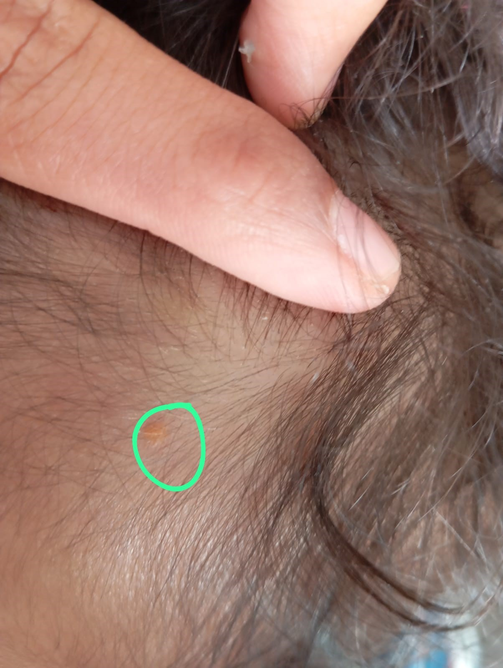
Figure 2: Juvenile Xanthogranuloma: An Orange papulonodule on the Cheek
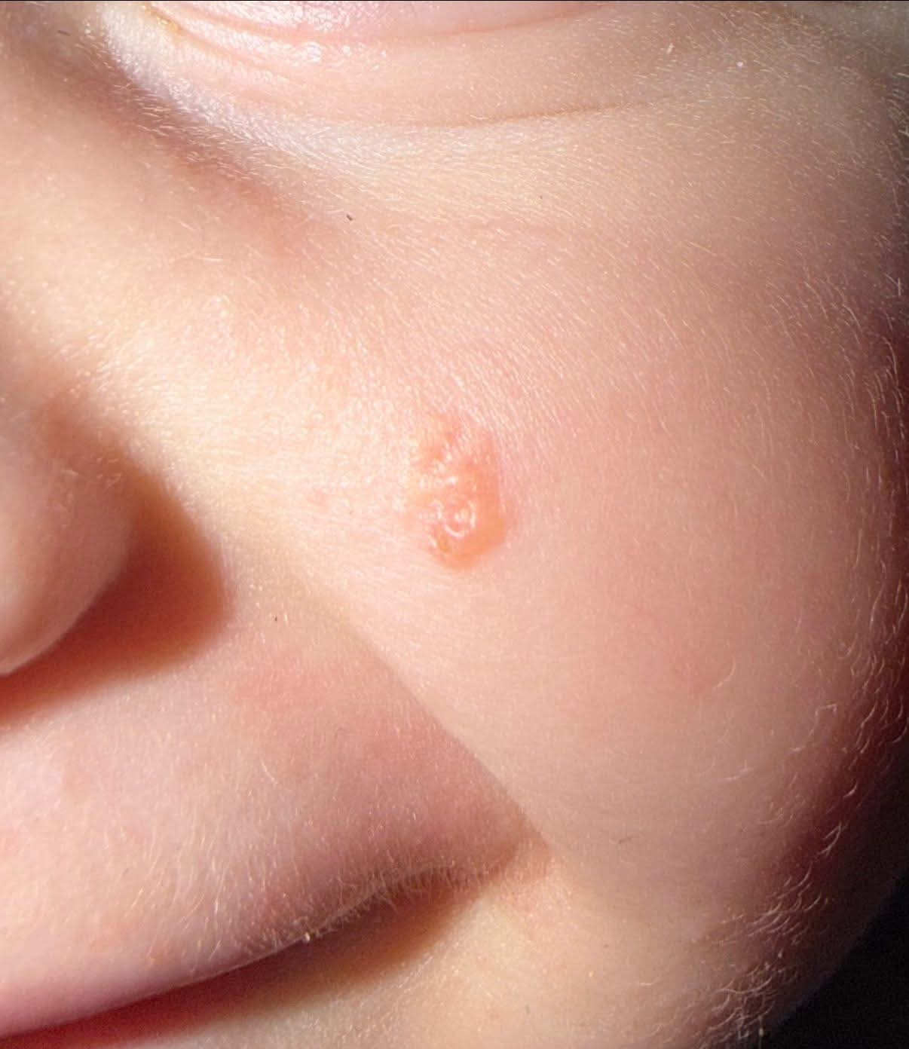

Discussion:
Juvenile xanthogranuloma is the most common non-Langerhans cell histiocytosis in children. It belongs to the group of benign histiocytic proliferations characterized by a dermal accumulation of dendritic cells derived from macrophages [2]. This condition occurs predominantly in infants and young children, with nearly 75% of cases diagnosed before one year of age, although later-onset forms have been described [3]. Clinically, juvenile xanthogranuloma presents as one or multiple well-demarcated papular or nodular lesions that are orange to yellow-brown in color and range in size from a few millimeters to several centimeters. Lesions preferentially involve the head, neck, and upper trunk. Solitary lesions are most frequent, whereas multiple lesions are less common and occur mainly in infants [3]. The diagnosis of juvenile xanthogranuloma is primarily clinical, particularly in typical presentations. Histologically, there is a dense, well-demarcated dermal or dermo‑hypodermal infiltrate of histiocytes without epidermal involvement [4]. The histiocytes have foamy cytoplasm and may be accompanied by multinucleated Touton giant cells, especially in more developed lesions. Although cutaneous involvement predominates, extracutaneous localizations have been reported, notably ocular, pulmonary, hepatic, neurological, and osseous sites. Ocular involvement is the most frequent extracutaneous manifestation [5]. The course of juvenile xanthogranuloma is spontaneously favorable in the majority of cases. Lesions typically regress over several years without specific treatment, sometimes leaving a slight atrophic scar or residual hyperpigmentation [6]. Therefore, a conservative (watchful waiting) therapeutic approach is generally recommended for isolated cutaneous forms.
The clinical profile in the present case—infancy, cephalic distribution, and two well-demarcated orange papules—is consistent with contemporary pediatric cohorts. Kundak and Çakır (2021) described juvenile xanthogranuloma predominantly in children, while Wee et al. (2022) reported that 69.4% of 147 pediatric patients presented before two years of age and that the head and neck were the most frequently involved sites. These findings support the clinical plausibility of the diagnosis in an 8-month-old with facial and scalp lesions while indicating that multiple lesions represent a less common, but recognized, presentation.
The histopathologic appearance can vary with lesion maturation; lipidization and Touton giant-cell formation may become more conspicuous as lesions evolve (Kubota et al., 2001). Salari and Dehner (2022) identified early, classic, and transitional histopathologic patterns in a large single-center series, whereas Fraitag and Emile (2022) emphasized integrating morphology with immunophenotype when distinguishing pediatric cutaneous histiocytoses. Accordingly, biopsy is especially useful when morphology is atypical, lesions evolve unexpectedly, or the differential diagnosis remains broad, although a characteristic uncomplicated cutaneous presentation may be managed primarily on clinical grounds.
Although the current infant had no extracutaneous signs, awareness of ocular disease remains clinically important because ocular juvenile xanthogranuloma may be associated with vision-threatening complications that require active ophthalmic management (Samara et al., 2015). At the same time, a more recent cohort of 147 Asian children identified no ophthalmologic complications and did not support routine ophthalmologic or systemic screening in the absence of clinical indications, even in children with multiple cutaneous lesions (Wee et al., 2022). Taken together, these data support individualized surveillance guided by ocular symptoms, lesion burden, age, and examination findings rather than indiscriminate extensive investigation.
The decision for observation in this case is also concordant with contemporary outcome data. Wee et al. (2022) documented spontaneous resolution in 57.7% of children, with a mean time to resolution of 18.8 months, and Kundak and Çakır (2021) similarly described a generally benign clinical course without extracutaneous involvement in their pediatric cohort. Thus, watchful waiting is reasonable for uncomplicated skin-limited disease, provided that clinical follow-up is maintained to identify unexpected progression or extracutaneous manifestations.

Conclusion:
Juvenile xanthogranuloma should be considered in infants presenting with well-defined yellow-orange papules or nodules, particularly when lesions are located on the head or face. In this case, the patient had two typical cephalic lesions without clinical evidence of extracutaneous involvement. The diagnosis was retained on clinical grounds, and conservative monitoring was selected because of the benign presentation. Recognition of this entity is important to reassure caregivers and avoid unnecessary treatment in uncomplicated cutaneous cases. Continued clinical follow-up remains appropriate to confirm favorable evolution and detect any unexpected change.

Consent :
All authors declare that ‘written informed consent was obtained from the patient (or other approved parties) for publication of this case report and accompanying images’.
Declaration of AI Use

This manuscript was prepared through the intellectual contributions of the author(s) to the study design, data analysis, interpretation of results, and scholarly content. Grammarly and ChatGPT were used solely to assist with grammatical refinement and reference formatting during manuscript revision. The author(s) accept full responsibility for the accuracy, integrity, and final content of the manuscript.

References:
- Hernandez-Martin A, Baselga E, Drolet BA, et al. Juvenile xanthogranuloma. J Am Acad Dermatol. 1997,36(3):355-367.
- Dehner LP. Juvenile xanthogranulomas in the first two decades of life: a clinicopathologic study of 174 cases with cutaneous and extracutaneous manifestations. Am J Surg Pathol. 2003,27(5):579-593.
- Janssen D, Harms D. Juvenile xanthogranuloma in childhood and adolescence: a clinicopathologic study of 129 patients. Am J Surg Pathol. 2005,29(1):21-28.
- Weitzman S, Jaffe R. Uncommon histiocytic disorders: the non-Langerhans cell histiocytoses. Pediatr Blood Cancer. 2005,45(3):256-264.
- Chang MW, Frieden IJ, Good W. The risk intraocular juvenile xanthogranuloma: survey of current practices and assessment of risk. J Am Acad Dermatol. 1996,34(3):445-449.
- Pires da Silva S, Viveiros C, Almeida R, Almeida Pereira M, Vaz R, Portela A. Juvenile xanthogranuloma : A case report. Rev Paul Pediatr. 2019,37(2):257-260.

Kundak, S., & Çakır, Y. (2021). Juvenile xanthogranuloma: Retrospective analysis of 44 pediatric cases (single tertiary care center experience). International Journal of Dermatology, 60(5), 564–569. https://doi.org/10.1111/ijd.15223
Wee, L. W. Y., Ling, H. Y., Ho, V. P. Y., Foong, A. Y. W., & Koh, M. J. A. (2022). Juvenile xanthogranulomas in Asian children. Dermatologic Therapy, 35(2), e15224. https://doi.org/10.1111/dth.15224
Salari, B., & Dehner, L. P. (2022). Juvenile and adult xanthogranuloma: A 30-year single-center experience and review of the disorder and its relationship to other histiocytoses. Annals of Diagnostic Pathology, 58, 151940. https://doi.org/10.1016/j.anndiagpath.2022.151940
Fraitag, S., & Emile, J.-F. (2022). Cutaneous histiocytoses in children. Histopathology, 80(1), 196–215. https://doi.org/10.1111/his.14569
Samara, W. A., Khoo, C. T. L., Say, E. A. T., Saktanasate, J., Eagle, R. C., Jr., Shields, J. A., & Shields, C. L. (2015). Juvenile xanthogranuloma involving the eye and ocular adnexa: Tumor control, visual outcomes, and globe salvage in 30 patients. Ophthalmology, 122(10), 2130–2138. https://doi.org/10.1016/j.ophtha.2015.06.009
Kubota, Y., Kiryu, H., Nakayama, J., & Koga, T. (2001). Histopathologic maturation of juvenile xanthogranuloma in a short period. Pediatric Dermatology, 18(2), 127–130. https://doi.org/10.1046/j.1525-1470.2001.018002127.x

