Case report

Multiple Trichoadenomas of the Legs: Clinical and Dermoscopic Features in a Case Report

Abstract
Trichoadenoma is an uncommon benign adnexal tumor of follicular origin that is usually described as a solitary, slow-growing nodule, most often involving the face. Multiple lesions and lower-limb involvement are unusual and may create diagnostic difficulty because the clinical appearance is nonspecific. This case report describes a 42-year-old patient who presented with multiple asymptomatic yellowish papulocystic lesions on both legs, evolving progressively over one year. The lesions were bilateral and located on the extensor surfaces of the legs. Dermoscopic examination showed small, grouped, rounded, poorly demarcated yellowish areas with a flaky appearance, associated with a few serpiginous vessels. Histopathological examination confirmed the diagnosis of trichoadenoma by demonstrating an adnexal tumor composed of multiple keratin-filled cystic structures containing lamellar keratin, with focal foreign-body-type reaction. The cysts were lined by regular epidermal epithelium, and the surrounding connective tissue showed fibroinflammatory changes. The present case highlights an unusual multiple papulocystic presentation of trichoadenoma involving the legs and illustrates the value of correlating clinical, dermoscopic, and histopathological findings. Because dermoscopic features may overlap with other adnexal tumors and basal cell carcinoma mimickers, histopathological confirmation remains essential for accurate diagnosis.

Introduction
Trichoadenoma is a very rare cutaneous adnexal tumor of follicular origin. It can occur at any age, regardless of sex (Lee et al., 2008). It typically presents as a solitary, slow-growing, skin-colored or yellowish nodule. The most common sites of involvement are the face and buttocks, although unusual locations have also been reported, including the neck, extremities, shoulder, and trunk. The diagnosis of trichoadenoma is primarily based on histopathological examination, which reveals multiple variably sized, intradermal cystic structures filled with lamellar keratin (Krishna Swaroop et al., 2008).
Clinicopathological and immunohistochemical studies place trichoadenoma within the spectrum of benign follicular neoplasms and support differentiation toward the follicular infundibulum and bulge region (Kurokawa et al., 2005; Shimanovich et al., 2010).
Because most reported lesions are solitary and clinically nonspecific, unusual morphologies or anatomical sites may be difficult to recognize without histopathological confirmation; reports from uncommon sites, including the vulva, further illustrate this phenotypic variability (Mahajan et al., 2015; Rahbari et al., 1977; Sangwaiya et al., 2017).
We report a rare case of multiple trichoadenomas involving the legs.

Keywords: Trichoadenoma, adnexal tumor, populocystic lesions, dermoscopic

Observation
A 42-year-old patient with no significant medical history presented with progressively developing, asymptomatic lesions that had been evolving for one year and were localized on the legs. Clinical examination revealed multiple yellowish papulovesicles arising on an erythematous, non-pruritic background (Figures 1 and 2). The lesions were bilateral and located on the extensor surfaces of the legs.
Dermoscopic examination revealed small, grouped, rounded, poorly demarcated yellowish areas with a flaky appearance, along with a few serpiginous vessels (Figure 3).
Histopathological examination confirmed the diagnosis, revealing an adnexal tumor composed of multiple keratin-filled cystic structures containing lamellar keratin, with focal foreign-body-type reaction. A regular epidermal epithelium lined the cysts. The surrounding connective tissue showed fibroinflammatory changes (Figure 4).

Discussion

Trichoadenoma is a rare cutaneous tumor that has been poorly described in the literature. It primarily affects the face, although other anatomical sites may be involved less frequently. Clinically, it usually presents as a solitary, asymptomatic nodule measuring up to 15 mm. Papular variants and multiple cystic lesions involving the buttocks have also been reported (Yamaguchi & Takino, 1992). Dermoscopic features have rarely been described and may closely resemble those of desmoplastic trichoepithelioma (Huet et al., 2020). Dermoscopy typically reveals small, rounded, white-to-yellowish structures surrounded by fine, irregular linear vessels (Huet et al., 2020). These white structures correspond to infundibular cysts observed on histopathological examination (Mir-Bonafé et al., 2021).
The bilateral multiplicity and lower-leg distribution in the present case differ from the predominantly solitary lesions described in classic and more recent reports, while remaining consistent with the broader clinical variability recognized for trichoadenoma (Mahajan et al., 2015; Rahbari et al., 1977; Sangwaiya et al., 2017).
Available dermoscopic reports indicate that white or yellowish structures and shiny white lines or circles can reflect the underlying infundibulocystic architecture; however, overlap with basal cell carcinoma and desmoplastic trichoepithelioma limits specificity, so dermoscopy is best considered an adjunct to histopathology (Pampena et al., 2019; Shimanovich et al., 2010).
The clinical features of trichoadenoma are nonspecific, and the diagnosis is primarily histopathological. Histopathological examination typically reveals numerous round-to-oval infundibulocystic structures containing eosinophilic lamellar keratin and lined by stratified epithelium, located within the superficial and mid dermis (Reibold et al., 1998). In addition, surrounding solid cellular complexes, predominantly round and well circumscribed, are observed. These are mainly composed of squamous cells and may show focal foreign-body reactions secondary to keratin extravasation.
The present histopathological findings are concordant with prior descriptions of keratin-filled infundibulocystic structures and with immunohistochemical evidence supporting follicular infundibular/bulge differentiation (Kurokawa et al., 2005; Rahbari et al., 1977; Shimanovich et al., 2010).
Accordingly, the combination of nonspecific clinical morphology, overlapping dermoscopic features, and characteristic histopathology supports a clinicopathological approach to diagnosis rather than reliance on clinical or dermoscopic appearance alone (Pampena et al., 2019; Shimanovich et al., 2010).

Conclusion

This case describes an unusual presentation of trichoadenoma as multiple papulocystic lesions involving both legs. Although trichoadenoma is classically reported as a solitary benign follicular tumor, this presentation supports the need to consider it in the differential diagnosis of multiple papulocystic or adnexal lesions at uncommon anatomical sites. Dermoscopy may provide useful supportive clues, but its findings are not specific. Histopathological examination remains necessary for confirmation and for distinction from other follicular or adnexal tumors with overlapping clinical and dermoscopic features.

Declaration of AI Use

This manuscript was prepared through the intellectual contributions of the author(s) to the study design, data analysis, interpretation of results, and scholarly content. Grammarly and ChatGPT were used solely to assist with grammatical refinement and reference formatting during manuscript revision. The author(s) accept full responsibility for the accuracy, integrity, and final content of the manuscript.

Conflicts of interest: The authors declare that they have no conflicts of interest.

References
Huet, P., Jegou, M.-H., Bourlond, F., Dupin, C., & Cribier, B. (2020). Trichoadénome: Description anatomoclinique et dermatoscopique. Annales de Dermatologie et de Vénéréologie, 147(5), 334–339. https://doi.org/10.1016/j.annder.2020.01.014
Krishna Swaroop, D. S., Ramakrishna, B. A., Bai, S. J., & Shanthi, V. (2008). Trichoadenoma of Nikolowski. Indian Journal of Pathology and Microbiology, 51(2), 277–279. https://doi.org/10.4103/0377-4929.41695
Kurokawa, I., Mizutani, H., Nishijima, S., Kato, N., Yasui, K., & Tsubura, A. (2005). Trichoadenoma: Cytokeratin expression suggesting differentiation towards the follicular infundibulum and follicular bulge regions. British Journal of Dermatology, 153(5), 1084–1086. https://doi.org/10.1111/j.1365-2133.2005.06929.x
Lee, J. H., Kim, Y. Y., Yoon, S. Y., Lee, J. D., & Cho, S. H. (2008). Unusual presentation of trichoadenoma in an infant. Acta Dermato-Venereologica, 88(3), 291–292. https://doi.org/10.2340/00015555-0408
Mahajan, S. R., Shah, C. A., Shah, M. M., & Bilimoria, E. F. (2015). A rare case of trichoadenoma over the vulva. Indian Journal of Sexually Transmitted Diseases and AIDS, 36(1), 83–85. https://doi.org/10.4103/0253-7184.156741
Mir-Bonafé, J. F., Mir-Bonafé, M., Mir-Bonafé, J. M., Rozas-Muñoz, E., Piquero-Casals, J., & Terrasa-Sagristà, F. (2021). Trichoadenoma: Dermoscopic clues of a rare adnexal tumour. Australasian Journal of Dermatology, 62(1), 75–77. https://doi.org/10.1111/ajd.13394
Pampena, R., Borsari, S., Piana, S., & Longo, C. (2019). Broadening the list of basal cell carcinoma mimickers: Dermoscopic features of trichoadenoma. Dermatology Practical & Conceptual, 9(2), 160–161. https://doi.org/10.5826/dpc.0902a17
Rahbari, H., Mehregan, A. H., & Pinkus, H. (1977). Trichoadenoma of Nikolowski. Journal of Cutaneous Pathology, 4(2), 90–98. https://doi.org/10.1111/j.1600-0560.1977.tb00893.x
Reibold, R., Undeutsch, W., & Fleiner, J. (1998). Trichoadenoma of Nikolowski—Review of four decades and seven new cases. Der Hautarzt, 49(12), 925–928. https://doi.org/10.1007/s001050050849
Sangwaiya, A., Bairwa, S., Kalhan, S., Sharma, P., & Satarkar, R. N. (2017). Trichoadenoma of Nikolowski—A rare tumour with unusual presentation over vulva. Journal of Clinical and Diagnostic Research, 11(1), ED05–ED06. https://doi.org/10.7860/JCDR/2017/24237.9188
Shimanovich, I., Krahl, D., & Rose, C. (2010). Trichoadenoma of Nikolowski is a distinct neoplasm within the spectrum of follicular tumors. Journal of the American Academy of Dermatology, 62(2), 277–283. https://doi.org/10.1016/j.jaad.2009.06.086
Yamaguchi, J., & Takino, C. (1992). A case of trichoadenoma arising in the buttock. The Journal of Dermatology, 19(8), 503–506. https://doi.org/10.1111/j.1346-8138.1992.tb03270.x

Figure 1 : Trichoadenoma: Multiple Bilateral Whitish Papulocystic Lesions on the Legs
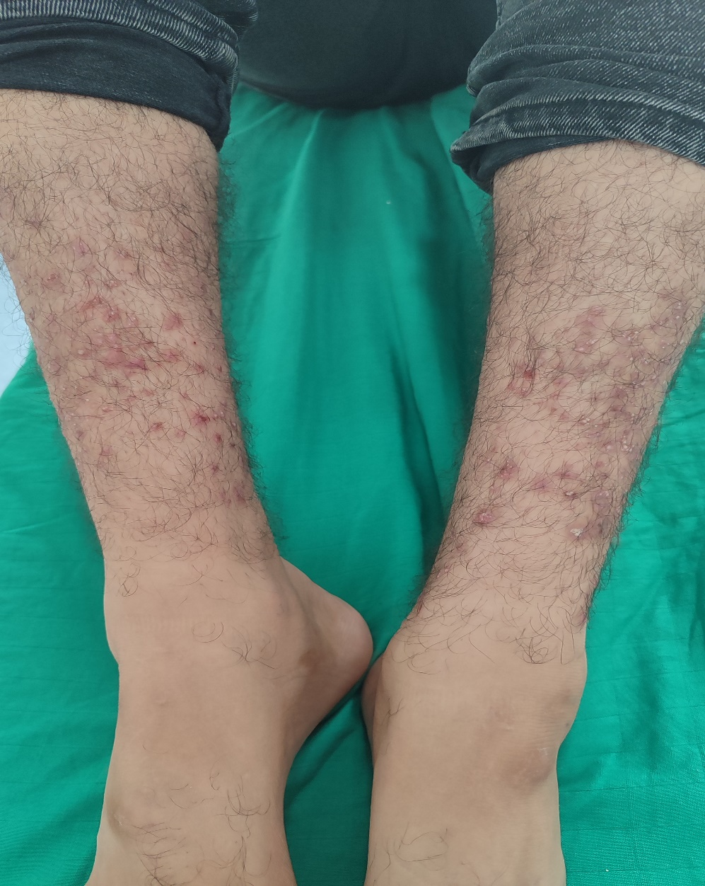

Figure 2 : Trichoadenoma: Multiple Bilateral Whitish Papulocystic Lesions on the Legs
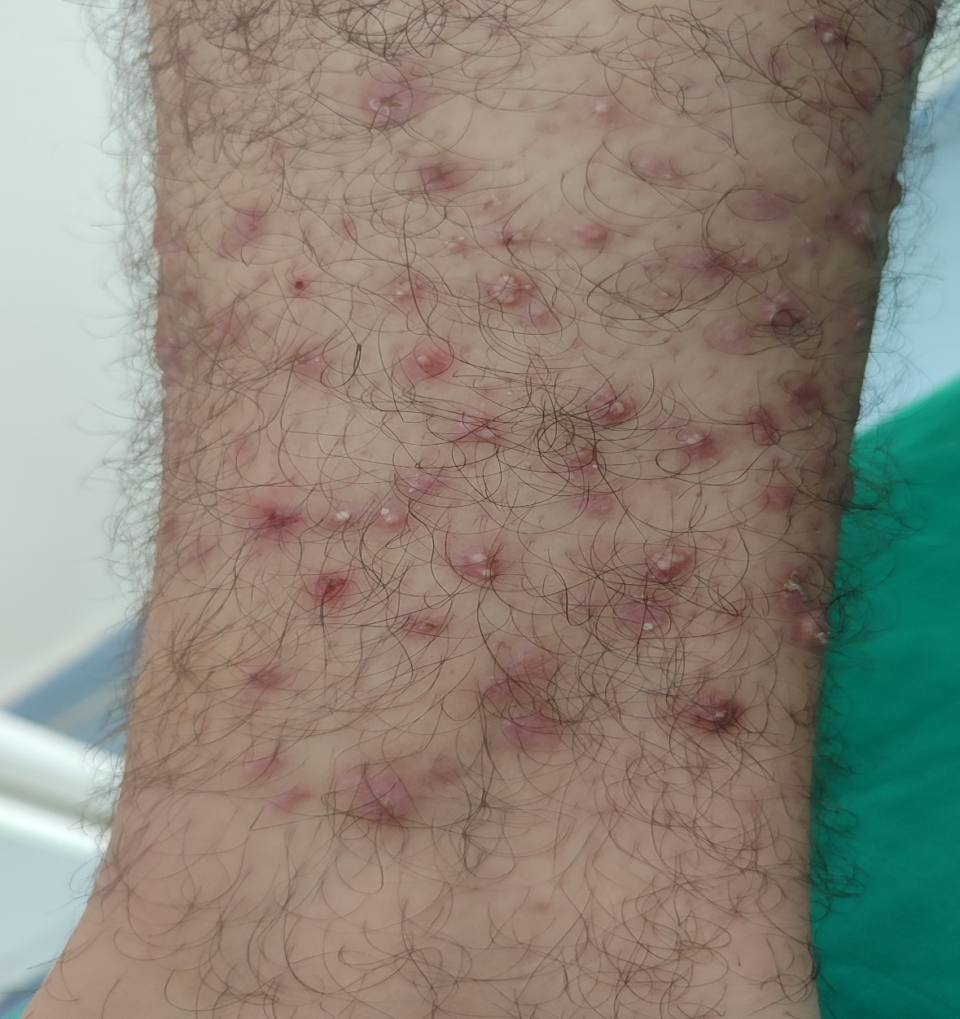

Figure 3 : Dermoscopy: small, grouped, poorly demarcated yellowish areas with a flaky appearance, along with a few serpiginous vessels.
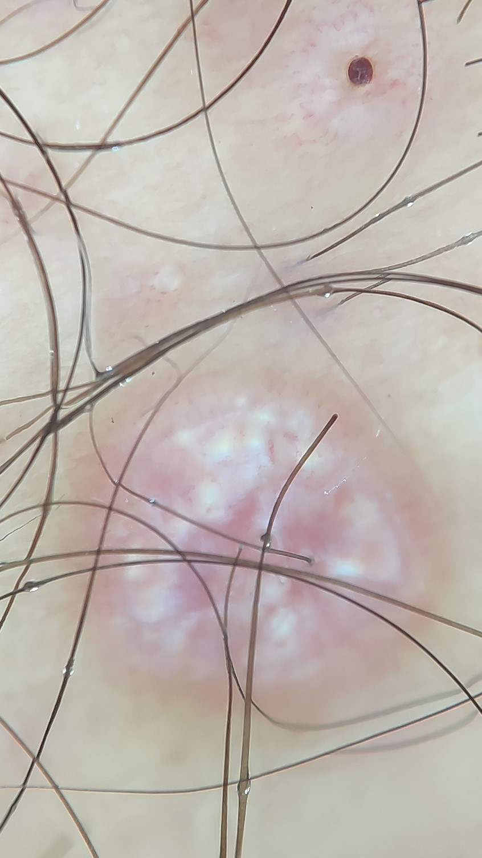

Figure 4 : Histopathology: Multiple keratin-filled cystic structures containing lamellar keratin.
