Botanical Characteristics and Pancreatic Lipase Inhibitory Activity of Ixora coccinea L. Flowers

Abstract
Aims: To describe the macroscopic morphology, the anatomical structure and the powder microscopy of the flowers of Ixora coccinea L., to screen their phytochemical constituents and to evaluate the in vitro pancreatic lipase inhibitory activity of the extracts prepared from them.
Study design: Laboratory experimental study combining descriptive pharmacognostic characterisation with an in vitro enzyme inhibition assay.
Place and Duration of Study: Department of Pharmaceutical Botany and analytical laboratories, Faculty of Pharmacy, Nguyen Tat Thanh University, Ho Chi Minh City, Vietnam, between April and June 2026.
Methodology: Flowers were collected in Vinh Huu commune, Dong Thap province, in April 2026. Morphology, the anatomy of root, stem, leaf and corolla tube after carmine red – iodine green double staining, and the diagnostic elements of the flower powder were examined by light microscopy. A total extract was obtained by cold maceration of 500 g of powdered flowers with ethanol 96 % and was successively partitioned with n–hexane, dichloromethane, ethyl acetate and n–butanol. Classes of constituents were identified by specific colour reactions. Lipase inhibition was measured by the p–nitrophenyl palmitate assay at 405 nm in three independent replicates, with orlistat as positive control.
Results: The morphology agreed in every respect with the published descriptions of the species. The anatomy of the vegetative organs and of the corolla tube was described and the diagnostic elements of the flower powder were established. The flowers contain flavonoids, tannins, polyphenols, anthocyanosides, proanthocyanidins, coumarins, anthraquinones and alkaloids. Maceration gave 62.42 g of total extract, an extraction yield of 12.34 % on a dry weight basis. The total extract was the most active, with IC₅₀ = 83.98 ± 4.38 µg/mL, followed by the ethyl acetate fraction (123.88 ± 3.25 µg/mL) and the n–butanol fraction (136.71 ± 3.49 µg/mL); orlistat gave 1.45 ± 0.22 µg/mL.
Conclusion: The study supplies the botanical data required for the standardisation of this herbal material in Vietnam and shows that the flowers of I. coccinea are a promising source for the development of products supporting the control of obesity through the inhibition of pancreatic lipase.
Keywords: Ixora coccinea L.; microscopic characteristics; phytochemical screening; pancreatic lipase inhibition; obesity.
1. Introduction
Obesity and the metabolic disorders that accompany it are increasing rapidly and have become one of the public health problems given priority for control worldwide. In Vietnam, economic development, a sedentary way of life and energy-dense eating habits have together brought about a considerable rise in the prevalence of obesity. Between 2010 and 2025 the proportion of children aged 5 to 19 years with a body mass index in the overweight range increased by 7.9 % and the proportion in the obese range by 8.7 %; it is estimated that by 2040 approximately 228 million children aged 5 to 19 years will be obese (World Obesity Federation, 2026).
Pancreatic lipase plays a key role in the hydrolysis of dietary triglycerides into free fatty acids and monoacylglycerols, which are then absorbed through the intestinal mucosa. Inhibitors of this enzyme consequently reduce part of the hydrolytic capacity and limit the amount of fat absorbed, thereby contributing to the control of body weight and to the lowering of blood lipids. Orlistat is at present the only lipase inhibitor in widespread clinical use; its gastrointestinal adverse effects have, however, encouraged the search for new inhibitors of natural origin (Birari & Bhutani, 2007).
Ixora coccinea L. is a species of the coffee family (Rubiaceae) that is commonly grown as an ornamental and is employed in the traditional medicine of many Asian countries. The plant contains several classes of compounds, among them flavonoids, naphthoquinones, alkaloids, tannins, steroids and saponins, and has been reported to possess antibacterial, antifungal, analgesic, anti-inflammatory, antioxidant and anti-pruritic activities (Do Huy Bich et al., 2004). In Vietnam, however, no work has yet been published either on the microscopic characteristics required for the standardisation of the herbal material or on the ability of the flowers to inhibit pancreatic lipase.
For these reasons the present study was undertaken with two objectives: to describe the macroscopic morphology, the anatomical structure and the powder microscopy of the flowers of I. coccinea; and to carry out a preliminary screening of their phytochemical constituents and to evaluate the in vitro pancreatic lipase inhibitory activity of the extracts prepared from them.
2. Materials and Methods
2.1 Materials and instruments
2.1.1 Plant material
The flowers of Ixora coccinea L. (Rubiaceae) were collected in Vinh Huu commune, Dong Thap province, Vietnam, in April 2026. Only fully opened flowers of the characteristic orange-red colour, taken from mature plants of normal growth and free from any sign of pest or disease, were retained; withered, bruised or mouldy flowers and material contaminated with foreign matter were discarded. A voucher specimen is deposited at the Department of Pharmaceutical Botany, Faculty of Pharmacy, Nguyen Tat Thanh University.
2.1.2 Chemicals
Distilled water, ethanol 96 %, n–hexane, dichloromethane, ethyl acetate, n–butanol, sodium hypochlorite solution, acetic acid 10 %, carmine red – iodine green stain, dimethyl sulfoxide, pancreatic lipase (Sigma-Aldrich, USA), orlistat and p–nitrophenyl palmitate (p–NPP).
2.1.3 Instruments
BX41 light microscope (Olympus, Japan), 96-well ELISA plate reader, S220-K pH meter (Mettler Toledo, Switzerland), WBU 45 – UM 500 drying oven (Memmert, Germany), Hei-VAP rotary vacuum evaporator (Germany), ALS 22-4N analytical balance (Kern, Germany), moisture analyser (Sartorius, Germany), Power Sonic 410 ultrasonic bath (Hwashin, Korea), water bath (Memmert, Germany) and the usual basic laboratory equipment.
2.2 Methods
2.2.1 Identification of the herbal material
The plant material was identified by comparative morphology combined with microscopy. The whole plant was examined, the dimensions of its parts were measured, its morphological characteristics were described and the description was compared with the published literature. Samples of root, stem, leaf and corolla tube were cut into thin sections with a razor blade, bleached with sodium hypochlorite solution, rinsed with acetic acid 10 % and double stained with carmine red – iodine green. The flowers were cut into small pieces, dried and ground to a powder for microscopic examination. The preparations were observed, photographed and described under the BX41 light microscope at magnifications of 4X, 10X and 40X (Department of Pharmacognosy, 2017).
2.2.2 Preparation of the extracts
Five hundred grams of powdered flowers was macerated in the cold with ethanol 96 % at a herbal material to solvent ratio of 1 : 25 for 24 h at room temperature, the operation being repeated three times. The combined extracts were concentrated under vacuum at about 50 °C to give the total ethanol 96 % extract. This total extract was dissolved in water at a ratio of 1 : 10 and successively partitioned with n–hexane, dichloromethane, ethyl acetate and n–butanol at a ratio of 1 : 1; each of the resulting solutions was evaporated under vacuum at about 50 °C to give the corresponding fraction. The moisture content of the powdered flowers and of every extract was determined on the moisture analyser, and the extraction yield H (%) was calculated on a dry weight basis as:
H (%) = [m₂(100 – h₂)] / [m₁(100 – h₁)] × 100
where:
m₁ and h₁: mass (g) and moisture content (%) of the starting material, that is the powdered flowers when the total extract is considered and the total extract when a fraction is considered;
m₂ and h₂: mass (g) and moisture content (%) of the extract or fraction obtained.
2.2.3 Preliminary phytochemical screening
Fifteen grams of dried flowers were extracted successively with solvents of increasing polarity, namely diethyl ether, ethanol 96 % and water. The resulting solutions were used to identify the classes of natural compounds by means of the specific colour reactions of the routine procedure (Department of Pharmacognosy, 2017). The extent to which each class was present was assessed semi-quantitatively from the intensity of the reaction.
2.2.4 Determination of the lipase inhibitory activity
The lipase inhibitory activity was determined by the method of Nguyen et al. (2024) with modifications. The reaction mixture consisted of 16 µL of the extract solution, 162 µL of Tris – HCl buffer at pH 8.5, 12 µL of lipase (150 U/mL) and 10 µL of p–NPP (5.6 mg dissolved in 1.6 mL of acetonitrile and made up to 5 mL with ethanol 96 %). The mixture was incubated for 25 min and the absorbance was read at 405 nm on a 96-well ELISA plate reader. Orlistat was used as the positive control over the concentration range 0.24, 0.12, 0.06, 0.03, 0.015, 0.0075, 0.00375 and 0.001875 mg/mL in ethanol 96 %. The percentage of enzyme inhibition I (%) was calculated as:
I (%) = {[(A_{std} – A_{std blank}) – (A_{test} – A_{test blank})] / (A_{std} – A_{std blank})} × 100
where A denotes the absorbance of the corresponding solution.
2.2.5 Statistical analysis
Each experiment was performed in three independent replicates. Data are expressed as mean ± standard deviation (mean ± SD). The IC₅₀ values were derived from the logarithmic regression equation relating the logarithm of the concentration to the percentage inhibition, using Microsoft Excel 2019 and GraphPad Prism.
3. Results and Discussion
3.1 Morphological characteristics
The plant is a small woody shrub 30 to 200 cm in height; the young stems are green and the older ones pale grey, the internodes being 0.8 to 1.0 cm apart, and the root system is of the taproot type. The leaves are simple and decussate; the blade is elliptic, 3.0 to 3.5 cm long and 0.8 to 1.0 cm wide, glabrous on both surfaces, glossy dark green above and pale green beneath, with the midrib prominent on the lower surface; the margin is entire, the apex bears a short mucro and the base is cordate to obtuse; the interpetiolar stipules are triangular. The inflorescence is a dichasial cyme, each small cyme bearing three to six flowers. The flowers are bisexual, actinomorphic and tetramerous, with contorted aestivation. The calyx consists of four free, campanulate, orange-red sepals. The corolla is fused into a tube 2.0 to 2.5 cm long, orange-red, divided above into four salver-shaped lobes, each 0.7 to 0.8 cm long and 0.3 to 0.4 cm wide. The androecium comprises four stamens inserted on the corolla tube and alternating with the corolla lobes; the filaments, 2.0 to 2.5 cm long, lie within the tube and the anthers are basifixed and extrorse. The gynoecium consists of two united carpels forming an inferior, two-locular ovary with axile placentation and a bifid stigma. The fruit is a globose berry with a smooth epicarp, green when young and purple when ripe; each fruit contains two seeds, one in each locule, convex on the dorsal side, concave and hairy on the ventral side (Fig. 1).
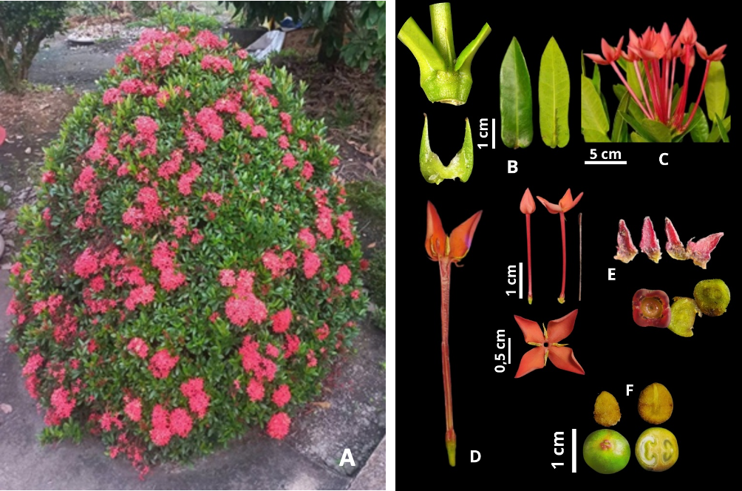
Fig. 1. Morphological characteristics of Ixora coccinea L.
A. Habit; B. Leaf and stipules; C. Inflorescence; D. Longitudinal section of the flower; E. Androecium and gynoecium; F. Fruit and seeds.
3.2 Anatomical structure
Root. The transverse section is almost circular. The cork consists of several layers of rectangular cells with cellulose walls, of uneven size and closely packed. The suberised layer comprises one to two layers of irregularly rectangular cells with suberised walls. The cortical parenchyma consists of fourteen to sixteen layers of irregularly polygonal cells with cellulose walls arranged without order. The endodermis with Casparian strips is a single layer of rectangular to polygonal cells. The pericycle comprises one to two layers of polygonal cells of uneven size, some of which are sclerified. The primary phloem lies immediately outside the secondary phloem, which is thin-walled and arranged in radial rows; the secondary xylem occupies the centre and the primary xylem is difficult to distinguish. Prismatic calcium oxalate crystals are scattered through the cortical parenchyma (Fig. 2).
Stem. The transverse section is almost circular. The epidermis is a single layer of polygonal cells of uneven size covered by a thin cuticle and bearing unicellular covering trichomes. The angular collenchyma comprises four to seven layers of irregularly polygonal cells with cellulose walls arranged without order. The cortical parenchyma consists of seven to ten layers of irregularly polygonal cells. The pericycle is sclerified and forms discontinuous groups of sclereids. The primary phloem consists of small polygonal cells with sinuous walls arranged without order, while the secondary phloem comprises four to six layers of polygonal cells arranged in radial rows. The secondary xylem consists of polygonal vessels of fairly uniform size showing centrifugal differentiation, and the primary xylem comprises three to four layers of polygonal cells alternating with the secondary xylem. The pith parenchyma consists of rounded polygonal cells arranged without order, and prismatic calcium oxalate crystals occur in the cortical parenchyma (Fig. 3).
Leaf. In the midrib, the upper and lower epidermis each consist of a single layer of relatively uniform rectangular to polygonal cells, closely packed and covered by a fairly thick cuticle. Angular collenchyma is present on both sides and comprises four to nine layers of rounded polygonal cells with cellulose walls. The parenchyma consists of five to seven layers of polygonal cells with cellulose walls. The vascular system comprises eighteen to twenty-two collateral bundles; the xylem consists of polygonal cells arranged in rows, the primary phloem of polygonal cells with cellulose walls of fairly uniform size arranged in straight rows, and one to three layers of sclereids lie outside the primary phloem. In the lamina, the upper and lower epidermis each consist of a single layer of rectangular cells of relatively uniform size, closely packed and covered by a thin cuticle; the palisade parenchyma comprises one to two layers of cells with cellulose walls and the spongy parenchyma likewise one to two layers; prismatic calcium oxalate crystals are present in the parenchyma of the midrib (Fig. 4).
Corolla tube. The inner and outer epidermis each consist of a single layer of polygonal cells of relatively uniform size. The parenchyma comprises eight to eleven layers of polygonal cells with cellulose walls, of uneven size and arranged without order. Eight vascular bundles are disposed on a single circle, each consisting of primary phloem and primary xylem; the primary phloem comprises two to four layers of polygonal cells of uneven size surrounding the primary xylem, which consists of one to two layers of irregularly polygonal cells with lignified walls arranged in an arc inside the phloem (Fig. 5).
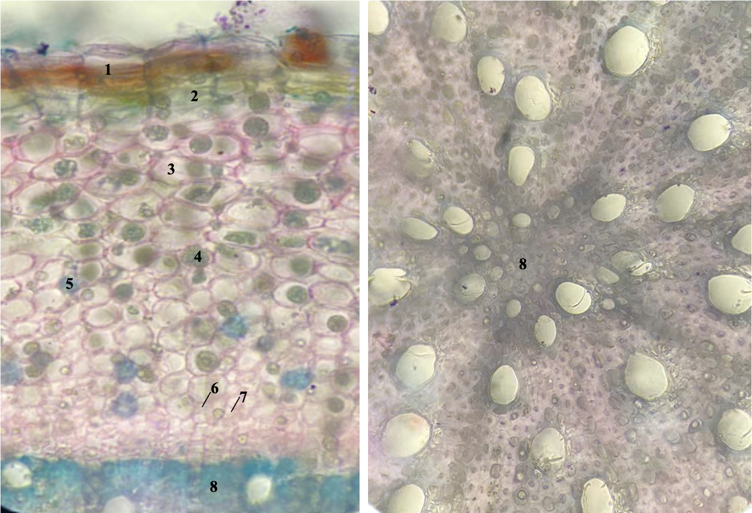
Fig. 2. Transverse section of the root (left, general view; right, detail)
(1) cork, (2) suberised layer, (3) cortical parenchyma with intercellular spaces, (4) calcium oxalate crystal, (5) sclereid, (6) primary phloem, (7) secondary phloem, (8) secondary xylem.
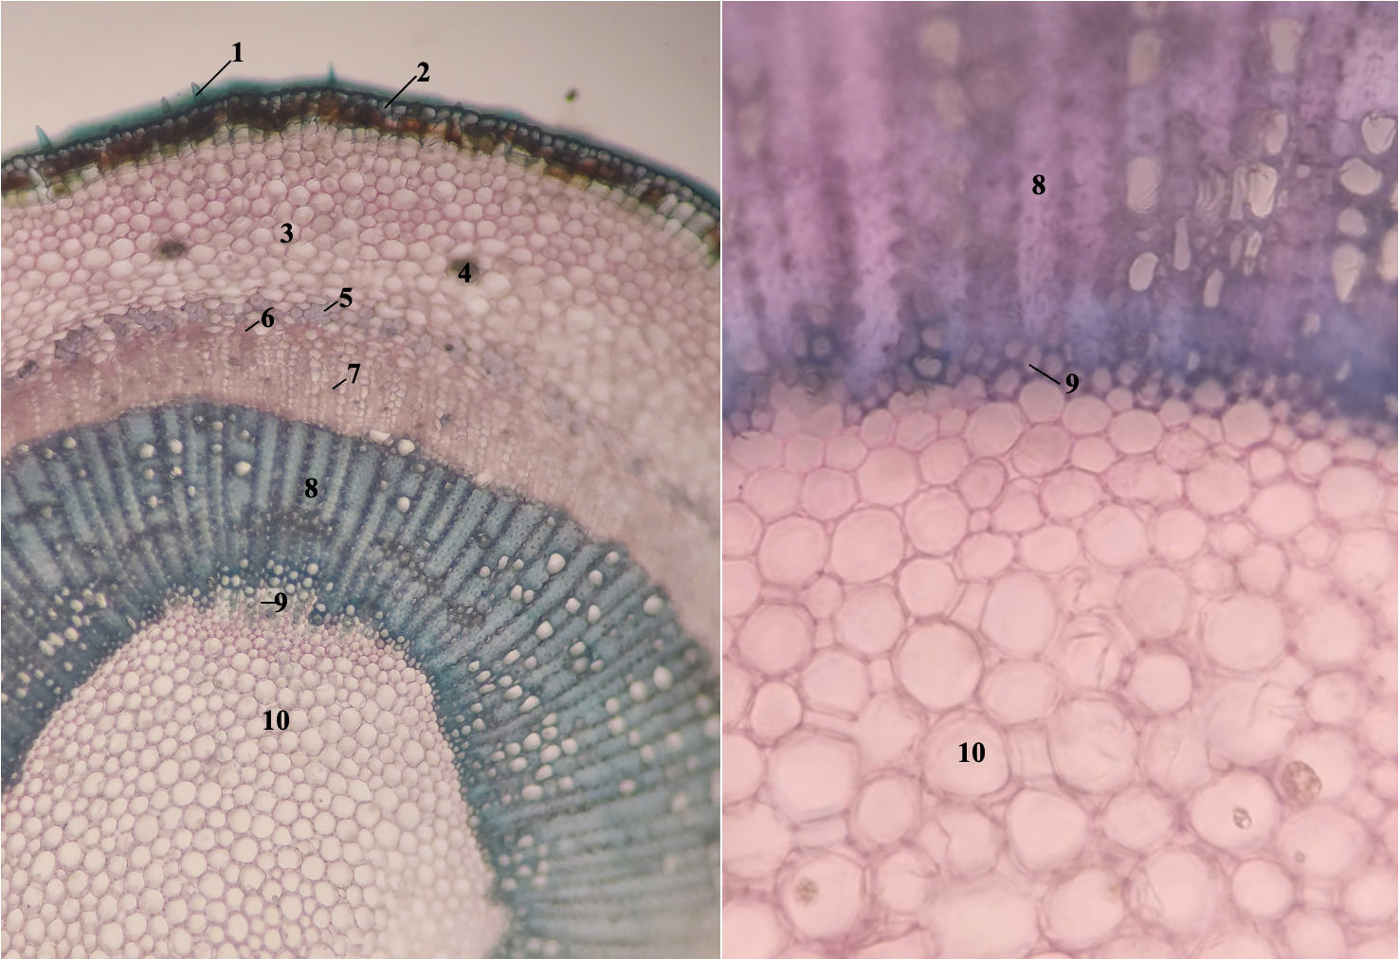
Fig. 3. Transverse section of the stem (left, general view; right, detail)
(1) unicellular covering trichome, (2) epidermis, (3) cortical parenchyma with intercellular spaces, (4) calcium oxalate crystal, (5) sclereid, (6) primary phloem, (7) secondary phloem, (8) secondary xylem, (9) primary xylem parenchyma, (10) pith parenchyma with intercellular spaces.
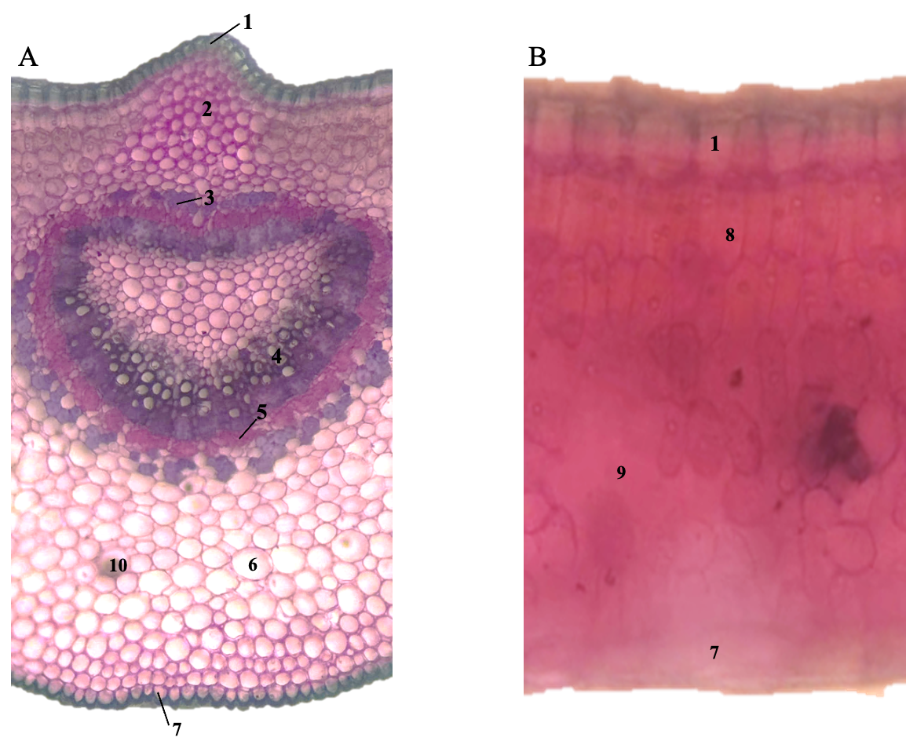
Fig. 4. Transverse section of the leaf, (A) midrib and (B) lamina
(1) upper epidermis, (2) collenchyma, (3) sclereid, (4) primary xylem, (5) primary phloem, (6) parenchyma with intercellular spaces, (7) lower epidermis, (8) palisade parenchyma, (9) spongy parenchyma, (10) calcium oxalate crystal.
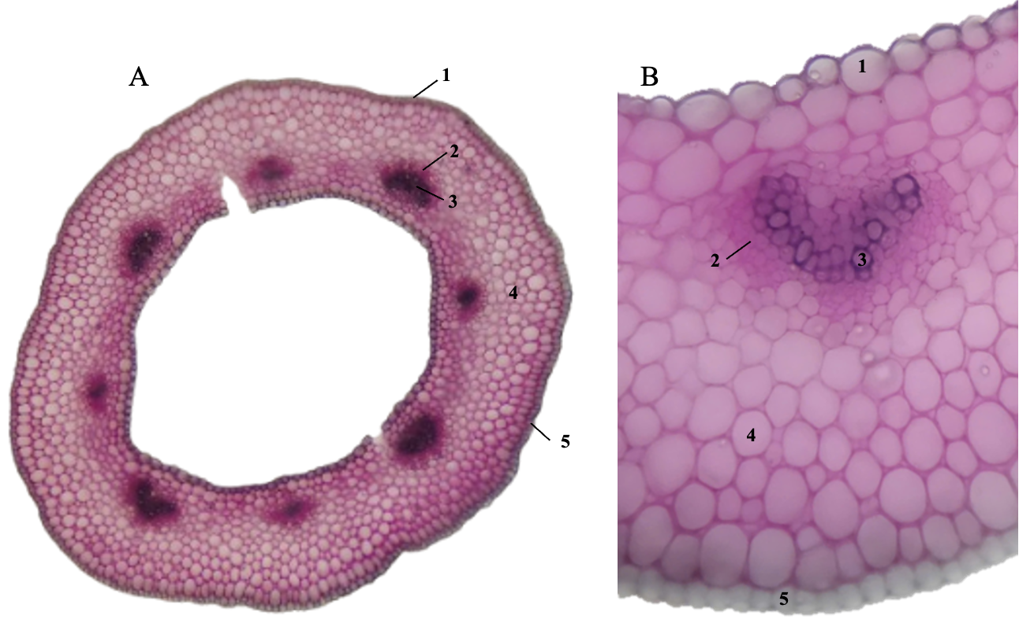
Fig. 5. Transverse section of the corolla tube, (A) general view and (B) detail
(1) outer epidermis, (2) primary phloem, (3) primary xylem, (4) parenchyma with intercellular spaces, (5) inner epidermis.
3.3 Microscopy of the flower powder
The powdered flowers are pale orange in colour (Fig. 6A), with a faint aromatic odour and no particular taste. Under the light microscope the following diagnostic elements are seen: stomata, fragments of pigment-bearing epidermis, ovoid pollen grains with three germ pores, unicellular covering trichomes and fragments of scalariform vessels (Fig. 6).
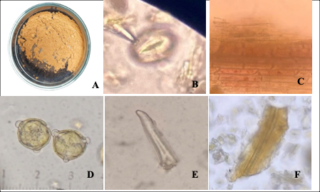
Fig. 6. Diagnostic elements of the flower powder of I. coccinea
A. Flower powder; B. Stoma; C. Fragment of pigment-bearing epidermis; D. Pollen grains; E. Unicellular covering trichome; F. Fragment of a scalariform vessel.
The morphology of the sample collected in Vinh Huu commune agreed in every respect with the descriptions of Ixora coccinea L. given in the published literature, particularly in those features that carry diagnostic weight, namely the triangular interpetiolar stipules, the orange-red dichasial cymes, the corolla fused into a long tube with four salver-shaped lobes, the stamens inserted on the corolla tube and alternating with the lobes, the inferior two-locular ovary and the berry containing two seeds (Lim, 2014; Gopalkrishnan & Chiranjeev, 2018). The authenticity of the material used in the study is thereby confirmed.
The study also supplies data on the anatomical structure and on the microscopy of the flower powder that were hitherto lacking in the Vietnamese literature. The unicellular covering trichomes on the stem epidermis, the sclerified pericycle and the clearly visible endodermis with Casparian strips in the root, together with the diagnostic elements of the flower powder such as the pollen grains with three germ pores, the fragments of pigment-bearing epidermis and the fragments of scalariform vessels, constitute criteria of practical value for the quality control and the identification of the herbal material, especially when it is presented as a powder and the external morphological characteristics are no longer available. Compared with an earlier description of the flowers of the same species, the elements recorded here are similar, which indicates that these microscopic criteria remain stable between different areas of collection (Gopalkrishnan & Chiranjeev, 2018).
3.4 Phytochemical constituents
The results of the preliminary identification of the phytochemical constituents of the flowers by specific colour reactions are presented in Table 1.
Table 1. Preliminary phytochemical screening of the flowers of Ixora coccinea L.
No. | Particulars | Result of the qualitative reaction
 |  | Diethyl ether extract | Ethanol extract | Aqueous extract
1 | Alkaloids | ++ | – | ++
2 | Flavonoids | – | +++ | +++
3 | Anthraquinones | – | + | +
4 | Saponins | – | – | +
5 | Coumarins | – | ++ | +
6 | Anthocyanosides | – | – | +++
7 | Proanthocyanidins | – | – | +++
8 | Polyphenols | – | ++ | +++
9 | Tannins | – | +++ | +++
10 | Reducing compounds | – | + | –
11 | Organic acids | ++ | + | –
(–) absent; (±) doubtful; (+) present in small amount; (++) present in large amount; (+++) present in very large amount.
The flowers proved to be rich in polar classes of compounds, flavonoids, tannins and polyphenols in particular being present in very large amounts in both the ethanol and the aqueous extracts, whereas anthocyanosides and proanthocyanidins were detected in the aqueous extract only. Alkaloids, saponins, anthraquinones, coumarins, reducing compounds and organic acids were present at lower levels.
This profile is consistent with earlier reports on the constituents of the genus Ixora (Do Huy Bich et al., 2004). The concentration of flavonoids, tannins, polyphenols, anthocyanosides and proanthocyanidins in the polar extracts is a noteworthy indication, since polyphenolic compounds, and particularly flavonoids and condensed tannins, have long been recognised as the most widespread natural inhibitors of pancreatic lipase, acting through non-specific interaction with the active site of the enzyme and through modification of the spatial configuration of the protein (Buchholz & Melzig, 2015).
3.5 Yield of the total extract and of the fractions
Five hundred grams of powdered flowers with a moisture content of 11.5 % macerated in the cold with ethanol 96 % gave 62.42 g of total extract with a moisture content of 12.56 %, corresponding to an extraction yield of 12.34 % calculated on the dry weight of the herbal material taken for the extraction. Liquid – liquid partitioning of this total extract with solvents of increasing polarity gave four fractions whose masses, moisture contents and yields are presented in Table 2.
Table 2. Yield of the fractions obtained from the total ethanol 96 % extract
Particulars | n–Hexane | Dichloromethane | Ethyl acetate | n–Butanol
Mass (g) | 6.19 | 9.63 | 15.71 | 10.56
Moisture (%) | 9.10 | 3.88 | 7.34 | 8.17
Yield (%) | 10.30 | 16.96 | 26.67 | 17.77
Yields are expressed on a dry weight basis, relative to the dry weight of the total extract.
The ethyl acetate fraction was by far the most abundant, accounting for more than a quarter of the dry weight of the total extract, followed by the n–butanol and the dichloromethane fractions, whereas the n–hexane fraction was the smallest. The distribution of the material between the fractions is therefore consistent with the phytochemical profile described above, the constituents of the flowers being predominantly of medium to high polarity.
3.6 Pancreatic lipase inhibitory activity of the extracts
The extracts prepared from the flowers inhibited pancreatic lipase to differing extents. The total ethanol 96 % extract was the most active, with an IC₅₀ of 83.98 ± 4.38 µg/mL. Among the fractions, the ethyl acetate fraction was the most active, followed by the n–butanol and the dichloromethane fractions, whereas the n–hexane fraction was the least active. The positive control orlistat gave an IC₅₀ of 1.45 ± 0.22 µg/mL (Table 3).
Table 3. Pancreatic lipase inhibitory activity of the extracts of I. coccinea flowers and of the reference compound
Test sample | IC₅₀ (µg/mL) | Regression equation | R²
Total ethanol 96 % extract | 83.98 ± 4.38 | y = 13.267 ln(x) + 82.964 | 0.9806
n–Hexane fraction | 1238.19 ± 19.48 | y = 19.036 ln(x) + 45.933 | 0.9598
Dichloromethane fraction | 259.07 ± 27.81 | y = 13.035 ln(x) + 67.606 | 0.9824
Ethyl acetate fraction | 123.88 ± 3.25 | y = 17.605 ln(x) + 86.767 | 0.9845
n–Butanol fraction | 136.71 ± 3.49 | y = 16.903 ln(x) + 83.635 | 0.9872
Orlistatª | 1.45 ± 0.22 | y = 7.4261 ln(x) + 98.532 | 0.9783
ª positive control. Data are expressed as mean ± SD (n = 3). In the regression equations, y is the percentage inhibition and x the concentration of the test sample in µg/mL.
The trend observed here supports the hypothesis set out above. The fractions of medium and high polarity, in which the phenolic compounds are concentrated, inhibited the enzyme far more effectively than the fraction of low polarity; the n–hexane fraction, which contains chiefly fats, sterols and other weakly polar substances, was on the contrary of virtually no significance in terms of activity. It is noteworthy that the total extract was more active than any of the fractions derived from it. Such an observation is usually explained either by a synergistic action between the classes of compounds coexisting in the total extract, or by the fact that liquid – liquid partitioning disperses the active constituents among several fractions, so that their concentration in any one fraction is no longer sufficient to maintain the original potency. From the standpoint of application, this result suggests that the total ethanol 96 % extract is the most suitable form of raw material for product development, being at once more potent and simpler to manufacture.
Compared with the reference compound, the potency of the extracts remains considerably lower than that of orlistat. This was to be expected when a multicomponent mixture is set against a pure active substance whose structure has been optimised and which acts by irreversible inhibition. In relation to other herbal materials evaluated by the same method, such as the polyphenol- and saponin-enriched extract of Musa balbisiana fruit, the level of activity recorded for the flowers of I. coccinea is relatively promising and sufficient to regard this species as an object deserving further study (Nguyen et al., 2024). The search for new lipase inhibitors of plant origin continues to attract interest, all the more so since the gastrointestinal adverse effects of orlistat limit adherence to treatment (Birari & Bhutani, 2007).
The study nevertheless has certain limitations. The activity has so far been assessed only in vitro on the isolated enzyme, which does not fully reflect the bioavailability and the metabolism of the compounds in the living organism. The constituents responsible for the effect have not been isolated and their structures have not been elucidated, so that no conclusion can yet be drawn about the mechanism of inhibition at the molecular level. Further work should therefore concentrate on the isolation of pure compounds from the total extract and from the ethyl acetate fraction, on the determination of the type of enzyme inhibition, and on the evaluation of the effect in experimental models of obesity as well as of the toxicity of the herbal material.
4. Conclusion
The study has provided a full description of the morphology, of the anatomical structure of the root, stem, leaf and corolla tube, and of the diagnostic elements of the flower powder of Ixora coccinea L. (Rubiaceae), thereby contributing to the database required for the standardisation and the quality control of this herbal material in Vietnam. The flowers contain numerous polar classes of compounds, among which flavonoids, tannins and polyphenols are prominent. The extracts prepared from them inhibit pancreatic lipase, the total ethanol 96 % extract, obtained from the powdered flowers in a yield of 12.34 % on a dry weight basis, being the most active, which shows that the flowers of I. coccinea are a promising source of raw material for the development of products supporting the control of obesity.
Competing Interests
Authors have declared that no competing interests exist.
Ethical Approval
The study was carried out entirely on plant material and on an in vitro model; neither human subjects nor experimental animals were involved, so that the work did not fall within the remit of the Ethics Committee in Biomedical Research. The herbal material was collected from a commonly cultivated source and does not belong to the list of endangered, precious or rare species given priority for protection. The Faculty of Pharmacy, Nguyen Tat Thanh University, has authorised the use and publication of the data presented.
Declaration of AI Use

This manuscript was prepared through the intellectual contributions of the author(s) to the study design, data analysis, interpretation of results, and scholarly content. Grammarly and ChatGPT were used solely to assist with grammatical refinement and reference formatting during manuscript revision. The author(s) accept full responsibility for the accuracy, integrity, and final content of the manuscript.

References
1. World Obesity Federation. (2026). World obesity atlas 2026: Childhood obesity (2nd ed.). London: World Obesity Federation.
2. Birari, R. B., & Bhutani, K. K. (2007). Pancreatic lipase inhibitors from natural sources: Unfolding the therapeutic potential. Drug Discov Today, 12(19-20), 879-889.
3. Do Huy Bich, Dang Quang Chung, Bui Xuan Chuong, Doan Thi Nhu, Pham Duy Mai, & Do Trung Dam. (2004). Medicinal plants and animals in Vietnam (Vol. 2, pp. 814-815). Hanoi: Science and Technics Publishing House.
4. Department of Pharmacognosy. (2017). Methods of research on medicinal plants. Ho Chi Minh City: Faculty of Pharmacy, University of Medicine and Pharmacy at Ho Chi Minh City.
5. Nguyen, T. T. H., Dinh, K. D., Nguyen, H. T., & Hoang, T. N. N. (2024). Anti-lipase and MCF-7 breast cancer cell proliferation inhibition in vitro of the extract-enriched polyphenols and saponins from Musa balbisiana fruit. HUIT J Sci, 24(1), 93-99.
6. Lim, T. K. (2014). Edible medicinal and non-medicinal plants: Volume 8, Flowers (pp. 734-744). Dordrecht: Springer.
7. Gopalkrishnan, B., & Chiranjeev, R. (2018). Pharmacognostical study of Ixora coccinea flower. Pharmacogn J, 10(5), 1042-1046.
8. Buchholz, T., & Melzig, M. F. (2015). Polyphenolic compounds as pancreatic lipase inhibitors. Planta Med, 81(10), 771-783.

