Assessment of Acute Oral Toxicity, Anti-inflammatory and Anti-hyperuricemic Activities of the Herbal Remedy Lamgout in Mice

Abstract
Background: Lamgout is an herbal preparation containing eight medicinal plants and was evaluated experimentally for acute oral toxicity, anti-inflammatory activity, and uric acid-lowering effects in mice. Methods: Swiss albino mice were used for the experiments. Acute oral toxicity was assessed following administration of the maximum feasible volume of Lamgout extract, corresponding to 182 g of dried herbal material/kg, with observation for up to 14 days. Anti-inflammatory activity was evaluated using 1% carrageenan-induced hind paw edema after oral treatment with Lamgout at 7 or 14 g of dried herb/kg; diclofenac 5 mg/kg served as the positive control. Anti-hyperuricemic activity was assessed in potassium oxonate-induced hyperuricemia using preventive and therapeutic models, with allopurinol 10 mg/kg as the positive control. Results: No mortality or observable signs of acute toxicity occurred following administration of 182 g of dried herb/kg. Both Lamgout doses significantly reduced carrageenan-induced paw edema compared with the model control. In the preventive model, plasma uric acid was reduced by 37.07% and 50.86% at 7 and 14 g/kg, respectively, compared with 82.76% for allopurinol. In the therapeutic model, the corresponding reductions were 40.52%, 43.97%, and 74.14%. Conclusion: Under the experimental conditions used, Lamgout showed no observable acute oral toxicity at the maximum tested dose and demonstrated anti-inflammatory and uric acid-lowering activities in mice. Further studies are required to characterize its active constituents, mechanisms, longer-term safety, and potential clinical relevance.

Keywords: Lamgout; acute oral toxicity; anti-inflammatory; hyperuricemia; carrageenan; potassium oxonate.
1. Introduction
For a long time gout was regarded as a rare condition, a disease of the wealthy. Since the beginning of the twenty-first century, however, its prevalence has been rising rapidly worldwide: between 1990 and 2017 approximately 7.4 million new cases were reported every year, and both the incidence and the number of years lived with disability attributable to gout have continued to increase across most regions (Safiri et al., 2020). Gout results from a disturbance of purine metabolism that raises the concentration of uric acid in the blood; when the solubility limit is exceeded, monosodium urate crystals precipitate in joints and soft tissues and trigger an intense inflammatory response.
The management of gout in modern medicine requires the combination of several classes of drugs: non-steroidal anti-inflammatory drugs and colchicine for the acute flare, and xanthine oxidase inhibitors such as allopurinol or febuxostat for long-term control of serum urate (Pillinger et al., 2020). Beneficial as they are, these agents are associated with adverse effects including gastritis, gastrointestinal bleeding, urticaria and erythema. Allopurinol in particular may cause peptic ulceration, rash, Stevens-Johnson syndrome, hepatocellular necrosis and hepatic granulomas (Rundles, 1985). These limitations explain the sustained interest of researchers in herbal preparations that combine an effective urate-lowering action with a more favourable safety profile.
The Lamgout remedy was formulated from eight medicinal plants whose uric acid-lowering activity has been documented in Vietnam and abroad: Gnetum montanum Markgr., Siegesbeckia orientalis L., Caesalpinia sappan L., Tinospora sinensis (Lour.) Merr., Angelica acutiloba (Siebold & Zucc.) Kitag., Cibotium barometz J. Sm., Cinnamomum cassia Blume and Stevia rebaudiana (Bertoni) Hemsley (Trinh Tuy An et al., 2017). Before such a formula can be recommended for clinical use in gout or gouty arthritis, however, its safety and its anti-inflammatory and urate-lowering efficacy must be established experimentally.
The present study was therefore undertaken with three specific objectives: to determine the acute oral toxicity of the Lamgout extract; to evaluate its anti-inflammatory activity in vivo on the 1 % carrageenan-induced paw edema model; and to evaluate its preventive and therapeutic effects on potassium oxonate-induced hyperuricemia in mice.
2. Materials and Methods
2.1 Materials and instruments
2.1.1 Test material
The aqueous Lamgout extract was supplied by Msc. Hoang Van Lam, formerly a lecturer at the Department of Botany, Hanoi University of Pharmacy. All the herbal ingredients complied with the standards laid down in the Vietnamese Pharmacopoeia V. The composition of one dose of the remedy is presented in Table 1.
Table 1. Composition of one dose of the Lamgout remedy
Ingredient (Vietnamese name / botanical name) | Weight (mg)
Gam (Gnetum montanum Markgr.) | 8000
Hy thiem (Siegesbeckia orientalis L.) | 5000
To moc (Caesalpinia sappan L.) | 5000
Day dau xuong (Tinospora sinensis (Lour.) Merr.) | 4500
Duong quy (Angelica acutiloba (Siebold & Zucc.) Kitag.) | 4000
Cau tich (Cibotium barometz J. Sm.) | 4000
Que chi (Cinnamomum cassia Blume) | 4000
Co ngot (Stevia rebaudiana (Bertoni) Hemsley) | 1900
Total | 36400
One dose of Lamgout contains a total of 36.4 g of dried herbal material, which was extracted with a suitable solvent and concentrated under vacuum to yield 3.54 g of soft extract; excipients, sodium benzoate as preservative and purified water were then added to a final volume of 10 mL. For the pharmacological experiments the extract was diluted with distilled water to the required concentrations, and all doses are expressed as grams of dried herbal material per kilogram of body weight. The remedy is intended to be taken by a 60 kg adult at two doses per day, equivalent to 1.2 g of dried herb/kg; conversion to the mouse with a factor of 11.76 gives a projected effective dose of 14 g of dried herb/kg/day, corresponding to 3.8 mL of Lamgout extract/kg/day (Ministry of Health of Vietnam, 2015).
2.1.2 Animals
Male and female Swiss albino mice, 6-8 weeks old and weighing 22 ± 2 g, were provided by the Institute of Vaccines and Medical Biologicals, Nha Trang. Only healthy animals free from malformation or abnormal behaviour were used. They were housed in cages of 25 × 35 × 15 cm with rice husk bedding and were acclimatised to laboratory conditions for two to three days before the experiments; pelleted food and water were available ad libitum throughout the study.
2.1.3 Chemicals
Uric acid assay kit (URIC ACID liquicolor, Human Ltd. Co., Germany), uric acid standard (Randox Laboratories Limited, United Kingdom), uric acid reagent (Elitech, France), carrageenan and potassium oxonate (Sigma Aldrich, USA), CMC-Na (Himedia, India), water-repellent solution (Ugo Basile, Italy), EDTA K3 tubes (An Phu Medical Investment JSC, Vietnam), NaCl 0.9 % (B. Braun, Vietnam), allopurinol 300 mg tablets (Domesco, Vietnam) and Voltaren® 50 tablets containing diclofenac 50 mg (Novartis, Turkey). Routine laboratory reagents were supplied by the Faculty of Pharmacy, Nguyen Tat Thanh University.
2.1.4 Instruments
Satorius CP 4202S technical balance (Germany), Kern ALS 22-4N analytical balance (Germany), Ugo Basile plethysmometer (Italy), BioTek ELISA reader (USA), Hermle centrifuge (Germany), Gilson micropipettes 1-10 µL and 100-1000 µL (USA) and 96-well plates (Biologix, Denmark).
2.2 Methods
2.2.1 Acute oral toxicity of the Lamgout extract
The acute oral toxicity study followed the Litchfield-Wilcoxon method (Do Trung Dam, 2014) and the regulations of the Ministry of Health of Vietnam on the evaluation of the safety and efficacy of traditional medicines. Principle. The acute toxicity of a test sample is characterised, where possible, by the median lethal dose (LD₅₀), that is the dose killing 50 % of the animals under defined conditions. The LD₅₀ allows the therapeutic index TI = LD₅₀/ED₅₀ to be calculated, ED₅₀ being the median effective dose; a substance is considered to have a satisfactory therapeutic window when TI ≥ 10. Procedure. Twelve healthy mice (50 % male, 50 % female) with glossy fur, clear eyes and normal behaviour were randomly allocated to two groups of six. The animals were kept under laboratory conditions for five to seven days and observed so that any abnormal individual could be excluded. Before the experiment the mice were fasted for at least 12 h with free access to water. The normal group then received distilled water, whereas the test group received a single oral dose of the Lamgout extract at the maximum feasible volume of 50 mL/kg body weight, in accordance with the national guidelines on preclinical and clinical trials of traditional medicines and herbal drugs (Ministry of Health of Vietnam, 2015). General motor activity, behaviour, coat condition, food and water intake, excretion and mortality were recorded for 72 h; if no abnormality or death occurred, observation was continued for 14 days. Had deaths been observed, the dose would have been reduced in order to establish LD₁₀₀, LD₀ and LD₅₀.
2.2.2 Anti-inflammatory activity on the carrageenan-induced paw edema model
Anti-inflammatory activity was studied on hind paw edema induced by λ-carrageenan according to the method of Winter et al. (1962). Carrageenan is a natural sulfated polysaccharide extracted from the red seaweed Chondrus crispus; in pharmacology it is widely used to screen anti-inflammatory agents, the maximum edema being reached within 3 to 5 h. A test sample endowed with anti-inflammatory activity reduces the volume of the injected paw. Preparation of solutions. A 1 % carrageenan suspension was soaked in 0.9 % NaCl for at least 2 h to allow complete swelling; the immersion solution consisted of 100 mL of 0.9 % NaCl in 900 mL of distilled water plus 1 mL of water-repellent solution. Procedure. The baseline volume (V₀) of the left hind paw of every mouse was measured with the plethysmometer by dipping the paw into the immersion solution up to the mark on the plantar surface; two readings were taken and averaged. The animals were then randomly allocated to five groups of ten in such a way that V₀ did not differ significantly between groups: group 1, normal (NOR), distilled water; group 2, model control (MC), distilled water; group 3, positive control (DIC 5), diclofenac 5 mg/kg; group 4 (L7), Lamgout extract 7 g of dried herb/kg; group 5 (L14), Lamgout extract 14 g of dried herb/kg. Distilled water, diclofenac or the test extract was administered orally once a day at a volume of 10 mL/kg at a fixed hour for six consecutive days. On the seventh day, after 12 h of fasting and 1 h after dosing, the mice of groups 2 to 5 received 0.04 mL of the 1 % carrageenan suspension into the plantar surface of the left hind paw, while the animals of group 1 received 0.9 % NaCl. The mice were then kept in cages fitted with a wire grid to avoid contact of the inflamed paw with the bedding and thus to prevent injury and infection. The paw volume (V_{t}) was measured 3, 5, 8, 24, 48 and 72 h after the injection. The degree of paw edema X (%) was calculated as:
X (%) = [(V_{t} – V₀) / V₀] × 100
where:
X: degree of paw edema (%);
V₀: paw volume before induction of inflammation (mL);
V_{t}: paw volume at time t after induction of inflammation (mL).
2.2.3 Preventive effect on potassium oxonate-induced hyperuricemia
Potassium oxonate, 1,4,5,6-tetrahydro-4,6-dioxo-s-triazine-2-carboxylic acid, is a uricase inhibitor. In studies of urate-lowering agents it partially blocks the conversion of uric acid into allantoin and thereby raises plasma uric acid in mice (Tang et al., 2017). Allopurinol 300 mg tablets (Domesco, Vietnam) served as positive control. Thirty mice were randomly allocated to five groups of six: group 1, normal (NOR), distilled water for 5 days; group 2, model control (MC), distilled water for 5 days; group 3 (ALLO 10), allopurinol 10 mg/kg for 5 days; groups 4 and 5, Lamgout extract at 7 g (L7) and 14 g (L14) of dried herb/kg for 5 days. All treatments were given orally at 10 mL/kg once daily for five consecutive days. On the fifth day, 1 h before dosing, the mice of groups 2 to 5 received an intraperitoneal injection of potassium oxonate 300 mg/kg at a volume of 10 mL/kg, whereas group 1 received 0.5 % CMC-Na at the same volume. Two hours after the injection, 50 µL of blood was collected from the tail vein into an EDTA K3 tube and centrifuged at 3000 rpm for 10 min at room temperature. Plasma uric acid was determined with the uric acid kit according to the instructions of the manufacturer at a wavelength of 505 nm, in parallel with a blank and a uric acid standard, and was calculated as:
C_{test} = [(OD_{test} – OD_{blank}) / (OD_{std} – OD_{blank})] × C_{std} (1)
where:
OD_{test}, OD_{blank}, OD_{std}: absorbance of the test sample, of the blank and of the uric acid standard measured at 505 nm;
C_{std}: concentration of the uric acid standard, 9.22 mg/dL;
C_{test}: plasma uric acid concentration of the test sample.
The percentage reduction of uric acid produced by a test sample was calculated as:
Reduction (%) = [(UA_{MC} – UA_{test}) / UA_{MC}] × 100 (2)
where UA_{MC} and UA_{test} are the plasma uric acid concentrations of the model control group and of the treated group respectively.
2.2.4 Therapeutic effect on acute hyperuricemia
At time T0 the mice were randomly allocated to five groups as described in section 2.2.3. The animals of the normal group received an intraperitoneal injection of 0.5 % CMC-Na, while acute hyperuricemia was induced in the remaining groups by an intraperitoneal injection of potassium oxonate 300 mg/kg dissolved in 0.5 % CMC-Na at a volume of 10 mL/kg. One hour after the injection (T = 1 h) the mice received distilled water, allopurinol or the test extract orally at 10 mL/kg. One hour after dosing (T = 2 h) blood was collected from the tail vein and plasma uric acid was measured spectrophotometrically at 505 nm in parallel with a blank and a uric acid standard. The plasma uric acid concentration and the percentage reduction were calculated with equations (1) and (2) as in section 2.2.3.
2.2.5 Statistical analysis
Data are expressed as mean ± SEM. Differences between groups in the inflammation and hyperuricemia models were analysed by the Mann-Whitney and Kruskal-Wallis tests using SPSS 26.0. Differences were considered statistically significant at the 95 % confidence level, that is when P < .05.
3. Results and Discussion
3.1 Acute oral toxicity of the Lamgout extract
In order to establish the scientific basis for the safety of the Lamgout extract in experimental animals, its acute toxicity was investigated first. The test was carried out on six mice (three males and three females) that received a single oral dose at the maximum feasible volume of 50 mL of extract/kg body weight, equivalent to 182 g of dried herbal material/kg. After administration all the animals remained healthy: they ate the pelleted food, drank normally, excreted normally and moved normally, no abnormal sign was observed and no mouse died within 72 h or during the following seven days of observation. Observation was continued for 14 days under normal husbandry conditions and no death occurred, nor any abnormality of behaviour, coat condition, feeding or excretion. The results are presented in Table 2.
Table 2. Survival and mortality of mice in the acute oral toxicity test
Group | No. of mice | No. of deaths | Mortality (%)
Normal (distilled water) | 6 | 0 | 0
Lamgout extract, 182 g dried herb/kg | 6 | 0 | 0
No LD₅₀ could therefore be determined for the Lamgout extract, which showed no acute oral toxicity at the maximum feasible dose D_{max} of 182 g of dried herb/kg. Compared with the projected effective dose in the mouse of 14 g of dried herb/kg, D_{max} is more than thirteen times higher, which corresponds to a therapeutic index TI ≥ 13. A drug is generally considered to possess a satisfactory therapeutic window when TI ≥ 10 (Do Trung Dam, 2014). These findings demonstrate that the Lamgout extract has a wide margin of safety and justified the selection of the two doses of 7 and 14 g of dried herb/kg, equivalent respectively to 1.9 and 3.8 mL of Lamgout extract/kg and to 1/26 and 1/13 of D_{max}, for the subsequent pharmacological experiments.
3.2 Anti-inflammatory activity of the Lamgout extract
The anti-inflammatory activity of the Lamgout extract at 7 and 14 g of dried herb/kg was evaluated on the model of paw edema induced by a 1 % carrageenan suspension. After the injection, the paw volume of the mice of all groups was measured 3, 5, 8, 24, 48 and 72 h later; the degrees of edema obtained are presented in Table 3 and illustrated in Fig. 1.
Table 3. Degree of paw edema (%) in the experimental groups over time
Group (n = 10) | 3 h | 5 h | 8 h | 24 h | 48 h | 72 h
NOR | 0.93 ± 0.62### | 0.87 ± 0.58### | 0.48 ± 0.48### | 0.91 ± 0.61### | 1.35 ± 0.69### | 0.00 ± 0.00###
MC | 71.65 ± 6.19*** | 64.72 ± 4.66*** | 60.57 ± 5.46*** | 54.10 ± 3.68*** | 49.39 ± 4.62*** | 42.97 ± 2.37***
DIC 5 | 38.15 ± 3.36***### | 33.10 ± 2.48***### | 26.33 ± 1.91***### | 22.13 ± 1.40***### | 25.21 ± 2.19***## | 16.95 ± 1.66***###
L7 | 45.37 ± 2.65***## | 38.15 ± 1.99***### | 32.26 ± 1.57***### | 26.57 ± 3.46***## | 28.10 ± 1.81***## | 24.43 ± 2.20***###
L14 | 43.73 ± 3.33***## | 34.01 ± 2.30***### | 28.60 ± 2.04***### | 24.87 ± 2.60***### | 25.54 ± 0.94***### | 22.99 ± 1.59***###
*, **, *** denote P < .05, P < .01 and P < .001 respectively for the difference from the normal group at the same time point; #, ##, ### denote the same probability levels for the difference from the model control group at the same time point. NOR: normal; MC: model control; DIC 5: diclofenac 5 mg/kg; L7 and L14: Lamgout extract at 7 and 14 g of dried herb/kg.
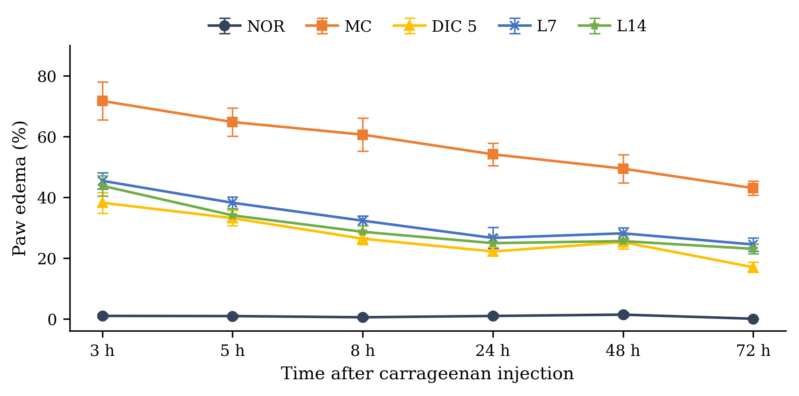
Fig. 1. Degree of paw edema of the experimental groups over time
Values are mean ± SEM (n = 10 per group).
Three hours after the injection the degree of edema in all the injected groups was significantly higher than in the normal group (P < .05), which shows that the injection procedure by itself did not induce inflammation of the paw. The paw of the model control group remained markedly swollen throughout the experiment, the swelling being maximal at 3 h and 5 h with values of 71.65 % and 64.72 %; this is entirely consistent with the known kinetics of carrageenan-induced edema, whose peak occurs within the first hours (Winter et al., 1962). The model was therefore successfully established.
After seven days of treatment, the positive control group receiving diclofenac 5 mg/kg showed a significant reduction of paw edema compared with the model control group (P < .05). The effect was already clear 3 h after the induction of inflammation, with a degree of edema of 38.15 %, and was maintained until the end of the experiment (16.95 % at 72 h), which demonstrates that the model responds appropriately to the reference anti-inflammatory drug.
The degree of edema in both Lamgout groups was lower than in the model control group at every time point examined (P < .05). At 3, 5 and 8 h after the injection the values were 45.37 %, 38.15 % and 32.26 % for the dose of 7 g/kg and 43.73 %, 34.01 % and 28.60 % for the dose of 14 g/kg, against 71.65 %, 64.72 % and 60.57 % in the model control group. The reduction was most pronounced on the first day, decreased slightly on the second day and then persisted until the end of the experiment, which is consistent with the acute nature of carrageenan-induced inflammation. The onset of action of the Lamgout extract was rapid, an anti-inflammatory effect being already evident 3 h after the induction of inflammation. When the two doses were compared with each other, the degrees of edema did not differ significantly at any time point (P > .05), and both were comparable to that of diclofenac 5 mg/kg.
Carrageenan is a sulfated polysaccharide whose sulfate groups initiate the inflammatory process by activating phospholipase A2. The first phase of carrageenan-induced inflammation results from the local injury caused by the injection and from the release of inflammatory mediators, in particular serotonin and histamine, whereas prostaglandins are the main mediators of the second phase, which begins about 3 h after the injection (Winter et al., 1962). The activity observed here is consistent with previous reports on the constituent herbs of the remedy. An ethanol extract of Tinospora inhibits COX-1, COX-2, 5-lipoxygenase and phospholipase A2, which decreases the release of TNF-α, IL-4, nitric oxide and IgE (Chi et al., 2016). An extract of Cinnamomum cassia twigs suppresses carrageenan-induced mechanical hypersensitivity and paw edema by lowering the concentrations of TNF-α, IL-1β, nitric oxide and PGE₂, while Western blot analysis shows a reduced expression of COX-2 and of inducible nitric oxide synthase in the plantar skin (Sun et al., 2016). Z-ligustilide, an active constituent of Angelica acutiloba, exerts anti-inflammatory activity by reducing the lipopolysaccharide-induced production of prostaglandin E₂, nitric oxide and the pro-inflammatory cytokines interleukin-6 and tumour necrosis factor-α (Uto et al., 2015). The stems, leaves and rhizomes of Gnetum montanum are rich in stilbenes and stilbene-related alkaloids and are used in folk medicine for lumbago and rheumatoid joint pain, and recent phytochemical work on Caesalpinia sappan has revealed cassane diterpenes, homoisoflavones and phenolic derivatives that provide a basis for the development of herbal medicines. The anti-inflammatory activity of the Lamgout remedy may thus be attributed to the combined contribution of its individual constituents.
Given these results, the doses of 7 and 14 g of dried herb/kg were retained for the evaluation of the uric acid-lowering activity in vivo.
3.3 Preventive effect of the Lamgout extract on hyperuricemia
The plasma uric acid concentrations measured after the injection of potassium oxonate in the preventive model are presented in Table 4 and Fig. 2.
Table 4. Plasma uric acid concentrations of the experimental groups in the preventive model
Group (n = 6) | Plasma uric acid (mg/dL) | Reduction vs. MC (%)
NOR | 1.55 ± 0.16** | –
MC | 3.05 ± 0.22 | –
ALLO 10 | 0.53 ± 0.05** | 82.76
L7 | 1.92 ± 0.45*## | 37.07
L14 | 1.50 ± 0.12**## | 50.86
*, ** denote P < .05 and P < .01 respectively for the difference from the model control group; #, ## denote the same probability levels for the difference from the allopurinol 10 mg/kg group. NOR: normal; MC: model control; ALLO 10: allopurinol 10 mg/kg; L7 and L14: Lamgout extract at 7 and 14 g of dried herb/kg.
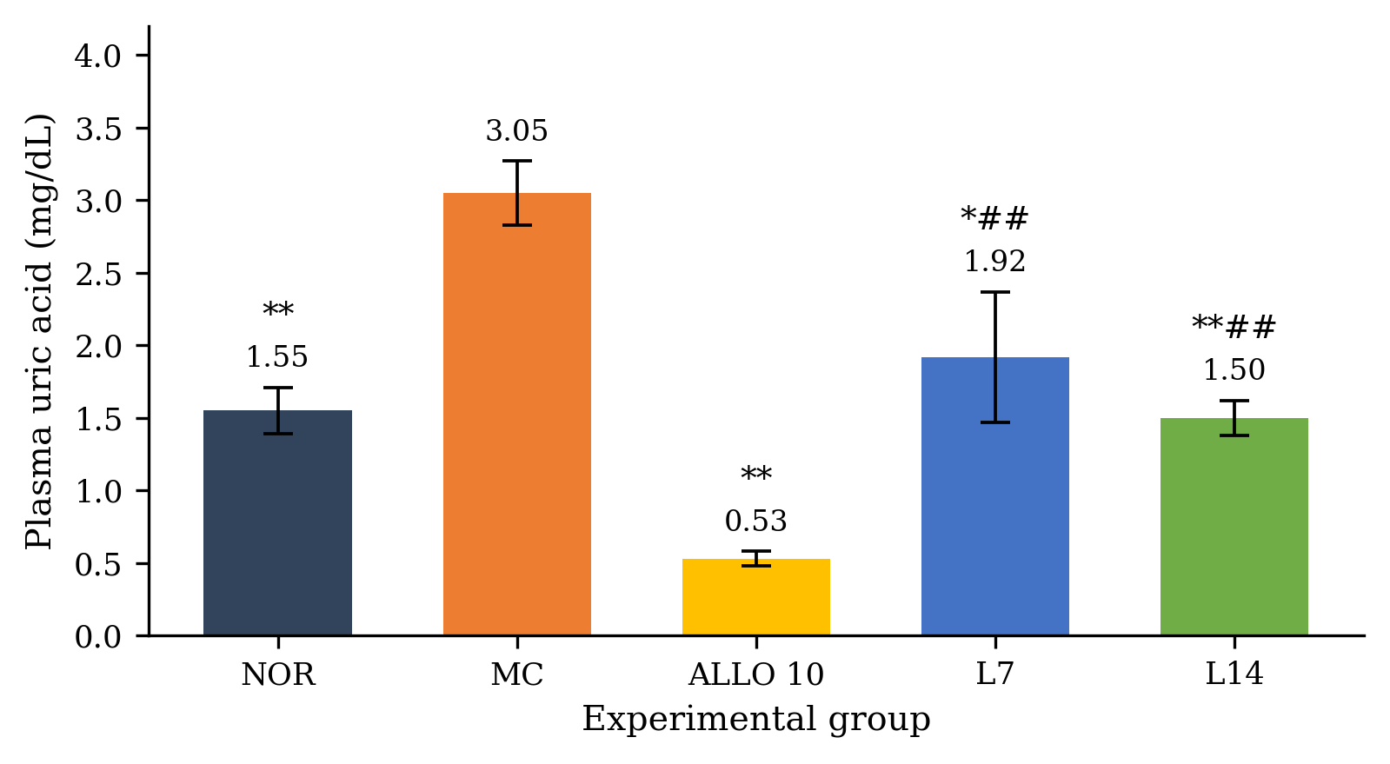
Fig. 2. Plasma uric acid concentrations of the experimental groups in the preventive model
Values are mean ± SEM (n = 6 per group).
After the intraperitoneal injection of potassium oxonate 300 mg/kg, the plasma uric acid concentration of the model control group rose to 3.05 mg/dL, significantly higher than that of the normal group (P < .01), an increase of 96.78 %. The model of hyperuricemia was therefore successfully established. The group receiving allopurinol 10 mg/kg as prophylaxis showed a plasma uric acid concentration of only 0.53 mg/dL, a significant reduction of 82.76 % compared with the model control group (P < .01).
The mice treated with the Lamgout extract at 7 and 14 g/kg had plasma uric acid concentrations of 1.92 mg/dL and 1.50 mg/dL respectively, corresponding to reductions of 37.07 % and 50.86 % relative to the model control group (P < .05). The concentration measured in the group receiving 7 g/kg did not differ significantly from that of the normal group (P > .05) and was comparable to that of the group receiving 14 g/kg. Both extract groups nevertheless remained significantly higher than the allopurinol group (P < .05). These results show that at 7 and 14 g of dried herb/kg the Lamgout extract is able to prevent the rise in plasma uric acid in mice with acute hyperuricemia.
3.4 Therapeutic effect of the Lamgout extract on hyperuricemia
In this experiment potassium oxonate was used to induce acute hyperuricemia, which was then treated with a single dose of allopurinol 10 mg/kg or of the Lamgout extract at 7 and 14 g/kg. One hour after dosing, blood was collected from the tail vein for the determination of plasma uric acid; the results are presented in Table 5 and Fig. 3.
Table 5. Plasma uric acid concentrations of the experimental groups in the therapeutic model
Group (n = 6) | Plasma uric acid (mg/dL) | Reduction vs. MC (%)
NOR | 1.71 ± 0.16** | –
MC | 3.05 ± 0.17 | –
ALLO 10 | 0.79 ± 0.11** | 74.14
L7 | 1.81 ± 0.12**## | 40.52
L14 | 1.71 ± 0.24**# | 43.97
*, ** denote P < .05 and P < .01 respectively for the difference from the model control group; #, ## denote the same probability levels for the difference from the allopurinol 10 mg/kg group.
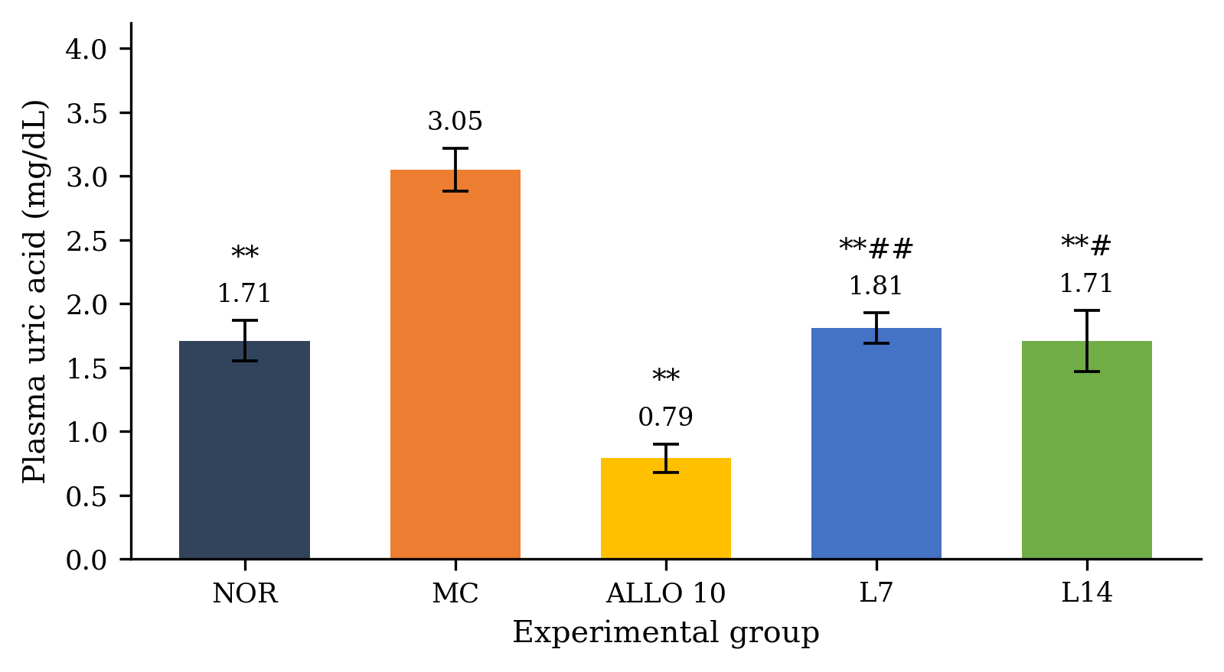
Fig. 3. Plasma uric acid concentrations of the experimental groups in the therapeutic model
Values are mean ± SEM (n = 6 per group).
The plasma uric acid concentration of the model control group rose to 3.05 mg/dL, an increase of 78.36 % that was statistically significant compared with the normal group (P < .01). Allopurinol 10 mg/kg lowered the concentration to 0.79 mg/dL, a significant difference from the model control group (P < .01).
In the mice treated with the Lamgout extract at 7 and 14 g/kg, plasma uric acid fell to 1.81 mg/dL and 1.71 mg/dL respectively, significantly lower than in the model control group (P < .01); in other words the extract reduced plasma uric acid by 40.52 % and 43.97 %. Both concentrations nevertheless differed significantly from that obtained with allopurinol 10 mg/kg (P < .05) and remained higher than in the allopurinol group. This is readily explained by the fact that allopurinol is a synthetic xanthine oxidase inhibitor whose onset of action is more rapid and whose effect is stronger than that of a preparation of natural origin such as the Lamgout extract. Allopurinol acts by inhibiting the terminal step of uric acid synthesis and is itself metabolised by xanthine oxidase into oxypurinol, which retains activity; its effect is therefore prolonged and a single daily administration is sufficient. Its use is, however, limited by adverse effects such as peptic ulceration, rash, Stevens-Johnson syndrome, hepatocellular necrosis and hepatic granulomas (Rundles, 1985), which is precisely why herbal alternatives are being sought.
3.5 Comparison of the uric acid-lowering effect in the two models
The percentage reductions of plasma uric acid obtained in the therapeutic and preventive models are compared in Table 6.
Table 6. Reduction of plasma uric acid by the Lamgout extract in the preventive and therapeutic models
Group | Preventive model (%) | Therapeutic model (%)
Allopurinol 10 mg/kg | 82.76 | 74.14
Lamgout 7 g dried herb/kg | 37.07 | 40.52
Lamgout 14 g dried herb/kg | 50.86 | 43.97
In the preventive model, plasma uric acid was reduced by 82.76 % in the allopurinol group and by 50.86 % in the group receiving Lamgout 14 g/kg, values higher than those recorded in the therapeutic model. This may be explained by the design of the two experiments: in the acute therapeutic model the animals received only a single dose of the test substance, whereas in the preventive model they were dosed for five consecutive days. Gout is classically divided into four clinical stages, among which the acute gouty arthritis flare and the intercritical period between flares. By demonstrating the uric acid-lowering activity of the Lamgout extract on two different models corresponding to two stages of the disease, the present study provides evidence relevant to both the treatment and the prevention of hyperuricemia in patients.
The effect obtained here with the higher dose of 14 g/kg compares favourably with that reported for other traditional formulas investigated on models of similar design in terms of animal species, positive control and method of induction of hyperuricemia.
Several herbs of the Lamgout remedy have also been reported to inhibit xanthine oxidase, the enzyme catalysing the terminal step of uric acid synthesis. This is the case of Siegesbeckia orientalis, whose phenolic-rich fraction combines anti-hyperuricemic, anti-inflammatory and analgesic activities (Nguyen et al., 2017), and of Cinnamomum cassia, Caesalpinia sappan and Tinospora sinensis, extracts of which inhibit the enzyme in vitro at concentrations below 100 µg/mL, the threshold generally used in screening studies to identify promising plant materials. Berberine, caffeic acid, myricetin and ferulic acid have been identified in the stems of the latter species, and myricetin inhibits xanthine oxidase by binding directly to the isoalloxazine ring of the enzyme. When such constituents are combined in appropriate proportions, a reinforcing effect on the inhibition of xanthine oxidase may be produced, although further work is required to confirm this hypothesis for the Lamgout remedy as a whole.
A mechanistic link may also be proposed between the two activities observed. Hypoxanthine is a metabolite and precursor of adenosine, so that plant materials inhibiting xanthine oxidase raise the blood concentration of hypoxanthine and thereby contribute to an increase in adenosine, an endogenous nucleoside that signals to anti-inflammatory cells through the A2A receptor. Herbal preparations lowering plasma uric acid may therefore also contribute to reducing the inflammation associated with gouty arthritis.
4. Conclusion
The aqueous Lamgout preparation produced no mortality or observable signs of acute toxicity in mice at the maximum tested dose equivalent to 182 g of dried herbal material/kg. At doses of 7 and 14 g/kg, the extract significantly reduced carrageenan-induced paw edema relative to the model control. The same doses also reduced plasma uric acid in potassium oxonate-induced hyperuricemia in both preventive and therapeutic experiments, although their uric acid-lowering effects were weaker than those of allopurinol 10 mg/kg. These findings provide preclinical evidence that Lamgout possesses anti-inflammatory and anti-hyperuricemic activities under the experimental conditions used. Further investigations are required to characterize its active constituents and mechanisms of action and to establish its longer-term safety before its potential therapeutic application can be assessed.
Competing Interests
Authors have declared that no competing interests exist.
Ethical Approval
All authors hereby declare that the "Principles of laboratory animal care" (NIH publication No. 85-23, revised 1985) were followed, as well as the specific national laws applicable in Vietnam. All experiments have been examined and approved by the appropriate ethics committee.

COMPETING INTERESTS DISCLAIMER:
Authors have declared that they have no known competing financial interests OR non-financial interests OR personal relationships that could have appeared to influence the work reported in this paper.

Declaration of AI Use

This manuscript was prepared through the intellectual contributions of the author(s) to the study design, data analysis, interpretation of results, and scholarly content. Grammarly and ChatGPT were used solely to assist with grammatical refinement and reference formatting during manuscript revision. The author(s) accept full responsibility for the accuracy, integrity, and final content of the manuscript.

References
1. Safiri, S., et al. (2020). Prevalence, incidence, and years lived with disability due to gout and its attributable risk factors for 195 countries and territories 1990-2017: A systematic analysis of the Global Burden of Disease Study 2017. Arthritis Rheumatol, 72(11), 1916-1927.
2. Pillinger, M. H., et al. (2020). Therapeutic approaches in the treatment of gout. Semin Arthritis Rheum, 50(3S), S24-S30.
3. Rundles, R. W. (1985). The development of allopurinol. Arch Intern Med, 145(8), 1492-1503.
4. Trinh Tuy An, et al. (2017). In vitro and in vivo screening of the hypouricemic activity of some medicinal plants collected in the southern provinces of Vietnam. J Pharm (Vietnam), 57(11).
5. Ministry of Health of Vietnam. (2015). Guidelines for preclinical and clinical trials of traditional medicines and herbal drugs. Hanoi: Ministry of Health of Vietnam.
6. Do Trung Dam. (2014). Methods for the determination of drug toxicity (pp. 15-190). Hanoi: Medical Publishing House.
7. Winter, C. A., Risley, E. A., & Nuss, G. W. (1962). Carrageenin-induced edema in hind paw of the rat as an assay for antiinflammatory drugs. Proc Soc Exp Biol Med, 111(3), 544-547.
8. Tang, D.-H., et al. (2017). Potassium oxonate induces acute hyperuricemia in the tree shrew (Tupaia belangeri chinensis). Exp Anim, 66(3), 209-216.
9. Chi, S., et al. (2016). Genus Tinospora: Ethnopharmacology, phytochemistry, and pharmacology. Evid Based Complement Alternat Med, 2016, 9232593.
10. Sun, L., et al. (2016). The essential oil from the twigs of Cinnamomum cassia Presl alleviates pain and inflammation in mice. J Ethnopharmacol, 194, 904-912.
11. Uto, T., et al. (2015). Anti-inflammatory activity of constituents isolated from aerial part of Angelica acutiloba Kitagawa. Phytother Res, 29(12), 1956-1963.
12. Nguyen, T. D., et al. (2017). Anti-hyperuricemic, anti-inflammatory and analgesic effects of Siegesbeckia orientalis L. resulting from the fraction with high phenolic content. BMC Complement Altern Med, 17, 191.

