Original Research Article

Green Integrated Enzyme–Ultrasound Extraction of Astaxanthin into Soybean Oil from Dried Haematococcus pluvialis: Synergistic Cell Disruption and Response Surface Optimization

.
ABSTRACT

Aims: To develop and optimize an enzyme-assisted ultrasound extraction process for direct recovery of astaxanthin into food-grade soybean oil from dried Haematococcus pluvialis biomass.
Study design: Laboratory-based experimental study involving preliminary single-factor screening followed by Box–Behnken response surface methodology.
Place and Duration of Study: Faculty of Pharmacy, Nguyen Tat ThanhUniversity, Ho Chi Minh City, Vietnam from December 2025 to August 2026.
Methodology: Standardized dried H. pluvialis biomass was subjected to six extraction treatments to evaluate the effects of cellulase, pectinase, and ultrasound, followed by screening of soybean, sunflower, and rice bran oils and cellulase ratios. Response surface methodology was subsequently applied to optimize total enzyme concentration, sonication duration, and liquid-to-solid ratio (L/S; mL oil/g dry biomass). Astaxanthin concentration was determined by UV–Vis spectrophotometry, while microscopic observation was used to assess cellular disruption.
Results: Cellulase, pectinase, combined cellulase–pectinase, and ultrasound treatments alone produced less than 0.3% astaxanthin recovery, whereas the combined enzyme–ultrasound treatment achieved 20.822 ± 0.322% recovery, approximately 75-fold higher than the control. Soybean oil and a 50:50 cellulase formulation showed the highest preliminary extraction performance. Response surface analysis identified the L/S ratio as the most influential factor. The predicted optimum was 2.0% total enzyme concentration, 35 min sonication, and an L/S ratio of 100 mL/g. Experimental validation yielded 79.71 ± 1.22% recovery (n = 6), compared with the predicted value of 79.63%.
Conclusion: The integrated enzyme–ultrasound process substantially enhanced astaxanthin recovery and provides a promising solvent-free, food-compatible approach for producing astaxanthin-enriched soybean oil from dried H. pluvialis biomass.

Keywords: Haematococcus pluvialis; astaxanthin; enzyme-assisted extraction; ultrasound-assisted extraction; soybean oil; response surface methodology

1. INTRODUCTION
Astaxanthin is a high-value ketocarotenoid with pronounced antioxidant activity and is widely investigated for applications in nutraceuticals, functional foods, cosmetics, and aquaculture. Among natural sources, the green microalga Haematococcus pluvialis is one of the most important biological sources of natural astaxanthin. During the encysted stage, H. pluvialis accumulates high levels of astaxanthin within a robust, multilayered cell wall, making intracellular pigment recovery a major downstream-processing challenge. The thick cell wall of H. pluvialis has been identified as one of the principal barriers to efficient astaxanthin extraction and represents an important technological constraint for economically viable algal biorefineries. [1]

Conventional astaxanthin extraction commonly relies on organic solvents or energy-intensive disruption technologies. Acid-assisted extraction followed by acetone treatment has been reported to provide efficient recovery from H. pluvialis, while other approaches include ultrasound-assisted extraction, supercritical carbon dioxide extraction, and direct extraction into vegetable oils. However, the choice of extraction technology involves a trade-off between cell-disruption efficiency, solvent use, energy consumption, product stability, and downstream processing requirements. [2, 3]

Ultrasound-assisted extraction (UAE) is attractive because acoustic cavitation can promote mechanical disruption and enhance mass transfer. Nevertheless, H. pluvialis is particularly resistant to ultrasound because of its highly robust cell-wall structure, and ultrasound alone may therefore provide limited extraction efficiency under mild conditions. Previous studies have demonstrated the feasibility of ultrasound-assisted processes for astaxanthin recovery, including response-surface optimization of liquid-to-solid ratio, extraction temperature, extraction time, and other operating variables.[3, 4]

Enzyme-assisted extraction provides a complementary strategy by targeting structural polysaccharides in the algal cell wall under relatively mild conditions. Cellulase and pectinase have both been investigated for astaxanthin release from H. pluvialis, with enzyme type, pH, temperature, and hydrolysis time influencing extraction performance. In particular, pectinase has been reported to provide greater astaxanthin release than cellulase under the conditions investigated, supporting the use of combined enzymatic systems for further investigation. [5]

Direct extraction into edible oils represents another attractive strategy because the recovered product can remain in a food-compatible lipid phase without requiring a subsequent solvent-removal step. Soybean oil has previously been evaluated as an extraction or co-solvent phase for astaxanthin recovery from H. pluvialis. More recently, an edible astaxanthin-containing soybean oil was produced from H. pluvialis biomass using an integrated cell-disruption and phase-separation process, demonstrating the practical potential of vegetable oils as carriers for astaxanthin-enriched products. [6, 7]

Despite these advances, the efficiency of direct oil-based extraction remains strongly dependent on the accessibility of intracellular astaxanthin. Combining biochemical cell-wall weakening with ultrasound-induced mechanical disruption therefore provides a rational strategy for addressing the structural resistance of H. pluvialis. The key question is whether these complementary mechanisms can provide an extraction response substantially greater than that obtained from either treatment alone.

Accordingly, this study aimed to develop and optimize an enzyme-assisted ultrasound extraction (EAUE) process for the direct recovery of astaxanthin into edible soybean oil from dried H. pluvialis biomass. The study was structured in four stages: (i) determination of the initial total astaxanthin content of the standardized biomass; (ii) evaluation of cellulase, pectinase, combined cellulase–pectinase, ultrasound, and combined enzyme–ultrasound treatments; (iii) screening of the carrier oil and cellulase–pectinase composition; and (iv) multivariate optimization of total enzyme concentration, sonication duration, and liquid-to-solid ratio using a Box–Behnken response-surface design. Astaxanthin concentration, recovery, and antioxidant activity were used to evaluate process performance. The resulting optimized process was subsequently validated experimentally.

2. material and methods

2.1. Object

The primary biological matrix utilized in this study was Haematococcus pluvialis strain UTEX 2505 microalgal biomass, cultivated at the Institute of High Technology, Nguyen Tat Thanh University. To preserve astaxanthin integrity, the harvested biomass was subjected to freeze-drying until a constant mass was achieved, with residual moisture strictly controlled at < 5%. The dried biomass was subsequently mechanically disrupted using a ball mill or stone mortar and passed through standard test sieves to isolate a highly uniform particle size distribution of 0.1–0.25 mm. The standardized powder was vacuum-sealed in opaque aluminum pouches and maintained at -20 °C to inhibit spontaneous auto-oxidation prior to experimental deployment.

2.2. Equipment

Equipment: A laboratory optical microscope (Optica, Italy), pH meter (Mettler Toledo S220, Switzerland), Z306 centrifuge (Hermle, Germany), UV–Vis spectrophotometer (Thermo Scientific, USA), vortex mixer (Labnet, USA), and Elma Select 100 ultrasonic bath (Elma, Germany) were used. Sample preparation was performed using a freeze dryer, ball mill, standard sieves, and thermostatic orbital shaker. The microscope was used to evaluate morphological changes in H. pluvialis cells following the extraction treatments.

2.3. Chemicals

Hydrochloric acid (HCl, 37% fuming; EMSURE®, ACS, ISO, Reag. Ph Eur) and acetone (99.8%, EMSURE®, Merck, Germany) were used for the reference extraction of total astaxanthin. Citrate buffer (0.1 M, pH 4.8) was used for biomass hydration and enzymatic pretreatment. Commercial cellulase (100,000 U/g) and pectinase (60,000 U/g) were obtained from Sunson Industry Group Co., Ltd. (China) and used for enzymatic cell-wall pretreatment. Food-grade soybean oil, rice bran oil, and sunflower oil (Tường An, Vietnam) were used as edible lipophilic extraction phases for preliminary carrier-oil screening. All chemicals and reagents were used as received unless otherwise stated.
2.4. Research Method
2.4.1. Determination of Initial Total Astaxanthin Content
The initial total astaxanthin content of standardized dried Haematococcus pluvialis biomass was determined as the reference value (M_{total}) for subsequent recovery calculations. Briefly, 10 mg of dried biomass was treated with 1.0 mL of 4 M HCl at 70 °C for 5 min, cooled to room temperature, and extracted repeatedly with acetone. Each extraction consisted of vortex homogenization, 10 min ultrasonication, and centrifugation at 4000 rpm for 5–10 min. Extraction was continued until the residual biomass was visibly decolorized. The combined acetone extracts were analyzed by UV–Vis spectrophotometry at 475 nm, and astaxanthin content was estimated using the specific extinction coefficient ($E_{1 cm}^{1\%}$=2100) in acetone. Results were expressed as mg astaxanthin/g dry biomass (mg/g DW), with correction for the total extraction volume and dilution factor. The determination was performed using eight independent replicates (n=8), and the mean value was used as M_{total.}
.2.4.2. Green Extraction Protocol
Six extraction treatments were evaluated: Control (no enzyme, no ultrasound), E1 (cellulase), E2 (pectinase), E3 (cellulase–pectinase), U (ultrasound alone), and EU (enzyme pretreatment followed by ultrasound).
For each treatment, 10 mg of standardized dried Haematococcus pluvialis biomass was hydrated in citrate buffer (pH 4.8). The E1, E2, E3, and EU treatments received the predetermined enzyme formulation, whereas the Control and U treatments were enzyme-free. After the enzyme pretreatment/hydration stage, the aqueous phase was removed and 1.0 mL of commercial food-grade soybean oil was added as the extraction phase.
The Control, E1, E2, and E3 treatments were extracted without ultrasound, whereas U and EU were subjected to ultrasound for the predetermined extraction time. After extraction, the mixtures were centrifuged to separate the oil phase from the residual biomass, and the recovered oil was collected, protected from light, and analyzed for astaxanthin content by the validated UV–Vis method. Each treatment was performed in triplicate (n=3).
2.4.3. Single-Factor Experimental Screening

To identify suitable conditions for subsequent extraction optimization, two key parameters were screened using a one-factor-at-a-time approach.

Carrier Oil Screening: Three edible oils—soybean oil, sunflower oil, and rice bran oil—were evaluated as lipophilic carrier phases under identical extraction conditions. Astaxanthin concentration and recovery were compared to determine the most suitable carrier oil for subsequent experiments.

Binary Enzyme Ratio Screening: The effect of the cellulase-to-pectinase ratio on astaxanthin recovery was evaluated using five enzyme formulations: 0:100, 25:75, 50:50, 75:25, and 100:0 (% w/w). The total enzyme concentration was kept constant, while only the relative proportion of cellulase and pectinase was varied. The formulation providing the highest astaxanthin recovery was selected for subsequent optimization.

2.4.4. Multi-Parametric Process Optimization (RSM)

Using Design-Expert software (or JMP Pro), optimize the Enzyme-Assisted Ultrasound Extraction (EAUE) settings such as total enzyme concentration, sonication duration, and oil volume to achieve the highest astaxanthin recovery yield. Design with 17 experiments, five key experiments (center points) with the following conditions: maximum extraction yield and optimal resource efficiency.
The model has the form:
Y = b₀ + b₁X₁ + b₂X₂ + b₃X₃ + b₁₁X₁² +b₂₂X₂² +b₃₃X₃² +b₁₂(X₁X₂) + b₁₃(X₁X₃) + b₂₃(X₂X₃)
Where, X₁ is, the total enzyme concentration (%), X₂ is the sonication duration (min), and X₃ is L/S ratio (mg/g). Create an experimental matrix table using the experimental levels provided, based on those found in Table 1.
Table 1. Experimental levels employed in the Box-Behnken Design model
Level | Total enzyme concentration (%) | Sonication duration (min) | L/S ratio (mL/g)
Original level  Variation range  Upper level  Lower level | 2  1.0  3.0  1.0 | 35  20  55  15 | 100  50  150  50

3. results and discussion

3.1 Results

3.1.1. Initial Total Astaxanthin Content (M_{total})

The initial total astaxanthin content of the standardized Haematococcus pluvialis biomass was determined by exhaustive acid-assisted extraction followed by acetone extraction and used as the reference value (M_{total}) for subsequent recovery calculations. The determined astaxanthin content ranged from 20.67 to 22.85 mg/g DW across eight independent replicates (n=8), with a mean value of 21.94 mg/g DW and an RSD of 2.83% (Table 2). The low RSD indicates good repeatability of the reference extraction and provides a consistent baseline for evaluating the efficiency of the subsequent enzyme-assisted ultrasound extraction process.

Table 2. Initial total astaxanthin content of standardized H. pluvialis biomass determined by exhaustive extraction (n=8)
Parameter | Value
Number replicates (n) | 8
Minimum value (mg/g DW) | 20.67
Maximum value (mg/g DW) | 22.85
Mean concentration (M_{total}) mg/g DW | 21.94
Relative Standard Deviation (RSD) | 2.83%

3.1.2. Effect of Enzymatic and Ultrasound-Assisted Treatments on Astaxanthin Recovery
The effects of enzymatic and ultrasound-assisted treatments on astaxanthin extraction from standardized dried Haematococcus pluvialis biomass were evaluated using six treatment conditions: untreated control (Control), cellulase pretreatment (E1), pectinase pretreatment (E2), combined cellulase–pectinase pretreatment (E3), ultrasound-assisted extraction alone (U), and combined enzyme–ultrasound extraction (EU). The astaxanthin concentrations and recovery yields obtained from the three independent replicates are summarized in Table 3.

Table 3. Astaxanthin concentration and recovery obtained from different enzymatic and ultrasound-assisted extraction treatments.
Treatment | Astaxanthin concentration (mg/g) | Recovery (%)
Control | 0.061 ± 0.001 | 0.277 ± 0.003
E1 – Cellulase | 0.047 ± 0.024 | 0.212 ± 0.107
E2 – Pectinase | 0.062 ± 0.022 | 0.284 ± 0.102
E3 – Cellulase + Pectinase | 0.044 ± 0.026 | 0.200 ± 0.117
U – Ultrasound | 0.042 ± 0.014 | 0.191 ± 0.062
EU – Enzyme + Ultrasound | 4.568 ± 0.071 | 20.822 ± 0.322

The Control and individual treatments resulted in very low astaxanthin recovery. The mean astaxanthin concentrations for Control, E1, E2, E3, and U were 0.061, 0.046, 0.062, 0.044, and 0.042 mg/g, respectively, corresponding to recovery yields of 0.277, 0.212, 0.284, 0.200, and 0.191%. These values represented less than 0.3% of the initial astaxanthin content (M_{total}=21.94) mg/g DW), indicating that cellulase, pectinase, their combination, or ultrasound alone produced only limited astaxanthin recovery under the conditions investigated.
In marked contrast, the combined enzyme–ultrasound treatment (EU) substantially enhanced astaxanthin extraction. The mean astaxanthin concentration reached 4.568 mg/g, corresponding to a recovery of 20.822%. Relative to the untreated Control, the EU treatment increased the recovered astaxanthin concentration by approximately 75-fold (4.568 vs. 0.061 mg/g) and produced a comparable increase in recovery from 0.277 to 20.822%.

One-way ANOVA demonstrated a highly significant effect of treatment on both astaxanthin concentration ((F_{5,12}=8808.80), (p<0.001)) and recovery ((F_{5,12}=8895.12), (p<0.001)). Post hoc analysis indicated that the EU treatment differed significantly from the other extraction treatments, whereas the Control, E1, E2, E3, and U groups showed no significant differences among one another. These results indicate that the substantial improvement in astaxanthin recovery was associated specifically with the combined application of enzymatic pretreatment and ultrasound rather than with either treatment applied independently.

3.1.2.1. Microscopic Evidence of Cellular Disruption

The microscopic observations were consistent with the quantitative extraction results (Figure 1). The Control cells exhibited predominantly intact spherical morphology with intense orange-red intracellular pigmentation. Similar cellular morphology was observed in the cellulase (E1), pectinase (E2), and cellulase–pectinase (E3) treatments, with most cells retaining their spherical shape and visible pigmentation Fig 1.

Ultrasound treatment alone (U) produced some morphological alterations and cellular debris; however, many apparently intact pigmented cells remained visible. In contrast, the combined enzyme–ultrasound treatment (EU) resulted in pronounced morphological disruption, characterized by a reduced number of intact pigmented cells, increased cellular debris, and the appearance of apparently decolorized cellular remnants.

The marked difference between the EU treatment and the individual treatments suggests that enzymatic pretreatment and ultrasound acted through complementary mechanisms. Enzymatic hydrolysis may weaken the polysaccharide-rich cellular matrix, thereby increasing cell susceptibility to subsequent ultrasonic disruption, while ultrasound-induced cavitation can enhance mechanical disruption and mass transfer. The substantially higher astaxanthin recovery observed for EU compared with the enzyme-only and ultrasound-only treatments is consistent with a strong supra-additive interaction between the two processes. However, the microscopic observations are considered supportive morphological evidence and do not by themselves establish the molecular mechanism of cell disruption.

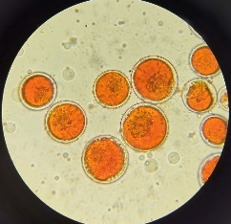  Control | 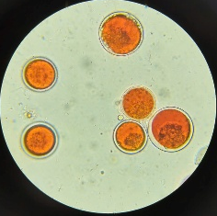  Cellulase (E1) | 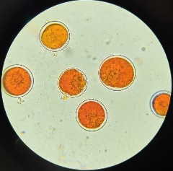  Pectinase (E2) | 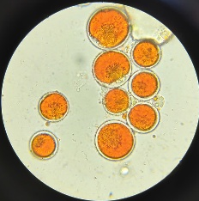  Cellulase–pectinase (E3) | 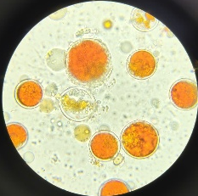  Ultrasound (U) | 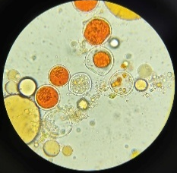  Enzyme–ultrasound (EU)
Fig.1. Microscopic evidence of cellular disruption in Haematococcus pluvialis following enzymatic and ultrasound-assisted treatments.

3.1.2.2 Overall Performance of the Integrated Extraction Process

The results demonstrate that the integrated enzyme–ultrasound process was substantially more effective than the individual treatments for recovering astaxanthin from dried H. pluvialis biomass. Although the enzyme-only and ultrasound-only treatments yielded recoveries below 0.3%, their combination increased recovery to 20.822%. This pronounced improvement provides the experimental basis for applying the enzyme–ultrasound system as the core extraction platform for subsequent response surface optimization.
The EU treatment was therefore selected for the subsequent screening and optimization experiments, with the cellulase–pectinase composition, total enzyme concentration, sonication duration, and liquid-to-solid ratio considered as process variables according to the experimental design.

3.1.3. Single-Factor Experimental Screening
Carrier oil screening. The type of carrier oil clearly affected astaxanthin extraction. Soybean oil provided the highest astaxanthin concentration (17.614 mg/g) and recovery (80.283 ± 0.606%), followed by sunflower oil (14.228 mg/g; 64.853 ± 2.728%) and rice bran oil (11.563 mg/g; 52.703 ± 1.559%). Soybean oil therefore showed the best extraction performance among the tested oils and was selected as the carrier oil for subsequent experiments.
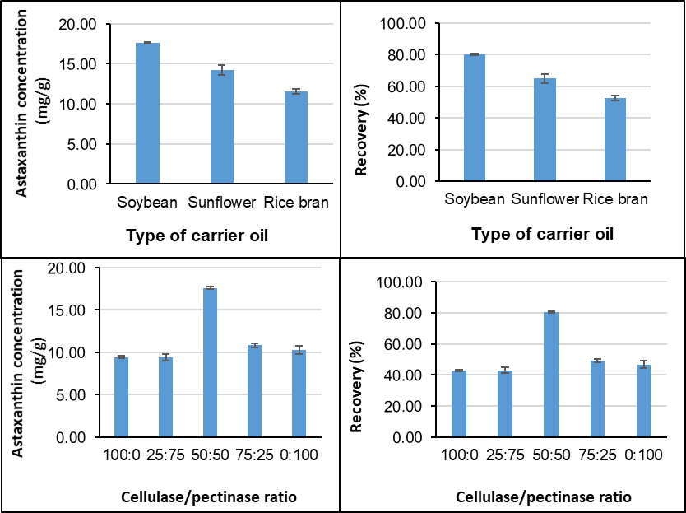
Cellulase/pectinase ratio screening. The relative proportion of cellulase and pectinase also substantially affected astaxanthin recovery. The 50:50 ratio gave the highest astaxanthin concentration (17.614 mg/g) and recovery (80.283 ± 0.606%). In comparison, the recovery values for the 100:0, 25:75, 75:25, and 0:100 ratios were 43.039 ± 0.579%, 42.913 ± 1.873%, 49.175 ± 1.104%, and 46.742 ± 2.243%, respectively. The markedly higher recovery obtained with the 50:50 formulation suggests that the combined action of cellulase and pectinase may facilitate more effective disruption of the cellular matrix and enhance astaxanthin release into the oil phase.
Fig.2. Effects of carrier oil type and cellulase-to-pectinase ratio on the astaxanthin concentration and recovery yield
Overall, soybean oil and the 50:50 cellulase/pectinase ratio were selected based on their superior astaxanthin concentration and recovery and were subsequently used as fixed conditions for the extraction optimization experiments.
3.1.4. Multi-Parametric Process Optimization (RSM)

Independent Variables: X₁ (total enzyme concentration); X₂ (sonication duration); X₃ (L/S ratio); and one dependent variable: Y (recovery yield). According to JMP analysis, the curve equation of the response surface model takes the following form:
Y = 79.626 - 18.556X₃ - 11.594X₁² - 14.410X₂2 - 9.810X₃²
where $Y$ is the dependent variable's response to the recovery yield.
"L/S ratio" is the most important factor influencing the recovery yield. The graph can be used to establish the appropriate extraction settings (Fig. 3), total enzyme concentration: 2%; sonication duration: 35 minutes; L/S ratio: 100 mL/g; predicted results: recovery yield (Y): 79.626%.
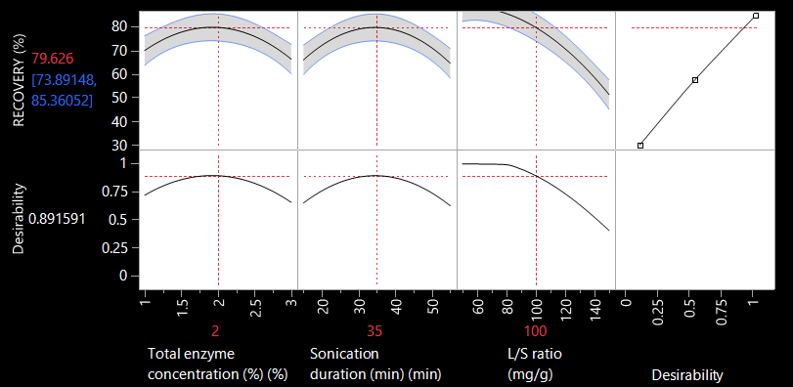
Under these optimal conditions, the actual experimental yield was 79.71 ± 1.22% (n = 6), which showed no significant difference from the predicted result of 79.63% (p > 0.05) (Table 4).
Fig. 3. Prediction profiler plot for the optimization of astaxanthin recovery yield.

Table 4. Experimental results
n | Recovery yield | Results of statistical processing
1 | 79.307 | n = 6
2 | 81.394 | Recovery Average = 79.708 %
3 | 80.149 | SD =1.165
4 | 80.077 | RSD = 1.462
5 | 79.456 | n = 6; p= 0,95; t = 2.57
6 | 77.864 | e = 1.22
Average | 79.708 | Confidence interval: 79.71 ± 1.22

So the optimal conditions are as follows: Total enzyme concentration: 2%; Sonication duration: 35 min; L/S ratio: 100 mL/g.

3.2 Discussion

3.2.1. Synergistic Effect of Enzymatic Pretreatment and Ultrasound

The present results demonstrated a pronounced enhancement in astaxanthin recovery when enzymatic pretreatment was combined with ultrasound-assisted extraction. Cellulase, pectinase, combined cellulase–pectinase treatment, and ultrasound alone resulted in recovery yields below 0.3%, whereas the combined enzyme–ultrasound treatment (EU) achieved a recovery of 20.822 ± 0.322%. The approximately 75-fold increase relative to the untreated control indicates that the combined treatment was substantially more effective than either treatment applied independently.

The limited recovery obtained with the individual treatments is consistent with the well-recognized resistance of Haematococcus pluvialis cysts to downstream cell disruption. The robust cell-wall structure of H. pluvialis represents a major technological barrier to intracellular astaxanthin recovery, and recent reviews continue to identify efficient cell disruption as one of the key challenges in the commercialization of microalgal astaxanthin [8, 9]. Ultrasound-assisted extraction can promote mechanical disruption and mass transfer through acoustic cavitation, whereas enzymatic pretreatment can weaken structural polysaccharides in the cell wall. Previous studies have demonstrated the usefulness of ultrasound-based processes for astaxanthin extraction and optimization [4, 10]

The microscopic observations obtained in the present study support this interpretation. The Control, E1, E2, and E3 treatments retained predominantly intact pigmented cells, whereas ultrasound alone caused only limited morphological disruption. In contrast, the EU treatment showed pronounced cellular disruption, increased cellular debris, and apparently decolorized cellular remnants. These observations are consistent with a complementary interaction in which enzymatic pretreatment increases cellular susceptibility to subsequent ultrasonic disruption. However, microscopy provides supportive morphological evidence rather than direct proof of the molecular mechanism.

The EU response was also substantially greater than that expected from the individual treatments according to the operational supra-additive criterion used in this study. Therefore, the data support the presence of a strong supra-additive interaction between enzymatic pretreatment and ultrasound under the investigated conditions. This interpretation is consistent with the broader trend toward integrating complementary physical and biological cell-disruption mechanisms to improve the downstream recovery of microalgal bioactive compounds [8, 9].

3.2.2. Influence of Carrier Oil and Enzyme Composition

The preliminary carrier-oil screening demonstrated that the extraction phase had a pronounced effect on astaxanthin recovery. Among the soybean, sunflower, and rice-bran oils evaluated in the present study, soybean oil produced the highest preliminary recovery (80.283 ± 0.606%) and was therefore selected as the carrier phase for subsequent optimization. The suitability of soybean oil as an edible carrier for H. pluvialis-derived astaxanthin is supported by previous research. Dong et al. reported the feasibility of soy-oil extraction of astaxanthin from H. pluvialis, while more recent work demonstrated the production of astaxanthin-containing soybean oil with a cumulative recovery of 66.41% and substantially enhanced antioxidant capacity [2, 7]

Recent research further confirms growing interest in vegetable oils as food-compatible extraction phases. Mansouri et al. (2026) compared several disruption strategies and investigated vegetable oils including argan, cannabis, and olive oils as non-polar extraction phases for H. pluvialis biomass [11]. These studies indicate that edible oils can serve not only as extraction phases but also as potential final carriers for astaxanthin-enriched lipid products. Accordingly, the significance of soybean oil in the present study does not rely on its use as a novel solvent, but rather on its integration into an enzyme-assisted ultrasound extraction platform.

The enzyme-composition screening further showed that the 50:50 cellulase–pectinase formulation provided the highest extraction performance among the tested enzyme ratios. This finding suggests that combining enzymes with complementary substrate specificities may improve accessibility of intracellular astaxanthin compared with either enzyme alone. Zhao et al. demonstrated that both cellulase and pectinase could improve astaxanthin release from H. pluvialis, with pectinase providing significantly greater release than cellulase under their investigated conditions [5]. The present findings extend this concept by showing that the relative composition of the two enzymes can also influence the performance of the integrated extraction process.

3.2.3. Response Surface Optimization, Model Validation, and Green Extraction Implications
The Box–Behnken response surface methodology successfully described the effects of total enzyme concentration, sonication duration, and liquid-to-solid (L/S) ratio on astaxanthin recovery. This approach is consistent with previous studies showing that ultrasound-assisted astaxanthin extraction is influenced by interacting process variables, including L/S ratio, extraction time, temperature, and solvent composition [7].
In the present study, the L/S ratio was the dominant factor affecting recovery. This effect is mechanistically plausible because the amount of oil relative to biomass influences the concentration gradient and partitioning of liberated astaxanthin into the lipid phase. However, increasing the oil volume does not necessarily maximize astaxanthin concentration in the final oil. Thus, L/S ratio should be optimized by balancing extraction recovery and product enrichment.
The model predicted an optimum at 2.0% total enzyme concentration, 35 min sonication, and an L/S ratio of 100 mL oil/g dry biomass. Experimental validation yielded 79.71 ± 1.22% recovery, compared with the predicted value of 79.63%, corresponding to a prediction error of approximately 0.10%. This close agreement confirms the good predictive performance of the model within the investigated experimental domain. The optimized recovery was also comparable to that reported for other ultrasound-assisted extraction processes for H. pluvialis, although optimum conditions vary depending on biomass characteristics, cell-disruption strategy, extraction medium, and ultrasound conditions [4].
The integrated process also offers potential advantages for green extraction. The use of edible soybean oil as the extraction phase avoids the need for volatile organic solvents in the final product stream and may reduce downstream solvent-removal requirements. Recent research has similarly demonstrated the production of astaxanthin-containing soybean oil with enhanced antioxidant properties [11].
Importantly, the novelty of this study does not lie in the individual use of soybean oil, ultrasound, or enzymatic treatment, as these approaches have been previously investigated. Rather, the contribution lies in their integration into a single process-development framework combining enzymatic pretreatment, ultrasound-assisted disruption, edible-oil extraction, mechanistic controls, microscopy, RSM optimization, and experimental validation. Overall, this integrated strategy substantially improved astaxanthin recovery from dried H. pluvialis biomass and provides a practical basis for developing astaxanthin-enriched edible oil products.

4. Conclusion

This study developed an integrated enzyme-assisted ultrasound extraction process for recovering astaxanthin from dried Haematococcus pluvialis into edible soybean oil. The standardized biomass contained 21.94 mg/g DW astaxanthin. The combined enzyme–ultrasound treatment increased recovery to 20.822 ± 0.322%, compared with <0.3% for the individual treatments. Soybean oil and a 50:50 cellulase–pectinase ratio were selected during preliminary screening. Box–Behnken optimization identified 2.0% total enzyme, 35 min sonication, and an L/S ratio of 100 mL/g as the optimal conditions, giving an experimental recovery of 79.71 ± 1.22%, close to the predicted value of 79.63%. The integrated process provides a promising organic-solvent-free approach for producing astaxanthin-enriched soybean oil from H. pluvialis biomass.

Competing interests

Authors have declared that no competing interests exist.

Consent (where ever applicable)
Not applicable. This study did not involve human participants, human tissues, or personal data.

Ethical approval (where ever applicable)

Not applicable. The study used non-animal Haematococcus pluvialis biomass and did not involve human or animal subjects.

Declaration of AI Use

This manuscript was prepared through the intellectual contributions of the author(s) to the study design, data analysis, interpretation of results, and scholarly content. Grammarly and ChatGPT were used solely to assist with grammatical refinement and reference formatting during manuscript revision. The author(s) accept full responsibility for the accuracy, integrity, and final content of the manuscript.

COMPETING INTERESTS DISCLAIMER:
Authors have declared that they have no known competing financial interests OR non-financial interests OR personal relationships that could have appeared to influence the work reported in this paper.

References

[1] B. Kim, S. Youn Lee, A. Lakshmi Narasimhan, S. Kim, and Y. K. Oh, "Cell disruption and astaxanthin extraction from Haematococcus pluvialis: Recent advances," Bioresour Technol, vol. 343, p. 126124, Jan 2022.
[2] S. Dong, Y. Huang, R. Zhang, S. Wang, and Y. Liu, "Four Different Methods Comparison for Extraction of Astaxanthin from Green Alga Haematococcus pluvialis," The Scientific World Journal, vol. 2014, p. 694305, 2014/01/01 2014.
[3] T.-B. Zou, Q. Jia, H.-W. Li, C.-X. Wang, and H.-F. Wu, "Response Surface Methodology for Ultrasound-Assisted Extraction of Astaxanthin from Haematococcus pluvialis," Marine Drugs, vol. 11, pp. 1644-1655, 2013.
[4] K. S. Khoo, K. W. Chew, G. Y. Yew, S. Manickam, C. W. Ooi, and P. L. Show, "Integrated ultrasound-assisted liquid biphasic flotation for efficient extraction of astaxanthin from Haematococcus pluvialis," Ultrasonics Sonochemistry, vol. 67, p. 105052, 2020/10/01/ 2020.
[5] X. Zhao, X. Zhang, H. Liu, H. Zhu, and Y. Zhu, "Enzyme-assisted extraction of astaxanthin from Haematococcus pluvialis and its stability and antioxidant activity," Food Sci Biotechnol, vol. 28, pp. 1637-1647, Dec 2019.
[6] S. Krichnavaruk, A. Shotipruk, M. Goto, and P. Pavasant, "Supercritical carbon dioxide extraction of astaxanthin from Haematococcus pluvialis with vegetable oils as co-solvent," Bioresource Technology, vol. 99, pp. 5556-5560, 2008/09/01/ 2008.
[7] J. Young Lee, J. Seop Lee, and S. Jun Sim, "Enhanced toxicity-free astaxanthin extraction from Haematococcus pluvialis via concurrent cell disruption and demulsification," Bioresource Technology, vol. 406, p. 130974, 2024/08/01/ 2024.
[8] S. Jaryal, A. K. Sharma, B. Y. Lamba, and A. Patel, "A comprehensive review on microalgae based astaxanthin: bioprocess optimization, technological barriers, industrial applications and future roadmap," Frontiers in Marine Science, vol. Volume 12 - 2025, 2025-November-07 2025.
[9] H. Cui, X. Zhu, X. Yu, S. Li, K. Wang, L. Wei, et al., "Advancements of astaxanthin production in Haematococcus pluvialis: Update insight and way forward," Biotechnology Advances, vol. 79, p. 108519, 2025/03/01/ 2025.
[10] T. B. Zou, Q. Jia, H. W. Li, C. X. Wang, and H. F. Wu, "Response surface methodology for ultrasound-assisted extraction of astaxanthin from Haematococcus pluvialis," Mar Drugs, vol. 11, pp. 1644-55, May 21 2013.
[11] Z. Mansouri, I. Lijassi, L. Rhazi, and I. Wahby, "Extraction of astaxanthin from fresh Haematococcus pluvialis biomass: a sustainable approach using vegetable oils," Arch Microbiol, vol. 208, May 13 2026.

